Name of Journal: World Journal of Gastrointestinal Endoscopy
Manuscript Type: Meta-analysis
Video capsule endoscope versus Double-balloon enteroscopy in the diagnosis of small bowel bleeding (Reviewer 2) A systematic review and meta-analysis

Hélcio Pedrosa Brito¹; Igor Braga Ribeiro¹, Diogo Turiani Hourneaux de Moura¹; Wanderley Marques Bernardo¹; Dalton Marques Chaves¹; Rogério Kuga¹; Ethan Dwane Maahs²; Robson Kiyoshi Ishida¹; Eduardo Turiani Hourneaux de Moura¹; Eduardo Guimarães Hourneaux de Moura¹
- Department of Endoscopy of Clinics Hospital of São Paulo University, São Paulo, 05403-00, Brazil
- University of California, Berkeley

ORCID number: Hélcio Pedrosa Brito (0000-0003-4170-2247); Igor Braga Ribeiro (0000-0003-1844-8973); Diogo Turiani Hourneaux de Moura (0000-0002-7446-0355); Wanderley Marques Bernardo (0000-0002-8597-5207); Dalton Marques Chaves (0000-0003-4026-533X); Rogério Kuga (0000-0001-8925-1946); Ethan Dwane Maahs (0000-0002-8861-7325); Robson Kiyoshi Ishida (0000-0002-3178-2952); Eduardo Turiani Hourneuax de Moura (0000-0002-5247-318X); Eduardo Guimarães Hourneaux de Moura (0000-0002-8023-3722)

Author contributions: Brito, H. P. acquisition of data, analysis, interpretation of data, drafting the article, revising the article, final approval; Bernardo, W. M. analysis and interpretation of data, drafting the article, final approval; Chaves, D. M. acquisition of data, drafting the article, revising the article, final approval; Moura, D. T. H. and Ribeiro, I. B.: analysis and interpretation of data, revising the article; Kuga, R. acquisition of data, drafting the article , revising the article, Maahs, E. revising the article; de Moura, E. T. H. drafting the article , revising the article; de Moura, E. G. H. analysis and interpretation of data, drafting the article, revising the article, final approval; Moura, E. G. H.: conception and design of the study, critical revision, final approval.

Supported by: none
Conflict-of-interest statement: The authors deny any conflict of interest.

PRISMA 2009 Checklist statement: page
Correspondence to: Igor Braga Ribeiro, MD. Department of Endoscopy of Clinics Hospital of São Paulo University, São Paulo, 05403-00, Brazil
E-mail: igorbraga1@gmail.com
Telephone: +55 -92-981377788

Double-balloon enteroscopy vs video capsule endoscope in the diagnosis of small bowel bleeding from a vascular source: a systematic review and meta-analysis

Hélcio Pedrosa Brito; Igor Braga Ribeiro; Diogo Turiani Hourneaux de Moura; Wanderley Marques Bernardo; Dalton Marques Chaves; Rogério Kuga, Ethan Dwane Maahs, Robson Kiyoshi Ishida¹, Eduardo Turiani Hourneuax de Moura, Eduardo Guimarães Hourneaux de Moura

Abstract
Aim: Compare the diagnostic accuracy of capsule endoscopy (VCE) and double-balloon enteroscopy (DBE) in cases of obscure gastrointestinal bleeding of vascular origin.
Methods: MEDLINE (via Pubmed), LILACS (via BVS) and Cochrane/CENTRAL virtual databases were searched for studies dated before 2017. We identified prospective and retrospective studies, including observational, cohort, single-blinded and multicenter ones, (Reviewer 2) comparing VCE and DBE for the diagnosis of obscure gastrointestinal bleeding and data of all the vascular sources of bleeding were collected. All patients were subjected to the same gold standard method. Relevant data were then extracted from each included study using a standardized extraction form. We calculated study variables (sensitivity, specificity, prevalence, positive and negative predictive values and accuracy) and performed a meta-analysis using the Meta-Disc software.
Results: In the per-patient analysis, 17 studies (1477 lesions) were included. We identified 3150 exams (1722 VCE and 1428 DBE) in 2043 patients and found 2248 sources of bleeding, 1467 of which were from vascular lesions. Of these 864 (58,5%) were diagnosed by VCE and 613 (41,5%) by BDE. The pretest probability for bleeding of vascular origin was 54.34%. The sensitivity of DBE was 84% (95% CI, 82 to 86% and heterogeneity, 78,00%) and the specificity was 92% (95% CI, 89 to 94% and heterogeneity, 92,0%). For DBE, the positive likelihood ratio was 11,29 (95% CI, 4,.83 to 26,40 and heterogeneity, 91.6%) and the negative likelihood ratio was 0.20 (95% CI, 0.15 to 0.27 and heterogeneity, 67,3%). Performing DBE after CE increased the diagnostic yield of(Reviewer 2) vascular lesion by 7%, from 83% to 90%.
Conclusion: The diagnostic accuracy of detecting small bowel bleeding from a vascular source is greater with the use of an isolated video capsule endoscope when compared to isolated double-balloon enteroscopy. However, concomitant use increases the detection rate of the bleeding source.

INTRODUCTION

Approximately 5% of gastrointestinal bleeding occurs between the ligament of Treitz and the ileocecal valve^{[1–3]} and can be classified as occult when there is no overt bleeding or overt bleeding with melena or hematochezia. Obscure gastrointestinal bleeding (OGIB) includes both definitions.^{[1,2,4]}
The most common sources of OGIB in older patients are small bowel angiectasias (30% to 40%), while tumors (17%) are more frequent in patients under 50 years old.^{[5,6]} Other causes include Meckel’s diverticula, radiation enteropathy, Dieulafoy’s lesions, small-bowel varices, nonsteroidal anti-inflammatory drug enteropathy and inflammatory bowel disease^{[7–10]}.
Although prior evaluation of proximal and distal parts of small bowel with upper and lower endoscopy is recommended, sometimes it is not possible to identify the bleeding source with these methods. In these cases, newer endoscopic evaluation techniques are recommended such as video capsule endoscopy (VCE) and deep enteroscopy (which encompasses spiral, single, and double-balloon enteroscopy).
The advent of VCE in 1998, enabled direct and painless visualization of small-bowel mucosa^{[4,11]}. Double-balloon enteroscopy (DBE), which has been on the market since 2003, allows for the endoscopic scrutiny of the entire small intestine, but it has the disadvantage of being an invasive procedure.
The diagnostic and therapeutic yield of these technologies has been compared with conventional approaches of push enteroscopy (PE), intraoperative enteroscopy and radiologic methods, showing greater diagnostic yield^{[12]}. Few studies comparing the diagnostic success of VCE and DBE are inconclusive in determining which of these two is superior, been this the reason why we decided to compare them in this review. (Reviewer 2)
Though there are already one meta-analyses comparing the efficacy of VCE and DBE in detecting an OGIB, this is the first systematic review and meta-analysis comparing OGIBs specifically in vascular origins.

OBJECTIVE
The objective of this study is to compare the diagnostic accuracy of capsule endoscopy (VCE) and double-balloon enteroscopy (DBE) in cases of obscure gastrointestinal bleeding of vascular origin.

MATERIALS AND METHODS
Protocols and Registration
This systematic review is in accordance with the Preferred Reporting Items for Systematic reviews and Meta-analyses (PRISMA) recommendations and registered on PROSPERO international database (www.crd.york.ac.uk/prospero/) under the number CRD42017078046.

Eligibility Criteria

a) types of studies: transversal studies from which was possible to extract information necessary to calculate using only directly or indirectly supplied data. No abstracts or data from unpublished research were accepted. There were no restrictions in terms of language or date of publication.
b) types of participants: patients with overt or occult OGIB (Reviewer 2) from a vascular source. There were no restrictions regarding sex, age, risk factors, or anemia level in the study participants.

c) types of interventions: video capsule endoscopy and double balloon endoscopy. Only studies that completed both exams, VCE followed by DBE, were included, regardless of where the procedure was performed, the type of colon cleaning, and the brand of the capsule or enteroscope.

d) outcome measures: the main outcomes were sensitivity, specificity, pre-test and post-test probabilities, positive and negative predictive values, and the accuracy of DBE.

Information Sources
In order to find articles, searches were conducted in MEDLINE (via Pubmed), LILACS (via BVS) and Cochrane/CENTRAL virtual databases.
Databases from March 2017 to April 2018, with no restriction regarding the idiom or the year of publication.
Search
The search used varied strategies depending on the database and are specified below:
– PubMed/Medline:
(ANGIODYSPLASIAS OR ARTERIOVENOUS OR MALFORMATION OR HEMORRHAGE OR GASTROINTESTINAL OR HEMORRHAGES OR HEMATOCHEZIA OR ANGIOECTASIA OR INTESTINES OR SMALL BOWELL BLEEDING OR INTESTINE OR DUODENUM OR DUODENAL OR JEJUNUM OR JEJUNAL OR ILEUM OR ILEAL OR BLEEDING OR INTESTINAL OR OCCULT OR OBSCUREOR FLEBECTASIAS) AND (DOUBLE BALLOON OR ENTEROSCOPY OR ENTEROSCOPES OR ENTEROSCOPIES OR DOUBLE BALLOON ENDOSCOPY OR CAPSULE ENDOSCOPY OR CAPSULE ENDOSCOPE OR FULL ENTEROSCOPY OR DEEP ENTEROSCOPY) AND (diagnosis/broad[filter])
– LILACS and Cochrane/CENTRAL:
enteroscopy AND capsule endoscopy AND obscure bleeding

Study Selection
Articles were initially selected after an assessment of the titles and abstracts in order to assess the relevance of the full text. Then, abstracts were read and those that did not fit the inclusion criteria were excluded. Two independent reviewers performed eligibility assessment and study selection. Disagreements between reviewers were resolved by consensus.

Data collection process
The method of data extraction from each included study consisted of filling out information sheets after the paper was read. Relevant data were then extracted from each included study using a standardized extraction form. One review author extracted data from the included studies, and a second author checked the extracted data. Disagreements were resolved by discussion between the two review authors.
Data Items
Age, gender, total number of patients, study design, VCE and DBE models, intestinal preparation, interval time between VCE and DBE, number of patients with diagnoses of small-bowel bleeding using VCE and DBE and number of vascular lesions found. Just bleeding caused by vascular lesions was considered true positive.(Reviewer 2)
Risk of bias in individual studies
To evaluate the risk of bias and the applicability of primary diagnostic accuracy studies we used the QUADAS- 2 tool (Table 01) which is structured in four domains. The first is patient selection, which we described in terms of risk of bias. The second is a description of the index test, including analysis of how it was conducted and interpreted. The third is the reference standard; its description, conduction and interpretation. The fourth is flow and timing, where we recorded any patient who did not receive the index test(s) and/or reference standard, which patients were excluded from the analysis, and the time interval or any interventions that occurred between the index test(s) and the reference standard.

Summary Measures
The sensitivity, specificity, pretest probability, positive and negative predictive values, and accuracy of DBE, were the primary outcome measures and were calculated using data provided from the original papers. Analysis was performed using CE as the gold standard for detection of small bowel lesions. We also created a summary receiver operating characteristic curve (sROC). All of these variables were subjected to per-lesion analyses. I-square was used to evaluate heterogeneity. Studies that remained under 50% of the SROC curve were removed.
Data were organized, and averages and standard deviations (SD) were calculated using Microsoft Excel Software 2013. Analysis was performed using the Meta-Disc 1.4 software.

RESULTS

In the per-patient analysis, 17 studies (1477 lesions) were included. In 3150 exams (1722 VCE and 1428 DBE) performed in 2043 patients, were identified 2248 sources of bleeding of which 1467 were found to be vascular lesions and 781 were related to other sources including tumor, ulcer, erosions, polyps and mass. (Reviewer 2 )864 (58,5%) were diagnosed by VCE and 613 (41,5%) by DBE.(Reviewer 2) Of these, 605 (40,9%) were angiodysplasia, 5 (0,33%) varices, 160 (10,8%) were described as flash blood and clots/ bleeding, active bleeding or bleed, 11 (0,74%) red spots, 45 (3,04%) were described as AVM, 10 (0,67%) Dieulafoy lesions, 7 (0,47%) angiomas and 74 (5,01%) were described generically as vascular lesions. Some patients were subjected to the same exam twice and some of the sources of bleeding were identified by both exams.
The sensitivity of DBE was 84% (95% confidence interval (CI), 82 to 86% and heterogeneity, 78,00%) (Fig. 1) and the specificity was 92% (95% CI, 89 to 94% and heterogeneity, 92,0%) (Fig. 2). The positive likelihood ratio was 11,29 (95% CI, 4,.83 to 26,40 and heterogeneity, 91.6%) (Fig. 3) and the negative likelihood ratio for was 0.20 (95% CI, 0.15 to 0.27 and heterogeneity, 67,3%) (Fig. 4)
The posttest probability of DBE in the studied population was 41,6% and was 85% for VCE. The area under the sROC curve for DBE was 0.9469 (Fig. 5); for VCE, this value was 0.9526 (Fig. 6). The difference between the areas under independent ROC Curves was 0.006 and the p-value was 0.41 (two-tailed).
Performing DBE after CE increased the diagnostic yield to vascular lesion (Reviewer 2) by 7%, from 83% to 90%

Study characteristics
Information extracted from each paper included: characteristics of trial participants (including age, gender), study design, VCE and DBE models, intestinal preparation, interval time between VCE and DBE, number of patients with diagnoses of small-bowel bleeding using VCE and DBE, number of vascular lesions found, and the source of obscure GI bleeding. (Table 02)
All the studies had similar characteristics; they studied the use of VCE and DBE in the diagnoses of OGIB sources, listing the sources separately. None of the studies classified vascular lesions according to the Yano^{[13]} or Saurin^{[14]} classification for vascular lesions of the small bowel.
A retrograde and/or anterograde route was decided based on VCE findings. Full enteroscopy using DBE was not always carried out. Interval time was different in all studies based on institutional protocols. There were different definitions for vascular lesions. Every study showed positive predictive value over 90%, except Fujimori, 2007^{[2]} (33,33%) and Zhang, ZH., 2015^{[15]} (53,31%).
The Fujimori, 2007^{[2]} article showed high heterogeneity in poll specificity and sensitivity, in addition to a poll accuracy under the medium media on SROC curve. Therefore, it was decided to exclude this paper.
Risk of bias within studies
Most studies (thirteen) had low risk of bias. In 3 studies, DBE was performed after VCE which could introduce bias in the route used (antegrade/retrograde)
QUADAS - 2 showed most studies did not showed bias. All studies followed the same pattern of inclusion: positive findings in VCE with posterior use of DBE done in the same center.
Kalra, A. S., 2015^{[16]} used Medtronic, Duluth, GA, USA VCE, while Ye Chu, 2016^{[17]} used the OMOM capsule endoscopic device. All other studies were performed using the Given Imaging device.

Complementary Analysis
Analyzing DBE as the standard procedure resulted in the following metrics for VCE; sensitivity of 93% (95% CI, 91 to 95% and heterogeneity, 89,0%); specificity of 82% (95% CI, 79 to 84% and heterogeneity, 87,3%); positive likelihood ratio of 5,44 (95% CI, 3,22 to 9,21 and heterogeneity, 88,0%); negative likelihood ratio of 0,07 (95% CI, 0,03 to 0,18 and heterogeneity, 91,3%) and accuracy, 86,75%.

DISCUSSION
VCE and DBE were developed as new examination techniques for the small intestine, and have the potential to overcome conventional enteroscopy.^{[11]} The small bowel is difficult to inspect with endoscopic methods. Prior to evaluation of the small bowel, it is recommended to repeat an upper digestive endoscopy and a colonoscopy.^{[18]} Although intraoperative enteroscopy is the best for observing the entire small bowel, it is the most invasive.
This is the first systematic review with meta-analysis to analyze the accuracy of DBE combined with VCE in diagnosing vascular lesions as a source of small-bowel bleeding. The studies selected showed homogeneous intervention in a large number of patients. Eligibility criteria were strict and selection and analysis were performed using international recognized protocols to avoid bias.
Saurin et al^{[14]} divided the small bowel lesions into three distinct groups: submucosal veins, diverticula and nodules are included in the P0 lesions group; red spots and small or isolated erosions are considered P1 lesions and angioectasias, varices, ulcerations and tumors represent P2 lesions. Yano et al ^{[13]} divided vascular small bowel lesions into 4 types, depending on their characteristics and the presence or absence of bleeding. None of the studies in this meta-analysis divided the vascular lesions according to these classifications. Many sources of obscure bleeding are of vascular origin. When an endoscopic capsule or enteroscopy examination is performed and a source of bleeding is not identified, the cause is considered to be vascular by default, so flash blood and clots/bleeding, active bleeding, and bleeding were considered as vascular sources in our study.
The benefits of VCE include the noninvasive nature of the test, patient acceptance, safety and diagnostic yield. However, it is limited by the inability to perform conventional endoscopic procedures such as air insufflation, local reexamination, rinsing, biopsy, therapeutic intervention and precise identification of lesions. However, in DBE, a complete small bowel examination is typically not possible using only one route, so it often requires combined oral and rectal approaches. Diagnostic algorithms to identify gastrointestinal bleeding have suggested that VCE is best used initially to identify the lesion. DBE is best used for performing a therapeutic procedure after VCE. For this reason, VCE was chosen as the gold standard to this review.
The diagnostic yield of VCE, DBE and single balloon enteroscopy (SBE) appears highest for patients with ongoing overt bleeding^{[19–21]}. Comparing VCE and single balloon enteroscopy, Shiani et al.^{[19]} found a strong degree of concordance between VCE and SBE for active bleeding and clots, but only moderate concordance for vascular lesions and fair concordance for ulcers. The diagnostic yield of VCE is higher if performed within 2 weeks (greatest in 48 to 72 hours). Timing of capsule endoscopy can influence the diagnosis and outcomes in patients with small-bowel bleeding by identifying patients for early intervention, leading to endoscopic or surgical interventions or changing in medical management^{[22]}. A study reported a high diagnostic and therapeutic yield (90%) with early (within 24 hours) DBE in 10 patients with overt small-bowel bleeding^{[23]}. (Reviewers 1 and 2)
To emergency in ongoing overt obscure gastrointestinal bleeding, European Society of Gastrointestinal Endoscopy suggests that small bowel capsule endoscopy or device assisted enterosocopy should be considered as a first line approach^{[24]}. Studies included in this meta-analysis did not differentiate the cause of bleeding between emergency or not. However, our result showed a greater accuracy of the VCE to find the vascular source of bleeding than the DBE. This result, demonstrates the ability of VCE to exclude lesions and to show the direction of the DBE. This results allow us to recommend the capsule as the first line in these cases. (Reviewer 1 and 2)

In the evaluation of OGIB, Martinez and cols.^{[25]} showed that the overall diagnostic yield of antegrade DBE is roughly equivalent to VCE, though the diagnostic yield of DBE is higher when pre-DBE imaging is positive. A source lesion is frequently identified when pre-DBE imaging is negative or not performed. Westerhof and cols.^{[26]}, in their systematic review with 9 articles, reported that the diagnostic yields of CE and DBE for obscure gastrointestinal bleeding varied between 38 and 83% for CE, and between 43 and 75% for DBE. The concordance between findings of CE with those of DBE varied between 29 and 92% and the most frequent diagnosis was angiodysplasias. Our review shows DBE is reasonably sensitive and has high specificity, however it performs worse VCE performance. Performing DBE after the CE, increases the vascular lesion detection index by 7%, from 83% to 90%.
This study is helpful in the choice of the best initial diagnostic procedure in patients in whom vascular bleeding is suspected, such as in cases of vascular syndromes, elderly patients and patients using anticoagulants. In many places, these procedures are associated with high costs and are not always available at the same center. Although there are suggestions for using DBE as the first choice in obscure bleeding, we have shown that, regardless of the severity of the case, VCE would be the best and safest choice, including a 7% increase in diagnostic yield of DBE.
(Reviewer 1)
Variables that have been associated with a higher detection rate includes earlier VCE, inpatient status, overt GI bleeding with tranfusion requirement, male sex, increasing age, use of warfarin and liver comorbidity^{[24]}. Unfortunately, the articles did not stratify the findings according to these variables but according to the findings of the examinations, preventing very interesting data from being collected and analyzed. (Reviewers 1 e 2)
A greater sensitivity of DBE in small bowel OGIB after using the VCE as the initial examination was found. Considering the high sensibility of VCE in relation to DBE (93% x 84%), we suggest this use in suspicion of vascular lesions. Despite the low specificity found when using VCE after DBE, its post-test result is double than DBE (85% x 41.6%) which would make us suggest to use this feature after DBE with a negative finding. In this meta-analysis, we included studies in which VCE was performed before enteroscopy, and the route was chosen according to the possible location of the finding in the VCE. This leads to a higher probability of finding in DBE. On the other hand, this also means that some enteroscopies were not completed since they only used one of the insertion pathways.
In one study^{[27]}, that attempted complete small bowel examination, all patients underwent both an antegrade and retrograde DBE procedure whereas in the other studies the DBE strategy varied
. In two studies, the antegrade or retrograde approach of DBE was chosen based on the VCE findings^{[2,28]}. One study^{[29]} chose the route of DBE based on the medical history. One study^{[4]} chose the antegrade route of DBE in all cases, followed by an alternate approach if considered necessary. In many studies, the decision to perform an additional DBE using the alternate route was made after considering several factors, including the results of the initial procedure, clinical indication, and patient consents. Two studies^{[29,30]} had a single-blinded design.
The mean age of our study was 57.2 years. Angiectasias accounts for 20% to 30% of small bowel bleeding and are more commonly seen in older patients. Also, bleeding in those who use nonsteroidal anti-inflammatory drugs and proper intestinal preparation [41] facilitates the identification of lesions. The analyzed studies did not stratify the findings in the examinations regarding age, use of medications (nonsteroidal anti-inflammatory drugs), urgency/emergency indications, and bowel preparation, which prevents us from analyzing more data that would bring valuable information^{[31]}.
Although studies have assessed the diagnostic yield of VCE, push enteroscopy, and device-assisted enteroscopy in OGIB, the precise significance of lesions identified and the impact on clinical outcome has not been consistently evaluated for those modalities. In the case of OGIB, a positive patient outcome should be either cessation of bleeding or resolution of anemia. Several studies have demonstrated a change in patient management and improved outcomes following VCE and device-assisted enteroscopy ^{[40].}
Of the included manuscripts, seven included patients follow-up. The mean duration of follow-up varied from 5 to 12 months. Patients remained bleeding in most of these studies, ranging from 65 to 81% including those whose findings were external of the small bowel ^{[4,25,27,31–34]}.

(Reviewer 1).

Our study has some limitations including non standardized follow-up of the patients after the exams, no standardized bowel preparation between the studies and no standard interval time between the exams. Also, performing DBE after a VCE exam facilitates the decision of the insertion route for enteroscopy. All of these limitions appears to favor DBE. The analyzed studies did not stratify the findings in the examinations regarding age, use of medications (nonsteroidal anti-inflammatory drugs), urgency / emergency of the indication, as well as of the preparation, which prevents that we can analyze more data that would bring valuable information. These are data that would enrich the revision, however they depend on the particularities of conduct of each author.

CONCLUSION

The diagnostic accuracy of detecting small bowel bleeding from a vascular source is greater with the use of an isolated video capsule endoscope when compared to isolated double-balloon enteroscopy. However, concomitant use increases the detection rate of the bleeding source.

Financial support and sponsorship
This research received no specific grant from any funding agency in the public, commercial, or not-for profit sectors.
Conﬂicts of interest
There are no conﬂicts of interest.

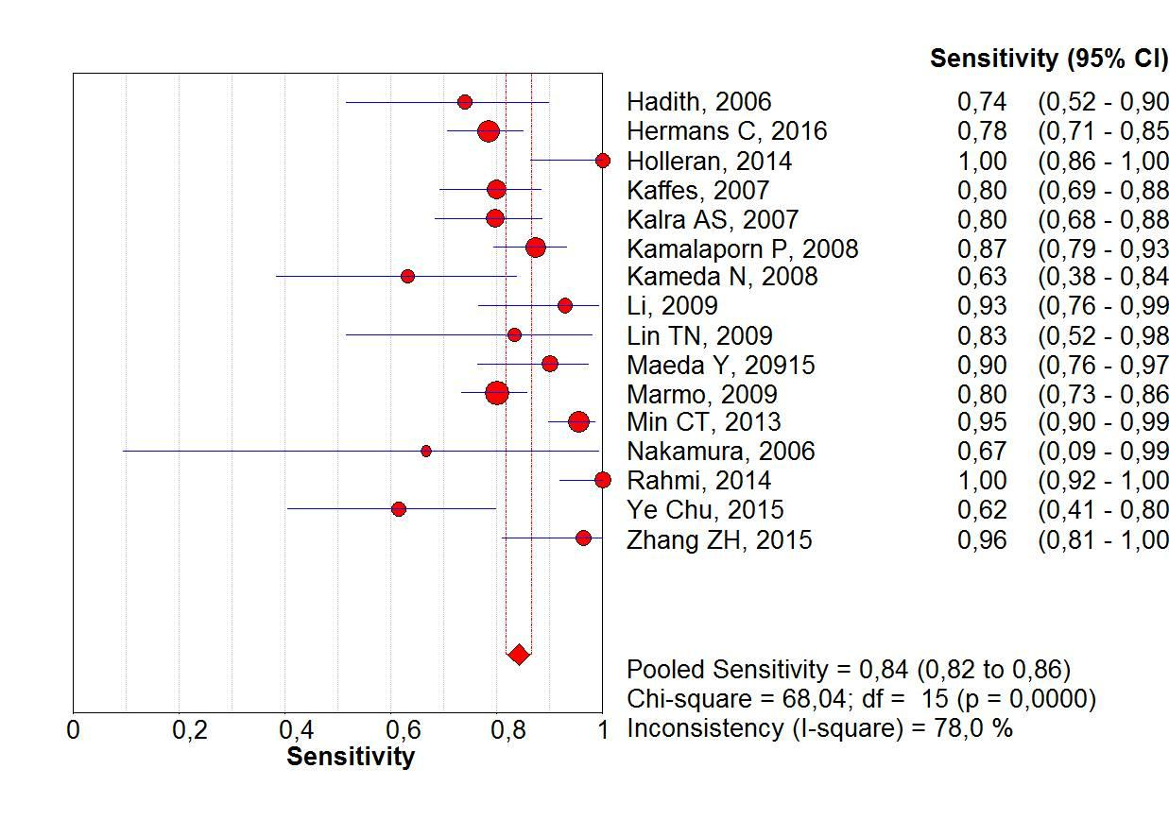
Figure 1: Forrest plot. DBE sensitivity per-lesion analysis
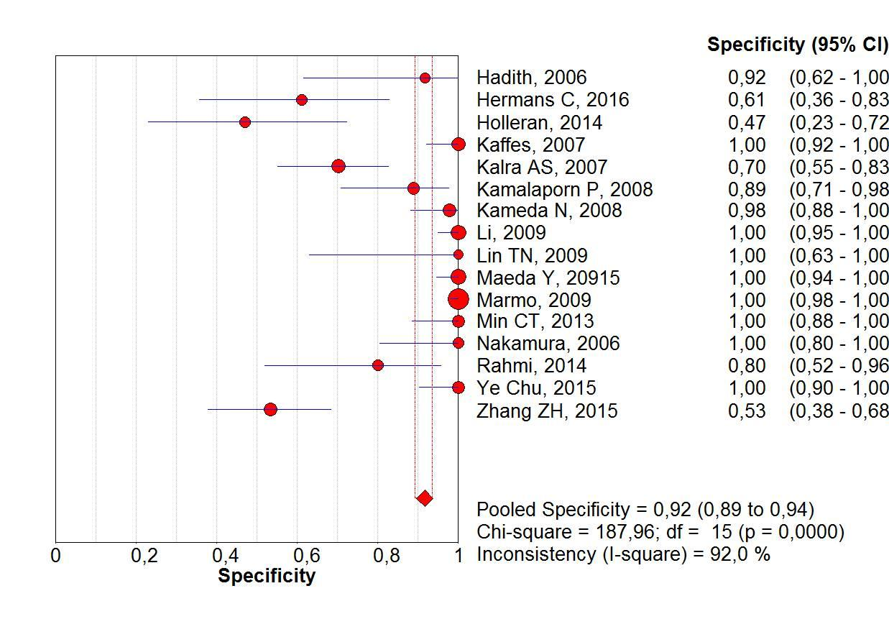
Figure 2: Forrest plot. DBE specificity per-patient analysis

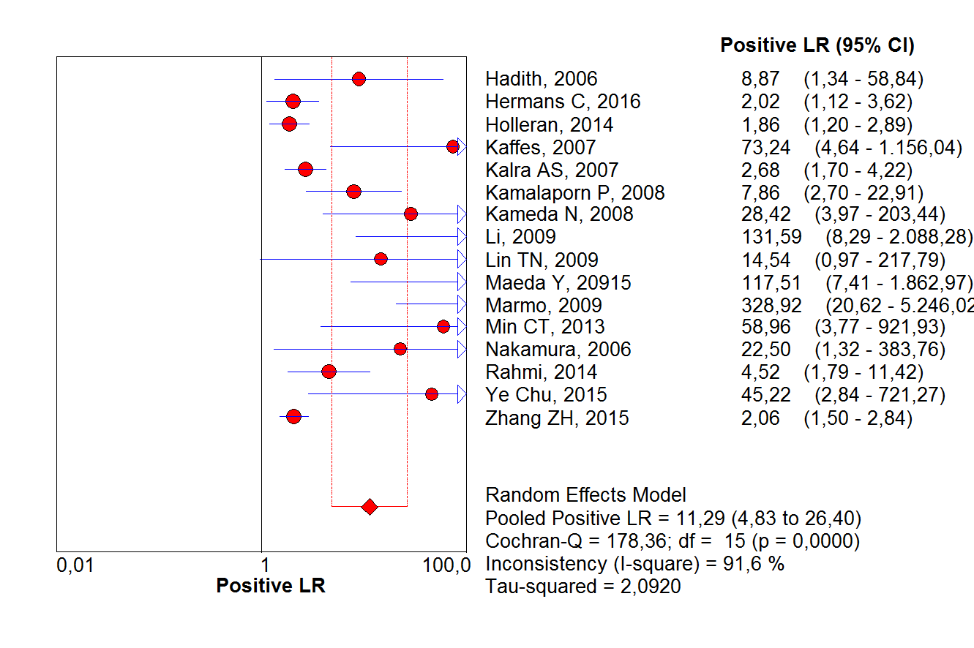
Figure 3: Forrest plot. DBE positive likelihood ratio per-patient analysis
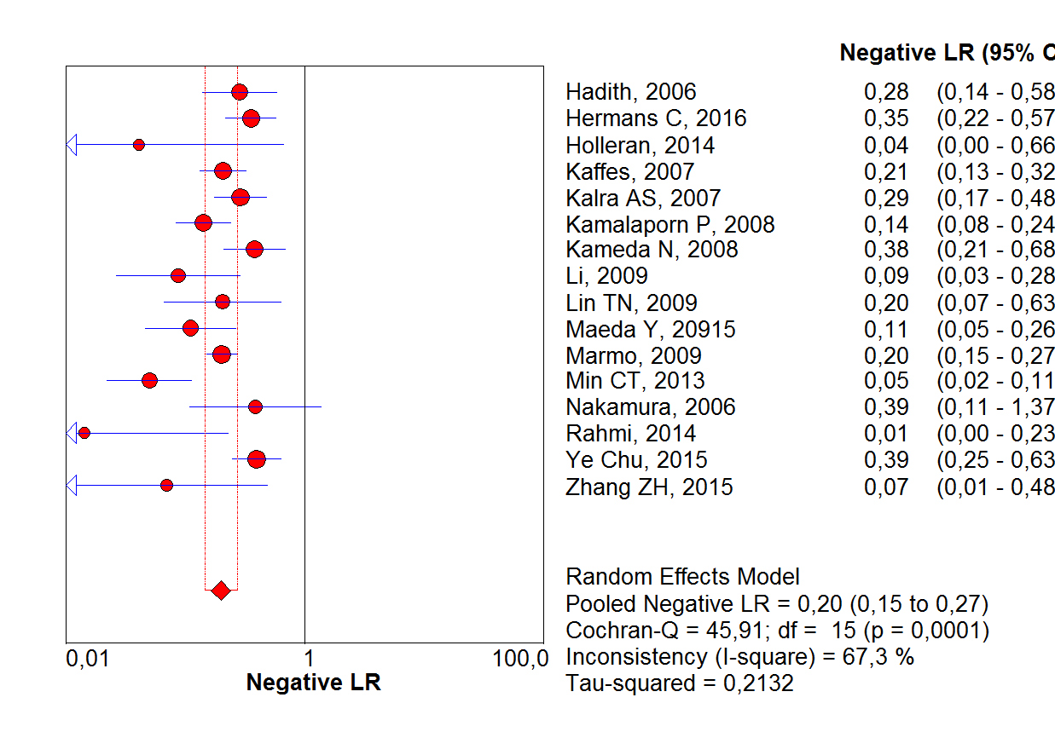
Figure 4: Forrest plot. DBE negative likelihood ratio per-patient analysis

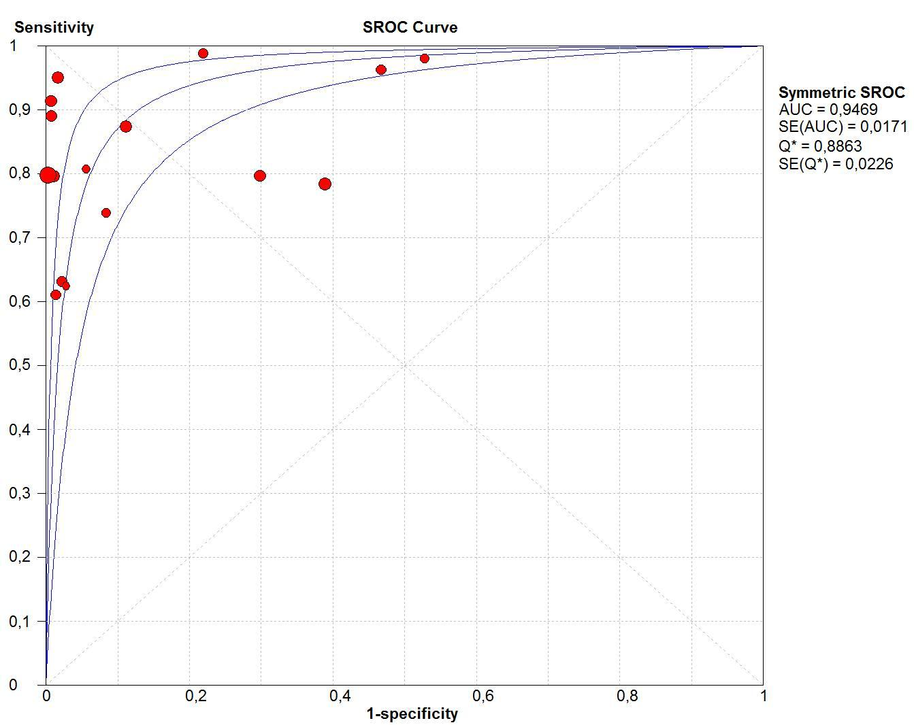
Figure 5: Summary receiver operating characteristic (sROC) curve for DBE in per-patient analysis

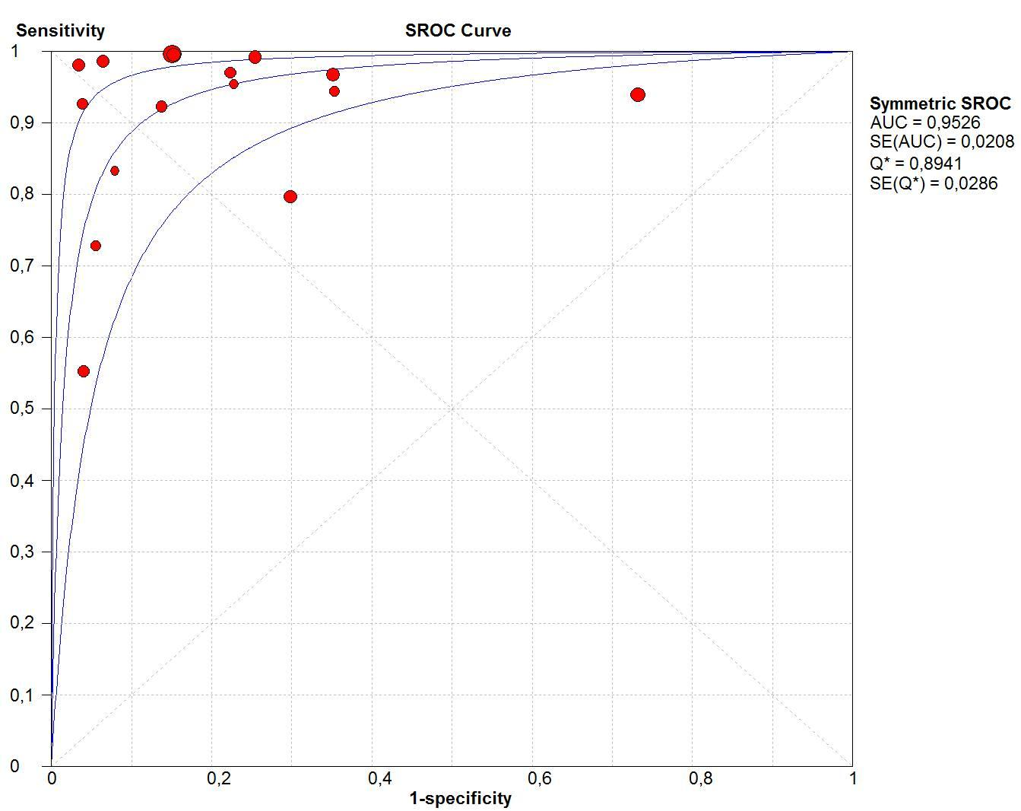
Figure 6: Summary receiver operating characteristic (sROC) curve for VCE in per-patient analysis

Figure 7: Flow Diagram - PRISMA
After abstract
Studies included in quantitative synthesis (meta-analysis)
(n = 16)
Full-text articles excluded
(n = 25)
Records excluded
(n = 3995)
Records screened
(n = 42)
Records after duplicates removed
(n = 4037)

Identification

Eligibility

Included

Screening

Records identified through database searching
(n = 4037)
Additional records identified through other sources
(n = 0)

Full-text articles assessed for eligibility
(n = 17)

Studies included in qualitative synthesis
(n = 16)

From: Moher D, Liberati A, Tetzlaff J, Altman DG, The PRISMA Group (2009). Preferred Reporting Items for Systematic Reviews and Meta-Analyses: The PRISMA Statement. PLoS Med 6(7): e1000097. doi:10.1371/journal.pmed100009^{[35]}

Stable
Instable
Conclusive
Inconclusive
Instable
Stable
Figure 8: Suggested management approach to overt and occult small-bowel bleeding after upper endoscopy and colonoscopy did not identify vascular bleeding origin. Positive test results should direct specific therapy. When VCE is contraindicated or unavailable, device-assisted endoscopy (DAE) may be the initial test for small-bowel evaluation.
Label: VCE, video capsule endoscopy; DBE, double balloon enteroscopy.

Study | Hadithi M., 2006^{[4]} | Hermans C., 2017^{[11]} | Holleran G., 2014^{[36]} | Kaffes AJ., 2007^{[37]}  Table 01: QUADAS 2. Risk of bias in individual studies | Kalra, A.S., 2015^{[16]} | Kamalapor P., 2008^{[30]} | Kameda N., 2008^{[27]} | Li X., 2010^{[38]} | Lin TN, 2007^{[39]} | Maeda Y., 2015^{[40]} | Marmo R., 2009^{[23]} | Min, CT., 2013^{[38]} | Nakamura, M., 2006^{[29]} | Rahmi,G., 2013^{[33]} | Ye Chu, 2016^{[17]} | Zhang, ZH., 2015^{[15]}
Was a consecutive or random sample of patients enrolled? | YES | UNCLEAR | UNCLEAR | YES | UNCLEAR | UNCLEAR | YES | YES | YES | YES | YES | YES | YES | YES | YES | UNCLEAR
Was a case-control design avoided? | YES | YES | NO | YES | YES | NO | YES | YES | YES | YES | YES | YES | YES | YES | YES | YES
Did the study avoid inappropriate exclusions | YES | YES | YES | YES | UNCLEAR | NO | YES | YES | YES | YES | YES | YES | YES | YES | YES | NO
Could the selection of patients have introduced bias? | LOW | MODERATE | HIGHT | LOW | HIGH | HIGH | LOW | LOW | LOW | LOW | LOW | LOW | LOW | LOW | LOW | HIGH
Are there concerns that the included patients do not match the review question? | LOW | LOW | LOW | LOW | LOW | LOW | LOW | LOW | LOW | LOW | LOW | LOW | LOW | LOW | LOW | HIGH
Were the index test results interpreted without knowledge of the results of the reference standard? | YES | NO | YES | NO | YES | NO | YES | UNCLEAR | UNCLEAR | UNCLEAR | YES | NO | YES | NO | NO | UNCLEAR
If a threshold was used, was it prespecified? | YES | YES | YES | YES | NO | YES | YES | YES | NO | YES | YES | NO | YES | YES | YES | YES
Could the conduct or interpretation of the index test have introduced bias? | LOW | MODERATE | LOW | MODERATE | MODERATE | MODERATE | LOW | MODERATE | MODERATE | MODERATE | LOW | HIGH | LOW | MODERATE | MODERATE | MODERATE
Are there concerns that the index test, its conduct,or interpretation differ from the review question? | LOW | LOW | LOW | LOW | LOW | LOW | LOW | LOW | LOW | LOW | LOW | LOW | LOW | LOW | LOW | HIGH
Is the reference standard likely to correctly classify the target condition? | YES | YES | YES | YES | YES | YES | YES | YES | YES | YES | YES | YES | YES | YES | NO | UNCLEAR
Were the reference standard results interpreted without knowledge of the results of the index test? | YES | NO | YES | NO | YES | YES | YES | YES | YES | YES | YES | YES | YES | YES | YES | UNCLEAR
Could the reference standard, its conduct, or its interpretation have introduced bias? | LOW | MODERATE | LOW | MODERATE | LOW | LOW | LOW | LOW | LOW | LOW | LOW | LOW | LOW | LOW | HIGH | HIGH
Are there concerns that the target condition as defined by the reference standard does not match the review question? | LOW | LOW | LOW | LOW | LOW | LOW | LOW | LOW | LOW | LOW | LOW | LOW | LOW | LOW | HIGH | HIGH
Was there an appropriate interval between index test(s) and reference standard? | YES | NO | NO | NO | NO | NO | YES | YES | YES | YES | YES | YES | YES | NO | YES | UNCLEAR
Did all patients receive a reference standard? | YES | YES | YES | YES | YES | YES | YES | YES | YES | YES | YES | YES | YES | YES | YES | YES
Did all patients receive the same reference standard? | NO | YES | YES | YES | YES | YES | YES | YES | YES | YES | YES | YES | YES | YES | YES | YES
Were all patients included in the analysis? | YES | YES | YES | YES | YES | YES | YES | YES | YES | YES | YES | YES | YES | YES | YES | YES
Could the patient flow have introduced bias? | MODERATE | LOW | LOW | LOW | LOW | MODERATE | LOW | LOW | LOW | LOW | LOW | LOW | LOW | MODERATE | LOW | LOW

Table 02: Studies characteristics
 | Median age; range | Total of patients | Study design | VCE Model | DBE Model | Praparation | Interval CE x DBE | N° of patients with diagnoses of SBB by CE/total CE performed | N°. of patients with diagnoses of SBB by DBE/total DBE performed
Fujimoto S., 2007^{[28]} | 64  (38-93) | 45  M: 25  F: 20 | Prospective study | Pillcam (Given  Imaging, Yoqneam, Israel). | EN−450P5 DBE diagnostic  model and/or the EN−450T5 | CE: 12h fast + 1L sodium sulfate/sodium bicarbonate  DBE: 72h after CE in 36pct | 72 hours | 18/45  Angiodysplasia: 6  Varices: 2 jejunal | 18/36
Hadithi M., 2006^{[4]} | 63.2  (19–86) | 35  M:22  F: 13 | Prospective blinded study | Given M2A, Given Imaging Ltd., Yoqneam, Israel | Fuji Photo Optical Incorporated  Company Fujinon Inc., Japan | CE: fast overnight  after the ingestion of 1 L of sodium sulphate/sodium bicarbonate solution  DBE: fast overnight after ingestion of 1 L clean prep. for the antegrade approach and bowel cleansing as for colonoscopy (4 L Klean prep) | 7 to 14 days | 21/35  AVM: 19  Fresh blood and clots: 5 | 28/35  AVM: 16  Fresh blood and clots: 2
Hermans C, 2017^{[11]} | 69 (18-91) | 146  M: 91  F: 55 | Retrospective observational study. | Olympus VC (Olympus EndoCapsule; Tokyo, Japan) and Pillcam VC (Covidien plc,  Dublin, Ireland) | Fujinon Double-Balloon Enteroscopy System (Fujinon GMBH, Germany),EN-450T5 | CE: 2 L PEG in a single or split dose  DBE: 1 L PEG divided into two doses to be used twice | 111  (1–1091) days | 105/134  Angiodysplasias: 70  active bleedings  without visible focus :35 | 93/146  Angiodysplasias: 19
Holleran, G., 2013^{[36]} | 54  (16–90) | 246  M: 130  F: 116 | Retrospective comparative study | SB1 or SB2 pillcam  (Given imaging, Yokneam, Israel) | Fujinon double-balloon enteroscope (EN-  450P5/20, Fujinon, Inc, Saitama, Japan) | CE: No preparation was required other than an overnight fast.  Anterograde DBE: overnight fast  Retrograde DBE: PEG the day prior | NR* | 40/46  Angiodysplasia: 10  Active bleeding: 3 | 116/246  Angiodysplasias: 44
Kaffes, A.J., 2007^{[31]} | 62 + 18 | 60 | Prospective cohort study | M2A; Given Imaging Ltd, Yoqneam, Israel) | Fujinon | CE, DBE: fasting period of 8 hours before the oral procedure and a bowel preparation with a sodium  (Picoprep; Pharmatel, Thornleigh, Australia) | NR* | 45/60  Angiectasia:28  Red spots: 9  Blood: 8 | 45/60  Angiectasia: 21  Red spots: 9  Blood: 8
Kalra, A. S., 2015^{[16]} | 66.6 ± 13.2 | 116  M:65  F: 51 | Retrospective review | Medtronic, Duluth, GA, USA | Fujifilm Medical System, Stanford, CT, USA | Retrograde DBE: bowel preparation the night before the procedure. | 1 year | /69 | 29/69  AVM: 29
Kamalaporn, P., 2008^{[30]} | 64.1  (34–83) | 195  M: 26  F:25 | Retrospective review | Given M2A CE system (Given Imaging Ltd, Israel) | Fujinon DBE system (Fuji Photo Optical Incorporated  Company, Fujinon Inc, Japan) | CE: 2 L to 4 L PEG and fasted overnight, at least 8 h before the procedure  DBE: 4 L PEG and fasted overnight | 139  (40 to 335) days | 181/202 studies  Angiodysplasia: 33  Bleeding: 22 | 56/56  Angiodysplasia: 36  Bleeding: 9
Kameda, N., 2008^{[27]} | 62.4  (27–84) | 32  M: 13  F: 19 | Prospective single-blind trial | Pill Cam capsule (M2A, Given Imaging, Yoqneam, Israel) | DBE system (FujinonToshiba ES System, Saitama, Japan) | CE: fasting after midnight on the evening before the examination (minimum 8 h)  DBE: overnight fasting and ingestion of 1 l of electrolyte lavage preparation (Niflec, Ajinomoto Pharma, Tokyo, Japan) in the morning. | 1- 7 days | 29/32  Angiodysplasia: 8  bleeding: 6 | 21/32  Angiodysplasia: 7  bleeding: 6
Li, X., 2010^{[34]} |  | 190 | Prospective study | M2A, Given Imaging, Ltd (Yoqneam, Israel) | Fujinon EN-450P5/  20 and EN-450P5/28 (Fujinon Inc, Saitama, Japan) | CE: 1 l of PEG electrolyte 12 h before the procedure  Anterograde DBE: fasted for 8 h.  Retrograde DBE: PEG electrolytes preparation 4 h before the examination | 5.8 days (1–18) | 165/190  AVM: 7  Fresh blood or clots: 8 | 34/51  AVM: 9  Bleeding: 0  Angioma: 4
Lin, TN., 2007^{[39]} | 63.5 ± 22.7 (11~87) | 10  M:3  F:7 | Prospective study | Pill Cam SB capsule  (Given Imaging, Yoqneam, Israel) | DBE: EN-  450P5 and the EN-450T5 | CE: fast overnight for 8-12 hours  Anterograde DBE: fasting for 6-8 hours  Retrograde DBE: bowel  cleansing as in a colonoscopy. | 7 Days | 9/10  Angiodysplasias: 3  Bleeding: 3 | 8/10  Angiodysplasias: 3  Varices: 1  Dieulafoy’s lesion: 1
Maeda, Y., 2010^{[40]} | 70  (30–92) | 89  M: 48  F: 41 | Retrospective analysis | PilCam SB® (SB1, SB2, or SB3) (Covidien, Irvine, CA, USA). | (EN-450 T5/W or EN-580 T, Fujinon Inc., Saitama,  Japan) | NR* | 24h | 58/89  Angiectasia: 8  AVM : 3  Dieulafoy lesion: 9  Varice: 2 | 29/37  Angiectasia:8  AVM: 3  Dieulafoy lesion:6  Varice: 1
Marmo R, 2008^{[23]} | 61.6 ± 16.2 | 193  M: 119  F: 74 | Prospective study | Pillcam SB | Fujinon Double-Balloon Enteroscopy System | Anterograde DBE: fasting period of 8 hours  Retrograde DBE: 4L PEG based preparation | 2 weeks | 175/193  Vascular lesions: 74  Blood or clot: 34 | 132/193  Vascular lesions: 72
Min, CT., 2013^{[38]} | 55.4  (23–78) | 62  M: 34  F:28 | Prospective study | Pill Cam SB capsule | EN-450P5 and the EN-450T5 (Fujinon) | CE: 2 L to 4 L PEG and fasted overnight  Anterograde DBE: fasting for 6-8 hours before the procedure.  Retrograde DBE: bowel  cleansing as in a colonoscopy. | 15 (4-60)  days | 44/62  Angiodysplasia: 26  Bleeding: 26 | 48/62  Angiodysplasia: 27  Bleeding: 30
Nakamura, M., 2006^{[29]} | 58.5  (25 ± 85) | 32  M: 21  F: 11 | Prospective and blinded | M2A, Given Imaging, | Fuji EN−450 T5/20 | CE: fluid diet for 12 h  and observed a fasting period starting at midnight  Anterograde DBE: fasted for 12 h  Retrograde DBE: clear liquid diet on the day before the examination and PEG electrolyte lavage solution on the morning of the examination | 48h | 19/32  Angiodysplasias: 4  Red spots: 2 | 12/28  Angiodysplasias: 2  Red spots: 2
Rahmi,G., 2013^{[33]} | 67 ± 11 | 383  M: 114  F: 269 | Prospective, multicenter study | PillCam SB device | EN-450P5 and  EN-450T5; Fujinon | CE: residue-free diet  2 days before VCE ingestion; 2L PEG solution the night before the examination; patients then fasted overnight  Anterograde DBE : No bowel preparation  Retrograde DBE: 4L of a PEG  solution was given the day before the procedure | 4.1±  6.3 months | 266/383  Angiodyslasia: 266 | 205/266  Angiodyslasia: 190
Ye Chu, 2016^{[17]} | 51.1 ± 17.1 | 121  M: 60  F: 61 | Study Cohorts | OMOM capsule endoscopic device  (Jinshan Science and Technology Group Co., Ltd, Chongqing,  China) | Fujinon EN-450P5/20 | CE: 2 L polyethylene glycol-based electrolyte solution 12 hours prior to the test, followed by an overnight fast for bowel preparation  Anterograde DBE: overnight  fast  Retrograde DBE: bowel preparation used for CE procedure the day before the examination | 1 week | 115/121  Angiodysplasia: 86%  Active bleeding: 6 | 29/46  Angiodysplasia: 9
Zhang, ZH., 2015^{[15]} | 47.19 (16-78) | 88  M: 64  F: 24 | Prospective study | Pill Cam SB | Fuji DBE system | CE: 3 liters of PEG (2 liters at 10:00 pm the night before the procedure, and 1 liter with the simethicone at 4:00 am on the morning of the procedure)  Anterograde DBE: fast for 6-8 h  Retrograde DBE: 2 L of PEG | NR | 53/88  MAV: 14  Hemangioma: 0  Diverticulum with a  Bleeding ulcer: 1 | 52/88  MAV:10  Hemangioma: 3  Diverticulum with a  Bleeding ulcer:7
 | Medians age; range | Patients | Study design | VCE Model | DBE Model | Praparation | Interval CEx x DBE | No. of patients with diagnoses of SBB by CE | No. of patients with diagnoses of SBB by DBE

M: male; F: female; SBB: small bowel bleeding; PEG: polyethylene glycol solution; VC: videocapsule, NR: Not related

References
1. Katz LB. The role of surgery in occult gastrointestinal bleeding. Semin Gastrointest Dis [Internet] 1999;10:78–81 [PMID: 10361899]Available from: http://www.ncbi.nlm.nih.gov/pubmed/10361899
2. Fujimori S, Seo T, Gudis K, Tanaka S, Mitsui K, Kobayashi T, Ehara A, Yonezawa M, Tatsuguchi A, Sakamoto C. Diagnosis and treatment of obscure gastrointestinal bleeding using combined capsule endoscopy and double balloon endoscopy: 1-year follow-up study. Endoscopy 2007;39:1053–8 [PMID: 18072055 DOI: 10.1055/s-2007-967014]
3. Sulbaran M, de Moura E, Bernardo W, Morais C, Oliveira J, Bustamante-Lopez L, Sakai P, Mönkemüller K, Safatle-Ribeiro A. Overtube-assisted enteroscopy and capsule endoscopy for the diagnosis of small-bowel polyps and tumors: a systematic review and meta-analysis. Endosc Int open [Internet] 2016;4:E151-63 [PMID: 26878042 DOI: 10.1055/s-0041-108261]Available from: http://www.ncbi.nlm.nih.gov/pubmed/26878042
4. Hadithi M, Heine GDN, Jacobs M, von Bodegraven AA, Mulder CJJ, Heine D, Jacobs M, Bodegraven A, Mulder CJJ. A prospective study comparing video capsule endoscopy with double-balloon enteroscopy in patients with obscure gastrointestinal bleeding. Am J Gastroenterol 2006;101:682 [DOI: http://dx.doi.org/10.1016/j.gie.2012.04.022]
5. Foutch PG. Angiodysplasia of the Gastrointestinal Tract. Am. J. Gastroenterol.1993;88:807–18 [PMID: 8389094 DOI: 10.1111/j.1572-0241.1993.tb03057.x]
6. Kwo PY, Tremaine WJ. Nonsteroidal anti-inflammatory drug-induced enteropathy: case discussion and review of the literature. Mayo Clin Proc [Internet] 1995;70:55–61 [PMID: 7808053 DOI: 10.4065/70.1.55]Available from: http://dx.doi.org/10.4065/70.1.55
7. Bartram CI, Amess JA. The diagnosis of Meckel’s diverticulum by small bowel enema in the investigation of obscure intestinal bleeding. Br J Surg 1980;67:417–8 [PMID: 6966954 DOI: 10.1002/bjs.1800670611]
8. Kodama M, Uto H, Numata M, Hori T, Murayama T, Sasaki F, Tsubouchi N, Ido A, Shimoda K, Tsubouchi H. Endoscopic characterization of the small bowel in patients with portal hypertension evaluated by double balloon endoscopy. J Gastroenterol 2008;43:589–96 [PMID: 18709480 DOI: 10.1007/s00535-008-2198-1]
9. Safatle-Ribeiro A, de Oliveira R, Zorrón Pu L, Caiado Â, de Moura E, Ribeiro U, Zilberstein B. Obscure gastrointestinal bleeding caused by intestinal lipomatosis: double-balloon endoscopic and laparoscopic views. Endoscopy [Internet] 2016;48:E61–2 [DOI: 10.1055/s-0042-101387]Available from: http://www.thieme-connect.de/DOI/DOI?10.1055/s-0042-101387
10. Ribeiro IB, Bernardo WM, Martins C, Touriani D, Moura H De, Baba ER, Josino IR, Miyahima NT, Andrés M, Cordero C, Arantes T. Colonic stent versus emergency surgery as treatment of malignant colonic obstruction in the palliative setting: a systematic review and meta-analysis. Endosc Int Open 2018;5:1–10 [DOI: 10.1055/a-0591-2883]
11. Hermans C, Stronkhorst A, Tjhie-Wensing A, Kamphuis J, van Balkom B, Dahlmans R, Gilissen L. Double-balloon endoscopy in overt and occult small bowel bleeding: Results, complications, and correlation with prior videocapsule endoscopy in a tertiary referral center. Clin Endosc 2017;50:69–75 [DOI: 10.5946/ce.2016.079]
12. Fisher L, Lee Krinsky M, Anderson MA, Appalaneni V, Banerjee S, Ben-Menachem T, Cash BD, Decker GA, Fanelli RD, Friis C, Fukami N, Harrison ME, Ikenberry SO, Jain R, Jue T, Khan K, Maple JT, Strohmeyer L, Sharaf R, Dominitz JA. The role of endoscopy in the management of obscure GI bleeding. Gastrointest. Endosc.2010;72:471–9 [PMID: 20801285 DOI: 10.1016/j.gie.2010.04.032]
13. Yano T, Yamamoto H, Sunada K, Miyata T, Iwamoto M, Hayashi Y, Arashiro M, Sugano K. Endoscopic classification of vascular lesions of the small intestine (with videos). Gastrointest Endosc [Internet] 2008;67:169–72 [PMID: 18155439 DOI: 10.1016/j.gie.2007.08.005]Available from: http://www.ncbi.nlm.nih.gov/pubmed/18155439
14. Saurin J-C, Delvaux M, Gaudin J-L, Fassler I, Villarejo J, Vahedi K, Bitoun A, Canard J-M, Souquet JC, Ponchon T, Florent C, Gay G. Diagnostic value of endoscopic capsule in patients with obscure digestive bleeding: blinded comparison with video push-enteroscopy. Endoscopy [Internet] 2003;35:576–84 [PMID: 12822092 DOI: 10.1055/s-2003-40244]Available from: http://www.ncbi.nlm.nih.gov/pubmed/12822092
15. Zhang Q, He Q, Liu J, Ma F, Zhi F, Bai Y. Combined use of capsule endoscopy and double-balloon enteroscopy in the diagnosis of obscure gastrointestinal bleeding: meta-analysis and pooled analysis. Hepatogastroenterology [Internet] 60:1885–91 [PMID: 24719922]Available from: http://www.ncbi.nlm.nih.gov/pubmed/24719922
16. Kalra AS, Walker AJ, Benson ME, Soni A, Guda NM, Misha M, Gopal D V. Comparison of capsule endoscopy findings to subsequent double balloon enteroscopy: A dual center experience. Diagn Ther Endosc 2015;2015 [PMID: 26420979 DOI: 10.1155/2015/438757]
17. Chu Y, Wu S, Qian Y, Wang Q, Li J, Tang Y, Bai T, Wang L. Complimentary imaging modalities for investigating obscure gastrointestinal bleeding: Capsule endoscopy, double-balloon enteroscopy, and computed tomographic enterography. Gastroenterol Res Pract 2016;2016 [PMID: 26858753 DOI: 10.1155/2016/8367519]
18. Ribeiro IB, Rezende DT, Madruga Neto AC., Al E. Endoscopic dual therapy for giant peptic ulcer hemorrhage. Endoscopy [Internet] 2018;[PMID: 30107634 DOI: 10.1055/a-0665-4142]Available from: http://www.thieme-connect.de/DOI/DOI?10.1055/a-0665-4142
19. Shiani A, Nieves J, Lipka S, Patel B, Kumar A, Brady P. Degree of concordance between single balloon enteroscopy and capsule endoscopy for obscure gastrointestinal bleeding after an initial positive capsule endoscopy finding. Therap Adv Gastroenterol [Internet] 2016;9:13–8 [DOI: 10.1177/1756283X15610042]Available from: http://journals.sagepub.com/doi/10.1177/1756283X15610042
20. Carey EJ, Fleischer DE. Investigation of the small bowel in gastrointestinal bleeding--enteroscopy and capsule endoscopy. Gastroenterol Clin North Am [Internet] 2005;34:719–34 [PMID: 16303579 DOI: 10.1016/j.gtc.2005.08.009]Available from: http://www.ncbi.nlm.nih.gov/pubmed/16303579
21. Gerson LB, Van Dam J. Wireless Capsule Endoscopy and Double-Balloon Enteroscopy for the Diagnosis of Obscure Gastrointestinal Bleeding. Tech Vasc Interv Radiol [Internet] 2004;7:130–5 [DOI: 10.1053/j.tvir.2004.12.004]Available from: http://linkinghub.elsevier.com/retrieve/pii/S1089251604000514
22. Wang A, Banerjee S, Barth BA, Bhat YM, Chauhan S, Gottlieb KT, Konda V, Maple JT, Murad F, Pfau PR, Pleskow DK, Siddiqui UD, Tokar JL, Rodriguez SA. Wireless capsule endoscopy. Gastrointest Endosc 2013;[PMID: 24119509 DOI: 10.1016/j.gie.2013.06.026]
23. Marmo R, Rotondano G, Casetti T, Manes G, Chilovi F, Sprujevnik T, Bianco M, Brancaccio M, Imbesi V, Benvenuti S, Pennazio M. Degree of concordance between double-balloon enteroscopy and capsule endoscopy in obscure gastrointestinal bleeding: a multicenter study. Endoscopy [Internet] 2009;41:587–92 [DOI: 10.1055/s-0029-1214896]Available from: http://www.thieme-connect.de/DOI/DOI?10.1055/s-0029-1214896
24. Pennazio M, Spada C, Eliakim R, Keuchel M, May A, Mulder CJ, Rondonotti E, Adler SN, Albert J, Baltes P, Barbaro F, Cellier C, Charton JP, Delvaux M, Despott EJ, Domagk D, Klein A, McAlindon M, Rosa B, Rowse G, Sanders DS, Saurin JC, Sidhu R, Dumonceau JM, Hassan C, Gralnek IM. Small-bowel capsule endoscopy and device-assisted enteroscopy for diagnosis and treatment of small-bowel disorders: European Society of Gastrointestinal Endoscopy (ESGE) Clinical Guideline. Endoscopy2015;[PMID: 25826168 DOI: 10.1055/s-0034-1391855]
25. Martínez EP-C, Pérez-Cuadrado Martínez E, Robles EP-C, Pérez-Cuadrado Robles E. Capsule endoscopy and deep enteroscopy. Endoscopy [Internet] 2014;46:787–90 [PMID: 25133478 DOI: 10.1055/s-0034-1377448]Available from: http://www.ncbi.nlm.nih.gov/pubmed/25133478
26. Westerhof J, Weersma RK, Koornstra JJ. Investigating obscure gastrointestinal bleeding: capsule endoscopy or double balloon enteroscopy? Neth J Med [Internet] 67:260–5 [PMID: 19687519]Available from: http://www.ncbi.nlm.nih.gov/pubmed/19687519
27. Kameda N, Higuchi K, Shiba M, Machida H, Okazaki H, Yamagami H, Tanigawa T, Watanabe K, Watanabe T, Tominaga K, Fujiwara Y, Oshitani N, Arakawa T. A prospective, single-blind trial comparing wireless capsule endoscopy and double-balloon enteroscopy in patients with obscure gastrointestinal bleeding. J Gastroenterol [Internet] 2008;43:434–40 [PMID: 1860038715 DOI: 10.1007/s00535-008-2182-9]Available from: http://link.springer.com/10.1007/s00535-008-2182-9
28. Otsuka T, Kawazoe S, Nakashita S, Kamachi S, Oeda S, Sumida C, Akiyama T, Ario K, Fujimoto M, Tabuchi M, Noda T. Low-dose rectal diclofenac for prevention of post-endoscopic retrograde cholangiopancreatography pancreatitis: A randomized controlled trial. J Gastroenterol 2012;47:912–7 [PMID: 22350703 DOI: 10.1007/s00535-012-0554-7]
29. Nakamura M, Niwa Y, Ohmiya N, Miyahara R, Ohashi A, Itoh A, Hirooka Y, Goto H. Preliminary comparison of capsule endoscopy and double-balloon enteroscopy in patients with suspected small-bowel bleeding. Endoscopy [Internet] 2006;38:59–66 [PMID: 16429356 DOI: 10.1055/s-2005-870446]Available from: http://www.ncbi.nlm.nih.gov/pubmed/16429356
30. Kamalaporn P, Cho S, Basset N, Cirocco M, May G, Kortan P, Kandel G, Marcon N. Double-balloon enteroscopy following capsule endoscopy in the management of obscure gastrointestinal bleeding: outcome of a combined approach. Can J Gastroenterol [Internet] 2008;22:491–5 [PMID: 18478135]Available from: http://www.ncbi.nlm.nih.gov/pubmed/8478135
31. Kaffes AJ, Siah C, Koo JH. Clinical outcomes after double-balloon enteroscopy in patients with obscure GI bleeding and a positive capsule endoscopy. Gastrointest Endosc 2007;66:304–9 [PMID: 17643704 DOI: 10.1016/j.gie.2007.02.044]
32. Gurudu SR, Bruining DH, Acosta RD, Eloubeidi MA, Faulx AL, Khashab MA, Kothari S, Lightdale JR, Muthusamy VR, Yang J, DeWitt JM. The role of endoscopy in the management of suspected small-bowel bleeding. Gastrointest Endosc [Internet] 2017;85:22–31 [DOI: 10.1016/j.gie.2016.06.013]Available from: http://linkinghub.elsevier.com/retrieve/pii/S0016510716302504
33. Rahmi G, Samaha E, Vahedi K, Delvaux M, Gay G, Lamouliatte H, Filoche B, Saurin J-C, Ponchon T, Rhun M Le, Coumaros D, Bichard P, Manière T, Lenain E, Chatellier G, Cellier C. Long-term follow-up of patients undergoing capsule and double-balloon enteroscopy for identification and treatment of small-bowel vascular lesions: a prospective, multicenter study. Endoscopy [Internet] 2014;46:591–7 [PMID: 24830401 DOI: 10.1055/s-0034-1365514]Available from: http://www.ncbi.nlm.nih.gov/pubmed/24830401
34. Li X, Dai J, Lu H, Gao Y, Chen H, Ge Z. A Prospective Study on Evaluating the Diagnostic Yield of Video Capsule Endoscopy Followed by Directed Double-Balloon Enteroscopy in Patients with Obscure Gastrointestinal Bleeding. Dig Dis Sci [Internet] 2010;55:1704–10 [DOI: 10.1007/s10620-009-0911-4]Available from: http://link.springer.com/10.1007/s10620-009-0911-4
35. Moher D, Liberati A, Tetzlaff J, Altman DG. Preferred Reporting Items for Systematic Reviews and Meta-Analyses : Ann Intern Med 2014;151:264–9 [PMID: 21603045 DOI: 10.1371/journal.pmed1000097]
36. Holleran G, Hall B, Alhinai M, Zaheer A, Leen R, Alakkari A, Mahmud N, McNamara D. Double-balloon enteroscopy in Ireland in the capsule endoscopy era. Ir J Med Sci 2015;184:257–62 [DOI: 10.1007/s11845-014-1097-0]
37. Fuller NR, Pearson S, Lau NS, Wlodarczyk J, Halstead MB, Tee HP, Chettiar R, Kaffes AJ. An intragastric balloon in the treatment of obese individuals with metabolic syndrome: A randomized controlled study. Obesity 2013;21:1561–70 [PMID: 23512773 DOI: 10.1002/oby.20414]
38. Tian Min C, Li Hua X, Ying Lin J, Yan Mei Y, Fei L, Jun Bo Q. The role of double-balloon enteroscopy following capsule endoscopy in diagnosis of obscure Small intestinal diseases. Pakistan J Med Sci [Internet] 2013;29:479–84 [PMID: 24353560]Available from: http://www.ncbi.nlm.nih.gov/pubmed/24353560
39. Lin T-N, Su M-Y, Hsu C-M, Lin W-P, Chiu C-T, Chen P-C. Combined use of capsule endoscopy and double-balloon enteroscopy in patients with obscure gastrointestinal bleeding. Chang Gung Med J [Internet] 31:450–6 [PMID: 19097591]Available from: http://www.ncbi.nlm.nih.gov/pubmed/19097591
40. Maeda Y, Moribata K, Deguchi H, Inoue I, Maekita T, Iguchi M, Tamai H, Kato J, Ichinose M. Video capsule endoscopy as the initial examination for overt obscure gastrointestinal bleeding can efficiently identify patients who require double-balloon enteroscopy. BMC Gastroenterol [Internet] 2015;15:132 [PMID: 26467439 DOI: 10.1186/s12876-015-0362-7]Available from: http://www.ncbi.nlm.nih.gov/pubmed/26467439

