Name of Journal: World Journal of Psychiatry
Manuscript NO: 69977
Manuscript Type: LETTER TO THE EDITOR

COVID-19, mental health and Indigenous populations in Brazil: The epidemic beyond the pandemic

Gonçalves Júnior J et al. COVID-19, mental health and Indigenous populations

Jucier Gonçalves Júnior, Jucycler Ferreira Freitas, Estelita Lima Cândido

Jucier Gonçalves Júnior, Internal Medicine - Division of Rheumatology, São Paulo University, São Paulo 01246-903, Brazil

Jucycler Ferreira Freitas, Estelita Lima Cândido, Post Graduate Program in Sustainable Regional Development, Federal University of Cariri, Juazeiro do Norte 63048-080, Ceara, Brazil

Author contributions: All authors contributed equally in the production of this paper.

Corresponding author: Jucier Gonçalves Júnior, MD, Academic Research, Internal Medicine - Division of Rheumathology, São Paulo University, Av. Dr. Arnaldo, 455, 3º andar - sala 3131 Cerqueira César, São Paulo 01246-903, Brazil. juciergjunior@hotmail.com

Received: July 18, 2021
Revised: October 5, 2021
Accepted: April 20, 2022
Published online: May 19, 2022

Abstract
The aim of this paper was to report on factors contributing to the deterioration of the mental health of Indigenous populations (IP) in Brazil. Five factors seem to have a direct impact on the mental health of IP in Brazil: (1) The absence of public policies; (2) Intellectual production; (3) Psychiatric medical care for remote areas (e.g., telemedicine) aimed at promoting the mental health of Brazil’s IP, which causes a huge gap in the process of assistance and social, psychological, economic and cultural valorization of native peoples; (4) The dissemination of fake news, which exposed, above all, older IP to risk behaviors in the pandemic, such as refusal of vaccination; and (5) The violence carried out on IP lands due to economic interests with mining/agribusiness.

Key Words: Brazil; COVID-19; Indigenous population; Mental health; Public health

©The Author(s) 2022. Published by Baishideng Publishing Group Inc. All rights reserved.

Citation: Gonçalves Júnior J, Freitas JF, Cândido EL. COVID-19, mental health and Indigenous populations in Brazil: The epidemic beyond the pandemic. World J Psychiatry 2022; 12(5): 766-769
URL: https://www.wjgnet.com/2220-3206/full/v12/i5/766.htm
DOI: https://dx.doi.org/10.5498/wjp.v12.i5.766

Core Tip: In Brazil, the mental health of the Indigenous population (healthy or with psychiatry disorders) suffers from several factors. Over the past 2 years, there has been growing violence against Indigenous people along with a considerable increase of fake news dissemination regarding the coronavirus disease 2019 pandemic currently afflicting them. These two factors, accentuated by the lack of public policies and scarce academic contribution in the area, make the mental health of the Indigenous population in Brazil an important public health problem.

TO THE EDITOR
With great interest we read the work of Diaz et al^{[1]} commenting on how the coronavirus disease 2019 (COVID-19) pandemic affects psychiatric patients disproportionately compared to the general population. Of the highlighted minority groups, the Indigenous population (IP) draws our attention. We would like, therefore, to contribute to the discussion with some factors that in our opinion may further worsen the mental health of these populations in Brazil. A summary of the points we consider important about the topic are presented in Figure 1.
As the authors pointed out, there is a dearth of public policies that address the promotion of mental health in Indigenous patients with psychiatric illnesses (IPPI)^{[1]}. Moreover, in Brazil, this situation is even more precarious. The most recent regulation on the mental health of the IPPI was only released by the Brazilian Ministry of Health in 2007 - the Policy of Comprehensive Mental Health Care for Indigenous Populations (“Política de Atenção Integral à Saúde Mental das Populações Indígenas”)^{[2]} (Figure 1). Besides that, academic production is limited. An integrative review carried out on the subject showed that of the 5510 articles found in 20 years of scientific publications, only 14 (0.2%) contemplated the mental health of the IPPI^{[3]}. This factor reinforces their findings: That there is a lack in mental health care for IPPI^{[1]}. However, in Brazil, in addition to the lack of mental health care, there is a gap between academic production and current legislation. At the same time, consecutive antibody seroprevalence surveys against COVID-19 conducted in urban areas in all regions of the Brazil reported a higher prevalence in IP than other ethnicities^{[4]}.
In Brazil, the spread of fake news is another important factor causing psychological distress in IPPI according to Figure 1. Studies have already demonstrated that advancement and dissemination of false information incite fear, anger, anguish and worsening of previous depressive and anxiety symptoms and can therefore be considered as an additional epidemic (“Infodemia”) within the COVID-19 pandemic^{[5]}. According to non-governmental organizations, which historically have been defending the health of IP, such as Articulação dos Povos Indígenas do Brasil and Conselho Indigenista Missionário, there is increasing fear and worry, especially by older members of IP, due to fake news. In fact, several news articles are aimed at promoting the ineffectiveness of vaccines for COVID-19 or associated nonexistent effects (e.g., “those who took the vaccine would die in a fortnight” or “those who took the vaccine turn into an alligator”)^{[6,7]}.
Another important factor with a negative impact on the mental health of the IPPI would be the rising rates of violence against IP during the COVID-19 pandemic (Figure 1). According to Conselho Indigenista Missionário, the cases of “invasions, illegal exploitation of resources and damage to property” in indigenous lands rose from 109 in 2018 to 256 in 2019. Occurrences of this type affected 151 indigenous lands and 143 peoples in twenty-three Brazilian states. There were also 35 cases of territorial conflicts, 33 cases of death threats, 34 cases of other types of threats, 13 cases of personal injury and 31 cases of deaths due to lack of assistance in the last year^{[7]}. The continuous rise observed between 2018 and 2019 has possibly worsened during the pandemic.
Thus, the absence of telemedicine/internet services, prejudice and religious barriers are important factors that worsen the IPPI’s mental health (Figure 1). In Brazil, in addition to these factors, the lack of knowledge of the epidemiological situation of mental illnesses in this population, the violence and the Infodemia are factors that increase psychological distress and make it difficult to draft and carry out public policies.

ACKNOWLEDGEMENTS
The authors are grateful to Hospital das Clínicas, Faculdade de Medicina da Universidade de São Paulo - SP and Programa de Pós-Graduação em Desenvolvimento Regional Sustentável (PRODER).

REFERENCES
1 Diaz A, Baweja R, Bonatakis JK, Baweja R. Global health disparities in vulnerable populations of psychiatric patients during the COVID-19 pandemic. World J Psychiatry 2021; 11: 94-108 [PMID: 33889535 DOI: 10.5498/wjp.v11.i4.94]
2 Brasil. Portaria nº 2759 de 25 de outubro de 2007. Estabelece diretrizes gerais para a Política de Atenção Integral à Saúde Mental das Populações Indígenas e cria o Comitê Gestor. [cited June 15 2021]. Available from: https://bvsms.saude.gov.br/bvs/saudelegis/gm/2007/prt2759_25_10_2007.html
3 Batista MQ, Zanello V. Saúde mental em contextos indígenas: Escassez de pesquisas brasileiras, invisibilidade das diferenças. Estud Psicol 2016; 21 [DOI: 10.5935/1678-4669.20160039]
4 Hallal PC, Hartwig FP, Horta BL, Silveira MF, Struchiner CJ, Vidaletti LP, Neumann NA, Pellanda LC, Dellagostin OA, Burattini MN, Victora GD, Menezes AMB, Barros FC, Barros AJD, Victora CG. SARS-CoV-2 antibody prevalence in Brazil: results from two successive nationwide serological household surveys. Lancet Glob Health 2020; 8: e1390-e1398 [PMID: 32979314 DOI: 10.1016/S2214-109X(20)30387-9]
5 Ornell F, Schuch JB, Sordi AO, Kessler FHP. "Pandemic fear" and COVID-19: mental health burden and strategies. Braz J Psychiatry 2020; 42: 232-235 [PMID: 32267343 DOI: 10.1590/1516-4446-2020-0008]
6 Articulação dos Povos Indígenas do Brasil. Vacinação de povos indígenas. 2021. [cited 30 May 2021]. Available from: https://apiboficial.org/?s=vacina%C3%A7%C3%A3o
7 Conselho Indigenista Missionário. Apib lança campanha para garantir vacinação contra Covid-19 para povos indígenas. 2021. [cited 19 May 2021]. Available from: https://cimi.org.br/2021/01/apib-lanca-campanha-para-garantir-vacinacao-contra-covid-19-para-povos-indigenas/
Footnotes
Conflict-of-interest statement: The author declare they do not have conflict of interest.

Open-Access: This article is an open-access article that was selected by an in-house editor and fully peer-reviewed by external reviewers. It is distributed in accordance with the Creative Commons Attribution NonCommercial (CC BY-NC 4.0) license, which permits others to distribute, remix, adapt, build upon this work non-commercially, and license their derivative works on different terms, provided the original work is properly cited and the use is non-commercial. See: http://creativecommons.org/Licenses/by-nc/4.0/

Provenance and peer review: Invited article; Externally peer reviewed
Peer-review model: Single blind

Peer-review started: July 18, 2021
First decision: October 4, 2021
Article in press: April 20, 2022

Specialty type: Psychiatry
Country/Territory of origin: Brazil
Peer-review report’s scientific quality classification
Grade A (Excellent): 0
Grade B (Very good): 0
Grade C (Good): C, C
Grade D (Fair): 0
Grade E (Poor): 0

P-Reviewer: Papadopoulos KI, Thailand; Yun JY, South Korea S-Editor: Wang JJ L-Editor: Filipodia P-Editor: Wang JJ
Figure Legends
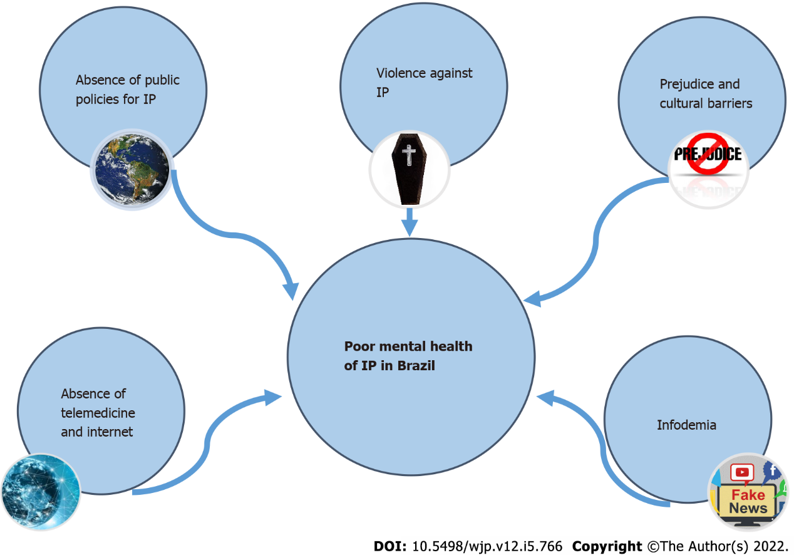
Figure 1 Factors that contribute to the worsening mental health of Indigenous peoples. IP: Indigenous people.

Published by Baishideng Publishing Group Inc
7041 Koll Center Parkway, Suite 160, Pleasanton, CA 94566, USA
Telephone: +1-925-3991568
E-mail: bpgoffice@wjgnet.com
Help Desk: https://www.f6publishing.com/helpdesk
https://www.wjgnet.com

© 2022 Baishideng Publishing Group Inc. All rights reserved.

