Name of Journal: World Journal of Clinical Cases
Manuscript NO: 88377
Manuscript Type: CASE REPORT

Inflammatory cutaneous metastases originating from gastric cancer: A case report

Tian L et al. Cutaneous metastases of gastric cancer

Lei Tian, Zhi-Bin Ye, Yun-Lei Du, Qiao-Fang Li, Li-Ya He, Hong-Zhen Zhang

Lei Tian, Qiao-Fang Li, Li-Ya He, Hong-Zhen Zhang, Department of Oncology, Hebei General Hospital, Shijiazhuang 050051, Hebei Province, China

Zhi-Bin Ye, Department of Gastrointestinal Surgery, Hebei General Hospital, Shijiazhuang 050051, Hebei Province, China

Yun-Lei Du, Department of Emergency, Hebei General Hospital, Shijiazhuang 050051, Hebei Province, China

Author contributions: Tian L and He LY provided clinical care for the patient; Tian L and Ye ZB wrote the manuscript; Li QF and Du YL were the attending consultant, Zhang HZ reviewed the final draft of the manuscript; all authors contributed to the writing, editing, and review of the manuscript.

Supported by Health Commission of Hebei Province, No. 20220919.

Corresponding author: Hong-Zhen Zhang, PhD, Chief Physician, Department of Oncology, Hebei General Hospital, No. 348 Heping West Street, Shijiazhuang 050051, Hebei Province, China. 931848183@qq.com

Received: September 24, 2023
Revised: October 22, 2023
Accepted: December 4, 2023
Published online:

Abstract
BACKGROUND
Cutaneous metastasis with gastric cancer (GC) origin is extremely rare and associated with poor prognosis. Nodular type is the most common type, while other forms are extremely rare.

CASE SUMMARY
This study describes severe skin redness, swelling, pain, and fever in a 65-year-old man diagnosed with GC, whose left chest wall, left upper limb, and left back were mainly affected. Firstly, the patient was diagnosed with “lymphangitis” and treated to promote lymphatic return. However, the symptoms were constantly deteriorating, and skin thickening and scattered small nodules gradually appeared. Finally, the skin biopsy confirmed cutaneous metastases, and the patient died 7 d later.

CONCLUSION
Our case highlights that cutaneous metastasis should be considered when skin lesions appear in patients with GC.

Key Words: Cutaneous metastasis; Gastric cancer; Inflammatory; Sclerodermoid; Nodular; Case report

Tian L, Ye ZB, Du YL, Li QF, He LY, Zhang HZ. Inflammatory cutaneous metastases originating from gastric cancer: A case report. World J Clin Cases 2023; In press

Core Tip: We describe a 65-year-old man with advanced gastric cancer and multiple metastases. He came to our hospital due to severe skin redness, swelling, pain, and fever in his left chest wall, left upper limb, and left back. He was diagnosed with “lymphangitis” and treated to promote lymphatic return. However, pain and swelling were constantly deteriorating, and skin thickening and scattered small nodules gradually appeared. Finally, the skin biopsy confirmed cutaneous metastases, and he died 7 d later. We review the related literatures and emphasize the importance of skin biopsy in case of any skin lesions.

INTRODUCTION
Gastric cancer (GC) is a highly heterogeneous disease, and the typical sites of metastasis are the liver, lung, bone, and the peritoneum^{[1]}. Cutaneous metastasis of GC is extremely rare, occurring in 0.2% to 1% of cases^{[2-4]}. Cutaneous metastasis usually occurs in the late stage but sometimes appears as the first manifestation^{[5-9]}. Single or multiple nodules are the most common clinical presentations^{[1,2,5-7,10-12]}. In this paper, we report a patient with GC who developed cutaneous metastases with extensive redness and swelling, followed by skin thickening and nodules. The patient died 7 d later after the diagnosis.

CASE PRESENTATION
Chief complaints
A 65-year-old man developed redness and swelling in the left chest wall, left upper limb, and left back in April, 2023.

History of present illness
His symptoms were obvious, accompanied by fever and pain.

History of past illness
The patient was admitted to our hospital in February, 2023, due to left shoulder pain. He had been diagnosed with stage IV poorly differentiated adenocarcinoma of the stomach in May 2022 and received eight cycles of XELOX chemotherapy (oxaliplatin plus capecitabine) in other hospitals. Computed tomography (CT) was performed and showed multiple lymph nodes, bones and liver metastases. He underwent an ultrasound-guided left cervical lymph node puncture biopsy. Pathological examination revealed poorly differentiated adenocarcinoma. Immunohistochemistry showed that cancer cells were positive for CK, CK7, and Villin and negative for Syn, CgA, and CD56. A small number of cells revealed CK20. HER2 was negative (Figure 1A), consistent with the primary GC. Sintilimab and albumin-bound paclitaxel were used as the second-line therapy. Unfortunately, he experienced progression after treatment with immune checkpoint inhibitors. Irinotecan was given as the third-line therapy.

Personal and family history
He had a history of coronary heart disease, but no family history of malignant tumors.

Physical examination
Cutaneous examination revealed the left upper limb, chest wall, and left back edema, with increased skin tension and enlarged pores.

Laboratory examinations
Blood biochemistry tests showed anemia with a hemoglobin level of 95 g/dL and hypoalbuminemia with an albumin level of 28.2 g/L, suggesting poor nutritional status.

Imaging examinations
Ultrasonography revealed subcutaneous edema, but no thrombosis was observed.

MULTIDISCIPLINARY EXPERT CONSULTATION
After a multidisciplinary consultation with oncologists, vascular surgeons, and dermatologists, he was diagnosed with “lymphangitis” and treated to promote lymphatic return. However, pain and swelling were constantly deteriorating, and skin thickening and scattered nodules gradually appeared (Figure 2). A skin biopsy was obtained from the left chest wall 7 wk later, and pathological assessment revealed poorly differentiated adenocarcinoma. Immunohistochemical staining showed CK7 (+), Villin (+), CK20 (weak+), CDX2(-), GATA-3(-), GCDFP-15(-), Mammaglobin (-) (Figure 1B), consistent with metastatic GC.

FINAL DIAGNOSIS
The patient was diagnosed with cutaneous metastases of GC.

TREATMENT
He received hospice care due to the low ECOG performance.

OUTCOME AND FOLLOW-UP
Unfortunately, the patient died 7 d later after the diagnosis of cutaneous metastasis.

DISCUSSION
Cutaneous metastasis occurs in 0.7%-9% of patients with internal cancers^{[3,13,14]}, usually originating from breast cancer, lung cancer and colorectal cancer^{[13,15]}. Approximately 70% of cutaneous metastases in women are caused by breast cancer^{[16]}. There are few reports on the cutaneous metastasis of GC. We found 13 cases in the PubMed database between 2014 and 2023 (Table 1). The most common site of cutaneous metastasis in GC is around the umbilicus and mainly occurs in males^{[2,3,5,13,17]}, and signet-ring cell carcinoma has a greater tendency^{[2-5,17]}.
The mechanisms of cutaneous metastasis are complex and incompletely understood. Some potential mechanisms include hematogenous, lymphatic, direct invasion and surgical implantation^{[5,15]}. Chemokines and their receptors have been demonstrated to be involved in cutaneous metastasis, but previous findings are still controversial^{[14]}. Hematogenous spread is the most likely manner of metastasis in our case due to the widespread nature of metastases.
Cutaneous metastases of GC mainly manifest as nodules or masses^{[1,5,10,11]}. Less frequently, they appear like sclerodermoid or inflammatory lesions^{[2,3,4,9]}. In most cases, the latter two manifestations gradually develop from nodules^{[2,4]}. In this case, we first observed the inflammatory lesions, followed by sclerodermoid lesions and nodules. To our knowledge, this form of progression has not been reported before. The most common site for cutaneous metastasis in GC is the abdomen, known as “Sister Mary Joseph Nodules”, while lesions of the chest wall, back and upper limbs were involved in this case. After being treated for lymphangitis and lymphedema, his symptoms did not alleviate. The diagnosis was not confirmed until a skin biopsy was taken 7 wk later.
Generally, cutaneous metastasis from GC implies that the tumor is inoperable and systemic therapy is needed. So far, only a few cases of resection have been reported^{[7,11]}. Extended survival can be achieved by complete resection of cutaneous metastases when other lesions are well controlled^{[11]}. Sometimes, surgical resection is performed as palliative treatment to relieve symptoms, such as pain^{[7]}.
Cutaneous metastasis in GC is generally a sign of poor prognosis^{[6,10]}, and the average survival time ranges from 1 to 28 wk in patients with cutaneous metastasis of GC^{[3,4,7,10]}. Compared to nodular forms, inflammatory lesions might mean a worse survival^{[4]}. Our patient died 7 d later after the diagnosis.

CONCLUSION
In conclusion, more attention should be paid to patients with GC who present with any skin lesions. If necessary, a skin biopsy specimen should be obtained to make an accurate and prompt diagnosis.

REFERENCES
1 He FJ, Zhang P, Wang MJ, Chen Y, Zhuang W. Left armpit subcutaneous metastasis of gastric cancer: A case report. World J Clin Cases 2019; 7: 4137-4143 [PMID: 31832419 DOI: 10.12998/wjcc.v7.i23.4137]
2 Yao S, Zhou P, Li Y, Li Q. Case report: A case of delayed cutaneous metastases from signet-ring cell mixed-type gastric cancer. Front Oncol 2023; 13: 1105080 [PMID: 36923441 DOI: 10.3389/fonc.2023.1105080]
3 Pliakou E, Lampropoulou DI, Nasi D, Aravantinos G. Skin metastases from gastric cancer, a rare entity masquerading as erysipelas: A case report. Mol Clin Oncol 2022; 16: 110 [PMID: 35620210 DOI: 10.3892/mco.2022.2543]
4 Demircioğlu D, Öztürk Durmaz E, Demirkesen C, Şahin S. Livedoid cutaneous metastasis of signet-ring cell gastric carcinoma. J Cutan Pathol 2021; 48: 785-788 [PMID: 33476049 DOI: 10.1111/cup.13969]
5 Bajoghli AA, Piselli A, Kemprecos H, Khosravi H, Cardis MA, Noel MS. Gastric carcinoma's primary presentation as multiple cutaneous nodules throughout the body. Cancer Treat Res Commun 2022; 31: 100532 [PMID: 35217487 DOI: 10.1016/j.ctarc.2022.100532]
6 Kirchberger MC. Unusual presentation of a cutaneous metastasis in the face arising from gastric cancer: a case report. SAGE Open Med Case Rep 2018; 6: 2050313X18795080 [PMID: 30214808 DOI: 10.1177/2050313X18795080]
7 Namikawa T, Munekage E, Munekage M, Maeda H, Yatabe T, Kitagawa H, Kobayashi M, Hanazaki K. Subcutaneous metastasis arising from gastric cancer: A case report. Mol Clin Oncol 2017; 6: 515-516 [PMID: 28413658 DOI: 10.3892/mco.2017.1175]
8 Ahmad B, Pierson N, Adnan MM, Phan M, Jenkins J, Pant S, Cherry M, Khawandanah M. Distant skin metastases as primary presentation of gastric cancer. J Community Support Oncol 2015; 13: 156-158 [PMID: 26102608 DOI: 10.12788/jcso.0127]
9 Kaur S, Aggarwal P, Dayal S, Sangwan A, Jain VK, Jindal N. Cutaneous Metastasis from Signet-ring Gastric Adenocarcinoma in a Carcinoma En Cuirasse Pattern: An Unusual Clinical-diagnostic Sequence. Indian J Dermatol 2015; 60: 637 [PMID: 26677305 DOI: 10.4103/0019-5154.169162]
10 Şahin M, Ekinci F, Çelik C, Temiz P, Erdoğan AP, Göksel G. A Rare Case Report of Skin Metastasis in Gastric Cancer. J Gastrointest Cancer 2021; 52: 1156-1158 [PMID: 33635503 DOI: 10.1007/s12029-021-00603-3]
11 Koyama R, Maeda Y, Minagawa N, Shinohara T, Hamada T. Late Cutaneous Metastasis Originating from Gastric Cancer with Synchronous Metastasis. Case Rep Gastroenterol 2019; 13: 95-101 [PMID: 31043935 DOI: 10.1159/000497099]
12 Gündüz Ö, Emeksiz MC, Atasoy P, Kidir M, Yalçin S, Demirkan S. Signet-ring Cells in the Skin: A Case of Late-onset Cutaneous Metastasis of Gastric Carcinoma and a Brief Review of Histological Approach. Dermatol Reports 2016; 8: 6819 [PMID: 28326183 DOI: 10.4081/dr.2016.6819]
13 Schadt CR. The cutaneous manifestations of gastrointestinal malignancy. Semin Oncol 2016; 43: 341-346 [PMID: 27178686 DOI: 10.1053/j.seminoncol.2016.02.028]
14 Hu SC, Chen GS, Wu CS, Chai CY, Chen WT, Lan CC. Rates of cutaneous metastases from different internal malignancies: experience from a Taiwanese medical center. J Am Acad Dermatol 2009; 60: 379-387 [PMID: 19056145 DOI: 10.1016/j.jaad.2008.10.007]
15 Nienhaus A, Rajakulendran R, Bernad E. Cutaneous Metastasis of Endometrial Cancer and Long-Term Survival: A Scoping Review and Our Experience. Diagnostics (Basel) 2023; 13 [PMID: 37568966 DOI: 10.3390/diagnostics13152603]
16 Tabak GH, Akdogan N, Ates Ozdemir D. Cutaneous metastasis of breast carcinoma presenting as milia-en-plaque. J Cosmet Dermatol 2022; 21: 1297-1299 [PMID: 33891364 DOI: 10.1111/jocd.14167]
17 Arslan D, Uysal M, Tatlı AM, Gunduz S, Goksu SS, Başsorgun Cİ, Coskun HS, Bozcuk H, Savaş B. Her-2 positive gastric cancer presented with thrombocytopenia and skin involvement: a case report. Case Rep Oncol Med 2014; 2014: 194636 [PMID: 25045559 DOI: 10.1155/2014/194636]

Footnotes
Informed consent statement: The patient’s family has verbally agreed to the reporting of the case.

Conflict-of-interest statement: All the authors report no relevant conflicts of interest for this article.

CARE Checklist (2016) statement: The authors have read CARE Checklist (2016), and the manuscript was prepared and revised according to CARE Checklist (2016).

Open-Access: This article is an open-access article that was selected by an in-house editor and fully peer-reviewed by external reviewers. It is distributed in accordance with the Creative Commons Attribution NonCommercial (CC BY-NC 4.0) license, which permits others to distribute, remix, adapt, build upon this work non-commercially, and license their derivative works on different terms, provided the original work is properly cited and the use is non-commercial. See: https://creativecommons.org/Licenses/by-nc/4.0/

Provenance and peer review: Unsolicited article; Externally peer reviewed.
Peer-review model: Single blind

Peer-review started: September 24, 2023
First decision: October 7, 2023
Article in press:

Specialty type: Oncology
Country/Territory of origin: China
Peer-review report’s scientific quality classification
Grade A (Excellent): 0
Grade B (Very good): 0
Grade C (Good): C, C
Grade D (Fair): D
Grade E (Poor): 0

P-Reviewer: Croce MV, Argentina; Iwamuro M, Japan S-Editor: Yan JP L-Editor: A P-Editor: Yan JP

Figure Legends
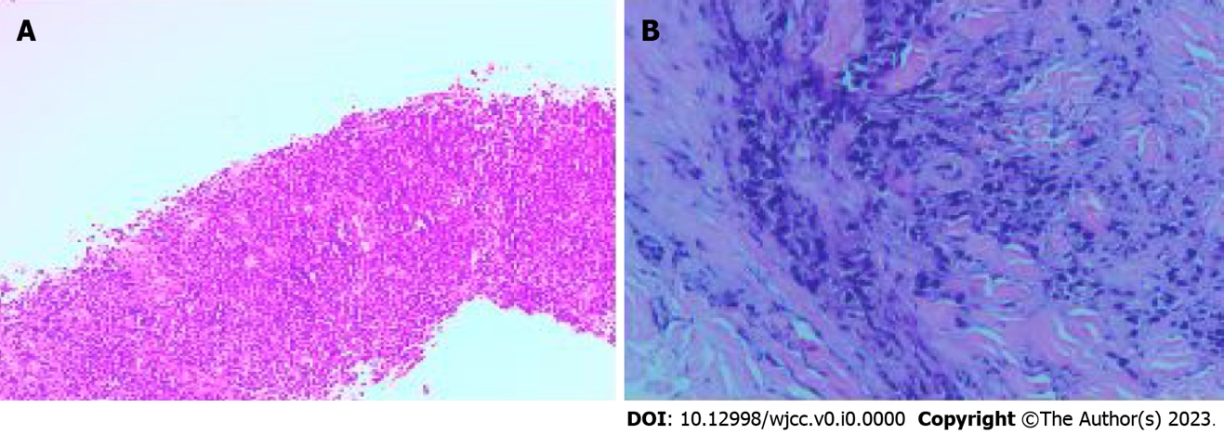

Figure 1 Pathological findings. Pathological examination revealed poorly differentiated adenocarcinoma. A: Biopsy of cervical lymph node; B: Skin biopsy of the chest wall.

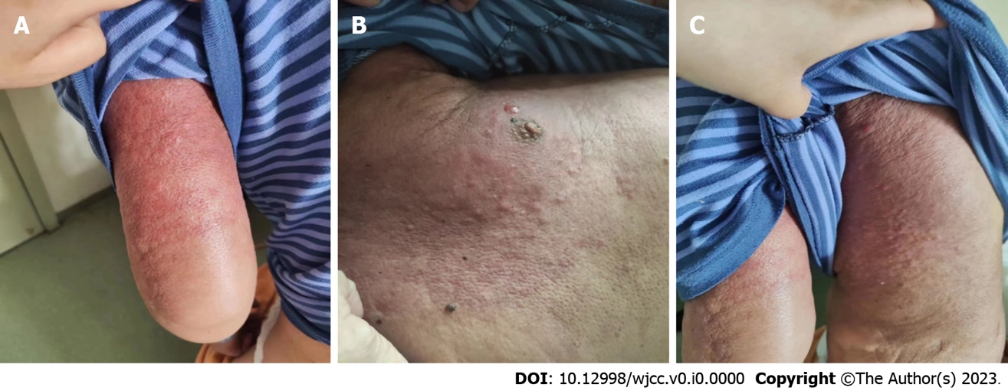
Figure 2 Cutaneous metastases from gastric cancer. The extensive skin redness and swelling, accompanied by skin thickening and scattered small nodules. This image is published with the patient’s guardian consent. A: Left upper limb; B: Left chest wall; C: Left back.

Table 1 Thirteen cases of cutaneous metastases of gastric cancer
Ref. | Year | Age | Sex | Site | First symptoms | Type | SRC | Resection | Prognosis
Yao et al^{[2]} | 2023 | 61 | M | Groin, scalp, thigh | No | Nodular, inflammatory, sclerodermoid | Yes | No | Unknown
Pliakou et al^{[3]} | 2022 | 42 | M | Abdomen, hemithorax, back | No | Inflammatory | Yes | No | Died 4 mo later
Bajoghli et al^{[5]} | 2022 | 44 | M | Face, trunk, upper limbs | Yes | Nodular | Yes | No | Unknown
Şahin et al^{[10]} | 2021 | 81 | F | Abdomen | No | Nodular | Unknown | No | Died 5 d later
Demircioğlu et al^{[4]} | 2021 | 53 | F | Abdomen, thigh | No | Inflammatory | Yes | No | Died 7 mo later
He et al^{[1]} | 2019 | 69 | M | Armpit | No | Nodular | Unknown | No | Unknown
Koyama et al^{[11]} | 2019 | 89 | M | Armpit | No | Nodular | No | Yes | Over 6 yr
Kirchberger^{[6]} | 2018 | 91 | M | Chin | Yes | Nodular | Unknown | No | Died 1 mo later
Namikawa et al^{[7]} | 2017 | 59 | M | Chest wall | Yes | Nodular | No | Yes | Died 6 mo later
Gündüz et al^{[12]} | 2017 | 57 | F | Face, neck, shoulders | No | Nodular | Yes | No | Unknown
Ahmad et al^{[8]} | 2015 | 49 | F | Scalp, face, upper limbs, shoulder, back, chest | Yes | Nodular | No | No | Unknown
Kaur et al^{[9]} | 2015 | 55 | M | Abdomen | Yes | Sclerodermoid | Yes | No | Unknown
Arslan et al^{[17]} | 2014 | 52 | M | Face, scalp | Yes | Nodular | Yes | No | Unknown
M: Male; F: Female; SRC: Signet-ring cell.

