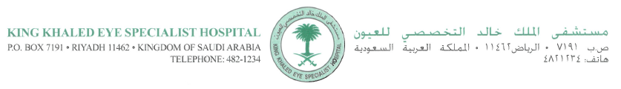

Riyadh, January 10th, 2013

World Series Journals
Baishideng Publishing Group Co., Limited
Room 903, Building D,
Ocean International Center,
No.62 Dongsihuan Zhonglu, Chaoyang District,
Beijing 100025, China
Telephone: +86-10-8538-1892
Fax: +86-10-8538-1893

RE: Manuscript to World Journal of Diabetes

Dear Editors and Reviewers:

We have taken in consideration all comments from reviewers 1 to #4. Please find attached a new version of the manuscript that I already had sent to you and you had kindly uploaded for me. Therefore, there are no changes regarding this last version but the reviewer’s comments have all been incorporated after each e-mail I received from you.

None of the authors have any financial interests to disclose.

Please use the following corresponding address:

J. Fernando Arevalo, MD FACS
Chief of Vitreoretinal Division
King Khaled Eye Specialist Hospital
Al-Oruba Street
PO Box 7191 Riyadh 11462 KSA
Phone: +966 (1) 482-1234 xt. 3860

E-mail: arevalojf@jhmi.edu

Copyright has been signed and included here. I hope everything is to your satisfaction.

We look forward to hearing from you soon.

Sincerely,
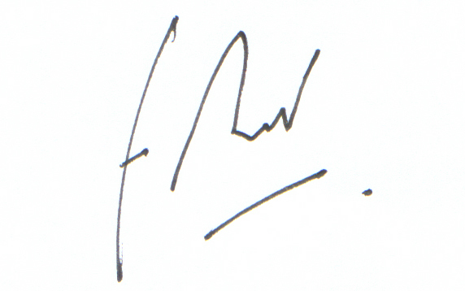
J. Fernando Arevalo, MD FACS

