Name of Journal: World Journal of Gastrointestinal Endoscopy
Manuscript NO: 85455
Manuscript Type: ORIGINAL ARTICLE

Retrospective Cohort Study
Endoscopic retrograde cholangiopancreatography-related early perforations: A study of effects of procedure duration, complexity, and endoscopist experience

Aloysius M et al. ERCP-related early Perf

Mark Aloysius, Hemant Goyal, Tejas Nikumbh, Niraj James Shah, Ghassan M Hammoud, Pritesh Mutha, Mairin Joseph-Talreja, Savio John, Ganesh Aswath, Vaibhav Wadhwa, Nirav Thosani

Mark Aloysius, Division of Gastroenterology, Department of Internal Medicine, SUNY Upstate Medical University, Syracuse, NY 13210, United States

Hemant Goyal, Pritesh Mutha, Mairin Joseph-Talreja, Vaibhav Wadhwa, Nirav Thosani, Department of Surgery, The University of Texas Health Science Center, Houston, TX 77030, United States

Tejas Nikumbh, Department of Internal Medicine, The Wright Center for Graduate Medical Education, Scranton, PA 18510, United States

Niraj James Shah, Ghassan M Hammoud, Department of Medicine, Division of Digestive Diseases, The University of Missouri at Columbia, Columbia, MO 65211, United States

Savio John, Ganesh Aswath, Department of Medicine, Upstate University Hospital, Syracuse, NY 13210, United States

Author contributions: Aloysius M and Goyal H designed the study, performed the statistical analysis, generated the figures, and edited the manuscript; Nikumbh T performed the literature review and drafted the initial version of the manuscript and revised manuscript; Shah NJ, Hammoud GM, Mutha P, and Joseph-Talreja M edited the manuscript; John S, Aswath G, Wadhwa V and Thosani N critically reviewed manuscript.

Corresponding author: Hemant Goyal, MD, Instructor, Department of Surgery, The University of Texas Health Science Center, No. 6431 Fannin, MSB 4.152, Houston, TX 77030, United States. doc.hemant@yahoo.com

Received: April 28, 2023
Revised: August 6, 2023
Accepted: September 27, 2023
Published online:

Abstract
BACKGROUND
Perforations (Perf) during endoscopic retrograde cholangiopancreatography (ERCP) are rare (< 1%) but potentially fatal events (up to 20% mortality). Given its rarity, most data is through case series studies from centers or analysis of large databases. Although a meta-analysis has shown fewer adverse events as a composite (bleeding, pancreatitis, Perf) during ERCP performed at high-volume centers, there is very little real-world data on endoscopist and center procedural volumes, ERCP duration and complexity on the occurrence of Perf.

AIM
To study the profile of Perf related to ERCP by center and endoscopist procedure volume, ERCP time, and complexity from a national endoscopic repository.

METHODS
Patients from clinical outcome research initiative national endoscopic database clinical outcomes research initiative-national endoscopic database (2000-2012) who underwent ERCP were stratified based on the endoscopist and center volume (quartiles), and total procedure duration and complexity grade of the ERCP based on procedure details. The effects of these variables on the Perf that occurred were studied. Continuous variables were compared between Perf and no Perfs (NoPerf) using the Mann-Whitney U test as the data demonstrated significant skewness and kurtosis.

RESULTS
A total of 14153 ERCPs were performed by 258 endoscopists, with 20 reported Perf (0.14%) among 16 endoscopists. Mean patient age in years 61.6 ± 14.8 vs 58.1 ± 18.8 (Perf vs. NoPerf, P = NS). The cannulation rate was 100% and 91.5% for Perf and NoPerf groups, respectively. 13/20 (65%) of endoscopists were high-volume performers in the 4th quartile, and 11/20 (55%) of Perf occurred in centers with the highest volumes (4th quartile). Total procedure duration in minutes was 60.1 ± 29.9 vs. 40.33 ± 23.5 (Perf vs. NoPerf, P < 0.001). Fluoroscopy duration in minutes was 3.3 ± 2.3 vs. 3.3 ± 2.6 (Perf vs. NoPerf P = NS). 50% of the procedures were complex and greater than grade 1 difficulty. 3/20 (15%) patients had prior biliary surgery. 13/20 (65%) had sphincterotomies performed with stent insertion. Peritonitis occurred in only 1/20 (0.5%).

CONCLUSION
Overall adverse events as a composite during ERCP are known to occur at a lower rate with higher volume endoscopists and centers. However, Perf studied from the national database show prolonged and more complex procedures performed by high-volume endoscopists at high-volume centers contribute to Perf.

Key Words: Endoscopic retrograde cholangiopancreatography; Endoscopy complications; Perforations

Aloysius M, Goyal H, Nikumbh T, Shah NJ, Hammoud GM, Mutha P, Joseph-Talreja M, John S, Aswath G, Wadhwa V, Thosani N. Endoscopic retrograde cholangiopancreatography-related early perforations: A study of effects of procedure duration, complexity, and endoscopist experience. World J Gastrointest Endosc 2023; In press

Core Tip: We analyzed the profile of perforations (Perf) related to endoscopic retrograde cholangiopancreatography (ERCP) from the clinical outcomes research initiative-national endoscopic database over 12 years. The retrospective analysis of 14153 ERCPs done by 258 endoscopists reported a Perf rate of 0.14% (20 Perf) among 16 endoscopists. The cannulation rate was 100% for Perf and 91.5% for no Perf groups. 65% of endoscopists were high-volume performers, and 55% of Perf occurred in centers with the highest volumes (4th quartile). Higher volume endoscopists and centres are known to have less ERCP-related adverse events. However, this national database study on Perf has shown prolonged and complex procedures performed by high-volume endoscopists at high-volume centers contributed to Perf.

INTRODUCTION
The indications for therapeutic endoscopic retrograde cholangiopancreatography (ERCP) have increased exponentially over the last decade^{[1]}. Consequently, the complexity of procedures has also increased along with the training required to achieve competencies to perform such high-risk procedures. As a result, the completion success and complication rates vary widely and appear related to the endoscopist volume^{[2,3]}.
Although perforation (Perf) during ERCP is uncommon (1%), it can be fatal with up to 20% mortality^{[4,5]}. Most data about ERCP-related Perfs is from case series or analysis of large databases. While a meta-analysis revealed lesser adverse overall events (bleeding, Perf, pancreatitis) during ERCP performed at high-volume centres^{[6]}, there is a lack of real-world data regarding endoscopist and centre procedural volumes, ERCP duration, and complexity on the occurrence of early Perf^{[5,7,8]}.
We analyzed a national endoscopic repository national institute of health (NIH)-clinical outcomes research initiative-national endoscopic database (CORI-NED) to study the profile of Perf related to ERCP by center and endoscopist procedure volume, ERCP time, and complexity.

MATERIALS AND METHODS
Database
CORI-NED is a large prospectively accrued population-based database maintained by NIH. CORI was established in 1995 to study the use and outcomes of endoscopy in diverse gastroenterology practice settings in the United States^{[9]}. Participating physicians are provided with an electronic health record completed at the endoscopy time and generate procedure reports. Once submitted, the report cannot be altered. Users are required to document at least 95% of the procedures in CORI. A limited dataset from every report is sent to NIH, where it is quality tested and compiled into CORI-NED. Anonymized data is collected and stored per strict health insurance portability and accountability act standards, and users must obtain data user agreements and Institutional Review Board (IRB) approval. This study was IRB-approved. As CORI-NED contains information generated at the time of ERCP, we examined early Perf discovered before the procedure report was generated, signed off, and submitted to the repository.

Study cohort, design and statistical analysis
Our study is a retrospective population-based analysis of early Perf related to ERCP. Patients over 18 years of age who underwent ERCP from 2000-2012 were studied. Data collected included age, sex, center volume, endoscopist volume, ERCP and fluoroscopy duration, indication, ERCP difficulty, prior biliary surgery dilation of strictures, sphincterotomy, sphincterotomy device used, stent placement, peritonitis. Patients were stratified based on the endoscopist’s and center’s volume (quartiles), total procedure duration, and complexity grade of the ERCP based on procedure details. We aim to identify age factor, ERCP fluoroscopy time, and total procedure time between patients who suffered Perf vs those who did not in the immediate post-procedural period (before the procedure note is uploaded as per CORI-NED).
The effects of these variables on the Perf that occurred were studied. In addition, continuous variables were compared between Perf and no Perfs (NoPerf) using the Mann-Whitney U test, as the data demonstrated significant skewness and kurtosis. All analysis was performed using SPSS (v28.0). The statistical review of the study was performed by a biomedical statistician. The grades of ERCP difficulty were defined by the grading system (Supplementary Table 1) proposed by Raju^{[10]}, Schutz and Abbott^{[11]} and were widely used during data collection.

RESULTS
14153 ERCPs performed by 258 endoscopists at 48 facilities were analyzed. 20 Perf (0.14%) were reported among 16 endoscopists. The mean patient age was 61.6 ± 14.8 vs 58.1 ± 18.8 years (Perf vs. NoPerf, P = NS, Figure 1A). The cannulation rate for Perf vs no Perf was 100% and 91.5%, respectively. 11/20 (55%) of Perf happened in the centres with the greatest volumes (4th quartile), while 13/20 (65%) of endoscopists were high-volume achievers.
Total procedure duration was 60.1 ± 29.9 vs. 40.33 ± 23.5 min (Perf vs. NoPerf, P < 0.001, Figure 1B). Fluoroscopy duration was 3.3 ± 2.3 vs. 3.3 ± 2.6 min (Perf vs. NoPerf P = NS, Figure 1C). To evaluate the differences between patients who perforated vs those who did not Mann-Whitney U test was utilized. The test revealed a significant difference in total procedural time between those who suffered Perf vs those who did not (Median 51 vs. 32 min, n = 20 vs. n = 14133), U = 8467 vs. 5816, Z = 3.536, P < 0.001, r = 118 (large effect size). Hence H0 was rejected. However, age and fluoroscopy time did not differ between the groups.
Half of the procedures were complex and more than grade 1 difficulty (Table 1). 3 out of 20 (15%) patients had prior biliary surgery. 13 out of 20 cases (65%) had sphincterotomies with stent insertion. 1 case (0.5%) had peritonitis (Table 1).
We also performed a multivariate regression analysis of age category, endoscopist ERCP volume quartile, fluoroscopy time, and total procedure time (Table 2). The regression analysis results demonstrate that only prolonged total procedural time among the parameters studied is associated with Perf (hazard ratios 1.022, 95% confidence interval 1.001-1.043, P < 0.036).

DISCUSSION
Our nationwide population-based study about ERCP identified several factors related to procedure complexity, center, and endoscopist performance as significant risk factors for ERCP-related Perf. The risk factors for ERCP-related Perf were a higher grade of complexity requiring a longer duration of the procedure, a high-volume center, and a high-volume endoscopist.
Overall, greater volume endoscopists and centres are reported to have a reduced rate of adverse events during ERCP^{[6]}. Currently, there is a lack of consensus on the minimum required volume to maintain ERCP competency. The minimum standards and mandatory curriculum required for an endoscopist and center to maintain ERCP skills have been recently defined in a multicenter clinical trial but have not been widely adopted^{[12]}. Short-term ERCP complications occur in about 10% of patients, including cholangitis, pancreatitis, bleeding, and Perf^{[13]}. It has also been suggested that ERCP-related complications, especially Perf, tend to occur more frequently in lower-volume centers by and with lower endoscopist volume by quartiles^{[5,6]}. An analysis of the Swedish National Register for Gallstone Surgery and ERCP^{[14]} has also shown that higher endoscopist and center case volumes are associated with safer ERCP, similar to our results. However, this study analyzed only ERCP for stones and malignancy as an indication of ERCP. They found that higher case and center volume correlated with lower complication rates and shorter procedure time in ERCP for Cannabidiol stones. Conversely, factors associated with Perf in our study were the prolonged duration of the procedure, as shown previously by other studies ^{[5,15,16]}. A large review of 142847 ERCPs found a 0.39% Perf rate, where sphincterotomy was responsible for 41% of Perf^{[17]}. Interestingly, in our study, ERCP with Perf had a 100% cannulation rate compared to 91.5% in ERCP with no Perf. Also, 50% of the Perf occurred in complex ERCPs (> grade 1 as per the classification proposed by Schultz and Abbott^{[11]} and colleagues)^{[18]}. The success rate of approximately ≥ 90% cannulation of the desired duct is a parameter to measure competency in performing ERCP^{[19]}.
The Perf rate following ERCP in our study was lower (0.14%) than in the three previous, where the rates were 0.45%, 0.72%, and 0.39%, respectively^{[4,5,17]}. Participating physicians in CORI-NED database are provided with an electronic health record completed at the endoscopy time and generate procedure reports. Once submitted, the report cannot be altered. Hence only the Perf detected during the peri-operative period are reported in the database. Thus only early Perf following ERCP are reported and studied. This may explain the low Perf rate reported in our study. However, research on Perf from the CORI-NED has revealed that extended, more complicated procedures carried out in high-volume centres by high-volume endoscopists are a factor in Perf. This is likely due to high-risk procedures with complex pathology been undertaken at tertiary and quaternary centers.
Early diagnosis is most important to reduce associated significant morbidity and mortality rates; thus, prompt management should be initiated as soon as possible. The late recognition of ERCP-related Perf, failure to adequately treat a Perf, and delayed surgery following failed non-operative management worsen outcomes^{[4,19-22]}.
The strength of the study is that the CORI-NED was utilized as the primary data source. CORI has strict quality-control measures for all its data. The data repository is checked for anomalies on a daily basis, and unusual activity prompts contact by CORI staff^{[9]}. Moreover, the data is derived from a variety of gastroenterology practice settings, with the majority of sites covered being community-based, followed by veterans’ administration and academic hospitals. This provides an evaluation of real-world representation of the practice of endoscopy.

Limits of the study
Our study results should be considered in light of its limitations, most of which are inherent to large database studies. First, this study is prone to site-selection bias. The sites unwilling to share data with CORI-NED may differ in their clinical practice from the participating sites. Generally, smaller practices with higher administrative burdens do not participate in additional data sharing on databases. These practices also refer complex procedures to high-volume centers and endoscopists. It is also likely that less experienced practitioners rarely publish their data^{[16,23]}. Second, CORI-NED database does not give the specific type of Perf encountered during the ERCP procedure. Thus we could not differentiate into duodenal Perf, peri-ampullary or bile duct Perf. Third, the endoscopic report was the source of data in this study. The CORI-NED database only records the clinical information and events during and immediately after the ERCP in the endoscopic report. Additionally, follow-up data analysis in CORI is limited. Hence delayed Perf would not have been picked up in the study. However, a review of 18 retrospective studies showed that most (73%) Perf are identified during the periprocedural period^{[17]}.

CONCLUSION
Our study shows that the increase in procedure complexity raises the requisite expertise to deal with complex pathology successfully. ERCP will continue its exponential growth to deal with more complex hepatobiliary pathologies. In order to raise the expertise of future endoscopists, higher volume centers with adequate training procedure numbers for aspiring endoscopists are the need of the hour.

ARTICLE HIGHLIGHTS
Research background
Endoscopic retrograde cholangiopancreatography (ERCP) is a widely performed procedure in gastroenterology. ERCP perforations (Perf) are rare complication however they lead to severe morbidity and can be fatal.

Research motivation
Clinical outcomes research initiative-national endoscopic database (CORI-NED) is a large prospectively accrued population-based database maintained by national institute of health (NIH). NIH established CORI in 1995 to study the use and outcomes of endoscopy in diverse gastroenterology practice settings in the United States. Our motivation was to study this large database and look into the complications associated with ERCP.

Research objectives
ERCP were stratified based on the endoscopist and center volume (quartiles), complexity of the ERCP and total procedure duration based on procedure details. The effects of these variables on the Perf were studied.

Research methods
ERCP related data from CORI NED database from 2000-2012 was analyzed. Continuous variables were compared between Perf and no Perf (NoPerf) groups using Mann-Whitney U test as the data demonstrated significant skewness and Kurtosis.

Research results
14153 ERCPs performed by 258 endoscopists at 48 facilities were analyzed. 20 Perfs (0.14%) were reported among 16 endoscopists. The cannulation rate for Perfs vs no Perfs was 100% and 91.5%, respectively. 11/20 (55%) of Perfs happened in the centres with the greatest volumes (4th quartile), while 13/20 (65%) of endoscopists were high-volume achievers. Total procedure duration in minutes was 60.1 ± 29.9 vs. 40.33 ± 23.5 (Perf vs. NoPerf, P < 0.001). Half of the procedures were complex and more than grade 1 difficulty (Table 1). 3 out of 20 (15%) patients had prior biliary surgery. 13 out of 20 cases (65%) had sphincterotomies with stent insertion. 1 case (0.5%) had peritonitis.

Research conclusions
Overall adverse events as a composite during ERCP are known to occur at a lower rate with higher volume endoscopists and centers.

Research perspectives
We analyzed the profile of Perfs related to ERCP from the CORI-NED database over 12 years. The retrospective analysis of 14153 ERCPs performed by 258 endoscopists reported 20 Perfs (0.14%) among 16 endoscopists. The cannulation rate was 100% for Perf and 91.5% for no Perf groups. 65% of endoscopists were high-volume performers, and 55% of Perfs occurred in centers with the highest volumes (4th quartile). Higher volume endoscopists and centres are known to have less ERCP-related adverse events. However, this national database study on Perfs has shown prolonged and complex procedures performed by high-volume endoscopists at high-volume centers contributed to Perfs.

REFERENCES
1 Moffatt DC, Yu BN, Yie W, Bernstein CN. Trends in utilization of diagnostic and therapeutic ERCP and cholecystectomy over the past 25 years: a population-based study. Gastrointest Endosc 2014; 79: 615-622 [PMID: 24119510 DOI: 10.1016/j.gie.2013.08.028]
2 Ekkelenkamp VE, de Man RA, Ter Borg F, Borg PC, Bruno MJ, Groenen MJ, Hansen BE, van Tilburg AJ, Rauws EA, Koch AD. Prospective evaluation of ERCP performance: results of a nationwide quality registry. Endoscopy 2015; 47: 503-507 [PMID: 25590180 DOI: 10.1055/s-0034-1391231]
3 Coté GA, Imler TD, Xu H, Teal E, French DD, Imperiale TF, Rosenman MB, Wilson J, Hui SL, Sherman S. Lower provider volume is associated with higher failure rates for endoscopic retrograde cholangiopancreatography. Med Care 2013; 51: 1040-1047 [PMID: 24226304 DOI: 10.1097/MLR.0b013e3182a502dc]
4 Wu HM, Dixon E, May GR, Sutherland FR. Management of perforation after endoscopic retrograde cholangiopancreatography (ERCP): a population-based review. HPB (Oxford) 2006; 8: 393-399 [PMID: 18333093 DOI: 10.1080/13651820600700617]
5 Langerth A, Isaksson B, Karlson BM, Urdzik J, Linder S. ERCP-related perforations: a population-based study of incidence, mortality, and risk factors. Surg Endosc 2020; 34: 1939-1947 [PMID: 31559577 DOI: 10.1007/s00464-019-06966-w]
6 Keswani RN, Qumseya BJ, O'Dwyer LC, Wani S. Association Between Endoscopist and Center Endoscopic Retrograde Cholangiopancreatography Volume With Procedure Success and Adverse Outcomes: A Systematic Review and Meta-analysis. Clin Gastroenterol Hepatol 2017; 15: 1866-1875.e3 [PMID: 28606848 DOI: 10.1016/j.cgh.2017.06.002]
7 Kodali S, Mönkemüller K, Kim H, Ramesh J, Trevino J, Varadarajulu S, Wilcox CM. ERCP-related perforations in the new millennium: A large tertiary referral center 10-year experience. United European Gastroenterol J 2015; 3: 25-30 [PMID: 25653856 DOI: 10.1177/2050640614560784]
8 Kim JH, Yoo BM, Kim JH, Kim MW, Kim WH. Management of ERCP-related perforations: outcomes of single institution in Korea. J Gastrointest Surg 2009; 13: 728-734 [PMID: 19130154 DOI: 10.1007/s11605-008-0786-2]
9 Ron-Tal Fisher O, Gralnek IM, Eisen GM, Williams JL, Holub JL. Endoscopic hemostasis is rarely used for hematochezia: a population-based study from the Clinical Outcomes Research Initiative National Endoscopic Database. Gastrointest Endosc 2014; 79: 317-325 [PMID: 24184172 DOI: 10.1016/j.gie.2013.09.004]
10 Raju GS. Grading ERCPs by degree of difficulty: a great concept. Gastrointest Endosc 2000; 52: 704-705 [PMID: 11060212 DOI: 10.1067/mge.2000.110076]
11 Schutz SM, Abbott RM. Grading ERCPs by degree of difficulty: a new concept to produce more meaningful outcome data. Gastrointest Endosc 2000; 51: 535-539 [PMID: 10805837 DOI: 10.1016/s0016-5107(00)70285-9]
12 Wani S, Han S, Simon V, Hall M, Early D, Aagaard E, Abidi WM, Banerjee S, Baron TH, Bartel M, Bowman E, Brauer BC, Buscaglia JM, Carlin L, Chak A, Chatrath H, Choudhary A, Confer B, Coté GA, Das KK, DiMaio CJ, Dries AM, Edmundowicz SA, El Chafic AH, El Hajj I, Ellert S, Ferreira J, Gamboa A, Gan IS, Gangarosa L, Gannavarapu B, Gordon SR, Guda NM, Hammad HT, Harris C, Jalaj S, Jowell P, Kenshil S, Klapman J, Kochman ML, Komanduri S, Lang G, Lee LS, Loren DE, Lukens FJ, Mullady D, Muthusamy RV, Nett AS, Olyaee MS, Pakseresht K, Perera P, Pfau P, Piraka C, Poneros JM, Rastogi A, Razzak A, Riff B, Saligram S, Scheiman JM, Schuster I, Shah RJ, Sharma R, Spaete JP, Singh A, Sohail M, Sreenarasimhaiah J, Stevens T, Tabibian JH, Tzimas D, Uppal DS, Urayama S, Vitterbo D, Wang AY, Wassef W, Yachimski P, Zepeda-Gomez S, Zuchelli T, Keswani RN. Setting minimum standards for training in EUS and ERCP: results from a prospective multicenter study evaluating learning curves and competence among advanced endoscopy trainees. Gastrointest Endosc 2019; 89: 1160-1168.e9 [PMID: 30738985 DOI: 10.1016/j.gie.2019.01.030]
13 Wojtun S, Gil J, Gietka W, Gil M. Endoscopic sphincterotomy for choledocholithiasis: a prospective single-center study on the short-term and long-term treatment results in 483 patients. Endoscopy 1997; 29: 258-265 [PMID: 9255528 DOI: 10.1055/s-2007-1004186]
14 Syrén EL, Sandblom G, Enochsson L, Eklund A, Isaksson B, Österberg J, Eriksson S. Outcome of ERCP related to case-volume. Surg Endosc 2022; 36: 5339-5347 [PMID: 34981237 DOI: 10.1007/s00464-021-08915-y]
15 Enns R, Eloubeidi MA, Mergener K, Jowell PS, Branch MS, Pappas TM, Baillie J. ERCP-related perforations: risk factors and management. Endoscopy 2002; 34: 293-298 [PMID: 11932784 DOI: 10.1055/s-2002-23650]
16 Cotton PB. Analysis of 59 ERCP lawsuits; mainly about indications. Gastrointest Endosc 2006; 63: 378-82; quiz 464 [PMID: 16500382 DOI: 10.1016/j.gie.2005.06.046]
17 Vezakis A, Fragulidis G, Polydorou A. Endoscopic retrograde cholangiopancreatography-related perforations: Diagnosis and management. World J Gastrointest Endosc 2015; 7: 1135-1141 [PMID: 26468337 DOI: 10.4253/wjge.v7.i14.1135]
18 Cotton PB, Eisen G, Romagnuolo J, Vargo J, Baron T, Tarnasky P, Schutz S, Jacobson B, Bott C, Petersen B. Grading the complexity of endoscopic procedures: results of an ASGE working party. Gastrointest Endosc 2011; 73: 868-874 [PMID: 21377673 DOI: 10.1016/j.gie.2010.12.036]
19 Cirocchi R, Kelly MD, Griffiths EA, Tabola R, Sartelli M, Carlini L, Ghersi S, Di Saverio S. A systematic review of the management and outcome of ERCP related duodenal perforations using a standardized classification system. Surgeon 2017; 15: 379-387 [PMID: 28619547 DOI: 10.1016/j.surge.2017.05.004]
20 Cappell MS, Friedel DM. Stricter national standards are required for credentialing of endoscopic-retrograde-cholangiopancreatography in the United States. World J Gastroenterol 2019; 25: 3468-3483 [PMID: 31367151 DOI: 10.3748/wjg.v25.i27.3468]
21 Tavusbay C, Alper E, Gökova M, Kamer E, Kar H, Atahan K, Özşay O, Gür Ö, Cin N, Çapkınoğlu E, Durak E. Management of perforation after endoscopic retrograde cholangiopancreatography. Ulus Travma Acil Cerrahi Derg 2016; 22: 441-448 [PMID: 27849320 DOI: 10.5505/tjtes.2016.42247]
22 Patil NS, Solanki N, Mishra PK, Sharma BC, Saluja SS. ERCP-related perforation: an analysis of operative outcomes in a large series over 12 years. Surg Endosc 2020; 34: 77-87 [PMID: 30859489 DOI: 10.1007/s00464-019-06733-x]
23 Smith ZL, Nickel KB, Olsen MA, Vargo JJ, Kushnir VM. Type of sedation and the need for unplanned interventions during ERCP: analysis of the clinical outcomes research initiative national endoscopic database (CORI-NED). Frontline Gastroenterol 2020; 11: 104-110 [PMID: 32133108 DOI: 10.1136/flgastro-2019-101175]

Footnotes
Institutional review board statement: The Institutional review board approval was not needed for this study originating from a publicly available database.

Informed consent statement: As the study used anonymous and pre-existing data, the requirement for the informed consent from patients was waived.

Conflict-of-interest statement: All the Authors have no conflict of interest related to the manuscript.

Data sharing statement: The original anonymous dataset is available on request from the corresponding author at doc.hemant@yahoo.com.

STROBE statement: The authors have read the STROBE Statement-checklist of items, and the manuscript was prepared and revised according to the STROBE Statement-checklist of items.

Open-Access: This article is an open-access article that was selected by an in-house editor and fully peer-reviewed by external reviewers. It is distributed in accordance with the Creative Commons Attribution NonCommercial (CC BY-NC 4.0) license, which permits others to distribute, remix, adapt, build upon this work non-commercially, and license their derivative works on different terms, provided the original work is properly cited and the use is non-commercial. See: https://creativecommons.org/Licenses/by-nc/4.0/

Provenance and peer review: Invited article; Externally peer reviewed.

Peer-review model: Single blind
Corresponding Author's Membership in Professional Societies: American Gastroenterological Association; American College of Gastroenterology; American Society for Gastrointestinal Endoscopy.

Peer-review started: April 28, 2023
First decision: July 4, 2023
Article in press:

Specialty type: Gastroenterology and hepatology
Country/Territory of origin: United States
Peer-review report’s scientific quality classification
Grade A (Excellent): 0
Grade B (Very good): 0
Grade C (Good): C, C
Grade D (Fair): 0
Grade E (Poor): 0

P-Reviewer: Ma L, China; Shrestha UK, Nepal S-Editor: Qu XL L-Editor: P-Editor:

Figure Legends
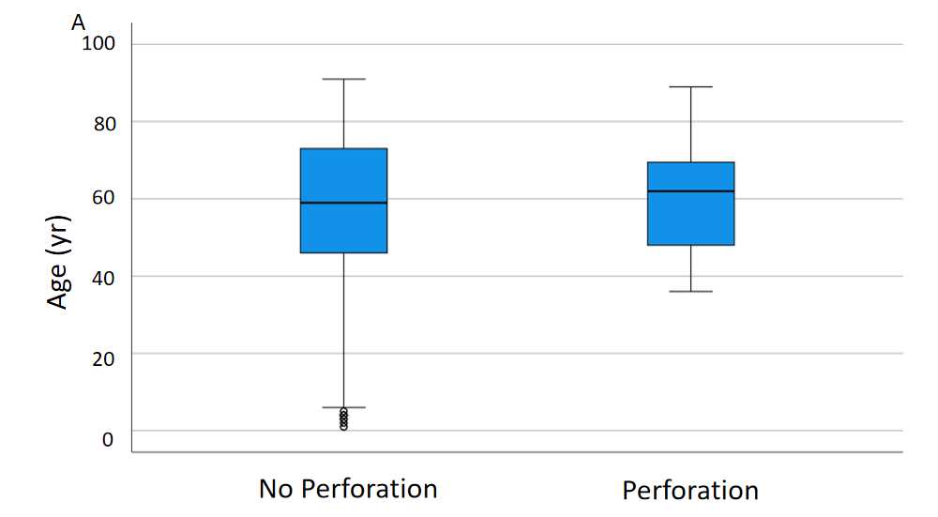
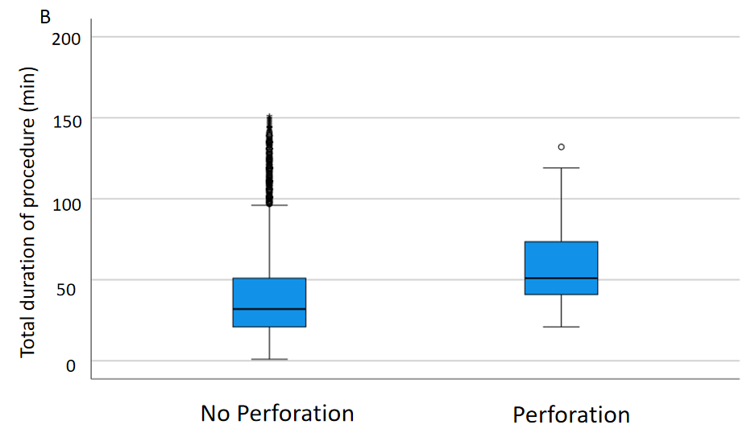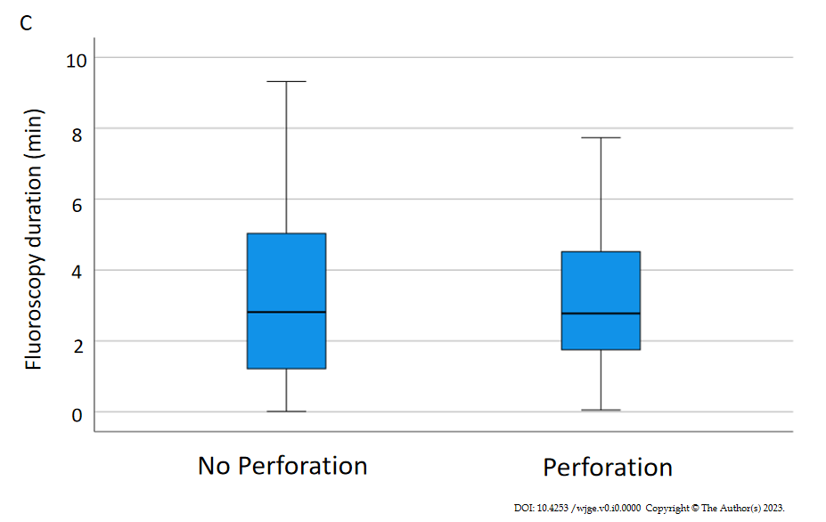
Figure 1 Comparison of age and time between perforation and no perforationgroup. A: Mean patient age was 61.6 ± 14.8 vs 58.1 ± 18.8 years [Perforation (Perf) vs. no Perfs (NoPerf), P = NS]; B: Total procedure duration was 60.1 ± 29.9 vs. 40.33 ± 23.5 min (Perf vs. NoPerf, P < 0.001); C: Fluoroscopy duration was 3.3 ± 2.3 vs. 3.3 ± 2.6 min (Perf vs. NoPerf P = NS).

Table 1 Details of the endoscopic retrograde cholangiopancreatographys associated with perforation for clinical outcomes research initiative-national endoscopic database
Physician | Physician volume quartile | Center volume quartile | Indication | ERCP difficulty grade | Dilation of strictures | Sphincterotomy performed | Stent placement | Sphincterotomy device | Peritonitis | Prior biliary surgery
1 | 4 | 4 | LHD tumor biopsy | 3 | No | No | No | NA | No | No
2 | 4 | 4 | Pancreatic tumor | 3 | No | Yes | Yes | ¹ | No | Yes
2 | 4 | 4 | CBD stone | 3 | Yes | Yes | Yes | Cotton cannulotome | No | No
2 | 4 | 4 | CBD stricture | 3 | Yes | Yes | Yes | Cotton cannulotome | No | No
3 | 3 | 3 | RHD tumor biopsy | 3 | No | Yes | Yes | Cotton cannulotome | No | No
4 | 3 | 2 | CBD stone | 1 | No | Yes | Yes | Cotton cannulotome | No | No
5 | 4 | 4 | CBD stone | 1 | No | Yes | Yes | Papillotome | Yes | No
6 | 4 | 3 | Stent placement | 1 | No | Yes | Yes | Autotome | No | No
7 | 4 | 3 | CBD stone | 1 | No | No | No | ¹ | No | No
8 | 3 | 4 | CBD stone | 1 | No | No | No | ¹ | No | No
9 | 4 | 3 | Pancreatic tumor | 3 | No | Yes | Yes | Cotton cannulotome | No | No
10 | 3 | 3 | Sphincter of oddi dysfunction | 3 | No | Yes | Yes | ¹ | No | No
11 | 4 | 4 | CBD stone | 2 | No | Yes | Yes | Cannulating sphincterotome | No | Yes
11 | 4 | 4 | Stent replacement | 1 | No | No | No | NA | No | No
11 | 4 | 4 | Pancreatic pseudocyst drainage | 4 | No | Yes | Yes | Needle knife precut | No | Yes
12 | 4 | 4 | CBD stone | 1 | No | Yes | Yes | ¹ | No | No
13 | 4 | 4 | CBD stone | 1 | No | No | No | NA | No | No
14 | 3 | 3 | Stent placement | 1 | No | Yes | Yes | Cotton cannulotome | No | No
15 | 3 | 3 | CBD stone | 1 | No | No | No | NA | No | No
16 | 3 | 3 | CBD stone | 3 | No | No | No | NA | No | Yes
¹Unavailable. LHD: Left hepatic duct; CBD: Common bile duct; ERCP: Endoscopic retrograde cholangiopancreatography.

Table 2 Multivariate regression analysis of age category, endoscopist endoscopic retrograde cholangiopancreatography volume quartile, fluoroscopy time, and total procedure time
Parameter studied | B | SE | Wald | df | P value | HR | 95% CI
Age category in yr (< 40, 40-60, 60-75, > 75). Endoscopist ERCP volume (n) quartiles (< 50, 50-100, 100-150, > 150) fluoroscopy time (minutes). Total duration of the procedure (minutes) | 0.086 | 0.271 | 0.101 | 1 | 0.75 | 1.09 | 0.64
 |  |  |  |  |  |  | 1.856
 | -0.094 | 0.241 | 0.152 | 1 | 0.697 | 0.91 | 0.568
 |  |  |  |  |  |  | 1.46
 | -0.104 | 0.133 | 0.611 | 1 | 0.435 | 0.901 | 0.694
 |  |  |  |  |  |  | 1.17
 | 0.022 | 0.01 | 4.403 | 1 | 0.036 | 1.022 | 1.001
 |  |  |  |  |  |  | 1.043
ERCP: Endoscopic retrograde cholangiopancreatography; HR: Hazard ratios; CI: Confidence interval.

