Name of Journal: World Journal of Clinical Cases
Manuscript NO: 45884
Manuscript Type: CASE REPORT

Clinical outcomes and safety of high-resolution manometry guided superficial partial circular muscle myotomy in per-oral endoscopic myotomy for Jackhammer esophagus: Two cases report

Choi YI et al. Superficial partial circular muscle myotomy for Jackhammer esophagus

Youn I Choi, Kyoung-Oh Kim, Dong Kyun Park, Jun-Won Chung, Yoon Jae Kim, Kwang An Kwon

Youn I Choi, Kyoung-Oh Kim, Dong Kyun Park, Jun-won Chung, Yoon Jae Kim, Kwang An Kwon, Department of Gastroenterology, Gil Medical Center, Gachon University, Incheon 21565, South Korea

ORCID number: Youn I Choi (0000-0001-6561-6752); Kyoung-Oh Kim (0000-0002-5365-2550); Dong Kyun Park (0000-0002-2862-6641); Jun-Won Chung (0000-0002-0869-7661); Yoon Jae Kim (0000-0001-8477-6823); Kwang An Kwon (0000-0002-2947-2111).

Author contributions: Choi YI, and Kim KO contributed to study concept and design, acquisition analysis and interpretation of data, drafting of the manuscript. Park DK contributed to enroll patients and critically revised the manuscript. Chung JW, Kim KO, and Kwon KA contributed to enrolled the patients. All authors read and approved the final manuscript.

Informed consent statement: Informed consent was obtained from the patient for publication of this report and any accompanying images.

Conflict-of-interest statement: The authors declare that they have no conflict of interest.

CARE Checklist (2016) statement: The authors have read the CARE Checklist (2016), and the manuscript was prepared and revised according to the CARE Checklist (2016).

Open-Access: This article is an open-access article which was selected by an in-house editor and fully peer-reviewed by external reviewers. It is distributed in accordance with the Creative Commons Attribution Non Commercial (CC BY-NC 4.0) license, which permits others to distribute, remix, adapt, build upon this work non-commercially, and license their derivative works on different terms, provided the original work is properly cited and the use is non-commercial. See: http://creativecommons.org/licenses/by-nc/4.0/

Manuscript source: Unsolicited manuscript

Corresponding author: Kyoung-Oh Kim, MD, PhD, Associate Professor, Doctor, Professor, Division of Gastroenterology, Department of Internal Medicine, Gil Medical Center, Gachon University, 21, Namdong-daero 774 beon-gil, Namdong-gu, Incheon 21565, South Korea. kkoimge@naver.com
Telephone: +82-32-4603778
Fax: +82-32-4603408

Received: January 19, 2019
Peer-review started: January 21, 2019
First decision: May 31, 2019
Revised: July 1, 2019
Accepted: July 20, 2019
Article in press:
Published online:

Abstract
BACKGROUND
Jack hammer esophagus is a relatively rare disease and to date, there is no dramatic treatment option. Recently, conventional per-oral endoscopic myotomy (POEM) have expanded their area into Jackhammer esophagus. However, several complications such as post procedure motility disorders (e.g., passage disturbance) are issues after POEM. To overcome these issues, we here introduced high-resolution manometry (HRM)-guided superficial partial circular muscle myotomy, which involves cutting only the superficial layer of the esophageal circular muscle.

CASE SUMMARY
We report two cases of patients with Jackhammer esophagus who were treated with HRM-guided extremely superficial partial circular muscle myotomy during POEM. Case 1 was a 53-year-old female with medication-refractory odynophagia and case 2 was a 47-year-old man who presented with chest pain. They were diagnosed with Jackhammer esophagus using HRM, and the hypercontractile segments of the esophagus were identified. HRM-guided extremely superficial partial circular muscle myotomy was performed while preserving the lower esophageal sphincter. Therefore, the circular and longitudinal muscle layers are preserved but hypercontractile movements are reduced, even after POEM. Patients’ clinical symptoms dramatically improved right after POEM, and 6-mo follow-up HRM revealed completely resolved status. During a 1-year follow-up period, patients were still in good health and remained symptom free.

CONCLUSION
HRM-guided superficial partial circular muscle myotomy may be a promising alternative to conventional POEM for treating Jackhammer esophagus with improved efficacy.

Key words: Jackhammer esophagus; Hypercontractile; Partial circular muscle myotomy; Case report

© The Author(s) 2019. Published by Baishideng Publishing Group Inc. All rights reserved.

Core tip: Jack hammer esophagus is a relatively rare disease and to date, there is no dramatic treatment option. Recently, conventional per-oral endoscopic myotomy (POEM) have expanded their area into Jackhammer esophagus. However, several complications such as post procedure motility disorders (e.g., passage disturbance) are issues after POEM. To overcome these issues, we here introduced high-resolution manometry-guided superficial partial circular muscle myotomy, which involves cutting only the superficial layer of the esophageal circular muscle for two patients.

Choi YI, Kim KO, Park DK, Chung JW, Kim YJ, Kwon KA. Clinical outcomes and safety of high-resolution manometry guided superficial partial circular muscle myotomy in per-oral endoscopic myotomy for Jackhammer esophagus: Two cases report. World J Clin Cases 2019; In press

INTRODUCTION
Jackhammer esophagus, also referred to as hypercontractile peristalsis, is a rare esophageal motility disorder characterized by hypertensive but normally propagated peristaltic contractions^{[1-3]}. The manometric criteria for Jackhammer esophagus are an initial average peristaltic amplitude > 180 mmHg in the distal esophagus using conventional manometry^{[1,3,4]} > 20% of swallows having a distal contractile integral (DCI) value > 8000 mmHg.s.cm, and normal latency on high-resolution manometry (HRM)^{[2,5-8]}. The therapeutic options for Jackhammer esophagus are pharmacologic agents such as nitrates, phosphodiesterase 5 inhibitors, low-dose antidepressants, proton pump inhibitors, and endoscopic botulinum toxin injection into the esophageal body. However, the efficacy of these methods is not satisfactory^{[1-3,9,10]}. Per-oral endoscopic myotomy (POEM) has been used as an alternative treatment to overcome the limitations of the above therapies. However, there are still concerns regarding post-POEM complications, such as passage disturbance and sigmoid esophagus^{[2,11-14]}. Jack hammer esophagus is a relatively rare disease and to date, there is no definitive and dramatic treatment options. including medication, endoscopic treatments or surgical treatments.
To reduce the risk of complications after conventional POEM^{[11,15]}, we introduced HRM-guided extremely superficial partial circular muscle myotomy during the POEM procedure for two Jackhammer esophagus cases. partial circular muscle myotomy involves cutting only the superficial layer of the esophageal circular muscle. Therefore, the circular and longitudinal muscle layers are preserved but hypercontractile movements are reduced, even after POEM. Moreover, hypercontractile segments were specifically targeted and measured though HRM.
Between April 2016 and August 2018, a total of 350 patients underwent HRM and 8 were diagnosed with Jackhammer esophagus in our hospitals. Two patients with medication-refractory Jackhammer esophagus underwent partial circular muscle myotomy during POEM. Herein, we describe two patients who presented with Jackhammer esophagus and were successfully treated using HRM-guided partial circular muscle myotomy during POEM.

CASE PRESENTATION
Chief complaints
Case 1: A 53-year-old woman was referred to our hospital for odynophagia and regurgitation.
Case 2: A 47-year-old man was referred to the gastrointestinal department for atypical chest pain for 6 mo.

History of present illness
Case 1: She had previously presented to a local hospital and had been prescribed oral proton pump inhibitors and nitroglycerin for several months, but her symptoms did not improve.
Case 2: He was previously presented to the cardiovascular department for atypical chest pain. However, his symptom was not improved even after stent angiography and administration of anti-angina medications and oral proton pump inhibitors for several months. After then he was referred to the gastrointestinal department.

History of past illness/ Personal and family history
Case 1: She had no known medical or surgical history. Her family history was negative.
Case 2: He had two-vessel cardiovascular disease with angina and a stent was inserted 5 years ago. Despite use of a patent stent, cardiovascular medications including nitrates, and a 3-mo trial of proton pump inhibitors, atypical squeezing pain in the epigastric region remained. His family history was negative.

Physical examination upon admission
Case 1: Physical examination on admission revealed no abnormal palpable mass on head and neck area.
Case 2: Physical examination on admission revealed no abnormal findings.

Laboratory examinations
Case 1: There were no abnormal findings on electrocardiogram, and laboratory tests including total blood count, liver function, renal function, and other basic chemical tests were normal.
Case 2: Laboratory tests were normal, including total blood count, liver function, renal function, and other basic chemical tests.

Imaging examinations
Case 1: Esophagography (barium radiography) showed spasmodic contraction of the distal esophagus and a narrowing of the esophageal cavity (Figure 1). HRM showed high-amplitude distal esophageal contractions with a DCI value > 8000 mmHg.s.cm for 6 of a total of 10 swallows. The highest DCI value was 13553 mmHg.s.cm (Figure 1). HRM showed high-amplitude distal esophageal contractions located 25-38 cm from the incisors according to the distance gauge of the pressure measuring tubes.
Case 2: On upper endoscopy, no abnormal findings were reported. Barium radiography showed spasmodic contractions of the distal esophagus and a narrow esophageal cavity (Figure 2). HRM showed high-amplitude distal esophageal contractions with a DCI value > 8000 mmHg.s.cm for 8 of a total of 10 swallows (Figure 2B). The highest DCI value was 21024 mmHg.s.cm. POEM was performed. HRM showed high-amplitude distal esophageal contractions located 28-39 cm from the incisors according to the distance gauge of the pressure measuring tubes.

FINAL DIAGNOSIS
Case 1: The final diagnosis was medication refractory Jack hammer esophagus without involvement of low esophageal sphincter.
Case 2: The final diagnosis was medication refractory Jack hammer esophagus without involvement of low esophageal sphincter.

TREATMENT
Case 1: The patient underwent HRM-guided superficial partial circular muscle myotomy (Figure 3). Since HRM showed high-amplitude distal esophageal contractions located 25-38 cm from the incisors, we performed partial circular muscle myotomy of the esophageal muscle on the right side (Figure 3). We preserved the lower esophageal sphincter.
Case 2: The patient underwent HRM-guided superficial partial circular muscle myotomy (Figure 3). Since HRM showed high-amplitude distal esophageal contractions located 25-38 cm from the incisors, we performed partial circular muscle myotomy of the esophageal muscle on the right side (Figure 3). We preserved the lower esophageal sphincter.
We performed HRM-guided superficial partial circular muscle myotomy of the esophageal muscle. Since HRM showed high-amplitude distal esophageal contractions located 28-39 cm from the incisors, we performed partial circular muscle myotomy of the esophageal muscle on the right side (Figure 3) and preserved the lower esophageal sphincter.

OUTCOME AND FOLLOW UP
Case 1: After the procedure, the patient’s symptoms dramatically improved and post-POEM HRM was within the normal range. During a 1-year follow-up period, patients were in good health and remained symptom free.
Case 2: After the procedure, the patient’s symptoms dramatically improved and post-POEM HRM was within the normal range (Figure 2C). During a 6-mo follow-up period, patients were in good health and remained symptom free.

DISCUSSION
We here report two patients with Jackhammer esophagus who were successfully treated with HRM-guided superficial partial circular muscle myotomy during POEM. After the procedures, both patients reported improve symptoms with no side effects. The current cases suggest that HRM-guided superficial partial circular muscle myotomy may be a potential treatment option for Jackhammer esophagus with a relatively low rate of post-procedure complications as compared to conventional POEM.
Jackhammer esophagus is rare and severe disease^{[2,16,17]}. Jackhammer esophagus is extremely high amplitudes contractions and within normal limit of peristatic contractions^{[4]}. Treatment strategy for Jackhammer esophagus includes medication for smooth muscle relation (nifedipine), anti-reflex medication, and pneumatic dilatation of LES^{[4]}. Because of the rare incidence of Jackhammer esophagus, proper evaluation of incidence is not easy, the medication refractory Jackhammer esophagus has been increasing. Recently for medical refractory Jackhammer esophagus, POEM was introduced^{[11]}.
POEM is the first clinically efficacious natural orifice transluminal endoscopic surgery (NOTES) with an endoscopic safety profile^{[1,15,18,19]}. However, despite its safety profile, post-POEM complications are not rare^{[6,7,9,20]}. Conventional POEM for Jackhammer esophagus is associated with several side effects including post-procedure sigmoid esophagus and ineffective esophageal motility^{[14,19]}. It remains debated whether the lower esophageal sphincter should be cut to prevent symptom development after the procedure^{[7,14,18]}. Recent systemic review showed that the pooled rate of clinical success in patients of Jackhammer esophagus for POEM was 89.6%^{[21]}. The success rates of both the length > 10 cm, and the length < 10 cm were 91.1% and 89.1%, respectively^{[21]}. There are several researches on the symptom in patients with Jackhammer esophagus and the pre-peak and post-peak phase of contraction^{[3,22]}. In these regards, to distinguish the contractile integral components of pre-peak and post peak phase contractile activity is important to treat Jack hammer disease^{[3,22]}. However, there are still concerns regarding post-POEM complications for medication refractory Jackhammer esophagus after POEM, such as passage disturbance and sigmoid esophagus^{[2,11-14]}.
To improve treatment efficacies and reduce the complications in the treatment of Jack hammer esophagus after POEM, we focused two issues: (1) to measure the accurate segments which are hypercontratile in the esophagus; and (2) to conserve the esophageal motility after POEM procedures. HRM-guided superficial partial circular muscle myotomy which we introduced is a modified type of conventional POEM, and this method is expected to reduce side effects and increase treatment efficacy^{[5,11,14]}. Because partial circular myotomy during POEM involves cutting only the superficial layer of the circular esophageal muscle and not the full thickness of the muscle nor the full circular muscle layer, even after POEM, the previously diagnosed Jackhammer esophagus consists circular and longitudinal layer of muscle with its nature but reduced hypercontractile movements^{[11,14,19]}. Moreover, in addition to region-targeted therapy, partial circular muscle myotomy was performed under HRM guidance to selectively detect hypercontractile segments. Therefore, decreased esophageal motility after the procedure are prevented. Moreover, it is not necessary to cut the lower esophageal sphincter in a partial circular myotomy when low esophageal sphincter is not involved^{[23]}. This method not only reduces the occurrence of side effects associated with conventional POEM, including partial or full thickness POEM, but also improves treatment efficacy.

CONCLUSION
HRM-guided superficial partial circular muscle myotomy during POEM may be a promising alternative to conventional POEM for the treatment of patients with Jackhammer esophagus who are refractory to conventional medical therapy, which is associated with improved efficacy and safety profile.

REFERENCES
1 Kandulski A, Fuchs KH, Weigt J, Malfertheiner P. Jackhammer esophagus: high-resolution manometry and therapeutic approach using peroral endoscopic myotomy (POEM). Dis Esophagus 2016; 29: 695-696 [PMID: 24460870 DOI: 10.1111/dote.12182]
2 Herregods TV, Smout AJ, Ooi JL, Sifrim D, Bredenoord AJ. Jackhammer esophagus: Observations on a European cohort. Neurogastroenterol Motil 2017; 29 [PMID: 27753176 DOI: 10.1111/nmo.12975]
3 Xiao Y, Carlson DA, Lin Z, Alhalel N, Pandolfino JE. Jackhammer esophagus: Assessing the balance between prepeak and postpeak contractile integral. Neurogastroenterol Motil 2018; 30: e13262 [PMID: 29193439 DOI: 10.1111/nmo.13262]
4 Jia Y, Arenas J, Hejazi RA, Elhanafi S, Saadi M, McCallum RW. Frequency of Jackhammer Esophagus as the Extreme Phenotypes of Esophageal Hypercontractility Based on the New Chicago Classification. J Clin Gastroenterol 2016; 50: 615-618 [PMID: 26927491 DOI: 10.1097/MCG.0000000000000496]
5 Roman S, Pandolfino JE, Chen J, Boris L, Luger D, Kahrilas PJ. Phenotypes and clinical context of hypercontractility in high-resolution esophageal pressure topography (EPT). Am J Gastroenterol 2012; 107: 37-45 [PMID: 21931377 DOI: 10.1038/ajg.2011.313]
6 Clermont MP, Ahuja NK. The Relevance of Spastic Esophageal Disorders as a Diagnostic Category. Curr Gastroenterol Rep 2018; 20: 42 [PMID: 30079434 DOI: 10.1007/s11894-018-0650-9]
7 Crespin OM, Liu LWC, Parmar A, Jackson TD, Hamid J, Shlomovitz E, Okrainec A. Safety and efficacy of POEM for treatment of achalasia: a systematic review of the literature. Surg Endosc 2017; 31: 2187-2201 [PMID: 27633440 DOI: 10.1007/s00464-016-5217-y]
8 Sato H, Takahashi K, Mizuno KI, Hashimoto S, Yokoyama J, Hasegawa G, Terai S. Esophageal motility disorders: new perspectives from high-resolution manometry and histopathology. J Gastroenterol 2018; 53: 484-493 [PMID: 29134329 DOI: 10.1007/s00535-017-1413-3]
9 Dawod E, Saumoy M, Xu MM, Kahaleh M. Peroral endoscopic myotomy (POEM) in jackhammer esophagus: a trick of the trade. Endoscopy 2017; 49: E254-E255 [PMID: 28759922 DOI: 10.1055/s-0043-115887]
10 Khan MA, Kumbhari V, Ngamruengphong S, Ismail A, Chen YI, Chavez YH, Bukhari M, Nollan R, Ismail MK, Onimaru M, Balassone V, Sharata A, Swanstrom L, Inoue H, Repici A, Khashab MA. Is POEM the Answer for Management of Spastic Esophageal Disorders? A Systematic Review and Meta-Analysis. Dig Dis Sci 2017; 62: 35-44 [PMID: 27858325 DOI: 10.1007/s10620-016-4373-1]
11 Li C, Gong A, Zhang J, Duan Z, Ge L, Xia N, Leng J, Li M, Liu Y. Clinical Outcomes and Safety of Partial Full-Thickness Myotomy versus Circular Muscle Myotomy in Peroral Endoscopic Myotomy for Achalasia Patients. Gastroenterol Res Pract 2017; 2017: 2676513 [PMID: 28316620 DOI: 10.1155/2017/2676513]
12 Al-Qaisi MT, Siddiki HA, Crowell MD, Burdick GE, Fleischer DE, Ramirez FC, Vela MF. The clinical significance of hypercontractile peristalsis: comparison of high-resolution manometric features, demographics, symptom presentation, and response to therapy in patients with Jackhammer esophagus versus Nutcracker esophagus. Dis Esophagus 2017; 30: 1-7 [PMID: 28881883 DOI: 10.1093/dote/dox085]
13 Roman S, Kahrilas PJ. Management of spastic disorders of the esophagus. Gastroenterol Clin North Am 2013; 42: 27-43 [PMID: 23452629 DOI: 10.1016/j.gtc.2012.11.002]
14 Bechara R, Ikeda H, Inoue H. Peroral endoscopic myotomy for Jackhammer esophagus: to cut or not to cut the lower esophageal sphincter. Endosc Int Open 2016; 4: E585-E588 [PMID: 27274539 DOI: 10.1055/s-0042-105204]
15 Kahn A, Al-Qaisi MT, Obeid RA, Katzka DA, Ravi KM, Ramirez FC, Crowell MD, Vela MF. Clinical features and long-term outcomes of lower esophageal sphincter-dependent and lower esophageal sphincter-independent jackhammer esophagus. Neurogastroenterol Motil 2019; 31: e13507 [PMID: 30443964 DOI: 10.1111/nmo.13507]
16 Isik A, Firat D, Yilmaz I, Peker K, Idiz O, Yilmaz B, Demiryilmaz I, Celebi F. A survey of current approaches to thyroid nodules and thyroid operations. Int J Surg 2018; 54: 100-104 [PMID: 29709542 DOI: 10.1016/j.ijsu.2018.04.037]
17 Isik A, Firat D, Peker K, Sayar I, Idiz O, Soytürk M. A case report of esophageal perforation: Complication of nasogastric tube placement. Am J Case Rep 2014; 15: 168-171 [PMID: 24803977 DOI: 10.12659/AJCR.890260]
18 Bechara R, Inoue H. POEM, the Prototypical "New NOTES" Procedure and First Successful NOTES Procedure. Gastrointest Endosc Clin N Am 2016; 26: 237-255 [PMID: 27036895 DOI: 10.1016/j.giec.2015.12.002]
19 Tanaka S, Toyonaga T, Kawara F, Grimm IS, Hoshi N, Abe H, Ohara Y, Morita Y, Umegaki E, Azuma T. Peroral endoscopic myotomy using FlushKnife BT: a single-center series. Endosc Int Open 2017; 5: E663-E669 [PMID: 28691051 DOI: 10.1055/s-0043-111721]
20 Schaheen LW, Sanchez MV, Luketich JD. Peroral Endoscopic Myotomy for Achalasia. Thorac Surg Clin 2018; 28: 499-506 [PMID: 30268295 DOI: 10.1016/j.thorsurg.2018.07.005]
21 Chandan S, Mohan BP, Chandan OC, Jha LK, Mashiana HS, Hewlett AT, Khashab MA. Clinical efficacy of per-oral endoscopic myotomy (POEM) for spastic esophageal disorders: a systematic review and meta-analysis. Surg Endosc 2019 [PMID: 31073769 DOI: 10.1007/s00464-019-06819-6]
22 Xiao Y, Carlson DA, Lin Z, Rinella N, Sifrim D, Pandolfino JE. Assessing the pre- and postpeak phases in a swallow using esophageal pressure topography. Neurogastroenterol Motil 2017; 29 [PMID: 28544141 DOI: 10.1111/nmo.13099]
23 Khashab MA, Familiari P, Draganov PV, Aridi HD, Cho JY, Ujiki M, Rio Tinto R, Louis H, Desai PN, Velanovich V, Albéniz E, Haji A, Marks J, Costamagna G, Devière J, Perbtani Y, Hedberg M, Estremera F, Martin Del Campo LA, Yang D, Bukhari M, Brewer O, Sanaei O, Fayad L, Agarwal A, Kumbhari V, Chen YI. Peroral endoscopic myotomy is effective and safe in non-achalasia esophageal motility disorders: an international multicenter study. Endosc Int Open 2018; 6: E1031-E1036 [PMID: 30105290 DOI: 10.1055/a-0625-6288]

P-Reviewer: Isik A S-Editor: Dou Y L-Editor: E-Editor:
Specialty type: Medicine, Research and Experimental
Country of origin: South Korea
Peer-review report classification
Grade A (Excellent): 0
Grade B (Very good): B
Grade C (Good): 0
Grade D (Fair): 0
Grade E (Poor): 0

A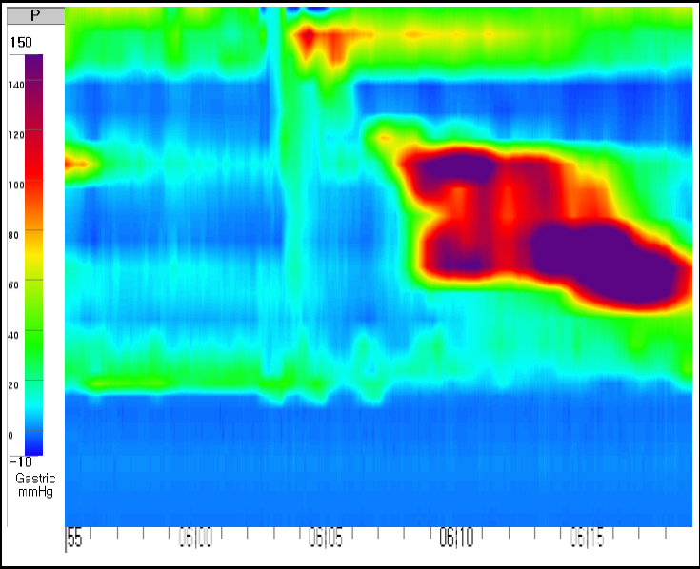 B 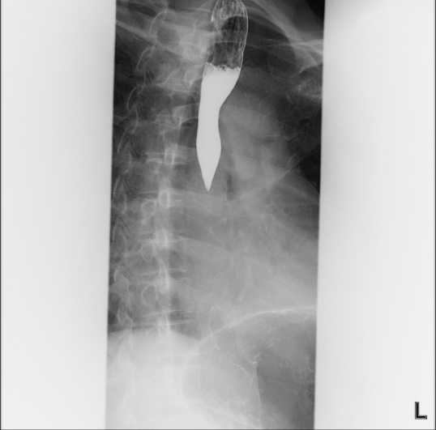
C 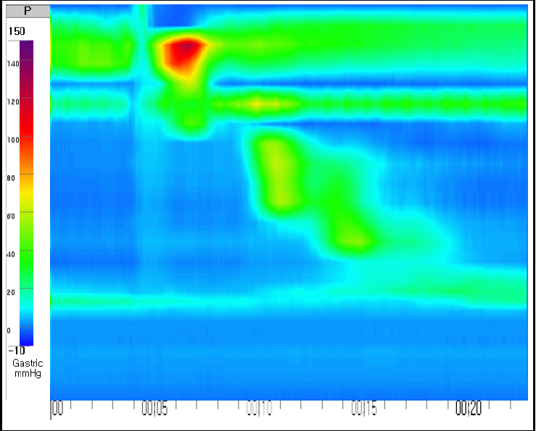 D 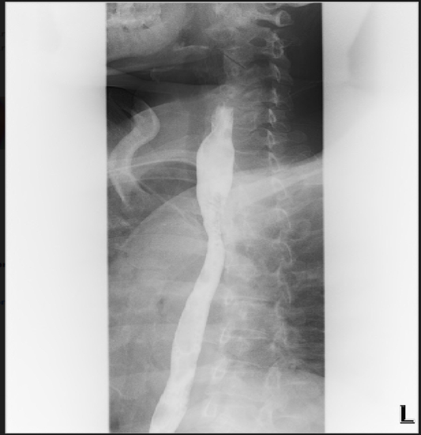
Figure1 The examination of 53-year-old woman conducted before superficial circular muscle per-oral esophageal myotomy. A: Pre-treatment high-resolution esophageal manometry (HRM) image depicted a jackhammer esophagus patient with distal contractile index over 8000 mmHg.s.cm; B-D: Barium radiography showed spasmodic contraction of the distal esophagus and a narrowing of the esophageal cavity (C) post-treatment HRM revealed distal contractile integral of 980 mmHg.s.cm (D) post-treatment esophagogram showed improved.

A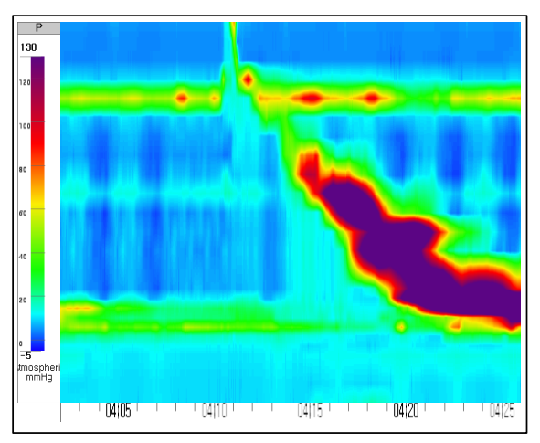 B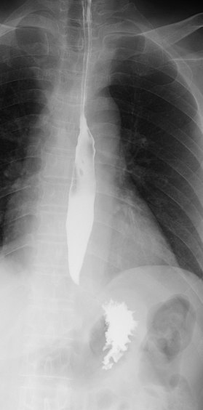
C 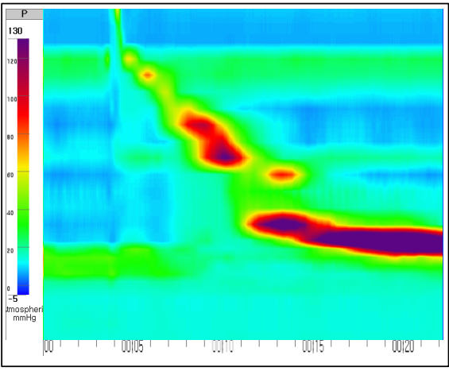 D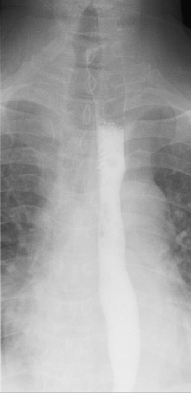
Figure 2 The examination of 47-year-old man conducted before superficial circular muscle per-oral esophageal myotomy. A: Pre-treatment high-resolution manometry (HRM) showed high-amplitude distal esophageal contractions with a distal contractile integral (DCI) value > 8000 mmHg.s.cm for 8 of a total of 10 swallows and the highest DCI value was 13553 mmHg.s.cm; B-D: Pre-treatment esophagography showed spasmodic contraction of the distal esophagus (C) post-treatment HRM revealed within normal range of DCI (D) post-treatment esophagogram showed improved function of passage of esoaphagus.

A
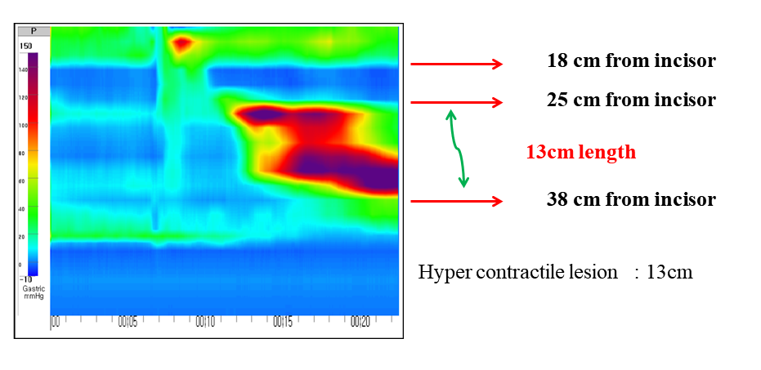
B
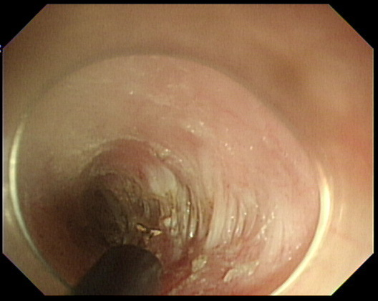
Figure 3 Procedures of high-resolution manometry guided superficial partial circular muscle myotomy. A: We first detect the hypercontractile lesion through high-resolution manometry (HRM), and in this patients’ case, HRM showed high-amplitude distal esophageal contractions located 25-38 cm from the incisors according to the distance gauge of the pressure measuring tubes. B: Therefore, we performed superficial partial circular muscle myotomy of the esophageal muscle on the right side, (B) superficial partial circular muscle myotomy during POEM. Remnant circular muscle.

