Name of journal: World Journal of Gastrointestinal Surgery
ESPS Manuscript NO: 5170
Columns: CASE REPORT

Recurrence of gastric cancer in the jejunal stump after radical total gastrectomy

Yoo JH et al. Recurrence of gastric cancer after RTG

Jong Han Yoo, Sang Hyuk Seo, Min Sung An, Tae Kwun Ha, Kwang Hee Kim, Ki Beom Bae, Chang Soo Choi, Sang Hun Oh, Young Kil Choi

Jong Han Yoo, Sang Hyuk Seo, Min Sung An, Tae Kwun Ha, Kwang Hee Kim, Ki Beom Bae, Chang Soo Choi, Sang Hun Oh, Young Kil Choi, Department of Surgery, Busan Paik Hospital, Inje University College of Medicine, Busan 614-735, South Korea

Author contributions: Yoo JH and Kim KH designed the report; Kim KH, Choi CS and Choi YK were attending doctors for the patient; Kim KH and Choi YK performed surgical operation; An MS, Ha TK and Bae KB organized the report; and Yoo JH and Seo SH wrote paper.

Correspondence to: Kwang Hee Kim, MD, Department of Surgery, Busan Paik Hospital, Inje University College of Medicine, Gaegum 2-dong, Busanjingu, Busan 614-735, South Korea. inwoodog@naver.com
Telephone: +82-51-890-6352 Fax: +82-51-898-9427

Received: August 19, 2013 Revised: January 16, 2014
Accepted: February 18, 2014
Published online:
Abstract
This is a very rare case of the recurrence of gastric cancer in the jejunal stump after radical total gastrectomy with Roux-en-Y reconstruction. In January of 2008, a 65-year-old man underwent radical total gastrectomy with Roux-en-Y reconstruction for stage IB gastric cancer of the upper body. At a follow-up in December of 2011, the patient had a recurrence of gastric cancer on gastroduodenofibroscope. The gastroduodenofibroscopic biopsy specimens shows a well-differentiated tubular adenocarcinoma. A computed tomography showed no lymphadenopathy or hepatic metastases. At laparotomy, there was a tumor in the jejunal stump involving the pancreatic tail and spleen. Therefore, the patient underwent jejunal pouch resection, distal pancreatectomy and splenectomy. On histopathologic examinations, the patient was diagnosed with gastric cancer.

© 2014 Baishideng Publishing Group Co., Limited. All rights reserved.

Key words: Gastric cancer; Recurrence; Jejunal stump

Yoo JH, Seo SH, An MS, Ha TK, Kim KH, Bae KB, Choi CS, Oh SH, Choi YK. Recurrence of gastric cancer in the jejunal stump after radical total gastrectomy.

Available from: URL:
DOI:
INTRODUCTION
The gastric cancer is such a highly prevalent cancer that occurs the most commonly in Korea. It shows a very good prognosis when detected earlier on a regular medical check-up. In the advanced cancer, however, a poor prognosis has been well documented. There are many recurrent cases of gastric cancer despite a radical surgery. Its recurrence occurs through hematogenous, peritoneal dissemination or via lymph node. We report a case of recurrence of gastric cancer in the jejunal stump after radical total gastrectomy with Roux-en-Y reconstruction.

CASE REPORT
A 65-year-old man presented with a recurrence on gastroduodenofibroscopy (Figure 1) at a follow-up after gastric cancer surgery. He underwent radical total gastrectomy with Roux-en-Y reconstruction (end to side esophagojejunostomy with circular stapler), for gastric cancer detected on gastroduodenofibroscopy in January 2008. The gastric cancer had a tumor node metastasis stage of IB (T2N0M0), which had the lesions of 2.5 cm × 2.0 cm in size on the posterior wall of the upper part of the gastric fundus. Based on histopathology, it had the findings that are suggestive of well-differentiated tubular adenocarcinoma. There were no lymph node metastasis and metastasis to other organs in the abdomen (Figure 2). Postoperatively, the patient underwent uneventful course without notable episodes and achieved a recovery. Then, during a period ranging from January 2008 to December 2009, the patient had been taking oral chemotherapeutic drugs (5-Fluorouracil). Following this, the patient had no recurrence and then received an outpatient follow-up. Meanwhile, in December 2011, the patient had a single small polypoid infiltrative ill-defined mass of approximately 1.2 cm in size at the site approximately 3 cm of the distal part of the esophago-jejunal junction to blind loop (the posterior wall of the jejunal stump) on gastroduodenofibroscopy (Figure 1). The patient therefore underwent histopathologic examinations, thus presenting with the findings that are suggestive of well-differentiated tubular adenocarcinoma. Therefore, for further evaluation and treatment, the patient was admitted. At the time of admission, the patient had a good systemic and nutritional status with stable vital signs. On examination, the patient had no palpable left supraclavicular lymph node. On abdominal examination, the patient had no tenderness, shifting dullness and palpable abdominal mass. In addition, the patient also had no positive findings on rectal examination. The patient underwent clinical laboratory tests for hemoglobin, WBC counts, platelet counts, serum electrolytes, serum biochemistry, urinalysis, serologic test and blood coagulation test, all of which were normal. Serum levels of carcinoembryonic antigen (CEA), a tumor marker, were 4.95 ng/mL. On abdominal computed tomography (CT) showed no recurrence and metastasis, which is also consistent with previous abdominal CT scans (Figure 3). Under general anesthesia, the patient underwent surgery for jejunal stump resection, distal pancreatectomy with splenectomy in January 2012. Intraoperatively, the patient presented with a tumor in the jejunum, invasion to the pancreatic tail and the spleen, and there was no evidence of hepatic or peritoneal recurrence, for which the patient underwent dissection of the jejunal stump, the pancreatic tail and the spleen. Postoperatively, the patient underwent uneventful course. On histopathologic examinations, the patient had a recurrence of the gastric cancer in the jejual pouch, the pancreatic tail and the spleen. Currently, the patient was receiving an injection of chemotherapy regimens (FOLFOX chemotheraphy).

DISCUSSION
The local recurrence of gastric cancer after total gastrectomy mostly occurs in the proximal region from the esophago-jejunal junction. Anastomotic or suture-line recurrence after gastrectomy is reported to be 3%-10%^{[1]}. The recurrence in the distal jejunal stump is a rare entity. The main theory that cause of mechanisms include submucosal or subserosal lymphatic spread of cancer, remainder of stump, and the implantation of exfoliated cancer cells^{[1,2]}. In this case, histological study revealed no lymph node metastasis, and no vessel permeation. And also both resection margins were negative for cancer cells. In this reason the theory of lymphatic spread of cancer and remainder of stump can reject. The implantation of exfoliated cancer cells may be the reason of recurrence, but it is unclear. The recurrence of anastomotsis or suture-line is rare and its mechanism is unclear but local recurrence can be treated by surgery. So early diagnosis of local recurrence can improve prognosis. gastroduodenofibroscopy can be useful device when detect intra-luminal recurrence. CT or positron emission tomography (PET) can detect gastric bed or regional lymph node. We recommend routine outpatient follow-up include gastroduodenofibroscopy, CT, and PET.
COMMENTS
Case characteristics
A 65-year-old man presented with gastric cancer recurrence as shown on gastroduodenofibroscopy.

Clinical diagnosis
Histopathologic examination revealed a diagnosis of gastric cancer.

Imaging diagnosis
Gastroduodenofibroscopy, computed tomography, and positron emission tomography.

Peer review
Yoo JH et al described a rare case with recurrence of gastric cancer in the jejunal pouch after radical total gastrectomy with Roux-en-Y reconstruction. This is an interesting case.
REFERENCES
1 Papachristou DN, Karas M, Fortner JG. Anastomotic recurrence in the oesophagus complicating gastrectomy for adenocarcinoma of the stomach. Br J Surg 1979; 66: 609-612 [PMID: 497643 DOI: 10.1002/bjs.1800660904]
2 Namikawa T, Kobayashi M, Okamoto K, Okabayashi T, Akimori T, Sugimoto T, Hanazaki K. Recurrence of gastric cancer in the jejunal pouch after completion gastrectomy. Gastric Cancer 2007; 10: 256-259 [PMID: 18095082 DOI: 10.1007/s10120-007-0441-8]
3 Nishimura M, Honda I, Watanabe S, Nagata M, Souda H, Miyazaki M. Recurrence in jejunal pouch after proximal gastrectomy for early upper gastric cancer. Gastric Cancer 2003; 6: 197-201 [PMID: 14520535 DOI: 10.1007/s10120-003-0242-7]

P-Reviewer: Hamai Y S-Editor: Wen LL L-Editor: E-Editor:

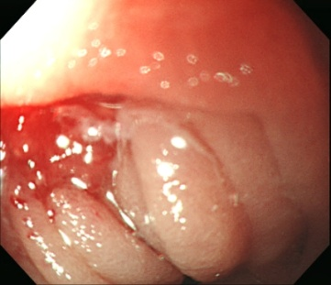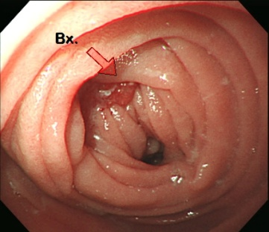
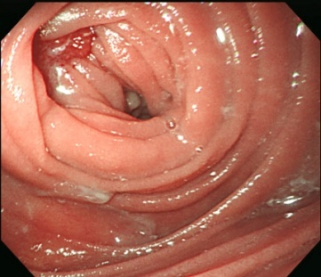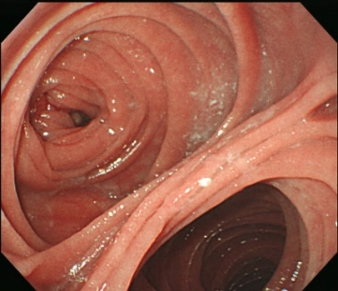

Figure 1 Endoscopic findings. There was medium-sized single small polypoid infiltrative ill-defined mass, with nodular overlying mucosa without bleeding evidence at jejunal pouch (1.2 cm in diameter). Tubular adenocarcinoma, well differentiated.

A B
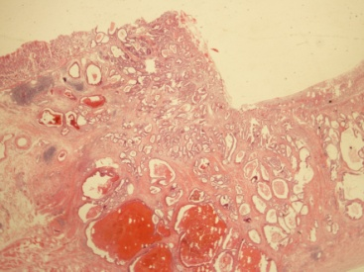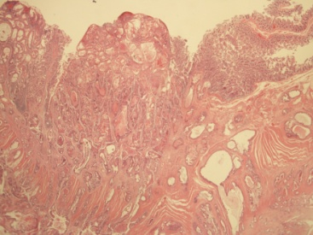
Figure 2 Pathologic findings. A: January 2008, slide of gastric cancer lesion (primary lesion); B: December 2011, slide of jejunal stump lesion (recurrent lesion).

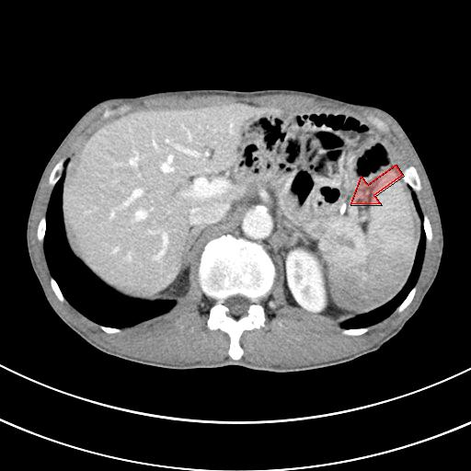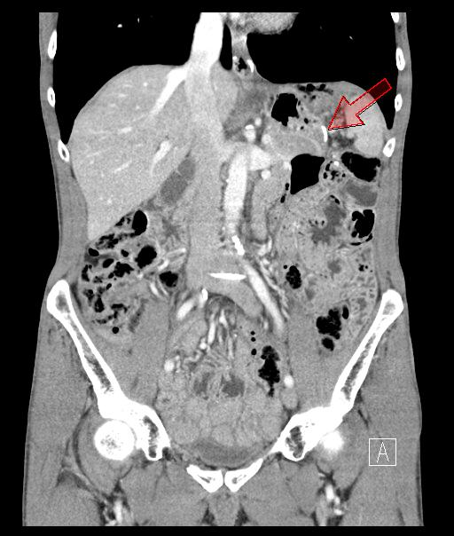

Figure 3 Pre-operation computed tomography findings No evidence of local tumor recurrence or distant metastasis. Arrow: Distal jejunal stump stapling line (recurrence site).

