Name of journal: World Journal of Gastroenterology
ESPS Manuscript NO: 28215
Manuscript Type: ORIGINAL ARTICLE

Basic Study
Antioxidant and anti-inflammatory action of melatonin in an experimental model of secondary biliary cirrhosis induced by bile duct ligation

Colares JR et al. Action of melatonin in a model BDL

Josieli Raskopf Colares, Elizângela Gonçalves Schemitt, Renata Minuzzo Hartmann, Francielli Licks, Mariana do Couto Soares, Adriane Dal Bosco, Norma Possa Marroni

Josieli Raskopf Colares, Elizângela Gonçalves Schemitt, Renata Minuzzo Hartmann, Adriane Dal Bosco, Graduate Program in Medical Sciences, Universidade Federal do Rio Grande do Sul, Porto Alegre 92425, Brazil

Josieli Raskopf Colares, Elizângela Gonçalves Schemitt, Renata Minuzzo Hartmann, Francielli Licks, Mariana do Couto Soares, Adriane Dal Bosco, Norma Possa Marroni, Laboratory of Experimental Hepatology and Gastroenterology, Hospital de Clínicas de Porto Alegre, Porto Alegre 90035, Brazil

Josieli Raskopf Colares, Elizângela Gonçalves Schemitt, Renata Minuzzo Hartmann, Francielli Licks, Mariana do Couto Soares, Adriane Dal Bosco, Norma Possa Marroni, Laboratory of Oxidative Stress and Antioxidants, Universidade Luterana do Brasil, Canoas 92425, Brazil

Francielli Licks, Graduate Program in Physiology, Universidade Federal do Rio Grande do Sul, Porto Alegre 90150, Brazil

Author contributions: The authors Colares JR and Marroni NP participated in the design, development, analysis, interpretation of data and writing of the article; Schemitt EG, Hartmann RM, Licks F, Soares MC and Bosco AD participated in the oxidative stress and immunohistochemistry analysis and the interpretation of results.

Supported by Research and Event Promotion (FIPE) end accomplished in Hospital de Clínicas de Porto Alegre (HCPA), No. 14-0474.

Institutional review board statement: The study was realized and approved by Ethics Committee of HCPA (No. 14-0474).

Institutional animal care and use committee statement: All collections of biological samples and analyzes carried out were in accordance with ethical principles of the Committee Ethics on Animal Use (CEUA-HCPA [No. 14-0474]).

Conflict-of-interest statement: To the best of our knowledge, no conflict of interest exists.

Data sharing statement: No additional data are available.

Open-Access: This article is an open-access article which was selected by an in-house editor and fully peer-reviewed by external reviewers. It is distributed in accordance with the Creative Commons Attribution Non Commercial (CC BY-NC 4.0) license, which permits others to distribute, remix, adapt, build upon this work non-commercially, and license their derivative works on different terms, provided the original work is properly cited and the use is non-commercial. See: http://creativecommons.org/licenses/by-nc/4.0/

Manuscript source: Invited manuscript

Correspondence to: Josieli Raskopf Colares, MD, In Cellular Biology and Molecular Applied to Health, Universidade Federal do Rio Grande do Sul, Francisco Alves, 160 Gravataí, Rio Grande do Sul, Brazil. jozy.ma@hotmail.com
Telephone: +55-51-97516065
Fax: +55-51-33598760

Received: June 28, 2016
Peer-review started: June 29, 2016
First decision: August 8, 2016
Revised: August 24, 2016
Accepted: September 14, 2016
Article in press:
Published online:

Abstract
AIM
To evaluate the effects of melatonin (Mel) on oxidative stress (OS) in an experimental model of bile duct ligation (BDL).

METHODS
Male Wistar rats (n = 32, weight ± 300 g) were allocated across four groups: CO (sham BDL), BDL (BDL surgery), CO + Mel (sham BDL and Mel administration) and BDL+Mel (BDL surgery and Mel administration). Mel was administered intraperitoneally for 2 wk, starting on postoperative day 15, at a dose of 20 mg/kg.

RESULTS
Mel was effective at the different standards, reestablishing normal liver enzyme levels, reducing the hepatosomatic and splenosomatic indices, restoring lipoperoxidation and antioxidant enzyme concentrations, reducing fibrosis and inflammation, and thereby reducing liver tissue injury in the treated animals.

CONCLUSION
The results of this study suggest a protective effect of melatonin when administered to rats with secondary biliary cirrhosis induced by bile duct ligation.

Key word: Antioxidant; Cirrhosis; Fibrosis; Melatonin; Oxidative Stress

© The Author(s) 2016. Published by Baishideng Publishing Group Inc. All rights reserved.

Core tip: Secondary biliary cirrhosis is a late complication of prolonged extrahepatic bile duct obstruction that leads to structural and functional changes in the liver. Mel (main product of the pineal gland) acts providing hepatic-protection in the experimental model of bile duct ligation.

Colares JR, Schemitt EG, Hartmann RM, Licks F, Soares MC, Bosco AD, Marroni NP. Antioxidant and anti-inflammatory action of melatonin in an experimental model of secondary biliary cirrhosis induced by bile duct ligation. World J Gastroenterol 2016; In press
INTRODUCTION
The liver has a complex structure, it allows plays a key role in operation and maintenance of several vital functions of the organism, including synthesis activity and excretion of substances. In the liver lobes, hepatocytes are arranged in orderly fashion from a central vein forming the sinusoids, from which they are separated by a narrow space (the space of Disse). This space is the site of the hepatic stellate cells (HSCs), which are known to possess contractile and fibrogenic properties, as well as the ability to synthesize extracellular matrix (ECM)^{[1-3]}.
Obstruction of the biliary tract is a congestive process that leads to numerous changes, such as ductular proliferation, stellate cell activation, and accumulation of ECM in the space of Disse. Occurrence of these changes may lead to the development of liver fibrosis, which, in turn, can lead to secondary biliary cirrhosis^{[4]}. Cirrhosis of the liver represents the most advanced stage of fibrosis, in which there is evident loss of structure of the hepatic parenchyma. It is directly associated with development of septa and fibrotic nodules, changes in hepatic blood flow, and high risk of liver failure^{[5]}.
Studies have shown that HSCs are directly involved in the process of fibrosis formation and their activation is influenced by products generated from lipid peroxidation (LPO), formation of reactive oxygen species (ROS), and presence of inflammatory mediators such as tumor necrosis factor alpha (TNF-α), inducible nitric oxide synthase (iNOS), interleukins, and nuclear factor kappa B (NF-kB)^{[4,6]}.
As cirrhosis constitutes a major public health problem^{[7]}, much research is being conducted to develop and test different substances that could be used in its treatment. The objective of such substances aims to improve quality of life, increasing survival, slowing disease progression, and, possibly, mitigating the damage caused by formation of ROS and free radicals (FR)^{[8,9]}.
Prolonged obstruction of the bile duct in rats is an experimental model for induction of secondary biliary cirrhosis^{[10]}. In this model, the characteristic features of the disease are established at approximately 28 d^{[10]}. Studies have demonstrated that the changes occurring in cirrhosis in human patients are similar to those found in experimental models, including jaundice, hepatomegaly, splenomegaly, abnormal gas exchange, and oxidative damage^{[11-15]}.
Melatonin (Mel, N-acetyl-5-methoxytryptamine) is the main product synthesized by the pineal gland, which produces Mel in a rhythmic manner, with production inhibited by light, therefore, its peak production occurs during the dark phase^{[16,17]}. Several effects have been attributed to Mel, including antioxidant capacity, as well as anti-inflammatory and immunomodulatory^{[18-21]}.
There is an existing important link between cirrhosis, inflammation and oxidative stress, in this sense treatments are required to protect the liver against these damage. Therefore, this present study investigated whether melatonin (an anti-inflammatory agent and antioxidant) would afford hepatic-protection in a experimental model of cirrhosis.

MATERIALS AND METHODS
Animals
All animal procedures were conducted in accordance with the recommendations of the Health Research Ethics Committee of the Research and Graduate Studies Group (GPPG) at Hospital de Clínicas de Porto Alegre (HCPA), Brazil (approval number 14-0474), and as recommended in the Guide for the Care and Use of Laboratory Animals^{[22,23]}. The sample comprised male Wistar rats (n = 32, weight ± 300 g) were allocated across four groups: CO (sham BDL), BDL (BDL surgery), CO+Mel (sham BDL and Mel administration) and BDL+Mel (BDL surgery and Mel administration). Cirrhosis was induced surgically by BDL as described by Kontouras et al^{[10]}.

Animal care and use statement
During the experiment, the animals were kept in boxes lined with wood shavings, under a 12-hours light/dark cycle and controlled temperature conditions (18–22°C), with free access to water and chow. As shown in Figure 1A, animals in the CO and CO+Mel groups only underwent localization and manipulation of the bile duct (sham surgery). Figures 1B and C show the procedures performed in the BDL and BDL+Mel groups respectively: after localization of the bile duct, it was isolated and tied off with two knots made with 3-0 silk thread. All animals were killed 29 days after the start of the experiment^{[24]}.

Administration of melatonin
Treatment started on day 15 after BDL surgery. Mel was administered at a dose of 20 mg/kg body weight, always at 7:00 p.m., away from light.

Extraction of plasma
After the blood was collected through the retro-orbital plexus and placed in assay tubes with heparin, was centrifuged at 4.000 rpm for ten minutes time. The precipitate was despised and the plasma removed with pipette (Labsystems 4500, 200-100 μL) for the different analyzes of AST, ALT and AP per commercial kit Labtest®.

Liver homogenates
For the preparation of the homogenate was used 9 mL of phosphate buffer solution (1.15% KCl) per gram of tissue (liver) and phenylmethylsulfonyl fluoride (PMSF) at a concentration of 100 mmol/L in isopropanol (10 µL/mL of KCl). The tissue was homogenized in ULTRA-TURRAX for 40 s at 0-2 ºC and subsequently centrifuged for 10 min at 3000 rpm in refrigerated centrifuge. The precipitate was discarded and the supernatant removed and frozen at -80 ºC for posterior biochemical analyses^{[25]}.

Liver enzyme activity
Activity of the liver enzymes aspartate aminotransferase (AST) and alanine aminotransferase (ALT), which are markers of hepatocyte integrity, were measured by the ultraviolet kinetic method. Alkaline phosphatase (AP) was measured by the colorimetric method. All tests were performed in plasma, under routine HCPA laboratory methods, using a Liquiform Labstest® commercial kit.

Hepatosomatic and splenosomatic indices
The liver and spleen were resected and weighed for derivation of the hepatosomatic index and splenosomatic index (SSI), which are calculated as the percentage of total organ (liver and spleen) weight divided by the body weight of the animal, i.e.,: HSI = liver weight (g) / rat weight (g) × 100; SSI = spleen weight (g) / rat weight (g) × 100^{[26]}.

Lipid peroxidation
Liver tissue samples were placed in test tubes containing a mixture of trichloroacetic acid (TCA) 10% and thiobarbituric acid (TBA) 0.67%, heated at 100°C in a water bath for 15 minutes, and cooled on ice for approximately 5 minutes. TBA reacts with lipid peroxidation products to form a Schiff base, whereas TCA is used to denature proteins present and acidify the reaction. After cooling the samples, 1.5 mL of n-butyl alcohol was added to extract the formed pigment. Samples were stirred for 45 seconds and centrifuged for 10 minutes at 3000 rpm. Finally, the stained product present in the top fraction was read in a spectrophotometer at a wavelength of 535 nm. The TBARS concentration obtained was expressed in nmol/mg protein^{[27]}.

Activity of antioxidant enzymes and glutathione levels
Superoxide dismutase: The activity of superoxide dismutase (SOD) is defined by its ability to inhibit the reaction of superoxide radicals with adrenaline, was monitored spectrophotometrically at 560 nm. Results were expressed in USOD/mg protein^{[28]}.

Catalase: The activity of CAT was determined by measuring the decrease in Absorption in action medium containing 50 mmol/L phosphate buﬀer saline (pH 7.2) and 0.3 mol/L hydrogen peroxide. The enzyme activity was assayed spectrophotometrically at 240 nm, and is expressed in pmol/mg protein^{[29]}.

Glutathione peroxidase: The activity of the antioxidant enzyme GPx as assessed by the NADPH oxidation rate in the presence of reduced glutathione (GSH) and glutathione reductase (GR). Sodium azide was added to inhibit catalase activity. The enzyme activity was measured spectrophotometrically at 340 nm and expressed in nmol/min/mg protein^{[30]}.

Glutathione S-transferase: The glutathione S-transferase (GST) activity assay is based on an enzyme reaction which at 30 °C catalyzes the formation of 1 µmol DNP-SG using GSH concentration 1 mmol/L and chloro dinitrobenzene (CDNB). The enzyme activity was measured spectrophotometrically at 340 nm and expressed as µmol/min/mg protein^{[31]}.

Glutathione reduced: To prepare the homogenate for measuring levels of glutathione reduced (GSH) was used for every 1 g of tissue, 20 mL of perchloric acid (2 mmol/L) + EDTA (4 mmol/L) diluted in 1 mL H₂O. The levels GSH are evaluated spectrophotometrically at 412 nm by quantifying intracellular levels of glutathione from modification of 2-nitrobenzoic acid (DTNB). Expressed in µmol/mg protein^{[32]}.

Histological analysis
After anatomical dissection of the liver of each animal, approximately 2 cm were removed for histological evaluation. The tissues were isolated and immersed in 10% buffered formalin for 24 h for fixation, followed by histological processing (dehydration in six a graded alcohol series, clearing in xylol at two concentrations, and embedding in paraffin at 64°C). The resulting paraffin blocks were attached to a microtome (Leitz® 1512) and slices of 3 µm thickness were obtained. These specimens were placed in a histological bath at 50 °C. For the staining step, the slides were immersed in vats containing hematoxylin–eosin and Picrosirius red (5 min in each stain). After it occurred hydration stage and was placed coverslip fixed with Canada Balsam or the blade finalizing the preparation process. The slides were examined by a pathologist blinded to group allocation and photographed under a NIKON LABOPHOT binocular microscope at 200 x magnification.

Immunohistochemistry (iNOS and TNF-α)
For immunohistochemistry, liver tissue samples were fixed in 10% formalin and placed in a histological tissue processor (ANCAP), through a graded ethanol series and two vats of xylene, for dehydration. Specimens were then embedded and blocks were cooled, modeled, and attached to a microtome (Leitz® 1512) to obtain slices 4 µm thick. The resulting slides were incubated with mouse anti-iNOS (SC-7271, Santa Cruz Biotechnology, Santa Cruz, CA, United States) and TNF-α polyclonal antibodies (SC-52746, Santa Cruz Biotechnology, Santa Cruz, CA, United States) at a dilution of 1:200 overnight at 4 °C, followed by incubation with the secondary antibody (SC-2005, Santa Cruz Biotechnology, Santa Cruz, CA, United States) at 1:300 for 30 min at room temperature. The slides were analyzed by a pathologist blinded to group allocation and photographed under a NIKON LABOPHOT binocular microscope at 200x magnification. Digital images were analyzed in ImagePro Plus version 4.5 (Media Cybernetics, Rockville, United States). The expression level was determined by multiplying the average density of the image by the percent area positively stained by the antibodies [brown colored areas obtained by reaction the by peroxidase + diaminobenzidine (DAB)].

Ethical consideration
The present study was accomplished in Hospital de Clínicas de Porto Alegre (HCPA) by the approval of the project No. 14-0474.

Animal care and use statement
All experimental design, collections of biological samples and analyzes carried out were in accordance with ethical principles of the Committee Ethics on Animal Use (CEUA-HCPA).

Statistical analysis
Quantitative data are presented as mean ± standard error. The comparison between groups was performed by one-way analysis of variance (ANOVA) followed by the Student–Newman–Keuls procedure. P < 0.05 was considered as statistically significant.

RESULTS
Liver enzyme activity
Evaluation of liver enzyme activity performed in plasma showed a significant increase in all enzymes in the BDL group compared with the control groups, as well as a significant reduction of these values in the BDL+Mel group compared to the BDL group. AST levels increased 379% in the BDL group compared to the CO group, and were 72% reduced in the BDL+Mel group compared to the BDL group. ALT, a specific marker of liver damage, was 186% increased in the BDL group in relation to the CO group and 60% lower in the BDL+Mel group compared to the BDL group. Alkaline phosphatase (AP) levels were 211% higher in the BDL group compared to the CO group and 72% lower in the BDL+Mel group compared to the BDL group (P < 0.001) (Table 1).

Hepatosomatic and splenosomatic indices
Analysis of HSI and SSI showed significant increases in the BDL group compared to control animals (CO and CO+Mel), as well as a significant decrease in the BDL+Mel group compared to the cirrhotic group (BDL) (Figure 2A and B).

Lipoperoxidation and GSH levels
The evaluation of LPO and GSH levels was performed on homogenized the liver.
The LPO analysis revealed a significant increase in LPO markers in the BDL group compared to the CO and CO+Mel groups, and administration of melatonin to BDL+Mel animals was associated with a significant decrease in damage in this group. GSH levels were increased in the BDL group compared to the control groups (CO and CO+Mel), and reduced in BDL+Mel compared to BDL (Figure 3A and B).

Antioxidant enzyme activity
Evaluation of SOD, CAT, GPx, and GST activity revealed reductions in SOD and CAT in BDL animals compared to controls (CO and CO+Mel), as well as functional recovery of these enzymes in the BDL+Mel group compared to the BDL group. Activity of GPx and GST were increased in the BDL group compared to both control groups (CO and CO+Mel), and decreased in the BDL+Mel group compared with BDL (Table 2).

Histological analysis
HE staining: In the control groups (CO and CO+Mel), histological analysis by HE staining revealed normal liver parenchyma with clearly defined hepatocyte cords. In the BDL group, there was tissue disorganization with loss of hepatocyte cords and inflammatory infiltration. In the cirrhotic group treated with Mel (BDL+Mel), restructuring of these patterns was observed, with formation of hepatocyte cords arising from a centrilobular vein (Figure 4).

Picrosirius staining: Assessment of liver fibrosis in Picrosirius stained sections revealed absence of fibrotic septa in the control groups (CO and CO+Mel). In animals subjected to BDL, there was positive labeling consistent with presence of fibrotic septa. However, in the BDL+Mel group, fibrosis was minimal (Figure 5).

Immunohistochemistry and quantification of iNOS and TNF-α
Liver specimens from the BDL group exhibited strong positive staining for iNOS (Figure 6) and TNF-α (Figure 7), whereas specimens from the CO and CO+Mel groups did not stain. Treatment with melatonin reduced iNOS and TNF-α positivity. Likewise, iNOS and TNF-α expression was significantly reduced in BDL+Mel compared to the BDL group (P < 0.001; Figures 6 and 7).

DISCUSSION
The BDL model is widely used to reproduce secondary biliary cirrhosis in animals, as it induces changes that closely resemble those seen in cirrhosis in humans and in experimental cirrhosis induced by carbon tetrachloride (CCl₄)^{[4,10,12]}.
Liver integrity can be evaluated by measuring levels of the enzymes AST, ALT, and AP. Increases in these markers suggest liver dysfunction^{[32]}. In the present study, animals subjected to BDL exhibited higher levels of AST, ALT, and AP than animals in all other groups. Our findings also demonstrated that administration of Mel to animals with cirrhosis induced by BDL reduced the liver damage caused by duct ligation. These results corroborate the findings of a previous study conducted by Bona et al^{[4]}, using the CCl₄ model of cirrhosis, in which animals exhibited a significant increase in AST, ALT, and AP levels and equally significant reductions of these markers after treatment with the antioxidant quercetin. Shu et al^{[9]} demonstrated that administration of tanshinone IIA, the active ingredient of Salvia miltiorrhiza, reduced ALT and AST levels in an experimental model of cirrhosis in rats.
The terms hepatomegaly and splenomegaly refer, respectively, to enlargement of the liver and spleen. Hepatomegaly is often associated with hepatobiliary diseases. Splenomegaly, in turn, is associated with numerous chronic diseases of the liver^{[34,35]}. In our study, both the HSI and SSI were significantly increased in the BDL group compared with both control groups, and both indices decreased to near control levels when administered to Mel in BDL+Mel group.
The splenomegaly observed in the BDL model is due to portal hypertension as a result of enlargement of the splenic veins. Hepatomegaly, in turn, is secondary to biliary retention and subsequent obstruction of biliary drainage, which ultimately leads to liver fibrosis^{[13,14,36]}. Using a model of liver damage induced by administration of polychlorinated biphenyls, Oliveira et al^{[33]} found that splenomegaly was minimal in exposed animals given the antioxidant quercetin. LPO causes disorganization of cell membranes, resulting in an increase in membrane permeability and consequent extravasation of enzymes, leading to cell death^{[37]}. Studies have demonstrated that MDA levels may be associated with increased LPO^{[5]}.
Studies report that, in the pathophysiology of biliary cirrhosis, liver damage is maximized by the action of free radicals^{[12]}. This phenomenon was also observed in the present study by measuring LPO, which was significantly higher in the cirrhotic group (BDL) when compared to the other groups and, accordingly, may have been associated with a process of cell membrane damage. Furthermore, the BDL+Mel group exhibited a significant decrease in LPO as compared with the BDL group, which suggests a protective role of Mel against LPO induced by BDL. These data corroborate a previous study by Bona et al^{[4]} (2012), in which LPO was found to be increased in a model of CCl₄-induced cirrhosis, and quercetin treatment appeared to decrease LPO significantly.
CAT catalyzes the breakdown of H₂O₂ into water and O₂. SOD is regarded as the first line of defense against ROS formation, and decreases in its activity could be related to increased LPO and heightened consumption of the enzyme in an attempt to decrease oxidative damage from ROS dismutation and H₂O₂ formation^{[38]}.
In the present study, activity of the antioxidant enzymes SOD and CAT was significantly decreased in the BDL group compared to all others, and Mel administration was able to restore activity of these enzymes to near-control levels. These data suggest that treatment with melatonin attenuated FR formation secondary to liver damage resulting from BDL-induced cirrhosis. These data corroborate the findings of Bona et al. (2012), a study in which rats with carbon tetrachloride (CCl₄)-induced cirrhosis exhibited an increase in antioxidant enzymes after treatment with quercetin^{[4]}.
Levels of the other enzymes evaluated (GPx and GST), as well as of GSH, were increased in BDL compared to the other groups, and decreased significantly to near-control values in the BDL+Mel group. The increases observed in cirrhotic animals may be associated with enzyme activation in an attempt to clear FRs and minimize oxidative damage from the disease, while the reduction in these levels in the group administered Mel suggests decreased FR formation^{[39]}. These data corroborate the findings of Amalia et al^{[38]}, who observed that, in a model of CCl₄-induced cirrhosis, GPx, GST, and GSH levels were increased, and treatment with quercetin appeared to decrease these values.
Changes in the hepatic parenchyma, as well as formation of fibrotic septa and necrosis, are often associated with the cirrhotic process^{[4]}. In our study, we observed loss of tissue organization in the BDL group when assessed by HE staining, demonstrating cellular disorganization with loss of hepatocyte cords and presence of inflammatory infiltrate. In the BDL+Mel group, a restructuring effect was observed, with tissue organization resembling that seen in the CO and CO+Mel groups.
Ferrari et al^{[40]} demonstrated that rats with cirrhosis, whether induced by BDL or by CCl₄, exhibit necrosis, fibrotic nodules, inflammatory infiltrate and cellular changes. Tieppo et al^{[14]} also observed that rats subjected to BDL exhibit hepatic changes with ductular proliferation and fibrosis, findings that improved in cirrhotic rats treated with quercetin.
Fibrosis is the end result of long-term liver injury. Evaluation of fibrotic area in Picrosirius-stained slides revealed increased collagen deposition in the BDL group, in contrast to BDL+Mel animals, in which collagen deposition was minimal. These data corroborate various studies which observed increased collagen deposition in the liver of rats with cirrhosis induced by CCl₄ and BDL^{[4,14]}. Saleh et al^{[41]} administered the natural marine compound Sepia officinalis, known for its major antioxidant, antibacterial, and antitumor effects, and observed a reduction in collagen deposition in animals subjected to bile duct ligation.
Increased production of TNF-α and iNOS is related to acute and chronic inflammatory processes. In the present study, we found higher TNF-α and iNOS expression in animals subjected to BDL, as well as decreased expression of these parameters in animals administered Mel. These findings corroborate those of Schemitt et al^{[42]}, who observed lower expression of TNF-α and iNOS in animals treated with glutamine in an experimental model of fulminant hepatic failure.
In view of the evidence presented herein, we suggest that the antioxidant and anti-inflammatory effects of melatonin acted to restore serum levels of liver enzymes and the hepatosomatic and splenosomatic indices; decrease lipid peroxidation; restore antioxidant enzymes; and attenuate collagen deposition, inflammation, and tissue damage in the liver of animals subjected to bile duct ligation. However, other pathways of melatonin action should be studied to elucidate the protective mechanisms involved in this experimental model.

ACKOWLEDGEMENTS
The authors would like to thank the Research Incentive Fund for the Hospital de Clínicas de Porto Alegre (FIPE/HCPA - project number 14-0474), for the financial support; the Coordination for the Higher-Level Personnel (CAPES), the Research Support Foundation os Rio Grande do Sul (FAPERGS); the National Council of Research Development (CNPq); the Federal University of Rio Grande do Sul (UFRGS) and the Lutheran University of Brazil (ULBRA) for the support.

COMMENTS
Background
Liver cirrhosis is characterized by the appearance of septa and fibrotic nodules. The bile duct ligation in rats is an effective experimental model of secondary biliary cirrhosis induction. The melatonin has proven to be a potent antioxidant in different experimental models.

Research frontiers
Experiments previous have proved that the melatonin it presents itself as potent antioxidant in different experimental models.

Innovations and breakthroughs
This is the first study evaluating the antioxidant capacity of melatonin in a surgical model of secondary biliary cirrhosis, in order to evaluate their possible therapeutic efficacy.

Applications
Despite the secondary biliary cirrhosis affect a significant number of patients, still does not have an effective treatment. Our data indicate that melatonin administration this may be a target for further study and aimed their applicability in patients aiming to better support the life of the same.

Terminology
N-acetyl-5-methoxytryptamine (Mel), a physiologic hormone synthesized of rhythmic manner by the pineal gland and with production inhibited by light. Your exogenous administration has been related to its antioxidant capacity, anti-inflammatory and immunomodulatory.

Peer-review
This manuscript is a good research article. The study is interesting and appropriated because provide novel information about the beneficial effects of melatonin on a model of cirrhosis. The authors study the antioxidant and anti-inflammatory effects of a treatment with the indoleamine and evaluate the possible reversion of the structural changes induced in the liver by bile duct ligation.
REFERENCES
1 Zimmerman HJ. Hepatotoxicity: The adverse effects of drugs and other chemicals on the liver. 2nd ed. Philadelphia: Lippincott Williams and Wilkins, 1999: 428–433
2 Friedman SL. Molecular regulation of hepatic fibrosis, an integrated cellular response to tissue injury. J Biol Chem 2000; 275: 2247-2250 [PMID: 10644669 DOI: 10.1074/jbc.275.4.2247]
3 Friedman SL. Mechanisms of hepatic fibrogenesis. Gastroenterology 2008; 134: 1655-1669 [PMID: 18471545 DOI: 10.1053/j.gastro.2008.03.003]
4 Bona S, Filippin LI, Di Naso FC, de David C, Valiatti B, Isoppo Schaun M, Xavier RM, Marroni NP. Effect of antioxidant treatment on fibrogenesis in rats with carbon tetrachloride-induced cirrhosis. ISRN Gastroenterol 2012; 2012: 762920 [PMID: 22577570 DOI: 10.5402/2012/762920]
5 Friedman SL. Liver fibrosis -- from bench to bedside. J Hepatol 2003; 38 Suppl 1: S38-S53 [PMID: 12591185 DOI: 10.1016/S0168-8278(02)00429-4]
6 Guimarães EL, Franceschi MF, Grivicich I, Dal-Pizzol F, Moreira JC, Guaragna RM, Borojevic R, Margis R, Guma FC. Relationship between oxidative stress levels and activation state on a hepatic stellate cell line. Liver Int 2006; 26: 477-485 [PMID: 16629652 DOI: 10.1111/j.1478-3231.2006.01245.x]
7 Sherlock S. Chronic hepatitis and cirrhosis. Hepatology 1984; 4: 25S-28S [PMID: 6420307]
8 Zhang Y, He Y, Yu H, Ma F, Wu J, Zhang X. Liquiritigenin Protects Rats from Carbon Tetrachloride Induced Hepatic Injury through PGC-1α Pathway. Evid Based Complement Alternat Med 2015; 2015: 649568 [PMID: 26199636 DOI: 10.1155/2015/649568]
9 Shu M, Hu XR, Hung ZA, Huang DD, Zhang S. Effects of tanshinone IIA on fibrosis in a rat model of cirrhosis through heme oxygenase-1, inflammation, oxidative stress and apoptosis. Mol Med Rep 2016; 13: 3036-3042 [PMID: 26936326 DOI: 10.3892/mmr.2016.4886]
10 Kountouras J, Billing BH, Scheuer PJ. Prolonged bile duct obstruction: a new experimental model for cirrhosis in the rat. Br J Exp Pathol 1984; 65: 305-311 [PMID: 6743531]
11 Chang SW, Ohara N. Increased pulmonary vascular permeability in rats with biliary cirrhosis: role of thromboxane A2. Am J Physiol 1993; 264: L245-L252 [PMID: 8460713]
12 Tieppo J, Vercelino R, Dias AS, Marroni CA, Marroni N. [Common bile duct ligation as a model of hepatopulmonary syndrome and oxidative stress]. Arq Gastroenterol 2005; 42: 244-248 [PMID: 16444380 DOI: 10.1590/S0004-28032005000400010]
13 Vercelino R, Tieppo J, Dias AS, Marroni CA, Garcia E, Meurer L, Picada JN, Marroni NP. N-acetylcysteine effects on genotoxic and oxidative stress parameters in cirrhotic rats with hepatopulmonary syndrome. Basic Clin Pharmacol Toxicol 2008; 102: 370-376 [PMID: 18341514 DOI: 10.1111/j.1742-7843.2007.00181.x]
14 Tieppo J, Cuevas MJ, Vercelino R, Tuñón MJ, Marroni NP, González-Gallego J. Quercetin administration ameliorates pulmonary complications of cirrhosis in rats. J Nutr 2009; 139: 1339-1346 [PMID: 19494027 DOI: 10.3945/jn.109.105353]
15 Silveira KC, Viau CM, Colares JR, Saffi J, Marroni NP, Porawski M. Cirrhosis induces apoptosis in renal tissue through intracellular oxidative stress. Arq Gastroenterol 2015; 52: 65-71 [PMID: 26017086 DOI: 10.1590/S0004-28032015000100014]
16 Espino J, Pariente JA, Rodríguez AB. Role of melatonin on diabetes-related metabolic disorders. World J Diabetes 2011; 2: 82-91 [PMID: 21860691 DOI: 10.4239/wjd.v2.i6.82]
17 Acuña-Castroviejo D, Escames G, Venegas C, Díaz-Casado ME, Lima-Cabello E, López LC, Rosales-Corral S, Tan DX, Reiter RJ. Extrapineal melatonin: sources, regulation, and potential functions. Cell Mol Life Sci 2014; 71: 2997-3025 [PMID: 24554058 DOI: 10.1007/s00018-014-1579-2]
18 Reiter RJ, Calvo JR, Karbownik M, Qi W, Tan DX. Melatonin and its relation to the immune system and inflammation. Ann N Y Acad Sci 2000; 917: 376-386 [PMID: 11268363 DOI: 10.1111/j.1749-6632.2000.tb05402.x]
19 Carrillo-Vico A, Guerrero JM, Lardone PJ, Reiter RJ. A review of the multiple actions of melatonin on the immune system. Endocrine 2005; 27: 189-200 [PMID: 16217132 DOI: 10.1385/ENDO: 27: 2: 189]
20 Neto JAS, de Castro BF. Melatonina, ritmos biológicos e sono-uma revisão da literatura. Rev Bras Neurol 2008; 44: 5-11
21 Rosa DP, Bona S, Simonetto D, Zettler C, Marroni CA, Marroni NP. Melatonin protects the liver and erythrocytes against oxidative stress in cirrhotic rats. Arq Gastroenterol 2010; 47: 72-78 [PMID: 20520979 DOI: 10.1590/S0004-28032010000100013]
22 Goldim JR, Raymundo MM. Pesquisa em saúde e direitos dos animais. 2 ed. Porto Alegre: HCPA; 1997
23 Committee for the Update of the Guide for the Care and Use of Laboratory Animals. Guide for the care and use of laboratory animals. 8th ed. Washington, D.C.: The national academies press; 2011
24 Grigorov I, Bogojević D, Jovanović S, Petrović A, Ivanović-Matić S, Zolotarevski L, Poznanović G, Martinović V. Hepatoprotective effects of melatonin against pronecrotic cellular events in streptozotocin-induced diabetic rats. J Physiol Biochem 2014; 70: 441-450 [PMID: 24604251 DOI: 10.1007/s13105-014-0322-7]
25 Llesuy SF, Milei J, Molina H, Boveris A, Milei S. Comparison of lipid peroxidation and myocardial damage induced by adriamycin and 4'-epiadriamycin in mice. Tumori 1985; 71: 241-249 [PMID: 3861023]
26 Lizama MAP, Takemoto RM, Ranzani-Paiva MJT, Ranzani-Paiva MJT, da Silva Ayroza LM, Pavanelli GC. Relação parasito-hospedeiro em peixes de pisciculturas da região de Assis, Estado de São Paulo, Brasil. 1. Oreochromis niloticus (Linnaeus, 1757). Acta Sci Biol Sci 2007; 29: 223-231 [DOI: 10.4025/actascibiolsci.v29i2.594]
27 Buege JA, Aust SD. Microsomal lipid peroxidation. Methods Enzymol 1978; 52: 302-310 [PMID: 672633]
28 Misra HP, Fridovich I. The role of superoxide anion in the autoxidation of epinephrine and a simple assay for superoxide dismutase. J Biol Chem 1972; 247: 3170-3175 [PMID: 4623845]
29 Boveris A, Chance B. The mitochondrial generation of hydrogen peroxide. General properties and effect of hyperbaric oxygen. Biochem J 1973; 134: 707-716 [PMID: 4749271]
30 Flohé L, Günzler WA. Assays of glutathione peroxidase. Methods Enzymol 1984; 105: 114-121 [PMID: 6727659]
31 Mannervik B, Guthenberg C. Glutathione transferase (human placenta). Methods Enzymol 1981; 77: 231-235 [PMID: 7329301]
32 BEUTLER E, DURON O, KELLY BM. Improved method for the determination of blood glutathione. J Lab Clin Med 1963; 61: 882-888 [PMID: 13967893]
33 Oliveira CR, Ceolin J, de Oliveira RR, Schemitt EG, Colares JR, Bauermann LF, Costabeber IH, Morgan-Martins MI, Mauriz JL, da Silva J, Reyes JM, Marroni NP. Efecto de La quercetina sobre La lesión hepática inducida por bifenilos policlorados en ratas. Nutr Hosp 2014; 29: 1141-1148
34 Vera-Méndez FJ, Trujillo-Santos AJ, Cano-Sánchez A, Delgado-Romero B. [Toxicity and causes of change of antiretroviral regimen among immigrant patients with HIV infection]. Rev Clin Esp 2011; 211: 66-67 [PMID: 21183167 DOI: 10.1016/j.rce.2010.06.008]
35 Vargas VP, Hurtado MR, Villalobos AJA. Esplenomegalia. Rev Fac Med 2013; 56: 37-45
36 Yaari A, Sikuler E, Keynan A, Ben-Zvi Z. Bromosulfophthalein disposition in chronically bile duct obstructed rats. J Hepatol 1992; 15: 67-72 [PMID: 1506659]
37 Mason RP, Walter MF, Mason PE. Effect of oxidative stress on membrane structure: small-angle X-ray diffraction analysis. Free Radic Biol Med 1997; 23: 419-425 [PMID: 9214578 DOI: 10.1016/S0891-5849(97)00101-9]
38 Amália PM, Possa MN, Augusto MC, Francisca LS. Quercetin prevents oxidative stress in cirrhotic rats. Dig Dis Sci 2007; 52: 2616-2621 [PMID: 17431769 DOI: 10.1007/s10620-007-9748-x]
39 Ferreira ICFR, Abreu RMV. Stress oxidativo, Antioxidantes e Fitoquímicos. Bioanálise 2007; 2: 32-39
40 Ferrari RS, Tieppo M, Rosa DP, Forgiarini Jr LA, Dias AS, Marroni NP. Lung and liver changes due to the induction of cirrhosis in two experimental models. Arq Gastroenterol 2013; 50: 208-213 [PMID: 24322193 DOI: 10.1590/S0004-28032013000200037]
41 Saleh H, Soliman AM, Mohamed AS, Marie MA. Antioxidant Effect of Sepia Ink Extract on Extrahepatic Cholestasis Induced by Bile Duct Ligation in Rats. Biomed Environ Sci 2015; 28: 582-594 [PMID: 26383596 DOI: 10.3967/bes2015.082]
42 Gonçalves Schemitt E, Raskopf Colares J, Minuzzo Hartmann R, Morgan-Martins MI, Marroni CA, Tuñón MJ, Possa Marroni N. [In Process Citation]. Nutr Hosp 2016; 33: 92 [PMID: 27238775 DOI: 10.20960/nh.92]

P-Reviewer: Chen WX, Maarman G, Vega-Naredo I S-Editor: Qi Y
L-Editor: E-Editor:

Specialty type: Gastroenterology and hepatology
Country of origin: Brasil
Peer-review report classification
Grade A (Excellent): 0
Grade B (Very good): B, B
Grade C (Good): C
Grade D (Fair): 0
Grade E (Poor): 0

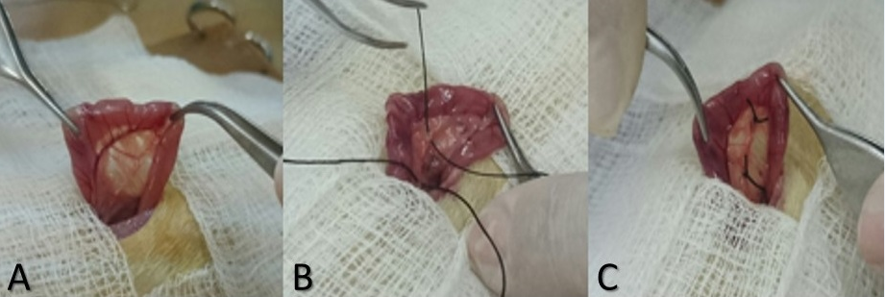 Figure 1 Bile duct ligation surgery. A: Localization of the bile duct; B: Passage of silk thread for duct isolation; C: Resection of the bile duct.

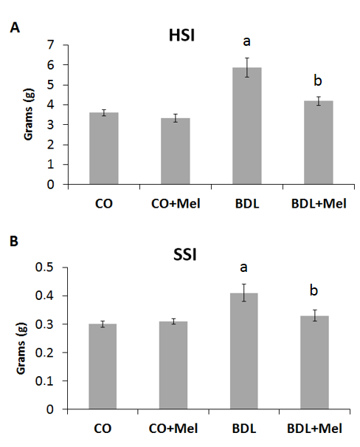
Figure 2 Mean hepatosomatic and splenosomatic index values in the different experimental groups. All results expressed as mean ± SE. Significant difference between BDL and controls groups (CO and CO+Mel) (ªP < 0.001). Significant difference between BDL and BDL+Mel (^{b}P < 0.001). CO: Control; CO+Mel: Control + melatonin; BDL: Bile duct ligation; BDL+Mel: Bile duct ligation + melatonin.
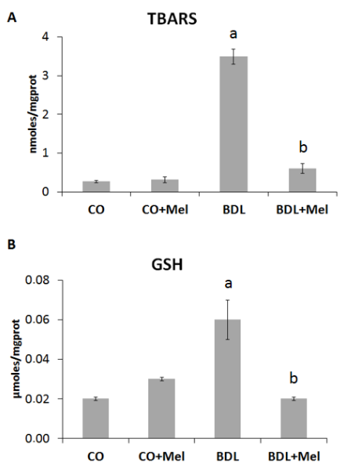
Figure 3 Lipoperoxidation markers and GSH levels in the different experimental groups. All results expressed as mean ± standard error (SE). Significant difference between BDL and controls groups (CO and CO+Mel) (ªP < 0.001). Significant difference between BDL and BDL+Mel (^{b}P < 0.001). CO: Control; CO+Mel: Control + melatonin; BDL: Bile duct ligation; BDL+Mel: Bile duct ligation + melatonin.
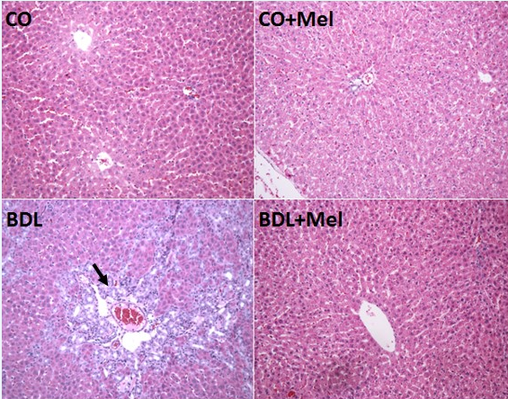
Figure 4 Histological analysis of liver tissue in the different experimental groups. HE staining, × 200 magnification. Arrow indicates the presence of inflammatory infiltrate. CO: Control; CO+Mel: Control + melatonin; BDL: Bile duct ligation; BDL+Mel: Bile duct ligation + melatonin.

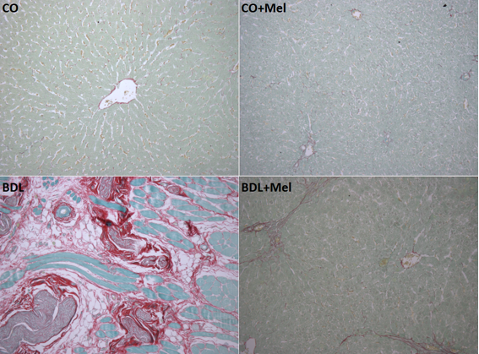
Figure 5 Histological analysis of liver tissue in the different experimental groups. Picrosirius staining, × 200 magnification. CO: Control; CO+Mel: Control + melatonin; BDL: Bile duct ligation; BDL+Mel: Bile duct ligation + melatonin.

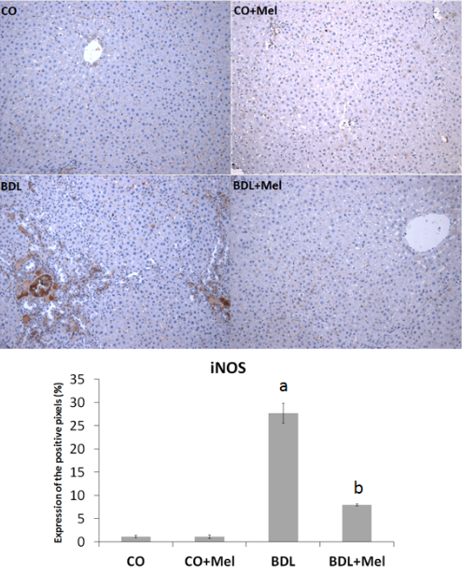
Figure 6 Expression of inducible nitric oxide synthase in the different experimental groups. Magnification × 200. All values expressed as mean ± standard error (SE). Significant difference between BDL and controls groups (CO and CO+Mel) (ªP < 0.001); Significant difference between BDL and BDL+Mel (^{b}P < 0.001). CO: Control; CO+Mel: Control + melatonin; BDL: Bile duct ligation; BDL+Mel: Bile duct ligation + melatonin.
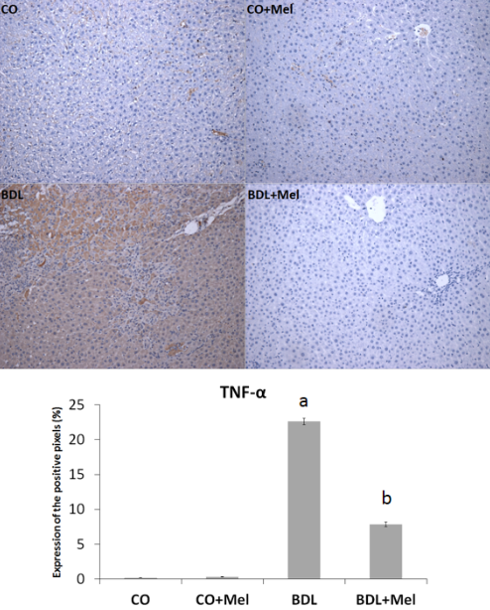
Figure 7 Expression of tumor necrosis factor in the different experimental groups. Magnification × 200. All values expressed as mean ± standard error (SE). Significant difference between BDL and controls groups (CO and CO+Mel) (ªP < 0.001). Significant difference between BDL and BDL+Mel (^{b}P < 0.001). CO: Control; CO+Mel: Control + melatonin; BDL: Bile duct ligation; BDL+Mel: Bile duct ligation + melatonin.

Table 1 Plasma levels of aspartate aminotransferase, alanine aminotransferase, and alkaline phosphatase in the different experimental groups
Group |  | AST (U/L) | ALT (U/L) | AP (U/L)
CO |  | 88.8 ± 0.07 | 37.0 ± 1.9 | 122.4 ± 13.5
CO+Mel |  | 90.4 ± 8.4 | 38.8 ± 3.2 | 111.6 ± 8.1
BDL |  | 425.8 ± 46.6ª | 105.8 ± 13.5ª | 381.2 ± 35.5ª
BDL+Mel |  | 117.5 ± 18.8^{b} | 42.0 ± 3.4^{b} | 104.3 ± 11.03^{b}
All concentrations expressed as mean ± SE. Significant difference between BDL and controls groups (CO and CO+Mel) (ªP < 0.001). Significant difference between BDL and BDL+Mel (^{b}P < 0.001). CO: Control; CO+Mel: Control + melatonin; BDL: Bile duct ligation; BDL+Mel: Bile duct ligation + melatonin.

Table 2 Activity of antioxidant enzymes in the different experimental groups
Groups | SOD  (USOD/mg prot) | CAT  (pmol/mg prot) | GPx  (nmol/min/mg prot) | GST  (µmol/min/mg prot)
CO | 2.43 ± 0.17 | 2.19 ± 0.21 | 6.93 ± 0.76 | 2.28 ± 0.20
CO+Mel | 2.31 ± 0.25 | 2.21 ± 0.28 | 7.15 ± 1.05 | 2.57 ± 0.09
BDL | 0.88 ± 0.21ª | 1.09 ± 0.01ª | 37.78 ± 2.39ª | 5.08 ± 0.43ª
BDL+Mel | 2.47 ± 0.22^{b} | 2.46 ± 0.04^{b} | 9.61 ± 1.20^{b} | 1.93 ± 0.21^{b}
All values expressed as mean ± SE. ªSignificant difference between BDL and controls groups (CO and CO+Mel) (SOD, P < 0.01; CAT, P < 0.05; GPx and GST, P < 0.001). ^{b}Significant difference between BDL and BDL+Mel (SOD and CAT, P < 0.01; GPx and GST, P < 0.001). CO: Control; CO+Mel: Control + melatonin; BDL: Bile duct ligation; BDL+Mel: Bile duct ligation + melatonin.

