Name of Journal: World Journal of Stem Cells
Manuscript NO: 82676
Manuscript Type: MINIREVIEWS

Mesenchymal stem/stromal cells-derived exosomes for osteoporosis treatment

Huo KL et al. Exosomes for osteoporosis treatment

Kai-Lun Huo, Tie-Yi Yang, Wei-Wei Zhang, Jin Shao

Kai-Lun Huo, Postgraduate Training Base in Shanghai Gongli Hospital, Ningxia Medical University, Yinchuan 750004, the Ningxia Hui Autonomous Region, China

Tie-Yi Yang, Jin Shao, Department of Orthopedics, Pudong New Area Gongli Hospital, School of Medical Technology, University of Shanghai for Science and Technology, Shanghai 200135, China

Wei-Wei Zhang, Department of Urology, Renji Hospital, School of Medicine, Shanghai Jiao Tong University, Shanghai 200127, China

Author contributions: Shao J and Zhang WW were responsible for the concept design; Huo KL, Shao J and Zhang WW wrote the main manuscript text and prepared Figures 1 and 2; Yang TY provided technical support; all authors reviewed the manuscript.

Supported by National Natural Science Foundation of China, No. 81703533; Natural Science Foundation of Shanghai, No. 20ZR1449500; Shanghai Jiao Tong University Medical Engineering Cross Fund, No. YG2019GD02; Science Technology Development Fund of Shanghai Pudong New Area, No. PKJ2020-Y28; and Medical Discipline Construction Project of Pudong Health Committee of Shanghai, No. PWYts2021-05.

Corresponding author: Jin Shao, MD, PhD, Associate Professor, Deputy Director, Department of Orthopedics, Pudong New Area Gongli Hospital, School of Medical Technology, University of Shanghai for Science and Technology, No. 219 Miaopu Road, Pudong New Area, Shanghai 200135, China. shaojin_1977@126.com

Received: December 26, 2022
Revised: January 17, 2023
Accepted: March 16, 2023
Published online: March 26, 2023

Abstract
Osteoporosis is a systemic bone disease, which leads to decreased bone mass and an increased risk of fragility fractures. Currently, there are many anti-resorption drugs and osteosynthesis drugs, which are effective in the treatment of osteoporosis, but their usage is limited due to their contraindications and side effects. In regenerative medicine, the unique repair ability of mesenchymal stem cells (MSCs) has been favored by researchers. The exosomes secreted by MSCs have signal transduction and molecular delivery mechanisms, which may have therapeutic effects. In this review, we describe the regulatory effects of MSCs-derived exosomes on osteoclasts, osteoblasts, and bone immunity. We aim to summarize the preclinical studies of exosome therapy in osteoporosis. Furthermore, we speculate that exosome therapy can be a future direction to improve bone health.

Key Words: Mesenchymal stem cells; Exosome; Osteoporosis; Osteoblasts; Osteoclasts; Bone immunity

©The Author(s) 2023. Published by Baishideng Publishing Group Inc. All rights reserved.

Citation: Huo KL, Yang TY, Zhang WW, Shao J. Mesenchymal stem/stromal cells-derived exosomes for osteoporosis treatment. World J Stem Cells 2023; 15(3): 83-89
URL: https://www.wjgnet.com/1948-0210/full/v15/i3/83.htm
DOI: https://dx.doi.org/10.4252/wjsc.v15.i3.83

Core Tip: Osteoporosis is one of the major diseases endangering bone health in the elderly. The existing treatment drugs have problems such as long-term administration and side effects; thus, it is fundamentally difficult to cure osteoporosis. Exosomes derived from mesenchymal stem cells (MSCs) are vesicles that deliver signals and molecules between cells and have shown substantial positive effects in pre-clinical trials. In this review, we summarize the latest progress of MSCs-derived exosomes in the regulation of bone metabolism.

INTRODUCTION
Osteoporosis (OP) is a chronic systemic bone disease. It is characterized by decreased bone mass and destruction of bone microstructures, resulting in decreased bone mineral density (BMD) and ultimately an increased risk of fragility fractures^{[1]}. The dynamic balance between bone formation and bone resorption is an important way to maintain normal bone metabolism. Osteoblasts promote bone formation by mineralizing the matrix, while osteoclasts degrade the bone matrix by secreting H+ and releasing cathepsin K, accelerating bone dissolution^{[2]}.
At present, the prevention and treatment of OP can be divided into adjuvant therapy and drug therapy. The therapeutic effects of drugs are mainly divided into two aspects: Inhibition of osteoclasts (inhibition of bone resorption) and stimulation of osteoblasts (promotion of bone formation). Among them, the drugs that inhibit bone resorption are denosumab, bisphosphonates and selective estrogen receptor modulators; and drugs that promote bone formation are teriparatide and abaloparatide. Romosozumab, a monoclonal antibody directed against sclerostin, has a dual regulatory effect, inhibiting bone resorption and promoting bone formation at the same time^{[3]}.
Although a variety of therapeutic drugs for OP have emerged, all the drugs mentioned above have side effects^{[4]}, and more novel and effective drugs and therapies are needed. There are new advances in the research on stem cells and their exosomes in tissue repair and treatment. Therefore, the new scheme of MSCs-derived exosomes for the treatment of OP has gradually become a therapeutic option^{[5]}.

Exosomes and mesenchymal stem cells
Exosomes are small vesicles secreted by cells with a diameter of 40 to 160 nm, which carry signals and molecules among cells. In addition, the exosomes secreted by the cells in diseased states contain specific microRNAs (miRNAs), which is helpful for the diagnosis of diseases^{[6]}. As a carrier of signal transduction and drug delivery, exosomes also have good potential in the treatment of diseases, and their effectiveness has been confirmed by numerous animal studies^{[7-13]} (Figure 1). In 1974, Friedenstein et al^{[14]} first discovered that mesenchymal stem cells (MSCs) in bone marrow have the potential for osteogenic differentiation. Later, researchers continued to explore the function of MSCs and found that MSCs are pluripotent stem cells, which have the ability to differentiate into osteoblasts, adipocytes, chondrocytes, cardiac muscle cells and skeletal muscle cells^{[15]}. Previous studies have found that therapy with MSCs can accelerate bone tissue repair and regeneration and maintain bone mass in OP^{[16,17]}.
MSCs-derived exosomes are likely to play a major role in mediating the therapeutic effect of MSCs^{[18,19]}. A schematic diagram illustrating the mechanisms of MSCs-derived exosomes in the treatment of OP is shown in Figure 2. Therefore, MSCs-derived exosomes are expected to be a new biological agent in the future.

MSCs-derived exosomes in the treatment of oP
Exosomes have the characteristics of good targeting ability, high permeability and low toxicity. Therefore, exosomes therapy has become one of the hot spots in the study of OP treatment. Bone regeneration is one of the main modalities in the treatment of OP and bone fracture. MSCs-derived exosomes can promote the formation of new bone with vasculature, biomechanics, and histology^{[20]}. MSCs-derived exosomes regulate bone metabolism and treat OP through signaling pathways, such as stimulating osteoblast differentiation from bone marrow stem cells, promoting osteoblast proliferation, inducing angiogenesis, and immunomodulation^{[21]}. During treatment, MSCs-derived exosomes achieve the purpose of bone regeneration and treatment of OP by carrying and transporting proteins, miRNAs, and artificial synthetic drugs^{[22-24]}. According to the pathogenesis of OP, exosomes are mainly involved in regulating the effects of osteoblasts, osteoclasts and bone immunity (Table 1).

Effects of MSCs-derived exosomes on osteoblasts
Osteoblasts are derived from pluripotent MSCs, which are major functional cells in bone matrix synthesis, secretion, and mineralization. Exosomes can directly regulate the activity of osteoblasts and then affect OP. MSCs-derived exosomes promoted the cell cycle of hFOB 1.19 cells, a type of osteoblast, and activated their proliferative activity through the MAPK pathway^{[25]}. It was also found that overexpression of miR-122-5p in MSCs-derived exosomes of bone marrow can increase the BMD of the femoral head through the MAPK pathway^{[26]}. Co-culture of MSCs-derived exosomes with bone marrow MSCs from osteoporotic rats resulted in increased levels of osteogenesis-related proteins and mineral deposition; in addition, the use of MSCs-derived exosomes promoted bone regeneration in a rat model of calvarial defects^{[27]}. One study showed that the infusion of bone marrow MSCs-derived exosomes carrying miR-335 into mice with fractures significantly accelerated fracture healing, as miR-335 in exosomes was able to inhibit VapB, activate the Wnt/β-catenin pathway, and promote osteoblast differentiation^{[28]}. Notably, exosomal miRNAs derived from MSCs are critical in regulating the function of osteoblasts. These miRNAs participate in and regulate some key signaling pathways and alter protein expression in osteoblasts. The positive roles of exosomes in osteoblast proliferation and differentiation, and the excellent therapeutic performance of exosomes in bone repair and bone mass recovery, indicate the potential of MSCs-derived exosomes in the treatment of OP.

Effects of MSCs-derived exosomes on osteoclasts
Osteoclasts originate from hematopoietic progenitor cells in the bone marrow, and play an osteolytic role by secreting H+ and cathepsin K^{[29,30]}. Adipose MSCs-derived exosomes inhibited NLRP3 in the osteoclasts of diabetic OP rat models and increased BMD^{[31]}. RANKL is a major factor in promoting the differentiation of preosteoclasts into osteoclasts, gingiva MSCs-derived exosomes can target Wnt5a in periodontal osteoclasts and inhibit the expression of RANKL, thus reducing the differentiation of osteoclasts^{[32]}. Of course, as a carrier of miRNA, exosomes will also have an effect on osteoclasts by carrying miRNA. Bone marrow MSCs-derived exosomes delivered miR-31a-5p to osteoclasts, which increased osteoclast number and bone resorption. In addition, BMD significantly increased in a rat model treated with miR-31a-5p inhibitor^{[33]}. These findings suggested that MSCs-derived exosomes can regulate osteoclast differentiation, increase bone density, and inhibit OP. Notably, bone marrow stromal cell-derived exosomes do not have any effect on osteoclasts at the surface of trabecular bone, and therefore do not play a role in preventing bone resorption^{[34]}. There are few studies on the regulation of osteoclast differentiation by MSCs-derived exosomes. Therefore, we need to further explore the potential of MSCs-derived exosomes in the treatment of OP by regulating osteoclast differentiation.

Effects of MSCs-derived exosomes On bone immunity
There is an intricate relationship between the immune system and the skeletal system. Activated immune cells release inflammatory mediators and cytokines that upset the balance of bone remodeling and activate osteoclasts, leading to bone loss and OP^{[35,36]}. MSCs-derived exosomes can regulate the immune system^{[37]}. After treatment with adipose MSCs-derived exosomes in mice with colitis, regulatory T cells returned to normal baseline level, and the levels of inflammatory factors such as interleukin (IL)-12 and tumor necrosis factor-α reduced^{[38]}. Exosomes derived from adipose and bone marrow MSCs can significantly increase the level of type II collagen in articular cartilage, promote articular cartilage formation and accelerate the recovery of osteoarthritis in mice^{[39]}. MSCs-derived exosomes promote the differentiation of bone marrow MSCs into osteoblasts by inhibiting the polarization of M1 macrophages and reducing the levels of inflammatory cytokines such as Il-1β and IL-6^{[40]}. MSCs-derived exosomes can regulate immunity and inflammation in vivo. Unfortunately, little is known about their role in bone immunity. However, available findings suggest the potential of MSCs-derived exosomes in the treatment of OP by modulating bone immunity.

CONCLUSION
At present, drug treatment of OP still focuses on inhibiting bone resorption and promoting bone formation. Drug therapy has a good effect, but long-term use of drugs can cause serious side effects. In the field of bone regeneration, stem cell therapy has significant efficacy, and exosomes are one of the important carriers of cell information and factors. Therefore, MSCs-derived exosomes may be a promising biological agent in the treatment of OP. This review focuses on the mechanism of MSCs-derived exosomes in the treatment of OP, by delivering miRNA, regulating related targets, and regulating bone immunity. Therefore, the potential of MSCs-derived exosomes in the treatment of OP is anticipated, but further preclinical studies are needed to prove the safety and reliability of exosome therapy and provide strong evidence for the clinical conversion of exosome therapy.

REFERENCES
1 Compston JE, McClung MR, Leslie WD. Osteoporosis. Lancet 2019; 393: 364-376 [PMID: 30696576 DOI: 10.1016/S0140-6736(18)32112-3]
2 Manolagas SC. Birth and death of bone cells: basic regulatory mechanisms and implications for the pathogenesis and treatment of osteoporosis. Endocr Rev 2000; 21: 115-137 [PMID: 10782361 DOI: 10.1210/edrv.21.2.0395]
3 McClung MR, Grauer A, Boonen S, Bolognese MA, Brown JP, Diez-Perez A, Langdahl BL, Reginster JY, Zanchetta JR, Wasserman SM, Katz L, Maddox J, Yang YC, Libanati C, Bone HG. Romosozumab in postmenopausal women with low bone mineral density. N Engl J Med 2014; 370: 412-420 [PMID: 24382002 DOI: 10.1056/NEJMoa1305224]
4 Tella SH, Gallagher JC. Prevention and treatment of postmenopausal osteoporosis. J Steroid Biochem Mol Biol 2014; 142: 155-170 [PMID: 24176761 DOI: 10.1016/j.jsbmb.2013.09.008]
5 Xie X, Xiong Y, Panayi AC, Hu L, Zhou W, Xue H, Lin Z, Chen L, Yan C, Mi B, Liu G. Exosomes as a Novel Approach to Reverse Osteoporosis: A Review of the Literature. Front Bioeng Biotechnol 2020; 8: 594247 [PMID: 33195163 DOI: 10.3389/fbioe.2020.594247]
6 Kong D, Chen T, Zheng X, Yang T, Zhang Y, Shao J. Comparative profile of exosomal microRNAs in postmenopausal women with various bone mineral densities by small RNA sequencing. Genomics 2021; 113: 1514-1521 [PMID: 33785399 DOI: 10.1016/j.ygeno.2021.03.028]
7 Kalluri R, LeBleu VS. The biology, function, and biomedical applications of exosomes. Science 2020; 367 [PMID: 32029601 DOI: 10.1126/science.aau6977]
8 Liu W, Li L, Rong Y, Qian D, Chen J, Zhou Z, Luo Y, Jiang D, Cheng L, Zhao S, Kong F, Wang J, Zhou Z, Xu T, Gong F, Huang Y, Gu C, Zhao X, Bai J, Wang F, Zhao W, Zhang L, Li X, Yin G, Fan J, Cai W. Hypoxic mesenchymal stem cell-derived exosomes promote bone fracture healing by the transfer of miR-126. Acta Biomater 2020; 103: 196-212 [PMID: 31857259 DOI: 10.1016/j.actbio.2019.12.020]
9 Yan B, Zhang Y, Liang C, Liu B, Ding F, Wang Y, Zhu B, Zhao R, Yu XY, Li Y. Stem cell-derived exosomes prevent pyroptosis and repair ischemic muscle injury through a novel exosome/circHIPK3/ FOXO3a pathway. Theranostics 2020; 10: 6728-6742 [PMID: 32550900 DOI: 10.7150/thno.42259]
10 Liu S, Chen X, Bao L, Liu T, Yuan P, Yang X, Qiu X, Gooding JJ, Bai Y, Xiao J, Pu F, Jin Y. Treatment of infarcted heart tissue via the capture and local delivery of circulating exosomes through antibody-conjugated magnetic nanoparticles. Nat Biomed Eng 2020; 4: 1063-1075 [PMID: 33159193 DOI: 10.1038/s41551-020-00637-1]
11 Kamerkar S, LeBleu VS, Sugimoto H, Yang S, Ruivo CF, Melo SA, Lee JJ, Kalluri R. Exosomes facilitate therapeutic targeting of oncogenic KRAS in pancreatic cancer. Nature 2017; 546: 498-503 [PMID: 28607485 DOI: 10.1038/nature22341]
12 Gao H, Jin Z, Bandyopadhyay G, Cunha E Rocha K, Liu X, Zhao H, Zhang D, Jouihan H, Pourshahian S, Kisseleva T, Brenner DA, Ying W, Olefsky JM. MiR-690 treatment causes decreased fibrosis and steatosis and restores specific Kupffer cell functions in NASH. Cell Metab 2022; 34: 978-990.e4 [PMID: 35700738 DOI: 10.1016/j.cmet.2022.05.008]
13 Tian W, Yang X, Yang H, Lv M, Sun X, Zhou B. Exosomal miR-338-3p suppresses non-small-cell lung cancer cells metastasis by inhibiting CHL1 through the MAPK signaling pathway. Cell Death Dis 2021; 12: 1030 [PMID: 34718336 DOI: 10.1038/s41419-021-04314-2]
14 Friedenstein AJ, Chailakhyan RK, Latsinik NV, Panasyuk AF, Keiliss-Borok IV. Stromal cells responsible for transferring the microenvironment of the hemopoietic tissues. Cloning in vitro and retransplantation in vivo. Transplantation 1974; 17: 331-340 [PMID: 4150881 DOI: 10.1097/00007890-197404000-00001]
15 Uccelli A, Moretta L, Pistoia V. Mesenchymal stem cells in health and disease. Nat Rev Immunol 2008; 8: 726-736 [PMID: 19172693 DOI: 10.1038/nri2395]
16 Chen T, Yang T, Zhang W, Shao J. The therapeutic potential of mesenchymal stem cells in treating osteoporosis. Biol Res 2021; 54: 42 [PMID: 34930472 DOI: 10.1186/s40659-021-00366-y]
17 Xu GP, Zhang XF, Sun L, Chen EM. Current and future uses of skeletal stem cells for bone regeneration. World J Stem Cells 2020; 12: 339-350 [PMID: 32547682 DOI: 10.4252/wjsc.v12.i5.339]
18 Pegtel DM, Gould SJ. Exosomes. Annu Rev Biochem 2019; 88: 487-514 [PMID: 31220978 DOI: 10.1146/annurev-biochem-013118-111902]
19 Álvarez-Viejo M. Mesenchymal stem cells from different sources and their derived exosomes: A pre-clinical perspective. World J Stem Cells 2020; 12: 100-109 [PMID: 32184935 DOI: 10.4252/wjsc.v12.i2.100]
20 Tan SHS, Wong JRY, Sim SJY, Tjio CKE, Wong KL, Chew JRJ, Hui JHP, Toh WS. Mesenchymal stem cell exosomes in bone regenerative strategies-a systematic review of preclinical studies. Mater Today Bio 2020; 7: 100067 [PMID: 32695985 DOI: 10.1016/j.mtbio.2020.100067]
21 Rudiansyah M, El-Sehrawy AA, Ahmad I, Terefe EM, Abdelbasset WK, Bokov DO, Salazar A, Rizaev JA, Muthanna FMS, Shalaby MN. Osteoporosis treatment by mesenchymal stromal/stem cells and their exosomes: Emphasis on signaling pathways and mechanisms. Life Sci 2022; 306: 120717 [PMID: 35792178 DOI: 10.1016/j.lfs.2022.120717]
22 Chen L, Mou S, Li F, Zeng Y, Sun Y, Horch RE, Wei W, Wang Z, Sun J. Self-Assembled Human Adipose-Derived Stem Cell-Derived Extracellular Vesicle-Functionalized Biotin-Doped Polypyrrole Titanium with Long-Term Stability and Potential Osteoinductive Ability. ACS Appl Mater Interfaces 2019; 11: 46183-46196 [PMID: 31718127 DOI: 10.1021/acsami.9b17015]
23 Li QC, Li C, Zhang W, Pi W, Han N. Potential Effects of Exosomes and their MicroRNA Carrier on Osteoporosis. Curr Pharm Des 2022; 28: 899-909 [PMID: 35088659 DOI: 10.2174/1381612828666220128104206]
24 Zuo R, Liu M, Wang Y, Li J, Wang W, Wu J, Sun C, Li B, Wang Z, Lan W, Zhang C, Shi C, Zhou Y. BM-MSC-derived exosomes alleviate radiation-induced bone loss by restoring the function of recipient BM-MSCs and activating Wnt/β-catenin signaling. Stem Cell Res Ther 2019; 10: 30 [PMID: 30646958 DOI: 10.1186/s13287-018-1121-9]
25 Zhao P, Xiao L, Peng J, Qian YQ, Huang CC. Exosomes derived from bone marrow mesenchymal stem cells improve osteoporosis through promoting osteoblast proliferation via MAPK pathway. Eur Rev Med Pharmacol Sci 2018; 22: 3962-3970 [PMID: 29949171 DOI: 10.26355/eurrev_201806_15280]
26 Liao W, Ning Y, Xu HJ, Zou WZ, Hu J, Liu XZ, Yang Y, Li ZH. BMSC-derived exosomes carrying microRNA-122-5p promote proliferation of osteoblasts in osteonecrosis of the femoral head. Clin Sci (Lond) 2019; 133: 1955-1975 [PMID: 31387936 DOI: 10.1042/CS20181064]
27 Qi X, Zhang J, Yuan H, Xu Z, Li Q, Niu X, Hu B, Wang Y, Li X. Exosomes Secreted by Human-Induced Pluripotent Stem Cell-Derived Mesenchymal Stem Cells Repair Critical-Sized Bone Defects through Enhanced Angiogenesis and Osteogenesis in Osteoporotic Rats. Int J Biol Sci 2016; 12: 836-849 [PMID: 27313497 DOI: 10.7150/ijbs.14809]
28 Hu H, Wang D, Li L, Yin H, He G, Zhang Y. Role of microRNA-335 carried by bone marrow mesenchymal stem cells-derived extracellular vesicles in bone fracture recovery. Cell Death Dis 2021; 12: 156 [PMID: 33542183 DOI: 10.1038/s41419-021-03430-3]
29 Boyle WJ, Simonet WS, Lacey DL. Osteoclast differentiation and activation. Nature 2003; 423: 337-342 [PMID: 12748652 DOI: 10.1038/nature01658]
30 Lotinun S, Kiviranta R, Matsubara T, Alzate JA, Neff L, Lüth A, Koskivirta I, Kleuser B, Vacher J, Vuorio E, Horne WC, Baron R. Osteoclast-specific cathepsin K deletion stimulates S1P-dependent bone formation. J Clin Invest 2013; 123: 666-681 [PMID: 23321671 DOI: 10.1172/JCI64840]
31 Zhang L, Wang Q, Su H, Cheng J. Exosomes from adipose derived mesenchymal stem cells alleviate diabetic osteoporosis in rats through suppressing NLRP3 inflammasome activation in osteoclasts. J Biosci Bioeng 2021; 131: 671-678 [PMID: 33849774 DOI: 10.1016/j.jbiosc.2021.02.007]
32 Nakao Y, Fukuda T, Zhang Q, Sanui T, Shinjo T, Kou X, Chen C, Liu D, Watanabe Y, Hayashi C, Yamato H, Yotsumoto K, Tanaka U, Taketomi T, Uchiumi T, Le AD, Shi S, Nishimura F. Exosomes from TNF-α-treated human gingiva-derived MSCs enhance M2 macrophage polarization and inhibit periodontal bone loss. Acta Biomater 2021; 122: 306-324 [PMID: 33359765 DOI: 10.1016/j.actbio.2020.12.046]
33 Xu R, Shen X, Si Y, Fu Y, Zhu W, Xiao T, Fu Z, Zhang P, Cheng J, Jiang H. MicroRNA-31a-5p from aging BMSCs links bone formation and resorption in the aged bone marrow microenvironment. Aging Cell 2018; 17: e12794 [PMID: 29896785 DOI: 10.1111/acel.12794]
34 Luo ZW, Li FX, Liu YW, Rao SS, Yin H, Huang J, Chen CY, Hu Y, Zhang Y, Tan YJ, Yuan LQ, Chen TH, Liu HM, Cao J, Liu ZZ, Wang ZX, Xie H. Aptamer-functionalized exosomes from bone marrow stromal cells target bone to promote bone regeneration. Nanoscale 2019; 11: 20884-20892 [PMID: 31660556 DOI: 10.1039/c9nr02791b]
35 Arron JR, Choi Y. Bone versus immune system. Nature 2000; 408: 535-536 [PMID: 11117729 DOI: 10.1038/35046196]
36 Srivastava RK, Dar HY, Mishra PK. Immunoporosis: Immunology of Osteoporosis-Role of T Cells. Front Immunol 2018; 9: 657 [PMID: 29675022 DOI: 10.3389/fimmu.2018.00657]
37 Ha DH, Kim HK, Lee J, Kwon HH, Park GH, Yang SH, Jung JY, Choi H, Lee JH, Sung S, Yi YW, Cho BS. Mesenchymal Stem/Stromal Cell-Derived Exosomes for Immunomodulatory Therapeutics and Skin Regeneration. Cells 2020; 9 [PMID: 32392899 DOI: 10.3390/cells9051157]
38 Heidari N, Abbasi-Kenarsari H, Namaki S, Baghaei K, Zali MR, Ghaffari Khaligh S, Hashemi SM. Adipose-derived mesenchymal stem cell-secreted exosome alleviates dextran sulfate sodium-induced acute colitis by Treg cell induction and inflammatory cytokine reduction. J Cell Physiol 2021; 236: 5906-5920 [PMID: 33728664 DOI: 10.1002/jcp.30275]
39 Fazaeli H, Kalhor N, Naserpour L, Davoodi F, Sheykhhasan M, Hosseini SKE, Rabiei M, Sheikholeslami A. A Comparative Study on the Effect of Exosomes Secreted by Mesenchymal Stem Cells Derived from Adipose and Bone Marrow Tissues in the Treatment of Osteoarthritis-Induced Mouse Model. Biomed Res Int 2021; 2021: 9688138 [PMID: 34616850 DOI: 10.1155/2021/9688138]
40 Wei F, Li Z, Crawford R, Xiao Y, Zhou Y. Immunoregulatory role of exosomes derived from differentiating mesenchymal stromal cells on inflammation and osteogenesis. J Tissue Eng Regen Med 2019; 13: 1978-1991 [PMID: 31359542 DOI: 10.1002/term.2947]

Footnotes
Conflict-of-interest statement: The authors declare no conflict of interests.

Open-Access: This article is an open-access article that was selected by an in-house editor and fully peer-reviewed by external reviewers. It is distributed in accordance with the Creative Commons Attribution NonCommercial (CC BY-NC 4.0) license, which permits others to distribute, remix, adapt, build upon this work non-commercially, and license their derivative works on different terms, provided the original work is properly cited and the use is non-commercial. See: https://creativecommons.org/Licenses/by-nc/4.0/

Provenance and peer review: Invited article; Externally peer reviewed.
Peer-review model: Single blind

Peer-review started: December 26, 2022
First decision: January 3, 2023
Article in press: March 16, 2023

Specialty type: Medicine, research and experimental
Country/Territory of origin: China
Peer-review report’s scientific quality classification
Grade A (Excellent): 0
Grade B (Very good): B, B
Grade C (Good): C, C
Grade D (Fair): 0
Grade E (Poor): 0

P-Reviewer: Gallone A, Italy; Jeyaraman M, India; Shalaby MN, Egypt; Ventura C, Italy S-Editor: Yan JP L-Editor: A P-Editor: Yan JP

Figure Legends
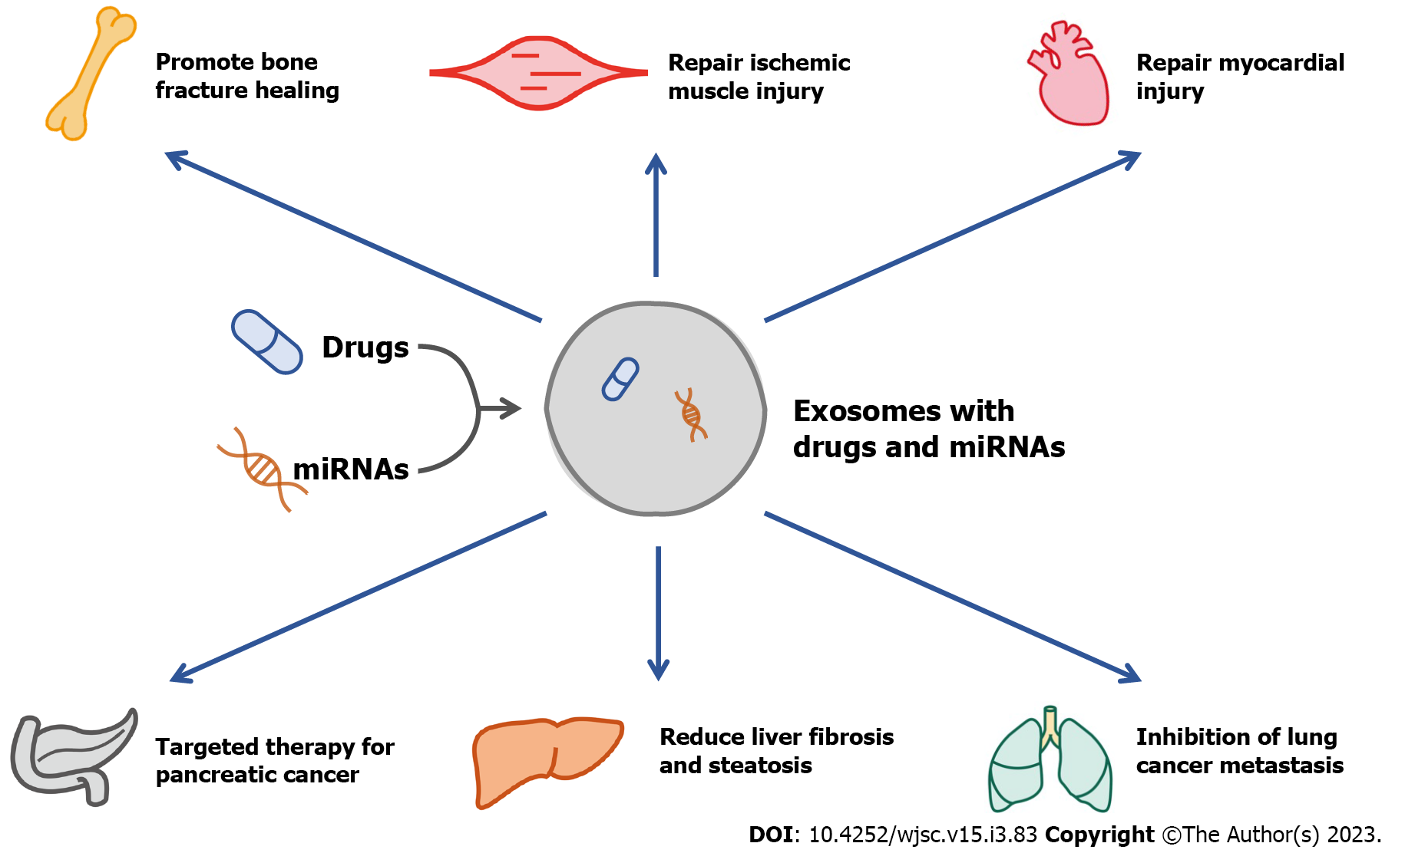

Figure 1 Schematic diagram illustrating the therapeutic potential of exosomes in diseases of multiple organs. miRNAs: MicroRNAs.

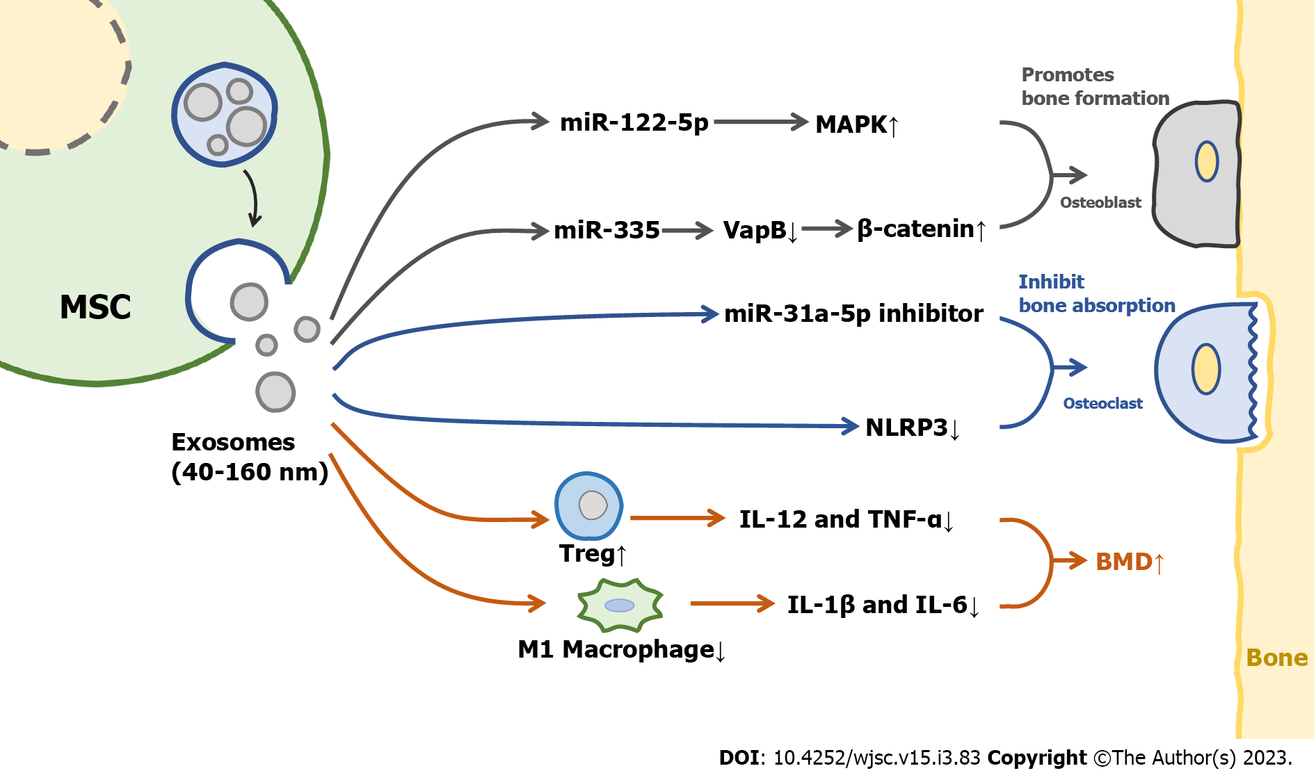

Figure 2 Schematic diagram illustrating the mechanisms of mesenchymal stem cells-derived exosomes in the treatment of osteoporosis. MSC: Mesenchymal stem cell; BMD: Bone mineral density.

Table 1 Summary of studies on mesenchymal stem cells-derived exosomes in osteoporosis treatment
Ref. | Exosome source | Cell type | Consequence
Zuo et al^{[24]}, 2019 | BMSCs | BMSCs (after irradiation) | Alleviating radiation-induced bone loss by restoring Wnt/β-Catenin signaling pathway
Zhao et al^{[25]}, 2018 | BMSCs | Osteoblasts (hFOB 1.19) | Promoting proliferation of osteoblasts via MAPK pathway
Liao et al^{[26]}, 2019 | BMSCs | Osteoblasts | Promoting proliferation of osteoblasts by carrying miR-122-5p
Qi et al^{[27]}, 2016 | hiPSC-MSCs | Osteoblasts | Promoting osteoblast proliferation, differentiation and bone formation
Hu et al^{[28]}, 2021 | BMSCs | Osteoblasts | Promoting differentiation of osteoblasts by carrying miR-335
Zhang et al^{[31]}, 2021 | AD-MSCs | Osteoclasts | Inhibiting NLRP3 inflammasome activation in osteoclasts
Nakao et al^{[32]}, 2021 | GMSCs | Osteoclasts | Inhibiting RANKL and reducing osteoclast formation by carrying miR-1260b via Wnt5a/JNK signal pathway
Xu et al^{[33]}, 2018 | BMSCs | Osteoclasts | Increasing the number of osteoclasts by carrying miR-31a-5p via RhoA pathway
Wei et al^{[40]}, 2019 | BMSCs | Osteoblasts | Promoting osteoblast differentiation by inhibiting macrophage polarization and reducing the levels of inflammatory factors
BMSCs: Bone marrow mesenchymal stem cells; hiPSC-MSCs: Mesenchymal stem cells derived from human induced pluripotent stem cells; AD-MSCs: Adipose derived mesenchymal stem cells; GMSCs: Gingival tissue-derived mesenchymal stem cells; MAPK: Mitogen-activated protein kinase; NLRP3: NLR family pyrin domain containing 3; RANKL: Receptor activator of NF-κB ligand; Wnt5a: Wnt family member 5A; JNK: c-Jun N-terminal kinases.

Published by Baishideng Publishing Group Inc
7041 Koll Center Parkway, Suite 160, Pleasanton, CA 94566, USA
Telephone: +1-925-3991568
E-mail: bpgoffice@wjgnet.com
Help Desk: https://www.f6publishing.com/helpdesk
https://www.wjgnet.com

© 2023 Baishideng Publishing Group Inc. All rights reserved.

