Name of Journal: World Journal of Gastrointestinal Oncology
Manuscript NO: 85771
Manuscript Type: CORRECTION

Correction to “Interleukin-34 promotes the proliferation and epithelial-mesenchymal transition of gastric cancer cells”

Li CH et al. Proliferative and EMT effects of IL-34

Chuan-Hong Li, Zhang-Ming Chen, Pei-Feng Chen, Lei Meng, Wan-Nian Sui, Song-Cheng Ying, A-Man Xu, Wen-Xiu Han

Chuan-Hong Li, Zhang-Ming Chen, Pei-Feng Chen, Lei Meng, Wan-Nian Sui, A-Man Xu, Wen-Xiu Han, Department of General Surgery, First Affiliated Hospital of Anhui Medical University, Hefei 230022, Anhui Province, China

Song-Cheng Ying, Department of Immunology, College of Basic Medicine, Anhui Medical University, Hefei 230022, Anhui Province, China

Author contributions: Li CH wrote the manuscript; All authors approved the submitted version.

Corresponding author: Wen-Xiu Han, MD, PhD, Professor, Department of General Surgery, First Affiliated Hospital of Anhui Medical University, No. 218 Jixi Avenue, Shushan District, Hefei 230022, Anhui Province, China. hwxhbh@126.com

Received: May 16, 2023
Revised: July 7, 2023
Accepted: July 31, 2023
Published online:

Abstract
Correction to “Interleukin-34 promotes the proliferation and epithelial-mesenchymal transition of gastric cancer cells”. In this article, we found the following error in Figure 3A: the panel image "24 h, sh-RNA1" in the AGS cells wound healing assay was incorrectly inserted during the preparation of the submission; the correct figure is provided in this correction.

Key Words: Correction; Gastric cancer; Interleukin-34; Proliferation; Epithelial-mesenchymal transition; Metastasis

Li CH, Chen ZM, Chen PF, Meng L, Sui WN, Ying SC, Xu AM, Han WX. Correction to “Interleukin-34 promotes the proliferation and epithelial-mesenchymal transition of gastric cancer cells”. World J Gastrointest Oncol 2023; In press

Core Tip: The aim of this manuscript is to correct the image in Figure 3A of “Li CH, Chen ZM, Chen PF, Meng L, Sui WN, Ying SC, Xu AM, Han WX. Interleukin-34 promotes the proliferation and epithelial-mesenchymal transition of gastric cancer cells. World J Gastrointest Oncol 2022; 14: 1968-1980 [PMID: 36310707 DOI: 10.4251/wjgo.v14.i10.1968].

TO THE EDITOR
Correction to: Li CH, Chen ZM, Chen PF, Meng L, Sui WN, Ying SC, Xu AM, Han WX. Interleukin-34 promotes the proliferation and epithelial-mesenchymal transition of gastric cancer cells. World J Gastrointest Oncol 2022; 14: 1968-1980 [PMID: 36310707 DOI: 10.4251/wjgo.v14.i10.1968]. We identified the following error in Figure 3A of the original version of the published article: the image relative to "24 h, sh-RNA1" in the AGS cell wound healing assay was inserted incorrectly during the preparation of the submission. The correct Figure is provided in this correction. This correction will have no influence on the interpretation of the results and conclusion in this study. We apologize for any inconvenience this may have caused.

REFERENCES
1 Li CH, Chen ZM, Chen PF, Meng L, Sui WN, Ying SC, Xu AM, Han WX. Interleukin-34 promotes the proliferation and epithelial-mesenchymal transition of gastric cancer cells. World J Gastrointest Oncol 2022; 14: 1968-1980 [PMID: 36310707 DOI: 10.4251/wjgo.v14.i10.1968]

Footnotes
Conflict-of-interest statement: There is no conflict of interest in this study.

Open-Access: This article is an open-access article that was selected by an in-house editor and fully peer-reviewed by external reviewers. It is distributed in accordance with the Creative Commons Attribution NonCommercial (CC BY-NC 4.0) license, which permits others to distribute, remix, adapt, build upon this work non-commercially, and license their derivative works on different terms, provided the original work is properly cited and the use is non-commercial. See: https://creativecommons.org/Licenses/by-nc/4.0/

Provenance and peer review: Unsolicited article; Externally peer reviewed.

Peer-review model: Single blind

Peer-review started: May 16, 2023
First decision: June 26, 2023
Article in press:

Specialty type: Oncology
Country/Territory of origin: China
Peer-review report’s scientific quality classification
Grade A (Excellent): A
Grade B (Very good): 0
Grade C (Good): C, C
Grade D (Fair): 0
Grade E (Poor): 0

P-Reviewer: Senchukova M, Russia; Sheykhhasan M, Iran; Yildiz K, Turkey S-Editor: Fan JR L-Editor: A P-Editor:

Figure Legends
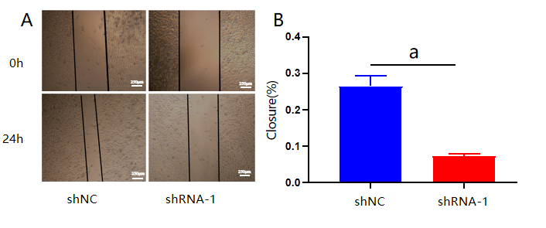
Figure 3 Interleukin-34 regulates the migration and invasiveness of AGS cells. A and B: Wound-healing assay revealed that downregulation of endogenous interleukin-34 significantly reduced the migration rate. Data derived from three independent experiments performed in triplicate and expressed as mean ± SD, and ªP < 0.05 was considered statistically significant.

