Name of Journal: World Journal of Clinical Cases
ESPS Manuscript NO: 24373
Manuscript Type: Case Report

Removal of large foreign body in rectosigmoid colon by colonoscopy using gastrolith forceps

Lin XD et al. Removal of large foreign body in rectosigmoid colon by colonoscopy

Xiao-Dong Lin, Guang-Yao Wu, Song-Hu Li, Zong-Quan Wen, Fu Zhang, Shao-Ping Yu

Xiao-Dong Lin, Guang-Yao Wu, Song-Hu Li, Zong-Quan Wen, Fu Zhang, Shao-Ping Yu, Department of Gastroenterology, Dongguan Kanghua Hospital, Dongguan 523080, Guangdong Province, China

Author contributions: This article was mainly written by Lin XD and Wu GY. Data were obtained by Lin XD, Li SH and Zhang F; Data were analyzed by Wu GY; Wen ZQ mainly performed the surgery assisted by Lin XD; Yu SP guided the whole work; all authors approved the final version.

Institutional review board statement: This case report was exempt from the Ethics Committee of Dongguan Kanghua Hospital.

Informed consent statement: The patient involved in this study gave his written informed consent authorizing use and disclosure of his protected health information.

Conflict-of-interest statement: No conflicts of interest exist.

Open-Access: This article is an open-access article which was selected by an in-house editor and fully peer-reviewed by external reviewers. It is distributed in accordance with the Creative Commons Attribution Non Commercial (CC BY-NC 4.0) license, which permits others to distribute, remix, adapt, build upon this work non-commercially, and license their derivative works on different terms, provided the original work is properly cited and the use is non-commercial. See: http://creativecommons.org/licenses/by-nc/4.0/

Correspondence to: Shao-Ping Yu, MD, Department of Gastroenterology, Dongguan Kanghua Hospital, 1000 Dongguan Avenue, Dongguan 523080, Guangdong Province, China. yushaopingmd@163.com
Telephone: +86-769-23095553

Received: January 19, 2016
Peer-review started: January 21, 2016
First decision: February 26, 2016
Revised: March 8, 2016
Accepted: April 5, 2016
Article in press:
Published online:

Abstract
Rectal foreign bodies (RFB) are man-made injury, it happened once in a while. The management depends on its depth and the consequence it caused. We here reported a case of rectal foreign body (a glass bottle about 38 mm × 75 mm) which is 13-15 cm from the anus. The patient had no sign of perforation, and we managed to removed it using endoscopy with gastrolith forceps.

Key words: Foreign body; Rectosigmoid; Endoscopy; Remove; Gastrolith forceps

©The Author(s) 2016.Published by Baishideng Publishing Group Inc. All rights reserved.

Core tip: Rectal foreign bodies happens once in a while. Majority of rectal foreign bodies inserted by adults are for self-gratification. As such they are likely to be smooth, rounded, cylindrical, or egg shaped to allow ease of introduction and removal. The factors that determine whether a rectal foreign body can be removed transanally are the shape, size, location of the object, and the presence or absence of perforation. We here reported a case of rectal foreign body (a glass bottle about 38 mm × 75 mm) which is 13-15 cm from the anus. The patient had no sign of perforation, and we managed to remove it using endoscopy with gastrolith forceps.

Lin XD, Wu GY, Li SH, Wen ZQ, Zhang F, Yu SP. Removal of large foreign body in rectosigmoid colon by colonoscopy using gastrolith forceps. World J Clin Cases 2016; In press
INTRODUCTION
Majority of rectal foreign bodies inserted by adults are for self-gratification. As such they are likely to be smooth, rounded, cylindrical, or egg shaped to allow ease of introduction and removal. The factors that determine whether a rectal foreign body can be removed transanally are the shape, size, location of the object, and the presence or absence of perforation. We here reported a case of rectal foreign body (a glass bottle about 38 mm × 75 mm) which is 13-15 cm from the anus. The patient had no sign of perforation, and we managed to removed it using endoscopy with gastrolith forceps.

CASE REPORT
A 40-year-old male was admitted due to retention of a large foreign body in rectal colon (Figure 1). He put a glass bottle into his anal in his self-sexual play 3 d before admitted. In physical examination, a cylindrical shape glass plat with about 4 cm in diameter could be touch in rectal touch 4cm from anus. Plain abdominal radiograph revealed a bottle shape foreign body (about 38 mm × 75 mm) retained in hypogastric zone adjacent to pubic symphysis, without sign of perforation. The open of the bottle is in the proximal of colon, and the basal of the bottle is near the anus which made it difficult to removal by anal speculum. The bottle slid into the rectosigmoid colon deeper during the procedure (Figure 2). We decided to have a colonoscopy as a last method before cutting him open. In the colonoscopy, a wide basal glass bottle fulfilled the whole colon 15 cm from the anus. Snare and basket were failed to noose the bottle (Figure 3). We decided to use gastrolith forceps to noose the bottle. After fully gas filling, we were able to noose the basal part of the bottle. The patient felt painful, so, lumbar anesthesia was performed to relief the spasm of the colon and pain. The bottle was carefully and slowly dragged to the open of the anus. And it was successfully removed outside the patient by colonoscopy. There was no sign of bleeding, injury or perforation in the post-extraction sigmoidoscopy and 2 d observation following. Then the patient was discharged. The patient had no perforation, bleeding nor fecal incontinence after a month follow up.

DISCUSSION
Majority of rectal foreign bodies inserted by adults are for self-gratification^{[1]}. As such they are likely to be smooth, rounded, cylindrical, or egg shaped to allow ease of introduction and removal^{[2]}. The factors that determine whether a rectal foreign body can be removed transanally are the shape, size, location of the object, and the presence or absence ofperforation^{[2]}. In the non-perforated stable patient, the object should be removed with a local block and/or conscious sedation via the transanal approach. If this fails, then the patient should go to the operating room for a deeper anesthetic and attempt at transanal extraction. Surgery with a laparotomy should be reserved for patients with perforation or ischemic bowel or cases of failed transanal attempts^{[3]}. Most of rectal foreign body can be removed transanally, but when it goes deeper to sigmoid colon, it is impossible to extract except via conlonscopy^{[4]}. In our patient, the basal, smooth, large part of the bottle is in distal colon, which makes it much difficult to remove out. We used gastrolith forceps to loop the bottle, and seized it tight enough to extract.

COMMENTS
Case characteristics
A 40-year-old male present at hospital seeking for medical help due to rectal foreign body insertion.

Clinical diagnosis
Rectal foreign body (glass bottle) insertion.

Differential diagnosis
Bowel perforation, intestinal necrosis, foreign body rupture.

Imaging diagnosis
A bottle shape foreign body (about 38 mm × 75 mm) retained in hypogastric zone adjacent to pubic symphysis, without sign of perforation.

Pathological diagnosis
Foreign body (glass bottle) of rectal.

Treatment
Removed using colonoscopy.

Related reports
Foreign bodies of different shape was reported, little smooth ones can be removed via transanal approach while irregular shape ones needed to surgical remove.

Term explanation
RFB Rectal foreign bodies.

Experiences and lessons
Rectal foreign bodies removal transannal approach, relax of patient, fully dilation of anus is very important.

Peer-review
This is an interesting case and the X-ray imaging is typical one of rectal foreign body, anesthesia before retreating the foreign body should be considered.

REFERENCES
1 Irizarry E, Gottesman L. Rectal sexual trauma including foreign bodies. Int J STD AIDS 1996; 7: 166-169 [PMID: 8799777 DOI: 10.1258/0956462961917555]
2 Singaporewalla RM, Tan DE, Tan TK. Use of endoscopic snare to extract a large rectosigmoid foreign body with review of literature. Surg Laparosc Endosc Percutan Tech 2007; 17: 145-148 [PMID: 17450100 DOI: 10.1097/SLE.0b013e318045bf1a]
3 Goldberg JE, Steele SR. Rectal foreign bodies. Surg Clin North Am 2010; 90: 173-84, Table of Contents [PMID: 20109641 DOI: 10.1016/j.suc.2009.10.004]
4 Coskun A, Erkan N, Yakan S, Yıldirim M, Cengiz F. Management of rectal foreign bodies. World J Emerg Surg 2013; 8: 11 [PMID: 23497492 DOI: 1 0.1186/1749-7922-8-11]

P-Reviewer: Day LW, Saligram S, Verma M S-Editor: Qi Y
L-Editor: E-Editor:

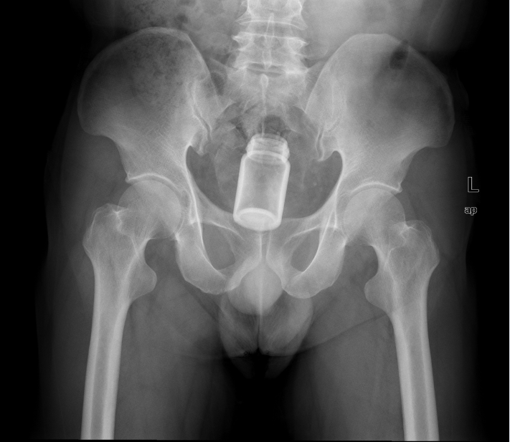Figure 1 A 40-year-old male was admitted due to retention of a large foreign body in his rectal colon. Plain abdominal radiograph revealed a bottle shape foreign body (about 38 mm × 75 mm) retained in rectal colon, with no sign of perforation (Figure 1).

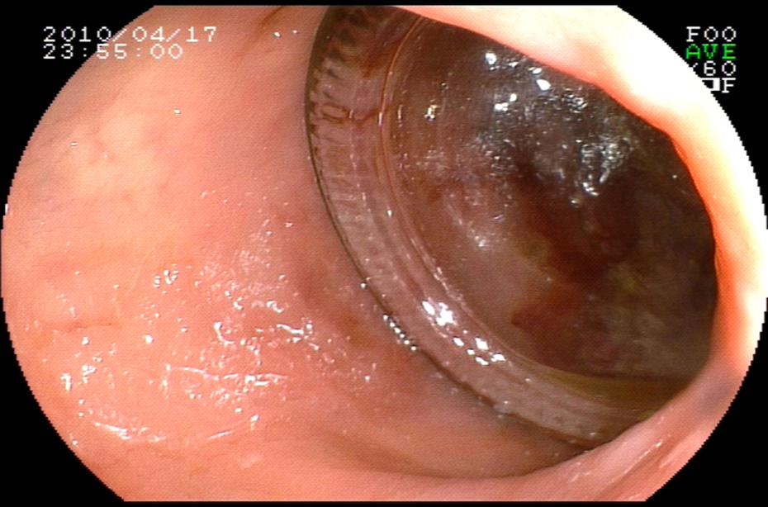
Figure 2 Bottle slid into the rectosigmoid colon deeper during examination. We decided to have a colonoscopy as a last try before cutting him open. In the colonoscopy, the glass bottle fulfilled the entire colon 15 cm from anus.

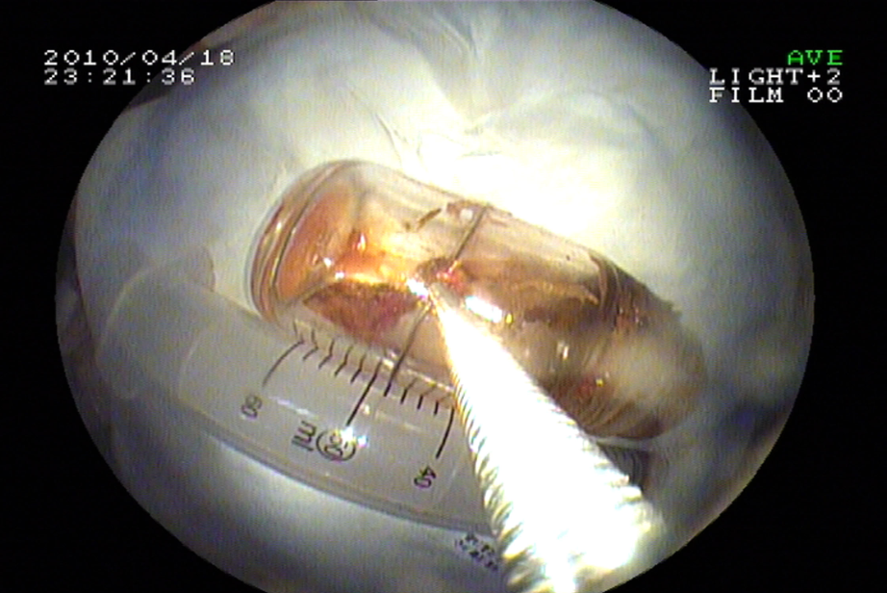
Figure 3 Snares and baskets failed to ensnare it. We used gastrolith forceps to retrieve the bottle. The bottle was carefully and slowly manipulated to the opening of the anus and successfully removed out by colonoscopy (Figure 3).

