Name of Journal: World Journal of Clinical Cases
Manuscript NO: 61599
Manuscript Type: CASE REPORT

Cronkhite-Canada syndrome with steroid dependency: A case report

Jiang D et al. Relapse of CCS with prednisone withdrawal

Dan Jiang, Guo-Du Tang, Ming-Yu Lai, Zhen-Ning Huang, Zhi-Hai Liang

Dan Jiang, Guo-Du Tang, Ming-Yu Lai, Zhen-Ning Huang, Zhi-Hai Liang, Department of Gastroenterology, First Affiliated Hospital of Guangxi Medical University, Nanning 530021, Guangxi Zhuang Autonomous Region, China

Author contributions: Jiang D collected basic patient information and imaging data and wrote the main content of the manuscript; Tang GD reviewed the literature and made the diagnosis; Lai MY and Huang ZN were responsible for the analysis and interpretation of data; Liang ZH was responsible for the conception and design of the study and the final approval of the version of the article to be published; All authors have read and approve the final manuscript.

Corresponding author: Zhi-Hai Liang, MD, Professor, Department of Gastroenterology, First Affiliated Hospital of Guangxi Medical University, No. 6 Shuangyong Road, Nanning 530021, Guangxi Zhuang Autonomous Region, China. lzh@stu.gxmu.edu.cn

Received: December 15, 2020
Revised: January 27, 2021
Accepted: March 15, 2021
Published online: May 16, 2021

Abstract
BACKGROUND
Cronkhite-Canada syndrome (CCS) is a rare nonhereditary disease characterized by chronic diarrhoea, diffuse gastrointestinal polyposis and ectodermal manifestations. The lethality of CCS can be up to 50% if it is untreated or if treatment is delayed or inadequate. More than 35% of the patients do not achieve long-term clinical remission after corticosteroid administration, with relapse occurring during or after the cessation of glucocorticoid use. The optimal strategy of maintenance therapy of this disease is controversial.

CASE SUMMARY
A 47-year-old man presented to the hospital with a 3-mo history of frequent watery diarrhoea, accompanied by macular skin pigmentation that included the palms and soles, and onychodystrophy of the fingernails and toenails. Gastroscopy and colonoscopy revealed numerous polyps in the stomach and colon. After other possibilities were ruled out by a series of examinations, CCS was diagnosed and treated with prednisone. The patient took prednisone for more than 1 year before achieving complete resolution of his symptoms and endoscopic findings. The patient was then given prednisone 5 mg/d for 6 mo of maintenance therapy. With clinical improvement and polyp regression, prednisone was discontinued. Eight mo after the discontinuation of prednisone, the diarrhoea and gastrointestinal polyps relapsed. Therefore, the patient was given the same dose of prednisone, and complete remission was achieved again.

CONCLUSION
It is necessary to extend the duration of prednisone maintenance therapy for CCS. Prednisone is still effective when readministered after relapse. Surveillance endoscopy at intervals of 1 year or less is recommended to assess mucosal disease activity.

Key Words: Cronkhite-Canada syndrome; Endoscopy; Prednisone; Relapse; Maintenance therapy; Case report

©The Author(s) 2021. Published by Baishideng Publishing Group Inc. All rights reserved.

Citation: Jiang D, Tang GD, Lai MY, Huang ZN, Liang ZH. Cronkhite-Canada syndrome with steroid dependency: A case report. World J Clin Cases 2021; 9(14): 3466-3471
URL: https://www.wjgnet.com/2307-8960/full/v9/i14/3466.htm
DOI: https://dx.doi.org/10.12998/wjcc.v9.i14.3466

Core Tip: Cronkhite-Canada syndrome (CCS) is a rare gastrointestinal polyposis syndrome. Here, we report a case of CCS that has been followed for almost 4 years. The patient was treated with prednisone. After he discontinued prednisone, his clinical and endoscopic manifestations relapsed. The patient was given prednisone again, and it was effective in bringing about a second remission. It is necessary to extend the duration of prednisone maintenance therapy for CCS. Surveillance endoscopy at intervals of 1 year or less is recommended to assess mucosal disease activity.

INTRODUCTION
Cronkhite-Canada syndrome (CCS) is a rare gastrointestinal polyposis syndrome characterized by dermatologic manifestations associated with chronic diarrhoea, malnutrition, and enteric protein wasting resulting from chronic inflammatory changes in the intestinal mucosa^{[1-3]}. Since the disease was first described in 1955, only approximately 500 patients with CCS have been reported worldwide, among which over 70% were from Japan^{[2,4,5]}. Although disease presentation has been well described, there is no consensus on the management of CCS. Its clinical course is characterized by progressive disease with occasional spontaneous remissions and frequent relapses^{[6]}. The lethality of CCS can be up to 50% if it is untreated or if treatment is delayed or inadequate. The 5-year mortality of CCS patients can be as high as 55% secondary to complications^{[7]}.

CASE PRESENTATION
Chief complaints
A 47-year-old Chinese man presented to the hospital with frequent watery diarrhoea.

History of present illness
The patient had no history of prior illness and no family history of any similar disease.

History of past illness
The patient’s symptoms had started 3 mo prior with frequent watery diarrhoea (4-5 times/d). For nearly a month, there was apparent blood in the diarrhoea and positive faecal occult blood with acid regurgitation, eructation, occasional nausea, and a weight loss of 10 kg within 2 mo. The patient was treated with symptomatic therapies, such as spasmolytics and antibiotics, which were ineffective in alleviating his symptoms.

Personal and family history
The patient had no history of prior illness and no family history of any similar disease.

Physical examination
A physical examination revealed marked alopecia; brownish macular pigmentation of the facial region, palms and soles; and onychodystrophy of the fingernails and toenails (Figure 1).

Laboratory evaluation
The laboratory findings included a positive faecal occult blood showing 0-2 red blood cells/haptoglobin, an albumin concentration of 32.7 g/L (normal range 40-55 g/L), and cytoplasmic antinuclear antibody positivity with a titre of 1:320.

Imaging evaluation
Gastroscopy revealed multiple polyps in the stomach and duodenum (Figure 2A). Endoscopic ultrasonography revealed diffuse thickening of the gastric mucosa to 8.5 mm (i.e. massive enlargement of the mucosa and submucosa), and the polyps originated from the mucosa, which was internally hyperechoic and inhomogeneous (Figure 2B). Colonoscopy revealed numerous polyps occupying the colonic and rectal mucosa (Figure 2C).

Further diagnostic work-up
Histological examination of biopsy specimens obtained from the colon and the stomach was consistent with hyperplastic polyps, and immunoglobulin G 4 staining was negative.

FINAL DIAGNOSIS
The final diagnosis of the present case was CCS.

TREATMENT
Oral administration of prednisone was initiated at 40 mg/d, and the daily steroid dose was varied in a tapered regimen, with a decrease of 5 mg every 4 wk.

OUTCOME AND FOLLOW-UP
After 3 mo of treatment, the gastrointestinal symptoms and ectodermal manifestations began disappearing one-by-one, and gastrointestinal endoscopy showed small, sparsely distributed polyps. After 6 mo of treatment, the patient’s skin colour was normal and his nail dystrophy was improved (Figure 3A and B). Gastroscopy and colonoscopy showed that the polyps were significantly reduced in size and number. However, the patient’s gastrointestinal manifestations relapsed, including diarrhoea; in response, we slowed the prednisone reduction, subtracting 5 mg from the daily dose only once every 3-6 mo. Until April 2018, the patient took only 5 mg of prednisone a day. After 14 mo of treatment, he was admitted to our hospital again for follow-up. The faecal occult blood test was negative; serum albumin levels had risen to normal. Additionally, the tumour markers were negative. Gastroscopy revealed several polyps with a diameter of 3-4 mm in the gastric antrum and duodenum. Some of the polyps were removed by endoscopic mucosal resection (Figure 3C). Colonoscopy revealed polyp regression (Figure 3D). Beginning in April 2018, the patient was given 5 mg of prednisone/d for 6 mo of maintenance therapy. With clinical improvement and polyp regression, prednisone was discontinued.
Eight mo after the discontinuation of prednisone, the patient developed ectodermal manifestations again and was reviewed by gastroscopy, which suggested a relapse of CCS. We began to treat the patient again with the original regimen (i.e. a dose of 40 mg prednisone qd po with a decrease of 5 mg every 4 wk). Prednisone was reduced to 10 mg/d and maintained for 6 mo. In October 2020, we reviewed the patient by gastroscopy and colonoscopy, which indicated that the mucosal lesions had disappeared.

DISCUSSION
CCS is a rare disease, and there is no consensus on therapy at present. Treatment for CCS is largely based on anecdotal evidence and traditionally consists of nutritional support, histamine receptor antagonists, steroids, immunosuppression, or Helicobacter pylori eradication. A retrospective analysis has confirmed that steroid therapy is the mainstay of medical treatment and that 30-49 mg/d of orally administered prednisolone is optimal for active CCS, suggesting that the prednisolone dose should be slowly tapered only after endoscopic confirmation of the regression of polyposis^{[2]}. The duration of therapy usually required is 6-12 mo. Once a sustained response is achieved, corticosteroids should be slowly tapered and eventually discontinued. Recurrences often respond to corticosteroid retreatment^{[8]}. More than 35% of patients failed to achieve long-term clinical remission after corticosteroid administration, and relapse occurred during or after the cessation of glucocorticoid use. A proportion of patients were prescribed low-dose (5-10 mg/d) corticosteroids or immunosuppressants to counteract the tendency to relapse^{[5]}.
As immunological dysregulation is one of the important factors hypothesized to be present in CCS, the long-term use of immunoregulatory drugs or biologics may be useful for active or refractory disease^{[9]}. Steroid-sparing therapies such as cyclosporine A and an antitumor necrosis factor-α agent, a combination that has shown promise in a few cases, can be used in steroid-resistant cases to induce or maintain clinical remission. Other case reports described the beneficial response of immunosuppressive therapies including infliximab, sirolimus, tacrolimus, methicillin, and mycophenolate mofetil^{[2,10-14]}. Azathioprine and mesalazine used with steroid maintenance therapy were reported to be associated with sustained clinical remission^{[3,15-17]}. In a study by Mao et al^{[17]}, the patient was given a dose of 1.25 mg/kg/d azathioprine (previous reports had specified a dose of 2 mg/kg/d). The prednisone dose was tapered after 6 wk of therapy, and azathioprine was initiated. Corticosteroid side effects resolved when the prednisone was tapered, and CCS symptoms remained controlled on azathioprine without adverse effects; the total course of treatment consisted of 6 wk of prednisone and 26 wk of azathioprine. In a study by Schulte et al^{[3]}, discontinuation of steroid therapy was not possible, and mesalazine (1000 mg tid) was added to prednisolone (10.0 mg/d). The steroid dosage was further reduced over the course of 3 years; when all polyps had disappeared and the steroid therapy was finished, the dosage of mesalazine was reduced in a stepwise fashion. Four years later, the mesalazine was stopped, and more than 14.0 years after the initial diagnosis, the patient was still in complete remission without any treatment.
In conclusion, the mainstay of medical treatment for CCS is steroid therapy. Endoscopic remission and histopathologic remission are the therapeutic goals. A standard dose-adjustment protocol for prednisolone in CCS patients has not been established. Prednisone treatment after relapse in this case is still effective. Treatment should, therefore, be individualized for each patient according to their symptoms and recorded response to previous therapy. In episodically active clinical disease, the frequent use of steroids is necessary to prevent endoscopic relapse. Azathioprine, mesalazine, and other drugs merit consideration as CCS maintenance therapy. Surveillance endoscopy at intervals of 1 year or less is recommended to assess mucosal disease activity.

CONCLUSION
Steroid therapy is the mainstay of medical treatment for CCS. Endoscopic remission and histopathologic remission are the therapeutic goals. In the current case, prednisone treatment was still effective after relapse. Treatment should, therefore, be individualized for each patient according to his or her symptoms and recorded responses to previous therapy. Surveillance endoscopy at intervals of 1 year or less is recommended to assess mucosal disease activity.

REFERENCES
1 Slavik T, Montgomery EA. Cronkhite–Canada syndrome six decades on: the many faces of an enigmatic disease. J Clin Pathol 2014; 67: 891-897 [PMID: 25004941 DOI: 10.1136/jclinpath-2014-202488]
2 Watanabe C, Komoto S, Tomita K, Hokari R, Tanaka M, Hirata I, Hibi T, Kaunitz JD, Miura S. Endoscopic and clinical evaluation of treatment and prognosis of Cronkhite-Canada syndrome: a Japanese nationwide survey. J Gastroenterol 2016; 51: 327-336 [PMID: 26216651 DOI: 10.1007/s00535-015-1107-7]
3 Schulte S, Kütting F, Mertens J, Kaufmann T, Drebber U, Nierhoff D, Töx U, Steffen HM. Case report of patient with a Cronkhite-Canada syndrome: sustained remission after treatment with corticosteroids and mesalazine. BMC Gastroenterol 2019; 19: 36 [PMID: 30813906 DOI: 10.1186/s12876-019-0944-x]
4 Zong Y, Zhao H, Yu L, Ji M, Wu Y, Zhang S. Case report-malignant transformation in Cronkhite-Canada syndrome polyp. Medicine (Baltimore) 2017; 96: e6051 [PMID: 28178153 DOI: 10.1097/MD.0000000000006051]
5 Liu S, You Y, Ruan G, Zhou L, Chen D, Wu D, Yan X, Zhang S, Zhou W, Li J, Qian J. The Long-Term Clinical and Endoscopic Outcomes of Cronkhite-Canada Syndrome. Clin Transl Gastroenterol 2020; 11: e00167 [PMID: 32352683 DOI: 10.14309/ctg.0000000000000167]
6 Ward E, Wolfsen HC, Ng C. Medical management of Cronkhite-Canada syndrome. South Med J 2002; 95: 272-274 [PMID: 11846261 DOI: 10.1097/00007611-200202000-00025]
7 Daniel ES, Ludwig SL, Lewin KJ, Ruprecht RM, Rajacich GM, Schwabe AD. The Cronkhite-Canada Syndrome. An analysis of clinical and pathologic features and therapy in 55 patients. Medicine (Baltimore) 1982; 61: 293-309 [PMID: 7109958]
8 Ward EM, Wolfsen HC. Pharmacological management of Cronkhite-Canada syndrome. Expert Opin Pharmacother 2003; 4: 385-389 [PMID: 12614190 DOI: 10.1517/14656566.4.3.385]
9 Bettington M, Brown IS, Kumarasinghe MP, de Boer B, Bettington A, Rosty C. The challenging diagnosis of Cronkhite-Canada syndrome in the upper gastrointestinal tract: a series of 7 cases with clinical follow-up. Am J Surg Pathol 2014; 38: 215-223 [PMID: 24418855 DOI: 10.1097/PAS.0000000000000098]
10 Ohmiya N, Nakamura M, Yamamura T, Yamada K, Nagura A, Yoshimura T, Hirooka Y, Matsumoto T, Hirata I, Goto H. Steroid-resistant Cronkhite-Canada syndrome successfully treated by cyclosporine and azathioprine. J Clin Gastroenterol 2014; 48: 463-464 [PMID: 24172181 DOI: 10.1097/MCG.0000000000000009]
11 Yamakawa K, Yoshino T, Watanabe K, Kawano K, Kurita A, Matsuzaki N, Yuba Y, Yazumi S. Effectiveness of cyclosporine as a treatment for steroid-resistant Cronkhite-Canada syndrome; two case reports. BMC Gastroenterol 2016; 16: 123 [PMID: 27716071 DOI: 10.1186/S12876-016-0541-1]
12 Langevin C, Chapdelaine H, Picard JM, Poitras P, Leduc R. Sirolimus in Refractory Cronkhite-Canada Syndrome and Focus on Standard Treatment. J Investig Med High Impact Case Rep 2018; 6: 2324709618765893 [PMID: 29619395 DOI: 10.1177/2324709618765893]
13 Taylor SA, Kelly J, Loomes DE. Cronkhite-Canada Syndrome: Sustained Clinical Response with Anti-TNF Therapy. Case Rep Med 2018; 2018: 9409732 [PMID: 30057620 DOI: 10.1155/2018/9409732]
14 Liu Y, Zhang L, Yang Y, Peng T. Cronkhite-Canada syndrome: report of a rare case and review of the literature. J Int Med Res 2020; 48: 300060520922427 [PMID: 32459145 DOI: 10.1177/0300060520922427]
15 Takakura M, Adachi H, Tsuchihashi N, Miyazaki E, Yoshioka Y, Yoshida K. A case of Cronkhite-Canada syndrome markedly improved with mesalazine therapy. Dig Endosc 2004; 16: 74-78 [DOI: 10.1111/j.1443-1661.2004.00306.x]
16 Flannery CM, Lunn JA. Cronkhite-Canada Syndrome: an unusual finding of gastro-intestinal adenomatous polyps in a syndrome characterized by hamartomatous polyps. Gastroenterol Rep (Oxf) 2015; 3: 254-257 [PMID: 24982130 DOI: 10.1093/gastro/gou041]
17 Mao EJ, Hyder SM, DeNucci TD, Fine S. A Successful Steroid-Sparing Approach in Cronkhite-Canada Syndrome. ACG Case Rep J 2019; 6: 1-4 [PMID: 31620498 DOI: 10.14309/crj.0000000000000055]

Footnotes
Informed consent statement: Informed written consent was obtained from the patient for publication of this report and any accompanying images.

Conflict-of-interest statement: The authors declare that they have no conflicts of interest.

CARE Checklist (2016) statement: The authors have read the CARE Checklist (2016), and the manuscript was prepared and revised according to the CARE Checklist (2016).

Open-Access: This article is an open-access article that was selected by an in-house editor and fully peer-reviewed by external reviewers. It is distributed in accordance with the Creative Commons Attribution NonCommercial (CC BY-NC 4.0) license, which permits others to distribute, remix, adapt, build upon this work non-commercially, and license their derivative works on different terms, provided the original work is properly cited and the use is non-commercial. See: http://creativecommons.org/Licenses/by-nc/4.0/

Manuscript source: Unsolicited manuscript

Peer-review started: December 15, 2020
First decision: January 17, 2021
Article in press: March 15, 2021

Specialty type: Medicine, research and experimental
Country/Territory of origin: China
Peer-review report’s scientific quality classification
Grade A (Excellent): 0
Grade B (Very good): 0
Grade C (Good): C
Grade D (Fair): 0
Grade E (Poor): 0

P-Reviewer: de Nucci G S-Editor: Fan JR L-Editor: Filipodia P-Editor: Liu JH

Figure Legends
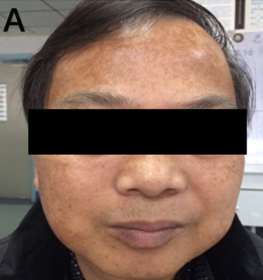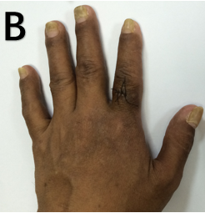
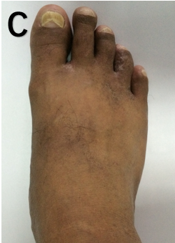
Figure 1 Physical examination findings included alopecia, brown macular pigmentation over the facial region, palms and soles, and onychodystrophy of the fingernails and toenails. A: Facial region; B: Palms; C: Soles.
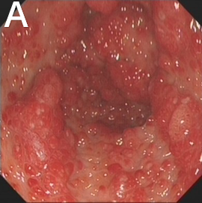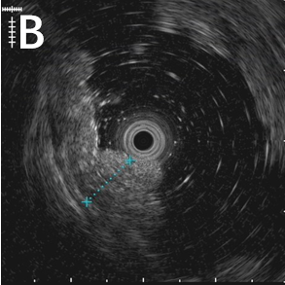
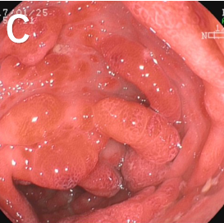
Figure 2 Gastroscopy. A: Gastroscopy revealed multiple polyps in the stomach; B: Endoscopic ultrasonography revealed diffuse thickening of the gastric mucosa of up to 8.5 mm in thickness; C: Colonoscopy revealed numerous polyps occupying the colonic and rectal mucosa.
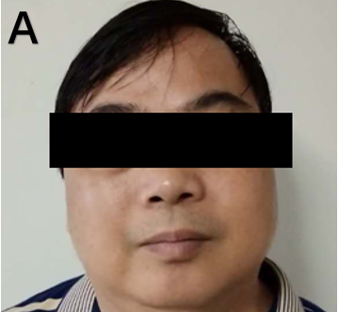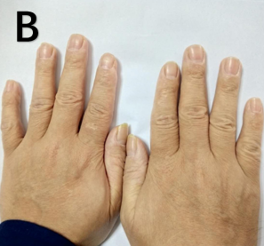
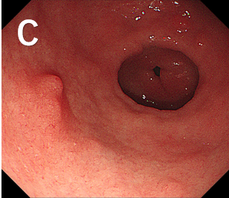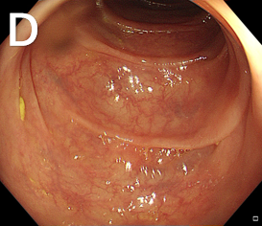
Figure 3 Examination after treatment. A: The patient showed great improvement in his skin pigmentation after 6-8 mo of steroid therapy; B: The patient showed great improvement in his nail dystrophy after 6-8 mo of steroid therapy; C and D: After 14 mo of treatment, gastroscopy revealed several polyps with a diameter of 3-4 mm in the gastric antrum (C), and colonoscopy revealed polyp regression (D).

Published by Baishideng Publishing Group Inc
7041 Koll Center Parkway, Suite 160, Pleasanton, CA 94566, USA
Telephone: +1-925-3991568
E-mail: bpgoffice@wjgnet.com
Help Desk: https://www.f6publishing.com/helpdesk
https://www.wjgnet.com

© 2021 Baishideng Publishing Group Inc. All rights reserved.

