Name of Journal: World Journal of Clinical Cases
Manuscript NO: 65337
Manuscript Type: CASE REPORT

Chorioamnionitis caused by Serratia marcescens in a healthcare worker: A case report

Park SY et al. Chorioamnionitis caused by S. marcescens

Sue Youn Park, Min Ji Kim, Sanghee Park, Nah Ihm Kim, Hyung Hoon Oh, Joungmin Kim

Sue Youn Park, Min Ji Kim, Sanghee Park, Joungmin Kim, Department of Anesthesiology and Pain Medicine, Chonnam National University Medical School, Gwangju 61469, South Korea

Nah Ihm Kim, Department of Pathology, Chonnam National University Medical School, Gwangju 61469, South Korea

Hyung Hoon Oh, Department of Internal Medicine, Chonnam National University Medical School, Gwangju 61469, South Korea

Author contributions: Park SY and Kim J wrote the manuscript; Kim MJ and Park S performed literature analysis; Kim NI has edited photos and figures; Oh HH revised the manuscript for important intellectual content; and all authors approved the final version of the manuscript to be submitted.

Supported by a grant of Chonnam National University Hwasun Hospital Research Institute of Clinical Medicine, No. HCRI19012.

Corresponding author: Joungmin Kim, MD, Associate Professor, Department of Anesthesiology and Pain Medicine, Chonnam National University Medical School, 42 Jebong-ro Dong-gu, Gwangju 61469, South Korea. tca77@hanmail.net

Received: March 5, 2021
Revised: April 7, 2021
Accepted: May 20, 2021
Published online: July 16, 2021

Abstract
BACKGROUND
Healthcare workers (HCWs) are at an increased risk for exposure to infections. Serratia marcescens (S. marcescens) is a gram-negative, opportunistic and nosocomial pathogen belonging to the Enterobacterieae family. A few case reports have been published of chorioamnionitis caused by S. marcescens infection. Immunological changes during pregnancy can also affect the risk of infection. However, few studies have examined hospital-acquired bacterial infection in pregnant HCWs.

CASE SUMMARY
A 33-year-old woman, a resident in anesthesiology, was admitted at 14 wk gestation for fever with chills. She had no medical history other than contact dermatitis of both hands that started from the beginning of the trainee. There was no obvious infection focus and no bacterial growth in blood cultures. She was discharged after 1 wk of empirical antibiotic treatment. At three weeks before the fever started, she had a blister on the site of contact dermatitis on both hands, she applied antibiotic ointment for three days and the blisters had healed. At 19 wk gestation, she had a high fever and was readmitted. Physical examination and image studies were nonspecific and the patient had no other symptoms. S. marcescens grew in blood cultures at 19 wk gestation. Treatment with intravenous antibiotics was started. However, she suffered a miscarriage at 22^{4/7} wk gestation. Pathologically, the amniotic membrane showed chorioamnionitis with a focal infarct. Subsequently, a placenta tissue culture grew S. marcescens.

CONCLUSION
HCWs can be exposed to pathogens that can cause opportunistic infections such as S. marcescens. Pregnancy affects the immune system, making it susceptible to opportunistic infections. Therefore, pregnant HCWs may require more preventive measures, including hand hygiene and avoid risk factors (ex. wrapping the skin).

Key Words: Serratia marcessens; Chorioamnionitis; Healthcare workers; Pregnancy; Case report

©The Author(s) 2021. Published by Baishideng Publishing Group Inc. All rights reserved.

Citation: Park SY, Kim MJ, Park S, Kim NI, Oh HH, Kim J. Chorioamnionitis caused by Serratia marcescens in a healthcare worker: A case report. World J Clin Cases 2021; 9(20): 5689-5694
URL: https://www.wjgnet.com/2307-8960/full/v9/i20/5689.htm
DOI: https://dx.doi.org/10.12998/wjcc.v9.i20.5689

Core Tip: In this case, a 33-year-old female patient suffered a miscarriage due to chorioamnionitis caused by Serratia marcescens infection. Although she performed aseptic procedures and hand hygiene during medical practice, it is suspected that the cause of the infection was the weakening of the skin line due to contact dermatitis. In addition, it is thought that changes in the immune system caused by pregnancy may also have an effect. Therefore, it is recommended that pregnant healthcare workers perform more meticulous hand hygiene and avoid infection risk factors (ex. wrapping the skin).
INTRODUCTION
Serratia marcescens (S. marcescens) is a Gram-negative anaerobic bacillus in the Enterobacteriaceae family. It is not a normal member of the human bacterial flora, although it can colonize the gastrointestinal, urinary, and respiratory tracts. The incidence of nosocomial infection of S. marcescens is 1%-2%, but it shows high mortality rate of 37%^{[1,2]}. There have been a few case reports of Serratia bacteremia associated with pregnant women, four of which resulted in miscarriage^{[3-8]}. Hand-to-hand transmissions by HCWs is the major mode of spread^{[9]}.
Healthcare workers (HCWs) are at increased risk for exposure to infections, including blood-borne, air-borne, and contact-transmitted infection. Blood-borne infections include human immunodeficiency virus and hepatitis B and C viruses^{[10]}. Air-borne transmitted infectious diseases include tuberculosis and viruses contained in operating room smoke^{[11]}. There are some reports of methicillin-resistant Staphylococcus aureus (MRSA) carriage and infection in HCWs, which is spread by contact^{[12]}.
Pregnant women tend to be more severely affected by infections due to the immunological changes caused by altered hormone levels^{[13]}. Therefore, pregnant HCWs may need more attention and care for infection prevention. However, hospital-acquired bacterial infection in pregnant HCWs has been studied less often. Here, we report a pregnant HCW with S. marcescens bacteremia that resulted in a spontaneous abortion.

CASE PRESENTATION
Chief complaints
A 33-year-old woman was admitted at 19 wk gestation for a fever with chills.

History of present illness
She was hospitalized at 14 wk of pregnancy with fever and dry cough. At that time, after receiving empirical antibiotic treatment (intravenous ceftriaxone 2 g and azithromycin 500 mg orally) for 1 wk, it improved. After discharge, she had an intermittent mild fever (37.5-38.0 °C) for 3 wk.

History of past illness
She had contact dermatitis of both hands that started from the beginning of trainee. She applied steroid ointment intermittently to control the symptoms of contact dermatitis. At three weeks before the 1st fever event (gestation 11 wk) had a blister on the site of contact dermatitis on both hands, she applied antibiotic ointment for three days and the blisters had healed.

Personal and family history
She was an anesthesiology resident and worked in intensive care units at gestational periods. She rounded the patients and, if necessary, performed endotracheal intubation or central venous catheterization. Family history was unremarkable.

Physical examination
The physical examination was unremarkable and the patient did not complain abdominal pain or urinary symptoms. A vaginal examination showed no leaking amniotic fluid.

Laboratory examinations
Laboratory tests indicated mildly increased white blood cell count, high C-reactive protein (CRP) (15.8 mg/dL; normal 0-0.3 mg/dL), and mildly elevated procalcitonin level (0.503 ng/mL; normal 0-0.5 ng/mL). Her thyroid, liver, and renal functions, coagulation profile, electrolytes, and lactate levels were normal. Polymerase chain reaction results of a vaginal discharge for sexually transmitted diseases were normal. Laboratory studies to rule out rheumatological diseases were all normal. After 2 d, the blood cultures grew S. marcescens.

Imaging examinations
Abdominal ultrasonography was nonspecific other than a 0.5 cm gallbladder polyp. The fetus and placenta appeared normal in obstetric ultrasonography. An additional abdominal and pelvic magnetic resonance imaging scan was also performed to find the cause of the fever, but it was also normal.

FINAL DIAGNOSIS
Fever was caused by S. marcescens cultured in the blood, and the site of infection was the chorionic tissue (later) found after abortion.

TREATMENT
Empirical cefepime 2 g intravenous (IV) was given every 8 h. After 2 d, the blood cultures grew S. marcescens. The antibiotic was changed to ceftriaxone 2 g IV daily as the bacteria were susceptible to ceftriaxone. On the 4th day of admission, she had a fever again, so the antibiotic was stepped up to cefepime. Figure 1 shows the timeline of the major clinical events.

OUTCOME AND FOLLOW-UP
Twenty-three days after admission, at 22^{4/7} wk gestation, she had a watery discharge and preterm premature rupture of the membrane (PPROM) was diagnosed as the vaginal discharge showed pH 8, pooling (+), Fern (+), and AmniSure (+). Cefepime 2 g IV every 8 h and clarithromycin 500 mg PO were started after taking blood cultures. Labor was induced and she delivered a 360 g dead male fetus. After 7 d of IV cefepime and 5 days of PO clarithromycin, the patient was afebrile and the leukocytosis and CRP level had normalized. She was discharged in good condition. The tissue culture from the placenta subsequently grew S. marcescens. Pathologically, the amniotic membrane showed chorioamnionitis with a focal infarct (Figure 2).

DISCUSSION
This present case reports healthy pregnant HCW developed an atypical reproductive system infection by S. marcescens, a Gram-negative bacillus that survives in environments such as drinking water pipes, hospital disinfectants, and medical instruments^{[14]}. It can also colonize the human gastrointestinal tract and skin for extended periods and is important, frequently found nosocomial pathogen. Many studies have traced S. marcescens outbreaks in hospitals to medical instruments^{[9,15-17]}. It is exogenously acquired, mostly via the hands of healthcare providers^{[9]}.
A few cases of S. marcescens infection during pregnancy have been reported^{[3,5-8]}. In four cases, the suspected routes of infection were chorionic-villus sampling^{[6]}, urinary tract infection due to a double ureter^{[6]}, the placement of a peripherally inserted central catheter^{[5]}, and prolonged PPROM^{[3]}. In another three cases, no route of infection was found. Our patient had no S. marcescens infection route other than skin route. Of the previous cases, S. marcescens infection during pregnancy has a poor prognosis, three had spontaneous abortions, one delivered a dead fetus, and three had live babies. Of the three cases that had live babies, one showed signs of chorioamnionitis^{[3]}, and two had placental abscesses on ultrasonography and continued the antibiotic treatment^{[4,5]}. In our patient, however, no infection focus was found until after the spontaneous abortion, so deciding the duration of antibiotic treatment was difficult.
There have been many reviews of adverse pregnancy outcomes among HCWs, such as congenital anomalies, fetal death, and fertility disorders^{[18-20]}. Two reviews considered the relationships between adverse pregnancy outcomes and specific exposures, such as anesthetic gases, antineoplastic agents, sterilizing agents, and radiation. But neither assessed hospital-acquired bacterial infection in a pregnant HCW. March et al^{[21]} reported that 66.1% of HCWs in an Italian long-term care facility were colonized by multidrug-resistant bacteria. Liu et al^{[22]} reported that intensive care unit HCWs have a higher proportion of multidrug-resistant Gram-negative bacteria colonization than non-medical workers (41.87% vs 28.57%, respectively). Peters et al^{[23]} reviewed the occupational infection risk with multidrug-resistant organisms, such as MRSA, vancomycin-resistant Enterococcus, and Gram-negative bacteria, in HCWs, but the comparison of results was limited due to data heterogeneity.
The occurrence of this rare case is suspected to be due to the patient's underlying disease, career and work environment. Skin is essential to maintaining a normal immune state from pathogens. If this barrier breaks down, the normal flora can become pathogens^{[24]}. The patient was in a state of collapsed skin defenses due to contact dermatitis. She applied steroid ointment intermittently to control the symptoms of contact dermatitis. Pregnant women may be more severely affected by infection than non-pregnant women due to major changes in their immune systems^{[25}.] In addition, since the patient is an HCW, it is a situation in which a lot of exposure to S. marcescens. is possible, and it is an environment in which medicines can be easily prescribed. Although there is no evidence that the skin lesions that occurred before fever was caused by S. marcescens, there is a case report that appeared in the form of blisters during Serratia infection^{[26]}.

CONCLUSION
This case is important because even a healthy HCW may be vulnerable to infection due to the immune system changes that occur during pregnancy. HCWs should be aware and cautioned that there is a risk of opportunistic infections at work. Also, HCWs who are pregnant may require more preventive precautions, including hand hygiene, and avoid risk factors (ex. wrapping the skin).

REFERENCES
1 Schaberg DR, Highsmith AK, Wachsmuth IK. Resistance plasmid transfer by Serratia marcescens in urine. Antimicrob Agents Chemother 1977; 11: 449-450 [PMID: 324391 DOI: 10.1128/aac.11.3.449]
2 Engel HJ, Collignon PJ, Whiting PT, Kennedy KJ. Serratia sp. bacteremia in Canberra, Australia: a population-based study over 10 years. Eur J Clin Microbiol Infect Dis 2009; 28: 821-824 [PMID: 19194731 DOI: 10.1007/s10096-009-0707-7]
3 Erenberg M, Yagel Y, Press F, Weintraub AY. Chorioamnionitis caused by Serratia marcescens in a healthy pregnant woman with preterm premature rupture of membranes: A rare case report and review of the literature. Eur J Obstet Gynecol Reprod Biol 2017; 211: 227-230 [PMID: 28283205 DOI: 10.1016/j.ejogrb.2017.02.024]
4 Mak ASL, Tang THC, Lam KW, Kwok ALM, Cheuk W, Wu TC, Leung KY. Prenatal sonography of placental abscess and prolonged antibiotic treatment for Serratia marcescens bacteremia. Clin Case Rep 2018; 6: 537-540 [PMID: 29531736 DOI: 10.1002/ccr3.1406]
5 Meirowitz NB, Fleischer A, Powers M, Hippolyte F. Diagnosis of placental abscess in association with recurrent maternal bacteremia in a twin pregnancy. Obstet Gynecol 2006; 107: 463-466 [PMID: 16449150 DOI: 10.1097/01.AOG.0000165268.09352.ed]
6 Prosser BJ, Horton J. A rare case of serratia sepsis and spontaneous abortion. N Engl J Med 2003; 348: 668-669 [PMID: 12584385 DOI: 10.1056/NEJM200302133480723]
7 Shimizu S, Kojima H, Yoshida C, Suzukawa K, Mukai HY, Hasegawa Y, Hitomi S, Nagasawa T. Chorioamnionitis caused by Serratia marcescens in a non-immunocompromised host. J Clin Pathol 2003; 56: 871-872 [PMID: 14600137 DOI: 10.1136/jcp.56.11.871]
8 Vale-Fernandes E, Moucho M, Brandão O, Montenegro N. Late miscarriage caused by Serratia marcescens: a rare but dire disease in pregnancy. BMJ Case Rep 2015; 2015 [PMID: 26002674 DOI: 10.1136/bcr-2015-210586]
9 de Vries JJ, Baas WH, van der Ploeg K, Heesink A, Degener JE, Arends JP. Outbreak of Serratia marcescens colonization and infection traced to a healthcare worker with long-term carriage on the hands. Infect Control Hosp Epidemiol 2006; 27: 1153-1158 [PMID: 17080370 DOI: 10.1086/508818]
10 Beltrami EM, Williams IT, Shapiro CN, Chamberland ME. Risk and management of blood-borne infections in health care workers. Clin Microbiol Rev 2000; 13: 385-407 [PMID: 10885983 DOI: 10.1128/cmr.13.3.385-407.2000]
11 Gloster HM Jr, Roenigk RK. Risk of acquiring human papillomavirus from the plume produced by the carbon dioxide laser in the treatment of warts. J Am Acad Dermatol 1995; 32: 436-441 [PMID: 7868712 DOI: 10.1016/0190-9622(95)90065-9]
12 Albrich WC, Harbarth S. Health-care workers: source, vector, or victim of MRSA? Lancet Infect Dis 2008; 8: 289-301 [PMID: 18471774 DOI: 10.1016/S1473-3099(08)70097-5]
13 Kourtis AP, Read JS, Jamieson DJ. Pregnancy and infection. N Engl J Med 2014; 371: 1077 [PMID: 25207782 DOI: 10.1056/NEJMc1408436]
14 Hejazi A, Falkiner FR. Serratia marcescens. J Med Microbiol 1997; 46: 903-912 [PMID: 9368530 DOI: 10.1099/00222615-46-11-903]
15 Arslan U, Erayman I, Kirdar S, Yuksekkaya S, Cimen O, Tuncer I, Bozdogan B. Serratia marcescens sepsis outbreak in a neonatal intensive care unit. Pediatr Int 2010; 52: 208-212 [PMID: 19664012 DOI: 10.1111/j.1442-200X.2009.02934.x]
16 Cullen MM, Trail A, Robinson M, Keaney M, Chadwick PR. Serratia marcescens outbreak in a neonatal intensive care unit prompting review of decontamination of laryngoscopes. J Hosp Infect 2005; 59: 68-70 [PMID: 15571857 DOI: 10.1016/j.jhin.2004.08.003]
17 Sokalski SJ, Jewell MA, Asmus-Shillington AC, Mulcahy J, Segreti J. An outbreak of Serratia marcescens in 14 adult cardiac surgical patients associated with 12-lead electrocardiogram bulbs. Arch Intern Med 1992; 152: 841-844 [PMID: 1558444]
18 Park C, Kang MY, Kim D, Park J, Eom H, Kim EA. Adverse pregnancy outcomes in healthcare workers: a Korean nationwide population-based study. Int Arch Occup Environ Health 2017; 90: 501-506 [PMID: 28321491 DOI: 10.1007/s00420-017-1213-3]
19 Quansah R, Jaakkola JJ. Occupational exposures and adverse pregnancy outcomes among nurses: a systematic review and meta-analysis. J Womens Health (Larchmt) 2010; 19: 1851-1862 [PMID: 20809857 DOI: 10.1089/jwh.2009.1876]
20 Warembourg C, Cordier S, Garlantézec R. An update systematic review of fetal death, congenital anomalies, and fertility disorders among health care workers. Am J Ind Med 2017; 60: 578-590 [PMID: 28514021 DOI: 10.1002/ajim.22711]
21 March A, Aschbacher R, Sleghel F, Soelva G, Kaczor M, Migliavacca R, Piazza A, Mattioni Marchetti V, Pagani L, Scalzo K, Pasquetto V, Pagani E. Colonization of residents and staff of an Italian long-term care facility and an adjacent acute care hospital geriatric unit by multidrug-resistant bacteria. New Microbiol 2017; 40: 258-263 [PMID: 28994446]
22 Liu H, Fei CN, Liu J, Ji XY, Song J. [Investigation on the status of multidrug-resistant gram-negative bacteria induced by occupational exposure among medical staff in ICU]. Zhonghua Lao Dong Wei Sheng Zhi Ye Bing Za Zhi 2018; 36: 734-737 [PMID: 30541191 DOI: 10.3760/cma.j.issn.1001-9391.2018.10.003]
23 Peters C, Dulon M, Nienhaus A, Schablon A. Occupational Infection Risk with Multidrug-Resistant Organisms in Health Personnel-A Systematic Review. Int J Environ Res Public Health 2019; 16 [PMID: 31167449 DOI: 10.3390/ijerph16111983]
24 Abdallah F, Mijouin L, Pichon C. Skin Immune Landscape: Inside and Outside the Organism. Mediators Inflamm 2017; 2017: 5095293 [PMID: 29180836 DOI: 10.1155/2017/5095293]
25 Chai LY, Rauff M, Ong JS, Kee AC, Teo FS. Serratia septicaemia in pregnancy: further evidence of altered immune response to severe bacterial infection in pregnancy. J Infect 2011; 63: 480-481 [PMID: 21884726 DOI: 10.1016/j.jinf.2011.08.012]
26 Bahadir A, Erduran E. Serratia marcessens infection presenting with papillovesicular rash similar to varicella zoster infection: a case report. North Clin Istanb 2015; 2: 55-58 [PMID: 28058340 DOI: 10.14744/nci.2015.27928]

Footnotes
Informed consent statement: Informed written consent was obtained from the patient for publication of this report and any accompanying images.

Conflict-of-interest statement: The authors declare that they have no conflict of interest.

CARE Checklist (2016) statement: The authors have read the CARE Checklist (2016), and the manuscript was prepared and revised according to the CARE Checklist (2016).

Open-Access: This article is an open-access article that was selected by an in-house editor and fully peer-reviewed by external reviewers. It is distributed in accordance with the Creative Commons Attribution NonCommercial (CC BY-NC 4.0) license, which permits others to distribute, remix, adapt, build upon this work non-commercially, and license their derivative works on different terms, provided the original work is properly cited and the use is non-commercial. See: http://creativecommons.org/Licenses/by-nc/4.0/

Manuscript source: Unsolicited manuscript

Peer-review started: March 5, 2021
First decision: April 4, 2021
Article in press: May 20, 2021

Specialty type: Infectious diseases
Country/Territory of origin: South Korea
Peer-review report’s scientific quality classification
Grade A (Excellent): 0
Grade B (Very good): 0
Grade C (Good): C, C
Grade D (Fair): 0
Grade E (Poor): 0

P-Reviewer: Anzola L S-Editor: Wang JL L-Editor: A P-Editor: Zhang YL

Figure Legends

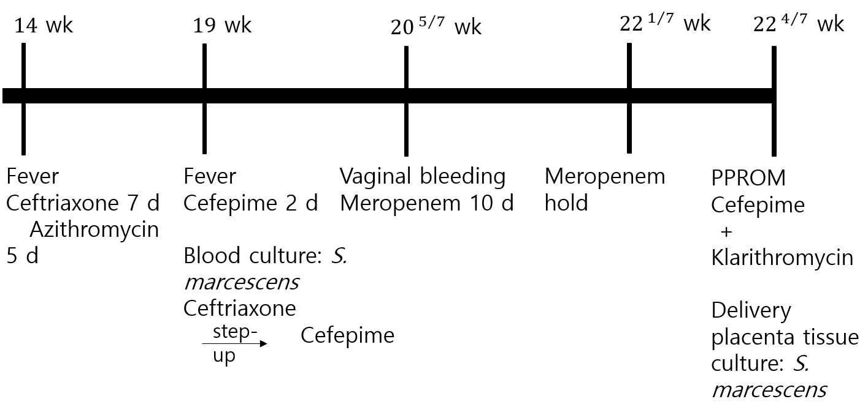
Figure 1 Timeline of the clinical events and antibiotic treatment. S. marcescens: Serratia marcescens.
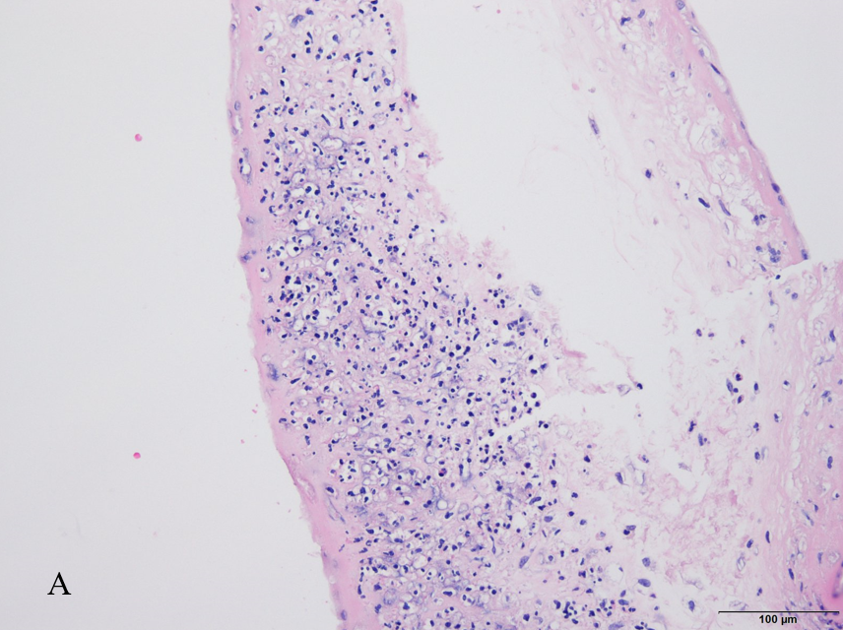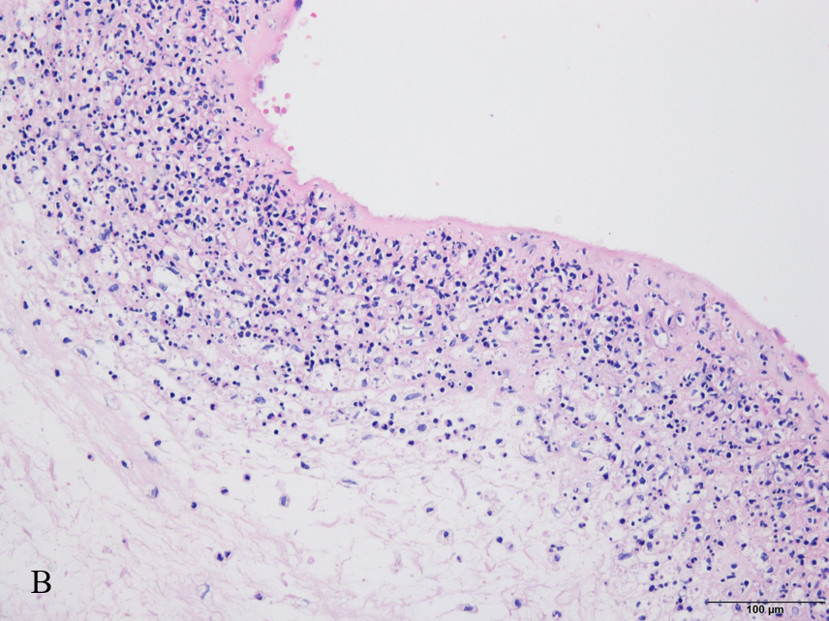
Figure 2 Massive infiltration of neutrophils in the amnion and chorion, suggestive of infectious chorioamnionitis. A: Amnion; B: Chorion.

Published by Baishideng Publishing Group Inc
7041 Koll Center Parkway, Suite 160, Pleasanton, CA 94566, USA
Telephone: +1-925-3991568
E-mail: bpgoffice@wjgnet.com
Help Desk: https://www.f6publishing.com/helpdesk
https://www.wjgnet.com

© 2021 Baishideng Publishing Group Inc. All rights reserved.

