Name of Journal: World Journal of Clinical Cases
Manuscript No: 39880
Manuscript Type: CASE REPORT

Unusual complication in patient with Gardner’s syndrome: Coexistence of triple gastrointestinal perforation and lower gastrointestinal bleeding

Akbulut S et al. Management of complicated Gardner’s syndrome

Sami Akbulut, Cemalettin Koc, Abuzer Dirican

Sami Akbulut, Cemalettin Koc, Abuzer Dirican, Department of Surgery and Liver Transplant Institute, Inonu University Faculty of Medicine, Malatya 44280, Turkey

ORCID number: Sami Akbulut (0000-0002-6864-7711); Cemalettin Koc (0000-0002-5676-6772); Abuzer Dirican (0000-0002-8647-3268).

Author contributions: Akbulut S designed the report; Akbulut S and Dirican A performed surgical procedure; Akbulut S and Koc C collected the patient’s clinical data; Akbulut S and and Koc C analyzed the data and wrote the paper.

Informed consent statement: Written informed consent was obtained from the patient for publication of this case report and accompanying images.

Conflict-of-interest statement: The author declares no potential conflict of interest

CARE Checklist (2013) statement: The authors have read the guidelines of the CARE Checklist (2013) and the manuscript adheres to CARE Checklist guidelines.

Open-Access: This article is an open-access article which was selected by an in-house editor and fully peer-reviewed by external reviewers. It is distributed in accordance with the Creative Commons Attribution Non Commercial (CC BY-NC 4.0) license, which permits others to distribute, remix, adapt, build upon this work non-commercially, and license their derivative works on different terms, provided the original work is properly cited and the use is non-commercial. See: http://creativecommons.org/licenses/by-nc/4.0/

Manuscript source: Invited manuscript

Correspondence to: Sami Akbulut, MD, Associate Professor, Department of Surgery and Liver Transplant Institute, Inonu University Faculty of Medicine, Elazig Yolu 10. Km, Malatya 44280, Turkey. sami.akbulut@inonu.edu.tr
Telephone: +90-422-3410660
Fax: +90-422-3410036

Received: May 18, 2018
Peer-review started: May 18, 2018
First decision: June 14, 2018
Revised: June 19, 2018
Accepted: June 28, 2018
Article in press:
Published online:

Abstract
Gardner’s syndrome (GS) is a rare syndrome with autosomal dominant inherited, which is characterized by multiple intestinal polyps, dental anomalies, desmoid tumors, and multiple soft tissue tumors. All gastrointestinal symptoms seen in GS are associated with the underlying familial adenomatosis polyposis and abdominal desmoid tumors, with the most common symptoms being anemia, lower gastrointestinal bleeding, abdominal pain, diarrhea, obstruction, a mucous defecation. To our best knowledge, no case of GS presented with gastrointestinal perforation and bleeding has ever been reported in the English language medical literature. A 37-year-old male who had been diagnosed with GS five years earlier was referred to our clinic for lower gastrointestinal bleeding. Despite the absence of a bleeding focus on conventional angiography, the patient was operated with laparotomy due to the persistence of signs and symptoms of mild peritonitis. On laparotomy, the patient was noted to have areas of perforation in duodenum, splenic flexura, and mid rectum. Third and fourth part of the duodenum, proximal 15-cm segment of jejunum, a 10-cm segment of terminal ileum, whole colon, and upper and middle rectum were resected, and duodeno-jejunal side-to side anastomosis and terminal ileostomy was performed. The histopathological analysis of the large mass measuring 30 cm × 20 cm was reported as a desmoid tumor; the pathological examination of the tumor foci detected in colonic specimen revealed poorly differentiated adenosquamous carcinoma.

Key words: Gardner’s syndrome; Complications; Gastrointestinal perforation; Gastrointestinal bleeding; Adenosquamous carcinoma

© The Author(s) 2018. Published by Baishideng Publishing Group Inc. All rights reserved.

Core tip: Gardner’s syndrome (GS) is a rare syndrome with autosomal dominant inherited, which is characterized by multiple intestinal polyps, dental anomalies, desmoid tumors, and multiple soft tissue tumors. All gastrointestinal symptoms seen in GS are associated with the underlying familial adenomatosis polyposis and abdominal desmoid tumors, with the most common symptoms being anemia, lower gastrointestinal bleeding, abdominal pain, diarrhea, obstruction, a mucous defecation. To our best knowledge, no case of GS presented with gastrointestinal perforation and bleeding has ever been reported in the English language medical literature. Herein, we aimed to report a complicated GS case that we managed for multiple intestinal perforation and massive gastrointestinal bleeding.

Akbulut S, Koc C, Dirican A. Unusual complication in patient with Gardner’s syndrome: Coexistence of triple gastrointestinal perforation and lower gastrointestinal bleeding. World J Clin Cases 2018; In press

INTRODUCTION
Gardner’s syndrome (GS) is a rare, autosomal dominant disorder characterized by gastrointestinal (colonic polyps, gastric polyps, duodenal polyps, desmoid tumor) and extragastrointestinal manifestations (osteomas, dental abnormality, epidermal cysts, fibromas, lipomas, pilomatricomas, congenital hypertrophy of retinal pigment epithelium, adrenal adenomas, nasal angiofibromas)^{[1,2]}. It was first considered as a variant of familial adenomatosis polyps (FAP); however, detection of adenomatous polyposis coli (APC) gene mutations in families with GS as well as extracolonic manifestations of GS in patients with FAP have shown that GS and FAP are in fact not very distinct entities from each other. Gastrointestinal symptoms seen in GS are usually closely related to the underlying FAP and abdominal desmoid tumors. The most common gastrointestinal symptoms are nonspecific abdominal pain, weight loss, palpable abdominal mass, diarrhea, obstruction, mucous defecation, and rarely, lower gastrointestinal bleeding^{[1-3]}. To our knowledge, no GS case presenting with gastrointestinal perforation and massive lower gastrointestinal bleeding has ever been reported in the English language medical literature. In this study we aimed to report a complicated GS case that we managed for multiple intestinal perforation and massive gastrointestinal bleeding.

CASE REPORT
A 37-year-old man (BMI = 19 kg/m²) who had been diagnosed with GS five years earlier was referred to our center with lower gastrointestinal bleeding. The patient’s male sibling died of colonic cancer but we had no information whether he also had GS. Having been transfused 12 units of whole blood suspension before being referred to our center, the patient had a final hemoglobin level of 8 g/dL, creatinine value of 2.9 mg/dL, albumin level of 2.1 g/dL and a total bilirubin level of 6.3 mg/dL. An endoscopic examination had failed to detect any abnormality except for duodenal polyposis. Colonoscopy was attempted, but no higher than rectosigmoid region was reached due to bleeding. On physical examination the patient was noted to have a mass with a size of 30 cm × 20 cm that originated from the right flank region and was partially fixed to the abdominal wall. On abdominal, thoracic wall, and axilla there were multiple lesions consistent with lipomas with a size range of 3 to 7 cm (Figures 1-4). There was a mass lesion compatible with an osteoma in the left mandible (Figure 5). Conventional celiac and mesenteric angiographies performed to detect the hemorrhagic focus showed no extravasation indicative of bleeding. The patient’s hemodynamic and biochemical parameters improved but as he had persistent signs of mild periotinits, a decision was made to proceed with surgery. Upon the request of the patient, first the mass lesions on the abdominal and thoracic walls were excised. Then, a midline incision was performed and approximately 500 cc seropurulent fluid was drained. On exploration there were areas of perforation at the fourth part of duodenum, splenic flexura of the colon, and middle part of the rectum. The perforations in the splenic flexura and middle part of the rectum were consistent with tumor perforation. Firstly, a resection includes the proximal 15-cm section of the jejunum, the third and fourth parts of the duodenum. Then, a side-to-side anastomosis was performed between proximal jejunum and the second part of the duodenum. There existed polypoid lesions in the mucosa of both anastomosed small intestinal segments. A tube was inserted from distal jejunum to the proximal part of the anastomosis in order to protect the jejuno-duodenal anastomosis. After carrying out a total abdominal colectomy including 10-cm distal ileum, whole colon, and upper/middle part of the rectum, the distal rectal stump was closed and an end ileostomy was created. Additionally, multiple masses consistent with metastases were detected in both lobes of the liver. The patient developed postoperative pneumothorax and a chest tube was inserted. Then, he developed severe lung infection at intensive care unit follow-up, and the attempts to extubate him failed. Therefore, a tracheostomy was opened. Despite having no gastrointestinal problem, the patient died due to pulmonary complications. The results of histopathological examination were as follows: Three foci of poorly differentiated adenosquamous carcinoma were present in the duodenal serosa, the largest of which was 10 mm in diameter. These cancer foci were considered to have developed secondarily to diffuse lymphovascular invasion of the tumor in the splenic flexura. There were a total of 260 polypoid lesions in the duodenal mucosa, the largest of which measured 10 mm in diameter. Two foci of poorly differentiated adenosquamous carcinoma (PanCK: strongly positive, CK5/6: 40% positive, Ki 67: 80% positive, CK20: negative, p53: negative, Synaptophysin: negative, CgA: negative) were present in the colon, the diameters of which were 80 mm and 30 mm. A total of 172 polypoid lesions were detected in the colonic and rectal mucosae, the largest of which had a diameter of 10 mm. Tumors were detected in both areas of colonic perforation. A tumor was detected in 5 of 40 lymph nodes in the colon specimen. The small lesions excised from the abdominal wall were reported as epidermoid cysts. The pathology examination of the large mass excised from the right flank region was revealed a desmoid tumor (S100: negative, Desmin: focal positive, α-SMA: positive, CD117: negative, DOG-1: negative, Ki67: 4%-5% positive).

DISCUSSION
In 1951, Gardner reported a significant association between colonic polyps with high malignancy potential and some bone and soft tissue tumors^{[1]}. In 1952, Gardner and his colleagues reported that the co-occurrence of multiple bone tumors and colonic polyps is an autosomal dominant condition^{[1]}. Gardner and his colleagues, in 1953, defined this syndrome characterized by hereditary colonic polyposis associated with bone and soft tissue tumors as GS^{[1]}. The gastrointestinal components of GS are colorectal polyps, gastric polyps, small bowel polyps, and mesenteric desmoid tumors. The extragastrointestinal components of GS include osteomas, dental anomalies (unerupted teeth, supernumerary teeth, dentigerous cysts, and odontomas), skin and subcutaneous lesions (epidermal cysts, fibromas, lipomas, pilomatricomas), desmoid tumors of abdominal wall, congenital hypertrophy of the retinal pigment epithelium, adrenal adenomas, and nasal angiofibromas. The incidence of cancers affecting extracolonic sites such as duodenum, periampullary region, thyroid, pancreas, stomach, central nervous system, liver, small bowel distal to the duodenum, and adrenal gland is increased one or several folds compared to the general population.
In 80% of persons with GS a hereditary mutation is found in the APC gene (5q21-5q22), a tumor suppressor gene located in the 21st and 22nd loci of the long arm of the fifth chromosome^{[1,2]}. Twenty percent of GS cases occur as a result of sporadic mutations in the APC gene but without a family history. To date, around 1400 mutations have been detected in the APC gene^{[1]}. Hence, the diversity of both gastrointestinal and extragastrointestinal manifestations of GS results from variability of penetration of the mutation in the APC gene. The number of colonic polyps depends on the localization of the mutation in the APC gene. Mutations occurring in the center of the APC gene result in a about 5000 colonic polyps. When mutations affect the proximal or distal parts of the gene, however, there occur approximately 1000 polyps in the colon. When mutations are found in the extreme ends of the APC gene, on the other hand, about 100 polyps develop, which is defined as attenuated FAP.
While the GS and FAP’s incidence range between 0.62 and 2.38 per million persons, the prevalence ranges between 0.88 and 46.5 per million persons^{[4-6]}. GS is seen equally in both sexes. The symptoms mostly appear in the second decade^{[1]}. Bone and soft tissue tumors usually appear 10 years earlier than the colonic polyps^{[1]}. Polyps start to appear with puberty but GS is diagnosed in the third decade of life in the majority of affected persons^{[1]}. In all untreated persons with GS malignant transformation develops in the fourth decade of life^{[1]}.
The gold standard for the diagnosis of GS and FAP is showing the APC gene mutation^{[1]}. This test is also very effective in showing gene mutations in the relatives of patients with GS^{[1]}. However, detection of multiple polyps in colonoscopy or showing bone and soft tissue tumors in physical examination, without making genetic diagnostic tests, is also sufficient for diagnosis^{[1]}. The differential diagnosis of GS includes Peutz–Jeghers syndrome, Juvenile polyposis, multiple hamartoma syndrome, Basal-cell nevus syndrome and Cronkite-Canada syndrome^{[2]}. In all of these syndromes, there are gastrointestinal polypoid lesions exist in varying rates. However, these syndromes importantly lack extraintestinal signs such as osteomas, epidermal inclusion cyst, and multiple impacted permanent teeth^{[2]}.
We are of the opinion that the case presented here would contribute to the literature, several aspects. Firstly, colorectal cancer shows an aggressive behavior. Despite being just under 40 years, the patient suffered a cancer as aggressive as causing multiple perforations, duodenal invasion, and liver metastases. To our opinion, the role of squamous differentiation is great in showing such an aggressive behavior. Adenosquamous cancers constitute 0.025% to 0.2% of all colorectal cancers although the corresponding rate of FAP is quite low^{[7,8]}. The rates of both local and distant metastasis are fairly higher for colorectal adenosquamous cancers than adenocancers. As one can extrapolate from the case presented here, colorectal adenosquamous cancers are highly aggressive cancers^{[7,8]}. To the best of our knowledge, no study in the literature has ever reported the development of colorectal adenosquamous cancer in cases of GS. This is because all polyps developing in FAP and GS are adenomatous polyps and tumors developing from these are adenocarcinoma. The second is the GS’s mode of presentation. Gastrointestinal signs and symptoms of GS are almost always related to the underlying FAP and desmoid tumors. Hence, the most common symptoms are anemia, abdominal pain intestinal obstruction, and hemorrhage. To our best knowledge, no case of GS presenting with massive lower gastrointetsinal bleeding and multiple intestinal perforations has been reported. In the present case we consider that the bleeding developed secondary to perforations. Detection of abundant blood in the perirectal pouch where the perforation opens supports our theory.
In conclusion, although GS is a rare condition, it should be taken seriously as it may cause colorectal cancers until the age of 40. Therefore, close follow-up of patients and performing prophylactic surgery at early stage are the most appropriate approaches. Patients diagnosed with upper gastrointestinal polyps should be closely followed with endoscopy. The case presented here clearly demonstrates that serious life-threatening complications like tumor perforation and massive bleeding may develop in neglected GS cases.

ARTICLE HIGHLIGHTS
Case characteristics
A 37-year-old cachectic male patient was referred to our center with lower gastrointestinal bleeding.

Clinical diagnosis
Gardner’s syndrome (GS), lower gastrointestinal bleeding due to gastrointestinal polyposis.

Differential diagnosis
Bleeding due to colorectal cancer, bleeding due to colonic polyposis.

Laboratory diagnosis
Hemoglobin: 8 g/dL, creatinine: 2.9 mg/dL, albumin: 2.1 g/dL, total bilirubin: 6.3 mg/dL.

Imaging diagnosis
Conventional celiac and mesenteric angiographies performed to detect the hemorrhagic focus showed no extravasation indicative of bleeding.

Pathological diagnosis
Poorly differentiated adenosquamous carcinoma of the colon + colorectal polyposis + duodenal polyposis + desmoid tumor.

Treatment
Resection of the distal duodenum and proximal jejunum + latero-lateral duodenojejunal anastomosis + total abdominal colectomy with end ileostomy+distal rectal stump closure + resection of the desmoid tumor like lesions.

Related reports
To our best knowledge, no case of GS presented with gastrointestinal perforation and bleeding has ever been reported in the English language medical literature.

Experiences and lessons
Although GS is a rare condition, it should be taken seriously as it may cause colorectal cancers until the age of 40. Therefore, close follow-up of patients and performing prophylactic surgery at early stage are the most appropriate approaches. Patients diagnosed with upper gastrointestinal polyps should be closely followed with endoscopy. The case presented here clearly demonstrates that serious life-threatening complications like tumor perforation and massive bleeding may develop in neglected GS cases.

REFERENCES
1 Fotiadis C, Tsekouras DK, Antonakis P, Sfiniadakis J, Genetzakis M, Zografos GC. Gardner's syndrome: a case report and review of the literature. World J Gastroenterol 2005; 11: 5408-5411 [PMID: 16149159 DOI: 10.3748/wjg.v11.i34.5408]
2 Bhargava P, Guttal K, Khan S, Shekhawat C. Polyps of malignancy: Gardner's syndrome. J Indian Acad Oral Med Radiol 2016; 28: 470-473 [DOI: 10.4103/jiaomr.JIAOMR_19_16]
3 Agrawal D, Newaskar V, Shrivastava S, Nayak PA. External manifestations of Gardner's syndrome as the presenting clinical entity. BMJ Case Rep 2014; 2014: pii: bcr2013200293 [PMID: 25139912 DOI: 10.1136/bcr-2013-200293]
4 Varesco L. Familial adenomatous polyposis: genetics and epidemiology. Tech Coloproctol 2004; 8 Suppl 2: s305-s308 [PMID: 15666112 DOI: 10.1007/s10151-004-0182-1]
5 Järvinen HJ. Epidemiology of familial adenomatous polyposis in Finland: impact of family screening on the colorectal cancer rate and survival. Gut 1992; 33: 357-360 [PMID: 1314763 DOI: 10.1136/gut.33.3.357]
6 Bülow S. Results of national registration of familial adenomatous polyposis. Gut 2003; 52: 742-746 [PMID: 12692062]
7 Kang DB, Oh JT, Jo HJ, Park WC. Primary adenosquamous carcinoma of the colon. J Korean Surg Soc 2011; 80 Suppl 1: S31-S35 [PMID: 22066079 DOI: 10.4174/jkss.2011.80.Suppl1.S31]
8 Sunkara T, Caughey ME, Makkar P, John F, Gaduputi V. Adenosquamous Carcinoma of the Colon. Case Rep Gastroenterol 2018; 11: 791-796 [PMID: 29606937 DOI: 10.1159/000485558]

P-Reviewer: Gurkan A, Zerem E S-Editor: Ji FF L-Editor: E-Editor:

Specialty type: Medicine, research and experimental
Country of origin: Turkey
Peer-review report classification
Grade A (Excellent): 0
Grade B (Very good): B
Grade C (Good): C
Grade D (Fair): 0
Grade E (Poor): 0

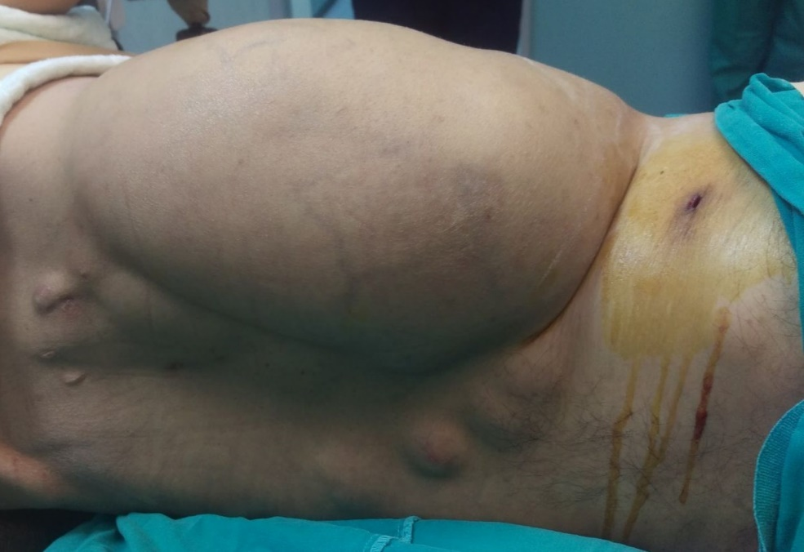
Figure 1 Posterior view of the giant desmoid tumor localized on the right flank area.

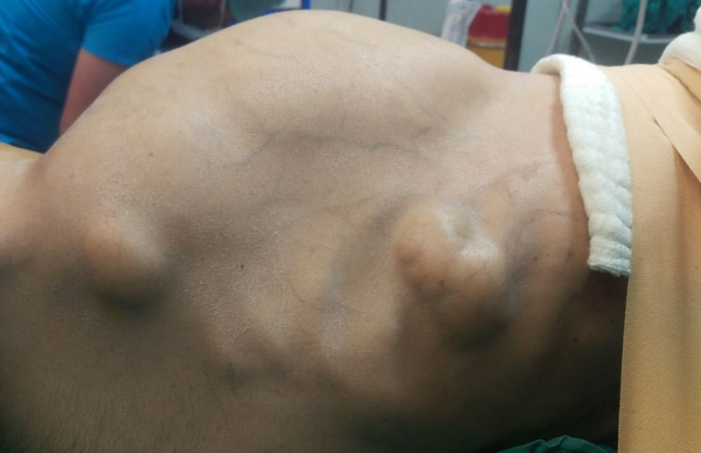
Figure 2 Anterior view of several epidermoid cysts together with giant desmoid tumor localized on the right flank area.

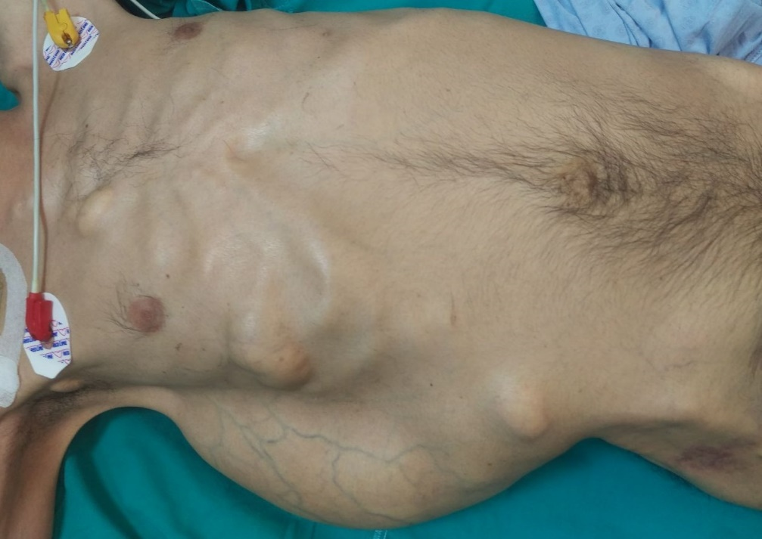
Figure 3 Top view of several epidermoid cysts together with giant desmoid tumor localized on the right flank area.

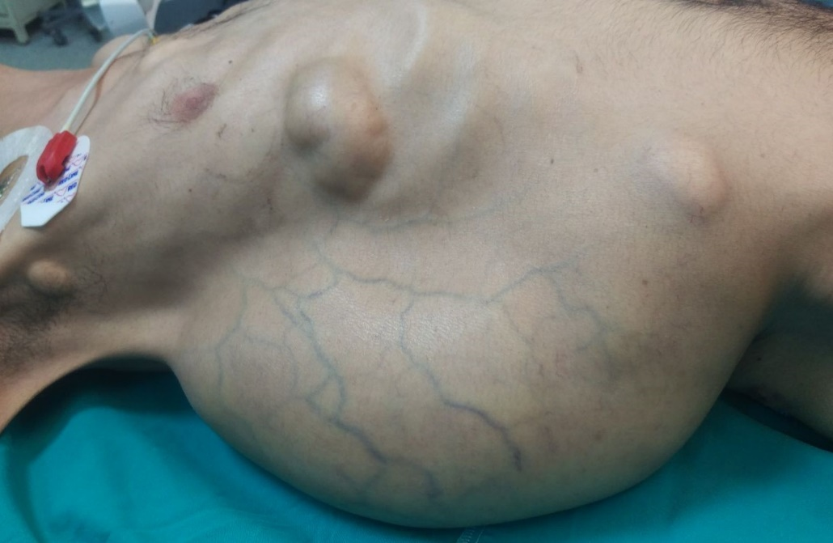

Figure 4 Lateral view of several epidermoid cysts together with giant desmoid tumor localized on the right flank area.

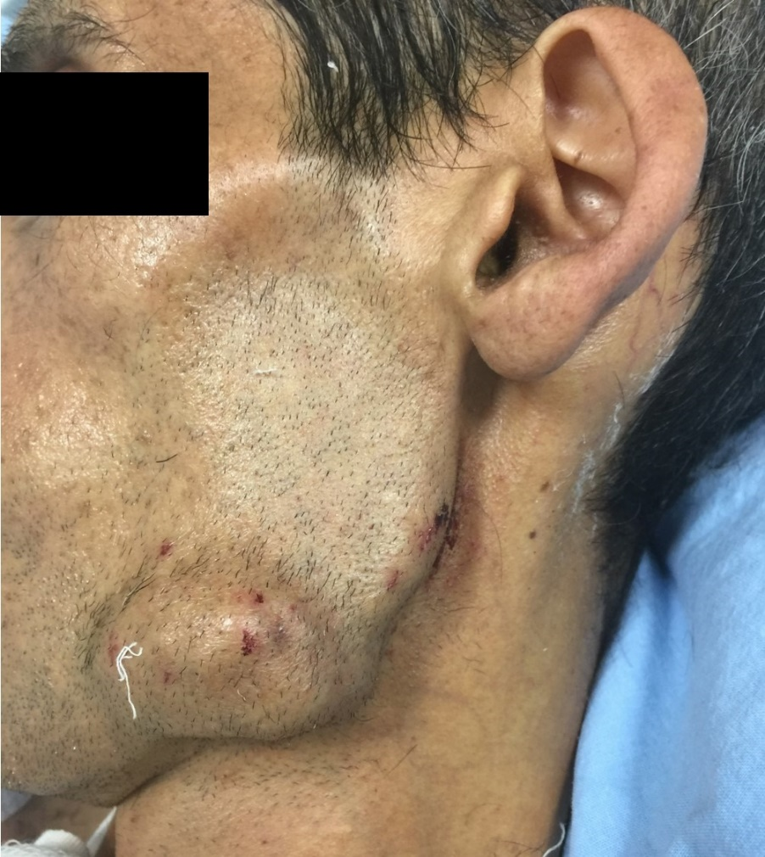
Figure 5 View of osteoma like lesion originating from left mandible.

