Name of Journal: World Journal of Gastrointestinal Oncology
Manuscript NO: 89093
Manuscript Type: ORIGINAL ARTICLE

Retrospective Study
Risk of cardiovascular death in patients with hepatocellular carcinoma based on the Fine-Gray model

Zhang YL et al. CVD death risk in HCC patients

Yu-Liang Zhang, Zi-Rong Liu, Zhi Liu, Yi Bai, Hao Chi, Da-Peng Chen, Ya-Min Zhang, Zi-Lin Cui

Yu-Liang Zhang, Hao Chi, Da-Peng Chen, First Central Clinical College, Tianjin Medical University, Tianjin 300070, China

Zi-Rong Liu, Zhi Liu, Yi Bai, Ya-Min Zhang, Zi-Lin Cui, Department of Hepatobiliary Surgery, Tianjin First Central Hospital, School of Medicine, Nankai University, Tianjin 300192, China

Author contributions: Cui ZL had full access to all of the data in the study and takes responsibility for the integrity of the data and the accuracy of the data analysis; Cui ZL and Zhang YL designed the research study; Zhang YL and Cui ZL performed the primary literature and data extraction; Zhang YL, Liu ZR, Liu Z, Bai Y, Chi H and Chen DP analyzed the data; Zhang YL and Cui ZL wrote the manuscript; Cui ZL, Bai Y and Zhang YM critically revised the manuscript for important intellectual content; and all authors read and approved the final version.

Supported by Health Technology Project of Tianjin, No. ZC20175.

Corresponding author: Zi-Lin Cui, PhD, Surgeon, Department of Hepatobiliary Surgery, Tianjin First Central Hospital, School of Medicine, Nankai University, No. 24 Fukang Road, Nankai District, Tianjin 300192, China. 13602184643@163.com

Received: October 20, 2023
Revised: December 15, 2023
Accepted: January 17, 2024
Published online:

Abstract
BACKGROUND
Hepatocellular carcinoma (HCC) is one of the most common types of cancers worldwide, ranking fifth among men and seventh among women, resulting in more than 7 million deaths annually. With the development of medical technology, the 5-year survival rate of HCC patients can be increased to 70%. However, HCC patients are often at increased risk of cardiovascular disease (CVD) death due to exposure to potentially cardiotoxic treatments compared with non-HCC patients. Moreover, CVD and cancer have become major disease burdens worldwide. Thus, further research is needed to lessen the risk of CVD death in HCC patient survivors.

AIM
To determine the independent risk factors for CVD death in HCC patients and predict cardiovascular mortality (CVM) in HCC patients.

METHODS
This study was conducted on the basis of the Surveillance, Epidemiology, and End Results database and included HCC patients with a diagnosis period from 2010 to 2015. The independent risk factors were identified using the Fine-Gray model. A nomograph was constructed to predict the CVM in HCC patients. The nomograph performance was measured using Harrell’s concordance index (C-index), calibration curve, receiver operating characteristic (ROC) curve, and area under the ROC curve (AUC) value. Moreover, the net benefit was estimated via decision curve analysis (DCA).

RESULTS
The study included 21545 HCC patients, of whom 619 died of CVD. Age (< 60) [1.981 (1.573-2.496), P < 0.001], marital status (married) [unmarried: 1.370 (1.076-1.745), P = 0.011], alpha fetoprotein (normal) [0.778 (0.640-0.946), P = 0.012], tumor size (≤ 2 cm) [(2, 5] cm: 1.420 (1.060-1.903), P = 0.019; > 5 cm: 2.090 (1.543-2.830), P < 0.001], surgery (no) [0.376 (0.297-0.476), P < 0.001], and chemotherapy(none/unknown) [0.578 (0.472-0.709), P < 0.001] were independent risk factors for CVD death in HCC patients. The discrimination and calibration of the nomograph were better. The C-index values for the training and validation sets were 0.736 and 0.665, respectively. The AUC values of the ROC curves at 2, 4, and 6 years were 0.702, 0.725, 0.740 in the training set and 0.697, 0.710, 0.744 in the validation set, respectively. The calibration curves showed that the predicted probabilities of the CVM prediction model in the training set vs the validation set were largely consistent with the actual probabilities. DCA demonstrated that the prediction model has a high net benefit.

CONCLUSION
Risk factors for CVD death in HCC patients were investigated for the first time. The nomograph served as an important reference tool for relevant clinical management decisions.

Key Words: Hepatocellular carcinoma; Cardiovascular disease deaths; Fine-Gray model; Risk factor; Nomograph; Predict

Zhang YL, Liu ZR, Liu Z, Bai Y, Chi H, Chen DP, Zhang YM, Cui ZL. Risk of cardiovascular death in patients with hepatocellular carcinoma based on the Fine-Gray model. World J Gastrointest Oncol 2024; In press

Core Tip: Hepatocellular carcinoma (HCC) is one of the most prevalent cancers worldwide. Studies have shown that HCC patients have chance to improve 5-year survival rate to 70%. How to avoid cardiovascular disease (CVD) death in HCC patients has become a problem worth exploring due to the course of treatment and the manifestation of certain paraneoplastic syndromes. In this study, we used Fine-Gray model to identify the independent risk factors for CVD death in HCC patients and constructed a predictive nomograph with high performance.

INTRODUCTION
Hepatocellular carcinoma (HCC) is one of the most common cancers worldwide, ranking fifth among men and seventh among women, resulting in more than 7 million deaths annually^{[1,2]}. Cardiovascular disease (CVD), which includes heart disease and stroke, is the most prevalent noncommunicable disease (NCD)^{[3]}. CVD is also the major cause of morbidity and mortality around the world, representing approximately one-third of all deaths^{[4]}. As the report goes, CVD and cancer are the major causes of death around the world, while being a major burden of disease in the world^{[3]}.
In the last decade, CVD has been recognized as one of the most frequent advanced comorbidities of cancer treatment^{[5]}. Advances in therapeutic approaches, especially the advent of immunotherapies, have revolutionized cancer treatment, allowing the lifespan of cancer patients to be extended, but at the same time leading to millions of cancer survivors currently at risk of developing CVD^{[6-8]}. In recent years, studies have found that the 5-year survival rate for HCC patients can increase to 70%, if an early diagnosis or some potential treatment is received^{[9]}. Cancer patients are at an elevated risk of CVD death from exposure to potentially cardiotoxic therapies compared with noncancer persons^{[10]}. Furthermore, in addition to cardiotoxicity from treatment, HCC patients often exhibit various paraneoplastic syndromes, including hypercholesterolemia, thrombocytosis, and hypercalcemia^{[11,12]}. All of this may lead to an increased risk of cardiovascular death in HCC patients^{[13-15]}. Therefore, how to prevent death from CVD in cancer survivors is a question worth exploring. Although several studies have addressed this field, they mainly focused on breast, colorectal, prostate, and other cancers^{[16-18]}, and studies focusing on CVD outcomes in HCC patients have not been reported.
Traditional survival analyses typically focus on only one outcome event, and ignoring observational endpoints in medical research is often not unique. This omission of observations for other endpoints is prone to bias and, in turn, produces an overestimation of the model’s predictive ability^{[19]}. Competing risks refer to events whose occurrence excludes the incidence of the major event of interest, and NCD deaths are a competing risk if the major event of interest is CVD death^{[20]}. This study chose to construct a prediction model via the Fine–Gray model with the aim of separating competing events from the outcome event of interest, eliminating the effect of competing events on the study.
The Surveillance, Epidemiology, and End Results (SEER) database is a publically accessible, federally funded cancer reporting system that represents the collaboration between the Centers for Disease Control and Prevention, the National Cancer Institute, and regional and state cancer registries and serves as the authoritative cancer statistics database in the United States^{[21]}. The SEER database contains data extracted from^{[18]} different geographic populations, representing rural, urban, and regional populations^{[22]}. The aim of this study was to investigate the independent influencing factors of CVD death in HCC patients and to construct a predictive model by analyzing HCC patients (age ≥ 18 years) diagnosed between 2010 and 2015 in. the SEER database to assess the probability of CVD death in HCC patients while effectively avoiding death due to CVD, improving prognosis, and improving the quality of life of HCC patients.

MATERIALS AND METHODS
Data sources and population selection
HCC patient information was extracted from the SEER database via SEER stat 8.4.0.1 with the liver site code C22.0, excluding Fibrolamellar histology (8171/3)^{[23]}. The inclusion criteria were as follows: (1) Patients aged 18 years or older and pathologically diagnosed with HCC; (2) diagnosed between 2010 and 2015; and (3) complete follow-up data. The patient information collected includes age, sex, race, marital status, year of diagnosis, pretreatment alpha fetoprotein (AFP) level, American Joint Committee on Cancer (AJCC) stage group, T stage, N stage, M stage, surgery, radiotherapy, and chemotherapy status, survival time, and cause of death. This study used the 7th edition of the AJCC staging. Data on patients with any of the abovementioned missing information were excluded (Supplementary Figure 1).

Outcome assessment
Death due to CVD was the primary observational endpoint. According to the SEER database, causes of death due to CVD include hypertension without heart disease, heart diseases, cerebrovascular diseases, aortic aneurysm and dissection, atherosclerosis, and other diseases of arteries, arterioles, and capillaries. Death from other causes was considered a competing event, and survival at the end of the study was considered a censored event.

Statistical analysis
In this study, categorical information was statistically described by number and percentage. The R software was used to divide all the study subjects into two parts in a ratio of 7:3, which were the training set and the validation set. The balance test between the two sets was performance using χ² test. In the training test, the Fine-Gray model was used for univariate and multivariate analyses. Multivariate analysis of statistically significant indicators in univariate analysis to explore risk factors for CVD death in HCC patients, which was measured as the adjusted hazard ratio (HR) and 95% confidence interval (CI), and a nomograph was established to predict the area under the receiver operating characteristic (ROC) curve (AUC) and the probability of survival at 2, 4, and 6 years in HCC patients. Harrell’s concordance C-index was calculated using bootstrap resampling (1000 replications) to measure the discriminatory ability of the nomograph. Consistency was gauged by calibration curves, while the predictive effect of the model was verified using the ROC curve and AUC^{[5,24]}. In addition, the net clinical benefit of the nomograph was estimated via decision curve analysis (DCA).
All statistical analyses for this study were conducted using SPSS 25.0 and the R software (version 4.2.2). The packages used included survival, caret, risk, regression, foreign, state, pROC, ggDCA, and pe. Furthermore, all tests were bilateral, and statistical significance was set at a P value of < 0.05.

RESULTS
Patient selections and baseline characteristics
In this study, 40401 HCC patients from the SEER database were included. Moreover, 45 patients under the age of 18; 39 patients with a T stage of T0; 5306 patients with missing or zero survival time; and 8966 patients with missing clinical data were excluded. Finally, 21545 HCC patients were included in the statistical analysis. Table 1 shows the detailed characteristics of the case arm, divorce, separation, or widowhood (DSW).

Balance test between the training and validation sets
As shown in Table 2, no significant differences in basic characteristics were observed between the HCC patients in the training and validation sets (P > 0.05). The results revealed that the distributions of each feature of the HCC patients in the training and validation sets were the same and the resulting nomogram prediction model in the training set could be validated in the validation set.

Univariate analysis of CVD-related death in HCC patients
As shown in Table 3, the HCC patients in the entire cohort were randomly assigned to the training set (N₁ = 15081) vs the validation set (N₂ = 6464) in a 7:3 ratio. The univariate analysis of the training set data revealed that age (HR, 2.054; 95%CI, 1.637-2.576), race [other (HR, 0.653; 95%CI, 0.493-0.864)], marital status [unmarried (HR, 1.322; 95%CI, 1.042-1.678); DSW (HR, 1.377; 95%CI, 1.099-1.726)], AFP (HR, 0.786; 95%CI, 0.647-0.954), AJCC stage group [grad Ⅱ (HR, 0.775; 95%CI, 0.611-0.982)], tumor size [(2, 5) cm (HR, 1.361; 95%CI, 1.018-1.821); > 5 cm (HR, 2.254; 95%CI, 1.667-3.048)], T stage [T2 (HR, 0.761; 95%CI, 0.602-0.960); T4 (HR, 1.806; 95%CI, 1.033-3.159)], surgery (HR, 0.447; 95%CI, 0.359-0.557), and chemotherapy (HR, 0.770; 95%CI, 0.637-0.931) were risk factors of CVD death in HCC patients.

Multifactorial analysis of CVD-related death in HCC patients
As shown in Figure 1, the variables that were statistically significant in the univariate analysis were included in the multivariate analysis. After adjustment of the model, the following independent risk factors for CVD death in HCC patients were finally obtained, including age (HR, 1.981; 95%CI, 1.573-2.496), marital status [unmarried (HR, 1.370; 95%CI, 1.076-1.745); DSW (HR, 1.240; 95%CI, 0.988-1.556)], AFP (HR, 0.778; 95%CI, 0.640-0.946), tumor size [(2, 5) cm (HR, 1.420; 95%CI, 1.060-1.903); > 5 cm (HR, 2.090; 95%CI, 1.543-2.830), surgery (HR, 0.376; 95%CI, 0.297-0.476), and chemotherapy (HR, 0.578; 95%CI, 0.472-0.709)].

Construction of the predictive model
Based on the results of the multifactorial analysis, the six variables of age, marital status, AFP, tumor size, surgery, and chemotherapy were incorporated into the prediction model of CVD death in HCC patients, and a nomograph was constructed to predict the probability of CVD death at 2, 4, and 6 years in HCC patients by summing the factor scores according to the individual condition of the patients (Figure 2).

Validation of the prediction model
This study used the data from both the training and validation sets to estimate the constructed nomogram model in terms of discrimination and calibration. The evaluation of the degree of discrimination was performed using the C-index obtained from bootstrap resampling, plotting the ROC curve, and calculating the AUC value. The C-index values were 0.736 and 0.665 in the training and development sets, respectively. Figure 3 shows the ROC curves of the nomogram model to predict the 2-, 4-, and 6-year cardiovascular mortalitys (CVMs) in HCC patients, with AUC values of 0.702, 0.725, and 0.740 in the training set and 0.697, 0.710, and 0.744 in the validation set. The AUC values were generally greater than 0.7, which indicated that the discrimination of the nomogram model was good. The calibration was evaluated by plotting the calibration curves of the training and development sets. If the predicted probability is close to the actual probability, the fitted line after the predicted probability that corresponds to the actual probability will be close to the reference line or overlap with the reference line. As shown in Figure 4, the predicted probabilities of CVMs at 2, 4, and 6 years were highly consistent with the actual probabilities, suggesting that the calibration of this nomogram model was good. Finally, in order to determine whether the nomogram prediction model was clinically useful, the net benefit of the model was evaluated using the DCA. As shown in Figure 5, in all plots, the nomogram showed a high net benefit.

DISCUSSION
Currently, CVD and cancer are the primary causes of premature death in 127 countries^{[25]}. Research has shown that the risk of CVD among cancer survivors is associated with common lifestyles or the toxicity of cancer treatment^{[26]}. For cancer patients, increasingly refined treatment options have greatly extended their survival. Therefore, cardiovascular care for cancer survivors should be emphasized to meet their clinical needs and improve their quality of life. This study is based on the SEER database and used the data of HCC patients with a diagnosis period from 2010 to 2015, which has a high clinical application value.
The factors associated with the CVD outcomes in HCC patients included age, marital status, pretreatment AFP level, tumor size, surgical status, and chemotherapy status. Consistent with the majority of most studies, we observed that the risk of CVD death in HCC patients increased with age^{[6,27,28]}. The American College of Cardiology revealed that advancing age can seriously affect its estimated 10-year CVD event risk^{[28]}. This may be associated with poorer physical fitness and longer acting time of lifestyle risk factors in elderly patients^{[29]}. Moreover, the present study revealed that unmarried people have a significantly increased risk of CVD death compared with married people, which is consistent with previous research results^{[30-32]}. It was revealed that marriage can have a beneficial effect on health by providing social support^{[33-35]}. The higher risk for unmarried individuals compared with married individuals may be due to a combination of lifestyle, body hormones, and stress. Numerous studies have also revealed that unmarried individuals have higher levels of loneliness, lower life satisfaction, and higher mortality from physical illness^{[36]}. Moreover, it is currently well documented that all different unmarried states are associated with an elevated risk of mortality^{[37]}. The findings of the present study revealed that the HCC patients with pretreatment AFP levels above normal had a reduced risk of CVD death. This may be due to the combined effects of interventions taken earlier when AFP positivity is present and the participants’ spontaneous health behavior changes that are effective in protecting their cardiovascular health, which in turn reaches the death-lowering effect of CVD. Studies assessing the link between AFP and CVD are limited, but an inverse association between AFP and CVD prevalence was proven in the study by Bracun et al^{[38]}, which is consistent with the results of the present study. Therefore, when the AFP levels are at normal levels in HCC patients, the importance of cardiovascular system care should be increased to avoid the occurrence of CVD death in HCC patients as much as possible. When categorizing tumor size, the risk of CVD death in HCC patients increases as tumor size increases. Recent studies have shown an inverse association between tumor size and CVD death^{[39,40]}. The findings of this analysis suggest that HCC patients undergoing surgery have a significantly lower risk of CVD death. This finding is in agreement with those of previous studies^{[5,17,41]}. It is worth noting that chemotherapy usually increases the risk of CVD because of the cardiotoxicity associated with this treatment modality^{[42]}. Transcatheter arterial chemoembolization (TACE) is the most common first-line treatment, while doxorubicin (DOX) is the most frequently used chemotherapy drug^{[43]}. Moreover, the clinical efficacy of DOX is often limited by its cardiotoxicity, nephrotoxicity and hepatotoxicity^{[44]}. Although TACE can improve the safety of the drug and minimize the incidence of adverse events, it can only reduce the toxicity of the drug, but not completely eliminate it. However, the results showed a lower risk of CVD death in HCC patients treated with chemotherapy, which is inconsistent with the cardiotoxic effects of chemotherapy. The reason for this result needs to be further investigated because of the lack of chemotherapy drug-related information in the SEER database. Several studies have suggested that this situation may result from the shorter survival time of this group of people who receive chemotherapy because of CVD death^{[5]}. In the supplemental analysis, we discussed the proportion of patients who received both chemotherapy and radiotherapy (Supplementary Table 1). We found that the higher the grade, the higher the proportion of patients receiving both radiotherapy and chemotherapy. Therefore, it should be considered that patients at higher grades who receive potentially cardiotoxic treatment are also more likely to die earlier due to their underlying HCC disease before they might develop a heart-specific disease in the long term^{[45]}. Another reason could be that differences in baseline conditions between the patients who receive chemotherapy and those who do not were observed, such as younger age at diagnosis, higher grading, and no CVD^{[45]}. Although the drugs that block the vascular endothelial growth factor signaling pathway have been shown to expand the treatment options for HCC, the use of such drugs also contributes to the increased risk of CVD death in HCC patients^{[46]}. However, the limitations of the data prohibit further discussion.
Most previous studies on the relationship between cancer and CVD death have used traditional survival analysis methods, such as Cox proportional-hazards regression models. The model does not well distinguish between the effects of competing events and often overestimates the risk of outcome events. In this study, we used the Fine-Gray model to exploit the independent hazard factors for CVD death in HCC patients and to construct a related predictive model. Based on the literature, the present study is the first to investigate the relationship between HCC and CVD death. The prediction model has high C-index and AUC values and high discrimination, and all variables are easily accessible, which provides convenience for clinical management. Based on the calibration curve, the model simultaneously has a high calibration level. Meanwhile, the DCA showed that the model can bring higher net benefits. The high degree of discrimination, calibration, and net benefit provided a solid foundation for the application of this prediction model.
The strengths of this study are as follows: (1) Adequate sample size; (2) less missing information, and (3) its emphasis on the association between HCC and CVD. However, this study has several limitations. First, this study has a retrospective design, which will inevitably produce bias. Second, the database does not include baseline information (e.g., body mass index, diabetes, and hypertension) or other factors associated with CVD. Third, the absence of information on chemotherapy regimens and therapeutic drugs in the SEER database prevented further investigation of the relationship between chemotherapy and CVD death. Finally, more external data are needed to validate the predictive power of the model.

CONCLUSION
Overall, this is the first study to investigate the independent risk factors for CVD death in HCC patients using data from the SEER database and construct a relevant prediction model. With high discrimination, calibration, and net benefit, the model effectively assessed CVMs in HCC patients and was able to serve as an important reference tool for relevant clinical management decisions in HCC patients. However, based on the lack of external data validation, the model remains to be further verified by further research.

ARTICLE HIGHLIGHTS
Research background
Hepatocellular carcinoma (HCC) is one of the most common tumors today. It is known that patients with HCC will have a higher risk of cardiovascular disease (CVD) death compared to non-HCC patients.

Research motivation
CVD is recognized as one of the most common complications of cancer treatment. As medical technology continues to mature, studies have found that the 5-year survival rate for HCC patients can be increased to 70% with early diagnosis and some potential treatments. Just because there are some unique treatment modalities (e.g. Transcatheter arterial chemoembolization) for HCC patients that have some limitations on the potential cardiotoxicity of drugs, it does not mean that we can ignore the potential cardiovascular burden of HCC patients.

Research objectives
The aim of this study was to identify the independent risk factors for CVD death in HCC patients, and to further provide a reference tool for the relevant clinical management decisions of HCC patients by constructing a prediction model for CVD death in HCC patients.

Research methods
In this study, data related to adult HCC patients with diagnosis years 2010-2015 in the Surveillance, Epidemiology, and End Results database were collected. In order to better eliminate the influence of competing events on the study, we utilized the Fine-Gray model to carry out the analysis and constructed a predictive model.

Research results
The study included 21545 patients with HCC, of whom 619 died of CVD. Age, marital status, alpha fetoprotein, tumor size, surgery, and chemotherapy were independent risk factors for CVD death in HCC patients. The discrimination as well as the calibration of the nomograph was better. Decision curve analysis demonstrated that the prediction model has a high net benefit.

Research conclusions
This study focuses on the cardiovascular risk of HCC patients for the first time. Meanwhile, the independent risk factors for CVD deaths in HCC patients were explored for the first time based on the Fine-Gray model, and a prediction model was constructed, which will serve as a reminder for future clinical work.

Research perspectives
Focusing on the burden of CVD in HCC patients and further exploring the impact of different drugs and routes of administration on CVD death in HCC patients.

REFERENCES
1 Wang W, Wei C. Advances in the early diagnosis of hepatocellular carcinoma. Genes Dis 2020; 7: 308-319 [PMID: 32884985 DOI: 10.1016/j.gendis.2020.01.014]
2 Sharma SA, Kowgier M, Hansen BE, Brouwer WP, Maan R, Wong D, Shah H, Khalili K, Yim C, Heathcote EJ, Janssen HLA, Sherman M, Hirschfield GM, Feld JJ. Toronto HCC risk index: A validated scoring system to predict 10-year risk of HCC in patients with cirrhosis. J Hepatol 2017 [PMID: 28844936 DOI: 10.1016/j.jhep.2017.07.033]
3 Silveira EA, Kliemann N, Noll M, Sarrafzadegan N, de Oliveira C. Visceral obesity and incident cancer and cardiovascular disease: An integrative review of the epidemiological evidence. Obes Rev 2021; 22: e13088 [PMID: 32692447 DOI: 10.1111/obr.13088]
4 Damen JA, Hooft L, Schuit E, Debray TP, Collins GS, Tzoulaki I, Lassale CM, Siontis GC, Chiocchia V, Roberts C, Schlüssel MM, Gerry S, Black JA, Heus P, van der Schouw YT, Peelen LM, Moons KG. Prediction models for cardiovascular disease risk in the general population: systematic review. BMJ 2016; 353: i2416 [PMID: 27184143 DOI: 10.1136/bmj.i2416]
5 Zhang S, Wang Y, Zhang P, Ai L, Liu T. Cardiovascular Outcomes in the Patients With Colorectal Cancer: A Multi-Registry-Based Cohort Study of 197,699 Cases in the Real World. Front Cardiovasc Med 2022; 9: 851833 [PMID: 35783821 DOI: 10.3389/fcvm.2022.851833]
6 Koene RJ, Prizment AE, Blaes A, Konety SH. Shared Risk Factors in Cardiovascular Disease and Cancer. Circulation 2016; 133: 1104-1114 [PMID: 26976915 DOI: 10.1161/CIRCULATIONAHA.115.020406]
7 Poels K, van Leent MMT, Boutros C, Tissot H, Roy S, Meerwaldt AE, Toner YCA, Reiche ME, Kusters PJH, Malinova T, Huveneers S, Kaufman AE, Mani V, Fayad ZA, de Winther MPJ, Marabelle A, Mulder WJM, Robert C, Seijkens TTP, Lutgens E. Immune Checkpoint Inhibitor Therapy Aggravates T Cell-Driven Plaque Inflammation in Atherosclerosis. JACC CardioOncol 2020; 2: 599-610 [PMID: 34396271 DOI: 10.1016/j.jaccao.2020.08.007]
8 Morad G, Helmink BA, Sharma P, Wargo JA. Hallmarks of response, resistance, and toxicity to immune checkpoint blockade. Cell 2022; 185: 576 [PMID: 35120665 DOI: 10.1016/j.cell.2022.01.008]
9 Kim DY, Han KH. Epidemiology and surveillance of hepatocellular carcinoma. Liver Cancer 2012; 1: 2-14 [PMID: 24159567 DOI: 10.1159/000339016]
10 Padegimas A, Clasen S, Ky B. Cardioprotective strategies to prevent breast cancer therapy-induced cardiotoxicity. Trends Cardiovasc Med 2020; 30: 22-28 [PMID: 30745071 DOI: 10.1016/j.tcm.2019.01.006]
11 Hwang SJ, Luo JC, Li CP, Chu CW, Wu JC, Lai CR, Chiang JH, Chau GY, Lui WY, Lee CC, Chang FY, Lee SD. Thrombocytosis: a paraneoplastic syndrome in patients with hepatocellular carcinoma. World J Gastroenterol 2004; 10: 2472-2477 [PMID: 15300887 DOI: 10.3748/wjg.v10.i17.2472]
12 Sohda T, Iwata K, Kitamura Y, Suzuki N, Takeyama Y, Irie M, Anan A, Nakane H, Yoshikane M, Watanabe H, Sakisaka S. Reduced expression of low-density lipoprotein receptor in hepatocellular carcinoma with paraneoplastic hypercholesterolemia. J Gastroenterol Hepatol 2008; 23: e153-e156 [PMID: 17784865 DOI: 10.1111/j.1440-1746.2007.05115.x]
13 Trinder M, Francis GA, Brunham LR. Association of Monogenic vs Polygenic Hypercholesterolemia With Risk of Atherosclerotic Cardiovascular Disease. JAMA Cardiol 2020; 5: 390-399 [PMID: 32049305 DOI: 10.1001/jamacardio.2019.5954]
14 Yoshikawa M, Takase O, Tsujimura T, Sano E, Hayashi M, Takato T, Hishikawa K. Long-term effects of low calcium dialysates on the serum calcium levels during maintenance hemodialysis treatments: A systematic review and meta-analysis. Sci Rep 2018; 8: 5310 [PMID: 29593281 DOI: 10.1038/s41598-018-23658-y]
15 Xu M, Chen R, Liu L, Liu X, Hou J, Liao J, Zhang P, Huang J, Lu L, Chen L, Fan M, Chen X, Zhu X, Liu B, Hu P. Systemic immune-inflammation index and incident cardiovascular diseases among middle-aged and elderly Chinese adults: The Dongfeng-Tongji cohort study. Atherosclerosis 2021; 323: 20-29 [PMID: 33773161 DOI: 10.1016/j.atherosclerosis.2021.02.012]
16 Greenlee H, Iribarren C, Rana JS, Cheng R, Nguyen-Huynh M, Rillamas-Sun E, Shi Z, Laurent CA, Lee VS, Roh JM, Santiago-Torres M, Shen H, Hershman DL, Kushi LH, Neugebauer R, Kwan ML. Risk of Cardiovascular Disease in Women With and Without Breast Cancer: The Pathways Heart Study. J Clin Oncol 2022; 40: 1647-1658 [PMID: 35385342 DOI: 10.1200/JCO.21.01736]
17 Gaitanidis A, Spathakis M, Tsalikidis C, Alevizakos M, Tsaroucha A, Pitiakoudis M. Risk factors for cardiovascular mortality in patients with colorectal cancer: a population-based study. Int J Clin Oncol 2019; 24: 501-507 [PMID: 30604158 DOI: 10.1007/s10147-018-01382-x]
18 Forster RB, Engeland A, Kvåle R, Hjellvik V, Bjørge T. Association between medical androgen deprivation therapy and long-term cardiovascular disease and all-cause mortality in nonmetastatic prostate cancer. Int J Cancer 2022; 151: 1109-1119 [PMID: 35489025 DOI: 10.1002/ijc.34058]
19 Cooper H, Wells S, Mehta S. Are competing-risk models superior to standard Cox models for predicting cardiovascular risk in older adults? Analysis of a whole-of-country primary prevention cohort aged ≥65 years. Int J Epidemiol 2022; 51: 604-614 [PMID: 34109395 DOI: 10.1093/ije/dyab116]
20 Austin PC, Putter H, Lee DS, Steyerberg EW. Estimation of the Absolute Risk of Cardiovascular Disease and Other Events: Issues With the Use of Multiple Fine-Gray Subdistribution Hazard Models. Circ Cardiovasc Qual Outcomes 2022; 15: e008368 [PMID: 35098725 DOI: 10.1161/CIRCOUTCOMES.121.008368]
21 Doll KM, Rademaker A, Sosa JA. Practical Guide to Surgical Data Sets: Surveillance, Epidemiology, and End Results (SEER) Database. JAMA Surg 2018; 153: 588-589 [PMID: 29617544 DOI: 10.1001/jamasurg.2018.0501]
22 Liang W, He J, Shen Y, Shen J, He Q, Zhang J, Jiang G, Wang Q, Liu L, Gao S, Liu D, Wang Z, Zhu Z, Ng CS, Liu CC, Petersen RH, Rocco G, D'Amico T, Brunelli A, Chen H, Zhi X, Liu B, Yang Y, Chen W, Zhou Q, He J. Impact of Examined Lymph Node Count on Precise Staging and Long-Term Survival of Resected Non-Small-Cell Lung Cancer: A Population Study of the US SEER Database and a Chinese Multi-Institutional Registry. J Clin Oncol 2017; 35: 1162-1170 [PMID: 28029318 DOI: 10.1200/JCO.2016.67.5140]
23 Ding J, Wen Z. Survival improvement and prognosis for hepatocellular carcinoma: analysis of the SEER database. BMC Cancer 2021; 21: 1157 [PMID: 34715816 DOI: 10.1186/s12885-021-08904-3]
24 Deng Y, Zhang N, Hua W, Cheng S, Niu H, Chen X, Gu M, Cai C, Liu X, Huang H, Cai M, Zhang S. Nomogram predicting death and heart transplantation before appropriate ICD shock in dilated cardiomyopathy. ESC Heart Fail 2022; 9: 1269-1278 [PMID: 35064655 DOI: 10.1002/ehf2.13808]
25 Bray F, Laversanne M, Weiderpass E, Soerjomataram I. The ever-increasing importance of cancer as a leading cause of premature death worldwide. Cancer 2021; 127: 3029-3030 [PMID: 34086348 DOI: 10.1002/cncr.33587]
26 Sturgeon KM, Deng L, Bluethmann SM, Zhou S, Trifiletti DM, Jiang C, Kelly SP, Zaorsky NG. A population-based study of cardiovascular disease mortality risk in US cancer patients. Eur Heart J 2019; 40: 3889-3897 [PMID: 31761945 DOI: 10.1093/eurheartj/ehz766]
27 Mehta LS, Watson KE, Barac A, Beckie TM, Bittner V, Cruz-Flores S, Dent S, Kondapalli L, Ky B, Okwuosa T, Piña IL, Volgman AS; American Heart Association Cardiovascular Disease in Women and Special Populations Committee of the Council on Clinical Cardiology; Council on Cardiovascular and Stroke Nursing; and Council on Quality of Care and Outcomes Research. Cardiovascular Disease and Breast Cancer: Where These Entities Intersect: A Scientific Statement From the American Heart Association. Circulation 2018; 137: e30-e66 [PMID: 29437116 DOI: 10.1161/CIR.0000000000000556]
28 US Preventive Services Task Force, Davidson KW, Barry MJ, Mangione CM, Cabana M, Chelmow D, Coker TR, Davis EM, Donahue KE, Jaén CR, Krist AH, Kubik M, Li L, Ogedegbe G, Pbert L, Ruiz JM, Stevermer J, Tseng CW, Wong JB. Aspirin Use to Prevent Cardiovascular Disease: US Preventive Services Task Force Recommendation Statement. JAMA 2022; 327: 1577-1584 [PMID: 35471505 DOI: 10.1001/jama.2022.4983]
29 Fang F, Fall K, Mittleman MA, Sparén P, Ye W, Adami HO, Valdimarsdóttir U. Suicide and cardiovascular death after a cancer diagnosis. N Engl J Med 2012; 366: 1310-1318 [PMID: 22475594 DOI: 10.1056/NEJMoa1110307]
30 Celeng C, Takx RAP, Lessmann N, Maurovich-Horvat P, Leiner T, Išgum I, de Jong PA. The Association Between Marital Status, Coronary Computed Tomography Imaging Biomarkers, and Mortality in a Lung Cancer Screening Population. J Thorac Imaging 2020; 35: 204-209 [PMID: 31651690 DOI: 10.1097/RTI.0000000000000457]
31 Wong CW, Kwok CS, Narain A, Gulati M, Mihalidou AS, Wu P, Alasnag M, Myint PK, Mamas MA. Marital status and risk of cardiovascular diseases: a systematic review and meta-analysis. Heart 2018; 104: 1937-1948 [PMID: 29921571 DOI: 10.1136/heartjnl-2018-313005]
32 Wang Y, Jiao Y, Nie J, O'Neil A, Huang W, Zhang L, Han J, Liu H, Zhu Y, Yu C, Woodward M. Sex differences in the association between marital status and the risk of cardiovascular, cancer, and all-cause mortality: a systematic review and meta-analysis of 7,881,040 individuals. Glob Health Res Policy 2020; 5: 4 [PMID: 32161813 DOI: 10.1186/s41256-020-00133-8]
33 Waite LJ. Does marriage matter? Demography 1995; 32: 483-507 [PMID: 8925942]
34 Hu YR, Goldman N. Mortality differentials by marital status: an international comparison. Demography 1990; 27: 233-250 [PMID: 2332088]
35 Wyke S, Ford G. Competing explanations for associations between marital status and health. Soc Sci Med 1992; 34: 523-532 [PMID: 1604359 DOI: 10.1016/0277-9536(92)90208-8]
36 Srivastava S, Debnath P, Shri N, Muhammad T. The association of widowhood and living alone with depression among older adults in India. Sci Rep 2021; 11: 21641 [PMID: 34737402 DOI: 10.1038/s41598-021-01238-x]
37 Molloy GJ, Stamatakis E, Randall G, Hamer M. Marital status, gender and cardiovascular mortality: behavioural, psychological distress and metabolic explanations. Soc Sci Med 2009; 69: 223-228 [PMID: 19501442 DOI: 10.1016/j.socscimed.2009.05.010]
38 Bracun V, Suthahar N, Shi C, de Wit S, Meijers WC, Klip IT, de Boer RA, Aboumsallem JP. Established Tumour Biomarkers Predict Cardiovascular Events and Mortality in the General Population. Front Cardiovasc Med 2021; 8: 753885 [PMID: 34957244 DOI: 10.3389/fcvm.2021.753885]
39 Chen C, Xu F, Yuan S, Zhao X, Qiao M, Han D, Lyu J. Competing risk analysis of cardiovascular death in patients with primary gallbladder cancer. Cancer Med 2023; 12: 2179-2186 [PMID: 35920057 DOI: 10.1002/cam4.5104]
40 Leoce NM, Jin Z, Kehm RD, Roh JM, Laurent CA, Kushi LH, Terry MB. Modeling risks of cardiovascular and cancer mortality following a diagnosis of loco-regional breast cancer. Breast Cancer Res 2021; 23: 91 [PMID: 34579765 DOI: 10.1186/s13058-021-01469-w]
41 Du B, Wang F, Wu L, Wang Z, Zhang D, Huang Z, Gao L, Li Y, Liang C, Li P, Yao R. Cause-specific mortality after diagnosis of thyroid cancer: a large population-based study. Endocrine 2021; 72: 179-189 [PMID: 32770440 DOI: 10.1007/s12020-020-02445-8]
42 Moslehi JJ. Cardiovascular Toxic Effects of Targeted Cancer Therapies. N Engl J Med 2016; 375: 1457-1467 [PMID: 27732808 DOI: 10.1056/NEJMra1100265]
43 Akada K, Koyama N, Taniguchi S, Miura Y, Aoshima K. Database analysis of patients with hepatocellular carcinoma and treatment flow in early and advanced stages. Pharmacol Res Perspect 2019; 7: e00486 [PMID: 31249691 DOI: 10.1002/prp2.486]
44 Park SS, Lee DM, Lim JH, Lee D, Park SJ, Kim HM, Sohn S, Yoon G, Eom YW, Jeong SY, Choi EK, Choi KS. Pyrrolidine dithiocarbamate reverses Bcl-xL-mediated apoptotic resistance to doxorubicin by inducing paraptosis. Carcinogenesis 2018; 39: 458-470 [PMID: 29329420 DOI: 10.1093/carcin/bgy003]
45 Weberpals J, Jansen L, Müller OJ, Brenner H. Long-term heart-specific mortality among 347 476 breast cancer patients treated with radiotherapy or chemotherapy: a registry-based cohort study. Eur Heart J 2018; 39: 3896-3903 [PMID: 29635274 DOI: 10.1093/eurheartj/ehy167]
46 Liu F, Hidru TH, Gao R, Lin Y, Liu Y, Fang F, Liu J, Li H, Yang X, Xia Y. Cancer patients with potential eligibility for vascular endothelial growth factor antagonists use have an increased risk for cardiovascular diseases comorbidities. J Hypertens 2020; 38: 426-433 [PMID: 31584518 DOI: 10.1097/HJH.0000000000002277]

Footnotes
Institutional review board statement: The data for this study came from a public database (SEER database), so this statement does not applicable.

Informed consent statement: The data for this study came from a public database (SEER database), so this statement does not applicable.

Conflict-of-interest statement: We have no financial relationships to disclose.

Data sharing statement: The data are available on application to the SEER database (https://seer.cancer.gov/). Technical appendix and statistical code from the corresponding author at 13602184643@163.com.

Open-Access: This article is an open-access article that was selected by an in-house editor and fully peer-reviewed by external reviewers. It is distributed in accordance with the Creative Commons Attribution NonCommercial (CC BY-NC 4.0) license, which permits others to distribute, remix, adapt, build upon this work non-commercially, and license their derivative works on different terms, provided the original work is properly cited and the use is non-commercial. See: https://creativecommons.org/Licenses/by-nc/4.0/

Provenance and peer review: Unsolicited article; Externally peer reviewed.

Peer-review model: Single blind

Peer-review started: October 20, 2023
First decision: December 5, 2023
Article in press:

Specialty type: Oncology
Country/Territory of origin: China
Peer-review report’s scientific quality classification
Grade A (Excellent): 0
Grade B (Very good): 0
Grade C (Good): C
Grade D (Fair): 0
Grade E (Poor): 0

P-Reviewer: Shelat VG, Singapore S-Editor: Qu XL L-Editor: P-Editor:
Figure Legends
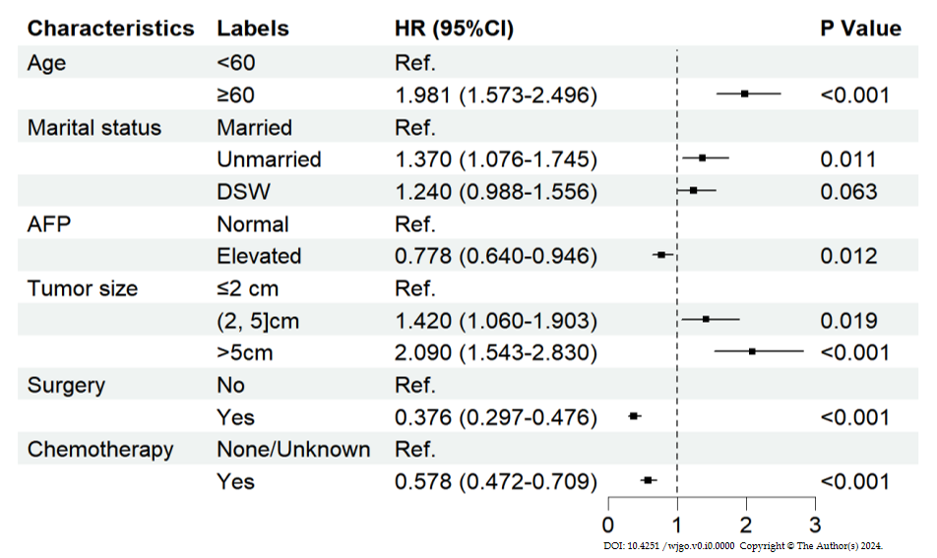
Figure 1 Multivariable analysis of cardiovascular disease in hepatocellular carcinoma patients. HR: Hazard ratio CI: Confidential interval; DSW: Divorced, separated, and widowed; AFP: Alpha fetoprotein.

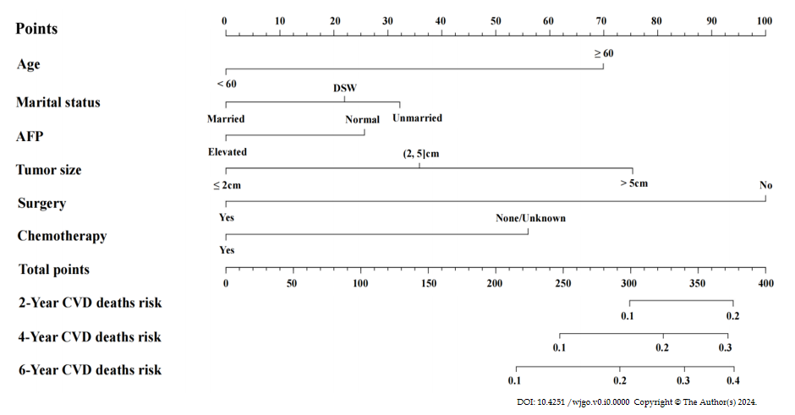
Figure 2 Fine-Gray model for predicting the 2-year, 4-year, and 6-year probabilities of cardiovascular disease death among hepatocellular carcinoma patients. CVD: Cardiovascular disease; DSW: Divorced, separated, and widowed; AFP: Alpha fetoprotein.

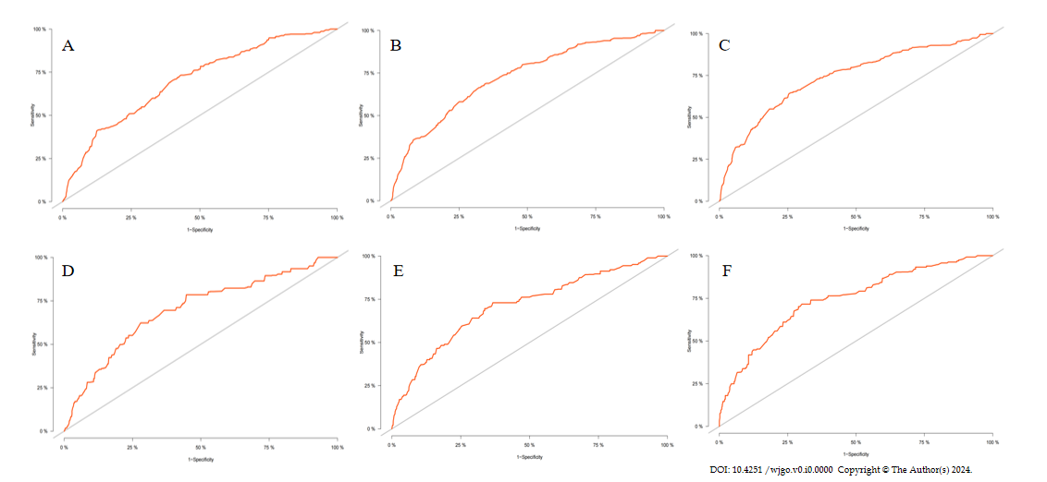
Figure 3 Receiver operating characteristiccurves analysis for nomogram discrimination evaluation of cardiovascular disease death prediction model in hepatocellular carcinoma patients. A: 2-year receiver operating characteristic (ROC) in training set; B: 4-year ROC in training set; C: 6-year ROC in training set; D: 2-year ROC in validation set; E: 4-year ROC in validation set; F: 6-year ROC in validation set.

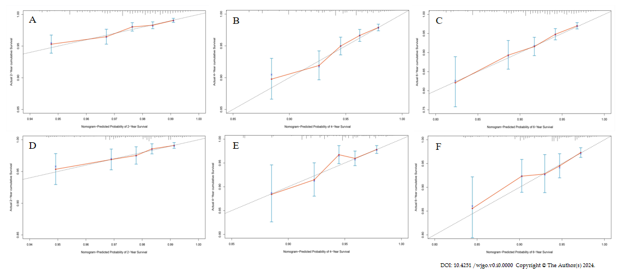
Figure 4 Calibration curve for nomogram calibration evaluation of cardiovascular disease death prediction model in hepatocellular carcinoma patients. A: 2-year cardiovascular mortality (CVM) in training set; B: 4-year CVM in training set; C: 6-year CVM in training set; D: 2-year CVM in validation set; E: 4-year CVM in validation set; F: 6-year CVM in validation set.

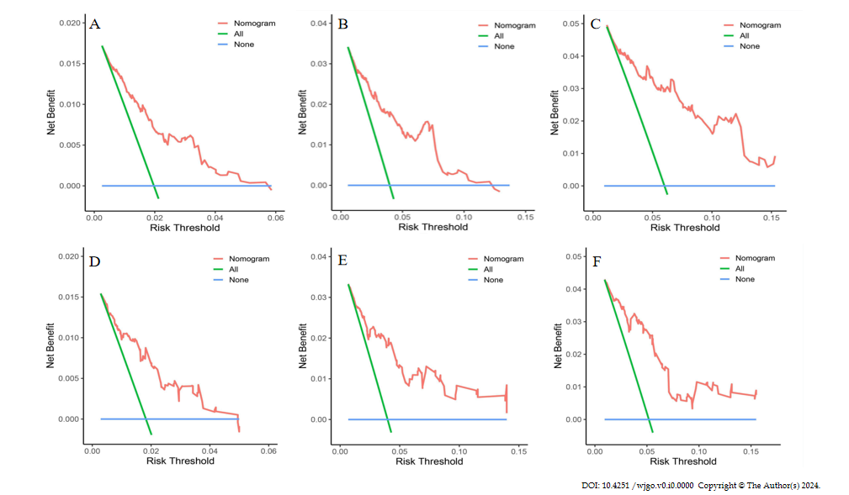
Figure 5 Decision curve analysis curves for nomogram calibration evaluation of cardiovascular disease death prediction model in hepatocellular carcinoma patients. A: 2-year decision curve analysis (DCA) curves in training set; B: 4-year DCA curves in training set; C: 6-year DCA curves in training set; D: 2-year DCA curves in validation set; E: 4-year DCA curves in validation set; F: 6-year DCA curves in validation set; DCA: Decision curve analysis.
Table 1 Demographic as well as clinicopathological characteristics of hepatocellular carcinoma patients
Characteristics | Labels | Participants N (%) | Alive N (%) | CVD deaths N (%)
Age | < 60 | 7667 (35.59) | 2142 (39.64) | 143 (23.10)
 | ≥ 60 | 13878 (64.41) | 3262 (60.36) | 476 (76.90)
Sex | Male | 16508 (76.62) | 3955 (73.19) | 487 (78.68)
 | Female | 5037 (23.38) | 1449 (26.81) | 132 (21.32)
Race | White | 14789 (68.64) | 3558 (65.84) | 441 (71.24)
 | Black | 2949 (13.69) | 611 (11.31) | 96 (15.51)
 | Other | 3807 (17.67) | 1235 (22.85) | 82 (13.25)
Marital status | Married | 11408 (52. 95) | 3315 (61.34) | 292 (47.17)
 | Unmarried | 4778 (22.18) | 1023 (18.93) | 147 (23.75)
 | DSW | 5359 (24.87) | 1066 (19.73) | 180 (29.08)
Year of diagnosis | 2010-2011 | 6234 (28.93) | 1158 (21.43) | 197 (31.83）
 | 2012-2013 | 7189 (33.37) | 1583 (29.29) | 203 (32.79)
 | 2014-2015 | 8122 (37.70) | 2663 (49.28) | 219 (35.38)
AFP | Normal | 6324 (29.35) | 2239 (41.43) | 239 (38.61)
 | Elevated | 15221 (70.65) | 3165 (58.57) | 380 (61.39)
Grade | GradeⅠ | 9423 (43.74) | 3384 (62.62) | 340 (54.93)
 | GradeⅡ | 5199 (24.13) | 1532 (28.35) | 139 (22.46)
 | GradeⅢ | 4153 (19.28) | 362 (6.70) | 101 (16.32)
 | GradeⅣ | 2770 (12.85) | 126 (2.33) | 39 (6.29)
Tumor size | ≤ 2 cm | 3227 (14.98) | 1420 (26.28) | 88 (14.22)
 | 2-5 cm | 10029 (46.55) | 3038 (56.22) | 290 (46.85)
 | > 5 cm | 8289 (38.47) | 946 (17.50) | 241 (38.93)
T stage | T₁ | 10049 (46.64) | 3429 (63.45) | 353 (57.03)
 | T₂ | 5668 (26.31) | 1561 (28.89) | 144 (23.26)
 | T₃ | 5191 (24.09) | 373 (6.90) | 106 (17.12)
 | T₄ | 637 (2.96) | 41 (0.76) | 16 (2.59)
N stage | N₀ | 20139 (93.47) | 5330 (98.63) | 599 (96.77)
 | N₁ | 1406 (6.53) | 74 (1.37) | 20 (3.23)
M stage | M₀ | 19595 (90.95) | 5339 (98.80) | 593 (95.80)
 | M₁ | 1950 (9.05) | 65 (1.20) | 26 (4.20)
Surgery | No | 15113 (70.15) | 2177 (40.28) | 460 (74.31)
 | Yes | 6432 (29.85) | 3227 (59.72) | 159 (25.69)
Radiotherapy | None/Unknown | 19400 (90.04) | 5031 (93.10) | 567 (91.60)
 | Yes | 2145 (9.96) | 373 (6.90) | 52 (8.40)
Chemotherapy | None/Unknown | 10566 (49.04) | 2837 (52.50) | 338 (54.60)
 | Yes | 10979 (50.96) | 2567 (47.50) | 281 (45.40)
CVD: Cardiovascular disease; DSW: Divorced, separated, and widowed; AFP: Alpha fetoprotein.
Table 2 Comparison of basic characteristics between patients in training and validation sets
Characteristics | Labels | Training set (N₁ = 15081) | Validation set  (N₂ = 6464) | P value
Age |  |  |  | 0.835
 | < 60 | 5360 (35.54) | 2307 (35.69)
 | ≥ 60 | 9721 (64.46) | 4157 (64.31)
Sex |  |  |  | 0.994
 | Male | 11555 (76.62) | 4953 (76.62)
 | Female | 3526 (23.38) | 1511 (23.38)
Race |  |  |  | 0.598
 | White | 10340 (68.56) | 4449 (68.83)
 | Black | 2087 (13.84) | 862 (13.34)
 | Other | 2654 (17.60) | 1153 (17.83)
Marital status |  |  |  | 0.552
 | Married | 7953 (52.74) | 3455 (53.45)
 | Unmarried | 3348 (22.20) | 1430 (22.12)
 | DSW | 3780 (25.06) | 1579 (24.43)
Year of diagnosis |  |  |  | 0.381
 | 2010-2011 | 4395 (29.14) | 1839 (28.45)
 | 2012-2013 | 4991 (33.09) | 2198 (34.00)
 | 2014-2015 | 5695 (37.77) | 2427 (37.55)
AFP |  |  |  | 0.231
 | Normal | 4390 (29.11) | 1934 (29.92)
 | Elevated | 10691 (70.89) | 4530 (70.08)
Grade |  |  |  | 0.160
 | GradeⅠ | 6574 (43.59) | 2849 (44.07)
 | GradeⅡ | 3692 (24.48) | 1507 (23.31)
 | GradeⅢ | 2864 (18.99) | 1289 (19.94)
 | GradeⅣ | 1951 (12.94) | 819 (12.68)
Tumor size |  |  |  | 0.201
 | ≤ 2 cm | 2301 (15.26) | 926 (14.33)
 | 2-5cm | 6986 (46.32) | 3043 (47.08)
 | > 5 cm | 5794 (38.42) | 2495 (38.59)
T stage |  |  |  | 0.193
 | T₁ | 7025 (46.58) | 3024 (46.78)
 | T₂ | 4018 (26.64) | 1650 (25.53)
 | T₃ | 3585 (23.77) | 1606 (24.85)
 | T₄ | 453 (3.01) | 184 (2.84)
N stage |  |  |  | 0.554
 | N₀ | 14087 (93.41) | 6052 (93.63)
 | N₁ | 994 (6.59) | 412 (6.37)
M stage |  |  |  | 0.680
 | M₀ | 13724 (91.00) | 5871 (90.83)
 | M₁ | 1357 (9.00) | 593 (9.17)
Surgery |  |  |  | 0.877
 | No | 10574 (70.11) | 4539 (70.22)
 | Yes | 4507 (29.89) | 1925 (29.78)
Radiotherapy |  |  |  | 0.675
 | None/unknown | 13588 (90.10) | 5812 (89.91)
 | Yes | 1493 (9.90) | 652 (10.09)
Chemotherapy |  |  |  | 0.180
 | None/unknown | 7441 (49.34) | 3125 (48.34)
 | Yes | 7640 (50.66) | 3339 (51.66)
DSW: Divorced, separated, and widowed; AFP: Alpha fetoprotein.
Table 3 Univariate analysis of cardiovascular disease in hepatocellular carcinoma patients in training test
Characteristics | Labels | HR (95%CI) | P value
Age | < 60 | Ref.
 | ≥ 60 | 2.054 (1.637-2.576) | < 0.001
Sex | Male | Ref.
 | Female | 0.872 (0.694-1.095) | 0.237
Race | White | Ref.
 | Black | 1.089 (0.830-1.428) | 0.539
 | Other | 0.653 (0.493-0.864) | 0.003
Marital status | Married | Ref.
 | Unmarried | 1.322 (1.042-1.678) | 0.022
 | DSW | 1.377 (1.099-1.726) | 0.006
Year of diagnosis | 2010-2011 | Ref.
 | 2012-2013 | 0.970 (0.764-1.231) | 0.802
 | 2014-2015 | 1.076 (0.846-1.370) | 0.549
AFP | Normal | Ref.
 | Elevated | 0.786 (0.647-0.954) | 0.015
Grade | GradeⅠ | Ref.
 | GradeⅡ | 0.775 (0.611-0.982) | 0.035
 | GradeⅢ | 1.263 (0.961-1.659) | 0.094
 | GradeⅣ | 0.860 (0.563-1.314) | 0.486
Tumor size | ≤ 2 cm | Ref.
 | 2-5 cm | 1.361 (1.018-1.821) | 0.038
 | > 5 cm | 2.254 (1.667-3.048) | < 0.001
T stage | T₁ | Ref.
 | T₂ | 0.761 (0.602-0.960) | 0.022
 | T₃ | 1.110 (0.844-1.460) | 0.454
 | T₄ | 1.806 (1.033-3.159) | 0.038
N stage | N₀ | Ref.
 | N₁ | 0.732 (0.400-1.339) | 0.311
M stage | M₀ | Ref.
 | M₁ | 1.039 (0.650-1.662) | 0.872
Surgery | No | Ref.
 | Yes | 0.447 (0.359-0.557) | < 0.001
Radiotherapy | None/unknown | Ref.
 | Yes | 1.203 (0.877-1.650) | 0.253
Chemotherapy | None/unknown | Ref.
 | Yes | 0.770 (0.637-0.931) | 0.007
HR: Hazard ratio; CI: Confidence interval; CVD: Cardiovascular disease; DSW: Divorced, separated, and widowed; AFP: Alpha fetoprotein.

