Name of Journal: World Journal of Clinical Cases
Manuscript NO: 71922
Manuscript Type: CASE REPORT

Synchronous but separate neuroendocrine tumor and high-grade dysplasia/adenoma of the gall bladder: A case report

Hsiao TH et al. Mixed GB cancer and carcinoid tumor

Tsung-Hsien Hsiao, Chao-Chuan Wu, Hui-Hwa Tseng, Jiann-Hwa Chen

Tsung-Hsien Hsiao, Division of Gastroenterology and Hepatology, Taipei Tzu Chi Hospital, New Taipei City 231, Taiwan

Chao-Chuan Wu, Department of Surgery, Taipei Tzu Chi Hospital, New Taipei City 231, Taiwan

Hui-Hwa Tseng, Department of Pathology, Taipei Tzu Chi Hospital, New Taipei City 231, Taiwan

Jiann-Hwa Chen, Division of Gastroenterology and Hepatology; Department of Internal Medicine, Taipei Tzu Chi Hospital, Buddhist Tzu Chi Medical Foundation, New Taipei City 231, Taiwan

Author contributions: Hsiao TH collected the data for the manuscript; Wu CC performed the surgery; Tseng HH conducted the pathological evaluation; Chen JH was responsible for the writing and revision of the manuscript.

Corresponding author: Jiann-Hwa Chen, MD, Director, Division of Gastroenterology and Hepatology; Department of Internal Medicine, Taipei Tzu Chi Hospital, Buddhist Tzu Chi Medical Foundation, No. 289 Chien Kao Road, Xin-dien, New Taipei City 231, Taiwan. jhctylci@gmail.com

Received: October 5, 2021
Revised: November 22, 2021
Accepted: January 19, 2022
Published online: March 6, 2022
Abstract
BACKGROUND
Gall bladder neuroendocrine tumors (GB-NETs) are rare, accounting for less than 0.5% of all NETs. They usually lack specific symptoms and are difficult to diagnose preoperatively. In most cases, GB-NETs are incidentally found after cholecystectomy for large polyps or cholelithiasis, causing acute or chronic cholecystitis. The coexistence of GB-NET and GB adenocarcinoma is very rare.

CASE SUMMARY
We report a case of synchronous but separate GB-NET and adenoma with high-grade dysplasia in a patient who had undergone surgery for a progressively growing GB polypoid lesion. To the best of our knowledge, simultaneous separation of NETs and cancer in the GB has not been reported.

CONCLUSION
Coexistent GB carcinoid tumor and adenocarcinoma is rare. A surveillance program is needed for these large GB polyps.

Key Words: Synchronous; Neuroendocrine tumor; Adenoma with high-grade dysplasia; Gall bladder; Case report

©The Author(s) 2022. Published by Baishideng Publishing Group Inc. All rights reserved.

Citation: Hsiao TH, Wu CC, Tseng HH, Chen JH. Synchronous but separate neuroendocrine tumor and high-grade dysplasia/adenoma of the gall bladder: A case report. World J Clin Cases 2022; 10(7): 2322-2329
URL: https://www.wjgnet.com/2307-8960/full/v10/i7/2322.htm
DOI: https://dx.doi.org/10.12998/wjcc.v10.i7.2322

Core Tip: Gall bladder (GB) polyps are commonly found in routine abdominal ultrasound examination; however, GB carcinoid tumors are rare, especially with the coexistence of an adenocarcinoma component. Physicians should be aware of rapidly growing GB polyps; in those cases, imaging examinations such as contrast-enhanced computed tomography and magnetic resonance imaging are needed to elucidate the nature of these lesions.

INTRODUCTION
A neuroendocrine tumor (NET) is a heterogeneous tumor, first reported and identified as a carcinoid tumor by Oberndorfer in 1907. NETs originate and spread from neuroendocrine cells and peptidergic neural crest Kulchitsky cells (silver-addicted cells)^{[1]}. The first case of a primary carcinoid tumor of the gall bladder (GB) was reported by Joel in 1929^{[2]}. Primary GB-NETs are very rare, and in the Surveillance, Epidemiology, and End Results (commonly known as SEER) registry, only 278 cases were reported between 1973 and 2005. The incidence of GB-NETs is less than 0.74/100,000, and represents 0.5% of all NETs and approximately 2% of all GB malignancies^{[3]}. They rarely occur because there are no neuroectodermal cells in the GB. Multipotent stem cells or neuroendocrine cells involved in intestinal or gastric metaplasia of the GB epithelium have recently been considered the origin of GB-NETs^{[4]}.
Here, we report a rare case of coexistent but separate NET and adenocarcinoma in situ in the GB.

CASE PRESENTATION
Chief complaints
A 61-year-old woman presented to the outpatient department with an abnormal magnetic resonance image (MRI) finding. She had undergone a medical checkup in another hospital, where she was advised to have a 1-2 cm segment of narrow lumen at the distal common bile duct (CBD) assessed further in another MRI study (Figure 1).

History of present illness
The patient denied having upper or right hypochondrial pain, and no jaundice was observed. She did not have fever or chills. Immunoglobulin G4 (IgG4) levels were slightly elevated (246 mg/dL; normal range: < 200 mg/dL), and initial abdominal ultrasound (US) showed a mildly thickened distal CBD wall and an approximately 1 cm polypoid lesion in the GB (Figure 2A); therefore, IgG4-related cholangitis was suspected. Because the patient had no symptoms, she underwent regular abdominal US exams and measurement of blood IgG4 Levels at 6- to 12-mo intervals. However, the 1-year follow-up abdominal US showed that the GB polyp had grown (Figure 2B). After another 6 mo, the polyp was even larger and more hypoechoic in appearance (Figure 2C). After an additional 6 mo, abdominal US with Doppler revealed a 2 cm polypoid tumor (Figure 2D). Contrast MRI T2-weighted images revealed a 2-cm tumor near the neck of the GB (Figure 3). Magnetic resonance cholangiopancreatography showed that the morphology of the stricture segment of the distal CBD was not significantly changed. The patient subsequently underwent surgery.

History of past illness
The patient’s medical history was unremarkable.

Personal and family history
The patient’s family history was unremarkable.

Physical examination
The patient’s physical examination was unremarkable. Her abdomen was soft, nontender and nondistended, with no palpable mass.

Laboratory examinations
Laboratory examinations, including complete blood count and blood chemistry tests, revealed that white blood cell count (9051/mL) and serum levels of C-reactive protein (0.72 mg/dL), alkaline phosphatase (82 IU/L), gamma-glutamyl transferase (32 IU/L), aspartate transaminase (19 U/L), and alanine aminotransferase (28 U/L) were all within normal limits. Serological tests for hepatitis B antigen, anti-hepatitis C antibody, alpha-fetoprotein, carcinoembryonic antigen, and carbohydrate antigen 19-9 were negative. The IgG4 Level at follow-up was also within the normal range.

Imaging examinations
Two years later, abdominal US showed that the GB polypoid lesion had progressively increased to greater than 2 cm in size. Contrast MRI T2-weighted images (Figure 3) revealed a 2-cm tumor near the neck of the GB, and malignancy was highly suspected.

MULTIDISCIPLINARY EXPERT CONSULTATION
This consultation was not undertaken.

FINAL DIAGNOSIS
GB neuroendocrine tumor grade 2 and synchronous adenocarcinoma in situ.

TREATMENT
Radical laparoscopic cholecystectomy with partial liver tissue resection was subsequently performed (Figure 4). The intraoperative findings revealed no evidence of inflammation in the peri-GB area. The CBD looked negative for overall abnormalities but there were tumor features noted in its appearance. However, the outer surface of the GB in the liver bed showed no tumor invasion. The pathological findings are tubulo-villous adenoma with high-grade dysplasia and gall bladder neuroendocrine tumor grade 2 (Figure 5).

OUTCOME AND FOLLOW-UP
After a 1-year follow up, the patient’s postoperative course was uneventful, with no recurrence. Regarding the CBD stricture, we suggest that patients receive endoscopic retrograde cholangiopancreatography brush cytology or endoscopic US with fine-needle aspiration biopsy.

DISCUSSION
More than 75% of GB cancers are adenocarcinomas, although many variant forms of GB carcinoma have been pathologically described^{[4]}. GB-NETs are relatively rare histological tumors, accounting for 0.5% of all NET cases and only 2.1% of GB cancer cases^{[3]}. Preoperative diagnosis of GB-NETs is difficult as patients tend to have no specific symptoms, and the radiological findings are not different from those of other GB tumors. Physicians rarely encounter patients with carcinoid tumors because they are often diagnosed postoperatively or postmortem.
The origin of GB carcinoid tumors is of great interest in relation to mucosal metaplasia. Recent investigations have shown that neuroendocrine cells are not present in normal GB mucosa, while their mucosa with gastric and/or intestinal metaplasia expresses a variety of multipotent stem cells or neuroendocrine cell transformation to secrete serotonin, glucagon, histamine, gastrin, or somatostatin substance^{[5-9]}. In a study of 103 GB patients with cholelithiasis, 12 (11.7%) had intestinal metaplasia. Of these cases, CGA and serotonin were expressed in 83.3% and 50% of patients, respectively^{[10]}. Cholelithiasis is the most important risk factor for GB cancer worldwide and is more prevalent in women; both GB adenocarcinomas and GB-NETs are also more common among women (68%)^{[11]}. In the study by Maitra et al^{[12]}, 12 patients with GB small cell carcinoma had a positive history of gallstones; moreover, 6 of the patients were positive for CGA and neuron-specific enolase, and 7 patients had foci of adenocarcinoma. Most GB adenocarcinomas also exhibit a gastric/intestinal type of differentiation and CGA-positive cells^{[13,14]}. There are several reports on the coexistence of GB-NETs and GB adenocarcinomas, and the possibility of a direct transition between the tumors remains an intriguing issue. A case report by Shimizu et al^{[15]} demonstrated that, pathologically, giant GB tumor has atypical cells with small round-to-oval nuclei and sparse eosinophilic cytoplasm; near this small cell proliferation was a focus of tubular adenocarcinoma, which showed a zone of transition from the small cell neuroendocrine pattern. In 2017, the World Health Organization (commonly known as WHO) updated the classification of NETs into three new categories (grades 1, 2, and 3 NETs) according to the proliferative ability of the tumor^{[16]}. Noda et al^{[17]} published an article related to carcinoid tumors of the GB with differentiated adenocarcinoma, and Sakaki et al^{[18]} reported a case of GB adenocarcinoma with florid neuroendocrine cell nests. Mixed endocrine non-endocrine neoplasms have been proposed for combined adenocarcinomas and neuroendocrine carcinomas. According to a previous investigation, coexistent GB-NETs and GB adenocarcinomas are interspersed with each other under a mucosal metaplastic background, indicating the transition between these tumors. However, this phenomenon was not observed in our case. The GB-NET maintained a distance from the GB adenocarcinoma, and no intestinal metaplasia was detected. In addition, the GB failed to show the presence of cholelithiasis, and only mild cholecystitis was observed. These conditions differ from those reported in the literature.
The treatment guidelines for GB-NETs are based on tumor grading. Surgery is the most efficient and only curative treatment. However, with the exception of functional NETs, which can be detected early when the tumor is still small, most NETs are large at diagnosis and thus definitive surgery is not feasible. The prognosis of GB neuroendocrine carcinoma is worse than that of other GB carcinomas, given its highly malignant biological behavior. Maitra et al^{[12]} and Soga^{[19]} reported that the 5-year survival rates are 8.3% and 0.0%, respectively. Traditional chemotherapy using streptozotocin, fluorouracil, doxorubicin, cisplatin, and etoposide is a mainstay treatment for grade 3 neuroendocrine cell carcinoma of the GB, but there are no reported cases of long-term survival. Remarkably, our case of synchronous early GB adenocarcinoma and grade II GB-NET (WHO) was completely resected by surgery, and there was no need for adjuvant therapy.
IgG4-related sclerosing disease (IgG4-RD), a systemic inflammatory syndrome characterized by obliterative phlebitis and extensive infiltration of IgG4-positive plasma cells and lymphocytes with fibrosis in multiple organs including the digestive tract^{[20-22]}, has been increasingly recognized in the past few years. IgG4-RD is a benign disease that often mimics malignant behavior; however, to date, there are no reports in the English-language literature of any association with malignant potential. In our case, the patient was suspected to have this disease due to distal CBD stricture and elevated IgG4 Level; hence, it is critical to differentiate IgG4-RD from the unknown nature of a biliary stricture. The possibility of pancreatic cancer, autoimmune pancreatitis, primary sclerosing cholangitis, CBD cancer, and IgG4 sclerosing cholangitis should be considered in patients with distal CBD stricture. We used imaging examinations to thoroughly investigate the narrow distal CBD of this patient. Because the patient refused any invasive procedure, tissue acquisition was not performed and no definite diagnosis could be made. The patient underwent regular abdominal US exams in follow-up. After 2 years, a progressively growing GB polypoid lesion was detected, and she agreed to undergo surgery. Interestingly, histopathological examination revealed concomitant but separate adenocarcinoma and NET in the GB. Six-month follow-ups are recommended for patients with polyps of 6-9 mm in size, and elective cholecystectomy should be considered if the polyps are greater than 10 mm in diameter^{[23]}. If patients refuse prompt surgery, follow-up investigation modalities should include enhanced computed tomography, contrast MRI, or contrast-enhanced harmonic endoscopic US^{[24]}. In our patient, the nature of the biliary stricture was not elucidated, but the GB polyp was treated. Synchronous or metachronous GB and CBD cancer has been reported in the literature; however, this is often related to congenital anomalous biliopancreatic duct union^{[25]}. In our patient, magnetic resonance cholangiopancreatography scan did not reveal the presence of a long common channel of the biliopancreatic duct.

CONCLUSION
GB carcinoid tumors are rare, especially coexisting with an adenocarcinoma component. Most combined GB carcinoid tumors and adenocarcinoma show GB-NETs with adenocarcinoma differentiation or vice versa and are often associated with cholelithiasis and/or cholecystitis. Surgical cholecystectomy is the treatment of choice for this disease. We present a case of concomitant but separate GB adenocarcinoma and GB-NET without transition changes or evident cholecystitis. The mechanism underlying the transformation of GB adenocarcinoma to GB-NETs requires further investigation in the future.

REFERENCES
1 Modlin IM, Lye KD, Kidd M. A 5-decade analysis of 13,715 carcinoid tumors. Cancer 2003; 97: 934-959 [PMID: 12569593 DOI: 10.1002/cncr.11105]
2 Joel W. Karzinoid der Gallenblase. Z Allg Pathol 1929; 46: 1
3 Yao JC, Hassan M, Phan A, Dagohoy C, Leary C, Mares JE, Abdalla EK, Fleming JB, Vauthey JN, Rashid A, Evans DB. One hundred years after "carcinoid": epidemiology of and prognostic factors for neuroendocrine tumors in 35,825 cases in the United States. J Clin Oncol 2008; 26: 3063-3072 [PMID: 18565894 DOI: 10.1200/JCO.2007.15.4377]
4 Eltawil KM, Gustafsson BI, Kidd M, Modlin IM. Neuroendocrine tumors of the gallbladder: an evaluation and reassessment of management strategy. J Clin Gastroenterol 2010; 44: 687-695 [PMID: 20375728 DOI: 10.1097/MCG.0b013e3181d7a6d4]
5 Delaquerriere L, Tremblay G, Riopelle JL. Argentaffine cells in chronic cholecystitis. Arch Pathol 1962; 74: 142-151 [PMID: 13885059]
6 Laitio M. Goblet cells, enterochromaffin cells, superficial gastric-type epithelium and antral-type glands in the gallbladder. Beitr Pathol 1975; 156: 343-358 [PMID: 1220670 DOI: 10.1016/s0005-8165(75)80044-8]
7 Laitio M. Morphology and histochemistry of non-tumorous gallbladder epithelium. A series of 103 cases. Pathol Res Pract 1980; 167: 335-345 [PMID: 7433241 DOI: 10.1016/S0344-0338(80)80063-X]
8 Albores-Saavedra J, Nadji M, Henson DE, Ziegels-Weissman J, Mones JM. Intestinal metaplasia of the gallbladder: a morphologic and immunocytochemical study. Hum Pathol 1986; 17: 614-620 [PMID: 2872152 DOI: 10.1016/s0046-8177(86)80134-4]
9 Yamamoto M, Nakajo S, Miyoshi N, Nakai S, Tahara E. Endocrine cell carcinoma (carcinoid) of the gallbladder. Am J Surg Pathol 1989; 13: 292-302 [PMID: 2648878 DOI: 10.1097/00000478-198904000-00004]
10 Sakamoto H, Mutoh H, Ido K, Satoh K, Hayakawa H, Sugano K. A close relationship between intestinal metaplasia and Cdx2 expression in human gallbladders with cholelithiasis. Hum Pathol 2007; 38: 66-71 [PMID: 16996572 DOI: 10.1016/j.humpath.2006.06.010]
11 Randi G, Franceschi S, La Vecchia C. Gallbladder cancer worldwide: geographical distribution and risk factors. Int J Cancer 2006; 118: 1591-1602 [PMID: 16397865 DOI: 10.1002/ijc.21683]
12 Maitra A, Tascilar M, Hruban RH, Offerhaus GJ, Albores-Saavedra J. Small cell carcinoma of the gallbladder: a clinicopathologic, immunohistochemical, and molecular pathology study of 12 cases. Am J Surg Pathol 2001; 25: 595-601 [PMID: 11342770 DOI: 10.1097/00000478-200105000-00005]
13 Kushima R, Lohe B, Borchard F. Differentiation towards gastric foveolar, mucopeptic and intestinal goblet cells in gallbladder adenocarcinomas. Histopathology 1996; 29: 443-448 [PMID: 8951489 DOI: 10.1046/j.1365-2559.1996.d01-520.x]
14 Albores-Saavedra J, Nadji M, Henson DE, Angeles-Angeles A. Entero-endocrine cell differentiation in carcinomas of the gallbladder and mucinous cystadenocarcinomas of the pancreas. Pathol Res Pract 1988; 183: 169-175 [PMID: 3387323 DOI: 10.1016/S0344-0338(88)80044-X]
15 Shimizu T, Tajiri T, Akimaru K, Arima Y, Yoshida H, Yokomuro S, Mamada Y, Taniai N, Mizuguchi Y, Kawahigashi Y, Naito Z. Combined neuroendocrine cell carcinoma and adenocarcinoma of the gallbladder: report of a case. J Nippon Med Sch 2006; 73: 101-105 [PMID: 16641536 DOI: 10.1272/jnms.73.101]
16 Choe J, Kim KW, Kim HJ, Kim DW, Kim KP, Hong SM, Ryu JS, Tirumani SH, Krajewski K, Ramaiya N. What Is New in the 2017 World Health Organization Classification and 8th American Joint Committee on Cancer Staging System for Pancreatic Neuroendocrine Neoplasms? Korean J Radiol 2019; 20: 5-17 [PMID: 30627018 DOI: 10.3348/kjr.2018.0040]
17 Noda M, Miwa A, Kitagawa M. Carcinoid tumors of the gallbladder with adenocarcinomatous differentiation: a morphologic and immunohistochemical study. Am J Gastroenterol 1989; 84: 953-957 [PMID: 2756987]
18 Sakaki M, Hirokawa M, Sano T, Horiguchi H, Wakatsuki S, Ogata S. Gallbladder Adenocarcinoma with Florid Neuroendocrine Cell Nests and Extensive Paneth Cell Metaplasia. Endocr Pathol 2000; 11: 365-371 [PMID: 12114761 DOI: 10.1385/ep:11:4:365]
19 Soga J. Primary endocrinomas (carcinoids and variant neoplasms) of the gallbladder. A statistical evaluation of 138 reported cases. J Exp Clin Cancer Res 2003; 22: 5-15 [PMID: 12725316]
20 Takahashi K, Ito H, Katsube T, Tsuboi A, Hashimoto M, Ota E, Mita K, Asakawa H, Hayashi T, Fujino K, Okamoto S. Immunoglobulin G4-related sclerosing cholecystitis presenting as gallbladder cancer: a case report. Surg Case Rep 2015; 1: 120 [PMID: 26943444 DOI: 10.1186/s40792-015-0123-4]
21 Ohara H, Okazaki K, Tsubouchi H, Inui K, Kawa S, Kamisawa T, Tazuma S, Uchida K, Hirano K, Yoshida H, Nishino T, Ko SB, Mizuno N, Hamano H, Kanno A, Notohara K, Hasebe O, Nakazawa T, Nakanuma Y, Takikawa H; Research Committee of IgG4-related Diseases; Research Committee of Intractable Diseases of Liver and Biliary Tract; Ministry of Health, Labor and Welfare, Japan; Japan Biliary Association. Clinical diagnostic criteria of IgG4-related sclerosing cholangitis 2012. J Hepatobiliary Pancreat Sci 2012; 19: 536-542 [PMID: 22717980 DOI: 10.1007/s00534-012-0521-y]
22 Kitagawa S, Zen Y, Harada K, Sasaki M, Sato Y, Minato H, Watanabe K, Kurumaya H, Katayanagi K, Masuda S, Niwa H, Tsuneyama K, Saito K, Haratake J, Takagawa K, Nakanuma Y. Abundant IgG4-positive plasma cell infiltration characterizes chronic sclerosing sialadenitis (Küttner's tumor). Am J Surg Pathol 2005; 29: 783-791 [PMID: 15897744 DOI: 10.1097/01.pas.0000164031.59940.fc]
23 Wiles R, Thoeni RF, Barbu ST, Vashist YK, Rafaelsen SR, Dewhurst C, Arvanitakis M, Lahaye M, Soltes M, Perinel J, Roberts SA. Management and follow-up of gallbladder polyps : Joint guidelines between the European Society of Gastrointestinal and Abdominal Radiology (ESGAR), European Association for Endoscopic Surgery and other Interventional Techniques (EAES), International Society of Digestive Surgery - European Federation (EFISDS) and European Society of Gastrointestinal Endoscopy (ESGE). Eur Radiol 2017; 27: 3856-3866 [PMID: 28185005 DOI: 10.1007/s00330-017-4742-y]
24 Choi JH, Seo DW, Choi JH, Park DH, Lee SS, Lee SK, Kim MH. Utility of contrast-enhanced harmonic EUS in the diagnosis of malignant gallbladder polyps (with videos). Gastrointest Endosc 2013; 78: 484-493 [PMID: 23642490 DOI: 10.1016/j.gie.2013.03.1328]
25 Rajekar H. Synchronous Gall Bladder and Bile Duct Cancer: A Short Series of Seven Cases and a Brief Review of Literature. J Clin Exp Hepatol 2017; 7: 115-120 [PMID: 28663675 DOI: 10.1016/j.jceh.2016.10.003]

Footnotes
Informed consent statement: Consent for surgery was obtained from the patient herself, who also consented to our publication of her anonymized case.

Conflict-of-interest statement: The authors declare having no conflicts of interest.

CARE Checklist (2016) statement: The authors have read the CARE Checklist (2016), and the manuscript was prepared and revised according to the CARE Checklist (2016).

Open-Access: This article is an open-access article that was selected by an in-house editor and fully peer-reviewed by external reviewers. It is distributed in accordance with the Creative Commons Attribution NonCommercial (CC BY-NC 4.0) license, which permits others to distribute, remix, adapt, build upon this work non-commercially, and license their derivative works on different terms, provided the original work is properly cited and the use is non-commercial. See: https://creativecommons.org/Licenses/by-nc/4.0/

Provenance and peer review: Unsolicited article; externally peer reviewed.
Peer-review model: Single blind

Peer-review started: October 5, 2021
First decision: November 8, 2021
Article in press: January 19, 2022

Specialty type: Gastroenterology and hepatology
Country/Territory of origin: Taiwan
Peer-review report’s scientific quality classification
Grade A (Excellent): 0
Grade B (Very good): B
Grade C (Good): C, C
Grade D (Fair): 0
Grade E (Poor): 0

P-Reviewer: Salimi M, Yap RV S-Editor: Liu JH L-Editor: A P-Editor: Liu JH
Figure Legends
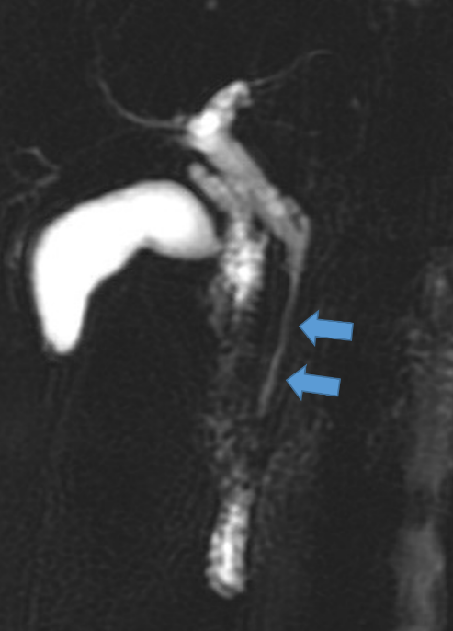
Figure 1 Magnetic resonance cholangiopancreatography showed a long-segmented luminal stricture in the distal common bile duct (arrows).
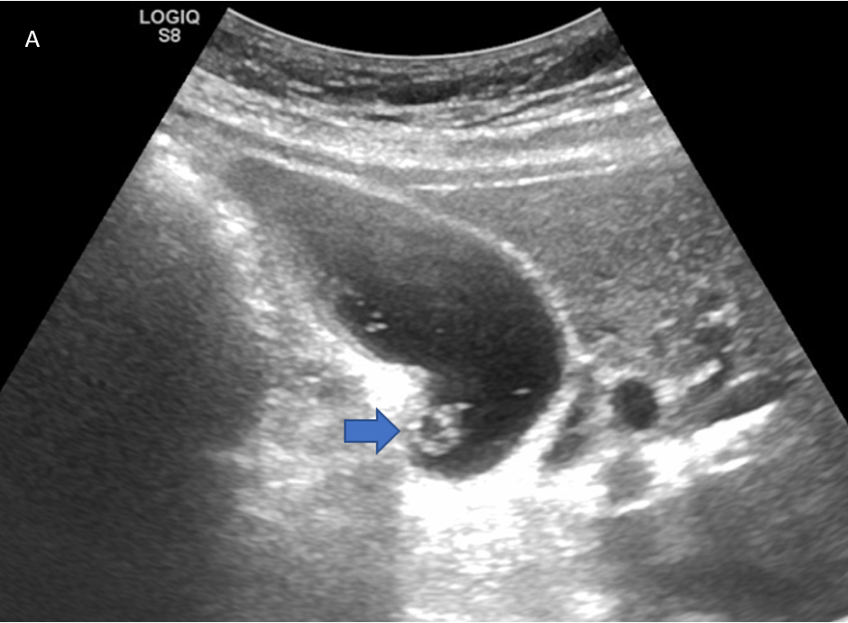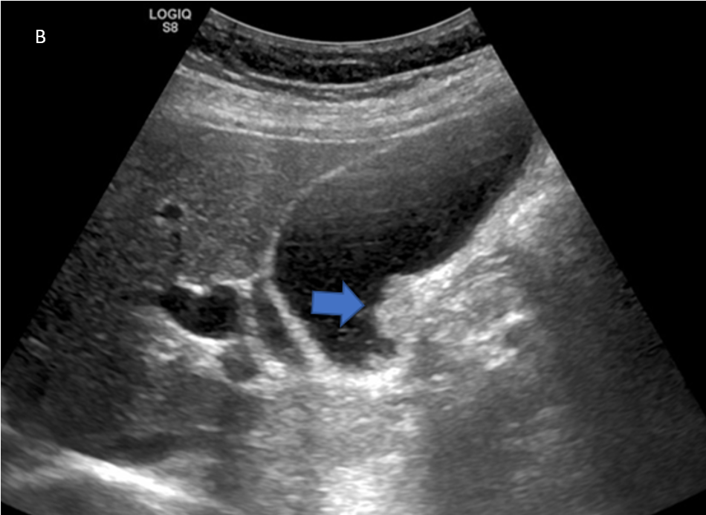
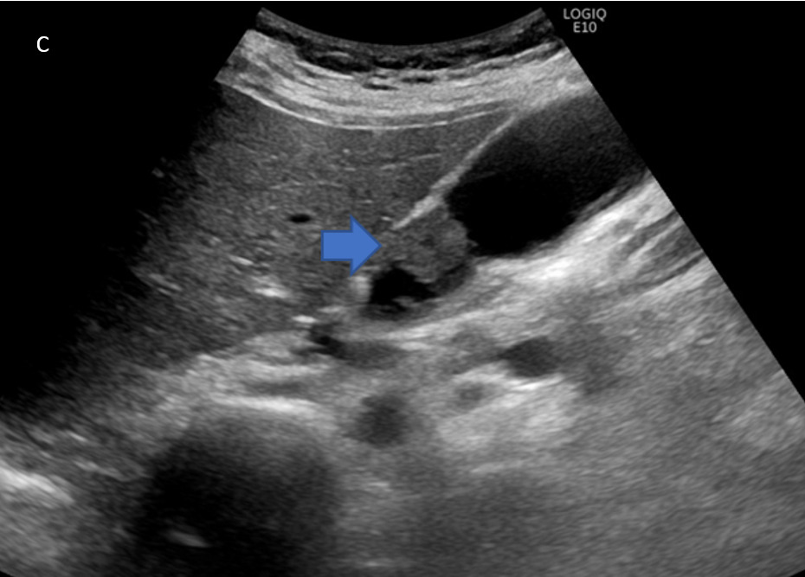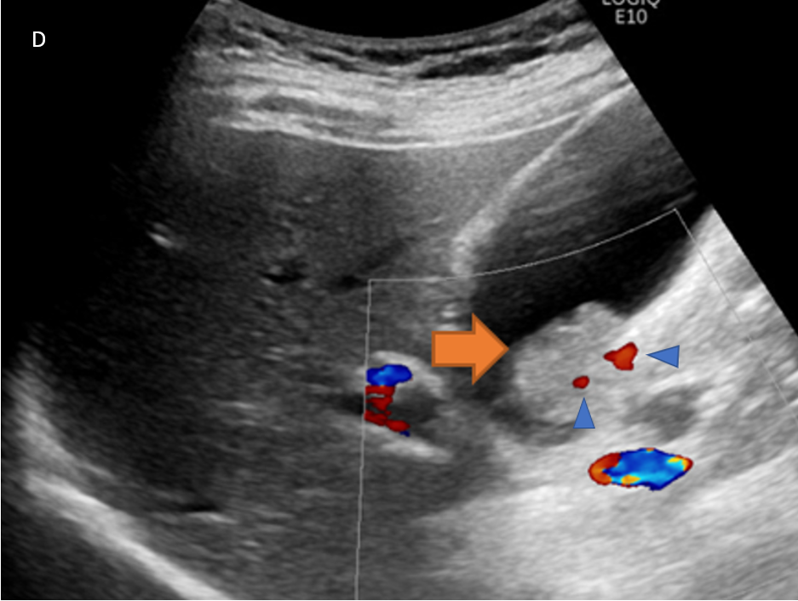
Figure 2 Evolutionary change in gall bladder polyp. A: A 1-cm hyperechoic lesion with hypoechoic component (polyp) at the gall bladder wall (arrow); B: The polyp became larger compared to its size 1 year prior (arrow); C: The polyp became hypoechoic (arrow) after another 6 mo; D: Ultrasound performed just before surgery revealed a Doppler signal (arrowhead) within the tumor (arrow).
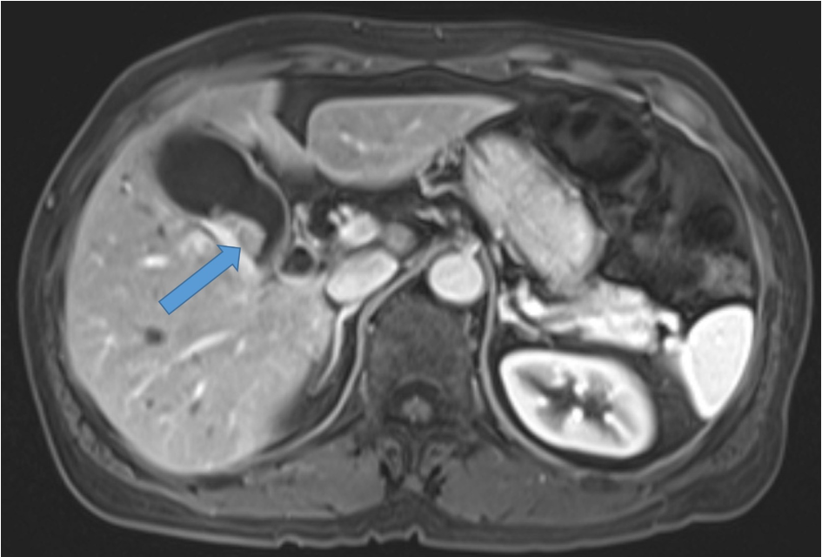
Figure 3 Contrast magnetic resonance imaging T2-weighted images revealed a 2-cm tumor near the gall bladder neck (arrow).

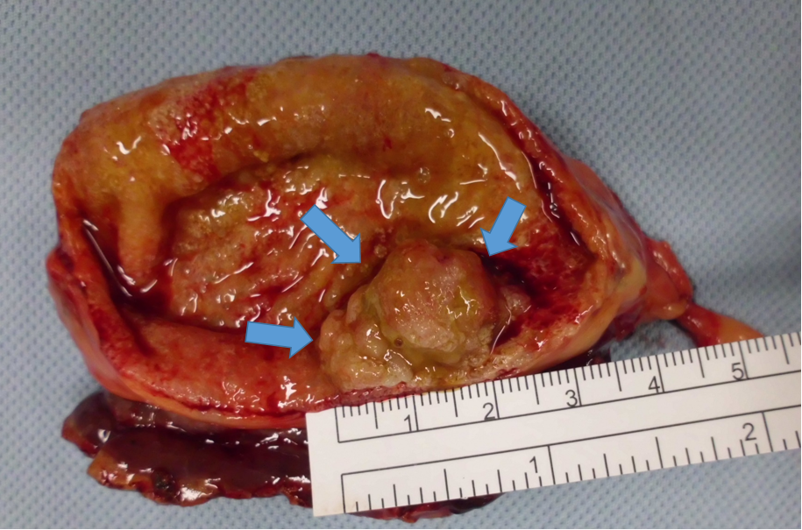
Figure 4 Surgical specimen revealed a 2-cm polypoid tumor mass (arrows) at the gall bladder neck.
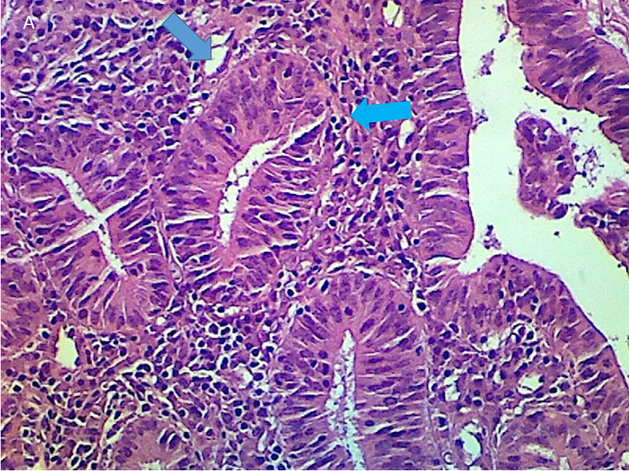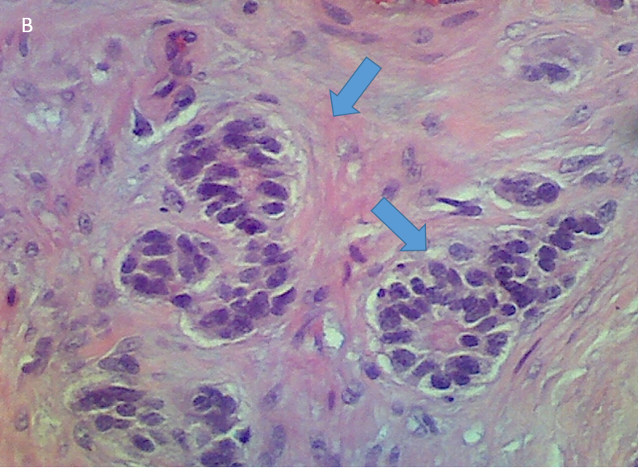
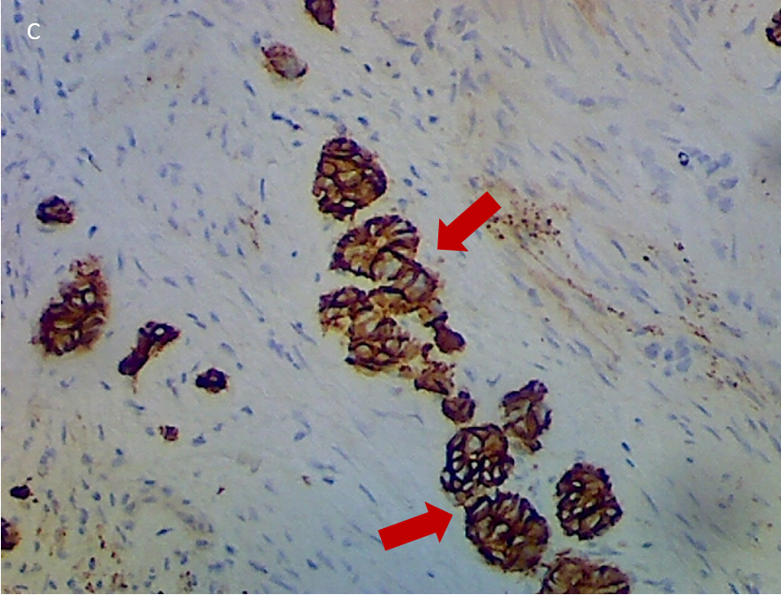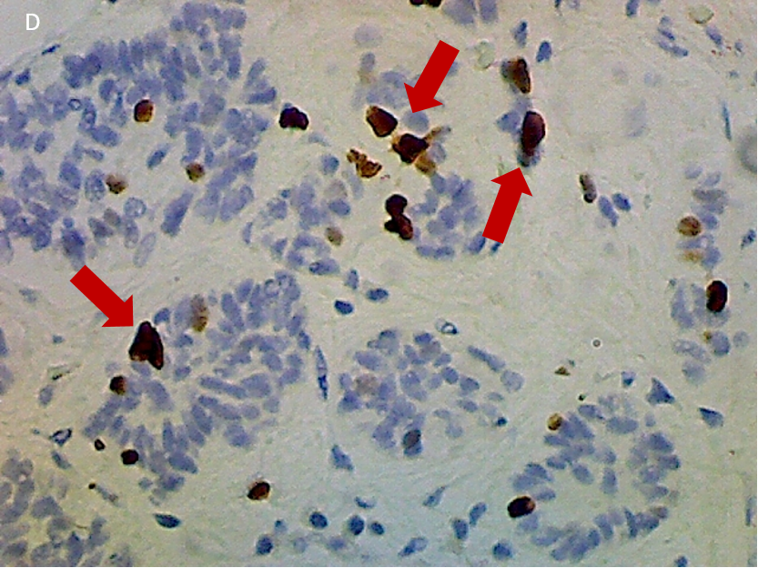
Figure 5 Postsurgical findings. A: Tubulo-villous adenoma with high-grade dysplasia (arrows); B: Gall bladder neuroendocrine tumor (GB-NET), 2 mm × 2 mm in dimension (arrows, hematoxylin and eosin staining); C: The tumor cells were positive for cluster of differentiation 56 (arrows); D: GB-NET, grade 2, Ki-67 index: 3%-5%, < 2 mitoses per 10 high-power fields (arrows).

Published by Baishideng Publishing Group Inc
7041 Koll Center Parkway, Suite 160, Pleasanton, CA 94566, USA
Telephone: +1-925-3991568
E-mail: bpgoffice@wjgnet.com
Help Desk: https://www.f6publishing.com/helpdesk
https://www.wjgnet.com

© 2022 Baishideng Publishing Group Inc. All rights reserved.

