Name of journal: World Journal of Gastroenterology
ESPS Manuscript NO: 10749
Columns: retrospective cohort study

fibroblast growth factor receptor 4 protein expression and clinicopathological features in gastric cancer

Chen H et al. GFR4 protein expression in gastric cancer

Hao Chen, Dan-Ping Shen, Zi-Zhen Zhang, Jia-Hua Liu, Yan-Ying Shen, Xing-Zhi Ni

Hao Chen, Dan-Ping Shen, Zi-Zhen Zhang, Jia-Hua Liu, Xing-Zhi Ni, Department of General Surgery, Ren Ji Hospital, School of Medicine, Shanghai Jiao Tong University, Shanghai 200127, China

Yan-Ying Shen, Department of Pathology, Ren Ji Hospital, School of Medicine, Shanghai Jiao Tong University, Shanghai 200127, China

Author contributions: Chen H, Shen YY and Ni XZ designed the study; Shen DP and Liu JH analyzed the data; Chen H wrote the paper; Ni XZ and Zhang ZZ revised the manuscript.

Correspondence to: Xing-Zhi Ni, MD, Professor of Medicine, Department of General Surgery, Ren Ji Hospital, School of Medicine, Shanghai Jiao Tong University, 1630 Dongfang Road, Shanghai 200127, China. niyin92@gmail.com

Telephone: +86-21-68383731 Fax: +86-21-58394262
Received: April 17, 2014 Revised: August 4, 2014
Accepted: September 5, 2014

Published online:

Abstract

Aim: To investigate fibroblast growth factor receptor 4 (FGFR4) protein expression in Chinese patients with resectable gastric cancer (GC) and the association with clinicopathological characteristics and survival.

Methods: About 175 gastric cancer patients who underwent curative surgery procedures were enrolled into this study. The protein expression of FGFR4 in formalin-fixed, paraffin-embedded (FFPE) gastric cancer tissues was determined by immunohistochemical (IHC) analysis. Patient clinicopathological data and survival information was also collected and χ² statistical analysis was performed to analyze FGFR4 protein expression amongst the subgroups with differing clinicopathological characteristics including; gender, age, tumor location, differentiation, tumor-node-metastasis stage, macroscopic type, depth of invasion, lymph node metastases, distant metastasis, neural invasion and vascular invasion. Furthermore, some common molecular markers of GC in our cancer center, including p53, p27, topoisomerase IIα (Topo IIα) were also detected by IHC and their association with FGFR4 protein expression explored. The probability of survival for different subgroups with different clinicopathological characteristics was calculated using the Kaplan-Meier method and survival curves plotted using log rank inspection.

RESULTS: About 77 cases (44%) were identified as highly expressing FGFR4 protein. Significantly different FGFR4 expression was observed between gastric cancers with differing expression of Topo IIα (log rank χ² = 9.4760, P = 0.0236). No significant difference was observed between subgroups defined by any other clinicopathological characteristics. The median survival time of the FGFR4 high expression (77 cases) and low expression groups (98 cases) was 27 mo and 39 mo, respectively. The five year survival rates and median survival times of gastric cancers with high FGFR4 expression were worse than those with low expression(30.8% vs 39.2%, 27 mo vs 39 mo), however no significant difference was observed in survival time (log rank χ² = 1.0477, P = 0.3060). Survival analysis revealed that FGFR4 high expression was a predictor of poor outcome in GC patients if the tumor was small (less than or equal to 3 cm in size) (log rank χ² = 5.5033, P = 0.0190), well differentiated (log rank χ² = 7.9757, P = 0.0047), and of T1 or T2 stage invasion depth (log rank χ² = 4.8827, P = 0.0271).

CONCLUSION: Our results suggest that high tumor expression of FGFR4 protein is not an independent risk factor for GC cancer initiation, but that it is a useful prognostic marker for GC patients when the tumor is relatively small, well differentiated, or in the early stages of invasion.

© 2014 Baishideng Publishing Group Inc. All rights reserved.

Key words: Gastric cancer; Fibroblast growth factor receptor 4; Protein expression; Clinicopathological characteristics; Prognosis

Core tip: This study investigated the possible contributions of fibroblast growth factor receptor 4 (FGFR4) protein expression as a risk factor for gastric cancer (GC), and the associations between protein expression and clinicopathological parameters. These results suggest that FGFR4 protein expression may correlate with expression of Topo IIα. Furthermore, we demonstrate that FGFR4 protein expression is not a risk factor for GC cancer initiation, but may be a useful prognostic marker for GC patients with tumors which are relatively small, well differentiated, or in the early stages of invasion.

Chen H, Shen DP, Zhang ZZ, Liu JH, Shen YY, Ni XZ. fibroblast growth factor receptor 4 protein expression and clinicopathological features in gastric cancer. World J Gastroenterol 2014; In press

Introduction
The overall survival of patients with gastric cancer continues to improve due to the introduction of multidisciplinary treatment approaches and the identification of novel targeted agents; however, gastric cancer remains the fourth most commonly diagnosed cancer and the second leading cause of cancer-related deaths worldwide^{[1,2]}. It remains of great clinical importance to identify new biomarkers for early diagnosis, targeted treatment and prognostic evaluation in gastric cancer.
The human fibroblast growth factor receptor 4 (FGFR4) protein belongs to the FGF receptor (FGFR) family of receptor tyrosine kinases, which are involved in the regulation of diverse cellular processes including cell growth, differentiation, survival, and migration^{[3]}. Targeting of such receptors with novel drugs is a proven therapeutic strategy, as exemplified by the clinical success of trastuzumab in treating patients with HER2 amplified breast cancer^{[4]}. The upregulation of FGFR4 protein expression occurs in prostate^{[5]}, breast^{[6]}, pancreatic^{[7]}, renal^{[8]} and ovarian cancers^{[9]}, and has been associated with resistance to chemotherapy in breast cancer^{[10]}. A growing body of research indicates that inhibition of the FGF pathway may present an effective therapeutic option for cancer. Moreover, activation of the FGFR pathway may, in some cases, provide a mechanism of resistance against current targeted and antiangiogenic drugs^{[11]}.
A recent report showed that high expression of FGFR4 protein accelerated the progression of advanced GC and might be associated with poor disease prognosis in GC patients^{[12]}. To our knowledge, this is the only report on an association between FGFR4 protein expression and gastric cancer progression in Chinese patients, and therefore requires further confirmation. Importantly, to date no studies have been conducted on the correlation between FGFR4 protein expression and the risk of gastric cancer. In this study, we investigated the expression of FGFR4 protein in the context of clinicopathological features and patient prognosis, using an expanded sample population of 175 Chinese patients with resectable gastric cancer.

MATERIALS AND METHODS

Patients
A retrospective cohort study was conducted and included 175 gastric cancer patients who underwent curative surgery at Ren Ji hospital, School of Medicine, Shanghai Jiao Tong University, from August 2006 to March 2009. We reviewed the medical charts and pathological records for clinicopathological parameters such as age, gender, histological subtype and pathological stage. Formalin-fixed, paraffin-embedded samples of tumors were evaluated for FGFR4 protein using immunohistochemical (IHC) analysis. None of the patients had undergone prior preoperative chemotherapy, radiation or targeted therapy. The study included 50 women and 125 men, with ages ranging from 28 to 85 years. The median age was 62 years. The tumor sample characteristics of all 175 cases are shown in Table 1. Of all the tumors examined, 32 (18.28%) were located in the cardiac region, 71 (40.58%) in the body, and 72 (41.14%) in the pylorus. 76 (43.43%) cases were poorly differentiated (grades I and II) whilst 99 (56.57%) cases were well differentiated (grades III and IV). tumor-node-metastasis (TNM) classification revealed that 37 cases were stage I (21.14%), 45 were stage II (25.71%), 69 were stage III (39.43%) and 24 were stage IV (13.71%). Clinical stage was determined according to the Union for International Cancer Control TNM staging system, and tumor grade was based on the World Health Organization classification. Postoperative follow-up ended in March, 2014.

Immunohistochemical staining
Tissue sections of paraffin-embedded formalin-fixed tissue blocks were deparaffinized with xylene for 5 min each, followed by two washes in 100% ethanol for 10 min each. Slides were then incubated in 95% ethanol for 10 min and washed twice in dH₂O for 5 min. Antigen retrieval was performed by placing slides in 10 mmol/L citrate buffer (pH 6.0) and using microwave treatment for 15 min. Tissue sections were cooled to room temperature (RT), washed in phosphate-buffered saline (PBS) and distilled water. IHC was carried out on 4-μm sections using specific antibodies against FGFR4 (sc-124, Santa Cruz), p53 (sc-126, Santa Cruz), p27(sc-393380, Santa Cruz), Topo IIα (sc-65743, Santa Cruz). IHC was examined by two pathologists who were experienced in gastrointestinal cancers unaware of the clinical information. Immunostains were standardized using appropriate positive and negative controls for each antibody.
The FGFR4 was evaluated according to both the signal intensity and the percentage of stained cells. The signal intensity was scored as negative (0), weak (1), moderate (2) or strong (3). Considering the percentage of FGFR4 immune-positive tumor cells, a score of 1 was given when < 10% of cells were positive; 2 when 10%–50% and 3 when > 50% of cells were positive. Both scores were multiplied and the resulting score was used to categorize FGFR4 expression as low expression (< 3) or high expression (>3).
The expression of p53, p27 and Topo IIα were assessed by determining the number of positively stained nuclei, with less than 10% of stained cells indicating a negative result. A score of 1 was given when 10%–30% of the cells stained positively. Scores of 2 or 3 were given when 30%–50% or > 50% of the cells stained positively, respectively.

Statistical analysis
Pearson χ² statistical analysis was performed to assess FGFR4 protein expression amongst the subgroups with differing clinicopathological characteristics. The probability of survival for different subgroups was calculated using the Kaplan-Meier method and the survival curves plotted using log rank test. All statistics were performed using 2-sided analysis, with a significance level of P < 0.05, using the “SPSS 19.0” statistical software package.

RESULTS

FGFR 4 protein expression
According to the criteria described previously, among 175 cases, 77 (44%) were FGFR4 protein high expression (Figure 1A) and 98 (56%) were low expression (Figure 1B).

Correlation of FGFR4 protein expression with clinicopathological characteristics
A significant correlation was observed between FGFR4 protein expression and Topo IIα expression in gastric cancers (log rank χ² = 9.4760, P = 0.0236). No relationships were observed between FGFR4 expression and gender, age, tumor size, tumor location, tumor differentiation, macroscopic type, p53 status, p27 status or TNM GC classification (P > 0.05; Table 1). Furthermore, within the subgroups, no relationships were observed between FGFR4 protein expression and depth of invasion, lymph node metastasis, distant metastasis, neural invasion or vascular invasion (Table 1).

Survival analysis
The five year survival rate for patients with tumors showing low expression of FGFR4 was 39.2%, and the median survival time was 39 mo. The five year survival rate for patients with tumors showing high FGFR4 expression was 30.8%, and median survival time was 27 mo. However, analysis of the entire patient cohort using Kaplan-Meier survival analysis showed no difference in survival between patients with high and low FGFR4 expressing tumors (log rank χ² = 1.0477, P = 0.3060). When the patient population was stratified by clinicopathological parameters, such as age at diagnosis, gender, tumor size, differentiation, pathological stage, neural or vascular invasion, we found that the expression of FGFR4 protein was associated with a shorter survival time in GC patients if the tumor was small (less than or equal to 3 cm in size) (log rank χ² = 5.5033, P = 0.0190, Figure 2A), well differentiated (log rank χ² = 7.9757, P = 0.0047, Figure 2B), or of T1 or T2 stage (log rank χ²= 4.8827, P = 0.0271, Figure 2C). No survival differences were observed in any of the other subgroups (Table 2).

DISCUSSION
In this single-center study, we investigated the FGFR4 protein expression status of 175 resectable gastric cancer specimens using IHC analysis. Herein, we focused on the role of FGFR4 as a prognostic marker for predicting cancer behavior and clinical outcome in gastric cancer patients undergoing curative surgery. To our knowledge, this is the largest study conducted so far.
Our data showed that 44% of cases (77) exhibit high FGFR4 protein expression, a result which is in keeping with a similarly high expression rate of around 38%, documented in a previous study which also reported that gastric cancer tissues have higher FGFR4 protein expression than normal tissues^{[13]}. Overexpression of FGFR4 protein has been described in various malignancies and shown to play an important biological role. Roidl A et al^{[14]} 2009 demonstrated that FGFR4 expression is up-regulated in response to doxorubicin treatment in apoptosis-resistant cancer cell clones. Turkington et al^{[15]} 2014 demonstrated that FGFR4 has an important role in resistance to oxaliplatin and 5-FU treatment in a range of colorectal cancer cell line models, whilst TM Zaid et al^{[9]} 2013 nicely demonstrated that gene silencing of FGFR4 and inhibition of ligand-receptor binding both significantly decreased ovarian tumor growth both in vitro and in vivo. Recently, a study using a combination of the FGFR4 inhibitor PD173074 and 5-fluorouracil showed an anti-proliferative and pro-apoptotic effect in gastric cancer cells in vitro^{[16]}. Targeting gastric cancers with high levels of FGFR4 protein expression therefore, may represent a new therapeutic modality .
In our 175 patient cohort, no relationships were observed between FGFR4 protein expression and age, gender, tumor location, tumor differentiation, macroscopic type, TNM classification or other clinicopathological characteristics (P > 0.05). This finding is in keeping with similar data from several published studies on gastric cancer, hepatocellular carcinoma^{[17]} and other tumor types. Results from earlier studies also showed that FGFR4 expression correlated significantly with the expression of human epidermal receptor 2 (HER-2), p21, and proliferating cell nuclear antigen (PCNA)^{[13]}. In our study, we found that FGFR4 expression correlated positively with Topo IIα expression, but not with p53 or p27.
Topo IIα is a nuclear enzyme which modulates the topology of chromosomal DNA by causing transient double-stranded DNA breaks. This enzyme plays key roles in a number of DNA-related processes^{[18]}, is essential for cell growth and is typically expressed at high levels in rapidly growing cancer cells^{[19]}. Notably, the fact that specific enzymatic inhibition of Topo IIα results in significant antitumor activity confirms that Topo IIα is an important target for anticancer agents^{[20]}. Furthermore, reports have also shown that Topo IIα is involved in multiple mechanisms of drug resistance in primary gastric cardiac adenocarcinoma^{[21]}. Hence, we suggest that the correlation of high FGFR4 and Topo IIα protein expression may, in part, explain the relatively poor prognosis for gastric cancer patients. Clearly, the underlying molecular mechanisms behind this are complex and require further investigation.
In our study, the median survival time and 5 year survival rate for patients with high FGFR4 protein expression are both worse than those with low expression. However, no statistically significant difference was observed (log rank χ² = 1.0477, P = 0.3060). This finding agrees with the analysis of 94 gastric cancer patients performed by Ye et al^{[12]} in 2012. We postulate that the up-regulation of FGFR4 may contribute to an antiapoptotic effect in gastric cancer cells^{[13]}, with similar data reported in hepatocellular carcinoma^{[22]} and colorectal cancer^{[23]}.
Notably, we did observe significant statistical differences in FGFR protein expression following stratification of tumors by size, differentiation, and invasion depth (P < 0.05). The high expression of FGFR4 appears to play an important role in the prognosis of gastric cancer with fewer other risk factors including small tumor size, degree of differentiation and early stage invasive depth. Our results highlight that FGFR4 protein expression is a prognostic factor in relatively small (less than 3 cm), well-differentiated (grades I and II) and early stage invasive (stages I and II) gastric cancer tumors.
The role of FGFR4 as a cancer prognostic factor however, still remains controversial. Li et al^{[24]} 2014 investigated 316 colorectal cancer cases and concluded that FGFR4 positivity was significantly correlated with shorter disease free survival (DFS) and overall survival (OS). A further study by Brito et al^{[25]} 2012 demonstrated that FGFR4 protein overexpression and gene amplification were predictors of poor outcome in adult patients with adrenocortical tumors. In contrast, Dutra et al^{[26]} 2012 showed that low FGFR4 protein expression was related with lymph node positivity and premature relapse of disease, as well as disease related death after analyzing 75 patients with squamous cell carcinoma of the mouth and oropharynx. Similar disagreement also occurs in gastric cancer. Ye et al^{[12]} 2012 analyzed 94 GC cases and subgroup analysis illustrated that in gastric cancer patients with III/IV stage, the prognosis of patients with high expression of FGFR4 was much poorer. This is in contrast to the data presented here however, we suggest that the smaller sample size of the Ye et al ^{[12]}study may explain these conflicting results. Our study included a higher proportion of patients with large tumors and late-stage disease compared to the study by Ye et al^{[12]}. A further possible explanation for this could be attributable to underestimation of the biomarker heterogeneity of gastric cancer. Clearly, further research with larger sample sizes are required to explain the full impact of FGFR4 on the development and prognosis of gastric cancer.
In conclusion, this is the largest study focusing on the expression of FGFR4 protein in gastric cancer. Notably, our data show that high FGFR4 protein expression is related to the expression of Topo IIα and poor overall survival for patients harboring relatively small (≤ 3 cm), well-differentiated tumors with early stage invasive depth. Overall, this study suggests that FGFR4 may represent an attractive therapeutic target in a subgroup of gastric cancers.

comments
Background
fibroblast growth factor (FGF) pathway may present an effective therapeutic option for cancer and FGF receptor 4 (FGFR4) protein expression is upregulated in several cancers. But the study about the role of FGFR4 in gastric cancer is still very few.

Research frontiers
We investigate FGFR4 protein expression in Chinese patients with resectable gastric cancer (GC) and the association with clinicopathological characteristics and survival.

Innovations and breakthroughs
This is the largest study focusing on the expression of FGFR4 protein expression in gastric cancer.

Applications
FGFR4 maybe an effective therapeutic biomarker for gastric cancer. More studies should be performed to investigate the role of FGFR4 in gastric cancer.

Peer review
This is an interesting article focusing on FGFR4 protein expression gastric cancer. They concluded that the FGFR4 high expression is not an independent risk factor for GC cancer initiation but that it is a useful prognostic marker for GC patients when the tumor is relatively small, well differentiated or in early depth invasion. More studies on the role of FGFR4 in gastric cancer should be performed.

REFERENCES
1 Jemal A, Siegel R, Xu J, Ward E. Cancer statistics, 2010. CA Cancer J Clin 2010; 60: 277-300 [PMID: 20610543 DOI: 10.3322/caac.20073]
2 Dikken JL, Jansen EP, Cats A, Bakker B, Hartgrink HH, Kranenbarg EM, Boot H, Putter H, Peeters KC, van de Velde CJ, Verheij M. Impact of the extent of surgery and postoperative chemoradiotherapy on recurrence patterns in gastric cancer. J Clin Oncol 2010; 28: 2430-2436 [PMID: 20368551 DOI: 10.1200/JCO.2009.26.9654]
3 Haugsten EM, Wiedlocha A, Olsnes S, Wesche J. Roles of fibroblast growth factor receptors in carcinogenesis. Mol Cancer Res 2010; 8: 1439-1452 [PMID: 21047773 DOI: 10.1158/1541-7786.MCR-10-0168]
4 Jain VK, Turner NC. Challenges and opportunities in the targeting of fibroblast growth factor receptors in breast cancer. Breast Cancer Res 2012; 14: 208 [PMID: 22731805 DOI: 10.1186/bcr3139]
5 Gowardhan B, Douglas DA, Mathers ME, McKie AB, McCracken SR, Robson CN, Leung HY. Evaluation of the fibroblast growth factor system as a potential target for therapy in human prostate cancer. Br J Cancer 2005; 92: 320-327 [PMID: 15655558 DOI: 10.1038/sj.bjc.6602274]
6 Tenhagen M, van Diest PJ, Ivanova IA, van der Wall E, van der Groep P. Fibroblast growth factor receptors in breast cancer: expression, downstream effects, and possible drug targets. Endocr Relat Cancer 2012; 19: R115-R129 [PMID: 22508544 DOI: 10.1530/ERC-12-0060]
7 Leung HY, Gullick WJ, Lemoine NR. Expression and functional activity of fibroblast growth factors and their receptors in human pancreatic cancer. Int J Cancer 1994; 59: 667-675 [PMID: 7960240]
8 Takahashi A, Sasaki H, Kim SJ, Kakizoe T, Miyao N, Sugimura T, Terada M, Tsukamoto T. Identification of receptor genes in renal cell carcinoma associated with angiogenesis by differential hybridization technique. Biochem Biophys Res Commun 1999; 257: 855-859 [PMID: 10208873]
9 Zaid TM, Yeung TL, Thompson MS, Leung CS, Harding T, Co NN, Schmandt RS, Kwan SY, Rodriguez-Aguay C, Lopez-Berestein G, Sood AK, Wong KK, Birrer MJ, Mok SC. Identification of FGFR4 as a potential therapeutic target for advanced-stage, high-grade serous ovarian cancer. Clin Cancer Res 2013; 19: 809-820 [PMID: 23344261 DOI: 10.1158/1078-0432.CCR-12-2736]
10 Sugiyama N, Varjosalo M, Meller P, Lohi J, Hyytiäinen M, Kilpinen S, Kallioniemi O, Ingvarsen S, Engelholm LH, Taipale J, Alitalo K, Keski-Oja J, Lehti K. Fibroblast growth factor receptor 4 regulates tumor invasion by coupling fibroblast growth factor signaling to extracellular matrix degradation. Cancer Res 2010; 70: 7851-7861 [PMID: 20876804 DOI: 10.1158/0008-5472.CAN-10-1223]
11 Kumar SB, Narasu L, Gundla R, Dayam R, J A R P S. Fibroblast growth factor receptor inhibitors. Curr Pharm Des 2013; 19: 687-701 [PMID: 23016864]
12 Ye YW, Zhang X, Zhou Y, Wu J, Zhao C, Yuan L, Wang G, Du C, Wang C, Shi Y. The correlations between the expression of FGFR4 protein and clinicopathological parameters as well as prognosis of gastric cancer patients. J Surg Oncol 2012; 106: 872-879 [PMID: 22585711 DOI: 10.1002/jso.23153]
13 Ye YW, Zhou Y, Yuan L, Wang CM, Du CY, Zhou XY, Zheng BQ, Cao X, Sun MH, Fu H, Shi YQ. Fibroblast growth factor receptor 4 regulates proliferation and antiapoptosis during gastric cancer progression. Cancer 2011; 117: 5304-5313 [PMID: 21567388 DOI: 10.1002/cncr.26207]
14 Roidl A, Berger HJ, Kumar S, Bange J, Knyazev P, Ullrich A. Resistance to chemotherapy is associated with fibroblast growth factor receptor 4 up-regulation. Clin Cancer Res 2009; 15: 2058-2066 [PMID: 19240166 DOI: 10.1158/1078-0432.CCR-08-0890]
15 Turkington RC, Longley DB, Allen WL, Stevenson L, McLaughlin K, Dunne PD, Blayney JK, Salto-Tellez M, Van Schaeybroeck S, Johnston PG. Fibroblast growth factor receptor 4 (FGFR4): a targetable regulator of drug resistance in colorectal cancer. Cell Death Dis 2014; 5: e1046 [PMID: 24503538 DOI: 10.1038/cddis.2014.10]
16 Ye YW, Hu S, Shi YQ, Zhang XF, Zhou Y, Zhao CL, Wang GJ, Wen JG, Zong H. Combination of the FGFR4 inhibitor PD173074 and 5-fluorouracil reduces proliferation and promotes apoptosis in gastric cancer. Oncol Rep 2013; 30: 2777-2784 [PMID: 24126887 DOI: 10.3892/or.2013.2796]
17 Chen Z, Xie B, Zhu Q, Xia Q, Jiang S, Cao R, Shi L, Qi D, Li X, Cai L. FGFR4 and TGF-β1 expression in hepatocellular carcinoma: correlation with clinicopathological features and prognosis. Int J Med Sci 2013; 10: 1868-1875 [PMID: 24324363 DOI: 10.7150/ijms.6868]
18 Giles GI, Sharma RP. Topoisomerase enzymes as therapeutic targets for cancer chemotherapy. Med Chem 2005; 1: 383-394 [PMID: 16789895]
19 Chen W, Qiu J, Shen YM. Topoisomerase IIα, rather than IIβ, is a promising target in development of anti-cancer drugs. Drug Discov Ther 2012; 6: 230-237 [PMID: 23229142]
20 Azarova AM, Lyu YL, Lin CP, Tsai YC, Lau JY, Wang JC, Liu LF. Roles of DNA topoisomerase II isozymes in chemotherapy and secondary malignancies. Proc Natl Acad Sci USA 2007; 104: 11014-11019 [PMID: 17578914 DOI: 10.1073/pnas.0704002104]
21 Shi H, Lu D, Shu Y, Shi W, Lu S, Wang K. Expression of multidrug-resistance-related proteins P-glycoprotein, glutathione-S-transferases, topoisomerase-II and lung resistance protein in primary gastric cardiac adenocarcinoma. Cancer Invest 2008; 26: 344-351 [PMID: 18443954 DOI: 10.1080/07357900701788072]
22 Mellor HR. Targeted inhibition of the FGF19-FGFR4 pathway in hepatocellular carcinoma; translational safety considerations. Liver Int 2014; 34: e1-e9 [PMID: 24393342 DOI: 10.1111/liv.12462]
23 Liu R, Li J, Xie K, Zhang T, Lei Y, Chen Y, Zhang L, Huang K, Wang K, Wu H, Wu M, Nice EC, Huang C, Wei Y. FGFR4 promotes stroma-induced epithelial-to-mesenchymal transition in colorectal cancer. Cancer Res 2013; 73: 5926-5935 [PMID: 23943801 DOI: 10.1158/0008-5472.CAN-12-4718]
24 Li CS, Zhang SX, Liu HJ, Shi YL, Li LP, Guo XB, Zhang ZH. Fibroblast growth factor receptor 4 as a potential prognostic and therapeutic marker in colorectal cancer. Biomarkers 2014; 19: 81-85 [PMID: 24410190 DOI: 10.3109/1354750X.2013.876555]
25 Brito LP, Ribeiro TC, Almeida MQ, Jorge AA, Soares IC, Latronico AC, Mendonca BB, Fragoso MC, Lerario AM. The role of fibroblast growth factor receptor 4 overexpression and gene amplification as prognostic markers in pediatric and adult adrenocortical tumors. Endocr Relat Cancer 2012; 19: L11-L13 [PMID: 22241720 DOI: 10.1530/ERC-11-0231]
26 Dutra RL, de Carvalho MB, Dos Santos M, Mercante AM, Gazito D, de Cicco R, Group G, Tajara EH, Louro ID, da Silva AM. FGFR4 profile as a prognostic marker in squamous cell carcinoma of the mouth and oropharynx. PLoS One 2012; 7: e50747 [PMID: 23226373 DOI: 10.1371/journal.pone.0050747]

P-Reviewer: Abbott DE, Uraoka T, Yahya RS S-Editor: Ma YJ L-Editor: E-Editor:

Table 1 Correlation of fibroblast growth factor receptor 4 expression with clinicopathological characteristics n (%)
Clinicopathological characteristics | n | FGFR4 positive |  | FGFR4 negative |  | χ² | P value
 | 175 | 77 (44.00) |  | 98 (56.00)
Gender |  |  |  |  |  | 0.1140 | 0.8663
Male | 125 | 56 (44.8) |  | 69 (55.20)
Female | 50 | 21 (42.00) |  | 29 (58.00)
Age |  |  |  |  |  | 0.9211 | 1.0000
< 60 | 72 | 32 (44.44) |  | 40 (55.56)
≥ 60 | 103 | 45 (43.69) |  | 58 (56.31)
Tumor size |  |  |  |  |  | 0.14 | 0.1518
≤ 3 cm | 60 | 31 (51.67) |  | 29 (48.33)
> 3 cm | 115 | 46 (40.00) |  | 69 (60.00)
Tumor location |  |  |  |  |  | 1.3942 | 0.4980
U | 32 | 17 (53.13) |  | 15 (46.88)
M | 71 | 29 (40.85) |  | 42 (59.15)
L | 72 | 31 (43.06) |  | 41 (56.94)
Tumor differentiation |  |  |  |  |  | 0.2191 | 0.1129
poor | 76 | 29 (38.16) |  | 47 (61.84)
well | 99 | 48 (48.48) |  | 51 (51.52)
Macroscopic type
EGC | 21 | 8 (38.10) |  | 13 (61.90) |  | 9.3842 | 0.0522
I | 9 | 3 (33.33) |  | 6 (66.67)
II | 5 | 3 (60.00) |  | 2 (40.00)
III | 127 | 62 (48.82) |  | 65 (51.18)
IV | 13 | 1 (7.69) |  | 12 (92.31)
TNM stages |  |  |  |  |  | 0.3499 | 0.9504
I | 37 | 15 (40.54) |  | 22 (59.46)
II | 45 | 21 (46.67) |  | 24 (53.33)
III | 69 | 30 (43.48) |  | 39 (56.52)
IV | 24 | 11 (45.83) |  | 13 (54.17)
T |  |  |  |  |  | 0.9523 | 0.8128
1 | 21 | 8 (38.10) |  | 13 (61.90)
2 | 29 | 14 (48.28) |  | 15 (51.72)
3 | 64 | 30 (46.88) |  | 34 (53.13)
4 | 61 | 25 (40.98) |  | 36 (59.02)
N |  |  |  |  |  | 1.8160 | 0.6115
0 | 55 | 27 (49.09) |  | 28 (50.91)
1 | 32 | 11 (34.38) |  | 21 (65.63)
2 | 24 | 11 (45.83) |  | 13 (54.17)
3 | 64 | 28 (43.75) |  | 36 (56.25)
M |  |  |  |  |  | 0.0379 | 1.0000
0 | 151 | 66 (43.71) |  | 85 (56.29)
1 | 24 | 11 (45.83) |  | 13 (54.17)
Neural invasion |  |  |  |  |  | 0.7576 | 0.5146
Yes | 25 | 9 (36.00) |  | 16 (64.00)
No | 150 | 68 (45.33) |  | 82 (54.67)
Vascular invasion |  |  |  |  |  | 0.4473 | 0.2356
Yes | 35 | 13 (37.14) |  | 22 (62.86)
No | 140 | 64 (45.71) |  | 76 (54.29)
P53 |  |  |  |  |  | 3.0941 | 0.3773
0 | 72 | 37 (51.39) |  | 35 (48.61)
1 | 43 | 16 (37.21) |  | 27 (62.79)
2 | 20 | 7 (35.00) |  | 13 (65.00)
3 | 40 | 17 (42.50) |  | 23 (57.50)
P27 |  |  |  |  |  | 0.9924 | 0.8031
0 | 87 | 37 (42.53) |  | 50 (57.47)
1 | 72 | 34 (47.22) |  | 38 (52.78)
2 | 12 | 4 (33.33) |  | 8 (66.67)
3 | 4 | 2 (50.00) |  | 2 (50.00)
Topo IIα |  |  |  |  |  | 9.4760 | 0.0236
0 | 83 | 29 (34.94) |  | 54 (65.06)
1 | 66 | 31 (46.97) |  | 35 (53.03)
2 | 25 | 14 (60.87) |  | 9 (39.13)
3 | 3 | 3 (100) |  | 0 (0)
FGFR4: fibroblast growth factor receptor 4; TNM: tumor-node-metastasis.

Table 2 Relationship of different clinicopathological characteristics and prognosis
Clinicopathological characteristics | FGFR4 positive |  | FGFR4 negative |  | χ² | P value
 | Median survival time (mo) | 5-yr survival  rate | Median survival time (mo) | 5-yr survival  rate
Gender
Male | 27 | 27.4 | 47 | 36.7 | 1.1198 | 0.2900
Female | 43 | 42.2 | 46 | 44.8 | 0.0000 | 0.9967
Age
< 60 | 31 | 23.9 | 35 | 30.0 | 0.4080 | 0.5230
≥ 60 | 44 | 36.1 | 52 | 46.0 | 0.6206 | 0.4308
Tumor size
≤ 3 cm | 42 | 40.4 | 60 | 69.0 | 5.5033 | 0.0190
> 3 cm | 22 | 24.8 | 24 | 26.2 | 0.0746 | 0.7848
Tumor location
U | 18 | 31.1 | 38 | 31.4 | 0.7164 | 0.3973
M | 43 | 31.5 | 46 | 38.1 | 0.0225 | 0.8807
L | 35 | 29.1 | 52 | 42.5 | 1.1274 | 0.2883
Tumor differentiation
poor | 17 | 23.4 | 35 | 20.1 | 2.2622 | 0.1326
well | 31 | 47.0 | 56 | 62.1 | 7.9757 | 0.0047
TNM stages
I + II | 56 | 57.7 | 60 | 69.6 | 1.3128 | 0.2519
III + IV | 15 | 3.5 | 19 | 10.6 | 0.5328 | 0.4654
T
T1 + T2 | 54 | 55.8 | 60 | 82.1 | 4.8827 | 0.0271
T3 + T4 | 22 | 19.4 | 18 | 21.3 | 0.0479 | 0.8268
N
N0 | 58 | 67.4 | 60 | 75.0 | 0.4856 | 0.4859
N1 + N2 + N3 | 18 | 10.1 | 25 | 24.3 | 2.5385 | 0.1111
M
0 | 43 | 35.3 | 52 | 45.4 | 1.2078 | 0.2718
1 | 9 | 0.0 | 12 | 0.0 | 0.4042 | 0.5249
Neural Invasion
Yes | 19 | 38.9 | 56 | 18.8 | 2.1949 | 0.1385
No | 36 | 30.2 | 49 | 43.3 | 3.1118 | 0.0777
Vascular Invasion
Yes | 21 | 13.8 | 22 | 14.3 | 0.0507 | 0.8219
No | 42 | 34.0 | 54 | 46.2 | 1.7283 | 0.1886
FGFR4: fibroblast growth factor receptor 4; TNM: tumor-node-metastasis.

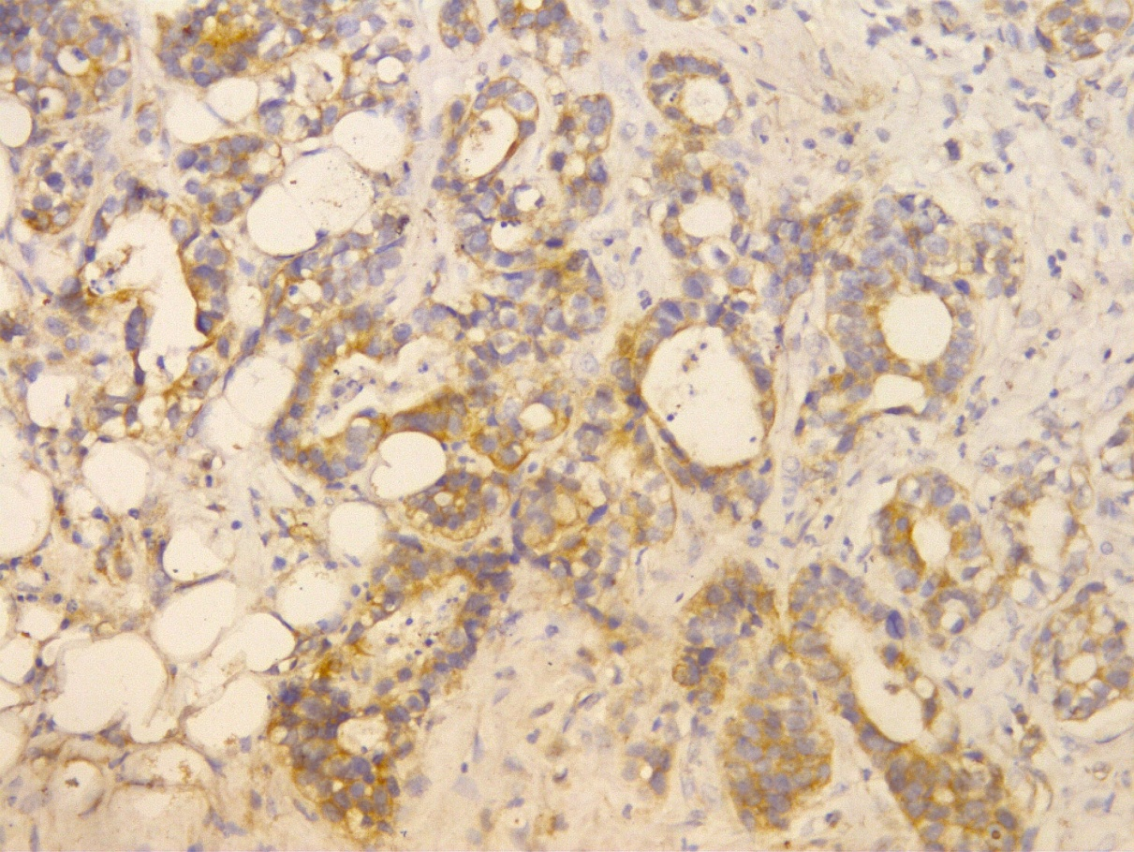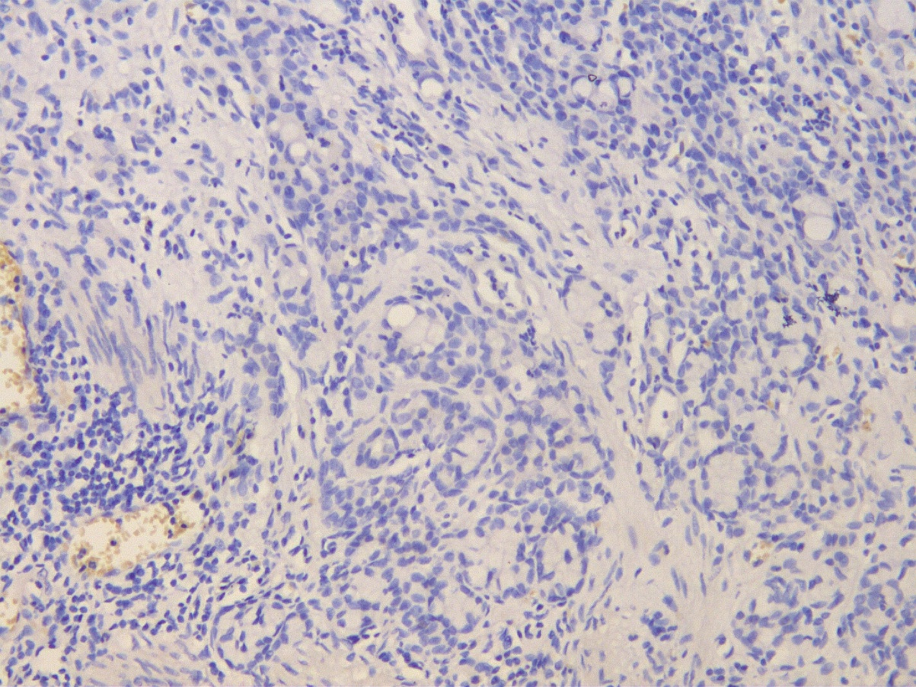
A B
Figure 1 Immunohistochemical analysis of fibroblast growth factor receptor 4 protein expression (× 200). A: High expression; B: Low expression.

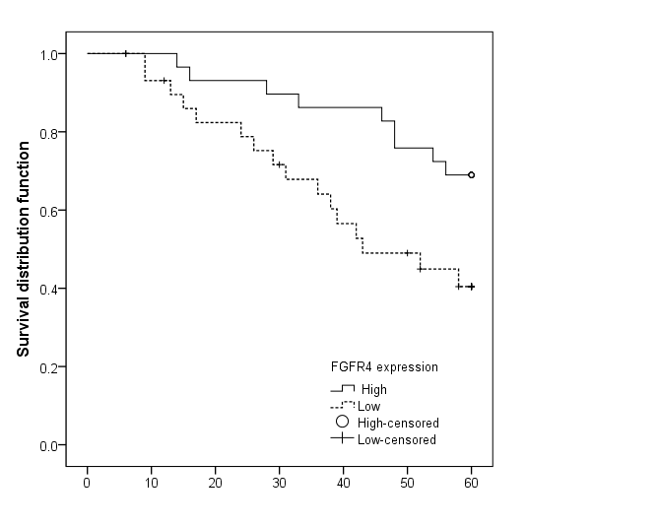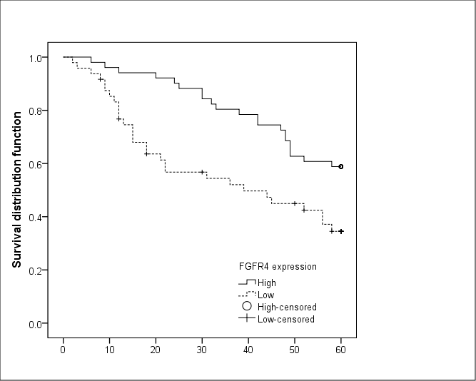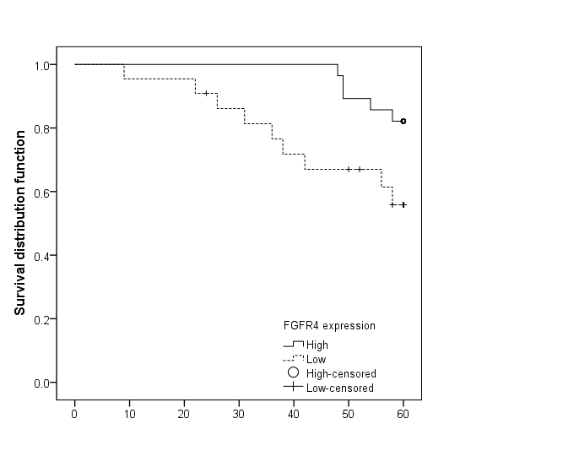
A B C
Figure 2 Significant difference was found between patients with high and low fibroblast growth factor receptor 4 protein expression after stratified Kaplan-Meier survival analysis. A: Patients with tumor size ≤ 3 cm; B: Patients with well-differentiated gastric cancer; C: Patients with gastric cancer classified as stage T1 or T2.

