Name of Journal: World Journal of Gastrointestinal Oncology
Manuscript NO: 76911
Manuscript Type: CORRECTION

Correction to “Genome-wide CRISPR-Cas9 screening identifies that hypoxia-inducible factor-1a-induced CBX8 transcription promotes pancreatic cancer progression via IRS1/AKT axis”

Teng BW et al. Correction letter

Bu-Wei Teng, Kun-Dong Zhang, Yu-Han Yang, Zeng-Ya Guo, Wei-Wei Chen, Zheng-Jun Qiu

Bu-Wei Teng, Department of General Surgery, Shanghai General Hospital of Nanjing Medical University, Shanghai 200080, China

Bu-Wei Teng, Department of General Surgery, Lianyungang Clinical College of Nanjing Medical University/The First People’s Hospital of Lianyungang, Lianyungang 222061, Jiangsu Province, China

Kun-Dong Zhang, Yu-Han Yang, Department of General Surgery, Shanghai General Hospital, Shanghai 200080, China

Zeng-Ya Guo, Wei-Wei Chen, Zheng-Jun Qiu, Department of General Surgery, Shanghai General Hospital, Shanghai 200080, China

Author contributions: Teng BW found and corrected the misused figure; Zhang KD, Yang YH, Guo ZY, Chen WW, and Qiu ZJ checked the correction.

Corresponding author: Zheng-Jun Qiu, MD, Chief Doctor, Director, Surgeon, Department of General Surgery, Shanghai General Hospital, No. 100 Haining Road, Shanghai 200080, China. zhengjun.qiu@shgh.cn

Received: April 6, 2022
Revised: June 15, 2022
Accepted: September 13, 2022
Published online:

Abstract
Correction to “Genome-wide CRISPR-Cas9 screening identifies that hypoxia-inducible factor-1a-induced CBX8 transcription promotes pancreatic cancer progression via IRS1/AKT axis” (PMID: 34853645 PMCID: PMC8603463 DOI: 10.4251/wjgo.v13.i11.1709). In this article, the picture of Figure 6C was misused due to our carelessness while typesetting. We corrected this mistake, and replaced the incorrect image with the correct one.

Key Words: Correction; Error; Figure; CRISPR-Cas9

Teng BW, Zhang KD, Yang YH, Guo ZY, Chen WW, Qiu ZJ. Correction to “Genome-wide CRISPR-Cas9 screening identifies that hypoxia-inducible factor-1a-induced CBX8 transcription promotes pancreatic cancer progression via IRS1/AKT axis.” World J Gastrointest Oncol 2022; In press

Core Tip: Correction to “Genome-wide CRISPR-Cas9 screening identifies that hypoxia-inducible factor-1a-induced CBX8 transcription promotes pancreatic cancer progression via IRS1/AKT axis.”

TO THE EDITOR
After confirming the figures in our manuscript, we were surprised to find a mistake in Figure 6C^{[1]}. It was an unintentional error that occurred when we typeset the images. We have replaced the incorrect images with the correct Figure 6C (Figure 1). Figure 6D-E was based on the correct image and does not need to be changed. We assure you that this mistake does not change the meaning of the picture or the conclusion of the manuscript. We apologize for our careless mistake, which has caused great inconvenience.

REFERENCES
1 Teng BW, Zhang KD, Yang YH, Guo ZY, Chen WW, Qiu ZJ. Genome-wide CRISPR-Cas9 screening identifies that hypoxia-inducible factor-1a-induced CBX8 transcription promotes pancreatic cancer progression via IRS1/AKT axis. World J Gastrointest Oncol 2021; 13: 1709-1724 [PMID: 34853645 DOI: 10.4251/wjgo.v13.i11.1709]

Footnotes
Conflict-of-interest statement: There are no conflicts of interest to report.

Open-Access: This article is an open-access article that was selected by an in-house editor and fully peer-reviewed by external reviewers. It is distributed in accordance with the Creative Commons Attribution NonCommercial (CC BY-NC 4.0) license, which permits others to distribute, remix, adapt, build upon this work non-commercially, and license their derivative works on different terms, provided the original work is properly cited and the use is non-commercial. See: https://creativecommons.org/Licenses/by-nc/4.0/

Provenance and peer review: Unsolicited article; Externally peer reviewed.
Peer-review model: Single blind

Peer-review started: April 6, 2022
First decision: June 12, 2022
Article in press:

Specialty type: Oncology
Country/Territory of origin: China
Peer-review report’s scientific quality classification
Grade A (Excellent): A
Grade B (Very good): B
Grade C (Good): C
Grade D (Fair): 0
Grade E (Poor): 0

P-Reviewer: Liu H, United States; Solimando AG, Italy; Trna J, Czech Republic S-Editor: Chen YL L-Editor: Filipodia P-Editor: Chen YL
Figure Legends
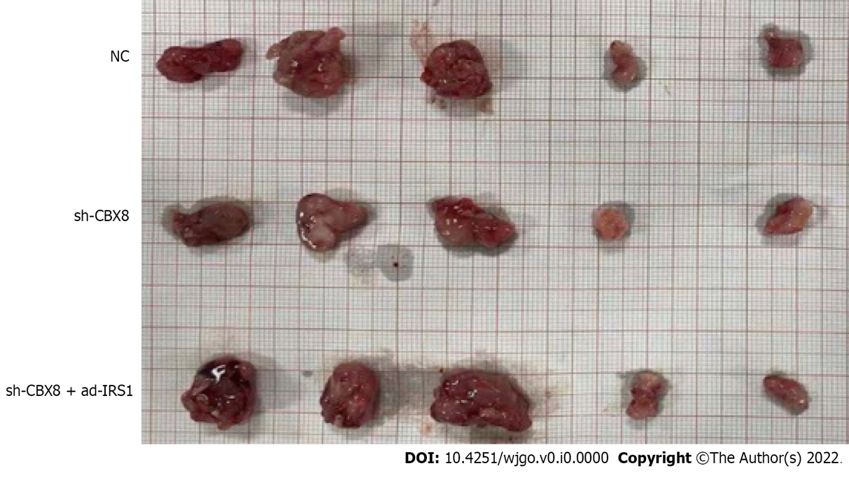
Figure 1 We replaced the incorrect images with the correct Figure 6C in “Genome-wide CRISPR-Cas9 screening identifies that hypoxia-inducible factor-1a-induced CBX8 transcription promotes pancreatic cancer progression via IRS1/AKT axis.”

