Name of Journal: World Journal of Clinical Cases
Manuscript NO: 61508
Manuscript Type: CASE REPORT

Hemoglobin Fukuoka caused unexpected hemoglobin A_{1c} results: A case report

Lin XP et al. Hb Fukuoka caused unexpected HbA_{1c} results

Xue-Ping Lin, Qiu-Rong Yuan, Shi-Qiong Niu, Xi Jiang, Zhi-Kun Wu, Zhao-Fan Luo

Xue-Ping Lin, Qiu-Rong Yuan, Shi-Qiong Niu, Xi Jiang, Zhi-Kun Wu, Zhao-Fan Luo, Department of Clinical Medical Laboratory, The Seventh Affiliated Hospital of Sun Yat-sen University, Shenzhen 518107, Guangdong Province, China

Author contributions: Lin XP encountered the case while working on the manuscript, reviewed the literature, and participated in drafting the manuscript; Yuan QR and Niu SQ reviewed the literature and participated in drafting the manuscript; Jiang X and Wu ZK participated in image processing and analysis; Luo ZF revised the manuscript for important intellectual content; all authors approved the final version of the manuscript as submitted.

Corresponding author: Zhao-Fan Luo, PhD, Professor, Department of Clinical Medical Laboratory, The Seventh Affiliated Hospital of Sun Yat-sen University, No. 628 Zhenyuan Road, Guangming District, Shenzhen 518107, Guangdong Province, China. luozhaofan@qq.com

Received: December 11, 2020
Revised: April 14, 2021
Accepted: May 20, 2021
Published online: July 16, 2021

Abstract
BACKGROUND
Glycated hemoglobin (Hb) (HbA_{1c}) is an indicator that is used to diagnose and monitor the treatment of diabetes. Many factors can affect the detection of HbA_{1c}. One of the most important of these factors is the Hb variant. Here, we report a rare Hb variant and evaluate its effect on HbA_{1c}.

CASE SUMMARY
A 35-year-old man was suspected of harboring an Hb variant following the measurement of HbA_{1c} with the Variant II Turbo 2.0 Hb detection system during a routine examination. Subsequently, we used the Arkray HA-8160 and ARCHITECT c4000 system to reanalyze HbA_{1c}. Finally, the Hb variant was detected with a Capillary2FP analyzer that operates on the principle of capillary electrophoresis. We also used gene sequencing to investigate the mutation site. The value of HbA_{1c} detected with the Variant II Turbo 2.0 system was 52.7%. However, the Arkray HA-8160 system did not display a result while the ARCHITECT c16000 system showed a result of 5.4%. The Capillary2FP analyzer did not reveal any abnormal Hb zones. However, gene sequencing identified the presence of a mutation in the Hb β2 chain [CD2(CAC>TAC),His>Tyr,HBB:c.7C>T]; the genotype was Hb Fukuoka.

CONCLUSION
Hb variants could cause abnormal HbA_{1c} results. For patients with Hb variants, different methods should be used to detect HbA_{1c}.

Key Words: Hemoglobin Fukuoka; Hemoglobin A_{1c}; Hemoglobin variant; High-performance liquid chromatography; Enzymatic method; Case report

©The Author(s) 2021. Published by Baishideng Publishing Group Inc. All rights reserved.

Citation: Lin XP, Yuan QR, Niu SQ, Jiang X, Wu ZK, Luo ZF. Hemoglobin Fukuoka caused unexpected hemoglobin A_{1c} results: A case report. World J Clin Cases 2021; 9(20): 5568-5574
URL: https://www.wjgnet.com/2307-8960/full/v9/i20/5568.htm
DOI: https://dx.doi.org/10.12998/wjcc.v9.i20.5568

Core Tip: Hemoglobin A_{1c} (HbA_{1c}) is an indicator of diabetes diagnosis and blood glucose monitoring. Therefore, the accuracy of HbA_{1c} results is of great significance to clinical diagnosis and treatment. This case had an abnormal HbA_{1c} result and traced back to a rare hemoglobin variant. Hemoglobin variants are one of the important factors affecting the accuracy of HbA_{1c} results. In this case, different methods were used to detect HbA_{1c}, which can provide reference evidence for subsequent cases and reduce false results reports.
INTRODUCTION
Hemoglobin A_{1c} (HbA_{1c}) is the main indicator recommended by the American Diabetes Association and the World Health Organization for the diagnosis of diabetes^{[1]}. HbA_{1c} is a stable compound that covalently bonds glucose and hemoglobin (Hb) β-chain N-terminal valine residues in human blood. It reflects the average blood glucose concentration over the previous 2 mo to 3 mo. However, the results of the HbA_{1c} are affected by a wide range of factors, including Hb variants, severe hemolytic anemia, and severe liver disease, etc. The most common factors that interfere with HbA_{1c} tests are Hb variants^{[2,3]}. In this paper, we report a case with abnormal HbA_{1c} values, which was eventually diagnosed as a rare Hb mutation.

CASE PRESENTATION
Chief complaints
A 35-year-old man arrived at our hospital for a physical examination in November 2018.

History of past illness
The patient had no special past history.

Personal and family history
The patient had no special personal and family history.

Physical examination
Normal physical examination without any obvious signs of abnormality.

Laboratory examinations
The HbA_{1c} result of 52.7% was out of the expected detection range (Figure 1A). The HbA_{1c} of the patient was remarkably elevated in comparison to the reference range (4.0%-6.4%). Data arising from routine blood analyses are shown in Table 1. The patient had normal liver function, normal fasting glucose, and no previous history of diabetes. The HbA_{1c} test was performed using the Biorad Variant II Turbo 2.0 automatic glycated Hb analyzer (Biorad, United States); the HbA_{1c} value was abnormally elevated, although the patient had no history of diabetes. Therefore, we suspected that the patient possessed Hb variants that interfered with the results of the HbA_{1c} test.

Further investigations for Hb variants
We attempted to confirm the HbA_{1c} value by using the Arkray HA-8160 automatic glycated Hb analyzer (Arcolai, Japan), which features high-performance liquid chromatography (HPLC), and the ARCHITECT c4000 system (Abbott, United States), which operates by enzymatic methods. The Arkray HA-8160 system returned no result; the instrument showed that the HbA_{1c} peak did not appear, and there was an abnormal protruding peak on the left of peak A₀ (Figure1B). The ARCHITECT c16000 enzyme assay returned a result of 5.4%.
Next, we used the Capillary2FP automated Hb analyzer (Sebia, France) to find the presence of abnormal Hb. Capillary electrophoresis showed no abnormal Hb bands (Figure 2).
In addition, the patient's genomic DNA was extracted using a Genomic DNA Isolation Kit (Kaipu, China) and the HBA1, HBA2, and HBB genes were amplified with specific forward/reverse primers and sequenced on an ABI3500 sequencer. HBA1 forward primer was 5´-CGCGCCAGCCAATGAGC-3´ and HBA1 reverse primer was 5´-ACACACATGGCTAGAACCTCTCTG-3´. HBA2 forward primer was 5´-GGGCTCCGCGCCAGCCAA-3´ and HBA2 reverse primer was 5´-CAAGGACCTCTCTGCAGCT-3´. HBB forward primer was 5´-TACGGCTGTCATCACTTAG-3´and HBB reverse primer was 5´-GCCACACTGAGTGAGCTGCACT-3´. We extracted a sample of whole blood from the patient and extracted genomic DNA. This was used as a template to amplify the Hb gene. Polymerase chain reaction amplicons were then sequenced. No thalassemia mutation types were found in the sequencing range for α1 and α2. However, the β-globin gene possessed a histidine > tyrosine (CAC >TAC) mutation in the 7th amino acid, C>T (Figure 3). Next, we searched the HbA_{1c} variant library website (http://globin.bx.psu.edu/hbvar/menu.html), which revealed that the Hb genotype was Hb Fukuoka (HBB:c.7C>T). Finally, the patient was confirmed to possess a heterozygous Hb Fukuoka mutation.

FINAL DIAGNOSIS
Finally, the patient was confirmed to possess a heterozygous Hb Fukuoka mutation.

TREATMENT
The patient was not treated.

OUTCOME AND FOLLOW-UP
For patients with Hb variants, we recommend the use of an assay that is not affected by interference caused by Hb variants.

DISCUSSION
The guidelines relating to diabetes mellitus that were published by the American Chemical Society in 2011 suggest that a patient should receive further research/investigation if HbA_{1c} > 15% or if the laboratory data are inconsistent with clinical manifestations. The guidelines also recommend the use of different test principles and methods so that the patient can be re-tested^{[4]}. In this case, the patient’s HbA_{1c} was 52.7%, significantly higher than 15%. The patient had no history of diabetes. Laboratory data were all within the normal quantitative range, including Hb, kidney and liver function parameters, and fasting blood glucose. Therefore, it was necessary to retest this patient and identify reasons that might underlie the abnormal HbA_{1c} result.
Biorad Variant II Turbo 2.0 and Arkray HA-8160 Glycation Hemoglobin analyzers are based on HPLC technology. Using this technology, it is possible to separate Hb fractions by differential affinity to the internal surface of the column or to the buffer. The greater the affinity to the buffer, the faster the elution, and the shorter the retention time. The greater the affinity to the analytical column, the slower the elution, and the longer the retention time. In this case, the Biorad Variant II Turbo 2.0 returned an HbA_{1c} result of 52.7%, and no result was detected by Arkray HA-8160. Therefore, we considered the possibility of interference caused by Hb variants. Hb variants can affect the separation of variants from HbA_{1c} or HbA by changing their charge, co-eluting with HbA1c, and replacing glycosylation sites^{[5,6]}. The NGSP website has declared that the common variants including S, C, D, and E have no effect on Biorad Variant II Turbo 2.0 (http://ngsp.org/factors.asp). However, some rare Hb variants can affect HbA_{1c} with HPLC^{[7,8]}. The ARCHITECT c16000 uses enzymatic methods to detect HbA_{1c} values. By lysing the whole blood sample and performing extensive proteolytic digestion, the Hb β chain releases amino acids, especially the glycated N-terminal valine. The signal generated by the glycosylated valine in the subsequent color-based reaction can then be used to calculate the HbA1c. At the analytical level, these methods are unaffected by the presence of Hb variants, such as HbC, HbD, HbE, and HbS. However, this method is unable to detect Hb variants^{[9]}. Therefore, an HbA_{1c} result of 5.4% can accurately reflect the glycated Hb of the patient. The Capillary 2FP system operates on the principle of capillary electrophoresis and was used to investigate for the presence of an Hb variant. The Capillary 2FP system showed no abnormal Hb bands. Gene sequencing identified the variant as an Hb Fukuoka heterozygote. This variant was first reported in Japan in 1985, and subsequently reported by both Harano et al^{[10]} and Farah et al^{[11]}. Harano et al^{[10]} found abnormal Hb peak in a diabetic patient's HbA_{1c} test in 1990, and identified that the patient had Hb Fukuoka. Furthermore, Farah et al^{[11]} identified the presence of Hb Fukuoka by performing electrophoresis examinations in a patient with anemia. As far as we know, this case was the first case to be discovered in China.
Several methods can be used to detect glycosylated Hb, including electrophoresis, immunoturbidimetric assay (immunoassay), enzymatic assay, boronate affinity, ion-exchange HPLC, or capillary electrophoresis. Laboratories should be aware of the limitations of their methods with respect to interference from other Hb variants and suggest alternative HbA_{1c} quantification methods^{[12,13]}. For patients with Hb variants, we recommend the use of an assay that is not affected by interference caused by Hb variants; this strategy will help avoid erroneous results that can mislead data in clinical practice^{[14]}. Glycated albumin and fructosamine are recommended as alternative indicators to monitor glycaemia when HbA_{1c} is disturbed^{[15]}.

CONCLUSION
The chromatographic pattern of abnormal Hb variants differs from that of normal samples, making it difficult for some instruments to determine accurate HbA_{1c} values. HbA_{1c} is an important indicator for the diagnosis, treatment, and monitoring of diabetes mellitus, and the accuracy of HbA_{1c} results is of paramount importance. But meanwhile, it is important for laboratory staff to be familiar with the factors that may cause interference, and to be able to communicate with clinicians in a timely manner to clarify the situation and make clinical suggestions. The ultimate goal is to ensure accurate and realistic test results so as to help clinical diagnosis.

ACKNOWLEDGEMENTS
We are grateful for instructive discussion with Professor Luo ZF.

REFERENCES
1 Jia W. Standardising HbA1c-based diabetes diagnosis: opportunities and challenges. Expert Rev Mol Diagn 2016; 16: 343-355 [PMID: 26680319 DOI: 10.1586/14737159.2016.1133299]
2 Weykamp C. HbA1c: a review of analytical and clinical aspects. Ann Lab Med 2013; 33: 393-400 [PMID: 24205486 DOI: 10.3343/alm.2013.33.6.393]
3 Campbell L, Pepper T, Shipman K. HbA1c: a review of non-glycaemic variables. J Clin Pathol 2019; 72: 12-19 [PMID: 30361394 DOI: 10.1136/jclinpath-2017-204755]
4 Sacks DB, Arnold M, Bakris GL, Bruns DE, Horvath AR, Kirkman MS, Lernmark A, Metzger BE, Nathan DM. Guidelines and recommendations for laboratory analysis in the diagnosis and management of diabetes mellitus. Clin Chem 2011; 57: e1-e47 [PMID: 21617152 DOI: 10.1373/clinchem.2010.161596]
5 Little RR, Roberts WL. A review of variant hemoglobins interfering with hemoglobin A1c measurement. J Diabetes Sci Technol 2009; 3: 446-451 [PMID: 20144281 DOI: 10.1177/193229680900300307]
6 Nasir NM, Thevarajah M, Yean CY. Hemoglobin variants detected by hemoglobin A1c (HbA1c) analysis and the effects on HbA1c measurements. Int J Diabetes Dev Ctries 2010; 30: 86-90 [PMID: 20535312 DOI: 10.4103/0973-3930.62598]
7 Little RR, La'ulu SL, Hanson SE, Rohlfing CL, Schmidt RL. Effects of 49 Different Rare Hb Variants on HbA1c Measurement in Eight Methods. J Diabetes Sci Technol 2015; 9: 849-856 [PMID: 25691657 DOI: 10.1177/1932296815572367]
8 Strickland SW, Campbell ST, Little RR, Bruns DE, Bazydlo LAL. Recognition of rare hemoglobin variants by hemoglobin A_{1c} measurement procedures. Clin Chim Acta 2018; 476: 67-74 [PMID: 29154790 DOI: 10.1016/j.cca.2017.11.012]
9 Rhea JM, Molinaro R. Pathology consultation on HbA(1c) methods and interferences. Am J Clin Pathol 2014; 141: 5-16 [PMID: 24343732 DOI: 10.1309/AJCPQ23GTTMLAEVL]
10 Harano T, Harano K, Ueda S, Imai K, Ohkuma A, Koya Y, Takahashi H. Hb Fukuoka [beta 2(NA2)His----Tyr]: a new mutation at the 2,3-diphosphoglycerate binding site. Hemoglobin 1990; 14: 199-205 [PMID: 2272842 DOI: 10.3109/03630269009046961]
11 Farah RA, Buchanan GR, Timmons CF, Phillips L, Fairbanks VF, Snow K, Hoyer JD. Double heterozygosity for Hb G-San Jose [beta7(A4)Glu-->Gly] and Hb Fukuoka [beta2(NA2)His-->Tyr] in a 2 1/2-year-old girl. Hemoglobin 1999; 23: 383-387 [PMID: 10569729 DOI: 10.3109/03630269909090756]
12 Yun YM, Ji M, Ko DH, Chun S, Kwon GC, Lee K, Song SH, Seong MW, Park SS, Song J. Hb variants in Korea: effect on HbA1c using five routine methods. Clin Chem Lab Med 2017; 55: 1234-1242 [PMID: 28107170 DOI: 10.1515/cclm-2016-0865]
13 Xu A, Chen W, Xia Y, Zhou Y, Ji L. Effects of common hemoglobin variants on HbA1c measurements in China: results for α- and β-globin variants measured by six methods. Clin Chem Lab Med 2018; 56: 1353-1361 [PMID: 29626415 DOI: 10.1515/cclm-2017-1211]
14 American Diabetes Association. 2. Classification and Diagnosis of Diabetes: Standards of Medical Care in Diabetes-2020. Diabetes Care 2020; 43: S14-S31 [PMID: 31862745 DOI: 10.2337/dc20-S002]
15 Ribeiro RT, Macedo MP, Raposo JF. HbA1c, Fructosamine, and Glycated Albumin in the Detection of Dysglycaemic Conditions. Curr Diabetes Rev 2016; 12: 14-19 [PMID: 26126638 DOI: 10.2174/1573399811666150701143112]

Footnotes
Informed consent statement: Informed written consent was obtained from the patient for publication of this report.

Conflict-of-interest statement: The authors declare that they have no conflicts of interest to report.

CARE Checklist (2016) statement: The authors have read the CARE Checklist (2016), and the manuscript was prepared and revised according to the CARE Checklist (2016).

Open-Access: This article is an open-access article that was selected by an in-house editor and fully peer-reviewed by external reviewers. It is distributed in accordance with the Creative Commons Attribution NonCommercial (CC BY-NC 4.0) license, which permits others to distribute, remix, adapt, build upon this work non-commercially, and license their derivative works on different terms, provided the original work is properly cited and the use is non-commercial. See: http://creativecommons.org/Licenses/by-nc/4.0/

Manuscript source: Unsolicited manuscript

Peer-review started: December 11, 2020
First decision: April 4, 2021
Article in press: May 20, 2021

Specialty type: Medicine, research and experimental
Country/Territory of origin: China
Peer-review report’s scientific quality classification
Grade A (Excellent): 0
Grade B (Very good): B
Grade C (Good): 0
Grade D (Fair): 0
Grade E (Poor): 0

P-Reviewer: Panyasai S S-Editor: Gao CC L-Editor: Wang TQ P-Editor: Wang LYT

Figure Legends
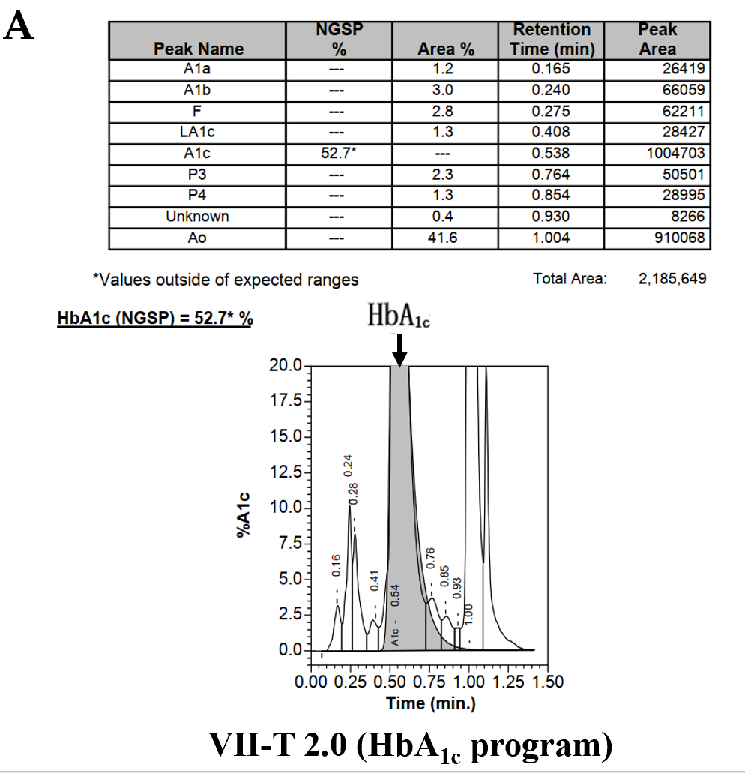
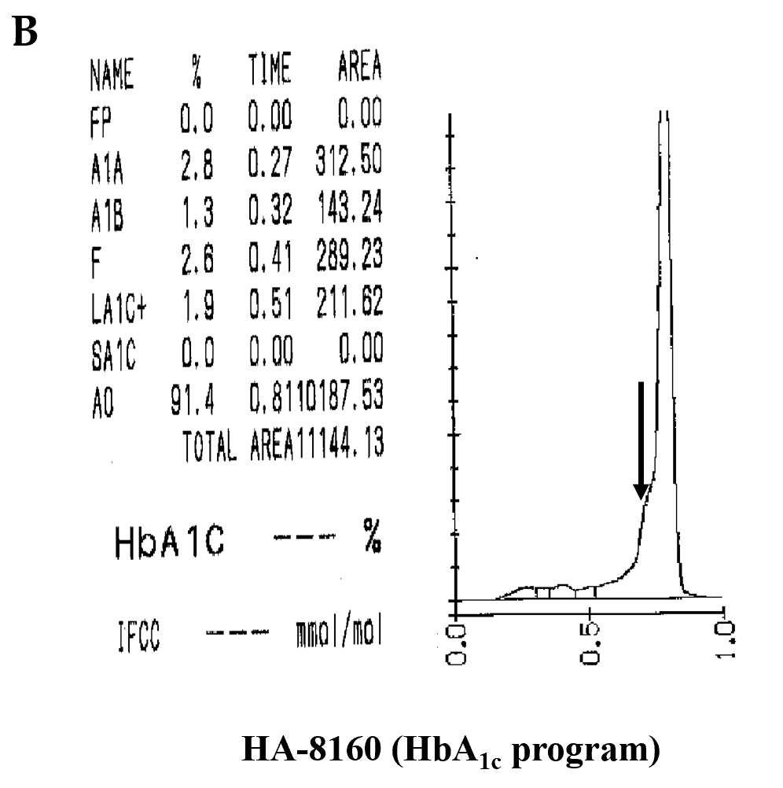
Figure 1 Detection of hemoglobin A_{1c} with a Variant II Turbo 2.0 system and an Arkray HA-8160 system. A: The peak of hemoglobin A_{1c} (HbA_{1c}) was abnormally elevated (orange arrow); B: The HbA_{1c} peak did not appear, and there was an abnormal protruding peak on the left of peak A₀ (orange arrow). HbA_{1c}: Hemoglobin A_{1c}.
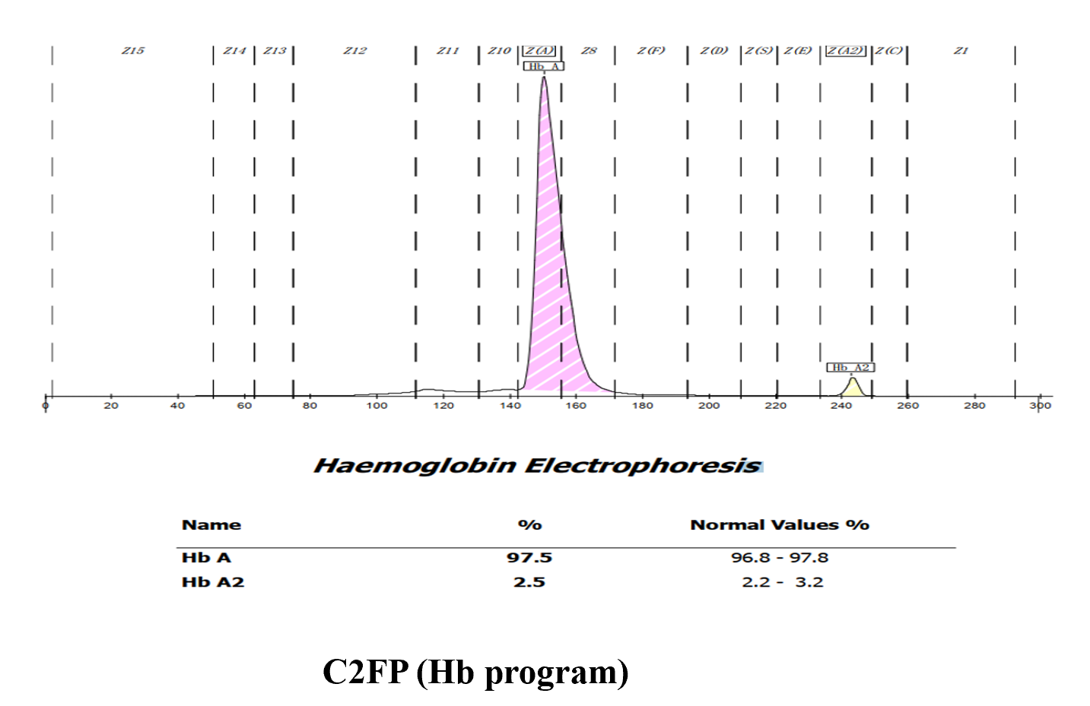
Figure 2 A Capillary2FP system was used to find the hemoglobin variant. Hb: Hemoglobin.
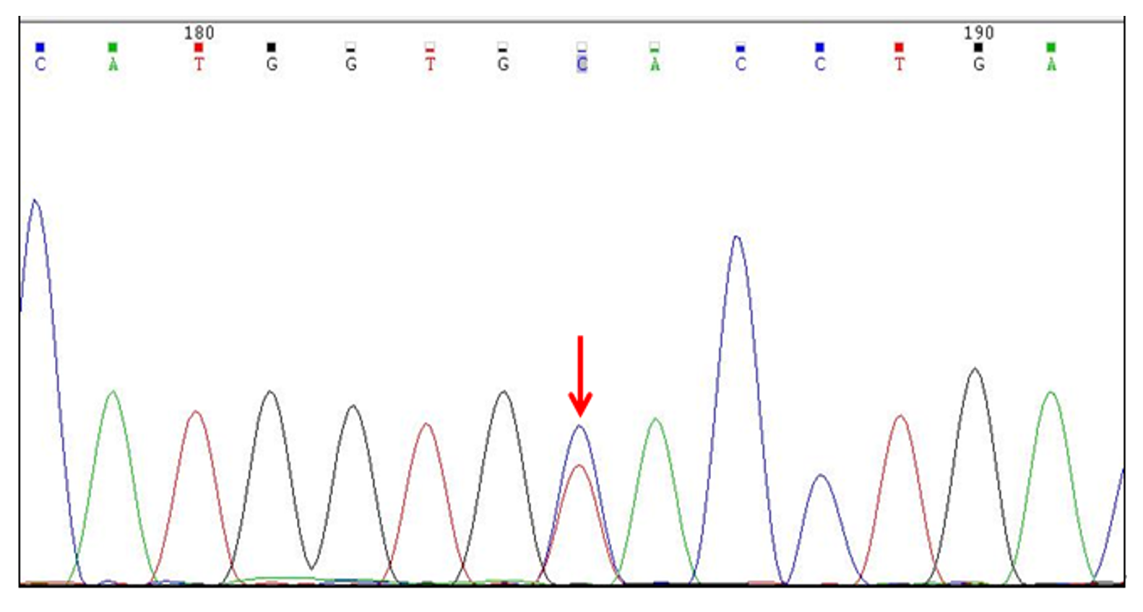
Figure 3 Gene sequencing results revealed a β chain mutation in the gene [CD2(CAC>TAC), His>Tyr, HBB:c.7C>T] (orange arrow).
Table 1 Routine blood data
 | Results | Reference range
Red blood cells (× 10¹²/L) | 5.6 | 4.3-5.8
Hemoglobin (g/L) | 161 | 130-175
Mean erythrocyte volume (fL) | 91 | 82-100
Mean erythrocyte hemoglobin volume (pg) | 29 | 27-34
Mean erythrocyte hemoglobin concen-tration (g/L) | 315 | 316-354
Erythrocyte distribution width (%) | 13 | 12-15
Total protein (g/L) | 79.3 | 65.0-85.0
Albumin (g/L) | 46.1 | 32.0-45.0
Alanine aminotransferase (U/L) | 19 | 0-55
Aspartate transferase (U/L) | 22 | 15-40
Blood creatinine (µmol/L) | 76 | 64-104
Blood urea nitrogen (mmol/L) | 4.8 | 3.2-7.4
Fasting glucose (mmol/L) | 4.71 | 3.90-6.10

Published by Baishideng Publishing Group Inc
7041 Koll Center Parkway, Suite 160, Pleasanton, CA 94566, USA
Telephone: +1-925-3991568
E-mail: bpgoffice@wjgnet.com
Help Desk: https://www.f6publishing.com/helpdesk
https://www.wjgnet.com

© 2021 Baishideng Publishing Group Inc. All rights reserved.

