Name of journal: World Journal of Gastroenterology
Manuscript NO: 33550
Manuscript Type: ORIGINAL ARTICLE

Observational Study
Couples of patients with ulcerative colitis exhibit a biologically relevant dysbiosis in fecal microbial metacommunities

Chen GL et al. Couples with UC have microbiota dysbiosis

Guang-Lan Chen, Ye Zhang, Wang-Yue Wang, Xue-Liang Ji, Fei Meng, Pei-Song Xu, Ning-Min Yang, Fu-Qiang Ye, Xiao-Chen Bo

Guang-Lan Chen, Ye Zhang, Wang-Yue Wang, Xue-Liang Ji, Department of Gastroenterology, Lishui People's Hospital, Lishui 323000, Zhejiang Province, China

Fei Meng, Pei-Song Xu, Ning-Min Yang, Department of Research Service, Zhiyuan Medical Inspection Institute Co., LTD, Hangzhou 310030, Zhejiang Province, China

Fu-Qiang Ye, Xiao-Chen Bo, Department of Radiation Toxicology and Oncology, Beijing Institute of Radiation Medicine, Beijing 100089, China

Author contributions: Guang LC, Yang NM and Bo XC formulated the problem; Zhang Ye, Wang WY collected samples; Meng F and Xu PS performed 16Sr RNA sequencing; Ye FQ performed analyzed the data; Guang LC, Meng F and Xu PS wrote the paper.

Supported by Lishui Science and Technology Bureau Research Fund, No. 2013JYZB43; Medical and Health Science and Technology Plan Project of Zhejiang Province, No.2015KYB371.

Institutional review board statement: No animal subjects were used in this study.

Clinical trial registration statement: This study was approved by the Ethics Committee of Lishui People’s Hospital.

Informed consent statement: All study participants, or their legal guardian, provided informed written consent prior to study enrollment.

Conflict-of-interest statement: To the best of our knowledge, no conflicts of interest exist.

Data sharing statement: No additional data are available.

Open-Access: This article is an open-access article which was selected by an in-house editor and fully peer-reviewed by external reviewers. It is distributed in accordance with the Creative Commons Attribution Non Commercial (CC BY-NC 4.0) license, which permits others to distribute, remix, adapt, build upon this work non-commercially, and license their derivative works on different terms, provided the original work is properly cited and the use is non-commercial. See: http://creativecommons.org/licenses/by-nc/4.0/

Manuscript source: Unsolicited manuscript

Correspondence to: Dr. Xiao-Chen Bo, Department of Radiation Toxicology and Oncology, Beijing Institute of Radiation Medicine, People’s Republic of China, Beijing 100089, China. boxc@bmi.ac.cn

Received: February 15, 2017
Peer-review started: February 16, 2017
First decision: April 7, 2017
Revised: April 10, 2017
Accepted: May 19, 2017
Article in press:
Published online:

Abstract
AIM
To investigate alterations in the fecal microbiome using 16S rRNA amplicon sequencing in couples in the same cohabitation environment.

METHODS
Fecal samples were collected from 8 ulcerative colitis (UC) patients and their healthy couples at Lishui People’s Hospital, Zhejiang Province, China. DNA was extracted and the variable regions V3 and V4 of the 16S rRNA genes were PCR amplified using a two-step PCR protocol. Clear reads were clustered into operational taxonomic units (OTUs) at the 97% sequence similarity level by UCLUST v1.2.22. The Wilcoxon rank-sum test (R v3.1.2) was used to compare inter-individual differences. Differences with P < 0.05 were considered statistically significant.

RESULTS
Fecal microbial communities were more similar among UC patients than their healthy couples (P = 0.024). UC individuals had a lower relative abundance of bacteria belonging to the Firmicutes, especially Blautia, Clostridium, Coprococcus and Roseburia (P < 0.05). Microbiota dysbiosis was detected in UC patients and their healthy couples, relevant genera included Akkermansiam, Bacteroides, Escherichia, Lactobacillales, Klebsiella and Parabacteroides. The enriched pathways in fecal samples of UC patients were related to lipid and nucleotide metabolism. Additionally, the pathway involved in membrane transport and metabolism of cofactors and vitamins was more abundant in healthy couples.

CONCLUSION
Our results suggest that microbial composition may be impacted in healthy couples cohabiting with UC patients, especially in terms of microbiota dysbiosis in healthy couples.

Key words: Ulcerative colitis; Patients; Healthy couples; Fecal microbial communities; Microbiota dysbiosis

© The Author(s) 2017. Published by Baishideng Publishing Group Inc. All rights reserved.

Core tip: To identify the influence on the gut microbial community between ulcerative colitis (UC) patients and their healthy couples, we investigated the gut bacterial community using 16S rRNA amplicon sequencing. The results showed that fecal microbial communities were more similar in UC patients, which had a lower relative abundance in Firmicutes bacteria. Microbiota dysbiosis was also founded in healthy couples. The pathway involved in lipid and nucleotide metabolism was more abundant in UC patients. The membrane transport and metabolism of cofactors and vitamins pathway was significantly enriched in healthy couples. Microbial composition may be impacted in healthy couples cohabiting with UC patients.

Guang LX, Zhang Y, Wang WY, Ji XL, Meng F, Xu PS, Yang NM, Bo XC. Couples of patients with ulcerative colitis exhibit a biologically relevant dysbiosis in fecal microbial metacommunities. World J Gastroenterol 2017; In press

Introduction
Ulcerative colitis (UC), one of the main types of inflammatory bowel disease (IBD), has become increasingly prevalent in developed countries over the past two decades^{[1]}. However, according to the latest Asian epidemiological investigation, the incidence of the IBD has dramatically expanded into developing countries with the increased westernization of lifestyles^{[1,2]}.
UC is a multi-faceted disorder associated with a germline genetic background, an aberrant immune system response and environmental factors^{[3]}. Recently, the gut microbial community has attracted substantial attention, especially the influence in healthy and IBD patients^{[4-6]}. Some alterations in the microbial community are shared in Crohn's disease (CD) and UC patients relative to healthy people, including reduced gut microbiota diversity (particularly Firmicutes), the presence of non-commensals, and increased abundance of pathogenic Proteobacteria strains^{[7,8]}. However, some alterations in the bacterial community are specific in UC. For example, increased presence of Escherichia coli and Fusobacterium spp group^{[6]} as well as a reduction in Clostridium coccoides group has been reported in UC patients^{[9]}.
At present, some studies demonstrate that environmental factors, including dietary age^{[9]}, habits^{[10]}, and obesity^{[11]}, impact the gut microbiota composition. We wondered whether the cohabitation environment can influence the microbial community. In 1994, an investigation of 10 couples showed that individuals with IBD symptoms before marriage influence their partners, resulting in similar symptoms in couples^{[12]}. However, these results mainly focused on clinical symptoms and did not involve gut microbial community.
Profiling the fecal microbiome using methods based on analysis of the 16S ribosomal RNA gene is less biased than cultivation-based approaches. In recent years, bacterial 16S rRNA amplicon sequencing, referred to as “16S rRNA gene sequencing”, has been widely utilized for metagenomic analysis of the environment, including analysis of the composition of the human and animal guts and fecal microbiota^{[13,14]}. In particular, compared with bacterial culture, 16S rRNA gene sequencing has a huge advantage in identifying new pathogens or difficult to culture bacteria with a culture-independent method. Compared with other high-throughput sequencing platforms (pyrosequencing, Life Technologies platform), the MiSeq platform generates the highest base sequence accuracy with little limitation on the DNA input^{[15,16]}. Although the cohabitation environment has been studied with 16S rRNA gene sequencing, many studies on the gut microbial community of IBD patients focus on comparisions between twins and siblings^{[11,17]}.
This study aims to deeply explore the composition of the UC gut bacterial community using 16S rRNA sequencing as well as to identify the influence on the gut microbial community between couples. Additionally, the current study investigates the predominant fecal microbiota of UC patients compared to healthy couples in a common cohabitation environment.

Materials and methods
Patient selection
The diagnosis of UC was determined by endoscopic and pathologic findings, and patients diagnosed with UC for longer than 3 months were recruited from Lishui People’s Hospital at Zhejiang Province. Healthy couples composing the control group, were recruited from a common living environment cohabiting with the UC patients. All participants in this study were divided into two groups (n=8 each) according to their disease status. Group A consisted of UC patients, including UC1-UC8. Group B consisted of their healthy partners, including HF1-HF8. The study was approved by the Ethics Committee of the hospital and all patients provided written informed consent upon enrolment.

Sample collection and DNA extraction
Fecal samples were collected from all participants and were immediately stored at -80 °C until further processing. The total DNA was extracted from 200 mg of fecal sample using the QIAamp DNA Stool Mini Kit (Qiagen, Inc., Valencia, CA, USA) according to the manufacturer’s instructions. The DNA concentration was quantified using a Qubit 2.0 Fluorometer and appropriately diluted based on the total DNA concentration.

16S amplicon-sequencing
The bacterial 16S rRNA gene, with variable regions V3 and V4, was amplified using a two-step PCR protocol. In brief, the first PCR was performed with universal primer (356F 5’-CCTACGGGNGGCWGCAG-3’ and 803R 5’-GACTACHVGGGTATCTAATCC-3’) and an attached overhang adapter (forward primer overhang adapter 5’-TCGTCGGCAGCGTCAGATGTGTATAAGAGACAG-3’ and reverse primer overhang adapter 5’-GTCTCGTGGGCTCGGAGATGTGTATAAGAGACAG-3’). The first PCR reaction mixture (20 μL) contained 10 ng of DNA template, 10 μL of 2 × High-Fidelity PCR Master Mix with HF Buffer (New England Biolabs, Ipswich, MA, United States), each primer at 5 μM and reagent-grade water (Sigma Aldrich, St. Louis, MO, United States). The first PCR program for V3 and V4 consisted of an initial denaturation of 95 °C for 3 min, which was followed by 25 cycles of denaturation at 95°C for 30 s, annealing at 60°C for 30 s, extension at 72 °C for 30 s, and a final extension at 72 °C for 5 min. Then, the PCR product was cleaned with AMPure XP DNA purification beads (Beckman Coulter, Danvers, MA, United States) according to the manufacturer’s instructions. The second PCR reaction mixture (25 μL) contained 2 μL of cleaned PCR products; 12.5 μL of 2 × High-Fidelity PCR Master Mix and HF Buffer; P5/P7 primers, including adapters and sample barcodes (Illumina), and reagent-grade water. The second PCR program was similar to the first PCR program except annealing was at 50 °C and the program was for 10 cycles. Finally, the PCR product was purified with AMPure XP beads to remove primer dimers and was then quantified on an Agilent Bioanalyzer 2100 with High Sensitivity DNA chips (Agilent Technologies, Santa Clara, CA, United States). The library of each sample was pooled at an equimolar concentration, and sequencing was performed on the Illumina MiSeq platform to generate 2 × 250 bp paired-end reads.

Taxonomic classification and pathway profiles of 16S rRNA gene sequencing data
We merged the paired-end reads using FLASH v1.2.11 and obtained ~460 bp V3-V4 16S sequences. Merged reads were processed with QIIME v1.8.0, which removed reads with N bases and trimmed reads with more than three consecutive low-quality bases (Q < 20). Then reads passing the high quality filters were aligned to the Greengenes Database (Aug, 2013 version), and USEARCH v6.1 was applied for chimera checking. Then, UCLUST v1.2.22 was used for operational taxonomic unit (OTU) clustering at the 97% sequence similarity level. Each OTU was classified according to assignment of the taxonomic rank using the reference dataset from the Ribosomal Database Project (version 2.2). Phylogenetic Investigation of Communities by Reconstruction of Unobserved States (PICRUSt) analysis was performed to generate Kyoto Encyclopedia of Genes and Genomes (KEGG) pathway profiles as previously described^{[18,19]}.

Statistical analysis
Correlations between the overlapping genera of the 16S rRNA gene sequencing were identified using Pearson’s correlation in the R language. The Wilcoxon rank-sum test (R v3.1.2) was employed to detect interindividual differences. Under the condition of multiple comparisons, P-values were corrected to control for the false-discovery rate. Differences with P < 0.05 were considered statistically significant.

Results
Study subjects and 16S rRNA sequencing
To measure the compositional and functional differences in the common living environment between the gut microbiota of UC and healthy individuals, 16 fecal samples were collected from 8 families, including 8 UC patients and 8 healthy control couples. All patients in this study were cohabiting with their couples. The demographics and characteristics of 8 UC patients and their couples are shown in Table 1.
16S rRNA amplicon-sequencing of fecal DNA samples was performed using next-generation sequencing (NGS) technology. Low-quality reads and chimera sequences were filtered from the raw data; eventually, we obtained an average of 47469 reads per sample. These reads corresponded to 1137 operational taxonomic units (OTUs) at the 97% sequence similarity level using UCLUST and identified 167 genera. There was no significant difference between the number of OTUs in UC patients and their families (947 ± 298.4 for UC patients and 1327.1 ± 419.9 for relatives, P = 0.071).

Microbiota diversity and similarity analyses
We used three metrics to characterize the fecal microbiota diversity between UC patients and their couples. Microbial alpha diversity was not significantly different by Chao1 analysis (P = 0.573). Additionally, there were no significant differences observed by Shannon-Wiener (P = 0.505) or Simpson’s indices (P = 0.574). The distribution of fecal microbiota was determined using Bray Curtis similarities analysis. The entire microbiota of UC patients was not significantly divergent from those of their couples who lived in the same environment (P = 0.449). However, using un-weighted analysis, the microbiota composition was more similar among UC patients than that in their couples (Figure 1, P = 0.024). These results indicated that cohabiting with UC patients may influence the fecal microbiota composition of healthy people, but higher dissimilarity of microbiota was still found in healthy couples.

Microbial composition
Although there was no significant difference in overall microbial diversity, some bacteria were significantly different between UC patients and their couples using the Wilcoxon test. As shown in Figure 2, at the genus level, 10 genera were less abundant in the fecal microbiota of UC patients than those of their healthy couples and only 1 bacterium had a higher abundance in UC patients (P < 0.05). At the phylum level, the 9 significantly different bacteria species belonged to Firmicutes, and the other bacteria were classified into Actinobacteria and Bacteroidetes.
In this study, fecal microbiota in UC patients showed a decrease in the Firmicutes bacteria, especially Blautia, Clostridium, Coprococcus and Roseburia. Blautia was detected at 5.81% in healthy couples, and this percentage was lower proportion in UC patients. Clostridium and Coprococcus accounted for 6.49% and 3.4% of the fecal microbiota composition of healthy couples, whereas these genera were less abundant in UC patients, with proportions of 0.96% and 0.45%, respectively. A similar trend was also observed when detecting the relative proportion of Roseburia, which is present in 1.48% of healthy families and 0.15% of UC patients. In other Firmicutes genera, such as Anaerostipes Lachnospira, Megasphaera and Turicibacter, there was a very low abundance in UC patients. Although they were not detected in all healthy families, these rare species in the families were significantly different from UC patients. For example, Anaerostipes was only detected in only UC patients at a percentage of 0.006%, but the percentage was 0.68% in healthy couples. Additionally, Alistipes belonging to Bacteroidetes and an unclassified bacterium of Actinobacteria did not appear in UC patients, but they were detected in healthy families at low abundances of 0.14% and 0.23%, respectively.

Microbiota dysbiosis
An unclassified bacterium belonging to Lactobacillales was detected in UC patients (UC1) with a higher relative abundance than in their couples (Figure 2, P = 0.032). The proportion of Lactobacillus genus showed large dysbiosis in patient UC1, accounting for 81.8% (Figure 3). Microbiota dysbiosis was also observed in other UC patients and their couples. In patient UC2, the first and second most abundant genera were Bacteroides and Parabacteroides, which were present in percentages of 58.63% and 28.93%, respectively (Figure 3). Bacteroides was also the dominant genus, accounting for 70.24% in patient UC6. In addition, the Escherichia genus accounted for 44.39% in patient UC5. For healthy couples, microbiota dysbiosis was also found, in a few individuals. For example, in HF6, the relative abundance of the Klebsiella genus reached 63.3%. Akkermansia, belonging to the Verrucomicrobia phylum was only detected in patient UC4 and his couples, accounting for 18.46% and 68.74%, respectively (Figure 3). Microbiota dysbiosis destroyed the gut microbiota composition and influenced its normal function, which may accelerate the occurrence of intestinal disease.

Microbial metabolic pathways
Through combining the microbial composition with a genome database from KEGG (Kyoto Encyclopedia of Genes and Genomes), 328 pathways were identified. We continued our analysis using the Wilcoxon test, and 20 of 328 (6.09%) total metabolic pathways were differentially abundant at Q < 0.05 between UC patients and their healthy couples. In UC patients, we observed that 10 pathways were significantly increased, especially those for lipid metabolism and nucleotide metabolism. Another 8 pathways, such as those involving membrane transport and metabolism of cofactors and vitamins, were more abundant in healthy couples (Table 2).
The lipid metabolic pathway, including primary bile acid biosynthesis, secondary bile acid biosynthesis (P = 0.019) and linoleic acid (P = 0.025), was significantly enriched in UC patients. The pathway involved in purine metabolism was more abundant in UC patients (P = 0.019). In contrast, there was a decrease in porphyrin and chlorophyll metabolism in UC patients (P = 0.032). In addition, UC patients had fewer ABC transporters for membrane transport (P = 0.041).

Discussion
Alteration in the composition of gut microbiota and decreases in community diversity are associated with the pathogenesis of UC^{[20]}. However, there is a poor understanding of the interaction between couples cohabiting a shared environment. In this study, we analyzed the differences in the bacterial profiles and metabolic pathways between UC patients and their couples living in a common environment. Marked microbiota dysbiosis and reduction of the diversity of Firmicutes were observed. Furthermore, to understand the functions of the different bacteria, we compared the differences in the microbial metabolic pathways. Lipid metabolism and the biosynthesis of bile acids were significantly up-regulated in UC patients.
Unlike in previous reports, we did not observe a significant difference in the disease state in OTU distribution^{[21]}. Additionally, we did not identify significant difference between UC patients and their families in terms of the microbial alpha diversity by the Chao1, Shannon and Simpson’s indices^{[20,22]}. In contrast, we confirmed the compositional similarity in UC patients and their couples. Although there was no direct evidence that gut microbiota could spread between IBD patients and normal individuals, the results of this study suggested that fecal microbiota likely influence each other during long-term inhabiting of UC patients. Remarkably, our results indicated that the fecal microbiota composition was more similar among UC patients than among healthy individuals (Figure 1). These findings further demonstrated that the gut microbiota composition and alterations play a crucial role in the occurrence of UC.
Although the cause of UC has many uncertain factors, gut microbiota dysbiosis has been considered a major trigger of inflammation^{[23]}. Consistent with previous studies^{[22,24]}, we also found that fecal microbiota in UC patients in the present study had a decrease in Firmicutes bacteria, especially in Blautia, Clostridium, Coprococcus and Roseburia bacteria (Figure 2). Although we realized that the gut microbial composition and its interaction with the host likely plays an important role in IBD, the relationship between these has remained a mystery. Our research further confirmed that Firmicutes plays a crucial role in UC patients. The reduction in Clostridium likely decreased the utilization of short chain fatty acid and butyric acid salt in intestinal epithelial cells and induced inflammation. The depletion of Actinobacteria and Bacteroidetes remained controversial, and we found that these bacteria were greatly depleted^{[21,25,26]}.
Interestingly, comparison of the relative abundance at the genus level using 16S rRNA gene sequencing from UC patients and their couples demonstrated that the composition of the fecal microbiota was dominated by Bacteroides in patients UC2 and UC6. By contrast, other samples, including in healthy couples, were not identified this situation. Additionally, in the healthy couples, HF4 and HF6 were dominated by Akkermansia and Klebsiella, respectively. We speculated that this microbiota dysbiosis is likely a consequence of the interaction in the same enviroment.
In agreement with previous studies, we observed that lipid metabolism was remarkably increased^{[27]}. Previous studies have suggested that commensal bacteria may increase or decrease certain specific metabolic pathways to participate in competition for limited energy resources while living in the host intestinal environment. Davenport et al. posited that due to the lack of carbohydrates in inflamed regions, such as in the case of mucin production dysfunction, gut commensal bacteria start metabolizing lipids and amino acids for necessary nutrients. This, hypothesis was supported by the decrease in Firmicutes that are unable to utilize amino acids for energy^{[27,28]}.
Furthermore, one study found that patients with IBD can have co-occurrence of primary biliary cirrhosis^{[29]}. In the present study, we observed a significant increase in both primary bile acid biosynthesis and secondary bile acid biosynthesis of lipids (P = 0.019) in UC patients (Table 2). In healthy individuals, it was difficult to detect bile acid in the blood. However, when liver cells are damaged, bile acid biosynthesis is abnormal and its concentration increased. We speculated that the increase in bile acid biosynthesis in UC patients may be associated with frequent liver disease, such as chronic liver disease or alloimmune liver disease. Of course, liver cell damage was also related to drug toxicity produced by long term medication and immune deficiency in UC patients. This would lead to oxidative stress, and some bacteria need to maintain homeostasis under oxidative stress. Interestingly, we observed an increase in linoleic acid metabolism in UC patients (P = 0.025). Linoleic acid is a type of unsaturated fatty acid that is associated with prostaglandin biosynthesis, and it could participate in liver injury protection.
In conclusion, this study presents a comprehensive evaluation of the bacterial composition and the differences in the pathway of UC fecal microbiota. Although our results were similar to the results of previous studies, we also identified an increased prevalence of the lipid metabolic pathway and bile acid biosynthesis. The gut microbiota of the UC patients and their partners likely influence each other. Furthermore, we verified that microbiota dysbiosis is more likely a consequence rather than a cause of inflammation.

COMMENTS
Background
Ulcerative colitis (UC), is one of the main types of inflammatory bowel disease. Compared to healthy people, some alterations in the microbial community are shared in Crohn's disease and UC patients. But, some alterations in the bacterial community are specific in UC patients. The authros wondered whether the cohabitation environment can influence the microbial community. Previous studies mainly focused on clinical symptoms and did not involve gut microbial community. Profiling the fecal microbiome using methods based on analysis of the 16S ribosomal RNA gene is less biased than cultivation-based approaches. Therefore, we investigated the gut bacterial community between UC patients and their healthy couples using 16S rRNA amplicon sequencing.

Research frontiers
Recently, the gut microbial community has attracted substantial attention, especially the influence in healthy and inflammatory bowel disease (IBD) patients. Some studies demonstrate that environmental factors, including dietary age, habits, and obesity, impact the gut microbiota composition.

Innovations and breakthroughs
This study is the first one to investigate the influence on the gut microbial community between UC patients and their healthy couples in a common cohabitation environment. This study showed that microbial composition may be impacted in healthy couples cohabiting with UC patients, especially in terms of microbiota dysbiosis in healthy couples.

Applications
In this study, the authors analyzed the differences in the bacterial profiles and metabolic pathways between UC patients and their couples living in a common environment. These findings further demonstrated that the gut microbiota composition and alterations play a crucial role in the occurrence of UC. Futhermore, the gut microbiota of the UC patients and their partners likely influence each other.

Terminology
16S rRNA gene sequencing is a non-culture method based on the high-throughput sequencing platforms. At present, 16S rRNA gene sequencing has been widely utilized for metagenomic analysis of the environment, including analysis of the composition of the human and animal guts and fecal microbiota.

Peer-review
Gut dysbiosis is considered one of the factors inducing inflammation in chronic IBD, but its role in the etiology of ulcerative colitis is controversial. There have been many studies on fecal microbiota in the last years. The present study using a very sensitive method for assessing bacterial strains and compared the microbiota in patients with inflammatory bowel disease with that of their healthy partners. The study assesses some type of bacteria only found in patients with UC. These bacteria are difficult to detect using less sensitive methods.

REFERENCES
1 Molodecky NA, Soon IS, Rabi DM, Ghali WA, Ferris M, Chernoff G, Benchimol EI, Panaccione R, Ghosh S, Barkema HW, Kaplan GG. Increasing incidence and prevalence of the inflammatory bowel diseases with time, based on systematic review. Gastroenterology 2012; 142: 46-54.e42; quiz e30 [PMID: 22001864 DOI: 10.1053/j.gastro.2011.10.001]
2 Ng SC. Epidemiology of inflammatory bowel disease: focus on Asia. Best Pract Res Clin Gastroenterol 2014; 28: 363-372 [PMID: 24913377 DOI: 10.1016/j.bpg.2014.04.003]
3 Flint HJ, Scott KP, Louis P, Duncan SH. The role of the gut microbiota in nutrition and health. Nat Rev Gastroenterol Hepatol 2012; 9: 577-589 [PMID: 22945443 DOI: 10.1038/nrgastro.2012.156]
4 Sokol H, Seksik P, Rigottier-Gois L, Lay C, Lepage P, Podglajen I, Marteau P, Doré J. Specificities of the fecal microbiota in inflammatory bowel disease. Inflamm Bowel Dis 2006; 12: 106-111 [PMID: 16432374 DOI: 10.1097/01.MIB.0000200323.38139.c6]
5 Sokol H, Lepage P, Seksik P, Doré J, Marteau P. Temperature gradient gel electrophoresis of fecal 16S rRNA reveals active Escherichia coli in the microbiota of patients with ulcerative colitis. J Clin Microbiol 2006; 44: 3172-3177 [PMID: 16954244 DOI: 10.1128/JCM.02600-05]
6 Sokol H, Lay C, Seksik P, Tannock GW. Analysis of bacterial bowel communities of IBD patients: what has it revealed? Inflamm Bowel Dis 2008; 14: 858-867 [PMID: 18275077 DOI: 10.1002/ibd.20392]
7 Kostic AD, Xavier RJ, Gevers D. The microbiome in inflammatory bowel disease: current status and the future ahead. Gastroenterology 2014; 146: 1489-1499 [PMID: 24560869 DOI: 10.1053/j.gastro.2014.02.009]
8 Ohkusa T, Sato N, Ogihara T, Morita K, Ogawa M, Okayasu I. Fusobacterium varium localized in the colonic mucosa of patients with ulcerative colitis stimulates species-specific antibody. J Gastroenterol Hepatol 2002; 17: 849-853 [PMID: 12164960]
9 Martín-de-Carpi J, Rodríguez A, Ramos E, Jiménez S, Martínez-Gómez MJ, Medina E. Increasing incidence of pediatric inflammatory bowel disease in Spain (1996-2009): the SPIRIT Registry. Inflamm Bowel Dis 2013; 19: 73-80 [PMID: 22535573 DOI: 10.1002/ibd.22980]
10 Wu GD, Chen J, Hoffmann C, Bittinger K, Chen YY, Keilbaugh SA, Bewtra M, Knights D, Walters WA, Knight R, Sinha R, Gilroy E, Gupta K, Baldassano R, Nessel L, Li H, Bushman FD, Lewis JD. Linking long-term dietary patterns with gut microbial enterotypes. Science 2011; 334: 105-108 [PMID: 21885731 DOI: 10.1126/science.1208344]
11 Turnbaugh PJ, Hamady M, Yatsunenko T, Cantarel BL, Duncan A, Ley RE, Sogin ML, Jones WJ, Roe BA, Affourtit JP, Egholm M, Henrissat B, Heath AC, Knight R, Gordon JI. A core gut microbiome in obese and lean twins. Nature 2009; 457: 480-484 [PMID: 19043404 DOI: 10.1038/nature07540]
12 Comes MC, Gower-Rousseau C, Colombel JF, Belaïche J, Van Kruiningen HJ, Nuttens MC, Cortot A. Inflammatory bowel disease in married couples: 10 cases in Nord Pas de Calais region of France and Liège county of Belgium. Gut 1994; 35: 1316-1318 [PMID: 7959244]
13 Shen H, Ye F, Xie L, Yang J, Li Z, Xu P, Meng F, Li L, Chen Y, Bo X, Ni M, Zhang X. Metagenomic sequencing of bile from gallstone patients to identify different microbial community patterns and novel biliary bacteria. Sci Rep 2015; 5: 17450 [PMID: 26625708 DOI: 10.1038/srep17450]
14 Jiang W, Wu N, Wang X, Chi Y, Zhang Y, Qiu X, Hu Y, Li J, Liu Y. Dysbiosis gut microbiota associated with inflammation and impaired mucosal immune function in intestine of humans with non-alcoholic fatty liver disease. Sci Rep 2015; 5: 8096 [PMID: 25644696 DOI: 10.1038/srep08096]
15 Loman NJ, Misra RV, Dallman TJ, Constantinidou C, Gharbia SE, Wain J, Pallen MJ. Performance comparison of benchtop high-throughput sequencing platforms. Nat Biotechnol 2012; 30: 434-439 [PMID: 22522955 DOI: 10.1038/nbt.2198]
16 Quail MA, Smith M, Coupland P, Otto TD, Harris SR, Connor TR, Bertoni A, Swerdlow HP, Gu Y. A tale of three next generation sequencing platforms: comparison of Ion Torrent, Pacific Biosciences and Illumina MiSeq sequencers. BMC Genomics 2012; 13: 341 [PMID: 22827831 DOI: 10.1186/1471-2164-13-341]
17 Hedin C, van der Gast CJ, Rogers GB, Cuthbertson L, McCartney S, Stagg AJ, Lindsay JO, Whelan K. Siblings of patients with Crohn's disease exhibit a biologically relevant dysbiosis in mucosal microbial metacommunities. Gut 2016; 65: 944-953 [PMID: 25856344 DOI: 10.1136/gutjnl-2014-308896]
18 Langille MG, Zaneveld J, Caporaso JG, McDonald D, Knights D, Reyes JA, Clemente JC, Burkepile DE, Vega Thurber RL, Knight R, Beiko RG, Huttenhower C. Predictive functional profiling of microbial communities using 16S rRNA marker gene sequences. Nat Biotechnol 2013; 31: 814-821 [PMID: 23975157 DOI: 10.1038/nbt.2676]
19 Ye F, Shen H, Li Z, Meng F, Li L, Yang J, Chen Y, Bo X, Zhang X, Ni M. Influence of the Biliary System on Biliary Bacteria Revealed by Bacterial Communities of the Human Biliary and Upper Digestive Tracts. PLoS One 2016; 11: e0150519 [PMID: 26930491 DOI: 10.1371/journal.pone.0150519]
20 Forbes JD, Van Domselaar G, Bernstein CN. Microbiome Survey of the Inflamed and Noninflamed Gut at Different Compartments Within the Gastrointestinal Tract of Inflammatory Bowel Disease Patients. Inflamm Bowel Dis 2016; 22: 817-825 [PMID: 26937623 DOI: 10.1097/MIB.0000000000000684]
21 Frank DN, St Amand AL, Feldman RA, Boedeker EC, Harpaz N, Pace NR. Molecular-phylogenetic characterization of microbial community imbalances in human inflammatory bowel diseases. Proc Natl Acad Sci U S A 2007; 104: 13780-13785 [PMID: 17699621 DOI: 10.1073/pnas.0706625104]
22 Manichanh C, Rigottier-Gois L, Bonnaud E, Gloux K, Pelletier E, Frangeul L, Nalin R, Jarrin C, Chardon P, Marteau P, Roca J, Dore J. Reduced diversity of faecal microbiota in Crohn's disease revealed by a metagenomic approach. Gut 2006; 55: 205-211 [PMID: 16188921 DOI: 10.1136/gut.2005.073817]
23 Hijova E, Soltesova A. Effects of probiotics and prebiotics in ulcerative colitis. Bratisl Lek Listy 2013; 114: 540-543 [PMID: 24020713]
24 Gophna U, Sommerfeld K, Gophna S, Doolittle WF, Veldhuyzen van Zanten SJ. Differences between tissue-associated intestinal microfloras of patients with Crohn's disease and ulcerative colitis. J Clin Microbiol 2006; 44: 4136-4141 [PMID: 16988016 DOI: 10.1128/JCM.01004-06]
25 Wang W, Chen L, Zhou R, Wang X, Song L, Huang S, Wang G, Xia B. Increased proportions of Bifidobacterium and the Lactobacillus group and loss of butyrate-producing bacteria in inflammatory bowel disease. J Clin Microbiol 2014; 52: 398-406 [PMID: 24478468 DOI: 10.1128/JCM.01500-13]
26 Gevers D, Kugathasan S, Denson LA, Vázquez-Baeza Y, Van Treuren W, Ren B, Schwager E, Knights D, Song SJ, Yassour M, Morgan XC, Kostic AD, Luo C, González A, McDonald D, Haberman Y, Walters T, Baker S, Rosh J, Stephens M, Heyman M, Markowitz J, Baldassano R, Griffiths A, Sylvester F, Mack D, Kim S, Crandall W, Hyams J, Huttenhower C, Knight R, Xavier RJ. The treatment-naive microbiome in new-onset Crohn's disease. Cell Host Microbe 2014; 15: 382-392 [PMID: 24629344 DOI: 10.1016/j.chom.2014.02.005]
27 Davenport M, Poles J, Leung JM, Wolff MJ, Abidi WM, Ullman T, Mayer L, Cho I, Loke P. Metabolic alterations to the mucosal microbiota in inflammatory bowel disease. Inflamm Bowel Dis 2014; 20: 723-731 [PMID: 24583479 DOI: 10.1097/MIB.0000000000000011]
28 Kamada N, Chen GY, Inohara N, Núñez G. Control of pathogens and pathobionts by the gut microbiota. Nat Immunol 2013; 14: 685-690 [PMID: 23778796 DOI: 10.1038/ni.2608]
29 Raszeja-Wyszomirska J, Wunsch E, Krawczyk M, Rigopoulou EI, Kostrzewa K, Norman GL, Bogdanos DP, Milkiewicz P. Assessment of health related quality of life in polish patients with primary biliary cirrhosis. Clin Res Hepatol Gastroenterol 2016; 40: 471-479 [PMID: 26621536 DOI: 10.1016/j.clinre.2015.10.006]

P-Reviewer: Bordas JM S-Editor: Qi Y L-Editor: E-Editor:
Specialty type: Gastroenterology and hepatology
Country of origin: China
Peer-review report classification
Grade A (Excellent): A
Grade B (Very good): 0
Grade C (Good): 0
Grade D (Fair): 0
Grade E (Poor): 0

Table 1 Information and clinical characteristics of ulcerative colitis patients and their healthy couples n (%)
 | UC patients (n = 8) | Healthy couples (n = 8)
Mean age (SD) | 53 (9.57) | 42.25 (9.41)
Male | 6 (75) | 3 (37.5)
Age at diagnosis
16-40 yr | 3 (37.5)
Above 40 yr | 5 (62.5)
Disease location
Colonic | 5 (62.5)
Rectal | 3 (37.5)
Concomitant upper GI disease | 4 (50)
CRP
Normal (0-10 mg/L) | 5 (62.5)
Abnormal | 3 (37.5)
GI: Gastrointestinal; CRP: C-reactive protein.

Table 2 Microbial metabolism differentially abundant in UC patients and their healthy couples
Pathway | UC patients |  |  | Healthy couples |  | P value
 | Mean abundance | Strandard error |  | Mean abundance | Strandard error
Membrane Transport
ABC transporters | 3.0271 |  | 0.5695 | 3.7117 | 0.713 | 0.04149
Signal Transduction
Phosphatidylinositol signaling system | 0.1022 |  | 0.0155 | 0.0845 | 0.0182 | 0.018959
Signaling Molecules and Interaction
G protein-coupled receptors | 1.76 × 10⁻⁵ |  | 3.63 × 10⁻⁵ | 6.54 × 10⁻⁵ | 1.02*10⁻⁵ | 0.02515
Infectious Diseases
Staphylococcus aureus infection | 0.295 |  | 0.582 | 0.00545 | 0.00442 | 0.041492
Biosynthesis of Other Secondary
Metabolites;Isoflavonoid biosynthesis | 8.97 × 10⁻⁶ |  | 8.03 × 10⁻⁶ | 9.75 × 10⁻⁷ | 1.39*10⁻⁷ | 0.003511
Novobiocin biosynthesis | 0.1161 |  | 0.01 | 0.1277 | 0.0122 | 0.02494
Carbohydrate Metabolism
C5-Branched dibasic acid metabolism | 0.287 |  | 0.0536 | 0.3214 | 0.0218 | 0.04149
Glycan Biosynthesis and Metabolism
Glycosphingolipid biosynthesis | 3.74 × 10⁻⁴ |  | 3.95 × 10⁻⁴ | 1.37 × 10⁻⁴ | 1.91 × 10⁻⁴ | 0.032476
Lipid Metabolism
Linoleic acid metabolism | 0.0851 |  | 0.0505 | 0.0518 | 0.0197 | 0.024942
Primary bile acid biosynthesis | 0.0416 |  | 0.0186 | 0.0257 | 0.012 | 0.018959
Secondary bile acid biosynthesis | 0.0414 |  | 0.0187 | 0.0255 | 0.012 | 0.018959
Metabolism of Cofactors and Vitamins
Porphyrin and chlorophyll metabolism | 0.7225 |  | 0.1723 | 0.8785 | 0.1079 | 0.03248
Nucleotide Metabolism
Purine metabolism | 2.2171 |  | 0.2176 | 2.0283 | 0.1561 | 0.018959
Xenobiotics Biodegradation and Metabolism
Atrazine degradation | 0.0227 |  | 0.0252 | 0.0441 | 0.0329 | 0.03248
Ethylbenzene degradation | 0.0769 |  | 0.0643 | 0.0429 | 0.00795 | 0.018959
Naphthalene degradation | 0.1827 |  | 0.0823 | 0.13 | 0.0261 | 0.018959
Nitrotoluene degradation | 0.0651 |  | 0.0346 | 0.1022 | 0.0198 | 0.02494
Styrene degradation | 0.0155 |  | 0.0131 | 0.0329 | 0.0231 | 0.02494
The dark color indicated the more abundance in heathy families (P < 0.05).

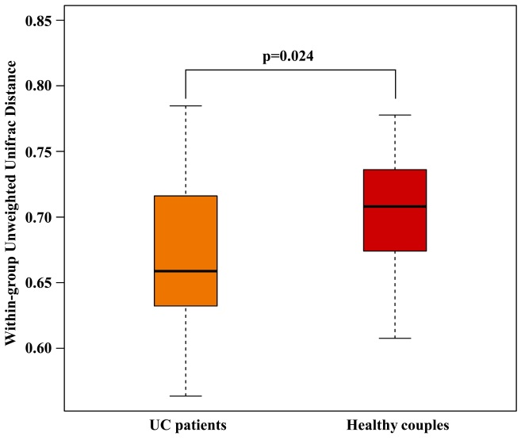
Figure 1 Distributions of the unweighted unifrac distance within the ulcerative colitis patient and healthy couples groups. Orange and red boxplots denoted the distributions of 16S rRNA gene sequencing of fecal samples in ulcerative colitis patients and healthy couples, respectively.

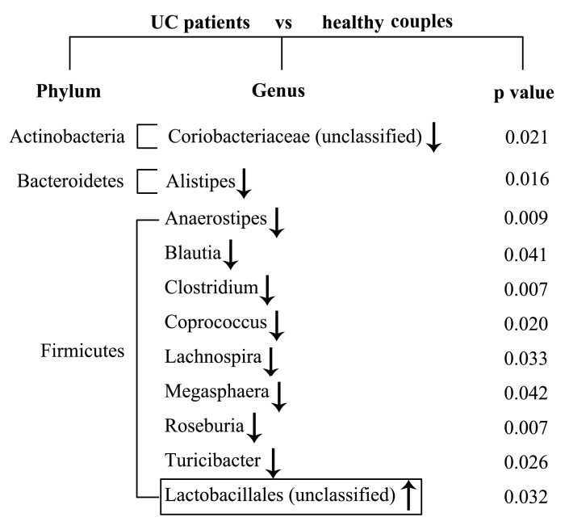

Figure 2 Significant differences in the fecal microbiota composition between ulcerative colitis patients and their healthy couples. Comparisons for each sample were calculated using the Wilcoxon test. The down arrows indicate the less abundant microbiota in ulcerative colitis (UC) patients, and the up arrow represents the more abundant microbiota in UC patients compared with their healthy couples.

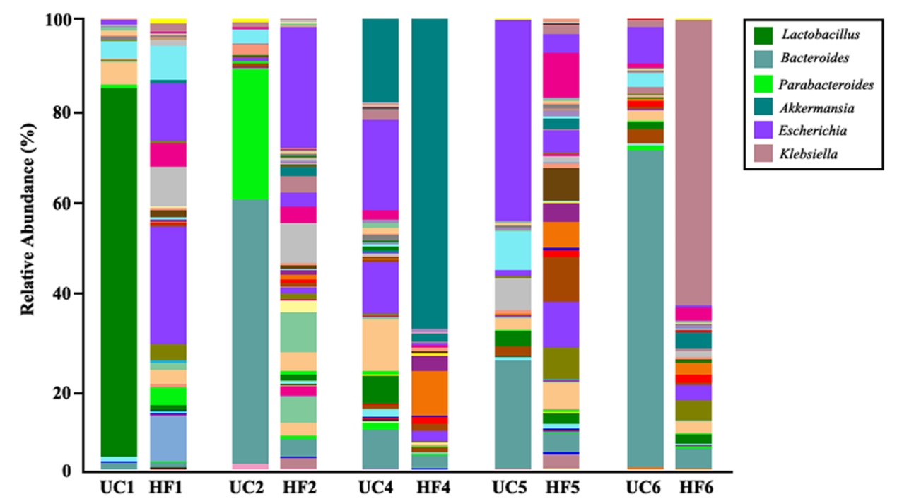
Figure 3 Relative abundance at the genus level as shown by 16S rRNA gene sequencing from ulcerative colitis patients and their couples showing microbiota imbalance. Each column represents one fecal sample and different colors indicate different genera in the microbiota composition. Microbiota with a substantial proportion imbalance are listed. UC: UC patient; HF: Healthy couples.

