Name of Journal: World Journal of Gastrointestinal Endoscopy
ESPS Manuscript NO: 18887
Manuscript Type: TOPIC HIGHLIGHT

2015 Advances in Laparoscopic Surgery

Laparoscopic esophagomyotomy for achalasia in children: A review

Pandian TK et al. Laparoscopic esophagomyotomy in children

T Kumar Pandian, Nimesh D Naik, Aodhnait S Fahy, Arman Arghami, David R Farley, Michael B Ishitani, Christopher R Moir

T Kumar Pandian, Nimesh D Naik, Aodhnait S Fahy, Arman Arghami, David R Farley, Mayo Clinic, Department of Surgery, Division of Subspecialty General Surgery, Rochester, MN 55905, United States

Arman Arghami, Mayo Clinic, Department of Surgery, Division of Cardiothoracic Surgery, Rochester, MN 55905, United States

Michael B Ishitani, Christopher R Moir, Mayo Clinic, Department of Surgery, Division of Pediatric Surgery, Rochester, MN 55905, United States

Author contributions: Pandian TK conceptualized the paper, conducted the literature search and content development; Naik ND, Fahy AS, and Arghami A conducted the literature search and content development; Moir CR served as senior author and oversaw content development; All authors were involved in manuscript development and revision; All authors read and approved the final manuscript.

Conflict-of-interest statement: The authors declare no conflicts-of-interest.

Open-Access: This article is an open-access article which was selected by an in-house editor and fully peer-reviewed by external reviewers. It is distributed in accordance with the Creative Commons Attribution Non Commercial (CC BY-NC 4.0) license, which permits others to distribute, remix, adapt, build upon this work non-commercially, and license their derivative works on different terms, provided the original work is properly cited and the use is non-commercial. See: http://creativecommons.org/licenses/by-nc/4.0/

correspondence to: David R Farley, MD, FACS, Mayo Clinic Department of Surgery, Division of Subspecialty General Surgery, 200 First Street SW, Rochester, MN 55905, United States. farley.david@mayo.edu
Telephone: +1-507-2842644
Fax: +1-507-2845196

Received: April 28, 2015
Peer Review started: May 6, 2015
First Decision: September 8, 2015
Revised: September 28, 2015
Accepted: November 13, 2015
Article in Press:
Published online:

Abstract
Esophageal achalasia in children is rare but ultimately requires endoscopic or surgical treatment. Historically, Heller esophagomyotomy has been recommended as the treatment of choice. The refinement of minimally invasive techniques has shifted the trend of treatment toward laparoscopic Heller myotomy (LHM) in adults and children with achalasia. A review of the available literature on LHM performed in patients < 18 years of age was conducted. The pediatric LHM experience is limited to one multi-institutional and several single-institutional retrospective studies. Available data suggest that LHM is safe and effective. There is a paucity of evidence on the need for and superiority of concurrent antireflux procedures. In addition, a more complete portrayal of complications and long-term (> 5 years) outcomes is needed. Due to the infrequency of achalasia in children, these characteristics are unlikely to be defined without collaboration between multiple pediatric surgery centers. The introduction of peroral endoscopic myotomy and single-incision techniques, continue the trend of innovative approaches that may eventually become the standard of care.

Key words: achalasia; esophagomyotomy; Heller myotomy; laparoscopy; outcomes

© The Author(s) 2015. Published by Baishideng Publishing Group Inc. All rights reserved.

Core tip: Laparoscopic Heller myotomy (LHM) is safe and effective in the pediatric achalasia population. Published studies are limited by their retrospective nature and small sample sizes. Further information regarding the need for and type of concurrent fundoplication, a more complete description of complications, and long-term (> 5 years) outcomes is needed. Peroral endoscopic myotomy and the single-incision approach are innovative techniques that may eventually prove to be the standard of care. Herein, we review the available literature on LHM in children with achalasia.

Pandian TK, Naik ND, Fahy AS, Arghami A, Farley DR, Ishitani MB, Moir CR. Laparoscopic esophagomyotomy for achalasia in children: A review. World J Gastrointest Endosc 2015; In press

INTRODUCTION
Achalasia overview and diagnosis
Achalasia is a motility disorder characterized by abnormal esophageal peristalsis and partial or complete failure of the lower esophageal sphincter (LES) to relax during deglutition. The condition was first described in 1674 by physician and neuroanatomist Sir Thomas Willis of England^{[1,2]}. It is an uncommon diagnosis with an overall incidence of 1.6 per 100000 individuals^{[3]}. Less than 5% of patients present under the age of 15^{[4,5]}; the childhood incidence is only 0.11 per 100000^{[6]}. The etiology of achalasia is not fully understood but it may result from degeneration of neurons in the esophageal wall^{[1,7]}. Associations with Down syndrome and Chagas disease have been described^{[8]}. Between 0.5% and 7% of children with Down syndrome have been found to have achalasia^{[8, 9]}. Children with the autosomal recessive Allgrove syndrome (triple A syndrome) suffer from alacrima, achalasia, ACTH-insufficiency, autonomic dysfunction, and neurodegeneration^{[10]}. These patients initially present with alacrima but achalasia is generally the first symptom which prompts pursuit of medical attention and diagnosis^{[11]}.
Clinical suspicion for achalasia should be raised in children with dysphagia to solids and liquids and regurgitation of undigested food or saliva^{[12]}. Symptoms may progress to chest pain, emesis, aspiration, weight loss, and failure to thrive^{[8]}. Table 1 summarizes common symptoms and associated conditions of achalasia in children. Manometry is the most sensitive diagnostic tool^{[13]} characterizing incomplete or complete absence of LES relaxation with concurrent distal esophageal aperistalsis. For patients with equivocal motility testing, a barium esophagram will reveal a proximally dilated esophagus with distal tapering (Figure 1), the classic “bird-beak” appearance^{[14]}. An abnormal esophagram should be followed by upper endoscopy, to rule out a structural abnormality such as a Schatzki ring or congenital cartilaginous stricture^{[15]}. Newer methodologies for diagnosis include high-resolution manometry (HRM) and multichannel intraluminal impedance pH monitoring (MII-pH); both of which can offer additional physiological details in diagnostic dilemmas^{[16]}. Specifically, HRM can plot the pressure generated by the esophagus, creating a topographical map which allows classification of achalasia into additional subtypes (I-III)^{[16]}. This information can then be used to provide tailored treatment. Using a series of electrodes, MII-pH can measure the intraluminal impedance of a food bolus^{[16]}. In general, HRM and MII-pH are not necessary if manometry is diagnostic.

Achalasia treatment overview
Treatment options for achalasia include pharmacological, endoscopic, or surgical methods. The primary goal is to decrease the pressure gradient across the LES. Calcium channel blockers are the most common pharmacological agents but their use in children is discouraged due to short-term effectiveness and concerning side effects^{[16-19]}.
Few reports focus on the endoscopic injection of botulinum toxin for achalasia in the pediatric population; however available data suggest the duration of therapeutic effect is short-lived and may be beneficial as a bridge to more definitive treatment modalities^{[16,20-22]}. Randomized controlled trials (RCT) in adults confirm that laparoscopic surgical esophagomyotomy (Heller myotomy, LHM) is as safe, more durable^{[23]}, and similar in cost long-term^{[24]}, than injection of botulinum toxin.
Endoscopic pneumatic dilation (EPD) for achalasia in children has been described for many decades. Older reports identified favorable efficacy and durability^{[4,25-29]} as the reason for EPD as the initial procedure of choice^{[4,27-30]}. More recent literature with longer follow-up is mixed; some data suggest high rates of symptom recurrence necessitating repeat EPD^{[17,31]}, while one study found an 87% overall 6-year success rate^{[32]} in children. In adults, a 2011 RCT reported equivalent therapeutic success of LHM and EPD at 2 years^{[33]}. Recent meta-analyses however, established that LHM results in few adverse events and higher rates of response compared to EPD^{[34]} and all other treatments^{[35]}.
Based on the aforementioned literature, it is clear that randomized trials are needed to differentiate the effectiveness and resilience of EPD and LHM in children. Despite the lack of conclusive evidence, refinement of laparoscopic techniques in pediatrics, low complication rates associated with LHM, and high rates of success have shifted treatment preferences toward LHM^{[17]}. Herein, we aim to provide an overview of laparoscopic esophagomyotomy for achalasia in children and examine the current literature on this procedure.

PROCEDURE DETAILS
Evolution from open to laparoscopic esophagomyotomy
Ernst Heller performed the first esophagomyotomy in 1913 via an open transabdominal approach and completed anterior and posterior myotomies on the distal esophagus^{[36]} (Figure 2A). The operation has undergone gradual modification including restriction to only an anterior myotomy^{[37]}, either a transthoracic or transabdominal approach^{[38]}, and the addition of antireflux procedures to the transabdominal method^{[39]}. However, the past three decades have witnessed the development of minimally invasive (MIS) approaches that have led to significant change in the management of achalasia in adult and pediatric patients. The first minimally invasive Heller myotomy (MIS-HM) was performed by Shimi et al^{[40]} via laparoscopy in 1991 on a 30-year old female. This patient was discharged on postoperative day (POD) #3 and was symptom-free at 3 mo. Pellegrini et al^{[41]}, then adapted the procedure for a thoracoscopic approach (THM) and this was well tolerated in 17 patients, with two conversions to open for mucosal lacerations. Dysphagia did not improve in the initial 3 patients however follow-up surgery extended the myotomies distally with favorable results. Originally, THM was the MIS procedure of choice and only patients with previous myotomies or thoracotomies underwent a laparoscopic operation^{[42]}. However, in the mid-1990s, groups began comparing THM and LHM and indicated that LHM with partial fundoplication led to reduced perioperative pain, shorter length of stays (LOS), less conversions to open procedures, improved relief of dysphagia and lower incidence of postoperative reflux^{[43]}. The risk of an incomplete myotomy with THM^{[44]}, as well as the addition of an antireflux fundoplication by laparoscopy^{[45,46]} were two key features that led to LHM gradually becoming the standard of care^{[47]}.

Operative steps for esophagomyotomy^{[16, 48-52]}
Some surgeons prefer that patients are limited to a liquid diet for 1-2 d preoperatively to minimize the amount of debris in the esophagus^{[48]}. After induction of general anesthesia, we perform esophageal suctioning prior to intubation to prevent the risk of aspiration. Patients are positioned in a modified lithotomy position and secured to the operating table such that there is low risk of slippage when placed in steep reverse Trendelenburg. An orogastric tube is placed and the surgeon stands between the legs of the patient (Figure 3). A total of 4-5 trocars are placed and similarly positioned as in an antireflux procedure (Figure 4). In adults, the port immediately cephalad to the umbilicus is typically used for the camera (30° laparoscope), whereas a transumbilical location is preferred in children. The remaining ports are utilized for retraction, dissection, and laparoscopic suturing. The size, location and role of each port is based on the child’s size and body habitus as well as surgeon preference.
Once pneumoperitoneum is established and all ports are placed, the operation is begun by cephalad retraction of the liver and incision of the gastro-hepatic ligament to identify the right crus of the diaphragm (Figure 5). The peritoneum and phrenoesophageal membrane are divided and dissection is carried across the anterior midline to identify the left diaphragmatic crus. Dissection is continues cephalad, staying anterior and lateral to expose 6-7 cm of the lower thoracic and abdominal esophagus. Care must be taken to identify and preserve the anterior and posterior vagus nerves. If an anterior (Dor) fundoplication is planned, further posterior dissection is not necessary. If a hiatal hernia is present, the crura are re-approximated posterior to the esophagus using interrupted sutures. For children undergoing fundoplication, the stomach is mobilized by dividing the short gastric vessels along the greater curvature from its midpoint to the angle of His.
To begin the myotomy, the esophageal fat pad is removed and the gastroesophageal junction (GEJ) is exposed. An esophageal dilator or bougie is placed transorally, to assist in splaying of the muscle fibers and to provide support during the myotomy. Traction is applied caudad and to the patient’s left, to expose the anterior surface of the esophagus. The myotomy is performed at the 11 o’clock position, typically using hook electrocautery (Figure 6). Many surgeons prefer to separate the longitudinal and circular muscle fibers of the esophagus bluntly after initial scoring sharply with electrocautery (Figure 7) or with other energy devices such as ultrasonic shears. The myotomy is then extended approximately 6 cm cephalad onto the esophagus, across the GEJ, and 2-3 cm onto the stomach (Figure 5B). Disruption and appropriate separation of muscle at the GEJ is often difficult due to decussation of the esophageal and gastric muscle fibers. The relationship between recurrence of dysphagia and length of myotomy extension onto the stomach is discussed in subsequent sections. While completing the myotomy, great care should be taken to avoid injury to the newly exposed mucosa. Previous Botox injections or EPD, prior to LHM may lead to scarring near the GEJ and portend a higher theoretical risk of perforation^{[48,53,54]}. Post-surgical data is mixed about this increased risk; at least one study suggests the risk is higher^{[55]} but others have shown there is no difference^{[56,57]}. If a perforation is suspected, it can be confirmed with endoscopy or esophageal water submersion and orogastric air insufflation. Mucosal disruptions are typically repaired in a primary fashion with interrupted absorbable suture.

Operative steps for partial fundoplication^{[16, 48-51]}
The options for an antireflux procedure include a partial or complete fundoplication. Most surgeons favor a partial fundoplication due to the risk for high LES pressures and progression of esophageal dilation when a full 360° wrap is performed^{[56-59]}.
If a 180° anterior (Dor) fundoplication (Figure 8) is planned, the short gastrics are divided and the gastric fundus is completely mobilized. In total, 2 rows of sutures between stomach and esophagus are used. The first row of 3 sutures is placed along the left esophageal wall. The cephalad-most stitch is triangular and incorporates the left diaphragmatic crus, the left side of the esophageal wall and the gastric fundus. The 2nd and 3rd stitches incorporate the fundus and left esophageal wall only. The more lateral portion of the fundus is then placed over the myotomy and is secured to the right esophageal wall in a similar fashion, utilizing a triangular stitch in the most cephalad position. The 2nd and 3rd stitches incorporate the fundus and right esophageal wall only. An additional 2-3 stitches are then placed from the anterior gastric fundus to the rim of the esophageal hiatus to relieve tension from the right-sided sutures.
To complete a 270° posterior (Toupet) fundoplication, the gastric fundus is mobilized as above. The fundus is then passed posterior to the GEJ junction (Figure 9A and B) to be secured to the right crus of the diaphragm (1-3 stitches) and the right edge of the myotomy (3 stitches). This is then repeated on the left esophageal wall (Figure 10).

Operative time, postoperative care, and cost
Published mean operative times for LHM with an antireflux procedure in children range from 120-190 min^{[17,52,54,60-65]}. Although there is some variation in hospital and surgeon postoperative LHM protocols, patients are often allowed to have sips of water or clear liquids on the day of surgery^{[51,64,66]} and an advancing diet beginning on POD #1^{[48-51,66]} or #3^{[52,63,64]}. Discharge often occurs on POD #3 or #4 (range POD 1.5-8)^{[52,61-64,67]}. At our institution, we begin an oral diet on the day of surgery and discharge children between POD #1-3 contingent on pain and dietary tolerance. Differences in institutional and surgeon experience with LHM likely explain the wide ranges reported in operative time and LOS.
To date, there is no description of associated hospital charges or cost of LHM for children in the literature. At our institution, the estimated average charge for LHM alone (without consideration of fundoplication or hospital stay) is $5277. In the adult literature, a study by Shaligram et al. reported an average hospital cost of $7441 for LHM with an antireflux procedure (exclusive of hospital stay) and that this cost was significantly lower than the open or robotic approach^{[68]}.

OUTCOMES
Overview
In general, outcomes of pediatric laparoscopic esophagomyotomy to relieve dysphagia have been favorable. The majority of data is based on small, single-center experiences with published success rates ranging from 43%-100%[6,17,52-54, 60,62-64,66,67,69-72]. The adult literature suggests success rates in the 80% range^{[16,73-75]}. It is important to note however, that the definition of “success” has not been fully delineated. Some reports classify treatment as effective only if patients did not have any dysphagia recurrence at the longest available follow-up. Others believe success was achieved if reoperation was not necessary, even if other adjunctive treatments such as EPD were required postoperatively. Unfortunately, long-term outcome data (> 5 years) is sparse.
The two main postoperative complications available in the pediatric LHM literature are recurrence of dysphagia and symptoms of gastroesophageal reflux (GER). A summary of these and all intraoperative complications reported is provided in Table 2.

Effectiveness of LHM and Adequate Myotomy
The three largest pediatric LHM studies in the literature consist of 26^{[67]}, 28^{[53]}, and 31^{[62]} patients. We published our experience with this procedure in 2009. Seven (27%) of the 26 children who underwent LHM at our institution had symptom recurrence within 5 years^{[67]}. Among these 7 patients, 3 underwent a second LHM, 3 received EPD and/or injection of botulinum toxin^{[67]}, and 1 patient had an unspecified procedure at a different institution. The 3 patients who underwent reoperation had extension of the myotomy proximally and/or distally. Similarly, in a United Kingdom based study by Pachl et al^{[53]}, 8 of 28 children required additional intervention within 3 years; 7 underwent EPD, of which 4 ultimately had a reoperation. The 8th patient proceeded directly to reoperation without EPD. Reoperative patients had revisions or extensions of the original myotomy^{[53]}. Esposito et al. published a 3-center experience in 2013 and found 5 of 31 children experienced recurrent dysphagia after LHM. Among these 5 patients, 2 had spontaneous resolution, 2 underwent EDP, and 1 underwent reoperation.
These results highlight the importance of performing an adequate myotomy. In a study by Tannuri et al^{[65]}, 15 children underwent LHM with a myotomy that extended 3-4 cm onto the stomach in contrast to the generally recommended 2-3 cm. Among these patients, 3 developed dysphagia; 2 cases resolved spontaneously and 1 patient required a single botulinum toxin injection. Traditionally, a longer myotomy in adults was thought to portend higher rates of GER (especially if done without an antireflux procedure)^{[30,65,76]} or formation of epiphrenic pseudodiverticula^{[77]}. This has not been definitively proven and continues to be debated with some authors claiming the contrary^{[44,78]}. What is known however, is that the esophageal muscular fibers need to be fully disrupted and the underlying mucosa exposed to prevent recurrence of dysphagia^{[41]}. The development of GER after LHM and data relating to an antireflux procedure are presented in subsequent sections.

Complications
Intraoperative complications during LHM in children include mucosal injury or perforation, aspiration, conversion to an open procedure, and hemorrhage. Mucosal injury and perforation appear to be the most common, with rates ranging from 0%-15% with the majority of studies reporting numbers < 10%^{[6,17,52-54,62-67,69,71]}. Almost all injuries were noted at the time of surgery, however a study by Rothenberg et al. did reveal a perforation that was discovered as late as POD #5^{[72]}. If discovered at the time of operation, a perforation should be closed primarily with interrupted absorbable suture^{[48-50]}. Children found to have perforation beyond the initial operative day, all underwent reoperation^{[52,62,72]}. Adult studies reveal similar rates of perforation and conversion to an open procedure^{[73,74]}.
In general, rates of adverse events are low when children undergo laparoscopic esophagomyotomy. However, the available studies are nearly all single-center experiences and the largest experience consists of only 31 patients. Heterogeneity between and within studies makes it difficult to draw causal relationships and define etiologies for complications. As evidenced by Table 2, there is a significant amount of missing complication data. Only 2 of the 15 studies included in this review discuss other postoperative events and none report rates of infection. This may represent the relative safety of LHM or may be a reflection of the low numbers of patients. Due to the rarity of achalasia in children, prospective, multi-institutional studies are needed to provide a more comprehensive picture of LHM safety.

COMPARISONS
Laparoscopic vs thoracoscopic Heller myotomy
The available literature reveals a larger experience with LHM than THM as a form of MIS-HM in children. There are few studies which directly compare these two approaches in the pediatric population. Mehra et al. reported their experience with MIS-HM in 2001. In this study, 18 of 22 patients underwent LHM compared to 4 patients with THM. Mean duration of hospitalization and mean time to resumption of soft feeds were lower for those undergoing LHM^{[70]}. Similarly, Rothenberg et al. found that THM resulted in slightly longer operative times and hospital stay in a study of 9 patients (4 THM, 5 LHM)^{[72]}. In a 2011 review article assessing available adult meta-analyses, the authors conclude that LHM results in shorter hospital stays and reduced operative time, but that overall outcomes are similar to THM^{[79]}.
The pediatric evidence comparing LHM and THM is not robust but extrapolation from adult studies suggests LHM is superior. Although not explicitly considered in the literature, postoperative pain and the necessity for tube thoracostomy are likely lower in children undergoing LHM.

The evidence for fundoplication
The need for a concomitant fundoplication during LHM to prevent postoperative GER continues to be debated both in the pediatric and adult populations^{[17,53]}. Among reported pediatric experiences, the study by Corda et al. in 2010 included 20 patients, none of whom underwent an antireflux procedure. In this series, no patients suffered from postoperative GER^{[66]}. The authors believe there is a higher chance for recurrent dysphagia when a fundoplication is performed and that it is easier to treat postoperative GER than dysphagia^{[66]}. Interestingly, another study by Pachl et al^{[53]} found that only 1 of 18 patients without an antireflux procedure had postoperative GER compared to 4 of 10 who suffered from symptoms in the fundoplication group. Of the remaining pediatric LHM studies which explicitly discuss this complication, most performed a Dor fundoplication with low rates of postoperative GER^{[52,54,63-65,67]}.
The adult literature has higher level evidence and appears to favor performance of a partial fundoplication. In a 2004 RCT, Richards and colleagues showed that the incidence of postoperative GER was significantly lower in patients who underwent a Dor fundoplication (9.1% vs 47.6%, p < 0.05)^{[59]}. In addition, a recent review article assessing multiple prospective studies, meta-analyses, and RCTs in adults concluded that a partial fundoplication is indicated after Heller myotomy to reduce incidence of GER^{[80]}.
Based on the available results, it is not clear whether all children should undergo a concomitant antireflux procedure during LHM. Multi-institutional randomized trials are needed to better answer this question. In the interim, surgeons should treat each patient individually and base the decision to proceed with a fundoplication on preoperative existence of GER or presence of predisposing risk factors for GER.

Type of fundoplication
If the decision to proceed with an antireflux procedure is made, the surgeon must decide what type of fundoplication to perform. The main advantage of a fundoplication is to prevent reflux and disadvantages include possible postoperative dysphagia or formation of diverticula. As evidenced in Table 2, the majority of LHM procedures performed in children are anterior or Dor fundoplications and most have favorable results. There are no pediatric studies comparing the various types of fundoplications directly. In the Mayo Clinic experience published in 2009, we found that only 1 out of 23 patients undergoing Toupet fundoplication experienced postoperative GER^{[67]}. In other studies with multiple types of fundoplications^{[17,63,70]}, it is not clear if patients suffered from postoperative GER and if they did, which fundoplication group performed better.
Katada et al^{[81]} reported on 30 adults who underwent a Toupet fundoplication with concurrent LHM. The authors found that this combination helped to straighten the esophagus, reduced LES pressure, and relieved dysphagia^{[81]}. They did find however, that 2 patients developed esophageal diverticula postoperatively. A recent review article assessing multiple prospective studies and RCTs comparing LHM with various types of concomitant fundoplication in adults concluded that a partial fundoplication (Dor or Toupet) were superior based on higher rates of dysphagia and slightly lower rates of GER when a full (360° Nissen) fundoplication was performed^{[80]}.
There is an obvious paucity of data to definitively recommend one type of antireflux procedure over another when performing LHM in children. Due to low rates of GER and complications found with various types of fundoplication, a multi-institutional RCT would be a valuable and feasible method to better understand this component of the LHM operation.

FUTURE DIRECTIONS
Peroral endoscopic myotomy
In the last decade, a new approach to performing esophageal myotomy has been gaining interest and attention. Peroral endoscopic myotomy was developed as a multi-institutional endeavor and initially described in 2007 after performance on pigs^{[82]}. It is performed entirely endoscopically. A small incision is made in the esophageal mucosa and a balloon dilator is passed into the submucosal space and inflated^{[82]}. Following this, the esophageal muscular fibers are separated with electrocautery and once the myotomy is complete, the small incision in the mucosa is closed with endoscopic clips or suturing^{[82]}. The major advantage of this technique is that it is incision-free and performed through a natural orifice. Since 2007, a number of small studies have been published on the human experience. A recent “white paper summary” found that therapeutic success was achieved in greater than 80% of these patients, self-limited adverse events occurred in < 10% of cases, and rates of post-procedure GER ranged from 20%-46%^{[83]}.
To date, 3 studies have assessed peroral endoscopic myotomy (POEM) in pediatric achalasia patients^{[52,84,85]}. The first published report was in a 3-year-old female with severe developmental issues in which total operative time was 198 min^{[85]}. There were no intraoperative or postoperative complications and the patient remained symptom-free at 1-year follow-up^{[85]}. A 2013 study completed the procedure on 3 patients with a mean age of 9.6 years in an average of 60 min^{[84]}. One patient had a small perforation of the mucosal flap and all 3 were discharged 4-7 d post-procedurally^{[84]}. One-year follow-up on 2 patients revealed that they remained symptom-free; the third patient was 1 mo post-procedure at the time of publication and also had no symptoms. The most recent and largest POEM study in children included a total of 9 patients and compared their outcomes directly with 9 patients undergoing LHM^{[52]}. The authors found that mean operative time was significantly lower (62 min vs 149 min, p < 0.01), myotomy length was longer (11 cm vs 7 cm, p = 0.26), postoperative oral intake occurred sooner (POD #2 vs POD #3, p < 0.01), and hospital stay was shorter (4.1 d vs 6 d, p < 0.01) in patients undergoing POEM^{[52]}. Operative and postoperative complications (mucosal perforation, GER) were similar, however 2 patients in the LHM group had recurrence of dysphagia and 1 POEM patient required evacuation of a pneumoperitoneum during the procedure^{[52]}.
Although the POEM experience for children with achalasia is limited, preliminary data suggests that it may be a viable and safe option when performed under experienced hands. Further studies are needed and ongoing.

Single incision LHM
Single-incision laparoscopic surgery for children has been gaining attention over the last 20 years^{[86]}. A number of procedures have been performed via 1 incision including appendectomy, cholecystectomy, colonic resections, pyloromyotomy, nephrectomy, and many others^{[86]}. In 2011, Kobayashi et al. reported their experience with single incision LHM (SI-LHM) in a 9-year-old boy. Operative time was 273 min, LOS was 8 d, and the patient had complete resolution of dysphagia with no symptoms of GER^{[87]}. Although further studies are necessary, this may be an additional operative approach to consider for children with achalasia.

CONCLUSION
Laparoscopic Heller myotomy has become the preferred treatment for pediatric patients with achalasia. Existing literature is limited to small retrospective studies. Available data suggest that LHM is safe and effective in children. A number of related issues are yet to be definitively proven. The need for and type of concurrent fundoplication, a more comprehensive description of complications, and long-term (> 5 years) outcomes information are poorly defined and require additional evaluation. Due to the rarity of achalasia in children, these characteristics will require collaboration between multiple pediatric surgery centers and should be performed in a prospective randomized fashion when appropriate. Finally, the advent of POEM and SI-LHM techniques could ultimately change the approach chosen for esophagomyotomy and may become the standard of care in the future.

References
1 Hirano I. Pathophysiology of achalasia and diffuse esophageal spasm. GI Motility Online 2006 [ doi: 10.1038/gimo22]
2 Cash BD, Wong RK. Historical perspective of achalasia. Gastrointest Endosc Clin N Am 2001; 11: 221-34, v [PMID: 11319058]
3 Sadowski DC, Ackah F, Jiang B, Svenson LW. Achalasia: incidence, prevalence and survival. A population-based study. Neurogastroenterol Motil 2010; 22: e256-e261 [PMID: 20465592 DOI: 10.1111/j.1365-2982.2010.01511.x]
4 Babu R, Grier D, Cusick E, Spicer RD. Pneumatic dilatation for childhood achalasia. Pediatr Surg Int 2001; 17: 505-507 [PMID: 11666045 DOI: 10.1007/s003830000574]
5 Franklin AL, Petrosyan M, Kane TD. Childhood achalasia: A comprehensive review of disease, diagnosis and therapeutic management. World J Gastrointest Endosc 2014; 6: 105-111 [PMID: 24748917 DOI: 10.4253/wjge.v6.i4.105]
6 Lee CW, Kays DW, Chen MK, Islam S. Outcomes of treatment of childhood achalasia. J Pediatr Surg 2010; 45: 1173-1177 [PMID: 20620315 DOI: 10.1016/j.jpedsurg.2010.02.086]
7 Reynolds JC, Parkman HP. Achalasia. Gastroenterol Clin North Am 1989; 18: 223-255 [PMID: 2668168]
8 Hallal C, Kieling CO, Nunes DL, Ferreira CT, Peterson G, Barros SG, Arruda CA, Fraga JC, Goldani HA. Diagnosis, misdiagnosis, and associated diseases of achalasia in children and adolescents: a twelve-year single center experience. Pediatr Surg Int 2012; 28: 1211-1217 [PMID: 23135808 DOI: 10.1007/s00383-012-3214-3]
9 Preiksaitis HG, Miller L, Pearson FG, Diamant NE. Achalasia in Down's syndrome. J Clin Gastroenterol 1994; 19: 105-107 [PMID: 7963353 DOI: 10.1097/00004836-199409000-00005]
10 Milenkovic T, Zdravkovic D, Savic N, Todorovic S, Mitrovic K, Koehler K, Huebner A. Triple A syndrome: 32 years experience of a single centre (1977-2008). Eur J Pediatr 2010; 169: 1323-1328 [PMID: 20499090 DOI: 10.1007/s00431-010-1222-7]
11 Phillip M, Hershkovitz E, Schulman H. Adrenal insufficiency after achalasia in the triple-A syndrome. Clin Pediatr (Phila) 1996; 35: 99-100 [PMID: 8775483 DOI: 10.1177/000992289603500208]
12 Fisichella PM, Raz D, Palazzo F, Niponmick I, Patti MG. Clinical, radiological, and manometric profile in 145 patients with untreated achalasia. World J Surg 2008; 32: 1974-1979 [PMID: 18575930 DOI: 10.1007/s00268-008-9656-z]
13 Hirano I, Tatum RP, Shi G, Sang Q, Joehl RJ, Kahrilas PJ. Manometric heterogeneity in patients with idiopathic achalasia. Gastroenterology 2001; 120: 789-798 [PMID: 11231931 DOI: 10.1053/gast.2001.22539]
14 Vaezi MF, Pandolfino JE, Vela MF. ACG clinical guideline: diagnosis and management of achalasia. Am J Gastroenterol 2013; 108: 1238-1249; quiz 1250 [PMID: 23877351 DOI: 10.1038/ajg.2013.196]
15 Liacouras CA, Piccoli DA. Achalasia. Pediatric gastroenterology: The requisites in pediatrics. 1st ed. Philadelphia: Mosby/Elsevier, 2008: 13-18
16 Roll GR, Rabl C, Ciovica R, Peeva S, Campos GM. A controversy that has been tough to swallow: is the treatment of achalasia now digested? J Gastrointest Surg 2010; 14 Suppl 1: S33-S45 [PMID: 19760373 DOI: 10.1007/s11605-009-1013-5]
17 Pastor AC, Mills J, Marcon MA, Himidan S, Kim PC. A single center 26-year experience with treatment of esophageal achalasia: is there an optimal method? J Pediatr Surg 2009; 44: 1349-1354 [PMID: 19573660 DOI: 10.1016/j.jpedsurg.2008.10.117]
18 Wang L, Li YM, Li L. Meta-analysis of randomized and controlled treatment trials for achalasia. Dig Dis Sci 2009; 54: 2303-2311 [PMID: 19107596 DOI: 10.1007/s10620-008-0637-8]
19 Maksimak M, Perlmutter DH, Winter HS. The use of nifedipine for the treatment of achalasia in children. J Pediatr Gastroenterol Nutr 1986; 5: 883-886 [PMID: 3794905 DOI: 10.1097/00005176-198611000-00010]
20 Hurwitz M, Bahar RJ, Ament ME, Tolia V, Molleston J, Reinstein LJ, Walton JM, Erhart N, Wasserman D, Justinich C, Vargas J. Evaluation of the use of botulinum toxin in children with achalasia. J Pediatr Gastroenterol Nutr 2000; 30: 509-514 [PMID: 10817280 DOI: 10.1097/00005176-200005000-00009]
21 Ip KS, Cameron DJ, Catto-Smith AG, Hardikar W. Botulinum toxin for achalasia in children. J Gastroenterol Hepatol 2000; 15: 1100-1104 [PMID: 11106087 DOI: 10.1046/j.1440-1746.2000.02341.x]
22 Khoshoo V, LaGarde DC, Udall JN Jr. Intrasphincteric injection of Botulinum toxin for treating achalasia in children. J Pediatr Gastroenterol Nutr 1997; 24: 439-441 [PMID: 9144129 DOI: 10.1097/00005176-199704000-00015]
23 Zaninotto G, Annese V, Costantini M, Del Genio A, Costantino M, Epifani M, Gatto G, D'onofrio V, Benini L, Contini S, Molena D, Battaglia G, Tardio B, Andriulli A, Ancona E. Randomized controlled trial of botulinum toxin versus laparoscopic heller myotomy for esophageal achalasia. Ann Surg 2004; 239: 364-370 [PMID: 15075653 DOI: 10.1097/01.sla.0000114217.52941.c5]
24 Zaninotto G, Vergadoro V, Annese V, Costantini M, Costantino M, Molena D, Rizzetto C, Epifani M, Ruol A, Nicoletti L, Ancona E. Botulinum toxin injection versus laparoscopic myotomy for the treatment of esophageal achalasia: economic analysis of a randomized trial. Surg Endosc 2004; 18: 691-695 [PMID: 15026896 DOI: 10.1007/s00464-003-8910-6]
25 Berquist WE, Byrne WJ, Ament ME, Fonkalsrud EW, Euler AR. Achalasia: diagnosis, management, and clinical course in 16 children. Pediatrics 1983; 71: 798-805 [PMID: 6835765]
26 Boyle JT, Cohen S, Watkins JB. Successful treatment of achalasia in childhood by pneumatic dilatation. J Pediatr 1981; 99: 35-40 [PMID: 7252667 DOI: 10.1016/S0022-3476(81)80953-5]
27 Hammond PD, Moore DJ, Davidson GP, Davies RP. Tandem balloon dilatation for childhood achalasia. Pediatr Radiol 1997; 27: 609-613 [PMID: 9211959 DOI: 10.1007/s002470050196]
28 Hamza AF, Awad HA, Hussein O. Cardiac achalasia in children. Dilatation or surgery? Eur J Pediatr Surg 1999; 9: 299-302 [PMID: 10584188 DOI: 10.1055/s-2008-1072268]
29 Khan AA, Shah SW, Alam A, Butt AK, Shafqat F. Efficacy of Rigiflex balloon dilatation in 12 children with achalasia: a 6-month prospective study showing weight gain and symptomatic improvement. Dis Esophagus 2002; 15: 167-170 [PMID: 12220427 DOI: 10.1046/j.1442-2050.2002.00246.x]
30 Piñeiro-Carrero VM, Sullivan CA, Rogers PL. Etiology and treatment of achalasia in the pediatric age group. Gastrointest Endosc Clin N Am 2001; 11: 387-408, viii [PMID: 11319069]
31 Lelli JL Jr, Drongowski RA, Coran AG. Efficacy of the transthoracic modified Heller myotomy in children with achalasia--a 21-year experience. J Pediatr Surg 1997; 32: 338-341 [PMID: 9044149 DOI: 10.1016/S0022-3468(97)90206-2]
32 Di Nardo G, Rossi P, Oliva S, Aloi M, Cozzi DA, Frediani S, Redler A, Mallardo S, Ferrari F, Cucchiara S. Pneumatic balloon dilation in pediatric achalasia: efficacy and factors predicting outcome at a single tertiary pediatric gastroenterology center. Gastrointest Endosc 2012; 76: 927-932 [PMID: 22921148 DOI: 10.1016/j.gie.2012.06.035]
33 Boeckxstaens GE, Annese V, des Varannes SB, Chaussade S, Costantini M, Cuttitta A, Elizalde JI, Fumagalli U, Gaudric M, Rohof WO, Smout AJ, Tack J, Zwinderman AH, Zaninotto G, Busch OR. Pneumatic dilation versus laparoscopic Heller's myotomy for idiopathic achalasia. N Engl J Med 2011; 364: 1807-1816 [PMID: 21561346 DOI: 10.1056/NEJMoa1010502]
34 Yaghoobi M, Mayrand S, Martel M, Roshan-Afshar I, Bijarchi R, Barkun A. Laparoscopic Heller's myotomy versus pneumatic dilation in the treatment of idiopathic achalasia: a meta-analysis of randomized, controlled trials. Gastrointest Endosc 2013; 78: 468-475 [PMID: 23684149 DOI: 10.1016/j.gie.2013.03.1335]
35 Campos GM, Vittinghoff E, Rabl C, Takata M, Gadenstätter M, Lin F, Ciovica R. Endoscopic and surgical treatments for achalasia: a systematic review and meta-analysis. Ann Surg 2009; 249: 45-57 [PMID: 19106675 DOI: 10.1097/SLA.0b013e31818e43ab]
36 Heller E. Extramucose Kardiaplastik beim chronischen Kardiospasmus mit Dilatation des Oesophagus. Mitt Grenzgeb Med Chir 1914; 27: 141-149
37 Zaaijer JH. Cardiospasm in the aged. Ann Surg 1923; 77: 615-617 [PMID: 17864830 DOI: 10.1097/00000658-192305000-00014]
38 Jaakkola A, Ovaska J, Isolauri J. Esophagocardiomyotomy for achalasia. Long-term clinical and endoscopic evaluation of transabdominal vs. transthoracic approach. Eur J Surg 1991; 157: 407-410 [PMID: 1681919]
39 Stipa SBR. Esophagomyotomy and antireflux operation for achalasia. Chir Gastroenterol 1976; 10: 3-7
40 Shimi S, Nathanson LK, Cuschieri A. Laparoscopic cardiomyotomy for achalasia. J R Coll Surg Edinb 1991; 36: 152-154 [PMID: 1833541]
41 Pellegrini C, Wetter LA, Patti M, Leichter R, Mussan G, Mori T, Bernstein G, Way L. Thoracoscopic esophagomyotomy. Initial experience with a new approach for the treatment of achalasia. Ann Surg 1992; 216: 291-26; discussion 291-26; [PMID: 1417178]
42 Raiser F, Perdikis G, Hinder RA, Swanstrom LL, Filipi CJ, McBride PJ, Katada N, Neary PJ. Heller myotomy via minimal-access surgery. An evaluation of antireflux procedures. Arch Surg 1996; 131: 593-57; discussion 593-57; [PMID: 8645064]
43 Patti MG, Arcerito M, De Pinto M, Feo CV, Tong J, Gantert W, Way LW. Comparison of thoracoscopic and laparoscopic Heller myotomy for achalasia. J Gastrointest Surg 1998; 2: 561-566 [PMID: 10457314]
44 Oelschlager BK, Chang L, Pellegrini CA. Improved outcome after extended gastric myotomy for achalasia. Arch Surg 2003; 138: 490-45; discussion 490-45; [PMID: 12742951 DOI: 10.1001/archsurg.138.5.490]
45 Burpee SE, Mamazza J, Schlachta CM, Bendavid Y, Klein L, Moloo H, Poulin EC. Objective analysis of gastroesophageal reflux after laparoscopic heller myotomy: an anti-reflux procedure is required. Surg Endosc 2005; 19: 9-14 [PMID: 15531966 DOI: 10.1007/s00464-004-8932-8]
46 Ramacciato G, Mercantini P, Amodio PM, Corigliano N, Barreca M, Stipa F, Ziparo V. The laparoscopic approach with antireflux surgery is superior to the thoracoscopic approach for the treatment of esophageal achalasia. Experience of a single surgical unit. Surg Endosc 2002; 16: 1431-1437 [PMID: 12072992 DOI: 10.1007/s00464-001-9215-2]
47 Stefanidis D, Richardson W, Farrell TM, Kohn GP, Augenstein V, Fanelli RD. SAGES guidelines for the surgical treatment of esophageal achalasia. Surg Endosc 2012; 26: 296-311 [PMID: 22044977 DOI: 10.1007/s00464-011-2017-2]
48 Campos GM, Ciovica R, Takata M. Laparoscopic Myotomy. Oper Tech Gen Surg 2006; 8: 161-169 [doi:10.1053/j.optechgensurg.2006.08.001]
49 Gorodner MV, Galvani C, Patti MG. Heller Myotomy. Oper Tech Gen Surg 2004; 6: 23-28 [doi:10.1053/j.optechgensurg.2004.01.006]
50 Patti MG, Fisichella PM. Laparoscopic Heller myotomy and Dor fundoplication for esophageal achalasia. How I do it. J Gastrointest Surg 2008; 12: 764-766 [PMID: 17957436 DOI: 10.1007/s11605-007-0368-8]
51 Tatum RP, Pellegrini CA. How I do it: laparoscopic Heller myotomy with Toupet fundoplication for achalasia. J Gastrointest Surg 2009; 13: 1120-1124 [PMID: 18622657 DOI: 10.1007/s11605-008-0585-9]
52 Caldaro T, Familiari P, Romeo EF, Gigante G, Marchese M, Contini AC, Federici di Abriola G, Cucchiara S, De Angelis P, Torroni F, Dall'Oglio L, Costamagna G. Treatment of esophageal achalasia in children: Today and tomorrow. J Pediatr Surg 2015; 50: 726-730 [PMID: 25783358 DOI: 10.1016/j.jpedsurg.2015.02.047]
53 Pachl MJ, Rex D, Decoppi P, Cross K, Kiely EM, Drake D, Pierro A, Curry JI. Paediatric laparoscopic Heller's cardiomyotomy: a single centre series. J Pediatr Surg 2014; 49: 289-92; discussion 292 [PMID: 24528969 DOI: 10.1016/j.jpedsurg.2013.11.042]
54 Patti MG, Albanese CT, Holcomb GW, Molena D, Fisichella PM, Perretta S, Way LW. Laparoscopic Heller myotomy and Dor fundoplication for esophageal achalasia in children. J Pediatr Surg 2001; 36: 1248-1251 [PMID: 11479868 DOI: 10.1053/jpsu.2001.25786]
55 Portale G, Costantini M, Rizzetto C, Guirroli E, Ceolin M, Salvador R, Ancona E, Zaninotto G. Long-term outcome of laparoscopic Heller-Dor surgery for esophageal achalasia: possible detrimental role of previous endoscopic treatment. J Gastrointest Surg 2005; 9: 1332-1339 [PMID: 16332491 DOI: 10.1016/j.gassur.2005.10.001]
56 Bonavina L, Incarbone R, Antoniazzi L, Reitano M, Peracchia A. Previous endoscopic treatment does not affect complication rate and outcome of laparoscopic Heller myotomy and anterior fundoplication for oesophageal achalasia. Ital J Gastroenterol Hepatol 1999; 31: 827-830 [PMID: 10669988]
57 Bonavina L, Incarbone R, Reitano M, Antoniazzi L, Peracchia A. Does previous endoscopic treatment affect the outcome of laparoscopic Heller myotomy? Ann Chir 2000; 125: 45-49 [PMID: 10921184 DOI: 10.1016/S0001-4001(00)99113-X]
58 Patti MG, Fisichella PM, Perretta S, Galvani C, Gorodner MV, Robinson T, Way LW. Impact of minimally invasive surgery on the treatment of esophageal achalasia: a decade of change. J Am Coll Surg 2003; 196: 698-703; discussion 703-5 [PMID: 12742198 DOI: 10.1016/S1072-7515(02)01837-9]
59 Richards WO, Torquati A, Holzman MD, Khaitan L, Byrne D, Lutfi R, Sharp KW. Heller myotomy versus Heller myotomy with Dor fundoplication for achalasia: a prospective randomized double-blind clinical trial. Ann Surg 2004; 240: 405-412; discussion 412-415 [PMID: 15319712 DOI: 10.1097/01.sla.0000136940.32255.51]
60 Esposito C, Cucchiara S, Borrelli O, Roblot-Maigret B, Desruelle P, Montupet P. Laparoscopic esophagomyotomy for the treatment of achalasia in children. A preliminary report of eight cases. Surg Endosc 2000; 14: 110-113 [PMID: 10656938 DOI: 10.1007/s004640000077]
61 Esposito C, Mendoza-Sagaon M, Roblot-Maigret B, Amici G, Desruelle P, Montupet P. Complications of laparoscopic treatment of esophageal achalasia in children. J Pediatr Surg 2000; 35: 680-683 [PMID: 10813322 DOI: 10.1053/jpsu.2000.5942]
62 Esposito C, Riccipetitoni G, Chiarenza SF, Roberti A, Vella C, Alicchio F, Fava G, Escolino M, De Pascale T, Settimi A. Long-term results of laparoscopic treatment of esophageal achalasia in children: a multicentric survey. J Laparoendosc Adv Surg Tech A 2013; 23: 955-959 [PMID: 24073839 DOI: 10.1089/lap.2013.0308]
63 Garzi A, Valla JS, Molinaro F, Amato G, Messina M. Minimally invasive surgery for achalasia: combined experience of two European centers. J Pediatr Gastroenterol Nutr 2007; 44: 587-591 [PMID: 17460491 DOI: 10.1097/MPG.0b013e318032062f]
64 Mattioli G, Esposito C, Pini Prato A, Doldo P, Castagnetti M, Barabino A, Gandullia P, Staiano AM, Settimi A, Cucchiara S, Montobbio G, Jasonni V. Results of the laparoscopic Heller-Dor procedure for pediatric esophageal achalasia. Surg Endosc 2003; 17: 1650-1652 [PMID: 12915969 DOI: 10.1007/s00464-002-9257-0]
65 Tannuri AC, Tannuri U, Velhote MC, Romão RL. Laparoscopic extended cardiomyotomy in children: an effective procedure for the treatment of esophageal achalasia. J Pediatr Surg 2010; 45: 1463-1466 [PMID: 20638525 DOI: 10.1016/j.jpedsurg.2009.08.023]
66 Corda L, Pacilli M, Clarke S, Fell JM, Rawat D, Haddad M. Laparoscopic oesophageal cardiomyotomy without fundoplication in children with achalasia: a 10-year experience: a retrospective review of the results of laparoscopic oesophageal cardiomyotomy without an anti-reflux procedure in children with achalasia. Surg Endosc 2010; 24: 40-44 [PMID: 19495877 DOI: 10.1007/s00464-009-0513-4]
67 Askegard-Giesmann JR, Grams JM, Hanna AM, Iqbal CW, Teh S, Moir CR. Minimally invasive Heller's myotomy in children: safe and effective. J Pediatr Surg 2009; 44: 909-911 [PMID: 19433168 DOI: 10.1016/j.jpedsurg.2009.01.022]
68 Shaligram A, Unnirevi J, Simorov A, Kothari VM, Oleynikov D. How does the robot affect outcomes? A retrospective review of open, laparoscopic, and robotic Heller myotomy for achalasia. Surg Endosc 2012; 26: 1047-1050 [PMID: 22038167 DOI: 10.1007/s00464-011-1994-5]
69 Holcomb GW 3rd, Richards WO, Riedel BD. Laparoscopic esophagomyotomy for achalasia in children. J Pediatr Surg 1996; 31: 716-718 [PMID: 8861491 DOI: 10.1016/S0022-3468(96)90685-5]
70 Mehra M, Bahar RJ, Ament ME, Waldhausen J, Gershman G, Georgeson K, Fox V, Fishman S, Werlin S, Sato T, Hill I, Tolia V, Atkinson J. Laparoscopic and thoracoscopic esophagomyotomy for children with achalasia. J Pediatr Gastroenterol Nutr 2001; 33: 466-471 [PMID: 11698765]
71 Paidas C, Cowgill SM, Boyle R, Al-Saadi S, Villadolid D, Rosemurgy AS. Laparoscopic Heller myotomy with anterior fundoplication ameliorates symptoms of achalasia in pediatric patients. J Am Coll Surg 2007; 204: 977-83; discussion 983-6 [PMID: 17481524 DOI: 10.1016/j.jamcollsurg.2006.12.046]
72 Rothenberg SS, Partrick DA, Bealer JF, Chang JH. Evaluation of minimally invasive approaches to achalasia in children. J Pediatr Surg 2001; 36: 808-810 [PMID: 11329595 DOI: 10.1053/jpsu.2001.22967]
73 Kilic A, Schuchert MJ, Pennathur A, Gilbert S, Landreneau RJ, Luketich JD. Long-term outcomes of laparoscopic Heller myotomy for achalasia. Surgery 2009; 146: 826-31; discussion 831-3 [PMID: 19789044 DOI: 10.1016/j.surg.2009.06.049]
74 Rosemurgy AS, Morton CA, Rosas M, Albrink M, Ross SB. A single institution's experience with more than 500 laparoscopic Heller myotomies for achalasia. J Am Coll Surg 2010; 210: 637-45, 645-7 [PMID: 20421021 DOI: 10.1016/j.jamcollsurg.2010.01.035]
75 Gutschow CA, Töx U, Leers J, Schäfer H, Prenzel KL, Hölscher AH. Botox, dilation, or myotomy? Clinical outcome of interventional and surgical therapies for achalasia. Langenbecks Arch Surg 2010; 395: 1093-1099 [PMID: 20845045 DOI: 10.1007/s00423-010-0711-5]
76 Ellis FH Jr, Watkins E Jr, Gibb SP, Heatley GJ. Ten to 20-year clinical results after short esophagomyotomy without an antireflux procedure (modified Heller operation) for esophageal achalasia. Eur J Cardiothorac Surg 1992; 6: 86-89; discussion 90 [PMID: 1581086 DOI: 10.1016/1010-7940(92)90080-H]
77 Chen LQ, Chughtai T, Sideris L, Nastos D, Taillefer R, Ferraro P, Duranceau A. Long-term effects of myotomy and partial fundoplication for esophageal achalasia. Dis Esophagus 2002; 15: 171-179 [PMID: 12220428 DOI: 10.1046/j.1442-2050.2002.00248.x]
78 Wright AS, Williams CW, Pellegrini CA, Oelschlager BK. Long-term outcomes confirm the superior efficacy of extended Heller myotomy with Toupet fundoplication for achalasia. Surg Endosc 2007; 21: 713-718 [PMID: 17332964 DOI: 10.1007/s00464-006-9165-9]
79 Hughes MJ, Chowdhry MF, Walker WS. Can thoracoscopic Heller's myotomy give equivalent results to the more usual laparoscopic Heller's myotomy in the treatment of achalasia? Interact Cardiovasc Thorac Surg 2011; 13: 77-81 [PMID: 21498789 DOI: 10.1510/icvts.2011.268169]
80 Mayo D, Griffiths EA, Khan OA, Szymankiewicz MA, Wakefield CW, Thompson SK. Does the addition of a fundoplication improve outcomes for patients undergoing laparoscopic Heller's cardiomyotomy? Int J Surg 2012; 10: 301-304 [PMID: 22510440 DOI: 10.1016/j.ijsu.2012.04.002]
81 Katada N, Sakuramoto S, Kobayashi N, Futawatari N, Kuroyama S, Kikuchi S, Watanabe M. Laparoscopic Heller myotomy with Toupet fundoplication for achalasia straightens the esophagus and relieves dysphagia. Am J Surg 2006; 192: 1-8 [PMID: 16769266 DOI: 10.1016/j.amjsurg.2006.01.027]
82 Pasricha PJ, Hawari R, Ahmed I, Chen J, Cotton PB, Hawes RH, Kalloo AN, Kantsevoy SV, Gostout CJ. Submucosal endoscopic esophageal myotomy: a novel experimental approach for the treatment of achalasia. Endoscopy 2007; 39: 761-764 [PMID: 17703382 DOI: 10.1055/s-2007-966764]
83 Stavropoulos SN, Desilets DJ, Fuchs KH, Gostout CJ, Haber G, Inoue H, Kochman ML, Modayil R, Savides T, Scott DJ, Swanstrom LL, Vassiliou MC. Per-oral endoscopic myotomy white paper summary. Surg Endosc 2014; 28: 2005-2019 [PMID: 24935204 DOI: 10.1007/s00464-014-3630-7]
84 Familiari P, Marchese M, Gigante G, Boskoski I, Tringali A, Perri V, Costamagna G. Peroral endoscopic myotomy for the treatment of achalasia in children. J Pediatr Gastroenterol Nutr 2013; 57: 794-797 [PMID: 23941997 DOI: 10.1097/MPG.0b013e3182a803f7]
85 Maselli R, Inoue H, Misawa M, Ikeda H, Hosoya T, Onimaru M, Yoshida A, Eleftheriadis N, Suzuki K, Kudo S. Peroral endoscopic myotomy (POEM) in a 3-year-old girl with severe growth retardation, achalasia, and Down syndrome. Endoscopy 2012; 44 Suppl 2 UCTN: E285-E287 [PMID: 22933258 DOI: 10.1055/s-0032-1309924]
86 Saldaña LJ, Targarona EM. Single-incision pediatric endosurgery: a systematic review. J Laparoendosc Adv Surg Tech A 2013; 23: 467-480 [PMID: 23560658 DOI: 10.1089/lap.2012.0467]
87 Kobayashi M, Mizuno M, Sasaki A, Arisue A, Akiyama S, Wakabayashi G. Single-port laparoscopic Heller myotomy and Dor fundoplication: initial experience with a new approach for the treatment of pediatric achalasia. J Pediatr Surg 2011; 46: 2200-2203 [PMID: 22075359 DOI: 10.1016/j.jpedsurg.2011.07.027]
P-Reviewer: Omura N S-Editor: Gong ZM
L-Editor: E-Editor:

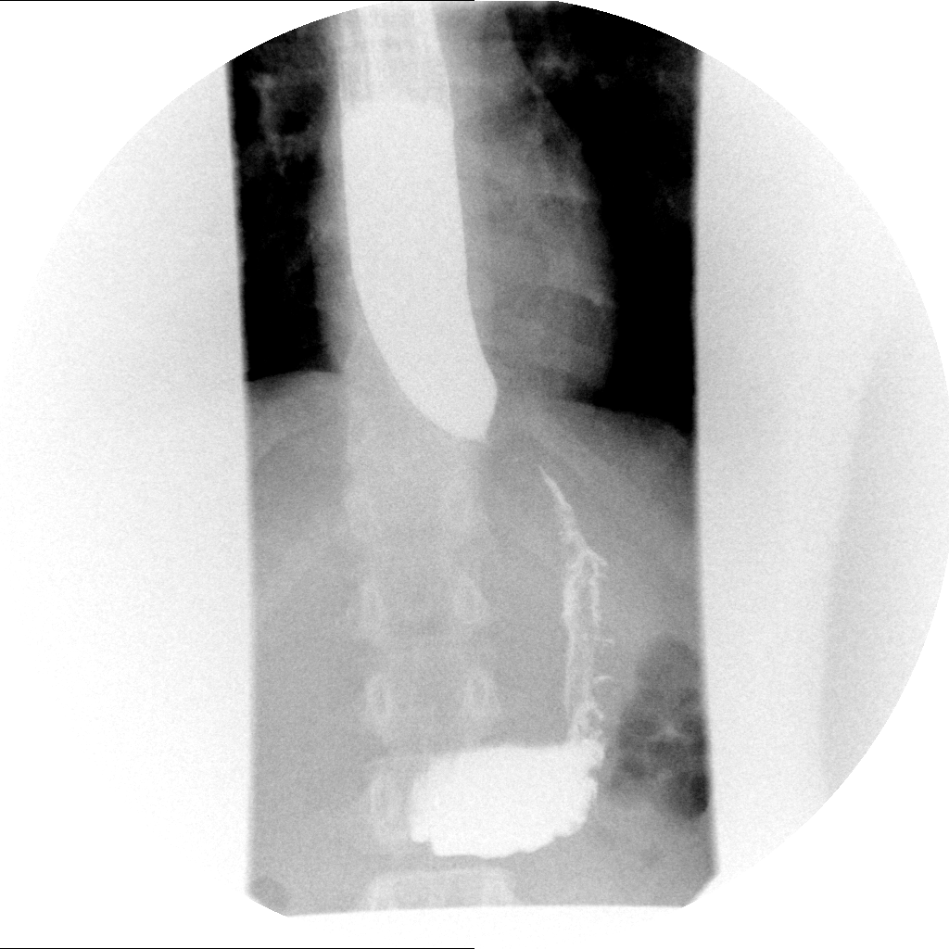
Figure 1 “Bird-beak” esophagram. Barium esophagram of a 16-year-old male demonstrating a dilated proximal esophagus with smooth tapering distally; findings consistent with achalasia.

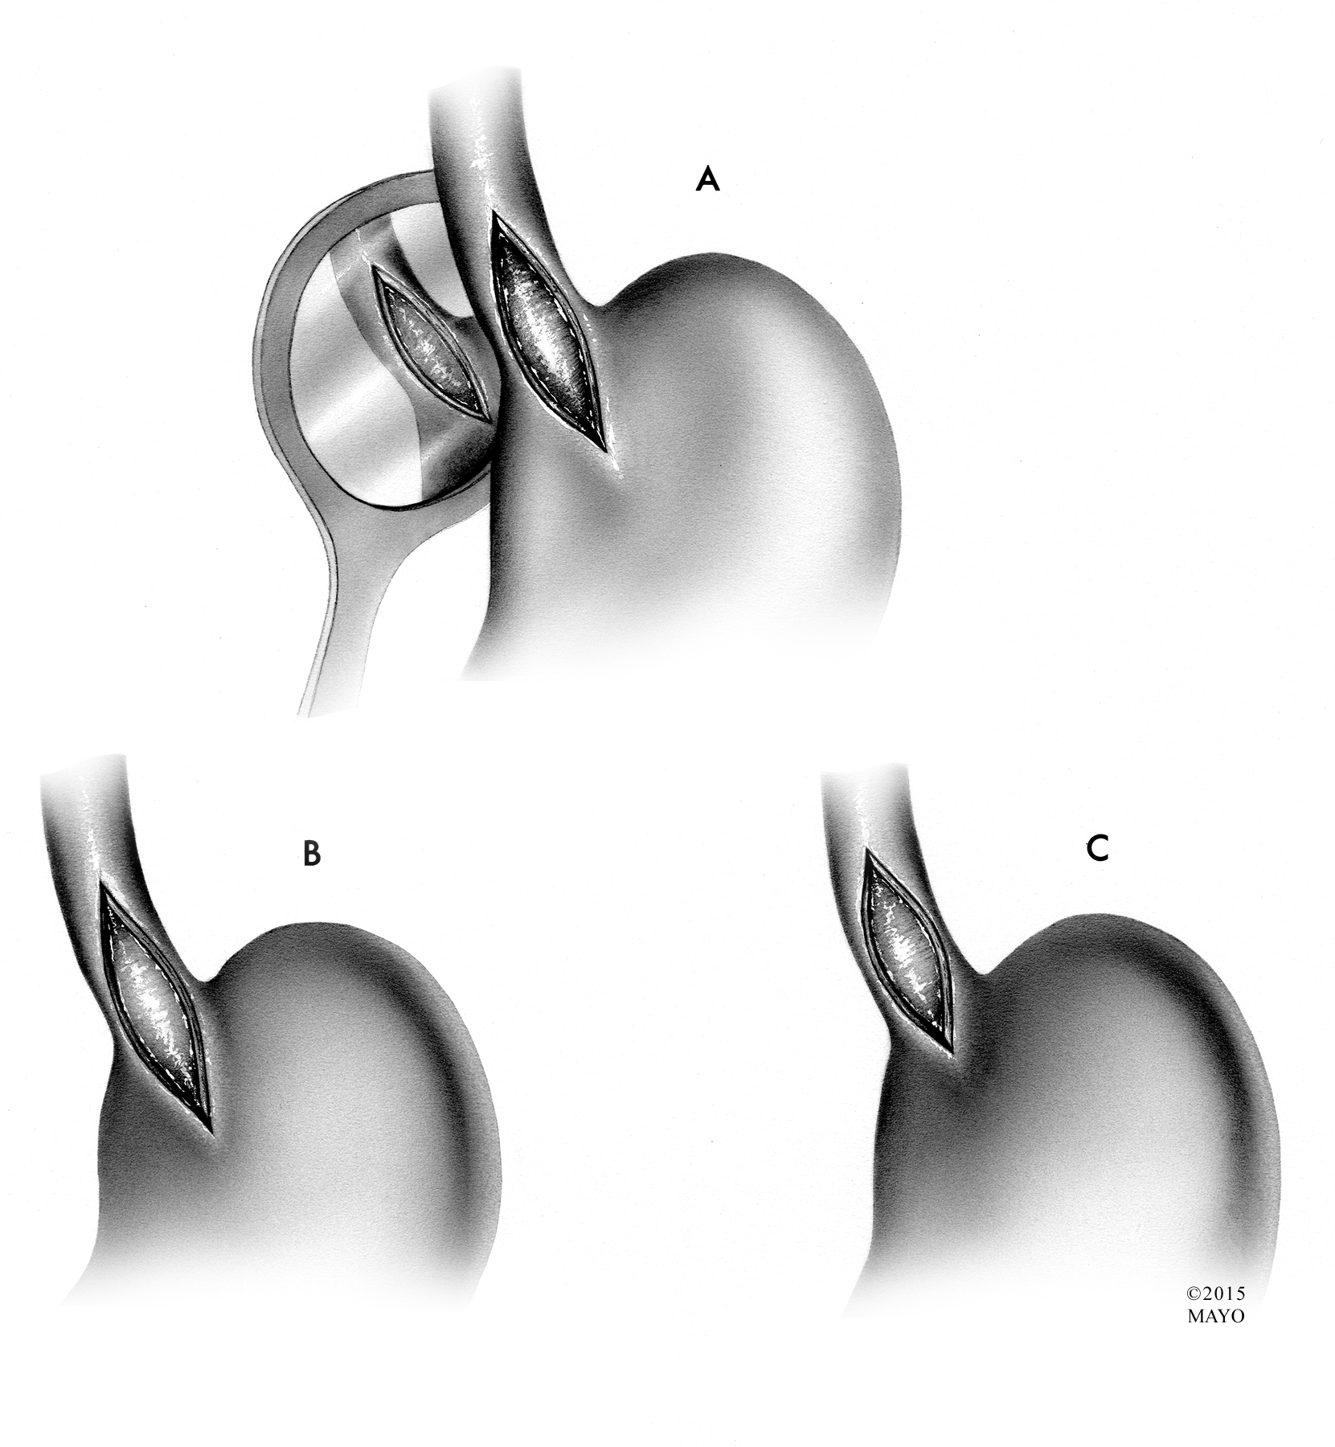
Figure 2 Esophageal myotomies. A: The original Heller myotomy, consisting of both anterior and posterior disruption of esophageal fibers. B: The most commonly performed Heller myotomy, with extension onto the stomach for 2-3 cm. C: Heller myotomy with minimal extension onto the stomach.

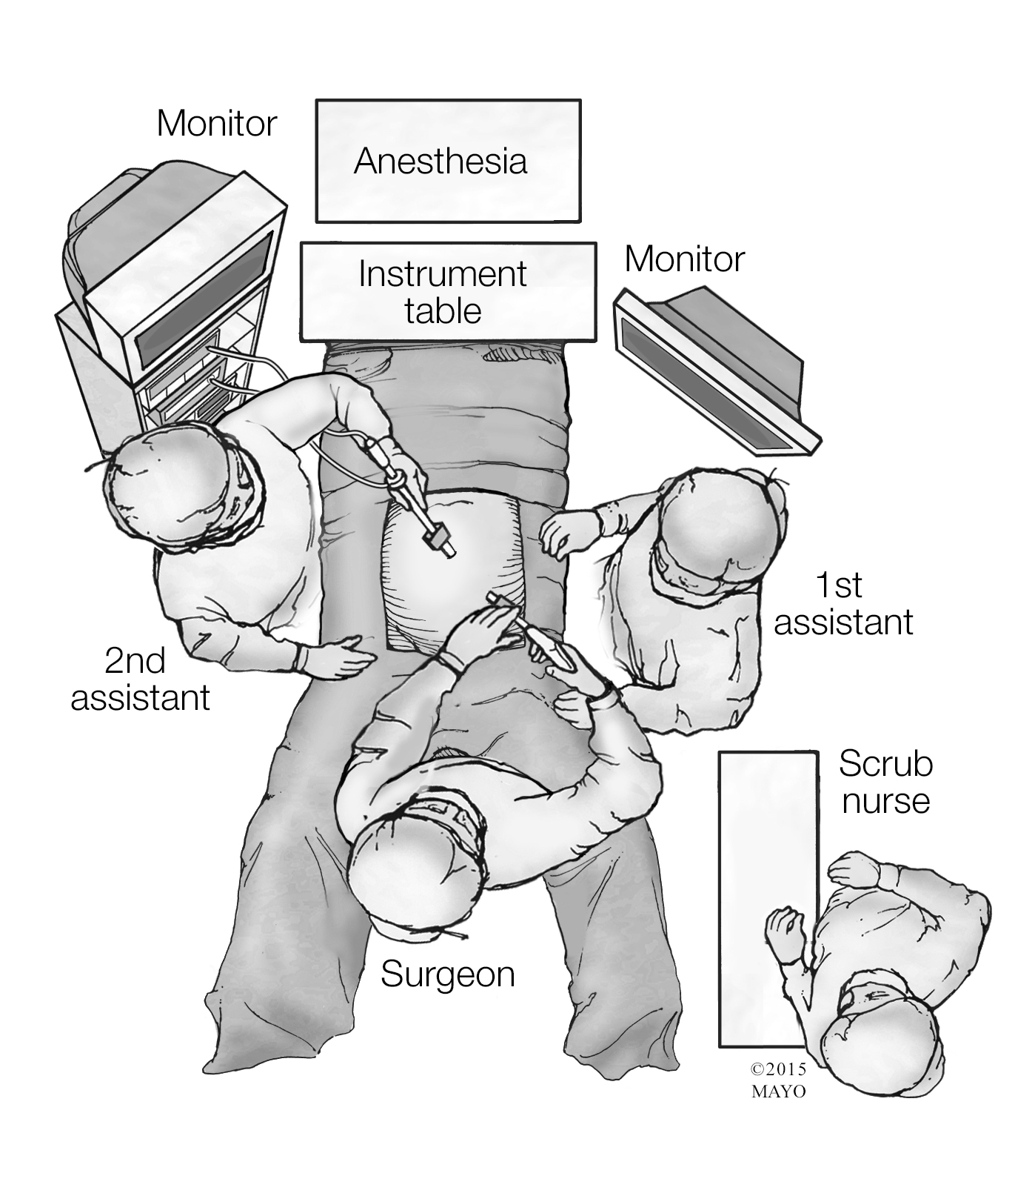
Figure 3 Patient positioning and operating room setup. The patient is placed in the modified lithotomy position and the surgeon stands between the patient’s legs. First and second assistants are to the right and left of the patient.

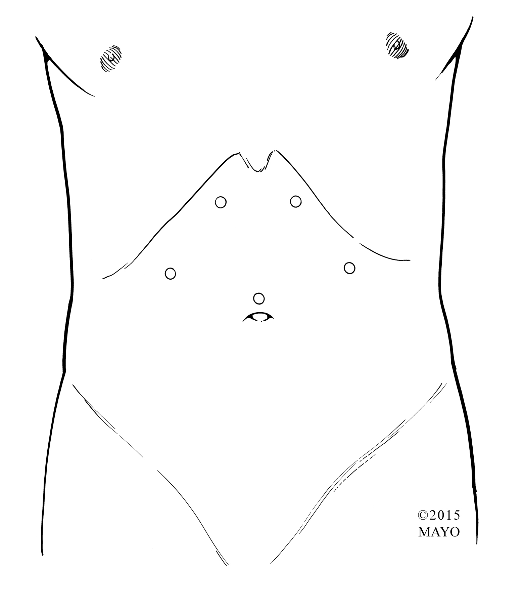
A
C
B
D
E
Adult
Child
Figure 4 Trocar placement. Example trocar arrangements. A: Laparoscope; D: babcock clamp or instrument to divide short gastrics; C: Liver retractor; D and E: Ports for dissecting and suturing; E: Electrocautery or ultrasonic shears for myotomy. The laparoscope is generally placed through a transumbilical port in children. The remaining ports are usually placed more caudad than in adults, with variable size (3 mm or 5 mm, rarely 10 mm), location, and function depending on patient body size/habitus and surgeon preference.

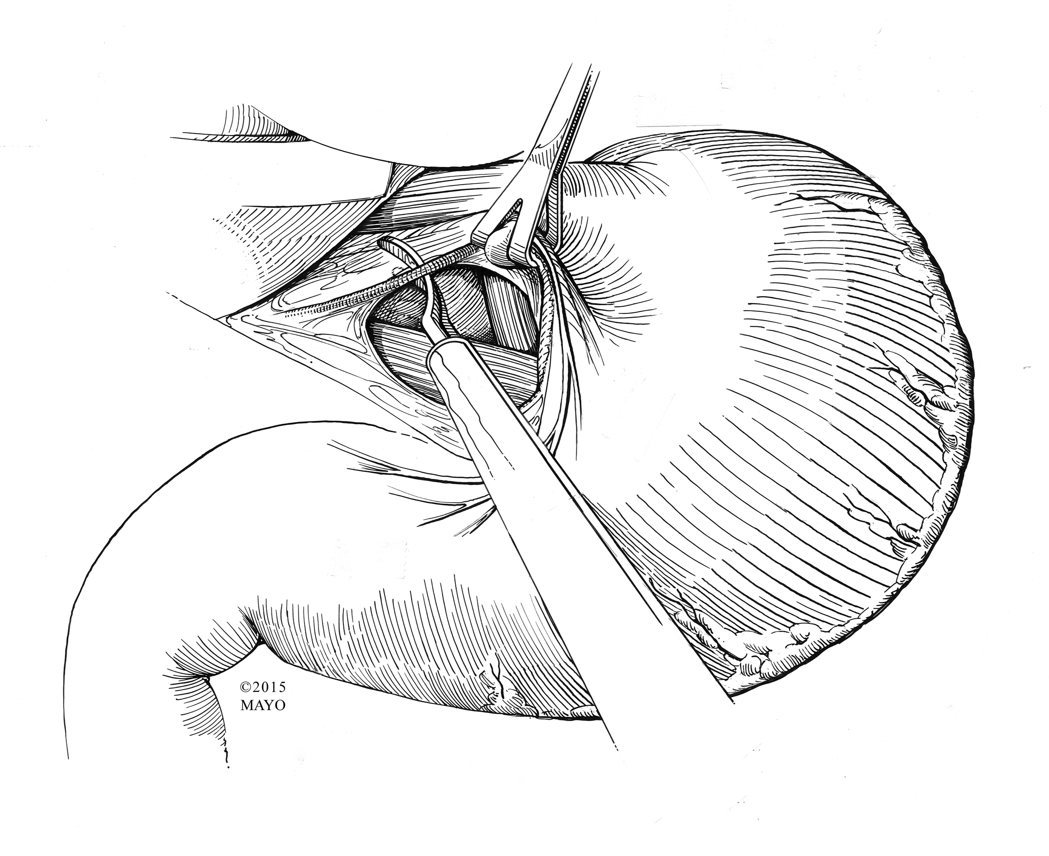
Figure 5 Incision of the gastrohepatic ligament. After retraction of the liver cephalad, the gastrohepatic ligament is incised and the lesser sac is entered. Blunt dissection is used to first identify the right crus of the diaphragm.

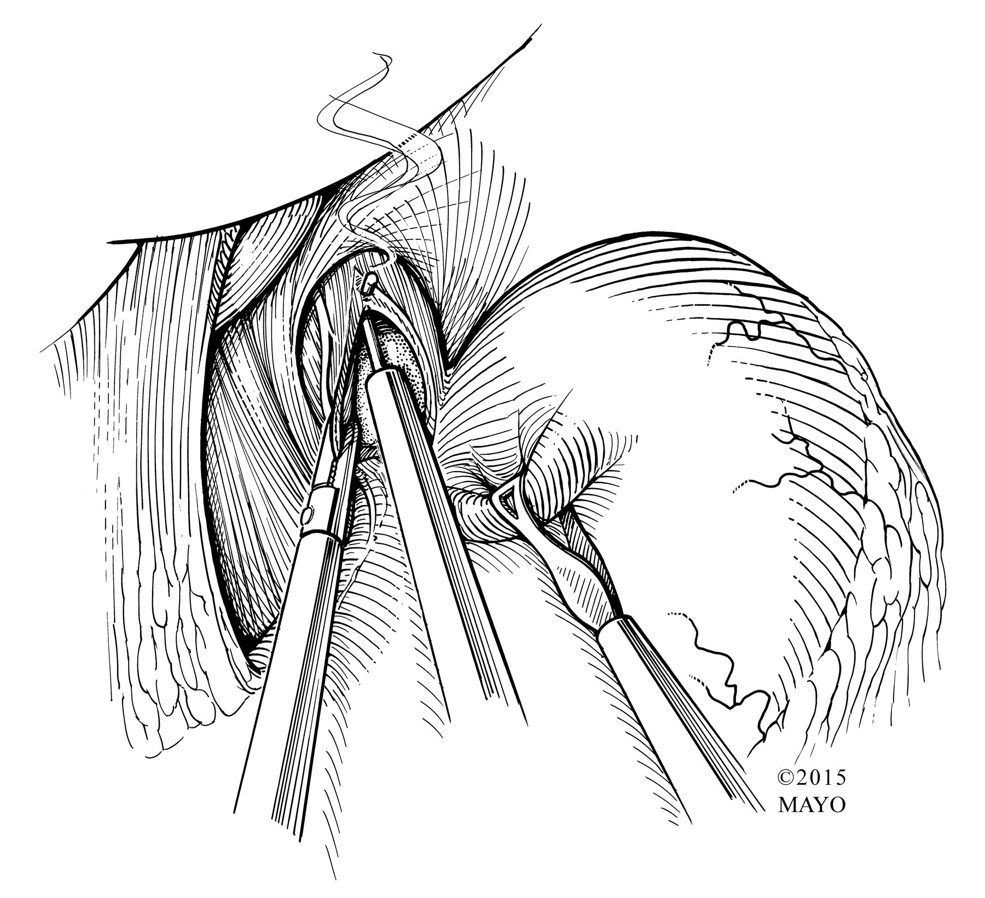
Figure 6 Myotomy with hook cautery. Electrocautery is used to begin the myotomy. It is performed at the 11 o’clock position on the anterior surface of the esophagus, taking care to avoid injury to the overlying vagus nerve. Once the submucosa is visible, blunt dissection is then typically employed to fully expose the mucosa.

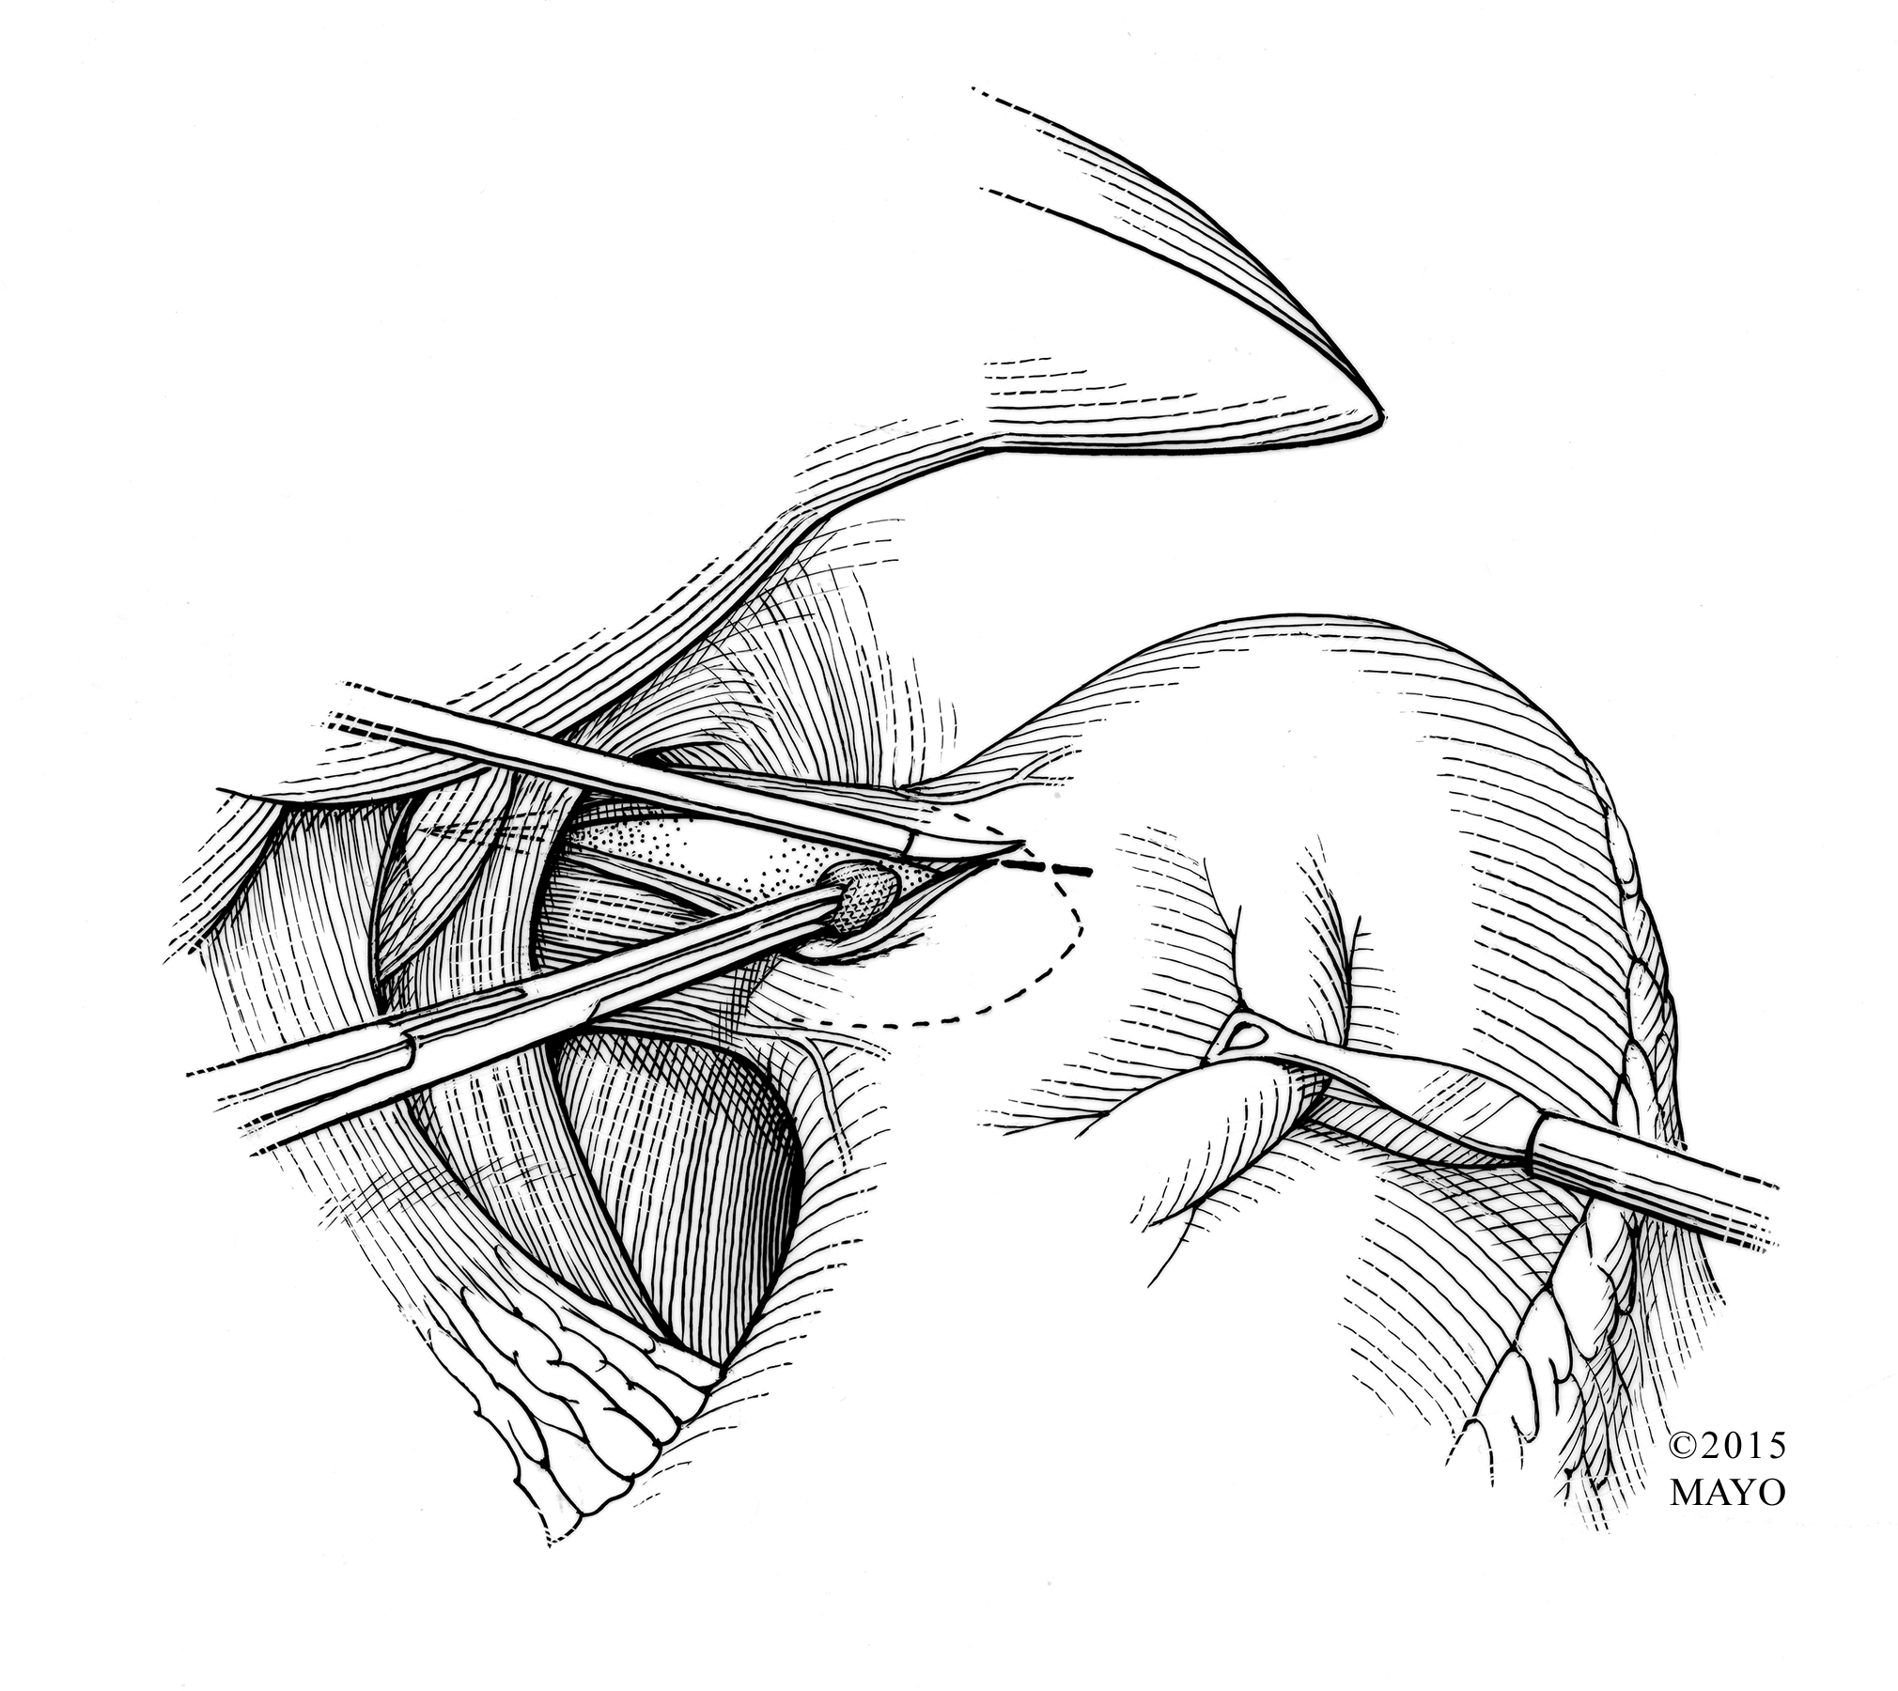
Figure 7 Myotomy with sharp and blunt dissection. Sharp and blunt dissection avoid the risk of thermal injury to the mucosa during myotomy.

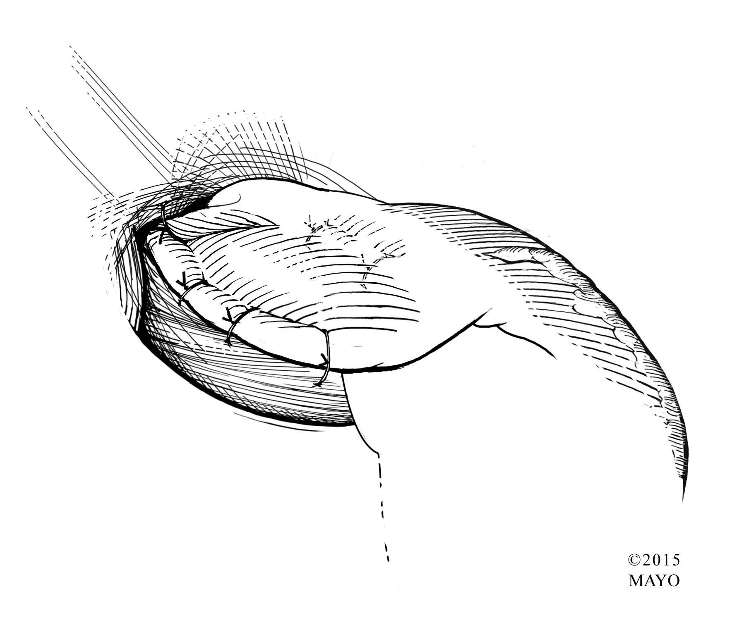
Figure 8 Anterior (Dor) fundoplication. The anterior (Dor) fundoplication is the most common fundoplication performed in children undergoing laparoscopic Heller myotomy. The fundus of the stomach is rolled over the myotomy and secured to the right and left edges of the cut esophageal muscle and crura. The myotomy is concealed. Additional stitches are placed from the anterior gastric fundus to the rim of the esophageal hiatus to relieve tension from the right sided sutures.

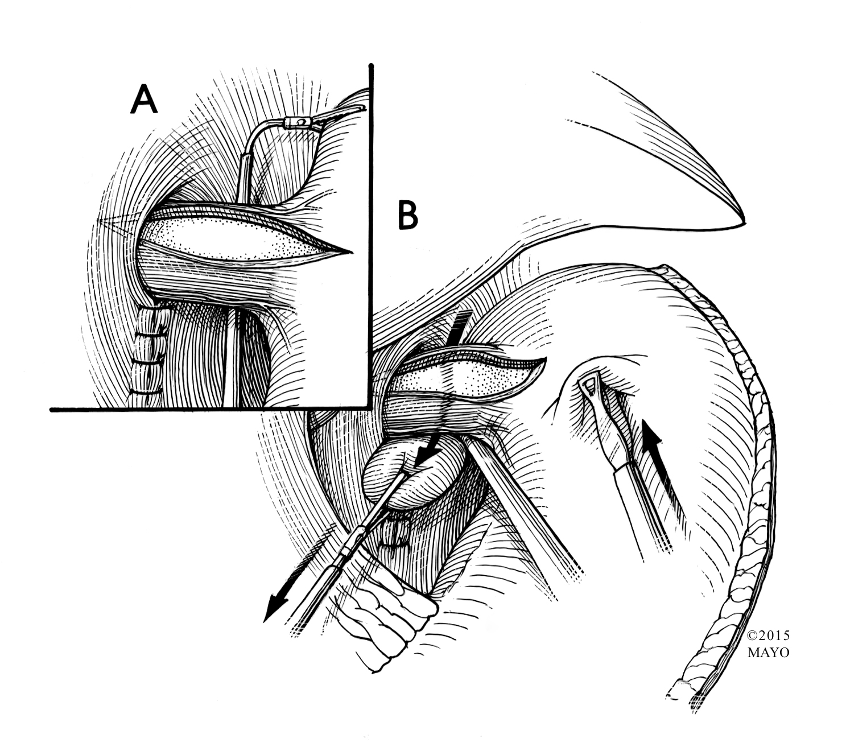
Figure 9 Passing gastric fundus posteriorly for Toupet fundoplication. A: Once the fundus is fully mobilized, it is handled by passing a grasper from right to left, posterior to the esophagus and gastroesophageal junction. B: The fundus is then pulled to the right and toward the right cut edge of the myotomy.

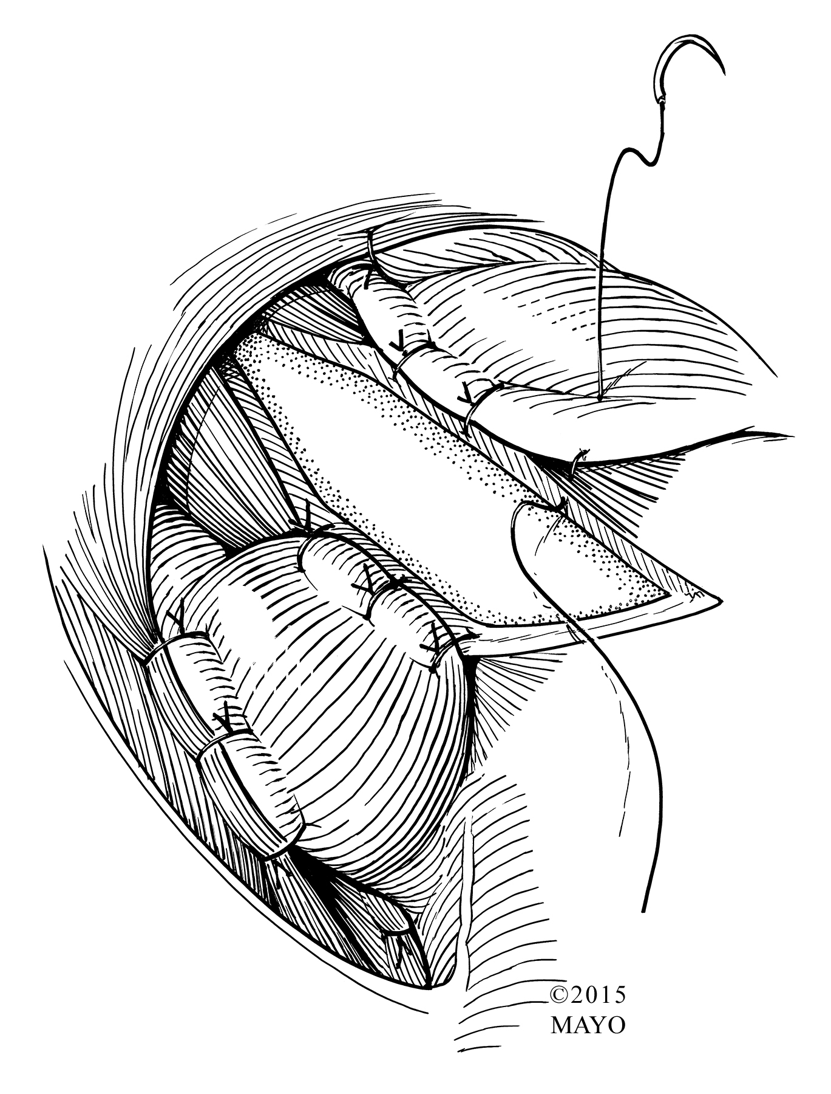
Figure 10 Posterior (Toupet) fundoplication. The stomach is secured to the right and left crura as well as the right and left cut edges of esophageal muscle, completing the posterior fundoplication. The myotomy remains exposed.

Table 1 Achalasia symptoms and associated conditions in children
Symptoms
Progressive dysphagia
Vomiting
Weight loss
Regurgitation
Aspiration
Chest pain
Failure to thrive
Associated conditions
Allgrove syndrome (triple A syndrome)
Down syndrome
Chagas disease

Table 2 Complications
Year | Study | LHM children (n) | Fundoplication (n) | Intraoperative complication (n) |  |  |  | Postoperative complication (n)
 |  |  |  | Mucosal injury or perforation | Aspiration Event | Conversion to open | Hemorrhage event | Recurrence of dysphagia | Symptoms of gastroesophageal reflux | Other
1996 | Holcomb et al^{[67]} | 2 | None | 0 | -/- | -/- | -/- | 0 | -/- | -/-
2001 | Mehra et al^{[68]} | 18 | 8 Dor, 8 Toupet, 2 Nissen | 2 | -/- | 2 | -/- | a | a | -/-
2001 | Patti et al^{[53]} | 13 | 12 Dor, 1 None | 0 | 0 | 0 | 0 | 0 | 1 | -/-
2001 | Rothenberg et al^{[70]} | 5 | 4 Dor, 1 Toupet | 1 (identified POD#5) | 0 | 0 | 0 | b | b | -/-
2003 | Mattioli et al^{[62]} | 20 | 20 Dor | 1 | -/- | -/- | 1 | 4 | 0 | -/-
2007 | Garzi et al^{[61]} | 12 | 6 Thal, 6 Dor | 1 | -/- | -/- | -/- | 0 | -/- | 3 pts w/odynophagia
2007 | Paidas et al^{[69]} | 14 | 14 Dor | 1 | -/- | -/- | -/- | a | a | -/-
2009 | Pastor et al^{[16]} | 14 | 11 Nissen, 3 Unknown | 2 (1 identified on unspecified POD) | -/- | 2 | -/- | b | b | -/-
2009 | Askegard-Giesmann et al^{[65]} | 26 | 2 Dor, 23 Toupet, 1 None | 2 | 1 | 0 | 0 | 7 | 1 | -/-
2010 | Corda et al^{[64]} | 20 | None | 3 | -/- | 4 | 1 | 5 | 0 | -/-
2010 | Lee et al^{[6]} | 7 | 4 Dor, 1 Nissen, 2 None | -/- | -/- | -/- | -/- | -/- | -/- | 1 pt w/DVT
2010 | Tannuri et al^{[63]} | 15 | 15 Dor | 0 | 0 | 1 | 0 | 3 | 0 | -/-
2013 | Esposito et al^{[60]} | 31 | 31 Dor | 3 (1 identified POD#2) | -/- | -/- | -/- | 5 | -/- | -/-
2014 | Pachl et al^{[53]} | 28 | 9 Dor, 1 Nissen, 18 None | 1 | -/- | -/- | -/- | 8 | 4 | -/-
2015 | Caldaro et al^{[51]} | 9 | 9 Dor | 1 (identified POD#1) | -/- | -/- | -/- | 2 | 1 | -/-
-/-: Not explicitly stated in the study; a: Complication reported as average score or unclear description of number; b: Multiple myotomy approaches (laparoscopic, thoracoscopic etc.) utilized in study cohort with unclear delineation of complications between groups; LHM: Laparoscopic Heller myotomy; DVT: deep venous thrombosis.

