Name of Journal: World Journal of Clinical Cases
Manuscript NO: 70964
Manuscript Type: CASE REPORT

An atypical primary malignant melanoma arising from the cervical nerve root: A case report and review of literture

Shi YF et al. Interesting growth pattern of intraspinal tumour

Yi-Feng Shi, Yu-Qi Chen, Hai-Feng Chen, Xin Hu

Yi-Feng Shi, Yu-Qi Chen, Hai-Feng Chen, Xin Hu, Department of Neurosurgery, West China Hospital, Chengdu 610041, Sichuan Province, China

Author contributions: Shi YF drafted the article or made critical revisions related to the important intellectual content of the manuscript; Chen YQ analyzed and interpreted the data; designed the research study; Chen HF approved the final version of the article to be published; Hu X provided substantial contributions to conception and design of the study; All authors issued final approval for the version to be submitted.

Corresponding author: Xin Hu, MD, Neurosurgeon, Department of Neurosurgery, West China Hospital, No. 37 Guo Xue Xiang, Wu Hou District, Chengdu 610041, Sichuan Province, China. huxingxxy@gmail.com

Received: August 21, 2021
Revised: October 29, 2021
Accepted: November 30, 2021
Published online:

Abstract
BACKGROUND
Primary melanomas affecting the central nervous system are very rare, and melanomas originating in the spinal canal or origin of the spinal nerve root are even rarer. As a consequence, not much is known about this.

CASE SUMMARY
Here we report a case of primary malignant melanoma originating in the cervical spinal cord nerve root. A 64-year-old woman presented with symptoms of numbness in the right side of the neck, pain, and hypoesthesia in the right upper limb which persisted for 1 year. Neurological examination showed that the superficial sensation in the right upper limb had decreased with muscle strength of grade 4. Magnetic resonance imaging examination revealed a mass (approximately 2.5 cm × 1.4 cm × 1 cm) in the right side of the spinal canal in the C-2 plane. Based on findings obtained during operation, perioperative examination, pathological diagnosis, and the diagnostic criteria of primary central melanoma proposed by Hayward, the mass was confirmed to be a melanoma of intraspinal nerve root origin.

CONCLUSION
This is the first case of primary malignant melanoma originating from cervical spinal cord nerve roots and spread along the inside and outside of the spinal canal. The clinical relevance of this case is discussed to provide new insights into the differential diagnosis of intraspinal tumours. Further studies are needed to better understand the mechanisms driving the growth pattern and development of this type of tumour.

Key Words: Spinal cord; Primary melanoma; Nerve root; Primary neoplasm; Case report

Shi YF, Chen YQ, Chen HF, Hu X. An atypical primary malignant melanoma arising from the cervical nerve root: A case report and review of literture. World J Clin Cases 2021; 0(0): 0000-0000 URL: https://www.wjgnet.com/2307-8960/full/v0/i0/0000.htm DOI: https://dx.doi.org/10.12998/wjcc.v0.i0.0000

Core Tip: Primary malignant melanoma arising from the cervical nerve root, and spreading along the inside and outside regions of the spinal canal is clinically rare. The clinical symptoms and imaging features of this case are atypical and can easily be misdiagnosed. In this case report, additional clinical characteristics and differential diagnoses are presented.

INTRODUCTION
Primary central nervous system melanomas are very rare, and account for about 1% of all melanomas^{[1]}. In addition, primary malignant melanoma in the spinal canal is even rarer with only several cases reported so far^{[2]}. Majority of such cases show nerve root involvement. Herein, we present an unusual case of primary malignant melanoma originating from the nerve root in the spinal canal without a history of irradiation exposure. To date, there have been only 5 similar cases^{[3,4]}. However, as far as we know, the patient described in this report presents the first case of primary malignant melanoma in which the growth occurs along the inside and outside of the spinal canal.

CASE PRESENTATION
Imaging examinations
Magnetic resonance imaging (MRI) examination showed a mass (approximately 2.5 cm × 1.4 cm × 1 cm) in the right side of the spinal canal in the C-2 plane. The mass exhibited high signal intensity on T1-weighted images and isointense on T2-weighted images. The signal intensity did not vary significantly between the T1-weighted images after contrast enhancement. The boundary was clear and spinal cord appeared significantly compressed and displaced to the left side (Figure 1). Results shown in Figure 1D indicate that the tumour extended beyond the intervertebral foramen to the outside of the spinal canal.

Laboratory examinations
Her preoperative laboratory examination, electrocardiogram, and lung computerized tomography (CT) findings were normal.

Physical examination
Neurological examination showed that the superficial sensation in the right upper limb had decreased accompanied by a muscle strength of grade 4. A general examination did not find any subcutaneous nodules or skin lesions.

Personal and family history
No positive personal or family history.

History of past illness
The patient had no previous medical history or a family history of malignant melanoma. She denied having any previous irradiation exposure.

History of present illness
The patient presented with progressive numbness in the right side of the neck, pain, and hypoesthesia in the right upper limb that occurred in the previous 1 year.

Chief complaints
A 64-year-old woman was admitted to our hospital with numbness in the right side of the neck, pain, and hypoesthesia in the right upper limb which persisted for 1 year.

MULTIDISCIPLINARY EXPERT CONSULTATION
None

FINAL DIAGNOSIS
Based on the findings obtained during operation, perioperative examination, pathological diagnosis, and the diagnostic criteria of primary central melanoma proposed by Hayward, the neoplasm was considered to be a melanoma of intraspinal nerve root origin with an atypical growth pattern.

TREATMENT
We adopted the posterior median approach which allowed us to successfully remove the tumour. During the operation, the subdural region appeared black. After opening the dura mater, a black object was seen wrapped in a membranous structure close to the nerve root. The object grew out of the spinal canal through the intervertebral foramen. The lesion was close to the pia mater surface of the spinal cord. However, it was clearly demarcated with spinal cord tissue and pia mater. It had a tough and solid texture, with little blood supply, and did not invade the dura mater (Figure 2A).

OUTCOME AND FOLLOW-UP
After operation, no postoperative neurological deficits were observed and postoperative pathological diagnosis confirmed malignant melanoma (Figure 2B-2E). A follow-up positron emission tomography/CT scan (Figure 2F) 1 mo after surgery showed total excision and no signs of metastasis and residual tumour. The postoperative course was uneventful, and the patient was discharged on the 14th day. At the last telephone follow-up in October 2021, the patient reported having no issues. We believe that her condition is stable based on routine follow-up MRIs.

DISCUSSION
Primary spinal cord melanoma is a very rare entity. Primary melanoma of the CNS originates from aberrant changes in pigment cells of the neural crest or from melanocytic elements of the pia mater during early embryonic development^{[5,6]}. The clinical presentation of this condition varies from person to person, depending on the location of the tumour^{[7]}. Primary spinal melanomas have been reported in different regions including intramedullary, intradural, and extradural lesions^{[8]}. Most of such cases occur within the cervical and thoracic cord^{[9]}. We retrospectively analysed 70 cases of primary spinal malignant melanoma between 1930 and 2021 on the PubMed Medline database. It was observed that tumours that grow from the inside to the outside of spinal canal are very rare (Table 1).

In terms of clinical manifestation, the most common initial symptom of spinal schwannoma is pain, followed by loss of nerve function^{[9]}. In our case, symptoms of nerve root stimulation were pronounced before operation, which matched the typical clinical manifestations of spinal schwannoma. For the spinal Schwannoma, MRI imaging shows a dumbbell shape and widening of intervertebral foramen^{[10]}. In our case, this growth pattern was first seen in the spinal melanoma. Using MRI, the primary imaging modality used for evaluation of spinal neoplasm^{[11]}, the signal of this lesion emerged from under the epidural of spinal cord, as in the case of schwannoma and meningioma^{[10]}. Besides, most of these lesions show signal hyperintensity on T1-weighted images^{[8,11]}, rarely iso-intensity on T2-weighted images^{[12,13]}, as well as mild to moderate homogenous enhancement^{[14,15]}. It should be that the MRI signal of the lesion showed signal hyperintensity on T1 weighted image and equal signal on T2. The signal intensity after enhancement was not significantly different from that on T1-weighted images. It has been postulated that a higher blood supply in a lesion yields a higher signal intensity after enhancement^{[16]}. The signal hyperintensity on T1-weighted image was due to the concentration of melanin, haemorrhages, and fat deposits^{[17,18]}. The signal characteristics of MRI may easily lead to misdiagnosis. It is important for surgeons to make an accurate diagnosis and be aware of the limitations of the diagnostic value of MRI. For instance, enhanced MRI revealed a pronounced dural tail sign, which is a classic characteristic of meningioma. However, T1-weighted images with hyperintensity and T2-weighted images with hypointensity are typical features for melanoma, and atypical for meningioma. In addition, intra-tumoral bleeding may cause uneven hyper-intensive signal in T1-weighted images. However, it has been reported that enhancement scan of melanoma originating from intramedullary melanoma will be significantly enhanced. Moreover, if there is bleeding in the tumour, the signal will show mixed density^{[19]}.

Moreover, blood supply within a tumour seen during the operation was not abundant. As a consequence, we hypothesized that there was no obvious enhancement in the enhanced scan of melanoma originating from the nerve root. These factors make the preoperative diagnosis of atypical cases difficult, and our case reveals the diverse growth patterns associated the imaging findings of primary central nervous system melanoma. This is extremely important for the design of surgical strategies^{[20]}. Thus, when making a preoperative diagnosis based on neuroimaging and clinical experience, there is need to make a more comprehensive prediction of the benign and malignant lesions before preventive measures are applied during operation and the tumour is excised. This only prevents metastasis and influences prognosis of patients.

In most melanomas occurring in the spine, they have primary lesions or metastases in other parts of the spine^{[21]}. Therefore, the present case adds to the understanding on such melanomas. Notably, the positive rate of Ki-67 index in the postoperative pathological examination of present case was more than 20%. In theory, cancer cells of this case will proliferate rapidly and are likely to metastasize^{[22,23]}. However, patients didn’t receive radiotherapy and chemotherapy. No recurrence or metastasis was found during follow-up, indicating that the primary malignant melanoma originating from the nerve root may have different biological characteristics^{[24]}, or such tumours have a better prognosis than do cutaneous melanomas^{[25]}. As a consequence, the primary malignant melanoma in the spinal canal may be less invasive than in other parts. which require more evidence-based medicine from the clinical experience. The choice of treatment^{[26,27]} for such cases is extremely important. Gross total resection has been shown to results in longer progression-free survival and survival compared with no or partial resection^{[28,29]}. Because the gross total resection of the tumour result in good outcomes and a longer longevity^{[30,31]}. Nevertheless, the efficacy of postoperative radiotherapy or chemotherapy is still controversial^{[32,33]}.

CONCLUSION
In the present report, we present the first case of a primary malignant melanoma originating from the cervical spinal cord nerve roots and grew from the inside to the outside of the spinal canal. Unlike most primary melanomas of the spinal canal, this case has an unusual tumour origin, growth pattern, and imaging findings. Therefore, it provides new insights into the understanding and differential diagnosis of intraspinal tumours. Further studies are needed to reveal the mechanisms driving the development and growth pattern of such a tumour.

ACKNOWLEDGEMENTS
The authors thank the staff (Department of Neurosurgery, West China Hospital) engaged in the surgery and clinical care of the patient.

REFERENCES
1 Puyana C, Denyer S, Burch T, Bhimani AD, McGuire LS, Patel AS, Mehta AI. Primary Malignant Melanoma of the Brain: A Population-Based Study. World Neurosurg 2019; 130: e1091-e1097 [PMID: 31323401 DOI: 10.1016/j.wneu.2019.07.095]
2 Zhang M, Liu R, Xiang Y, et al Primary Spinal Cord Melanoma: A Case Report and a Systemic Review of Overall Survival. World neurosurgery 2018; 114: 408-420. [DOI: 10.1016/j.wneu.2018.03.169]
3 Lee CH, Moon KY, Chung CK, Kim HJ, Chang KH, Park SH, Jahng TA. Primary intradural extramedullary melanoma of the cervical spinal cord: case report. Spine (Phila Pa 1976) 2010; 35: E303-E307 [PMID: 20308942 DOI: 10.1097/BRS.0b013e3181ccb1b3]
4 Zou C, Cheng W, Zhu C, Guo Q, Wu A. Primary Extradural Melanoma Arising in Cervical Spinal Nerve Root. World Neurosurg 2018; 111: 211-215 [PMID: 29288844 DOI: 10.1016/j.wneu.2017.12.117]
5 PAPPENHEIM E, BHATTACHARJI SK. Primary melanoma of the central nervous system. Clinical-pathological report of a case, with survey and discussion of the literature. Arch Neurol 1962; 7: 101-113 [PMID: 14483757 DOI: 10.1001/archneur.1962.04210020023003]
6 Yamasaki T, Kikuchi H, Yamashita J, Asato R, Fujita M. Primary spinal intramedullary malignant melanoma: case report. Neurosurgery 1989; 25: 117-121 [PMID: 2755570 DOI: 10.1097/00006123-198907000-00023]
7 Vij M, Jaiswal S, Jaiswal AK, Behari S. Primary spinal melanoma of the cervical leptomeninges: report of a case with brief review of literature. Neurol India 2010; 58: 781-783 [PMID: 21045512 DOI: 10.4103/0028-3886.72209]
8 Farrokh D, Fransen P, Faverly D. MR findings of a primary intramedullary malignant melanoma: case report and literature review. AJNR Am J Neuroradiol 2001; 22: 1864-1866 [PMID: 11733317]
9 Tuz Zahra F, Ajmal Z, Qian J, Wrzesinski S. Primary Intramedullary Spinal Melanoma: A Rare Disease of the Spinal Cord. Cureus 2021; 13: e16194 [DOI: 10.7759/cureus.16194]
10 Olex-Zarychta D. Clinical Significance of Pain in Differential Diagnosis between Spinal Meningioma and Schwannoma. Case Rep Oncol Med 2020; 2020: 7947242 [PMID: 32670651 DOI: 10.1155/2020/7947242]
11 Jaiswal S, Vij M, Tungria A, Jaiswal AK, Srivastava AK, Behari S. Primary melanocytic tumors of the central nervous system: a neuroradiological and clinicopathological study of five cases and brief review of literature. Neurol India 2011; 59: 413-419 [PMID: 21743173 DOI: 10.4103/0028-3886.82758]
12 Kounin GK, Romansky KV, Traykov LD, Shotekov PM, Stoilova DZ. Primary spinal melanoma with bilateral papilledema. Clin Neurol Neurosurg 2005; 107: 525-527 [PMID: 16202828 DOI: 10.1016/j.clineuro.2004.10.013]
13 Lee NK, Lee BH, Hwang YJ, Sohn MJ, Chang S, Kim YH, Cha SJ, Cho HJ. Findings from CT, MRI, and PET/CT of a primary malignant melanoma arising in a spinal nerve root. European spine journal 2010; 19: 174-178 [DOI: 10.1007/s00586-010-1285-1]
14 Kinnen F, Fleck S, Baldauf J, Hans V, Daeschlein G, Rathmann E, Schroeder HWS, Marx S. Primary leptomeningeal melanocytic tumors of the spine: report of two cases and review of the literature. World neurosurgery 2019; 124: 228-236 [DOI: 10.1016/j.wneu.2019.01.015]
15 Kanatas AN, Bullock MD, Pal D, Chakrabarty A, Chumas P. Intradural extramedullary primary malignant melanoma radiographically mimicking a neurofibroma. Br J Neurosurg 2007; 21: 39-40 [PMID: 17453774 DOI: 10.1080/02688690701242235]
16 Unal B, Castillo M. MRI features of a primary thoracic epidural melanoma: a case report. Clin Imaging 2007; 31: 273-275 [PMID: 17599623 DOI: 10.1016/j.clinimag.2007.02.023]
17 Smith A, Rushing E, Smirniotopoulos J. Pigmented lesions of the central nervous system: radiologic-pathologic correlation. Radiographics 2009; 29: 1503-1524 [DOI: 10.1148/rg.295095109]
18 Isiklar I, Leeds NE, Fuller GN, Kumar AJ. Intracranial metastatic melanoma: correlation between MR imaging characteristics and melanin content. AJR Am J Roentgenol 1995; 165: 1503-1512 [PMID: 7484597 DOI: 10.2214/ajr.165.6.7484597]
19 Chatterjee R, Nascimento FA, Heck KA, Ropper AE, Sabichi AL. Primary Spinal Cord Melanoma - An Uncommon Entity. Can J Neurol Sci 2019; 46: 348-350 [PMID: 31084668 DOI: 10.1017/cjn.2019.28]
20 Larson TC 3rd, Houser OW, Onofrio BM, Piepgras DG. Primary spinal melanoma. J Neurosurg 1987; 66: 47-49 [PMID: 3783259 DOI: 10.3171/jns.1987.66.1.0047]
21 Haberfellner E, Elbaroody M, Alkhamees AF, Alaosta A, Eaton S, Quint E, Shahab S, O'Connor A, Im J, Khan A, El-Gohary Y, Lotfy M, Sawan M, Shamisa A, Soliman MAR. Primary Spinal Melanoma: Case Report and Systematic Review. Clin Neurol Neurosurg 2021; 205: 106649 [PMID: 33932774 DOI: 10.1016/j.clineuro.2021.106649]
22 Asi-Bautista MC, Heidemann SM, Meert KL, Canady AI, Sarnaik AP. Tumor necrosis factor-alpha, interleukin-1 beta, and interleukin-6 concentrations in cerebrospinal fluid predict ventriculoperitoneal shunt infection. Crit Care Med 1997; 25: 1713-1716 [PMID: 9377887 DOI: 10.1097/00003246-199710000-00022]
23 Schöder H, Larson S, Yeung H. PET/CT in oncology: integration into clinical management of lymphoma, melanoma, and gastrointestinal malignancies. J Nucl Med 2004; 45: 72S-81S [DOI: 10.1097/00003072-200412000-00012]
24 Sanz-Trelles A, Arranz-Salas IM, Valenzuela-Serrano MI. Melanoma arising in and limited to a spinal nerve root of the cauda equina. Histopathology 2003; 43: 603-604 [PMID: 14636261 DOI: 10.1111/j.1365-2559.2003.01679.x]
25 Brat DJ, Giannini C, Scheithauer BW, Burger PC. Primary melanocytic neoplasms of the central nervous systems. Am J Surg Pathol 1999; 23: 745-754 [PMID: 10403296 DOI: 10.1097/00000478-199907000-00001]
26 Balakrishnan R, Porag R, Asif DS, Satter AM, Taufiq M, Gaddam SS. Primary Intracranial Melanoma with Early Leptomeningeal Spread: A Case Report and Treatment Options Available. Case Rep Oncol Med 2015; 2015: 293802 [PMID: 26294993 DOI: 10.1155/2015/293802]
27 Fujimori K, Sakai K, Higashiyama F, Oya F, Maejima T, Miyake T. Primary central nervous system malignant melanoma with leptomeningeal melanomatosis: a case report and review of the literature. Neurosurg Rev 2018; 41: 333-339 [PMID: 28986666 DOI: 10.1007/s10143-017-0914-0]
28 Salpietro FM, Alafaci C, Gervasio O, La Rosa G, Baio A, Francolini DC, Batolo D, Tomasello F. Primary cervical melanoma with brain metastases. Case report and review of the literature. J Neurosurg 1998; 89: 659-666 [PMID: 9761064 DOI: 10.3171/jns.1998.89.4.0659]
29 Yu J, Zhao DD, Chen S, Zhang JM, Xu J. Primary melanoma of the cervical spine with cerebral metastases: case report and review of the literature. J Int Med Res 2012; 40: 1207-1215 [PMID: 22906295 DOI: 10.1177/147323001204000341]
30 Marx S, Fleck SK, Manwaring J, Vogelgesang S, Langner S, Schroeder HW. Primary leptomeningeal melanoma of the cervical spine mimicking a meningioma-a case report. J Neurol Surg Rep 2014; 75: e93-e97 [PMID: 25083399 DOI: 10.1055/s-0034-1372474]
31 Wu L, Yao N, Fang J, Yang J, Xu Y. Clinical features and long-term outcomes of primary spinal malignant melanoma: a single center experience. J Neurooncol 2017; 135: 513-519 [PMID: 28819705 DOI: 10.1007/s11060-017-2593-7]
32 Patchell R, Tibbs P, Regine W, Payne R, Saris S, Kryscio RJ, Mohiuddin M, Young B. Direct decompressive surgical resection in the treatment of spinal cord compression caused by metastatic cancer: a randomised trial. Lancet (London, England) 2005; 366: 643-648 [DOI: 10.1016/s0140-6736(05)66954-1]
33 Fuld AD, Speck ME, Harris BT, Simmons NE, Corless CL, Tsongalis GJ, Pastel DA, Hartford AC, Ernstoff MS. Primary melanoma of the spinal cord: a case report, molecular footprint, and review of the literature. J Clin Oncol 2011; 29: e499-502 [DOI: 10.1200/jco.2010.34.0695]

Footnotes
Informed consent statement: Informed consent was provided by the patient and his close relatives for the publication of this report and any accompanying images.

Conflict-of-interest statement: There is no conflict of interest related to the manuscript.

CARE Checklist (2016) statement: The authors have read the CARE Checklist (2016), and the manuscript was prepared and revised according to the CARE Checklist (2016).

Open-Access: This article is an open-access article that was selected by an in-house editor and fully peer-reviewed by external reviewers. It is distributed in accordance with the Creative Commons Attribution NonCommercial (CC BY-NC 4.0) license, which permits others to distribute, remix, adapt, build upon this work non-commercially, and license their derivative works on different terms, provided the original work is properly cited and the use is non-commercial. See: https://creativecommons.org/Licenses/by-nc/4.0/

Provenance and peer review: Unsolicited article; Externally peer reviewed.
Peer-review model: Single blind

Peer-review started: August 21, 2021
First decision: September 29, 2021
Article in press:

Specialty type: Neurosciences
Country/Territory of origin: China
Peer-review report’s scientific quality classification
Grade A (Excellent): 0
Grade B (Very good): 0
Grade C (Good): C, C
Grade D (Fair): 0
Grade E (Poor): 0

P-Reviewer: Almzeogi MA, Velikova TV S-Editor: Wang JL L-Editor: A P-Editor: Wang JL
Figure Legends
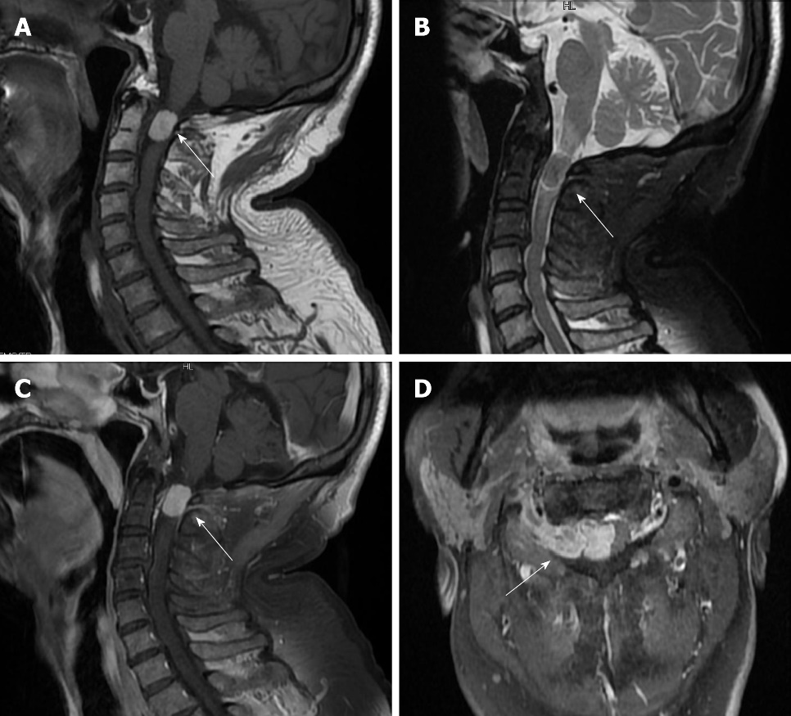
Figure 1 A: T1-weighted showed high-intensity; B: T2-weighted was equal-signal; C: Contrast Enhancement showed clear boundary, and the spinal cord is significantly compressed and displaced to the left side; D: White arrow the tumor grew out of spinal canal through intervertebral foramen.

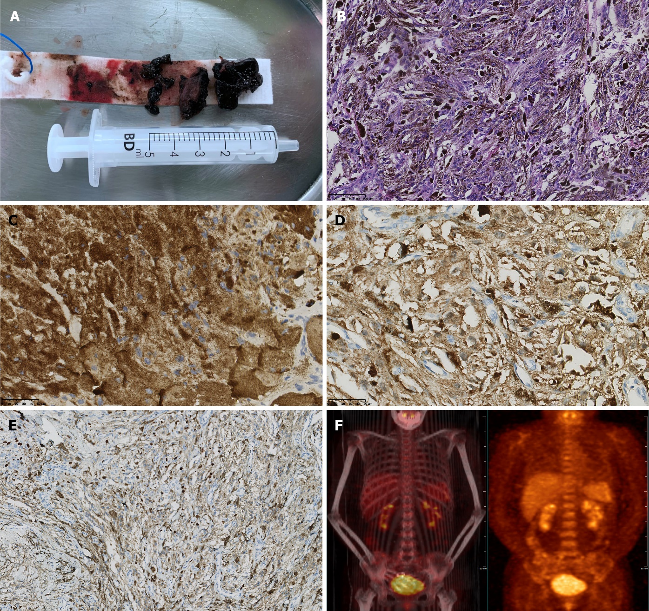
Figure 2 A: A black mass (tumor) was tough and solid, lack of blood supply; B: Hematoxylin-eosin stain (HE, original magnification ×200); C: HMB45(+); D: S100(+); E: Ki67 (approximately 20%); F: Positron emission tomography/ computerized tomography scan showed negative.

Table 1 Primary spinal melanoma: A review of the available English literature since 1930
Tumor feature | Number of patients
Growth pattern
Communicating the intervertebral Foramen | 1
Extradural | 5
Intradural-extramedullary | 33
Intradural-intra-and extra-medullary | 4
Intramedullary | 22
Other | 5
Location
Cervical | 24
Thoracic | 33
Lumbar | 10
Sacral | 3

