Name of journal: World Journal of Gastroenterology
ESPS Manuscript NO: 10899
Columns: CASE REPORT

Indocyanine green fluorescence and three-dimensional imaging of right gastroepiploic artery in gastric tube cancer

Nakano T et al. Image of right gastroepiploic artery

Toru Nakano, Tadashi Sakurai, Shota Maruyama, Yohei Ozawa, Takashi Kamei, Go Miyata, Noriaki Ohuchi

Toru Nakano, Tadashi Sakurai, Shota Maruyama, Yohei Ozawa, Takashi Kamei, Go Miyata, Noriaki Ohuchi, Division of Advanced Surgical Science and Technology, Tohoku University Graduate School of Medicine, Sendai, Miyagi 980-8574, Japan

Author contributions: Nakano T is the main author of this article; Nakano T, Sakurai T, Kamei T and Miyata G were attending doctors and performed clinical treatment including surgical operation; Maruyama S, Ozawa Y and Ohuchi N reviewed the manuscript; all authors have read and approved the final manuscript.

Correspondence to: Toru Nakano, MD, PhD, Division of Advanced Surgical Science and Technology, Tohoku University Graduate School of Medicine, 1-1 Seiryo-machi, Aoba-ku, Sendai, Miyagi 980-8574, Japan. torun@med.tohoku.ac.jp
Telephone: +81-22-7177214 Fax: +81-22-7177217

Received: April 24, 2014 Revised: June 19, 2014
Accepted: July 15, 2014

Published online:

Abstract
A 79-year-old male was admitted to our hospital for the treatment of cancer of the gastric tube. Gastrointestinal examination revealed a T1b Union for International Cancer Control (UICC) tumor at the pyloric region of the gastric tube. Laparotomy did not reveal infiltration into the serosa, peritoneal dissemination, regional lymph node swelling, or distant metastasis. We performed a distal gastrectomy preserving the right gastroepiploic artery by referencing the preoperative three-dimensional computed tomoangiography. We also evaluated the blood flow of the right gastroepiploic artery and in the proximal gastric tube by using indocyanine green fluorescence imaging intra-operatively and then followed with a gastrojejunal anastomosis with Roux-en-Y reconstruction. The definitive diagnosis was moderately differentiated adenocarcinoma of the gastric tube, pT1bN0M0, pStage IA UICC. His postoperative course was uneventful. Three-dimensional computed tomographic imaging is effective for assessing the course of blood vessels and the relationship with the surrounding structures. Intraoperative evaluation of blood flow of the right gastroepiploic artery and of the gastric tube in the anastomotic portion is very valuable information and could contribute to a safe gastrointestinal reconstruction.

© 2014 Baishideng Publishing Group Inc. All rights reserved.

Key words: Gastrectomy; Indocyanine green; Computed tomography; Mediastinum; Metachronous cancer

Core tip: A report of a 79-year-old male who presented with a metachronous gastric tube cancer following an esophageal squamous cell carcinoma. It is necessary for less invasive surgery as the resection of the distal part of the tube to prevent right gastroepiploic artery. Curative resection of the distal part of the gastric tube was performed while safely preserving the right gastroepiploic artery by referencing the preoperative three-dimensional computed tomoangiography. The intraoperative evaluation of blood flow by using indocyanine green fluorescence imaging contributed critical information about the blood flow of right gastroepiploic artery and gastric tube; we then followed with the Roux-en-Y reconstruction.

Nakano T, Sakurai T, Maruyama S, Ozawa Y, Kamei T, Miyata G, Ohuchi N. Indocyanine green fluorescence and three dimensional imaging of right gastroepiploic artery in gastric tube cancer. World J Gastroenterol 2014; In press

INTRODUCTION
Long-term survival after esophagectomy has potentially increased the likelihood of metachronous malignancies. Secondary cancer in the reconstructed gastric tube after esophagectomy also should be considered and annual follow-up endoscopy can be useful in the detection of curable cancers^{[1]}. It is important that surgical strategies are decided according to both physical and cancerous conditions^{[2]}. Because the surgical invasion of a total gastric tube resection procedure for gastric tube cancer may be too intensive, minimally invasive therapy such as partial resection of the gastric tube may be desirable for the cancer that has not advanced. The reconstructed gastric tube is dominantly fed by the right gastroepiploic artery. It is necessary to preserve this artery to avoid ischemia of the gastric tube. There are few reports mention about the three dimensional computed tomoangiography and indocyanine green fluorescence for surgical navigation during the treatment for the gastric tube cancer. Here we report a case of distal gastrectomy with the safe preservation of the right gastroepiploic artery after using the preoperative three-dimensional CT for the confirmation of blood flow of the vessel and in the proximal gastric tube.

CASE REPORT
A 79-year-old male was admitted to our hospital for the treatment of cancer of the gastric tube after radical surgery for esophageal cancer. Five years previously, he had undergone subtotal esophagectomy for the treatment of esophageal squamous cell carcinoma followed by lifting the gastric tube through the posterior mediastinal route. The esophageal tumor stage was pT1pN1cM0 [Union for International Cancer Control (UICC)] and there was no adjuvant therapy. At a routine annual endoscopy, a superficial slightly depressed type tumor was found in a prepyloric lesion of the gastric tube. On admission, gastrointestinal examination revealed a cT1b tumor (UICC) at the pyloric region of the gastric tube that was very close to the pylorus ring; this was diagnosed as adenocarcinoma by endoscopic biopsy (Figure 1). Contrast-enhanced computed tomography of the abdomen and chest revealed no regional or distant signs of tumor spread, and enlarged regional lymph nodes; furthermore, there was no evidence of recurrence of esophageal cancer. Three-dimensional computed tomography (3D-CT) visualized the location of the course of the right gastroepiploic artery (Figure 2A) and relationship with pyloric region of gastric tube and neighboring organs (Figure 2B). The patient underwent transabdominal surgery. Laparotomy did not reveal infiltration into the serosa, peritoneal dissemination, lymph node swelling, or distant metastasis. We performed a distal gastrectomy (resection of the distal part of the gastric tube) safely preserving the right gastroepiploic artery with reference to the preoperative 3D-CT. The resected specimen showed a slightly depressed-type tumor, measuring 20 mm × 15 mm in size (Figure 3). Rapid histological diagnosis during surgery showed free-form cancer invasion of the proximal and distal surgical margins. We intraoperatively evaluated the blood flow along the gastric tube by using indocyanine green (ICG) fluorescence imaging (Figure 4). Intravenous ICG injection revealed good blood flow at the surgical margins of the proximal gastric tube and of the right gastroepiploic artery. We performed a gastrojejunal anastomosis with Roux-en-Y reconstruction. Histological examination showed modelately differentiated tubular adenocarcinoma. The resected gastric tube included small amount of adipose tissue containing no lymphoid tissue histologically. The definitive diagnosis was moderately differentiated adenocarcinoma of the gastric tube, pT1bN0M0, pStage IA according to the TNM classification of malignant tumors (UICC). His postoperative course was uneventful. Postoperative upper gastrointestinal investigation did not reveal stenosis or leakage. The patient started a diet on post-operative day 3 and left the hospital on post-operative day 13.

DISCUSSION
In recent years, there has been an improved prognosis for esophageal cancer surgery patients^{[3]}; therefore, there is a need to be aware of risk of metachronous cancers. Motoyama et al^{[1]} has reported that 3.5% of the patients treated for esophageal cancer and reconstructed using a gastric tube were found to have carcinoma of the gastric tube.
Although we evaluated the invasion depth by upper gastrointestinal endoscopy, it was reported that endoscopic ultrasonography was useful in diagnosis of invasion depth and lymph node metastasis of esophageal cancer or stomach cancer to determine the clinical stage^{[4]}. Early stage gastric tube cancer can be managed with endoscopic treatment. Endoscopic submucosal dissection for gastric tube cancer was feasible and effective for curative patients^{[5]}. These patients who do not become the adaptation of ESD could be candidates for resection of the gastric tube. Total or partial gastrectomy for gastric tube cancer is a complex procedure and carries a high morbidity and mortality rate; it should still be considered as the treatment of choice in multifocal or locally advanced cases^{[6]}. Although resection of the gastric tube with lymphadenectomy is standard and a reliable treatment for gastric tube cancer, resection of the tube through the mediastinal route exposes the patient to a great deal of surgical stress. The difficulty of the operative procedure differs according to the route of the reconstruction^{[7]}. There have been reports about the significant surgical risks in total gastric tube resections because of the difficulty of the adhesiolysis necessary to reach the mediastinum^{[1,8,9]}. Therapeutic strategies for gastric tube cancer should be determined depending on the curative effect and surgical stress. Reduction surgery such as partial resection of gastric tube or the omission of lymph node dissection should also be taken into account according to the patient status^{[10]}.
As a less invasive procedure, distal gastrectomy could be appropriate in some cases, in which the right gastroepiploic artery was preserved to maintain the blood supply for the proximal gastric tube^{[2, 11]}. The reconstructed gastric tube is dominantly fed by the right gastroepiploic artery. Knowledge of the vascular anatomy before surgery is of great importance in patients with previous surgery^{[12]}. The 3D-computed tomographic image is very effective for assessing the blood vessel course and relationship with the surrounding structure while obtaining surgical navigation^{[13-15]}. It has been reported that the ICG fluorescence method was useful in evaluating the blood flow of reconstructed gastric tube intraoperatively followed by esophageal resection^{[16]}. Intravenous ICG injection for fluorescence imaging is also useful to verify the blood flow of the proximal gastric tube^{[10]}. Intraoperative evaluation of the blood flow of the right gastroepiploic artery and of the gastric tube in the anastomotic portion is very valuable information and could contribute to a safe gastrointestinal reconstruction.

COMMENTS
Case characteristics
79-year-old male who presented with a metachronous gastric tube cancer, following an esophageal carcinoma after radical esophagectomy followed with reconstruction through mediastinal route.

Clinical diagnosis
Gastrointestinal examination revealed a superficial tumor at the pyloric region of the gastric tube that was very close to the pylorus ring.

Differential diagnosis
Gastric tube ulcer, recurrence tumor derived from resected esophageal cancer.

Laboratory diagnosis
WBC 3.7 k/uL; HGB 13.6 gm/dL; CEA 1.5 ng/mL; SCC 0.9 ng/mL; metabolic panel and liver function test were within normal limits.

Imaging diagnosis
Computed tomography scan of the abdomen and chest revealed no regional or distant signs of tumor spread, and enlarged regional lymph nodes.

Pathological diagnosis
The endoscopic biopsy specimen showed an adenocarcinoma of the gastric tube.

Treatment
Distal gastrectomy preserving the right gastroepiploic artery was performed, and then followed with a gastrojejunal anastomosis with Roux-en-Y reconstruction.

Related reports
A less invasive surgery such as the resection of the distal part of the gastric tube is essential to prevent right gastroepiploic artery.

Term explanation
Indocyanine green (ICG) bound to plasma proteins is visualized as a fluorescent image excited by near-infrared light.

Experiences and lessons
The 3D-CT is very effective for assessing the blood vessel course and intraoperative blood vessel detection and blood flow evaluation based on ICG would allow minimizing the risk of vascular damage, especially about the non-anatomical.
Peer review
A distal gastrectomy was performed for the treatment of the gastric tube cancer, preserving the right gastroepiploic artery by referencing the preoperative three-dimensional computed tomoangiography. The blood flow of the right gastroepiploic artery was also evaluated by using indocyanine green fluorescence imaging intra-operatively.

REFERENCES
1 Motoyama S, Saito R, Kitamura M, Suzuki H, Nakamura M, Okuyama M, Imano H, Inoue Y, Ogawa J. Prospective endoscopic follow-up results of reconstructed gastric tube. Hepatogastroenterology 2003; 50: 666-669 [PMID: 12828056]
2 Yoshida T, Nagahama T, Maruyama M, Ebuchi M. Endoscopic comparison of two cases: distal resection of reconstructed gastric tube. Hepatogastroenterology 2002; 49: 371-374 [PMID: 11995453]
3 Bamba T, Kosugi S, Takeuchi M, Kobayashi M, Kanda T, Matsuki A, Hatakeyama K. Surveillance and treatment for second primary cancer in the gastric tube after radical esophagectomy. Surg Endosc 2010; 24: 1310-1317 [PMID: 19997933 DOI: 10.1007/s00464-009-0766-y]
4 Nonaka S, Oda I, Sato C, Abe S, Suzuki H, Yoshinaga S, Hokamura N, Igaki H, Tachimori Y, Taniguchi H, Kushima R, Saito Y. Endoscopic submucosal dissection for gastric tube cancer after esophagectomy. Gastrointest Endosc 2014; 79: 260-270 [PMID: 24060521 DOI: 10.1016/j.gie.2013.07.059]
5 Ben-nun A, Soudack M, Best LA. Gastric tube gastrectomy. Dis Esophagus 2000; 13: 243-244 [PMID: 11206641 DOI: 10.1046/j.1442-2050.2000.00119.x]
6 Koyanagi K, Ozawa S, Ando N, Shih CH, Nakamura E, Takeuchi H, Hayashi K, Kitajima M. Case report: Metachronous early gastric carcinoma in a reconstructed gastric tube after radical operation for oesophageal carcinoma. J Gastroenterol Hepatol 1998; 13: 311-315 [PMID: 9570246 DOI: 10.1111/j.1440-1746.1998.01561.x]
7 Akita H, Doki Y, Ishikawa O, Takachi K, Miyashiro I, Sasaki Y, Ohigashi H, Murata K, Noura S, Yamada T, Eguchi H, Imaoka S. Total removal of the posterior mediastinal gastric conduit due to gastric cancer after esophagectomy. J Surg Oncol 2004; 85: 204-208 [PMID: 14991878 DOI: 10.1002/jso.20017]
8 Okamoto N, Ozawa S, Kitagawa Y, Shimizu Y, Kitajima M. Metachronous gastric carcinoma from a gastric tube after radical surgery for esophageal carcinoma. Ann Thorac Surg 2004; 77: 1189-1192 [PMID: 15063232 DOI: 10.1016/j.athoracsur.2003.09.071]
9 Ariyoshi Y, Fujiwara H, Shiozaki A, Konishi H, Komatsu S, Kubota T. [Minimally invasive surgery for cancer arising in a reconstructed gastric tube after esophagectomy based on evaluation of blood and lymphatic flow by indocyanine green fluorescence imaging]. Ga kagaku ryoho Cancer chemotherapy 2013; 40: 2170-2172
10 Motoyama S, Saito R, Okuyama M, Maruyama K, Ogawa J. Treating gastric tube cancer with distal gastrectomy preserving the gastroepiploic artery. Ann Thorac Surg 2006; 81: 751-753 [PMID: 16427900 DOI: 10.1016/j.athoracsur.2004.11.011]
11 Gockel I, Lang H, Mildenberger P. Necessity of preoperative imaging of the gastro-epiploic arcade prior to esophageal resection. Hepatogastroenterology 2009; 56: 711-713 [PMID: 19621687]
12 Kato T, Takase K, Ichikawa H, Satomi S, Takahashi S. Thoracic duct visualization: combined use of multidetector-row computed tomography and magnetic resonance imaging. J Comput Assist Tomogr 2011; 35: 260-265 [PMID: 21412101 DOI: 10.1097/RCT.0b013e31820a0b0e]
13 Nakano T, Okamoto H, Maruyama S, Ohuchi N. Three-dimensional imaging of a thoracic duct cyst before thoracoscopic surgery. Eur J Cardiothorac Surg 2014; 45: 585 [PMID: 23803505 DOI: 10.1093/ejcts/ezt317]
14 Otani Y, Furukawa T, Suganuma K, Yoshida M, Saikawa Y, Kubota T, Kumai K, Mukai M, Kameyama K, Takami H, Kitajima M. Minimally invasive surgery for gastric carcinoid tumor. Biomed Pharmacother 2002; 56 Suppl 1: 217s-221s [PMID: 12487286 DOI: 10.1016/S0753-3322(02)00282-2]
15 Murawa D, Hünerbein M, Spychała A, Nowaczyk P, Połom K, Murawa P. Indocyanine green angiography for evaluation of gastric conduit perfusion during esophagectomy--first experience. Acta Chir Belg 2012; 112: 275-280 [PMID: 23008991]
16 Shimada Y, Okumura T, Nagata T, Sawada S, Matsui K, Hori R, Yoshioka I, Yoshida T, Osada R, Tsukada K. Usefulness of blood supply visualization by indocyanine green fluorescence for reconstruction during esophagectomy. Esophagus 2011; 8: 259-266 [PMID: 22557942 DOI: 10.1007/s10388-011-0291-7]

P-Reviewers: Marrelli D S-Editor: Qi Y L-Editor: E-Editor:

Figure 1 Upper gastrointestinal endoscopic examination. Superficial slightly depressed-type tumor [cT1b (UICC)] at the pyloric region of gastric tube was diagnosed as adenocarcinoma by endoscopic biopsy.
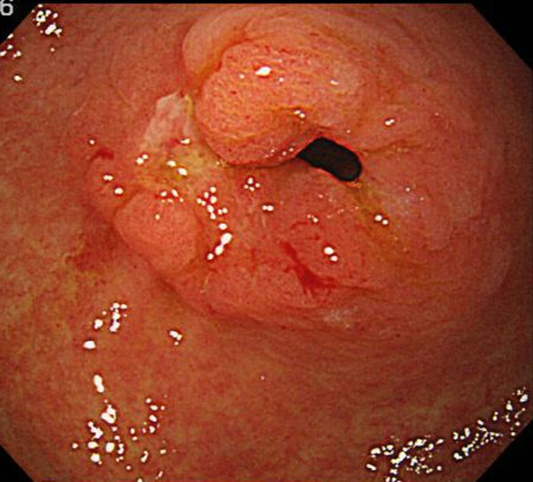

Figure 2 Three-dimensional computed tomography. A: The courses of the branches of celiac artery were well visualized while obtaining surgical navigation; B: Relationship with the gastric tube and surrounding structures were well visualized while obtaining surgical navigation. Arrows shows the running of right gastroepiploic artery. L: liver, IVC: Inferior vena cava; Pa: pancreas; G: Gastric tube; Py: Pylorus; CHA: Common hepatic artery; RGEA: Right gastroepiploic artery; GDA: Gastroduodenal artery; PHA: Proper hepatic artery.
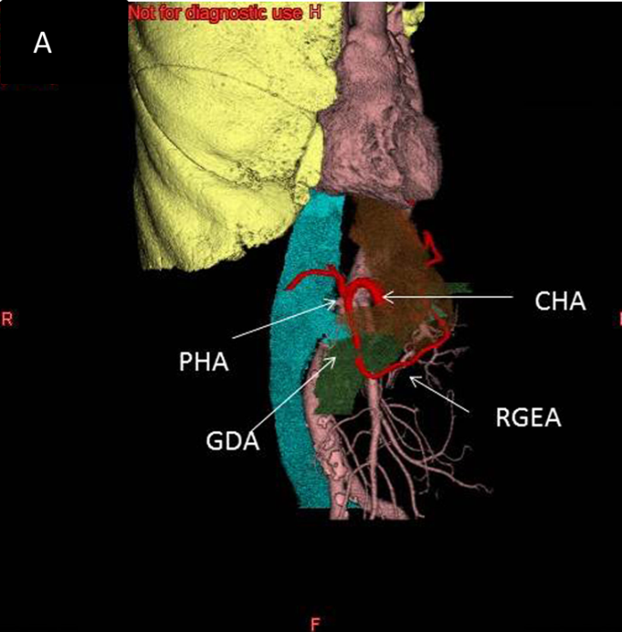
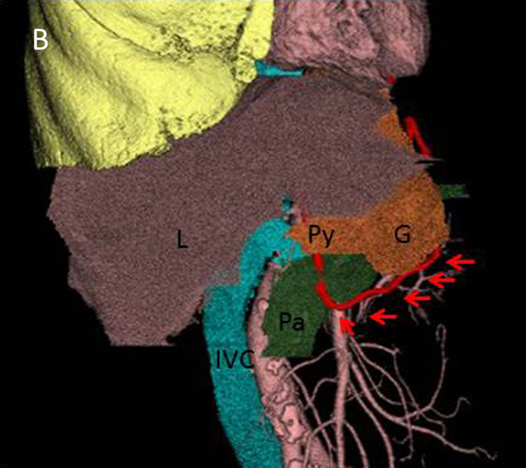

Figure 3 Resected specimen of the gastric tube. Resected specimen showed a slightly depressed-type tumor (arrows) in the pyloric lesion of gastric tube measuring 20 mm × 15 mm in size.

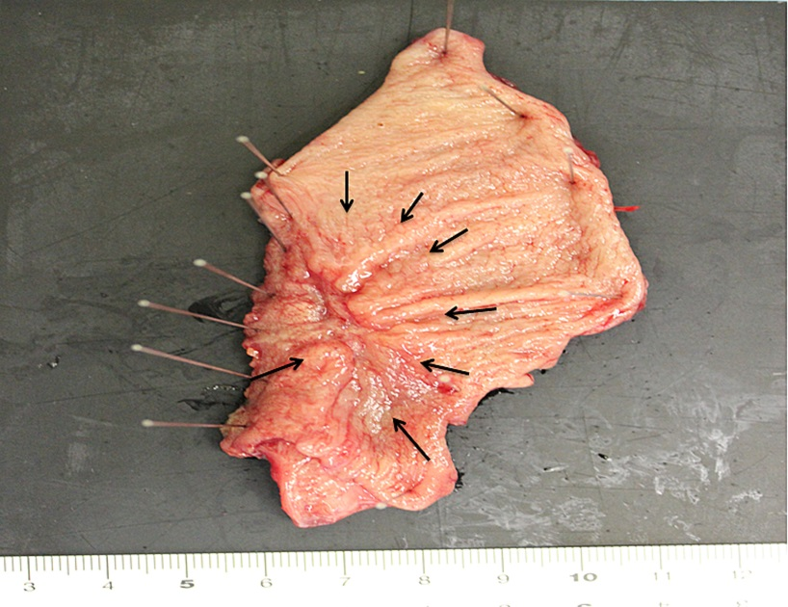

Figure 4 Intraoperative indocyanine green fluorescence imaging. Intravenous administration of indocyanine green (ICG) showed that the blood flow of the right gastroepiploic artery and surgical margin of the gastric tube was sufficiently maintained in the proximal gastric tube. Proximal margin of gastric tube (red arrows); Course of the right gastroepiploic artery (Green arrows). Duo: Margin of the duodenum; G: Proximal gastric tube.
