Name of Journal: World Journal of Clinical Urology
Manuscript NO: 75973
Manuscript Type: CASE REPORT

Scrotal strangulation in the differential diagnosis of acute scrotum: A case report

Frumer M et al. Scrotal strangulation

Michael Frumer, David Ben-Meir

Michael Frumer, David Ben-Meir, Department of Urology, Schneider Children's Medical Center of Israel, Petach Tikva 4941492, Israel

Author contributions: Frumer M researched the literature and conceived the study; Frumer M was involved in patient recruitment, systematic review of the literature and data analysis. Frumer M wrote the first draft of the manuscript. Ben-Meir D was involved in the systematic review of the literature and reviewed and edited the manuscript; All authors approved the final version of the manuscript.

Corresponding author: Michael Frumer, MD, Department of Urology, Schneider Children's Medical Center of Israel, Petach Tikva 4941492, Israel. mic1039@gmail.com

Received: February 23, 2022
Revised: May 23, 2022
Accepted: August 5, 2022
Published online: August 29, 2022

Abstract
BACKGROUND
Acute scrotal pain and swelling are common presentations in the emergency department. Urgent surgical intervention is justified in up to one-third of cases, whereas two-thirds of them should be treated conservatively.

CASE SUMMARY
We report a case of scrotal only strangulation in a child and review the available literature.

CONCLUSION
Due to its rarity, scrotal strangulation can be a diagnostic challenge. Skin ulceration and edema may well indicate the presence of a strangulation object. A high index of suspicion and appropriate physical examination, especially in patients with a mental disability or behavioral disorder, are key to early diagnosis and treatment.

Key Words: Scrotum; Physical examination; Ultrasonography; Urogenital trauma; Emergency medicine; Pediatrics; Case report

©The Author(s) 2022. Published by Baishideng Publishing Group Inc. All rights reserved.

Citation: Frumer M, Ben-Meir D. Scrotal strangulation in the differential diagnosis of acute scrotum: A case report. World J Clin Urol 2022; 11(1): 1-5
URL: https://www.wjgnet.com/2219-2816/full/v11/i1/1.htm
DOI: https://dx.doi.org/10.5410/wjcu.v11.i1.1

Core Tip: An extremely rare etiology of painful scrotal swelling, which emphasizes the paramount importance of the basic physical examination, especially in patients with a mental disability or behavioral disorder.

INTRODUCTION
Acute scrotal pain and swelling are common presentations in the emergency department (ED). Urgent surgical intervention is justified in up to one-third of cases, whereas two-thirds of them should be treated conservatively. Common causes of acute scrotal pain in children and adolescents include torsion of the appendix testis, epididymitis, and testicular torsion. Scrotal strangulation by external pressure is an extremely rare cause. We report a case of scrotal only strangulation in a child and review the available literature.

CASE PRESENTATION
Chief complaints
The patient demonstrated bilateral scrotal redness, pain, swelling, and tenderness.

History of present illness
An 11-year-old child was brought to the ED by his parents due to a 5-d history of pain, bilateral scrotal redness, swelling, and tenderness. The child refused to cooperate, and a physical examination was impossible, beyond looking at the scrotum (Figure 1).
A scrotal Doppler ultrasound was performed, demonstrating normal size and symmetrical testicles with homogeneous echogenicity, bilateral hydrocele, and increased scrotal skin thickness (Figure 2). The child was discharged from the hospital with a diagnosis of idiopathic scrotal edema. His scrotal pain and swelling worsened under treatment with non-steroidal anti-inflammatory drugs, Mebendazole, and antihistamine. After 3 days he revisited the ED, where he refused to undergo a physical examination. The parents agreed to sedate him, and finally a physical examination was carried out using Midazolam. Scrotal strangulation by nylon zip-tie was found (Figure 3).

Personal and family history
The child had an intellectual disability.

Physical examination
Physical examination showed bilateral scrotal redness, swelling, and tenderness.

Imaging examinations
Scrotal Doppler ultrasound demonstrated normal size and symmetrical testicles with homogeneous echogenicity, bilateral hydrocele, and increased scrotal skin thickness (Figure 2).

FINAL DIAGNOSIS
Scrotal strangulation by a nylon zip-tie.

TREATMENT
The zip-tie was removed using regular scissors, relieving the pain within a few minutes.

OUTCOME AND FOLLOW-UP
The scrotal swelling reduced in the following 10 d, and the incision underwent secondary healing in the following month. Psychological evaluation and subsequent assistance by a psychologist and social worker were given to the patient and his parents.
A systematic literature search was performed in PubMed and the Cochrane Library databases up to December 2021. The search key terms included “scrotal entrapment”, "scrotal strangulation", "penoscrotal strangulation", "genital incarceration", and "scrotal incarceration". Inclusion criteria were a diagnosis of scrotal or penoscrotal strangulation. The search yielded 232 articles. Excluded were “penile only strangulation” and “incarcerated scrotal hernias” cases. References in the included papers were checked for relevant cases, and any germane paper found was reviewed in the present study. All demographic and clinical data were recorded.
The key terms retrieved 17 relevant papers from 1994 to 2020 that reported on 19 cases: 16 cases of penoscrotal strangulation and three of scrotal strangulation, including the present case (Supplementary Table 1).
The median patient age was 46 years (IQR 55, 34), and the current case is the first report of pediatric scrotal strangulation in the literature. The median time to presentation was 2 d (IQR 1, 3), and 16 (84%) patients did not pose a diagnostic challenge and were diagnosed at the first clinical examination. The other three patients were diagnosed by repeated physical examinations, or by computed tomography and open surgery. The most common constricting device was a metallic ring (74%). Mental illness or drug addiction were present in 5/19 (26.5%) patients and of these, 4/5 (80%) presented with a more severe clinical course or worse outcomes.

DISCUSSION
Scrotal strangulation is a surgical emergency and an extremely rare etiology of acute scrotum. The rarity is verified in the present study, as only 18 cases of penoscrotal or scrotal strangulation in adults were found in the literature. The current case is the first reported in children.
Patients often present with local pain, swelling, paresthesia, and urinary symptoms^{[1]}. In most cases, medical history was the most useful element in making an accurate diagnosis. Depending on the duration of incarceration, there can also be ulceration and necrosis of the skin, more frequently associated with the use of sharp plastic rather than smooth metal constricting devices. Severe complications such as sepsis or penile amputation and bilateral orchiectomy were reported in three cases, and one of them was fatal^{[2]}.
In the present case of an 11-year old boy with limited medical history and poor cooperation, scrotal entrapment by a nylon zip-tie was diagnosed 8 days after the onset of symptoms. The normal appearance of the uninvolved penis and the scrotal swelling obscured the zip-tie, challenging the diagnosis. According to the literature, delay in diagnosis and treatment (including the need for various imaging tests, examination under anesthesia, or surgical exploration) are more frequent in patients with mental illness or drug addiction, causing severe long-term consequences^{[2-4]}.
In adults, a wide variety of strangulating objects have been described. In most reported cases, the constrictive devices were used intentionally by the patient, mainly for sexual pleasure. Penile strangulations in children are well reported, with accidental hair-tie strangulation as the most common mechanism^{[5]}, although some authors question the rate of accidental cases^{[6]}. Scrotal entrapment is unlikely to occur by accident. Child abuse, violence by peers and siblings, and attention-seeking behavior are all possible causes. Therefore, any penoscrotal or scrotal strangulation in children requires an in-depth investigation.

CONCLUSION
Due to its rarity, scrotal strangulation can be a diagnostic challenge. Skin ulceration and edema may well indicate the presence of a strangulation object. A high index of suspicion and appropriate physical examination, especially in patients with a mental disability or behavioral disorder, are key to early diagnosis and treatment.

REFERENCES
1 Lu Y, Tan TW, Lau KW. Successful removal of a penoscrotal constricting ring in a 49-year-old male. Asian J Urol 2017; 4: 262-264 [PMID: 29387560 DOI: 10.1016/j.ajur.2017.01.003]
2 Patel NH, Schulman A, Bloom J, Uppaluri N, Iorga M, Parikh S, Phillips J, Choudhury M. Penile and Scrotal Strangulation due to Metal Rings: Case Reports and a Review of the Literature. Case Rep Surg 2018; 2018: 5216826 [PMID: 29780654 DOI: 10.1155/2018/5216826]
3 Bart S, Culty T, Pizzoferrato AC, Thibault F, Girault N, Chartier-Kastler E, Richard F. [Complete necrosis of the penis and testes by strangulation in a psychotic patient]. Prog Urol 2008; 18: 483-485 [PMID: 18602612 DOI: 10.1016/j.purol.2008.04.014]
4 Harris E, Llompart D, Izquierdo G, Aziz MA. Patient With Penile and Scrotal Strangulation Due to Prolonged Use of a Metal Ring Device. Cureus 2020; 12: e11928 [PMID: 33425509 DOI: 10.7759/cureus.11928]
5 El-Bahnasawy MS, El-Sherbiny MT. Paediatric penile trauma. BJU Int 2002; 90: 92-96 [PMID: 12081778 DOI: 10.1046/j.1464-410x.2002.02741.x]
6 Saiad MO. Penile injuries in children. Turk J Urol 2018; 44: 351-356 [PMID: 29932405 DOI: 10.5152/tud.2018.92231]

Footnotes
Informed consent statement: The legal guardian provided informed written consent

Conflict-of-interest statement: All authors declare that they have no conflict of interest.

CARE Checklist (2016) statement: The authors have read the CARE Checklist (2016), and the manuscript was prepared and revised according to the CARE Checklist (2016).

Open-Access: This article is an open-access article that was selected by an in-house editor and fully peer-reviewed by external reviewers. It is distributed in accordance with the Creative Commons Attribution NonCommercial (CC BY-NC 4.0) license, which permits others to distribute, remix, adapt, build upon this work non-commercially, and license their derivative works on different terms, provided the original work is properly cited and the use is non-commercial. See: https://creativecommons.org/Licenses/by-nc/4.0/

Provenance and peer review: Unsolicited article; Externally peer reviewed.
Peer-review model: Single blind
Corresponding Author's Membership in Professional Societies: American Urological Association. European Society for Paediatric Urology.

Peer-review started: February 23, 2022
First decision: May 12, 2022
Article in press: August 5, 2022

Specialty type: Urology and nephrology
Country/Territory of origin: Israel
Peer-review report’s scientific quality classification
Grade A (Excellent): 0
Grade B (Very good): 0
Grade C (Good): C, C, C
Grade D (Fair): 0
Grade E (Poor): 0

P-Reviewer: Bains L, India; Markic D, Croatia; Moralioglu S, Turkey S-Editor: Liu JH L-Editor: Webster JR P-Editor: Liu JH
Figure Legends
Figure 1 Bilateral scrotal redness and swelling. Note a serous discharge on the scrotal skin, which appears edematous.

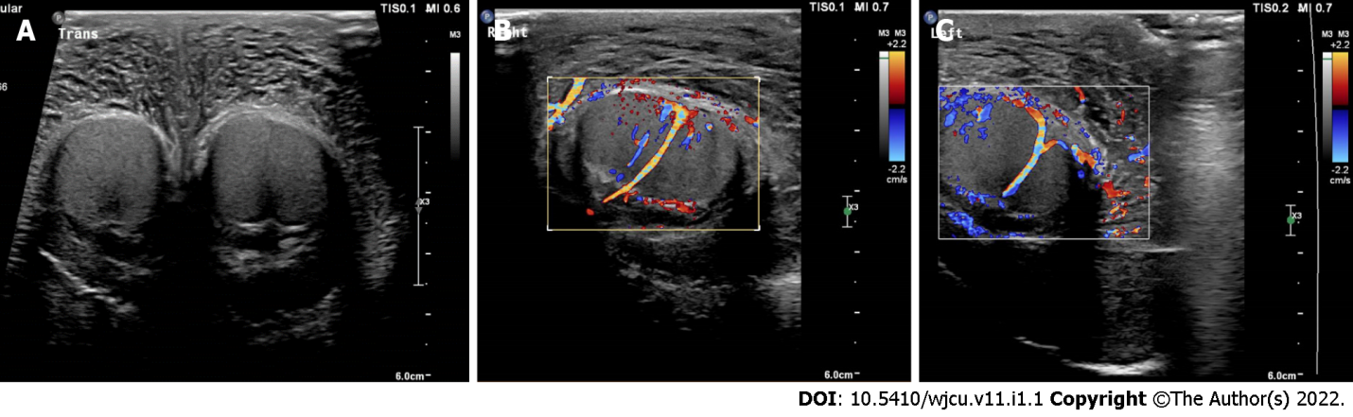
Figure 2 Scrotal ultrasound. A: Bilateral view; B: Normal blood flow on right; C: Left testicle.
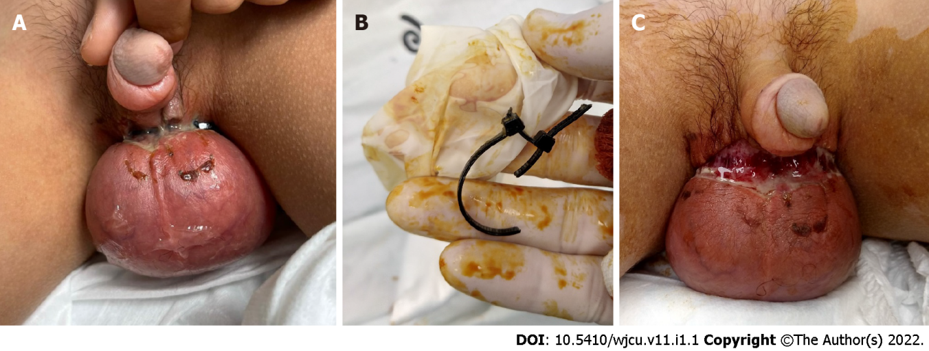
Figure 3 Idiopathic scrotal edema. A and B: Scrotal entrapment by zip-tie; C: Friable skin with ulceration and purulent drainage.

Published by Baishideng Publishing Group Inc
7041 Koll Center Parkway, Suite 160, Pleasanton, CA 94566, USA
Telephone: +1-925-3991568
E-mail: bpgoffice@wjgnet.com
Help Desk: https://www.f6publishing.com/helpdesk
https://www.wjgnet.com

© 2022 Baishideng Publishing Group Inc. All rights reserved.

