Name of Journal: World Journal of Gastroenterology
Manuscript NO: 75476
Manuscript Type: ORIGINAL ARTICLE

Retrospective Study
Novel index for the prediction of significant liver fibrosis and cirrhosis in chronic hepatitis B patients in China

Liao MJ et al. AGPR predicting liver fibrosis and cirrhosis

Min-Jun Liao, Jun Li, Wei Dang, Dong-Bo Chen, Wan-Ying Qin, Pu Chen, Bi-Geng Zhao, Li-Ying Ren, Ting-Feng Xu, Hong-Song Chen, Wei-Jia Liao

Min-Jun Liao, Jun Li, Wei Dang, Wan-Ying Qin, Bi-Geng Zhao, Li-Ying Ren, Ting-Feng Xu, Wei-Jia Liao, Laboratory of Hepatobiliary and Pancreatic Surgery, The Affiliated Hospital of Guilin Medical University, Guilin 541001, Guangxi Zhuang Autonomous Region, China

Min-Jun Liao, Guangdong Provincial Key Laboratory of Gastroenterology, Department of Gastroenterology and Hepatology Unit, Nanfang Hospital, Southern Medical University, Guangzhou 510515, Guangdong Province, China

Jun Li, Genetics and Precision Medicine Laboratory, The Affiliated Hospital of Guilin Medical University, Guilin 541001, Guangxi Zhuang Autonomous Region, China

Dong-Bo Chen, Pu Chen, Hong-Song Chen, Beijing Key Laboratory of Hepatitis C and Immunotherapy for Liver Disease, Peking University People’s Hospital, Beijing 100044, China

Author contributions: Liao MJ, Li J, and Dang W contributed equally to this work; Liao WJ was the guarantor and designed the study; Liao MJ, Li J, Chen DB, Qin WY, Chen P, Zhao BG, Ren LY, Xu TF, and Liao WJ participated in the acquisition, analysis, and interpretation of the data; Li J and Dang W drafted the initial manuscript; Chen HS and Liao WJ revised the article critically for important intellectual content.

Supported by the National Natural Science Foundation of China, No. 81372163; the Natural Science Foundation of Guangxi, No. 2018GXNSFDA138001; the Science and Technology Planning Project of Guilin, No. 20190218-1; the Opening Project of Key laboratory of High-Incidence-Tumor Prevention & Treatment (Guangxi Medical University), Ministry of Education, No. GKE-KF202101; and the Program of Guangxi Zhuang Autonomous Region Health and Family Planning Commission, No. Z20210706 and No. Z20190665.

Corresponding author: Wei-Jia Liao, MD, Chief Doctor, Professor, Laboratory of Hepatobiliary and Pancreatic Surgery, The Affiliated Hospital of Guilin Medical University, No. 15 Lequn Road, Xiufeng District, Guilin 541001, Guangxi Zhuang Autonomous Region, China. liaoweijia288@163.com

Received: February 14, 2022
Revised: March 23, 2022
Accepted: June 18, 2022
Published online: July 21, 2022

Abstract
BACKGROUND
Noninvasive, practical, and convenient means of detection for the prediction of liver fibrosis and cirrhosis in China are greatly needed.

AIM
To develop a precise noninvasive test to stage liver fibrosis and cirrhosis.

METHODS
With liver biopsy as the gold standard, we established a new index, [alkaline phosphatase (U/L) + gamma-glutamyl transpeptidase (U/L)/platelet (10⁹/L) (AGPR)], to predict liver fibrosis and cirrhosis. In addition, we compared the area under the receiver operating characteristic curve (AUROC) of AGPR, gamma-glutamyl transpeptidase to platelet ratio, aspartate transaminase to platelet ratio index, and FIB-4 and evaluated the accuracy of these routine laboratory indices in predicting liver fibrosis and cirrhosis.

RESULTS
Correlation analysis revealed a significant positive correlation between AGPR and liver fibrosis stage (P < 0.001). In the training cohort, the AUROC of AGPR was 0.83 (95%CI: 0.78-0.87) for predicting fibrosis (≥ F2), 0.84 (95%CI: 0.79-0.88) for predicting extensive fibrosis (≥ F3), and 0.87 (95%CI: 0.83-0.91) for predicting cirrhosis (F4). In the validation cohort, the AUROCs of AGPR to predict ≥ F2, ≥ F3 and F4 were 0.83 (95%CI: 0.77-0.88), 0.83 (95%CI: 0.77-0.89), and 0.84 (95%CI: 0.78-0.89), respectively.

CONCLUSION
The AGPR index should become a new, simple, accurate, and noninvasive marker to predict liver fibrosis and cirrhosis in chronic hepatitis B patients.

Key Words: Liver; Fibrosis; Cirrhosis; Prediction; Novel noninvasive marker; Chronic hepatitis B

©The Author(s) 2022. Published by Baishideng Publishing Group Inc. All rights reserved.

Citation: Liao MJ, Li J, Dang W, Chen DB, Qin WY, Chen P, Zhao BG, Ren LY, Xu TF, Chen HS, Liao WJ. Novel index for the prediction of significant liver fibrosis and cirrhosis in chronic hepatitis B patients in China. World J Gastroenterol 2022; 28(27): 3503-3513
URL: https://www.wjgnet.com/1007-9327/full/v28/i27/3503.htm
DOI: https://dx.doi.org/10.3748/wjg.v28.i27.3503

Core Tip: Chronic hepatitis B virus (HBV) infection is highly endemic in China, and routine assessment of chronic hepatitis B patients is greatly needed to guide management and indicate the need for treatment. In this study, we established a new index to stage liver fibrosis and cirrhosis in patients with chronic HBV infection in China. In addition, the study compared the predictive performance between the new index and other noninvasive indices. The new index is suitable for regular monitoring and is crucial for the management of patients with liver fibrosis/cirrhosis.

INTRODUCTION
Chronic hepatitis B virus (HBV) infection is a public issue that affects human health. Patients who are chronically infected with HBV have a tendency to develop liver fibrosis, liver cirrhosis and even more serious conditions, such as hepatocellular carcinoma (HCC). It has been reported that liver fibrosis can be reversed in patients with varying degrees of fibrosis by removing pathogenic factors, including HBV infection and alcohol^{[1,2]}. It would benefit patients to obtain early diagnosis and effective treatment of liver fibrosis before the disease worsens. Hence, measures should be taken to achieve early diagnosis of liver fibrosis to avoid disease progression caused by HBV infection.
Liver biopsy has always been regarded as the gold standard to evaluate liver histology and assess the degree of fibrosis^{[3]}. However, liver biopsy has shortcomings. Like any surgery, liver biopsy carries some risks, such as puncture of the lung or gallbladder, infection, bleeding, and pain, although these complications are rare^{[4]}. In addition, a major problem is the sampling error and significant variability of fibrosis assessment by liver biopsy^{[5]}. Transient elastography performed with FibroScan is a new technique to measure liver stiffness, and it has the advantages of noninvasiveness, good reproducibility and higher objectivity^{[6-8]}. However, the FibroScan device and its maintenance are expensive, limiting the use of transient elastography in low- and middle-income countries and making it unsuitable for routine monitoring of liver fibrosis/cirrhosis in patients with chronic liver disease in economically poor areas. In recent years, researchers have been interested in finding a potential marker of liver fibrosis/cirrhosis or developing a multifactorial model from peripheral blood^{[9]}. Noninvasive fibrosis tests based on routine laboratory indices have become available and are increasingly used to both assess and stage liver fibrosis; these include the aspartate transaminase (AST)-to-platelet (PLT) ratio index (APRI)^{[10]}, FIB-4^{[11]} and the gamma-glutamyl transpeptidase (γ-GT) to PLT ratio (GPR)^{[12]}. These indices are inexpensive, available and noninvasive for assessment of the stages of fibrosis/cirrhosis and can be easily performed in outpatient settings with limited conditions. Among these, the APRI was recommended by the World Health Organization as the most useful noninvasive tool to assess cirrhosis in resource-limited settings; however, FIB-4 was not recommended because it is not used for the detection of cirrhosis^{[13]}. However, the levels of sensitivity and positive predictive value were low for APRI^{[14]}. Therefore, there is an urgent need to find a more reliable method that is noninvasive, inexpensive, convenient and feasible for assessing liver disease stage and identifying patients who need treatment.
In this study, we tested a novel noninvasive index, the alkaline phosphatase (ALP) and γ-GT to PLT ratio (AGPR), for the assessment of liver fibrosis and cirrhosis through statistical analysis of clinical data. Moreover, we compared the diagnostic values of the AGPR, GPR, APRI and FIB-4 indices.

MATERIALS AND METHODS
Patients
The patients who participated in this study were divided into a training set and a validation set. Patients in the training set received treatment at the Affiliated Hospital of Guilin Medical University (Guilin, People’s Republic of China). Patients in the validation set received treatments at the Peking University People’s Hospital (Beijing, Guangxi Zhuang Autonomous Region, China). All patients were under treatment from May 2005 to October 2016, and all underwent systematic examinations, including abdominal ultrasound, routine laboratory tests and liver histological examination tests. The clinicopathologic characteristics of all patients, including age, gender, alcohol consumption, smoking status, hepatitis B e-antigen (HbeAg) status, fibrosis and cirrhosis stage, activity grade, white blood cell (WBC) count, neutrophil count (NEUT), lymphocyte count (LYMPH), PLT count, albumin, globulin, total bilirubin (TBIL), direct bilirubin (DBIL), alanine aminotransferase (ALT), AST, ALP, γ-GT and AGPR were collected and are detailed in Table 1. All patients in the study were chronically infected with HBV and were positive for hepatitis B surface antigen.

Liver histological examination
Some basic clinical examinations that ensure that patients are relatively safe when performing liver puncture surgery should be performed. In addition, physicians should obtain informed consent from the patients prior to surgery. Ultrasound localization was performed on consenting and suitable patients for liver biopsy procedures. Qualified liver tissue samples were formalin-fixed and paraffin-embedded for pathological analysis. Liver fibrosis and cirrhosis were graded as follows according to the METAVIR system: F0, no fibrosis; F1, fibrosis in the portal vein zone but no fibrous septa; F2, a small amount of fibrous septa; F3, many fibrous septa but no cirrhosis; F4, cirrhosis^{[15]}. All biopsy samples were assessed separately by two liver pathologists who were blinded to the clinical information. If the results of their evaluation were discordant, a third highly experienced hepatopathologist blinded to patient information reviewed the contested samples. Samples were excluded from the study population if the pathologists failed to reach consensus.

Computational formula
AGPR was calculated as [ALP (U/L) + γ-GT (U/L)]/PLT count (10⁹/L). APRI was calculated as (AST/ULN)/PLT count (10⁹/L) × 100^{[10]}. FIB-4 was calculated by the formula: Age (years) × AST (U/L)/[PLT (10⁹/L) × ALT (U/L)^{1/2}]^{[11]}. The formula for GPR was γ-GT/ULN of γ-GT/PLT count (10⁹/L) × 100^{[12]}.

Statistical analysis
Student’s t test was used for continuous variables, and Pearson’s χ² test or Fisher’s exact test was used for categorical variables to compare baseline characteristics. Data are presented as the mean ± SD or proportions. Univariable logistic regression was used for the variables of age, gender, WBC, NEUT, LYMPH, PLT, albumin, globulin, TBIL, DBIL, ALT, AST, ALP, γ-GT and AGPR. The receiver operating characteristic (ROC) curves were drawn to evaluate the accuracy rate of diagnosis for the AGPR, GPR, APRI, and FIB-4. The sensitivity, specificity, positive and negative predictive values, positive and negative likelihood ratio, hazard ratio and the area under the ROC curve (AUROC) of the four non-invasive markers for fibrosis and cirrhosis staging were obtained through comparison and analysis of F0-1 vs F2-4, F0-2 vs F3-4, and F0-3 vs F4, respectively. Data analysis was performed using SPSS software (version 24.0). A P value < 0.05 was regarded as statistically significant.

RESULTS
Study populations of the training and validation cohorts
Patients involved in this study needed to meet certain criteria. Those criteria were as follows: (1) Study patients were infected with HBV and underwent systematic examinations, including abdominal ultrasound, routine laboratory tests and liver biopsies; (2) Patients with HCC or other tumors were excluded; (3) Patients with coinfection of HCV, HIV or HDV were excluded; and (4) Patients with highly controversial results on liver fibrosis pathological grading were excluded. Figure 1 displays the selection principles.
Clinical data related to this study are summarized in Table 1. There were no statistically significant differences between the training and validation cohorts in terms of age, gender, drinking status, smoking status, HbeAg, fibrosis stage, activity grade, WBC, NEUT, LYMPH, PLT, albumin, globulin, TBIL, DBIL, ALT, AST, ALP, γ-GT or AGPR (P > 0.05). Nonsignificant differences between the two study groups revealed that the selection of training and validation cohorts was reasonable.

AGPR predicts significant hepatic fibrosis and cirrhosis
Univariable analyses showed that the presence of significant liver fibrosis (≥ F2) was related to gender, WBC, NEUT, PLT, albumin, globulin, TBIL, DBIL, AST, ALP, γ-GT and AGPR (Table 2). In the training cohort, correlation analysis revealed a significant positive correlation between AGPR and liver fibrosis stage (r = 0.567, P < 0.001) (Figure 2A). In the validation cohort, there was also a positive correlation between AGPR and liver fibrosis stage (r = 0.524, P < 0.001), as shown in Supplementary Table 1 and Supplementary Figure 1A. Box plots showed that liver fibrosis stage positively correlated with ALP + γ-GT (r = 0.352, P < 0.001), GPR (r = 0.509, P < 0.001), APRI (r = 0.428, P < 0.001) and FIB-4 (r = 0.416, P < 0.001) in the training cohort (Figure 2B and D-F). The severity of liver fibrosis stage correlated significantly with a gradual increase in the levels of these indicators. There was a negative correlation between PLT count and liver fibrosis stage (r = -0.362, P < 0.001) in the training cohort (Figure 2C). The severity of liver fibrosis decreased with increasing PLT count. Similar results were obtained in the validation cohort, and the specific data related to these results are shown in Supplementary Figure 1B-F and Supplementary Table 2.

Comparisons of AUROC between AGPR and other noninvasive indices
The summary AUROC, sensitivity, specificity, positive and negative predictive values, positive and negative likelihood ratios, and hazard ratios for the detection of fibrosis and cirrhosis for AGPR, GPR, APRI and FIB-4 are displayed in Table 3. In the training cohort, the AUROC of AGPR (0.83, 95%CI: 0.78-0.87) was higher than that of GPR (0.77, 95%CI: 0.72-0.82; P = 0.008), APRI (0.72, 95%CI: 0.67-0.77; P < 0.0001) and FIB-4 (0.74, 95%CI: 0.69-0.79; P = 0.0004) for the prediction of significant fibrosis (≥ F2). For the assessment of extensive fibrosis (≥ F3), the AUROC of AGPR (0.84, 95%CI: 0.79-0.88) was also higher than that of GPR (0.81, 95%CI: 0.76-0.85; P < 0.0001), APRI (0.70, 95%CI: 0.64-0.75; P < 0.0001) and FIB-4 (0.75, 95%CI: 0.69-0.80; P = 0.0005). For the diagnosis of cirrhosis (F4), the AUROC of AGPR was 0.87 (95%CI: 0.83-0.91), which was higher than that of GPR (0.80, 95%CI: 0.75-0.84; P = 0.0001), APRI (0.76, 95%CI: 0.70-0.8; P = 0.0002) and FIB-4 (0.80, 95%CI: 0.75-0.84; P = 0.022) (Figure 3A and Table 3). For identifying patients with significant fibrosis and cirrhosis, the summary sensitivities of AGPR were 83.1% and 88.6%, respectively, while the summary specificities of AGPR were 73.4% and 75.4%, respectively. The sensitivity, specificity, positive and negative predictive values, positive and negative likelihood ratios, and hazard ratios of the other noninvasive indices are detailed in Table 3. Our results revealed that AGPR had the best overall performance among these noninvasive indices.
We further evaluated the diagnostic accuracy and performance of these noninvasive indices in the validation cohort. Similar to the results from the training cohort, the AUROC of AGPR was better than that of GPR (0.78, 95%CI: 0.71-0.83), APRI (0.77, 95%CI: 0.70-0.83), and FIB-4 (0.77, 95%CI: 0.71-0.83) (Figure 3B and Table 3).

DISCUSSION
Cirrhosis is one of the top 20 causes of disability-adjusted life years and life lost years, accounting for 1.6% and 2.1% of the global burden, respectively^{[16]}. Cirrhosis is also the 11th most common cause of death worldwide^{[16]}. Recently, Xu et al^{[17]} provided updated guidelines for the management of liver cirrhosis in China. However, better screening for early fibrosis or cirrhosis remains a challenge. Finding an inexpensive, noninvasive, convenient, feasible and precise parameter to stage liver fibrosis is the expectation of all medical staff in China. Although liver biopsy is a good measure for the assessment of liver fibrosis grade, many patients do not accept it, or they are not suitable for the test^{[18,19]}. FibroScan is a noninvasive diagnostic technique and its diagnostic accuracy is high. However, its application is limited because of its high cost^{[20]}. Consequently, the development of noninvasive assessment methods for liver fibrosis in patients with chronic HBV infection appears especially important in clinical practice.
In the present study, we developed a new simple, convenient and noninvasive index (AGPR) to predict significant liver fibrosis in chronic HBV-infected patients in China. The correlation coefficients between liver fibrosis stage and AGPR suggest that AGPR is a good test for the assessment of significant liver fibrosis and cirrhosis.
The AGPR index was established on the basis of ALP, γ-GT and PLT. These three indicators are clinical evaluations of features of fibrosis/cirrhosis and evidence of decompensation. Hepatitis is related to ALP^{[21,22]} and γ-GT^{[23,24]}. ALP is useful in the diagnosis of chronic liver diseases^{[25]}. A study showed that serum ALP level was significantly different in patients with or without liver cirrhosis^{[26]}. In a report, γ-GT was demonstrated to be an independent predictor of hepatic fibrosis^{[27]}. The circulating PLT count has been recommended as a biomarker of hepatic fibrosis and cirrhosis^{[28]}. Based on these findings, each of the three variables is related to the degree of liver fibrosis. The antiviral treatment, anti-inflammatory and hepatoprotective treatment have a greater impact on serum levels of aminotransferases, such as AST and ALT. However, according to clinical observation, ALP and γ-GT are regarded as less specific for liver injury than AST and ALT. The effects of antiviral therapy, anti-inflammatory therapy and hepatoprotective therapy on ALP and γ-GT are not as obvious as on AST and ALT. As a matter of fact, elevated serum γ-GT levels are strongly associated with alcohol consumption. However, the researchers have reported that the high-risk liver disease mortality due to elevated γ-GT was not affected by alcohol consumption^{[29]}.
A routine assessment of liver fibrosis stage for patients with chronic HBV infection is needed to guide management and to indicate the need for treatment. However, the diagnosis of liver fibrosis and compensated cirrhosis cannot be based on clinically obvious features. Noninvasive fibrosis tests are now increasingly used for evaluating liver fibrosis, reducing the need for liver biopsy. AGPR may be a new promising noninvasive fibrosis test to assist in the selection of optimal candidates for antiviral therapy. The AGPR test is inexpensive, routinely available at health-care facilities, and can be performed by untrained staff. It is suitable for conventional monitoring of hepatic fibrosis and cirrhosis. The Guidelines Development Group prioritized urgent initiation of antiviral therapy for patients with cirrhosis based on APRI score > 2 in adults, regardless of ALT or HBV DNA levels^{[13]}. However, when applying an APRI score > 2 in this study, the sensitivity for the diagnosis of cirrhosis was only 43.2% and 50.1% in the training and validation cohorts, respectively. This suggested that more than 50% of patients with cirrhosis would be incorrectly classified as not having cirrhosis, which may lead to delayed initiation of treatment. In contrast, the sensitivity of AGPR for the diagnosis of cirrhosis was high at 88.6% and 92.3% in the training and validation cohorts, respectively. Therefore, our data suggested that AGPR may be a preferred noninvasive test to detect the presence of significant fibrosis and cirrhosis. It may serve as a simple index to make treatment decisions in patients without evidence of cirrhosis in China and other resource-limited settings where HBV infection is endemic.
Our study has some limitations. First, the selection of samples was limited to a population with chronic HBV infection in China. Whether AGPR can be generalized to different geographical areas (the infection of hepatitis C virus is endemic) remains to be determined. Second, the time span of over 10 years for our selected samples was too long (from May 2005 to October 2016). Over this time period, substantial changes have taken place in terms of medical equipment and physical examination technologies, which may reduce the accuracy of our study results. Finally, there are many factors involved in liver fibrosis. The impact of various interference factors on the diagnostic accuracy of the AGPR index has not been fully evaluated. Some interference may affect the precision of our index.

CONCLUSION
In summary, the AGPR index may be an accurate noninvasive test for predicting significant liver fibrosis and cirrhosis in patients with chronic HBV infection in China. In addition, it is suitable for conventional monitoring. Therefore, for the prediction of liver fibrosis and cirrhosis, the AGPR index is a promising noninvasive marker that is worthy of further attention and research.

ARTICLE HIGHLIGHTS
Research background
Patients infected with hepatitis B virus (HBV) tend to develop liver fibrosis and liver cirrhosis. Those with cirrhosis have a high risk of hepatic decompensation and hepatitis B- related hepatocellular carcinoma.

Research motivation
Liver biopsy was used to ascertain the degree of fibrosis/cirrhosis. However, as an invasive procedure, liver biopsy has many disadvantages. The Guidelines Development Group recommended the use of noninvasive tests to assist in the assessment of liver disease stage and the diagnosis of fibrosis/cirrhosis. The use of a noninvasive test can reduce the need for liver biopsy.

Research objectives
The present study aimed to develop a precise noninvasive test to stage liver fibrosis/cirrhosis and compare the diagnostic values between different noninvasive methods.

Research methods
Univariable logistic regression was used to identify significant predictive factors. Correlation analysis was performed to reveal the correlation between clinical parameters and liver stage. Receiver operating characteristic (ROC) curves were drawn to evaluate the diagnostic accuracy of different noninvasive methods.

Research results
The presence of liver fibrosis was significantly related to alkaline phosphatase and the gamma-glutamyl transpeptidase to platelet ratio (AGPR). There was a significant positive correlation between AGPR and liver fibrosis stage. The area under the ROC curve values of AGPR were 0.83, 0.84, and 0.87 for the prediction of significant fibrosis, extensive fibrosis, and cirrhosis, respectively. The AGPR index had a better overall performance than other noninvasive indices.

Research conclusions
AGPR can be used to detect the presence of significant fibrosis, extensive fibrosis, and cirrhosis with high diagnostic accuracy, sensitivity, and specificity in patients with chronic HBV infection.

Research perspectives
The AGPR index is a promising noninvasive marker for assessing liver disease stage. The use of AGPR can help with the routine monitoring of hepatic fibrosis and cirrhosis.

REFERENCES
1 Sun M, Kisseleva T. Reversibility of liver fibrosis. Clin Res Hepatol Gastroenterol 2015; 39 Suppl 1: S60-S63 [PMID: 26206574 DOI: 10.1016/j.clinre.2015.06.015]
2 Rockey DC. Liver Fibrosis Reversion After Suppression of Hepatitis B Virus. Clin Liver Dis 2016; 20: 667-679 [PMID: 27742006 DOI: 10.1016/j.cld.2016.06.003]
3 Park YE, Kim BK, Park JY, Kim DY, Ahn SH, Han KH, Han S, Jeon MY, Heo JY, Song K, Kim SU. Gamma-glutamyl transpeptidase-to-platelet ratio is an independent predictor of hepatitis B virus-related liver cancer. J Gastroenterol Hepatol 2017; 32: 1221-1229 [PMID: 27859587 DOI: 10.1111/jgh.13653]
4 Li Y, Chen Y, Zhao Y. The diagnostic value of the FIB-4 index for staging hepatitis B-related fibrosis: a meta-analysis. PLoS One 2014; 9: e105728 [PMID: 25165830 DOI: 10.1371/journal.pone.0105728]
5 Friedman LS. Controversies in liver biopsy: who, where, when, how, why? Curr Gastroenterol Rep 2004; 6: 30-36 [PMID: 14720451 DOI: 10.1007/s11894-004-0023-4]
6 Meng F, Zheng Y, Zhang Q, Mu X, Xu X, Zhang H, Ding L. Noninvasive evaluation of liver fibrosis using real-time tissue elastography and transient elastography (FibroScan). J Ultrasound Med 2015; 34: 403-410 [PMID: 25715361 DOI: 10.7863/ultra.34.3.403]
7 Dong DR, Hao MN, Li C, Peng Z, Liu X, Wang GP, Ma AL. Acoustic radiation force impulse elastography, FibroScan®, Forns' index and their combination in the assessment of liver fibrosis in patients with chronic hepatitis B, and the impact of inflammatory activity and steatosis on these diagnostic methods. Mol Med Rep 2015; 11: 4174-4182 [PMID: 25651500 DOI: 10.3892/mmr.2015.3299]
8 Jia J, Hou J, Ding H, Chen G, Xie Q, Wang Y, Zeng M, Zhao J, Wang T, Hu X, Schuppan D. Transient elastography compared to serum markers to predict liver fibrosis in a cohort of Chinese patients with chronic hepatitis B. J Gastroenterol Hepatol 2015; 30: 756-762 [PMID: 25353058 DOI: 10.1111/jgh.12840]
9 Liao Y, Wei R, Yao R, Qin L, Li J, Yu J, Liao W. AGLR is a novel index for the prognosis of hepatocellular carcinoma patients: a retrospective study. BMC Surg 2021; 21: 72 [PMID: 33536005 DOI: 10.1186/s12893-020-01037-7]
10 Wai CT, Greenson JK, Fontana RJ, Kalbfleisch JD, Marrero JA, Conjeevaram HS, Lok AS. A simple noninvasive index can predict both significant fibrosis and cirrhosis in patients with chronic hepatitis C. Hepatology 2003; 38: 518-526 [PMID: 12883497 DOI: 10.1053/jhep.2003.50346]
11 Sterling RK, Lissen E, Clumeck N, Sola R, Correa MC, Montaner J, S Sulkowski M, Torriani FJ, Dieterich DT, Thomas DL, Messinger D, Nelson M; APRICOT Clinical Investigators. Development of a simple noninvasive index to predict significant fibrosis in patients with HIV/HCV coinfection. Hepatology 2006; 43: 1317-1325 [PMID: 16729309 DOI: 10.1002/hep.21178]
12 Lemoine M, Shimakawa Y, Nayagam S, Khalil M, Suso P, Lloyd J, Goldin R, Njai HF, Ndow G, Taal M, Cooke G, D'Alessandro U, Vray M, Mbaye PS, Njie R, Mallet V, Thursz M. The gamma-glutamyl transpeptidase to platelet ratio (GPR) predicts significant liver fibrosis and cirrhosis in patients with chronic HBV infection in West Africa. Gut 2016; 65: 1369-1376 [PMID: 26109530 DOI: 10.1136/gutjnl-2015-309260]
13 World Health Organization. Guidelines for the Prevention, Care and Treatment of Persons with chronic Hepatitis B infection. 2015. [Cited 13 Mar 2018]. Available from: http://whoint/hiv/pub/hepatitis/hepatitis-b-guidelines/en/
14 Li Q, Song J, Huang Y, Li X, Zhuo Q, Li W, Chen C, Lu C, Qi X, Chen L. The Gamma-Glutamyl-Transpeptidase to Platelet Ratio Does not Show Advantages than APRI and Fib-4 in Diagnosing Significant Fibrosis and Cirrhosis in Patients With Chronic Hepatitis B: A Retrospective Cohort Study in China. Medicine (Baltimore) 2016; 95: e3372 [PMID: 27100421 DOI: 10.1097/MD.0000000000003372]
15 Bedossa P, Poynard T. An algorithm for the grading of activity in chronic hepatitis C. The METAVIR Cooperative Study Group. Hepatology 1996; 24: 289-293 [PMID: 8690394 DOI: 10.1002/hep.510240201]
16 Asrani SK, Devarbhavi H, Eaton J, Kamath PS. Burden of liver diseases in the world. J Hepatol 2019; 70: 151-171 [PMID: 30266282 DOI: 10.1016/j.jhep.2018.09.014]
17 Xu XY, Ding HG, Li WG, Xu JH, Han Y, Jia JD, Wei L, Duan ZP, Ling-Hu EQ, Zhuang H. Chinese guidelines on the management of liver cirrhosis (abbreviated version). World J Gastroenterol 2020; 26: 7088-7103 [PMID: 33362370 DOI: 10.3748/wjg.v26.i45.7088]
18 McGill DB, Rakela J, Zinsmeister AR, Ott BJ. A 21-year experience with major hemorrhage after percutaneous liver biopsy. Gastroenterology 1990; 99: 1396-1400 [PMID: 2101588 DOI: 10.1016/0016-5085(90)91167-5]
19 Nalbantoglu IL, Brunt EM. Role of liver biopsy in nonalcoholic fatty liver disease. World J Gastroenterol 2014; 20: 9026-9037 [PMID: 25083076 DOI: 10.3748/wjg.v20.i27.9026]
20 Sun W, Cui H, Li N, Wei Y, Lai S, Yang Y, Yin X, Chen DF. Comparison of FIB-4 index, NAFLD fibrosis score and BARD score for prediction of advanced fibrosis in adult patients with non-alcoholic fatty liver disease: A meta-analysis study. Hepatol Res 2016; 46: 862-870 [PMID: 26763834 DOI: 10.1111/hepr.12647]
21 Aggarwal SK, Radhakrishnan S. Syphilitic hepatitis: Look for raised alkaline phosphatase level. Med J Armed Forces India 2016; 72: 192-193 [PMID: 27257335 DOI: 10.1016/j.mjafi.2015.11.011]
22 Kasztelan-Szczerbinska B, Slomka M, Celinski K, Szczerbinski M. Alkaline phosphatase: the next independent predictor of the poor 90-day outcome in alcoholic hepatitis. Biomed Res Int 2013; 2013: 614081 [PMID: 24151614 DOI: 10.1155/2013/614081]
23 Huang CF, Chuang WL, Yu ML. Interference of diabetes on the association of γ-glutamyl transpeptidase to platelet ratio with liver fibrosis in chronic hepatitis C. Kaohsiung J Med Sci 2016; 32: 334-335 [PMID: 27377848 DOI: 10.1016/j.kjms.2016.04.004]
24 Benini F, Pigozzi MG, Baisini O, Romanini L, Ahmed H, Pozzi A, Ricci C, Lanzini A. Increased serum gamma-glutamyl-transpeptidase concentration is associated with nonalcoholic steatosis and not with cholestasis in patients with chronic hepatitis C. J Gastroenterol Hepatol 2007; 22: 1621-1626 [PMID: 17845689 DOI: 10.1111/j.1440-1746.2006.04733.x]
25 Barreto AV, Alecrim VM, Medeiros TB, Domingues AL, Lopes EP, Martins JR, Nader HB, Diniz GT, Montenegro SM, Morais CN. New index for the diagnosis of liver fibrosis in Schistosomiasis mansoni. Arq Gastroenterol 2017; 54: 51-56 [PMID: 28079240 DOI: 10.1590/S0004-2803.2017v54n1-10]
26 Cho HJ, Kim SS, Ahn SJ, Park JH, Kim DJ, Kim YB, Cho SW, Cheong JY. Serum transferrin as a liver fibrosis biomarker in patients with chronic hepatitis B. Clin Mol Hepatol 2014; 20: 347-354 [PMID: 25548740 DOI: 10.3350/cmh.2014.20.4.347]
27 Nishikawa H, Hasegawa K, Ishii A, Takata R, Enomoto H, Yoh K, Kishino K, Shimono Y, Iwata Y, Nakano C, Nishimura T, Aizawa N, Sakai Y, Ikeda N, Takashima T, Iijima H, Nishiguchi S. A proposed predictive model for advanced fibrosis in patients with chronic hepatitis B and its validation. Medicine (Baltimore) 2016; 95: e4679 [PMID: 27583895 DOI: 10.1097/MD.0000000000004679]
28 Pradella P, Bonetto S, Turchetto S, Uxa L, Comar C, Zorat F, De Angelis V, Pozzato G. Platelet production and destruction in liver cirrhosis. J Hepatol 2011; 54: 894-900 [PMID: 21145808 DOI: 10.1016/j.jhep.2010.08.018]
29 Ruhl CE, Everhart JE. Elevated serum alanine aminotransferase and gamma-glutamyltransferase and mortality in the United States population. Gastroenterology 2009; 136: 477-85.e11 [PMID: 19100265 DOI: 10.1053/j.gastro.2008.10.052]

Footnotes
Institutional review board statement: The study was reviewed and approved by the research ethics committee of Affiliated Hospital of Guilin Medical University.

Informed consent statement: Informed consent was obtained from all patients.

Conflict-of-interest statement: There are no conflicts of interest to report.

Data sharing statement: No additional data are available.

Open-Access: This article is an open-access article that was selected by an in-house editor and fully peer-reviewed by external reviewers. It is distributed in accordance with the Creative Commons Attribution NonCommercial (CC BY-NC 4.0) license, which permits others to distribute, remix, adapt, build upon this work non-commercially, and license their derivative works on different terms, provided the original work is properly cited and the use is non-commercial. See: https://creativecommons.org/Licenses/by-nc/4.0/

Provenance and peer review: Unsolicited article; Externally peer reviewed.
Peer-review model: Single blind

Peer-review started: February 14, 2022
First decision: March 9, 2022
Article in press: June 18, 2022

Specialty type: Gastroenterology and hepatology
Country/Territory of origin: China
Peer-review report’s scientific quality classification
Grade A (Excellent): 0
Grade B (Very good): B
Grade C (Good): C
Grade D (Fair): 0
Grade E (Poor): 0

P-Reviewer: Jiang KP, China; Leowattana W, Thailand S-Editor: Yan JP L-Editor: A P-Editor: Yan JP

Figure Legends
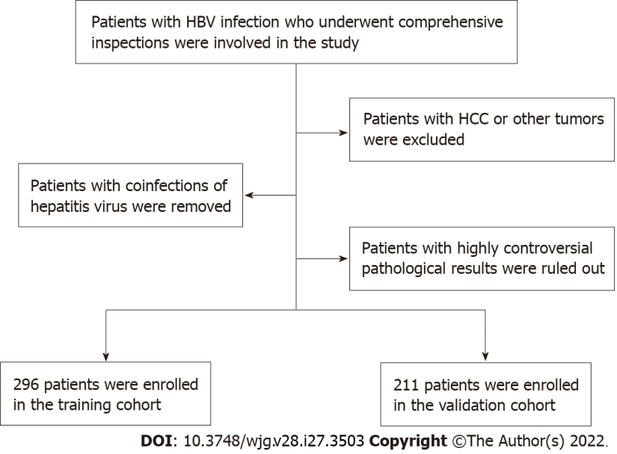

Figure 1 Selection principles of study population. HBV: Hepatitis B virus; HCC: Hepatocellular carcinoma.

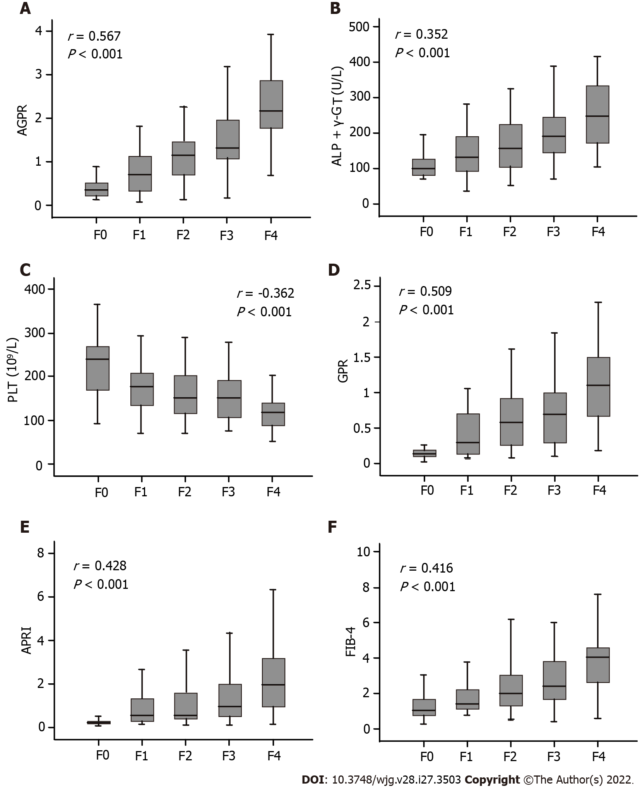

Figure 2 Box plots of [alkaline phosphatase (U/L) + gamma-glutamyl transpeptidase (U/L)]/platelet (10⁹/L) (A), alkaline phosphatase + gamma-glutamyl transpeptidase (B), platelet (C), gamma-glutamyl transpeptidase to platelet ratio (D), aspartate aminotransferase-to-platelet ratio index (E), and age × aspartate transaminase/platelet × alanine aminotransferase (F) according to the METAVIR fibrosis stage in the training cohort. AGPR: [Alkaline phosphatase (U/L) + gamma-glutamyl transpeptidase (U/L)]/platelet (10⁹/L); ALP + γ-GT: Alkaline phosphatase + gamma-glutamyl transpeptidase; PLT: Platelet; GPR: Gamma-glutamyl transpeptidase to platelet ratio; APRI: Aspartate aminotransferase-to-platelet ratio index; FIB-4: Age × aspartate transaminase/platelet × alanine aminotransferase.

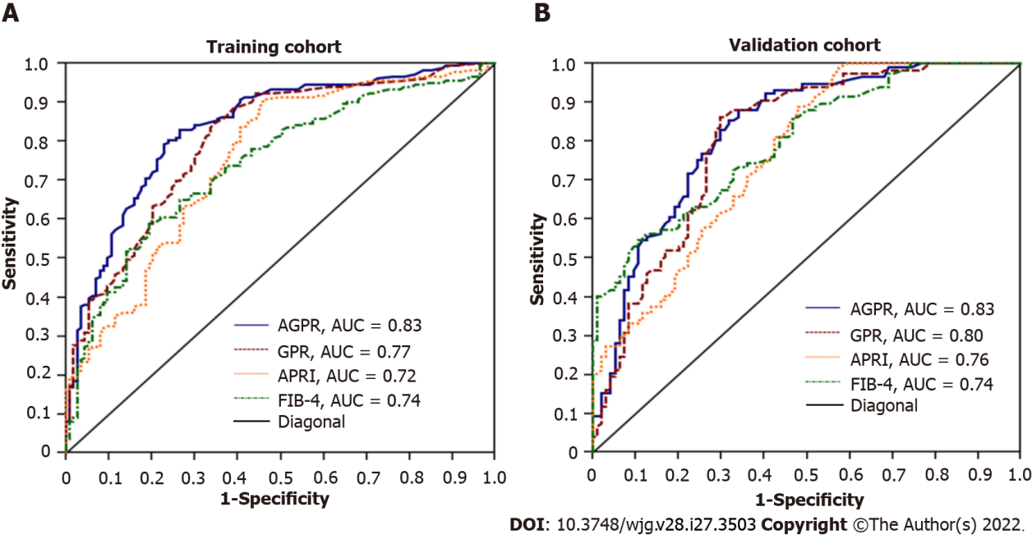

Figure 3 The receiver operating characteristic analysis of [alkaline phosphatase (U/L) + gamma-glutamyl transpeptidase (U/L)]/platelet (10⁹/L), amma-glutamyl transpeptidase to platelet ratio, aspartate aminotransferase-to-platelet ratio index and age × aspartate transaminase/platelet × alanine aminotransferase in the training (A) and validation cohorts (B). AGPR: [Alkaline phosphatase (U/L) + gamma-glutamyl transpeptidase (U/L)]/platelet (10⁹/L); GPR: Gamma-glutamyl transpeptidase to platelet ratio; APRI: Aspartate aminotransferase-to-platelet ratio index; FIB-4: Age × aspartate transaminase/platelet × alanine aminotransferase; AUC: Area under the curve.

Table 1 Clinical and biochemical data of examined patients
Parameter | Training cohort (n = 296)¹ | Validation cohort (n = 211)¹ | P value
Age (yr) | 42.47 ± 11.98 | 41.21 ± 11.36 | 0.167
Gender: Female/male (n) | 75/221 | 40/171 | 0.091
Drinking: Yes/no (n) | 127/169 | 101/110 | 0.268
Smoking: Yes/no (n) | 92/204 | 68/143 | 0.784
HbeAg: Negative/positive | 16/280 | 15/196 | 0.430
Fibrosis stage: F0/F1/F2/F3/F4 | 55/58/75/64/44 | 47/47/37/54/26 | 0.194
Activity grade: A0/A1/A2/A3/A4 | 16/92/113/69/6 | 15/72/69/52/3 | 0.446
WBC (× 10⁹/L) | 5.89 ± 2.55 | 6.34 ± 4.32 | 0.150
NEUT × 10⁹/L) | 3.55 ± 2.44 | 3.66 ± 2.61 | 0.611
LYMPH (× 10⁹/L) | 1.72 ± 0.62 | 1.80 ± 0.63 | 0.063
PLT (× 10⁹/L) | 171.61 ± 66.87 | 174.48 ± 61.62 | 0.636
Albumin (g/L) | 41.12 ± 19.09 | 39.94 ± 6.07 | 0.380
Globulin (g/L) | 29.67 ± 5.45 | 29.14 ± 5.80 | 0.298
TBIL (μmol/L) | 16.51 ± 8.44 | 16.73 ± 7.63 | 0.768
DBIL (μmol/L) | 6.91 ± 5.03 | 7.07 ± 4.33 | 0.699
ALT (U/L) | 73.31 ± 65.41 | 96.85 ± 83.62 | 0.002
AST (U/L) | 72.59 ± 63.29 | 77.44 ± 67.34 | 0.411
ALP (U/L) | 97.70 ± 41.98 | 104.32 ± 49.25 | 0.104
γ-GT (U/L) | 85.64 ± 69.68 | 97.98 ± 75.36 | 0.058
AGPR | 1.26 ± 0.84 | 1.32 ± 0.89 | 0.431
¹Data presented as the mean ± SD or proportions.
HbeAg: Hepatitis B e-antigen; WBC: White blood cell; NEUT: Neutrophil count; LYMPH: Lymphocyte count; PLT: Platelet; TBIL: Total bilirubin; DBIL: Direct bilirubin; ALT: Alanine aminotransferase; AST: Aspartate aminotransferase; ALP: Alkaline phosphatase; γ-GT: Gamma-glutamyl transpeptidase; AGPR: [Alkaline phosphatase (U/L) + gamma-glutamyl transpeptidase (U/L)]/platelet (10⁹/L).

Table 2 Univariate analysis in the training cohort
Parameter | Fibrosis (F0-1) (n = 113)¹ | Fibrosis (F2-4) (n = 183)¹ | P value
Age (yr) | 45.15 ± 14.97 | 43.63 ± 13.32 | 0.363
Gender: Female/male (n) | 37/76 | 38/145 | 0.021
WBC (× 10⁹/L) | 6.45 ± 3.02 | 5.55 ± 2.14 | 0.003
NEUT (× 10⁹/L) | 4.14 ± 3.0 | 3.18 ± 1.95 | 0.001
LYMPH (× 10⁹/L) | 1.67 ± 0.60 | 1.68 ± 0.63 | 0.828
PLT (× 10⁹/L) | 206.0 ± 68.39 | 150.55 ± 56.49 | < 0.001
Albumin (g/L) | 41.26 ± 5.93 | 39.29 ± 5.66 | 0.005
Globulin (g/L) | 27.46 ± 4.46 | 31.04 ± 5.56 | < 0.001
TBIL (μmol/L) | 13.82 ± 7.06 | 17.12 ± 8.8 | < 0.001
DBIL (μmol/L) | 6.43 ± 3.72 | 7.81 ± 4.49 | < 0.001
ALT (U/L) | 65.01 ± 70.72 | 78.42 ± 66.62 | 0.101
AST (U/L) | 56.61 ± 55.11 | 82.45 ± 66.09 | 0.001
ALP (U/L) | 79.06 ± 34.16 | 109.2 ± 42.31 | < 0.001
γ-GT (U/L) | 51.84 ± 47.06 | 106.5 ± 73.21 | < 0.001
AGPR | 0.72 ± 0.49 | 1.61 ± 0.83 | < 0.001
¹Data presented as the mean ± SD or proportions.
WBC: White blood cell; NEUT: Neutrophil count; LYMPH: Lymphocyte count; PLT: Platelet; TBIL: Total bilirubin; DBIL: Direct bilirubin; ALT: Alanine aminotransferase; AST: Aspartate aminotransferase; ALP: Alkaline phosphatase; γ-GT: Gamma-glutamyl transpeptidase; AGPR: [Alkaline phosphatase (U/L) + gamma-glutamyl transpeptidase (U/L)]/platelet (10⁹/L).

Table 3 Comparisons of the receiver operating characteristic curve between different non-invasive indices
 | Training cohort (n = 296) |  |  |  |  |  | Validation cohort (n = 211)
 | F0-1 vs F2-4 |  | F0-2 vs F3-4 |  | F0-3 vs F4 |  | F0-1 vs F2-4 |  | F0-2 vs F3-4 |  |  | F0-3 vs F4
AGPR
AUROC (95%CI) | 0.83 (0.78-0.87) |  | 0.84 (0.79-0.88) |  | 0.87 (0.83-0.91) |  | 0.83 (0.77-0.88) |  | 0.83 (0.77-0.89) |  |  | 0.84 (0.78-0.89)
Cut-off values | 0.87 |  | 1.20 |  | 1.40 |  | 0.87 |  | 1.20 |  |  | 1.40
Se/Sp (%) | 83.1/73.4 |  | 72.22/80.3 |  | 88.6/75.4 |  | 85.5/68.1 |  | 78.7/70.2 |  |  | 92.3/67.0
PPV/NPV (%) | 83.5/72.8 |  | 67.8/83.4 |  | 38.6/97.4 |  | 76.9/79.0 |  | 61.8/84.4 |  |  | 28.2/98.4
Positive/negative LR | 3.13/0.23 |  | 3.67/0.35 |  | 3.60/0.15 |  | 2.68/0.21 |  | 2.65/0.30 |  |  | 2.80/0.11
HR (95%CI) | 8.48 (5.22-14.33) |  | 7.56 (4.76-9.83) |  | 8.10 (5.11-11.63) |  | 8.02 (4.95-15.62) |  | 7.06 (4.51-12.35) |  |  | 5.06 (3.89-7.72)
GPR
AUROC (95%CI) | 0.77 (0.72-0.82) |  | 0.81 (0.76-0.85) |  | 0.80 (0.75-0.84) |  | 0.80 (0.74-0.85) |  | 0.81 (0.74-0.87) |  |  | 0.78 (0.71-0.83)
Cut-off values | 0.32 |  | 0.32 |  | 0.56 |  | 0.32 |  | 0.32 |  |  | 0.56
Se/Sp (%) | 73.7/70.8 |  | 76.8/54.8 |  | 79.5/65.9 |  | 86.3/67.0 |  | 91.2/56.5 |  |  | 75.0/62.3
PPV/NPV (%) | 80.4/62.5 |  | 49.4/80.5 |  | 28.9/94.9 |  | 76.5/79.7 |  | 56.2/91.4 |  |  | 26.5/86.9
Positive/negative LR | 2.53/0.37 |  | 1.70/0.42 |  | 2.33/0.31 |  | 2.62/0.20 |  | 2.10/0.15 |  |  | 1.95/0.41
HR (95%CI) | 6.53 (4.81-9.62) |  | 6.72 (3.96-9.63) |  | 6.47 (4.08-9.83) |  | 6.45 (3.58-11.61) |  | 7.30 (3.87-14.62) |  |  | 4.84 (3.28-7.95)
APRI
AUROC (95%CI) | 0.72 (0.67-0.77) |  | 0.70 (0.64-0.75) |  | 0.76 (0.70-0.81) |  | 0.76 (0.70-0.82) |  | 0.74 (0.67-0.82) |  |  | 0.77 (0.70-0.83)
Cut-off values | 0.5 | 1.5 | - |  | 1.0 | 2.0 | 0.5 | 1.5 | - | 1.0 |  | 2.0
Se/Sp (%) | 80.9/58.4 | 36.1/79.7 | - |  | 77.3/64.7 | 43.2/83.3 | 83.8/54.3 | 34.1/76.6 | - | 70.1/68.6 |  | 50.1/78.3
PPV/NPV (%) | 75.9/65.3 | 74.2/43.5 | - |  | 27.6/94.2 | 31.1/89.4 | 69.5/72.9 | 64.5/48.3 | - | 26.3/92.7 |  | 30.8/91.9
Positive/negative LR | 1.94/0.33 | 1.77/0.80 | - |  | 2.19/0.35 | 2.59/0.68 | 1.83/0.30 | 1.46/0.86 | - | 2.12/0.44 |  | 3.16/0.63
HR (95%CI) | 2.61 (1.85-3.67) |  | 1.85 (1.41-2.42) |  | 2.09 (1.63-2.55) |  | 1.59 (1.23-2.07) |  | 2.64 (1.76-4.32) |  |  | 2.13 (1.71-2.58)
FIB-4
AUROC (95%CI) | 0.74 (0.69-0.79) |  | 0.75 (0.69-0.80) |  | 0.80 (0.75-0.84) |  | 0.74 (0.67-0.80) |  | 0.79 (0.73-0.84) |  |  | 0.77 (0.71-0.83)
Cut-off values | - |  | 1.45 | 3.25 | - |  | - |  | 1.45 |  | 3.25 | -
Se/Sp (%) | - |  | 87.9/47.3 | 42.6/87.2 | - |  | - |  | 77.5/58.1 |  | 37.5/93.1 | -
PPV/NPV (%) | - |  | 49.0/87.3 | 65.7/72.6 | - |  | - |  | 53.0/80.9 |  | 76.9/70.9 | -
Positive/negative LR | - |  | 1.67/0.25 | 3.34/0.66 | - |  | - |  | 1.85/0.39 |  | 5.46/0.67 | -
HR (95%CI) | 1.86 (1.52-2.53) |  | 1.94 (1.55-2.42) |  | 2.17 (1.77-2.56) |  | 1.98 (1.50-2.62) |  | 2.11 (1.63-2.74) |  |  | 1.87 (1.68-2.36)
Comparison of AUROC
AGPR and GPR | P = 0.008 |  | P < 0.0001 |  | P = 0.0001 |  | P = 0.028 |  | P = 0.005 |  |  | P = 0.0008
AGPR and APRI | P < 0.0001 |  | P < 0.0001 |  | P = 0.0002 |  | P = 0.0001 |  | P = 0.0001 |  |  | P = 0.134
AGPR and FIB-4 | P = 0.0004 |  | P = 0.0005 |  | P = 0.022 |  | P = 0.007 |  | P = 0.174 |  |  | P = 0.100
GPR and APRI | P = 0.0007 |  | P = 0.0028 |  | P = 0.284 |  | P = 0.003 |  | P = 0.016 |  |  | P = 0.831
GPR and FIB-4 | P = 0.026 |  | P = 0.331 |  | P = 0.922 |  | P = 0.093 |  | P = 0.929 |  |  | P = 0.591
APRI and FIB-4 | P = 0.455 |  | P = 0.028 |  | P = 0.061 |  | P = 0.248 |  | P = 0.008 |  |  | P = 0.795
AGPR: [Alkaline phosphatase (U/L) + gamma-glutamyl transpeptidase (U/L)]/platelet count (10⁹/L); AUROC: Area under the receiver operating characteristic curve; Se: Sensitivity; Sp: Specificity; PPV: Positive predictive value; NPV: Negative predictive value; LR: Likelihood ratio; HR: Hazard ratio; CI: Confidence interval; GPR: Gamma-glutamyl transpeptidase to platelet ratio; APRI: Aspartate aminotransferase-to-platelet ratio index; FIB-4: Age (years) × aspartate aminotransferase (U/L)/[platelet (10⁹/L) × alanine aminotransferase (U/L)^{1/2}].

Published by Baishideng Publishing Group Inc
7041 Koll Center Parkway, Suite 160, Pleasanton, CA 94566, USA
Telephone: +1-925-3991568
E-mail: bpgoffice@wjgnet.com
Help Desk: https://www.f6publishing.com/helpdesk
https://www.wjgnet.com

© 2022 Baishideng Publishing Group Inc. All rights reserved.

