Name of journal: World Journal of Virology
ESPS Manuscript NO: 12055
Columns: Original Articles

Substrate specificity of avian influenza H5N1 neuraminidase

Onsirisakul N et al. Substrate specificity of H5N1 NA

Naruthai Onsirisakul, Shin-ichi Nakakita, Chompunuch Boonarkart, Alita Kongchanagul, Ornpreya Suptawiwat, Pilaipan Puthavathana, Krisada Chaichuen, Kanokwan Kittiniyom, Yasuo Suzuki, Prasert Auewarakul

Naruthai Onsirisakul, Kanokwan Kittiniyom, Department of Clinical Microbiology and Applied Technology, Faculty of Medical Technology, Mahidol University, Bangkok 73170, Thailand

Naruthai Onsirisakul, Chompunuch Boonarkart, Ornpreya Suptawiwat, Pilaipan Puthavathana, Prasert Auewarakul, Department of Microbiology, Faculty of Medicine Siriraj Hospital, Mahidol Univeristy, Bangkok 10700, Thailand

Shin-ichi Nakakita, Division of Functional Glycomics, Life Sciences Research Center, Kagawa University, Takamatsu 761-0793, Japan

Alita Kongchanagul, Institute of Molecular Biosciences, Mahidol University, Nakhon Pathom 73170, Thailand

Krisada Chaichuen, Faculty of Veterinary Science, Mahidol University, Nakorn Pathom 73170, Thailand

Yasuo Suzuki, College of Life and Health Sciences, Chubu University, Kasugai 487-8501, Japan

Author contributions: Onsirisakul N preformed the majority of experiments; Nakakita S performed HPLC; Boonarkart C, Suptawiwat O, Kongchanagul A helped to perform and proved the constructs; Puthavathana P, Chaichuen K provided the viruses; Suzuki Y provided the glycopolymer; Kittiniyom K provided the supervision; Auewarakul P supervised and edited manuscript.

Supported by Thailand Research Fund, the Office of the Higher Education Commission and Mahidol University under the National Research Universities Initiative

Correspondence to: Prasert Auewarakul, Professor, Department of Microbiology, Faculty of Medicine Siriraj Hospital, Mahidol Univeristy, 2 Prannok Road, Bangkoknoi, Bangkok 10700, Thailand. sipaw@mahidol.ac.th

Telephone: +81-662-4198291 Fax: +81-662-4184148

Received: June 19, 2014 Revised: September 3, 2014
Accepted: October 14, 2014

Published online:

Abstract
AIM: To characterise neuraminidase (NA) substrate specificity of avian influenza H5N1 strains from humans and birds comparing to seasonal influenza virus.

METHODS: Avian influenza H5N1 strains from humans and birds were recruited for characterising their NA substrate specificity by using a modified commercial fluorescence Amplex Red assay. This method can identify the preference of α2,3-linked sialic acid or α2,3-linked sialic acid. Moreover, to avoid the bias of input virus, reverse genetic virus using NA gene from human isolated H5N1 were generated and used to compare with the seasonal influenza virus. Lastly, the substrate specificity profile was further confirmed by high-performance liquid chromatography (HPLC) analysis of the enzymatic product.

RESULTS: The H5N1 NA showed higher activity on α2,3-linked sialic acid than α2,6-linked (P < 0.0001). To compare the NA activity between the H5N1 and seasonal influenza viruses, reverse genetic viruses carrying the NA of H5N1 viruses and NA from a seasonal H3N2 virus was generated. In these reverse genetic viruses, the NA activity of the H5N1 showed markedly higher activity against α2,3-linked sialic acid than that of the H3N2 virus, whereas the activities on α2,6-linkage were comparable. Interestingly, NA from an H5N1 human isolate that was previously shown to have heamagglutinin (HA) with dual specificity showed reduced activity on α2,3-linkage. To confirm the substrate specificity profile, HPLC analytic of enzymatic product was performed. Similar to Amplex red assay, H5N1 virus showed abundant preference on α2,3-linked sialic acid.

CONCLUSION: H5N1 virus maintains the avian specific NA and NA changes may be needed to accompany changes in HA receptor preference for the viral adaptation to humans.

© 2014 Baishideng Publishing Group Inc. All rights reserved.

Key words: H5N1 avian influenza virus; Neuraminidase; Sialic acid; Adaptation; Substrate preference

Core tip: We analyzed neuraminidase (NA) substrate specificity of avian influenza H5N1 strains from humans and birds using a modified fluorescence assay, and the substrate specificity profile was further confirmed by high-performance liquid chromatography analysis of the enzymatic product. The H5N1 NA showed higher activity on α2,3-linkage. Interestingly, NA from an H5N1 human isolate that was previously shown to have heamagglutinin (HA) with dual specificity showed reduced activity on α2,3-linkage. These suggest that the H5N1 virus maintains the avian specific NA activity and that changes in the NA may be needed to compensate for changes in the HA specificity for the viral adaptation to human hosts.

Onsirisakul N, Nakakita S, Boonarkart C, Kongchanagul A, Suptawiwat O, Puthavathana P, Chaichuen K, Kittiniyom K, Suzuki Y, Auewarakul P. Substrate specificity of avian influenza H5N1 neuraminidase. World J Virol 2014, In press

INTRODUCTION
Neuraminidase (NA) is a tetrameric type II transmembrane glycoprotein on the envelope of influenza virus. NA molecule consists of three domains: globular head, stalk and transmembrane domains^{[1-3]}. The function of NA is to cleave terminally bound sialic acid on carbohydrate chains of glycans on cell surface and viral envelope in order to release newly budded virions from host cells^{[2]}. If the function of NA is impaired, sialyl residues on the surface of virus particles and infected cells will be bound by heamagglutinin (HA), which leads to virus aggregation at the cell surface preventing the dissemination of infection^{[4,5]}.
HA of avian and human influenza viruses bind preferentially to α2,3- and α2,6-linked sialic acid, respectively. This difference is believed to play an important role in the interspecies barrier of influenza transmission between avian species and human. A change in the receptor preference is required for emergence of a new pandemic strain from avian influenza viruses^{[6]}. HA and NA counteract each other, and their activities need to be balanced for the efficient viral replication and respiratory- droplet transmission^{[4,7]} NA activities on α2,3- and α2,6-linked sialic acid have been previously characterized for some avian and seasonal influenza viruses^{[8-10]}. NA of N2 subtype from human and avian influenza viruses had been studied for substrate specificity^{[8,9]} Avian and early human isolated N2 showed much more activity on α2,3-linked sialic acid than α2,6-linked. However, late human N2 isolation trended toward increase substrate specificity for α2,6-linked while maintaining the α2,3-linked activity. The N1 substrate specificity had also been studied^{[10]}. Similar to N2 activity, N1 isolated from avian hosts showed much higher activity on α2,3- than α2,6-linked substrate, while human viruses showed reduced activity to α2,3- and increased activity to α2,6-linked sialic acid. From these finding we can conclude that human isolated NA shows the increased substrate specificity on α2,6-linked,which is found in human respiratory tract ,while maintaining specificity on α2,3-linked sialic acid^{[8,9]}. Because α2,3-linked sialic acid is expressed on the intestines of aquatic birds which is believed to be the primordial reservoir for all subtype of influenza A virus^{[11]}. Occasionally viruses are transmitted to other host species and introduce avian viral gene to non-avian hosts like human. This situation can lead to severe outbreaks or pandemics^{[11]}. Moreover, a recent study showed that replacing NA gene of North American triple reassortant swine influenza virus with that of 2009 pandemic H1N1 virus altered the enzymatic activity and led to an enhanced efficiency of respiratory-droplet transmission in ferrets^{[7]}. Therefore, the monitoring of NA activity on substrate specificity is needed.
Highly pathogenic H5N1 avian influenza virus is causing a wide-spread epidemic in poultry with occasional transmission to humans and poses a serious pandemic threat. While receptor preference of H5N1 HA has been extensively studied^{[12-14]}, data on their NA substrate specificity are scarce. We therefore characterised NA activity of H5N1 viruses in comparison to NA of a seasonal influenza virus.

MATERIALS AND METHODS
Cell and virus culture
Madin-Darby canine kidney (MDCK) cells were maintained in minimum essential medium (MEM) with 10% fetal bovine serum (FBS) in the present of Gentamicin, Penicillin G and Fungizone. 293T cell were maintained in Dulbecco’s modified Eagle medium supplemented with 10% FBS, antibiotics and antifungal. Viruses used in this study are shown in Table 1. Viruses were cultured in MDCK cells in MEM without phenol red to avoid the interference with the fluorescent assay^{[15,16]}.

Generation of reverse genetic virus
Reverse genetic viruses were generated by DNA transfection as described by Hoffmann et al^{[17]}. The NA genes were extracted from A/Thailand/KAN-1A/2004, A/Thailand/676/2005, A/Thailand/3(SP-83)/2004 and seasonal influenza virus, A/Thailand/AW10/2010 (H3N2), respectively and cloned into pHW2000. Then, 1 µg of pHW2000 expressing NA-DNA was transfected into the co-cultured of MDCK and 293 T cell in Opti-MEM (Gibco, United States) with the other seven genomic segments of A/Puerto Rico/8/34(H1N1) in the presence of TransLT according to the manufacturer’s instructions. Thirty hours post transfection, fresh Opti-MEM containing TPCK-trypsin was added to the cells at the final concentration 0.5 µg/mL in the cell suspension. The HA titer of the NA reverse genetic virus was determined by Hemagglutination test.

NA Amplex Red® assay
NA activity was assayed using Amplex Red® assay following the instruction provided by the manufacturer (Molecular Probe, Inc.). This assay utilizes Amplex Red to detect H₂O₂ generated by oxidation of desialiated galactose which is the end product of neuraminidase action. In the presence of horseradish peroxidase, H₂O₂ reacts with 1:1 stoichimetry with Amplex Red reagent, then, generates Resorufin, the red-fluorescent oxidation product, which is detected at 640 nm. The method had been modified in order to study the substrate specificity by using 2 types of glycopolymer instead of fetuin. The substrates which were applied for this assay was Neu5Acα2,3LacNAcb-p-Aminophenyl (pAP) and Neu5Acα2,6LacNAcb-pAP which contained α2,3-linked sialic acid and α2,6-linked sialic acid, respectively^{[12,18]}. Briefly, 10 µL of 64 HA unit of virus was mix with 10 µL of Amplex red reaction mixture in the present of 0.5 µg of either Neu5Acα2,3LacNAcb-pAP or Neu5Acα2,6LacNAcb-pAP for virus and 2 µg of each for reverse genetic virus. The NA activity on each substrate was detected at 640 nm after incubation at 37 °C for 110 min. Percentage of fluorescence correlated to NA activity of each virus was subtract with mock and plotted and analysed by using GraphPad Prism version 4.0 for windows (GraphPad software, San Diego, California; http://www.graphpad.com). Mean ± SEM from triplicate experiments were calculated for NA activity. One-way Anova were used to determine P-value for the significant difference between viruses. A P-value of ≤ 0.05 was considered significant.

NA assay by high-performance liquid chromatography
To confirm the NA activity by Amplex Red® assay, NA was determined the activity by using high-performance liquid chromatography (HPLC) as previously described^{[19]}. Viruses was incubated at 37 °C for 2 h with buffer and 10 pmole of each Neu5Acα2,3- or Neu5Acα2,6-pyridylamino (PA)-glycopolymer shown in Figure 1. Twenty-five microlitres of saturated NaHCO₃ were added, then heated at 100 °C for 10 min to inactivate virus. The reaction then concentrated by using CentriVap (Labconco, United States) prior analysis with HPLC which was performed on a Shodex NH2P-50 4E column (4.6 x 250 mm) at a flow rate of 0.6 mL/min. PA-glycopolymers were detected by fluorescence (excitation wavelength, 310 nm; emission wavelength, 380 nm). Two eluents were used, A and B. Eluent A was acetonitorile:water:acetic acid (930:70:3, v/v/v) adjusted to pH 7.0 with aqueous ammonia; Eluent B was acetonitorile:water:acetic acid (200:800:3, v/v/v) adjusted to pH 7.0 with aqueous ammonia. The column was equilibrated with Eluent A:Eluent B (95:5). After injecting Eluent A:Eluent B (86:14) in 3 min, to Eluent A:Eluent B (73:27) in 17 min, to Eluent A:Eluent B (52:48) in 59 min, and then to Eluent A:Eluent B (25:75) in 6 min.

RESULTS
NA substrate specificity of H5N1 viruses from humans and animals
The substrate specificity NA from H5N1 using two synthetic glycopolymers as substrate in Amplex Red® fluorescence assay was shown in Figure 2. The NA activity was 10-30 fluorescence unit, average 23.55 ± 1.489 (mean ± SEM), on α2,3-linked sialosides (Figure 2A) and 5-10 fluorescence unit, average 6.133 ± 0.667 (mean ± SEM) on α2,6-linked sialosides (Figure 2B). Comparing between the two substrates, H5N1 isolates from humans and animals showed higher activity on α2,3-linked sialic acid than α2,6-linked (P < 0.0001) with the ratio of activity on α2,3-linked sialosides to the activity on α2,6-linked sialosides of 4.685 ± 0.2092 (mean ± SEM) (Figure 2C).
Moreover, the NA activity of the reverse genetic viruses on 2,3- and 2,6-linked sialosides were shown in Figure 3A and 3B, respectively. While the NA from the H3N2 virus showed low activity on both α2,3- and α2,6-linkage, the reverse genetic viruses with the NA from the H5N1 viruses showed markedly higher activity on α2,3-linkage than on α2,6-linkage giving a high α2,3- to α2,6-ratio with P-value = 0.0249 (Figure 3C).

NA substrate specificity by HPLC analysis
To confirm the NA specificity profile, another assay using PA-glycopolymers and HPLC analysis of the enzymatic products was performed on a human isolate of the H5N1 virus (KAN-1) (Table 2). In concordance with the Amplex Red® assay, the H5N1 NA showed robust activity on α2,3-linked glycopolymers and undetectable activity on α2,6-linked glycopolymers. The two assays thus together conclusively showed that NA activity of the H5N1 virus had a α2,3-linkage preference.

DISCUSSION
Although, thiobarbituric acid method is the gold standard to detect NA activity, it is time-consuming and sensitive to interference by complex culture media^{[20]}. Moreover, these methods use NANA, 4-methylumbellifery or fetuin as the substrate, which could not distinguish the substrate specificity because fetuin contained both α2,3-linked and α2,6-linked sialosides. In order to detect the NA substrate specificity, there are several proposing methods to differentiate the substrate specificity, i.e., BODIPY-labeled substrate, glycan array and library screening format^{[10,21-23]}. These methods required modification and purification on neuraminidase which is not the original forms of neuraminidase from influenza virus^{[21,22]}. To avoid the modification on influenza neuraminidase, the commercial Amplex Red® assay was modified by changing the substrate. In this assay all viruses had to be cultured in phenol red free medium to avoid the interference of fluorescent assay as previously described^{[15]}. Similar to Amplex Red® assay, NA activity by HPLC also use the fluorescent labeled substrates and can detect the NA activity from the virus directly. Moreover, HPLC can also separate the size of digested substrates^{[19]} which reflect to NA activity whether it completely or partially digest substrates with more than one sialic acid molecules.
Not only alpha-linkage that affect the substrate specificity, but the sialygalactoside; the basic form of sialic acid also effected the substrate specificity because their variations between species^{[24]}. There are 3 forms of sialic acid, N-acetylneuraminic acid (Neu5Ac), N-glycolylneuraminic acid (Neu5Gc) and deamineuraminic acid^{[21,24,25]}. Several studies showed that most of human viruses prefer to cleave Neu5Ac, which is predominantly expressed on human upper respiratory tract and is the most abundant sialic form in nature ^{[21,24-26]}. Therefore, this study used the Neu5Acα2,3- and Neu5Acα2,6-linkage which are the majority form of sialic acid in human on for substrate specificity.
The NA substrate specificities of this study is in agreement with previously published data showing predominant NA activity on α2,3-linked sialosides in avian viruses^{[8,21,22]}. However, the input virus in the NA assay of this study was normalized by their HA unit, a difference in HA activity may bias the amount of the input virus. To avoid this problem, reverse genetic viruses carrying NA from either human isolated H5N1 or a seasonal influenza virus (H3N2) with the rest of the genome including HA from PR8 strain was generated. Therefore, the viral input can be reliably normalized and the NA activity between the H5N1 NA and the H3N2 NA could be reliably compared.
The general patterns of NA substrate preference of avian and seasonal influenza viruses are in agreement with previously published data^{[10,27-29]}. The similar sialic acid preference between HA and NA of the same group of viruses suggests that compatibility between HA and NA is important for optimal viral infection. On the other hand, NA function is not only to release progeny virions from producer cells but also to help virions penetrate mucus layer of respiratory mucosa^{[24,30]}. This may explain why seasonal influenza viruses maintain α2,3-linkage specific NA activity despite their HA specificity to only α2,6-linked sialic acid. Human mucin is rich in α2,3-linked sialic acid, and NA activity against this type of sialic acid may be required for virions to reach target cells underneath the mucus layer^{[31]}. The high α2,3-linkage specific NA activity of H5N1 avian influenza virus may help the virus penetrate the mucus layer and enhance the viral infection in humans.
Although the change in NA substrate preference does not seem to be a prerequisite for emergence of a pandemic virus, the NA substrate preference of H3N2 seasonal influenza virus and the H5N1 isolate with dual-specific HA (A/Thailand/Th676/2005, which was previously shown to have a dual specific HA conferred by two mutations at position 129 and 134^{[12]}) suggested that the adaptation by decreasing α2,3-specific activity may help balance the HA adaptation toward human receptor specificity. The balance between HA and NA play a crucial role in the viral fitness and the emergence of pandemic virus^{[23,32]}. The NA mutations, A138S, E259D, N325T and A343T, were observed. These mutations were located near either framework or active site of the NA^{[9,33-35]}. Therefore, the adaptation of NA function may be resulting from either each or combination of these mutations.

COMMENTS
Background
Neuraminidase (NA) is a glycoprotein on the envelope of influenza virus. NA cleaves viral receptor on the cell surface in order to release virions from host cells. If the NA function is impaired, virions will aggregate on the cell surface hindering the dissemination of infection. NA activities on bird-type and human-type receptor substrate have been previously characterised for some avian and seasonal influenza viruses. It can be concluded that NA from human viruses shows the increased substrate specificity on human-type sialic acid, which is found in human respiratory tract, while maintaining specificity on bird-type sialic acid. Occasionally viruses are transmitted to other host species and introduce avian viral gene to non-avian hosts like human and this can lead to severe outbreaks or pandemics. Therefore, the monitoring of NA activity on substrate specificity is required.

Research frontiers
Highly pathogenic H5N1 avian influenza virus is causing a wide-spread epidemic in poultry with occasional transmission to humans and poses a serious pandemic threat. We therefore characterised NA activity of H5N1 viruses in comparison to NA of a seasonal influenza virus.

Innovations and breakthroughs
In order to study the NA substrate specificity, there are several proposing methods to differentiate the substrate specificity which required modification and purification on neuraminidase which is not the original forms of neuraminidase from influenza virus. To avoid the modification on influenza neuraminidase, the commercial Amplex Red® assay was modified by changing the substrate, instead. Similarly, HPLC used fluorescent labelled substrates and can detect the NA activity from the virus directly.
Our data showed that H5N1 avian influenza isolates from both humans and birds maintained the NA activity profile with preference for bird-type receptor, except for a human isolates that was previously shown to have HA with dual specificity. This H5N1 virus showed reduced activity on bird-type substrate suggesting a requirement for compatibility with its HA that gained binding to human-type receptor. A138S, E259D, N325T and A343T mutations were found in the NA of this virus.

Applications
This study suggests that NA substrate specificity must be monitored for assessing the risk of cross-species transmission.

Terminology
α2,3-linked sialic acid or bird type substrate is the sialic acid that is mostly found in avian gastrointestinal and respiratory tract while α2,6-linked sialic acid is abundant in human respiratory tract.

Peer review
The authors have performed a good study, the manuscript is interesting.

REFERENCES
1 Air GM, Laver WG. The neuraminidase of influenza virus. Proteins 1989; 6: 341-356 [PMID: 2482974 DOI: 10.1002/prot.340060402]
2 Katinger D, Mochalova L, Chinarev A, Bovin N, Romanova J. Specificity of neuraminidase activity from influenza viruses isolated in different hosts tested with novel substrates. Arch Virol 2004; 149: 2131-2140 [PMID: 15503202 DOI: 10.1007/s00705-004-0364-1]
3 Wanitchang A, Wongwisarnsri S, Yongkiettrakul S, Jongkaewwattana A. Extraction of catalytically active neuraminidase of H5N1 influenza virus using thrombin proteolytic cleavage. J Virol Methods 2010; 163: 137-143 [PMID: 19766141 DOI: 10.1016/j.jviromet.2009.09.011]
4 Mitnaul LJ, Matrosovich MN, Castrucci MR, Tuzikov AB, Bovin NV, Kobasa D, Kawaoka Y. Balanced hemagglutinin and neuraminidase activities are critical for efficient replication of influenza A virus. J Virol 2000; 74: 6015-6020 [PMID: 10846083 DOI: 10.1128/JVI.74.13.6015-6020.2000]
5 Shtyrya Y, Mochalova L, Voznova G, Rudneva I, Shilov A, Kaverin N, Bovin N. Adjustment of receptor-binding and neuraminidase substrate specificities in avian-human reassortant influenza viruses. Glycoconj J 2009; 26: 99-109 [PMID: 18661232 DOI: 10.1007/s10719-008-9169-x]
6 Gamblin SJ, Skehel JJ. Influenza hemagglutinin and neuraminidase membrane glycoproteins. J Biol Chem 2010; 285: 28403-28409 [PMID: 20538598 DOI: 10.1074/jbc.R110.129809]
7 Yen HL, Liang CH, Wu CY, Forrest HL, Ferguson A, Choy KT, Jones J, Wong DD, Cheung PP, Hsu CH, Li OT, Yuen KM, Chan RW, Poon LL, Chan MC, Nicholls JM, Krauss S, Wong CH, Guan Y, Webster RG, Webby RJ, Peiris M. Hemagglutinin-neuraminidase balance confers respiratory-droplet transmissibility of the pandemic H1N1 influenza virus in ferrets. Proc Natl Acad Sci U S A 2011; 108: 14264-14269 [PMID: 21825167 DOI: 10.1073/pnas.1111000108]
8 Kobasa D, Wells K, Kawaoka Y. Amino acids responsible for the absolute sialidase activity of the influenza A virus neuraminidase: relationship to growth in the duck intestine. J Virol 2001; 75: 11773-11780 [PMID: 11689658 DOI: 10.1128/JVI.75.23.11773-11780.2001]
9 Mochalova L, Kurova V, Shtyrya Y, Korchagina E, Gambaryan A, Belyanchikov I, Bovin N. Oligosaccharide specificity of influenza H1N1 virus neuraminidases. Arch Virol 2007; 152: 2047-2057 [PMID: 17680329 DOI: 10.1007/s00705-007-1024-z]
10 Kobasa D, Kodihalli S, Luo M, Castrucci MR, Donatelli I, Suzuki Y, Suzuki T, Kawaoka Y. Amino acid residues contributing to the substrate specificity of the influenza A virus neuraminidase. J Virol 1999; 73: 6743-6751 [PMID: 10400772]
11 Webster RG, Bean WJ, Gorman OT, Chambers TM, Kawaoka Y. Evolution and ecology of influenza A viruses. Microbiol Rev 1992; 56: 152-179 [PMID: 1579108]
12 Auewarakul P, Suptawiwat O, Kongchanagul A, Sangma C, Suzuki Y, Ungchusak K, Louisirirotchanakul S, Lerdsamran H, Pooruk P, Thitithanyanont A, Pittayawonganon C, Guo CT, Hiramatsu H, Jampangern W, Chunsutthiwat S, Puthavathana P. An avian influenza H5N1 virus that binds to a human-type receptor. J Virol 2007; 81: 9950-9955 [PMID: 17626098 DOI: 10.1128/JVI.00468-07]
13 Stevens J, Blixt O, Tumpey TM, Taubenberger JK, Paulson JC, Wilson IA. Structure and receptor specificity of the hemagglutinin from an H5N1 influenza virus. Science 2006; 312: 404-410 [PMID: 16543414 DOI: 10.1126/science.1124513]
14 Yamada S, Suzuki Y, Suzuki T, Le MQ, Nidom CA, Sakai-Tagawa Y, Muramoto Y, Ito M, Kiso M, Horimoto T, Shinya K, Sawada T, Kiso M, Usui T, Murata T, Lin Y, Hay A, Haire LF, Stevens DJ, Russell RJ, Gamblin SJ, Skehel JJ, Kawaoka Y. Haemagglutinin mutations responsible for the binding of H5N1 influenza A viruses to human-type receptors. Nature 2006; 444: 378-382 [PMID: 17108965 DOI: 10.1038/nature05264]
15 Buxton RC, Edwards B, Juo RR, Voyta JC, Tisdale M, Bethell RC. Development of a sensitive chemiluminescent neuraminidase assay for the determination of influenza virus susceptibility to zanamivir. Anal Biochem 2000; 280: 291-300 [PMID: 10790313 DOI: 10.1006/abio.2000.4517]
16 Nayak DP, Reichl U. Neuraminidase activity assays for monitoring MDCK cell culture derived influenza virus. J Virol Methods 2004; 122: 9-15 [PMID: 15488615 DOI: 10.1016/j.jviromet.2004.07.005]
17 Hoffmann E, Neumann G, Kawaoka Y, Hobom G, Webster RG. A DNA transfection system for generation of influenza A virus from eight plasmids. Proc Natl Acad Sci U S A 2000; 97: 6108-6113 [PMID: 10801978 DOI: 10.1073/pnas.100133697]
18 Totani K, Kubota T, Kuroda T, Murata T, Hidari KI, Suzuki T, Suzuki Y, Kobayashi K, Ashida H, Yamamoto K, Usui T. Chemoenzymatic synthesis and application of glycopolymers containing multivalent sialyloligosaccharides with a poly(L-glutamic acid) backbone for inhibition of infection by influenza viruses. Glycobiology 2003; 13: 315-326 [PMID: 12626382 DOI: 10.1093/glycob/cwg032]
19 Fujimoto I, Menon KK, Otake Y, Tanaka F, Wada H, Takahashi H, Tsuji S, Natsuka S, Nakakita Si, Hase S, Ikenaka K. Systematic analysis of N-linked sugar chains from whole tissue employing partial automation. Anal Biochem 1999; 267: 336-343 [PMID: 10036139 DOI: 10.1006/abio.1998.2968]
20 Warren L. The thiobarbituric acid assay of sialic acids. J Biol Chem 1959; 234: 1971-1975 [PMID: 13672998]
21 Li Y, Cao H, Dao N, Luo Z, Yu H, Chen Y, Xing Z, Baumgarth N, Cardona C, Chen X. High-throughput neuraminidase substrate specificity study of human and avian influenza A viruses. Virology 2011; 415: 12-19 [PMID: 21501853 DOI: 10.1016/j.virol.2011.03.024]
22 Zhu X, McBride R, Nycholat CM, Yu W, Paulson JC, Wilson IA. Influenza virus neuraminidases with reduced enzymatic activity that avidly bind sialic Acid receptors. J Virol 2012; 86: 13371-13383 [PMID: 23015718 DOI: 10.1128/JVI.01426-12]
23 Xu R, Zhu X, McBride R, Nycholat CM, Yu W, Paulson JC, Wilson IA. Functional balance of the hemagglutinin and neuraminidase activities accompanies the emergence of the 2009 H1N1 influenza pandemic. J Virol 2012; 86: 9221-9232 [PMID: 22718832 DOI: 10.1128/JVI.00697-12]
24 Cohen M, Zhang XQ, Senaati HP, Chen HW, Varki NM, Schooley RT, Gagneux P. Influenza A penetrates host mucus by cleaving sialic acids with neuraminidase. Virol J 2013; 10: 321 [PMID: 24261589 DOI: 10.1186/1743-422X-10-321]
25 Yu H, Huang S, Chokhawala H, Sun M, Zheng H, Chen X. Highly efficient chemoenzymatic synthesis of naturally occurring and non-natural alpha-2,6-linked sialosides: a P. damsela alpha-2,6-sialyltransferase with extremely flexible donor-substrate specificity. Angew Chem Int Ed Engl 2006; 45: 3938-3944 [PMID: 16721893 DOI: 10.1002/anie.200600572]
26 Cao H, Li Y, Lau K, Muthana S, Yu H, Cheng J, Chokhawala HA, Sugiarto G, Zhang L, Chen X. Sialidase substrate specificity studies using chemoenzymatically synthesized sialosides containing C5-modified sialic acids. Org Biomol Chem 2009; 7: 5137-5145 [PMID: 20024109 DOI: 10.1039/b916305k]
27 Baum LG, Paulson JC. The N2 neuraminidase of human influenza virus has acquired a substrate specificity complementary to the hemagglutinin receptor specificity. Virology 1991; 180: 10-15 [PMID: 1984642 DOI: 10.1016/0042-6822(91)90003-T]
28 Couceiro JN, Baum LG. Characterization of the hemagglutinin receptor specificity and neuraminidase substrate specificity of clinical isolates of human influenza A viruses. Mem Inst Oswaldo Cruz 1994; 89: 587-591 [PMID: 8524060]
29 Mochalova LV, Korchagina EY, Kurova VS, Shtyria JA, Gambaryan AS, Bovin NV. Fluorescent assay for studying the substrate specificity of neuraminidase. Anal Biochem 2005; 341: 190-193 [PMID: 15866544 DOI: 10.1016/j.ab.2005.02.019]
30 Colman PM. Influenza virus neuraminidase: structure, antibodies, and inhibitors. Protein Sci 1994; 3: 1687-1696 [PMID: 7849585]
31 Breg J, Van Halbeek H, Vliegenthart JF, Lamblin G, Houvenaghel MC, Roussel P. Structure of sialyl-oligosaccharides isolated from bronchial mucus glycoproteins of patients (blood group O) suffering from cystic fibrosis. Eur J Biochem 1987; 168: 57-68 [PMID: 3665919]
32 Ward MJ, Lycett SJ, Avila D, Bollback JP, Leigh Brown AJ. Evolutionary interactions between haemagglutinin and neuraminidase in avian influenza. BMC Evol Biol 2013; 13: 222 [PMID: 24103105 DOI: 10.1186/1471-2148-13-222]
33 Gong J, Xu W, Zhang J. Structure and functions of influenza virus neuraminidase. Curr Med Chem 2007; 14: 113-122 [PMID: 17266572 DOI: 10.2174/092986707779313444]
34 Russell RJ, Haire LF, Stevens DJ, Collins PJ, Lin YP, Blackburn GM, Hay AJ, Gamblin SJ, Skehel JJ. The structure of H5N1 avian influenza neuraminidase suggests new opportunities for drug design. Nature 2006; 443: 45-49 [PMID: 16915235 DOI: 10.1038/nature05114]
35 Xu X, Zhu X, Dwek RA, Stevens J, Wilson IA. Structural characterization of the 1918 influenza virus H1N1 neuraminidase. J Virol 2008; 82: 10493-10501 [PMID: 18715929 DOI: 10.1128/JVI.00959-08]
P-Reviewer: Kamal SA S-Editor: Tian YL
L-Editor: E-Editor:

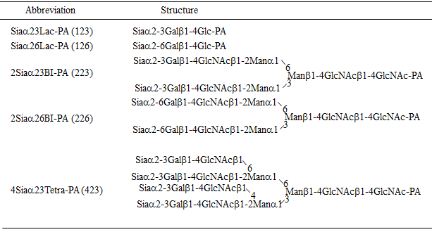
Figure 1 Pyridylamino oligosaccharide that used for high-performance liquid chromatography neuraminidase assay.

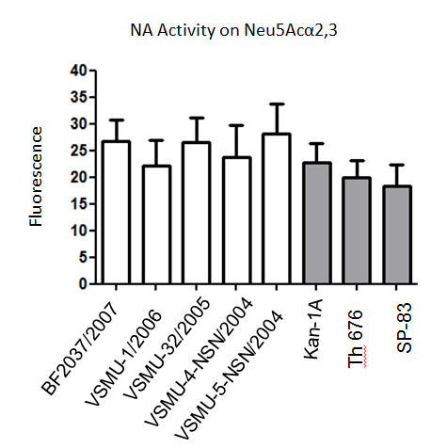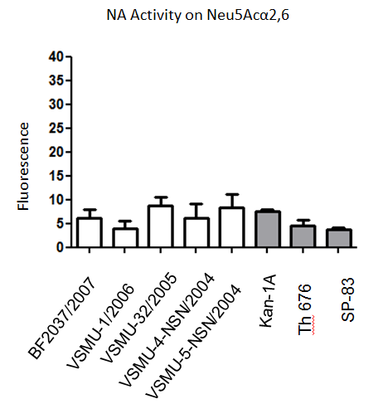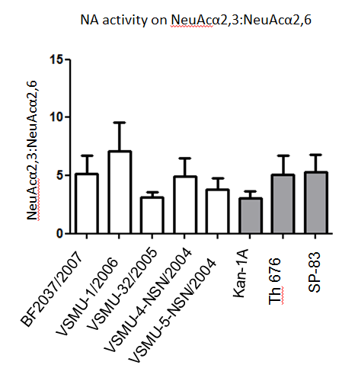
Figure 2 The N1 activity on substrate specificity by Amplex Red® assay. Substrate-specific neuraminidase activity of H5N1 avian influenza viruses isolated from animal (open bars) and human (dark bars) was measured by a modified Amplex Red® assay. The α2,3-linked sialoside specific activity was measured using Neu5Acα2,3LacNAcb-pAP as substrate (A), whereas the α2,6-linked sialoside specific activity was measured using Neu5Acα2,6LacNAcb-pAP (B). The fluorescence related to neuraminidase activity from triplicate experiments had been shown as mean ± SEM. In order to show substrate preference, ratios between the α2,3- and α2,6-specific activity are shown (C).
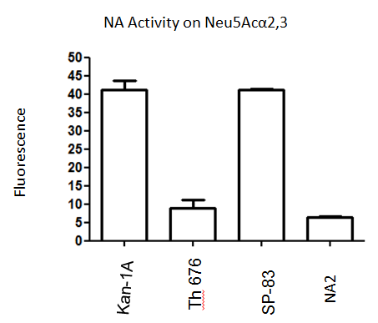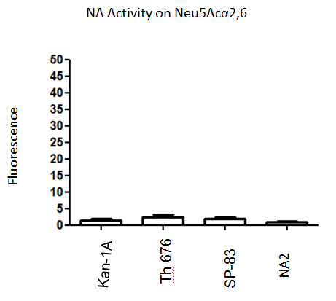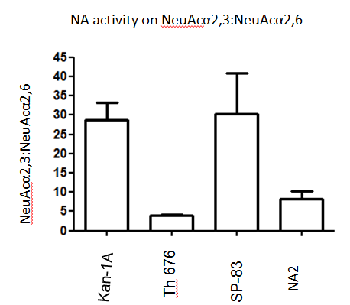
Figure 3 The neuraminidase activity on substrate specificity of reverse genetic virus by using Amplex Red® assay. The neuraminidase (NA) activity on α2,3- and α2,6-sialosides was shown in term of mean ± SEM from individual triplicate experiments on (A) and (B), respectively. The ratios of α2,3- and α2,6-substrate specific NA activity are shown on (C).

Virus | Subtype | Passage | Source
A/Thailand/KAN-1A/2004 | H5N1 | MDCK8 | Human
A/Thailand/676/2005 | H5N1 | MDCK8 | Human
A/Thailand/3(SP-83)/2004 | H5N1 | MDCK8 | Human
A/Openbill stork/Thailand/VSMU-4-NSA/2004 | H5N1 | MDCK4 | Avian
A/Openbill stork/Thailand/VSMU-5-NSA/2004 | H5N1 | MDCK4 | Avian
A/Chicken/Bangkok/VS-MU-1/2006 | H5N1 | MDCK4 | Avian
A/Chicken/Thailand/BF2037/2007 | H5N1 | MDCK4 | Avian
A/Openbill stork/Thailand (Nakhonsawon)/VSMU-32/2005 | H5N1 | MDCK4 | Avian
Table 1 Virus strains and sources

MDCK: Madin-Darby canine kidney.
Table 2 Neuraminidase activity measured by high-performance liquid chromatography analysis
Linkage type | Siaαx Lac-PA | DiSiaαx BI-PA |  | 4Siaαx Tetra-PA
 | Digested | One sialic digested (%) | Two sialic digested (%) | Completely digested (%)
α2,3 | 100 | 3.5 | 96.5 | 100
α2,6 | 0 | 0 | 0 | ND
ND: Not done.

