Name of Journal: World Journal of Clinical Cases
Manuscript NO: 62268
Manuscript Type: CASE REPORT

Coronary artery aneurysm combined with myocardial bridge: A case report

Ye Z et al. CAA and myocardial bridge

Zhen Ye, Xian-Feng Dong, Yuan-Ming Yan, Yu-Kun Luo

Zhen Ye, Xian-Feng Dong, Yuan-Ming Yan, Yu-Kun Luo, Department of Cardiology, Fujian Medical University Union Hospital, Fuzhou 350001, Fujian Province, China

Zhen Ye, Xian-Feng Dong, Yuan-Ming Yan, Yu-Kun Luo, Fujian Institute of Coronary Artery Disease, Fuzhou 350001, Fujian Province, China

Zhen Ye, Xian-Feng Dong, Yuan-Ming Yan, Yu-Kun Luo, Fujian Heart Medical Center, Fuzhou 350001, Fujian Province, China

Author contributions: Ye Z reviewed the literature and drafted and edited the manuscript; Luo YK reviewed the manuscript and brought the necessary changes; Dong XF and Yan YM helped in writing the manuscript and providing the images; all authors have read and approved the final manuscript.

Corresponding author: Yu-Kun Luo, MD, Assistant Professor, Chief Doctor, Department of Cardiology, Fujian Medical University Union Hospital, No. 29 Xinquan Road, Fuzhou 350001, Fujian Province, China. luoyukun@hotmail.com

Received: January 4, 2021
Revised: January 27, 2021
Accepted: February 8, 2021
Published online:

Abstract
BACKGROUND
Coronary artery aneurysm combined with myocardial bridge is a very rare clinical situation. The prognosis of this clinical situation is not yet clear.

CASE SUMMARY
A coronary artery aneurysm and myocardial bridge in the same segment of the coronary artery were found in a 54-year-old female patient who underwent coronary angiography and intravascular ultrasound examination. Through conservative treatment, the patient was discharged from the hospital smoothly, and she was in good condition during 5 mo of follow-up.

CONCLUSION
Coronary artery aneurysm combined with myocardial bridge seems to have a good prognosis, but due to the rarity of this clinical situation, further research and follow-up are needed.

Key Words: Coronary artery aneurysm; Myocardial bridge; Coronary angiography; Intravascular ultrasound; Chest pain; Case report

Ye Z, Dong XF, Yan YM, Luo YK. Coronary artery aneurysm combined with myocardial bridge: A case report. World J Clin Cases 2021; In press

Core Tip: We found a rare condition, in which a coronary artery aneurysm and myocardial bridge co-occurred in the same segment of the coronary artery, by coronary angiography and intravascular ultrasound examination. The prognosis of this clinical situation seems to be good, but due to its rarity, further research and follow-up are needed.
INTRODUCTION
Coronary artery aneurysm (CAA) is defined as fractional dilation of coronary arteries. The diameter of the dilated segment is at least 1.5 times larger than that of the adjacent normal segment. When exceeding four times the diameter of the adjacent normal segment, it is called a giant coronary aneurysm. Diffuse coronary artery dilation is called coronary artery ectasia^{[1,2]}. The normal coronary arteries and their main branches run on the surface of the heart. When some of the coronary arteries penetrate into the myocardium, they are compressed during myocardial systole. This part of the coronary arteries is called the tunnel artery, and the myocardium on its surface is called the myocardial bridge^{[3,4]}.
CAA and myocardial bridge are relatively rare diseases, and coexistence in the same segment of a coronary artery is an even rarer clinical situation. This clinical situation is rarely reported, and its prognosis is still unclear.

CASE PRESENTATION
Chief complaints
In May 2020, a 54-year-old woman was hospitalized with a chief complaint of exertional chest pain for more than 10 years.

History of present illness
Chest pain was located in the upper part of the sternum, lasted for approximately a few seconds, and could be relieved after rest. The symptoms worsened 6 mo prior, with chest pain occurring after mild activity and more frequently than before.

History of past illness
The patient had a history of hypertension for more than 5 years and took drugs regularly to control her blood pressure, and her blood pressure was acceptable.

Personal and family history
The patient had no significant prior personal or family history.

Physical examination
The patient’s blood pressure was 159/104 mmHg on admission, and the remainder of the physical examination showed no obvious abnormalities.

Laboratory examinations
The low-density lipoprotein cholesterol was 4.18 mmol/L (normal reference range: 1.10-3.50 mmol/L), cardiac biomarkers such as troponin and N-terminal pro-brain natriuretic peptide were normal, and the other blood tests were also approximately normal.

Imaging examinations
Electrocardiogram showed abnormal Q waves in leads II, III, aVF, V5-V6, and V7-V9 and slight elevation of the ST segment in leads II, III, aVF, and V1-V4. There were no remarkable findings on ultrasonic cardiogram.
Subsequent coronary angiography (CAG) revealed a normal right coronary artery and circumflex artery without any anomalies or sign of atherosclerosis. In the proximal to middle part of the left anterior descending artery (LAD), there was a near 25 mm long tumor-like aneurysm. The diameter of this aneurysm varied with the cardiac cycle. During cardiac systole, the aneurism was compressed by approximately 70% (Figure 1A and B). There was no obvious sign of atherosclerosis within other segments of LAD. Following intravascular ultrasound (IVUS) examination showed that the maximum diameter of the CAA during systole was 7.7 mm, the minimum diameter during systole was 4.02 mm, and the muscle bridge was clearly visible above the coronary artery (Figure 2A and B).

FINAL DIAGNOSIS
The final diagnosis of the presented case was CAA combined with myocardial bridge.

TREATMENT
After invasive coronary examination, the patient’s discharge medications included aspirin 100 mg/d, rosuvastatin 10 mg/d, metoprolol 47.5 mg/d, and amlodipine 5 mg/d.

OUTCOME AND FOLLOW-UP
The patient was then discharged because of symptom relief, and she was recently in good condition at the 5-mo follow-up by phone.

DISCUSSION
The incidence of CAA ranges from 1.2% to 4.9% and is most common in the right coronary artery, followed by the LAD branch and left circumflex branch, with the left main artery being the least affected^{[5]}. It is currently believed that the most common cause of coronary aneurysms in adults is atherosclerosis, accounting for approximately 50%, and the most common cause in children is Kawasaki disease. Other rare causes include inflammatory diseases, connective tissue diseases, infection, congenital diseases, iatrogenic diseases, and drugs^{[1,6]}. The detection rate of myocardial bridge in CAG ranges from 1.5% to 16%, but the detection rate in autopsy can be as high as 80%; moreover, the majority of cases of myocardial bridge occur in the LAD. Myocardial bridge is considered a congenital benign disease^{[3,4]}.
The combination of CAA and myocardial bridge at the same site of a coronary artery is relatively rare in clinical practice. Manfred Mauser and Manish Motwani have reported two such cases, but they only relied on CAG to diagnose this special coronary phenomenon^{[7,8]}. CAG can reveal the location, size, and shape of the CAA, but the size of the CAA may be underestimated when thrombi form in the lumen of the CAA^{[9,10]}. Therefore, we combined IVUS with CAG to conduct further examination of our patient. IVUS allows to observe whether the aneurysm has a complete three-layer vascular wall structure to distinguish between true and false aneurysms and whether there is thrombosis in the aneurysm lumen^{[11]}. True aneurysms have intact intima, media, and adventitia, while the vascular integrity of false aneurysms is lost and they lack at least one layer of the artery wall and consist of a single or double layer that protrudes outward^{[12]}. Myocardial bridge can manifest as a characteristic "half-moon" transparent echo area around the lumen in IVUS^{[13]}. In this case, IVUS showed that there was no obvious plaque or thrombosis formation in the CAA segment, and the myocardial bridge was clearly shown around the CAA.
It was a pity that we missed the further functional examinations such as single photon emission tomography, scintigraphy, or nuclear magnetic resonance, so we could not exclude the presence of ischemia or microvascular disease in this case.

CONCLUSION
The prognosis of CAA may be better when it is combined with myocardial bridge. Furthermore, myocardial bridge may limit the excessive expansion of the coronary arteries, and periodic compression of the CAA by the myocardial bridge may reduce congestion in the aneurysm, which could be a risk factor for thrombosis. The outcome of such a rare combination needs further research and follow-up.

REFERENCES
1 Sheikh AS, Hailan A, Kinnaird T, Choudhury A, Smith D. Coronary Artery Aneurysm: Evaluation, Prognosis, and Proposed Treatment Strategies. Heart Views 2019; 20: 101-108 [PMID: 31620255 DOI: 10.4103/HEARTVIEWS.HEARTVIEWS_1_19]
2 Kawsara A, Núñez Gil IJ, Alqahtani F, Moreland J, Rihal CS, Alkhouli M. Management of Coronary Artery Aneurysms. JACC Cardiovasc Interv 2018; 11: 1211-1223 [PMID: 29976357 DOI: 10.1016/j.jcin.2018.02.041]
3 Kalaria VG, Koradia N, Breall JA. Myocardial Bridge: a clinical review. Catheter Cardiovasc Interv 2002; 57: 552-556 [PMID: 12455095 DOI: 10.1002/ccd.10219]
4 Alegria JR, Herrmann J, Holmes DR Jr, Lerman A, Rihal CS. Myocardial bridging. Eur Heart J 2005; 26: 1159-1168 [PMID: 15764618 DOI: 10.1093/eurheartj/ehi203]
5 Devabhaktuni S, Mercedes A, Diep J, Ahsan C. Coronary Artery Ectasia-A Review of Current Literature. Curr Cardiol Rev 2016; 12: 318-323 [PMID: 27142049 DOI: 10.2174/1573403x12666160504100159]
6 Morita H, Ozawa H, Yamazaki S, Yamauchi Y, Tsuji M, Katsumata T, Ishizaka N. A case of giant coronary artery aneurysm with fistulous connection to the pulmonary artery: a case report and review of the literature. Intern Med 2012; 51: 1361-1366 [PMID: 22687842 DOI: 10.2169/internalmedicine.51.7134]
7 Mauser M. Combination of aneurysm and myocardial bridging at the same site of a coronary artery in a patient with obstructive hypertrophic cardiomyopathy. Catheter Cardiovasc Interv 2000; 49: 325-327 [PMID: 10700068 DOI: 10.1002/(sici)1522-726x(200003)49:3<325::aid-ccd21>3.0.co;2-z]
8 Motwani M, Arya S, MacDonald JE. Myocardial bridging with a coronary artery aneurysm and left ventricular stunning. Am J Med Sci 2011; 341: 510-511 [PMID: 21613937 DOI: 10.1097/MAJ.0b013e3182116a60]
9 Pahlavan PS, Niroomand F. Coronary artery aneurysm: a review. Clin Cardiol 2006; 29: 439-443 [PMID: 17063947 DOI: 10.1002/clc.4960291005]
10 Murthy PA, Mohammed TL, Read K, Gilkeson RC, White CS. MDCT of coronary artery aneurysms. AJR Am J Roentgenol 2005; 184: S19-S20 [PMID: 15728009 DOI: 10.2214/ajr.184.3_supplement.01840s19]
11 Sanidas EA, Vavuranakis M, Papaioannou TG, Kakadiaris IA, Carlier S, Syros G, Dangas G, Stefanadis C. Study of atheromatous plaque using intravascular ultrasound. Hellenic J Cardiol 2008; 49: 415-421 [PMID: 19110928]
12 Kar S, Webel RR. Diagnosis and treatment of spontaneous coronary artery pseudoaneurysm: Rare anomaly with potentially significant clinical implications. Catheter Cardiovasc Interv 2017; 90: 589-597 [PMID: 28258964 DOI: 10.1002/ccd.26997]
13 Ge J, Erbel R, Rupprecht HJ, Koch L, Kearney P, Görge G, Haude M, Meyer J. Comparison of intravascular ultrasound and angiography in the assessment of myocardial bridging. Circulation 1994; 89: 1725-1732 [PMID: 8149538 DOI: 10.1161/01.cir.89.4.1725]

Footnotes
Informed consent statement: Informed written consent was obtained from the patient for publication of this report and any accompanying images.

Conflict-of-interest statement: The authors declare that they have no conflict of interest to report.

CARE Checklist (2016) statement: The authors have read the CARE Checklist (2016), and the manuscript was prepared and revised according to the CARE Checklist (2016).

Open-Access: This article is an open-access article that was selected by an in-house editor and fully peer-reviewed by external reviewers. It is distributed in accordance with the Creative Commons Attribution NonCommercial (CC BY-NC 4.0) license, which permits others to distribute, remix, adapt, build upon this work non-commercially, and license their derivative works on different terms, provided the original work is properly cited and the use is non-commercial. See: http://creativecommons.org/Licenses/by-nc/4.0/

Manuscript source: Unsolicited manuscript

Peer-review started: January 4, 2021
First decision: January 24, 2021
Article in press:

Specialty type: Medicine, research and experimental
Country/Territory of origin: China
Peer-review report’s scientific quality classification
Grade A (Excellent): 0
Grade B (Very good): B, B
Grade C (Good): C
Grade D (Fair): D
Grade E (Poor): 0

P-Reviewer: Naswhan AJ, Rostagno C S-Editor: Gao CC L-Editor: Wang TQ P-Editor:
Figure Legends
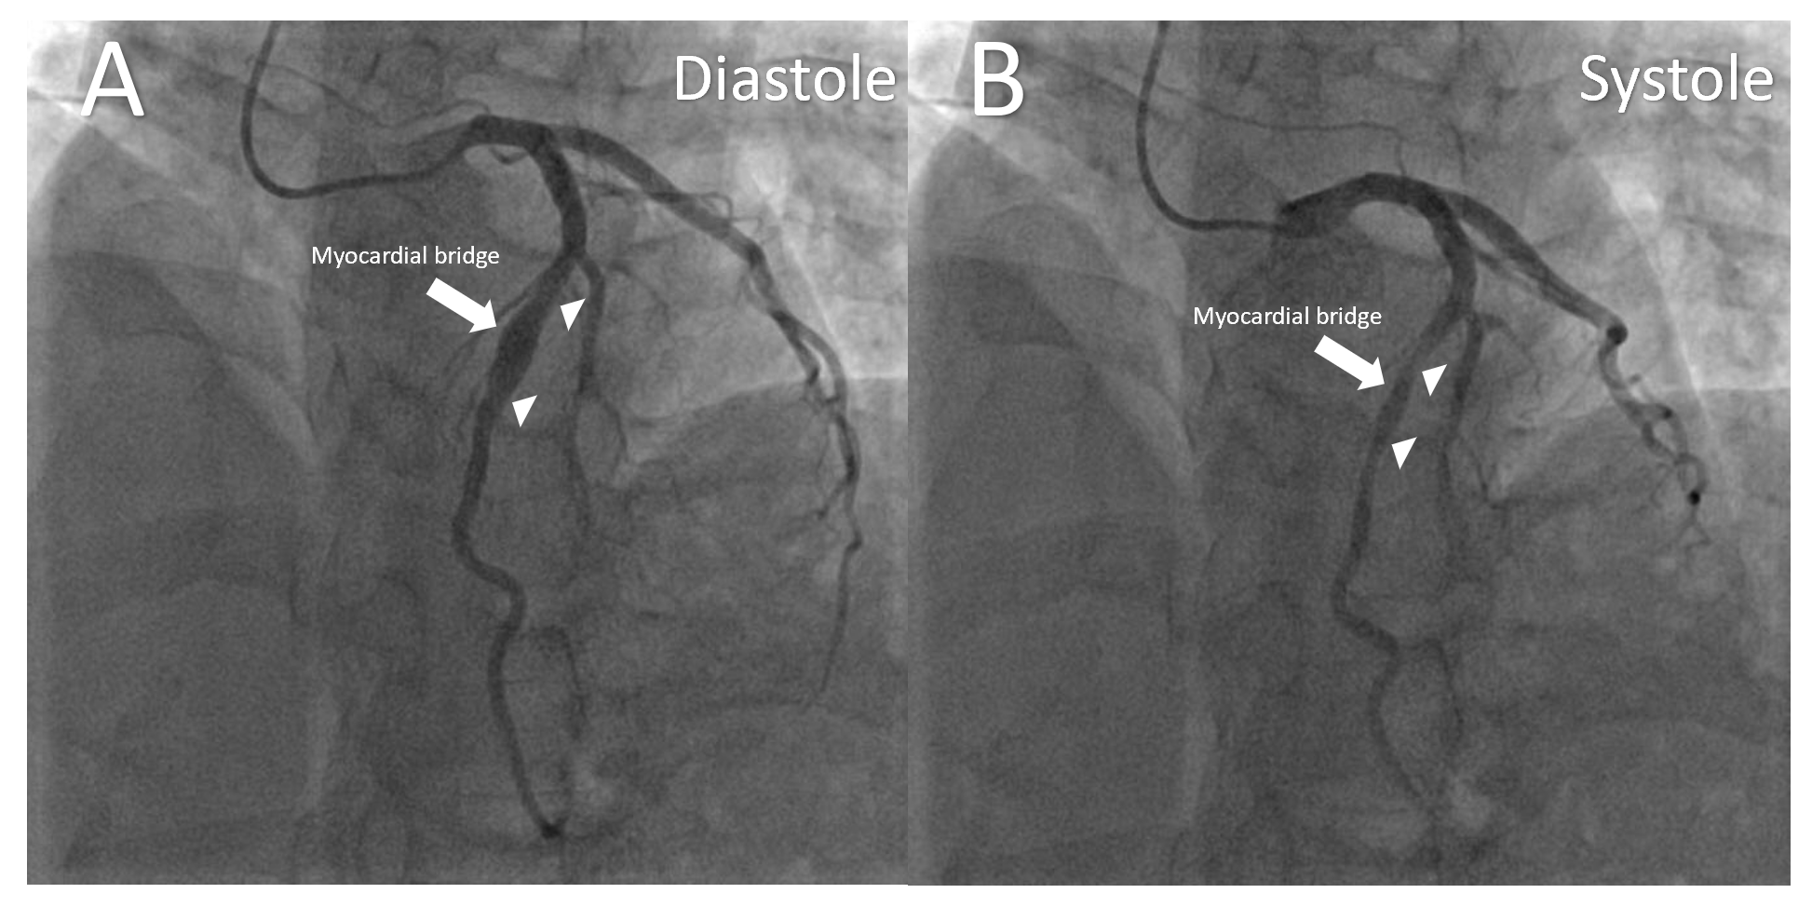
Figure 1 Images of coronary angiography. A: Coronary angiography showed the coronary artery aneurysm (CAA) in the middle left anterior descending artery during diastole; B: Coronary angiography showed that the CAA was compressed by the myocardial bridge during systole. The arrow indicates the location of the myocardial bridge, and the triangles indicate the start and end of the CAA.
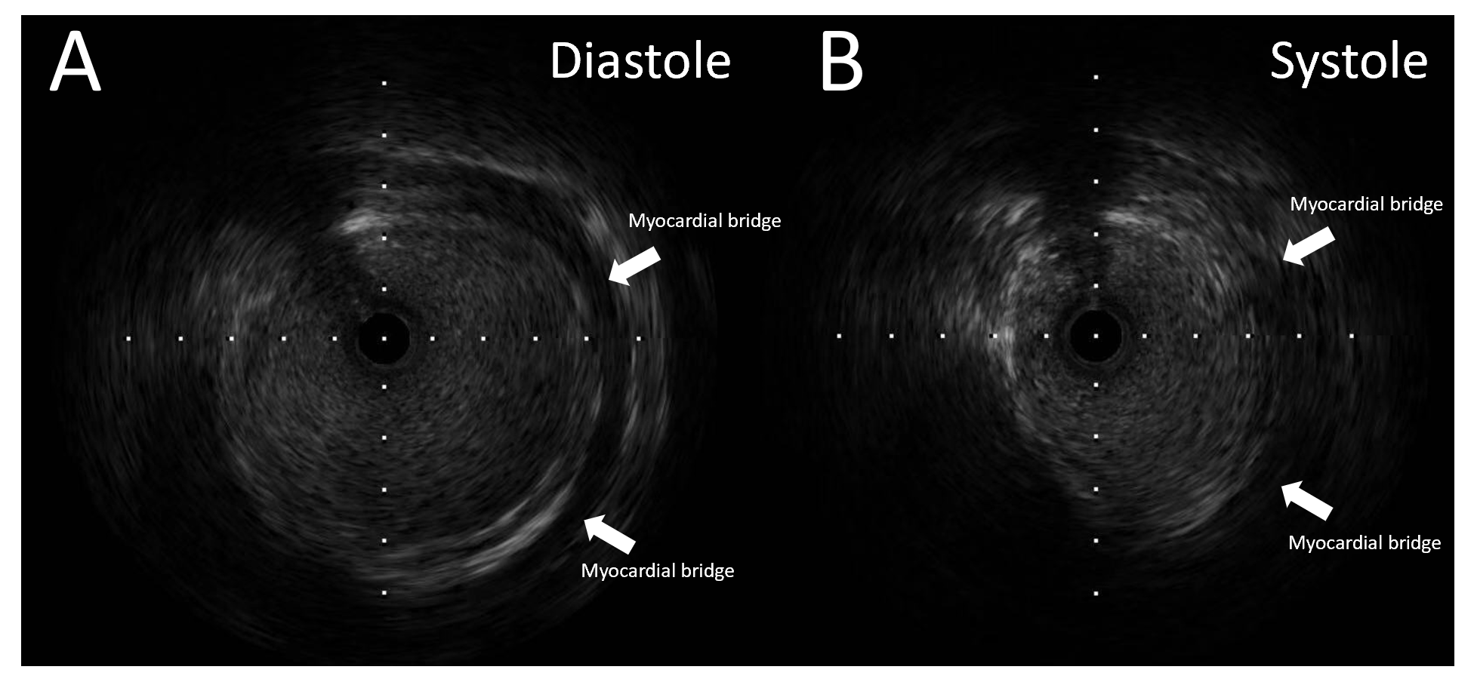
Figure 2 Images of intravascular ultrasound. A: Intravascular ultrasound showed the coronary artery aneurysm and myocardial bridge during diastole; B: Intravascular ultrasound showed that the coronary artery aneurysm was compressed by the myocardial bridge during systole. The arrows indicate the location of the myocardial bridge.

