Name of Journal: World Journal of Gastrointestinal Surgery
Manuscript NO: 88581
Manuscript Type: ORIGINAL ARTICLE

Clinical and Translational Research
Construction and validation of somatic mutation-derived long non-coding RNAs signatures of genomic instability to predict prognosis of hepatocellular carcinoma

Duan BT et al. Somatic mutation LncRNA in HCC

Bo-Tao Duan, Xue-Kai Zhao, Yang-Yang Cui, De-Zheng Liu, Lin Wang, Lei Zhou, Xing-Yuan Zhang

Bo-Tao Duan, Xue-Kai Zhao, Yang-Yang Cui, De-Zheng Liu, Lei Zhou, Xing-Yuan Zhang, Department of Hepatobiliary Surgery, Binzhou Medical University Hospital, Binzhou 256600, Shandong Province, China

Lin Wang, Department of Ophthalmology, Binzhou Medical University Hospital, Binzhou 256603, Shandong Province, China

Co-first authors: Bo-Tao Duan and Xue-Kai Zhao.

Author contributions: Duan BT and Zhao XK drafted the manuscript; Zhou L and Zhang XY provided guiding advice on manuscript editing. All authors approved the final version of the manuscript.

Corresponding author: Lei Zhou, MD, Full Professor, Department of Hepatobiliary Surgery, Binzhou Medical University Hospital, No. 661 Huanghe 2nd Road, Binzhou 256600, Shandong Province, China. dr_zhlei@163.com

Received: October 2, 2023
Revised: December 20, 2023
Accepted: February 19, 2024
Published online:

Abstract
BACKGROUND
Long non-coding RNAs (LncRNAs) have been found to be a potential prognostic factor for cancers, including hepatocellular carcinoma (HCC). Some LncRNAs have been confirmed as potential indicators to quantify genomic instability (GI). Nevertheless, GI-LncRNAs remain largely unexplored. This study established a GI-derived LncRNA signature (GILncSig) that can predict the prognosis of HCC patients.

AIM
To establish a GILncSig that can predict the prognosis of HCC patients.

METHODS
Identification of GI-LncRNAs was conducted by combining LncRNA expression and somatic mutation profiles. The GI-LncRNAs were then analyzed for functional enrichment. The GILncSig was established in the training set by Cox regression analysis, and its predictive ability was verified in the testing set and TCGA set. In addition, we explored the effects of the GILncSig and TP53 on prognosis.

RESULTS
A total of 88 GI-LncRNAs were found, and functional enrichment analysis showed that their functions were mainly involved in small molecule metabolism and GI. The GILncSig was constructed by 5 LncRNAs (miR210HG, AC016735.1, AC116351.1, AC010643.1, LUCAT1). In the training set, the prognosis of high-risk patients was significantly worse than that of low-risk patients, and similar results were verified in the testing set and TCGA set. Multivariate Cox regression analysis and stratified analysis confirmed that the GILncSig could be used as an independent prognostic factor. Receiver operating characteristic curve analysis of the GILncSig showed that the area under the curve (0.773) was higher than the two LncRNA signatures published recently. Furthermore, the GILncSig may have a better predictive performance than TP53 mutation status alone.

CONCLUSION
We established a GILncSig that can predict the prognosis of HCC patients, which will help to guide prognostic evaluation and treatment decisions.

Key Words: Genomic instability; Long noncoding RNA; Hepatocellular carcinoma; Prognosis; Diagnosis

Duan BT, Zhao XK, Cui YY, Liu DZ, Wang L, Zhou L, Zhang XY. Construction and validation of somatic mutation-derived long non-coding RNAs signatures of genomic instability to predict prognosis of hepatocellular carcinoma. World J Gastrointest Surg 2024; In press

Core Tip: Identification of genomic instability (GI)-long non-coding RNAs (LncRNAs) was conducted by combining LncRNA expression and somatic mutation profiles. The GI-LncRNAs were then analyzed for functional enrichment. The GI-derived LncRNA signature (GILncSig) was established in the training set by Cox regression analysis, and its predictive ability was verified in the testing set and TCGA set. A total of 88 GI-LncRNAs were found, and functional enrichment analysis showed that their functions were mainly involved in small molecule metabolism and GI. We established a GILncSig that can predict the prognosis of hepatocellular carcinoma patients, which will help to guide prognostic evaluation and treatment decisions.

INTRODUCTION
Hepatocellular carcinoma (HCC) is one of the cancers with the highest mortality rate among all malignant tumors, ranking sixth among common cancers^{[1,2]}. Worldwide, the mortality rate of patients with HCC ranks second among the total mortality of all cancers. The incidence rate and mortality of liver cancer in East Asia, Southeast Asia, Africa and southern Europe are particularly prevalent^{[3]}. The incidence rate of HCC is increasing year by year, which is, of course, related to the improvement in diagnostic mode and the shortening of cancer monitoring interval. In the past, viral hepatitis was the main epidemiological cause of HCC, but with implementation of hepatitis B vaccination and the hepatitis C treatment plan worldwide, the annual incidence rate of HCC with viral hepatitis as the main cause has decreased. In addition, increasing evidence suggests that non-alcoholic fatty liver disease and non-alcoholic steatohepatitis (NASH) contribute to the development of HCC and are becoming increasingly common causes of HCC worldwide. With the implementation of viral hepatitis treatment plans, the epidemiological etiology of HCC is likely to shift from viral hepatitis to NASH^{[4-6]}. It is well known that HCC is a fairly complex disease. The current prognostic factors for HCC include tumor size, number, vascular invasion, extrahepatic spread, severity of underlying liver disease as defined by bilirubin and portal hypertension, as well as corresponding qualified treatment modalities^{[7]}. Traditional surgical treatment and locoregional therapies have obvious efficacy for some HCC patients, but some patients still have the possibility of long-term recurrence, with poor prognosis and high mortality^{[8]}. In systematic treatment regimens, advanced HCC patients can generally be treated with tyrosine kinase inhibitors (TKIs). With the increasing understanding and characterization of the immune characteristics of the tumor microenvironment, immune checkpoint inhibitors (ICI) methods further expand the systemic treatment of HCC. The current emerging comprehensive systemic treatment method combines the above two methods, and there is evidence that the combination therapy of ICI + TKI has achieved certain results. However, existing research evidence suggests that the treatment options currently used in clinical practice are still relatively ineffective. In fact, although the efficacy has significantly improved following the introduction of ICI, the objective response rate to treatment is still largely inadequate. Most patients do not have good responses, and the 5-year overall survival (OS) of metastatic HCC is still unsatisfactory. Currently, efforts should mainly focus on expanding treatment targets and searching for reliable biomarkers as much as possible, which will help adjust treatment choices and avoid the risks and costs associated with drug ineffectiveness and side effects^{[9]}. Therefore, new biomarkers are eagerly needed to predict the prognosis of HCC patients.
Genomic instability (GI) has been verified to be one of the characteristics of malignant tumors^{[10]}. Chromosomal instability and microsatellite instability are two major types of GI, and more importantly, they are significantly associated with the prognosis of cancer patients^{[11]}. The underlying mechanism may be related to the oxidative stress response and the joint defect of DNA damage checkpoint and repair pathway^{[12]}. It also proves that molecular markers have great potential in quantifying GI. For example, Mettu et al^{[13]} demonstrated that their identified 12-gene GI signature could predict disease outcomes in multiple cancer types with epithelial origins. A mutation-derived gene signature of GI that can help in predicting the OS of patients with HCC was constructed by Song et al^{[14]}. Therefore, these GI signatures may be a potential new therapeutic direction for HCC patients.
Long non-coding RNAs (LncRNAs) are non-protein coding transcripts greater than or equal to 200 nucleotides in length^{[15]}. More and more evidence suggests that LncRNA is becoming a potential regulator for GI and to some extent quantifying the level of GI^{[16,17]}. For example, some studies have found that a discovered NORAD or LINC00657 regulates genomic stability by isolating pumilio proteins^{[18]}. LncRNA dysfunction is closely associated with the occurrence of various tumors, including HCC^{[19]}. Li et al^{[20]} found that LncRNA Ftx overexpression promoted the proliferation, invasion and migration of HCC cells^{[20]}. Although a considerable number of LncRNAs have been discovered to be related to genomic stability, the clinical application of other GI-LncRNAs in cancer has largely been unexplored, but have great potential as new prognostic biomarkers.
Therefore, in our study, we attempted to establish a GI-derived LncRNA signature (GILncSig) that could help predict the prognosis of HCC patients by combining the LncRNA expression profile with the somatic mutation profile.

MATERIALS AND METHODS
Data sources
The data in this study mainly included clinical characteristics, somatic mutation information, and transcriptome expression data of HCC which were extracted from TCGA portal (https://portal.gdc.cancer.gov/). A total of 424 files with mRNA and LncRNA profiles (including 50 normal and 374 tumor tissues), 377 clinical characteristics of HCC patients and 372 patients with somatic mutation information were obtained. All HCC patients (n = 343) were randomly divided into the training set and the testing set (chi-square test showed that there was no statistical difference between the training set and the testing set) for further construction and verification of the LncRNA signature.

Identification of GI-LncRNAs
In order to identify GI-LncRNAs, we first calculated the cumulative number of somatic mutations for each patient in HCC samples by combining the LncRNA expression profile and the somatic mutation profile, and arranged them from large to small. The patients in the top quarter are referred to as genomically unstable (GU) samples, and the patients in the bottom quarter are genomically stable (GS) samples. The differentially expressed LncRNAs [absolute value of fold change was greater than 1, and the adjusted P value of false discovery rate (FDR) was less than 0.05] between the two groups were defined as genome instability-associated LncRNAs.
Hierarchical cluster analysis was performed on all samples, and differentially expressed LncRNAs were used to identify the GU-like group and GS-like group. In order to examine the correlation between GI-LncRNAs and mRNA pairings, the top 10 mRNAs most related to each GI-LncRNA were screened using the Pearson correlation coefficient. On this basis, a co-expression network was established. Subsequently, functional enrichment analysis was performed on the co-expressed LncRNA-associated mRNAs to reveal the potential biological characteristics of GI-LncRNA, including Gene Ontology (GO) terms and Kyoto Encyclopedia of Genes and Genomes (KEGG) pathways. ClusterProfiler software in R-version 4.0.2^{[21]} was used for functional enrichment analysis.

Establishment of the GILncSig
In the training set, the GILncSig formula with risk score was established based on the results of multivariate Cox regression analysis and the expression level of GI-LncRNA. The formula was as follows: GILncSig (patient) = ∑(expression of LncRNA_{n}*coef (LncRNA_{n})), where GILncSig (patient) is a prognostic risk score for the HCC patient, and the LncRNAn represents the nth of independent prognostic LncRNAs. The coef (LncRNAn) represents the contribution index of LncRNAi to prognostic risk score from the Cox regression analyses^{[21]}. In the training set, patients' median risk score was used as a dividing line between patients in the high-risk group (high GILncSig) and those in the low-risk group (low GILncSig). The prediction ability of GILncSig was verified by the Kaplan-Meier (K-M) method (P < 0.05 was considered significant). Moreover, the performance was further evaluated by the time-dependent receiver operating characteristic (ROC) curve. All calculations and analyses in this paper were performed using R-version 4.0.2.

Validation of the GILncSig
We first validated the model on a randomly assigned test set and a TCGA set containing all patients. Similar to the training set, we used the GILncSig to calculate the risk scores of each patient within the two sets separately and divided them into two groups of high and low risk within the respective sets. The same K-M analysis and ROC curves were used to validate the GILncSig between the two groups in each of the two pools. Secondly, we used Cox regression analysis to verify whether the GILncSig could be distinguished from other clinical features as an independent prognostic factor. We also performed ROC curve analysis of the GILncSig with two extant LncRNA signatures predicting HCC prognosis and compared their area under the curve (AUC), and then we verified whether the GILncSig could be applied to patients with different clinical characteristics using K-M analysis. In addition, we also analyzed the prognostic value of the GILncSig in combination with TP53.

RESULTS
Identification of GI-LncRNAs in HCC
According to the number of somatic mutations in each patient, we were able to establish the GS group (n = 90) and GU group (n = 93). Differential expression analysis of LncRNA expression profiles of the two groups was then conducted, and 88 different LncRNAs with statistical significance were obtained (|fold change| > 1 and FDR adjusted P < 0.05). Of these, 56 LncRNAs were found to be upregulated and 32 to be downregulated. The heat map (Figure 1A) shows the top 20 LncRNAs with the largest differential expression. Unsupervised hierarchical clustering analysis was performed on all HCC samples based on the expression levels of 88 differentially expressed LncRNAs, and 374 samples were divided into two groups, which are shown in Figure 1B. The lever of somatic mutations in the GU-like group was significantly higher than in the GS-like group (Figure 1C). In addition, the expression of H2AX was compared between the two groups. It was found that the expression of H2AX in the GU-like group was significantly higher than that in the GS-like group (P < 0.01, Figure 1D). H2AX has been found to promote rapid division of cancer cells and is significantly associated with GI^{[22]}.
Next, we used functional enrichment analysis to predict the potential functions of these GI-LncRNAs. We screened the top 10 protein-coding genes (PCGs) with the strongest correlation with LncRNA. On this basis, an LncRNA-mRNA co-expression network was constructed (Figure 2A). The GO analysis of co-expressed LncRNA-associated mRNAs showed that mRNAs and LncRNA-corrected PCG in the network were significantly enriched in the metabolic process, including the small molecule catabolic process and fatty acid metabolic process (P < 0.05, Figure 2B). In terms of KEGG pathway analysis, 22 significantly rich pathways were found, including pyrimidine metabolism, purine metabolism, and folate biosynthesis (P < 0.05, Figure 2C). The results of functional enrichment analysis showed that 88 differentially expressed LncRNAs could participate in a variety of cancer-related biological processes by interfering with a variety of metabolic pathways, among these processes, gene instability could be affected by interfering with gene synthesis.

Development of a GILncSig outcome prediction in the training set
To further explore the prognostic effects of these GI-LncRNAs, we randomly divided all HCC patients into two groups: The training set (n = 172) and testing set (n = 171). Univariate Cox regression analysis was performed on the samples in the training set to analyze the association between OS and LncRNA expression levels of 88 GI-LncRNAs in the training set. A total of 13 LncRNAs were discovered to be significantly correlated with the prognosis of HCC patients (P < 0.05, Figure 3A). Multivariate Cox regression analysis of these 13 LncRNAs was then conducted. Finally, 5 of the 13 candidates LncRNAs (miR210HG, AC016735.1, AC116351.1, AC010643.1 and LUCAT1) in multivariate Cox analysis showed prognostic significance, and are considered to be independent prognostic factors. On this basis, the GILncSig was constructed and was used to assess the prognostic risk of HCC patients. The formula used was as follows: GILncSig = (0.0867 × expression level of MIR210HG) + (0. 0454 × expression level of AC016735.1) + (0.1316 × expression level of AC116351.1) + (0.3036×expression level of AC010643.1) + (0.2557 × expression level of LUCAT1). In the GILncSig, the coefficients of these 5 LncRNAs were all positive, and their high expression was associated with poor prognosis. This indicates that these LncRNAs are risk factors.
Risk scores were calculated for all patients in the training set using the GILncSig. Patients with risk scores equal to or higher than the median value were included in the high-risk group, and the remaining patients were included in the low-risk group. Log-rank tests and K-M analysis showed that patients in the low-risk group had significantly better survival outcomes than those in the high-risk group (P < 0.001, Figure 3B). The 5-year survival rates in the two groups were 9.3% (high-risk group) and 19.8% (low-risk group). The ROC curve analysis of the GILncSig over time is shown in Figure 3C, and the AUC was 0.773. At the same time, GILncSig expression level, somatic mutation count and expression level of H2AX, UBQLN4 genes (a newly discovered driver of GI^{[23]}) were also observed to change with an increase in the risk score (Figure 3D). For patients with high scores, the expression of miR210HG, AC016735.1, AC116351.1, AC010643.1 and LUCAT1 were up-regulated. Compared with the low-risk group, somatic mutations were more frequent in the high-risk group (P = 0.0011, Figure 3E). In addition, the expression of UBQLN4 and H2AX were higher in high-risk patients than in low-risk patients (P < 0.01, Figure 3F).

Independent validation of the GILncSig on the RNA-seq platform of HCC data
Subsequently, in order to examine the credibility of the prognostic performance of the GILncSig, we used the independent testing set of 171 patients to determine this. Similarly, using the GILncSig to calculate the risk score of patients in the testing set, the patients were also divided into the high-risk group (n = 76) and low-risk group (n = 95) according to the same method as in the training set, and the K-M analysis also showed significant differences between the two groups. The OS rate in the low-risk group was significantly better than that in the high-risk group (P = 0.013, Figure 4A). The 5-year survival rate in the high-risk group was 3.95%, which was lower than that in the low-risk group (12.63%). In the testing set, ROC curve analysis of the GILncSig over time showed that the AUC was 0.679 (Figure 4B). Similar to the training set, the expression of GILncSig as well as somatic mutation count and the expression of H2AX, UBQLN4 in the testing set were mostly positively correlated with the risk value (P < 0.01, Figure 4C). The somatic cell mutation rate of the high-risk group in the testing set was slightly higher than that of the low-risk group (P = 0.18, Figure 4D). The expression level of UBQLN4 and H2AX in the low-risk group was significantly lower than that in the high-risk group (Figure 4E, P < 0.01).
Similarly, we divided all patients in the TCGA set into the high-risk group (n = 162) and low-risk group (n = 181) and used the same method to verify the performance of the GILncSig. As expected, we obtained similar but more meaningful results. The OS rate and 5-year survival rate (6.79% to 16.02%) of patients in the high-risk group were lower than those in the low-risk group (P < 0.01, Figure 4F). ROC curve analysis of the GILncSig in the TCGA set over time showed that the AUC value was 0.730 (Figure 4G). Figure 4H shows the expression of GILncSig, somatic mutation count and the expression of UBQLN4, H2AX in the TCGA set. As expected, the somatic cell mutation rate and the expression levels of UBQLN4 and H2AX in the high-risk group were significantly higher than those in the low-risk group (Figure 4I, P = 0.0011; P < 0.01, respectively).

Comparison of the prediction ability of the GILncSig with existing LncRNA signatures
The predictive performance of the GILncSig in our study was then compared with two published LncRNA signatures for predicting HCC prognosis: 6-LncRNA signature derived from Gu’s study (hereinafter referred to as GuLncSig)^{[24]} and 4-LncRNA signature derived from Wu’s study (hereinafter referred to as WuLncSig)^{[25]} using the same TCGA patient cohort. On this basis, ROC curve analysis was used to evaluate the prognostic performance of these signatures. As shown in Figure 5, the AUC of the the GILncSig was 0.736, which was higher than that of GulncSig (AUC = 0.664) and WulncSig (AUC = 0.725). These results may indicate that the GILncSig has better prognostic performance than the two recently published LncRNA signatures.

Independence of the GILncSig from other clinical factors
To verify whether the GILncSig can be used as an independent clinical variable to evaluate the prognosis of HCC patients, multivariate Cox regression analyses were performed for age, sex, grade, stage, and prognostic risk score based on the GILncSig. The GILncSig was found to be statistically significant as an independent prognostic factor (P < 0.05, Table 1). To determine whether the GILncSig can be applied to different clinical traits, we first divided the TCGA group into groups older than 65 years (n = 141) and younger than or equal to 65 years (n = 235) and the risk scores of patients in each age group were calculated by the GILncSig. Patients in each group were divided into high-risk and low-risk groups according to the median risk score. The results showed significant differences in survival between the two groups (P < 0.01, Figure 6A). Next, TCGA patients were also divided into the male group (n = 255) and female group (n = 122) and then the patients in each group were divided into the high-risk group and low-risk group by the GILncSig. In the male group, the difference in OS between the high and low risk groups was considered significant and meaningful, whereas in the female group, the result was not significant (Figure 6B, P < 0.001, P = 0.952). We next used the same method to divide patients into two groups according to other clinical conditions, such as grade, stage, T stage, M stage, N stage, and then divided them into the high and low risk group using the GILncSig. As expected, Figure 6C-G shows that in most clinical subgroups, the OS of low-risk patients was significantly better than that of high-risk patients, including Grade 1-2 (P < 0.001), M0 (P < 0.001), N0 (P < 0.001), T1-2 (P = 0.002), and Stage I-II (P = 0.006). However, the results in the M1, N1-3 and stage III-IV were seemingly meaningless (P > 0.1), and the P value was only slightly significant in Grade 3-4 (0.089) and T3-4 (P = 0.085).
These findings may mean that the GILncSig can be used as a reliable independent prognostic factor to predict the prognosis of HCC patients. It appears to be a better predictor of prognosis for HCC patients in the early stages of the disease.

Further exploration of the predictive power of the GILncSig
TP53 mutation is the most common mutation in HCC, and it affects the progression and prognosis of the disease^{[26]}. Mutations in TP53 are closely related to poor survival in HCC patients, and can be used as an independent prognostic biomarker in HCC^{[27]}. As shown in Figure 7A, the percentage of patients with TP53 mutations was 51%, 43% and 47% in the high-risk groups of the training set, testing set and TCGA set, respectively, which were significantly higher than 21%, 12% and 16% in the low-risk group in each set. This suggests that the GILncSig is also associated with TP53 mutation status. In addition, K-M survival analysis of TCGA patients was further performed in combination with TP53 mutation status and the GILncSig. As expected, patients in the TP53 wild-type combined with GS-like group had the best prognosis and those in the TP53 mutant combined with GU-like group had the worst prognosis. Patients with the same TP53 mutation status had a better prognosis than those in the GU-like group (P = 0.009, Figure 7B). These results suggest that the GILncSig may have a more reliable predictive power for HCC patients than TP53 mutation status alone.

DISCUSSION
In the past few years, a large number of studies have been conducted on the initiation, diagnosis and treatment of HCC^{[28,29]}. At present, traditional clinicopathological features are still used as a tool to predict the prognosis of HCC^{[30]}. An imaging examination is essential for the diagnosis of liver cancer, but the sensitivity of imaging will be greatly reduced due to the small lesions and insignificant symptoms of early liver cancer^{[31]}. In recent decades, among all biomarkers for the diagnosis of HCC, alpha-fetoprotein (AFP) is the most widely used and relatively reliable. Abnormal plasma AFP level is closely related to HCC malignancy^{[32]}. However, due to its lack of sensitivity and specificity, the results are unsatisfactory in the diagnosis of early liver cancer^{[33]}. Therefore, the identification of new reliable prognostic indicators is urgently required to evaluate the prognosis of HCC patients.
In recent years, with the rapid development of high-throughput sequencing technology, GI-LncRNAs have been gradually identified as potential prognostic indicators^{[16,17]}. It is reported that GI is one of the ubiquitous characteristics of cancer^{[10,34,35]}. It also has great potential as one of the prognostic factors in HCC patients^{[12]}. In addition, aberrant expression of LncRNAs may affect cell proliferation, tumor progression or metastasis, suggesting that LncRNAs may also be new prognostic factors for HCC by affecting GI^{[36]}. A considerable number of studies have found that some LncRNAs are associated with gene instability, thus affecting the prognosis of cancer, such as MANCR^{[37]}, CCAT2^{[38]} and NORAD^{[17]}. Nevertheless, it is still difficult to identify GI-LncRNAs, their significance in predicting the clinical outcome of HCC is unclear, and their potential as a new prognostic marker remains to be explored. Thus, we constructed a computational framework for identifying genome instability-related LncRNAs by combining LncRNA expression with tumor mutant phenotype.
In this study, we first obtained 88 GI-LncRNAs by comprehensive analysis of the LncRNA profile and somatic mutation downloaded from TCGA database. PCGs closely associated with LncRNAs were identified and analyzed for functional enrichment. Through KEGG and GO pathway analysis, we found that their biological processes and biological pathways mainly involved the small molecule catabolic process and fatty acid metabolic process, pyrimidine metabolism, purine metabolism, and folate biosynthesis. Pyrimidine metabolism, purine metabolism and folate biosynthesis are involved in DNA synthesis. Dysfunction related to DNA damage will lead to cell cycle imbalance and GI^{[39]}. In addition, the Fanconi anemia pathway is composed of a complex DNA damage signal and repair network, which is very important in preventing GI^{[40]}.
In addition, we obtained five GI-LncRNAs (miR210HG, AC016735.1, AC116351.1, AC010643.1 and LUCAT1), and further explored the roles these GI-LncRNAs play in predicting the clinical outcome of HCC patients. Based on this, the GILncSig was established. Subsequently, the GILncSig was used to divide the patients into two groups with high and low risk. In the training set, patients in the low-risk group survived longer than those in the high-risk group, and the independent TCGA set and testing set further validated this result. The area under the ROC curve of the GILncSig in the three groups mentioned above was 0.773, 0.679 and 0.736 respectively, which demonstrated that the GILncSig has excellent prognostic ability. In all HCC cohorts, we found that the number of somatic mutations was higher in the high-risk group than in the low-risk group. In addition, the expression of UBQLN4 and H2AX was significantly higher in high-risk patients than in low-risk patients. UBQLN4 is an identified driver of gene instability in a variety of cancers, and its overexpression in HCC tissues leads to poor prognosis^{[23,41]}. A recent study indicated that HCC patients with high expression of miR210HG had a worse prognosis than those with low expression^{[42]}. LUCAT1 has also been found to be directly associated with the development and progression of cancers, including HCC, and its inhibition of ANXA2 phosphorylation in HCC promotes tumorigenesis^{[43,44]}. AC010643.1 and AC116351.1 have been used as key components of the recently published LncRNA signatures for predicting HCC prognosis, suggesting that they have great potential as new prognostic markers^{[25,45,46]}. However, little is known about AC016735.1. In general, these 5 LncRNAs play a crucial role in the pathogenesis of cancer and have potential prognostic value. TP53 is a common mutation site in cancer, and its mutation type is significantly associated with lower survival rate of HCC patients^{[47,48]}. According to the GILncSig, the mutation rate of TP53 in high-risk patients was significantly higher than that in low-risk patients. In addition, there was a significant difference in survival between high-risk and low-risk patients with TP53 mutations. Therefore, it is of great significance for personalized prognostic evaluation of HCC patients.
Many previous studies have used similar methods to find prognosis-related LncRNAs and establish LncRNA signatures to predict the prognosis of HCC, such as the studies by Huang et al^{[49]} and Wu et al^{[25]}. Moreover, as all data used in this study were collected from TCGA database, similar results could be obtained when searching for GI-LncRNAs and exploring their functional pathways. The difference is that all HCC patients were divided into the training set and the testing set according to the principle of random grouping. As a result, the calculated prognosis-related LncRNAs were different, and the established formula of the GILncSig was also different. In addition, the AUC of the GILncSig in this study was relatively high. Subsequently, the GILncSig showed good performance in both the independent testing set and TCGA set. Although this study quantified the GI index of HCC patients and established the GILncSig to assess patient outcomes, there are still some limitations that need to be further investigated. Firstly, the GILncSig was based on a single TCGA database, which requires an independent, large and comprehensive database for further verification. Due to the limited availability of LncRNAs in HCC samples in the GEO database, we did not use the GEO database for further study. In addition, the GILncSig was determined using the computational framework based on mutation hypothesis. In the future, in vivo or in vitro experiments are needed to verify its mechanism in the development of liver cancer.

CONCLUSION
We established a computational framework for identifying genome instability-related LncRNAs by combining LncRNA expression with tumor mutant phenotype, which can be used as an independent biomarker to predict the clinical outcome of HCC patients. This is helpful for prognosis assessment and further clinical decision-making in HCC patients.

ARTICLE HIGHLIGHTS
Research background
Long stranded non coding RNA (LncRNA) has been found to be a potential prognostic factor in cancer, including hepatocellular carcinoma (HCC). Some LncRNAs have been confirmed as potential indicators for quantifying genomic instability (GI). However, GI-LncRNAs have yet to be largely explored. This study established the GI-derived LncRNA signature (GILncSig), which can predict the prognosis of HCC patients.

Research motivation
We established a GILncSig that can predict the prognosis of HCC patients, which can help to guide prognostic evaluation and treatment decisions.

Research objectives
The aim of this study was to establish a GILncSig for predicting the prognosis of HCC patients. At present, the treatment of liver cancer has achieved certain results. However, existing research evidence suggests that the treatment options currently used in clinical practice are still relatively ineffective. The objective effective rate of treatment is still largely inadequate, and most patients do not have good responses. The 5-year overall survival of metastatic HCC is still not ideal. Further research should mainly focus on expanding treatment targets and searching for reliable biomarkers, which will help adjust treatment choices and avoid the risks and costs associated with drug ineffectiveness and side effects. Therefore, there is an urgent need for new biomarkers to predict the prognosis of HCC patients.

Research methods
GI-LncRNAs were identified by combining LncRNA expression and somatic mutation profiles. Next, GI-LncRNAs were analyzed for functional enrichment. The GILncSig was established in the training set by Cox regression analysis, and its predictive ability was verified in the testing set and TCGA set. In addition, we explored the effects of the GILncSig and TP53 on prognosis.

Research results
A total of 88 GI-LncRNAs were found, and functional enrichment analysis showed that their functions were mainly involved in small molecule metabolism and GI. The GILncSig was constructed by 5 LncRNAs (miR210HG, AC016735.1, AC116351.1, AC010643.1, LUCAT1). In the training set, the prognosis of high-risk patients was significantly worse than that of low-risk patients, and similar results were verified in the testing set and TCGA set. Multivariate Cox regression analysis and stratified analysis confirmed that the GILncSig could be used as an independent prognostic factor. ROC curve analysis of the GILncSig showed that its area under the curve (0.773) was higher than the two LncRNA signatures published recently. Furthermore, the GILncSig may have a better predictive performance than TP53 mutation status alone.

Research conclusions
We established a GILncSig that can predict the prognosis of HCC patients, which will help to guide prognostic evaluation and treatment decisions.

Research perspectives
It is necessary to find new reliable biomarkers to predict the prognosis of HCC patients, adjust the treatment plan, and avoid the risks and costs associated with drug ineffectiveness and side effects.

REFERENCES
1 Ferlay J, Soerjomataram I, Dikshit R, Eser S, Mathers C, Rebelo M, Parkin DM, Forman D, Bray F. Cancer incidence and mortality worldwide: sources, methods and major patterns in GLOBOCAN 2012. Int J Cancer 2015; 136: E359-E386 [PMID: 25220842 DOI: 10.1002/ijc.29210]
2 Li C, Li R, Zhang W. Progress in non-invasive detection of liver fibrosis. Cancer Biol Med 2018; 15: 124-136 [PMID: 29951337 DOI: 10.20892/j.issn.2095-3941.2018.0018]
3 Bertuccio P, Turati F, Carioli G, Rodriguez T, La Vecchia C, Malvezzi M, Negri E. Global trends and predictions in hepatocellular carcinoma mortality. J Hepatol 2017; 67: 302-309 [PMID: 28336466 DOI: 10.1016/j.jhep.2017.03.011]
4 World Gastroenterology Organisation Global Guidelines. Nonalcoholic fatty liver disease and nonalcoholic steatohepatitis 2012. [cited 10 January 2024]. Available from: https://www.researchgate.net/publication/286312478_Nonalcoholic_Fatty_Liver_Disease_and_Nonalcoholic_Steatohepatitis
5 Singal AG, Lampertico P, Nahon P. Epidemiology and surveillance for hepatocellular carcinoma: New trends. J Hepatol 2020; 72: 250-261 [PMID: 31954490 DOI: 10.1016/j.jhep.2019.08.025]
6 Garuti F, Neri A, Avanzato F, Gramenzi A, Rampoldi D, Rucci P, Farinati F, Giannini EG, Piscaglia F, Rapaccini GL, Di Marco M, Caturelli E, Zoli M, Sacco R, Cabibbo G, Marra F, Mega A, Morisco F, Gasbarrini A, Svegliati-Baroni G, Foschi FG, Missale G, Masotto A, Nardone G, Raimondo G, Azzaroli F, Vidili G, Brunetto MR, Trevisani F; ITA.LI.CA study group. The changing scenario of hepatocellular carcinoma in Italy: an update. Liver Int 2021; 41: 585-597 [PMID: 33219585 DOI: 10.1111/liv.14735]
7 Llovet JM, Schwartz M, Mazzaferro V. Resection and liver transplantation for hepatocellular carcinoma. Semin Liver Dis 2005; 25: 181-200 [PMID: 15918147 DOI: 10.1055/s-2005-871198]
8 Hartke J, Johnson M, Ghabril M. The diagnosis and treatment of hepatocellular carcinoma. Semin Diagn Pathol 2017; 34: 153-159 [PMID: 28108047 DOI: 10.1053/j.semdp.2016.12.011]
9 Stefanini B, Ielasi L, Chen R, Abbati C, Tonnini M, Tovoli F, Granito A. TKIs in combination with immunotherapy for hepatocellular carcinoma. Expert Rev Anticancer Ther 2023; 23: 279-291 [PMID: 36794716 DOI: 10.1080/14737140.2023.2181162]
10 Negrini S, Gorgoulis VG, Halazonetis TD. Genomic instability--an evolving hallmark of cancer. Nat Rev Mol Cell Biol 2010; 11: 220-228 [PMID: 20177397 DOI: 10.1038/nrm2858]
11 Burrell RA, McGranahan N, Bartek J, Swanton C. The causes and consequences of genetic heterogeneity in cancer evolution. Nature 2013; 501: 338-345 [PMID: 24048066 DOI: 10.1038/nature12625]
12 Rao CV, Asch AS, Yamada HY. Frequently mutated genes/pathways and genomic instability as prevention targets in liver cancer. Carcinogenesis 2017; 38: 2-11 [PMID: 27838634 DOI: 10.1093/carcin/bgw118]
13 Mettu RK, Wan YW, Habermann JK, Ried T, Guo NL. A 12-gene genomic instability signature predicts clinical outcomes in multiple cancer types. Int J Biol Markers 2010; 25: 219-228 [PMID: 21161944 DOI: 10.5301/jbm.2010.6079]
14 Song ZB, Yu Y, Zhang GP, Li SQ. Genomic Instability of Mutation-Derived Gene Prognostic Signatures for Hepatocellular Carcinoma. Front Cell Dev Biol 2021; 9: 728574 [PMID: 34676211 DOI: 10.3389/fcell.2021.728574]
15 Rinn JL, Chang HY. Genome regulation by long noncoding RNAs. Annu Rev Biochem 2012; 81: 145-166 [PMID: 22663078 DOI: 10.1146/annurev-biochem-051410-092902]
16 Aguilera A, García-Muse T. Causes of genome instability. Annu Rev Genet 2013; 47: 1-32 [PMID: 23909437 DOI: 10.1146/annurev-genet-111212-133232]
17 Munschauer M, Nguyen CT, Sirokman K, Hartigan CR, Hogstrom L, Engreitz JM, Ulirsch JC, Fulco CP, Subramanian V, Chen J, Schenone M, Guttman M, Carr SA, Lander ES. The NORAD lncRNA assembles a topoisomerase complex critical for genome stability. Nature 2018; 561: 132-136 [PMID: 30150775 DOI: 10.1038/s41586-018-0453-z]
18 Lee S, Kopp F, Chang TC, Sataluri A, Chen B, Sivakumar S, Yu H, Xie Y, Mendell JT. Noncoding RNA NORAD Regulates Genomic Stability by Sequestering PUMILIO Proteins. Cell 2016; 164: 69-80 [PMID: 26724866 DOI: 10.1016/j.cell.2015.12.017]
19 Huarte M, Rinn JL. Large non-coding RNAs: missing links in cancer? Hum Mol Genet 2010; 19: R152-R161 [PMID: 20729297 DOI: 10.1093/hmg/ddq353]
20 Li X, Zhao Q, Qi J, Wang W, Zhang D, Li Z, Qin C. lncRNA Ftx promotes aerobic glycolysis and tumor progression through the PPARγ pathway in hepatocellular carcinoma. Int J Oncol 2018; 53: 551-566 [PMID: 29845188 DOI: 10.3892/ijo.2018.4418]
21 Bao S, Zhao H, Yuan J, Fan D, Zhang Z, Su J, Zhou M. Computational identification of mutator-derived lncRNA signatures of genome instability for improving the clinical outcome of cancers: a case study in breast cancer. Brief Bioinform 2020; 21: 1742-1755 [PMID: 31665214 DOI: 10.1093/bib/bbz118]
22 Seo J, Kim SC, Lee HS, Kim JK, Shon HJ, Salleh NL, Desai KV, Lee JH, Kang ES, Kim JS, Choi JK. Genome-wide profiles of H2AX and γ-H2AX differentiate endogenous and exogenous DNA damage hotspots in human cells. Nucleic Acids Res 2012; 40: 5965-5974 [PMID: 22467212 DOI: 10.1093/nar/gks287]
23 Jachimowicz RD, Beleggia F, Isensee J, Velpula BB, Goergens J, Bustos MA, Doll MA, Shenoy A, Checa-Rodriguez C, Wiederstein JL, Baranes-Bachar K, Bartenhagen C, Hertwig F, Teper N, Nishi T, Schmitt A, Distelmaier F, Lüdecke HJ, Albrecht B, Krüger M, Schumacher B, Geiger T, Hoon DSB, Huertas P, Fischer M, Hucho T, Peifer M, Ziv Y, Reinhardt HC, Wieczorek D, Shiloh Y. UBQLN4 Represses Homologous Recombination and Is Overexpressed in Aggressive Tumors. Cell 2019; 176: 505-519.e22 [PMID: 30612738 DOI: 10.1016/j.cell.2018.11.024]
24 Gu JX, Zhang X, Miao RC, Xiang XH, Fu YN, Zhang JY, Liu C, Qu K. Six-long non-coding RNA signature predicts recurrence-free survival in hepatocellular carcinoma. World J Gastroenterol 2019; 25: 220-232 [PMID: 30670911 DOI: 10.3748/wjg.v25.i2.220]
25 Wu J, Ren X, Wang N, Zhou R, Chen M, Cai Y, Lin S, Zhang H, Xie X, Dang C, Zhang S, Zhou Z. A Mutation-Related Long Noncoding RNA Signature of Genome Instability Predicts Immune Infiltration and Hepatocellular Carcinoma Prognosis. Front Genet 2021; 12: 779554 [PMID: 34880908 DOI: 10.3389/fgene.2021.779554]
26 Long J, Wang A, Bai Y, Lin J, Yang X, Wang D, Yang X, Jiang Y, Zhao H. Development and validation of a TP53-associated immune prognostic model for hepatocellular carcinoma. EBioMedicine 2019; 42: 363-374 [PMID: 30885723 DOI: 10.1016/j.ebiom.2019.03.022]
27 Zucman-Rossi J, Villanueva A, Nault JC, Llovet JM. Genetic Landscape and Biomarkers of Hepatocellular Carcinoma. Gastroenterology 2015; 149: 1226-1239.e4 [PMID: 26099527 DOI: 10.1053/j.gastro.2015.05.061]
28 Ayuso C, Rimola J, Vilana R, Burrel M, Darnell A, García-Criado Á, Bianchi L, Belmonte E, Caparroz C, Barrufet M, Bruix J, Brú C. Diagnosis and staging of hepatocellular carcinoma (HCC): current guidelines. Eur J Radiol 2018; 101: 72-81 [PMID: 29571804 DOI: 10.1016/j.ejrad.2018.01.025]
29 Yang JD, Heimbach JK. New advances in the diagnosis and management of hepatocellular carcinoma. BMJ 2020; 371: m3544 [PMID: 33106289 DOI: 10.1136/bmj.m3544]
30 Fujiwara N, Friedman SL, Goossens N, Hoshida Y. Risk factors and prevention of hepatocellular carcinoma in the era of precision medicine. J Hepatol 2018; 68: 526-549 [PMID: 28989095 DOI: 10.1016/j.jhep.2017.09.016]
31 Lin D, Yang HI, Nguyen N, Hoang J, Kim Y, Vu V, Le A, Chaung K, Nguyen V, Trinh H, Li J, Zhang J, Hsing A, Chen CJ, Nguyen MH. Reduction of chronic hepatitis B-related hepatocellular carcinoma with anti-viral therapy, including low risk patients. Aliment Pharmacol Ther 2016; 44: 846-855 [PMID: 27549411 DOI: 10.1111/apt.13774]
32 Waldmann TA, McIntire KR. The use of a radioimmunoassay for alpha-fetoprotein in the diagnosis of malignancy. Cancer 1974; 34: suppl:1510-suppl:1515 [PMID: 4138906 DOI: 10.1002/1097-0142(197410)34:8+<1510::aid-cncr2820340824>3.0.co;2-y]
33 Wang W, Wei C. Advances in the early diagnosis of hepatocellular carcinoma. Genes Dis 2020; 7: 308-319 [PMID: 32884985 DOI: 10.1016/j.gendis.2020.01.014]
34 Bartkova J, Horejsí Z, Koed K, Krämer A, Tort F, Zieger K, Guldberg P, Sehested M, Nesland JM, Lukas C, Ørntoft T, Lukas J, Bartek J. DNA damage response as a candidate anti-cancer barrier in early human tumorigenesis. Nature 2005; 434: 864-870 [PMID: 15829956 DOI: 10.1038/nature03482]
35 Gorgoulis VG, Vassiliou LV, Karakaidos P, Zacharatos P, Kotsinas A, Liloglou T, Venere M, Ditullio RA Jr, Kastrinakis NG, Levy B, Kletsas D, Yoneta A, Herlyn M, Kittas C, Halazonetis TD. Activation of the DNA damage checkpoint and genomic instability in human precancerous lesions. Nature 2005; 434: 907-913 [PMID: 15829965 DOI: 10.1038/nature03485]
36 Sanchez Calle A, Kawamura Y, Yamamoto Y, Takeshita F, Ochiya T. Emerging roles of long non-coding RNA in cancer. Cancer Sci 2018; 109: 2093-2100 [PMID: 29774630 DOI: 10.1111/cas.13642]
37 Tracy KM, Tye CE, Ghule PN, Malaby HLH, Stumpff J, Stein JL, Stein GS, Lian JB. Mitotically-Associated lncRNA (MANCR) Affects Genomic Stability and Cell Division in Aggressive Breast Cancer. Mol Cancer Res 2018; 16: 587-598 [PMID: 29378907 DOI: 10.1158/1541-7786.MCR-17-0548]
38 Chen B, Dragomir MP, Fabris L, Bayraktar R, Knutsen E, Liu X, Tang C, Li Y, Shimura T, Ivkovic TC, De Los Santos MC, Anfossi S, Shimizu M, Shah MY, Ling H, Shen P, Multani AS, Pardini B, Burks JK, Katayama H, Reineke LC, Huo L, Syed M, Song S, Ferracin M, Oki E, Fromm B, Ivan C, Bhuvaneshwar K, Gusev Y, Mimori K, Menter D, Sen S, Matsuyama T, Uetake H, Vasilescu C, Kopetz S, Parker-Thornburg J, Taguchi A, Hanash SM, Girnita L, Slaby O, Goel A, Varani G, Gagea M, Li C, Ajani JA, Calin GA. The Long Noncoding RNA CCAT2 Induces Chromosomal Instability Through BOP1-AURKB Signaling. Gastroenterology 2020; 159: 2146-2162.e33 [PMID: 32805281 DOI: 10.1053/j.gastro.2020.08.018]
39 Wenzel ES, Singh ATK. Cell-cycle Checkpoints and Aneuploidy on the Path to Cancer. In Vivo 2018; 32: 1-5 [PMID: 29275292 DOI: 10.21873/invivo.11197]
40 Palovcak A, Liu W, Yuan F, Zhang Y. Maintenance of genome stability by Fanconi anemia proteins. Cell Biosci 2017; 7: 8 [PMID: 28239445 DOI: 10.1186/s13578-016-0134-2]
41 Yu Y, Xu P, Cui G, Xu X, Li K, Chen X, Bao J. UBQLN4 promotes progression of HCC via activating wnt-β-catenin pathway and is regulated by miR-370. Cancer Cell Int 2020; 20: 3 [PMID: 31911755 DOI: 10.1186/s12935-019-1078-5]
42 Wang Y, Li W, Chen X, Li Y, Wen P, Xu F. MIR210HG predicts poor prognosis and functions as an oncogenic lncRNA in hepatocellular carcinoma. Biomed Pharmacother 2019; 111: 1297-1301 [PMID: 30841443 DOI: 10.1016/j.biopha.2018.12.134]
43 Xing C, Sun SG, Yue ZQ, Bai F. Role of lncRNA LUCAT1 in cancer. Biomed Pharmacother 2021; 134: 111158 [PMID: 33360049 DOI: 10.1016/j.biopha.2020.111158]
44 Lou Y, Yu Y, Xu X, Zhou S, Shen H, Fan T, Wu D, Yin J, Li G. Long non-coding RNA LUCAT1 promotes tumourigenesis by inhibiting ANXA2 phosphorylation in hepatocellular carcinoma. J Cell Mol Med 2019; 23: 1873-1884 [PMID: 30588744 DOI: 10.1111/jcmm.14088]
45 Xu M, Ma T, Shi S, Xing J, Xi Y. Development and Validation of a Mutational Burden-Associated LncRNA Signature for Improving the Clinical Outcome of Hepatocellular Carcinoma. Life (Basel) 2021; 11 [PMID: 34947843 DOI: 10.3390/life11121312]
46 Zeng H, Liu C, Zhou X, Liu L. A New Prognostic Strategy Based on four DNA Repair-Associated lncRNAs for Hepatocellular Carcinoma. Comb Chem High Throughput Screen 2022; 25: 906-918 [PMID: 33653241 DOI: 10.2174/1386207324666210302091432]
47 Gao Q, Zhu H, Dong L, Shi W, Chen R, Song Z, Huang C, Li J, Dong X, Zhou Y, Liu Q, Ma L, Wang X, Zhou J, Liu Y, Boja E, Robles AI, Ma W, Wang P, Li Y, Ding L, Wen B, Zhang B, Rodriguez H, Gao D, Zhou H, Fan J. Integrated Proteogenomic Characterization of HBV-Related Hepatocellular Carcinoma. Cell 2019; 179: 561-577.e22 [PMID: 31585088 DOI: 10.1016/j.cell.2019.08.052]
48 Yang C, Huang X, Li Y, Chen J, Lv Y, Dai S. Prognosis and personalized treatment prediction in TP53-mutant hepatocellular carcinoma: an in silico strategy towards precision oncology. Brief Bioinform 2021; 22 [PMID: 32789496 DOI: 10.1093/bib/bbaa164]
49 Huang DP, Liao MM, Tong JJ, Yuan WQ, Peng DT, Lai JP, Zeng YH, Qiu YJ, Tong GD. Construction of a genome instability-derived lncRNA-based risk scoring system for the prognosis of hepatocellular carcinoma. Aging (Albany NY) 2021; 13: 24621-24639 [PMID: 34799469 DOI: 10.18632/aging.203698]

Footnotes
Institutional review board statement: No human or animal research was included in this study.

Clinical trial registration statement: This study is a bioinformatics article and does not involve clinical trials. There are no relevant participants involved.

Informed consent statement: No human research was included in this study.

Conflict-of-interest statement: The authors declare that they have no competing interests.

Data sharing statement: No additional data are available.

Open-Access: This article is an open-access article that was selected by an in-house editor and fully peer-reviewed by external reviewers. It is distributed in accordance with the Creative Commons Attribution NonCommercial (CC BY-NC 4.0) license, which permits others to distribute, remix, adapt, build upon this work non-commercially, and license their derivative works on different terms, provided the original work is properly cited and the use is non-commercial. See: https://creativecommons.org/Licenses/by-nc/4.0/

Provenance and peer review: Unsolicited article; Externally peer reviewed.

Peer-review model: Single blind

Peer-review started: October 2, 2023
First decision: December 8, 2023
Article in press:

Specialty type: Gastroenterology and hepatology
Country/Territory of origin: China
Peer-review report’s scientific quality classification
Grade A (Excellent): 0
Grade B (Very good): B
Grade C (Good): 0
Grade D (Fair): 0
Grade E (Poor): 0

P-Reviewer: Beenet L, United States S-Editor: Fan JR L-Editor: Webster JR P-Editor:
Figure Legends
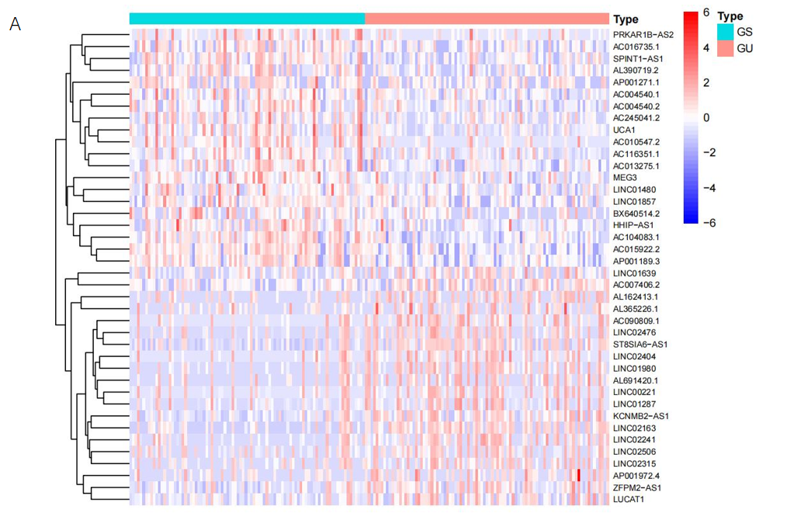
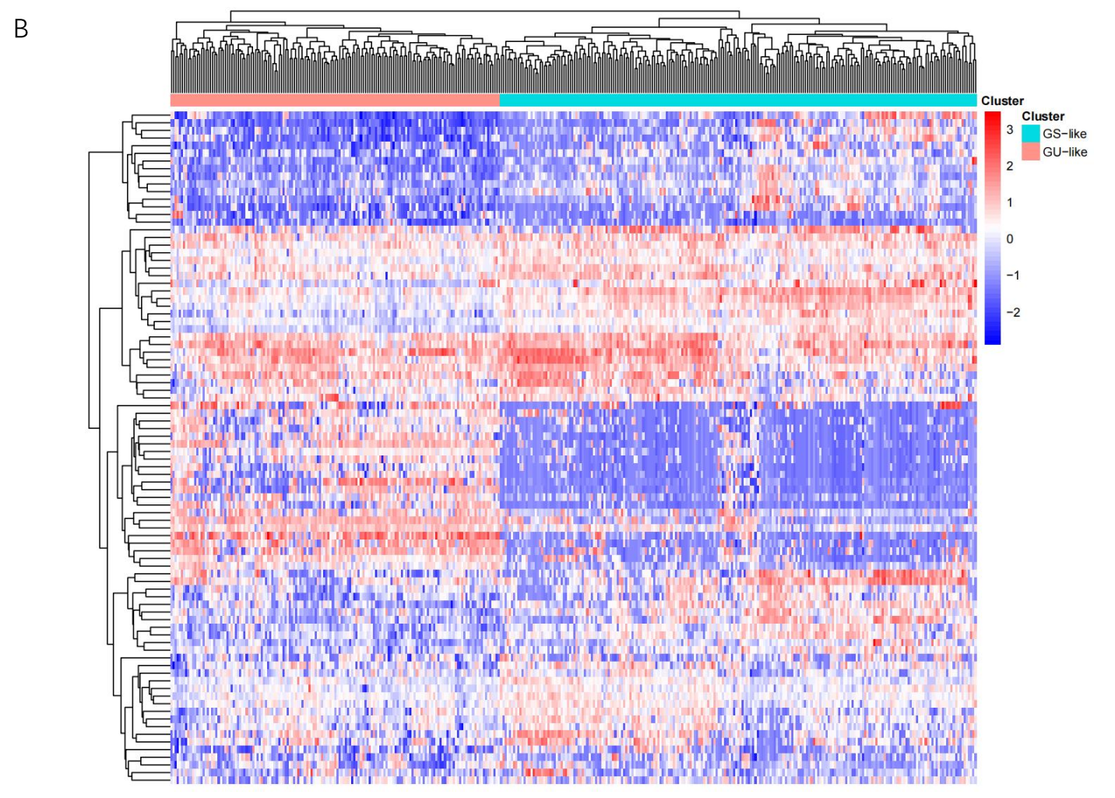
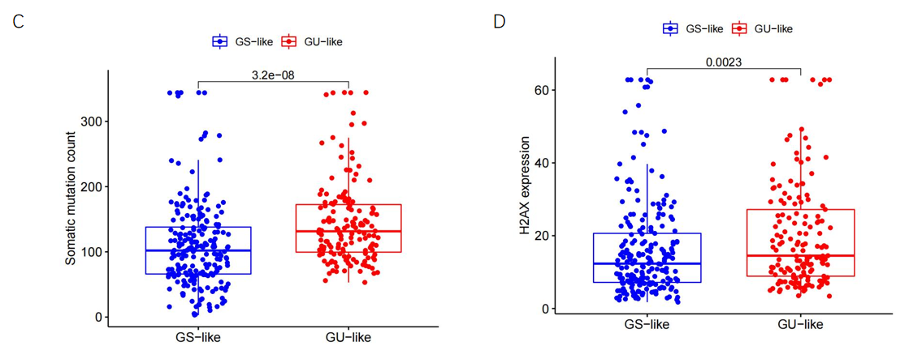
Figure 1 Identification of genomic instability-related long non-coding RNAs in patients with hepatocellular carcinoma. A: The top 20 long non-coding RNAs (LncRNAs) significantly expressed between the genomically unstable (GU) and genomically stable (GS) groups; B: Unsupervised hierarchical clustering analysis was conducted on 374 tumor samples in the TCGA set using 88 differentially expressed LncRNAs. The left orange cluster is the GU-like group, and the right blue cluster is the GS-like group; C: Boxplots of somatic mutations between the GU-like group and GS-like group; D: Boxplots of H2AX expression level in the GU-like group and GS-like group. The expression level of H2AX in the GU-like group is significantly higher than that in the GS-like group. GU: Genomically unstable; GS: Genomically stable.
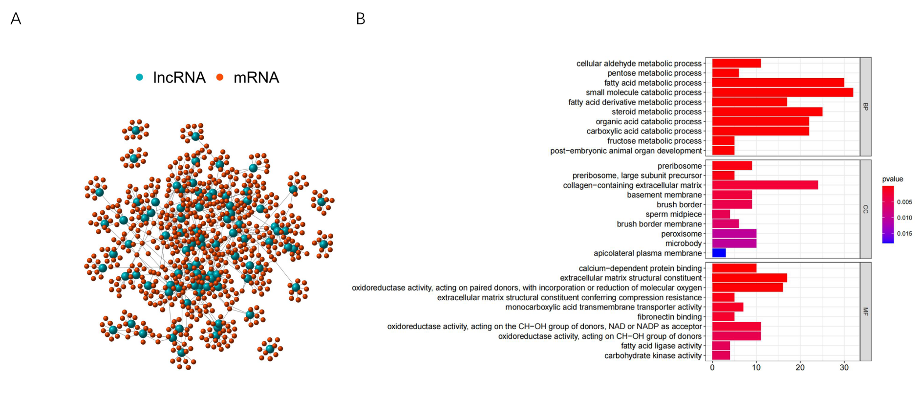
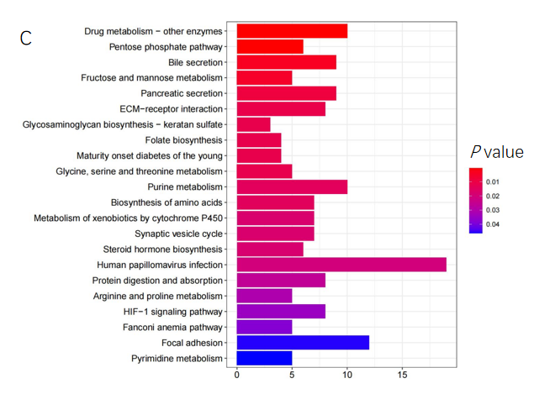
Figure 2 Functional analysis of the genomic instability-related long non-coding RNAs. A: Co-expression network of genomic instability-related long non-coding RNAs (LncRNAs) and mRNAs. The red circles represent mRNAs, and the blue circles represent LncRNAs; B and C: Functional enrichment analysis of Gene Ontology terms and Kyoto Encyclopedia of Genes and Genomes for mRNAs co-expressed with LncRNAs.
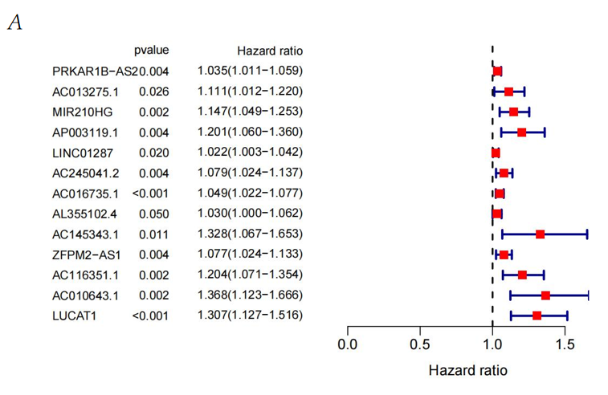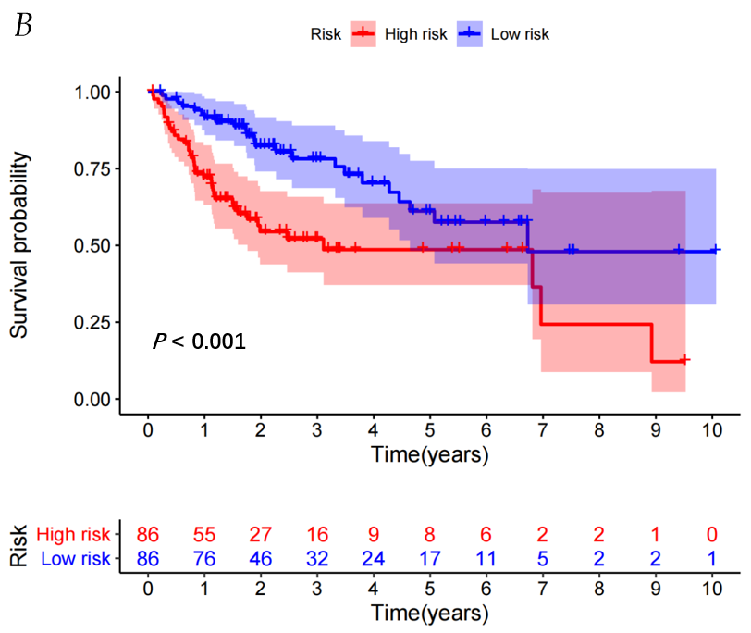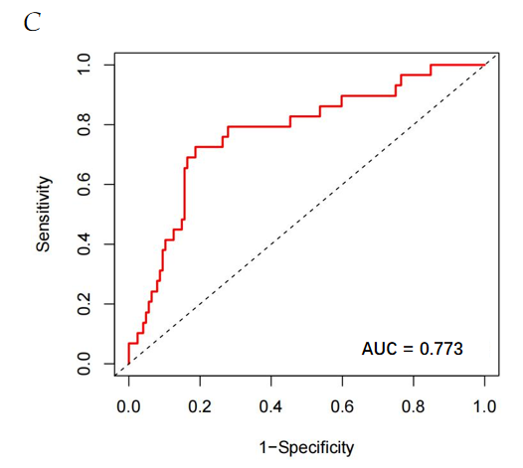
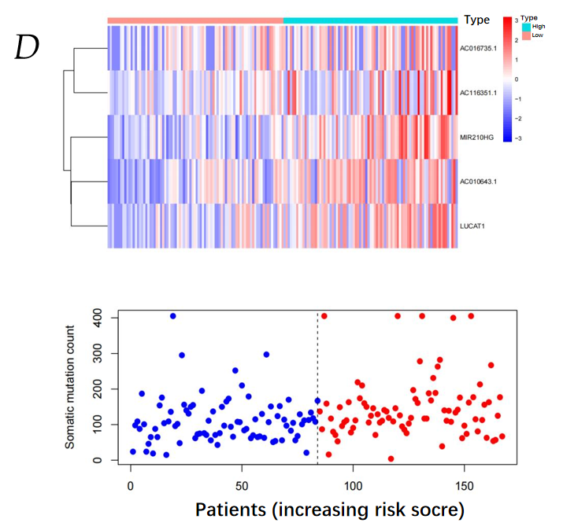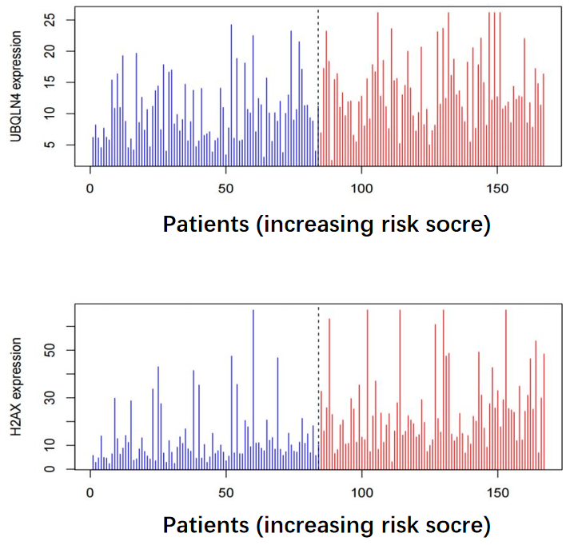
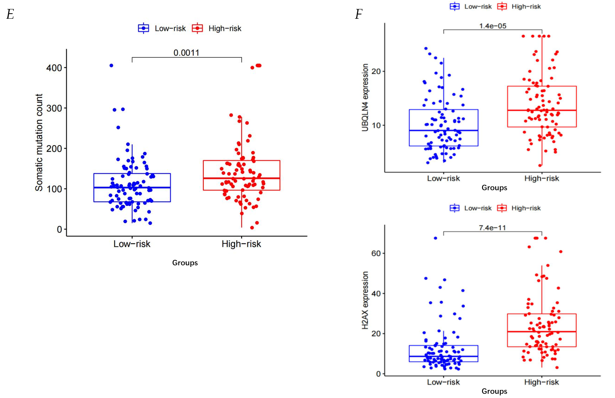
Figure 3 Identification of the genomic instability-derived long non-coding RNAs signature in the training set. A: Forest plot: The P value, risk coefficient (HR) of 13 genomic instability (GI)-long non-coding RNAs (LncRNAs) in the training set analyzed by univariate Cox regression were significantly associated with hepatocellular carcinoma prognosis; B: Kaplan–Meier analysis of OS in patients with low or high risk according to the GI-derived LncRNAs signature (GILncSig) score in the training set; C: Time-dependent receiver operating characteristic curves analysis of the GILncSig; D: The LncRNA expression patterns, distribution of somatic mutations, UBQLN4 and H2AX expression with increasing GILncSig score; E: Somatic mutations count in the high-risk and low-risk groups for the training set patients. Red represents the high-risk group, and blue represents the low-risk group; F: The boxplots of UBQLN4 expression and H2AX expression between the high-risk and low-risk groups in the training group.
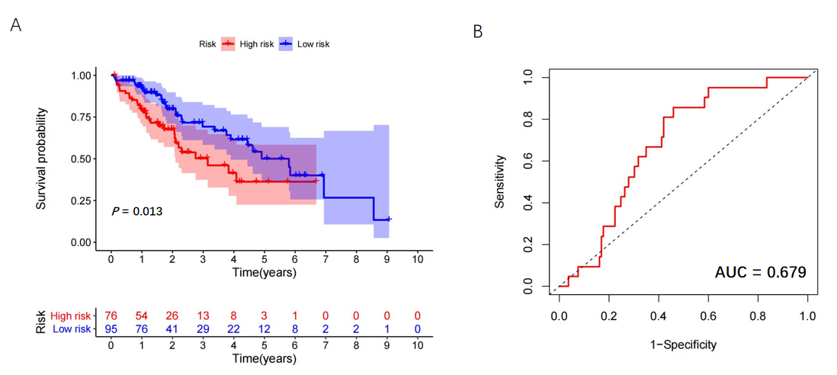
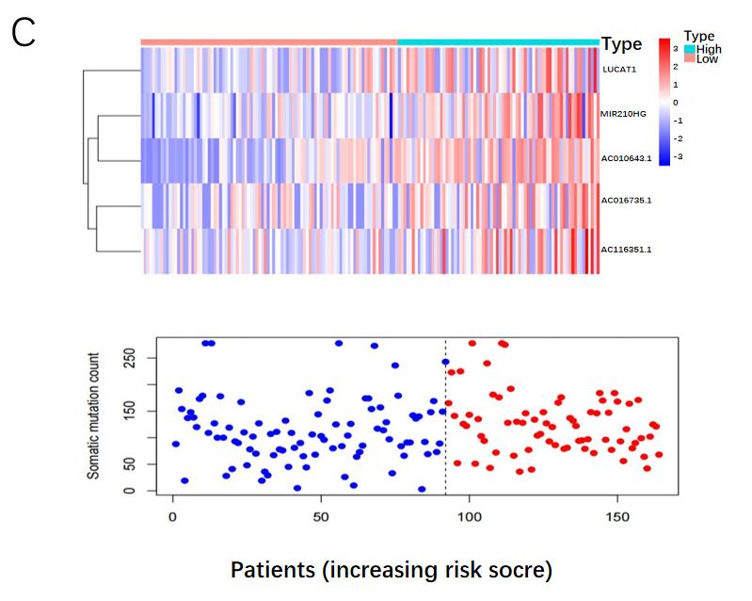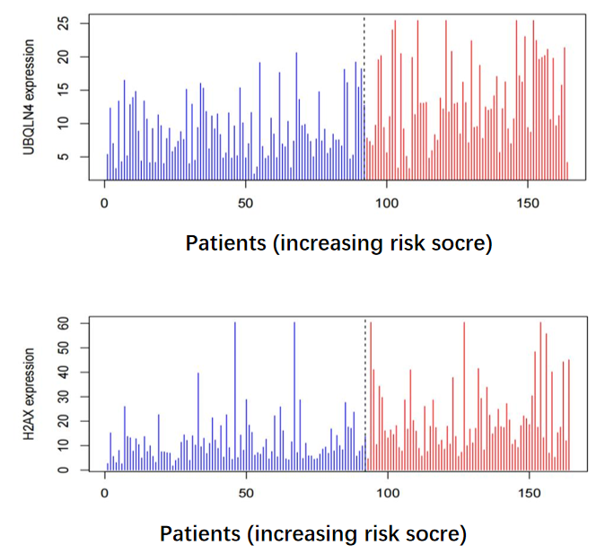
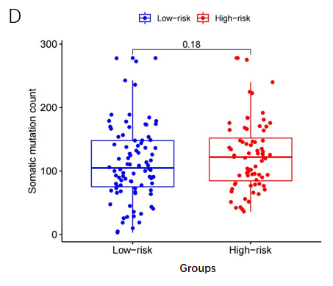
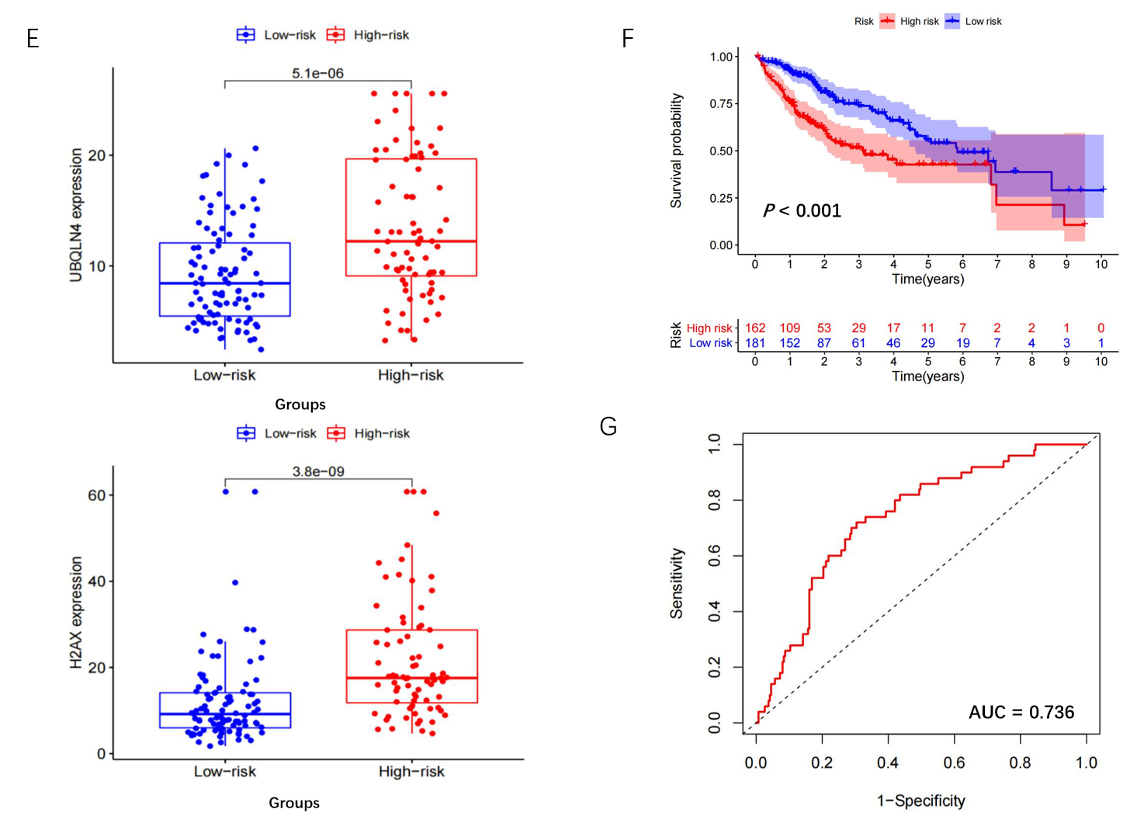
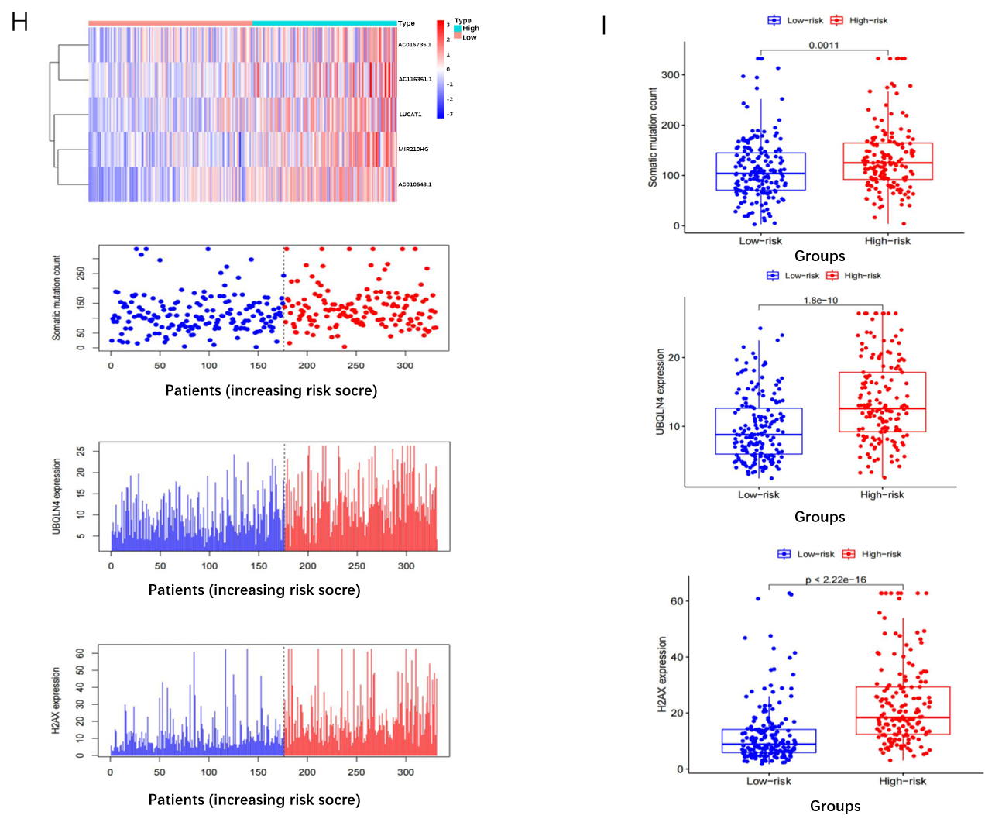
Figure 4 The genomic instability-derived long non-coding RNAs signature was verified in the testing set and TCGA set. A: Kaplan–Meier survival analysis of the high-risk and low-risk groups in the testing set; B: Time-dependent receiver operating characteristic (ROC) curves analysis of the genomic instability-derived long non-coding RNAs signature (GILncSig) in the testing set; C: Long non-coding RNAs (LncRNAs) expression patterns, distribution of somatic mutations, UBQLN4 and H2AX expression with increasing GILncSig score in the testing set; D: The boxplots of the distribution of somatic mutations between the high-risk and low-risk groups in the testing group; E: The boxplots of the UBQLN4 expression and the H2AX expression between the high-risk and low-risk groups in the testing group; F: Kaplan–Meier survival analysis of high-risk and low-risk groups in the TCGA set; G: Time-dependent ROC curves analysis of the GILncSig in the TCGA set; H: LncRNA expression patterns, distribution of somatic mutations, UBQLN4 and H2AX expression with increasing GILncSig score in the TCGA set; I: The boxplots of the distribution of somatic mutations, and the expression of UBQLN4, H2AX between the high-risk and low-risk groups in the TCGA group.
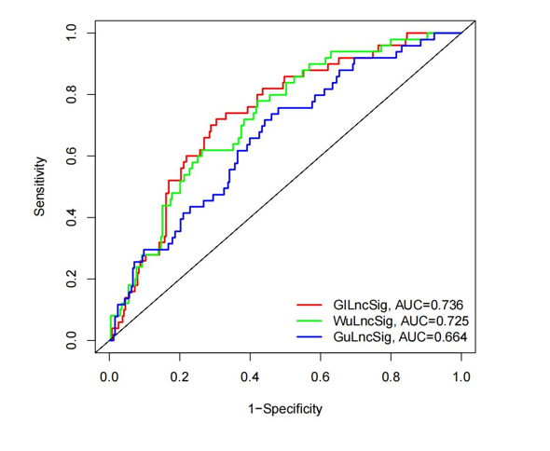
Figure 5 Receiver operating characteristic analysis was used to evaluate the performance of the genomic instability-derived long non-coding RNAs signature, genomically unstable-derived long non-coding RNAs signature, and WuLncSig. The area under the curve of overall survival for the genomic instability-derived long non-coding RNAs (LncRNAs) signature, genomically unstable-derived LncRNAs signature and WulncSig was 0.736, 0.664 and 0.725, respectively. GILncSig: Genomic instability-derived long non-coding RNAs signature; GuLncSig: Genomically unstable-derived long non-coding RNAs signature; WuLncSig: LncRNA signature derived from Wu’s study; AUC: Area under the curve.
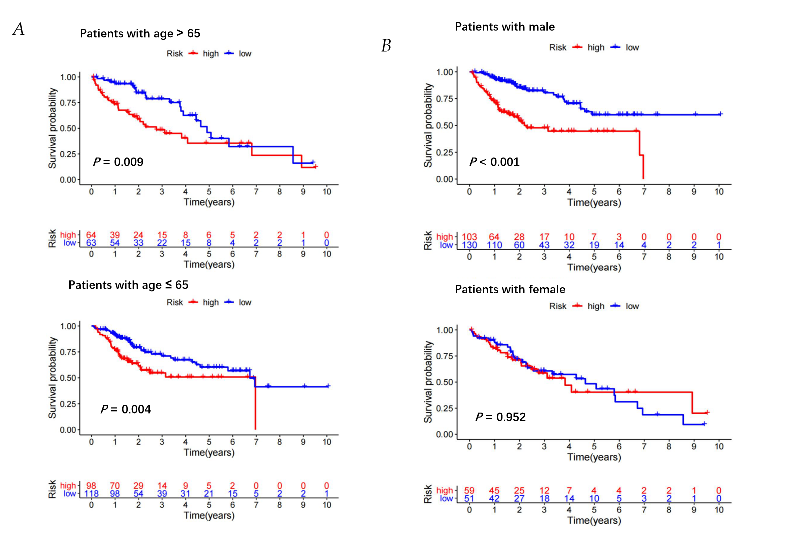
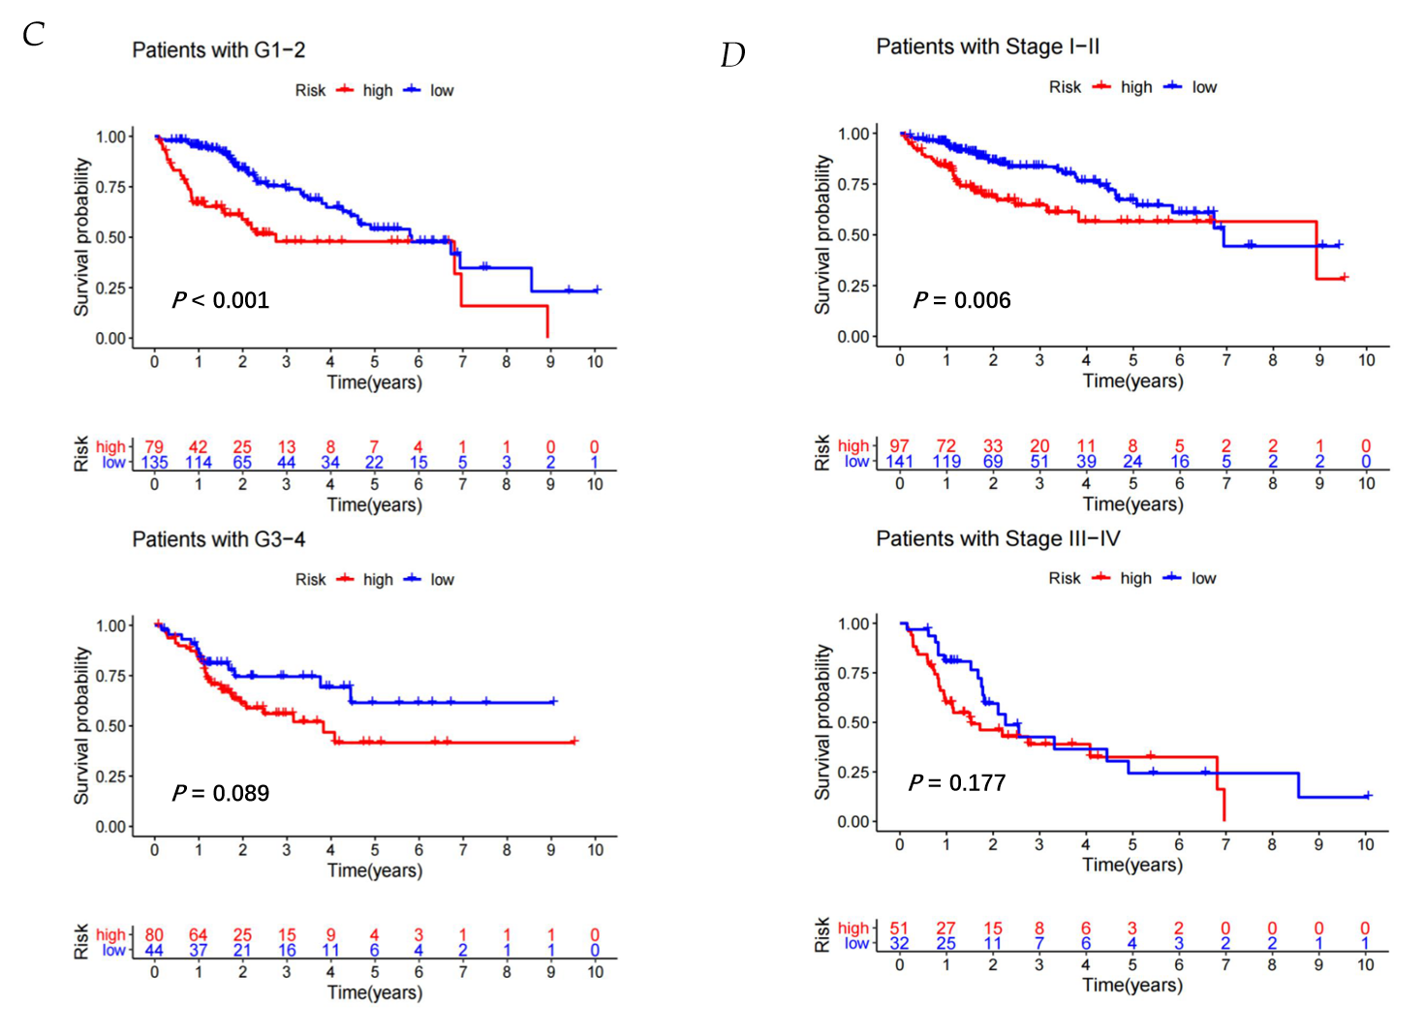
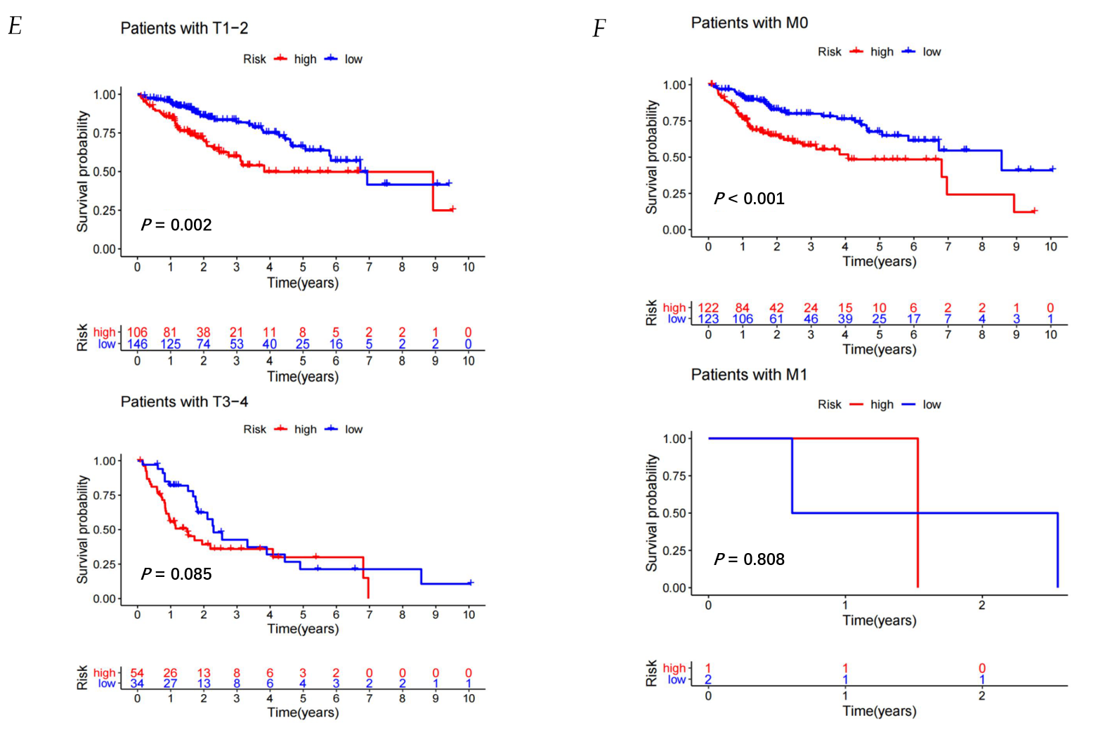
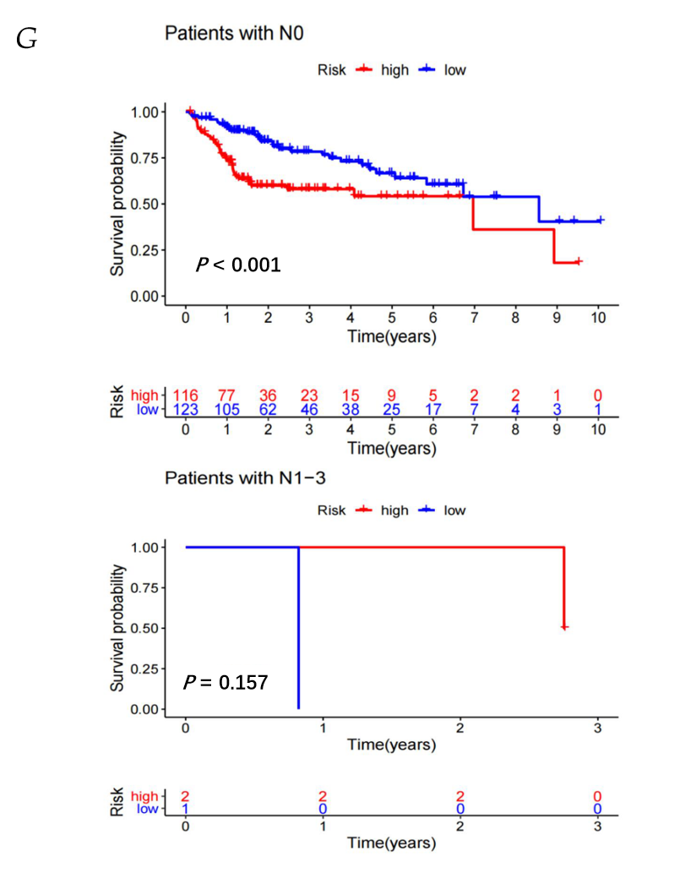
Figure 6 Kaplan–Meier survival analyses of patients with different clinical characteristics. Kaplan–Meier curve analysis of overall survival in the high-risk and low-risk groups. A: Age older than 65 years and age younger than or equal to 65 years; B: Male and female; C: Grade 1-2 and Grade 3-4; D: Stage I-II and stage III-IV; E: T1-2 and T3-4; F: M0 and M1; G: N0 and N1-3.
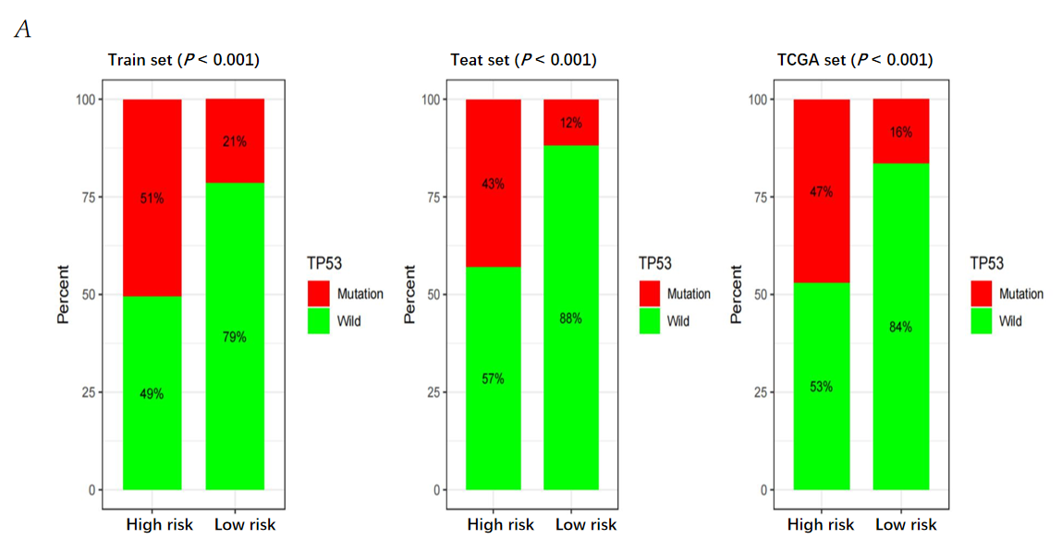
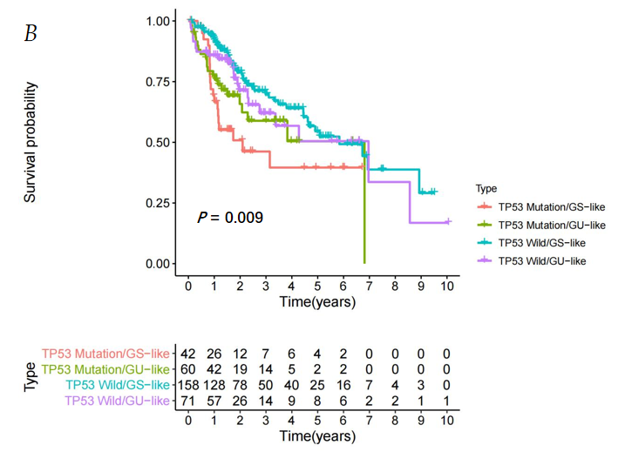
Figure 7 Comparison of the genomic instability-derived long non-coding RNA signature with TP53 mutation status for prognosis. A: The proportion of TP53 mutation in the high- and low-risk groups in the training set, testing set and the TCGA set; B: Kaplan-Meier curve analysis of overall survival based on TP53 mutation status and genomic instability-derived long non-coding RNA signature classification. GU: Genomically unstable; GS: Genomically stable.

Table 1 Univariate and multivariate Cox regression analysis were performed for the risk score models which were based on the genomic instability-derived long non-coding RNAs signature and the overall survival of each patient group
Variables | Univariate model |  |  |  | Multivariate model
 | HR | HR.95L | HR.95H | P value | HR | HR.95L | HR.95H | P value
Training set (n = 172)
Age | 1.006525828 | 0.98572802 | 1.02776245 | 0.541469061
Gender | 0.807010011 | 0.462541245 | 1.40801532 | 0.450226707
Grade | 1.042610761 | 0.723413296 | 1.50265029 | 0.822943265
Stage | 1.761758723 | 1.309037988 | 2.37104945 | 0.000186258 | 1.659300183 | 1.22204964 | 2.252999 | 0.001175
GILncSig (risk score) | 1.188529556 | 1.113059499 | 1.26911679 | 2.47E-07 | 1.162772947 | 1.0877837 | 1.242932 | 9.26E-06
Testing set (n = 171)
Age | 1.004801347 | 0.984472975 | 1.02554948 | 0.646002639
Gender | 0.698036023 | 0.401683709 | 1.21302975 | 0.202306355
Grade | 1.239812446 | 0.8513541 | 1.80551771 | 0.262350748
Stage | 1.847252215 | 1.362695682 | 2.50411063 | 7.70E-05
GILncSig (risk score) | 1.006092566 | 0.964257819 | 1.04974233 | 0.779239112 | 1.847252215 | 1.36269568 | 2.504111 | 7.70E-05
TCGA set (n = 343)
Age | 1.005264743 | 0.990686911 | 1.02005709 | 0.481098302
Gender | 0.757517136 | 0.513257347 | 1.11802045 | 0.162034315
Grade | 1.121252512 | 0.864806496 | 1.45374393 | 0.387728497
Stage | 1.807719072 | 1.462607075 | 2.23426257 | 4.31E-08
GILncSig (risk score) | 1.026022708 | 0.998101217 | 1.05472529 | 0.068008495 | 1.807719072 | 1.46260708 | 2.234263 | 4.31E-08
GILncSig: Genomic instability-derived long non-coding RNAs signature.

