Name of Journal: World Journal of Gastroenterology
Manuscript NO: 61348
Manuscript Type: META-ANALYSIS

T-tube vs no T-tube for biliary tract reconstruction in adult orthotopic liver transplantation: An updated systematic review and meta-analysis

Zhao JZ et al. T-tube in orthotopic liver transplantation

Jun-Zhou Zhao, Lin-Lan Qiao, Zhao-Qing Du, Jia Zhang, Meng-Zhou Wang, Tao Wang, Wu-Ming Liu, Lin Zhang, Jian Dong, Zheng Wu, Rong-Qian Wu

Jun-Zhou Zhao, Lin-Lan Qiao, Zhao-Qing Du, Jia Zhang, Meng-Zhou Wang, Tao Wang, Wu-Ming Liu, Lin Zhang, Jian Dong, Zheng Wu, Department of Hepatobiliary Surgery, First Affiliated Hospital of Xi’an Jiaotong University, Xi’an 710061, Shaanxi Province, China

Jun-Zhou Zhao, Lin-Lan Qiao, Zhao-Qing Du, Jia Zhang, Rong-Qian Wu, National Local Joint Engineering Research Center for Precision Surgery and Regenerative Medicine, First Affiliated Hospital of Xi’an Jiaotong University, Xi’an 710061, Shaanxi Province, China

Author contributions: All authors contributed to the study; Zhao JZ participated in the search strategy design and performed most statistical analyses and paper writing; Qiao LL, Du ZQ, and Zhang J did a literature search of the databases in parallel, built up selection criteria, and selected the potential studies; Wang MZ and Wang T defined the interventions and outcomes; Liu WM, Zhang L, and Dong J assessed the studies’ quality and figured out the characteristics of the selected studies; Wu Z assisted with the design of the study; Wu RQ designed and supervised the study and revised the manuscript.

Supported by National Natural Science Foundation of China, No. 81770491; and The Innovation Capacity Support Plan of Shaanxi Province, No. 2020TD-040.

Corresponding author: Rong-Qian Wu, MD, PhD, Professor, National Local Joint Engineering Research Center for Precision Surgery and Regenerative Medicine, First Affiliated Hospital of Xi’an Jiaotong University, No. 76 West Yanta Road, Xi’an 710061, Shaanxi Province, China. rwu001@mail.xjtu.edu.cn

Received: December 3, 2020
Revised: December 29, 2020
Accepted: March 18, 2021
Published online: April 14, 2021

Abstract
BACKGROUND
Whether to use a T-tube for biliary anastomosis during orthotopic liver transplantation (OLT) remains a debatable question. Some surgeons chose to use a T-tube because they believed that it reduces the incidence of biliary strictures. Advances in surgical techniques during the last decades have significantly decreased the overall incidence of postoperative biliary complications. Whether using a T-tube during OLT is still associated with the reduced incidence of biliary strictures needs to be re-evaluated.

AIM
To provide an updated systematic review and meta-analysis on using a T-tube during adult OLT.

METHODS
In the electronic databases MEDLINE, PubMed, Scopus, ClinicalTrials.gov, the Cochrane Library, the Cochrane Hepato-Biliary Group Controlled Trails Register, and the Cochrane Central Register of Controlled Trials, we identified 17 studies (eight randomized controlled trials and nine comparative studies) from January 1995 to October 2020. The data of the studies before and after 2010 were separately extracted. We chose the overall biliary complications, bile leaks or fistulas, biliary strictures (anastomotic or non-anastomotic), and cholangitis as outcomes. Odds ratios (ORs) with 95% confidence intervals (CIs) were calculated to describe the results of the outcomes. Furthermore, the test for overall effect (Z) was used to test the difference between OR and 1, where P ≤ 0.05 indicated a significant difference between OR value and 1.

RESULTS
A total of 1053 subjects before 2010 and 1346 subjects after 2010 were included in this meta-analysis. The pooled results showed that using a T-tube reduced the incidence of postoperative biliary strictures in studies before 2010 (P = 0.012, OR = 0.62, 95%CI: 0.42-0.90), while the same benefit was not seen in studies after 2010 (P = 0.60, OR = 0.76, 95%CI: 0.27-2.12). No significant difference in the incidence of overall biliary complications (P = 0.37, OR = 1.41, 95%CI: 0.66-2.98), bile leaks (P = 0.89, OR = 1.04, 95%CI: 0.63-1.70), and cholangitis (P = 0.27, OR = 2.00, 95%CI: 0.59-6.84) was observed between using and not using a T-tube before 2010. However, using a T-tube appeared to increase the incidence of overall biliary complications (P = 0.049, OR = 1.49, 95%CI: 1.00-2.22), bile leaks (P = 0.048, OR = 1.91, 95%CI: 1.01-3.64), and cholangitis (P = 0.02, OR = 7.21, 95%CI: 1.37-38.00) after 2010. A random-effects model was used in biliary strictures (after 2010), overall biliary complications (before 2010), and cholangitis (before 2010) due to their heterogeneity (I² = 62.3%, 85.4%, and 53.6%, respectively). In the sensitivity analysis (only RCTs included), bile leak (P = 0.66) lost the significance after 2010 and a random-effects model was used in overall biliary complications (before 2010), cholangitis (before 2010), bile leaks (after 2010), and biliary strictures (after 2010) because of their heterogeneity (I² = 92.2%, 65.6%, 50.9%, and 80.3%, respectively).

CONCLUSION
In conclusion, the evidence gathered in our updated meta-analysis showed that the studies published in the last decade did not provide enough evidence to support the routine use of T-tube in adults during OLT.

Key Words: Orthotopic liver transplantation; T-tube; Biliary tract reconstruction; Biliary complications; Biliary strictures; Meta-analysis

©The Author(s) 2021. Published by Baishideng Publishing Group Inc. All rights reserved.

Citation: Zhao JZ, Qiao LL, Du ZQ, Zhang J, Wang MZ, Wang T, Liu WM, Zhang L, Dong J, Wu Z, Wu RQ. T-tube vs no T-tube for biliary tract reconstruction in adult orthotopic liver transplantation: An updated systematic review and meta-analysis. World J Gastroenterol 2021; 27(14): 1507-1523
URL: https://www.wjgnet.com/1007-9327/full/v27/i14/1507.htm
DOI: https://dx.doi.org/10.3748/wjg.v27.i14.1507

Core Tip: This is the first meta-analysis that compared the postoperative outcomes with or without a T-tube in biliary reconstruction during orthotopic liver transplantation (OLT) before and after 2010. Before 2010, T-tube was favorable for biliary stricture and had no influence on overall biliary complications, bile leaks, and cholangitis. After 2010, not using a T-tube was good for overall biliary complications and cholangitis; however, using a T-tube was not associated with biliary strictures and showed an unbeneficial trend for bile leaks. Therefore, the studies published in the last decade did not provide enough evidence to support the use of T-tube during adult OLT.
INTRODUCTION
Orthotopic liver transplantation (OLT) is an effective treatment for end-stage liver diseases^{[1,2]}. Although the overall outcome of OLT has improved significantly during the last decades, biliary complications, such as biliary strictures and bile leaks, remain the major causes of morbidity and mortality^{[3]}. Biliary anastomosis was thought to be the Achilles’ heel of liver transplantation^{[4]}.
T-tube has been routinely used for biliary anastomosis during conventional hepatobiliary surgery^{[5,6]}. However, its use in biliary reconstruction during OLT remains controversial. Several randomized controlled trials (RCTs) and comparative studies have been conducted to evaluate the value of using a T-tube in biliary reconstruction during OLT. The results, however, remained inconclusive. Even meta-analyses on this issue have provided different suggestions; Sun et al^{[7]} indicated that T-tube was an excellent tool for biliary tract reconstruction while Sotiropoulos et al^{[8]} suggested that abandonment of T-tube was better.
Some surgeons chose to use a T-tube during OLT because they believed that it reduces the incidence of biliary strictures. Recent advances in surgical techniques have significantly decreased the overall incidence of postoperative biliary complications. Whether using a T-tube during OLT is still associated with the reduced incidence of biliary strictures needs to be re-evaluated. Therefore, we performed this updated systematic review and meta-analysis to compare biliary complications with and without a T-tube during OLT in studies conducted before and after 2010^{[7-27]}. We tried to find the current value of using a T-tube for biliary reconstruction during adult OLT.

MATERIALS AND METHODS
Search strategy and selection criteria
To find relevant studies, the electronic databases MEDLINE, PubMed, Scopus, ClinicalTrials.gov, the Cochrane Library, the Cochrane Hepato-Biliary Group Controlled Trails Register, and the Cochrane Central Register of Controlled Trials were used to retrieve papers in English literature from January 1995 to October 2020. The search terms included “OLT” (or “Liver Grafting” or “Liver Transplantations” or “Liver Transplant” or “Hepatic Transplantations”) and “T-tube” (or “Stents”) and “Biliary Tract Reconstruction” (or “Bile Ducts Reconstruction” or “Bile Duct”). Relevant comparative studies and RCTs on biliary tract reconstruction during OLT were identified. Manual search was still needed to seek further data from the article list.

Inclusion criteria
The inclusion criteria were: (1) Trails including OLT recipients (≥ 18 years); (2) Trials with primary reports of overall biliary complications and at least one biliary complication (bile leaks or fistula, anastomotic or non-anastomotic strictures, and cholangitis); and (3) Trials using choledochocholedochostomy (CCS) to reconstruct the bile duct. RCTs and comparative studies were considered, while news, commentaries, and case reports were excluded. The other exclusion criteria were as follows: (1) Liver recipient age less than 18 years; (2) Retransplantations; (3) Significant donor and recipient duct size mismatch; and (4) Diagnosis of some autoimmune diseases (e.g., primary sclerosing cholangitis).

Data extraction
The data of the studies before and after 2010 were separately extracted. Three authors did a literature search of the above databases in parallel and reached consensus on most items. The differences in opinion were discussed by all authors and came to an agreement finally. The following variables were considered: Authors, year of publication, number of patients, sex, mean age of subjects, and cold ischemia time (CIT) (min). The following outcomes were evaluated: Overall biliary complications, bile leaks or fistulas, biliary strictures (anastomotic or non-anastomotic), and cholangitis.

Intervention and outcome definition
In case that a T-tube was used, a T-tube was inserted into the bile duct after the biliary tract reconstruction of end-to-end or side-to-side CCS. In case that T-tube was not used, there was not any T-tube used in the end-to-end or side-to-side CCS. The main outcomes were defined as bile leaks, biliary strictures, and cholangitis. Bile leaks were suspected in patients with abdominal pain and fever. Biliary strictures were indicated by the biochemical elevations of alkaline phosphatase and total bilirubin levels in patients without allograft rejection or hepatic artery thrombosis^{[28]}. Bile leaks and biliary strictures were diagnosed by percutaneous transhepatic cholangiography, endoscopic retrograde cholangio-pancreatography, and T-tube cholangiogram^{[29]}. In addition, biliary strictures can also be diagnosed by computed tomography and magnetic resonance imaging. Cholangitis was suspected when the infectious symptoms with cholestatic parameters occurred, and the Charcot triad (right upper quadrant pain, jaundice, and fever) was also a characteristic of cholangitis^{[30]}.

Quality assessment
The quality of the studies in the systematic review and meta-analysis was determined using the Jadad composite scale^{[31]}. The following parameters were evaluated: Randomized study, description of randomization, description of withdrawals and dropouts, double-blinded study, and description of double blinding. Each of these was scored as one point. The maximum of points was five. A greater score indicated better quality of selected studies.

Data analysis
This systematic review and meta-analysis were performed with STATA software (StataCorp. 2017. Stata Statistical Software: Release 15. College Station, TX: StataCorp LLC.). Outcomes evaluated were: Overall biliary complications, bile leaks or fistulas, biliary strictures, and cholangitis. Odds ratios (ORs) with 95% confidence intervals (CIs) were calculated to describe the results of dichotomous outcomes. Furthermore, the test for overall effect (Z) was used to test the difference between OR and 1, where P ≤ 0.05 indicated a significant difference between OR value and 1. Statistical heterogeneity was assessed with the statistics I², where P ≤ 0.05 or I² > 50% were considered as having significant heterogeneity^{[32]}. A fixed-effects model was suitable to estimate the cases with homogeneity (I² ≤ 50%) while a random-effects model should be used when significant heterogeneity (I² > 50%) was detected. The Egger test (bias, P) was used to detect the publication bias, where P ≤ 0.05 indicated a significant publication bias^{[33]}. Sensitivity analysis based on ten RCTs was used to test the stability of the results of meta-analysis including all studies.

RESULTS
Characteristics of selected studies
There were 267 studies published between 1995 and 2020, of which 109 were excluded because they did not mention the use of a T-tube during OLT. Fourteen reviews, five case reports, and one letter were also excluded. After the full texts of the potential studies had been retrieved, only 20 studies met the inclusion criteria. A study was excluded because it was the preliminary result of a RCT while the final result of the RCT was already included^{[34]}. Two studies were excluded because of the lack of no reference to patient selection or confounding variables^{[35]} or the use of a T-tube in patients without a T-tube^{[36]}. Finally, eight RCTs and nine comparative studies with 2199 subjects were included in our meta-analysis (Figure 1). Among them, 1053 subjects were from studies conducted before 2010 and 1146 were from studies conducted after 2010. Five RCTs got 3 points on the Jadad scale while three RCTs got only 2 points. The mean Jadad score of RCTs was 2.63 points. Seven comparative studies are retrospective, whereas two comparative studies are prospective. The observation period was at least 3 mo except for one with only 2 mo. In most studies, the T-tube was removed 3 mo after the biliary reconstruction operation, but in one comparative study, the T-tube was removed only 9 wk after operation. One study had selection bias for the use of a T-tube and another study was biased on the intention-to-treat^{[13]}. There were no significant differences in age, CIT, and gender (data not shown). Detailed data and results are summarized in Tables 1 and 2, respectively.

Results of meta-analysis including all studies
The pooled resulted showed that in studies conducted between 1995 and 2010, the use of a T-tube appeared to reduce the incidence of biliary strictures (P = 0.012, OR = 0.62, 95%CI: 0.42-0.90, Figure 2A and Table 3), while for studies conducted after 2010, there was no significant difference between the “with T-tube” group and the “without T-tube” group in the occurrence of biliary strictures (P = 0.60, OR = 0.76, 95%CI: 0.27-2.12, Figure 2B). No significant differences in the incidences of overall biliary complications (P = 0.37, OR = 1.41, 95%CI: 0.66-2.98, Figure 3A), bile leak (P = 0.89, OR = 1.04, 95%CI: 0.63-1.70, Figure 4A), and cholangitis (P = 0.27, OR = 2.00, 95%CI: 0.59-6.84, Figure 5A) were observed between using and not using a T-tube in studies conducted before 2010. However, using a T-tube appeared to increase the incidences of overall biliary complications (P = 0.049, OR = 1.49, 95%CI: 1.00-2.22, Figure 3B), bile leak (P = 0.048, OR = 1.91, 95%CI: 1.01-3.64, Figure 4B), and cholangitis (P = 0.02, OR = 7.21, 95%CI: 1.37-38.00, Figure 5B) in studies conducted after 2010. A random-effects model was used in biliary strictures (in studies after 2010), overall biliary complications (in studies before 2010), and cholangitis (in studies before 2010) due to their heterogeneity (I² = 62.3%, 85.4%, and 53.6%, respectively). Unfortunately, we failed to figure out the source of heterogeneity. Sensitivity analysis failed to reveal the main cause of the heterogeneity. Funnel plots detected a publication bias for bile leaks (Egger: Bias = 2.43, P = 0.003) and for cholangitis (Egger: Bias = 2.97, P = 0.02).

Results of sensitivity analysis including only RCTs
The meta-analysis with only RCTs showed that except for bile leaks which lost the significance in studies after 2010 (P = 0.66), the rest outcomes remained unchanged. Overall biliary complications and cholangitis were not evaluated because only one RCT was available to provide the information and the publication bias tests were not applicable (Table 4). A random-effects model was used in overall biliary complications (in studies before 2010), cholangitis (in studies before 2010), and biliary strictures (in studies after 2010) because of their heterogeneity (I² = 92.2%, 65.6%, 50.9%, and 80.3%, respectively). Funnel plots did not detect any publication bias among the outcomes.

DISCUSSION
Whether to use a T-tube or not during OLT remains a challenging question for today’s transplant surgeons. The advantages of using a T-tube are the real-time monitoring of the color and quantity of bile. Therefore, using a T-tube can get the condition of transplanted liver and an access of the radiographic imaging of the biliary tree^{[10,12,14]}. And the use of a T-tube has been thought to reduce intraductal pressure to protect biliary anastomosis^{[12,37]}. However, the use of a T-tube may also contribute to the development of biliary leaks and cholangitis^{[15,16,25]}. Although, in the period from 1995 to 2010, the data showed that the use of a T-tube could reduce the incidence of biliary strictures, the use of a T-tube had no influence on the occurrence of overall biliary complications, cholangitis, and bile leak. However, in the current updated (from 2010 to 2020) meta-analysis, we documented that the use of a T-tube did not reduce the incidence of biliary strictures and it appeared to increase the development of overall biliary complications and cholangitis and showed an unfavorable trend for bile leaks.
Reduction of the postoperative development of anastomotic or non-anastomotic strictures is considered an inherent trait of using a T-tube during OLT. Indeed, inserting a T-tube is still a useful way to decrease the use of invasive diagnostic techniques like endoscopic retrograde cholangiography^{[26,38]}, when a patient is suspected with bile leaks, just as the past decade data showed. However, unlike most studies, there was no significant difference between the “with T-tube” group and the “without T-tube” group in the occurrence of biliary strictures in the period from 2010 to 2020 in our analysis. Biliary stricture could occur in the non-anastomotic part due to the lack of the blood supply^{[39,40]}. And bile leak, infection, and wound contraction may contribute to anastomotic biliary stricture^{[41-43]}. The inflammatory reaction and fibrosis processes may occur in the biliary tract wall contacting with the T-tube due to the foreign body reaction to a T-tube^{[44,45]}. If a T-tube was placed on the biliary tract for a long time, T-tube will alter the local host defense mechanism to increase the susceptibility to infection which may induce biliary fibrosis^{[46,47]}. Fortunately, the recent advancement in surgical techniques has significantly improved the short-term outcomes after OLT^{[48,49]}.
Bile leaks commonly complicate liver transplantation. They usually occur in the early postoperative period or after the T-tube removal. And bile leaks prolonged the hospital stay, increased the medical costs, and disturbed the postoperative recovery^{[50]}. Some physicians thought that the use of a T-tube plays an important role in development of bile leaks in recipients^{[51]}. In the results of our study, there was no significant difference in the incidence of bile leaks between the “with T-tube” group and the “without T-tube” group in the period from 1995 to 2010. Nevertheless, we found that the use of a T-tube increased the risk of developing bile leaks in biliary reconstruction during OLT in the period from 2010 to 2020. Unfortunately, in the sensitivity analysis, bile leaks lost the significance, which lowered the statistic power of the results. Therefore, at least in part, our data demonstrated that T-tube showed an unbeneficial trend for bile leaks. Previous studies showed that 5% to 15% of patients suffered from bile leaks after T-tube removal^{[52,53]}. And the biliary anastomosis or T-tube exit site was a major source of the bile leakage^{[54,55]}. The delayed formation of a fibrous trajectory to allow safe removal of T-tube may play an important role in the incidence of bile leak^{[56]}. In addition, multiple biliary reconstructions also contributed to the occurrence of the bile leaks and were associated with a poor prognosis of patients^{[57]}.
Cholangitis always seems to be a direct outcome of usage of T-tube in biliary reconstruction during OLT. Our study documented that the development of cholangitis had a significant difference between the “with T-tube” group and the “without T-tube” group in the period from 2010 to 2020. However, in the period from 1995 to 2010, we found that cholangitis did not reach the significance between the two groups. There was a trend that T-tube increased the risk of cholangitis. A T-tube was a bridge between the abdominal cavity and external environment to facilitate entry of bacteria into human body. And the surface of a T-tube is a good platform for bacteria to implant so bacteria could form biofilm which help bacteria proliferate better^{[58,59]}. The biofilm in T-tube plays an important role in occurrence of cholangitis^{[60,61]}. If the T-tube was broken by the patient carelessly, the bile may flow out of the biliary tree to induce bacterial infection. Most patients were immunocompromised because of immunosuppressors after OLT, which made patients vulnerable to bacterial or viral infection. In another words, it is fatal for some patients suffering from infections such as cholangitis. T-tube inserting also increased the risk of long-term biliary inflammation and biliary tract fibrosis^{[47]}.
As for overall biliary complications, there was no significant difference between the two groups in the period from 1995 to 2010. Interestingly, our document showed that the use of a T-tube did play a role in development of all kinds of biliary complications in the period from 2010 to 2020. The modern diagnostic devices and the advanced endoscopic technique revealed many latent complications (small thrombosis, local infections, mild internal hemorrhage, and so on), which were difficult to be detected in the past^{[10,13,14]}.
There may be a potential bias because several outcomes had significant publication bias. Since our meta-analysis contained nonrandomized studies and some comparative studies that had selection bias, both contributed to the article’s limitation. Although we reduced the heterogeneity of the selected studies via using random-effects models, the inherent bias still partially existed. And almost all the comparative studies got just 1 point on the Jadad scale; however, the five RCTs got 3 points on the Jadad scale while three RCTs got 2 points, which indicated that the quality of the selected studies was not very high. In addition, the retrospective design of the comparative studies may introduce recall bias and reporting bias.

CONCLUSION
In conclusion, the data in our study showed that the use of a T-tube is a beneficial factor for biliary strictures before 2010, whereas no benefit was observed for overall biliary complications, biliary leak, and cholangitis in the same period. According to the studies after 2010, not using a T-tube is beneficial in terms of overall biliary complications and cholangitis; however (after sensitivity analysis), the use of a T-tube is not associated with biliary strictures and shows an unbeneficial trend for bile leaks. Therefore, the evidence gathered in our updated meta-analysis showed that the studies published in the last decade did not provide enough evidence to support the routine use of T-tube in adults during OLT.

ARTICLE HIGHLIGHTS
Research background
The use of the T-tube in the reconstruction of the biliary tree during orthotopic liver transplantation (OLT) is still debatable.

Research motivation
Biliary complications after OLT, including bile leaks, cholangitis, and biliary strictures, prolonged the hospital stay, impaired the postoperative recovery, and increased the medical costs. T-tube was involved in the occurrence of these biliary complications. Therefore, it is helpful to identify the role of T-tube in the incidence of the biliary complications.

Research objectives
We performed a meta-analysis to evaluate whether patients benefit from the use of a T-tube during OLT.

Research methods
We calculated odds ratios with 95% confidence intervals to identify the role of a T-tube in the incidence of the overall biliary complications, bile leaks, cholangitis, and biliary strictures.

Research results
We discovered that T-tube had no influence on the risk of the overall biliary complications, bile leaks, and cholangitis and reduced the incidence of biliary strictures in the period from 1995 to 2010. However, in the recent decade (from 2010 to 2020), we found that T-tube did not affect the occurrence of biliary strictures and increased the incidence of overall biliary complications and cholangitis. And the use of a T-tube showed an unbeneficial trend for bile leak after 2010.

Research conclusions
In conclusion, the evidence gathered in our updated meta-analysis showed that the studies published in the last decade did not provide enough evidence to support the routine use of T-tube in adults during OLT.

Research perspectives
More T-tube-related outcomes should be included in the future meta-analysis so the advantages and disadvantages would be evaluated better.

ACKNOWLEDGEMENTS
All the statistical descriptions and data analyses in this study have been reviewed by Zhong-Hai Zhu from Department of Epidemiology and Health Statistics, School of Public Health of Xi’an Jiaotong University and Bo Wang, MD and PhD from Xi’an Jiaotong University.

REFERENCES
1 Sanchez-Urdazpal L, Gores GJ, Ward EM, Maus TP, Buckel EG, Steers JL, Wiesner RH, Krom RA. Diagnostic features and clinical outcome of ischemic-type biliary complications after liver transplantation. Hepatology 1993; 17: 605-609 [PMID: 8477965 DOI: 10.1002/hep.1840170413]
2 Busuttil RW, Shaked A, Millis JM, Jurim O, Colquhoun SD, Shackleton CR, Nuesse BJ, Csete M, Goldstein LI, McDiarmid SV. One thousand liver transplants. The lessons learned. Ann Surg 1994; 219: 490-7; discussion 498-9 [PMID: 8185400 DOI: 10.1097/00000658-199405000-00007]
3 Moy BT, Birk JW. A Review on the Management of Biliary Complications after Orthotopic Liver Transplantation. J Clin Transl Hepatol 2019; 7: 61-71 [PMID: 30944822 DOI: 10.14218/JCTH.2018.00028]
4 Pereira P, Peixoto A. Biliary Complications - The "Achilles Heel" of Orthotopic Liver Transplantation. GE Port J Gastroenterol 2018; 25: 1-3 [PMID: 29457042 DOI: 10.1159/000480489]
5 Jabłonska B. End-to-end ductal anastomosis in biliary reconstruction: indications and limitations. Can J Surg 2014; 57: 271-277 [PMID: 25078933 DOI: 10.1503/cjs.016613]
6 Sankarankutty AK, Mente ED, Cardoso NM, Castro-E-Silva O. T-tube or no T-tube for bile duct anastomosis in orthotopic liver transplantation. Hepatobiliary Surg Nutr 2013; 2: 171-173 [PMID: 24570938 DOI: 10.3978/j.issn.2304-3881.2013.05.04]
7 Sun N, Zhang J, Li X, Zhang C, Zhou X, Zhang C. Biliary tract reconstruction with or without T-tube in orthotopic liver transplantation: a systematic review and meta-analysis. Expert Rev Gastroenterol Hepatol 2015; 9: 529-538 [PMID: 25583036 DOI: 10.1586/17474124.2015.1002084]
8 Sotiropoulos GC, Sgourakis G, Radtke A, Molmenti EP, Goumas K, Mylona S, Fouzas I, Karaliotas C, Lang H. Orthotopic liver transplantation: T-tube or not T-tube? Systematic review and meta-analysis of results. Transplantation 2009; 87: 1672-1680 [PMID: 19502959 DOI: 10.1097/TP.0b013e3181a5cf3f]
9 Randall HB, Wachs ME, Somberg KA, Lake JR, Emond JC, Ascher NL, Roberts JP. The use of the T tube after orthotopic liver transplantation. Transplantation 1996; 61: 258-261 [PMID: 8600634]
10 Vougas V, Rela M, Gane E, Muiesan P, Melendez HV, Williams R, Heaton ND. A prospective randomised trial of bile duct reconstruction at liver transplantation: T tube or no T tube? Transpl Int 1996; 9: 392-395 [PMID: 8819276]
11 Nuño J, Vicente E, Turrión VS, Pereira F, Ardaiz J, Cuervas V, Bárcena R, García M, San Roman AL, Candela A, Honrubia A, Moreno A. Biliary tract reconstruction after liver transplantation: with or without T-tube? Transplant Proc 1997; 29: 564-565 [PMID: 9123131]
12 Rabkin JM, Orloff SL, Reed MH, Wheeler LJ, Corless CL, Benner KG, Flora KD, Rosen HR, Olyaei AJ. Biliary tract complications of side-to-side without T tube versus end-to-end with or without T tube choledochocholedochostomy in liver transplant recipients. Transplantation 1998; 65: 193-199 [PMID: 9458013 DOI: 10.1097/00007890-199801270-00008]
13 Shimoda M, Saab S, Morrisey M, Ghobrial RM, Farmer DG, Chen P, Han SH, Bedford RA, Goldstein LI, Martin P, Busuttil RW. A cost-effectiveness analysis of biliary anastomosis with or without T-tube after orthotopic liver transplantation. Am J Transplant 2001; 1: 157-161 [PMID: 12099364]
14 Scatton O, Meunier B, Cherqui D, Boillot O, Sauvanet A, Boudjema K, Launois B, Fagniez PL, Belghiti J, Wolff P, Houssin D, Soubrane O. Randomized trial of choledochocholedochostomy with or without a T tube in orthotopic liver transplantation. Ann Surg 2001; 233: 432-437 [PMID: 11224633 DOI: 10.1097/00000658-200103000-00019]
15 Elola-Olaso AM, Diaz JC, Gonzalez EM, García Garcia I, Domene PO, Olivares S, Sanz RG, Suarez YF, Calvo J. Preliminary study of choledochocholedochostomy without T tube in liver transplantation: a comparative study. Transplant Proc 2005; 37: 3922-3923 [PMID: 16386585 DOI: 10.1016/j.transproceed.2005.10.047]
16 Amador A, Charco R, Marti J, Alvarez G, Ferrer J, Mans E, Fuster J, Fondevila C, Garcia-Valdecasas JC. Cost/efficacy clinical trial about the use of T-tube in cadaveric donor liver transplant: preliminary results. Transplant Proc 2005; 37: 1129-1130 [PMID: 15848645 DOI: 10.1016/j.transproceed.2005.01.015]
17 Lin CH, Yu JC, Chen TW, Chuang CH, Tsai YC, Chen SY, Hsieh CB. The experience of biliary tract complications after liver transplantation. Transplant Proc 2007; 39: 3251-3256 [PMID: 18089365 DOI: 10.1016/j.transproceed.2007.06.079]
18 Li T, Chen ZS, Zeng FJ, Ming CS, Zhang WJ, Liu DG, Jiang JP, Du DF, Klaus Chen ZH. Impact of early biliary complications in liver transplantation in the presence or absence of a T-tube: a Chinese transplant centre experience. Postgrad Med J 2007; 83: 120-123 [PMID: 17308216 DOI: 10.1136/pgmj.2006.049171]
19 Weiss S, Schmidt SC, Ulrich F, Pascher A, Schumacher G, Stockmann M, Puhl G, Guckelberger O, Neumann UP, Pratschke J, Neuhaus P. Biliary reconstruction using a side-to-side choledochocholedochostomy with or without T-tube in deceased donor liver transplantation: a prospective randomized trial. Ann Surg 2009; 250: 766-771 [PMID: 19809299 DOI: 10.1097/SLA.0b013e3181bd920a]
20 López-Andújar R, Orón EM, Carregnato AF, Suárez FV, Herraiz AM, Rodríguez FS, Carbó JJ, Ibars EP, Sos JE, Suárez AR, Castillo MP, Pallardó JM, De Juan Burgueño M. T-tube or no T-tube in cadaveric orthotopic liver transplantation: the eternal dilemma: results of a prospective and randomized clinical trial. Ann Surg 2013; 258: 21-29 [PMID: 23426348 DOI: 10.1097/SLA.0b013e318286e0a0]
21 Anila T, Chaudhary N, Chaudary A. Abstract # P-82 Randomised Clinical Trial of Removable Intraductal Stenting in Duct-To-Duct Biliary Anastomosis in Living Related Liver Transplantation. Transplantation 2015; 99: 157 [DOI: 10.1097/01.tp.0000469973.81769.3c]
22 García Bernardo CM, González-Pinto Arrillaga I, Miyar de León A, Cadahia Rodrigo V, González Dieguez L, Barneo Serra L, Vázquez Velasco L. T-tube Systematic Use in the Biliary Anastomosis: Comparison of Two Consecutive Series of Liver Transplantation. Transplant Proc 2016; 48: 3003-3005 [PMID: 27932131 DOI: 10.1016/j.transproceed.2016.07.048]
23 Santosh Kumar KY, Mathew JS, Balakrishnan D, Bharathan VK, Thankamony Amma BSP, Gopalakrishnan U, Narayana Menon R, Dhar P, Vayoth SO, Sudhindran S. Intraductal Transanastomotic Stenting in Duct-to-Duct Biliary Reconstruction after Living-Donor Liver Transplantation: A Randomized Trial. J Am Coll Surg 2017; 225: 747-754 [PMID: 28916322 DOI: 10.1016/j.jamcollsurg.2017.08.024]
24 Ong M, Slater K, Hodgkinson P, Dunn N, Fawcett J. To stent or not to stent: the use of transanastomotic biliary stents in liver transplantation and patient outcomes. ANZ J Surg 2018; 88: 603-606 [PMID: 29667284 DOI: 10.1111/ans.14383]
25 López-Andújar R, Maupoey J, Escrig J, Granero P, Vila JJ, Ibáñez V, Boscá A, García-Eliz M, Benlloch S, Orbis JF, Montalvá EM. Selective Indication of T-Tube in Liver Transplantation: Prospective Validation of the Results of a Randomized Controlled Trial. Transplant Proc 2019; 51: 44-49 [PMID: 30736977 DOI: 10.1016/j.transproceed.2018.03.133]
26 Riediger C, Müller MW, Michalski CW, Hüser N, Schuster T, Kleeff J, Friess H. T-Tube or no T-tube in the reconstruction of the biliary tract during orthotopic liver transplantation: systematic review and meta-analysis. Liver Transpl 2010; 16: 705-717 [PMID: 20517904 DOI: 10.1002/lt.22070]
27 Huang WD, Jiang JK, Lu YQ. Value of T-tube in biliary tract reconstruction during orthotopic liver transplantation: a meta-analysis. J Zhejiang Univ Sci B 2011; 12: 357-364 [PMID: 21528489 DOI: 10.1631/jzus.B1100054]
28 Naik P, Sritharan V, Bandi P, Madhavarapu M. A single centre prospective study of liver function tests in post liver transplant patients. Indian J Clin Biochem 2013; 28: 38-45 [PMID: 24381419 DOI: 10.1007/s12291-012-0245-4]
29 Thuluvath PJ, Atassi T, Lee J. An endoscopic approach to biliary complications following orthotopic liver transplantation. Liver Int 2003; 23: 156-162 [PMID: 12955878 DOI: 10.1034/j.1600-0676.2003.00823.x]
30 Zimmer V, Lammert F. Acute Bacterial Cholangitis. Viszeralmedizin 2015; 31: 166-172 [PMID: 26468310 DOI: 10.1159/000430965]
31 Jadad AR, Moore RA, Carroll D, Jenkinson C, Reynolds DJ, Gavaghan DJ, McQuay HJ. Assessing the quality of reports of randomized clinical trials: is blinding necessary? Control Clin Trials 1996; 17: 1-12 [PMID: 8721797 DOI: 10.1016/0197-2456(95)00134-4]
32 Higgins JP, Thompson SG, Deeks JJ, Altman DG. Measuring inconsistency in meta-analyses. BMJ 2003; 327: 557-560 [PMID: 12958120 DOI: 10.1136/bmj.327.7414.557]
33 Egger M, Davey Smith G, Schneider M, Minder C. Bias in meta-analysis detected by a simple, graphical test. BMJ 1997; 315: 629-634 [PMID: 9310563 DOI: 10.1136/bmj.315.7109.629]
34 López-Andújar R, Montalva E, Frangi A, Vergara F, San Juan F, De Juan M, Moya A, Jose Vila J, Pareja E, Berenguer M. T-tube or not T-tube in deceased donor liver transplantation. Preliminary results of a prospective randomized trial. Joint International Congress of ILTS, ELITA, and LICAGE 2011; USA. MA: Liver Transplantation, 2011: S103-S103.
35 Jeffrey GP, Brind AM, Ormonde DG, Frazer CK, Ferguson J, Bell R, Kierath A, Reed WD, House AK. Management of biliary tract complications following liver transplantation. Aust N Z J Surg 1999; 69: 717-722 [PMID: 10527348 DOI: 10.1046/j.1440-1622.1999.01671.x]
36 Kusano T, Randall HB, Roberts JP, Ascher NL. The use of stents for duct-to-duct anastomoses of biliary reconstruction in orthotopic liver transplantation. Hepatogastroenterology 2005; 52: 695-699 [PMID: 15966185]
37 Neuhaus P, Blumhardt G, Bechstein WO, Steffen R, Platz KP, Keck H. Technique and results of biliary reconstruction using side-to-side choledochocholedochostomy in 300 orthotopic liver transplants. Ann Surg 1994; 219: 426-434 [PMID: 8161269 DOI: 10.1097/00000658-199404000-00014]
38 Jacobs LK, Shayani V, Sackier JM. Common bile duct T-tubes. A caveat and recommendations for management. Surg Endosc 1998; 12: 60-62 [PMID: 9419307 DOI: 10.1007/s004649900595]
39 Zajko AB, Campbell WL, Logsdon GA, Bron KM, Tzakis A, Esquivel CO, Starzl TE. Cholangiographic findings in hepatic artery occlusion after liver transplantation. AJR Am J Roentgenol 1987; 149: 485-489 [PMID: 3303874 DOI: 10.2214/ajr.149.3.485]
40 Buis CI, Hoekstra H, Verdonk RC, Porte RJ. Causes and consequences of ischemic-type biliary lesions after liver transplantation. J Hepatobiliary Pancreat Surg 2006; 13: 517-524 [PMID: 17139425 DOI: 10.1007/s00534-005-1080-2]
41 Maingot R. Postoperative strictures of the bile ducts--causes, prevention, repair procedures. Br J Clin Pract 1977; 31: 117-126 [PMID: 588410]
42 Rozga J, Ahrén B, Andersson R, Emody L, Wadström T, Bengmark S. Effect of biliary infection on common bile duct healing in the rat. Br J Surg 1991; 78: 1329-1331 [PMID: 1760696 DOI: 10.1002/bjs.1800781120]
43 Casey WJ, Peacock EE Jr. Some factors affecting pathophysiology of bile duct stenosis. Surg Forum 1977; 28: 414-416 [PMID: 617486]
44 Pinzani M, Luong TV. Pathogenesis of biliary fibrosis. Biochim Biophys Acta Mol Basis Dis 2018; 1864: 1279-1283 [PMID: 28754450 DOI: 10.1016/j.bbadis.2017.07.026]
45 Koivusalo A, Makisalo H, Talja M, Cormio L, Ruutu M, Wolff H, Hockerstedt K. Biocompatibility of latex and silicone T tubes in the porcine common bile duct: an experimental study. Res Exp Med (Berl) 1996; 196: 53-66 [PMID: 8833487 DOI: 10.1007/BF02576828]
46 Yu JL, Andersson R, Wang LQ, Ljungh A, Bengmark S. Experimental foreign-body infection in the biliary tract in rats. Scand J Gastroenterol 1995; 30: 478-483 [PMID: 7638576 DOI: 10.3109/00365529509093311]
47 Wang L, Dong P, Zhang Y, Liu X, Tian B. Iatrogenic bile duct Injury with a retained T-tube in common bile duct for 10 years: A case report. Medicine (Baltimore) 2019; 98: e15127 [PMID: 30985676 DOI: 10.1097/MD.0000000000015127]
48 Yoshizumi T, Harada N, Mori M. Biliary Stricture: The Achilles Heel of Pediatric Living Donor Liver Transplantation. Transplantation 2019; 103: 1758-1759 [PMID: 30747842 DOI: 10.1097/TP.0000000000002573]
49 Marubashi S, Dono K, Nagano H, Kobayashi S, Takeda Y, Umeshita K, Monden M, Doki Y, Mori M. Biliary reconstruction in living donor liver transplantation: technical invention and risk factor analysis for anastomotic stricture. Transplantation 2009; 88: 1123-1130 [PMID: 19898209 DOI: 10.1097/TP.0b013e3181ba184a]
50 Fang C, Yan S, Zheng S. Bile Leakage after Liver Transplantation. Open Med (Wars) 2017; 12: 424-429 [PMID: 29318188 DOI: 10.1515/med-2017-0062]
51 Gastaca M, Matarranz A, Muñoz F, Valdivieso A, Aguinaga A, Testillano M, Bustamante J, Terreros I, Suarez MJ, Montejo M, Ortiz de Urbina J. Biliary complications in orthotopic liver transplantation using choledochocholedochostomy with a T-tube. Transplant Proc 2012; 44: 1554-1556 [PMID: 22841211 DOI: 10.1016/j.transproceed.2012.05.025]
52 Sheng R, Sammon JK, Zajko AB, Campbell WL. Bile leak after hepatic transplantation: cholangiographic features, prevalence, and clinical outcome. Radiology 1994; 192: 413-416 [PMID: 8029406 DOI: 10.1148/radiology.192.2.8029406]
53 Grande L, Pérez-Castilla A, Matus D, Rodriguez-Montalvo C, Rimola A, Navasa M, García-Valdecasas JC, Visa J. Routine use of the T tube in the biliary reconstruction of liver transplantation: is it worthwhile? Transplant Proc 1999; 31: 2396-2397 [PMID: 10500637 DOI: 10.1016/s0041-1345(99)00398-x]
54 Lerut J, Gordon RD, Iwatsuki S, Esquivel CO, Todo S, Tzakis A, Starzl TE. Biliary tract complications in human orthotopic liver transplantation. Transplantation 1987; 43: 47-51 [PMID: 3541321 DOI: 10.1097/00007890-198701000-00011]
55 Ostroff JW, Roberts JP, Gordon RL, Ring EJ, Ascher NL. The management of T tube leaks in orthotopic liver transplant recipients with endoscopically placed nasobiliary catheters. Transplantation 1990; 49: 922-924 [PMID: 2336710 DOI: 10.1097/00007890-199005000-00018]
56 Ben-Ari Z, Neville L, Davidson B, Rolles K, Burroughs AK. Infection rates with and without T-tube splintage of common bile duct anastomosis in liver transplantation. Transpl Int 1998; 11: 123-126 [PMID: 9561678 DOI: 10.1007/s001470050115]
57 Gondolesi GE, Varotti G, Florman SS, Muñoz L, Fishbein TM, Emre SH, Schwartz ME, Miller C. Biliary complications in 96 consecutive right lobe living donor transplant recipients. Transplantation 2004; 77: 1842-1848 [PMID: 15223901 DOI: 10.1097/01.tp.0000123077.78702.0c]
58 Koivusalo A, Mäkisalo H, Talja M, Siitonen A, Vuopio-Varkila J, Ruutu M, Höckerstedt K. Bacterial adherence and biofilm formation on latex and silicone T-tubes in relation to bacterial contamination of bile. Scand J Gastroenterol 1996; 31: 398-403 [PMID: 8726310 DOI: 10.3109/00365529609006417]
59 Gillatt DA, May RE, Kennedy R, Longstaff AJ. Complications of T-tube drainage of the common bile duct. Ann R Coll Surg Engl 1985; 67: 370-371 [PMID: 4073767]
60 Jirapinyo P, AlSamman MA, Thompson CC. Impact of infected stent removal on recurrent cholangitis with time-to-event analysis. Surg Endosc 2019; 33: 4109-4115 [PMID: 30927127 DOI: 10.1007/s00464-019-06714-0]
61 Gigot JF, Leese T, Dereme T, Coutinho J, Castaing D, Bismuth H. Acute cholangitis. Multivariate analysis of risk factors. Ann Surg 1989; 209: 435-438 [PMID: 2930289 DOI: 10.1097/00000658-198904000-00008]

Footnotes
Conflict-of-interest statement: All authors declare no conflicts of interest related to this article.

PRISMA 2009 Checklist statement: The authors have read the PRISMA 2009 Checklist and finished the manuscripts according to the PRISMA 2009 Checklist.

Open-Access: This article is an open-access article that was selected by an in-house editor and fully peer-reviewed by external reviewers. It is distributed in accordance with the Creative Commons Attribution NonCommercial (CC BY-NC 4.0) license, which permits others to distribute, remix, adapt, build upon this work non-commercially, and license their derivative works on different terms, provided the original work is properly cited and the use is non-commercial. See: http://creativecommons.org/Licenses/by-nc/4.0/

Manuscript source: Unsolicited manuscript

Peer-review started: December 3, 2020
First decision: December 21, 2020
Article in press: March 18, 2021

Specialty type: Gastroenterology and hepatology
Country/Territory of origin: China
Peer-review report’s scientific quality classification
Grade A (Excellent): 0
Grade B (Very good): B, B
Grade C (Good): C, C, C
Grade D (Fair): 0
Grade E (Poor): 0

P-Reviewer: Ferrarese A, Nah YW, Padilla PM S-Editor: Fan JR L-Editor: Wang TQ P-Editor: Li JH
Figure Legends
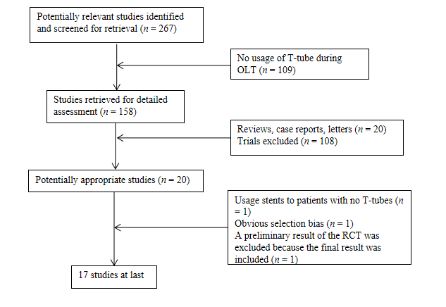
Figure 1 Flowchart of selection process of randomized control trials and comparative studies. RCT: Randomized control trials; OLT: Orthotopic liver transplantation.
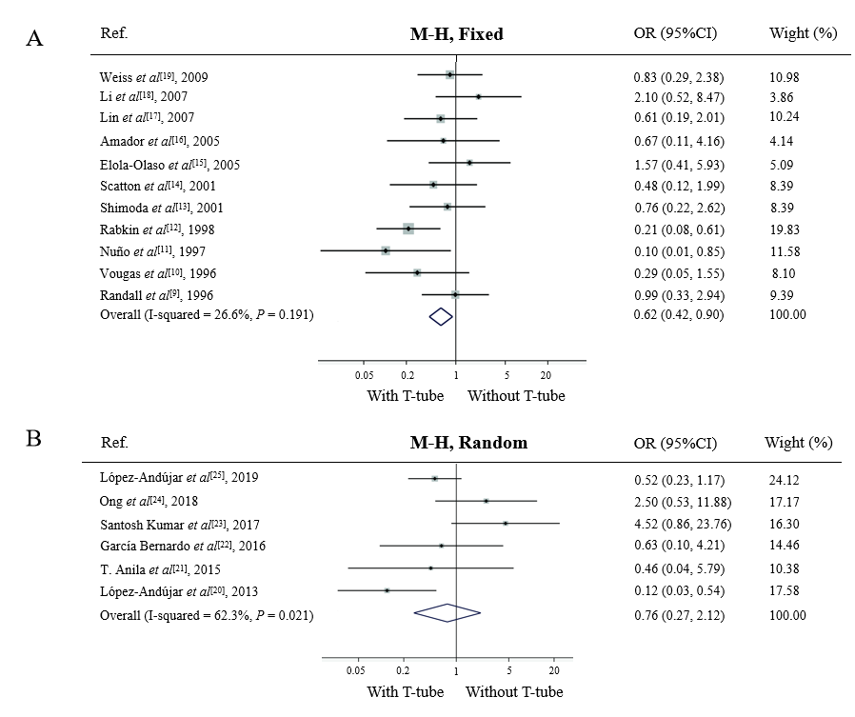
Figure 2 Biliary strictures. A: In the period from 1995 to 2010, odds ratio (OR) for biliary strictures between “T-tube” group and “without T-tube” group was calculated with a fixed-effects model. The shape of diamond represents the overall effect of OR with 95% confidence interval (CI). The use of T-tube decreased the incidence of biliary strictures; B: In the period from 2010 to 2020, OR for biliary strictures between “T-tube” group and “without T-tube” group was calculated with a random-effects model. The shape of diamond represents the overall effect of OR with 95%CI. There was no significant difference between the two groups. OR: Odds ratio; CI: Confidence interval.
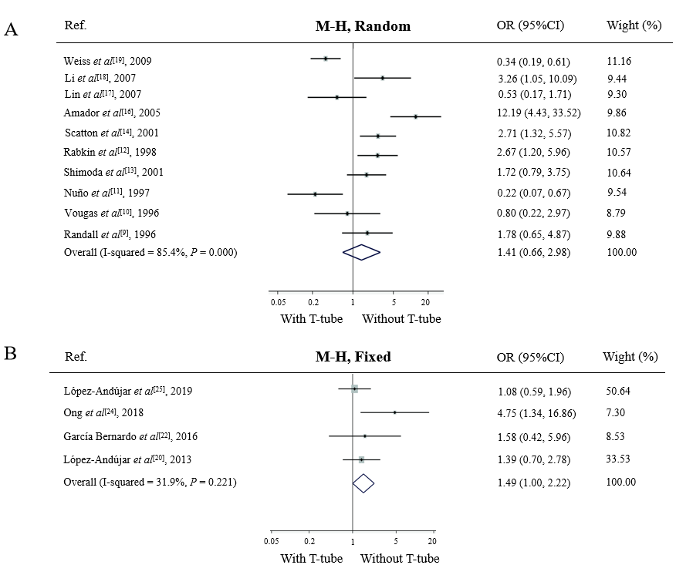
Figure 3 Overall biliary complications. A: In the period from 1995 to 2010, odds ratio (OR) for overall biliary complications between “T-tube” group and “without T-tube” group was calculated with a random-effects model. The shape of diamond represents the overall effect of OR with 95% confidence interval (CI). The use of T-tube had no influence on occurrence of overall biliary complication; B: In the period from 2010 to 2020, OR for overall biliary complications between “T-tube” group and “without T-tube” group was calculated with a fixed-effects model. The shape of diamond represents the overall effect of OR with 95%CI. The occurrence of overall biliary complications was significantly higher in “T-tube” group. OR: Odds ratio; CI: Confidence interval.
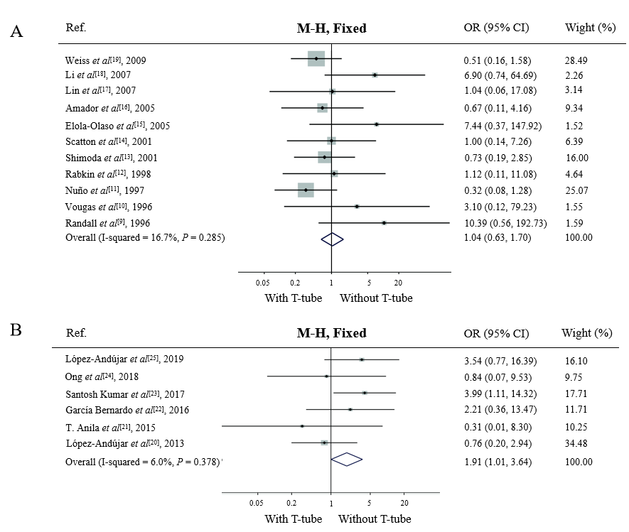
Figure 4 Bile leaks. A: In the period from 1995 to 2010, odds ratio (OR) for peritonitis between “T-tube” group and “without T-tube” group was calculated with the fixed model. The shape of diamond represents the overall effect of OR with 95% confidence interval (CI). There was no significant difference between the two groups; B: In the period from 2010 to 2020, OR for peritonitis between “T-tube” group and “without T-tube” group was calculated with the fixed model. The shape of diamond represents the overall effect of OR with 95%CI. The incidence rate of bile leaks was significantly higher in “T-tube” group. OR: Odds ratio; CI: Confidence interval.
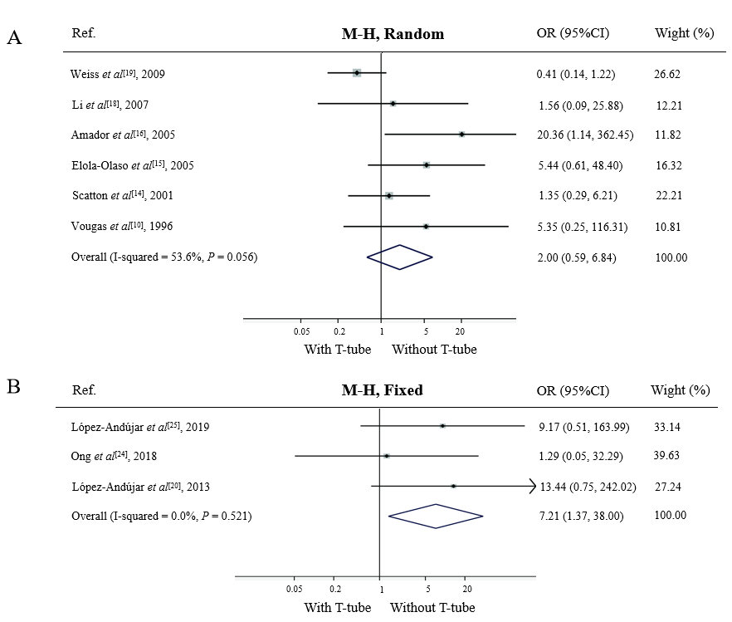
Figure 5 Cholangitis. A: In the period from 1995 to 2010, odds ratio (OR) for cholangitis between “T-tube” group and “without T-tube” group was calculated with a random-effects model. The shape of diamond represents the overall effect of OR with 95% confidence interval (CI). There was no significant difference between the two groups; B: In the period from 2010 to 2020, OR for peritonitis between “T-tube” group and “without T-tube” group was calculated with a fixed-effects model. The shape of diamond represents the overall effect of OR with 95%CI. The incidence rate of bile leaks was significantly higher in “T-tube” group. OR: Odds ratio; CI: Confidence interval.

Table 1 Characteristics of all studies
Ref. | Study design | Year | T-tube | Number of patients | Gender¹ | Mean age (year)³ | Mean CIT^{2,3} (min) | Jadad score
López-Andújar et al^{[25]} | CS | 2019 | Y | 240 | 139/101 | 58 ± 18 | 268 ± 109 | 1
 |  |  | N | 165 | 89/76 | 63 ± 14 | 265 ± 105
Ong et al^{[24]} | CS | 2018 | Y | 88 | 64/24 | 55 | 327 | 1
 |  |  | N | 37 | 27/10 | 51 | 316
Santosh Kumar et al^{[23]} | RCT | 2017 | Y | 31 | NR | 43.4 ± 11.1 | NR | 2
 |  |  | N | 33 | NR | 48.5 ± 11.6 | NR
García Bernardo et al^{[22]} | CS | 2016 | Y | 23 | 21/2 | 55.3 ± 9.7 | 321 ± 108 | 1
 |  |  | N | 23 | 20/3 | 57.7 ± 6.6 | 343 ± 100
T. Anila et al^{[21]} | RCT | 2015 | Y | 13 | NR | NR | 73.3 ± 25.1 | 2
 |  |  | N | 13 | NR | NR | 74.9 ± 31.5
López-Andújar et al^{[20]} | RCT | 2013 | Y | 95 | 75/20 | 53.7 ± 7.68 | 316 ± 157 | 3
 |  |  | N | 92 | 66/26 | 53.2 ± 8.68 | 297 ± 143
Weiss et al^{[19]} | RCT | 2009 | Y | 99 | 69/30 | 53.3 ± 9.8 | 597 ± 159 | 3
 |  |  | N | 95 | 60/35 | 55.3 ± 6.7 | 559 ± 178
Lin et al^{[17]} | CS | 2007 | Y | 51 | 45/6 | 50.1 ± 10.0 | NR | 1
 |  |  | N | 53 | 47/6 | 52.0 ± 10.0 | NR
Li et al^{[18]} | CS | 2007 | Y | 33 | 30/3 | 47.2 ± 9.4 | 479 + 98 | 1
 |  |  | N | 51 | 46/5 | 42.5 ± 13.5 | 457 + 89
Amador et al^{[16]} | RCT | 2005 | Y | 53 | 21/32 | 51.8 ± 9.4 | 362 | 3
 |  |  | N | 54 | 24/30 | 50.6 ± 10.6 | 390
Elola-Olaso et al^{[15]} | CS | 2005 | Y | 50 | 29/71 | 51.93 ± 9.8 | NR | 1
 |  |  | N | 50 |  |  | NR
Scatton et al^{[14]} | RCT | 2001 | Y | 90 | 62/28 | 48.3 ± 9.9 | 604 ± 194 | 3
 |  |  | N | 90 | 58/32 | 49.2 ± 9.5 | 570 ± 153
Shimoda et al^{[13]} | CS | 2001 | Y | 76 | 33/43 | 51.8 ± 11.7 | NR | 1
 |  |  | N | 71 | 32/39 | 52.9 ± 12.3 | NR
Rabkin et al^{[12]} | CS | 1998 | Y | 118 | 43/75 | 47.7 | 610 | 1
 |  |  | N | 44 | 7/37 | 48.0 | 522
Nuño et al^{[11]} | RCT | 1997 | Y | 50 | NR | NR | NR | 2
 |  |  | N | 48 | NR | NR | NR
Vougas et al^{[10]} | RCT | 1996 | Y | 30 | 12/18 | 42.0 | 678 | 3
 |  |  | N | 30 | 13/17 | 45.0 | 696
Randall et al^{[9]} | CS | 1996 | Y | 59 | NR | NR | NR | 1
 |  |  | N | 51 | NR | NR | NR
¹Female/Male.
²Mean ± standard deviation or mean.
³Cold ischemia time.
NR: No reference; Y: Yes; N: No; CS: Comparative study; RCT: Randomized control trial; CIT: Cold ischemia time.
Table 2 Measurements of outcomes provided in all studies
Outcome | Ref. | Year | With T-tube | Without T-tube
Total biliary complications | López-Andújar et al^{[25]} | 2019 | 31/240 | 20/165
 | Ong et al^{[24]} | 2018 | 26/88 | 3/37
 | García Bernardo et al^{[22]} | 2016 | 7/23 | 5/23
 | López-Andújar et al^{[20]} | 2013 | 24/95 | 18/92
 | Weiss et al^{[19]} | 2009 | 27/99 | 50/95
 | Li et al^{[18]} | 2007 | 10/33 | 6/51
 | Lin et al^{[17]} | 2007 | 5/51 | 9/53
 | Amador et al^{[16]} | 2005 | 32/53 | 6/54
 | Scatton et al^{[14]} | 2001 | 30/90 | 14/90
 | Shimoda et al^{[13]} | 2001 | 25/76 | 11/71
 | Rabkin et al^{[12]} | 1998 | 43/118 | 11/44
 | Nuño et al^{[11]} | 1997 | 5/50 | 16/48
 | Vougas et al^{[10]} | 1996 | 5/30 | 6/30
 | Randall et al^{[9]} | 1996 | 13/59 | 7/51
Bile leak | López-Andújar et al^{[25]} | 2019 | 10/240 | 2/165
 | Ong et al^{[24]} | 2018 | 2/88 | 1/37
 | Santosh Kumar et al^{[23]} | 2017 | 11/31 | 4/33
 | García Bernardo et al^{[22]} | 2016 | 4/23 | 2/23
 | T. Anila et al^{[21]} | 2015 | 0/13 | 1/13
 | López-Andújar et al^{[20]} | 2013 | 4/95 | 5/92
 | Weiss et al^{[19]} | 2009 | 5/99 | 9/95
 | Li et al^{[18]} | 2007 | 4/33 | 1/51
 | Lin et al^{[17]} | 2007 | 1/51 | 1/53
 | Amador et al^{[16]} | 2005 | 2/53 | 3/54
 | Elola-Olaso et al^{[15]} | 2005 | 3/47 | 0/50
 | Scatton et al^{[14]} | 2001 | 2/90 | 2/90
 | Shimoda et al^{[13]} | 2001 | 4/76 | 5/71
 | Rabkin et al^{[12]} | 1998 | 3/118 | 1/44
 | Nuño et al^{[11]} | 1997 | 3/50 | 8/48
 | Vougas et al^{[10]} | 1996 | 1/30 | 0/30
 | Randall et al^{[9]} | 1996 | 5/59 | 0/51
Biliary stricture | López-Andújar et al^{[25]} | 2019 | 11/240 | 14/165
 | Ong et al^{[24]} | 2018 | 11/88 | 2/37
 | Santosh Kumar et al^{[23]} | 2017 | 7/31 | 2/33
 | García Bernardo et al^{[22]} | 2016 | 2/23 | 3/23
 | T. Anila et al^{[21]} | 2015 | 1/13 | 2/13
 | López-Andújar et al^{[20]} | 2013 | 2/95 | 14/92
 | Weiss et al^{[19]} | 2009 | 7/99 | 8/95
 | Li et al^{[18]} | 2007 | 5/33 | 4/51
 | Lin et al^{[17]} | 2007 | 5/51 | 8/53
 | Amador et al^{[16]} | 2005 | 6/53 | 3/54
 | Elola-Olaso et al^{[15]} | 2005 | 6/44 | 4/46
 | Scatton et al^{[14]} | 2001 | 3/90 | 6/90
 | Shimoda et al^{[13]} | 2001 | 5/76 | 6/71
 | Rabkin et al^{[12]} | 1998 | 7/118 | 10/44
 | Nuño et al^{[11]} | 1997 | 1/50 | 8/48
 | Vougas et al^{[10]} | 1996 | 2/30 | 6/30
 | Randall et al^{[9]} | 1996 | 8/59 | 7/51
Cholangitis | López-Andújar et al^{[25]} | 2019 | 6/240 | 0/165
 | Ong et al^{[24]} | 2018 | 1/88 | 0/37
 | López-Andújar et al^{[20]} | 2013 | 6/95 | 0/92
 | Weiss et al^{[19]} | 2009 | 5/99 | 11/95
 | Li et al^{[18]} | 2007 | 1/33 | 1/51
 | Amador et al^{[16]} | 2005 | 8/53 | 0/54
 | Elola-Olaso et al^{[15]} | 2005 | 5/45 | 1/49
 | Scatton et al^{[14]} | 2001 | 4/90 | 3/90
 | Vougas et al^{[10]} | 1996 | 2/30 | 0/30
Bold typed studies indicate randomized control trials.
Table 3 Meta-analysis of outcomes (all studies included)
Period | Outcome | Studies | Participants | Effect size OR, 95%CI (fixed/random) | Heterogeneity | Test for overall effect (fixed/random) | Publication bias | Study quality¹ | Favors
1995-2010 | Overall biliary complications | 10 | 1246 | 1.41 [0.66, 2.98] | I² = 85.4% (^{b}P = 0.001) | Z = 0.89/(P = 0.37) | Egger: Bias = 1.92; P = 0.60 | 3 × 4, 2 × 1, 1 × 5 | None
 | Bile leak | 11 | 1346 | 1.04 [0.63, 1.70] | I ² = 16.7% (P = 0.29) | Z = 0.14/(P = 0.89) | Egger: Bias = 2.43; ^{b}P = 0.003 | 3 × 4, 2 × 1, 1 × 6 | None
 | Biliary stricture | 11 | 1346 | 0.62 [0.42, 0.90] | I ² = 26.6% (P = 0.19) | Z = 2.51/(ªP = 0.012) | Egger: Bias = -1.09; P = 0.56 | 3 × 4, 2 × 1, 1 × 6 | With T-tube
 | Cholangitis | 6 | 725 | 2.00 [0.59, 6.84] | I ² = 53.6% (P = 0.06) | Z = 1.11/(P = 0.27) | Egger: Bias = 2.97; ªP = 0.02 | 3 × 4, 1 × 2 | None
2010-2020 | Overall biliary  complications | 4 | 763 | 1.49 [1.00, 2.22] | I ² = 31.9% (P = 0.22) | Z = 1.97/(ªP = 0.049) | Egger: Bias = 2.50; P = 0.22 | 3 × 1, 1 × 3 | Without T-tube
 | Bile leak | 6 | 853 | 1.91 [1.01, 3.64] | I ² = 6.0% (P = 0.38) | Z = 1.98/(ªP = 0.048) | Egger: Bias = -1.69; P = 0.30 | 3 × 1, 2 × 2, 1×3 | Without T-tube
 | Biliary stricture | 6 | 853 | 0.76 [0.27, 2.12] | I ² = 62.3% (ªP = 0.02) | Z = 0.53/(P = 0.60) | Egger: Bias = 0.84; P = 0.70 | 3 × 1, 2 × 2, 1 × 3 | None
 | Cholangitis | 3 | 717 | 7.21 [1.37, 38.00] | I ² = 0.0% (P = 0.52) | Z = 2.33/(ªP = 0.02) | Egger: Bias = -12.51; P = 0.12 | 3 × 1, 1 × 2 | Without T-tube
¹Jadad scores × study number.
ªP < 0.05.
^{b}P < 0.01.
Odds ratio < 1 indicates the use of a T-tube. OR: Odds ratio; CI: Confidence interval.
Table 4 Sensitivity analysis of outcomes (only randomized control trials included)
Period | Outcome | Studies | participants | Effect size OR, 95%CI (fixed/random) | Heterogeneity | Test for overall effect (fixed/random) | Publication bias | Study quality¹ | Favors
1995-2010 | Overall biliary  complications | 5 | 639 | 1.15 [0.28, 4.72] | I² = 92.2% (^{b}P = 0.001) | Z = 0.19/(P = 0.85) | Egger: Bias = 2.63; P = 0.71 | 3 × 4, 2 × 1 | None
 | Bile leak | 5 | 639 | 0.56 [0.28, 1.13] | I² = 0.0% (P = 0.72) | Z = 1.62/(P = 0.11) | Egger: Bias = 1.72; P = 0.08 | 3 × 4, 2 × 1 | None
 | Biliary stricture | 5 | 639 | 0.45 [0.24, 0.85] | I² = 0.0% (P = 0.46) | Z = 2.47/(ªP = 0.014) | Egger: Bias= -2.78; P = 0.10 | 3 × 4, 2 × 1 | With T-tube
 | Cholangitis | 4 | 541 | 1.83 [0.36, 9.41] | I² = 65.6% (ªP = 0.03) | Z = 0.72/(P = 0.47) | Egger: Bias = 3.39; P = 0.054 | 3 × 4 | None
2010-2020 | Bile leak | 3 | 277 | 1.38 [0.34, 5.65] | I² = 50.9% (P = 0.13) | Z = 0.45/(P = 0.66) | Egger: Bias = -1.94; P = 0.62 | 3 × 2, 2 × 1 | None
 | Biliary stricture | 3 | 277 | 0.63 [0.06, 6.99] | I² = 80.3% (ªP = 0.01) | Z = 0.38/(P = 0.71) | Egger: Bias = 1.08; P = 0.92 | 3 × 2, 2 × 1 | None
¹Jadad scores × study number.
ªP < 0.05.
^{b}P < 0.01.
Odds ratio < 1 indicates the use of a T-tube. OR: Odds ratio; CI: Confidence interval.

Published by Baishideng Publishing Group Inc
7041 Koll Center Parkway, Suite 160, Pleasanton, CA 94566, USA
Telephone: +1-925-3991568
E-mail: bpgoffice@wjgnet.com
Help Desk: https://www.f6publishing.com/helpdesk
https://www.wjgnet.com

© 2021 Baishideng Publishing Group Inc. All rights reserved.

