Name of Journal: World Journal of Clinical Cases
Manuscript NO: 72585
Manuscript Type: CASE REPORT

Diagnosis of spontaneous isolated superior mesenteric artery dissection with ultrasound: A case report

Zhang Y et al. Superior mesenteric artery dissection ultrasound

Yi Zhang, Jiang-Ying Zhou, Jian Liu, Chen Bai

Yi Zhang, Jian Liu, Jiang-Ying Zhou, Department of Ultrasound, The First Affiliated Hospital of Chengdu Medical College, Chengdu 610599, Sichuan Province, China

Chen Bai, Department of Radiology, The First Affiliated Hospital of Chengdu Medical College, Chengdu 610599, Sichuan Province, China

Author contributions: Zhang Y conceived and supervised the study; Zhang Y and Liu J designed experiments; Zhang Y and Bai C performed experiments; Zhang Y, Zhou JY and Bai C analyzed data; Zhang Y wrote the manuscript; Zhang Y and Liu J made manuscript revisions; All authors reviewed the results and approved the final version of the manuscript.

Corresponding author: Jian Liu, PhD, Department of Ultrasound, The First Affiliated Hospital of Chengdu Medical College, No. 278 Baoguang Avenue Middle Section, Xindu District, Chengdu 610599, Sichuan Province, China. liujiansh@126.com

Received: October 21, 2021
Revised: March 16, 2022
Accepted: April 15, 2022
Published online:

ABSTRACT
BACKGROUND
Spontaneous isolated superior mesenteric artery dissection (SISMAD) is a rare disease that originates from the superior mesenteric artery, without the presence of aortic and other arterial dissections. Most cases are diagnosed using contrast-enhanced computed tomography (CECT), whereas the application of ultrasound is less common.

CASE SUMMARY
Here, we report a case of SISMAD with sudden epigastric pain that worsened as the main symptom after eating. The patient had a long history of hypertension with unknown blood pressure control but no history of smoking or alcohol consumption. This case was initially diagnosed using ultrasound and the results were later confirmed by CECT. After admission, the patient fasted, followed by parenteral nutrition support and fluid supplementation to maintain electrolyte and acid–base balance. Metoprolol succinate sustained-release tablets and aspirin were given as nonoperative treatments. After 1 wk, the symptoms improved, and the patient was discharged. During telephone follow-up, the patient did not develop similar symptoms.

CONCLUSION
Whether ultrasound can be used as a routine and noninvasive imaging method for the diagnosis of SISMAD needs further exploration.

Key Words: Abdominal pain; Ultrasound; Spontaneous isolated superior mesenteric artery dissection; Color doppler; Diagnosis; Case report

Zhang Y, Zhou J, Liu JY, Bai C. Diagnosis of spontaneous isolated superior mesenteric artery dissection with ultrasound: A case report. World J Clin Cases 2022; In press

Core tip: Spontaneous isolated superior mesenteric artery dissection is a rare disease. Contrast-enhanced computed tomography (CECT) is often the preferred diagnostic method for this disease. The initial diagnosis of this disease by ultrasound is rarely reported. Compared to CECT, ultrasound is a convenient, rapid, noninvasive, inexpensive and feasible bedside imaging method, which can be used to diagnose superior mesenteric artery dissection.

INTRODUCTION
Spontaneous isolated superior mesenteric artery dissection (SISMAD), first reported in 1947, is a dissection disease arising from the superior mesenteric artery, without aortic and other arterial dissections^{[1]}.
Clinical manifestations of SISMAD are atypical. The most common symptoms include sudden persistent or paroxysmal severe abdominal pain, accompanied by other gastrointestinal symptoms. Also, some of the patients are asymptomatic. In addition, clinical and physical examinations reveal no specificity, and no laboratory indicators for SISMAD are currently available^{[2,3]}. SISMAD may directly lead to intestinal ischemic necrosis and arterial rupture, which endangers the life of patients if not treated in a timely manner^{[4,5]}. At present, the diagnosis of SISMAD is mainly dependent on imaging examinations, and contrast-enhanced computed tomography (CECT) and computed tomography angiography (CTA) are most commonly used^{[6,7]}. Ultrasound is rarely used to diagnose SIDSMA. Here, we reported an ultrasound-confirmed SISMAD case without dissecting aneurysm or thrombosis, suggesting that ultrasound could be used in the diagnosis of SISMAD.

CASE PRESENTATION
Chief complaints
A 64-year-old Chinese Han female patient was admitted to the First Affiliated Hospital of Chengdu Medical College on April 27, 2020, due to intermittent pain in the upper abdomen.

History of present illness
Epigastric pain became worse after eating for 3 d.

History of past illness
She had a history of hypertension for > 10 years and was on antihypertensive medication, but her blood pressure control was unknown. The patient received a cardiac pacemaker implant 2 years ago, and was given dabigatran ester (capsules 110 mg bid) as long-term anticoagulant therapy after surgery. She underwent cholecystectomy in the First Affiliated Hospital of Chengdu Medical College due to calculous cholecystitis on March 21, 2019.

Personal and family history
The patient did not have any history of smoking or alcohol consumption.

Physical examination
The blood pressure was 170/110 mmHg at admission.

Laboratory examinations
No other obvious abnormalities were detected based on physical examination and laboratory tests.

Imaging examinations
Abdominal ultrasound was routinely performed since the patient had superior abdominal pain. However, no obvious abnormalities in the liver, pancreas and spleen were observed. Strip echoes were found in the lumen about 1.6 cm from the opening of the superior mesenteric artery distal to the main trunk of the superior mesenteric artery with stripped intima. The arterial lumen was divided into true and false lumen by the exfoliated intima. Ventral false lumen had a large diameter, while that of the dorsal true lumen was small. Lumen sonopenetrability was normal, and no thrombosis was detected. Proximal to the exfoliated intima, a 3-mm wide rupture was observed (Figure 1). Color Doppler imaging showed blood flow passing through the incision. The blood flow in the ventral lumen was dark, while colored blood flow signals were observed in the dorsal lumen. Pulse Doppler was used to assess blood flow velocity in the true lumen (Figure 2).

FINAL DIAGNOSIS
Ultrasonography of the abdominal aorta showed no shed intimal echo (Figure 1), suggesting isolated superior mesenteric artery dissection, which was later confirmed by CECT (Figure 3).

TREATMENT
After admission, the patient fasted, followed by parenteral nutrition support and fluid supplementation to maintain electrolyte and acid–base balance. Metoprolol succinate sustained-release tablets (47.5 mg/d) were given to lower blood pressure, and aspirin (100 mg/d) was given as an antiplatelet treatment.

OUTCOME AND FOLLOW-UP
After 1 wk, the symptoms improved, and the patient was discharged. During telephone follow-up at 1, 3 and 6 mo after discharge, the patient did not experience similar symptoms and did not visit any local medical facility for imaging re-examination.

DISCUSSION
Currently, the most commonly used imaging methods for the diagnosis of SISMAD are CTA and CECT^{[8]}, and only a few diagnosed cases have been confirmed by ultrasound^{[9-12]}. In this case report, ordinary grayscale ultrasound could detect the start and end points of the intimal exfoliation in the superior mesenteric artery, the location and number of ruptures, and whether there was thrombus in the lumen. Color Doppler ultrasonography was used to investigate the blood flow through the rupture sites, the blood flow velocity in the true and false lumen, and the filling defect areas caused by thrombus in real time. Yun et al^{[13]} classified SISMAD into types I, II (IIa and IIb) and III. In this case, a rupture was detected about 1.6 cm from the opening of the superior mesenteric artery, while its distal end was closed. No thrombosis was detected in either the true or false lumen, and the ultrasound finding was in line with a type IIa SISMAD.
Isolated superior mesenteric artery dissection is a rare disease with unknown etiology. It has been reported that male sex, smoking, atherosclerosis, hypertension, hyperlipidemia, cystic necrosis of the middle artery, and Asian ethnicity might be related to the pathogenesis of SISMAD^{[14-16]}. Among these, hypertension plays a crucial role in the development of arterial dissection. In our case, the patient had a history of hypertension for > 10 years. Furthermore, SISMAD was a rare acute abdomen with no specific clinical manifestations. The primary symptoms were sudden and severe abdominal pains, mainly epigastric pain^{[17,18]}. Our patient had intermittent pain in the upper abdomen without any specific positive signs. Currently, conservative treatment, endovascular surgery, interventional radiology, and open surgery are therapeutic modalities for patients with SISMAD, but there are no clear recommendations for the treatment of SISMAD^{[15,16,19,20]}. According to current guidelines, SISMAD treatment strategies are designed to control clinical symptoms and prevent complications such as intestinal necrosis. Most studies recommend initial treatment based on clinical presentation at admission. If SISMAD is found accidentally during CTA in other settings, the patient can be carefully observed and treated conservatively^{[6,21]}. Asymptomatic patients receiving conservative treatments do not need secondary interventions^{[22]}. In symptomatic SISMAD patients, EVT may be performed before mesenteric ischemia progresses if clinical symptoms persist. The reconstruction of SMA was significantly improved after EVT, especially for patients with Yun's IIb phenotype^{[23]}.
Although CTA or CECT could clearly display and classify the type of superior mesenteric artery dissection, especially small distal branch vessels, there was an issue of contrast agent allergy as patients received a large radiation dose^{[24]}. Ultrasound was simple and easy to perform, radiation free, and repeatable, and could clearly observe the echoes of exfoliated intima, the positions of the rupture and the thrombosis, and hemodynamic changes could be displayed using Doppler ultrasound. Also, bedside examination could be performed when necessary^{[12,25]}. It has also been suggested that early transition to ultrasound imaging exam should be considered in the follow-up of SISMAD patients, which may help to reduce radiation, contrast, and associated costs^{[17]}.

CONCLUSION
This case report suggests that ultrasound is a noninvasive examination method for routine screening of SISMAD, which could provide a clinical management basis for the diagnosis and treatment of the disease.

REFERENCES
1 Bauersfeld SR. Dissecting aneurysm of the aorta; a presentation of 15 cases and a review of the recent literature. Ann Intern Med 1947; 26: 873-889 [PMID: 20242656 DOI: 10.7326/0003-4819-26-6-873]
2 Xu L, Shao J, Zhang D, Qiu C, Wang J, Li K, Fang L, Zhang X, Lei J, Lai Z, Ma J, Yu Y, Yu X, Du F, Qi W, Chen J, Liu B. Long-term outcomes of conservative treatment and endovascular treatment in patients with symptomatic spontaneous isolated superior mesenteric artery dissection: a single-center experience. BMC Cardiovasc Disord 2020; 20: 256 [PMID: 32471346 DOI: 10.1186/s12872-020-01532-y]
3 Tanaka Y, Yoshimuta T, Kimura K, Iino K, Tamura Y, Sakata K, Hayashi K, Takemura H, Yamagishi M, Kawashiri MA. Clinical characteristics of spontaneous isolated visceral artery dissection. J Vasc Surg 2018; 67: 1127-1133 [PMID: 29056349 DOI: 10.1016/j.jvs.2017.08.054]
4 Kim H, Park H, Park SJ, Park BW, Hwang JC, Seo YW, Cho HR. Outcomes of Spontaneous Isolated Superior Mesenteric Artery Dissection Without Antithrombotic Use. Eur J Vasc Endovasc Surg 2018; 55: 132-137 [PMID: 29229279 DOI: 10.1016/j.ejvs.2017.11.002]
5 Karaolanis G, Antonopoulos C, Tsilimigras DI, Moris D, Moulakakis K. Spontaneous isolated superior mesenteric artery dissection: Systematic review and meta-analysis. Vascular 2019; 27: 324-337 [PMID: 30621507 DOI: 10.1177/1708538118818625]
6 Kimura Y, Kato T, Nagao K, Izumi T, Haruna T, Ueyama K, Inada T, Inoko M. Outcomes and Radiographic Findings of Isolated Spontaneous Superior Mesenteric Artery Dissection. Eur J Vasc Endovasc Surg 2017; 53: 276-281 [PMID: 28012909 DOI: 10.1016/j.ejvs.2016.11.012]
7 Tomita K, Obara H, Sekimoto Y, Matsubara K, Watada S, Fujimura N, Shibutani S, Nagasaki K, Hayashi S, Harada H, Asami A, Uchida N, Kakefuda T, Kitagawa Y. Evolution of Computed Tomographic Characteristics of Spontaneous Isolated Superior Mesenteric Artery Dissection During Conservative Management. Circ J 2016; 80: 1452-1459 [PMID: 27118619 DOI: 10.1253/circj.CJ-15-1369]
8 Nath A, Yewale S, Kousha M. Spontaneous Isolated Superior Mesenteric Artery Dissection. Case Rep Gastroenterol 2016; 10: 775-780 [PMID: 28203123 DOI: 10.1159/000448879]
9 Ishimura M, Hayashi R, Shimotsuka H, Ogawa K, Iuchi K. A case of isolated superior mesenteric artery dissection evaluated clinical course by ultrasonography. ChoonpaIgaku 2008; 35: 191-195 [DOI: 10.3179/jjmu.35.191]
10 Davis CB, Kendall JL. Emergency bedside ultrasound diagnosis of superior mesenteric artery dissection complicating acute aortic dissection. J Emerg Med 2013; 45: 894-896 [PMID: 23932465 DOI: 10.1016/j.jemermed.2013.04.025]
11 Huang CY, Sun JT, Lien WC. Early Detection of Superior Mesenteric Artery Dissection by Ultrasound: Two Case Reports. J Med Ultrasound 2019; 27: 47-49 [PMID: 31031536 DOI: 10.4103/JMU.JMU_81_18]
12 Bao S, Wang T, Jin X, Zhang S, Qi H, Dong D, Mou X, Zhang X, Li C. Diagnostic value of color Doppler sonography for spontaneous isolated superior mesenteric artery dissection. Exp Ther Med 2019; 17: 3489-3494 [PMID: 30988728 DOI: 10.3892/etm.2019.7399]
13 Yun WS, Kim YW, Park KB, Cho SK, Do YS, Lee KB, Kim DI, Kim DK. Clinical and angiographic follow-up of spontaneous isolated superior mesenteric artery dissection. Eur J Vasc Endovasc Surg 2009; 37: 572-577 [PMID: 19208448 DOI: 10.1016/j.ejvs.2008.12.010]
14 Shiraki H, Kasamoto M, Yasutomi M, Kaji S, Akutsu K, Furukawa Y, Shimizu W, Inoue N. Clinical Features of Spontaneous Isolated Dissection of Abdominal Visceral Arteries. J Clin Med Res 2020; 12: 13-17 [PMID: 32010417 DOI: 10.14740/jocmr3916]
15 Luan JY, Guan X, Li X, Wang CM, Li TR, Zhang L, Han JT. Isolated superior mesenteric artery dissection in China. J Vasc Surg 2016; 63: 530-536 [PMID: 26597665 DOI: 10.1016/j.jvs.2015.09.047]
16 Kim YW. Current Understandings of Spontaneous Isolated Superior Mesenteric Artery Dissection. Vasc Specialist Int 2016; 32: 37-43 [PMID: 27386450 DOI: 10.5758/vsi.2016.32.2.37]
17 Zettervall SL, Karthaus EG, Soden PA, Buck DB, Ultee KH, Schermerhorn ML, Wyers MC. Clinical presentation, management, follow-up, and outcomes of isolated celiac and superior mesenteric artery dissections. J Vasc Surg 2017; 65: 91-98 [PMID: 27773728 DOI: 10.1016/j.jvs.2016.08.080]
18 DeCarlo C, Ganguli S, Borges JC, Schainfeld RM, Mintz AJ, Mintz J, Jaff MR, Weinberg I. Presentation, treatment, and outcomes in patients with spontaneous isolated celiac and superior mesenteric artery dissection. Vasc Med 2017; 22: 505-511 [PMID: 28901215 DOI: 10.1177/1358863X17729770]
19 Takahashi B, Nakayama Y, Shiroma S, Ido K. Three Case Report of Spontaneous Isolated Dissection of the Superior Mesenteric Artery-With an Algorithm Proposed for the Management. Ann Vasc Dis 2015; 8: 120-123 [PMID: 26131035 DOI: 10.3400/avd.cr.15-00013]
20 Acosta S, Gonçalves FB. Management of Spontaneous Isolated Mesenteric Artery Dissection: A Systematic Review. Scand J Surg 2021; 110: 130-138 [PMID: 33724090 DOI: 10.1177/14574969211000546]
21 Qiu C, He Y, Li D, Shang T, Wang X, Wu Z, Zhang H. Mid-Term Results of Endovascular Treatment for Spontaneous Isolated Dissection of the Superior Mesenteric Artery. Eur J Vasc Endovasc Surg 2019; 58: 88-95 [PMID: 31160187 DOI: 10.1016/j.ejvs.2018.11.013]
22 Wang J, He Y, Zhao J, Yuan D, Xu H, Ma Y, Huang B, Yang Y, Bian H, Wang Z. Systematic review and meta-analysis of current evidence in spontaneous isolated celiac and superior mesenteric artery dissection. J Vasc Surg 2018; 68: 1228-1240.e9 [PMID: 30126785 DOI: 10.1016/j.jvs.2018.05.014]
23 Yu SH, Hii IH, Wu IH. Comparison of Superior Mesenteric Artery Remodeling and Clinical Outcomes between Conservative or Endovascular Treatment in Spontaneous Isolated Superior Mesenteric Artery Dissection. J Clin Med 2022; 11 [PMID: 35054159 DOI: 10.3390/jcm11020465]
24 Mandlik V, Prantl L, Schreyer AG. Contrast Media Extravasation in CT and MRI - A Literature Review and Strategies for Therapy. Rofo 2019; 191: 25-32 [PMID: 29913522 DOI: 10.1055/a-0628-7095]
25 Czihal M, Lottspeich C, Hoffmann U. Ultrasound imaging in the diagnosis of large vessel vasculitis. Vasa 2017; 46: 241-253 [PMID: 28332442 DOI: 10.1024/0301-1526/a000625]
Footnotes
Informed consent statement: Informed consent was obtained from the patient for the publication of the imaging data and other clinical information. The patient understood that her identity would not be disclosed.

Conflict-of-interest statement: The authors have no potential conflicts of interest to disclose.

CARE Checklist (2016) statement: The authors read the CARE Checklist (2016), and the manuscript was prepared and revised according to the CARE Checklist (2016).

Open-Access: This article is an open-access article that was selected by an in-house editor and fully peer-reviewed by external reviewers. It is distributed in accordance with the Creative Commons Attribution NonCommercial (CC BY-NC 4.0) license, which permits others to distribute, remix, adapt, build upon this work non-commercially, and license their derivative works on different terms, provided the original work is properly cited and the use is non-commercial. See: https://creativecommons.org/Licenses/by-nc/4.0/

Provenance and peer review: Unsolicited article; Externally peer reviewed.
Peer-review model: Single blind

Peer-review started: October 21, 2021
First decision: March 7, 2022
Article in press:

Specialty type: Radiology, nuclear medicine and medical imaging
Country/Territory of origin: China
Peer-review report’s scientific quality classification
Grade A (Excellent): 0
Grade B (Very good): B
Grade C (Good): 0
Grade D (Fair): 0
Grade E (Poor): 0

P-Reviewer: Ghannam WM, Egypt S-Editor: Liu JH L-Editor: Kerr C P-Editor: Liu JH
Figure Legends
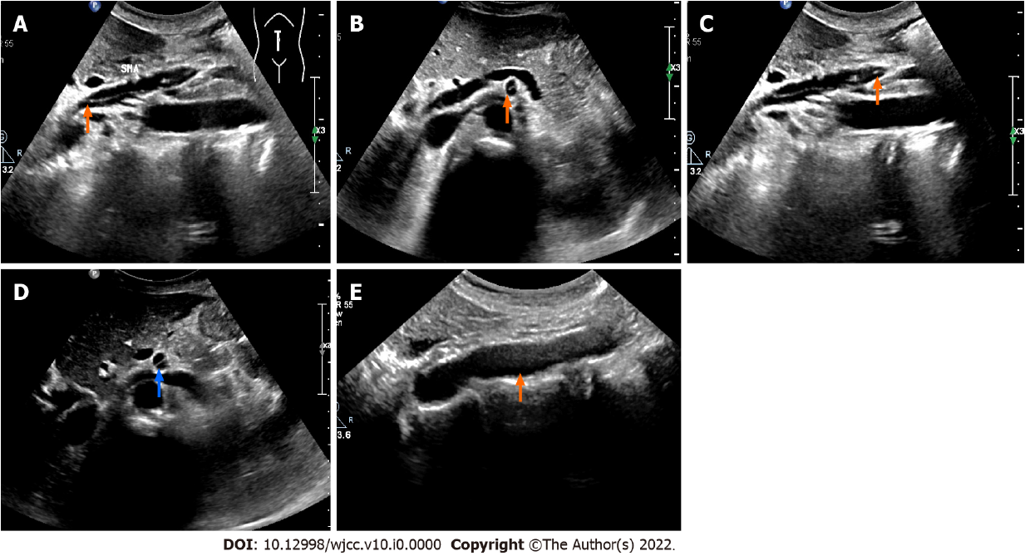
Figure 1 Gray-scale ultrasound showed the superior mesenteric artery dissection and abdominal aorta. A: Ultrasonic longitudinal view demonstrated the opening of superior mesenteric artery dissection (SISMAD) (orange arrow); B: Transverse view demonstrated the opening of SISMAD (orange arrow); C: Ultrasonic longitudinal view showed the distal end of SISMAD (orange arrow); D: Transverse view showed the distal end of SISMAD (blue arrow); E: No abnormal echo was observed in the abdominal aortic lumen (orange arrow).
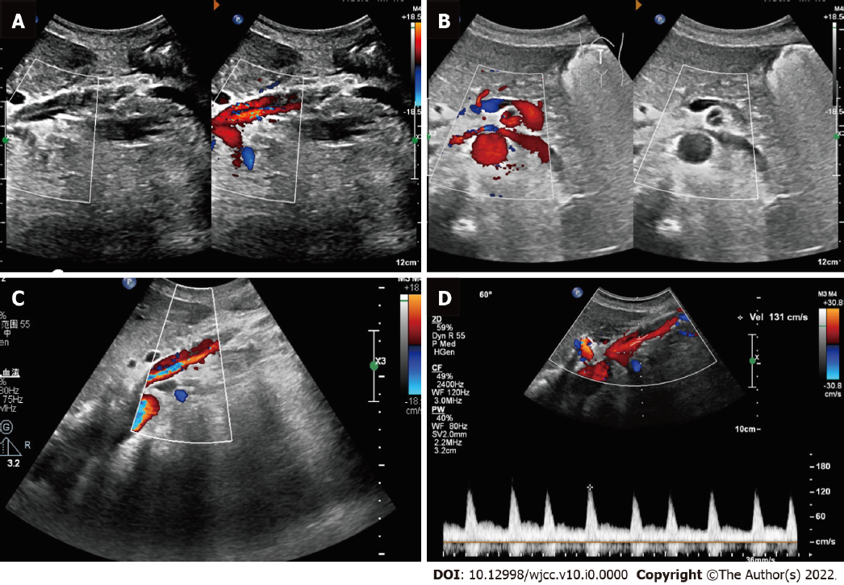
Figure 2 Doppler ultrasound showed the blood flow of the superior mesenteric artery dissection. A: Ultrasonic longitudinal view showed the flow at the opening of the superior mesenteric artery dissection (SISMAD); B: Ultrasonic transverse view showed the flow at the opening of the SISMAD; C: Color Doppler flow imaging showed the true and false lumens of the SISMAD; D: True lumen velocity of superior mesenteric artery dissection was measured by spectral Doppler.
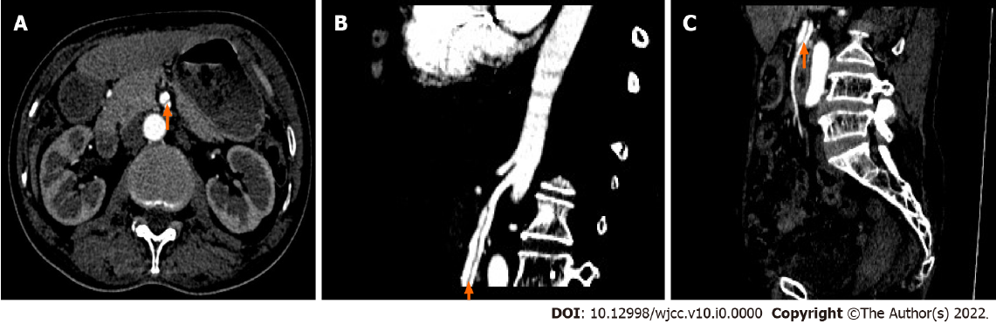
Figure 3 Contrast enhanced computed tomography (CECT) showed superior mesenteric artery dissection. A: Cross-sectional view of the superior mesenteric artery dissection (SISMAD) (orange arrow) on CECT; B: Sagittal view of proximal SISMAD on CECT (orange arrow); C: Sagittal view of distal SISMAD on CECT (orange arrow).

