Name of Journal: World Journal of Clinical Cases
Manuscript NO: 73135
Manuscript Type: CASE REPORT

Neuroendocrine tumour of the descending part of the duodenum complicated with schwannoma: A case report

Zhang L et al. Duodenal NET with schwannoma

Lu Zhang, Chi Zhang, Shu-Yan Feng, Pan-Pan Ma, Shuo Zhang, Qian-Qian Wang

Lu Zhang, Chi Zhang, Shu-Yan Feng, Pan-Pan Ma, Shuo Zhang, Qian-Qian Wang, Department of Gastroenterology, The First Affiliated Hospital, Zhejiang Chinese Medical University, Hangzhou 310006, Zhejiang Province, China

Author contributions: Zhang L and Zhang S were involved in the conception of the study; Zhang L and Zhang C were involved in writing the article; Zhang L, Ma PP, Feng SY, Wang QQ and Zhang S critically revised the manuscript; all authors read and approved the final manuscript.

Supported by the National Natural Science Foundation of China, No. 82074214; and the Research Fund Project of Zhejiang Chinese Medical University, No. 2019ZY02.

Corresponding author: Qian-Qian Wang, Doctor, Department of Gastroenterology, The First Affiliated Hospital, Zhejiang Chinese Medical University, No. 54 Youdian Road, Shangcheng District, Hangzhou 310006, Zhejiang Province, China. w18072348608@163.com

Received: November 21, 2021
Revised: January 6, 2022
Accepted: April 4, 2022
Published online:

Abstract
BACKGROUND
No known case of neuroendocrine tumour (NET) with schwannoma has been reported.

CASE SUMMARY
A 63-year-old female presented to our hospital with nausea and vomiting. Upper gastrointestinal endoscopy revealed a mass in the descending part of the duodenum. Using ultrasound gastroscopy, we found that the tumour originated from the submucosa and showed low echo. We removed the tumour by electrocoagulation and sent it for pathological biopsy.

CONCLUSION
Immunohistochemical results showed that the mass was a rare NET with neurilemmoma.

Key Words: Neuroendocrine tumour; Schwannoma; Duodenum; Endoscopy; Immunohistochemistry; Trap with current; Case report

Zhang L, Zhang C, Feng SY, Ma PP, Zhang S, Wang QQ. Neuroendocrine tumour of the descending part of the duodenum complicated with schwannoma: A case report. World J Clin Cases 2022; In press

Core Tip: Neuroendocrine tumours (NETs) and schwannomas of the duodenum are quite rare and few clinical cases have been reported. To the best of our knowledge, this is the first publication of a NET of descending duodenum complicated with schwannoma. Through a review of relevant literature, we can deepen the understanding of this type of tumour.

INTRODUCTION
Neuroendocrine tumours (NETs) are rare tumours originating from neuroendocrine cells that account for approximately 2% of all malignant tumours, and approximately 50.6% of NETs are found in the digestive system; duodenal NETs are extremely rare, accounting for only 2%-3% of gastrointestinal NETs^{[1]}. Schwannoma is a benign tumour originating from the nerve fibre sheath, accounting for approximately 5% of all soft tissue tumours; it is mostly located in the body surface and auditory nerve, less often in the digestive tract, and even more rarely in the duodenum^{[2]}.

CASE PRESENTATION
Chief complaints
One month of nausea and vomiting.

History of present illness
A 63-year-old female underwent upper gastrointestinal endoscopy at a local, grassroots hospital due to 1 mo of nausea and vomiting, and a large nipple was found in the descending part of the duodenum. The patient’s faecal occult blood test was positive. The patient had obvious symptoms of nausea and vomiting, often vomiting with no stomach contents and had lost 2 kg of weight within a month. Before the operation, we administered symptomatic treatment, such as replenishing gastric protective fluid. After excluding relevant surgical contraindications, endoscopic examination was performed on the patient in our hospital, and we found a protuberant mass above the nipple of the descending duodenum, with a smooth surface and a diameter of approximately 0.5 cm. A 12 MHz ultrasound probe showed that the tumour originated from the submucosa and showed low echo. We used a nylon noose to trap the tumour, cut the bottom of the base by snaring with an electrocurrent, and clamped the wound with a titanium clip to stop the bleeding (Figure 1). To confirm the diagnosis, the excised specimens were sent for pathological examination and immunohistochemistry. One week after the operation, the patient recovered smoothly and was discharged from the hospital. The pathological results showed that the tumour in the descending part of the duodenum was a NET (grade 1) with schwannoma, and the cutting edge was negative (Figure 2). The results of immunohistochemical staining indicated that the tumour cells were positive for antigen KI-67, broad-spectrum cytokeratin, CD56, synaptophysin (Syn), chromogranin A (CgA), S-100, nerve specific enolase, CD68, CD163, and myoglobin and were negative for CD34, succinate dehydrogenase B, CD117, DOG-1, smooth muscle actin, desmin, cytokeratin (CK) 7, CK20, and myogenic differentiation 1 (Figures 3 and 4).

History of past illness
The patient has a history of infection with tuberculosis 40 years ago. The history of surgical trauma was bronchiectasis in 2015, hysterectomy and minimally invasive hysteroptosis in 2020.

Personal and family history
Parents have a history of hypertension.

Physical examination
Mild tenderness in the abdomen, no rebound pain.

Laboratory examinations
Immunohistochemical results showed that the mass was a rare NET with neurilemmoma.

Imaging examinations
Mediastinal computed tomography (CT) showed no tumour metastasis.

MULTIDISCIPLINARY EXPERT CONSULTATION
Because this patient does not have other systemic diseases, multidisciplinary experts were not invited to discuss it.

FINAL DIAGNOSIS
NET of the descending part of the duodenum complicated with schwannoma.

TREATMENT
We removed the tumour by electrocoagulation and gave the patient some other symptomatic treatment to help stopping vomiting and protect the stomach.

OUTCOME AND FOLLOW-UP
Mediastinal CT showed no tumour metastasis, and the prognosis of the patient is good.

DISCUSSION
There may be rare cases of NETs with schwannoma in the descending part of the duodenum worldwide, but there are no clinical reports. To the best of our knowledge, this is the first clinical case report of a duodenal NET complicated with schwannoma, which has high clinical value. Endoscopic NETs and schwannomas of the duodenum do not have specific features and are often mistaken for enlarged duodenal papilla, resulting in missed diagnosis and worsening of the disease. Endoscopic ultrasonography (EUS) is of high value in the diagnosis of these two kinds of tumours. Under EUS, most of the lesions are hypoechoic lesions originating from the submucosa, with clear boundaries and homogeneous internal echoes, which is consistent with our ultrasound results^{[3]}. Duodenal schwannoma is extremely rare in gastrointestinal mesenchymal tumours, and only a few cases have been reported thus far. Duodenal neurilemmoma is often found by accident and is difficult to diagnose before surgery. There was no typical duodenal schwannoma under ordinary endoscopy. Due to the rare nature of duodenal schwannoma, no typical endoscopic ultrasonographic features have been reported^{[4]}. The immunohistochemical results of the specimen remain the gold standard for diagnosis. NET cells are often positive for CgA, CD56, CK, and Syn, while schwannoma cells are often positive for S-100^{[5]}, which is consistent with our immunohistochemical results. Endoscopic treatment is usually the first choice for gastrointestinal NETs or schwannomas with diameters less than 1 cm, as it does not invade the lamina propria and because endoscopic treatment has the characteristics of less trauma, less cost, good prognosis, and easy follow-up after the operation^{[6]}. It has been reported that snare polypectomy has a very high complete resection rate of gastrointestinal NETs (93.8%), and this rate may be high for several reasons. First, decoy polypectomy is more commonly used in smaller tumours (< 5.2 mm), and the appearance of polyps is more likely to be limited to the mucosa. The second reason is that electrosurgical devices, such as argon plasma coagulators, damage a larger field of vision during treatment. Therefore, for some small gastrointestinal NETs with specific shapes, the use of decoy electrocoagulation is completely effective^{[7]}. In this case, we used EUS to determine the lesion level and endoscopic electrocoagulation for R0 resection, suggesting the feasibility and broad prospect of early endoscopic diagnosis and treatment of the tumour. The KI-67 index of the specimen was approximately 1%, suggesting that the NET phase was G1. In addition, we examined the vertical edge of the specimen with a high-power microscope. The vertical edge was negative, and there was no lymphatic invasion, which proved that we successfully removed the tumour completely. Mediastinal CT showed no tumour metastasis, and the prognosis of the patient is good.

CONCLUSION
To the best of our knowledge, this is the first publication of a neuroendocrine tumour of descending duodenum complicated with schwannoma. We removed the tumour by electrocoagulation completely and the patient recovered and was discharged.

REFERENCES
1 Oronsky B, Ma PC, Morgensztern D, Carter CA. Nothing But NET: A Review of Neuroendocrine Tumors and Carcinomas. Neoplasia 2017; 19: 991-1002 [PMID: 29091800 DOI: 10.1016/j.neo.2017.09.002]
2 Madero Velázquez L, Uceda F, Buendía L. Duodenal schwannoma, an infrequent entity. Rev Esp Enferm Dig 2021; 113: 548-549 [PMID: 33244978 DOI: 10.17235/reed.2020.7371/2020]
3 De Angelis C, Manfrè SF, Bruno M, Pellicano R. Hegemony and cost-effectiveness of endoscopic ultrasound (EUS) in the field of gastroenteropancreatic-neuroendocrine tumors (GEP-NETs). Minerva Med 2014; 105: 363-370 [PMID: 25325565]
4 Mori Y, Kurita A, Yazumi S. Gastrointestinal: Schwannoma of the duodenum. J Gastroenterol Hepatol 2020; 35: 1855 [PMID: 32390278 DOI:10.1111/jgh.15075]
5 Bellizzi AM. Immunohistochemistry in the diagnosis and classification of neuroendocrine neoplasms: what can brown do for you? Hum Pathol 2020; 96: 8-33 [PMID: 31857137 DOI: 10.1016/j.humpath.2019.12.002]
6 Scherübl H, Cadiot G. Early Gastroenteropancreatic Neuroendocrine Tumors: Endoscopic Therapy and Surveillance. Visc Med 2017; 33: 332-338 [PMID: 29177161 DOI: 10.1159/000459404]
7 Sun W, Wu S, Han X, Yang C. Effectiveness of Endoscopic Treatment for Gastrointestinal Neuroendocrine Tumors: A Retrospective Study. Medicine (Baltimore) 2016; 95: e3308 [PMID: 27082572 DOI: 10.1097/MD.0000000000003308]

Footnotes
Informed consent statement: Informed written consent was obtained from the patient for publication of this report and any accompanying images.

Conflict-of-interest statement: The authors declare that they have no conflict of interest.

CARE Checklist (2016) statement: The authors have read the CARE Checklist (2016), and the manuscript was prepared and revised according to the CARE Checklist (2016).

Open-Access: This article is an open-access article that was selected by an in-house editor and fully peer-reviewed by external reviewers. It is distributed in accordance with the Creative Commons Attribution NonCommercial (CC BY-NC 4.0) license, which permits others to distribute, remix, adapt, build upon this work non-commercially, and license their derivative works on different terms, provided the original work is properly cited and the use is non-commercial. See: https://creativecommons.org/Licenses/by-nc/4.0/

Provenance and peer review: Unsolicited article; Externally peer reviewed.
Peer-review model: Single blind

Peer-review started: November 21, 2021
First decision: December 26, 2021
Article in press:

Specialty type: Gastroenterology and hepatology
Country/Territory of origin: China
Peer-review report’s scientific quality classification
Grade A (Excellent): 0
Grade B (Very good): 0
Grade C (Good): 0
Grade D (Fair): D, D, D
Grade E (Poor): 0

P-Reviewer: Cerwenka H; Austria, Endo S; Japan, Symeonidis N; Greece S-Editor: Guo XR L-Editor: Filipodia P-Editor: Guo XR

Figure Legends
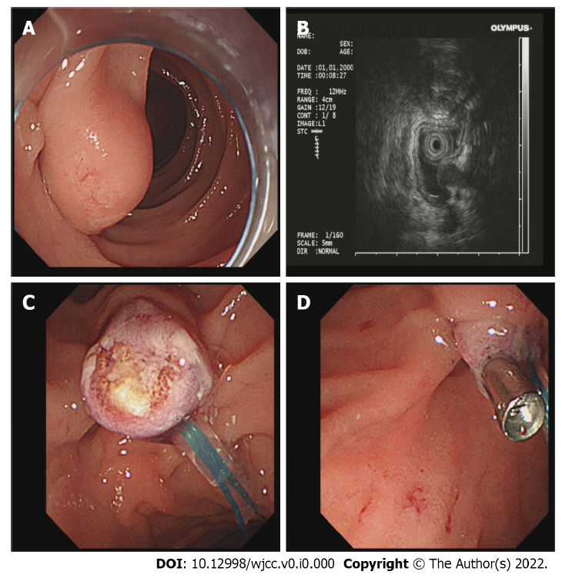
Figure 1 Endoscopic resection of the tumour. A: Tumour in the descending part of the duodenum in the natural state; B: Using endoscopic ultrasonography to explore the tumour; C: Endoscopic electrocoagulation for resection of the tumour; D: A titanium clip was used to clamp the wound to stop the bleeding.
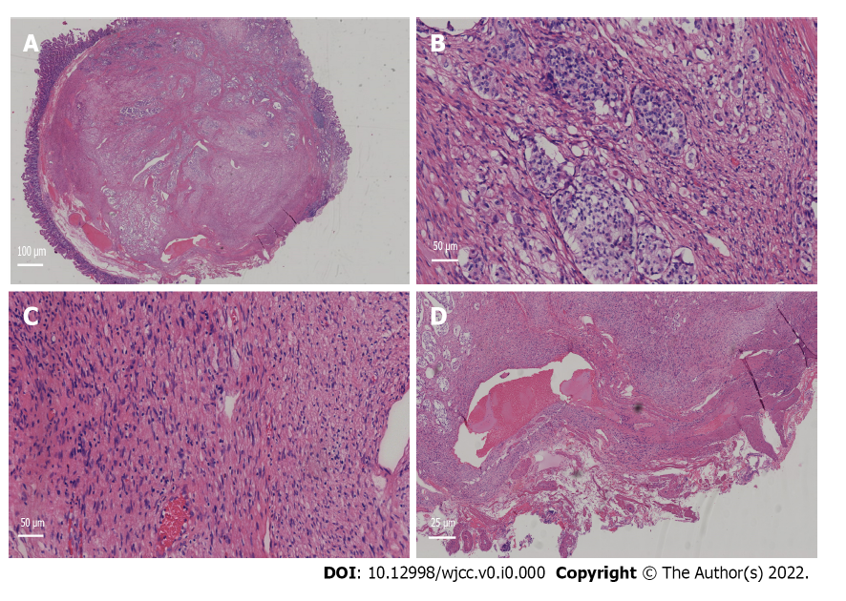
Figure 2 Pathological manifestation of the tumour under a light microscope. A: Pathological tissue (Magnification: 100 ×). The lower right corner is the nesting tissue of the schwannoma, and the rest is the vesicle-like tissue of the neuroendocrine tumour; B: Neuroendocrine tumour tissue (Magnification: 200 ×); C: Schwannoma tissue (Magnification: 200 ×); D: The vertical incisal margin was negative, and there was no lymphatic vascular invasion (Magnification: 400 ×).
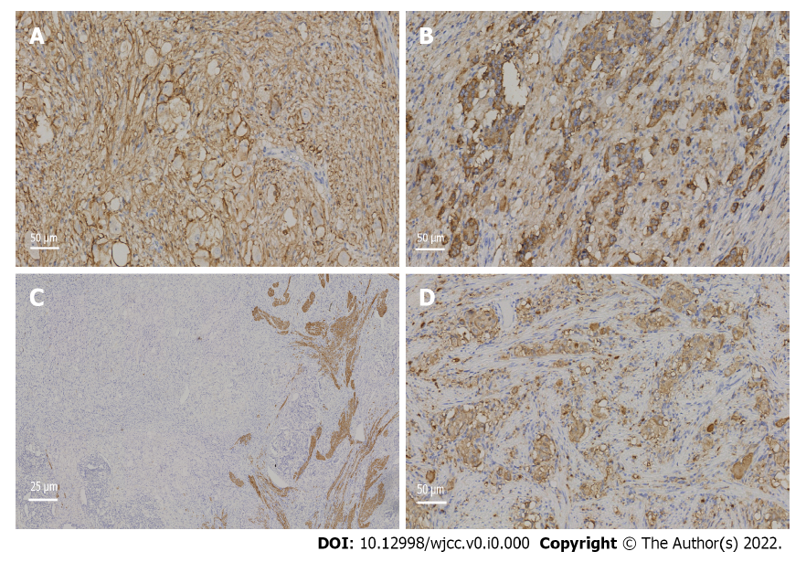
Figure 3 Immunohistochemical neuroendocrine tumour results. A: CD56⁺ (Magnification: 200 ×); B: Chromogranin A+ (Magnification: 200 ×); C: Desmin+ (Magnification: 400 ×); D: Synaptophysin+ (Magnification: 200 ×).
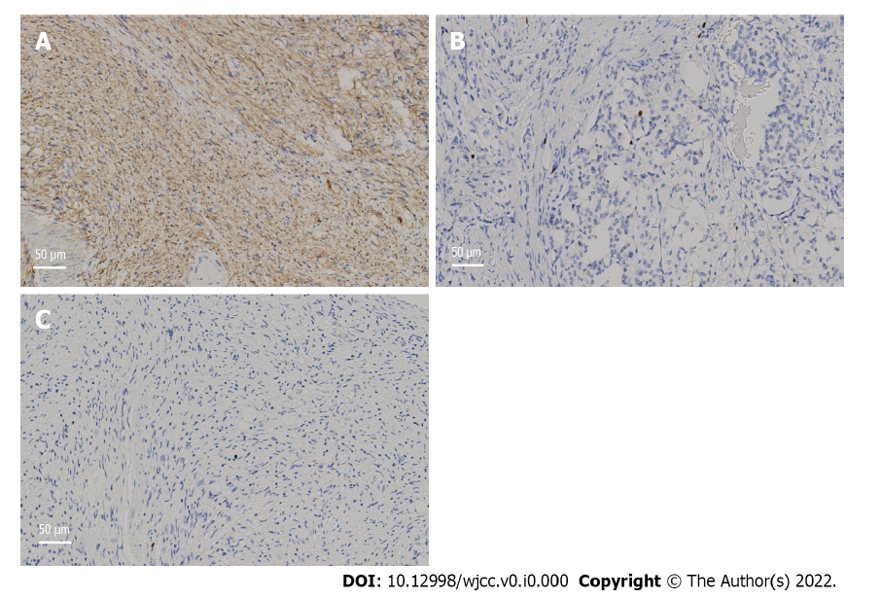
Figure 4 Immunohistochemical results. A: S100+ expression in schwannoma (Magnification: 200 ×); B: The antigen KI-67 index of the neuroendocrine tumour was approximately 1% (Magnification: 200 ×); C: The KI-67 index of the schwannoma was approximately 1% (Magnification: 200 ×).

