Name of Journal: World Journal of Clinical Cases
Manuscript NO: 69783
Manuscript Type: CASE REPORT

Heart failure as an adverse effect of infliximab for Crohn's disease: A case report and review of the literature

Grillo TG et al. Heart failure as adverse effect of infliximab

Thais Gagno Grillo, Luciana Rocha Almeida, Rodrigo Fedatto Beraldo, Mariana Barros Marcondes, Diego Aparecido Rios Queiróz, Daniel Luiz da Silva, Rodrigo Quera, Julio Pinheiro Baima, Rogerio Saad-Hossne, Ligia Yukie Sassaki

Thais Gagno Grillo, Luciana Rocha Almeida, Rodrigo Fedatto Beraldo, Mariana Barros Marcondes, Diego Aparecido Rios Queiróz, Julio Pinheiro Baima, Rogerio Saad-Hossne, Ligia Yukie Sassaki, Department of Internal Medicine, São Paulo State University (Unesp), Medical School, Botucatu 18618687, São Paulo, Brazil

Daniel Luiz da Silva, Department of Pathology, São Paulo State University (Unesp), Medical School, Botucatu 18618687, São Paulo, Brazil

Rodrigo Quera, Inflammatory Bowel Disease Program, Digestive Disease Center Clínica Universidad de los Andes, Santiago 7550000, Chile

Author contributions: All authors contributed to this manuscript; Grillo TG, Almeida LR, Beraldo RF, Marcondes MB, Queiróz DAR, Baima JP, Saad-Hossne R, and Sassaki LY contributed to the conception and design of the study, acquisition, analysis, and interpretation of the data, drafting the article, revising it critically for important intellectual content, and final approval of the version to be submitted; da Silva DL contributed to the description of the histopathological findings, critically reviewing the important intellectual content, and final approval of the version to be submitted; Quera R contributed to the analysis and interpretation of the data, revising the manuscript critically for important intellectual content, and final approval of the version to be submitted.

Corresponding author: Thais Gagno Grillo, MD, Medical Assistant, Department of Internal Medicine, São Paulo State University (Unesp), Medical School, Av. Prof. Mário Rubens Guimarães Montenegro, s/n, Botucatu 18618687, São Paulo, Brazil. thaisgagno@gmail.com

Received: July 11, 2021
Revised: August 8, 2021
Accepted: September 8, 2021
Published online:

Abstract
BACKGROUND
Anti-tumor necrosis factor agents were the first biologic therapy approved for the management of Crohn's disease (CD). Heart failure (HF) is a rare but potential adverse effect of these medications. The objective of this report is to describe a patient with CD who developed HF after the use of infliximab.

CASE SUMMARY
A 50-year-old woman with a history of hypertension and diabetes presented with abdominal pain, diarrhea, and weight loss. Colonoscopy and enterotomography showed ulcerations, areas of stenosis and dilation in the terminal ileum, and thickening of the intestinal wall. The patient underwent ileocolectomy and the surgical specimen confirmed the diagnosis of stenosing CD. The patient started infliximab and azathioprine treatment to prevent post-surgical recurrence. At 6 mo after initiating infliximab therapy, the patient complained of dyspnea, orthopnea, and paroxysmal nocturnal dyspnea that gradually worsened. Echocardiography revealed biventricular dysfunction, moderate cardiac insufficiency, an ejection fraction of 36%, and moderate pericardial effusion, consistent with HF. The cardiac disease was considered an infliximab adverse effect and the drug was discontinued. The patient received treatment with diuretics for HF and showed improvement of symptoms and cardiac function. Currently, the patient is using anti-interleukin for CD and is asymptomatic.

CONCLUSION
This reported case supports the need to investigate risk factors for HF in inflammatory bowel disease patients and to consider the risk-benefit of introducing infliximab therapy in such patients presenting with HF risk factors.

Key Words: Heart failure; Infliximab; Anti-tumor necrosis factor therapy; Crohn's disease; Inflammatory bowel disease; Case report

Grillo TG, Almeida LR, Beraldo RF, Marcondes MB, Queiróz DAR, da Silva DL, Quera R, Baima JP, Saad-Hossne R, Sassaki LY. Heart failure as an adverse effect of infliximab for Crohn's disease: A case report and review of the literature. World J Clin Cases 2021; In press

Core Tip: Anti-tumor necrosis factor agents were the first biologic therapy approved for the management of Crohn's disease (CD). While rare, heart failure (HF) is a potential adverse effect of these medications. In this report we describe a patient with CD who developed HF after treatment with infliximab. The clinical, diagnosis, imaging, and treatment details are all provided and discussed in this case report. This reported case supports the need to investigate risk factors for HF in inflammatory bowel disease patients and to consider the risk-benefit of introducing infliximab therapy in such patients presenting with HF risk factors.

INTRODUCTION
Infliximab is a monoclonal antibody against tumor necrosis factor (TNF) and has revolutionized the treatment of Crohn's disease (CD)^{[1]}. Despite its effectiveness in promoting clinical and endoscopic responses^{[2]}, the medication is not free from adverse events, such as anaphylactic reactions, increased risk of infections and neoplasms such as lymphomas, appearance of autoimmune diseases such as psoriasis and systemic lupus erythematosus, and more rarely, heart failure (HF)^{[3,4]}.
HF is a clinical syndrome resulting from structural and functional cardiac abnormalities, resulting in insufficient supply of oxygen and nutrients to tissues^{[5]}. The prevalence of HF worldwide is 23 million people^{[5]}. The role of TNF in the pathophysiology of HF is controversial. However, Levine et al^{[6]} demonstrated increased serum levels of TNF in patients with advanced HF and Torre-Amione et al^{[7]} showed that TNF levels correlate with disease severity. Furthermore, clinical studies of agents that promote TNF blockade were initially promising^{[8-10]}. However, large-scale randomized studies were discontinued as the results showed no improvement in HF or mortality^{[11]}. Moreover, the use of infliximab is associated with worse outcomes in some HF patients, showing that TNF blockers may exacerbate or even trigger HF^{[12]}. The current case report describes a patient with CD who manifested HF after treatment with infliximab. In addition, the current relevant literature is reviewed.

CASE PRESENTATION
Chief complaints
A 50-year-old woman with previous resection of the small intestine due to a stenosing CD disease, receiving treatment with infliximab, presented in the Emergency Room complaining of dyspnea, orthopnea, and paroxysmal nocturnal dyspnea.

History of present illness
In 2016, the patient presented with diarrhea with 10 liquid bowel movements/day associated with abdominal pain, nausea, vomiting, and weight loss of 25 kg over 6 mo. Physical examination revealed a 10-cm mass in the mesogastric region. Colonoscopy showed ulcerated stenosis of the ileocecal regions and the anatomopathological examination was consistent with nonspecific colitis with mild inflammatory activity. Abdominal ultrasound showed a segmental inflammatory process in the small intestine. Small bowel follow-through (Figure 1) and computed tomography enterography (Figure 2) showed irregularities in the mucosa consistent with ulcerations in the small intestine, stenosis and dilation in the terminal ileum, and thickening of the intestinal wall with hypervascularity of the mesentery and vascular dilatation (comb sign). Based on these clinical findings, a suspicion of small bowel CD was raised. The patient opted for an exploratory laparotomy in 2018, in which thickening of the terminal ileum was observed, and an ileocolectomy (70 cm) with ileus-ascending-anastomosis was performed (Figure 3). Anatomopathological (Figure 4) evaluation showed the presence of extensive longitudinal ulcerations, marked fibrosis of the submucosa, muscular hypertrophy, and subserous lymphoid accumulations, suggesting chronic inflammation and consistent with fibro-stenosing CD. Due to extensive resection of the small intestine and presence of residual lesions, combined treatment with infliximab (5 mg/kg) and azathioprine (2 mg/kg/d) was chosen. Colonoscopy performed 6 mo after initiation of the treatment showed four erosions in the ileocolonic anastomosis and one ulcer in the neo-terminal ileum (Rutgeerts score i2). Due to the endoscopic observed activity, the dose of infliximab was increased to 10 mg/kg. Infliximab and anti-infliximab antibody trough levels were not available. Thirty days after infliximab dose optimization, the patient complained of dyspnea, orthopnea, and paroxysmal nocturnal dyspnea. She reported the onset of mild symptoms with progressive worsening since the introduction of infliximab.

History of past illness
The patient presented a medical history of diabetes and arterial hypertension was treated with glibenclamide, losartan, and hydrochlorothiazide.

Personal and family history
There was no family history.

Physical examination
On physical examination, the patient presented with tachypnea (26 rpm), tachycardia (116 bpm), jugular venous distension, right hypochondrial pain, hepatomegaly (3 cm), and lower limb edema.

Imaging examinations
Chest radiography showed an increase in the cardiac area. Electrocardiogram findings included sinus rhythm, signs of left atrial overload, and alteration of diffuse repolarization with strain pattern of V4-V6. Echocardiography revealed biventricular dysfunction, moderate HF, and an ejection fraction of 36%. Coronary angiography was performed, and coronary artery disease was ruled out.

FINAL DIAGNOSIS
The final diagnosis was HF as an adverse effect of infliximab therapy.

TREATMENT
The infliximab was withdrawal and furosemide was prescribed. Significant improvement in symptoms was noted after 5 d of modified treatment. The patient started treatment for HF with enalapril, carvedilol, spironolactone, and amlodipine and remained asymptomatic. A new echocardiography examination showed an ejection fraction of 42%, moderate systolic dysfunction with diffuse hypokinesia, eccentric hypertrophy, significant increase of left atrium, restrictive diastolic dysfunction, mild insufficiency of aortic and tricuspid valves, and mild pulmonary arterial hypertension (42 mmHg).

OUTCOME AND FOLLOW-UP
After discontinuation of the anti-TNF therapy, the patient started exhibiting symptoms of CD activity, such as diarrhea, abdominal pain, fatigue, and weight loss. The patient then started treatment for CD with anti-IL-23 (investigational product) with significant improvement of symptoms. Currently, she has three evacuations per day with no bleeding or abdominal pain. Colonoscopy showed more than five aphthous ulcers < 5 mm each in the neo-terminal ileum without lesions in the anastomosis (Rutgeerts score i2). The patient will undergo a new colonoscopy after one year of therapy.

DISCUSSION
Treatment of CD aims for clinical and endoscopic remission and includes the use of antibiotics, steroids, immunosuppressants, and biological therapies including anti-TNF, anti-integrin, and anti-interleukin agents^{[13,14]}. Anti-TNF agents include infliximab, adalimumab, and certolizumab^{[2]} and are indicated in patients refractory or intolerant to corticosteroids, thiopurines, and methotrexate.
The choice of the drug should take into account the location, activity, and severity of the disease, response to previous therapies, presence of complications, medication efficacy, and development of side effects, in addition to the presence of extra-intestinal manifestations^{[13,15]}. Individual patient characteristics, such as preference for route of administration, costs, and risk benefit of the drugs, should also be assessed^{[13,15]}. In the current reported case, infliximab combined with azathioprine was chosen as the therapeutic option, taking into account access to medication and the patient's preference for intravenous administration. These drugs were provided by the state's high-cost drug dispensing program^{[16]}.
Anti-TNF agents have good long-term safety profiles^{[17]}. Contraindications for their use include the presence of active infection, demyelinating disease, cancer, and HF [absolute in the New York Heart Association (NYHA) Functional Classification NYHA III–IV and relative in NYHA II]^{[18,19]}. The patient in the current report had risk factors for the development of cardiovascular disease, such as hypertension and diabetes, but had no previous diagnosis or symptoms suggesting HF at the time that infliximab was prescribed. The patient had no previous echocardiogram. The consensus regarding the treatment of inflammatory bowel disease (IBD)^{[14,20]} does not recommend screening or assessment of cardiac function before initiating anti-TNF therapy. According to the American Heart Failure guidelines^{[21]}, there is evidence supporting the use of brain natriuretic peptides (BNP) to aid in the diagnosis or exclusion of HF as a cause of symptoms. These biomarkers are increasingly being used in population screening to detect incident HF, despite not having a formal recommendation^{[21]} or being available for use in clinical practice.
The ATTACH (Anti-TNF Therapy Against Congestive Heart failure) trial^{[3]} evaluated the efficacy and safety of infliximab in patients with moderate to severe HF (NYHA classes III and IV). The study found that symptoms worsened and concluded that short-term TNF-α antagonism did not demonstrate a benefit and was associated with greater occurrence of adverse events and mortality. Therefore, their use is not indicated under these conditions. Kwon et al^{[22]} followed patients with rheumatoid arthritis, psoriatic arthritis, and CD that were treated with anti-TNF (etanercept or infliximab) and observed 47 patients who developed HF, of which 81% had no previous symptoms and 19% had worsening of preexisting symptoms. Among those who developed HF, 50% did not have risk factors, such as myocardial infarction, coronary disease, hypertension, or diabetes^{[22]}. The average interval between the first anti-TNF infusion and diagnosis of HF was 3.5 mo (24 h to 24 mo)^{[22]}. The mean age of the patients was 62 years^{[22]}, demonstrating that HF ​​can manifest at any time during the use of the medication, even in patients without a diagnosis or previous symptoms. In our current case, we observed clinical and echocardiographic manifestations of HF 8 mo after the first infusion of infliximab, despite reports of symptoms beginning since the first infusion. However, the symptoms were mild and not considered by the patient after the first infusion. She only reported symptoms when they became disabling after the dose of the medication was increased.
Studies have sought to clarify the precise role of TNF-α in the regulation of cardiac function in patients with IBD, especially in the progression of HF^{[23]}. The biological activity of TNF-α seems to be related to its serum concentration. At low levels, it induces local inflammation with the expression of adhesion molecules and stimulates the production of IL-1. At an increased level, systemic effects can be observed, such as fever, increases in acute phase reagents, cachexia, hypotension, and cardiovascular collapse^{[18]}. Its intracellular effects occur by binding to two membrane receptors, TNF receptors 1 and 2 (TNFR1 and TNFR2)^{[24]}. TNFR1 is expressed in most cells of the immune system and other systems, such as the heart, and mediates pro-inflammatory and pro-apoptotic signals^{[18]}. In contrast, TNFR2 is found in hematopoietic and endothelial cells and is related to survival pathways^{[18]}. There is also induction of complement-dependent and antibody-dependent cytotoxicity through the binding to transmembrane TNF expressed in cells^{[25]}. TNF-α contributes to the progression of HF by inducing uncoupling of the β-adrenergic receptor, increasing the reaction of oxygen species formation, promoting the synthesis of nitric oxide contributing to contractile dysfunction, and increasing IL-6 and IL-1 levels, which increase myocardial dysfunction^{[26]}. Structural changes such as reduced left ventricular function and left ventricular dilation, in addition to severe changes such as hypertrophy, apoptosis, and cardiac fibrosis, may be observed in patients with sustained TNF-α expression in the myocardium^{[27]}.
Reverse signaling is another mechanism responsible for the cardiotoxic effects of TNF-α. Transmembrane TNF produced by cardiac cells functions as a receptor for anti-TNF agents, which serves as a signal for the production of more TNF-α in the tissue and thereby increases cardiotoxicity^{[28,29]}. Therefore, drug-induced HF should be suspected in patients who develop HF after receiving any anti-TNF therapy and discontinuation of medication is recommended in these cases^{[26]}. In a meta-analysis conducted by Kwon et al^{[22]}, ten patients under 50 years of age who developed HF after the use of anti-TNF were evaluated. Of these patients, nine discontinued the medication, three presented complete HF resolution, six presented partial improvement, and one died. In the current case, infliximab was discontinued, and diuretic therapy was initiated for HF treatment. The patient showed improvement of symptoms and echocardiographic parameters after discontinuation of the anti-TNF; however, complete recovery of cardiac function was not achieved.
The mechanism by which infliximab causes HF in patients with CD remains uncertain. As such adverse events in populations using these medications are under-reported, it is difficult to infer a causal relationship. Attention should be paid to the recent development or exacerbation of HF in patients who have started anti-TNF therapy. Should this occur, biological therapy with another mechanism of action should be considered.
We believe that the reported patient probably had previous asymptomatic cardiac structural damage, related to presented risk factors such as diabetes mellitus and arterial hypertension, characterizing stage B of AHA/ACC classification^{[30]}. With exposure to infliximab, especially after dose optimization to 10 mg/kg, HF decompensation could be observed. Thus, we could assume that exposure to infliximab was the main causal factor related to the onset of acute HF in this patient, who probably had previous structural heart disease.
Patients with symptomatic HF are classified as having AHA/ACC C or D stage, and their symptoms are qualified according to a symptomatic score, with NYHA being the most used score of them^{[30]}. In patients with severe symptomatic HF NYHA III and IV, the recommendation is to avoid use of infliximab^{[18,19]}. In patients with HF and mild symptoms (NYHA I and II), who worsen after using infliximab, it is recommended to discontinue the medication to assess cardiac function and to start the adequate treatment for the cardiac condition. However, there are no recommendations for asymptomatic patients, in AHA/ACC stages A or B. Stage A of the AHA/ACC classification includes patients at increased risk of developing HF but without cardiac damage or any cardiac symptoms. Stage B comprises patients with structural or functional cardiac damage, but asymptomatic^{[30]}.
We recommend for patients in AHA/ACC stage A who are indicated to use infliximab: (1) Pre-treatment basal BNP dosage; (2) strict control of associated comorbidities such as diabetes mellitus, arterial hypertension, and coronary artery disease; (3) close monitoring of signs and symptoms of HF after starting treatment with infliximab; and (4) infliximab concentration monitoring and dose correction according to the therapeutic target.
The recommendations for patients in stage B of the AHA/ACC are: (1) Pretreatment echocardiography in patients with baseline BNP levels above the reference value for outpatients; (2) if echocardiography (current or previous < 5 years) is normal or with minimal change, the recommendations are the same for patients in stage A of the AHA/ACC, as detailed above; and (3) if echocardiography (current or previous) shows signs of structural and/or functional heart disease, it is recommended to start infliximab after adequate control of comorbidities, and introduction and dose adjustment of beta-blockers and angiotensin converting enzyme inhibitors or angiotensin receptor blockers. In addition, it is recommended to avoid other medications that potentially cause HF decompensation, use dose of 5 mg/kg for infliximab, other specialties medical monitoring, and strictly monitor signs and symptoms of HF. We also emphasize the need for further studies on this topic.
In the present case, other possible causal factors of HF have been ruled out. Chagasic myocarditis, an endemic disease in Latin America caused by infection by Trypanosoma cruzi, was ruled out by Chagas negative serology and the absence of electrocardiographic findings of the disease such as conduction disorders, low QRS voltage, arrhythmias, and changes in the QT interval^{[31]}. Viral myocarditis is an important differential diagnosis in the face of acute HF in an immunosuppressed patient. However, the patient did not present infectious symptoms, common in this type of infection, and there was an improvement with the suspension of anti-TNF. Endomyocardial biopsy, indicated for confirmation of viral myocarditis, was not performed due to the absence of criteria for the procedure, such as the presence of ventricular arrhythmias or atrioventricular block, hemodynamic instability, or lack of therapeutic response^{[32]}. The acute coronary syndrome was excluded through cardiac catheterization.

CONCLUSION
The reported case supports the need to investigate risk factors for HF in IBD patients and to consider the risk-benefit of introducing anti-TNF therapy in such patients presenting HF risk factors.

REFERENCES
1 Rahier JF, Ben-Horin S, Chowers Y, Conlon C, De Munter P, D'Haens G, Domènech E, Eliakim R, Eser A, Frater J, Gassull M, Giladi M, Kaser A, Lémann M, Moreels T, Moschen A, Pollok R, Reinisch W, Schunter M, Stange EF, Tilg H, Van Assche G, Viget N, Vucelic B, Walsh A, Weiss G, Yazdanpanah Y, Zabana Y, Travis SP, Colombel JF; European Crohn's and Colitis Organisation (ECCO). European evidence-based Consensus on the prevention, diagnosis and management of opportunistic infections in inflammatory bowel disease. J Crohns Colitis 2009; 3: 47-91 [PMID: 21172250 DOI: 10.1016/j.crohns.2009.02.010]
2 Gomollón F, Dignass A, Annese V, Tilg H, Van Assche G, Lindsay JO, Peyrin-Biroulet L, Cullen GJ, Daperno M, Kucharzik T, Rieder F, Almer S, Armuzzi A, Harbord M, Langhorst J, Sans M, Chowers Y, Fiorino G, Juillerat P, Mantzaris GJ, Rizzello F, Vavricka S, Gionchetti P; ECCO. 3rd European Evidence-based Consensus on the Diagnosis and Management of Crohn's Disease 2016: Part 1: Diagnosis and Medical Management. J Crohns Colitis 2017; 11: 3-25 [PMID: 27660341 DOI: 10.1093/ecco-jcc/jjw168]
3 Chung ES, Packer M, Lo KH, Fasanmade AA, Willerson JT; Anti-TNF Therapy Against Congestive Heart Failure Investigators. Randomized, double-blind, placebo-controlled, pilot trial of infliximab, a chimeric monoclonal antibody to tumor necrosis factor-alpha, in patients with moderate-to-severe heart failure: results of the anti-TNF Therapy Against Congestive Heart Failure (ATTACH) trial. Circulation 2003; 107: 3133-3140 [PMID: 12796126 DOI: 10.1161/01.CIR.0000077913.60364.D2]
4 Scheinfeld N. A comprehensive review and evaluation of the side effects of the tumor necrosis factor alpha blockers etanercept, infliximab and adalimumab. J Dermatolog Treat 2004; 15: 280-294 [PMID: 15370396 DOI: 10.1080/09546630410017275]
5 Stanciu AE. Cytokines in heart failure. Adv Clin Chem 2019; 93: 63-113 [PMID: 31655733 DOI: 10.1016/bs.acc.2019.07.002]
6 Levine B, Kalman J, Mayer L, Fillit HM, Packer M. Elevated circulating levels of tumor necrosis factor in severe chronic heart failure. N Engl J Med 1990; 323: 236-241 [PMID: 2195340 DOI: 10.1056/NEJM199007263230405]
7 Torre-Amione G, Kapadia S, Benedict C, Oral H, Young JB, Mann DL. Proinflammatory cytokine levels in patients with depressed left ventricular ejection fraction: a report from the Studies of Left Ventricular Dysfunction (SOLVD). J Am Coll Cardiol 1996; 27: 1201-1206 [PMID: 8609343 DOI: 10.1016/0735-1097(95)00589-7]
8 Sliwa K, Skudicky D, Candy G, Wisenbaugh T, Sareli P. Randomised investigation of effects of pentoxifylline on left-ventricular performance in idiopathic dilated cardiomyopathy. Lancet 1998; 351: 1091-1093 [PMID: 9660578 DOI: 10.1016/S0140-6736(97)09338-0]
9 Deswal A, Bozkurt B, Seta Y, Parilti-Eiswirth S, Hayes FA, Blosch C, Mann DL. Safety and efficacy of a soluble P75 tumor necrosis factor receptor (Enbrel, etanercept) in patients with advanced heart failure. Circulation 1999; 99: 3224-3226 [PMID: 10385494 DOI: 10.1161/01.cir.99.25.3224]
10 Bozkurt B, Torre-Amione G, Warren MS, Whitmore J, Soran OZ, Feldman AM, Mann DL. Results of targeted anti-tumor necrosis factor therapy with etanercept (ENBREL) in patients with advanced heart failure. Circulation 2001; 103: 1044-1047 [PMID: 11222463 DOI: 10.1161/01.cir.103.8.1044]
11 Louis A, Cleland JG, Crabbe S, Ford S, Thackray S, Houghton T, Clark A. Clinical Trials Update: CAPRICORN, COPERNICUS, MIRACLE, STAF, RITZ-2, RECOVER and RENAISSANCE and cachexia and cholesterol in heart failure. Highlights of the Scientific Sessions of the American College of Cardiology, 2001. Eur J Heart Fail 2001; 3: 381-387 [PMID: 11378012 DOI: 10.1016/s1388-9842(01)00149-0]
12 Page RL 2nd, O'Bryant CL, Cheng D, Dow TJ, Ky B, Stein CM, Spencer AP, Trupp RJ, Lindenfeld J; American Heart Association Clinical Pharmacology and Heart Failure and Transplantation Committees of the Council on Clinical Cardiology; Council on Cardiovascular Surgery and Anesthesia; Council on Cardiovascular and Stroke Nursing; and Council on Quality of Care and Outcomes Research. Drugs That May Cause or Exacerbate Heart Failure: A Scientific Statement From the American Heart Association. Circulation 2016; 134: e32-e69 [PMID: 27400984 DOI: 10.1161/CIR.0000000000000426]
13 Lichtenstein GR, Loftus EV, Isaacs KL, Regueiro MD, Gerson LB, Sands BE. ACG Clinical Guideline: Management of Crohn's Disease in Adults. Am J Gastroenterol 2018; 113: 481-517 [PMID: 29610508 DOI: 10.1038/ajg.2018.27]
14 Torres J, Bonovas S, Doherty G, Kucharzik T, Gisbert JP, Raine T, Adamina M, Armuzzi A, Bachmann O, Bager P, Biancone L, Bokemeyer B, Bossuyt P, Burisch J, Collins P, El-Hussuna A, Ellul P, Frei-Lanter C, Furfaro F, Gingert C, Gionchetti P, Gomollon F, González-Lorenzo M, Gordon H, Hlavaty T, Juillerat P, Katsanos K, Kopylov U, Krustins E, Lytras T, Maaser C, Magro F, Marshall JK, Myrelid P, Pellino G, Rosa I, Sabino J, Savarino E, Spinelli A, Stassen L, Uzzan M, Vavricka S, Verstockt B, Warusavitarne J, Zmora O, Fiorino G. ECCO Guidelines on Therapeutics in Crohn's Disease: Medical Treatment. J Crohns Colitis 2020; 14: 4-22 [PMID: 31711158 DOI: 10.1093/ecco-jcc/jjz180]
15 Maaser C, Sturm A, Vavricka SR, Kucharzik T, Fiorino G, Annese V, Calabrese E, Baumgart DC, Bettenworth D, Borralho Nunes P, Burisch J, Castiglione F, Eliakim R, Ellul P, González-Lama Y, Gordon H, Halligan S, Katsanos K, Kopylov U, Kotze PG, Krustinš E, Laghi A, Limdi JK, Rieder F, Rimola J, Taylor SA, Tolan D, van Rheenen P, Verstockt B, Stoker J; European Crohn’s and Colitis Organisation [ECCO] and the European Society of Gastrointestinal and Abdominal Radiology [ESGAR]. ECCO-ESGAR Guideline for Diagnostic Assessment in IBD Part 1: Initial diagnosis, monitoring of known IBD, detection of complications. J Crohns Colitis 2019; 13: 144-164 [PMID: 30137275 DOI: 10.1093/ecco-jcc/jjy113]
16 Ministry of Health, Brazil. Crohn's Disease Clinical Protocol and Therapeutic Guidelines. 2017. [cited 1 July 2021]. Available from: http://conitec.gov.br/images/Protocolos/Portaria_Conjunta_14_PCDT_Doenca_de_Crohn_28_11_2017.pdf
17 Lin J, Ziring D, Desai S, Kim S, Wong M, Korin Y, Braun J, Reed E, Gjertson D, Singh RR. TNFalpha blockade in human diseases: an overview of efficacy and safety. Clin Immunol 2008; 126: 13-30 [PMID: 17916445 DOI: 10.1016/j.clim.2007.08.012]
18 Cacciapaglia F, Navarini L, Menna P, Salvatorelli E, Minotti G, Afeltra A. Cardiovascular safety of anti-TNF-alpha therapies: facts and unsettled issues. Autoimmun Rev 2011; 10: 631-635 [PMID: 21539939 DOI: 10.1016/j.autrev.2011.04.014]
19 Orlando A, Armuzzi A, Papi C, Annese V, Ardizzone S, Biancone L, Bortoli A, Castiglione F, D'Incà R, Gionchetti P, Kohn A, Poggioli G, Rizzello F, Vecchi M, Cottone M; Italian Society of Gastroenterology; Italian Group for the study of Inflammatory Bowel Disease. The Italian Society of Gastroenterology (SIGE) and the Italian Group for the study of Inflammatory Bowel Disease (IG-IBD) Clinical Practice Guidelines: The use of tumor necrosis factor-alpha antagonist therapy in inflammatory bowel disease. Dig Liver Dis 2011; 43: 1-20 [PMID: 20843756 DOI: 10.1016/j.dld.2010.07.010]
20 Brazilian Study Group of Inflammatory Bowel Disease. Consensus guidelines for the management of inflammatory bowel disease. Arq Gastroenterol 2010; 47: 313-325 [PMID: 21140096 DOI: 10.1590/s0004-28032010000300019]
21 Yancy CW, Jessup M, Bozkurt B, Butler J, Casey DE Jr, Colvin MM, Drazner MH, Filippatos GS, Fonarow GC, Givertz MM, Hollenberg SM, Lindenfeld J, Masoudi FA, McBride PE, Peterson PN, Stevenson LW, Westlake C. 2017 ACC/AHA/HFSA Focused Update of the 2013 ACCF/AHA Guideline for the Management of Heart Failure: A Report of the American College of Cardiology/American Heart Association Task Force on Clinical Practice Guidelines and the Heart Failure Society of America. J Am Coll Cardiol 2017; 70: 776-803 [PMID: 28461007 DOI: 10.1016/j.jacc.2017.04.025]
22 Kwon HJ, Coté TR, Cuffe MS, Kramer JM, Braun MM. Case reports of heart failure after therapy with a tumor necrosis factor antagonist. Ann Intern Med 2003; 138: 807-811 [PMID: 12755552 DOI: 10.7326/0003-4819-138-10-200305200-00008]
23 Khanna D, McMahon M, Furst DE. Anti-tumor necrosis factor alpha therapy and heart failure: what have we learned and where do we go from here? Arthritis Rheum 2004; 50: 1040-1050 [PMID: 15077286 DOI: 10.1002/art.20164]
24 Parameswaran N, Patial S. Tumor necrosis factor-α signaling in macrophages. Crit Rev Eukaryot Gene Expr 2010; 20: 87-103 [PMID: 21133840 DOI: 10.1615/critreveukargeneexpr.v20.i2.10]
25 Sfikakis PP. The first decade of biologic TNF antagonists in clinical practice: lessons learned, unresolved issues and future directions. Curr Dir Autoimmun 2010; 11: 180-210 [PMID: 20173395 DOI: 10.1159/000289205]
26 Sinagra E, Perricone G, Romano C, Cottone M. Heart failure and anti tumor necrosis factor-alpha in systemic chronic inflammatory diseases. Eur J Intern Med 2013; 24: 385-392 [PMID: 23333028 DOI: 10.1016/j.ejim.2012.12.015]
27 Kleinbongard P, Heusch G, Schulz R. TNFalpha in atherosclerosis, myocardial ischemia/reperfusion and heart failure. Pharmacol Ther 2010; 127: 295-314 [PMID: 20621692 DOI: 10.1016/j.pharmthera.2010.05.002]
28 Eissner G, Kirchner S, Lindner H, Kolch W, Janosch P, Grell M, Scheurich P, Andreesen R, Holler E. Reverse signaling through transmembrane TNF confers resistance to lipopolysaccharide in human monocytes and macrophages. J Immunol 2000; 164: 6193-6198 [PMID: 10843670 DOI: 10.4049/jimmunol.164.12.6193]
29 Juhász K, Buzás K, Duda E. Importance of reverse signaling of the TNF superfamily in immune regulation. Expert Rev Clin Immunol 2013; 9: 335-348 [PMID: 23557269 DOI: 10.1586/eci.13.14]
30 Yancy CW, Jessup M, Bozkurt B, Butler J, Casey DE Jr, Drazner MH, Fonarow GC, Geraci SA, Horwich T, Januzzi JL, Johnson MR, Kasper EK, Levy WC, Masoudi FA, McBride PE, McMurray JJ, Mitchell JE, Peterson PN, Riegel B, Sam F, Stevenson LW, Tang WH, Tsai EJ, Wilkoff BL; American College of Cardiology Foundation; American Heart Association Task Force on Practice Guidelines. 2013 ACCF/AHA guideline for the management of heart failure: a report of the American College of Cardiology Foundation/American Heart Association Task Force on Practice Guidelines. J Am Coll Cardiol 2013; 62: e147-e239 [PMID: 23747642 DOI: 10.1016/j.jacc.2013.05.019]
31 Cooper LT Jr. Myocarditis. N Engl J Med 2009; 360: 1526-1538 [PMID: 19357408 DOI: 10.1056/NEJMra0800028]
32 Montera MW, Mesquita ET, Colafranceschi AS, Oliveira AC Jr, Rabischoffsky A, Ianni BM, Rochitte CE, Mady C, Mesquita CT, Azevedo CF, Bocchi EA, Saad EB, Braga FG, Fernandes F, Ramires FJ, Bacal F, Feitosa GS, Figueira HR, Souza Neto JD, Moura LA, Campos LA, Bittencourt MI, Barbosa Mde M, Moreira Mda C, Higuchi Mde L, Schwartzmann P, Rocha RM, Pereira SB, Mangini S, Martins SM, Bordignon S, Salles VA; Sociedade Brasileira de Cardiologia. I Brazilian guidelines on myocarditis and pericarditis. Arq Bras Cardiol 2013; 100: 1-36 [PMID: 23765413 DOI: 10.5935/abc.2013S004]

Footnotes
Informed consent statement: Written informed consent was obtained from the patient for publication of this case report and any accompanying images.

Conflict-of-interest statement: The authors state that they have no conflicts of interest regarding this case report.

CARE Checklist (2016) statement: The authors have read the CARE Checklist (2016) statement, and the manuscript was prepared and revised according to the CARE Statement-checklist of items.

Open-Access: This article is an open-access article that was selected by an in-house editor and fully peer-reviewed by external reviewers. It is distributed in accordance with the Creative Commons Attribution NonCommercial (CC BY-NC 4.0) license, which permits others to distribute, remix, adapt, build upon this work non-commercially, and license their derivative works on different terms, provided the original work is properly cited and the use is non-commercial. See: http://creativecommons.org/Licenses/by-nc/4.0/

Manuscript source: Unsolicited manuscript

Peer-review started: July 11, 2021
First decision: July 26, 2021
Article in press:

Specialty type: Gastroenterology and hepatology
Country/Territory of origin: Brazil
Peer-review report’s scientific quality classification
Grade A (Excellent): 0
Grade B (Very good): 0
Grade C (Good): C, C
Grade D (Fair): 0
Grade E (Poor): 0

P-Reviewer: Vasudevan A, Wen XL S-Editor: Yan JP L-Editor: Wang TQ P-Editor:
Figure Legends

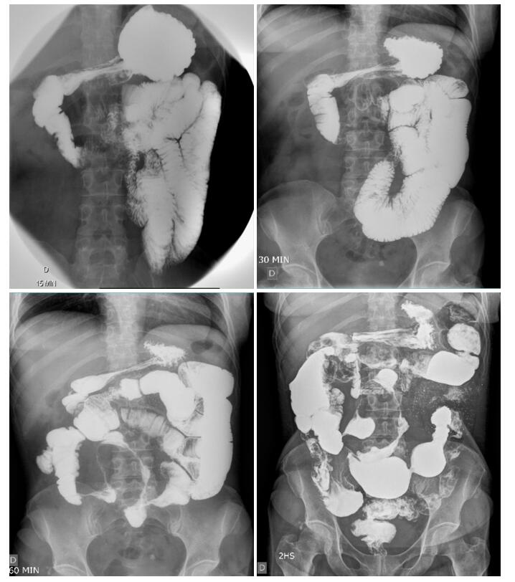
Figure 1 Small bowel follow-through showing accelerated intestinal transit. Areas of stenosis in portions of the ileum, and the ileocecal valve with filiform aspect interspersed with areas of intestinal dilation. Presence of mucous relief irregularity with “cobblestone” images due to filiform ulcerations.

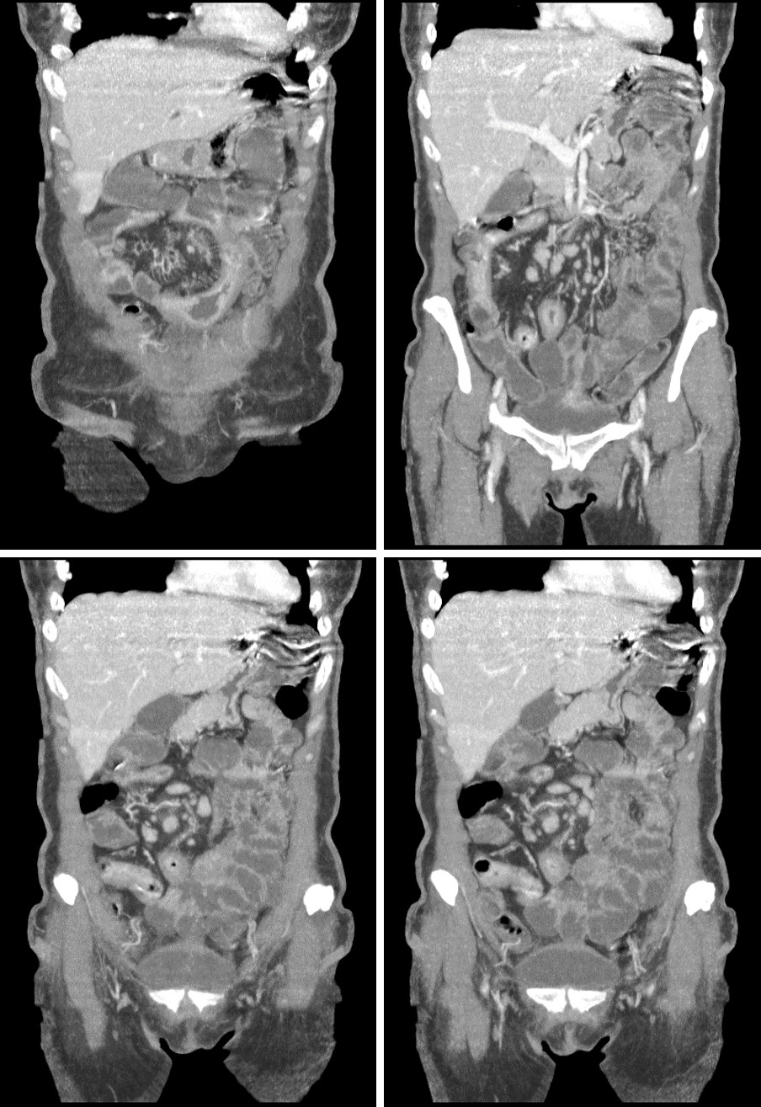
Figure 2 Computed tomography enterography. Mucosal irregularities consistent with ulcerations in the small intestine, stenosis and dilation in the terminal ileum, and thickening of the intestinal wall with hypervascularity of the mesentery and vascular dilatation (comb sign).

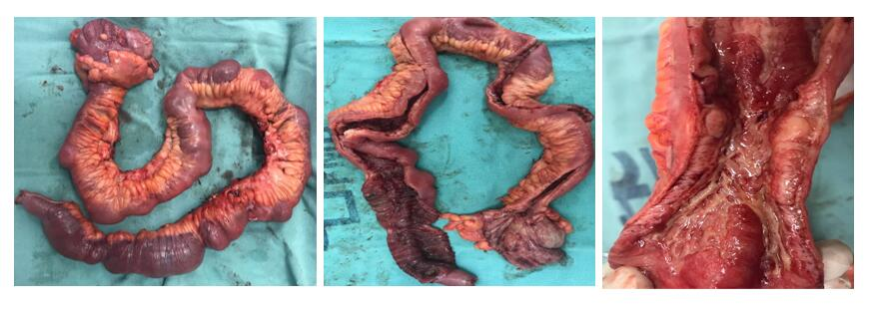
Figure 3 Surgical specimen measuring 70 cm showing severe disease with thickening of the ileum associated with ulcerations, stenosis, and dilation and mesenteric infiltration.

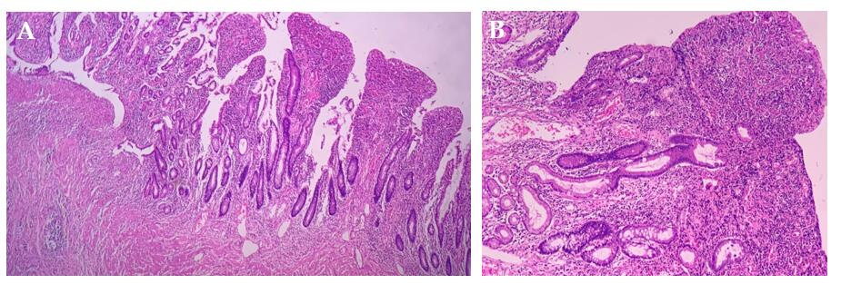
Figure 4 Histopathological diagnosis. A: Chronic transmural inflammation with ulceration, intense submucosal fibrosis, and granulation tissue formation (H&E, 40 ×); B: Chronic colitis with ulceration, extensive chronic inflammatory infiltrate with plasmacytosis, architectural distortion of crypts, and partial loss of goblet cells (H&E, 100 ×).

