Name of journal: World Journal of Gastroenterology
ESPS Manuscript NO: 13237
Columns: ORIGINAL ARTICLES

Negative impact of bone-marrow-derived mesenchymal stem cells on DSS-induced colitis

Nam YS et al. Effects of BM-MSC on IBD

Young-Sun Nam, Nayoun Kim, Keon-Il Im, Jung-Yeon Lim, Eun-Sol Lee, Seok-Goo Cho

Young-Sun Nam, Nayoun Kim, Keon-Il Im, Jung-Yeon Lim, Eun-Sol Lee, Institute for Translational Research and Molecular Imaging, The Catholic University of Korea College of Medicine, Seoul 137-701, South Korea

Seok-Goo Cho, Department of Hematology, Catholic Blood and Marrow Transplantation Center, Seoul St. Mary’s Hospital, Institute for Translational Research and Molecular Imaging, The Catholic niversity of Korea College of Medicine, Seoul 137-701, South Korea

Author contributions: Nam YS performed the majority of experiments and wrote the manuscript; Kim N, Im KI, Lim JY and Lee ES provided analytical tools and the collection of mouse sample; Cho SG designed the study and finally confirmed the manuscript.

Supported by Korea Healthcare Technology R and D Project No. HI12C0193 (A120241), the Ministry for Health, Welfare, and Family Affairs, South Korea

Correspondence to: Seok-Goo Cho, MD, PhD, Professor, Department of Hematology, Catholic Blood and Marrow Transplantation Center, Seoul St. Mary’s Hospital, Institute for Translational Research and Molecular Imaging, The Catholic niversity of Korea College of Medicine, 222 Banpo-daero, Seocho-gu, Seoul 137-701, South Korea. chosg@catholic.ac.kr
Telephone: +82-2-22586052 Fax: +82-2-599-3589

Received: August 13, 2014 Revised: September 5, 2014
Accepted: October 14, 2014

Published online:

Abstract
AIM: To investigate the effects of mesenchymal stem cells (MSCs) on dextran sulphate sodium (DSS)-induced inflammatory bowel disease (IBD).

METHOD: C57BL/6 mice were fed 3.5% (g/L) DSS. On day seven, the mice received intraperitoneal injections of 1 × 10⁶ MSCs. The survival rate, disease activity index values, and body weight, were monitored daily. On day ten, colon lengths and histopathological changes were assessed. In addition, immunoregulatory changes following MSC administration were evaluated by determining the levels of effector T cell responses in the spleen and mesenteric lymph nodes (mLN), and the expression levels of inflammatory cytokines in homogenised colons.

RESULTS: Intraperitoneal administration of MSCs did not prevent development of colitis and did not reduce the clinicopathological severity of IBD. No significant difference was evident in either survival rate or disease activity index score between the control and MSC-treated group. Day-ten-sacrificed mice exhibited no significant difference in either colon length or histopathological findings. Indeed, the MSC-treated group exhibited elevated levels of IL-6 and TGF-β, and a reduced level of IL-10, in spleens, mesenteric lymph nodes (mLN), and homogenised colons. The IL-17 level was lower in the mLN of the MSC-treated group (P = 0.0126). In homogenised colons, the IL-17 and TNF-α (P = 0.0092) expression levels were also lower in the treated group. Although MSCs have been suggested to aid in resolution of IBD, we found no significant histopathological or clinical improvement.

CONCLUSION: Our study suggested that simple infusion of MSCs would have the limitations of therapeutic approach on IBD. Functional enhancement of MSCs is needed in further study.

© 2014 Baishideng Publishing Group Inc. All rights reserved.

Key words: Dextran sodium sulphate; Crohn’s disease; Inflammatory bowel disease; Mesenchymal stem cells; Ulcerative colitis

Core Tip: We evaluated the effects of mesenchymal stem cells (MSCs) on inflammatory bowel disease (IBD). Although MSCs are considered to be useful therapeutic agents for treatment of IBD, their efficacy has not been immunologically confirmed. We found that MSCs did not exert significant effects because the cells cannot restore the immune balance. Also, MSCs did not influence the relative levels of IL-6 and IL-10. Recent studies have shown that MSCs may be effective upon local infusion, or in combination with other agents. Therefore, new approaches toward regulation of the immunoregulatory properties of MSCs are required if such cells are to be used to alleviate IBD.

Nam YS, Kim N, Im KI, Lim JY, Lee ES, Cho SG. Negative impact of bone-marrow-derived mesenchymal stem cells on DSS-induced colitis. World J Gastroenterol 2014; In press
Introduction
The inflammatory bowel diseases (IBDs) are principally Crohn’s disease (CD) and ulcerative colitis (UC). Although the developmental mechanism remains poorly understood, IBD pathogenesis is characterised by the development of an exaggerated immune response to intestinal bacteria in genetically susceptible individuals^{[1,2]}.The current therapies for IBD include anti-TNF-α and anti-IFN-γ antibodies, and anti-α-integrin drugs. Although symptoms are thus relieved, there is no cure. Furthermore, relapse is always a risk. Thus, it is essential to develop more effective therapeutic approaches to treat IBD. Recently, the utility of MSCs has been suggested, because MSCs exert immunosuppressive effects and aid in tissue repair^{[3-8]}.
Some pre-clinical studies explored the utility of MSCs in treatment of IBD^{[9-12]}. MSCs were injected subcutaneously, intravenously, or intraperitoneally, and attenuated IBD. However, the MSCs used had been pre-treated; the cells used included IL-12p40-transduced MSCs; Aire^{-/-}MSCs; and MSCs coated with MAdCAM01 and VCAM-1 antibodies.
Some clinical data on the use of MSCs to treat IBD have appeared^{[13-20]}. MSCs were infused intralesionally or through a fistula, thus not systemically. The work confirmed that MSCs improved fistular pathogenesis. Recently, allogeneic MSCs have been used to treat IBD; the cells were delivered via intralesional or intrafistular injection. Portilla et al^{[15]} considered that local injection was preferable to systemic infusion when IBD was to be treated.
As MSCs exhibit immunomodulatory effects, we hypothesised that MSCs per se would exert therapeutic effects in IBD models. Although MSCs are used to treat autoimmune diseases such as GvHD, rheumatoid arthritis (RA)^{[21-26],} and possible rejection of skin allografts^{[27]}; any potential role for MSCs in IBD treatment remains unclear. Thus, in the present study, we explored the anti-inflammatory actions of mouse bone-marrow-derived MSCs used to treat DSS-induced IBD.

Materials and methods
Mice
Eight-to-ten-week-old female C57BL/6 (B6, H-2k^{b}) mice were purchased from OrientBio (Sungnam, Korea) and were maintained under specific pathogen-free conditions in an animal facility in which the humidity was controlled at 55% (± 5%); with a light/dark cycle of 12 h; and at a temperature of 22°C (± 1°C). The air in the facility was HEPA-filtered to exclude bacteria and viruses. Mouse chow and tap water were available ad libitum. All protocols used were approved by the Animal Care and Use Committee of the Catholic University of Korea.

Induction of DSS-induced colitis
IBD was induced by feeding mice 3.5% (g/L) dextran sulphate sodium (DSS, molecular weight 36-50 ku, MP biomedicals, Illkirch, France) dissolved in UV-sterilised tap water, available ad libitum for seven days. On day seven, all animals were returned to plain water. Survival after DSS administration was monitored daily, and disease activity index (DAI) scores assessed. The DAI evaluates changes in three clinical parameters: weight loss, stool consistency, and rectal bleeding.

Isolation, culture, and administration of MSCs
Donor (C57BL/6, H-2kb) bone marrow cells were collected by flushing mouse femurs and tibias with Dulbecco’s modified Eagle’s medium (Gibco, Carlsbad, CA) supplemented with 15% (mL/L) heat-inactivated foetal bovine serum (FBS) (Gibco). Suspended cells were plated in 95 mm-diameter culture dishes in 1-ml amounts of complete medium, at a density of 2 × 10⁷ cells/mL. Cultures were incubated at 37°C under 5% (mL/L) CO₂ in a humidified chamber. After 3 h, nonadherent cells were removed by changing the medium. Cells at 80% confluence were trypsinised by incubation in 0.5 mL of 0.25% trypsin/1 mmol/L ethylenediaminetetraacetic acid for 2 min at room temperature. Trypsin was neutralised by addition of 1.5 mL of complete medium. Cells were harvested and expanded in 75-T flasks; cultures were maintained at 37°C under 5% (mL/L) CO₂ in a humidified chamber and subcultured before confluence was attained. After 10 passages, the MSCs were surface-stained for c-kit, CD11b, CD34, CD106, CD45, CD31, Sca-1, CD44, and CD29, and were next characterised by flow cytometry. Prior to surface staining, the cells were Fc-blocked with 1 µg of mouse spleen and mLN 1 × 10⁵ cells for 15 min at room temperature. After blocking, 1µl amounts of antibody solutions were added and incubation for 30 min at room temperature followed. Unbound antibody was removed by washing the cells in flow cytometry staining buffer. Mice were injected intraperitoneally (ip) with 1 × 10⁶ MSCs one weeks after DSS induction. Control mice were injected ip with equal volumes of phosphate-buffered saline (PBS) (Gibco) at the same time points.

Flow cytometric analysis
Mononuclear cells were immunostained with various combinations of the following fluorescent-label-conjugated antibodies: CD25-APC (eBioscience, San Diego, CA), CD4-Percp (eBioscience), Foxp3-PE (eBioscience), IFN-γ-APC (eBioscience), IL-4-PE (BD PharMingen, San Jose, CA), IL-17-FITC (eBioscience), and IL-6-PE (BioLegend, San Diego, CA). Before staining for intracellular cytokines, the cells were stimulated in culture medium containing phorbol myristate acetate (25 ng/mL; Sigma-Aldrich, St. Louis. MO), ionomycin (250 ng/mL; Sigma-Aldrich), or monensin (GolgiStop, 1 μl/ml; BD PharMingen) in an incubator under 5% (mL/L) CO₂ at 37°C for 4 h. An intracellular staining kit (eBioscience) was used according to the manufacturer’s protocol. Flow cytometry was performed on a fluorescence-activated cell sorting (FACS) Calibur cytometer (BD PharMingen) running FlowJo software (TreeStar, Ashland, OR).

Histopathological evaluation
Mice were euthanized for blinded histopathological analysis of IBD target tissue (the large intestine). Organs were harvested, cryo-embedded, and sectioned. The sections were fixed in 10% (mL/L) buffered formalin (Sigma-Aldrich) and stained with haematoxylin (Sigma-Aldrich) and eosin Y [1% (g/L) solutions; Muto Pure Chemical Co., Ltd, Tokyo, Japan] prior to histological examination.

Enzyme-linked immunosorbent assay for IFN- γ, IL-17, IL-6, IL-10, TNF-α, and TGF-β
Colons were homogenised in “homogeniser buffer” [50 m mol/L Tris-HCL (pH 7.4), 250 mmol/L NaCl, 5 mmol/L EDTA] with protease inhibitors (Roche, Indianapolis, IN) and centrifuged at 11000 g for 15 min. The resulting supernatants were collected and subjected to sandwich Enzyme-linked immunosorbent assay (ELISA) as follows. Solutions of anti-mouse IFN-γ, IL-17, IL-6, IL-10, TNF-α, and TGF-β (R and D Systems, Minneapolis, MN) were added to wells of a 96-well plate (Nunc, Roskilde, Denmark) and incubated overnight at 4°C. Wells were blocked with blocking solution [PBS with 1% (g/L) bovine serum albumin (BSA) and 0.05% (mL/L) Tween 20] for 2 h at room temperature. The test samples and standard recombinant IFN-γ, IL-17, IL-6, IL-10, TNF-α, and TGF-β (R and D Systems) were added to separate wells of the 96-well plate, and the plate incubated at room temperature for 2 h. The plate was washed, biotinylated antibodies against IFN-γ, IL-17, IL-6, IL-10, and TNF-α; and an anti-TGF-β polyclonal antibody (R and D Systems) added; and reactions allowed to proceed for 2 h at room temperature. The plate was washed, a 2000-fold dilution of ExtrAvidin-alkaline phosphatase (Sigma-Aldrich) added, and the reaction allowed to proceed for a further 2 h. The plate was washed and 50-μL amounts of P-nitrophenyl phosphate disodium salt (Pierce Chemical Company, Rockford, IL) diluted to 1 mg/mL in diethanolamine buffer were added to each well.

Statistical analysis
Data are presented as means ± SD. Using GraphPad Prism (version 5.01), Student’s t-test or analysis of variance was employed to assess the statistical significance of differences between experimental groups. Survival was compared between groups by Kaplan-Meier analysis and using the log-rank test. A P value < 0.05 was considered to indicate statistical significance.

Results
Phenotypes of culture-expanded MSCs
Whole bone marrow cells of C57BL/6 mice were cultured, non-adherent cells removed, and spindle-like cells expanded. Culture-expanded MSCs showed a typical fibroblast-like morphology under the microscope and were uniformly positive for Sca-1, CD44, and CD29; but negative for c-kit, CD11b, CD31, CD34, CD45, CD80, CD86, and CD106 (data not shown).

Clinical outcome of MSC therapy in the DSS-induced IBD model
To explore the effects of MSCs on IBD, we gave single ip injections of donor bone marrow-derived MSCs to DSS-induced IBD mice (Figure 1). C57BL/6 mice were fed 3.5% (g/L) DSS ad libitum from day zero to day six. On day seven, mice received ip injections of 1 × 10⁶ MSCs. The median survival times were ten days for the control group and eleven days for the MSC-treated group. Thus, injection of MSCs did not improve survival (Figure 2A). Also, the DAI scores did not differ between the two groups (Figure 2B), as was also true of body weight changes from day zero (Figure 2C). We concluded that MSCs exerted no significant clinical effect in our IBD model.

Histopathological changes following MSC therapy in the DSS-induced IBD model
On day ten large intestines (from the appendix to the anus) were harvested and colon lengths measured. The median colon lengths were 3.8 cm in the control group and 3.7 cm in the MSC-treated group (Figure 3). The median colon length in normal mice not fed DSS was 6.4 cm. Generally, shorter colon length correlates with the severity of IBD pathogenesis. Our data showed that MSCs did not inhibit the reduction in colon length seen in the IBD model.
Distal colons were harvested on day ten, fixed in 10% (mL/L) buffered formalin, and stained with haematoxylin and eosin (HE). DSS-induced IBD is characterised by goblet cell loss and inflammatory cell infiltration. Unlike normal mice, the control and MSC-treated groups exhibited epithelial disruption, damage to the lamina muscularis mucosae, and submucosal oedema (Figure 4). Thus, MSC treatment did not inhibit the intestinal inflammation seen in the DSS-induced IBD model.

Reciprocal regulation of IL-6 and IL-10 in spleens of mice with DSS-colitis upon MSC therapy
To confirm that MSCs exerted immunoregulatory effects on T-cells, we measured the levels of pro-inflammatory cytokines and helper T-cell cytokines, and that of regulatory T (T_{reg}) cells, by flow cytometry via FACS. The cytokine levels in the MSC-treated group were similar to those in the control group (Figure 5A). The median percentage of IFN-γ in the control group was 1.1%, and 1.02% in the MSC-treated group. The median percentages of IL-4, IL-17, IL-6, IL-10, and T_{reg} cells in the control group were 5.64, 2.63, 1.49, 1.46, and 22.2%, respectively; and those in the MSC-treated group 5.97, 2.41, 1.88, 1.65, and 21.3%, respectively. Figure 5B shows the percentages of cytokines in mLN. The average percentages of IFN-γ, IL-4, IL-6, IL-10, and T_{reg} cells in the control group were 2.24, 4.02, 2.19, 0.89, and 22.65%, respectively; and those in the MSC-treated group 2.53, 6.11, 2.82, 1.57, and 21.15%, respectively. The mean percentage of IL-17 in the control group was 2.61% and that in the MSC-treated group 1.92% (P = 0.0126). Although the level of IL-17 in mLN was slightly higher in the MSC-treated group, the levels of most other cytokines, including IFN-γ, IL-4, IL-6, and IL-10; and T_{reg} cells, did not differ significantly between the groups. Interestingly, in the spleen, the percentage of IL-6 was elevated and that of IL-10 reduced in the MSC-treated group.

Changes in the cytokine profile of homogenised colonic tissue of DSS-treated mice after MSC therapy
Finally, we analysed homogenised colon supernatants via ELISA to explore the local immunoregulatory effects of MSCs. Mouse colons were harvested on day ten after DSS treatment, faeces was removed and the colons homogenised in a buffer containing protease inhibitors. The levels of IFN-γ, IL-17, TNF-α, and TGF-β were lower in the MSC-treated compared to the control group; the levels of IFN-γ, IL-17, TNF-α, and TGF-β in the control group were 4010.58, 14.42, 24.94, and 269.96 pg/mL, respectively; and those in the MSC-treated group 3 201.51, 6.9865, 14.25 (P = 0.0092), and 246.21 pg/mL respectively. Although the levels of IFN-γ, IL-17, and TGF-β decreased upon MSC treatment, the reductions were not statistically significant. The level of IL-4 in the MSC-treated group was 34.15 pg/mL and that in the control group 22.18 pg/mL; the level thus decreased upon MSC treatment. As also found in the spleen, the level of IL-6 increased and that of IL-10 decreased in the MSC-treated group. In the control group, the level of IL-6 was 387.48 pg/mL and that of IL-10 156.25 pg/mL. In the MSC-treated group, the level of IL-6 was 546.71 pg/mL and that of IL-10 35.89 pg/mL. Interestingly, the level of IL-10 decreased by more than fourfold in the MSC-treated group.

DISCUSSION
Currently, MSCs are used to treat chronic inflammatory diseases including GvHD, RA, and IBD^{[28]}. However, no clear therapeutic effect of MSCs on IBD has been shown. Considerable progress has been made in understanding the mechanisms by which MSCs exert immunomodulatory functions. MSCs exert immunosuppressive and anti-inflammatory effects and are considered to suppress T cell proliferation^{[29-31]}. MSCs suppress T cells in a manner independent of variations in the major histocompatibility complex (MHC)^{[32]}, and exert effects on lymphocytes involved in both the innate and adaptive immune systems. Our goal was to treat IBD with MSCs; we hypothesised that MSCs would exert immunomodulatory effects that would be of clinical value in improving the pathogenesis of IBD.
However, we found, for the first time, that MSCs were not helpful in IBD treatment; the cells were not clinically efficacious. MSCs were unable to restore the immune balance. Both our in vivo and ex vivo data indicate that MSCs were not effective. Also, the ex vivo data indicate that MSCs did not influence the balance between IL-6 and IL-10 levels.
Although MSCs are known to possess immunomodulatory properties, these have recently been shown to not be constitutive, being rather highly dependent on inflammatory conditions. “Licensing” by acute inflammatory Th1-type cytokines^{[33,34]}, especially the pro-inflammatory cytokine IFN-γ^{[35,36]}, is required. Polchert et al^{[37]} evaluated the roles played by IFN-γ-activated MSCs, and the role of IFN-γ in such activation. MSCs were activated in the presence of IFN-γ. However, in a chronic inflammatory environment, MSCs may aggravate inflammation. It is thought that, in autoimmune environments such as IBD, GvHD, and RA, MSCs secrete cytokines that aggravate the Th17 condition. Examples of MSCs aggravating, or having no effect on, autoimmune diseases such as RA are extant^{[22,26,38,39]}. Also, in a previous study, we showed that MSCs were ineffective for treating Th17-mediated collagen-induced arthritis (CIA)^{[25]}. Those data, and our present findings, suggest that MSCs are unable to exert immunomodulatory functions when a Th17 response is in play.
Also, MSCs are known to produce IL-6 and TGF-β, which play important roles in regulating the differentiation of naïve T cells into Th17 or T_{reg} cells^{[22,40,41]}. MSCs produce (only) TGF-β in the absence of stimulatory cytokines; but synthesise high levels of IL-6 in the presence of pro-inflammatory cytokines such as IFN-γ or TNF-α. Although TGF-β promotes the differentiation of naïve T cells into anti-inflammatory T_{reg} cells, TGF-β and IL-6 (acting together) polarise T cells into pro-inflammatory Th17 cells^{[42-44]}. Several studies, including our previous work, confirmed that MSCs can promote the expansion of Th17 cells under appropriate conditions^{[25]}. In our present work, we found that MSCs did not exert significant effects in a DSS-induced IBD model. The high levels of IL-6 and TGF-β developing in the colon after DSS induction may have allowed the MSCs to induce Th17 cell proliferation and expansion.
Some pre-clinical studies on the use of MSCs for treatment of IBD have appeared (Table 1). We found a total of five papers. However, some authors did not use MSCs alone, rather subjecting the MSCs to IL-12p40 transduction^{[11]}, AIRE knockout^{[10]}, or coating with antibodies against MAdCAM-1 and VCAM-1^{[9]}. Other authors did use MSCs alone to treat IBD. However, although one report claimed that multiple MSC infusion improved the clinical symptoms of IBD, the levels of only TNF-α and IL-1β were shown^{[10]}.
Some clinical studies have explored the effects of adipose-derived stem cells (ASCs) and MSCs in IBD patients. Table 2 summarises the data. ASCs and MSCs were used to treat fistulas. In all studies, stem cells were injected after tract curettage and closing. Although all studies reported improvements in IBD symptoms, the basic pathogenesis of IBD was not affected.
Thus, MSC infusion alone may not be sufficient to re-establish the immune balance in IBD patients. MSCs may require other factors to exert polarised immunomodulatory functions in an established chronic inflammatory environment^{[46]}. Several studies have shown that MSCs treated in various ways improved IBD pathogenesis^{[9,11,12]}. In our earlier work, we found that TGF-β-transduced MSCs improved CIA symptoms^{[25]}. Also, we evaluated combinatorial cell therapy (MSCs and T_{reg} cells) of skin allografts^{[27]} and GvHD^{[47]}, and explored whether such therapy enhanced solid-organ transplant tolerance^{[48]}. We also found that administration of MSCs with T_{reg} cells, or IL-10-producing Tr1 cells, was an efficient therapeutic approach in the DSS-induced IBD model; the IL-10 level in the colon was reduced in MSC-treated groups. Therefore, MSCs in combination with other factors, and/or multiple injections of MSCs, may be effective for treatment of IBD. We suggest that further studies are needed to explore the localisation and survival of MSCs administered by intraperitoneal infusion in the murine IBD model.

COMMENTS
Background
Inflammatory bowel disease (IBD) is an inflammatory autoimmune disorder of the colon caused by colonic microbes, dietary habits, and/or genetic factors. IBD is common in Western countries. IBD patients present with clinical symptoms of diarrhoea, and, histopathologically, immune cell infiltration of the colon is evident. Complete recovery is rare; relapses are common. Recently, mesenchymal stem cells (MSCs) have emerged as a new therapeutic approach for autoimmune diseases accompanied by inflammatory changes.

Research frontiers
MSCs are under preclinical and clinical investigation as a new treatment for autoimmune diseases.

Innovations and breakthroughs
IBD has been treated using MSCs combined with other interventions, such as genetic modification of MSCs. In the present study, the authors report, for the first time, that MSCs alone do not exert significant effects on IBD. MSCs were unable to regulate the balance between IL-6 and IL-10 levels.

Applications
This study provides the first evidence that the use of MSCs alone to treat IBD may be inadequate. If MSCs are to be used, their immunomodulatory function must be improved by addition of other factors; for example T_{reg} cells or IL-10-producing Tr1 cells, and/or genetic modification.

Terminology
MSCs are self-renewing multipotent progenitor cells with the potential to differentiate into many other cell types of mesodermal origin. Also, MSCs exert immunosuppressive effects that do not depend on major histocompatibility complex matching. Therefore, MSCs are used in therapeutic approaches for inflammatory and autoimmune diseases.

Peer review
This is a good study. The authors document the poor efficacy of MSCs used to treat autoimmune diseases, employing a DSS-induced IBD model. The results are interesting in that MSCs did not exhibit the expected immunomodulatory functions in a chronic inflammatory environment.
REFERENCES
1 Cho JH. The genetics and immunopathogenesis of inflammatory bowel disease. Nat Rev Immunol 2008; 8: 458-466 [PMID: 18500230 DOI: 10.1038/nri2340]
2 Xavier RJ, Podolsky DK. Unravelling the pathogenesis of inflammatory bowel disease. Nature 2007; 448: 427-434 [PMID: 17653185 DOI: 10.1038/nature06005]
3 Dexter TM, Spooncer E, Schofield R, Lord BI, Simmons P. Haemopoietic stem cells and the problem of self-renewal. Blood Cells 1984; 10: 315-339 [PMID: 6543654]
4 Imaeda T. Ultrastructure of L-phase variants isolated from a culture of Mycobacterium phlei. J Med Microbiol 1975; 8: 389-395 [PMID: 1177288]
5 Phinney DG, Prockop DJ. Concise review: mesenchymal stem/multipotent stromal cells: the state of transdifferentiation and modes of tissue repair--current views. Stem Cells 2007; 25: 2896-2902 [PMID: 17901396 DOI: 10.1634/stemcells.2007-0637]
6 Pittenger MF, Mackay AM, Beck SC, Jaiswal RK, Douglas R, Mosca JD, Moorman MA, Simonetti DW, Craig S, Marshak DR. Multilineage potential of adult human mesenchymal stem cells. Science 1999; 284: 143-147 [PMID: 10102814]
7 Sanchez-Ramos J, Song S, Cardozo-Pelaez F, Hazzi C, Stedeford T, Willing A, Freeman TB, Saporta S, Janssen W, Patel N, Cooper DR, Sanberg PR. Adult bone marrow stromal cells differentiate into neural cells in vitro. Exp Neurol 2000; 164: 247-256 [PMID: 10915564 DOI: 10.1006/exnr.2000.7389]
8 Singer NG, Caplan AI. Mesenchymal stem cells: mechanisms of inflammation. Annu Rev Pathol 2011; 6: 457-478 [PMID: 21073342 DOI: 10.1146/annurev-pathol-011110-130230]
9 Ko IK, Kim BG, Awadallah A, Mikulan J, Lin P, Letterio JJ, Dennis JE. Targeting improves MSC treatment of inflammatory bowel disease. Mol Ther 2010; 18: 1365-1372 [PMID: 20389289 DOI: 10.1038/mt.2010.54]
10 He XW, He XS, Lian L, Wu XJ, Lan P. Systemic infusion of bone marrow-derived mesenchymal stem cells for treatment of experimental colitis in mice. Dig Dis Sci 2012; 57: 3136-3144 [PMID: 22752635 DOI: 10.1007/s10620-012-2290-5]
11 Kim DJ, Kim KS, Song MY, Seo SH, Kim SJ, Yang BG, Jang MH, Sung YC. Delivery of IL-12p40 ameliorates DSS-induced colitis by suppressing IL-17A expression and inflammation in the intestinal mucosa. Clin Immunol 2012; 144: 190-199 [PMID: 22836084 DOI: 10.1016/j.clim.2012.06.009]
12 Parekkadan B, Fletcher AL, Li M, Tjota MY, Bellemare-Pelletier A, Milwid JM, Lee JW, Yarmush ML, Turley SJ. Aire controls mesenchymal stem cell-mediated suppression in chronic colitis. Mol Ther 2012; 20: 178-186 [PMID: 21952165 DOI: 10.1038/mt.2011.192]
13 Cho YB, Lee WY, Park KJ, Kim M, Yoo HW, Yu CS. Autologous adipose tissue-derived stem cells for the treatment of Crohn's fistula: a phase I clinical study. Cell Transplant 2013; 22: 279-285 [PMID: 23006344 DOI: 10.3727/096368912X656045]
14 Ciccocioppo R, Bernardo ME, Sgarella A, Maccario R, Avanzini MA, Ubezio C, Minelli A, Alvisi C, Vanoli A, Calliada F, Dionigi P, Perotti C, Locatelli F, Corazza GR. Autologous bone marrow-derived mesenchymal stromal cells in the treatment of fistulising Crohn's disease. Gut 2011; 60: 788-798 [PMID: 21257987 DOI: 10.1136/gut.2010.214841]
15 de la Portilla F, Alba F, García-Olmo D, Herrerías JM, González FX, Galindo A. Expanded allogeneic adipose-derived stem cells (eASCs) for the treatment of complex perianal fistula in Crohn's disease: results from a multicenter phase I/IIa clinical trial. Int J Colorectal Dis 2013; 28: 313-323 [PMID: 23053677 DOI: 10.1007/s00384-012-1581-9]
16 García-Olmo D, García-Arranz M, Herreros D, Pascual I, Peiro C, Rodríguez-Montes JA. A phase I clinical trial of the treatment of Crohn's fistula by adipose mesenchymal stem cell transplantation. Dis Colon Rectum 2005; 48: 1416-1423 [PMID: 15933795 DOI: 10.1007/s10350-005-0052-6]
17 Garcia-Olmo D, Herreros D, Pascual I, Pascual JA, Del-Valle E, Zorrilla J, De-La-Quintana P, Garcia-Arranz M, Pascual M. Expanded adipose-derived stem cells for the treatment of complex perianal fistula: a phase II clinical trial. Dis Colon Rectum 2009; 52: 79-86 [PMID: 19273960 DOI: 10.1007/DCR.0b013e3181973487]
18 Guadalajara H, Herreros D, De-La-Quintana P, Trebol J, Garcia-Arranz M, Garcia-Olmo D. Long-term follow-up of patients undergoing adipose-derived adult stem cell administration to treat complex perianal fistulas. Int J Colorectal Dis 2012; 27: 595-600 [PMID: 22065114 DOI: 10.1007/s00384-011-1350-1]
19 Herreros MD, Garcia-Arranz M, Guadalajara H, De-La-Quintana P, Garcia-Olmo D. Autologous expanded adipose-derived stem cells for the treatment of complex cryptoglandular perianal fistulas: a phase III randomized clinical trial (FATT 1: fistula Advanced Therapy Trial 1) and long-term evaluation. Dis Colon Rectum 2012; 55: 762-772 [PMID: 22706128 DOI: 10.1097/DCR.0b013e318255364a]
20 Lee WY, Park KJ, Cho YB, Yoon SN, Song KH, Kim do S, Jung SH, Kim M, Yoo HW, Kim I, Ha H, Yu CS. Autologous adipose tissue-derived stem cells treatment demonstrated favorable and sustainable therapeutic effect for Crohn's fistula. Stem Cells 2013; 31: 2575-2581 [PMID: 23404825 DOI: 10.1002/stem.1357]
21 Bouffi C, Bony C, Courties G, Jorgensen C, Noël D. IL-6-dependent PGE2 secretion by mesenchymal stem cells inhibits local inflammation in experimental arthritis. PLoS One 2010; 5: e14247 [PMID: 21151872 DOI: 10.1371/journal.pone.0014247]
22 Chen B, Hu J, Liao L, Sun Z, Han Q, Song Z, Zhao RC. Flk-1+ mesenchymal stem cells aggravate collagen-induced arthritis by up-regulating interleukin-6. Clin Exp Immunol 2010; 159: 292-302 [PMID: 20002448 DOI: 10.1111/j.1365-2249.2009.04069.x]
23 González MA, Gonzalez-Rey E, Rico L, Büscher D, Delgado M. Treatment of experimental arthritis by inducing immune tolerance with human adipose-derived mesenchymal stem cells. Arthritis Rheum 2009; 60: 1006-1019 [PMID: 19333946 DOI: 10.1002/art.24405]
24 Liu Y, Mu R, Wang S, Long L, Liu X, Li R, Sun J, Guo J, Zhang X, Guo J, Yu P, Li C, Liu X, Huang Z, Wang D, Li H, Gu Z, Liu B, Li Z. Therapeutic potential of human umbilical cord mesenchymal stem cells in the treatment of rheumatoid arthritis. Arthritis Res Ther 2010; 12: R210 [PMID: 21080925 DOI: 10.1186/ar3187]
25 Park MJ, Park HS, Cho ML, Oh HJ, Cho YG, Min SY, Chung BH, Lee JW, Kim HY, Cho SG. Transforming growth factor β-transduced mesenchymal stem cells ameliorate experimental autoimmune arthritis through reciprocal regulation of Treg/Th17 cells and osteoclastogenesis. Arthritis Rheum 2011; 63: 1668-1680 [PMID: 21384335 DOI: 10.1002/art.30326]
26 Schurgers E, Kelchtermans H, Mitera T, Geboes L, Matthys P. Discrepancy between the in vitro and in vivo effects of murine mesenchymal stem cells on T-cell proliferation and collagen-induced arthritis. Arthritis Res Ther 2010; 12: R31 [PMID: 20175883 DOI: 10.1186/ar2939]
27 Lee JH, Jeon EJ, Kim N, Nam YS, Im KI, Lim JY, Kim EJ, Cho ML, Han KT, Cho SG. The synergistic immunoregulatory effects of culture-expanded mesenchymal stromal cells and CD4(+)25(+)Foxp3+ regulatory T cells on skin allograft rejection. PLoS One 2013; 8: e70968 [PMID: 23940676 DOI: 10.1371/journal.pone.0070968]
28 Kim EJ, Kim N, Cho SG. The potential use of mesenchymal stem cells in hematopoietic stem cell transplantation. Exp Mol Med 2013; 45: e2 [PMID: 23306700 DOI: 10.1038/emm.2013.2]
29 Di Nicola M, Carlo-Stella C, Magni M, Milanesi M, Longoni PD, Matteucci P, Grisanti S, Gianni AM. Human bone marrow stromal cells suppress T-lymphocyte proliferation induced by cellular or nonspecific mitogenic stimuli. Blood 2002; 99: 3838-3843 [PMID: 11986244]
30 English K, Ryan JM, Tobin L, Murphy MJ, Barry FP, Mahon BP. Cell contact, prostaglandin E(2) and transforming growth factor beta 1 play non-redundant roles in human mesenchymal stem cell induction of CD4+CD25(High) forkhead box P3+ regulatory T cells. Clin Exp Immunol 2009; 156: 149-160 [PMID: 19210524 DOI: 10.1111/j.1365-2249.2009.03874.x]
31 Glennie S, Soeiro I, Dyson PJ, Lam EW, Dazzi F. Bone marrow mesenchymal stem cells induce division arrest anergy of activated T cells. Blood 2005; 105: 2821-2827 [PMID: 15591115 DOI: 10.1182/blood-2004-09-3696]
32 Stagg J, Pommey S, Eliopoulos N, Galipeau J. Interferon-gamma-stimulated marrow stromal cells: a new type of nonhematopoietic antigen-presenting cell. Blood 2006; 107: 2570-2577 [PMID: 16293599 DOI: 10.1182/blood-2005-07-2793]
33 Kim N, Im KI, Lim JY, Jeon EJ, Nam YS, Kim EJ, Cho SG. Mesenchymal stem cells for the treatment and prevention of graft-versus-host disease: experiments and practice. Ann Hematol 2013; 92: 1295-1308 [PMID: 23722500 DOI: 10.1007/s00277-013-1796-z]
34 Marigo I, Dazzi F. The immunomodulatory properties of mesenchymal stem cells. Semin Immunopathol 2011; 33: 593-602 [PMID: 21499984 DOI: 10.1007/s00281-011-0267-7]
35 Dazzi F, Marelli-Berg FM. Mesenchymal stem cells for graft-versus-host disease: close encounters with T cells. Eur J Immunol 2008; 38: 1479-1482 [PMID: 18493977 DOI: 10.1002/eji.200838433]
36 Krampera M, Cosmi L, Angeli R, Pasini A, Liotta F, Andreini A, Santarlasci V, Mazzinghi B, Pizzolo G, Vinante F, Romagnani P, Maggi E, Romagnani S, Annunziato F. Role for interferon-gamma in the immunomodulatory activity of human bone marrow mesenchymal stem cells. Stem Cells 2006; 24: 386-398 [PMID: 16123384 DOI: 10.1634/stemcells.2005-0008]
37 Polchert D, Sobinsky J, Douglas G, Kidd M, Moadsiri A, Reina E, Genrich K, Mehrotra S, Setty S, Smith B, Bartholomew A. IFN-gamma activation of mesenchymal stem cells for treatment and prevention of graft versus host disease. Eur J Immunol 2008; 38: 1745-1755 [PMID: 18493986 DOI: 10.1002/eji.200738129]
38 Choi JJ, Yoo SA, Park SJ, Kang YJ, Kim WU, Oh IH, Cho CS. Mesenchymal stem cells overexpressing interleukin-10 attenuate collagen-induced arthritis in mice. Clin Exp Immunol 2008; 153: 269-276 [PMID: 18713142 DOI: 10.1111/j.1365-2249.2008.03683.x]
39 Djouad F, Fritz V, Apparailly F, Louis-Plence P, Bony C, Sany J, Jorgensen C, Noël D. Reversal of the immunosuppressive properties of mesenchymal stem cells by tumor necrosis factor alpha in collagen-induced arthritis. Arthritis Rheum 2005; 52: 1595-1603 [PMID: 15880818 DOI: 10.1002/art.21012]
40 Eljaafari A, Tartelin ML, Aissaoui H, Chevrel G, Osta B, Lavocat F, Miossec P. Bone marrow-derived and synovium-derived mesenchymal cells promote Th17 cell expansion and activation through caspase 1 activation: contribution to the chronicity of rheumatoid arthritis. Arthritis Rheum 2012; 64: 2147-2157 [PMID: 22275154 DOI: 10.1002/art.34391]
41 Guo Z, Zheng C, Chen Z, Gu D, Du W, Ge J, Han Z, Yang R. Fetal BM-derived mesenchymal stem cells promote the expansion of human Th17 cells, but inhibit the production of Th1 cells. Eur J Immunol 2009; 39: 2840-2849 [PMID: 19637224 DOI: 10.1002/eji.200839070]
42 Bettelli E, Carrier Y, Gao W, Korn T, Strom TB, Oukka M, Weiner HL, Kuchroo VK. Reciprocal developmental pathways for the generation of pathogenic effector TH17 and regulatory T cells. Nature 2006; 441: 235-238 [PMID: 16648838 DOI: 10.1038/nature04753]
43 Park JS, Park MK, Lee SY, Oh HJ, Lim MA, Cho WT, Kim EK, Ju JH, Park YW, Park SH, Cho ML, Kim HY. TWEAK promotes the production of Interleukin-17 in rheumatoid arthritis. Cytokine 2012; 60: 143-149 [PMID: 22819243 DOI: 10.1016/j.cyto.2012.06.285]
44 Veldhoen M, Hocking RJ, Atkins CJ, Locksley RM, Stockinger B. TGFbeta in the context of an inflammatory cytokine milieu supports de novo differentiation of IL-17-producing T cells. Immunity 2006; 24: 179-189 [PMID: 16473830 DOI: 10.1016/j.immuni.2006.01.001]
45 Svobodova E, Krulova M, Zajicova A, Pokorna K, Prochazkova J, Trosan P, Holan V. The role of mouse mesenchymal stem cells in differentiation of naive T-cells into anti-inflammatory regulatory T-cell or proinflammatory helper T-cell 17 population. Stem Cells Dev 2012; 21: 901-910 [PMID: 21663543 DOI: 10.1089/scd.2011.0157]
46 Kim N, Cho SG. Clinical applications of mesenchymal stem cells. Korean J Intern Med 2013; 28: 387-402 [PMID: 23864795 DOI: 10.3904/kjim.2013.28.4.387]
47 Lim JY, Park MJ, Im KI, Kim N, Jeon EJ, Kim EJ, Cho ML, Cho SG. Combination cell therapy using mesenchymal stem cells and regulatory T-cells provides a synergistic immunomodulatory effect associated with reciprocal regulation of TH1/TH2 and th17/treg cells in a murine acute graft-versus-host disease model. Cell Transplant 2014; 23: 703-714 [PMID: 23452894 DOI: 10.3727/096368913X664577]
48 Im KI, Park MJ, Kim N, Lim JY, Park HS, Lee SH, Nam YS, Lee ES, Lee JH, Cho ML, Cho SG. Induction of mixed chimerism using combinatory cell-based immune modulation with mesenchymal stem cells and regulatory T cells for solid-organ transplant tolerance. Stem Cells Dev 2014; 23: 2364-2376 [PMID: 24804993 DOI: 10.1089/scd.2013.0617]
49 Gonzalez-Rey E, Anderson P, González MA, Rico L, Büscher D, Delgado M. Human adult stem cells derived from adipose tissue protect against experimental colitis and sepsis. Gut 2009; 58: 929-939 [PMID: 19136511 DOI: 10.1136/gut.2008.168534]

P-Reviewers: Lakatos PL S-Editor: Qi Y L-Editor: E-Editor:

Figure 1 Survival proportions, disease activity index scores, and body weight changes in the normal, control and mesenchymal stem cells -treated groups. A: After DSS administration, compared to the control group, the mesenchymal stem cells (MSC)-treated group did not exhibit prolonged survival (n = 8, all tests were performed in triplicate.); B: No difference in disease activity index scores (which consider weight loss, stool consistency, and the extent of rectal bleeding) was evident between the control and MSC-treated groups (n = 10, all tests were performed in triplicate).
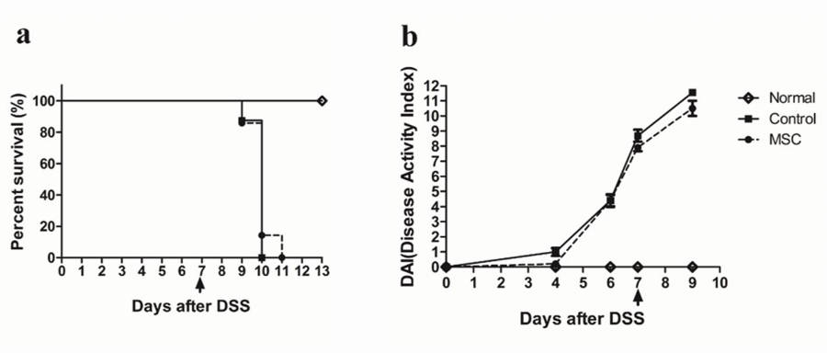

Figure 2 Colon lengths of normal, control, and mesenchymal stem cells -treated mice. Colon lengths (from the appendix to the anus) were measured, and were similar in the control and MSC-treated groups, but longer in the normal group. Values are mean ± SE (n = 2, all tests were performed in triplicate).
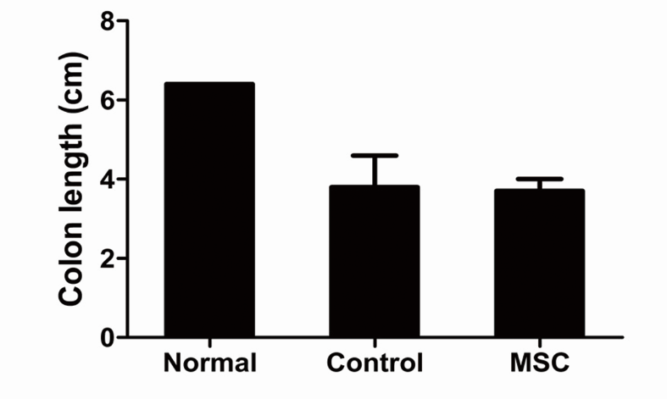
Figure 3 Histopathological changes in the colon after mesenchymal stem cells infusion. Colons were fixed and stained with haematoxylin and eosin, and paraffin sections microscopically examined (× 200 and × 400). Both the control and mesenchymal stem cells -treated groups exhibited symptoms of colon damage, but the normal group did not.
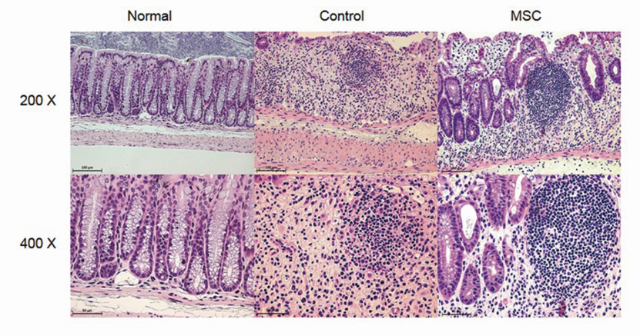

Figure 4 Changes in cytokine levels in the spleen and mesenteric lymph nodes. A: The percentages of IFN-γ, IL-4, IL-6, IL-10, and IL-17; and T_{reg} cells in the spleen analysed by fluorescence-activated cell sorting (FACS); B: The expression level of cytokines and Treg cells in the mesenteric lymph nodes (mLN) analysed by FACS (n = 2, all tests were performed in triplicate.) Mice were sacrificed on day ten, and the levels of IFN-γ, IL-4, IL-6, IL-10, and IL-17; and T_{reg} cells, in the spleen and mLNs, were analysed by FACS (n = 2, all tests were performed in triplicate).
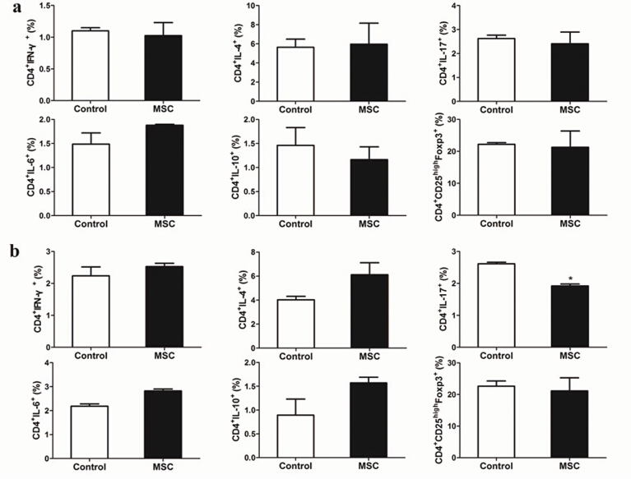

Figure 5 Changes in cytokine levels in the colon. Mice colons were harvested and the levels of IFN-γ, IL-4, IL-6, IL-10, IL-17, and TNF-α in homogenised colon supernatants measured by ELISA (n = 2; all tests were performed in triplicate).
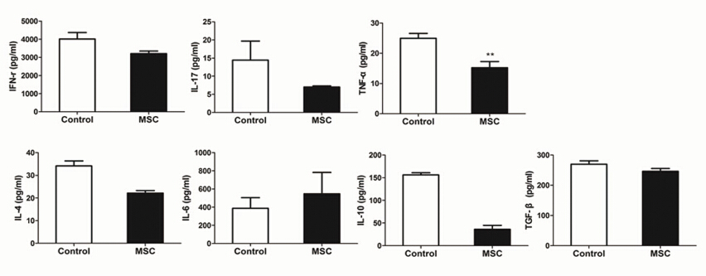

Table 1 Preclinical studies of mesenchymal stem cells therapy for inflammatory bowel disease
Ref. | Model | Induction method | MSC source | Dose | Route | Time | Characteristic | Outcome
Kim et al^{[11]} | C57BL./6 | 2% (g/L) DSS | Xenogeneic: RAT (SD) BM | 1 × 10⁵ | SC | 0, 3, 6 d  6, 9, 12 d | IL-12p40-transduced | Positive
He et al^{[10]} | BALB/c | 4% (g/L) DSS | Syngeneic: Mouse (BALB/c) BM | 1 × 10⁶ | IV | 2, 5, 8 d | Multiple injection | Positive
Parekkadan et al^{[12]} | RAG-1^{-/-} | C57BL/6 CD4⁺CD45RB^{hi} 5 × 10⁵  IV injection | Allogeneic: Mouse (Aire^{-/-}) BM | 2.5 × 10⁵ | IV | 0, 3 wk | Aire^{-/-} injection | Positive
Ko et al^{[9]} | C57BL/6 | 5% (g/L) DSS | Allogeneic: Mouse (C57BL-10 × CBA/CA) BM | 1 × 10⁶ | IV | 2 d | MAdCAM-1- VCAM-1-Ab-coated | Positive
Rey et al^{[49]} | C57BL/6 | a : 5% (g/L) DSS  c : 3% (g/L) DSS | Xenogeneic: Human adipose,  Syngeneic: Mouse (C57BL/6) BM,  Allogeneic: Mouse (BALB/c) BM | a : hMSC  1 × 10⁵ -5 × 10⁶  mMSC 1 × 10⁶  c : hMSC 1 × 10⁶ | IP | a: 2 d  c: 7 d of each cycle | hMSC | Positive
MSC: Mesenchymal stem cells; MHC: Major histocompatibility complex; BM: Bone marrow; SC: Subcutaneous; IV: Intravenous; IP: Intraperitoneal; a: Acute; c: Chronic; hMSC: Human MSC; mMSC: Mouse MSC; MAdCAM-1: Mucosal addressin cell adhesion molecule-1; VCAM-1: Vascular cell adhesion molecule-1.
Table 2 Clinical trials of adipose-derived stem cells and mesenchymal stem cells inflammatory bowel disease therapies
Ref. | Disease | Phase | No. of patients | Stem cell source | Route | Outcome
Portilla et al^{[15]} | Complex perianal fistula | Ⅰ/Ⅱ | 24 | ASC;  Allo-adipose | Intralesional | Improved
Lee et al^{[20]} | Crohn’s fistula | Ⅱ | 43 | ASC;  Allo-adipose | Intralesional | Improved
Cho et al^{[13]} | Crohn’s fistula | Ⅰ | 10 | ASC;  Allo-adipose | Intrafistula | Improved
Herreros et al^{[19]} | Complex cryptoglandular perianal fistula | Ⅲ | 200 | ASC;  Allo-adipose | Intrafistula | Improved
Guadalajara et al^{[18]} | Complex perianal fistula | Ⅱ | 24 | ASC;  Allo-liposuction | Intrafistula | Improved
Ciccocioppo et al^{[14]} | Crohn’s fistula | Ⅰ/Ⅱ | 12 | MSC;  Allo-BM | Intrafistula | Improved
Garcia-Olmo et al^{[17]} | Complex perianal fistula | Ⅱ | 14 | ASC;  Auto-adipose | Intrafistula | Improved
Garcia-Olmo et al^{[16]} | Crohn’s fistula | Ⅰ | 10 | ASC;  Allo-adipose | Intrafistula | Improved
MSC: Mesenchymal stem cells; ASC: Adipose-derived stem cells.

