Name of Journal: World Journal of Clinical Cases
Manuscript NO: 85409
Manuscript Type: CASE REPORT

Self-strangulation induced penile partial amputation: A case report

Maimaitiming ABLT et al. Penile partial amputation

A-Bu-Lai-Ti Maimaitiming, Ye-Li-Su-Dan Mulati, Ai-Re-Ti Apizi, Xiao-Dong Li

A-Bu-Lai-Ti Maimaitiming, Ye-Li-Su-Dan Mulati, Ai-Re-Ti Apizi, Xiao-Dong Li, Department of Urology, The First Affiliated Hospital of Xinjiang Medical University, Xinjiang Clinical Research Center for Genitourinary System, Urumqi 830011, Xinjiang Uygur Autonomous Region, China

Author contributions: Maimaitiming ABLT and Mulati YLSD contribute equally; Maimaitiming ABLT and Mulati YLSD contributed to manuscript writing and editing, data collection and data analysis; Apizi ART and Li XD contributed to conceptualization and supervision; all authors have read and approved the final manuscript.

Supported by Natural Science Foundation of the Xinjiang Uygur Autonomous Region from The First Affiliated Hospital of Xinjiang Medical University, No. 2022D01C782.

Corresponding author: Xiao-Dong Li, MD, Associate Chief Physician, Department of Urology, The First Affiliated Hospital of Xinjiang Medical University, Xinjiang Clinical Research Center for Genitourinary System, No. 137 Liyushan South Road, Urumqi 830011, Xinjiang Uygur Autonomous Region, China. lxd705@163.com

Received: April 26, 2023
Revised: June 20, 2023
Accepted: July 17, 2023
Published online: August 6, 2023

Abstract
BACKGROUND
Traumatic amputation of the penis is a rare surgical emergency, usually caused by self-mutilation, accidents, circumcision, assault and animal attacks. This study aimed to summarize our treatment experience involving penile reconstruction in a rare case of a self-strangulation induced chronical penile partial amputation.

CASE SUMMARY
A 22-year-old man presented with self-strangulation induced chronical penile partial amputation for 3 mo where the penile proximal part was 1 cm far from the pubis. Reconstruction methods included end-to-end anastomosis of the urethral mucosa, proximal anastomosis of the corpus cavernosum and tunica albuginea of the penis, anastomosis of the deep dorsal vein, dorsal artery, and superficial dorsal vein. Patient urinated smoothly after the catheter was removed on day 21. 3 mo after the surgery, the patient's penile preliminary cosmetic appearance was satisfactory, with occasional morning erections. Distal penile sensation was preserved, yet erection hardness of the distal penis was not satisfactory.

CONCLUSION
Complete preoperative assessment and prompt surgical intervention decreases loss of residual penile functions.

Key Words: Amputation; Reconstruction; Body dysmorphic disorders; Psychological treatment; Case report

©The Author(s) 2023. Published by Baishideng Publishing Group Inc. All rights reserved.

Citation: Maimaitiming ABLT, Mulati YLSD, Apizi ART, Li XD. Self-strangulation induced penile partial amputation: A case report. World J Clin Cases 2023; 11(22): 5373-5381
URL: https://www.wjgnet.com/2307-8960/full/v11/i22/5373.htm
DOI: https://dx.doi.org/10.12998/wjcc.v11.i22.5373

Core Tip: We report a rare case of penile partial amputation. Through complete preoperative evaluation and appropriate surgical management, the patient's penile urination and erectile function were preserved. At the same time, the importance of psychological intervention on the rehabilitation of patients with self-injury was further discussed.

INTRODUCTION
Traumatic amputation of the penis is a rare surgical emergency, usually caused by self-mutilation, accidents, circumcision, assault and animal attacks^{[1]}. Penile self-mutilation is even rarer that related to mental and mood disorders and is reported sporadically. Treatment of penile amputation requires stabilization of the patient and special attention to underlying psychiatric disorders. Therefore, for these patients, a detailed medical history should be taken to determine the patient's mental state incase for later intervention management if necessary. Studies have shown that in most cases of self-amputation, resolution and treatment of psychiatric disorders usually results in a strong desire to preserve the penis. Studies have shown that, in most cases of self-amputation, resolution and treatment of mental illness usually results in a strong desire to preserve the penis^{[2]}.
Penile amputation as a surgical emergency does not require imaging most of the time^{[3]}. Patients often undergo surgery directly for emergencies, such as edema, swelling, cyanosis, severe pain caused by acute ischemia of the distal penis. In severe cases, the patient may even lose the penis permanently. However, the patient in our case delayed the golden time of treatment due to personal reasons. Under this situation, adequate preoperative imaging evaluation, including penis flow ultrasound, penis nerve electrophysiology and urethroscopy evaluation, will greatly help the success rate of reconstruction, the recovery of urinary and erectile function.

CASE PRESENTATION
Chief complaints
A 22-year-old unmarried patient complained of “repeatedly tying his penis with rubber bands for more than 3 mo” and was admitted to the andrology ward of the Urology Department of the First Affiliated Hospital of Xinjiang Medical University.

History of present illness
Patient’s penis was partial amputated with a residue connection about 1 cm in diameter and leaks urine at the tied shaft.

History of past illness
The patient stated he started to tie his penis with rubber bands discontinuously 3 mo ago. The initial binding site is about 2-3 cm proximal to the coronal groove of the penis, which lasted for about one week resulting in a defect of about 1 cm deep in the first stangulation ring so the patient released the tying rubber bands temporarily. One week later, the patient rebind the penis, which worsened her condition.

Personal and family history
The patient denied any family history of psychiatric illness. No autism-like manifestations were found during a consultation with a psychologist.

Physical examination
On genital examination, Partial connections remained in the proximal penis was observed (Figure 1). Postoperative follow-up showed that the penile wound was in good condition, the appearance was satisfactory, patient’s urination and erectile function were recovered (Figure 2).

Laboratory examinations
The patient's laboratory test results reveal no notable abnormalities.

Imaging examinations
Color Doppler ultrasonography indicated that bilateral corpus cavernosum and corpus spongiosum were severed near the root of the penis; there is blood flow distribution in part of the cortex of the severed penis; part of the penile fascia at the part of the severed penile fascia is still continuous, and blood flow is seen in the continuous fascia, but no obvious blood flow signal was found in the severed corpus cavernosum and corpus spongiosum (Figure 3).
Flexible cystoscopy (Video 1): Using a flexible cystoscope to enter the urethra, a circular stenosis can be seen in the urethra about 8 cm away from the external urethral orifice where the flexible cystoscope cannot pass through. Meanwhile, the flexible cystoscope guide light can be seen outside the second strangulation ring.

FINAL DIAGNOSIS
The patient was finally diagnosed with strangulation induced penile partial amputation.

TREATMENT
Considering that the patient's distal penile blood supply was still residual, replantation might maintain good blood perfusion, we decided to perform penile reimplantation surgery with the core goal of maximizing the preservation of the patient's long-term urination and erectile function for the patient. The surgery was performed under general anesthesia by two urologists who were skilled in penile reconstruction surgery.
Preoperative observations: The penis was seen to be semi-disconnected at the root, the penile corpus cavernosum and urethral sponge were disconnected, the disconnected stump had skin attached, and the urethra was narrowed at both ends of the dissection. The residual connecting tissues were hard in texture and the thinnest diameter was about 7 mm, and ultrasound confirmed that there was a small amount of arterial blood flow signal inside the area. The arterial flow signal decreased after twisting the penis. A slight strangulation of the penile body was seen 2 cm from the external urethra, the distal penile skin temperature was low, and the original skin recovered red slowly after pressing the glans, which was considered to be in an ischemic state.
Surgical procedure: Adequate preoperative disinfection of the surgical area was performed. Circumferentially incised the skin attached to the stump, freed the proximal urethra, excised the narrowed part of the urethra to fully expose the normal urethra. Same approach were used for the proximal dissection of the urethra and penile corpus cavernosum. Trabeculated epidermis at the site of the connecting tissue could be buried under the skin. Due to the dorsal neurovascular bundle of the penis was surrounded by the middle dorsal segment of colles' fascia and tunica albuginea, and the surrounding tissue was relatively tough. In this case, it didn’t get too much damaged, which being the reason there were still blood flow signal in the stump of the penis. After intermittently suturing the corpus cavernosum, mediastinum and urethra with absorbable suture, a urinary catheter was placed, and the skin at both ends was trimmed and anastomosed. The continuity of the penile corpus cavernosum and urethra was completely restored, and the appearance of the penis was restored (Figure 4).

OUTCOME AND FOLLOW-UP
The catheter was maintained for 21 d after surgery. Postoperative follow-ups are shown in Figure 3. Three months after reconstruction, the preliminary cosmetic appearance was satisfactory with occasional morning erection. Patient had a grade 3 erection according to The Erection Hardness Score after injected papaverine into the corpus cavernosum during the penile ultrasound examination (Figure 5). Pharmarco penile duplex color doppler ultrasonograghy assessment data 3 mo after surgery was shown in Table 1. The patient was satisfied with the restoration of reconstruction.

DISCUSSION
Penile amputation is a rare and challenging injury, like other traumatic penile injuries including penile fracture, penetrating penile injuries and penile soft tissue injuries, it is considered as emergency^{[4]}. But cases of chronic strangulated partial penile amputation have not been reported so far. This case report may be the first to be reported. To this end, we reviewed relevant literature to summarize key points and experiences in the treatment of acute penile trauma.
The most common complications after amputation penile reconstruction include skin necrosis, penile skin hypoesthesia, urethral stricture, erectile dysfunction, and urethral fistula^{[1]}. Previous studies determined that immediate penile exploration and blood supply recovery are considered the most common and current management of penile amputation with experts demonstrating that it leads to the fastest recovery in erectile, urinary function and positive cosmetic outcomes^{[5]}. Based on the summary of relevant literature and case reports, we conclude that amputation type, tissue defect area, ischemic time and urethral injury are factors that need to be evaluated before surgery. These have a significant impact on the success of penile replantation or reconstruction. It should be emphasized that a thorough physical examination should not delay surgical intervention, as better intraoperative examination can be achieved in the operating room.
Types of penile amputation include total and partial amputations. Although there are still tissue connections in partial penile amputation, the degree of tissue damage in partial penile amputation is sometimes more severe than that in total amputation. Morrison et al^{[6]} concluded in their study that critically appraises the current literature on penile replantation that complete amputation seems to predict better sensory outcomes in bivariate analysis. Complete penile amputation may give the surgeon better access to nerves for neurorrhaphy, which ultimately could allow for better sensation. In particular, the asymmetry of the dissected tissue caused by strangulation will lead to poor postoperative anastomosis and affect the surgical effect. As for total penile amputation caused by neat cutting, the wound conditions will be easier to manage but also total amputation usually means more severe ischemia.
Facing cases with large tissue defects, in order to achieve the maximum restorative effect, local plastic correction is needed, which generally needs to be decided according to the patient's condition. Available choices include abdominal wall under the island flap, groin flap and other conditional flaps with less subcutaneous fat and no obvious variation in vascular distribution. Scrotal flaps are also used in a few cases. However, due to the large number of folds and pores of scrotal flaps, the filled defects often have poor appearance after repair and obvious scar remains.
The application of microsurgery downstream free flap transplantation makes the reconstruction and repair of penile injuries with large tissue defects more diversified. At present, various free skin flaps, such as radial free forearm flap, superficial inferior epigastric artery flap and superficial circumflex iliac artery flap, had been attempted for phallic construction, aiming at functional as well as cosmetic result^{[7]}.
According to reports in the literature, the survival rate was higher after replantation if the duration of warm ischemia was < 6 h, or the duration of cold ischemia was < 16 h for the amputated organs^{[8]}. Previous studies suggested that total ischemic time of the penis below 15 h (mean 7 h) is associated with the successful outcome of the penile replantation. Henry et al^{[9]} reported a successful case of penile reconstruction after 23 h of ischemia^{[9]}. Although there is no unified standard for the golden time limit of ischemic time after penile amputation, the shorter the amputation time, the higher the success rate of replantation and reconstruction.
A consensus in the contemporary literature acknowledges that the microsurgical revascularization and approximation of the penile shaft structures provide early and adequate restoration of penile blood flow with the best outcome of penile replantation survival, erectile and voiding functions^{[10-12]}. For cases with urethral injury, adequate intraoperative evaluation was performed to clarify the type of urethral penile injury, including partial and complete rupture. According to the treatment principle of anterior urethral injury, simple indwelling catheter and urethral repair were used respectively.
Retrograde urethrocystography (RGU) can detect contrast agent leakage at the site of occult urethral rupture. Some authors consider RGU to be compulsory if diagnosis of urethral rupture is suspected^{[13,14]}. At the same time, RGU can also evaluate and diagnose the postoperative complications such as urethral fistula and urethral stricture.
Principles of penile reconstruction surgery are: Judiciously debride necrotic tissue, anastomose the severed urethra, repair the tunica albuginea and microsurgical repair for the dorsal nerves, arteries and veins^{[2,15-17]}. Ottaiano et al^{[18]} summarized in a review of the literature on reconstruction that immediate reconstruction of penile injuries typically occurs by means of suspension or entrapment can reduce complications^{[18]}. Recent publications have investigated the anatomical approaches to penile allografts and suggested that connection of cavernosal, dorsal, and pudendal arteries would allow for optimal reperfusion^{[10,19]}.
Previous studies have also suggested that microvascular repair yields superior outcomes, especially for venous out-flow^{[20,21]}. Babaei et al^{[22]} summarized that although the initial reconstruction under direct vision had a good effect on the recovery of appearance and urination function in most cases, skin necrosis and other complications were also common. With the application of microscopic technology, reconstruction meeting higher and higher anatomical requirements, especially the microsurgical anastomosis of penile blood vessels and nerves, which reduces the risk of penile skin necrosis.
Besides corporeal sinusoidal blood flow and its venous outflow are two critical factors for successful survival of penile replantation. Some authors contend that the arteries do not provide a significant amount of vascular flow, add more operative time, and result in damage to the erectile tissue. However, studies showed that erectile function remains in up to 86%, penile sensation up to 82% of patients who undergo microvascular reanastomosis of the dorsal arteries, although this may be diminished when compared with preinjury state^{[23]}. In Zhong et al’s study, they also mentioned using hyperbaric oxygen to accelerate the healing process which was of particular interest^{[23]}. Damage assessing of the arteries and veins along with microvascular reanastomosis are very helpful for the surgical outcomes and reducing complications. Multiple venous anastomoses help to reduce venous congestion. Superficial veins help to ensure skin vitality as well as the dorsal deep veins^{[24]}. Morrison et al^{[6]} reviewed 74 published articles related to this topic, and reported the outcomes and replantation-related complications in 106 cases. Complete penile amputation accounted for 74.8% of these men, most of whom recovered micturition (97.4%) and erectile functions (77.5%). Skin necrosis (54.8%) and venous thrombosis (20.2%) were the most common complications. Multivariate analysis indicated anastomosis of a great number of the dorsal arteries and nerves were associated with better sexual function and recovery of urination along with normal sensation. Moreover, the number of anastomosed vessels was negatively correlated with adverse outcomes. During the perioperative period, routine observations include penile skin color, filling, overall vitality, temperature, and capillary refilling time^{[9]}. Arterial blood flow should be monitored using a hand-held Doppler device, and the observation time can be arranged according to the actual situation.
Whether it is penile amputation caused by accidental injury or self-harm behavior, it is very important to evaluate the patient's psychological and mental health during the whole treatment cycle, as well as the necessary psychological intervention. Especially for patients presenting with self-harm behavior.
Currently, relevant surgical literatures have not paid special attention to the mental health of such patients. However, it is very common for patients with penile amputation to experience a series of stress reactions after the injury. According to the severity of the patient's condition, personality characteristics, education level and other aspects, the clinical manifestations of this stress response are mild or severe, and psychological changes are common phenomena. In addition to negative emotions such as sadness and depression, increased psychological vigilance, avoidance, hyperactivity, anxiety, and impaired self-cognition may affect the treatment effect. In particular, the postoperative body image disorder makes the patient have an unacceptable aversion to the reconstructed and repaired penis, and extreme patients may self-harm again^{[25]}. Therefore, helping patients to establish a positive concept of coping with stress and conducting corresponding psychological counseling in a timely manner are indispensable for patients who have undergone penile reconstruction surgery in receiving the reconstructed penis and physical and mental health recovery after surgery.

CONCLUSION
Penile amputation is a rare emergency in urology. It is necessary to evaluate the damage of the penis, and immediate surgical treatment is essential for the recovery of appearance, urination, and erectile function of the truncated penis^{[26-28]}. Reconstruction should be performed to the greatest extent possible, although very few patients may face delays in the optimal timing of treatment. At the same time, psychological concern and treatment guidance for patients with penile amputation are also a link that needs to be paid attention to in clinical practice.

ACKNOWLEDGEMENTS
We thank the patient and all participating authors for their contributions.

REFERENCES
1 Raheem OA, Mirheydar HS, Patel ND, Patel SH, Suliman A, Buckley JC. Surgical management of traumatic penile amputation: a case report and review of the world literature. Sex Med 2015; 3: 49-53 [PMID: 25844175 DOI: 10.1002/sm2.54]
2 Chou EK, Tai YT, Wu CI, Lin MS, Chen HH, Chang SC. Penile replantation, complication management, and technique refinement. Microsurgery 2008; 28: 153-156 [PMID: 18286649 DOI: 10.1002/micr.20470]
3 Bachoo S, Batura D. Fractures of the penis. Br J Hosp Med (Lond) 2021; 82: 1-9 [DOI: 10.12968/hmed.2020.0715]
4 Patial T, Sharma G, Raina P. Traumatic penile amputation: a case report. BMC Urol 2017; 17: 93 [PMID: 29017517 DOI: 10.1186/s12894-017-0285-4]
5 Kominsky H, Beebe S, Shah N, Jenkins LC. Surgical reconstruction for penile fracture: a systematic review. Int J Impot Res 2020; 32: 75-80 [PMID: 31685943 DOI: 10.1038/s41443-019-0212-1]
6 Morrison SD, Shakir A, Vyas KS, Remington AC, Mogni B, Wilson SC, Grant DW, Cho DY, Rahnemai-Azar AA, Lee GK, Friedrich JB, Mardini S. Penile Replantation: A Retrospective Analysis of Outcomes and Complications. J Reconstr Microsurg 2017; 33: 227-232 [PMID: 28002849 DOI: 10.1055/s-0036-1597567]
7 Salem HK, Mostafa T. Primary anastomosis of the traumatically amputated penis. Andrologia 2009; 41: 264-267 [PMID: 19601940 DOI: 10.1111/j.1439-0272.2009.00925.x]
8 Lowe MA, Chapman W, Berger RE. Repair of a traumatically amputated penis with return of erectile function. J Urol 1991; 145: 1267-1270 [PMID: 1822958 DOI: 10.1016/s0022-5347(17)38597-x]
9 Henry N, Bergman H, Foong D, Filobbos G. Successful penile replantation after complete amputation and 23 h ischaemia time: the first in reported literature. BMJ Case Rep 2020; 13 [PMID: 32601141 DOI: 10.1136/bcr-2020-234964]
10 Biswas G. Technical considerations and outcomes in penile replantation. Semin Plast Surg 2013; 27: 205-210 [PMID: 24872770 DOI: 10.1055/s-0033-1360588]
11 Jezior JR, Brady JD, Schlossberg SM. Management of penile amputation injuries. World J Surg 2001; 25: 1602-1609 [PMID: 11775199 DOI: 10.1007/s00268-001-0157-6]
12 Roche NA, Vermeulen BT, Blondeel PN, Stillaert FB. Technical recommendations for penile replantation based on lessons learned from penile reconstruction. J Reconstr Microsurg 2012; 28: 247-250 [PMID: 22399258 DOI: 10.1055/s-0032-1306373]
13 Mydlo JH, Hayyeri M, Macchia RJ. Urethrography and cavernosography imaging in a small series of penile fractures: a comparison with surgical findings. Urology 1998; 51: 616-619 [PMID: 9586616 DOI: 10.1016/s0090-4295(97)00701-2]
14 Ganem JP, Kennelly MJ. Ruptured Mondor's disease of the penis mimicking penile fracture. J Urol 1998; 159: 1302 [PMID: 9507863]
15 Amer T, Wilson R, Chlosta P, AlBuheissi S, Qazi H, Fraser M, Aboumarzouk OM. Penile Fracture: A Meta-Analysis. Urol Int 2016; 96: 315-329 [PMID: 26953932 DOI: 10.1159/000444884]
16 Morey AF, Metro MJ, Carney KJ, Miller KS, McAninch JW. Consensus on genitourinary trauma: external genitalia. BJU Int 2004; 94: 507-515 [PMID: 15329102 DOI: 10.1111/j.1464-410X.2004.04993.x]
17 Shaeer O. Restoration of the penis following amputation at circumcision: Shaeer's A-Y plasty. J Sex Med 2008; 5: 1013-1021 [PMID: 18086176 DOI: 10.1111/j.1743-6109.2007.00675.x]
18 Ottaiano N, Pincus J, Tannenbaum J, Dawood O, Raheem O. Penile reconstruction: An up-to-date review of the literature. Arab J Urol 2021; 19: 353-362 [PMID: 34552786 DOI: 10.1080/2090598X.2021.1957410]
19 Tuffaha SH, Sacks JM, Shores JT, Brandacher G, Lee WPA, Cooney DS, Redett RJ. Using the dorsal, cavernosal, and external pudendal arteries for penile transplantation: technical considerations and perfusion territories. Plast Reconstr Surg 2014; 134: 111e-119e [PMID: 24622570 DOI: 10.1097/PRS.0000000000000277]
20 Darewicz B, Galek L, Darewicz J, Kudelski J, Malczyk E. Successful microsurgical replantation of an amputated penis. Int Urol Nephrol 2001; 33: 385-386 [PMID: 12092662 DOI: 10.1023/a:1015226115774]
21 Babaei AR, Safarinejad MR. Penile replantation, science or myth? A systematic review. Urol J 2007; 4: 62-65 [PMID: 17701923]
22 Babaei A, Safarinejad MR, Farrokhi F, Iran-Pour E. Penile reconstruction: evaluation of the most accepted techniques. Urol J 2010; 7: 71-78 [PMID: 20535691]
23 Zhong Z, Dong Z, Lu Q, Li Y, Lv C, Zhu X, Zhao X, Zhang X, Morales F, Ichim TE. Successful penile replantation with adjuvant hyperbaric oxygen treatment. Urology 2007; 69: 983.e3-983.e5 [PMID: 17482954 DOI: 10.1016/j.urology.2007.02.024]
24 Yang M, Zhao M, Li S, Li Y. Penile reconstruction by the free scapular flap and malleable penis prosthesis. Ann Plast Surg 2007; 59: 95-101 [PMID: 17589270 DOI: 10.1097/01.sap.0000253745.07940.da]
25 Gui YT, Cai ZM, Zhu H. Penile Reconstruction. Beijing: Peking University Medical Press, 2010
26 Noh J, Kang TW, Heo T, Kwon DD, Park K, Ryu SB. Penile strangulation treated with the modified string method. Urology 2004; 64: 591 [PMID: 15351614 DOI: 10.1016/j.urology.2004.04.058]
27 Cook A, Khoury AE, Bagli DJ, Farhat WA, Pippi Salle JL. Use of buccal mucosa to simulate the coronal sulcus after traumatic penile amputation. Urology 2005; 66: 1109 [PMID: 16286143 DOI: 10.1016/j.urology.2005.05.010]
28 Charlesworth P, Campbell A, Kamaledeen S, Joshi A. Surgical repair of traumatic amputation of the glans. Urology 2011; 77: 1472-1473 [PMID: 21256558 DOI: 10.1016/j.urology.2010.08.034]

Footnotes
Informed consent statement: Informed written consent was obtained from the patient for publication of this report and any accompanying images.

Conflict-of-interest statement: The authors declare that they have no conflict of interest to disclose.

CARE Checklist (2016) statement: The authors have read the CARE Checklist (2016), and the manuscript was prepared and revised according to the CARE Checklist (2016).

Open-Access: This article is an open-access article that was selected by an in-house editor and fully peer-reviewed by external reviewers. It is distributed in accordance with the Creative Commons Attribution NonCommercial (CC BY-NC 4.0) license, which permits others to distribute, remix, adapt, build upon this work non-commercially, and license their derivative works on different terms, provided the original work is properly cited and the use is non-commercial. See: https://creativecommons.org/Licenses/by-nc/4.0/

Provenance and peer review: Unsolicited article; Externally peer reviewed.

Peer-review model: Single blind

Peer-review started: April 26, 2023
First decision: June 12, 2023
Article in press: July 17, 2023

Specialty type: Medicine, research and experimental
Country/Territory of origin: China
Peer-review report’s scientific quality classification
Grade A (Excellent): 0
Grade B (Very good): B
Grade C (Good): C
Grade D (Fair): D
Grade E (Poor): 0

P-Reviewer: Othmen MB, Tunisia; Sarier M, Turkey; Surani S, United States S-Editor: Fan JR L-Editor: P-Editor: Zhang XD

Figure Legends
Figure 1 Preoperative physical examination. The clinical presentation depicts a traumatic partial amputation on the proximal penile shaft with only a partial residual connection between the proximal and distal ends of the penis. The image shows the first tourniquet indicated by the black arrow, the second tourniquet indicated by the white arrow, and the proximal opening of the disconnected urethra indicated by the yellow arrow.
Figure 2 Postoperative follow-ups. The image depicts the wound recovery status of patients at 3 d, 14 d, and 3 mo after surgical treatment. A: 3 d; B: 14 d; C: 3 mo.
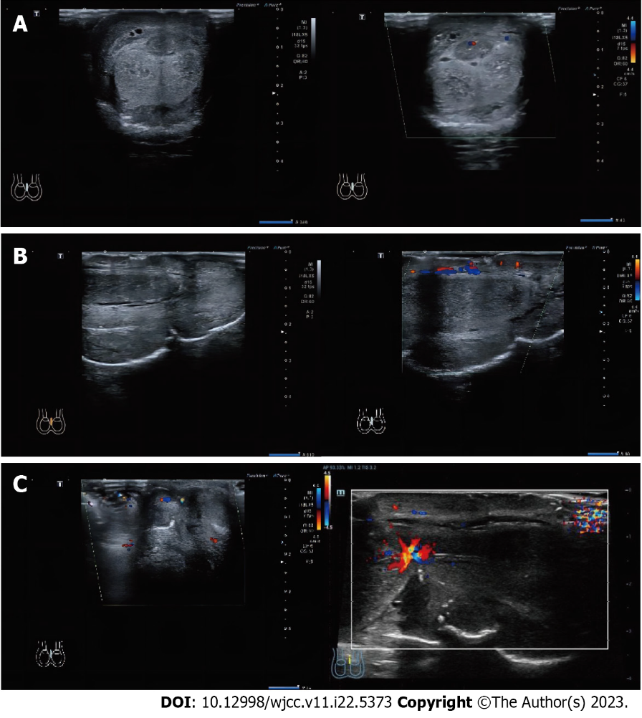
Figure 3 Preoperative Doppler ultrasonography. The image depicts the color Doppler ultrasound display of the blood flow signal in the coronal and sagittal planes, as well as the strangulation site of the penis. A: Coronal plane; B: Vertical plane; C: Strangulation site.
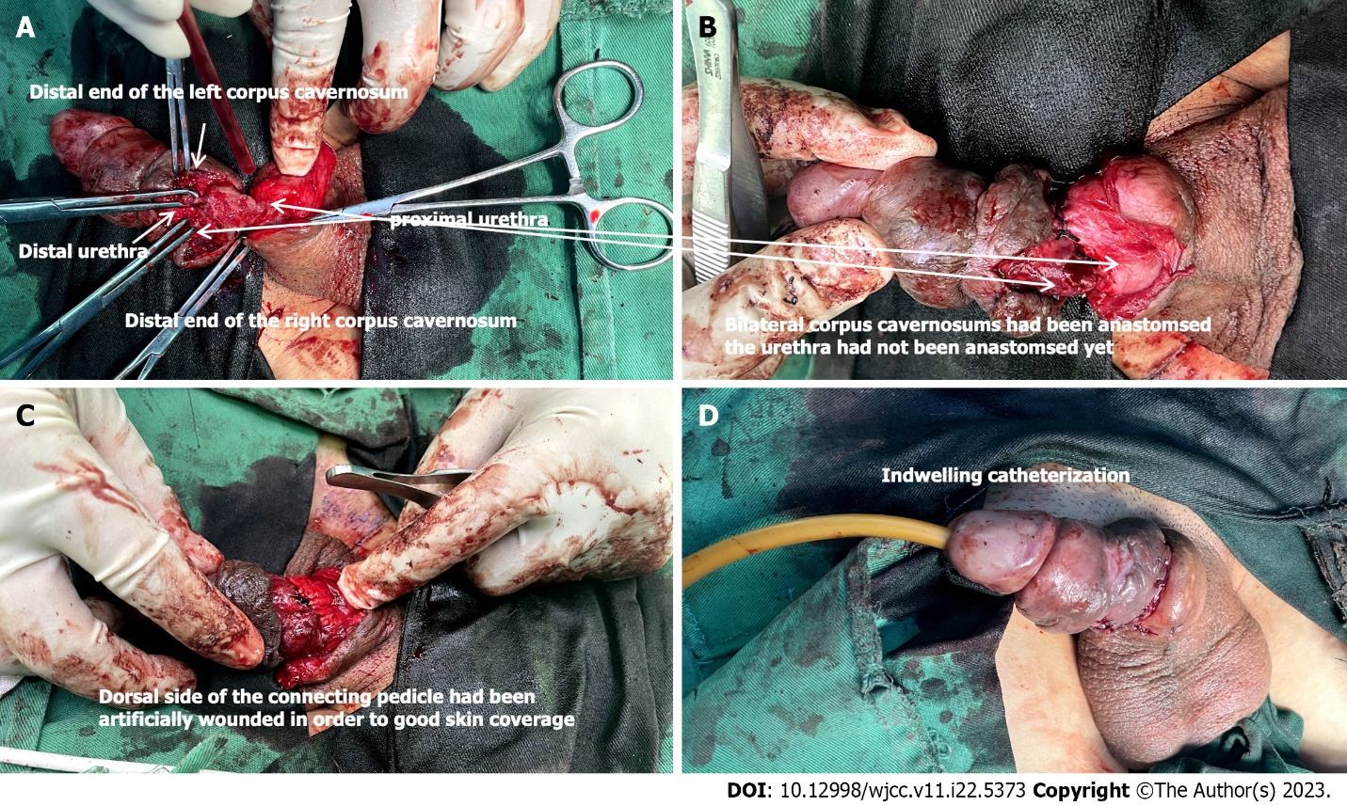
Figure 4 Surgery procedure. Urethral anastomosis and reconstruction was performed. A: Adequately expose the pertinent anatomical structures of the surgical site; B: Approximate the severed corpus cavernosum of the penis; C: Implement local wound management to optimize skin coverage; D: Insertion of a urinary catheter.
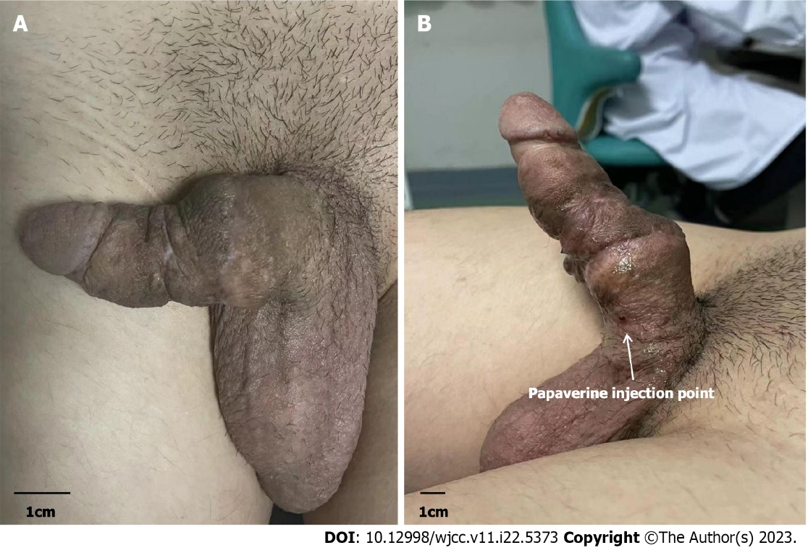
Figure 5 Postoperative pharmarco penile duplex color doppler ultrasonograghy 3 mo after surgery. A: Natural state; B: 5 min after papaverine injection.
Table 1 Pharmarco penile duplex color doppler ultrasonograghy assessment data 3 mo after surgery (before, 5 min and 10 min after papaverine injection)
 |  | Before injection | 5 min after | 10 min after
Corpus cavernosum (mm)
 | L | 1.1 | 2 | 2
 | R | 1.1 | 1.9 | 1.9
Deep dorsal penile artery (mm)
 | L | 0.4 | 1.2 | 1.2
 | R | 0.4 | 1.2 | 1.2
PSV (cm/s)
 | L | / | 65 | 89.9
 | R | / | 56.3 | 64.8
EDV (cm/s)
 | L | / | -3.9 | -6.7
 | R | / | -4.3 | -4.9
RI
 | L | / | 1.1 | 1.1
 | R | / | 1.1 | 1.1
PSV: Peak systolic velocity; EDV: End diastolic velocity; RI: Resistance index.

Published by Baishideng Publishing Group Inc
7041 Koll Center Parkway, Suite 160, Pleasanton, CA 94566, USA
Telephone: +1-925-3991568
E-mail: bpgoffice@wjgnet.com
Help Desk: https://www.f6publishing.com/helpdesk
https://www.wjgnet.com

© 2023 Baishideng Publishing Group Inc. All rights reserved.

