Name of Journal: World Journal of Stem Cells
Manuscript NO: 78294
Manuscript Type: ORIGINAL ARTICLE

Basic Study
Mammalian Ste20-like kinase 1 inhibition as a cellular mediator of anoikis in mouse bone marrow mesenchymal stem cells

Zhang T et al. Mst1 inhibition prevents anoikis of mBMSCs

Tao Zhang, Qian Zhang, Wan-Cheng Yu

Tao Zhang, Qian Zhang, Wan-Cheng Yu, Department of Cardiovascular Surgery, Shandong Provincial Hospital Affiliated to Shandong First Medical University, Jinan 250062, Shandong Province, China

Author contributions: Yu WC contributed to the conception and design and manuscript writing; Zhang T contributed to conception and design, collection and assembly of data, data analysis and interpretation. Yu WC, Zhang T, Zhang Q performed the experiments; All authors participated in discussing, revising the manuscript, and approving the final manuscript; All authors have read and approve the final manuscript.

Supported by Natural Science Foundation of Shandong Province, China, No. ZR2020MH014, No. ZR2021QH179 and No. ZR2021MH182.

Corresponding author: Wan-Cheng Yu, Doctor, MD, Surgeon, Department of Cardiovascular Surgery, Shandong Provincial Hospital Affiliated to Shandong First Medical University, No. 324 Jingwu Weiqi Road, Jinan 250062, Shandong Province, China. yuwancheng123@126.com

Received: June 30, 2022
Revised: January 6, 2023
Accepted: February 16, 2023
Published online: March 26, 2023

Abstract
BACKGROUND
The low survival rate of mesenchymal stem cells (MSCs) caused by anoikis, a form of apoptosis, limits the therapeutic efficacy of MSCs. As a proapoptotic molecule, mammalian Ste20-like kinase 1 (Mst1) can increase the production of reactive oxygen species (ROS), thereby promoting anoikis. Recently, we found that Mst1 inhibition could protect mouse bone marrow MSCs (mBMSCs) from H₂O₂-induced cell apoptosis by inducing autophagy and reducing ROS production. However, the influence of Mst1 inhibition on anoikis in mBMSCs remains unclear.

AIM
To investigate the mechanisms by which Mst1 inhibition acts on anoikis in isolated mBMSCs.

METHODS
Poly-2-hydroxyethyl methacrylate-induced anoikis was used following the silencing of Mst1 expression by short hairpin RNA (shRNA) adenovirus transfection. Integrin (ITGs) were tested by flow cytometry. Autophagy and ITGα5β1 were inhibited using 3-methyladenine and small interfering RNA, respectively. The alterations in anoikis were measured by Terminal-deoxynucleoitidyl Transferase Mediated Nick End Labeling and anoikis assays. The levels of the anoikis-related proteins ITGα5, ITGβ1, and phospho-focal adhesion kinase and the activation of caspase 3 and the autophagy-related proteins microtubules associated protein 1 light chain 3 II/I, Beclin1 and p62 were detected by Western blotting.

RESULTS
In isolated mBMSCs, Mst1 expression was upregulated, and Mst1 inhibition significantly reduced cell apoptosis, induced autophagy and decreased ROS levels. Mechanistically, we found that Mst1 inhibition could upregulate ITGα5 and ITGβ1 expression but not ITGα4, ITGαv, or ITGβ3 expression. Moreover, autophagy induced by upregulated ITGα5β1 expression following Mst1 inhibition played an essential role in the protective efficacy of Mst1 inhibition in averting anoikis.

CONCLUSION
Mst1 inhibition ameliorated autophagy formation, increased ITGα5β1 expression, and decreased the excessive production of ROS, thereby reducing cell apoptosis in isolated mBMSCs. Based on these results, Mst1 inhibition may provide a promising strategy to overcome anoikis of implanted MSCs.

Key Words: Mouse bone marrow mesenchymal stem cell; Mammalian sterile 20-like kinase 1; Anoikis; Integrin; Autophagy; Reactive oxygen species

©The Author(s) 2023. Published by Baishideng Publishing Group Inc. All rights reserved.

Citation: Zhang T, Zhang Q, Yu WC. Mammalian Ste20-like kinase 1 inhibition as a cellular mediator of anoikis in mouse bone marrow mesenchymal stem cells. World J Stem Cells 2023; 15(3): 90-104
URL: https://www.wjgnet.com/1948-0210/full/v15/i3/90.htm
DOI: https://dx.doi.org/10.4252/wjsc.v15.i3.90

Core Tip: In isolated mouse bone marrow mesenchymal stem cell (mBMSCs), Mammalian sterile 20-like kinase 1 (Mst1) inhibition could ameliorate not only autophagy formation but also upregulate integrin (ITG) α5β1 expression (but not ITGα4, ITGαv, or ITGβ3). In addition, Mst1 inhibition-induced autophagy could scavenge the excessive production of ITGα5β1-triggered ROS. Therefore, Mst1 inhibition-based infusion may improve the survival of MSCs, thereby serving as an ideal candidate for clinical transplantation in pulmonary arterial hypertension.

INTRODUCTION
Mesenchymal stem cell (MSC) therapy is characterized by anti-inflammatory, immunomodulatory, and regenerative properties, providing an attractive therapeutic approach for pulmonary arterial hypertension (PAH)^{[1]}. Despite the therapeutic potential of MSCs for improving the outcomes of PAH patients^{[2,3]}, no more than 5% of cells survive after transplant^{[4]}. Thus, the low survival rate of the grafted cells is widely perceived as the major hindrance for an MSC-based therapy for PAH.
Anoikis occurs when cells detach from the extracellular matrix and subsequently undergo apoptosis, and potentially acts as a major enabling factor for the apoptosis of transplanted cells^{[5,6]}. Indeed, after isolation from the extracellular matrix (ECM) and injection into the circulatory system for transplantation, MSCs will undergo anoikis, also referred to as cell isolation-induced apoptosis, leading to a series of alterations in anoikis signalling pathways^{[3,7,8]}. Anoikis can be induced by destruction of integrin (ITGs) signalling or deletion of ITGs genes^{[9]}. After isolation, focal adhesion kinase (FAK), a key downstream target of ITGs, is recruited to focal adhesion sites, consequently activating cell survival signals, such as blocking caspase 3 expression^{[10]}. However, it remains unknown whether ITGs signalling is involved in the process of anoikis in MSCs.
Autophagy is a dynamic process that maintains homeostasis by preventing the accumulation of excessive biomolecules and impaired cells and organelles. There is accumulating evidence of a link between autophagy and anoikis^{[11]}. Previously, we demonstrated that mammalian Ste20-like kinase 1 (Mst1) inhibition could reduce H₂O₂-induced apoptosis of mBMSCs by inducing autophagy formation^{[12]}. Mst1 is a serine/threonine kinase, known as a key mediator in cellular processes, including mediating the apoptosis^{[13]}. However, the molecular mechanism by which Mst1 inhibition mediates autophagy and anoikis in isolated mBMSCs remains to be clarified.
In this study, we investigated the potential regulatory effect of Mst1 inhibition on ITGs signalling, autophagy and anoikis in isolated mBMSCs.

MATERIALS AND METHODS
Cell culture
The mBMSCs were obtained as previously described^{[12]}. Cultured mBMSCs between passages 3 and 5 were selected for subsequent experiments.

Adenovirus infection
Adenovirus harbouring Mst1 short hair RNA (Ad-sh-Mst1) and the control vector for Mst1 shRNA (Ad-NC-Mst1) were purchased from WZ Biosciences (China). Vector details have been previously described^{[12]}. The shRNA sequence targeting Mst1 in mice was GCCCTCACGTA GTCAAGTATT.

siRNA transfection
The small interfering RNAs (siRNAs) were obtained from GenePharma (China). The sense and antisense strand sequences of siRNA are as follows: Mouse siRNA-ITGα5, 5ʹ-GCAGGGAGAUGAAGAUCUACCʹ (sense) and 5ʹ-UAGAUCUUCAUCUCCCUGCAGʹ (antisense); mouse siRNA-ITGβ1, 5ʹ-GGAGAACCACAGAAGUUUACA-3ʹ (sense) and 5ʹ-UAAACUUCUGUGGUUCUCCUG-3ʹ (antisense); and siRNA-negative control (NC), 5ʹ-UUCUCCGAACGUGUCACGUTTʹ (sense) and 5ʹ-ACGUGACACGUUCGGAGAATT-3ʹ (antisense). Subsequently, 24 h after infection with Ad-sh-Mst1, mBMSCs at 75% confluence were transfected with ITGα5, ITGβ1 or NC siRNA (50 nM) using Lipofectamine RNAi MAX (13778500, Invitrogen) according to the manufacturer’s instructions. The expression of ITGα5 or ITGβ1 was substantially blocked by the transfected siRNA.

Cell treatment
Petri dishes coated with polyhydroxyethyl methacrylate [Poly-HEMA, 529257, Sigma, United States of America (USA)] were used to prevent cells from adhering to the tissue culture plates. Briefly, poly-HEMA stock material was dissolved in 95% ethanol at a concentration of 12 mg/mL, and 1 mL of 12 mg/mL poly-HEMA was added to each well of a 6-well plate and then dried overnight on a clean bench. Cells were transfected as previously described. Cells (5 × 10⁵) were coated with 12.5 mg/mL poly-HEMA in each well for a certain period of time.
To inhibit autophagy, cells were pretreated with 5 mmol/L 3-MA (189490, Selleck, USA) for 1 h and then cultured in poly-HEMA-precoated plates for a certain period of time.

Assay of intracellular ROS
As mentioned above, cellular ROS were assessed using the ROS probe 2,7-Dichlorodihydrofluorescein diacetate (DCFH-DA), S0033, Beyotime Biotechnology, China)^{[12]}. The mean fluorescence intensity was detected via flow cytometry.

Isolation-induced anoikis assay
Anoikis was analysed using an in situ Direct DNA Fragmentation Terminal-deoxynucleoitidyl Transferase Mediated Nick End Labeling (TUNEL) Assay Kit [ab66108, Abcam, The United Kingdom of Great Britain and Northern Ireland (UK)]. After incubation in poly-HEMA-coated plates, the cells were collected and added to 70% ice ethanol for 30 min. Ethanol was then removed, and the cells were resuspended in washing buffer and then stained with a staining solution for 60 min. Prior to the addition of the PI/RNase A solution, the cells were washed twice with rinse buffer. Quantification analysis was performed by BectonDickinson Fluorescence Activating Cell Sorter (BD FACSDiva) software, [Ex/Em = 488/520 nm for fluoresceine isothiocyanate and 488/623 nm for propidium iodide)].
Anoikis was also detected by a CytoSelect™ 24-Well Anoikis Assay (XY-CBA-080, Cell Biolabs, USA) according to the manufacturer's instructions. Briefly, cells (1 × 10⁶ cells/well) were cultured in each well of 24-well plate for 36 h before staining with ethidium homodimer (EthD-1) at 37°C for 1 h. The presence of red EthD-1 fluorescence in dead cells was observed by a fluorescence microscope, and cell viability was determined using a thiazolyl blue tetrazolium bromide (MTT) assay.

Flow cytometry
Cells were incubated in poly-HEMA-coated petri dishes for 36 h, centrifuged at 300 × g for 5 min and cultured in antibodies (ITGα4 [1/500 dilution, 553157, BD], ITGα5 [1/500 dilution, 557447, BD], ITGαv [1/300 dilution, 740946, BD], ITGβ1 [1/500 dilution, 561796, BD], ITGβ3 [1/100 dilution, 740677, BD]) for 1 h according to the operation manual.

Cell adhesion
After culture in poly-HEMA-coated petri dishes, the collected cells were resuspended in complete α-MEM and then plated in triplicate (5× 10⁴ cells/well) onto wells coated with fibronectin (10 g/mL), which was previously blocked with 1% BSA for 1 h. After 6 h, the cells were washed with phosphate belanced solution (PBS) and stained with crystal violet. Unbound dye was removed with PBS before adding a 10% acetic acid solution. The absorbance was read at 630 nm using a Multiskan MK3 microplate reader. The experiment was repeated three times. Cell adhesion was calculated according to the proportion of adhered cells in the control group.

Cytokine levels
The supernatants in each group were collected after culture in poly-HEMA-coated petri dishes for 36 h. The levels of anti-inflammatory cytokines were measured using a BD™ Cytometric Bead Array (CBA) Mouse Th1/Th2/Th17 Cytokine Kit (561665, BD, USA) in accordance with the instruction manual. The levels of interleukin (IL)-4 (IL-4), IL-10, IL-17A and IL-6 in cell supernatants were measured using flow cytometry. Data analysis was performed as previously described^{[14]}.

Nude mouse tumorigenicity
All animal procedures were approved by the Animal Care and Use Committee of Shandong Provincial Hospital Affiliated to Shandong First Medical University (IACUC protocol, Approval No. 2020-333). A total of 10 female nude mice (4 wk old) were purchased from Beijing Vital River Laboratory Animal Technology Co., Ltd. and raised in a specific pathogen-free environment. Mice were placed at a standard room temperature at a normal day-night cycle with free access to standard diet and water. Afterwards, 5.0 × 10⁶ mBMSCs (n = 3), mBMSC/NC-Mst1 (n = 3), and mBMSC/sh-Mst1 (n = 4) were injected into the right flank near the hind legs of each nude mouse. The tumours were measured with a Vernier calliper every 4 d. Sixty days after cell inoculation, all mice were anaesthetized with ether, and tissues were collected.

Quantitative real-time polymerase chain reaction (qPCR)
qPCR was performed as previously reported^{[12]}. mBMSCs were differentiated via 21-d exposure to osteogenic or adipogenic conditions, and total mRNA from mBMSCs subjected to these conditions and siRNA-transfected cells was isolated using TRIzol Reagent (15596026, Thermo Fisher Scientific, USA). The RNA was subsequently reverse transcribed into cDNA and amplified using the SYBR® Premix Ex TaqTM II kit (RR420, Takara, JPN) and d ABI 7500 real-time PCR system (Applied Biosystems). Each experiment was repeated three times. Data were normalized through the 2^{-ΔΔCT} method using the housekeeping gene glyceraldehyde-3-phosphate dehydrogenase. The primer sequences are shown in Supporting Information Supplementary Table 1.

Western blot analysis
To determine protein expression, Western blot analysis was performed. After culture in poly-HEMA-coated plates, whole-cell protein extracts were prepared in radio-immunoprecipitation assay lysis buffer, subjected to sodium dodecyl sulfate-polyacrylamide gel electrophoresis, and transferred onto polyvinylidene fluoride membranes. The membranes were then blocked with 5% skimmed milk or Bovine serum albumin in Tris-Buffered Saline Tween-20 for 1 h and incubated overnight at 4 ℃ with the following primary antibodies (diluted by Western Primary Antibody Buffer, P0023A, Beyotime): Mst1 (1:1000, ab51134, Abcam), ITGα5 (1:1000, ab150361, Abcam), ITGβ1 (1:1000, ab179471, Abcam), phospho-FAK (Tyr397) [1:500, 3283S, Cell Signaling Technology (CST)], FAK (1:1,000, 3285S, CST), activated caspase 3 (1:1000, ab214430, Abcam), and caspase 3 (1:1000, ab18297, Abcam). GAPDH (1:1000, 5174S, CST) served as the loading control. Anti-rabbit IgG and HRP-linked antibodies (1:1000, 7074S, CST) were used. The relative protein expression levels were compared with GAPDH using ImageJ software.

Statistical analysis
All results are expressed as the mean ± SD. One-way Analysis of Variance was used for data analysis. P < 0.05 was considered statistically significant.

RESULTS
The loss of attachment to ECM increased the rate of aberrant cell apoptosis, ROS levels, and Mst1 expression and inhibited autophagy in mBMSCs
As the ability to reduce cell adhesivity to culture plates, Poly-HEMA was used to simulate an anchorage-independent culture condition. In present study, the sensitivity of mBMSCs to anoikis in Poly-HEMA-pre-coated condition were tested.
Using the TUNEL and Anoikis Assay Kit, the results showed an increased rate of mBMSC apoptosis in a time-dependent manner under poly-HEMA-induced isolated conditions (Figure 1A, B, D and E), suggesting that anoikis of mBMSCs could be induced in precoated poly-HEMA plates. In addition, the cell adhesion decreased at 24 h, 36 h, and 48 h compared with that at 0 h (Figure 1G).
Moreover, staining of intracellular ROS with the ROS probe DCFH-DA showed increased ROS levels at 24, 36, and 48 h compared with 0 h (Figure 1C and F), demonstrating the production of ROS in poly-HEMA-induced isolated mBMSCs.
To determine the alterations in Mst1 expression, autophagy and the FAK/Caspase 3 pathway in mBMSCs under isolated conditions, the protein level of Mst1, autophagy-related proteins (LC3 II/I, Beclin1, p62), p-FAK, and activated caspase 3 was detected by Western blot analysis. The data suggested that Mst1 was upregulated in isolated mBMSCs (Figure 1H). Moreover, the expression of p-FAK decreased, and the activation of caspase 3 increased in a time-dependent manner (Figure 1I). Similarly, LC3 II/I and Beclin1 expression was downregulated, and p62 expression was upregulated in a time-dependent manner (Figure 1H).

Mst1 inhibition upregulated ITGα5 and ITGβ1 expression in isolated mBMSCs
The mBMSCs were infected with adenovirus containing Mst1 shRNA. The effect of shRNA on inhibiting Mst1 expression were measured by qPCR and Western blot (Supporting Information Supplementary Figure 1).
Evidence has shown that ITGs, the heterodimeric cell surface adhesion receptors, mediates anoikis. In this study, the alterations of ITGs in isolated mBMSCs/sh-Mst1 were tested.
The expression profiles of ITGα5, ITGαv, ITGα4, ITGβ1, and ITGβ3 in poly-HEMA-treated mBMSCs were compared by flow cytometry. Compared with the control mBMSC levels, the poly-HEMA-treated isolated mBMSC levels of ITGα5, ITGαv, ITGα4, ITGβ1, and ITGβ3 were significantly decreased (Figure 2). Compared with isolated mBMSCs, isolated mBMSCs/sh-Mst1 show an upwards trend in ITGα5 and ITGβ1 expression. However, there was no difference of the expression profiles of ITGαv, ITGα4, and ITGβ3 between isolated mBMSCs and isolated mBMSCs/sh-Mst1 (Figure 2). This study suggested that the inhibition of Mst1 could reactivate the expression of ITGα5 and ITGβ1.

Suppression of Mst1 expression protected mBMSCs from anoikis by activating autophagy.
mBMSCs were cultured in precoated poly-HEMA plates for 36 h. A significant decrease in cell apoptosis was observed in mBMSCs/sh-Mst1 (Figure 3A, B, D and E). Similar to the above results, cell adhesion was ameliorated by silencing Mst1 expression (Figure 3G). These results indicated that Mst1 inhibition suppressed ECM-isolated-induced anoikis in mBMSCs.
In addition, flow cytometric analysis confirmed decreased ROS levels in isolated mBMSCs/sh-Mst1 compared with those of isolated mBMSCs, whereas ROS levels were re-elevated by the autophagy inhibitor 3-MA (Figure 3C and F).
Western blot assay further suggested the above conception. FAK, has been recognised as the key mediator of cell–substrate adhesion. Western blot analysis results showed that mBMSC/sh-Mst1 exhibited robust FAK activation (Figure 3I). Similar to apoptosis, the activation of caspase can induce anoikis. Thus, we tested effect of Mst1 inhibition on the activation of caspase 3 by Western blotting. In Figure 3I, silencing Mst1 expression significantly inhibited caspase 3 activation in suspension-grown mBMSCs. This study indicated that silencing Mst1 expression could reactivate the FAK/Caspase3 pathway in anchorage-independent mBMSCs. However, 3-MA, an autophagy inhibitor, had no effect on the expression of ITGα5 and ITGβ1 or on cell adhesion (Figure 3I).
Consistent with the previous results, Mst1 inhibition reactivated autophagy in mBMSCs under isolated conditions, which can be demonstrated by the upregulated expression of LC3 II/I and Beclin1 and downregulated expression of p62 (Figure 3H). Furthermore, the number of mBMSCs/sh-Mst1 undergoing anoikis was increased after pretreatment with 3-MA (Figure 3H). In conclusion, the protective effect of Mst1 knockdown on anoikis in mBMSCs is associated with autophagy.

Inhibition of ITGα5β1 reversed the protective effects of Mst1 inhibition against anoikis in mBMSCs
To determine whether ITGα5 or ITGβ1 contributes to anoikis resistance in mBMSC/sh-Mst1 cells, siRNA was used to knock down ITGα5 or ITGβ1 expression, respectively (Supplementary information, Supplementary Figure 2).
In isolated mBMSC/sh-Mst1, cell apoptosis was increased, and cell adhesion was blocked by siRNA-mediated ablation of ITGα5 or ITGβ1 (Figure 4A, B, D, E and G). Similarly, p-FAK expression was downregulated and caspase3 activation was upregulated using ITGα5 or ITGβ1 siRNA (Figure 4I). In addition, LC3 II/I, Beclin1 and p62 expression was also reversed by ITGα5 or ITGβ1 siRNA (Figure 4H). In addition, the results in Figure 4C and F suggested that the ROS level was reduced by ITGα5 or ITGβ1 siRNA.

The properties and biological safety of mBMSCs/sh-Mst1
In isolated conditions, the levels of anti-inflammatory cytokines IL-4, IL-10 and IL-17A increased, while the level of pro-inflammatory cytokine IL-6 decreased in mBMSCs/sh-Mst1 compared with those of other mBMSCs (Figure 5A).
We assessed the effect of silencing Mst1 expression on the osteogenic differentiation of mBMSCs. In Figure 5B, Mst1 inhibition was correlated with increased osteogenic differentiation of mBMSCs. Subsequently, qPCR was performed to accurately determine the role of Mst1 inhibition on osteogenic differentiation in mBMSCs. As known as the markers of osteoblast differentiation, we tested the mRNA levels of runt-related transcription factor 2 (Runx2) and alkaline phosphatase (ALP). We found that the expression of Runx2 and ALP were both increased in mBMSC/sh-Mst1 (Figure 5B)^{[15]}.
There was no tumour‐like mass in animals injected with mBMSC/sh-Mst1 after 60 d post-injection. After 60 d post-injection, we collected the subcutaneous tissue and the lung, liver, kidney and heart. There were no difference of the weights of the lung, liver, kidney and heart among each group (Figure 5C and Supporting Information Supplementary Table 2). It also showed that no stromal structures appeared in subcutaneous tissue of mBMSCs/sh-Mst1 groups (Figure 5C).

DISCUSSION
Convincing suggestion has confirmed that anoikis limits the therapeutic efficacy of MSC transplantation for tissue repair^{[16]}. Herein, this study has proven that mBMSC/sh-Mst1 could survive after isolation from the ECM, and this response was mediated by the effect of Mst1 inhibition-induced autophagy on ITGα5β1-modulated production of ROS.
Corresponding alterations in cell-ECM isolation and autophagy also exist^{[17]}. As a special type of apoptotic cell death, anoikis contributes to the loss of cell attachment to the ECM^{[18,19]}. In the present study, we observed increased cell apoptosis and inhibited autophagy, as well as upregulated Mst1 expression in isolated mBMSCs. One hypothesis derived from a combination of previous studies is that Mst1 inhibition can not only overcome anoikis but also induce autophagy in isolated mBMSCs. In this study, we confirmed that mBMSCs averted anoikis by Mst1 inhibition-induced autophagy. Autophagy promotes cell survival or apoptosis in a stimulus-dependent manner. A series of experiments have elucidated the role of autophagy in promoting cell survival during anoikis^{[20]}. Accordingly, our results established Mst1 inhibition-induced autophagy as a survival mechanism in isolated mBMSCs.
ITGs are transmembrane αβ heterodimers, with at least 18 well-known α and 8 β subunits. An increasing amount of experimental data has demonstrated that cells can overcome anoikis by changing ITGs expression^{[21]}. In addition, ITGs-mediated cell adhesion to ECM is critical for maintaining appropriate cellular function and survival^{[22]}. Therefore, the upregulation of ITGs allows cells to survive during anoikis^{[9,22,23]}. This study has proved that the expression of ITGα5 and ITGβ1 were increased in cultured mBMSCs/sh-Mst1 under cell isolation conditions. Furthermore, upregulated ITGα5 and ITGβ1 expression may be the underlying mechanism of anoikis resistance in mBMSCs/sh-Mst1. These results suggested the role of ITGα5β1 downstream of Mst1, as well as a collaboration between ITGα5 and ITGβ1, in anoikis-resistant mBMSCs/sh-Mst1.
ITGs relay signals from the ECM to initiate intracellular signalling through intracellular ROS production^{[24]}, by which p-FAK expression is mediated^{[25]}. Moreover, a recent study confirmed that excessive or persistent increases in ROS levels might promote the process of anoikis^{[26]}. However, high ROS levels may also promote the formation of autophagy, which could contribute to reducing ROS accumulation^{[27]}. Despite the essential role of increased ROS levels in anoikis resistance reported in several studies^{[28]}, we still hypothesized the necessity of appropriate cellular regulation of ROS levels for anoikis inhibition. As a result, we speculated that a negative-feedback loop was formed among Mst1 inhibition-induced autophagy, Mst1 inhibition-triggered ITGα5β1 and ROS levels. Mst1 inhibition increased ITGα5β1 expression, thereby facilitating cell adhesion. In addition, Mst1 inhibition-induced autophagy reduced the level of ITGα5β1-triggered ROS in isolated mBMSCs, which contributed to the evasion of anoikis, elucidating why 3-MA did not affect the expression of ITGα5 or ITGβ1.
Mst1 has been known to play a key role in the signalling pathway that controls manifold cellular processes^{[29]}. In the present study, silencing Mst1 expression was found to ameliorate the anti-inflammatory cytokine production, osteogenic differentiation capability and cell proliferation of mBMSCs, thereby making mBMSCs/sh-Mst1 an attractive target for anti-inflammatory, immunomodulatory, and regenerative therapies and potentially improving the curative efficacy of mBMSCs in PAH^{[1-3]}.
Regardless of the extraordinary safety profile of MSC therapy verified in clinical trial data, several scholarly reviews have proposed that MSCs play a role in tumorigenesis and progression^{[18,30,31]}. Therefore, the enhancement of the anti-anoikis ability of MSCs may promote tumorigenesis. However, in the present study, tumorigenic experiments in nude mice demonstrated the safety profile of mBMSC/sh-Mst1 administration.

CONCLUSION
In summary, the mechanism by which Mst1 inhibition acts on anoikis in mBMSCs was expounded in this study. First, Mst1 inhibition was demonstrated to ameliorate not only autophagy formation but also ITGα5β1 expression. Second, Mst1 inhibition-induced autophagy could scavenge the excessive production of ITGα5β1-triggered ROS. Third, silencing Mst1 expression not only ameliorated the pluripotency of mBMSCs but also retained the safety profile of mBMSCs. Overall, Mst1 inhibition-based infusion may improve the therapeutic efficacy of MSCs, thereby serving as the ideal candidate for clinical transplant therapy in PAH.

ARTICLE HIGHLIGHTS
Research background
Anoikis plays a limiting role in the therapeutic efficacy of mesenchymal stem cells (MSCs). As a proapoptotic molecule, mammalian Ste20-like kinase 1 (Mst1) can increase the production of reactive oxygen species (ROS), thereby promoting anoikis. Recently, Mst1 inhibition was found to protect mouse bone marrow MSCs (mBMSCs) from H₂O₂-induced cell apoptosis by inducing autophagy and reducing ROS production. However, the influence of Mst1 inhibition on anoikis in mBMSCs remains unclear.

Research motivation
To investigate whether Mst1 inhibition could reduce anoikis in isolated mBMSCs.

Research objectives
To investigate the mechanisms by which Mst1 inhibition acts on anoikis in isolated mBMSCs.

Research methods
Poly-2-hydroxyethyl methacrylate-induced anoikis was used following Mst1 inhibition in mBMSCs. Integrin (ITGs) levels were tested by flow cytometry. Autophagy and ITGα5β1 were inhibited using 3-methyladenine and small interfering RNA, respectively. The alterations in anoikis were evaluated by Terminal-deoxynucleoitidyl Transferase Mediated Nick End Labeling and anoikis assays. The levels of the anoikis-related proteins ITGα5, ITGβ1, and phospho-focal adhesion kinase, which activate caspase 3, and the autophagy-related proteins microtubules associated protein 1 light chain 3 II/I, Beclin1 and p62 were detected by Western blotting.

Research results
In isolated mBMSCs, Mst1 expression was upregulated, and Mst1 inhibition significantly reduced cell apoptosis, induced autophagy and decreased ROS levels. Mechanistically, we found that Mst1 inhibition upregulated ITGα5 and ITGβ1 expression but not ITGα4, ITGαv, or ITGβ3 expression. Moreover, ITGα5β1 upregulation and autophagy induction by Mst1 inhibition played an essential role in terms of the protective efficacy of Mst1 inhibition on averting anoikis.

Research conclusions
Mst1 inhibition ameliorated autophagy formation, increased ITGα5β1 expression, and decreased the excessive production of ROS, thereby reducing cell apoptosis in isolated mBMSCs. On this basis, Mst1 inhibition may provide a promising strategy to overcome the anoikis of transplanted MSCs.

Research perspectives
In isolated mBMSCs, Mst1 inhibition ameliorated not only autophagy formation but also ITGα5β1 expression (not ITGα4, ITGαv, or ITGβ3). Mst1 inhibition-induced autophagy scavenged excessive ITGα5β1-triggered ROS. Consequently, Mst1 inhibition-based infusion may improve the therapeutic efficacy of MSCs, thereby serving as an ideal candidate for clinical transplantation in pulmonary arterial hypertension.

REFERENCES
1 Bari E, Ferrarotti I, Torre ML, Corsico AG, Perteghella S. Mesenchymal stem/stromal cell secretome for lung regeneration: The long way through "pharmaceuticalization" for the best formulation. J Control Release 2019; 309: 11-24 [PMID: 31326462 DOI: 10.1016/j.jconrel.2019.07.022]
2 Cruz FF, Rocco PRM. The potential of mesenchymal stem cell therapy for chronic lung disease. Expert Rev Respir Med 2020; 14: 31-39 [PMID: 31608724 DOI: 10.1080/17476348.2020.1679628]
3 Muhammad SA, Abbas AY, Saidu Y, Fakurazi S, Bilbis LS. Therapeutic efficacy of mesenchymal stromal cells and secretome in pulmonary arterial hypertension: A systematic review and meta-analysis. Biochimie 2020; 168: 156-168 [PMID: 31678635 DOI: 10.1016/j.biochi.2019.10.016]
4 Gomberg-Maitland M, Bull TM, Saggar R, Barst RJ, Elgazayerly A, Fleming TR, Grimminger F, Rainisio M, Stewart DJ, Stockbridge N, Ventura C, Ghofrani AH, Rubin LJ. New trial designs and potential therapies for pulmonary artery hypertension. J Am Coll Cardiol 2013; 62: D82-D91 [PMID: 24355645 DOI: 10.1016/j.jacc.2013.10.026]
5 Hernanda PY, Pedroza-Gonzalez A, van der Laan LJ, Bröker ME, Hoogduijn MJ, Ijzermans JN, Bruno MJ, Janssen HL, Peppelenbosch MP, Pan Q. Tumor promotion through the mesenchymal stem cell compartment in human hepatocellular carcinoma. Carcinogenesis 2013; 34: 2330-2340 [PMID: 23740837 DOI: 10.1093/carcin/bgt210]
6 Robey TE, Saiget MK, Reinecke H, Murry CE. Systems approaches to preventing transplanted cell death in cardiac repair. J Mol Cell Cardiol 2008; 45: 567-581 [PMID: 18466917 DOI: 10.1016/j.yjmcc.2008.03.009]
7 Yu X, Cohen DM, Chen CS. miR-125b Is an adhesion-regulated microRNA that protects mesenchymal stem cells from anoikis. Stem Cells 2012; 30: 956-964 [PMID: 22331826 DOI: 10.1002/stem.1064]
8 Lee S, Choi E, Cha MJ, Hwang KC. Cell adhesion and long-term survival of transplanted mesenchymal stem cells: a prerequisite for cell therapy. Oxid Med Cell Longev 2015; 2015: 632902 [PMID: 25722795 DOI: 10.1155/2015/632902]
9 Paoli P, Giannoni E, Chiarugi P. Anoikis molecular pathways and its role in cancer progression. Biochim Biophys Acta 2013; 1833: 3481-3498 [PMID: 23830918 DOI: 10.1016/j.bbamcr.2013.06.026]
10 Terasaki M, Iida T, Kikuchi F, Tamura K, Endo T, Kuramitsu Y, Tanaka T, Maeda H, Miyashita K, Mutoh M. Fucoxanthin potentiates anoikis in colon mucosa and prevents carcinogenesis in AOM/DSS model mice. J Nutr Biochem 2019; 64: 198-205 [PMID: 30530259 DOI: 10.1016/j.jnutbio.2018.10.007]
11 Yang J, Zheng Z, Yan X, Li X, Liu Z, Ma Z. Integration of autophagy and anoikis resistance in solid tumors. Anat Rec (Hoboken) 2013; 296: 1501-1508 [PMID: 23963853 DOI: 10.1002/ar.22769]
12 Zhang Q, Cheng X, Zhang H, Zhang T, Wang Z, Zhang W, Yu W. Dissecting molecular mechanisms underlying H(2)O(2)-induced apoptosis of mouse bone marrow mesenchymal stem cell: role of Mst1 inhibition. Stem Cell Res Ther 2020; 11: 526 [PMID: 33298178 DOI: 10.1186/s13287-020-02041-7]
13 Avruch J, Zhou D, Fitamant J, Bardeesy N, Mou F, Barrufet LR. Protein kinases of the Hippo pathway: regulation and substrates. Semin Cell Dev Biol 2012; 23: 770-784 [PMID: 22898666 DOI: 10.1016/j.semcdb.2012.07.002]
14 Yu W, Chen H, Yang H, Ding J, Xia P, Mei X, Wang L, Chen S, Zou C, Wang LX. Dissecting Molecular Mechanisms Underlying Pulmonary Vascular Smooth Muscle Cell Dedifferentiation in Pulmonary Hypertension: Role of Mutated Caveolin-1 (Cav1(F92A))-Bone Marrow Mesenchymal Stem Cells. Heart Lung Circ 2019; 28: 1587-1597 [PMID: 30262154 DOI: 10.1016/j.hlc.2018.08.002]
15 Chou LY, Chen CH, Chuang SC, Cheng TL, Lin YH, Chou HC, Fu YC, Wang YH, Wang CZ. Discoidin Domain Receptor 1 Regulates Runx2 during Osteogenesis of Osteoblasts and Promotes Bone Ossification via Phosphorylation of p38. Int J Mol Sci 2020; 21 [PMID: 33003599 DOI: 10.3390/ijms21197210]
16 Song H, Cha MJ, Song BW, Kim IK, Chang W, Lim S, Choi EJ, Ham O, Lee SY, Chung N, Jang Y, Hwang KC. Reactive oxygen species inhibit adhesion of mesenchymal stem cells implanted into ischemic myocardium via interference of focal adhesion complex. Stem Cells 2010; 28: 555-563 [PMID: 20073042 DOI: 10.1002/stem.302]
17 Debnath J. Detachment-induced autophagy during anoikis and lumen formation in epithelial acini. Autophagy 2008; 4: 351-353 [PMID: 18196957 DOI: 10.4161/auto.5523]
18 Tang Q, Chen Q, Lai X, Liu S, Chen Y, Zheng Z, Xie Q, Maldonado M, Cai Z, Qin S, Ho G, Ma L. Malignant transformation potentials of human umbilical cord mesenchymal stem cells both spontaneously and via 3-methycholanthrene induction. PLoS One 2013; 8: e81844 [PMID: 24339974 DOI: 10.1371/journal.pone.0081844]
19 Gilmore AP. Anoikis. Cell Death Differ 2005; 12 Suppl 2: 1473-1477 [PMID: 16247493 DOI: 10.1038/sj.cdd.4401723]
20 Tuloup-Minguez V, Greffard A, Codogno P, Botti J. Regulation of autophagy by extracellular matrix glycoproteins in HeLa cells. Autophagy 2011; 7: 27-39 [PMID: 20980830 DOI: 10.4161/auto.7.1.13851]
21 Hynes RO. The extracellular matrix: not just pretty fibrils. Science 2009; 326: 1216-1219 [PMID: 19965464 DOI: 10.1126/science.1176009]
22 Frisch SM, Vuori K, Ruoslahti E, Chan-Hui PY. Control of adhesion-dependent cell survival by focal adhesion kinase. J Cell Biol 1996; 134: 793-799 [PMID: 8707856 DOI: 10.1083/jcb.134.3.793]
23 Giancotti FG, Ruoslahti E. Integrin signaling. Science 1999; 285: 1028-1032 [PMID: 10446041 DOI: 10.1126/science.285.5430.1028]
24 Huang H, Du W, Brekken RA. Extracellular Matrix Induction of Intracellular Reactive Oxygen Species. Antioxid Redox Signal 2017; 27: 774-784 [PMID: 28791881 DOI: 10.1089/ars.2017.7305]
25 Li K, Zhao G, Ao J, Gong D, Zhang J, Chen Y, Li J, Huang L, Xiang R, Hu J, Lin P, Wei Y. ZNF32 induces anoikis resistance through maintaining redox homeostasis and activating Src/FAK signaling in hepatocellular carcinoma. Cancer Lett 2019; 442: 271-278 [PMID: 30439540 DOI: 10.1016/j.canlet.2018.09.033]
26 Mao Y, Qiao JD, Chen S, Zhou X, Wang Z, Cai S, Li L, Luo Y. Kallistatin Inhibits Anoikis Resistance and Metastasis of Ectopic Endometrium Cells by Modulating MnSOD and Caspase 3 Signaling. Reprod Sci 2021; 28: 1012-1019 [PMID: 33449348 DOI: 10.1007/s43032-020-00421-1]
27 Li L, Tan J, Miao Y, Lei P, Zhang Q. ROS and Autophagy: Interactions and Molecular Regulatory Mechanisms. Cell Mol Neurobiol 2015; 35: 615-621 [PMID: 25722131 DOI: 10.1007/s10571-015-0166-x]
28 Idelchik MDPS, Begley U, Begley TJ, Melendez JA. Mitochondrial ROS control of cancer. Semin Cancer Biol 2017; 47: 57-66 [PMID: 28445781 DOI: 10.1016/j.semcancer.2017.04.005]
29 Wang S, Zhou L, Ling L, Meng X, Chu F, Zhang S, Zhou F. The Crosstalk Between Hippo-YAP Pathway and Innate Immunity. Front Immunol 2020; 11: 323 [PMID: 32174922 DOI: 10.3389/fimmu.2020.00323]
30 Galland S, Stamenkovic I. Mesenchymal stromal cells in cancer: a review of their immunomodulatory functions and dual effects on tumor progression. J Pathol 2020; 250: 555-572 [PMID: 31608444 DOI: 10.1002/path.5357]
31 Timaner M, Tsai KK, Shaked Y. The multifaceted role of mesenchymal stem cells in cancer. Semin Cancer Biol 2020; 60: 225-237 [PMID: 31212021 DOI: 10.1016/j.semcancer.2019.06.003]
Footnotes
Institutional animal care and use committee statement: Ethical approval was obtain from the Institutional Animal Care and Use Committee of Shandong Provincial Hospital Affiliated to Shandong First Medical University. Experimental procedures were carried out according to the internationally accepted norms and principles under protocol (Approval No. 2020-333).

Conflict-of-interest statement: The authors declare that they have no conflicts of interest with the contents of this article.

Data sharing statement: No additional data are available.

ARRIVE guidelines statement: The authors have read the ARRIVE guidelines, and the manuscript was prepared and revised according to the ARRIVE guidelines.

Open-Access: This article is an open-access article that was selected by an in-house editor and fully peer-reviewed by external reviewers. It is distributed in accordance with the Creative Commons Attribution NonCommercial (CC BY-NC 4.0) license, which permits others to distribute, remix, adapt, build upon this work non-commercially, and license their derivative works on different terms, provided the original work is properly cited and the use is non-commercial. See: https://creativecommons.org/Licenses/by-nc/4.0/

Provenance and peer review: Unsolicited article; Externally peer reviewed.

Peer-review model: Single blind

Peer-review started: June 30, 2022
First decision: December 30, 2022
Article in press: February 16, 2023

Specialty type: Cell and tissue engineering
Country/Territory of origin: China
Peer-review report’s scientific quality classification
Grade A (Excellent): 0
Grade B (Very good): B
Grade C (Good): C, C, C
Grade D (Fair): 0
Grade E (Poor): 0

P-Reviewer: Li SC, United States; Begum S, Pakistan; Gallone A, Italy; Tanabe S, Japan S-Editor: Liu GL L-Editor: A P-Editor: Zhang XD
Figure Legends
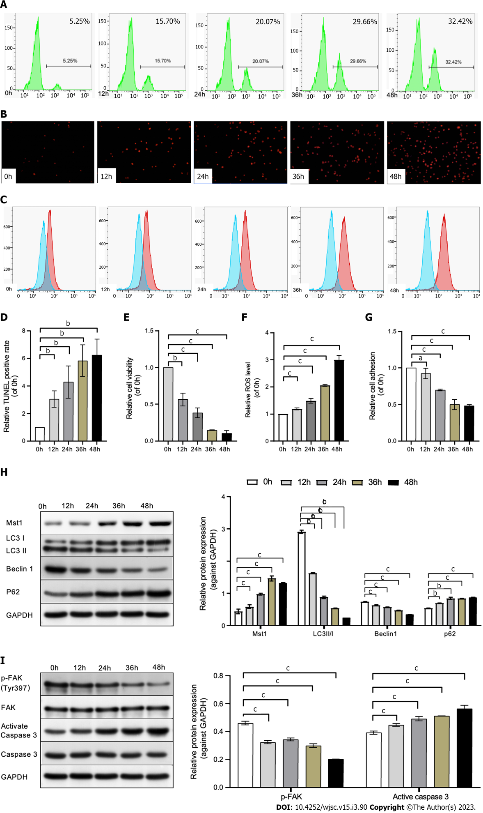
Figure 1 Mouse bone marrow mesenchymal stem cells exhibit susceptibility to anoikis under detachment conditions. A: Terminal-deoxynucleoitidyl Transferase Mediated Nick End Labeling (TUNEL)-positive cells (apoptotic cells) of mouse bone marrow mesenchymal stem cells (mBMSCs) cultured in precoated Poly-2-hydroxyethyl methacrylate conditions for 0 h, 12 h, 24 h, 36 h and 48 h using flow cytometry; B: Fluorescence staining images of dead cells; C: Reactive oxygen species (ROS) levels were measured using the ROS probe 2,7-Dichlorodihydrofluorescein diacetate by flow cytometry at 0 h, 12 h, 24 h, 36 h and 48 h; D: Quantitative analysis of the rate of TUNEL-positive cells; E: Quantification of live cells using a thiazolyl blue tetrazolium bromide assay; F: Quantitative analysis of the intracellular ROS level; G: Cell adhesion was expressed as fold changes between 0 h groups; H and I: Mammalian Ste20-like kinase 1 (Mst1), microtubules associated protein 1 light chain 3 II/I, p62, Beclin1, phospho-focal adhesion kinase, and activated caspase 3 expression levels at 0 h, 12 h, 24 h, 36 h and 48 h were evaluated by Western blot analysis; The expression of protein was expressed as the fold change relative to glyceraldehyde-3-phosphate dehydrogenase. Values are the mean ± SD of three independent experiments in each case. TUNEL: Terminal-deoxynucleoitidyl Transferase Mediated Nick End Labeling; ROS: Reactive oxygen species; Mst1: Mammalian Ste20-like kinase 1; LC3-II/I: Microtubules associated protein 1 light chain 3 II/I; p-FAK: Phospho-focal adhesion kinase; GAPDH: Glyceraldehyde-3-phosphate dehydrogenase. ^{C}P < 0.01; ^{b}P < 0.05; ªP > 0.05.

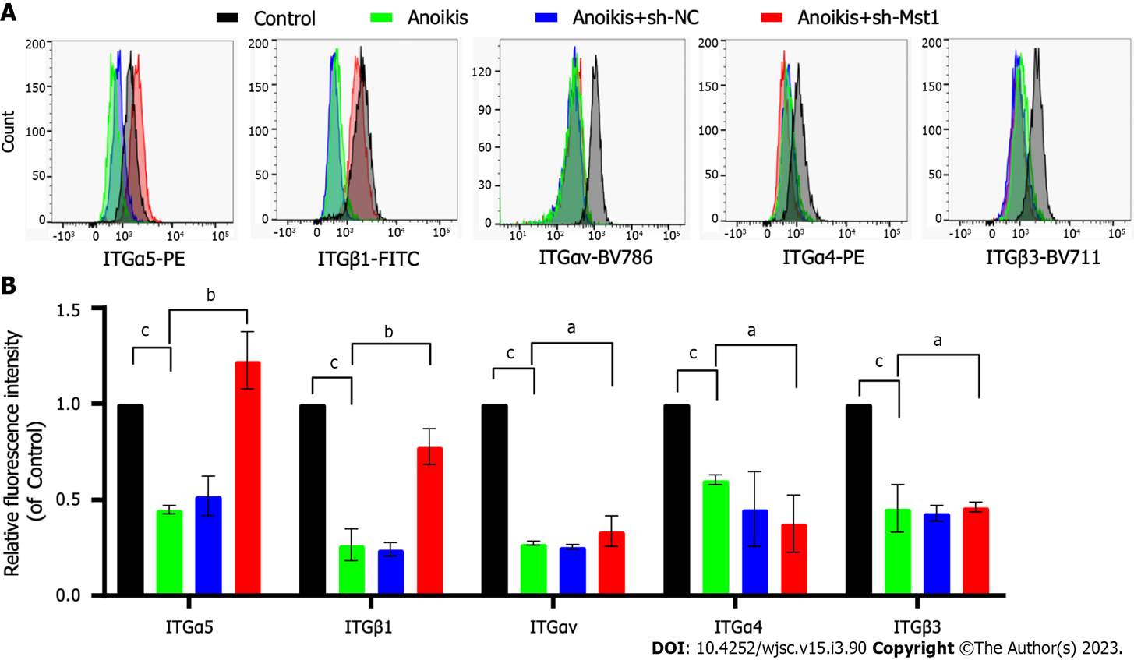
Figure 2 Changes in integrin protein expression in detached mouse bone marrow mesenchymal stem cells/sh-Mammalian Ste20-like kinase 1. Cells were cultured in detached conditions for 36 h. A: Flow cytometry analysis investigating the expression of integrinα5 (ITGα5), ITGαv, ITGα4, ITGβ1 and ITGβ3; B: Data are expressed as the fold change compared to the control groups. Values are expressed as the mean ± SD, n = 3. ITG: Integrin. ^{C}P < 0.01; ^{b}P < 0.05; ªP > 0.05.

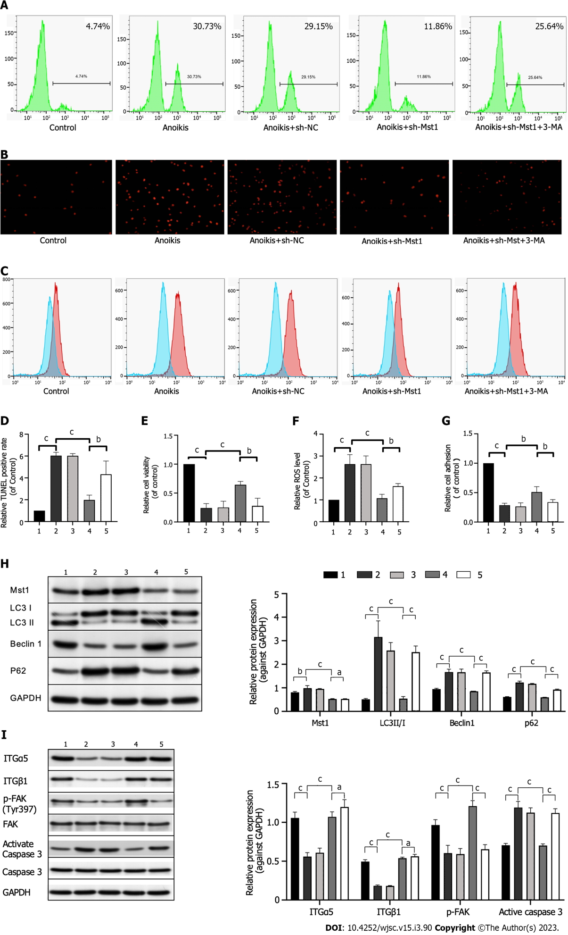
Figure 3 Mammalian Ste20-like kinase 1 inhibition-induced autophagy reduced cell apoptosis in detached mouse bone marrow mesenchymal stem cells. A: Terminal-deoxynucleoitidyl Transferase Mediated Nick End Labeling (TUNEL)-positive cells analysed by flow cytometry; B: Representative images and quantification of fluorescence staining of dead cells; C: Reactive oxygen species (ROS) levels were measured using the ROS probe 2,7-Dichlorodihydrofluorescein diacetate by flow cytometry. D: Quantitative analysis of the rate of TUNEL-positive cells. E: Quantification of live cells using a thiazolyl blue tetrazolium bromide assay. F: Quantitative analysis of the intracellular ROS level. G: Cell adhesion was evaluated as the fold change compared back to the control groups; H and I: Mammalian Ste20-like kinase 1 (Mst1), microtubules associated protein 1 light chain 3 II/I, p62, Beclin1, phospho-focal adhesion kinase, and activated caspase 3 expression were evaluated by Western blot analysis. glyceraldehyde-3-phosphate dehydrogenase served as a control. Values are the mean ± SD, and experiments were completed in triplicate. 3-MA: 3-methyladenine; TUNEL: Terminal-deoxynucleoitidyl Transferase Mediated Nick End Labeling; ROS: Reactive oxygen species; Mst1: Mammalian Ste20-like kinase 1; LC3-II/I: Microtubules associated protein 1 light chain 3 II/I; p-FAK: Phospho-focal adhesion kinase; GAPDH: Glyceraldehyde-3-phosphate dehydrogenase. 1. Control group; 2. Anoikis group; 3. Anoikis + sh-NC group; 4. Anoikis + sh-Mst1 group; 5. Anoikis + sh-Mst1 + 3-MA group. ^{C}P < 0.01; ^{b}P < 0.05; ªP > 0.05.

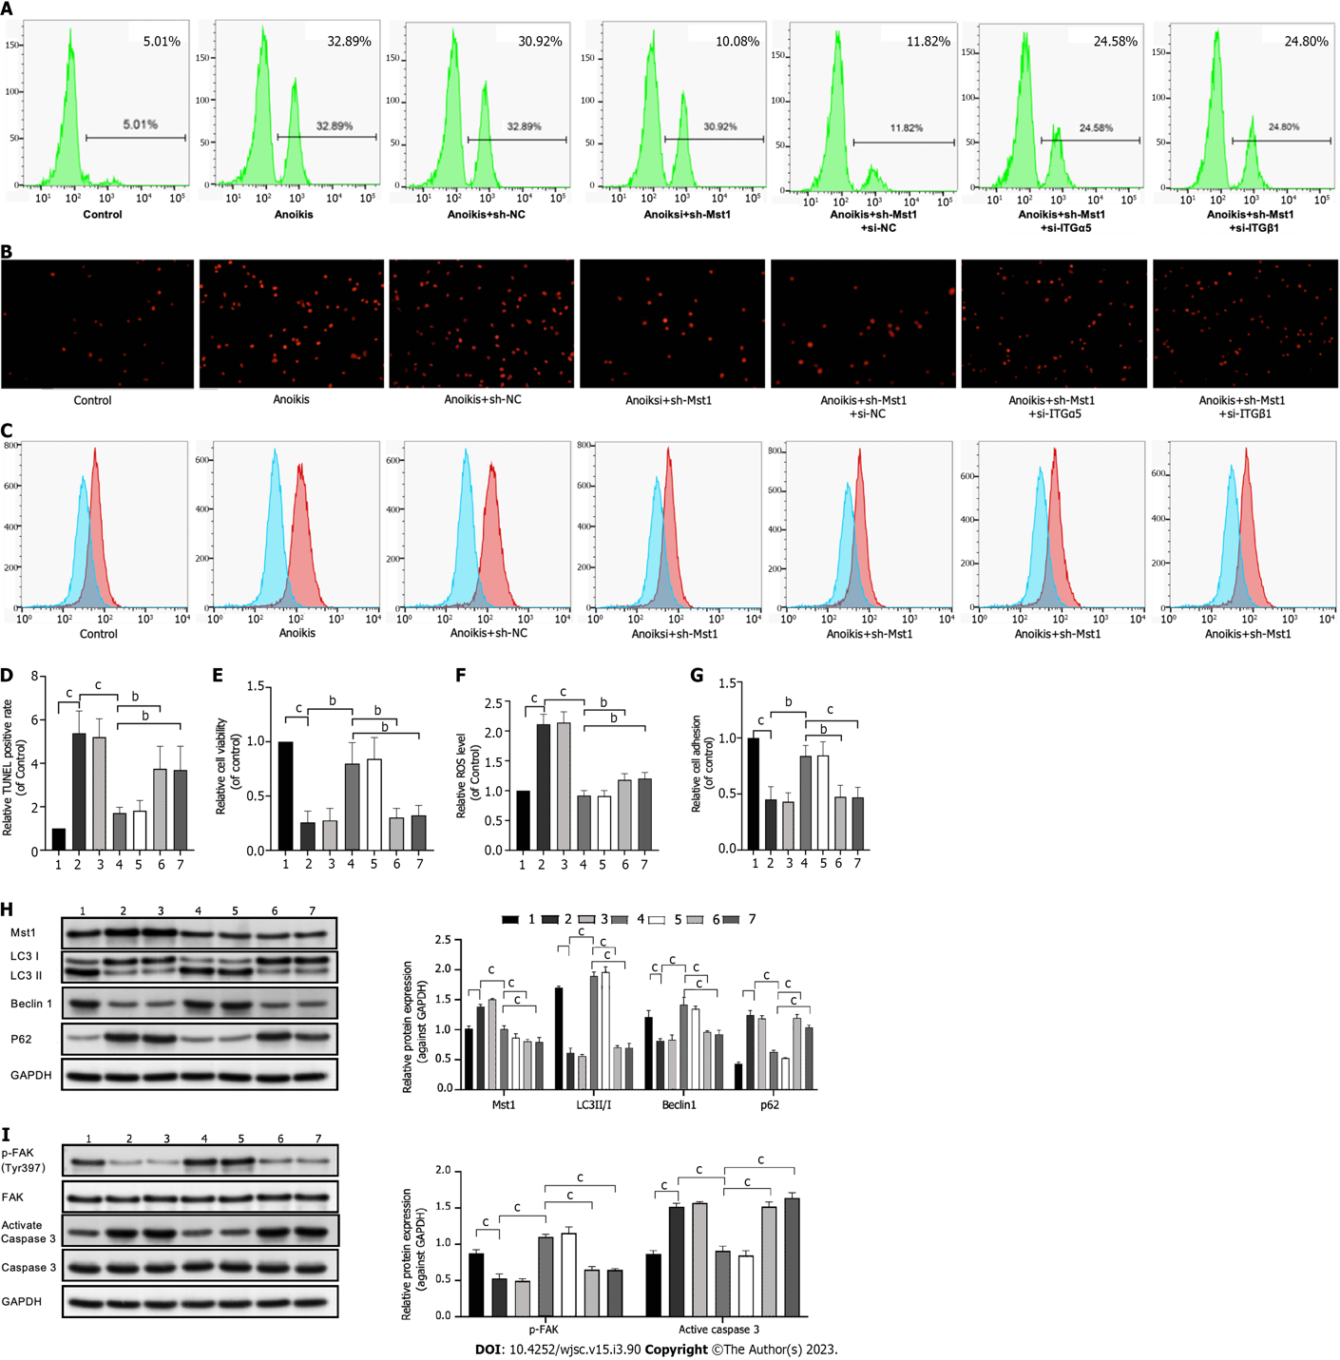
Figure 4 Upregulated integrinα5β1 expression triggered by Mammalian Ste20-like kinase 1 inhibition protected mouse bone marrow mesenchymal stem cells from anoikis. A: Terminal-deoxynucleoitidyl Transferase Mediated Nick End Labeling (TUNEL)-positive cells analysed by flow cytometry; B: Representative images and quantification of fluorescence staining of dead cells; C: Reactive oxygen species (ROS) levels were measured by flow cytometry; D: Quantitative analysis of the rate of TUNEL-positive cells; E: Quantification of live cells using a thiazolyl blue tetrazolium bromide assay; F: Quantitative analysis of the intracellular ROS level; G: Cell adhesion was evaluated as the fold change compared back to the control groups; H and I: Western blotting was used to measure the expression levels of Mammalian Ste20-like kinase 1 (Mst1), microtubules associated protein 1 light chain 3 II/I, p62, Beclin1, phospho-focal adhesion kinase, and activated caspase 3. glyceraldehyde-3-phosphate dehydrogenase was used as the loading control. Values are expressed as the mean ± SD. Measurements were performed in three replicates. 3-MA: 3-methyladenine; TUNEL: Terminal-deoxynucleoitidyl Transferase Mediated Nick End Labeling; ROS: Reactive oxygen species; Mst1: Mammalian Ste20-like kinase 1; LC3-II/I: Microtubules associated protein 1 light chain 3 II/I; p-FAK: Phospho-focal adhesion kinase; GAPDH: Glyceraldehyde-3-phosphate dehydrogenase. 1. Control group; 2. Anoikis group; 3. Anoikis + sh-NC group; 4. Anoikis + sh-Mst1 group; 5. Anoikis + sh-Mst1 + si-NC group; 6. Anoikis + sh-Mst1 + si-ITGα5; 7. Anoikis + sh-Mst1 + si-ITGβ1. ^{C}P < 0.01; ^{b}P < 0.05; ªP > 0.05.

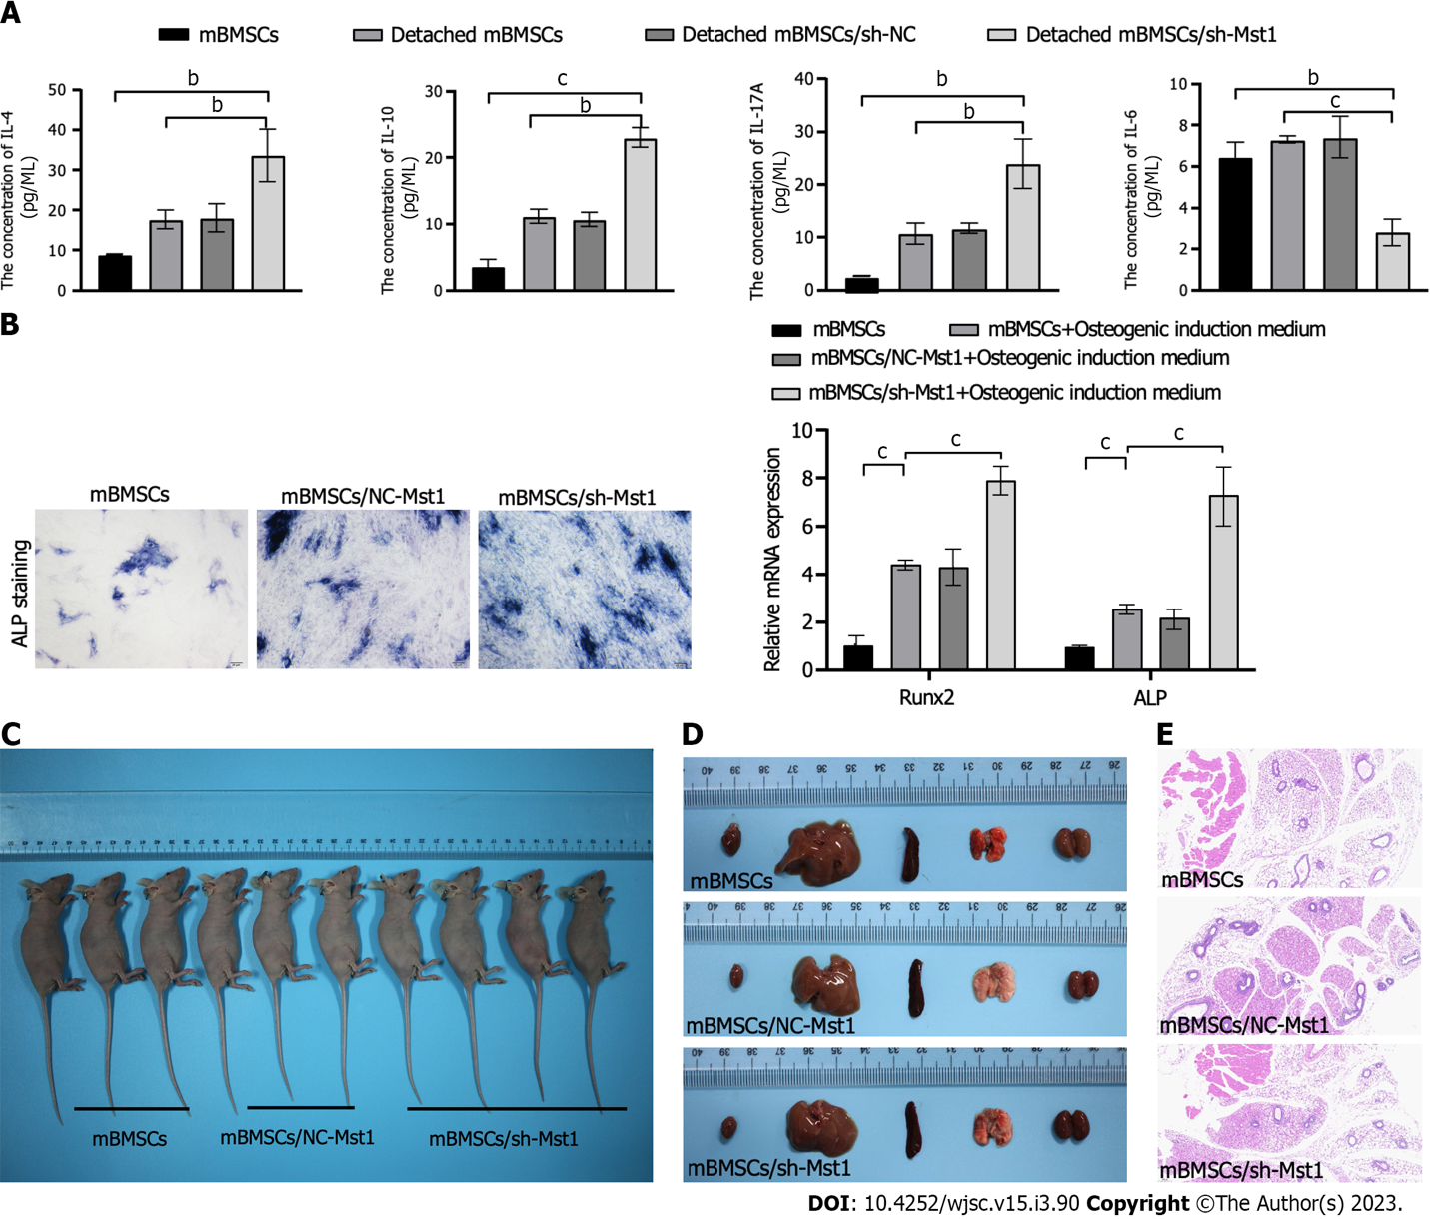
Figure 5 The properties and biological safety of mouse bone marrow mesenchymal stem cells/sh-Mammalian Ste20-like kinase 1. A: The levels of interleukin-4 (IL-4), IL-10, IL-17A and IL-6 were measured using a Cytometric Bead Array Cytokine Kit in detached mouse bone marrow mesenchymal stem cells (mBMSCs); B: Representative images of alkaline phosphatase (ALP) staining of mBMSCs after culture in osteogenesis induction medium for 21 d; C: Quantitative real-time polymerase chain reaction analysis of the relative mRNA expression levels of runt-related transcription factor 2 (Runx2) and ALP in mBMSCs cultured in adipogenesis induction medium for 21 d; D: Nude mice were subcutaneously implanted with mBMSCs (n = 3), mBMSCs/NC-Mst1 (n = 3), and mBMSCs/sh-Mst1 (n = 4). Representative images of the heart, liver, spleen, lung and kidney in each group 60 d postinjection; E. Paraffin-embedded subcutaneous sections derived from cell-injection sites were stained with haematoxylin and eosin. Data are the mean ± SD of three technical replicates. mBMSCs: Mouse bone marrow mesenchymal stem cells; Mst1: Mammalian Ste20-like kinase 1; IL: Interleukin; Runx2: Runt-related transcription factor 2; ALP: Alkaline phosphatase. ^{C}P < 0.01; ^{b}P < 0.05; ªP > 0.05.

Published by Baishideng Publishing Group Inc
7041 Koll Center Parkway, Suite 160, Pleasanton, CA 94566, USA
Telephone: +1-925-3991568
E-mail: bpgoffice@wjgnet.com
Help Desk: https://www.f6publishing.com/helpdesk
https://www.wjgnet.com

© 2023 Baishideng Publishing Group Inc. All rights reserved.

