Name of journal: World Journal of Gastroenterology
ESPS Manuscript NO: 28005
Manuscript Type: ORIGINAL ARTICLE

Basic Study
Fecal microbiota in pouchitis and ulcerative colitis

Li KY et al. Fecal microbiota in pouchitis and UC

Kai-Yu Li, Jian-Lin Wang, Jiang-Peng Wei, Sen-Yang Gao, Ying-Ying Zhang, Li-Tian Wang, Gang Liu

Kai-Yu Li, Jiang-Peng Wei , Sen-Yang Gao, Ying-Ying Zhang, Li-Tian Wang, Gang Liu, Department of General Surgery, Tianjin Medical University General Hospital, Tianjin 300052, China

Jian-Lin Wang, Department of General Surgery, Tianjin NanKai Hospital, Tianjin 300100, China

Author contributions: Li KY made study conception and design, acquired the data and contributed to final approval of the version of the article to be published; Wang JL performed the majority of experiments and analyzed the data; Wei JP analyzed and interpretation of data and drafted the manuscript; Gao SY and Zhang YY made statistical analysis and drafted the manuscript; Wang LT analyzed and interpreted the data. Liu Gang revised the manuscript for important intellectual content; supplied administrative, technical, or material support.

Supported by Academician Jie-Shou Li Intestinal Barrier Research Fundation, No. LJS_201008.

Institutional review board statement: The study was reviewed and approved by Tianjin Medical University General Hospital Institutional Review Board, Tianjin 300052, China.

Conflict-of-interest statement: This work was presented as a poster at the 10th International Congress on Autoimmunity in Leipzig, Germany, April 6-10, 2016. We have no financial relationships to disclose.

Data sharing statement: No additional data are available.

Open-Access: This article is an open-access article which was selected by an in-house editor and fully peer-reviewed by external reviewers. It is distributed in accordance with the Creative Commons Attribution Non Commercial (CC BY-NC 4.0) license, which permits others to distribute, remix, adapt, build upon this work non-commercially, and license their derivative works on different terms, provided the original work is properly cited and the use is non-commercial. See: http://creativecommons.org/licenses/by-nc/4.0/

Manuscript source: Invited manuscript

Correspondence to: Gang Liu, MD, PhD, Department of General Surgery, Tianjin Medical University General Hospital, Tianjin 300052, China. landmark1503@sina.com
Telephone: +86-22-60363901
Fax: +86-22-60362365

Received: June 24, 2016
Peer-review started: June 24, 2016
First decision: August 8, 2016
Revised: August 15, 2016
Accepted: August 30, 2016
Article in press:
Published online:

Abstract
AIM
To investigate the changes in microbiota in feces of patients with ulcerative colitis (UC) and pouchitis by genomic technology.

METHODS
Fecal samples were obtained from UC patients with or without ileal pouch-anal anastomosis (IPAA) procedure, as well as healthy persons. Touchdown polymerase chain reaction technique was chose to amplify the whole V3 region of 16S rRNA which was transcribed from deoxyribose nucleic acid extraction in fecal samples. Denaturing gradient gel electrophoresis technique was employed to separate amplicons. The band profiles and similarity indices were digitally analyzed. The predominant microbiota in different groups was confirmed by sequencing the 16S rRNA gene.

RESULTS
Microbial biodiversity in healthy people was significantly greater compared with UC groups (P < 0.001) and IPAA groups (P < 0.001). In comparation with healthy controls, UC patients in remission and mildly active stage, the predominant species of moderately and severely active UC patients changed obviously. Besides, the proportion of the dominant microbiota, which was negatively correlated with disease activity of UC (r = -6.591, P < 0.01), was decreased in pouchitis. Two kinds of bacteria, Faecalibacterium prausnitzii and Eubacterium rectale, were detected fewer in number in UC. Patients with pouchitis have altered composition of microbiota compared with UC patients. Microbiota from pouchitis was fewer than that from severely active UC patients. Sequencing results showed similar microbiota such as Clostridium perfringens (C. perfringens) were shared in both UC and pouchitis.

CONCLUSION
Less diverse fecal microbiota was present in patients with UC and pouchitis. Increase of C. perfringens in fecal may play a role in exacerbation of UC and pouchitis.

Key words: Pouchitis; Intestinal flora; Ulcerative colitis; Disease activity index; Ileal pouch-anal anastomosis

© The Author (s) 2016. Published by Baishideng Publishing Group Inc. All rights reserved.

Core tip: Dysbiosis occuring in pouchitis might be similar to that observed in ulcerative colitis (UC). This research was designed to determine the altered microflora in patients with UC and pouchitis, and to investigate the relationship between them. Our study demonstrated the reduced biodiversity of fecal microbiota in UC and pouchitis patients. The results showed altered composition of intestinal microbiota in UC and pouchitis, including decreased number of two kinds of commonly seen bacteria in UC, and higher quantity of Clostridium perfringens in both UC and pouchitis. The increase of this bacterium in feces may play a role in exacerbation of UC and pouchitis.

Li KY, Wang JL, Wei JP, Gao SY, Zhang YY, Wang LT, Liu G. Fecal microbiota in pouchitis and ulcerative colitis. World J Gastroenterol 2016; In press

INTRODUCTION
One of the most common complications in ulcerative colitis (UC) patients operated with ileal pouch-anal anastomosis (IPAA) surgery is pouchitis^{[1]}. Interestingly, it is rarely seen in postoperative patients attacked familial adenomatous polyposis. Gut microbiome plays a vital role in UC^{[2]}. Antibiotics and probiotics are used to treat and prevent pouchitis^{[3]}. The microbiome in UC gut may play a vital role in UC pathogenesis^{[4]}.
However, direct evidence of the role of microflora in pathogenesis of pouchitis is lacking. Studies have shown variation in microbiota in pouchitis and healthy controls and no consensus was available based on different culture methods and molecular biology techniques^{[3]}. Johnson et al^{[5]} and Lim et al^{[6]} showed no differences between pouchitis and no pouchitis (NP) groups. Some studies suggest a reduction in bacterial diversity in pouchitis but not dysbiosis^{[7]}. Some studies reveal an increase in bacterial diversity in pouchitis^{[8]}, such as increased numbers of Clostridium and Eubacterium^{[9]},while others showed less Enterococcaceae in pouchitis^{[10]}. The findings of the most recent study reveal that the disorders due to protective and harmful bacteria are associated with pouch inflammation^{[11]}. The emergence of R. gnavus, B. vulgatus and Clostridium perfringens (C. perfringens) and deficiency of Blautia and Roseburia in patients with UC before IPAA is closely related to pouchitis^{[12]}.
Denaturing gradient gel electrophoresis (DGGE) was reported to be used in facilitating the analysis of changes in the composition of intestinal microbiota^{[2]}. We hypothesized that dysbiosis occurring in the pouch might be similar to dysbiosis observed in UC. We determined the altered microflora in pouchitis and UC, and investigated the relationship between them.

MATERIALS AND METHODS
Patients and fecal samples
Patients with IPAA for UC were recruited. Pouchitis was diagnosed based on symptoms, endoscopy and histology of the pouch. Patients underwent pouch endoscopy and biopsy. Physicians recorded clinical data, the pouch appearance and pathological manifestations based on the Pouchitis Disease Activity Index (PDAI)^{[13]}. Antibiotic or other drug therapy was stopped to prevent variations in microbiome 4 wk before collecting the fecal sample. A limited number of patients with pouch were excluded from the study because of antibiotic or probiotic usage for pouchitis or severe concomitant disease.
According to PDAI, patients with IPAA were divided into two groups: NP, PDAI < 7 points (n = 11) and pouchitis, PDAI ≥ 7 points (n = 8). Matched fecal samples were obtained from healthy people (n = 16) and 41 UC patients who did not undergo IPAA. All the UC patients without a pouch underwent endoscopy. Mayo Scoring System for Assessment of Ulcerative Colitis Activity was employed to divide patients with UC into remission group (n = 10), mildly activity group (n = 11), moderately activity group (n = 10) and severely activity group (n = 10).
All fecal samples were collected at the hospital and preserved at 4 °C. Upon arrival at the laboratory, the samples were frozen at −80 °C within 12 h. This study was reviewed and approved by Tianjin Medical University General Hospital Ethical Committee (China). Patient data were summarized in Table 1.

Fecal DNA extraction
Fecal DNA kit (Aidlab Biotechnologies Co, Ltd, Beijing, China) was used to isolate DNA from frozen feces individually following the manufacturer’s guideline and previously described^{[14]}. Following 1% agarose gel electrophoresis the eluted DNA was quantified on a NanoDrop2000 Spectrophotometer.

PCR amplification
The genomic DNA and universal primers including forward and reverse primers (AuGCT DNA technologies, Beijing, China) were employed to amplify the whole fragment V3 region of 16S rRNA gene.
After 15 cycles of thermocycling on a PCR system (Bio-Rad, US) the amplified product was verified by 2 % agarose electrophoresis. The amplified DNA was quantified on a NanoDrop2000 Spectrophotometer, and recorded by DH2000 gel imaging analysis.

DGGE for amplified 16S rRNA gene
DGGE was chosen to separate PCR amplicons according to the rules of Muyzer et al^{[15]} with some modifications. A 10 % polyacrylamide combined with Tris-acetate-EDTA (TAE) buffer was used for polyacrylamide gels with denaturing gradient at a range from 30 % to 70 %. A stacking gel was added before polymerization of the denaturing gel, followed by appropriate comb insertion. Electrophoresis was performed at 200 V for 5 min and 85 V for 16 h in 0.5 × TAE buffer subsequently at a constant 60 ◦C. After staining with AgNO3^{[16]}, the gels were desiccated overnight at 60 ◦C.

Digital processing of DGGE profiles
Following the manufacturer's instructions, DGGE profiles were digitally analyzed using Quantity One-4.6.5 in UNIVERSAL HOODⅡ Gel Imaging System (Beijing, China). After normalizing the gels, the band in each sample was marked by the software, and manual corrections were conducted. The number of DGGE bands were shown as mean ± SD. Based on gray value, Dice similarity and UPGMA tree analysis were conducted using Quantity One software. Canoco software was used to conduct Principal Component Analysis (PCA).

DGGE band extraction and sequencing
Based on the digital results, the bands distinguishing the groups were purified after excision and sequenced from the gel. Mixture of gel slice and 15 μL TE buffer was heated at 65 °C for 10 min to elute DNA from the gel. The DNA solution was amplified with the universal V3 primers F357+GC clamp and R518. DGGE gel expansion facilitated the purification of the bands. DGGE with an adjusted gradient 32 were used to check the amplicons, which were excised at least three times until a single band was obtained. The DGGE was repeated to purify the PCR product before sequencing. In the final round, the amplicons were analyzed with the original sample profiles from which they were excised and visually analyzed for purification of the correct bands.
When the purified bands matched with the targeted bands, amplicons were chosen to sequence using an ABI Prism. Sequences were read with primers R518 and F357 (without clamp), respectively. BioNumerics software was used for sequencing. GenBank DNA database were searched via BLAST homology searches. According to BLAST results, the sequences of phylogenetic neighbour species for reference, whose similarities were up to 90%, were included in cluster analysis using multiple sequence alignments. The purified band sequences were allocated to the most probable species according to the average linking method.

Statistical analysis
The Quantity One software was used for Dice similarity analysis and UPGMA tree analysis. DGGE strips bands were presented as mean ± SD. Shapiro–Wilk test was used to test normality of band number and Dice analysis data. The content of each sample was similar. The homogeneity of variance was still robust and highly efficient. The band number of DGGE strips showed normal distribution unlike the Dice analysis results. Therefore, the three groups were tested with SNK test. The Bonferroni test was chosen to compare DGGE strips and band numbers among the five groups. An extension t test after non-parametric Kruskal–Wallis H test was employed to compare the Dice analysis results among multiple groups. The correlation between disease activity and bacterial count was assessed with Spearman correlation coefficient. SPSS 19.0 software was employed to analyze all the data. Two-tailed tests were used in all analysis and P values of ≤ 0.05 were considered statistically significant.

RESULTS
Bacteria in fecal samples from UC
The demographic details of study patients are seen in Table 1. DNA extracts from the fecal samples in different individuals presented variable number of bands after PCR-DGGE analysis. A band represents identical or similar sequences of V3 regions of 16S rRNA gene, reflecting the dominant bacterial communities in the fecal samples.
Examination of digital DGGE profiles from healthy controls showed relative stability among the different individuals (Figure 1). Profiles from UC patients showed in Figure 2 suggested significant variation in the position and number of bands when compared with the healthy controls. The number of bands, which reflected diverse microbiota, was 17 ± 3 in the 16 healthy controls and 13 ± 3 in the 41 UC patients (P = 0.001). Changes were also seen among the subgroups in UC patients (Figure 3). These results reveal that the number of predominant microbiota was negatively correlated with Mayo classification (r = -6.591, P < 0.01). Kruskal–Wallis H test showed greater similarity between groups than within the groups, which revealed variation in predominant microbiota with clinical status (Table 2). UPGMA tree analysis showed similar conclusion (Figure 4). PCA analysis of normal and UC groups revealed great differences in the predominant species among control group, remission and mild group, and moderate and severe group (Figure 5).
Sequence results after purification (based on digital DGGE profiles) showed the presence of greater number of C. perfringens and fewer Faecalibacterium prausnitzii and Eubacterium rectale in UC than in control group. C. perfringens occurred predominantly in severe UC.

Bacteria in fecal samples of pouchitis
Significant changes occurred in the position and number of bands from patients with pouchitis when compared with NP and healthy controls (Figure 6). Differences in the number of bands in controls (17 ± 3 bands), NP (11 ± 3 bands) and pouchitis (8 ± 2 bands) are shown in Figure 7 (ANOVA test). Bonferroni test showed greater similarity between groups than within groups, suggesting differences in the predominant species in normal, NP and pouchitis groups (Table3). These results suggest that patients with pouchitis showed altered composition of microbiota compared with normal individuals. UPGMA tree analysis yielded similar conclusions (Figure 8). PCA analysis of normal and UC groups revealed great variation in the predominant species in moderate and severe UC compared with normal, remission and mildly active UC, which also differed from each other (Figure 9).
Sequencing results after purification (based on digital DGGE profiles) showed less Eubacterium rectale and more C. perfringens in pouchitis than in NP and control groups.
As shown in Table 4, the DGGE profiles in pouchitis patients varied significantly from UC in remission to severe state, while NP group of patients differed from UC in remission. The results showed that patients with pouch have altered composition of microbiota compared with UC patients (Figure 10). Microbiota from pouchitis was fewer than in UC patients with a severe condition. A normal pouch can be as diverse as mild, moderate and severe UC. Sequencing results in both UC and pouchitis shared similar microbiota such as C. perfringens.

DISCUSSION
In this study, we focused on UC patients after IPAA surgery, specifically compared patients developing pouch inflammation with those without surgery. Our digital analysis of stool samples showed that the predominant microbiota in UC patients was reduced when compared with normal group. Sequence analysis showed a higher number of C. perfringens and fewer Faecalibacterium prausnitzii and Eubacterium rectale in the UC group. Levels of Eubacterium rectale (butyrate-producing bacteria) group was significantly reduced on UC mucosa^{[17]}, and had a high age dependence. High clinical activity indices (CAI), as well as sigmoidoscopy scores (SS), were related with Eubacterium rectale^{[18]}. Vermeiren considered less Eubacterium rectale showed in UC patients via a dynamic gut model of mucin environment^{[17]}. C. perfringens, which is a kind of Gram-positive, anaerobic, spore-forming bacillus of Clostridia genus, can be found in the intestinal contents of both animals and humans^{[19]}. C. perfringens is an intestinal commensal as well as pathogen, for example, via production of toxins that damage the host tissues^{[20]}. C. perfringens exerts proteolytic and mucinase activity, both of which may mediate the pathogenesis of inflammatory bowel disease (IBD)^{[21]}. C. perfringens found in IBD patients, which is deemed to be a important factor during the immunopathogenesis of IBD, may be a result of dysbiosis^{[22]}.The results from Falk showed that there were more C. perfringens in pouchitis patients . Some studies found that 21% of the total bacteria in colonic specimens, which were collected from patients attacked UC, belonged to clostridia of clusters I, II and XI, which were not found in the control groups^{[23]}. We should keep in mind that ileum tissues of UC patients were the origin of the present pouches^{[24]}. F. prausnitzii is the most species-specific microbe in the study of IBD. Sokol et al^{[25]} studied a small group of 17 UC patients and reported a reduction in active UC patients. A strong anti-inflammatory effect of F. prausnitzii has been demonstrated both in vitro and in vivo^{[26]}. Machiels et al^{[27]} observed a significant inverse correlation between disease activity, indicating that a deficiency of this species provokes or enhance inflammation. F prausnitzii produces high concentrations of butyrate, a vital energy source for colonocytes, and also prevents mucosal atrophy. Consequently, butyrate improves the mucosal barrier function of the colon. Further, butyrate exhibits immunomodulatory and anti-inflammatory effects as it downregulates the pro-inflammatory cytokines^{[28]}. Our data show that bacterial biodiversity in feces was decreased distinctly with the severity of Mayo classification compared with healthy controls. Studies demonstrated that the mucosal biopsies from patients with active Crohn’s disease or active UC manifest reduced bacterial diversity after analysis of 16S rRNA gene^{[29]}. Furthermore, Manichanh^{[30]} reported a reduced phylum Firmicutes in Crohn’s disease in remission using an extensive metagenomic analysis. Consistent with previous studies, our results confirmed that bacterial diversity was reduced in fecal samples from UC patients in different grade, and demonstrated the changes in microbial composition among subgroups in UC. The decreased biodiversity in UC may destroy the stability of gut ecosystem. The results revealed that changes in the predominant bacteria were consistent with Mayo classification. Therefore, we suggest that the fecal microflora in UC patients is reduced in aggravated intestinal lesions. A previous study by Wills^{[31]} reported patient-specific shifts in microbial composition in UC patients with altered pathological activity over time. The changes were more pronounced in CD cases than in UC patients, suggesting their role in the inflammatory process in UC.
On the other hand, DGGE profiles from pouchitis patients varied from UC and healthy controls in the number of bands. We showed a decrease in bacterial diversity and reduced abundance of predominant bacteria in UC pouches. Ruminococcus gnavus (R. gnavus) infection, especially occurring as the predominant microbiota before colectomy, increased the risk of pouchitis 1 year after IPAA^{[12]}. R. gnavus produces the bacteriocin ruminococcin A, which inhibits the growth of phylogenetically-related species and various bifidobacterial and clostridial species^{[32]}. The bacteriocin also degraded intestinal mucin^{[33]}. It also induced α-galactosidase and β-glucuronidase activity in vitro^{[34]}. β-glucuronidase activity generates toxic metabolites in the colon, which provoke local inflammation. Png et al^{[35]} observed an increase of mucolytic bacteria including R. gnavus in biopsies of patients with UC and CD. Our data are supported by reports from several groups that analyzed fecal or biopsy samples using different DNA-based methods^{[7]}, further confirming the association between changes in microbiota and pouchitis. On the contrary, the variability in endogenous factors, including secretion of mucins, defensins, cytokines, and immunoglobulins, may also affect the composition of predominant bacterial species in UC and pouchits. However, data about these secretions affecting the variability of UC is limited. Studies involving UC have revealed that a high percentage of fecal bacteria (about 30%–40% of dominant species) belong to unusual genus in healthy populations^{[36]}. Hypothetically, the decresed number of stable commensals in individuals, who are genetically susceptible for pouchitis, break this first line of natural defense against potentially invasive bacteria, which result in inflammation.
In conclusion, our research demonstrates the reduced biodiversity of fecal microbiota in UC and pouchitis patients. Fewer numbers of Faecalibacterium prausnitzii and Eubacterium rectale showed in UC. More R. gnavus were found in pouchitis. More C. perfringens occurred in both UC and pouchitis.

COMMENTS
Background
Pouchitis is a commonly-seen complication of patients with ulcerative colitis (UC) following ileal pouch-anal anastomosis (IPAA) procedure. Gut microbiome is considered playing a vital role in the occurrence and development of UC. Besides, antibiotics and probiotics have already been used in treatment and prevention of pouchitis. However, direct evidence of dysbacteriosis in pouchitis is lacking now.

Research frontiers
Gut microbiata is hot topic in intestinal inflammation field, especially in inflammatory bowel disease, where data are often conflicting.

Innovations and Breakthroughs
The authors demonstrated the role of the reduced diversity and the changed composition of intestinal microbiata in the pathogenesis of pouchitis. We confirmed that Faecalibacterium prausnitzii and Eubacterium rectal were reduced in UC patients and Clostridium perfringens was significantly increased in UC and pouchitis.

Applications
The findings provide new clues to better understand the pathogenesis of pouchitis in UC patients operated IPAA, although it won’t be immediately used in treatment of pouchitis.

Terminology
Pouchitis: It’s an inflammation in intestinal pouch, which is established following proctocoloctomy IPAA procedure for patients with UC to prevent permanent abdominal fistula. It could result in serious consequence, such as blood diarrhea, even ileal pouch failure.

Peer-review
The manuscript definitely deals with a hot topic in the inflammatory bowel disease and intestinal inflammation field, where data are often conflicting. The deep insight and detailed description made by the authors of the diversity of microbiota in healthy people and patients will provide new clues to better understand the pathogenesis of pouchitis following IPAA for UC.

REFERENCES
1 Morgan XC, Kabakchiev B, Waldron L, Tyler AD, Tickle TL, Milgrom R, Stempak JM, Gevers D, Xavier RJ, Silverberg MS, Huttenhower C. Associations between host gene expression, the mucosal microbiome, and clinical outcome in the pelvic pouch of patients with inflammatory bowel disease. Genome Biol 2015; 16: 67 [PMID: 25887922 DOI: 10.1186/s13059-015-0637-x]
2 Martinez C, Antolin M, Santos J, Torrejon A, Casellas F, Borruel N, Guarner F, Malagelada JR. Unstable composition of the fecal microbiota in ulcerative colitis during clinical remission. Am J Gastroenterol 2008; 103: 643-648 [PMID: 18341488 DOI: 10.1111/j.1572-0241.2007.01592.x]
3 McLaughlin SD, Clark SK, Tekkis PP, Nicholls RJ, Ciclitira PJ. The bacterial pathogenesis and treatment of pouchitis. Therap Adv Gastroenterol 2010; 3: 335-348 [PMID: 21180613 DOI: 10.1177/1756283X10370611]
4 Wu H, Shen B. Pouchitis: lessons for inflammatory bowel disease. Curr Opin Gastroenterol 2009; 25: 314-322 [PMID: 19349860 DOI: 10.1097/MOG.0b013e32832b36eb]
5 Johnson MW, Rogers GB, Bruce KD, Lilley AK, von Herbay A, Forbes A, Ciclitira PJ, Nicholls RJ. Bacterial community diversity in cultures derived from healthy and inflamed ileal pouches after restorative proctocolectomy. Inflamm Bowel Dis 2009; 15: 1803-1811 [PMID: 19637361 DOI: 10.1002/ibd.21022]
6 Lim M, Adams JD, Wilcox M, Finan P, Sagar P, Burke D. An assessment of bacterial dysbiosis in pouchitis using terminal restriction fragment length polymorphisms of 16S ribosomal DNA from pouch effluent microbiota. Dis Colon Rectum 2009; 52: 1492-1500 [PMID: 19617766 DOI: 10.1007/DCR.0b013e3181a7b77a]
7 McLaughlin SD, Walker AW, Churcher C, Clark SK, Tekkis PP, Johnson MW, Parkhill J, Ciclitira PJ, Dougan G, Nicholls RJ, Petrovska L. The bacteriology of pouchitis: a molecular phylogenetic analysis using 16S rRNA gene cloning and sequencing. Ann Surg 2010; 252: 90-98 [PMID: 20562611 DOI: 10.1097/SLA.0b013e3181e3dc8b]
8 Komanduri S, Gillevet PM, Sikaroodi M, Mutlu E, Keshavarzian A. Dysbiosis in pouchitis: evidence of unique microfloral patterns in pouch inflammation. Clin Gastroenterol Hepatol 2007; 5: 352-360 [PMID: 17368235 DOI: 10.1016/j.cgh.2007.01.001]
9 Zella GC, Hait EJ, Glavan T, Gevers D, Ward DV, Kitts CL, Korzenik JR. Distinct microbiome in pouchitis compared to healthy pouches in ulcerative colitis and familial adenomatous polyposis. Inflamm Bowel Dis 2011; 17: 1092-1100 [PMID: 20845425 DOI: 10.1002/ibd.21460]
10 Scarpa M, Grillo A, Faggian D, Ruffolo C, Bonello E, D'Incà R, Scarpa M, Castagliuolo I, Angriman I. Relationship between mucosa-associated microbiota and inflammatory parameters in the ileal pouch after restorative proctocolectomy for ulcerative colitis. Surgery 2011; 150: 56-67 [PMID: 21549404 DOI: 10.1016/j.surg.2011.02.009]
11 Reshef L, Kovacs A, Ofer A, Yahav L, Maharshak N, Keren N, Konikoff FM, Tulchinsky H, Gophna U, Dotan I. Pouch Inflammation Is Associated With a Decrease in Specific Bacterial Taxa. Gastroenterology 2015; 149: 718-727 [PMID: 26026389 DOI: 10.1053/j.gastro.2015.05.041]
12 Machiels K, Sabino J, Vandermosten L, Joossens M, Arijs I, de Bruyn M, Eeckhaut V, Van Assche G, Ferrante M, Verhaegen J, Van Steen K, Van Immerseel F, Huys G, Verbeke K, Wolthuis A, de Buck VOA, D'Hoore A, Rutgeerts P, Vermeire S. Specific members of the predominant gut microbiota predict pouchitis following colectomy and IPAA in UC. Gut 2015; : [PMID: 26423113 DOI: 10.1136/gutjnl-2015-309398]
13 Sandborn WJ, Tremaine WJ, Batts KP, Pemberton JH, Phillips SF. Pouchitis after ileal pouch-anal anastomosis: a Pouchitis Disease Activity Index. Mayo Clin Proc 1994; 69: 409-415 [PMID: 8170189]
14 Vanhoutte T, Huys G, Brandt E, Swings J. Temporal stability analysis of the microbiota in human feces by denaturing gradient gel electrophoresis using universal and group-specific 16S rRNA gene primers. FEMS Microbiol Ecol 2004; 48: 437-446 [PMID: 19712312 DOI: 10.1016/j.femsec.2004.03.001]
15 Muyzer G, de Waal EC, Uitterlinden AG. Profiling of complex microbial populations by denaturing gradient gel electrophoresis analysis of polymerase chain reaction-amplified genes coding for 16S rRNA. Appl Environ Microbiol 1993; 59: 695-700 [PMID: 7683183]
16 Sanguinetti CJ, Dias Neto E, Simpson AJ. Rapid silver staining and recovery of PCR products separated on polyacrylamide gels. Biotechniques 1994; 17: 914-921 [PMID: 7840973]
17 Vermeiren J, Van den Abbeele P, Laukens D, Vigsnaes LK, De Vos M, Boon N, Van de Wiele T. Decreased colonization of fecal Clostridium coccoides/Eubacterium rectale species from ulcerative colitis patients in an in vitro dynamic gut model with mucin environment. FEMS Microbiol Ecol 2012; 79: 685-696 [PMID: 22092917 DOI: 10.1111/j.1574-6941.2011.01252.x]
18 Fite A, Macfarlane S, Furrie E, Bahrami B, Cummings JH, Steinke DT, Macfarlane GT. Longitudinal analyses of gut mucosal microbiotas in ulcerative colitis in relation to patient age and disease severity and duration. J Clin Microbiol 2013; 51: 849-856 [PMID: 23269735 DOI: 10.1128/JCM.02574-12]
19 Varga J, Stirewalt VL, Melville SB. The CcpA protein is necessary for efficient sporulation and enterotoxin gene (cpe) regulation in Clostridium perfringens. J Bacteriol 2004; 186: 5221-5229 [PMID: 15292123 DOI: 10.1128/JB.186.16.5221-5229.2004]
20 Hatheway CL. Toxigenic clostridia. Clin Microbiol Rev 1990; 3: 66-98 [PMID: 2404569]
21 Pruteanu M, Hyland NP, Clarke DJ, Kiely B, Shanahan F. Degradation of the extracellular matrix components by bacterial-derived metalloproteases: implications for inflammatory bowel diseases. Inflamm Bowel Dis 2011; 17: 1189-1200 [PMID: 20853433 DOI: 10.1002/ibd.21475]
22 Hansen JJ. Immune Responses to Intestinal Microbes in Inflammatory Bowel Diseases. Curr Allergy Asthma Rep 2015; 15: 61 [PMID: 26306907 DOI: 10.1007/s11882-015-0562-9]
23 Kleessen B, Kroesen AJ, Buhr HJ, Blaut M. Mucosal and invading bacteria in patients with inflammatory bowel disease compared with controls. Scand J Gastroenterol 2002; 37: 1034-1041 [PMID: 12374228]
24 Falk A, Olsson C, Ahrné S, Molin G, Adawi D, Jeppsson B. Ileal pelvic pouch microbiota from two former ulcerative colitis patients, analysed by DNA-based methods, were unstable over time and showed the presence of Clostridium perfringens. Scand J Gastroenterol 2007; 42: 973-985 [PMID: 17613928 DOI: 10.1080/00365520701204238]
25 Sokol H, Seksik P, Furet JP, Firmesse O, Nion-Larmurier I, Beaugerie L, Cosnes J, Corthier G, Marteau P, Doré J. Low counts of Faecalibacterium prausnitzii in colitis microbiota. Inflamm Bowel Dis 2009; 15: 1183-1189 [PMID: 19235886 DOI: 10.1002/ibd.20903]
26 Sokol H, Pigneur B, Watterlot L, Lakhdari O, Bermúdez-Humarán LG, Gratadoux JJ, Blugeon S, Bridonneau C, Furet JP, Corthier G, Grangette C, Vasquez N, Pochart P, Trugnan G, Thomas G, Blottière HM, Doré J, Marteau P, Seksik P, Langella P. Faecalibacterium prausnitzii is an anti-inflammatory commensal bacterium identified by gut microbiota analysis of Crohn disease patients. Proc Natl Acad Sci U S A 2008; 105: 16731-16736 [PMID: 18936492 DOI: 10.1073/pnas.0804812105]
27 Machiels K, Joossens M, Sabino J, De Preter V, Arijs I, Eeckhaut V, Ballet V, Claes K, Van Immerseel F, Verbeke K, Ferrante M, Verhaegen J, Rutgeerts P, Vermeire S. A decrease of the butyrate-producing species Roseburia hominis and Faecalibacterium prausnitzii defines dysbiosis in patients with ulcerative colitis. Gut 2014; 63: 1275-1283 [PMID: 24021287 DOI: 10.1136/gutjnl-2013-304833]
28 Segain JP, Raingeard de la Blétière D, Bourreille A, Leray V, Gervois N, Rosales C, Ferrier L, Bonnet C, Blottière HM, Galmiche JP. Butyrate inhibits inflammatory responses through NFkappaB inhibition: implications for Crohn's disease. Gut 2000; 47: 397-403 [PMID: 10940278]
29 Ott SJ, Musfeldt M, Wenderoth DF, Hampe J, Brant O, Fölsch UR, Timmis KN, Schreiber S. Reduction in diversity of the colonic mucosa associated bacterial microflora in patients with active inflammatory bowel disease. Gut 2004; 53: 685-693 [PMID: 15082587]
30 Manichanh C, Rigottier-Gois L, Bonnaud E, Gloux K, Pelletier E, Frangeul L, Nalin R, Jarrin C, Chardon P, Marteau P, Roca J, Dore J. Reduced diversity of faecal microbiota in Crohn's disease revealed by a metagenomic approach. Gut 2006; 55: 205-211 [PMID: 16188921 DOI: 10.1136/gut.2005.073817]
31 Wills ES, Jonkers DM, Savelkoul PH, Masclee AA, Pierik MJ, Penders J. Fecal microbial composition of ulcerative colitis and Crohn's disease patients in remission and subsequent exacerbation. PLoS One 2014; 9: e90981 [PMID: 24608638 DOI: 10.1371/journal.pone.0090981]
32 Dabard J, Bridonneau C, Phillipe C, Anglade P, Molle D, Nardi M, Ladire M, Girardin H, Marcille F, Gomez A, Fons M. Ruminococcin A, a new lantibiotic produced by a Ruminococcus gnavus strain isolated from human feces. Appl Environ Microbiol 2001; 67: 4111-4118 [PMID: 11526013]
33 Dethlefsen L, Eckburg PB, Bik EM, Relman DA. Assembly of the human intestinal microbiota. Trends Ecol Evol 2006; 21: 517-523 [PMID: 16820245 DOI: 10.1016/j.tree.2006.06.013]
34 Cervera-Tison M, Tailford LE, Fuell C, Bruel L, Sulzenbacher G, Henrissat B, Berrin JG, Fons M, Giardina T, Juge N. Functional analysis of family GH36 α-galactosidases from Ruminococcus gnavus E1: insights into the metabolism of a plant oligosaccharide by a human gut symbiont. Appl Environ Microbiol 2012; 78: 7720-7732 [PMID: 22923411 DOI: 10.1128/AEM.01350-12]
35 Png CW, Lindén SK, Gilshenan KS, Zoetendal EG, McSweeney CS, Sly LI, McGuckin MA, Florin TH. Mucolytic bacteria with increased prevalence in IBD mucosa augment in vitro utilization of mucin by other bacteria. Am J Gastroenterol 2010; 105: 2420-2428 [PMID: 20648002 DOI: 10.1038/ajg.2010.281]
36 Seksik P, Rigottier-Gois L, Gramet G, Sutren M, Pochart P, Marteau P, Jian R, Doré J. Alterations of the dominant faecal bacterial groups in patients with Crohn's disease of the colon. Gut 2003; 52: 237-242 [PMID: 12524406]
P-Reviewer: Caviglia R, Pastorelli L S-Editor: Yu J L-Editor: E-Editor:
Specialty type: Gastroenterology and hepatology
Country of origin: China
Peer-review report classification
Grade A (Excellent): 0
Grade B (Very good): 0
Grade C (Good): C,C
Grade D (Fair): 0
Grade E (Poor): 0

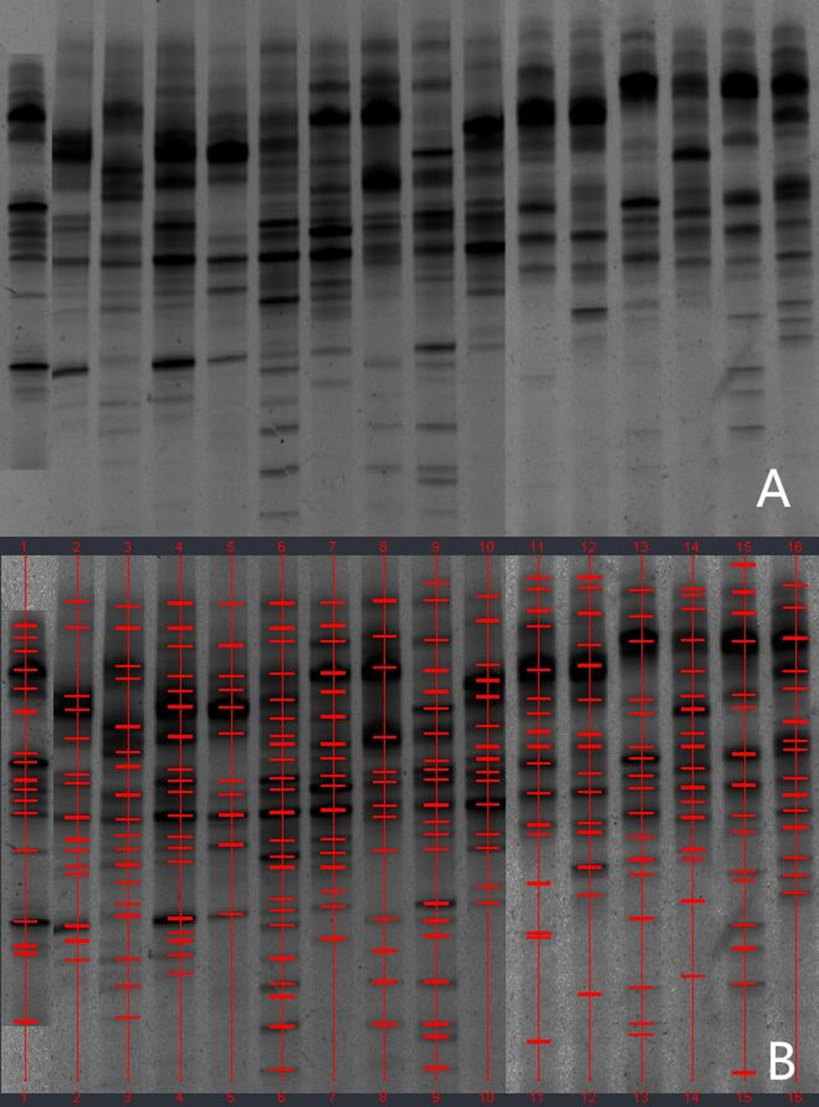
Figure 1 Denaturing gradient gel electrophoresis profiles of fecal samples from healthy controls. A: Denaturing gradient gel electrophoresis (DGGE) profiles; B: marked DGGE profiles. DGGE bands showed relative stability among different individuals.

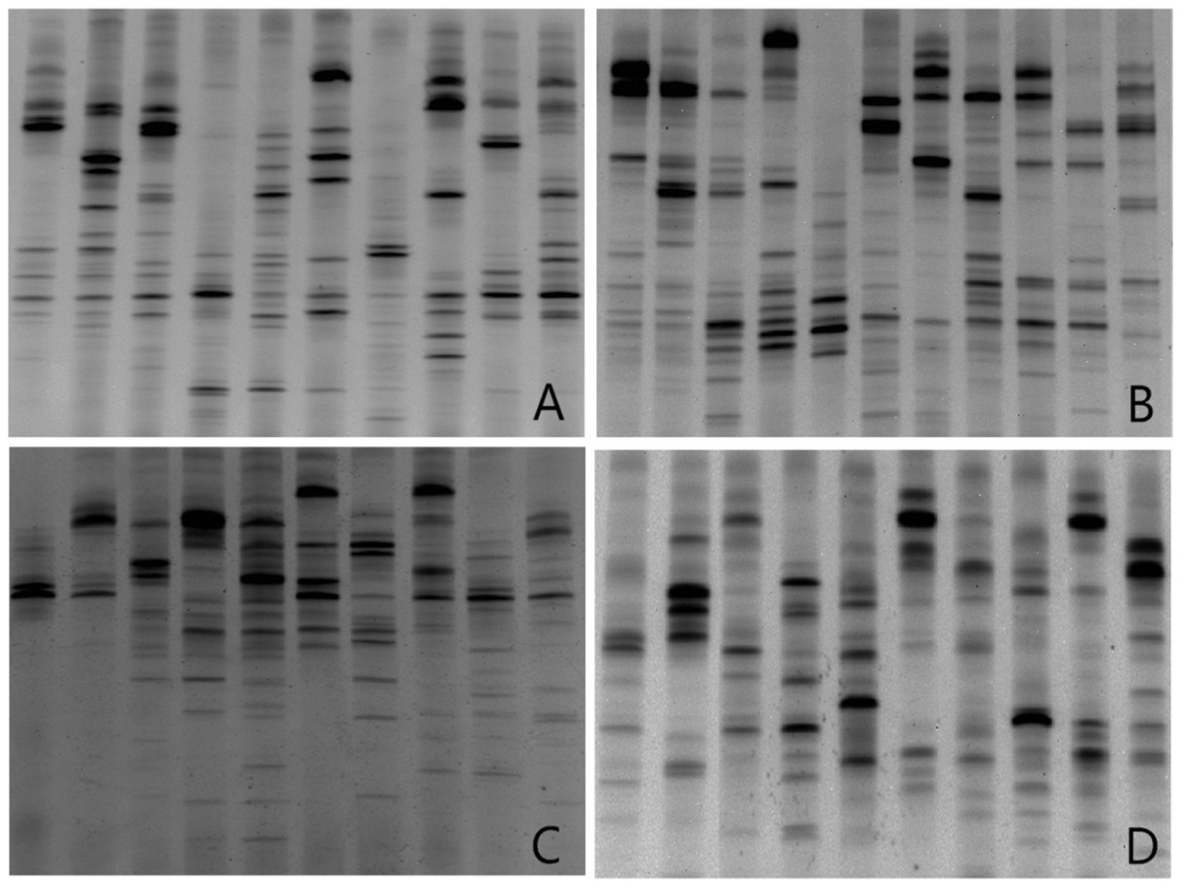
Figure 2 Denaturing gradient gel electrophoresis profiles showed microbial biodiversity in different ulcerative colitis groups. A: Ulcerative colitis (UC) patients in remission; B: UC patients in mildly active stage; C: UC patients in moderately active stage; D: UC patients in severely active stage.

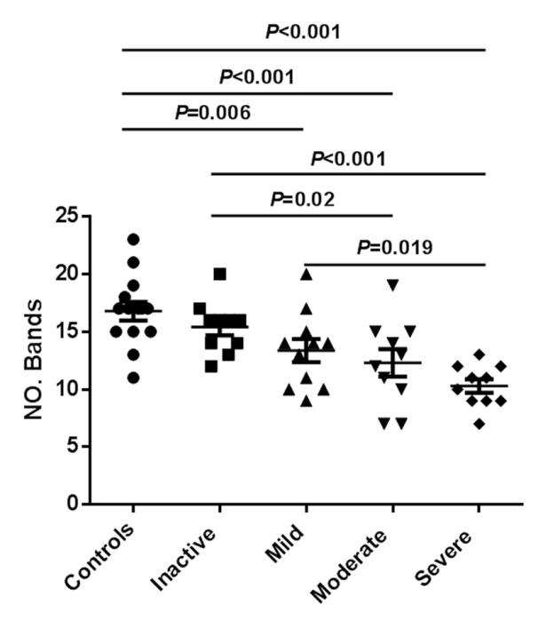
Figure 3 Number of bands in denaturing gradient gel electrophoresis profiles of samples obtained from 41 ulcerative colitis patients. The number of bands was reduced significantly from healthy controls to severe ulcerative colitis (UC).

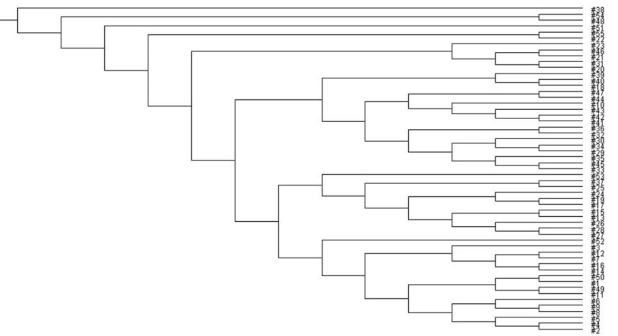
Figure 4 UPGMA tree analysis of healthy people and ulcerative colitis patients in different stages. 1-16: healthy people; 17-26: ulcerative colitis (UC) patients in remission; 27-37: UC patients in mildly active stage, 38-47: UC patients in moderately active stage; 48-57: UC patients in severely active stage. UPGMA tree analysis showed a significant difference among groups of healthy people and UC patients in different stages.

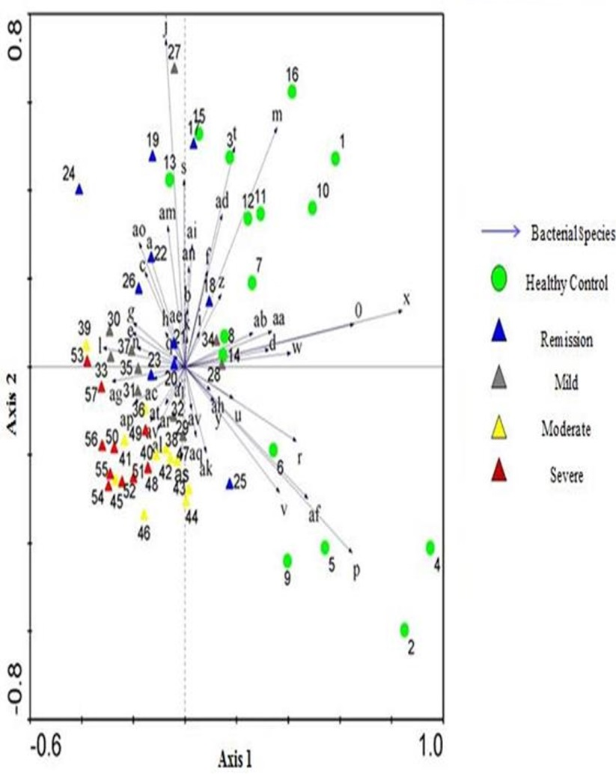
Figure 5 Principal Component Analysis of denaturing gradient gel electrophoresis microbial profiles in fecal samples of healthy people and ulcerative colitis C patients in different stages. Clustering of similar microbial profiles showed systematic differences among different groups.

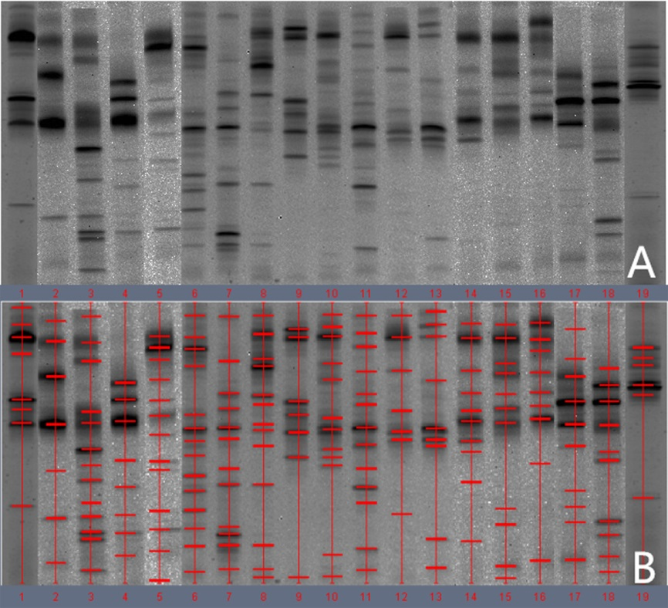
Figure 6 Denaturing gradient gel electrophoresis profiles of fecal samples from patients with pouchitis. A: Denaturing gradient gel electrophoresis (DGGE) profiles; B: Marked DGGE profiles. DGGE bands revealed relative stability of microbiota in pouchitis group changing.

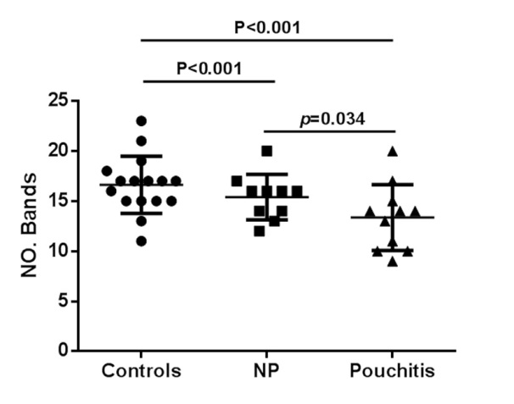
Figure 7 Number of bands in denaturing gradient gel electrophoresis profiles of samples obtained from patients performed surgery. The number of bands was reduced significantly in pouchitis compared with control group and no pouchitis group.

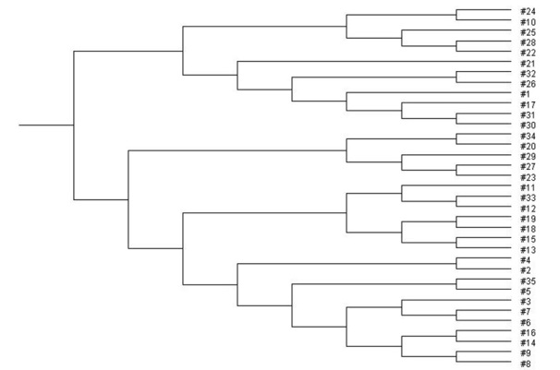
Figure 8 UPGMA tree analysis of healthy people and postoperative patients. 1-16: healthy people; 17-27: patients without pouchitis; 28-35: patients with pouchitis. UPGMA tree analysis showed a significant difference among three groups.

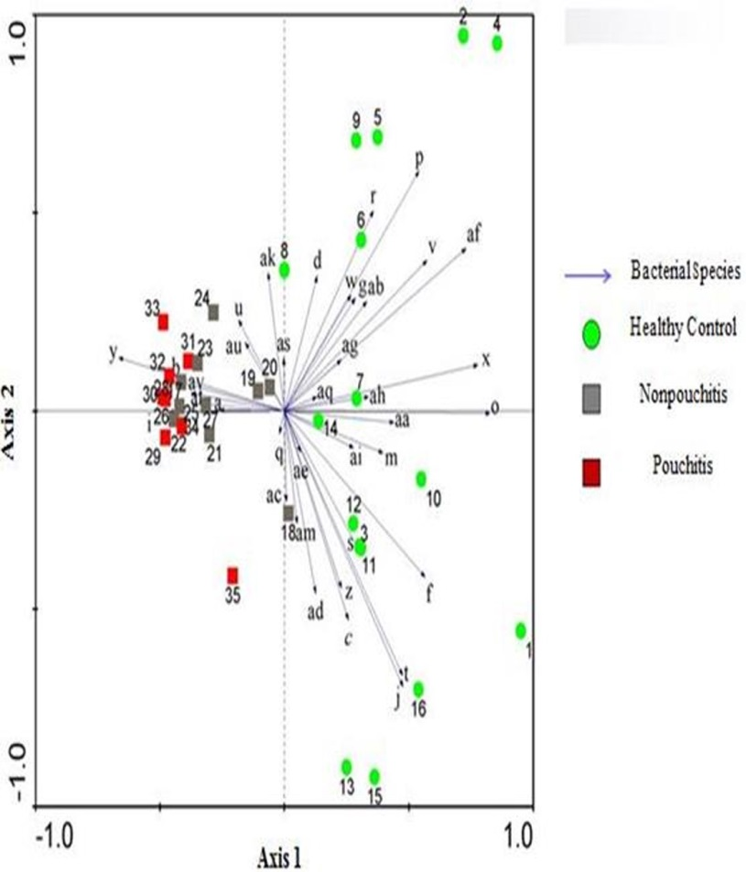
Figure 9 Principal Component Analysis of denaturing gradient gel electrophoresis microbial profiles in fecal samples of healthy people and patients with pouch. Clustering of similar microbial profiles showed significant differences among three groups.

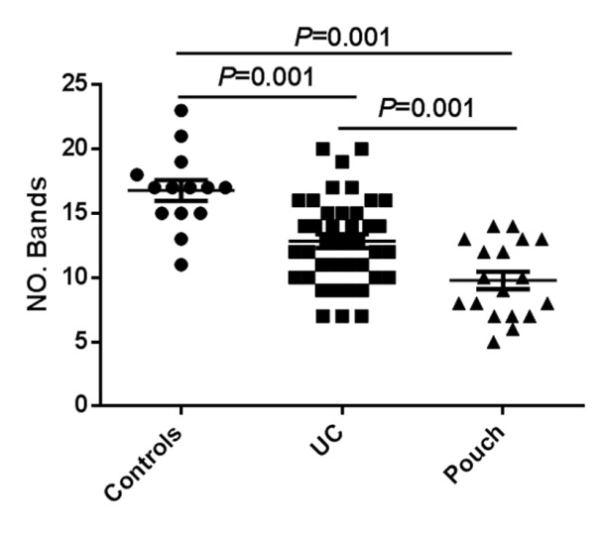
Figure 10 Number of bands in denaturing gradient gel electrophoresis profiles of samples obtained from all subjects. The number of bands was reduced significantly in pouch group compared with control group and ulcerative colitis (UC) group.

Table 1 Demographic and clinical characteristics of patients
 | Healthy controls | UC (n = 41) |  |  |  |  | Pouch (n = 19)
 |  | Remission | Mild | Moderate | Severe | Pouchitis |  | NP
Number of patients | 16 | 10 | 11 | 10 | 10 | 8 |  | 11
Sex, n, M/F | 9/7 | 5/5 | 7/4 | 5/5 | 6/4 | 5/3 |  | 5/6
Age (yr) | 46.2 ± 10.5 | 41.8 ± 9.2 | 43.9 ± 10.5 | 46 ± 8.2 | 40.8 ± 11.3 | 44.9 ± 15.6 |  | 47.8 ± 13.2
UC duration (yr) | NA | 5 ± 1.6 | 7 ± 0.9 | 5.2 ± 1.7 | 4 ± 2.7 | NA |  | NA
Pouch duration (yr) | NA | NA | NA | NA | NA | 2.8 ± 1.5 |  | 3.9 ± 2.2
BMI | 24.5 ± 2.3 | 25.2 ± 1.6 | 24.8 ± 3.5 | 23.9 ± 2.7 | 24.4 ± 3.1 | 24.9 ± 2.2 |  | 24.3 ± 3.5
Mayo score | NA | ≤ 2 | 4.2 ± 0.7 | 8.5 ± 1.2 | 11.5 ± 0.3 | ≥ 7 |  | < 7
Age at colectomy | NA | NA | NA | NA | NA | 40.6 ± 12.9 |  | 42.4 ± 9.22
Standard medication (%) | NA | 0 (0) | 5 (46) | 8 (80) | 10 (100) | 8 (100) |  | 3 (27)
Smoking (% at recruitment) | 10 (62.5) | 4 (40) | 3 (27.3) | 2 (20) | 3 (30) | 4 (50) |  | 5 (45.5)
Previous number of episodes of pouchitis (%) | NA | NA | NA | NA | NA | 4 (50) |  | 3 (27)
Number of patients with chronic pouchitis (%) | NA | NA | NA | NA | NA | 3 (37.5) |  | 2 (18)
Secondary causes of pouchitis (%) | NA | NA | NA | NA | NA | 2 (25) |  | 2 (19)
UC: Ulcerative colitis; NA: Not available.

Table 2 Dice analysis of normal control and ulcerative colitis subgroups
Group | Control | Remission | Mild | Moderate | Severe
Control | (49.79 ± 11.24)%¹ | (35.32 ± 14.86)% | (30.13 ± 11.23)% | (31.98 ± 16.48)% | (28.18 ± 14.99)%
Remission |  | (42.89 ± 18.29)%¹ | (32.79 ± 13.68)% | (30.22 ± 15.28)% | (26.28 ± 13.94)%
Mild |  |  | (41.83 ± 16.38)%¹ | (29.89 ± 13.10)% | (28.31 ± 18.39)%
Moderate |  |  |  | (43.45 ± 21.32)%¹ | (28.88 ± 13.69)%
Severe |  |  |  |  | (37.12 ± 19.98)%¹
¹P < 0.05; result from similarity in the same group vs similarity in different groups.

Table 3 Dice analysis of normal control and pouch subgroups
Group | Control | Pouchitis | NP
Control | (49.79 ± 11.24)%¹ | (25.33 ± 11.13)% | (28.86 ± 14.23)%
Pouchitis |  | (35.43 ± 13.30)%¹ | (20.87 ± 12.31)%
NP |  |  | (35.39 ± 10.80)%¹
¹P < 0.05; result from similarity in the same group vs similarity in different groups. NP: No pouchitis.

Table 4 Bacterial diversity comparison
 | Healthy controls | UC |  |  |  |  | Pouch
 |  | Remission | Mild | Moderate | Severe | NP |  | Pouchitis
Healthy controls | - | 0.298 | 0.006¹ | 0.001¹ | 0.000¹ | 0.000¹ |  | 0.000¹
Remission UC | 0.298 | - | 0.113 | 0.020¹ | 0.000¹ | 0.014¹ |  | 0.003¹
Mild UC | 0.006¹ | 0.113 | - | 0.404 | 0.019¹ | 0.007¹ |  | 0.125
Moderate UC | 0.001¹ | 0.020¹ | 0.404 | - | 0.128 | 0.009¹ |  | 0.448
Severe UC | 0.000¹ | 0.000¹ | 0.019¹ | 0.128 | - | 0.019¹ |  | 0.496
NP: PDAI < 7 | 0.000¹ | 0.014¹ | 0.007¹ | 0.009¹ | 0.019¹ | - |  | 0.034¹
Pouchitis: PDAI ≥ 7 | 0.000¹ | 0.003¹ | 0.005¹ | 0.448 | 0.496 | 0.034¹ |  | -
¹P < 0.05. NP: No pouchitis; UC: Ulcerative colitis; PDAI: Pouchitis Disease Activity Index.

