Name of Journal: World Journal of Clinical Cases
Manuscript NO: 75214
Manuscript Type: CASE REPORT

Ectopic Cushing's syndrome in a patient with metastatic Merkel cell carcinoma: A case report

Ishay A et al. Merkle cell carcinoma and Cushing syndrome

Avraham Ishay, Elia Touma, Olga Vornicova, Roni Dodiuk-Gad, Tal Goldman, Naiel Bisharat

Avraham Ishay, Endocrine and Diabetes Unit, Emek Medical Center, Afula 18134, Israel

Avraham Ishay, Roni Dodiuk-Gad, Naiel Bisharat, Ruth and Bruce Rappaport Faculty of Medicine, Technion-Israel Institute of Technology, Haifa 3200003, Israel

Elia Touma, Department of Internal Medicine D, Emek Medical Center, Afula 18134, Israel

Olga Vornicova, Department of Oncology, Emek Medical Center, Afula 18134, Israel

Roni Dodiuk-Gad, Department of Dermatology, Emek Medical Center, Afula 18134, Israel

Tal Goldman, Department of Pathology, Emek Medical Center, Afula 18134, Israel

Naiel Bisharat, Department of Medicine D, Emek Medical Center, Afula 18134, Israel

Author contributions: Ishay A and Touma E were the patient's physicians, wrote the manuscript, and reviewed the literature; Vornicova O, Dodiuk Gad, and Bisharat N were involved in the patient treatment and contributed to manuscript drafting; Goldman T was the pathologist and prepared and interpreted the pathology images.

Corresponding author: Avraham Ishay, MD, Chief Physician, Senior Lecturer, Endocrine and Diabetes Unit, Emek Medical Center, Rabin Ave 21, Afula 18134, Israel. ishay_av@clalit.co.il

Received: January 21, 2022
Revised: April 3, 2022
Accepted: June 13, 2022
Published online: August 6, 2022

Abstract
BACKGROUND
Ectopic Cushing syndrome (ECS) is a rare condition commonly associated with neuroendocrine tumors (NET), mainly bronchial carcinoids. The association of paraneoplastic syndrome with Merkle cell carcinoma (MCC) is limited to individual case reports.

CASE SUMMARY
In this article we report an unusual and striking presentation of ECS in a patient with known metastatic MCC. An elderly patient presented with new onset severe hypertension, hyperglycemia and hypokalemia, muscle wasting, and peripheral edema. A diagnosis of adrenocorticotropic hormone dependent, non-pituitary, Cushing syndrome was established. Medical therapy inhibiting adrenal function was promptly started but unfortunately the patient survived only a few days after diagnosis.

CONCLUSION
The occurrence of an aggressive form of ECS in patients with NET should be recognized as an ominous event. To our knowledge, the association of this complication in a patient with MCC had not been reported.

Key Words: Merkle cell carcinoma; Paraneoplastic syndrome; Ectopic Cushing's syndrome; Neuroendocrine tumor; Hypercortisolism; Skin cancer; Case report

©The Author(s) 2022. Published by Baishideng Publishing Group Inc. All rights reserved.

Citation: Ishay A, Touma E, Vornicova O, Dodiuk-Gad R, Goldman T, Bisharat N. Ectopic Cushing's syndrome in a patient with metastatic Merkel cell carcinoma: A case report. World J Clin Cases 2022; 10(22): 7989-7993
URL: https://www.wjgnet.com/2307-8960/full/v10/i22/7989.htm
DOI: https://dx.doi.org/10.12998/wjcc.v10.i22.7989

Core Tip: Merkel cell carcinoma (MCC) is an uncommon but highly aggressive skin cancer with neuroendocrine features. Its incidence and mortality are increasing. We describe an elderly patient with a 2-year history of metastatic MCC, with no apparent cutaneous lesion at diagnosis, who presented with uncontrolled hypertension, diabetes mellitus, and hypokalemia. A diagnosis of ectopic Cushing syndrome was established. The occurrence of ectopic Cushing syndrome in patients with neuroendocrine tumor is a major cause of poor prognosis. To our knowledge, this is the first reported case of ectopic Cushing syndrome linked to the rapid progression of a metastatic MCC.

INTRODUCTION
Merkel cell carcinoma (MCC) is an uncommon but highly aggressive skin cancer with neuroendocrine features^{[1]}. It was first described by Toker in 1972 as "trabecular carcinoma of the skin"^{[2]}. Evidence suggests that its incidence and mortality are increasing across the world^{[3]}. Ectopic Cushing syndrome (ECS) is a rare condition due to ectopic production of adrenocorticotropic hormone by non-pituitary tumors. The adrenocorticotropic hormone producing neoplasms usually originate from neuroendocrine tumors (NET) and can present as benign indolent tumors or aggressive metastatic tumors with a poor prognosis^{[4]}. Although in the past elevated adrenocorticopic hormone levels in plasma and tumoral tissue were demonstrated in patients with MCC^{[5,6]}, there are no reports of adrenocorticopic hormone producing MCC that fulfill the diagnostic criteria for ECS. We describe a patient with metastatic MCC who developed an aggressive form of ECS.

CASE PRESENTATION
Chief complaints
An 82-year-old man with a 2-year history of MCC was referred for evaluation and treatment of uncontrolled high blood pressure and new onset hyperglycemia.

History of present illness
In 2018, a cervical lymphadenopathy biopsy showed metastatic MCC with no apparent primary cutaneous lesion (Figure 1). Multiple bone metastases were demonstrated by an ¹⁸F (18-fluorodeoxyglucose) PET/CT scan (¹⁸FDG-PET/CT). No pathological uptake was seen in the lungs. The patient achieved good response to avelumab initially as disclosed by a significant reduction of uptake intensity in cervical lymph nodes and in the skeleton on a subsequent ¹⁸FDG-PET/CT scan. But thereafter, the disease progressed despite adjuvant radiotherapy and systemic therapy including etoposide, carboplatin, and topotecan. Indeed, a further ¹⁸FDG-PET/CT scan showed intensification of the uptake in bones, and new metastases in mediastinal lymph nodes and multiple cutaneous lesions. Noticeably, no disease was present in the lungs.

History of past illness
The patient’s history was significant for multiple surgical treatments for squamous cell carcinoma and basal cell carcinoma of the skin.

Personal and family history
Multiple surgical treatments for squamous cell carcinoma and basal cell carcinoma of the skin.

Physical examination
Physical examination revealed high blood pressure (198/100), and a 4 cm-sized purplish-blue tumor in his central chest (Figure 2), bilateral axillary lymphadenopathy, and bilateral lower extremities pitting edema. The clinical phenotype was dominated by weight loss and muscle wasting.

Laboratory examinations
Initial blood work revealed a glucose level of 241 mg/dL with hypokalemia (2.7 nmol/L). The 24-h free urine Cortisol level was 9986 nmol/24 hr (normal values: 57.7-806.8). After high dose (8 mg) overnight dexamethasone suppression test (HDST), the 8-am serum cortisol was 44.9 µg/dL (normal values: 4.3-22.4). Serum adrenocorticopic hormone level was elevated: 106 pg/mL (0.0-46). Testing with intravenous corticotropin releasing hormone (CRH) administration did not affect adrenocorticopic hormone or cortisol levels, which is typical of ECS (Table 1)

Imaging examinations
Magnetic resonance imaging scan of the pituitary gland was normal.

FINAL DIAGNOSIS
Ectopic adrenocorticopic hormone dependent Cushing's syndrome.

TREATMENT
The patient was treated with ketoconazole.

OUTCOME AND FOLLOW-UP
The patient’s blood pressure and glucose levels were normalized; however, his general state did not allow additional antineoplastic therapy and he died within few days.

DISCUSSION
We present an 82-year patient with a metastatic MCC presenting with an overwhelming form of ECS. ECS is a rare condition which accounts for about 10%-20% cases of adrenocorticopic hormone dependent Cushing syndrome. Neuroendocrine tumors (NETs), principally bronchial carcinoids, are the most frequent causes of ECS. Less frequent causes are thymic carcinoids and pancreatic NETs^{[7]}. Small cell lung carcinoma is a known cause of ECS, but in our patient imaging studies did not reveal any lung lesions. Recently, a case of metastatic NET of unknown origin presenting with ECS was reported^{[8]}. Several manifestations of MCC-associated paraneoplastic syndromes have been reported^{[9]}, but ECS associated with MCC has not be described, even though a case of metastatic MCC within a cortisol-producing adrenal adenoma has been recently reported^{[10]}. The time elapsed between the first symptoms of hypercortisolism and the diagnosis of ECS may predict the prognosis of the underlying malignancy. The shorter it is, the poorer is the prognosis. In addition to the grade of NET, the severity of cortisol excess is an independent negative prognostic factor^{[7]}. The molecular mechanisms underlying ECS-associated malignant tumors include aberrant processing of the proopiomelanocortin (POMC) gene leading to release in the circulation of high molecular weight adrenocorticopic hormone precursors like POMC and pro- adrenocorticopic hormone. It is speculated that the ability of the tumor to express aberrant molecules is related to the progression of the disease^{[11]}. If ectopic adrenocorticopic hormone producing malignancy is diagnosed early as a localized disease, surgical removal of the primary tumor is the treatment of choice, but it is rarely achievable in patients with aggressive neoplasms. In this ECS group, a prompt control of hypercortisolism should be attempted by medical treatment or alternatively by adrenalectomy^{[4]}.

CONCLUSION
MCC and neuroendocrine ECS are both rare conditions. The occurrence of ECS in patients with metastatic NETs is a major cause of poor prognosis. The suspicion of Cushing syndrome should receive adequate attention and prompt evaluation to confirm the diagnosis and initiate rapidly the treatment to attain a more favorable prognosis.

REFERENCES
1 Becker JC, Stang A, DeCaprio JA, Cerroni L, Lebbé C, Veness M, Nghiem P. Merkel cell carcinoma. Nat Rev Dis Primers 2017; 3: 17077 [PMID: 29072302 DOI: 10.1038/nrdp.2017.77]
2 Toker C. Trabecular carcinoma of the skin. Arch Dermatol 1972; 105: 107-110 [PMID: 5009611]
3 Emge DA, Cardones AR. Updates on Merkel Cell Carcinoma. Dermatol Clin 2019; 37: 489-503 [PMID: 31466589 DOI: 10.1016/j.det.2019.06.002]
4 Araujo Castro M, Marazuela Azpiroz M. Two types of ectopic Cushing syndrome or a continuum? Review. Pituitary 2018; 21: 535-544 [PMID: 29766359 DOI: 10.1007/s11102-018-0894-2]
5 Iwasaki H, Mitsui T, Kikuchi M, Imai T, Fukushima K. Neuroendocrine carcinoma (trabecular carcinoma) of the skin with ectopic ACTH production. Cancer 1981; 48: 753-756 [PMID: 6265057 DOI: 10.1002/1097-0142(19810801)48:3<753::aid-cncr2820480315>3.0.co;2-9]
6 Anzai S, Sato T, Takayasu S, Asada Y, Terashi H, Takasaki S. Postoperative hyponatremia in a patient with ACTH-producing Merkel cell carcinoma. J Dermatol 2000; 27: 397-400 [PMID: 10920586 DOI: 10.1111/j.1346-8138.2000.tb02190.x]
7 Davi' MV, Cosaro E, Piacentini S, Reimondo G, Albiger N, Arnaldi G, Faggiano A, Mantovani G, Fazio N, Piovesan A, Arvat E, Grimaldi F, Canu L, Mannelli M, Ambrogio AG, Pecori Giraldi F, Martini C, Lania A, Albertelli M, Ferone D, Zatelli MC, Campana D, Colao A, Scaroni C, Terzolo M, De Marinis L, Cingarlini S, Micciolo R, Francia G. Prognostic factors in ectopic Cushing's syndrome due to neuroendocrine tumors: a multicenter study. Eur J Endocrinol 2017; 176: 453-461 [PMID: 28183788 DOI: 10.1530/EJE-16-0809]
8 Bostan H, Duger H, Akhanli P, Calapkulu M, Turkmenoglu TT, Erdol AK, Duru SA, Sencar ME, Kizilgul M, Ucan B, Ozbek M, Cakal E. Cushing's syndrome due to adrenocorticotropic hormone-secreting metastatic neuroendocrine tumor of unknown primary origin: a case report and literature review. Hormones (Athens) 2022; 21: 147-154 [PMID: 34478059 DOI: 10.1007/s42000-021-00316-z]
9 Iyer JG, Parvathaneni K, Bhatia S, Tarabadkar ES, Blom A, Doumani R, McKenzie J, Asgari MM, Nghiem P. Paraneoplastic syndromes (PNS) associated with Merkel cell carcinoma (MCC): A case series of 8 patients highlighting different clinical manifestations. J Am Acad Dermatol 2016; 75: 541-547 [PMID: 27177440 DOI: 10.1016/j.jaad.2016.04.040]
10 Maier A, Kerut SE, Subauste JS, Curry S. “SUN-181 A Case of Metastatic Merkel Cell Carcinoma Within a Cortisol-Producing Adrenal Adenoma.” J Endoc Soc 2020 [DOI: 10.1210/jendso/bvaa046.1385]
11 Terzolo M, Reimondo G, Alì A, Bovio S, Daffara F, Paccotti P, Angeli A. Ectopic ACTH syndrome: molecular bases and clinical heterogeneity. Ann Oncol 2001; 12 Suppl 2: S83-S87 [PMID: 11762358 DOI: 10.1093/annonc/12.suppl_2.s83]

Footnotes
Informed consent statement: Not applicable.

Conflict-of-interest statement: All the authors declare that they have no conflict of interest to disclose.

CARE Checklist (2016) statement: The authors have read the CARE Checklist (2016), and the manuscript was prepared and revised according to the CARE Checklist (2016).

Open-Access: This article is an open-access article that was selected by an in-house editor and fully peer-reviewed by external reviewers. It is distributed in accordance with the Creative Commons Attribution NonCommercial (CC BY-NC 4.0) license, which permits others to distribute, remix, adapt, build upon this work non-commercially, and license their derivative works on different terms, provided the original work is properly cited and the use is non-commercial. See: https://creativecommons.org/Licenses/by-nc/4.0/

Provenance and peer review: Unsolicited article; Externally peer reviewed.
Peer-review model: Single blind

Peer-review started: January 21, 2022
First decision: March 23, 2022
Article in press: June 13, 2022

Specialty type: Endocrinology and metabolism
Country/Territory of origin: Israel
Peer-review report’s scientific quality classification
Grade A (Excellent): 0
Grade B (Very good): B
Grade C (Good): 0
Grade D (Fair): D
Grade E (Poor): 0

P-Reviewer: Saglam S, Turkey; Tan HY, China A-Editor: Zhu JQ, China S-Editor: Liu JH L-Editor: Wang TQ P-Editor: Liu JH
Figure Legends
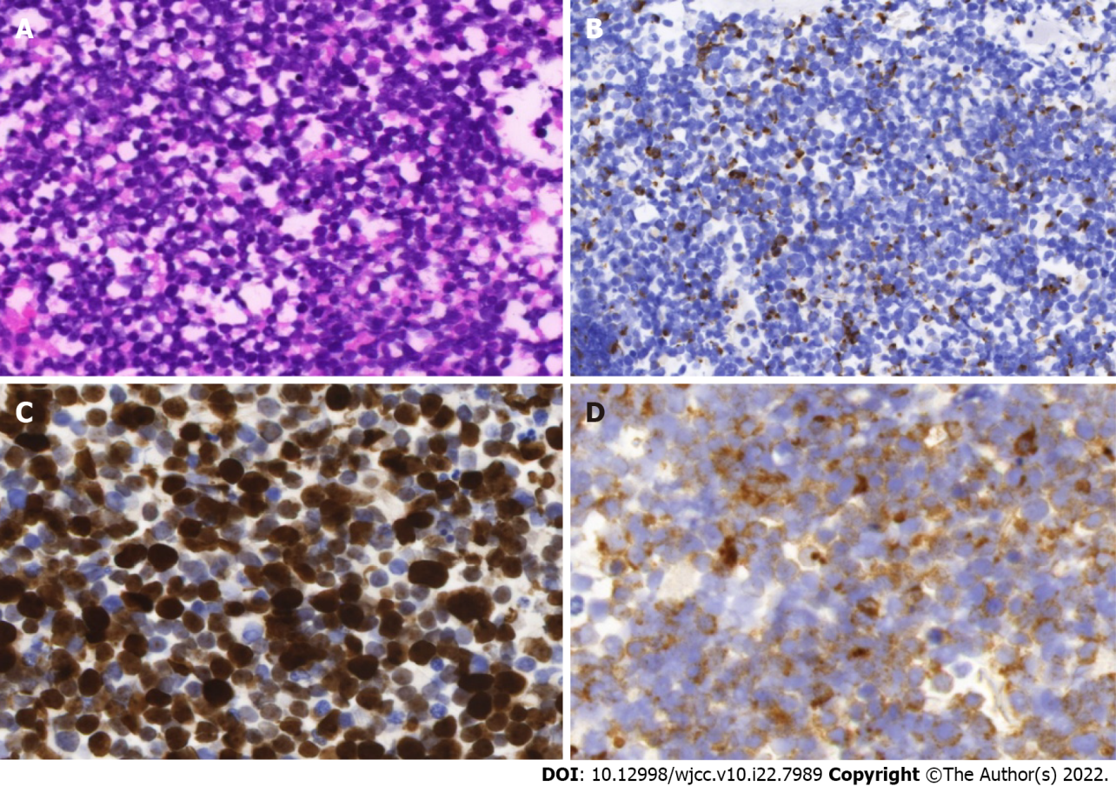
Figure 1 Histological and immunohistochemical images of Merkel cell carcinoma. A: Hematoxylin and eosin staining showed “small round blue cell tumor”; B: Immunohistochemical staining for keratin 20 showed perinuclear dot-like staining. C: Immunohistochemical staining for KI-67 showed a very high proliferative index; D: Immunohistochemical staining for synaptophysin showed the staining of the neuroendocrine granules in the cytoplasm of cells. Magnification, × 400.
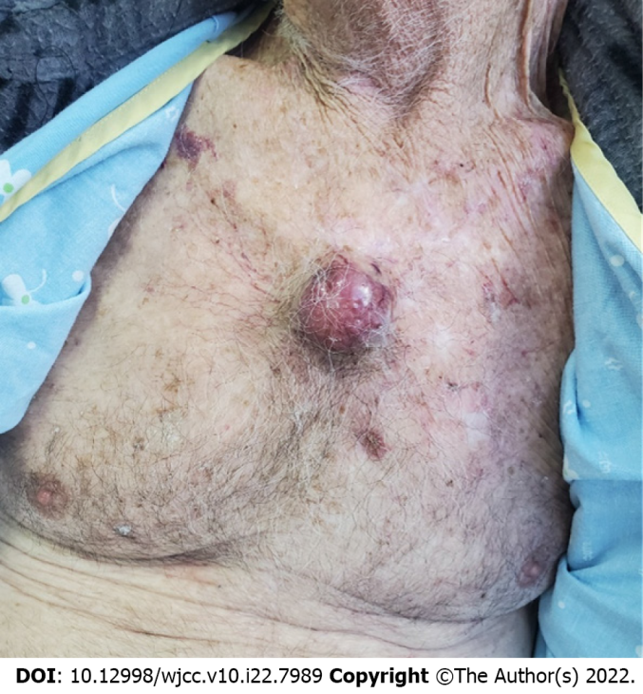
Figure 2 A large Merkle cell carcinoma metastasis on the central chest.
Table 1 Cortisol and adrenocorticotropic hormone (ACTH) levels after stimulation with IV corticotropin releasing hormone 100 µg
Time (mn) | -15 | 0 | 15 | 30 | 45 | 60 | 90 | 120
Cortisol (µg/d) | 52.22 | 48.92 | 45.48 | 56.11 | 51.44 | 52.1 | 53.08 | 56.65
ACTH (pmol/mL) | 92.9 | 110 | 129 | 128 | 122 | 96.1 | 119 | 120

Published by Baishideng Publishing Group Inc
7041 Koll Center Parkway, Suite 160, Pleasanton, CA 94566, USA
Telephone: +1-925-3991568
E-mail: bpgoffice@wjgnet.com
Help Desk: https://www.f6publishing.com/helpdesk
https://www.wjgnet.com

© 2022 Baishideng Publishing Group Inc. All rights reserved.

