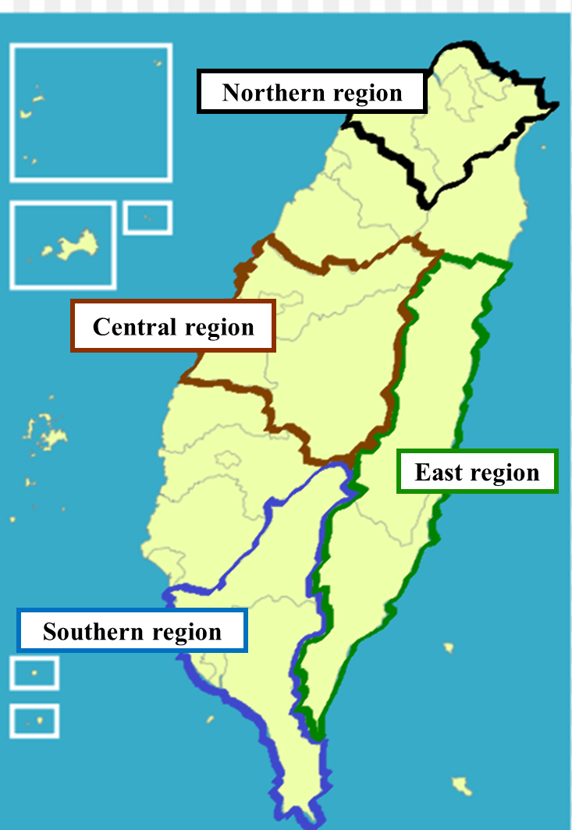
Supplemental Figure 1. The Northern, Central, Southern, and Eastern regions of Taiwan

Supplemental Table 1. The Definition of ICD-9-CM Codes for Acute Upper Respiratory Tract Infections.
ICD-9-CM Codes | Definitions
465 | Acute Upper Respiratory Infections of Multiple or Unspecific Sites
487.1 | Influenza with other respiratory manifestations
488.02 | Influenza due to identified avian influenza virus with other respiratory manifestations
488.01 | Influenza due to identified avian influenza virus with pneumonia
034.0 | Streptococcal sore throat

Supplemental Table 2. Classification of the Hazards of PM2.5 and PM10 by Concentration
The concentration of pollutants and impact on health
 | PM2.5 (μg/ m³) | PM10 (μg/ m³)
Good | 0.0-15.4 | 0.0-54.0
Moderate | 15.5-35.4 | 55.0-125.0
Unhealthy for Sensitive Groups | 35.5-54.4 | 126.0-254.0
Unhealthy | 54.5-150.4 | 255.0-354.0
Very Unhealthy | 150.5-250.4 | 355.0-424.0
Hazardous | 250.5-500.4 | 425.0-604.0

