Name of Journal: World Journal of Radiology
ESPS Manuscript NO: 29365
Manuscript Type: Review

Potential role of imaging in assessing harmful effects on spermatogenesis in adult testes with varicocele

Tsili AC et al. Imaging of spermatogenesis in varicocele

Athina C Tsili, Olga N Xiropotamou, Anastasios Sylakos, Vasilios Maliakas, Nikolaos Sofikitis, Maria I Argyropoulou

Athina C Tsili, Olga N Xiropotamou, Vasilios Maliakas, Maria I Argyropoulou, Department of Clinical Radiology, University of Ioannina, Medical School, University Campus, Epirus 45110, Greece

Anastasios Sylakos, Nikolaos Sofikitis, Department of Urology, University of Ioannina, Medical School, University Campus, Epirus 45110, Greece

Author contributions: Tsili AC and Xiropotamou ON contributed equally to this work; Tsili AC, Sofiktis N and Argyropoulou MI designed the research; Xiropotamou ON, Sylakos A and Maliakas V performed the research and analyzed the data; Tsili AC and Xiropotamou ON wrote the paper; all authors approved the final version of the article to be published.

Conflict-of-interest statement: The authors declare no conflicts of interest related to this publication.

Open-Access: This article is an open-access article which was selected by an in-house editor and fully peer-reviewed by external reviewers. It is distributed in accordance with the Creative Commons Attribution Non Commercial (CC BY-NC 4.0) license, which permits others to distribute, remix, adapt, build upon this work non-commercially, and license their derivative works on different terms, provided the original work is properly cited and the use is non-commercial. See: http://creativecommons.org/licenses/by-nc/4.0/

Manuscript source: Invited manuscript

Correspondence to: Athina C Tsili, MD, Assistant Professor, Department of Clinical Radiology, University of Ioannina, Medical School, University Campus, Ioannina, Epirus 45110, Greece. a_tsili@yahoo.gr
Telephone: +30-69-76510904
Fax: +30-26-51007862

Received: August 10, 2016
Peer-review started: August 11, 2016
First decision: September 12, 2016
Revised: November 2, 2016
Accepted: December 16, 2016
Article in press:
Published online:

Abstract
Varicocele is characterized by an abnormal dilatation and retrograde blood flow in the spermatic veins. Varicocele is the leading correctable cause of male infertility. Although it is highly prevalent in infertile men, it is also observed in individuals with normal fertility. Determining which men are negatively affected by varicocele would enable clinicians to better select those men who will benefit from treatment. To assess the functional status of the testes in men with varicocele, Color Doppler sonographic parameters were evaluated. Testicular arterial blood flow was significantly reduced in men with varicocele, reflecting an impairment of spermatogenesis. An improvement in the testicular blood supply was found after varicocelectomy on spectral Doppler analysis. Testicular contrast harmonic imaging and elastography might improve our knowledge about the influence of varicocele on intratesticular microcirculation and tissue stiffness, respectively, providing possible information on the early damage of testicular structure by varicocele. Magnetic resonance imaging (MRI), with measurement of apparent diffusion coefficient has been used to assess the degree of testicular dysfunction and to evaluate the effectiveness of varicocele repair. Large prospective studies are needed to validate the possible role of functional sonography and MRI in the assessment of early defects of spermatogenesis in testes with varicocele.

Key words: Varicocele; Spermatogenesis; Diagnostic imaging; Ultrasonography; Doppler ultrasound imaging; Magnetic resonance imaging; Functional

© The Author(s) 2016. Published by Baishideng Publishing Group Inc. All rights reserved.

Core tip: Varicocele is known as one of the main causes of male infertility. However, many controversies exist regarding the effect of varicocele on male reproductive potential, which patients to treat and whether repair leads to an improvement of the fertility status. Non-invasive imaging modalities, including functional sonography and magnetic resonance imaging, might provide useful information on the early damage of testicular structure by varicoceles, therefore helping clinicians target repair efforts to those men who will benefit from varicocele treatment.

Tsili AC, Xiropotamou ON, Sylakos A, Maliakas V, Sofikitis N, Argyropoulou MI. Potential role of imaging in assessing harmful effects on spermatogenesis in adult testes with varicocele. World J Radiol 2016; In press

INTRODUCTION
Male infertility is a social problem, representing the causal factor for infertility in 50% of cases and the sole cause in 30% of infertile couples^{[1-3]}. Varicocele is the most common andrological disorder between adolescents and adult males. Its clinical significance is mainly related to fertility, as it represents the most common cause of impaired male fertility and the most common treatable cause of infertility^{[4-10]}. The origin of the word varicocele comes from varico (a combining form meaning “varix” in Latin) and cele (a combining form meaning “tumor” in Greek) and dates to 1730-1740.
Varicocele has been one of the most controversial topics of debate in the fields of andrology and urology, regarding the effect of varicocele on male infertility and whether repair leads to improvement of fertility status^{[4-10]}. While most men with varicocele are able to father children, most evidence suggests that varicocele has detrimental effects on male reproductive potential. A non-invasive imaging technique providing answers to questions regarding which patients with varicocele are at risk for infertility and which will benefit from varicocele repair, would be extremely useful.

DEFINITION AND EPIDEMIOLOGY
Varicocele is clinically defined as an abnormal dilation of the veins of the pampiniform venous plexus and the testicular veins with continuous or intermittent reflux of venous blood^{[4,5,11]}. Primary varicoceles are due to venous reflux into the pampiniform plexus from the internal spermatic vein because of incontinent venous valves, and they usually occur on the left side. Secondary varicoceles are the result of increased pressure in the testicular veins, which can be related to several causes, such as hydronephrosis, abdominal and retroperitoneal neoplasms, and the so-called nutcracker phenomenon, which involves compression of the left renal vein between the superior mesenteric artery and aorta^{[4,12-15]}. Although varicoceles are almost always more common and larger on the left side, they are bilateral in 50% of cases^{[14]}. The uncommon, isolated right-sided varicocele always necessitates further investigation, as this finding may be associated with in situ vs or retroperitoneal malignancies^{[4,14]}.
Varicocele epidemiology is incompletely understood^{[14]}. A clinical varicocele is found in approximately 15% of all adult males, up to 35% of infertile men and 81% of men presenting with secondary infertility. When classified according to semen analysis parameters, 12% of infertile men with normal semen analyses and 25.4% of those with abnormal results were found to have clinical varicocele^{[4,5,8,12,14]}. This disorder may be present at birth or in young children, but the incidence substantially increases in adolescents coinciding with pubertal development^{[4,5,14]}. The prevalence of varicocele also increases with advancing age, with an increase of approximately 10% per decade of life, probably because of the aging of venous valves^{[14]}.
An association between varicocele and varicose veins of the lower extremities and an inverse relationship between the prevalence of varicocele and body mass index (BMI) have been suggested^{[4-16]}. Hereditary factors may also play a role in the prevalence of varicocele^{[14,17]}.

ETIOLOGY AND PATHOGENESIS
The exact etiology of varicocele is still unknown, but it is probably multifactorial^{[4,5,12,13,18]}. The cause for the high incidence of left varicocele is that the left internal spermatic vein runs vertically to drain into the ipsilateral renal vein at a right angle, when the man is in the standing position, and thus, the endoluminal pressure in the renal vein is transmitted backward, opposing flow from the internal spermatic vein. On the right side, the internal spermatic vein runs tangentially to join the inferior vena cava, resulting in less flow turbulence and back pressure in the vein and therefore in a lower incidence of venous dilation on the right side. However, Gat et al^{[19]} reported that varicocele is mainly a bilateral disease, expressed earlier on the left side, with a right-sided venous return problem presenting in 86% of infertile men with clinically significant varicocele.
Several other theories related to the etiological factors of varicocele have been proposed, including the following: incompetence or absence of venous valves in the spermatic veins, obstructed venous drainage, vascular contractions of the left testicular vein caused by catecholamines from the left adrenal gland and the so-called nutcracker phenomenon^{[4,5,12,13,18,20,21]}.

CLINICAL FINDINGS-CLASSIFICATION
Clinically, varicocele is characterized by an abnormal enlargement of the spermatic veins of the venous plexus, which drains the blood from the testes, associated with an anomalous intermittent or continuous backflow of blood into the plexus. In adult males, most cases are asymptomatic, often revealed during an investigation related to infertility and/or because of an unfavorable outcome of semen analysis^{[5]}. Rarely, it may present with scrotal pain or create esthetic problems or discomfort due to the presence of significant enlargement of the scrotum^{[5,12]}.
Clinical varicocele was found to be a significant risk factor for decreased sperm count, motility and morphology in adult infertile men^{[22,23]}. A study conducted by the World Health Organization (WHO) reported that both sperm concentration and motility were lower in men with varicocele compared to individuals without varicocele^{[22]}. Recently, Agarwal et al^{[23]} in a systematic review assessing the effects of varicocele on semen parameters based on the new 2010 WHO laboratory criteria for the examination of the human semen, reported that varicocele was associated with reduced sperm count, motility and morphology^{[23]}.
Physical examination represents the gold standard for the diagnosis of clinically significant varicoceles^{[5,8,12,24]}. It is used by clinical urologists and pediatricians, consisting of palpation performed with the patient in the standing position and observation of the scrotum during the Valsalva maneuver. The classification system published by Dubin and Amelar in 1970 is the most commonly used and includes the following three degrees of varicocele: Grade 1, varicocele detectable by palpation only during the Valsalva maneuver; Grade 2, varicocele detectable by simple palpation; and, Grade 3: varicocele visible on inspection and palpation^{[24]}. However, this system has limitations because its diagnostic accuracy is closely associated with physician’s experience. A study involving experienced andrologists and clinicians identified a significant inter-observer and intra-observer variability in the grading of varicoceles based on the above classification^{[12]}.
Histology from a testicular biopsy in men with varicocele has shown depressed spermatogenesis with maturation arrest, sloughing of the spermatogenic epithelium, profusion of Leydig cells, thickening of the tubular basement membrane and interstitial blood vessel wall with luminal narrowing, and increased deposition of interstitial fibrous tissue^{[25]}.

PATHOPHYSIOLOGY
The pathophysiology of impaired spermatogenesis in varicocele is multifactorial. A combination of several factors affects spermatogenesis and sperm function, and the relative involvement of these factors is different in each patient^{[4,7,8,25]}. Several pathophysiologic mechanisms resulting in impairment of spermatogenesis in left varicocele have been proposed, including heat stress, notch signaling, cadmium accumulation, insufficiency of the hypothalamo-pituitary-gonadal axis, retrograde flow of adrenal or renal metabolites, possible disruptions of blood-testis barrier, testicular hypoxia and alterations in testicular extracellular fluid dynamics^{[4,7,8,25]}. Interstitial lesions, including the proliferation of Leydig cells, thickening of the tubular basement membrane and blood vessel wall with luminal narrowing, and increased deposition of interstitial collagen fibers may also play an important role in varicocele-related testicular dysfunction^{[25]}.
Current evidence suggests the primary role of reactive oxygen species (ROS) and the resultant oxidative stress (OS) in the pathogenesis of varicocele-associated male infertility^{[4,7,8,18,25,26]}. Excessive ROS has also been associated with sperm DNA fragmentation (SDF), which may mediate the clinical manifestation of poor sperm function and infertility related to varicocele^{[4,7,8,18,25-27]}. A significantly less total acrosin activity in the spermatozoa of infertile men with varicocele and an abnormal retention of cytoplasmic droplets by human spermatozoa, which is negatively correlated with sperm motility, are other potential contributing factors for the diminished sperm function in individuals with varicocele^{[4,28]}.
Using animal models, bilateral detrimental effects on testicular temperature, blood flow, and histology have been reported to occur in cases of unilateral varicocele, probably related either to the dilatation of the right testicular vein in individuals with left varicocele or the role of the sympathetic nervous system^{[4,29,30]}. The development of a unilateral varicocele affecting bilateral Leydig cell secretory function results in a significant reduction in bilateral intratesticular testosterone cοntent, which, in turn, affects the Sertoli cell secretory function and epididymal maturation process, all contributing to the reduced male reproductive potential^{[4]}. Recent advances in biomolecular techniques and mass spectrometry equipment have allowed us to better understand the molecular pathways associated with varicocele and male infertility^{[25,31,32]}.

DIAGNOSIS
In the past, various diagnostic imaging modalities were used for the evaluation of varicoceles, including venography, scintigraphy, and thermography^{[33-35]}. Labeled blood-pool scintigraphy was reported as an accurate and noninvasive method for the detection and grading of varicocele. The main contribution of radionuclide blood-pool imaging of the scrotum was in the detection and grading of subclinical varicocele in infertile men with no other cause of infertility. The technique was also accurate in the diagnosis of recurrent varicocele^{[33-35]}. However, the above methods have been replaced by less invasive and more easily performed diagnostic tools, especially ultrasonographic examination of the scrotum.
Ultrasonography (US) is currently the most established and widely used modality for the study of varicoceles, with 97% sensitivity and 94% specificity in the diagnosis of clinical varicocele and 83%-95% sensitivity in the diagnosis of subclinical varicocele^{[5,12,13,33,36,37]}. The classic US features of a varicocele is that of “multiple, anechoic, serpiginous, tubular structures” near the superior and lateral aspects of the testis. Color, power, or spectral Doppler US with settings optimized for low flow velocities is used complimentary to aid in the diagnosis of varicoceles. Τypical Doppler findings include venous flow at rest, with intermittent or continuous flow reversal with Valsalva maneuver (Figures 1 and 2)^{[5,33]}.
However, there are no homogeneous US criteria regarding the extent of venous dilation or reflux that must be present to meet the definition of a varicocele^{[5,12,13,36-45]}. A widely accepted US criterion for the diagnosis of varicocele is the existence of veins larger than 2 mm in diameter, with 95% sensitivity ^{38]}. In general, clinicians agree that clinically relevant varicoceles are more than 2.5-3 mm in diameter^{[33]}. Multiple grading systems exist for classifying the US findings of varicocele; however, all have a low predictive value in terms of impairment of spermatogenesis, which is the main indication for any therapeutic plan^{[5,12,13,31,46,47]}. The Sarteschi (Table 1) and Chiou et al^{[47]} (Table 2) classifications systems are among the most commonly used.
Advances in US and magnetic resonance imaging (MRI) provide the potential to expand the role of imaging beyond that of visual confirmation and characterization of varicoceles. Τhe ability to identify the early signs of testicular dysfunction based on imaging findings may have implications for the selection of patients for varicocele repair.

US IN THE EVALUATION OF INTRATESTICULAR MICROCIRCULATION IN TESTES WITH VARICOCELE
The testis gets its arterial supply mainly from the testicular artery (TA) supplemented with the cremasteric artery and the deferential artery, all coursing through the deep inguinal canal to enter the spermatic cord^{[48-51]}. TA penetrates the tunica albuginea along the posterior surface of the testis and divides into capsular arteries. These capsular branches then give rise to the centripetal arteries which carry blood from the capsular surface, centrally towards the mediastinum along the testicular septa. Branches of the centripetal arteries then course backward towards the capsular surface, known as recurrent rami. In approximately 50% of testes, the transtesticular artery can also be seen passing directly from the testicular artery at the mediastinum into the parenchyma^{[48-51]}. Testicular perfusion can be evaluated with color Doppler (CD), power Doppler, and spectral Doppler US. The spectral waveform of the intratesticular arteries characteristically has a low-resistance pattern, with a mean resistive index (RI) in adults and postpubertal boys of 0.62 (range, 0.48 – 0.75)^{[48]}.
Several clinical studies have assessed the effects of varicocele on testicular blood flow by US^{[49,50-56]}. In an early study, Ross et al^{[52]} compared the testicular blood flow in 248 patients with varicocele and 34 fertile volunteers with color Doppler ultrasonography (CDUS) and reported no significant differences^{[52]}. A similar result was reported by Grasso Leanza et al^{[53]}. In this study, the peak systolic velocity (PSV) of the testicular arteries was evaluated in men with varicocele and healthy subjects with normal or impaired spermatogenesis using CDUS. No significant difference was found in relation to the presence or degree of varicocele^{[53]}.
However, in subsequent studies, CDUS proved to be sensitive in assessing alterations in intratesticular circulation in testes with clinical varicocele^{[37,49,54-56]}. A significant decrease in testicular arterial blood flow and an increase in RI and PSV in testes with clinical varicocele were reported^{[37,49,54-56]}. Semiz et al^{[37]} concluded that spectral Doppler parameters might be used as a noninvasive method to assess the hemodynamic changes and testicular microcirculation in cases of clinical varicocele^{[37]}. The PSV, end-diastolic velocity (EDV), RI and pulsatility index (PI) from capsular and intratesticular arteries in 50 men with clinical varicocele were measured and correlated with semen analysis parameters, including count, motility, volume and morphology. PSV significantly correlated with sperm count in men with unilateral and bilateral varicocele. No significant correlation between EDV, RI, PI and semen analysis results was found^{[37]}. Unsal et al^{[54]} evaluated the effects of clinical varicocele on testicular microcirculation comparing PSV, EDV, RI and PI from capsular and intratesticular arteries in 15 men with left clinical varicocele and 34 controls^{[54]}. The authors found a significantly greater RI and PI of capsular branches of the left testes (RI = 0.68 ± 0.04; PI = 1.22 ± 0.15) compared to the control group (RI = 0.64 ± 0.06; PI = 1.07 ± 0.18)^{[54]}.
Biaggioti et al^{[55]} reported that spectral Doppler traces from the TA can be used to differentiate the various causes of impaired spermatogenesis^{[55]}. The RI and PSV proved the most reliable indicators for routine clinical use to identify infertile men in this study, whereas EDV, FSH and TV were not. Specifically, men with varicoceles or, varicoceles and male accessory glans inflammation or fertile men with varicoceles had the highest PSV and RI^{[55]}.
In cases of subclinical varicocele, no significant changes in intratesticular perfusion are probably seen on CDUS^{[50]}. Akcar et al^{[50]} assessed the testicular volume (TV) and the RI from centripetal intratesticular arteries in 27 men with left varicocele, 96% of which were subclinical. The authors found that subclinical varicocele is not associated with testicular atrophy and does not affect the intratesticular arterial resistance^{[50]}.
Testicular contrast harmonic imaging has been proposed as an adjuvant diagnostic tool in the assessment of the effects of varicocele on intratesticular microcirculation^{[57]}. Caretta et al^{[57]} in a study of 90 patients with left varicocele, associated with either normozoospermia or oligospermia calculated contrast material arrival time in the arteriolar circulation (wash-in), time to peak arterial circulation, arrival time in the venular circulation (washout) and mean transit time in each testis after intravenous administration of contrast agent containing phospholipid stabilized microbubbles filled with sulfur hexafluoride. All parameters were significantly higher in patients with varicocele plus normozoospermia or oligospermia compared to controls, although they did not correlate with varicocele grading. A negative linear correlation between total sperm count and left mean transit time was found in patients with varicocele. In the multivariate analysis, left mean transit time was the only independent predicting parameter of oligospermia in this study^{[57]}.
Tissue elastography (TE) is a relatively new imaging technique that measures the stiffness of tissue^{[58-60]}. TE has been reported as a useful diagnostic tool, further enhancing the characterization of focal testicular lesions^{[58-60]}. Acoustic radiation force impulse (ARFI) elastography represents one of the main types of elastography currently in use, involving the estimation of shear wave speed. In a prospective controlled study of 30 men with clinical varicocele and 30 controls, Dede et al^{[61]} concluded that ARFI elastography may be used to assess the early damage of testicular structure by varicocele^{[61]}. Mean elastography results were signiﬁcantly different between the two groups and signiﬁcantly lower in testes with varicoceles. Signiﬁcant negative correlations between FSH and testis elasticity was also reported. Additionally, a negative correlation was determined between varicocele grade and elasticity of testes^{[61]}.

ROLE OF MRI
Although US represents the primary imaging modality in the assessment of scrotal diseases, MRI has recently emerged as an important supplemental diagnostic tool, used both as a problem-solving technique in patients with inconclusive US findings and as a primary imaging modality^{[62-64]}. Recently, functional MRI techniques, including diffusion-weighted imaging (DWI), dynamic contrast-enhanced (DCE) MRI and MR spectroscopy have added important diagnostic information to the interpretation of testicular diseases^{[65-75]}.
DWI, with the calculation of apparent diffusion coefficient (ADC), is an evolving technique that can be used to improve tissue characterization if interpreted in combination with the findings of conventional MR sequences. DWI applications in scrotal pathology include characterization of intratesticular lesions, diagnosis of testicular torsion and detection and localization of nonpalpable undescended testes^{[65-67]}. Karakas et al^{[72]} in a preliminary study of 25 men with varicocele and 25 healthy volunteers recommended the potential role of DWI for the early detection and the determination of the degree of testicular damage due to varicocele^{[72]}. The authors found lower ADC both in the ipsilateral and contralateral testicular parenchyma of patients with varicocele, compared to that of healthy volunteers. A significant negative correlation between the mean ADC and venous diameter was also found^{[72]}. Decreased ADC of the ipsilateral testis in patients with varicocele might be associated with hypoxia and fibrosis. Decreased ADC of the contralateral testis might be related to hormonal and autoimmune factors and heat stress^{[72]}.
DCE-MRI evaluates the kinetics of the distribution of the paramagnetic contrast medium in the microvessels and the interstitial spaces of the tissues used. The technique has been useful in the characterization of scrotal lesions and the discrimination of various causes of acute scrotal pain^{[68,69,73-75]}. Normal testes enhance slowly, moderately and homogeneously with a linear increase in signal intensity during the entire dynamic period (type I curve)^{[68,69]}. This pattern of enhancement is probably related to an intact “blood-testis” barrier. Minor disruptions of the blood-testis barrier could be associated with alterations of testicular perfusion in testes with varicocele and could be detected using DCE-MRI^{[72]}.
Although MRI is not routinely used in the assessment of testes with varicocele, large prospective studies evaluating functional MRI data might validate the possible role of this technique in the investigation of harmful effects on spermatogenesis.

TREATMENT
There are numerous surgical and non-surgical techniques for treating clinically significant varicocele, although there is no consensus on which might be considered the treatment of choice^{[4,5,7,8,11,25,76-78]}. Microsurgical varicocelectomy is the most recommended type of therapy and is associated with fewer complications and lower recurrence rates, compared to the other techniques^{[4,11]}.
Varicocele embolization represents a technically feasible, minimally invasive and outpatient treatment option for men with varicocele, with high success rates. A major advantage of embolization over surgery is the ability to simultaneously perform intra-operative venography^{[79-83]}. Postoperative recurrence of varicocele has been mainly attributed to the persistence of collaterals or anomalous veins missed during surgical ligation^{[84-86]}. Better anatomic delineation on pre-embolization venography enables the identification of these veins, therefore reducing the possibility of future recurrences^{[79-86]}. Embolization may be suggested for patients with recurrence, although no strong evidence to recommend the ideal treatment for recurrent varicocele exists^{[79-86]}.
The diagnosis and treatment of varicoceles are embraced by the American Society for Reproductive Medicine (ASRM), American Urological Association (AUA) and European Urological Association (EAU), and the recommendations are presented in Table 3^{[8,76-78]}. If varicocele repair is decided, it is advisable to include both sides, if a clinically palpable varicocele is present bilaterally. For now, the available data indicate no benefit for subclinical varicocele treatment^{[11]}.
Another controversial topic in urology is the effects of varicocele treatment on male infertility^{[11]}. Several studies indicated that varicocele repair improves semen parameters, including sperm density, count, concentration, motility and morphology and the percentage of progressively motile sperm in most treated men with clinical νaricoceIe and abnormal semen parameters^{[4,5,9]}. In addition to the improvement in semen parameters, varicocele repair may allow a couple with severely impaired semen parameters to have less invasive treatment. Men with severe oligospermia who would otherwise require in vitro fertilization/intra cytoplasmic sperm injection (IVF-ICSI) to conceive may have adequate improvement in semen analysis to allow intrauterine insemination (IUI) instead of IVF-ICSI, and those with oligospermia may have sufficient improvement in semen parameters to allow natural conception in some cases. Surgical varicocele repair also proved useful in alleviating OS-associated infertility and improving sperm nuclear DΝΑ integrity. Temporal changes in the testicular histology after varicocelectomy, including maturation of the germ cells, with the absence of meiotic abnormalities and normalization of the number of Leydig cells, have been reported^{[8]}.
The debate about the role of varicocele repair in male infertility mainly lies on its actual positive effect on improving natural fertility. Several studies attempting to investigate this issue have yielded equivocal results. However, most of the existing data agree that varicocele repair increases natural pregnancy rates and mitigates the need for multiple assisted reproductive technology (ART) cycles^{[87-89]}. Recently, there is increased evidence that clinically significant varicocele may influence testosterone production, and some researchers advocate varicocele repair in cases of decreased testosterone levels, including patients with non-obstructive azoospermia^{[90-92]}.

US ASSESSMENT OF TESTICULAR BLOOD FLOW AFTER VARICOCELE REPAIR
Several groups have assessed the effects of varicocelectomy on testicular arterial blood flow by CDUS^{[51,93-98]}. Sun et al^{[93]}used CDUS to assess the changes in testicular perfusion following laparoscopic varicocele clipping in 14 children and reported no significant change^{[93]}. However, the authors evaluated only the magnitude of arterial perfusion, not using any arterial flow parameters^{[93]}. Student et al^{[94]} reported no major changes in RI after laparoscopic varicocelectomy in comparing cases with spermatic artery ligation to those with spermatic artery preservation^{[94]}. Tanriverdi et al^{[96]} compared microsurgery and high ligation varicocelectomy by evaluating intratesticular arterial flow 7 d after surgery and reported no significant difference between the preoperative and postoperative RI in both groups^{[96]}. A similar study comparing two laparoscopic surgical methods of varicocelectomy at 3 mo follow-up demonstrated that mean RI in the group of patients with spermatic artery ligation was comparable to the group of spermatic artery preservation.
However, subsequent studies reported a correlation between CDUS parameters and the effects of varicocele repair^{[51,97,98]}. Balci et al^{[97]} assessed the long-term effects of varicocele repair on intratesticular arterial RI in 26 infertile men with left varicocele, undergoing subinguinal varicocelectomy. CDUS was performed before and 6 mo after the operation, and spectral Doppler indexes were measured in the intratesticular arteries and correlated with semen analysis results. RI, PI and EDV decreased significantly after surgery, but no significant change was observed in PSV. Surgery resulted in a significant increase in total sperm count, motility, morphology, and total motile sperm count, although no significant correlation was found between sperm parameters and RI^{[97]}. CDUS was performed by Tahran et al^{[98]} in 30 men with left clinical varicocele who underwent a microsurgical inguinal varicocelectomy before, 3 and 6 mo after surgery^{[98]}. Spectral Doppler parameters, including PSV, EDV, RI and PI, were measured from testicular, capsular, and intratesticular arteries and were correlated with preoperative and postoperative semen analysis results. A significant improvement in both testicular blood supply and sperm parameters was found. Specifically, PSV and EDV in the left TA increased, whereas RI and PI in the left capsular and intratesticular arteries decreased significantly after surgery, both reflecting an increase in testicular arterial blood flow. Regarding semen analysis, significant increases in sperm concentration, morphology percentage, and total motile sperm concentration were seen 3 mo after surgery^{[98]}. Recently, Zhang et al^{[51]} evaluated the effects of laparoscopic varicocelectomy (LV) and microsurgical subinguinal varicocelectomy (MV) on testicular microcirculation using CDUS and concluded that the RI and the PI of ipsilateral capsular artery (CA) and intratesticular artery (ITA) probably represent important indexes for the prognosis after varicocelectomy^{[51]}. Specifically, the authors found a significant decrease in the mean values of PSV, PI and RI of CA and ITA after LV and MV, but no significant change in EDV. In comparing the two groups, the RI and PI of left CA and ITA in the third month and of ITA in the sixth month postoperatively in the MV group were significantly lower than those in the LV group. Both types of surgery resulted in a significant increase in the sperm density, morphology and total motile sperm count. Moreover, the PI and RI of ipsilateral CA and ITA seemed negatively correlated with sperm quality^{[51]}.

CONCLUSION
Varicocele is a common medical condition entangled with many controversies. Determining which patients are negatively affected by varicocele would help clinicians better select those men who will benefit the most from therapy. Functional imaging techniques, including US and MRI, might provide early indications of testicular dysfunction in testes with varicocele. Large prospective studies are needed to validate the potential role of non-invasive imaging, including US and MRI, in the assessment of the functional status of the testis in men with varicocele, thereby helping to differentiate causal from incidental varicocele.

REFERENCES
1 Simpson WL, Rausch DR. Imaging of male infertility: pictorial review. AJR Am J Roentgenol 2009; 192: S98-107 (Quiz S108-11) [PMID: 19458104 DOI: 10.2214/AJR.07.7109]
2 Ammar T, Sidhu PS, Wilkins CJ. Male infertility: the role of imaging in diagnosis and management. Br J Radiol 2012; 85 Spec No 1: S59-S68 [PMID: 22763036 DOI: 10.1259/bjr/31818161]
3 Donkol RH. Imaging in male-factor obstructive infertility. World J Radiol 2010; 2: 172-179 [PMID: 21161032 DOI: 10.4329/wjr.v2.i5.172]
4 Sofikitis N, Stavrou S, Skouros S, Dimitriadis F, Tsounapi P, Takenaka A. Mysteries facts and fiction in varicocele pathophysiology and treatment. European Urology Supplements 2014; 13: 89-99 [DOI: 10.1016/j.eursup.2014.07.002].
5 Valentino M, Bertolotto M, Derchi L, Pavlica P. Children and adults varicocele: diagnostic issues and therapeutical strategies. J Ultrasound 2014; 17: 185-193 [PMID: 25177391 DOI: 10.1007/s40477-014-0088-3]
6 Chiba K, Ramasamy R, Lamb DJ, Lipshultz LI. The varicocele: diagnostic dilemmas, therapeutic challenges and future perspectives. Asian J Androl 2016; 18: 276-281 [PMID: 26698233 DOI: 10.4103/1008-682X.167724]
7 Esteves SC, Agarwal A. Afterword to varicocele and male infertility: current concepts and future perspectives. Asian J Androl 2016; 18: 319-322 [PMID: 26780876 DOI: 10.4103/1008-682X.172820]
8 Shridharani A, Owen RC, Elkelany OO, Kim ED. The significance of clinical practice guidelines on adult varicocele detection and management. Asian J Androl 2016; 18: 269-275 [PMID: 26806081 DOI: 10.4103/1]
9 Tiseo BC, Esteves SC, Cocuzza MS. Summary evidence on the effects of varicocele treatment to improve natural fertility in subfertile men. Asian J Androl 2016; 18: 239-245 [PMID: 26806080 DOI: 10.4103/1008-682X.172639]
10 Will MA, Swain J, Fode M, Sonksen J, Christman GM, Ohl D. The great debate: varicocele treatment and impact on fertility. Fertil Steril 2011; 95: 841-852 [PMID: 21272869 DOI: 10.1016/j.fertnstert.2011.01.002]
11 Baazeem A, Belzile E, Ciampi A, Dohle G, Jarvi K, Salonia A, Weidner W, Zini A. Varicocele and male factor infertility treatment: a new meta-analysis and review of the role of varicocele repair. Eur Urol 2011; 60: 796-808 [PMID: 21733620 DOI: 10.1016/j.eururo.2011.06.018]
12 Iosa G, Lazzarini D. Hemodynamic classification of varicoceles in men: our experience. J Ultrasound 2013; 16: 57-63 [PMID: 24294344 DOI: 10.1007/s40477-013-0016-y]
13 Pauroso S, Di Leo N, Fulle I, Di Segni M, Alessi S, Maggini E. Varicocele: Ultrasonographic assessment in daily clinical practice. J Ultrasound 2011; 14: 199-204 [PMID: 23396816 DOI: 10.1016/j.jus.2011.08.001]
14 Alsaikhan B, Alrabeeah K, Delouya G, Zini A. Epidemiology of varicocele. Asian J Androl 2016; 18: 179-181 [PMID: 26763551 DOI: 10.4103/1008-682X.172640]
15 Gulleroglu K, Gulleroglu B, Baskin E. Nutcracker syndrome. World J Nephrol 2014; 3: 277-281 [PMID: 25374822 DOI: 10.5527/wjn.v3.i4.277]
16 Nielsen ME, Zderic S, Freedland SJ, Jarow JP. Insight on pathogenesis of varicoceles: relationship of varicocele and body mass index. Urology 2006; 68: 392-396 [PMID: 16904459 DOI: 10.1016/j.urology.2006.02.005]
17 Gökçe A, Davarci M, Yalçinkaya FR, Güven EO, Kaya YS, Helvaci MR, Balbay MD. Hereditary behavior of varicocele. J Androl 2010; 31: 288-290 [PMID: 19834129 DOI: 10.2164/jandrol.109.008698]
18 Cho CL, Esteves SC, Agarwal A. Novel insights into the pathophysiology of varicocele and its association with reactive oxygen species and sperm DNA fragmentation. Asian J Androl 2016; 18: 186-193 [PMID: 26732105 DOI: 10.4103/1008-682X.170441]
19 Gat Y, Bachar GN, Everaert K, Levinger U, Gornish M. Induction of spermatogenesis in azoospermic men after internal spermatic vein embolization for the treatment of varicocele. Hum Reprod 2005; 20: 1013-1017 [PMID: 15618245 DOI: 10.1093/humrep/deh706]
20 Sofikitis N, Dritsas K, Miyagawa I, Koutselinis A. Anatomical characteristics of the left testicular venous system in man. Arch Androl 1993; 30: 79-85 [PMID: 8470944 DOI: 10.3109/01485019308987738]
21 Sofikitis N, Miyagawa I. Experimental models for the study of varicocele: a selected review. Jpn J Fertil Steril 1993; 38: 168-177
22 The influence of varicocele on parameters of fertility in a large group of men presenting to infertility clinics. The influence of varicocele on parameters of fertility in a large group of men presenting to infertility clinics. World Health Organization. Fertil Steril 1992; 57: 1289-1293 [PMID: 1601152 DOI: 10.1016/S0015-0282(16)55089-4]
23 Agarwal A, Sharma R, Harlev A, Esteves SC. Effect of varicocele on semen characteristics according to the new 2010 World Health Organization criteria: a systematic review and meta-analysis. Asian J Androl 2016; 18: 163-170 [PMID: 26780872 DOI: 10.4103/1008-682X.172638]
24 Dubin L, Amelar RD. Varicocele size and results of varicocelectomy in selected subfertile men with varicocele. Fertil Steril 1970; 21: 606-609 [PMID: 5433164]
25 Shiraishi K, Matsuyama H, Takihara H. Pathophysiology of varicocele in male infertility in the era of assisted reproductive technology. Int J Urol 2012; 19: 538-550 [PMID: 22417329 DOI: 10.1111/j.1442-2042.2012.02982.x]
26 Agarwal A, Prabakaran S, Allamaneni SS. Relationship between oxidative stress, varicocele and infertility: a meta-analysis. Reprod Biomed Online 2006; 12: 630-633 [PMID: 16790111 DOI: 10.1016/S1472-6483(10)61190-X]
27 Wang YJ, Zhang RQ, Lin YJ, Zhang RG, Zhang WL. Relationship between varicocele and sperm DNA damage and the effect of varicocele repair: a meta-analysis. Reprod Biomed Online 2012; 25: 307-314 [PMID: 22809864 DOI: 10.1016/j.rbmo.2012.05.002]
28 Sofikitis N, Miyagawa I, Zavos PM, Inaga S, Iino A, Toda T, Harada T, Mio Y, Terakawa N. Acrosin profiles of human spermatozoa recovered from the new Sperm Prep II filtration column. Tohoku J Exp Med 1992; 166: 451-457 [PMID: 1502691 DOI: 10.1620/tjem.166.451]
29 Sofikitis N, Takahashi C, Nakamura I, Hirakawa S, Miyagawa I. Surgical repair of secondary right varicocele in rats with primary left varicocele: effects on fertility, testicular temperature, spermatogenesis, and sperm maturation. Arch Androl 1992; 28: 43-52 [PMID: 1550427 DOI: 10.3109/01485019208987679]
30 Oztürk H, Tander B, Aydin A, Okumus Z, Cetinkursun S. The effects of chemical sympathectomy on testicular injury in varicocele. BJU Int 2001; 87: 232-234 [PMID: 11167648 DOI: 10.1046/j.1464-410x.2001.01987.x]
31 Camargo M, Intasqui P, Bertolla RP. Proteomic profile of seminal plasma in adolescents and adults with treated and untreated varicocele. Asian J Androl 2016; 18: 194-201 [PMID: 26643563 DOI: 10.4103/1008-682Χ.168788]
32 Agarwal A, Sharma R, Samanta L, Durairajanayagam D, Sabanegh E. Proteomic signatures of infertile men with clinical varicocele and their validation studies reveal mitochondrial dysfunction leading to infertility. Asian J Androl 2016; 18: 282-291 [PMID: 26732106 DOI: 10.4103/1008-682X.170445]
33 Belay RE, Huang GO, Shen JK, Ko EY. Diagnosis of clinical and subclinical varicocele: how has it evolved? Asian J Androl 2016; 18: 182-185 [PMID: 26780869 DOI: 10.4103/1008-682X.169991]
34 Freund J, Handelsman DJ, Bautovich GJ, Conway AJ, Morris JG. Detection of varicocele by radionuclide blood-pool scanning. Radiology 1980; 137: 227-230 [PMID: 7422850 DOI: 10.1148/radiology.137.1.7422850]
35 Paz A, Melloul M. Comparison of radionuclide scrotal blood-pool index versus gonadal venography in the diagnosis of varicocele. J Nucl Med 1998; 39: 1069-1074 [PMID: 9627346 DOI: 10.1097/00005392-199901000-00129]
36 Kim YS, Kim SK, Cho IC, Min SK. Efficacy of scrotal Doppler ultrasonography with the Valsalva maneuver, standing position, and resting-Valsalva ratio for varicocele diagnosis. Korean J Urol 2015; 56: 144-149 [PMID: 25685302 DOI: 10.4111/kju.2015.56.2.144]
37 Semiz I, Tokgöz O, Tokgoz H, Voyvoda N, Serifoglu I, Erdem Z. The investigation of correlation between semen analysis parameters and intraparenchymal testicular spectral Doppler indices in patients with clinical varicocele. Ultrasound Q 2014; 30: 33-40 [PMID: 24901777 DOI: 10.1097/RUQ.0000000000000055]
38 Gonda RL, Karo JJ, Forte RA, O'Donnell KT. Diagnosis of subclinical varicocele in infertility. AJR Am J Roentgenol 1987; 148: 71-75 [PMID: 3024475 DOI: 10.2214/ajr.148.1.71]
39 Aydos K, Baltaci S, Salih M, Anafarta K, Bedük Y, Gülsoy U. Use of color Doppler sonography in the evaluation of varicoceles. Eur Urol 1993; 24: 221-225 [PMID: 8375443]
40 Cina A, Minnetti M, Pirronti T, Vittoria Spampinato M, Canadè A, Oliva G, Ribatti D, Bonomo L. Sonographic quantitative evaluation of scrotal veins in healthy subjects: normative values and implications for the diagnosis of varicocele. Eur Urol 2006; 50: 345-350 [PMID: 16542771 DOI: 10.1016/j.eururo.2006.02.055]
41 Kocakoc E, Serhatlioglu S, Kiris A, Bozgeyik Z, Ozdemir H, Bodakci MN. Color Doppler sonographic evaluation of inter-relations between diameter, reflux and flow volume of testicular veins in varicocele. Eur J Radiol 2003; 47: 251-256 [PMID: 12927671 DOI: 10.1016/S0720-048X(02)00182-1]
42 Lee J, Binsaleh S, Lo K, Jarvi K. Varicoceles: the diagnostic dilemma. J Androl 2008; 29: 143-146 [PMID: 18077824 DOI: 10.2164/jandrol.107.003467]
43 Pilatz A, Altinkilic B, Köhler E, Marconi M, Weidner W. Color Doppler ultrasound imaging in varicoceles: is the venous diameter sufficient for predicting clinical and subclinical varicocele? World J Urol 2011; 29: 645-650 [PMID: 21607575 DOI: 10.1007/s00345-011-0701-4]
44 Stahl P, Schlegel PN. Standardization and documentation of varicocele evaluation. Curr Opin Urol 2011; 21: 500-505 [PMID: 21926627 DOI: 10.1097/MOU.0b013e32834b8698]
45 Eskew LA, Watson NE, Wolfman N, Bechtold R, Scharling E, Jarow JP. Ultrasonographic diagnosis of varicoceles. Fertil Steril 1993; 60: 693-697 [PMID: 8405527 DOI: dx.doi.org/10.1016/S0090-4295(97)00452-4]
46 Sarteschi LM, Liguori G, Trombetta C. Varicocele. In: Sarteschi LM, Menchini-Fabris GF. Ecografia andrologica. Athena Srl: Modena, 2003: 139-155
47 Chiou RK, Anderson JC, Wobig RK, Rosinsky DE, Matamoros A, Chen WS, Taylor RJ. Color Doppler ultrasound criteria to diagnose varicoceles: correlation of a new scoring system with physical examination. Urology 1997; 50: 953-956 [PMID: 9426729 DOI: 10.1016/S0090-4295(97)00452-4]
48 Dogra VS, Gottlieb RH, Oka M, Rubens DJ. Sonography of the scrotum. Radiology 2003; 227: 18-36 [PMID: 12616012 DOI: 10.1148/radiol.2271001744]
49 Schurich M, Aigner F, Frauscher F, Pallwein L. The role of ultrasound in assessment of male fertility. Eur J Obstet Gynecol Reprod Biol 2009; 144 Suppl 1: S192-S198 [PMID: 19303691 DOI: 10.1016/j.ejogrb.2009.02.034]
50 Akcar N, Turgut M, Adapinar B, Ozkan IR. Intratesticular arterial resistance and testicular volume in infertile men with subclinical varicocele. J Clin Ultrasound 2004; 32: 389-393 [PMID: 15372446 DOI: 10.1002/jcu.20059]
51 Zhang M, Du L, Liu Z, Qi H, Chu Q. The effects of varicocelectomy on testicular arterial blood flow: laparoscopic surgery versus microsurgery. Urol J 2014; 11: 1900-1906 [PMID: 25361712]
52 Ross JA, Watson NE, Jarow JP. The effect of varicoceles on testicular blood flow in man. Urology 1994; 44: 535-539 [PMID: 7941192 DOI: 10.106/S0090-4295(94)80053-7]
53 Grasso Leanza F, Pepe P, Panella P, Pepe F. [Volocimetric evaluation of spermatic vessels with echo color doppler in patients with idiopathic varicocele]. Minerva Urol Nefrol 1997; 49: 179-182 [PMID: 9557498]
54 Unsal A, Turgut AT, Taşkin F, Koşar U, Karaman CZ. Resistance and pulsatility index increase in capsular branches of testicular artery: indicator of impaired testicular microcirculation in varicocele? J Clin Ultrasound 2007; 35: 191-195 [PMID: 17366558 DOI: 10.1002/jcu.20331]
55 Biagiotti G, Cavallini G, Modenini F, Vitali G, Gianaroli L. Spermatogenesis and spectral echo-colour Doppler traces from the main testicular artery. BJU Int 2002; 90: 903-908 [PMID: 12460354 DOI: 10.1046/j.1464-410X.2002.03033.x]
56 Gordon SJ, Campbell S, Bhardwa J, Nargund VH. Spermatogenesis and spectral echo-colour Doppler traces from the main testicular artery. BJU Int 2003; 91: 897-898 [PMID: 12780864 DOI: 10.1046/j.1464-410X.2003.t01-3-04246.x]
57 Caretta N, Palego P, Schipilliti M, Torino M, Pati M, Ferlin A, Foresta C. Testicular contrast harmonic imaging to evaluate intratesticular perfusion alterations in patients with varicocele. J Urol 2010; 183: 263-269 [PMID: 19942233 DOI: 10.1016/j.juro.2009.08.140]
58 Huang DY, Sidhu PS. Focal testicular lesions: colour Doppler ultrasound, contrast-enhanced ultrasound and tissue elastography as adjuvants to the diagnosis. Br J Radiol 2012; 85 Spec No 1: S41-S53 [PMID: 22674702 DOI: 10.1259/bjr/30029741]
59 Aigner F, De Zordo T, Pallwein-Prettner L, Junker D, Schäfer G, Pichler R, Leonhartsberger N, Pinggera G, Dogra VS, Frauscher F. Real-time sonoelastography for the evaluation of testicular lesions. Radiology 2012; 263: 584-589 [PMID: 22396607 DOI: 10.1148/radiol.12111732]
60 Goddi A, Sacchi A, Magistretti G, Almolla J, Salvadore M. Real-time tissue elastography for testicular lesion assessment. Eur Radiol 2012; 22: 721-730 [PMID: 22028111 DOI: 10.1007/s00330-011-2312-2]
61 Dede O, Teke M, Daggulli M, Utangaç M, Baş O, Penbegül N. Elastography to assess the effect of varicoceles on testes: a prospective controlled study. Andrologia 2016; 48: 257-261 [PMID: 26011193 DOI: 10.1111/and.12440]
62 Tsili AC, Giannakis D, Sylakos A, Ntorkou A, Sofikitis N, Argyropoulou MI. MR imaging of scrotum. Magn Reson Imaging Clin N Am 2014; 22: 217-38, vi [PMID: 24792679 DOI: 10.1016/j.mric.2014.01.007]
63 Aganovic L, Cassidy F. Imaging of the scrotum. Radiol Clin North Am 2012; 50: 1145-1165 [PMID: 23122043 DOI: 10.1016/j.rcl.2012.08.003]
64 Cassidy FH, Ishioka KM, McMahon CJ, Chu P, Sakamoto K, Lee KS, Aganovic L. MR imaging of scrotal tumors and pseudotumors. Radiographics 2010; 30: 665-683 [PMID: 20462987 DOI: 10.1148/rg.303095049]
65 Tsili AC, Argyropoulou MI, Giannakis D, Tsampalas S, Sofikitis N, Tsampoulas K. Diffusion-weighted MR imaging of normal and abnormal scrotum: preliminary results. Asian J Androl 2012; 14: 649-654 [PMID: 22367182 DOI: 10.1038/aja.2011.172]
66 Maki D, Watanabe Y, Nagayama M, Ishimori T, Okumura A, Amoh Y, Nakashita S, Terai A, Dodo Y. Diffusion-weighted magnetic resonance imaging in the detection of testicular torsion: feasibility study. J Magn Reson Imaging 2011; 34: 1137-1142 [PMID: 21928380 DOI: 10.1002/jmri.22698]
67 Kantarci M, Doganay S, Yalcin A, Aksoy Y, Yilmaz-Cankaya B, Salman B. Diagnostic performance of diffusion-weighted MRI in the detection of nonpalpable undescended testes: comparison with conventional MRI and surgical findings. AJR Am J Roentgenol 2010; 195: W268-W273 [PMID: 20858788 DOI: 10.2214/AJR.10.4221]
68 Tsili AC, Argyropoulou MI, Astrakas LG, Ntoulia EA, Giannakis D, Sofikitis N, Tsampoulas K. Dynamic contrast-enhanced subtraction MRI for characterizing intratesticular mass lesions. AJR Am J Roentgenol 2013; 200: 578-585 [PMID: 23436847 DOI: 10.2214/AJR.12.9064]
69 Watanabe Y, Dohke M, Ohkubo K, Ishimori T, Amoh Y, Okumura A, Oda K, Hayashi T, Dodo Y, Arai Y. Scrotal disorders: evaluation of testicular enhancement patterns at dynamic contrast-enhanced subtraction MR imaging. Radiology 2000; 217: 219-227 [PMID: 11012448 DOI: 10.1148/radiology.217.1.r00oc41219]
70 Aaronson DS, Iman R, Walsh TJ, Kurhanewicz J, Turek PJ. A novel application of 1H magnetic resonance spectroscopy: non-invasive identification of spermatogenesis in men with non-obstructive azoospermia. Hum Reprod 2010; 25: 847-852 [PMID: 20124393 DOI: 10.1093/humrep/dep475]
71 Tsili AC, Astrakas LG, Ntorkou A, Giannakis D, Stavrou S, Maliakas V, Sofikitis N, Argyropoulou MI. MR Spectra of Normal Adult Testes and Variations with Age: Preliminary Observations. Eur Radiol 2016; 26: 2261-2267 [PMID: 26474986 DOI: 10.1007/s00330-015-4055-y]
72 Karakas E, Karakas O, Cullu N, Badem OF, Boyacı FN, Gulum M, Cece H. Diffusion-weighted MRI of the testes in patients with varicocele: a preliminary study. AJR Am J Roentgenol 2014; 202: 324-328 [PMID: 24450672 DOI: 10.2214/AJR.13.10594]
73 Choyke PL. Dynamic contrast-enhanced MR imaging of the scrotum: reality check. Radiology 2000; 217: 14-15 [PMID: 11012418 DOI: 10.1148/radiology.217.1.r00oc4414]
74 Terai A, Yoshimura K, Ichioka K, Ueda N, Utsunomiya N, Kohei N, Arai Y, Watanabe Y. Dynamic contrast-enhanced subtraction magnetic resonance imaging in diagnostics of testicular torsion. Urology 2006; 67: 1278-1282 [PMID: 16765192 DOI: 10.1016/j.urology.2005.12.021]
75 Watanabe Y, Nagayama M, Okumura A, Amoh Y, Suga T, Terai A, Dodo Y. MR imaging of testicular torsion: features of testicular hemorrhagic necrosis and clinical outcomes. J Magn Reson Imaging 2007; 26: 100-108 [PMID: 17659558 DOI: 10.1002/jmri.20946]
76 Practice Committee of the American Society for Reproductive Medicine; Society for Male Reproduction and Urology. Report on varicocele and infertility: a committee opinion. Fertil Steril 2014; 102: 1556-1560 [PMID: 25458620 DOI: 10.1016/j.fertnstert.2014.10.007]
77 American Urological Association Education and Research, Inc. Report on Varicocele and Infertility: An AUA Best Practice Policy and ASRM Practice Committee Report. Linthicum, MD: American Urological Association, Inc.; Birmingham, AL: American Society for Reproductive Medicine; 2001. Available from: URL: http//www.auanet.org/common/pdf/education/clinical-guidance/Varicocele-Archive.pdf
78 Jungwirth A, Giwercman A, Tournaye H, Diemer T, Kopa Z, Dohle G, Krausz C. European Association of Urology guidelines on Male Infertility: the 2012 update. Eur Urol 2012; 62: 324-332 [PMID: 22591628 DOI: 10.1016/j.eururo.2012.04.048]
79 Halpern J, Mittal S, Pereira K, Bhatia S, Ramasamy R. Percutaneous embolization of varicocele: technique, indications, relative contraindications, and complications. Asian J Androl 2016; 18: 234-238 [PMID: 26658060 DOI: 10.4103/1008-682X.169985]
80 Nabi G, Asterlings S, Greene DR, Marsh RL. Percutaneous embolization of varicoceles: outcomes and correlation of semen improvement with pregnancy. Urology 2004; 63: 359-363 [PMID: 14972491 DOI: 10.1016/j.urology.2003.09.026]
81 Sze DY, Kao JS, Frisoli JK, McCallum SW, Kennedy WA, Razavi MK. Persistent and recurrent postsurgical varicoceles: venographic anatomy and treatment with N-butyl cyanoacrylate embolization. J Vasc Interv Radiol 2008; 19: 539-545 [PMID: 18375298 DOI: 10.1016/j.jvir.2007.11.009]
82 Rais-Bahrami S, Montag S, George AK, Rastinehad AR, Palmer LS, Siegel DN. Angiographic findings of primary versus salvage varicoceles treated with selective gonadal vein embolization: an explanation for surgical treatment failure. J Endourol 2012; 26: 556-560 [PMID: 22077657 DOI: 10.1089/end.2011.0387]
83 Jargiello T, Drelich-Zbroja A, Falkowski A, Sojka M, Pyra K, Szczerbo-Trojanowska M. Endovascular transcatheter embolization of recurrent postsurgical varicocele: anatomic reasons for surgical failure. Acta Radiol 2015; 56: 63-69 [PMID: 24413222 DOI: 10.1177/0284185113519624]
84 Rotker K, Sigman M. Recurrent varicocele. Asian J Androl 2016; 18: 229-233 [PMID: 26806078 DOI: 10.4103/1008-682X.171578]
85 Cayan S, Shavakhabov S, Kadioğlu A. Treatment of palpable varicocele in infertile men: a meta-analysis to define the best technique. J Androl 2009; 30: 33-40 [PMID: 18772487 DOI: 10.2164/jandrol.108.005967]
86 Cayan S, Kadioglu TC, Tefekli A, Kadioglu A, Tellaloglu S. Comparison of results and complications of high ligation surgery and microsurgical high inguinal varicocelectomy in the treatment of varicocele. Urology 2000; 55: 750-754 [PMID: 10792094 DOI: 10.2164/jandrol.112.016444]
87 Chiles KA, Schlegel PN. Cost-effectiveness of varicocele surgery in the era of assisted reproductive technology. Asian J Androl 2016; 18: 259-261 [PMID: 26732113 DOI: 10.4103/1008-682X.172644]
88 Esteves SC, Roque M, Agarwal A. Outcome of assisted reproductive technology in men with treated and untreated varicocele: systematic review and meta-analysis. Asian J Androl 2016; 18: 254-258 [PMID: 26510504 DOI: 10.4103/1008-682X.163269]
89 Pathak P, Chandrashekar A, Hakky TS, Pastuszak AW. Varicocele management in the era of in vitro fertilization/intracytoplasmic sperm injection. Asian J Androl 2016; 18: 343-348 [PMID: 27030086]
90 Schlegel PN, Goldstein M. Alternate indications for varicocele repair: non-obstructive azoospermia, pain, androgen deficiency and progressive testicular dysfunction. Fertil Steril 2011; 96: 1288-1293 [PMID: 22130099 DOI: 10.1016/j.fertnstert.2011.10.033]
91 Esteves SC, Miyaoka R, Roque M, Agarwal A. Outcome of varicocele repair in men with nonobstructive azoospermia: systematic review and meta-analysis. Asian J Androl 2016; 18: 246-253 [PMID: 26680033 DOI: 10.4103/1008-682X.169562]
92 Dabaja AA, Goldstein M. When is a varicocele repair indicated: the dilemma of hypogonadism and erectile dysfunction? Asian J Androl 2016; 18: 213-216 [PMID: 26696437 DOI: 10.4103/1008-682X.169560]
93 Sun N, Cheung TT, Khong PL, Chan KL, Tam PK. Varicocele: Laparoscopic clipping and color Doppler follow-up. J Pediatr Surg 2001; 36: 1704-1707 [PMID: 11685706 DOI: 10.1053/jpsu.2001.27967]
94 Student V, Zátura F, Scheinar J, Vrtal R, Vrána J. Testicle hemodynamics in patients after laparoscopic varicocelectomy evaluated using color Doppler sonography. Eur Urol 1998; 33: 91-93 [PMID: 9471047]
95 Tarhan S, Gümüs B, Gündüz I, Ayyildiz V, Göktan C. Effect of varicocele on testicular artery blood flow in men--color Doppler investigation. Scand J Urol Nephrol 2003; 37: 38-42 [PMID: 12745742 DOI: 10.1080/00365590310008677]
96 Tanriverdi O, Miroglu C, Horasanli K, Altay B, Caliskan KC, Gumus E. Testicular blood flow measurements and mean resistive index values after microsurgical and high ligation varicocelectomy. Urology 2006; 67: 1262-1265 [PMID: 16765187 DOI: 10.1016/j.urology.2005.12.033]
97 Balci A, Karazincir S, Gorur S, Sumbas H, Egilmez E, Inandi T. Long-term effect of varicocele repair on intratesticular arterial resistance index. J Clin Ultrasound 2008; 36: 148-152 [PMID: 18088054 DOI: 10.1002/jcu.20439]
98 Tarhan S, Ucer O, Sahin MO, Gumus B. Long-term effect of microsurgical inguinal varicocelectomy on testicular blood flow. J Androl 2011; 32: 33-39 [PMID: 20671143 DOI: 10.2164/jandrol.109.009977]

P-Reviewer: Chen SS, Rais-Bahrami S, Seo JT S-Editor: Qiu S L-Editor: E-Editor:

Table 1 Sarteschi classification
Grade | Characteristics
1  2  3  4  5 | Venous reflux at the emergence of the scrotal vein only during Valsalva maneuver; hypertrophy of the venous wall without stasis  Supratesticular reflux only during the Valsalva maneuver; venous stasis Without varicosities  Peritesticular reflux during the Valsalva maneuver; overt varicocele with Early stage varices of the cremasteric vein  Spontaneous basal reflux that increases during the Valsalva maneuver; possible testicular hypotrophy, overt varicocele, varicosities in the pampiniform plexus  Spontaneous basal reflux that does not increase during the Valsalva maneuver; testicular hypotrophy, overt varicocele, varicosities in the pampiniform plexus

Table 2 Chiou et al^{[47]} classification (total score of ≥ 4 defined as varicocele)
Characteristics | Grade
Maximum vein diameter (mm)  < 2.5  2.5-2.9  3-3.9  > 4  Plexus/sum of diameter of veins  no plexus identified  plexus (+) with sum diameter < 3 mm  plexus (+) with sum diameter 3-5.9 mm  plexus (+) with sum diameter > 6 mm  Change of flow velocity on Valsalva maneuver  < 2 cm/s or duration < 1 s  2-4.9  5-9.9  > 10  Total score | 0  1  2  3  0  1  2  3  0  1  2  3  0-9

Table 3 Summary of recommendations for the diagnosis and treatment of varicoceles
 | ASRM/SMRU | AUA | EAU
Guideline title | Report on varicocele and infertility: a committee opinion | The optimal evaluation of the infertile male: AUA best practice statement | Guidelines on male infertility
Infertile male evaluation | Medical and reproductive history, physical examination and at least two semen analyses | Complete medical history, physical examination by a urologist or other specialist in male reproduction and at least two semen analyses | Medical history and physical examination, including semen analysis: one semen analysis is sufficient if normal, two will be performed if the first one is abnormal based on WHO 2010 criteria
Optimal method to detect varicocele | Physical examination; varicoceles graded, 1 to 3 | Physical examination; varicoceles graded, 1 to 3 | Physical examination; varicoceles graded, 1 to 3
Role of scrotal US | For inconclusive physical examination | Indicated in those patients in whom physical examination is difficult or inadequate or a testicular mass is suspected | Used to confirm presence of varicocele identified on physical examination
Indications for treatment of varicocele | If the male partner of a couple attempting to conceive has a varicocele, treatment should be considered if most or all the following are met: clinically palpable varicocele; abnormal semen parameters; known infertility; female partner has normal fertility or a potentially treatable cause of infertility; time to conception is not a concern. An adult male who is not currently attempting to achieve conception but has a palpable varicocele, abnormal semen analyses and a desire for future fertility, and/or pain related to the varicocele is also a candidate for varicocele repair | Not stated | Varicocele repair may be effective in men with abnormal semen analysis, a clinical varicocele and otherwise unexplained infertility of duration > 2 yr
Contraindications to treatment | Patients with either normal semen analysis, isolated teratozoospermia, or a subclinical varicocele; and, if IVF or IVF‑ICSI is otherwise required for the treatment of a female factor infertility | Not stated
Method of treatment | There are two types of varicocele management, surgical repair and percutaneous embolization. Multiple types exist within each category. None of these has been proven superior to the others in its ability to improve fertility, although there are differences in recurrence rates with microsurgical subinguinal varicocelectomy having the lowest recurrence rates | Not stated | Reviews all types of treatment within guidelines and provides complication and recurrence rates of each, without specific recommendations

ASRM: American Society of Reproductive Medicine; SMRU: Society of Male Reproduction and Urology; AUA: American Urological Association; EAU: European Association of Urology; WHO: World Health Organization; IVF: In vitro fertilization; ICSI: Intracytoplasmic sperm injection.

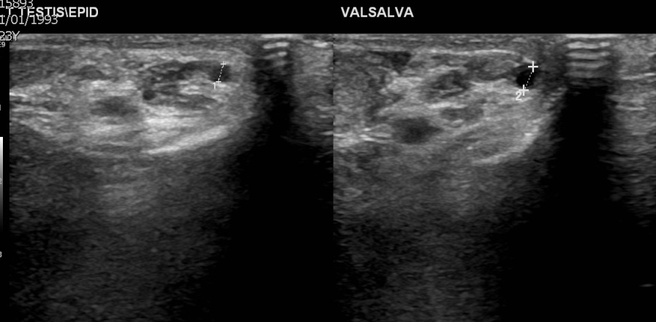
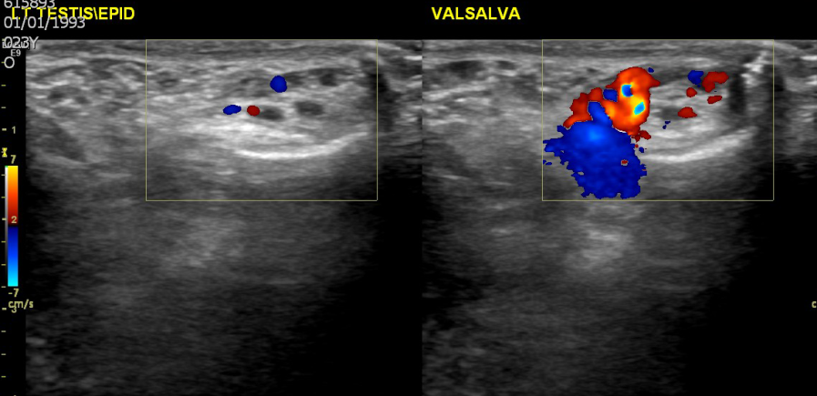
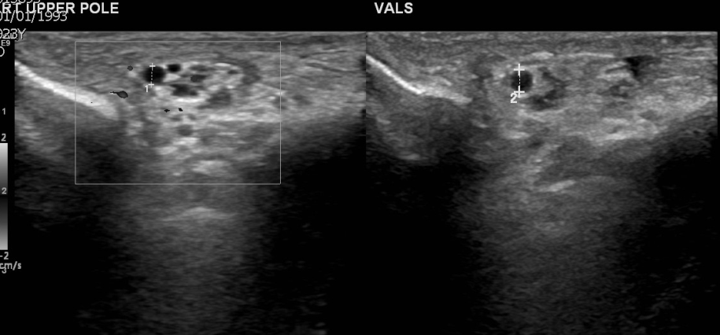
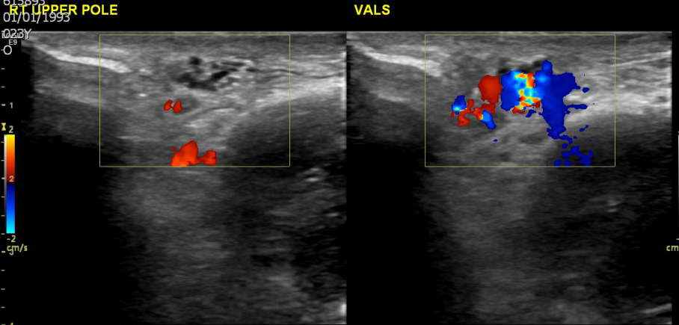
Figure 1 A 24-year-old man with bilateral varicocele. A: Gray-scale sonographic images, longitudinal sections at the supratesticular region of the left hemiscrotum at rest and during the Valsalva maneuver. The maximal diameter of the left spermatic veins is 2.5 mm at rest and 3.5 mm during the Valsalva maneuver; B: Color Doppler sonographic images, longitudinal sections same level show blood flow reversal after Valsalva maneuver; C: Gray-scale sonographic images, longitudinal sections at the right supratesticular region. The maximal diameter of the right spermatic veins is 2.3 mm at rest and 2.8 mm during the Valsalva maneuver; D: Color Doppler sonographic images, longitudinal sections show flow reversal with Valsalva maneuver.

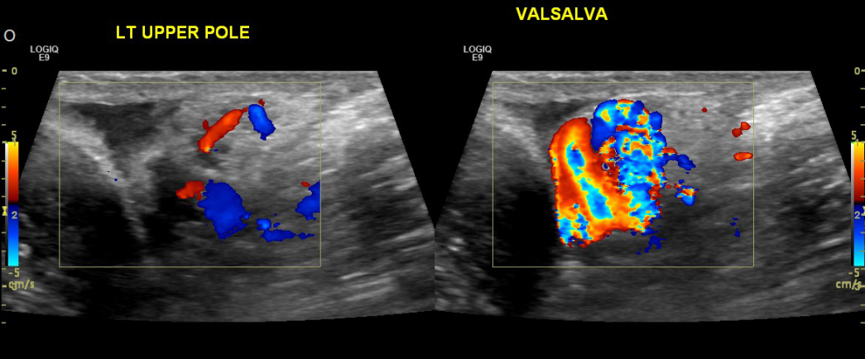
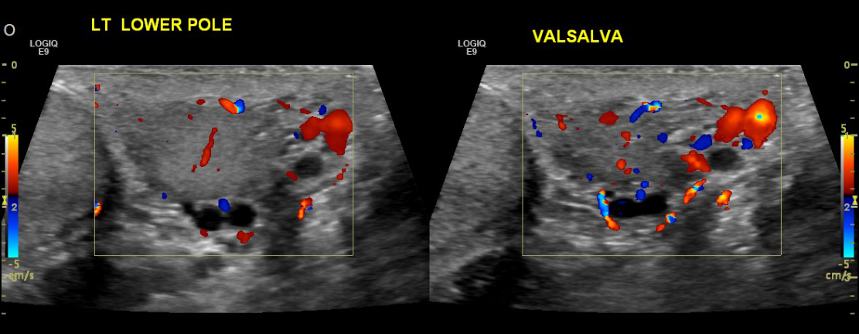
Figure 2 A 36-year-old man with left varicocele. Color Doppler sonographic images, longitudinal sections at the level of the upper (A) and lower pole (B) of the left testis depict blow flow reversal seen during the Valsalva maneuver.

