Name of journal: World Journal of Gastroenterology
Manuscript NO: 39852
Manuscript Type: ORIGINAL ARTICLE

Basic Study
Low expression of CDK5RAP3 and DDRGK1 indicates a poor prognosis in patients with gastric cancer

Lin JX et al. CDK5RAP3 and DDRGK1 in gastric cancer

Jian-Xian Lin, Xin-Sheng Xie, Xiong-Feng Weng, Chao-Hui Zheng, Jian-Wei Xie, Jia-Bin Wang, Jun Lu, Qi-Yue Chen, Long-Long Cao, Mi Lin, Ru-Hong Tu, Ping Li, Chang-Ming Huang

Jian-Xian Lin, Xin-Sheng Xie, Xiong-Feng Weng, Chao-Hui Zheng, Jian-Wei Xie, Jia-Bin Wang, Jun Lu, Qi-Yue Chen, Long-Long Cao, Mi Lin, Ru-Hong Tu, Ping Li, Chang-Ming Huang, Department of Gastric Surgery, Fujian Medical University Union Hospital, Fuzhou 350001, Fujian Province, China

Jian-Xian Lin, Xin-Sheng Xie, Xiong-Feng Weng, Chao-Hui Zheng, Jian-Wei Xie, Jia-Bin Wang, Jun Lu, Qi-Yue Chen, Long-Long Cao, Mi Lin, Ru-Hong Tu, Ping Li, Chang-Ming Huang, Key Laboratory of Ministry of Education of Gastrointestinal Cancer, Fujian Medical University, Fuzhou 350108, Fujian Province, China

Jian-Xian Lin, Xin-Sheng Xie, Xiong-Feng Weng, Chao-Hui Zheng, Jian-Wei Xie, Jia-Bin Wang, Jun Lu, Ping Li, Chang-Ming Huang, Fujian Key Laboratory of Tumor Microbiology, Fujian Medical University, Fuzhou 350108, Fujian Province, China

ORCID number: Jian-Xian Lin (0000-0002-5006-4454); Xin-Sheng Xie (0000-0003-0126-0376); Xiong-Feng Weng (0000-0002-5513-0588); Chao-Hui Zheng (0000-0003-0157-5167); Jian-Wei Xie (0000-0001-9000-5638); Jia-Bin Wang (0000-0002-2023-0183); Jun Lu (0000-0002-8459-4867); Qi-Yue Chen (0000-0001-6391-4043); Long-Long Cao (0000-0003-3144-3050); Mi Lin (0000-0001-7299-6159); Ru-Hong Tu (0000-0002-7491-3879); Ping Li (0000-0002-9418-9339); Chang-Ming Huang (0000-0002-0019-885X).

Author contributions: Lin JX, Xie XS and Weng XF contributed equally to this article and should be considered co-first authors; Huang CM and Li P conceived and designed the study, and should be as the co-corresponding authors; Lin JX, Xie XS and Weng XF performed the experiments; Zheng CH, Xie JW, Wang JB, Lu J, Chen QY, Cao LL, Lin M and Tu RH analyzed and interpreted the data; Lin JX, Xie XS and Weng XF drafted the manuscript. All authors approved the final version of the article to be published.

Supported by the Science Foundation of the Fujian Province, China, No. 2018J01307; Startup Fund for scientific research, Fujian Medical University, No. 2016QH024; Scientific and technological innovation joint capital projects of Fujian Province, No. 2016Y9031; Minimally invasive medical center of Fujian Province, No. 2011708#; and the Young and Middle-aged Talent Training Project of the Fujian Provincial Health and Family Planning Commission, No. 2014-ZQNJC-13.

Institutional review board statement: This study was reviewed and approved by the Ethics Committee of the Fujian Medical University Union Hospital.

Conflict-of-interest statement: To the best of our knowledge, no conflict of interest exists.

Data sharing statement: No additional data are available.

Open-Access: This article is an open-access article which was selected by an in-house editor and fully peer-reviewed by external reviewers. It is distributed in accordance with the Creative Commons Attribution Non Commercial (CC BY-NC 4.0) license, which permits others to distribute, remix, adapt, build upon this work non-commercially, and license their derivative works on different terms, provided the original work is properly cited and the use is non-commercial. See: http://creativecommons.org/licenses/by-nc/4.0/

Manuscript source: Unsolicited manuscript

Correspondence to: Chang-Ming Huang, MD, Doctor, Professor, Department of Gastric Surgery, Fujian Medical University Union Hospital, No.29 Xinquan Road, Fuzhou 350001, Fujian Province, China. hcmlr2002@163.com
Telephone: +86-591-83363366
Fax: +86-591-83363366

Received: May 19, 2018
Peer-review started: May 22, 2018
First decision: May 30, 2018
Revised: June 11, 2018
Accepted: June 25, 2018
Article in press:
Published online:

Abstract
AIM
To investigate the effects of different levels of expression of CDK5RAP3 and DDRGK1 on long-term survival of patients undergoing radical gastrectomy.

METHODS
The expression of CDK5RAP3 and DDRGK1 was detected by immunohistochemistry in 135 patients who received standard gastrectomy were enrolled in the study. Western Blot was used to detect the expression of CDK5RAP3 and DDRGK1 in gastric cancer and its adjacent tissues and cell lines. The correlations between the expression of CDK5RAP3 and DDRGK1 and clinicopathological factors were analyzed, and the value of each parameter to the prognosis of the patients was compared. Receiver operating characteristic analysis was used to compare the accuracy of the prediction of clinical outcome by the parameters.

RESULTS
CDK5RAP3 and DDRGK1 was down-regulated expression in the gastric cancer than its respective adjacent non-tumor tissues. The expression of CDK5RAP3 was closely related to the age of the patients (P = 0.035) and the T stage of the tumor (P = 0.017). The expression of DDRGK1 was correlated with the sex of the patients (P = 0.080), the degree of tumor differentiation (P = 0.036), the histological type (P = 0.036) and the N stage of the tumor (P = 0.014). Low expression CDK5RAP3 or DDRGK1 is poor prognostic factor for gastric cancer patients. Prognostic analysis showed that the co-expression of CDK5RAP3 and DDRGK1 was an independent prognostic factor correlating with the overall survival of gastric cancer patients. Combined expression analysis of CDK5RAP3 and DDRGK1 may provide a more accurate prognostic value for overall survival.

Conclusion
The co-expression of CDK5RAP3 and DDRGK1 is an independent prognostic factor for gastric cancer which can provide a more accurate model for the long-term prognosis.

Key words: Gastric cancer; CDK5RAP3; DDRGK1; Prognosis

© The Author(s) 2018. Published by Baishideng Publishing Group Inc. All rights reserved.

Core tip: The expression of CDK5RAP3 and DDRGK1 down-regulated in gastric cancer tissues. Low expression CDK5RAP3 or DDRGK1 is poor prognostic factor for gastric cancer patients. The co-expression of CDK5RAP3 and DDRGK1 is an independent prognostic factor for the overall survival of patients with gastric cancer. Moreover, we also found that co-expression of CDK5RAP3 and DDRGK1 can provide a more accurate model for the long-term prognosis of gastric cancer.

Lin JX, Xie XS, Weng XF, Zheng CH, Xie JW, Wang JB, Lu J, Chen QY, Cao LL, Lin M, Tu RH, Li P, Huang CM. Low expression of CDK5RAP3 and DDRGK1 indicates a poor prognosis in patients with gastric cancer. World J Gastroenterol 2018; In press

Introduction
Although the morbidity and mortality of the primary gastric cancer has declined in recent decades, it is still the second most common cause of cancer-related death worldwide^{[1-3]}. At present, the etiology and pathogenesis of gastric cancer has not yet been fully clarified. There is also a lack of specific and highly effective therapeutic drugs available for use in clinical practice. The symptom specificity of early gastric cancer is not obvious, so most patients are already in advanced stages before receiving medical treatment, which seriously affects the prognosis of patients. Therefore, searching for molecular markers that can be used as an independent prognostic factor for gastric cancer is of great significance for the early diagnosis and targeted treatment of gastric cancer.
The cyclin-dependent kinase 5 activating binding protein (CDK5RAP3, also called C53) was first identified as a binding protein of the cyclin-dependent kinase 5 (CDK5) activators P35 and P39^{[4]}. In recent years, an increasing number of studies have been conducted on the role of CDK5RAP3 in tumors, but its expression and role in different tumors has been found to be different. An et al^{[5]} reported that CDK5RAP3 inhibited the phosphorylation and activation of p38 by promoting the binding of p38 and p53-induced protein phosphatase 1 to inhibit tumor proliferation. However, Stav et al^{[6]} found that the expression of CDK5RAP3 in most cancer tissues was increased, which is of great significance in the diagnosis of lung cancer. The expression and function of CDK5RAP3 are also controversial in the same types of tumors. Mak et al^{[7]} found that CDK5RAP3 was highly expressed in hepatocellular cancer and that it could promote the metastasis of hepatoma cancer cell by activating p21-activated protease 4 and down-regulating the expression of tumor suppressor gene p14. However, Zhao et al^{[8]} showed that the expression of CDK5RAP3 protein was down-regulated in hepatocellular cancer and that down-regulation of CDK5RAP3 expression was associated with a poor prognosis.
Recent studies have shown that DDRGK1 interacts with CDK5RAP3^{[9]}. DDRGK1 was cloned from human liver in 2010 by Lemaire et al^{[10]} DDRGK1 is located on the short arm of chromosome 20 (20p13), also known as UFBP1, C20orf116, and dJ1187M17. The DDRGK1 sequence is highly conserved and exists in many tissues and organs. Its N-terminal 1-28 amino acid residue region is highly hydrophobic and is an endoplasmic reticulum anchor sequence; 65-69 amino acid residues are nuclear localization signals. The 229-273 amino acid residues near the C-terminus are the protein PCI domain^{[11]}. Studies have shown that proteins containing a PCI domain are primarily responsible for the construction and assembly of protein complexes^{[12]}. Peng et al^{[13]} found that DDRGK1 interacts with IkBa and regulates its stability, thereby regulating the transcriptional activity of NF-kB. At present, there are few studies on the co-expression of CDK5RAP3 and DDRGK1 in gastric cancer and its impact on prognosis. In this study, we examined the expression of CDK5RAP3 and DDRGK1 in 135 cases of gastric cancer, and analyzed their correlation with clinicopathological features and long-term prognosis of the patients.

Materials and Methods
Human gastric tumor tissues
The gastric cancer specimens were obtained from 135 patients with gastric adenocarcinoma, who had undergone D2 lymph node dissection and gastrectomy for gastric cancer at the Department of Gastric Surgery, Fujian Medical University Union Hospital (Fujian, China) with available detailed clinic pathologic parameters, between January 2013 and June 2015. All patients received their first diagnosis of gastric cancer and received no other treatment, such as chemotherapy, before surgery. All diagnoses were confirmed by pathology after surgery. Gastric cancer was confirmed by hematoxylin and eosin (H&E) staining in all cases. The clinicopathological data of the 135 GC patients included age, sex, size of the primary tumor, location of the primary tumor, degree of differentiation, histological type, Borrmann type, depth of invasion, lymph node metastasis, distant metastasis and TNM stage. The pathologic stage of the tumor was re-assessed according to the TNM classification of gastric cancer (eighth edition) of the International Union against Cancer (2016).The clinical and pathological data were recorded prospectively for the retrospective analysis. This study was approved by the ethics committee of Fujian Medical University Union Hospital and written consent was obtained from all patients involved.

Immunohistochemistry
Paraffin sections containing sufficient formalin fixed tumor tissue were sectioned continuously at a thickness of 4 μ m and were mounted on silage coated slides for immunohistochemical analysis. The slices were deparaffinized with xylene and rehydrated in 95%, 85% and 75% ethanol. Antigen retrieval was performed by subjecting the slides to high-pressure sterilization at 121°C for 2 min in 0.01 mol/L sodium citrate buffer solutions (pH 6.0). Endogenous peroxidase activity was blocked by incubating the slides with 3% H₂O₂ at room temperature for 10 min. The slices were then washed in phosphate buffered saline (PBS) solution and blocked in 10% goat serum (Zhongshan Biotechnology Co. Ltd.) for 30 min. Next, the sections were incubated with diluted rabbit anti-human CDK5RAP3 (ab157203, 1:200 dilution; Abcam) or DDRGK1 (21445-1-AP, 1.50 dilution; Proteintech) overnight in a humidified chamber at 4°C. After three washes in PBS, the sections were incubated with the secondary antibody conjugated to horseradish peroxidase at room temperature for 30 min. The signal was developed with diaminobenzidine solution, which was followed by counterstaining in 20% hematoxylin. Finally, all slides were dehydrated and mounted on cover glass. For negative controls, non-specific antibody diluent was substituted for the primary antibody.

Evaluation of immunostaining intensity
The immunohistochemistry (IHC) of the tissue sections were examined by 2 experienced pathologists, who scored the slides according to the intensity of cell staining and the proportion of positively stained tumor cells. The definition for the evaluation of CDK5RAP3 and DDRGK1 staining intensity was as follows: no staining (score of 0), weak staining (light yellow, score of 1), moderate staining (yellow brown, score of 2) and strong staining (brown, score of 3). The positive proportion of stained tumor cells was scored as follows: ≤ 5% positive cells (score of 0), 6% to 25% positive cells (score of 1), 26% to 50% positive cells (score of 2), ≥ 51% positive cells (score of 3). If the total scores (intensity multiply percentage score) was less than 3, the protein expression was considered low, however, if the score was 4 or higher, the protein expression was considered high (Figure 1A).

Western blot
After the cells grew to a degree of convergence of 90%-100%, the cells were flushed twice with pre-cooled PBS and then extracted with RIPA pyrolysis solution (Thermo Fisher Scientific, Waltham, MA, USA) containing a 10% cocktail (Roche, South San Francisco, CA, USA).Protein samples (40 μg per lane) were separated on 10% polyacrylamide gels by the SDS-PAGE method and transferred to PVDF membranes. Then, at room temperature, 5% skim milk was used to block the PVDF membrane for 1 h. The membrane was then incubated at 4°C with the primary antibody (anti-cyclin D1, anti-HA, anti-P-AKT(S473), anti-AKT, anti-P-GSK3β(S9), anti-GSK3β or anti-GAPDH) and washed with washing buffer TBS-T 3 times, 5 min each time, then incubated at room temperature with the HRP second antibody (Cell Signaling Technology) for 1 h. GAPDH was used as an internal control. Finally, the membrane was washed with TBS-T for 30 min and the protein bands were detected by an enhanced chemiluminescence method (Amersham Corporation, Arlin-gton Heights, IL, United States).

Follow-up
All patients were followed up once every 3 mo for the first 2 years and were then followed up every six months for the next 3-5 years. The last follow-up time point was December 2018. Follow-up routine examinations, including a physical examination, laboratory tests (CA19-9, CEA and CA72-4), chest X-ray, abdominal CT, B ultrasound, and gastroscopy were performed each year. The total survival time was defined as the time from surgery to the last follow-up, or the time of death, or the expiration of the follow-up database (e.g., lost to follow-up, death from other diseases, etc.)

Statistical analysis
All of the data were processed by the SPSS23.0 statistical software package. Appropriate test methods, such as the χ² test or Fisher's exact test, were selected according to the type of variables and the purpose of comparison. The survival rate was calculated by the Kaplan-Meier method, and the subsequent survival curve was plotted. The log-rank test was used to compare the survival rates. Cox regression was used to analyze the independent factors that affected the prognosis. The area under the ROC curve was used to compare the prognostic ability of different indexes. The difference was statistically significant when p < 0. 05.

Results
Expression status of CDK5RAP3 and DDRGK1 in gastric cancer
Of 135 patients with primary gastric cancer, 109 patients (80.7%) had low expression of CDK5RAP3 and 26 patients (19.3%) had high expression. The DDRGK1 immunohistochemical score showed low expression in 98 cases (72.6%) and high expression in 37 cases (27.4%) (Table 1). Western blotting was used to detect the expression of CDK5RAP3 and DDRGK1 in the tumor and adjacent tissues of 9 patients with gastric cancer. It was found that the expression of CDK5RAP3 and DDRGK1 in 6 patients was higher in respective adjacent non-tumor tissues than that in gastric cancer tissues (Figure 1B). In addition, the expression of CDK5RAP3 and DDRGK1 in gastric cancer cell lines decreased with the decrease of differentiation degree of the gastric cancer cell lines (Figure 1C). We also found that the histological scores of CDK5RAP3 and DDRGK1 in adjacent tissues were higher than those in cancer tissues, with a statistically significant difference (Figure 1D).

Relationships between CDK5RAP3 and DDRGK1 protein expression in gastric cancer tissues and clinicopathological parameters
We analyzed the relationship between CDK5RAP3 and DDRGK1 protein expression in gastric cancer tissues and various clinicopathological data. The expression of CDK5RAP3 in gastric cancer was correlated with the age (P = 0.035) and T stage of the tumor (P = 0.017). However, the expression of DDRGK1 in gastric cancer was closely correlated with the differentiation degree (P = 0.036), the histological type (P = 0.036) and N stage of tumor (P = 0.014), as shown in Table 1. The co-expression level of CDK5RAP3 and DDRGK1 was related to sex (P = 0.024), T stage (P = 0.026), N stage (P = 0.048) and TNM stage (P = 0.016), as shown in table 2.

Expression levels of CDK5RAP3 and DDRGK1 are correlated with the prognosis of patients with gastric cancer
The median follow-up time was 30.0 mo, and the 3-year survival rate was 70.7%. Survival analysis showed that the 3-year survival rate of gastric cancer patients with low expression of CDK5RAP3 was 71.1%, which was lower than that of patients with high expression of CDK5RAP3 (90.8%, Figure 2A). The survival time of gastric cancer patients with low expression of DDRGK1 was significantly lower than that of patients with high expression of DDRGK1 (67.7% vs 91.9%, Figure 2B). When combining analysis of CDK5RAP3 and DDRGK1, the 3-year survival rate of gastric cancer patients with low expression of CDK5RAP3 and DDRGK1 was 64.2%, which was significantly lower than that of the patients with high expression of CDK5RAP3 and DDRGK1 (Figure 3A). We compared the prognostic value of high expression of CDK5RAP3 and low expression of DDRGK1 to low expression of CDK5RAP3 and high expression of DDRGK1, and there were no significant difference between these survival curves (supplementary figure 1). So we combined the two groups into a group for further analysis. Further stratification analysis showed that the prognosis was the best when CDK5RAP3 and DDRGK1 were both highly expressed, and the prognosis was the worse when either CDK5RAP3 or DDRGK1 was highly expressed, while the worst prognosis was correlated with low expression of both CDK5RAP3 and DDRGK1 (Figure 3B). In addition, we used immunoprecipitation combined with mass spectrometry (in HGC cell line) to find CDK5RAP3 binding protein and potential downstream targets, the results of string analysis show that CDK5RAP3 can bind DDRGK1 (supplementary figure 2).

Univariate and multivariate analyses of the prognosis in the entire group
Univariate analysis showed that the overall survival was correlated with the T status (P = 0.026), N status (P = 0.031), M status (P = 0.005), TNM stage (P = 0.001), and the expression level of CDK5RAP3 (P = 0.023) and DDRGK1 (P = 0.015) in gastric cancer tissues and the co-expression level of CDK5RAP3 and DDRGK1 in gastric cancer tissues (P = 0.001) (Table 3). Multivariate Cox prognostic analysis showed that the co-expression levels of CDK5RAP3 and DDRGK1 (P = 0.009) and the TNM stage (P = 0.007) were both independent prognostic factors in gastric cancer patients (Table 4).

The relationship between the expression of CDK5RAP3 and DDRGK1 and TNM stage
As shown in Figure 4, we established a ROC curve to compare the expression of CDK5RAP3 or DDRGK1 alone and the expression of CDK5RAP3 and DDRGK1 together with TNM stage in gastric cancer prognostication. The results showed that the area under the curve of the combination of CDK5RAP3 and DDRGK1 (AUC: 0.649, 95%CI: 0.548-0.751, P = 0.009) was larger than that of CDK5RAP3 or DDRGK1 expression alone (CDK5RAP3: AUC: 0.589，95%CI: 0.486-0.693, P = 0.120; DDRGK1: AUC：0.605, 95%CI: 0.501-0.708, P = 0.069). In addition, the prognostic value of the combined expression of CDK5RAP3 and DDRGK1 was closer to that of the TNM stage (AUC: 0.683, 95%CI: 0.591-0.776, P = 0.001).

Discussion
In recent years, although some progress has been made in the treatment of gastric cancer, the prognosis of gastric cancer patients is still not optimistic because the majority of patients are only diagnosed in moderate or advanced stages, and the effect of adjuvant therapy is limited. Therefore, finding new biomarkers will help to improve earlier diagnosis and treatment of gastric cancer. DDRGK1 is not only a target protein of ufmylation, but is also an integral component of the ufmylation modification system. Ufmylation mediated by DDRGK1 plays an important role in carcinogenesis^{[14,15]}. Shiwaku et al^{[16]} found that the amino acid sequence of CDK5RAP3 contained an ubiquitin protein ligase binding region. Wu's study^{[9]} found that CDK5RAP3 can interacted with DDRGK1 and UFL1 (called RCAD in their study) and regulate the stability of CDK5RAP3 and DDRGK1. Therefore, based on these previous reports and our finding, we speculate that the function of CDK5RAP3 and DDRGK1 is related. However, the expression of CDK5RAP3 and DDRGK1 in gastric cancer and their influence on clinicopathological characteristics and prognosis have not previously been reported.
CDK5RAP3 is widely expressed in various tissues and cells of the whole body, including the heart, brain, skeletal muscle, placenta, lung, liver, kidney and pancreas^{[17]}. In early embryonic development, CDK5RAP3 regulates cell cycle progression, epidermal cell adhesion and migration^{[4]}. Recent studies have suggested that CDK5RAP3 plays an important role in various cancers such as lung cancer, liver cancer, head and neck cancer^{[6,18,19]}. Our study found that the 3-year survival rate of patients with low expression of CDK5RAP3 was lower than that of patients with high expression of CDK5RAP3 (p < 0.05), and the expression of CDK5 RAP3 was correlated with tumor T stage, suggesting that CDK5RAP3 is involved in gastric cancer. It may play a role in suppressing cancer, which is also consistent with our previous research results^{[20]}. In the case of DDRGK1, some studies have shown that DDRGK1 is a tumor suppressor. The ufmylation of DDRGK1 itself is essential for its combination with UfL1 and activation of the UfL1 ubiquitin ligase. If DDRGK1 is unable to undergo ufmylation, it cannot bind and activate UFL1 activity, thereby blocking the ufmylation of the nuclear receptor co-activator ASC1 and, inhibiting the binding of ASC1 and the transcription factors p300 and SRC1 to the downstream target genes of the estrogen receptor ERα ^{[11,14,21]}.
In this study, the survival of gastric cancer patients with low expression of DDRGK1 was significantly shorter than that of patients with high expression of DDRGK1 (p < 0.05), and the expression of DDRGK1 was related to tumor differentiation, histological type and N stage. It has also been suggested that DDRGK1 may play a role in suppressing the progression of gastric cancer.
In addition, we found that patients with low expression of CDK5RAP3 and DDRGK1 had the worst prognosis while patients with high expression of both proteins had the best prognosis, and the other patients were between them. Further analysis showed that the accuracy of prognostication with a combination of CDK5RAP3 and DDRGK1 was higher than that of CDK5 RAP3 or DDRGK1 alone. We showed that the combined expression of CDK5RAP3 and DDRGK1 had a better ability to predict the overall survival rate of gastric cancer patients. In Xi et al.'s study^{[13]}, DDRGK1 interacted with IkBa and regulated its stability, thereby regulating the transcriptional activity of NF-kB and its target gene expression. However, Wang's study^{[9]} of CDK5RAP3 found that down-regulation of CDK5RAP3 increased cell invasiveness and increased the transcriptional activity of NF-kB. CDK5RAP3 binds to RelA to inhibit its phosphorylation and increase the binding of HDAC to RERA, thereby inhibiting the transcriptional activity of NF-kB. CDK5RAP3 and DDRGK1 can interact with each other, and their roles in the NF-kB pathway are similar. Therefore, we hypothesized that their impact on prognosis may be related to the overlapping of the two tumor suppressing effects. However, the interaction between CDK5RAP3 and DDRGK1 in gastric cancer has not been fully elucidated. And further manipulate both gene’s expression in different gastric cancer cell lines, and investigate the characteristics and mechanism of these gene’s effects on gastric cancer are needed in the further study.
In summary, low expression of CDK5RAP3 and DDRGK1 are closely related to the prognosis of gastric cancer, and the co-expression of CDK5RAP3 and DDRGK1 is an independent prognostic factor correlated with the overall survival of gastric cancer patients.

ARTICLE HIGHLIGHTS
Research background
Although the morbidity and mortality of the primary gastric cancer has declined in recent decades, it is still the third most common cause of cancer-related death worldwide. The symptoms of early gastric cancer are not highly specific, misdiagnosis and missed diagnosis may occur. Therefore, finding new biomarkers will help to improve earlier diagnosis and treatment of gastric cancer. In recent years, an increasing number of studies on the prognostic indicators of gastric cancer have been published. However, the expression of CDK5RAP3 and DDRGK1 in gastric cancer and its influence on prognosis have not yet been reported.

Research motivation
At present, the etiology and pathogenesis of gastric cancer has not yet been fully clarified. There is also a lack of specific and highly effective therapeutic drugs available for use in clinical practice. The symptom specificity of early gastric cancer is not obvious, so most patients are already in advanced stages before receiving medical treatment, which seriously affects the prognosis of patients. Therefore, searching for molecular markers that can be used as an independent prognostic factor for gastric cancer is of great significance for the early diagnosis and targeted treatment of gastric cancer. A series of studies on tumor prognostic factors expected to provide a new target for the treatment of gastric cancer while provides new targets for the treatment of gastric cancer. The expression of CDK5RAP3 and DDRGK1 in gastric cancer and their influence on clinicopathological characteristics and prognosis have not previously been discussed.

Research objectives
The aim of this study is to identify some novel effective biomarkers to classify patients with low or high risk on survival, would provide a guide to clinicians to select therapeutic strategies for patients and provide personalized therapy according to the predicted risk of survivals. In this study, we investigated two interacting proteins, CDK5RAP3 and DDRGK1, which surgeons can use to decide patient management strategies.

Research methods
We used immunohistochemistry to detect the expression of CDK5RAP3 and DDRGK1 in gastric cancer and adjacent tissues. Western Blot was used to detect the expression of CDK5RAP3 and DDRGK1 in gastric cancer and its adjacent tissues and cell lines. According to immunohistochemistry scores, the patients were divided into CDK5RAP3 high expression group and CDK5RAP3 low expression group, DDRGK1 high expression group and DDRGK1 low expression group, and the relationship between the expression level and clinical pathological data was analyzed. Furthermore，based on the combined expression of CDK5RAP3 and DDRGK1, we classified the patients into three subtypes: CDK5RAP3 and DDRGK1 high (n = 9), CDK5RAP3 or DDRGK1 low (n = 45) and CDK5RAP3 and DDRGK1 low (n = 81). Then, we used Kaplan-Meier method to analyze the effect of different expression patterns on prognosis.

Research results
Our research found that the expression of CDK5RAP3 and DDRGK1 was down-regulated in the gastric cancer. Low expression CDK5RAP3 or DDRGK1 is poor prognostic factor for gastric cancer patients. Moreover，prognostic analysis showed that the co-expression of CDK5RAP3 and DDRGK1 was an independent prognostic factor correlating with the overall survival of gastric cancer patients. And combined expression analysis of CDK5RAP3 and DDRGK1 may provide a more accurate prognostic value for overall survival. This study presents two interacting proteins, which surgeons can use to decide patient management strategies. Surgeons can also use these makers to predict the prognosis of gastric cancer patients through an analysis of CDK5RAP3 and DDRGK1 protein expression in preoperative biopsy and tumor specimens.

Research conclusions
This study found that low expression of CDK5RAP3 and DDRGK1 are closely related to the poor prognosis of gastric cancer patients, and the co-expression of CDK5RAP3 and DDRGK1 is an independent prognostic factor correlated with the overall survival of gastric cancer patients. These two interacting protein, CDK5RAP3 and DDRGK1, which surgeons can use to decide patient management strategies. Surgeons can also use these makers to predict the prognosis of gastric cancer patients through an analysis of CDK5RAP3 and DDRGK1 protein expression in preoperative biopsy and tumor specimens.
We hypotheses that CDK5RAP3 and DDRGK1 are key genes which may participate in the biological regulation of gastric cancer，the detail mechanism of them in gastric cancer are still not been fully elucidated and further studies are needed. And we believe that with advances in technology, human may find more effective and new indicators in the future to guide treatment, improve prognosis, and reduce the recurrence rate and mortality of patients with gastric cancer.

Research perspectives
This study found the prognostic value of two interacting proteins, CDK5RAP3 and DDRGK1, by detecting the expression of both in clinical specimens, combined with detailed clinical pathological data analysis. This study provided ideas for finding new tumor prognosis related molecules. Manipulate both CDK5RAP3 and DDRGK1 expression in different gastric cancer cell lines, such as overexpression or knockdown, will need in in the future research. Further study is necessary to investigate the characteristics of cancer cells and explore the mechanism of CDK5RAP3 and DDRGK1 affecting the development of gastric cancer by in vitro cell model and vivo xenograft model.

REFERENCES
1 Sano T, Sasako M, Yamamoto S, Nashimoto A, Kurita A, Hiratsuka M, Tsujinaka T, Kinoshita T, Arai K, Yamamura Y, Okajima K. Gastric cancer surgery: morbidity and mortality results from a prospective randomized controlled trial comparing D2 and extended para-aortic lymphadenectomy--Japan Clinical Oncology Group study 9501. J Clin Oncol 2004; 22: 2767-2773 [PMID: 15199090 DOI: 10.1200/JCO.2004.10.184]
2 Papenfuss WA, Kukar M, Oxenberg J, Attwood K, Nurkin S, Malhotra U, Wilkinson NW. Morbidity and mortality associated with gastrectomy for gastric cancer. Ann Surg Oncol 2014; 21: 3008-3014 [PMID: 24700300 DOI: 10.1245/s10434-014-3664-z]
3 Wöhrer SS, Raderer M, Hejna M. Palliative chemotherapy for advanced gastric cancer. Ann Oncol 2004; 15: 1585-1595 [PMID: 15520058 DOI: 10.1093/annonc/mdh422]
4 Wang X, Ching YP, Lam WH, Qi Z, Zhang M, Wang JH. Identification of a common protein association region in the neuronal Cdk5 activator. J Biol Chem 2000; 275: 31763-31769 [PMID: 10915792 DOI: 10.1074/jbc.M004358200]
5 An H, Lu X, Liu D, Yarbrough WG. LZAP inhibits p38 MAPK (p38) phosphorylation and activity by facilitating p38 association with the wild-type p53 induced phosphatase 1 (WIP1). PLoS One 2011; 6: e16427 [PMID: 21283629 DOI: 10.1371/journal.pone.0016427]
6 Stav D, Bar I, Sandbank J. Usefulness of CDK5RAP3, CCNB2, and RAGE genes for the diagnosis of lung adenocarcinoma. Int J Biol Markers 2007; 22: 108-113 [PMID: 17549666]
7 Mak GW, Chan MM, Leong VY, Lee JM, Yau TO, Ng IO, Ching YP. Overexpression of a novel activator of PAK4, the CDK5 kinase-associated protein CDK5RAP3, promotes hepatocellular carcinoma metastasis. Cancer Res 2011; 71: 2949-2958 [PMID: 21385901 DOI: 10.1158/0008-5472.CAN-10-4046]
8 Zhao JJ, Pan K, Li JJ, Chen YB, Chen JG, Lv L, Wang DD, Pan QZ, Chen MS, Xia JC. Identification of LZAP as a new candidate tumor suppressor in hepatocellular carcinoma. PLoS One 2011; 6: e26608 [PMID: 22028922 DOI: 10.1371/journal.pone.0026608]
9 Wu J, Lei G, Mei M, Tang Y, Li H. A novel C53/LZAP-interacting protein regulates stability of C53/LZAP and DDRGK domain-containing Protein 1 (DDRGK1) and modulates NF-kappaB signaling. J Biol Chem 2010; 285: 15126-15136 [PMID: 20228063 DOI: 10.1074/jbc.M110.110619]
10 Neziri D, Ilhan A, Maj M, Majdic O, Baumgartner-Parzer S, Cohen G, Base W, Wagner L. Cloning and molecular characterization of Dashurin encoded by C20orf116, a PCI-domain containing protein. Biochim Biophys Acta 2010; 1800: 430-438 [PMID: 20036718 DOI: 10.1016/j.bbagen.2009.12.004]
11 Lemaire K, Moura RF, Granvik M, Igoillo-Esteve M, Hohmeier HE, Hendrickx N, Newgard CB, Waelkens E, Cnop M, Schuit F. Ubiquitin fold modifier 1 (UFM1) and its target UFBP1 protect pancreatic beta cells from ER stress-induced apoptosis. PLoS One 2011; 6: e18517 [PMID: 21494687 DOI: 10.1371/journal.pone.0018517]
12 Hofmann K, Bucher P. The PCI domain: a common theme in three multiprotein complexes. Trends Biochem Sci 1998; 23: 204-205 [PMID: 9644972]
13 Xi P, Ding D, Zhou J, Wang M, Cong YS. DDRGK1 regulates NF-κB activity by modulating IκBα stability. PLoS One 2013; 8: e64231 [PMID: 23675531 DOI: 10.1371/journal.pone.0064231]
14 Yoo HM, Kang SH, Kim JY, Lee JE, Seong MW, Lee SW, Ka SH, Sou YS, Komatsu M, Tanaka K, Lee ST, Noh DY, Baek SH, Jeon YJ, Chung CH. Modification of ASC1 by UFM1 is crucial for ERα transactivation and breast cancer development. Mol Cell 2014; 56: 261-274 [PMID: 25219498 DOI: 10.1016/j.molcel.2014.08.007]
15 Tatsumi K, Sou YS, Tada N, Nakamura E, Iemura S, Natsume T, Kang SH, Chung CH, Kasahara M, Kominami E, Yamamoto M, Tanaka K, Komatsu M. A novel type of E3 ligase for the Ufm1 conjugation system. J Biol Chem 2010; 285: 5417-5427 [PMID: 20018847 DOI: 10.1074/jbc.M109.036814]
16 Shiwaku H, Yoshimura N, Tamura T, Sone M, Ogishima S, Watase K, Tagawa K, Okazawa H. Suppression of the novel ER protein Maxer by mutant ataxin-1 in Bergman glia contributes to non-cell-autonomous toxicity. EMBO J 2010; 29: 2446-2460 [PMID: 20531390 DOI: 10.1038/emboj.2010.116]
17 Lew J, Beaudette K, Litwin CM, Wang JH. Purification and characterization of a novel proline-directed protein kinase from bovine brain. J Biol Chem 1992; 267: 13383-13390 [PMID: 1618840]
18 Mak GW, Lai WL, Zhou Y, Li M, Ng IO, Ching YP. CDK5RAP3 is a novel repressor of p14ARF in hepatocellular carcinoma cells. PLoS One 2012; 7: e42210 [PMID: 22860085 DOI: 10.1371/journal.pone.0042210]
19 Wang J, An H, Mayo MW, Baldwin AS, Yarbrough WG. LZAP, a putative tumor suppressor, selectively inhibits NF-kappaB. Cancer Cell 2007; 12: 239-251 [PMID: 17785205 DOI: 10.1016/j.ccr.2007.07.002]
20 Wang JB, Wang ZW, Li Y, Huang CQ, Zheng CH, Li P, Xie JW, Lin JX, Lu J, Chen QY, Cao LL, Lin M, Tu RH, Lin Y, Huang CM. CDK5RAP3 acts as a tumor suppressor in gastric cancer through inhibition of β-catenin signaling. Cancer Lett 2017; 385: 188-197 [PMID: 27793695 DOI: 10.1016/j.canlet.2016.10.024]
21 Merbl Y, Refour P, Patel H, Springer M, Kirschner MW. Profiling of ubiquitin-like modifications reveals features of mitotic control. Cell 2013; 152: 1160-1172 [PMID: 23452859 DOI: 10.1016/j.cell.2013.02.007]
P-Reviewer: Chuang SM, Tomizawa M, Zhang J S-Editor: Gong ZM
L-Editor: E-Editor:
Specialty type: Gastroenterology and hepatology
Country of origin: China
Peer-review report classification
Grade A (Excellent): 0
Grade B (Very good): B
Grade C (Good): C
Grade D (Fair): D
Grade E (Poor): 0

Table 1 Relationships between CDK5RAP3 and DDRGK1 protein expressions in gastric cancer tissues and various clinicopathological variables
variables | Total | CDK5RAP3 expression |  |  |  | DDRGK1 expression
 |  | Low | high | χ2 | P | low | high | χ2 | P
Gender |  |  |  | 1.659 | 0.198 |  |  | 3.057 | 0.080
Male | 107 | 84 | 23 |  |  | 74 | 33
Female | 28 | 25 | 3 |  |  | 24 | 4
Age (yr) |  |  |  | 4.441 | 0.035 |  |  | 0.719 | 0.397
> 60 | 91 | 78 | 13 |  |  | 64 | 27
≤ 60 | 44 | 31 | 13 |  |  | 34 | 10
Tumor size (cm) |  |  |  | 0.125 | 0.723 |  |  | 0.043 | 0.835
> 5 | 53 | 42 | 11 |  |  | 39 | 14
≤ 5 | 72 | 67 | 15 |  |  | 59 | 23
Location of tumor |  |  |  | 3.860 | 0.277 |  |  | 1.537 | 0.674
Lower 1/3 | 55 | 48 | 7 |  |  | 37 | 18
Middle 1/3 | 20 | 15 | 5 |  |  | 16 | 4
Upper 1/3 | 45 | 36 | 9 |  |  | 34 | 11
More than 1/3 | 15 | 10 | 5 |  |  | 11 | 4
Borrmann type |  |  |  | 0.285 | 0.593 |  |  | 1.312 | 0.252
I + II type | 31 | 24 | 7 |  |  | 25 | 6
III + IV type | 104 | 85 | 19 |  |  | 73 | 31
Degree of differentiation |  |  |  | 0.187 | 0.666 |  |  | 4.414 | 0.036
Well/moderate | 57 | 47 | 10 |  |  | 36 | 21
Poor and not | 78 | 62 | 16 |  |  | 62 | 16
Histological type |  |  |  | 1.271 | 0.736 |  |  | 8.547 | 0.036
Papillary | 58 | 48 | 10 |  |  | 39 | 19
Tubular | 42 | 32 | 10 |  |  | 27 | 15
Mucinous | 10 | 9 | 1 |  |  | 9 | 1
Signet-ring cell | 25 | 20 | 5 |  |  | 23 | 2
Depth of invasion |  |  |  | 5.674 | 0.017 |  |  | 1.428 | 0.232
T1 + T2 | 21 | 13 | 8 |  |  | 13 | 8
T3 + T4 | 114 | 96 | 18 |  |  | 85 | 29
Lymph node metastasis |  |  |  | 0.008 | 0.927 |  |  | 6.023 | 0.014
Negative | 20 | 16 | 4 |  |  | 10 | 10
Positive | 115 | 93 | 22 |  |  | 88 | 27
TNM stage |  |  |  | 1.383 | 0.240 |  |  | 2.632 | 0.105
Ⅰ + Ⅱ | 44 | 33 | 11 |  |  | 28 | 16
Ⅲ + Ⅳ | 91 | 76 | 15 |  |  | 70 | 21
Distant metastasis |  |  |  | 1.761 | 0.184 |  |  | 0.639 | 0.424
Negative | 128 | 102 | 26 |  |  | 92 | 36
Positive | 7 | 7 | 0 |  |  | 6 | 1

Table 2 Relationships between different CDK5RAP3 and DDRGK1 protein expression status in gastric cancer tissues and various clinicopathological variables
Variables | Total | C53 and DDRGK1 low expression | C53 and/or DDRGK1 high expression | χ2 | P value
Gender
Male | 107 | 59 | 48 | 5.077 | 0.024
Female | 28 | 22 | 6
Age (yr)
> 60 | 91 | 55 | 36 | 0.022 | 0.881
≤ 60 | 44 | 26 | 18
Tumor size (cm)
> 5 | 53 | 32 | 21 | 0.005 | 0.943
≤ 5 | 82 | 49 | 33
Location of tumor
Lower 1/3 | 55 | 33 | 22 | 1.481 | 0.687
Middle 1/3 | 20 | 12 | 8
Upper 1/3 | 45 | 29 | 16
More than 1/3 | 15 | 7 | 8
Borrmann type
I + II type | 31 | 20 | 11 | 0.342 | 0.559
III + IV type | 104 | 61 | 43
Degree of differentiation
Well/moderate | 57 | 31 | 26 | 1.296 | 0.255
Poor and not | 78 | 50 | 28
Histological type
Papillary | 57 | 33 | 25 | 4.415 | 0.220
Tubular | 42 | 22 | 20
Mucinous | 10 | 8 | 2
Signet-ring cell | 25 | 18 | 7
Depth of invasion
T1 + T2 | 21 | 8 | 13 | 4.972 | 0.026
T3 + T4 | 114 | 73 | 41
Lymph node metastasis
Negative | 20 | 8 | 12 | 3.913 | 0.048
Positive | 115 | 73 | 42
TNM stage
Ⅰ + Ⅱ | 44 | 20 | 24 | 5.754 | 0.016
Ⅲ + Ⅳ | 91 | 61 | 30
Distant metastasis
Negative | 126 | 75 | 53 | 2.034 | 0.154
Positive | 7 | 6 | 1

Table 3 Univariate analysis of the correlation between clinicopathological parameters and survival of patients with gastric cancer
Clinicopathological parameters | Three-year  cumulative survival rate | Log-rank test | p value
Gender
Male | 75.4 | 0.395 | 0.530
Female | 71.4
Age (yr)
> 60 | 75.4 | 0.163 | 0.686
≤ 60 | 73.8
Tumor size (cm)
> 5 | 68.3 | 0.988 | 0.320
≤ 5 | 79.3
Location of tumor
Lower 1/3 | 78.2 | 3.438 | 0.329
Middle 1/3 | 83.6
Upper 1/3 | 63.3
More than 1/3 | 86.7
Borrmann type
I + II | 76.9 | 0.373 | 0.541
III + IV | 74.0
Degree of differentiation
Well/moderate | 75.5 | 0.111 | 0.739
Poor and not | 74.2
Histological type
Papillary | 70.0 | 4.386 | 0.223
Tubular | 85.6
Mucinous | 70.0
Signet-ring cell | 69.1
Depth of invasion
T1 + T2 | 91.7 | 4.950 | 0.026
T3 + T4 | 71.7
Lymph node metastasis
Negative | 95.0 | 4.629 | 0.031
Positive | 71.2
TNM stage
Ⅰ + Ⅱ | 92.3 | 11.424 | 0.001
Ⅲ + Ⅳ | 66.3
Distant metastasis
Negative | 76.7 | 8.015 | 0.005
Positive | 42.9
CDK5RAP3 expression
Low | 71.1 | 5.168 | 0.023
High | 90.8
DDRGK1 expression
Low | 67.7 | 5.971 | 0.015
High | 91.9
CDK5RAP3/DDRGK1 expression
CDK5RAP3 and/or DDRGK1 high | 90.1 | 10.415 | 0.001
CDK5RAP3 and DDRGK1 low | 64.2
Table 4 Multivariate analysis of the correlation between clinicopathological parameters and survival time of patients with gastric cancer
Covariates | Coefficient | Standard error | HR | 95%CI for HR | p value
CDK5RAP3 expression (high vs low) | -1.226 | 0.735 | 0.294 | 0.070-1.239 | 0.095
DDRGK1 expression (high vs. low) | -0.979 | 0.536 | 0.376 | 0.131-1.074 | 0.068
CDK5RAP3 and DDRGK1 expression  (low/low vs. high and/or high) | 1.178 | 0.453 | 3.247 | 1.336-7.891 | 0.009
Depth of invasion (T3,T4 vs T1,T2) | 1.071 | 1.045 | 2.920 | 0.376-22.635 | 0.305
Lymph node metastasis (positive vs negative) | 1.538 | 1.020 | 1.974 | 0.631-34.367 | 0.132
Distant metastasis (positive vs negative) | 0.861 | 0.544 | 2.365 | 0.815-6.8631 | 0.113
TNM stage (stage III and IV vs I and II) | -1.630 | 0.608 | 7.195 | 0.060-0.645 | 0.007

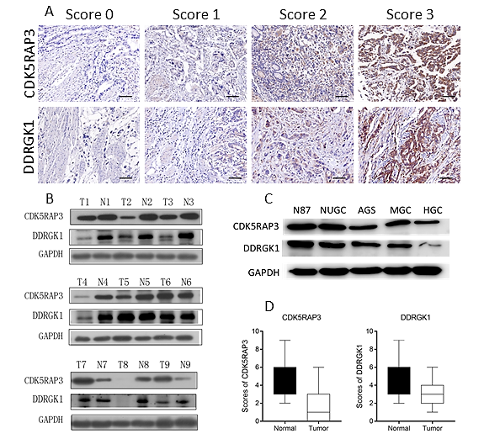
Figure 1 Expression levels of CDK5RAP3 and DDRGK1 in gastric cancer and adjacent non-tumor tissues. A: Immunohistochemical staining of CDK5RAP3 and DDRGK1 expression in gastric cancer tissue and the criteria for immunohistochemistry scores following the intensity of positive signals. Scale bar = 100 μm; B: Western blot of CDK5RAP3 and DDRGK1 in gastric cancer and adjacent non-tumor tissues in 9 patients; C: Western blot of CDK5RAP3 and DDRGK1 in 5 gastric cancer cells. D: CDK5RAP3 and DDRGK1 expression scores are shown as box plots, with the horizontal lines representing the median; the bottom and top of the boxes representing the 25th and 75th percentiles, respectively; and the vertical bars representing the range of data. The expression of CDK5RAP3 and DDRGK1 in gastric tumor tissues and respective adjacent non-tumor tissues was compared using the t-test. n = 135 (P < 0.001).

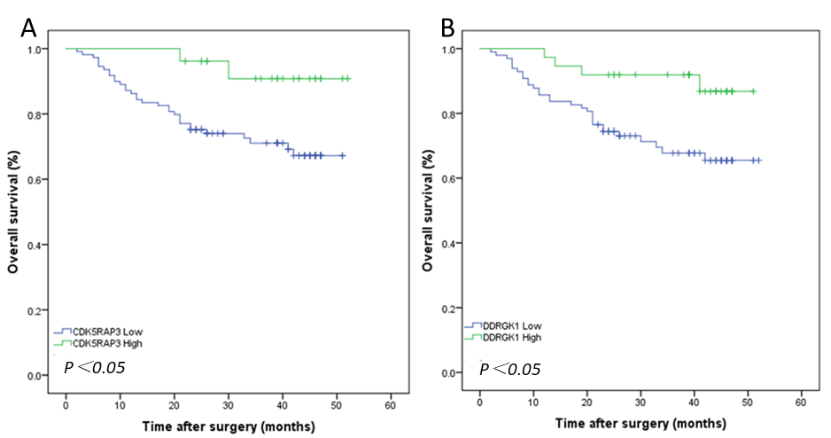
Figure 2 Kaplan–Meier analysis of the correlation between the expression of CDK5RAP3 and DDRGK1 and the overall survival of gastric cancer patients.

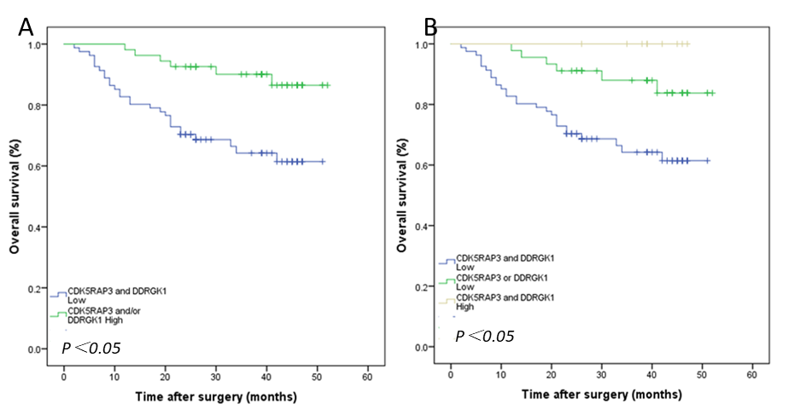
Figure 3 Kaplan–Meier analysis of the correlation between combined the expression of CDK5RAP3 and DDRGK1 with the overall survival of gastric cancer patients.

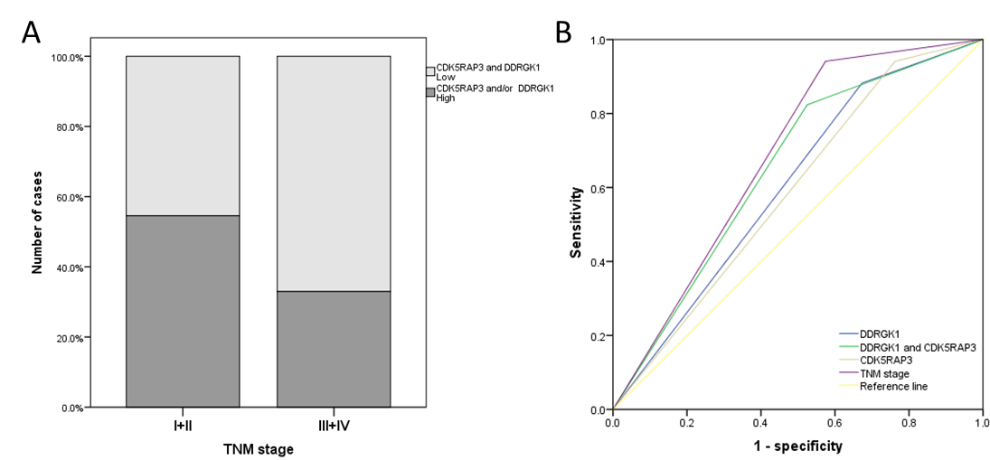
Figure 4 Receiver operating characteristic analysis of the sensitivity and specificity of the predictive value of DDRGK1 expression model, CDK5RAP3 expression model, the combined of CDK5RAP3 and DDRGK1 model and the TNM model. A: Co-expression of CDK5RAP3 and DDRGK1 were significant correlated with TNM stage. B: The area under the ROC curve was 0.649 (0.548–0.751) for the co-expression of CDK5RAP3 and DDRGK1 model, 0.598 (0.486–0.693) for the CDK5RAP3 expression model, 0.605 (0.501-0.708) for the DDRGK1 expression model, 0.659 (0.562-0.756) for the TNM model.

