Name of journal: World Journal of Orthopedics
ESPS Manuscript NO: 8281
Columns: TOPIC HIGHLIGHT

WJO 5th Anniversary Special Issues (6): Osteoporosis

Management bone loss of the proximal femur in revision hip arthroplasty: Update on reconstructive options

Sakellariou VI et al. Reconstructive options for proximal femoral defects

Vasileios I Sakellariou, George C Babis

Vasileios I Sakellariou, First Department of Orthopaedics, Medical School, University of Athens, ATTIKON University General Hospital, Chaidari 12462, Greece

George C Babis, Second Department of Orthopaedics, Medical School, University of Athens, Nea Ionia General Hospital, Athens 14233, Greece

Author contributions: Sakellariou VI and Babis GC solely contributed to this paper.

Correspondence to: George C Babis, MD, PhD, Professor and Chairman of Orthopaedics, Second Department of Orthopaedics, Medical School, University of Athens, Nea Ionia General Hospital, 3-5 Ag. Olgas Street, Athens 14233, Greece. george.babis@gmail.com

Telephone: +30-213-2057956 Fax: +30-213-2057783

Received: December 23, 2013 Revised: July 11, 2014
Accepted: July 18, 2014

Published online:

Abstract
The number of revision total hip arthroplasties is expected to rise as the indications for arthroplasty will expand due to the aging population. The prevalence of extensive proximal femoral bone loss is expected to increase subsequently. The etiology of bone loss from the proximal femur after total hip arthroplasty is multifactorial. Stress shielding, massive osteolysis, extensive loosening and multiple prior surgeries consist the most common etiologies. Reconstruction of extensive bone loss of the proximal femur during a revision hip arthroplasty is a major challenge for even the most experienced orthopaedic surgeon. The amount of femoral bone loss and the bone quality of the remaining metaphyseal and diaphyseal bone dictate the selection of appropriate reconstructive option. These include the use of impaction allografting, distal press-fit fixation, allograft-prosthesis composites and tumor megaprostheses. This review article is a concise review of the current literature and provides an algorithmic approach for reconstruction of different types of proximal femoral bone defects.

© 2014 Baishideng Publishing Group Inc. All rights reserved.

Key words: Arthroplasty; Proximal; Femur; Reconstruction; Bone loss

Core tip: Massive osteolysis, stress-shielding, periprosthetic infections or multiple revisions can consist the most common etiologies for extensive loss of bone stock of the proximal femur. The amount of femoral bone loss and the bone quality of the remaining metaphyseal and diaphyseal bone dictate the selection of appropriate reconstructive option. These include the use of impaction allografting, distal press-fit fixation, allograft-prosthesis composites and tumor megaprostheses. The present study is a concise review of the current literature presenting an algorithmic approach for reconstruction of different types of proximal femoral bone defects.

Sakellariou VI, Babis GC. Management bone loss of the proximal femur in revision hip arthroplasty: Update on reconstructive options. World J Orthop 2014; In press

INTRODUCTION
Approximately 250.000 primary and over 50.000 revision total hip arthroplasty procedures are performed in the United States each year^{[1]}. The number of revision total hip arthroplasties is expected to rise as the indications for arthroplasty will expand due to the aging population and the continuous advances in technology and surgical techniques^{[1,2]}. Massive osteolysis, stress-shielding, periprosthetic infections or multiple revisions can eventually lead to extensive loss of bone stock in the proximal femur^{[2,3]}. Additionaly, osteolysis due to loosening and wear and pre-existing osteoporosis may result to deficient femoral bone stock. Femoral bone loss as a result of failed total hip arthroplasty is a problem that continues to challenge orthopaedic surgeons. The aim of the present study is to provide an algorithmic approach for reconstruction of different types of proximal femoral bone defects through a concise review of the current literature.

CLASSIFICATION
Multiple systems have been used to classify the severity of bone loss of the proximal femur. Most of these classification systems are descriptive of the amount and the area of bone loss. Using a standardized approach the investigators try to accurately define the structural integrity of the metaphyseal and diaphyseal bone, suggesting the available options of implant fixation to the remaining host bone.
The classifications proposed by (1) the AAOS Committee on the Hip^{[4]} and (2) Della Valle and Paprosky^{[5]} are most commonly used to describe the amount of femoral bone loss and propose guidelines for treatment of each type of proximal femoral bone deficiency.
The AAOS classification divides the femoral bone defects into segmental and cavitary^{[4]}. Segmental defects include loss of supporting cortical bone, whereas the cavitary defects are defined as any bony loss of the cancellous medullary bone. Malalignment refers to any compromise of the femoral architecture and natural geometry resulting into angular or rotational deformities. Stenosis is the partial or complete occlusion of the femoral canal as a result of a previous trauma or hypertrophic bone reaction. Discontinuity refers to the loss of cortical continuity due to pre-existing fracture or established non-union.
The Paprosky classification^{[5]} of proximal femoral defects is used to assess the amount of bone loss and define the morphology of remaining proximal femoral bone stock; it also provides guidelines for treatment. Paprosky Type I defects are characterized by minimal metaphyseal cancellous bone loss with intact diaphysis. Type II defects have more extensive cancellous bone loss including the whole metaphysis down to the level of the lesser trochanter. In type IIIA defects, there is an extensive bone deficit of the proximal femur; the metaphyseal bone is non-supportive; however, there is adequate diaphyseal bone (intact circumferential bone more than 4 cm in length) for distal fixation of a cementless stem. In Type IIIB defects the available diaphyseal bone is less than 4 cm in length. Type IV femora have a widened diaphysis that provides no support for cementless fixation.

PREOPERATIVE PLANNING
Meticulous preoperative planning is of paramount importance before proceeding to a complex revision surgery that includes exchange of the femoral component. Preoperative planning is helpful in assessing the type of proximal femur defficiency, evaluating the radiographic leg length discrepancy and selecting the proper implant in terms of size, length and offset. Calibrated X-rays of the pelvis and the affected hip in 2 projections (anteroposterior and lateral) are required in order to better evaluate the amount of bone loss, classify the bony defect and select the optimal reconstructive option^{[6]}.
However, plain radiographs are not always sufficient to assess with accuracy the amount of bone loss and the quality of remaining bone. Computed tomography (CT) scans provide superior image quality and may processed and reconstructed into 3 dimensional projections that are extremely valuable for preoperative planning and implant selection.; However, metallic artifacts may limit the clarity of imaging especially in the presence of metal implants in the under-study area,. In complex cases, CT scan images with metallic artifact subtraction and three-dimensional reconstruction consist a useful tool for precise assessment of the amount of bone loss and the specific variations of the femoral anatomy preoperatively (Figure 1).
Magnetic resonance imaging (MRI) has gained popularity in assessing the integrity of soft tissue and especially of the abductor musculature in a painful THA. Especially, in the presence of metal-on-metal articulation identification of potential adverse reaction to metal debris is of significant importance. Metal artifact reduction (MARS) MRI appears to be the most useful tool for diagnosing, staging and monitoring these types of adverse reactions to metal debris^{[7]} (Figure 2).

RECONSTRUCTIVE OPTIONS
Revision of the femoral component and reconstruction of a femur with severe bone loss is a complex procedure. Improvements in prosthetic designs and implant materials have been associated with superior clinical outcomes and better implant survivorship.
The main objectives of femoral reconstruction during revision hip surgery are to preserve the remaining bone of the femur, as much as possible, and to provide a stable implant fixation. Restoration of hip function, joint stability and leg length equality are important goals of reconstructive procedure^{[3,5]}.
An algorithmic approach to restore the bone defect of the proximal femur based on previously published classification systems is presented in Table 1^{[4, 5]}.
According to Paprosky classification^{[5]}, Type I proximal femoral defects that are characterized by minimal metaphyseal cancellous bone loss with intact diaphysis may be easily reconstructed using cementless or cemented primary stems with common length and geometry (Figure 3). No additional mode of fixation (fully porous coating or distal fixation implants) is usually required.
In type II defects, with extensive metaphyseal bone loss and intact diaphysis, the reconstructive options are associated with the quality of metaphyseal bone. Modular stems with proximal fixation are preferred^{[8]}. This permits load transfer through the proximal metaphyseal bone more physiologically. However, when the medial cortex of the femoral neck is compromised a calcar replacement stem may be used in order to provide a more secure proximal fixation and accurately restore leg length. In a recent study, Emerson et al^{[9]} showed that calcar replacement stems with 40% porous-coating have excellent clinical outcome with a very low incidence of mechanical failure (3%). Ninety-four percent of these stems remain in-situ 11.5 years after implantation, which is a superior outcome comparing to most cemented femoral revision series^{[9]}.
In type IIIA defects, the cancellous bone of the proximal femoral metaphysis is defective; However, the femoral diaphysis is still intact and more than 4 cm of cortical bone is available for distal fixation. This type of femoral defects requires the use of cementless stems with distal (diaphyseal) fixation^{[10-12]}. Extensively porous coated stems (Figure 4) or modular stems (Figure 5), which are fluted distally and porous coated proximally, may be used to achieve adequate diaphyseal fixation^{[13,14]}. Under-sizing of the femoral component is the most frequently referred cause of failure that leads to implant subsidence and loss of mechanical support^{[13,14]}. Meticulous preparation of the femoral canal is of paramount importance in order to achieve optimal fit and fill of the stem to the femoral canal and secure fixation of the flutes into the cortical bone^{[13,14]}.
In the type IIIB femoral defects, less than 4cm of intact diaphysis is available for distal fixation. The use of extensively porous-coated stems have been associated with poor survivorship and therefore they are not recommended. The current literature includes a number of studies presenting cementless femoral revisions using extensively porous-coated stems. Lawrence et al^{[15]} showed that 5.7% of these stems failed and needed revision of the femoral implant 7.4 years post operatively. In another study, Weeden and Paprosky found that extensively porous-coated revision stems are associated with an incidence of aseptic loosening and mechanical failure of 4.1% after a 14.2 years postoperatively^{[14]}.
Impaction grafting of the defective femur and reconstruction using a cemented stem would be a favorable option for this setting^{[16-20]}. In a study of Lamberton at al., the technique of impaction allografting and use of cemented revision stem was presented^{[18]}. The authors included a cohort 540 revision arthroplasties and showed that the survival rate of impaction grafting is approximately when considering the aseptic loosening and revision for any reason as the endpoints is 98% and 84% respectively after a mean 10 years of follow-up. Dislocation (4.1%) and femoral fracture (5.4%) were shown to be the most common complications of this procedure. In another study, incorporating the data from the Sweedish registry, that included 1305 revisions of the femoral component and reconstruction using the impaction grafting technique found that the survival rate at 15 years postoperatively was very high approaching 94%^{[21]}. The effect of surface finish of the femoral components still remains debatable. Polished stems without collar and roughened stems with a collar have been both used. Studies from the current literature have failed to reveal any statistically significant difference on the clinical outcome and the survivorship of these arthroplasties^{[21]}. However, the technique of impaction grafting is challenging and time consuming. Specialized instrumentation and a large volume of cancellous bone allografts are required^{[21]}. Therefore, reconstruction with a modular cementless tapered fluted stem would be a viable alternative option.
Tapered fluted stems have been historically susceptible to subsidence and associated with high dislocation rates^{[22-25]}. Newer stem designs with modular configuration, which allow independent size selection of the proximal and distal segments, have been associated with lower rates of subsidence and improved restoration of limb length and femoral offset (Figure 6). Mechanical failure of the modular taper due to fretting corrosion has been reported^{[26]}. For this reason, several authors recommend the use of some kind of additional structural support to the proximal body of the prosthesis by using allografts or by wraping the remaining host bone around the proximal segment of the modular stem^{[27]}. A recent retrospective multicenter study that included a series of 143 hips reconstructed with the same modular fluted tapered stem, found that the mean survivorship of these stems reaches 97% at an average 40 mo follow-up while the mean subsidence was 2.1-mm^{[10]}. These components may be combined with various types of single or multiple femoral osteotomies (i.e., sish-kebab technique); multiple osteotomies allow for restoration of the anatomical axis of the femur, an easier access of the distal segment of the modular stem, thus reducing the risk of femoral fracture or perforation of the cortex^{[28]} (Figure 7) .
Type IV femoral defects are the most challenging subtype because there is no intact isthmus to provide adequate distal fixation of the component. For this reason, the treatment options include reconstruction of the femoral canal with impaction grafting and insertion of a cemented stem or using a tumor megaprosthesis to replace the defective proximal femur^{[3,29-33]}.
The use of allograft prosthetic composite (i.e., combination of a cemented long stem and a bulk allograft of the proximal femur) that is attached to the host bone distally is another reconstructive option^{[3,29-33]}. This technique has attracted interest because it may potentially preserve the existing bone stock and establish a good bony foundation for future revisions, especially in younger patients. The allograft offers mechanical properties similar to the patient’s own bone and allows reconstruction of sizeable deficits. This may be considered as a biologic reconstructive option; except for the preservation of bone stock, the use of a structural allograft may allow for reattachment of the hip abductors in an effort to preserve hip function and gait^{[3,29-33]}.
The technique of reconstruction of large defects of the proximal femur using an allograft-prosthesis composite is very demanding. An appropriately sized allograft is osteotomized at the desired subtrochanteric level in order to match the bony defect of the proximal femur. Next, the allograft is reamed and broached and a long stem is cemented at the back table (Figure 8). Then, the allograft-prosthesis composite is implanted to the native femur with the use of cement or not, depending on the selected type of implant and the quality of host bone (Figure 9). Although the issue of proximal cementing of the stem into the proximal femoral allograft is well documented by Haddad et al^{[34, 35]} and Gross et al^{[36]} showing that there is a high failure rate in cases of cementless fixation, there is no such a reconciliation regarding distal fixation into the host bone. In a recently published study, we have found that there is no statistically significant difference between cemented and cementless fixation regarding implant survivorship. Gross et al^{[36]} however have shown cementing the allograft-prosthesis composite distally into the host bone should probably be avoided because it might compromise the distal femur during future revision.
Size matching of the allograft to the host bone may be problematic, and has been addressed by the use of additional cortical struts and circumferential cables or wires. Intussusception of the allograft bone into the host bone has also been reported in cases of significant allograft-host canal mismatch^{[3,31]}. When rigidly fixed, strut grafts may also provide an extensive surface area of contact with the host bone for supplemental union and incorporation^{[37]}. Several techniques have been utilized in order to improve the rotational stability of the whole construct, including different types of osteotomies (oblique, step-cut, lateral sleeve) or stabilization with the use of additional hardware (plates and screws, plates and cables, strut grafts and cables).
While the published results of APC technique have been encouraging, they have generally involved relatively short-term follow-up. However, interpretation of many clinical studies is problematic because they use different (or no) classifications for proximal bone loss and utilize different surgical techniques of allograft fixation. The reported survival rates of APC reconstruction vary in the current literature, ranging from 72 to 90 percent at five years and 64 to 86 percent at ten years^{[35,38-41]}. We have recently published a study with probably the longest clinical follow-up showing a survival rate that reaches 92.7 percent at two years 78.2 percent at five years, and 69 percent at ten years^{[3]}.
Allograft resorption has been reported as the major concern, which has been occasionally associated with early failures and could be a significantly greater problem at a longer follow-up^{[41,42]}. Immunological matching between allograft and host femora, condition of the soft tissues attachments and vascularity of the host bed are other parameters that may affect incorporation of the allograft and could be related to the survivorship of the APC reconstructions^{[33,41,42]}.
Resorption of the allograft is a potential complication. Resorption is usually found at the periosteal surface of the allograft^{[38,43,44]}. A possible explanation is that the cement on the endosteal surface inhibits access by host granulation tissue^{[38,43,44]}. Contrarily, on the periosteal surface there is access to host tissue and, therefore, neo-vascularization may lead to bone resorption^{[38,43,44]}. By using strong cortical allograft bone, this process is expected to be evident at a later stage, and therefore composite graft-cement-implant reconstructions should last for an adequate period of time. Gross et al^{[45]} reviewed 168 proximal femoral allografts reporting only one significant and six minor resorptions at an average follow up of 4.8 years. In another study, Masri et al^{[46]} found four mild and ten severe resorptions in thirty-nine cases at mean 5.1 years postoperatively. Haddad et al^{[41]} used cementing technique to both proximal and distal femur in forty femoral revisions and found nine cases with mild resorption, four with moderate, and seven with severe resorption, which resulted in an overall 50 percent resorption rate at 8.8 years. Backley et al^{[38]} opted to wrap the remnants of the proximal femur around the allograft; the authors found twelve mild to moderate and only one severe resorption in forty-eight allograft-prosthesis composites eleven years post revision surgery. Safir et al^{[47]} conducted a study with a minimum 15 year-follow-up, and showed that minor resorption was radiographically evident in 93 hips resulting in an overall resorption rate of 58 percent.
The literature shows a large variety of complications and a wide range of complication rates associated with proximal femur reconstructions using APCs. Hip dislocations, allograft-host bone junction non-unions, postoperative infections, periprosthetic fractures and aseptic loosening of the femoral components are the most significant complications. The incidence of these complications is quite variable: Hip dislocation is seen in 3.1 to 54 percent of cases, nonunion of the allograft host bone junction in 4.7 to 20 percent, trochanteric non union in 25 to 27 percent, postoperative infection in 3.3 to 8 percent, periprosthetic fracture in 2 to 5 percent, and aseptic loosening in 1 to 12 percent[3,29,30,32,33,35,36,38,41,45,48].
Proximal femur replacement using the so-called “mega-prostheses” is an alternative option in cases of severe proximal femoral bone loss^{[49,50]} (Figure 10). These implants are primarily designed for reconstruction of large bony defects after tumour resection, but they have also been utilized to replace the deficient proximal femur during hip revision surgery. In general, our philosophy is to use proximal femoral replacement implants in older, less active patients. The Mayo experience with proximal femoral replacement prostheses^{[50]} showed survivorship of the femoral component, with revision as the endpoint, of 81 per cent at eleven years. However, the improvement in function was not statistically significant. Deficiency of the abductor mechanism or inability to secure the abductor mechanism to the metal surface of the implant is a major concern associated with the use of megaprostheses^{[37]}. New prosthetic designs offer several options for re-attachment of the abductors. However, insufficiency of their function is associated with high dislocation rates, which still remains the major drawback of this type of reconstruction. Nonetheless, current proximal femur replacement may be best suited for the elderly and inactive patients for whom resection arthroplasty would probably be the only alternative^{[49,50]}.

CONCLUSION
Reconstruction of the proximal femur during revision surgery is a challenging procedure. The remaining supportive bone of the metaphyseal and diaphyseal segments of the femur is the main contributing factors to determine the selection of the appropriate reconstructive option during revision surgery. Planning ahead is always essential to assure that multiple reconstructive techniques will be available at the time of surgery.
With regards to reconstruction of massive proximal femoral bone defects allograft-implant composites consist a more biologic reconstructive technique. This is a very demanding and challenging procedure that requires meticulous preoperative planning; it is time-consuming and potential intraoperative modifications may be needed. Ten-year survival rates reach 70%. Considering the complexity of these cases, the reported clinical and radiographic outcome of APCs is satisfactory. A stable allograft-host junction is essential for success. Allograft-host femoral canal mismatch can be managed with the intussusception technique, which is a good alternative over standard step-cut osteotomies. Distal fixation can be achieved using either cemented or cementless stems without compromising total survivorship. Proximal femur replacement consists a viable alternative that is best suited for elderly and inactive patients.

REFERENCES
1 Kurtz S, Mowat F, Ong K, Chan N, Lau E, Halpern M. Prevalence of primary and revision total hip and knee arthroplasty in the United States from 1990 through 2002. J Bone Joint Surg Am 2005; 87: 1487-1497 [PMID: 15995115 DOI: 10.2106/JBJS.D.02441]
2 Lohmander LS, Engesaeter LB, Herberts P, Ingvarsson T, Lucht U, Puolakka TJ. Standardized incidence rates of total hip replacement for primary hip osteoarthritis in the 5 Nordic countries: similarities and differences. Acta Orthop 2006; 77: 733-740 [PMID: 17068703 DOI: 10.1080/17453670610012917]
3 Babis GC, Sakellariou VI, O'Connor MI, Hanssen AD, Sim FH. Proximal femoral allograft-prosthesis composites in revision hip replacement: a 12-year follow-up study. J Bone Joint Surg Br 2010; 92: 349-355 [PMID: 20190304 DOI: 10.1302/0301-620X.92B3.23112]
4 D'Antonio J, McCarthy JC, Bargar WL, Borden LS, Cappelo WN, Collis DK, Steinberg ME, Wedge JH. Classification of femoral abnormalities in total hip arthroplasty. Clin Orthop Relat Res 1993; (296): 133-139 [PMID: 8222415]
5 Valle CJ, Paprosky WG. Classification and an algorithmic approach to the reconstruction of femoral deficiency in revision total hip arthroplasty. J Bone Joint Surg Am 2003; 85-A Suppl 4: 1-6 [PMID: 14652388]
6 Saleh KJ, Holtzman J, Gafni A, Saleh L, Davis A, Resig S, Gross AE. Reliability and intraoperative validity of preoperative assessment of standardized plain radiographs in predicting bone loss at revision hip surgery. J Bone Joint Surg Am 2001; 83-A: 1040-1046 [PMID: 11451973]
7 Toms AP, Smith-Bateman C, Malcolm PN, Cahir J, Graves M. Optimization of metal artefact reduction (MAR) sequences for MRI of total hip prostheses. Clin Radiol 2010; 65: 447-452 [PMID: 20451011 DOI: 10.1016/j.crad.2009.12.014]
8 Cameron HU. The long-term success of modular proximal fixation stems in revision total hip arthroplasty. J Arthroplasty 2002; 17: 138-141 [PMID: 12068425 DOI: 10.1054/arth.2002.32462]
9 Emerson RH, Head WC, Higgins LL. Clinical and radiographic analysis of the Mallory-Head femoral component in revision total hip arthroplasty. A minimum 8.8-year and average eleven-year follow-up study. J Bone Joint Surg Am 2003; 85-A: 1921-1926 [PMID: 14563799]
10 Kwong LM, Miller AJ, Lubinus P. A modular distal fixation option for proximal bone loss in revision total hip arthroplasty: a 2- to 6-year follow-up study. J Arthroplasty 2003; 18: 94-97 [PMID: 12730939 DOI: 10.1054/arth.2003.50083]
11 McCarthy JC, Lee JA. Complex revision total hip arthroplasty with modular stems at a mean of 14 years. Clin Orthop Relat Res 2007; 465: 166-169 [PMID: 17891035]
12 Paprosky WG, Aribindi R. Hip replacement: treatment of femoral bone loss using distal bypass fixation. Instr Course Lect 2000; 49: 119-130 [PMID: 10829168]
13 Paprosky WG, Greidanus NV, Antoniou J. Minimum 10-year-results of extensively porous-coated stems in revision hip arthroplasty. Clin Orthop Relat Res 1999; (369): 230-242 [PMID: 10611878 DOI: 10.1097/00003086-199912000-00024]
14 Weeden SH, Paprosky WG. Minimal 11-year follow-up of extensively porous-coated stems in femoral revision total hip arthroplasty. J Arthroplasty 2002; 17: 134-137 [PMID: 12068424 DOI: 10.1054/arth.2002.32461]
15 Lawrence JM, Engh CA, Macalino GE, Lauro GR. Outcome of revision hip arthroplasty done without cement. J Bone Joint Surg Am 1994; 76: 965-973 [PMID: 8027124]
16 Duncan CP, Masterson EL, Masri BA. Impaction allografting with cement for the management of femoral bone loss. Orthop Clin North Am 1998; 29: 297-305 [PMID: 9553574 DOI: 10.1016/S0030-5898(05)70327-8]
17 Halliday BR, English HW, Timperley AJ, Gie GA, Ling RS. Femoral impaction grafting with cement in revision total hip replacement. Evolution of the technique and results. J Bone Joint Surg Br 2003; 85: 809-817 [PMID: 12931796]
18 Lamberton TD, Kenny PJ, Whitehouse SL, Timperley AJ, Gie GA. Femoral impaction grafting in revision total hip arthroplasty: a follow-up of 540 hips. J Arthroplasty 2011; 26: 1154-1160 [PMID: 21570802 DOI: 10.1016/j.arth.2011.03.028]
19 Morgan HD, Leopold SS. Impaction allografting of the femur in revision total hip surgery. Am J Orthop (Belle Mead NJ) 2004; 33: 381-383 [PMID: 15379231]
20 Morgan HD, McCallister W, Cho MS, Casnellie MT, Leopold SS. Impaction allografting for femoral component revision: clinical update. Clin Orthop Relat Res 2004; (420): 160-168 [PMID: 15057092 DOI: 10.1097/00003086-200403000-00022]
21 Ornstein E, Linder L, Ranstam J, Lewold S, Eisler T, Torper M. Femoral impaction bone grafting with the Exeter stem - the Swedish experience: survivorship analysis of 1305 revisions performed between 1989 and 2002. J Bone Joint Surg Br 2009; 91: 441-446 [PMID: 19336801 DOI: 10.1302/0301-620X.91B4.21319]
22 Regis D, Sandri A, Bonetti I. Long-term results of femoral revision with the Wagner Self-Locking stem. Surg Technol Int 2013; 23: 243-250 [PMID: 24081844]
23 Van Houwelingen AP, Duncan CP, Masri BA, Greidanus NV, Garbuz DS. High survival of modular tapered stems for proximal femoral bone defects at 5 to 10 years followup. Clin Orthop Relat Res 2013; 471: 454-462 [PMID: 22948527 DOI: 10.1007/s11999-012-2552-8]
24 Rodriguez JA, Deshmukh AJ, Klauser WU, Rasquinha VJ, Lubinus P, Ranawat CS. Patterns of osseointegration and remodeling in femoral revision with bone loss using modular, tapered, fluted, titanium stems. J Arthroplasty 2011; 26: 1409-17.e1 [PMID: 21855273 DOI: 10.1016/j.arth.2011.06.021]
25 McInnis DP, Horne G, Devane PA. Femoral revision with a fluted, tapered, modular stem seventy patients followed for a mean of 3.9 years. J Arthroplasty 2006; 21: 372-380 [PMID: 16627145 DOI: 10.1016/j.arth.2005.08.022]
26 Kop AM, Keogh C, Swarts E. Proximal component modularity in THA--at what cost? An implant retrieval study. Clin Orthop Relat Res 2012; 470: 1885-1894 [PMID: 22048865 DOI: 10.1007/s11999-011-2155-9]
27 Pluhar GE, Heiner JP, Manley PA, Bogdanske JJ, Vanderby R, Markel MD. Comparison of three methods of gluteal muscle attachment to an allograft/endoprosthetic composite in a canine model. J Orthop Res 2000; 18: 56-63 [PMID: 10716279]
28 Dallari D, Pignatti G, Stagni C, Giavaresi G, Del Piccolo N, Rani N, Veronesi F, Fini M. Total hip arthroplasty with shortening osteotomy in congenital major hip dislocation sequelae. Orthopedics 2011; 34: e328-e333 [PMID: 21815571]
29 Donati D, Giacomini S, Gozzi E, Mercuri M. Proximal femur reconstruction by an allograft prosthesis composite. Clin Orthop Relat Res 2002; (394): 192-200 [PMID: 11795733 DOI: 10.1097/00003086-200201000-00023]
30 Farid Y, Lin PP, Lewis VO, Yasko AW. Endoprosthetic and allograft-prosthetic composite reconstruction of the proximal femur for bone neoplasms. Clin Orthop Relat Res 2006; 442: 223-229 [PMID: 16394765 DOI: 10.1097/01.blo.0000181491.39048.fe]
31 Lee SH, Ahn YJ, Chung SJ, Kim BK, Hwang JH. The use of allograft prosthesis composite for extensive proximal femoral bone deficiencies: a 2- to 9.8-year follow-up study. J Arthroplasty 2009; 24: 1241-1248 [PMID: 19646843 DOI: 10.1016/j.arth.2009.06.006]
32 Roque PJ, Mankin HJ, Malchau H. Proximal femoral allograft: prognostic indicators. J Arthroplasty 2010; 25: 1028-1033 [PMID: 19879727 DOI: 10.1016/j.arth.2009.07.018]
33 Wang JW, Wang CJ. Proximal femoral allografts for bone deficiencies in revision hip arthroplasty: a medium-term follow-up study. J Arthroplasty 2004; 19: 845-852 [PMID: 15483799 DOI: 10.1016/j.arth.2004.02.035]
34 Haddad FS, Garbuz DS, Masri BA, Duncan CP, Hutchison CR, Gross AE. Femoral bone loss in patients managed with revision hip replacement: results of circumferential allograft replacement. Instr Course Lect 2000; 49: 147-162 [PMID: 10829171]
35 Haddad FS, Spangehl MJ, Masri BA, Garbuz DS, Duncan CP. Circumferential allograft replacement of the proximal femur. A critical analysis. Clin Orthop Relat Res 2000; (371): 98-107 [PMID: 10693554 DOI: 10.1097/00003086-200002000-00011]
36 Gross AE, Hutchison CR. Proximal femoral allografts for reconstruction of bone stock in revision hip arthroplasty. Orthopedics 1998; 21: 999-1001 [PMID: 9769045]
37 Crawford SA, Siney PD, Wroblewski BM. Revision of failed total hip arthroplasty with a proximal femoral modular cemented stem. J Bone Joint Surg Br 2000; 82: 684-688 [PMID: 10963166 DOI: 10.1302/0301-620X.82B5.10685]
38 Blackley HR, Davis AM, Hutchison CR, Gross AE. Proximal femoral allografts for reconstruction of bone stock in revision arthroplasty of the hip. A nine to fifteen-year follow-up. J Bone Joint Surg Am 2001; 83-A: 346-354 [PMID: 11263637]
39 Head WC, Berklacich FM, Malinin TI, Emerson RH. Proximal femoral allografts in revision total hip arthroplasty. Clin Orthop Relat Res 1987; (225): 22-36 [PMID: 3315377]
40 Zmolek JC, Dorr LD. Revision total hip arthroplasty. The use of solid allograft. J Arthroplasty 1993; 8: 361-370 [PMID: 8409987 DOI: 10.1016/S0883-5403(06)80034-3]
41 Haddad FS, Garbuz DS, Masri BA, Duncan CP. Structural proximal femoral allografts for failed total hip replacements: a minimum review of five years. J Bone Joint Surg Br 2000; 82: 830-836 [PMID: 10990306 DOI: 10.1302/0301-620X.82B6.10485]
42 Chandler H, Clark J, Murphy S, McCarthy J, Penenberg B, Danylchuk K, Roehr B. Reconstruction of major segmental loss of the proximal femur in revision total hip arthroplasty. Clin Orthop Relat Res 1994; (298): 67-74 [PMID: 8118997]
43 Roos BD, Roos MV, Camisa A. Circumferential proximal femoral allografts in revision hip arthroplasty: four to 20 years follow-up. Hip Int 2013; 23: 66-71 [PMID: 23423656]
44 Sporer SM, Paprosky WG. Femoral fixation in the face of considerable bone loss: the use of modular stems. Clin Orthop Relat Res 2004; (429): 227-231 [PMID: 15577492 DOI: 10.1097/01.blo.0000150120.80409.0d]
45 Gross AE, Hutchison CR. Proximal femoral allografts for reconstruction of bone stock in revision arthroplasty of the hip. Orthop Clin North Am 1998; 29: 313-317 [PMID: 9553576 DOI: 10.1016/S0030-5898(05)70329-1]
46 Masri BA, Masterson EL, Duncan CP. The classification and radiographic evaluation of bone loss in revision hip arthroplasty. Orthop Clin North Am 1998; 29: 219-227 [PMID: 9553567 DOI: 10.1016/S0030-5898(05)70320-5]
47 Safir O, Kellett CF, Flint M, Backstein D, Gross AE. Revision of the deficient proximal femur with a proximal femoral allograft. Clin Orthop Relat Res 2009; 467: 206-212 [PMID: 18972178 DOI: 10.1007/s11999-008-0573-0]
48 Biau DJ, Larousserie F, Thévenin F, Piperno-Neumann S, Anract P. Results of 32 allograft-prosthesis composite reconstructions of the proximal femur. Clin Orthop Relat Res 2010; 468: 834-845 [PMID: 19851817 DOI: 10.1007/s11999-009-1132-z]
49 Parvizi J, Sim FH. Proximal femoral replacements with megaprostheses. Clin Orthop Relat Res 2004; (420): 169-175 [PMID: 15057093 DOI: 10.1097/00003086-200403000-00023]
50 Parvizi J, Tarity TD, Slenker N, Wade F, Trappler R, Hozack WJ, Sim FH. Proximal femoral replacement in patients with non-neoplastic conditions. J Bone Joint Surg Am 2007; 89: 1036-1043 [PMID: 17473141 DOI: 10.2106/JBJS.F.00241]

P-Reviewer: Cartmell S, Emara KM, Maheshwari AV, Vilaboa N
S-Editor: Song XX L-Editor: E-Editor:

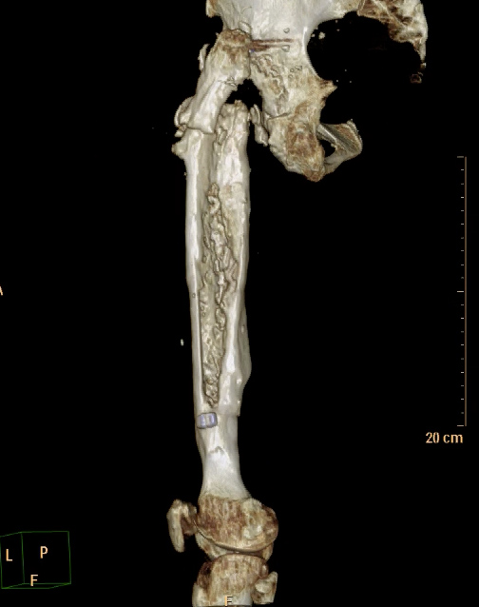
A

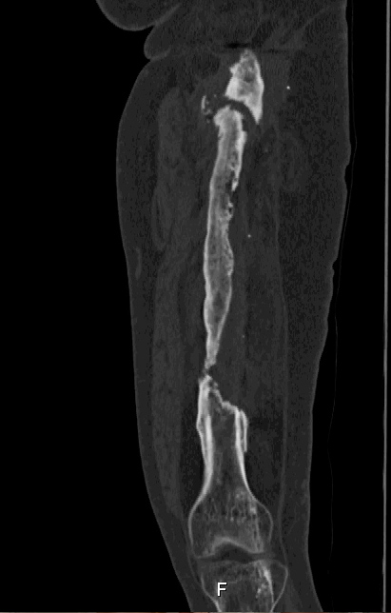
B

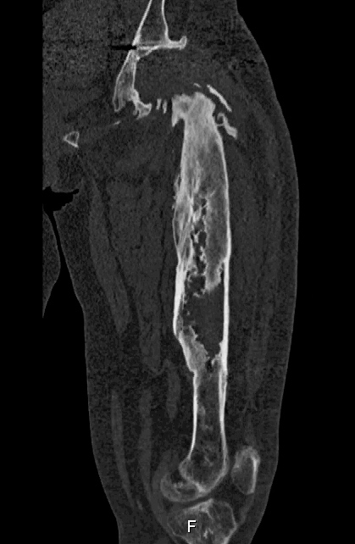
C
Figure 1 CT scan images with metallic artifact subtraction and three-dimensional reconstruction consist a useful tool for precise assessment of the amount of bone loss and the specific variations of the femoral anatomy preoperatively. A: CT scan image of the left femur (posterior projection) with metallic artifact subtraction and three-dimensional reconstruction showing precisely the amount of bone loss of the proximal part of the femur; B: Coronal; C: Sagittal view of the same case.

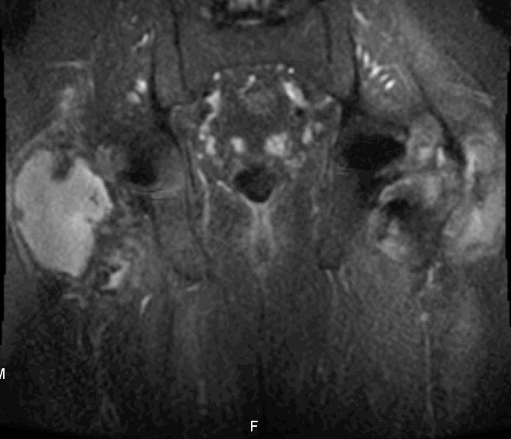
Figure 2 Metal artifact reduction magnetic resonance imaging (coronal view) showing the adverse reactions to metal debris and formation of pseudocapsules in both hips following bilateral total hip arthroplasties with modular necks.

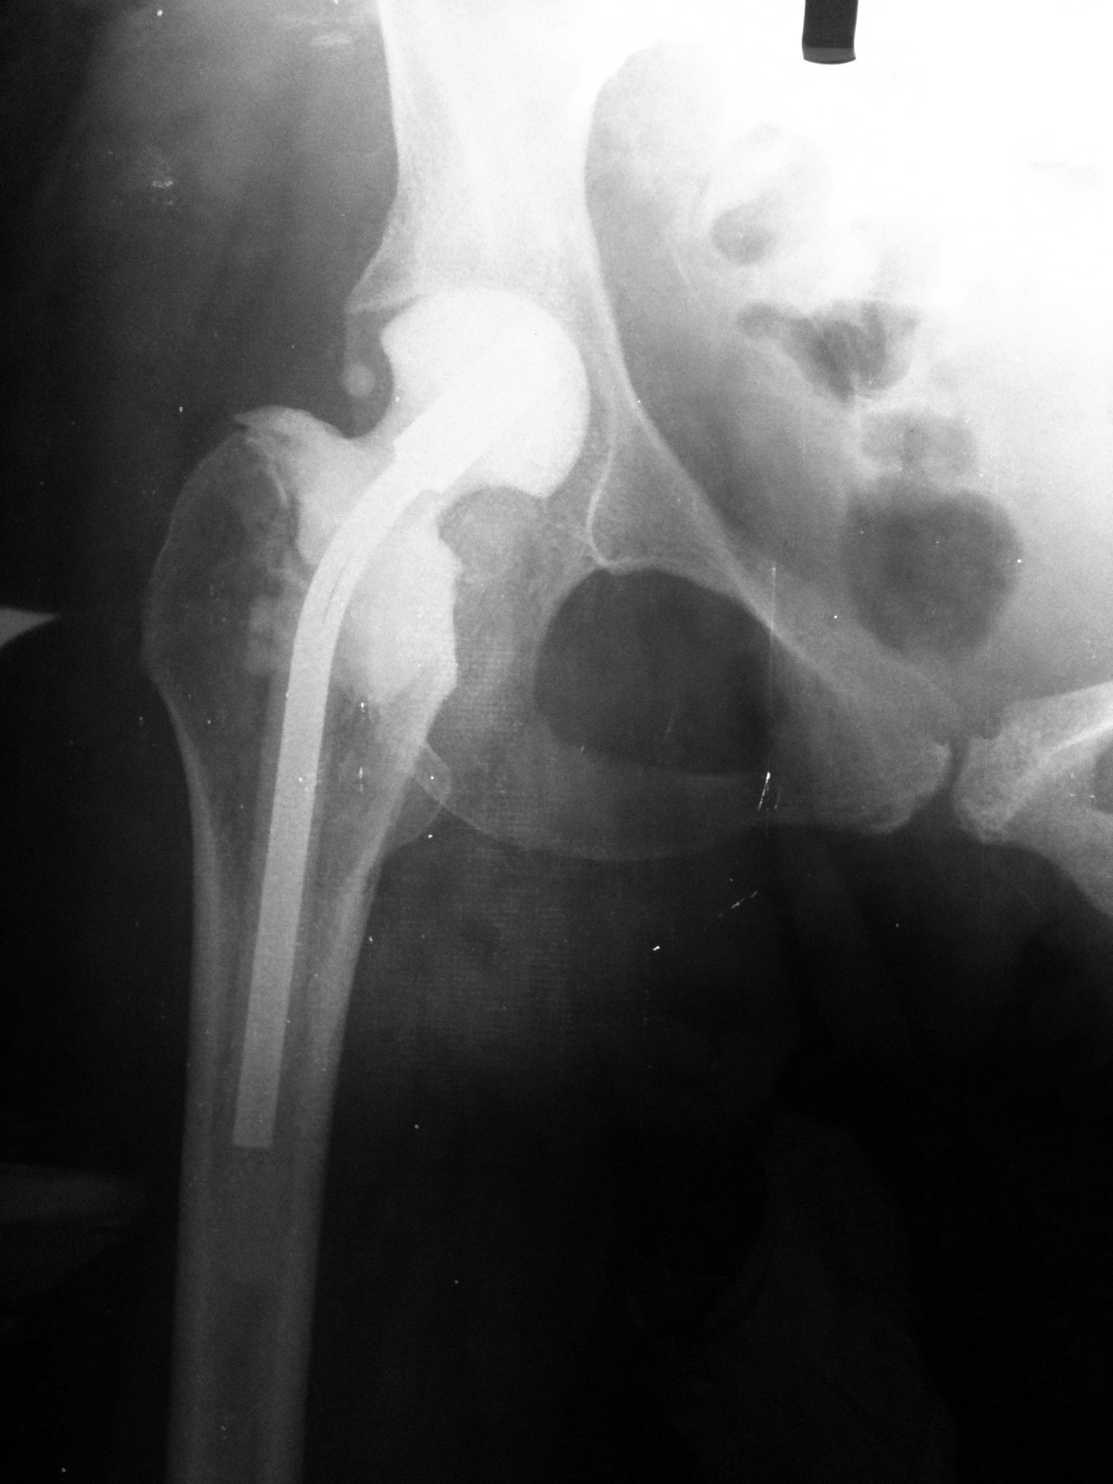
A

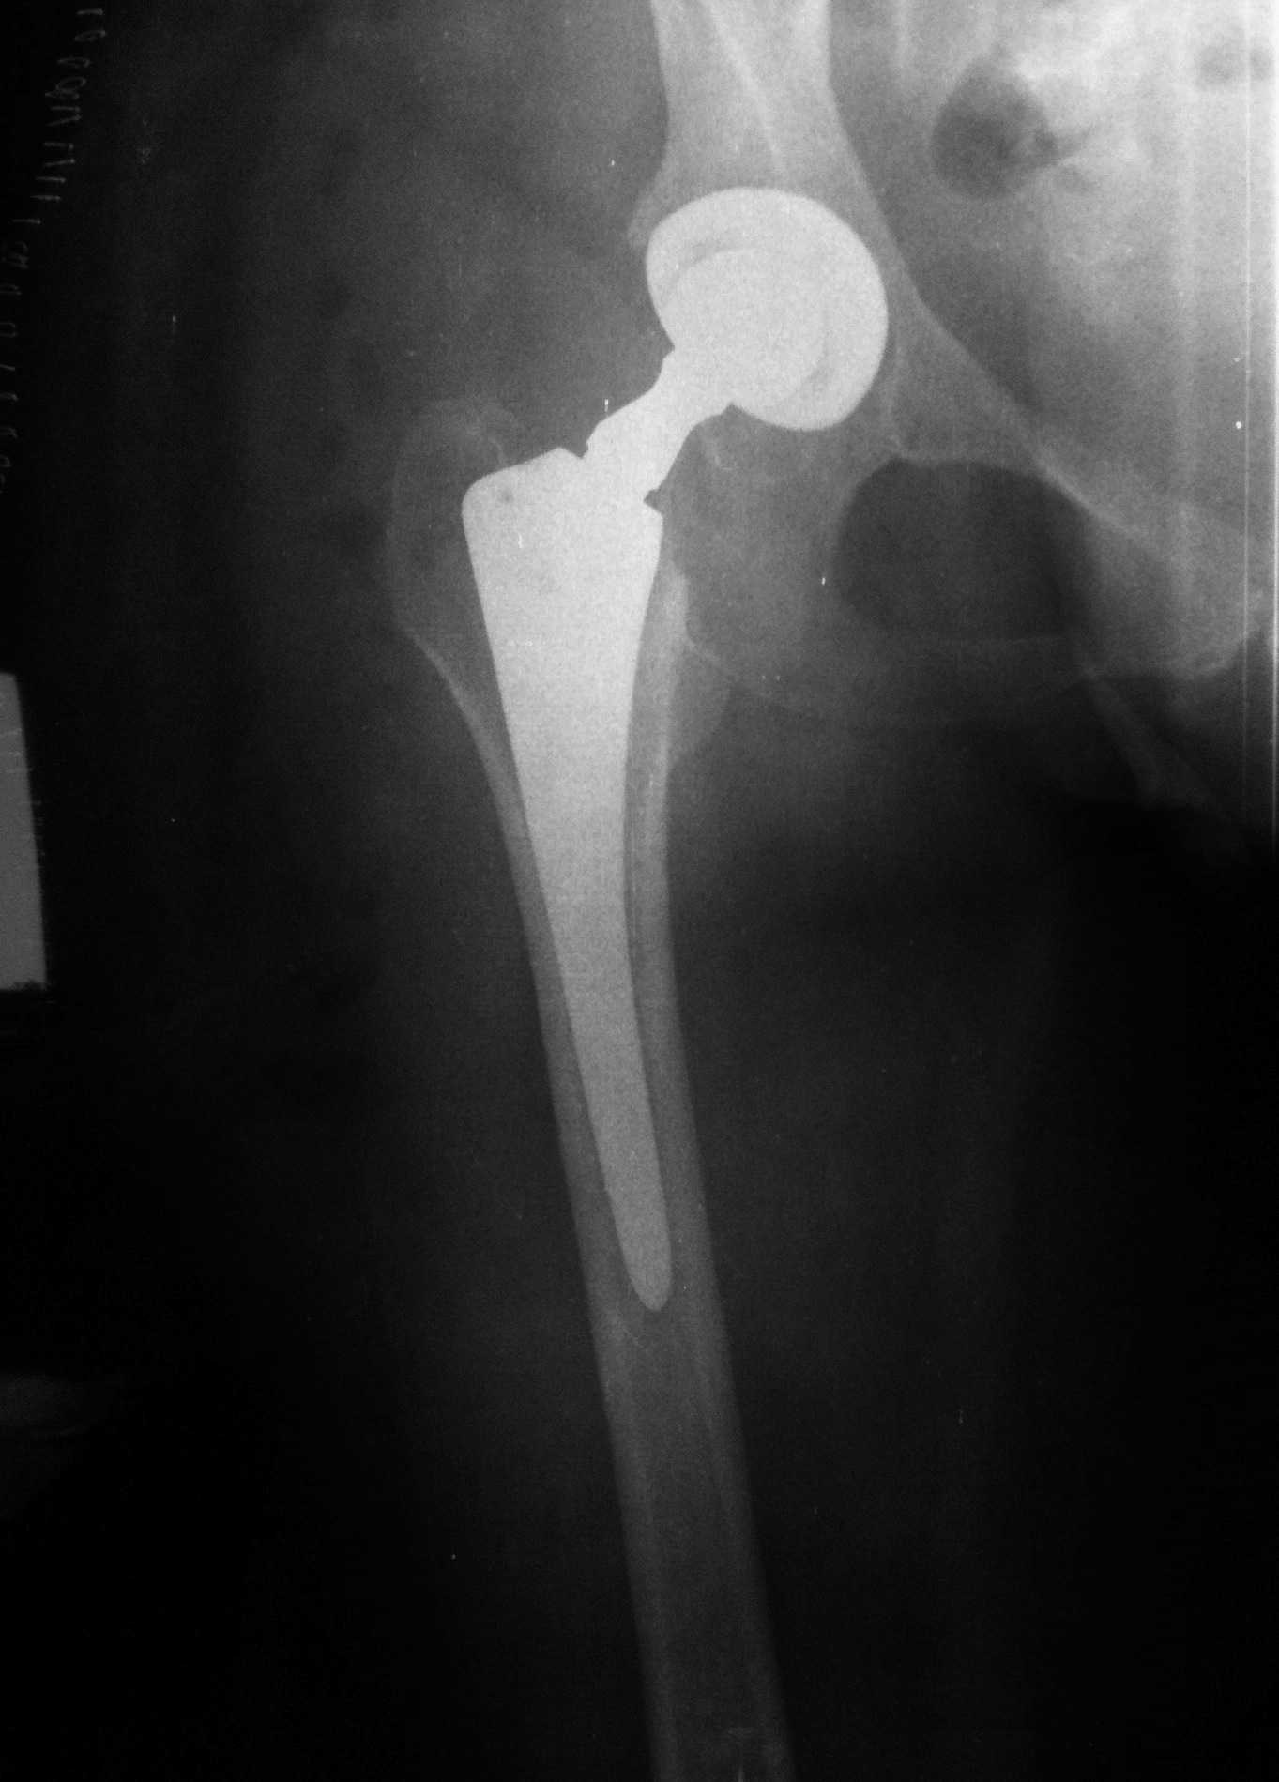
B
Figure 3 Anteroposterior radiograph of bone loss. A: Anteroposterior (AP) radiograph of the right hip showing minimal bone loss of the proximal metaphyseal bone secondary to periprosthetic hip infection. A antibiotic cement spacer was implanted after irrigation and debridement during the first stage of a two-stage exchange arthroplasty; B: AP radiograph of the same hip after the second stage. The metaphyseal bone loss was minimal and a cementless primary stems with common length and geometry was used.

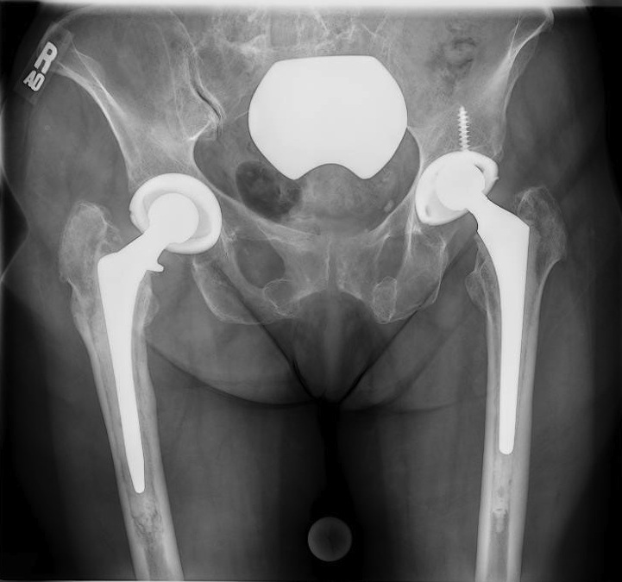
A

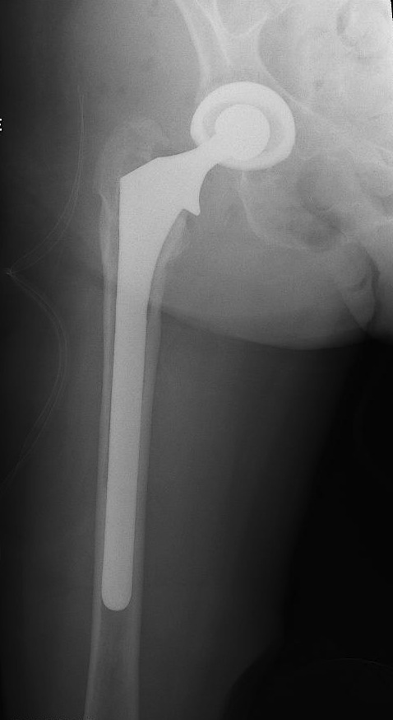
B
Figure 4 Extensively porous coated stems. A: Anteroposterior (AP) radiograph of the pelvis demonstrating bilateral total hip arthroplasties. In right hip there is evident loosening of the femoral stem and extensive metaphyseal cancellous bone loss with some diaphyseal bone loss, which is limited to less than 4 cm of diaphyseal bone; B: AP radiograph of the same hip post revision using an extensively porous coated stem.

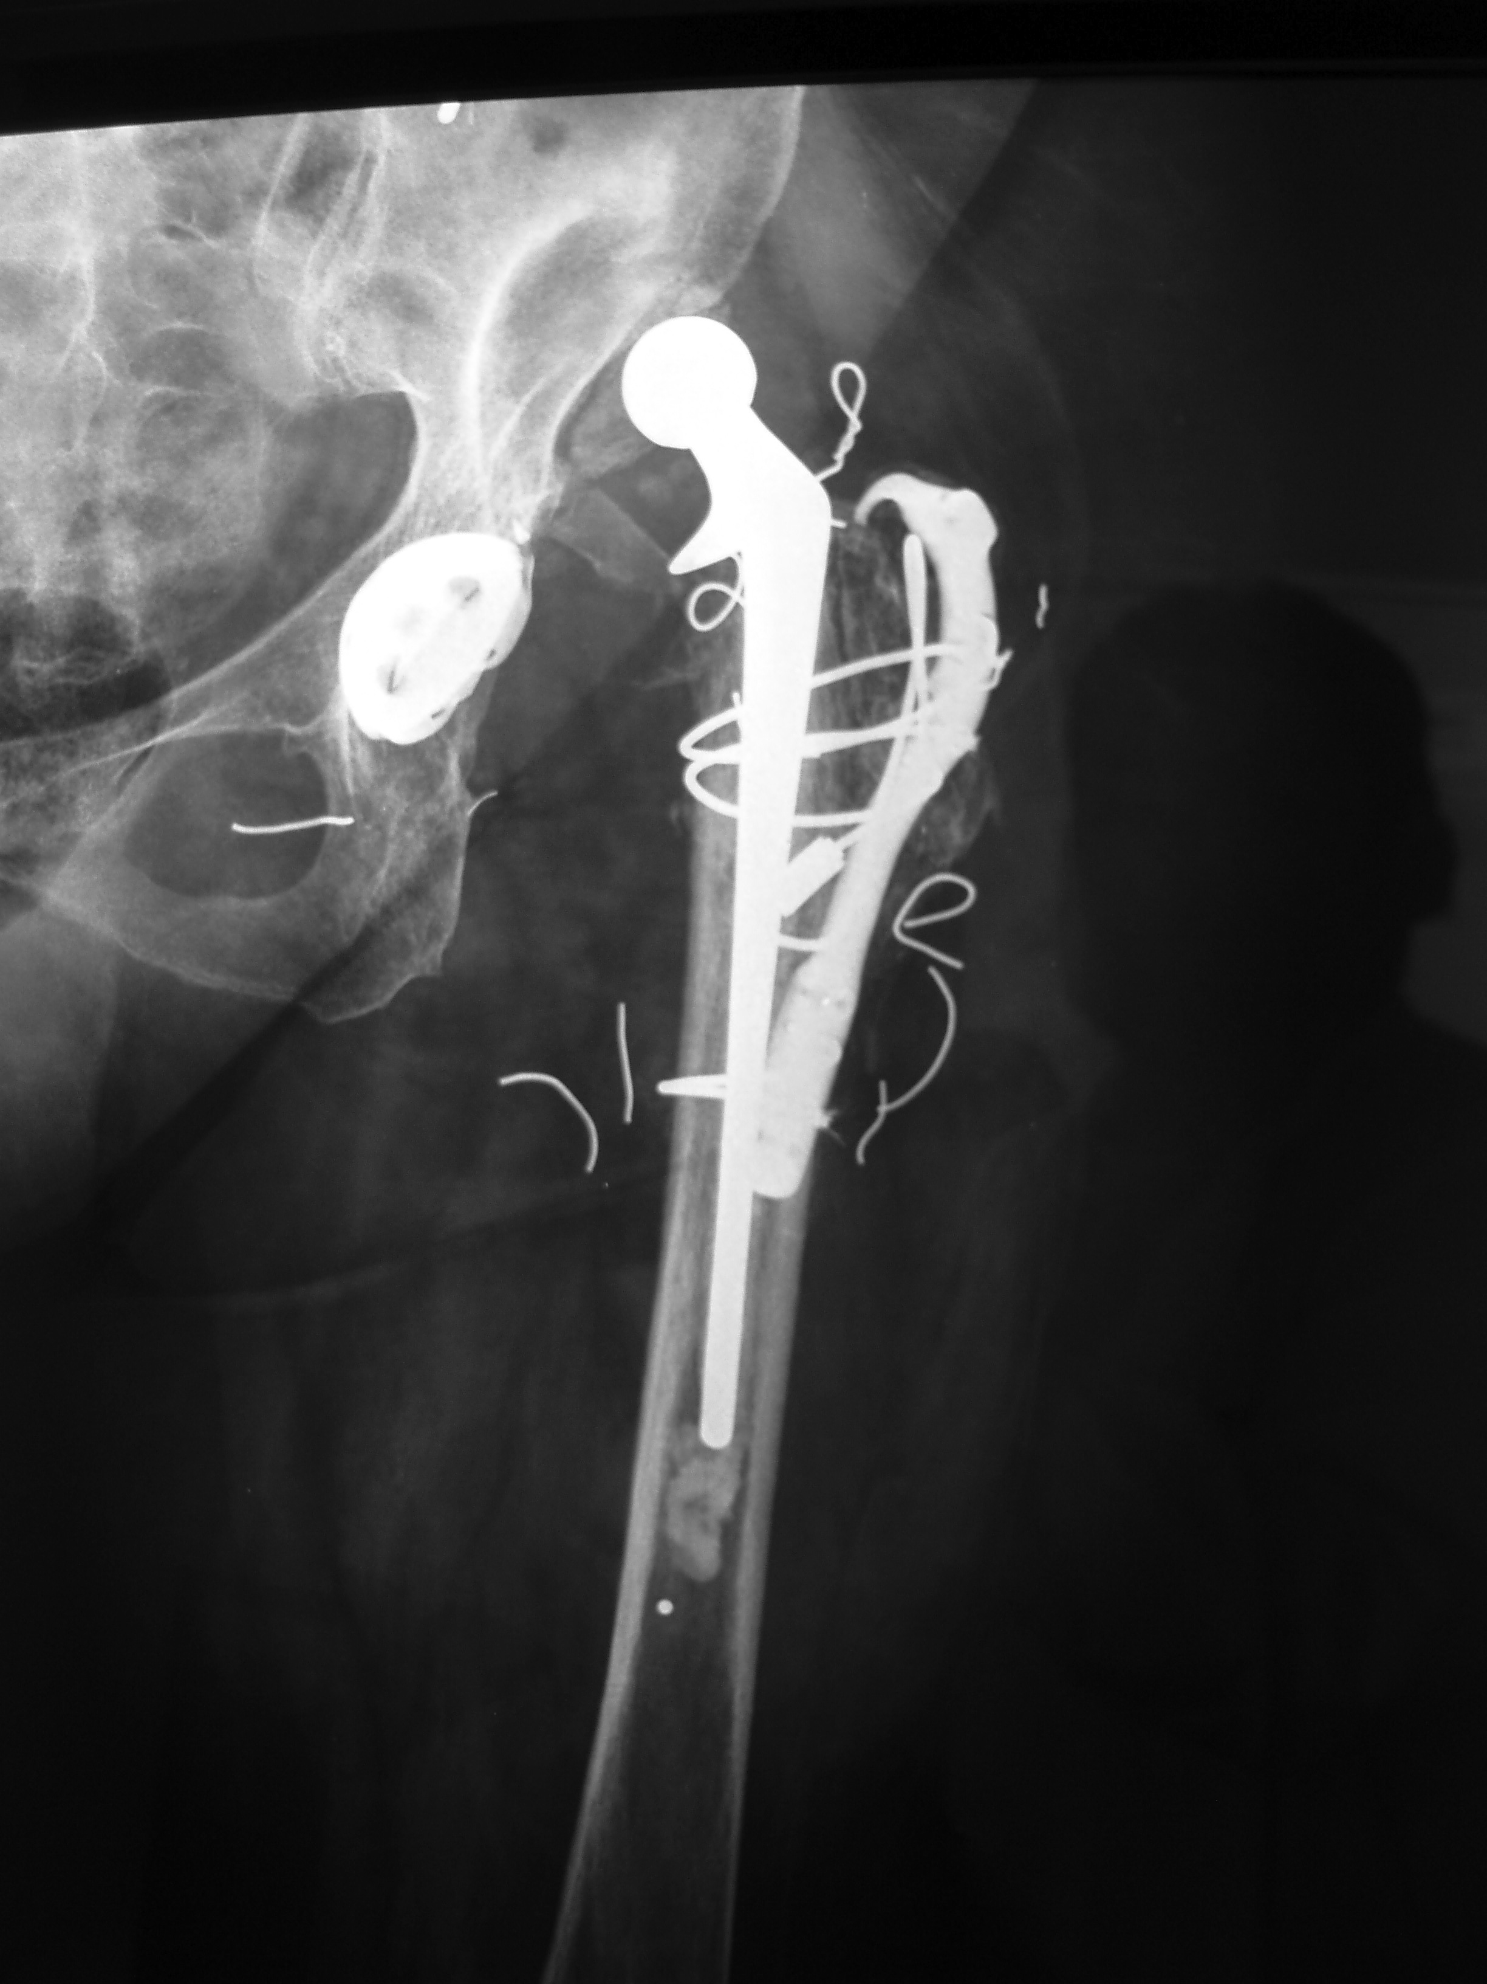
A

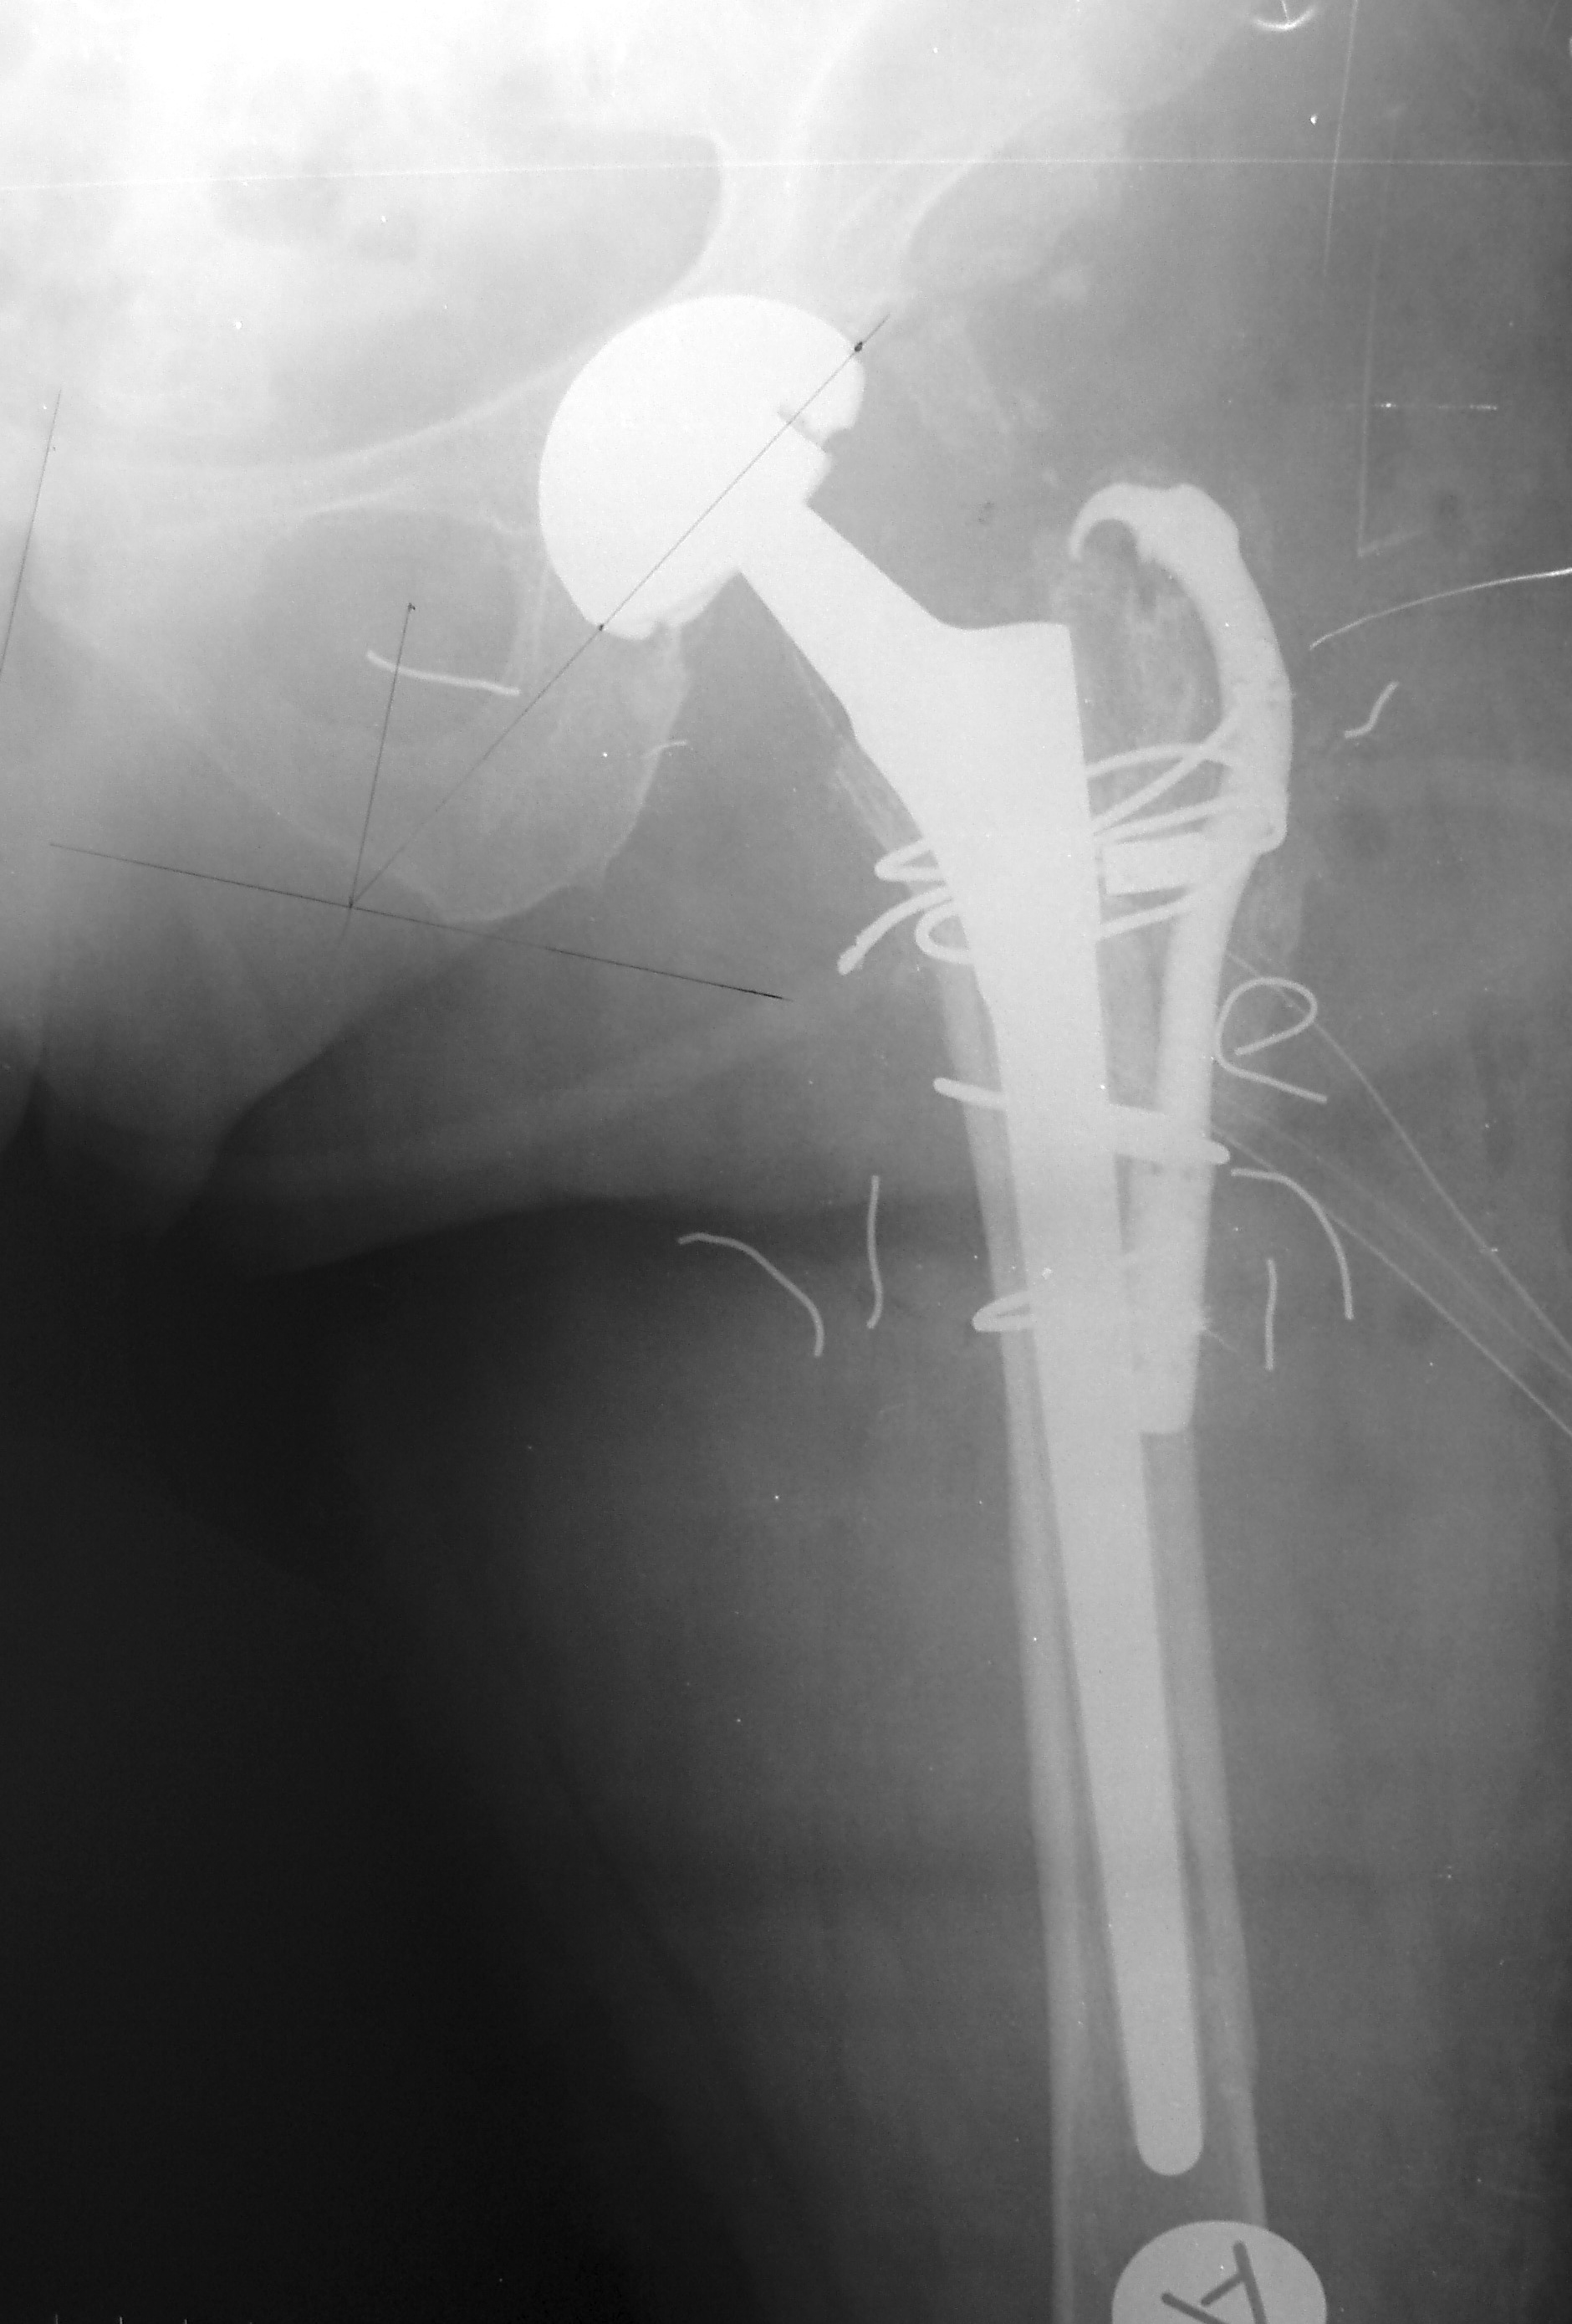
B

Figure 5 Modular stems. A: Preoperative anteroposterior (AP) radiograph of a dislocated left hip with a Paprosky type IIIA defect; B: Postoperative AP radiograph of the revised hip with a modular stem.

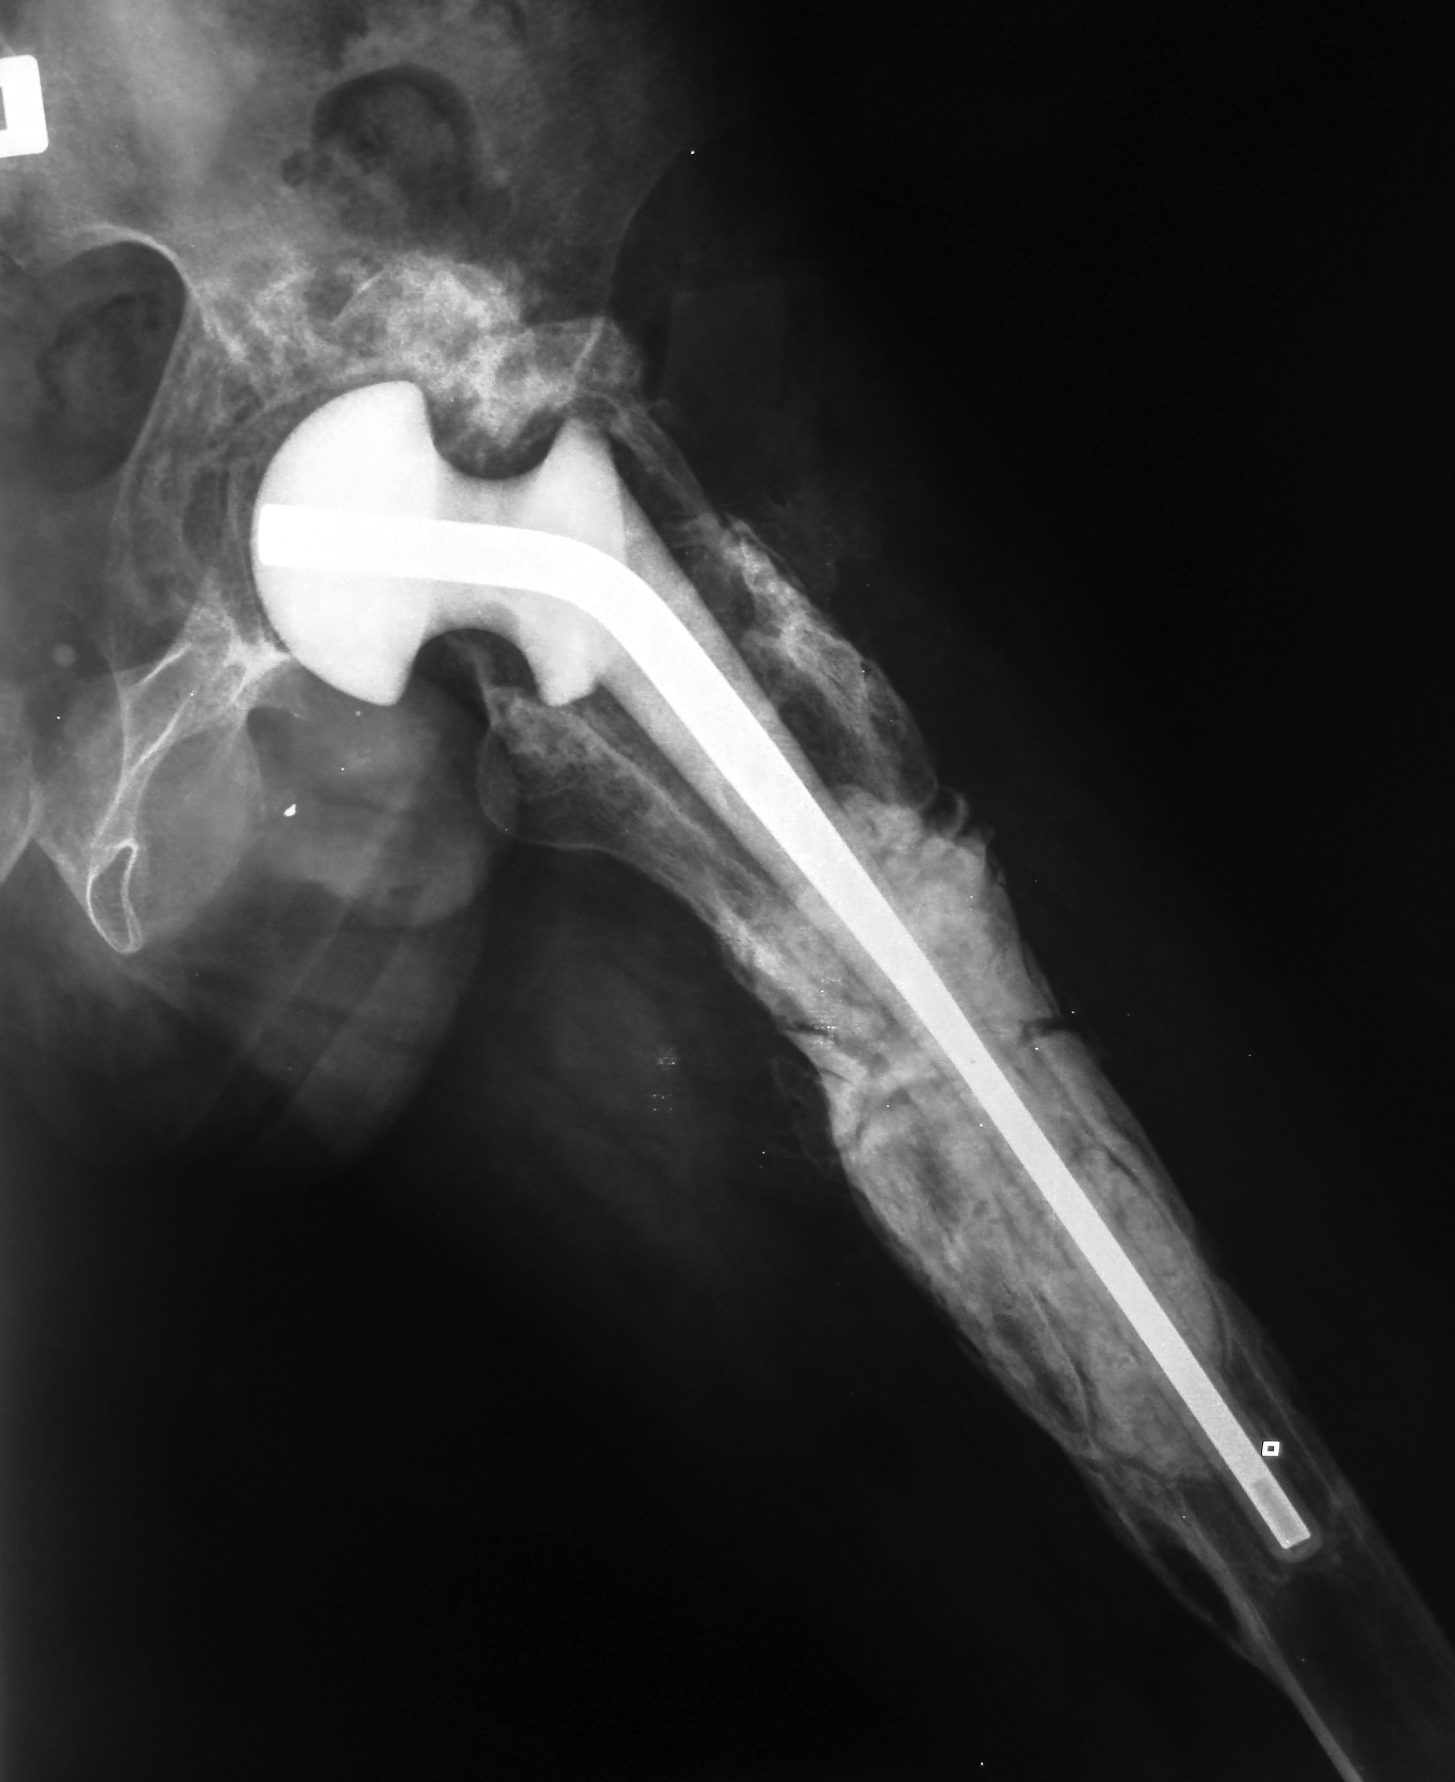
A

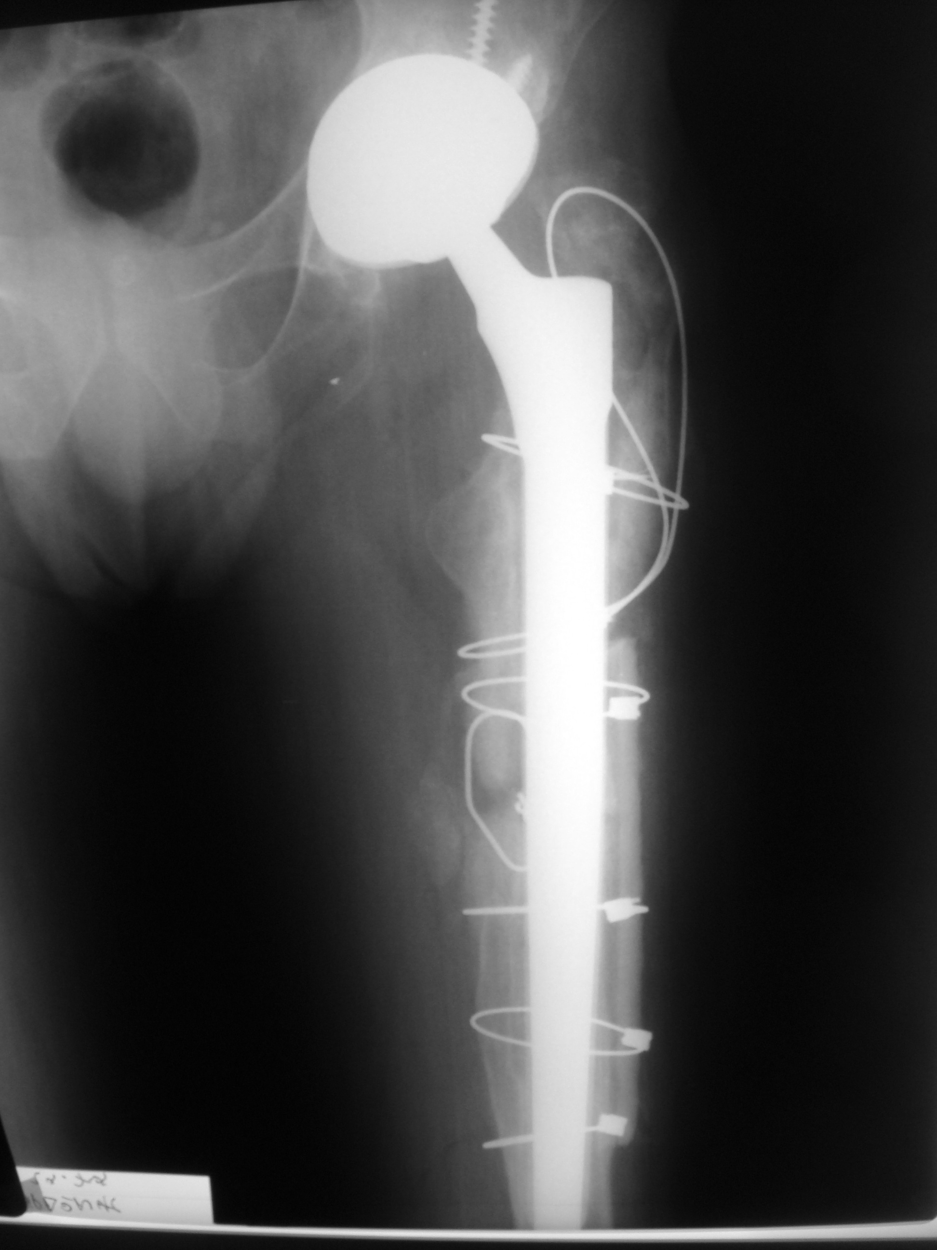
B

Figure 6 Newer stem designs with modular configuration have been associated with lower rates of subsidence and improved restoration of limb length and femoral offset. A: Anteroposterior (AP) radiograph of the left hip showing extensive bone loss of the proximal metaphyseal bone with significant diaphyseal bone loss (Paparosky type IIIB) secondary to periprosthetic hip infection. A antibiotic cement spacer was implanted after irrigation and debridement during the first stage of a two-stage exchange arthroplasty; B: AP radiograph of the same hip after the second stage using a distal fixation taper fluted stem.

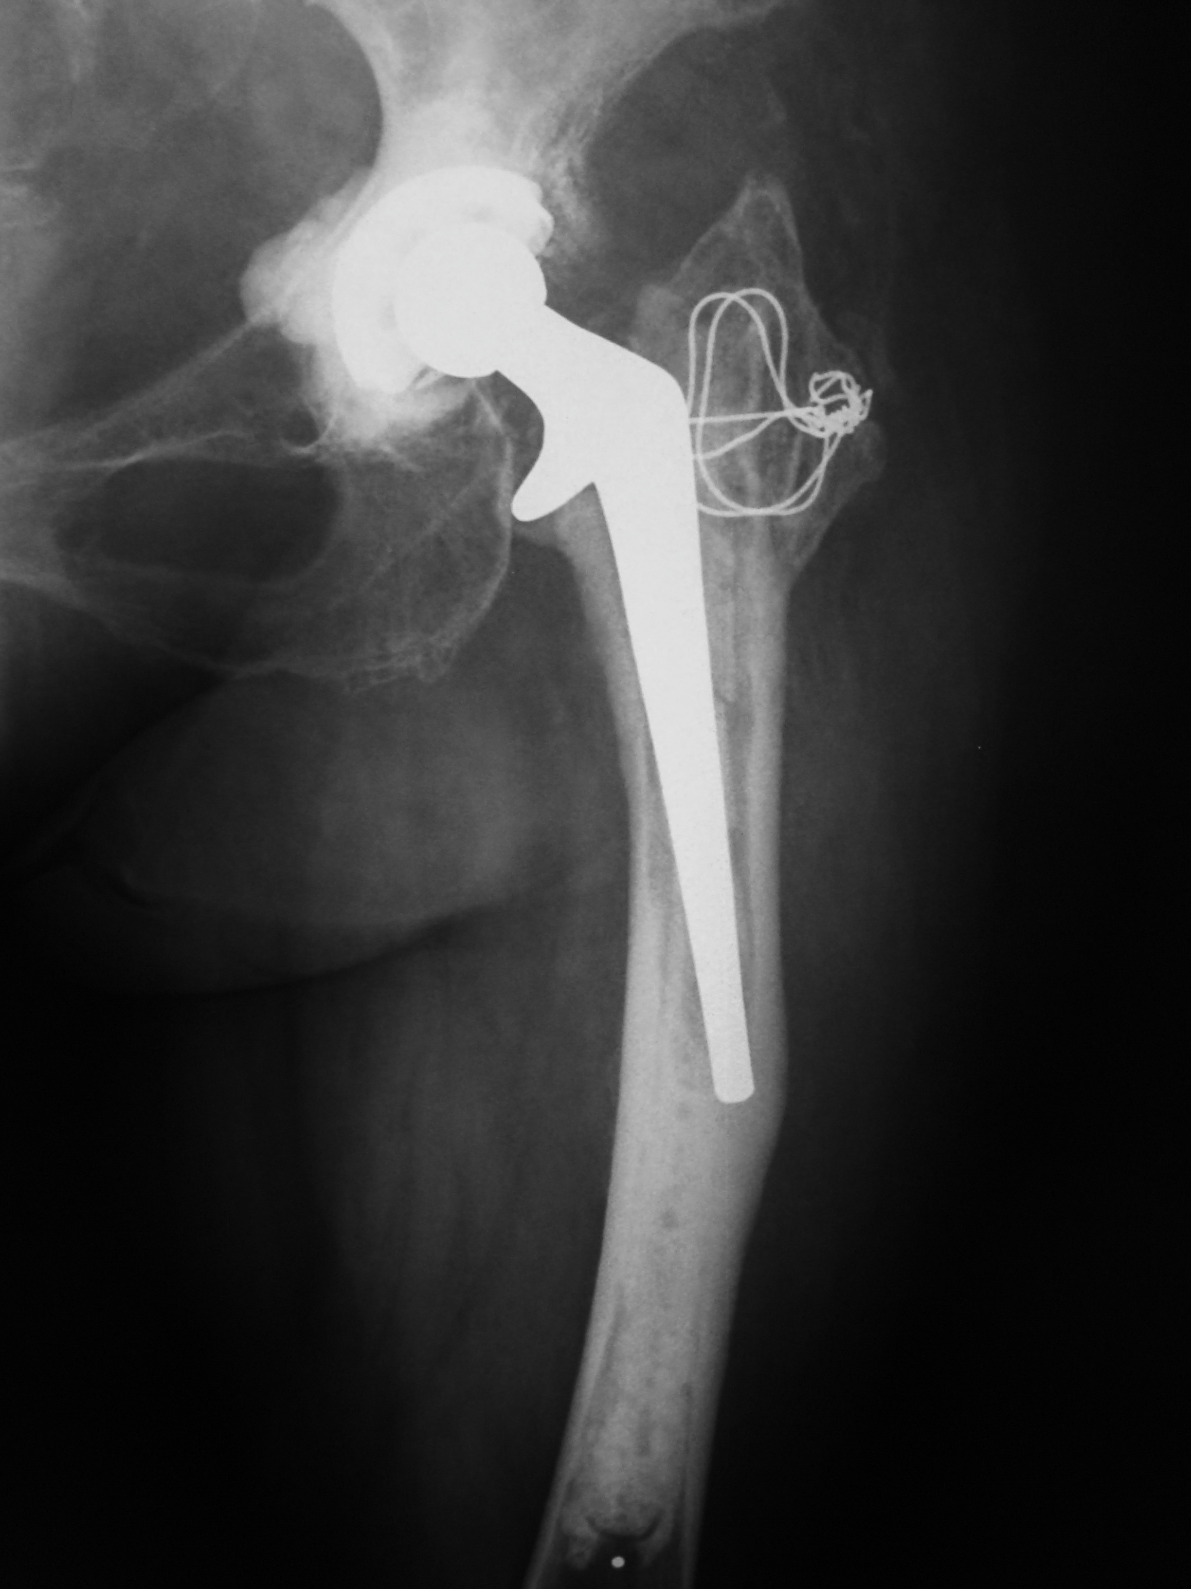
A

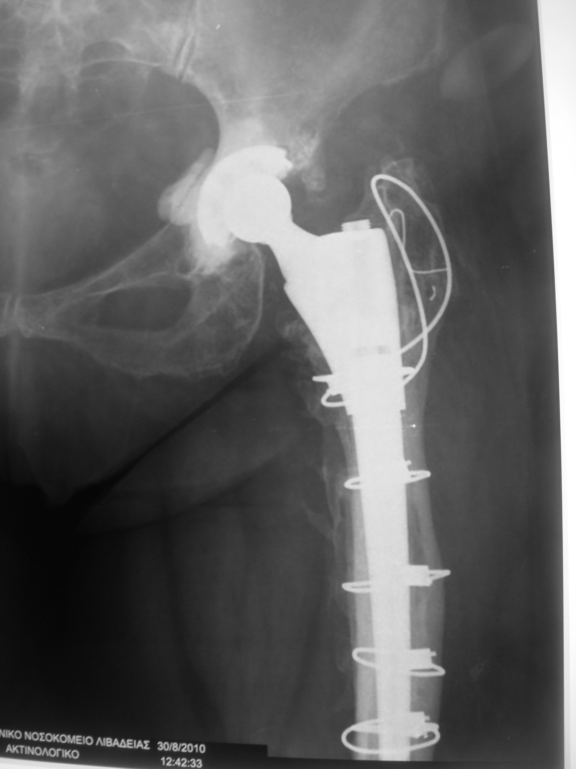
B
Figure 7 Multiple osteotomies allow for restoration of the anatomical axis of the femur, an easier access of the distal segment of the modular stem, thus reducing the risk of femoral fracture or perforation of the cortex. A: Anteroposterior (AP) radiograph of the left hip showing a cemented femoral component that is failed in varus, resulting in a slight angular malalignment of femur; B: AP radiograph of the same hip after revision of the femoral component using a modular stem, which combines both proximal metaphyseal and distal fixation due to the taper design and the distal flutes. A healed corrective osteotomy at the level of the mid-diaphysis facilitated the insertion of the stem and correction of the angular deformity to its neutral axis.

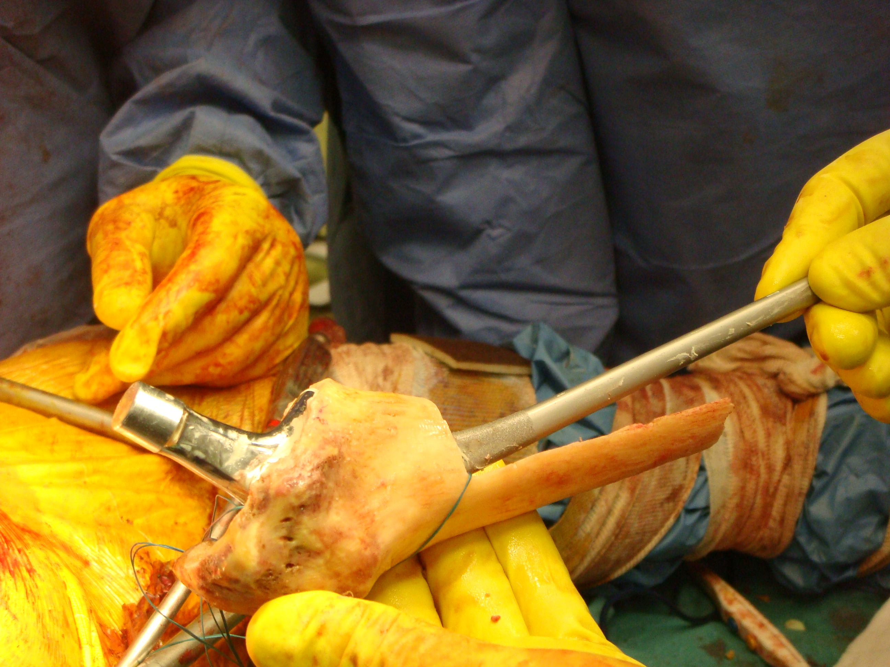
A

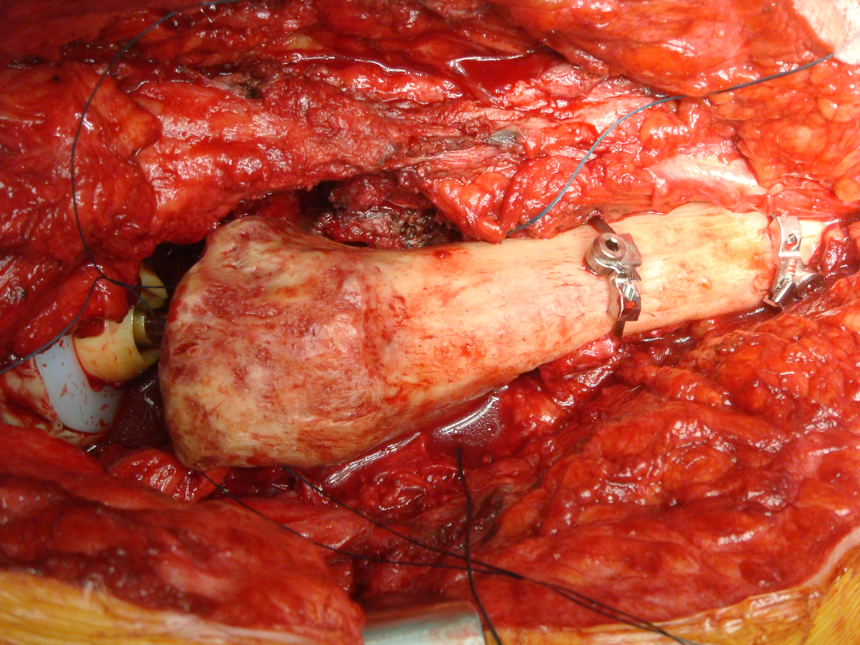
B
Figure 8 The allograft is reamed and broached and a long stem is cemented at the back table. A: Intraoperative picture demonstrating the allograft-prosthesis composite preparation. An allograft of appropriate size is osteotomized at the desired subtrochanteric level in order to match the bony defect of the proximal femur. The allograft is reamed and broached and a long stem is cemented at the back table; B: Intraoperative picture showing the allograft-prosthesis composite with a lateral sleeve that offers a wide area of bone contact with the distal host femur. Circlage cables are used to secure the allograft-host bone fixation.

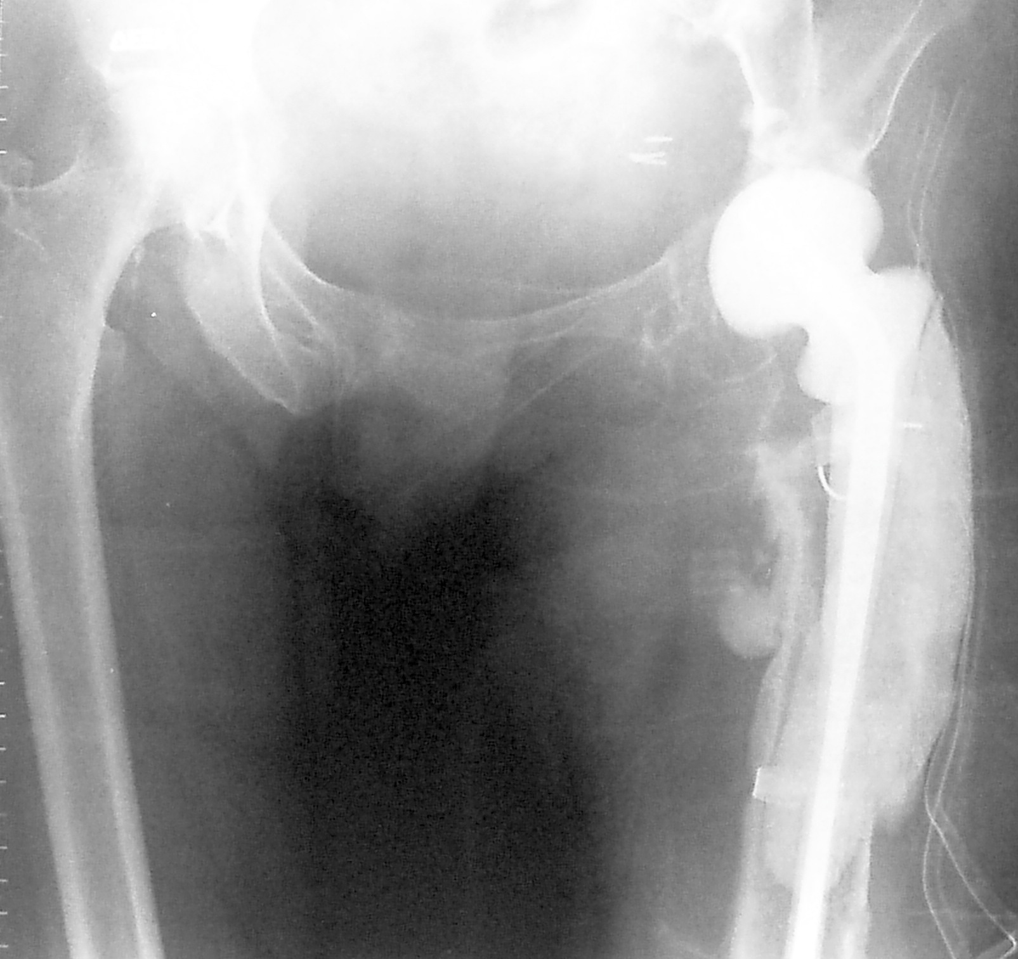
A

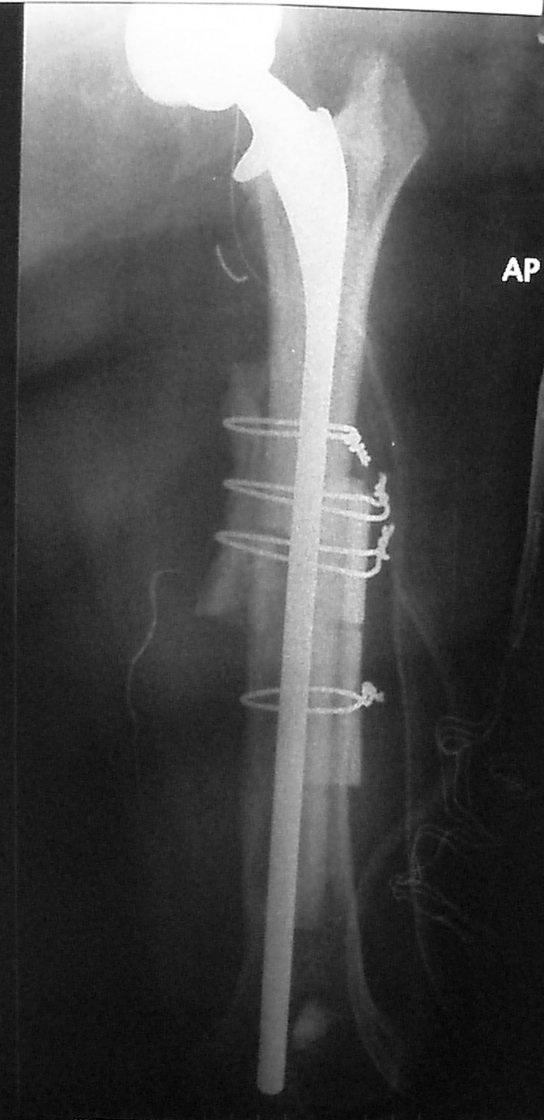
Figure 9 The allograft-prosthesis composite is implanted to the native femur with the use of cement or not, depending on the selected type of implant and the quality of host bone. A: Anteroposterior (AP) radiograph of the pelvis demonstrating a Paprosky Type IV femoral defect of the left hip as a result of a periprosthetic infection. The femoral canal is widened and there is no sufficient diaphyseal support for future cementless fixation; B: Postoperative AP radiograph of the left hip showing reconstruction of the proximal femoral defect with the use of an allograft-prosthesis composite. Remnants of the host bone are wrapped-around the femur at the level of the allograft-host bone junction in order to improve incorporation of the allograft to the host femur.

A

B
Figure 10 Proximal femur replacement using the so-called “mega-prostheses” is an alternative option in cases of severe proximal femoral bone loss. A: Anteroposterior (AP) radiograph of the pelvis showing a left revision total hip arthroplasty in a 82-year-old male patient with an extensive structural defect of the lateral femoral cortex resulting in a painful and mechanically loose construct of a periprosthetic hip fracture; B: Postoperative AP radiograph of the right hip showing the replacement of the proximal femoral with a megaprosthesis.

Table 1 Algorithmic approach of proximal femur reconstruction according to Paprosky classification
Type | Description | Treatment option
I | Minimal metaphyseal cancellous bone loss  Intact diaphysis | Cementless or cemented primary stems with common length and geometry
Ii | More extensive cancellous bone loss including the whole metaphysis down to the level of the lesser trochanter | Proximally fixed stem (usually modular)  Calcar replacement stem if medial cortex of the femoral neck is compromised
Iiia | Extensive metaphyseal and diaphyseal bone loss of the femur;  More than 4 cm of diaphyseal bone are available for distal fixation of cementless stem | Cementless stems with distal (diaphyseal)  Extensively porous coated stems  Modular stems fluted distally and porous coated proximally
Iiib | Available diaphyseal bone is less than 4 cm in length | Extensively porous-coated stems  Impaction grafting + cemented stem  Modular cementless tapered fluted stem
Iv | Widened diaphysis that provides no support for cementless fixation | Impaction grafting + cemented stem  Allograft prosthetic composite  Tumor megaprosthesis

