Name of Journal: World Journal of Gastroenterology
Manuscript NO: 91254
Manuscript Type: ORIGINAL ARTICLE

Clinical Trials Study
Early proactive monitoring of DNA-thioguanine in patients with Crohn’s disease predicts thiopurine-induced late leucopenia in NUDT15/TPMT normal metabolizers

Yang T et al. Early metabolite concentration predicts late leucopenia

Ting Yang, Kang Chao, Xia Zhu, Xue-Ding Wang, Sumyuet Chan, Yan-Ping Guan, Jing Mao, Pan Li, Shao-Xing Guan, Wen Xie, Xiang Gao, Min Huang

Ting Yang, Xia Zhu, Xue-Ding Wang, Sumyuet Chan, Yan-Ping Guan, Jing Mao, Pan Li, Shao-Xing Guan, Min Huang, School of Pharmaceutical Sciences, Sun Yat-sen University, Guangzhou 510006, Guangdong Province, China

Ting Yang, Min Huang, Institute of Clinical Pharmacology, Sun Yat-sen University, Guangzhou 510006, Guangdong Province, China

Kang Chao, Xia Zhu, Xiang Gao, Department of Gastroenterology, The Sixth Affiliated Hospital, Sun Yat-sen University, Guangzhou 510655, Guangdong Province, China

Xia Zhu, Department of Pharmacy, The First Affiliated Hospital, Sun Yat-sen University, Guangzhou 510080, Guangdong Province, China

Wen Xie, Center for Pharmacogenetics and Department of Pharmaceutical Sciences, University of Pittsburgh, Pittsburgh, PA 15261, United States

Author contributions: Yang T, Chao K, and Zhu X contributed equally to this work. Huang M and Gao X contributed to the study conceptualization and supervision and funding acquisition; Chao K and Gao X contributed to the acquisition and curation of data; Mao J and Li P helped to collect and process the blood samples; Guan SX and Xie W monitored the project progress and contributed to the writing and revision of the manuscript; Zhu X, Wang XD, and Guan YP helped to detect the genotypes and revise the manuscript; Yang T and Chan S detected drug concentrations; Yang T administered the project, analyzed the data, and wrote the manuscript; and all authors have read and approved the final manuscript.

Supported by the National Natural Science Foundation of China, No. 82020108031, No. 81973398, and No. 82104290; Guangdong Provincial Key Laboratory of Construction Foundation, No. 2020B1212060034; and Guangdong Basic and Applied Basic Research Foundation, No. 2022A1515012549 and No. 2023A1515012667.

Corresponding author: Min Huang, PhD, Professor, School of Pharmaceutical Sciences, Sun Yat-sen University, No. 132 East Outer Ring Road, Guangzhou Higher Education Mega Center, Guangzhou 510006, Guangdong Province, China. huangmin@mail.sysu.edu.cn

Received: December 26, 2023
Revised: February 11, 2024
Accepted: March 5, 2024
Published online:

Abstract
BACKGROUND
Thiopurine-induced leucopenia significantly hinders the wide application of thiopurines. Dose optimization guided by nudix hydrolase 15 (NUDT15) has significantly reduced the early leucopenia rate, but there are no definitive biomarkers for late risk leucopenia prediction.

AIM
To determine the predictive value of early monitoring of DNA-thioguanine (DNATG) or 6-thioguanine nucleotides (6TGN) for late leucopenia under a NUDT15-guided thiopurine dosing strategy in patients with Crohn’s disease (CD).

METHODS
Blood samples were collected within two months after thiopurine initiation for detection of metabolite concentrations. Late leucopenia was defined as a leukocyte count < 3.5 × 10⁹/L over two months.

RESULTS
Of 148 patients studied, late leucopenia was observed in 15.6% (17/109) of NUDT15/thiopurine methyltransferase (TPMT) normal and 64.1% (25/39) of intermediate metabolizers. In patients suffering late leucopenia, early DNATG levels were significantly higher than in those who did not develop late leucopenia (P = 4.9 × 10⁻¹³). The DNATG threshold of 319.43 fmol/μg DNA could predict late leucopenia in the entire sample with an area under the curve (AUC) of 0.855 (sensitivity 83%, specificity 81%), and in NUDT15/TPMT normal metabolizers, the predictive performance of a threshold of 315.72 fmol/μg DNA was much more remarkable with an AUC of 0.902 (sensitivity 88%, specificity 85%). 6TGN had a relatively poor correlation with late leucopenia whether in the entire sample (P = 0.021) or NUDT15/TPMT normal or intermediate metabolizers (P = 0.018, P = 0.55, respectively).

CONCLUSION
Proactive therapeutic drug monitoring of DNATG could be an effective strategy to prevent late leucopenia in both NUDT15/TPMT normal and intermediate metabolizers with CD, especially the former.

Key Words: Thiopurine-induced late leucopenia; DNA-thioguanine; 6-thioguanine nucleotide; Proactive therapeutic drug monitoring; Crohn’s disease

Yang T, Chao K, Zhu X, Wang XD, Chan S, Guan YP, Mao J, Li P, Guan SX, Xie W, Gao X, Huang M. Early proactive monitoring of DNA-thioguanine in patients with Crohn’s disease predicts thiopurine-induced late leucopenia in NUDT15/TPMT normal metabolizers. World J Gastroenterol 2024; In press

Core Tip: This study pioneeringly explores if early proactive monitoring of DNA-thioguanine (DNATG) or 6-thioguanine nucleotides stable concentration within two months could predict late leucopenia susceptible population under a nudix hydrolase 15 (NUDT15) genotype-guided thiopurines dosing strategy in patients with Crohn’s disease. We first provide evidence indicating that early proactive monitoring of DNATG during the initial stages of thiopurine therapy could be an effective strategy to discern patients susceptible to developing late leukopenia, especially in NUDT15/thiopurine methyltransferase normal metabolizers, with a concentration threshold of 315.72 fmol/μg DNA.

INTRODUCTION
Thiopurines, mercaptopurine (MP), and azathioprine (AZA) have been widely used in inflammatory bowel disease (IBD) for 70 years^{[1]}. However, up to 10%-30% of patients discontinue therapy primarily due to adverse effects. Thiopurine-induced leucopenia is one of the most common and potentially fatal toxicities, particularly in Asian populations^{[2]}.
Thiopurine methyltransferase (TPMT), a key enzyme in thiopurine metabolism, is involved in the inactive conversion of thiopurines. TPMT polymorphisms are significantly associated with thiopurine-induced leucopenia and have been a landmark discovery in genomics to guide the clinical application of thiopurines. However, the guiding value of TPMT for thiopurine clinical usage is very limited in Asia, because the mutation frequency of TPMT*3C, as the most prevalent variant in Asia, is only 1%-3%^{[3,4]}. Until 2014, a genome-wide association study in Korea revealed a common missense variant, nudix hydrolase 15 (NUDT1)*3 (rs116855232, R139C, p.Arg139Cys), which strongly increased individual susceptibility to thiopurine-induced leucopenia, bringing the gospel to Asian patients for safe use of thiopurines^{[5]}.
Thiopurine-induced leucopenia occurs at any time during treatment, ranging from early (within two months) to late onset (over two months)^{[6,7]}. Thiopurine-induced severe, early-onset leucopenia, we now know, can be attributed largely to NUDT15 deficiency. Since its introduction, the highly predictive value of NUDT15*3 for thiopurine-induced leucopenia, mainly for early leucopenia (within two months), has been consistently confirmed, but so far, no definitive conclusion has been reached concerning late leucopenia (over two months)^{[5,8-10]}. In a prospective study, we showed that halved dosage for NUDT15*3 heterozygous patients reduced the incidence of early leucopenia by approximately 50%, but it did not reduce the risk of late leucopenia^{[9]}. Similar findings were also reported in a Japanese study^{[10]}. As thiopurine-induced late leucopenia is common, occurring in as high as 20%-40% of IBD patients^{[5,8,10]}, regular follow-up and therapeutic drug monitoring (TDM) are crucial during long-term thiopurine maintenance therapy.
Thiopurine drugs need to undergo extensive enzymatic conversion into 6-thioguanine nucleotides (6TGN) to exert their pharmacological and cytotoxic action. The role of the 6TGN level as an integral component of thiopurine monitoring to minimize adverse reactions has been investigated for decades^{[1,11-13]}. However, whether 6TGN monitoring can reduce thiopurine-induced leucopenia is controversial and debatable^{[8,13-17]}. Two studies have recently shown that late DNA-thioguanine (DNATG), a NUDT15-associated subcellular DNA-incorporated thiopurine metabolite, was strongly related to thiopurine-induced late leucopenia, compared to 6TGN^{[3,16]}.
Therefore, it is necessary to verify whether proactive TDM of DNATG or 6TGN in the initial medication phase can predict the occurrence of late leucopenia. After all, early identification of patients at risk of thiopurine-induced late leucopenia is of greater significance than metabolite concentration monitoring after routine blood tests indicating signs of leucopenia.
Herein, we conducted a prospective observational study to explore whether early proactive TDM of DNATG stable concentration within two months could help predict the leucopenia-susceptible population under a NUDT15 genotype-guided thiopurine dosing strategy in patients with Crohn’s disease (CD)^{[9]}, compared with 6TGN concentrations over the same period.

MATERIALS AND METHODS
Patient recruitment and study design
Patients diagnosed with CD from June 2019 to December 2022 were recruited in the Sixth Affiliated Hospital, Sun Yat-sen University. After prescribed thiopurines, patients were clinically followed up within two months when blood specimens were collected for TDM (6TGN, DNATG), and every two to three months thereafter. At each follow-up visit, clinical data, and routine blood tests were recorded. Medication adherence was followed up prospectively for a minimum duration of six months to monitor whether leucopenia occurred.
NUDT15 and TPMT genotypes were detected before treatment initiation. Patients with NUDT15 wild-type were prescribed the target dose of 2.0 mg/kg/d AZA or 1.0 mg/kg/d 6-MP, and heterozygous patients were administered the target dose of 1.0 mg/kg/d AZA or 0.5 mg/kg/d 6-MP. Thiopurines were contraindicated in patients with homozygous mutations. The initial dose of AZA was 1.0 mg/kg/d in the wild-type group or 0.5 mg/kg/d in the heterozygous group and then increased to the target dosage in approximately one to two weeks^{[9]}. The dose of 6-MP in mg/kg body weight was obtained by multiplying the dose of AZA by 0.5 as a conversion factor. DNATG and 6TGN levels were determined within the two-month follow up during which patients were medication stable and did not complain of any thiopurine-induced discomfort. The design of this study is depicted in Figure 1.
The clinical information was recorded at every visit until thiopurine discontinuation due to inefficacy, adverse drug reactions, and poor adherence/loss to follow-up. A white blood cell count < 3.5 × 10⁹/L after two or more months of treatment was defined as thiopurine-induced late leucopenia. The exclusion criteria were as follows: Patients with blood transfusion or administration of cyclosporine or methotrexate; patients with insufficient function of the heart, liver, or kidneys; patients with active infection at the sampling time point; and patients suffering from acute adverse reactions within two months. The present study was approved by the Ethics Committee of the Sixth Affiliated Hospital of Sun Yat-sen University. This trial is registered with the Chinese Clinical Trials Register (No. ChiCTR2100050295). All patients recruited provided a written informed consent form to participate in the trial.

Genotyping and TDM
DNA was extracted from peripheral leukocytes according to the manufacturer’s instructions (TIANGEN DP349-02, Beijing, China). TPMT*2 (rs1800462, G238C), *3A (rs100460 and rs1142345), *3B (rs100460, G460A), *3C (rs1142345, A719G), and NUDT15*3 (rs116855232, C415T), *5 (rs186364861, G52A), and *6 (rs746071566) genotypes were determined by Sanger sequencing. Detailed methods of quantitative detection of DNATG concentration in leukocytes and 6TGN concentration in erythrocytes have been published previously^{[3]}.

Statistical analysis
Statistical analyses were performed using GraphPad Prism 9.5 (GraphPad, La Jolla, CA, United States) and R software (version 4.2.1; R Foundation). The continuous values are shown as medians (ranges) or median ± interquartile range (IQR) according to the distribution of the values. The nonparametric Spearman test was used for all correlation analyses. χ² and Fisher’s exact probability tests were used to analyze categorical data, while Mann-Whitney tests were used to analyze measurement data.
The performance and a target threshold of 6TGN or DNATG were evaluated by computing receiver operating characteristic (ROC) curves and the area under the ROC curves (AUC) using the pROC package in R. Cumulative incidence rates of late leucopenia during follow-up were constructed using the Kaplan-Meier method, and the survival curves were compared using the log-rank test with survival and survminer packages in R. Cox proportional hazards regression was used for both univariate and multivariate analysis of thiopurine-induced late leucopenia. Data visualization was performed in Prism 9.5 and the R packages survminer, rms and, ggplot2. Statistical significance was indicated at the 0.05 level.

RESULTS
Patient characteristics
The flow chart of patient enrollment, exclusion, and follow-up is depicted in Figure 1. A total of 165 patients were recruited in this study, and 17 patients were excluded due to drug discontinuation/dose change/loss of follow-up. A total of 148 patients with DNATG and 6TGN measurements within two months were analyzed in this study. The median patient follow-up time was 13.1 months, with 82.4% of patients followed longitudinally for six months or more. In our study, late leucopenia was observed in 15.6% (17/109) of the NUDT15/TPMT normal and 64.1% (25/39) of intermediate metabolizers, consistent with previous observations in similar populations^{[4,9,15,18]}. Of the 148 patients, 3 were heterozygous for TPMT*3C, and 37 were heterozygous for low activity NUDT15 alleles (21 NUDT15*1/*3, 14 NUDT15*1/*2, 2 NUDT15*1/*6). There were no significant differences in sex, age, dose, weight, comedication, or hematologic indices except for platelets (Table 1).

Correlation between early thiopurine metabolite concentrations and peripheral leukocyte, neutrophil, lymphocyte, and monocyte counts
There was a significant negative correlation between early DNATG concentration and the minimum peripheral leukocyte, neutrophil, lymphocyte, and, monocyte counts during follow-up (r = -0.3231, P < 0.0001; r = -0.1834, P = 0.0260; r = -0.1793, P = 0.0320; r = -0.2854, P = 0.0004; respectively, Figure 2A-D). Similarly, a marginally significant negative correlation was found between early DNATG concentration and the average peripheral leukocyte, neutrophil, lymphocyte, and monocyte counts during follow-up (r = -0.1806, P = 0.0280; r = -0.1473, P = 0.0740; r = -0.1419, P = 0.0850; r = -0.2392, P = 0.0034; respectively, Figure 2E-H). By contrast, no significant correlation was found between the early 6TGN concentration and the minimum or average peripheral leukocyte, neutrophil, and lymphocyte counts during follow-up, except for monocyte counts (r = -0.2459, P = 0.0026; r = -0.1692, P = 0.0398; respectively, Figure 3).

Association of early thiopurine metabolite concentrations with late leucopenia
Median early DNATG concentrations were much higher in patients who developed late leucopenia than in those who did not [394.9 ± 137.4 fmol/μg DNA (n = 42) vs 225.3 ± 139.6 fmol/μg DNA (n = 106), P = 4.9 × 10⁻¹³, Figure 4A]. In patients with TPMT/NUDT15 wild-type (n = 109)], early DNATG concentration [401.1 ± 222.9 fmol/μg DNA (n = 17) vs 221.1 ± 140.8 fmol/μg DNA (n = 92), P = 4.9 × 10⁻⁹, Figure 5A] was associated with late leucopenia with much higher significance than in heterozygous patients [382.5 ± 143.1 fmol/μg DNA (n = 25) vs 240.5 ± 248.3 fmol/μg DNA (n = 14), P = 0.024; 3 for TPMT*3C, 21 for NUDT15*3, 2 for NUDT15*6, 14 for NUDT15*2, Figure 5A].
By contrast, median early 6TGN concentrations were slightly higher in patients who developed late leucopenia than in those who did not [322.4 ± 210.6 pmol/8 × 10⁸ red blood cells (RBCs) (n = 42) vs 247.5 ± 182.5 pmol/8 × 10⁸ RBCs (n = 106), P = 0.021, Figure 4B]. Notably, the early 6TGN concentration did not exhibit a significant difference in TPMT/NUDT15 heterozygous patients with or without late leucopenia [310.0 ± 180.6 pmol/8 × 10⁸ RBCs (n = 25) vs 249.9 ± 303.9 pmol/8 × 10⁸ RBCs (n = 14), P = 0.55], although it did in TPMT/NUDT15 wild-type patients with or without late leucopenia [333.7 ± 270.7 pmol/8 × 10⁸ RBCs (n = 17) vs 247.5 ± 162.9 pmol/8 × 10⁸ RBCs (n = 92), P = 0.018] (Figure 5B).

Predictive performance of early thiopurine metabolite concentration for late leucopenia
The AUC of the ROC analysis for early DNATG concentrations was 0.855 (sensitivity 83%, specificity 81%) in the total population (Figure 6A), 0.902 (sensitivity 88%, specificity 85%) in TPMT/NUDT15 wild-type (Figure 6B), and 0.72 (sensitivity 79%, specificity 72%) in heterozygous subgroups (Figure 6C) and the cutoff values of DNATG were 319.43, 315.72, and 354.68 fmol/μg DNA, respectively.
The AUC of the ROC analysis for early 6TGN concentration was 0.622 (sensitivity 66%, specificity 60%) in the total population (Figure 6A), 0.680 (sensitivity 71%, specificity 67%) in TPMT/NUDT15 wild-type (Figure 6B), and 0.560 (sensitivity 50%, specificity 64%) in heterozygous subgroups (Figure 6C). Additionally, discontinuations occurred in 35.7% (15/42) of patients who developed late leucopenia (median follow-up: 5.8 months), with 80% (12/15) of them taking the drug for less than a year. Similarly, early DNATG levels were much more impressive in predicting discontinuation events due to recurrent leucopenia, with an AUC of 0.812 (sensitivity 87%, specificity 77%) in the total population, and 0.864 (sensitivity 100%, specificity 67%) in the TPMT/NUDT15 wild-type population (Supplementary Figure 1).
Kaplan-Meier survival analysis showed that the cumulative incidence rates of late leucopenia during follow-up were significantly increased in patients with DNATG concentrations greater than 319.43 fmol/μg DNA in the total population and 315.72 fmol/μg DNA in the TPMT/NUDT15 wild-type population (Figure 7).

Multivariable prediction model for thiopurine-induced late leucopenia
Univariate Cox regression analysis of 148 patients on stable thiopurine therapy showed that age, weight, early DNATG and 6TGN concentrations, and NUDT15 genotypes were relevant determinants for the development of late leucopenia (P < 0.1). After discarding the nonsignificant factors, 6TGN concentrations, in the multivariate analysis, the final Cox model included age, early DNATG concentration, and NUDT15 genotypes (P < 0.05). Predictive variables and hazard ratios for the development of leucopenia are presented in Table 2. To improve the feasibility of clinical application, a nomogram based on multivariate analysis results is shown in Figure 8.

DISCUSSION
This is the first time that the DNATG level has been reported to be applicable in the prediction of thiopurine-induced late leucopenia. To date, few studies have been conducted to determine the worth of DNATG level and its correlation with thiopurine-induced late leucopenia in IBD patients. In our previous study, we found that late DNATG levels were significantly correlated with late leucopenia and were a better independent factor for late leucopenia than 6TGN. Therefore, we proposed that proactive quantification of DNATG may be a good way to predict late leucopenia and this prospective observational study was conducted thereafter. In this study, we also found that early DNATG concentrations were consistent with late concentrations in representative patients with multiple follow-up DNATG measurements (Supplementary Figure 2), which further indicated the reliability and feasibility of early proactive quantification of DNATG.
In the previous decade, investigations on individualized thiopurines were mainly focused on genotypes of TPMT and NUDT15. The Clinical Pharmacogenetics Implementation Consortium guidelines recommend initial thiopurine dose adjustment based on TPMT and NUDT15 genotypes^{[19]}. Numerous studies have consistently reported that NUDT15 variants serve as the sole or major factors linked to thiopurine-induced early leucopenia, exhibiting a sensitivity and specificity higher than 90%, while TPMT variants demonstrate a sensitivity of 12.1% and a specificity of 97.6%^{[5]}. In addition, some studies have also shown an association between NUDT15 variants and late leucopenia^{[8]}. In the present study, we verified that NUDT15 was a significant independent factor for late risk, and therefore, the importance of pretreatment for the determination of the NUDT15 genotype cannot be overemphasized.
Nonetheless, a large portion of thiopurine-induced leucopenia cannot be explained by NUDT15/TPMT deficiency, which was manifested by the variation in leucopenia in patients receiving optimized thiopurines based on the genotype of NUDT15/TPMT^{[9]}. Meanwhile, a high incidence of late leucopenia (10%-20%) can still be seen in the NUDT15/TPMT wild-type population^{[3,4,9,18]}. It is very important to identify biomarkers for risk in the populations mentioned above.
TDM of 6TGN has been employed in some clinical settings as a strategy to predict thiopurine-induced toxicity for over two decades although the value of 6TGN TDM is still controversial^{[20-22]}. Kang et al^{[23]} reported that the 6-TGN level (goal < 167.1 pmol/8 × 10⁸ RBCs) could be used to adjust AZA doses to reduce late thiopurine-induced leucopenia in NUDT15 intermediate metabolizers.
However, a large number of studies have shown that 6TGN levels are not significantly different between groups with and without leucopenia^{[8,13-16]}. In our previous study^{[4]}, late 6TGN levels were significantly associated with late leucopenia in patients with wild-type NUDT15 R139C (P = 0.006, median 413.0 vs 279.7 pmol/8 × 10⁸ RBCs), while no significant association was found between 6TGN levels and leucopenia in patients with NUDT15 R139C variants (P = 0.26). Similarly, in the present study, the early concentrations of 6TGN exhibited no significant difference in TPMT/NUDT15 heterozygous patients with or without late leucopenia (P = 0.55), although it did in the entire sample and TPMT/NUDT15 wild-type patients with or without late leucopenia (P = 0.021, 0.018, respectively). This discrepancy may be because in the study performed by Kang et al^{[23]}, 6TGN concentrations were monitored regularly, and doses were adjusted accordingly so that 6TGN levels would be within the therapeutic range of 235-450 pmol/8 × 10⁸ RBCs^{[24]}. In our study, the doses were only adjusted based on genotypes before thiopurine administration.
Furthermore, our current study found that compared to 6TGN, early DNATG levels were more significantly correlated with thiopurine-induced late leucopenia (P = 4.9 × 10⁻¹³ vs P = 0.021). The DNATG threshold of 319.43 fmol/μg DNA predicted late leucopenia in the entire sample with an AUC of 0.855 (sensitivity 83%, specificity 81%), and in the NUDT15/TPMT normal metabolizers, the predictability of a threshold of 315.72 fmol/μg DNA was much more impressive with an AUC of 0.902 (sensitivity 88%, specificity 85%). Notably, early DNATG levels were much more impressive in predicting discontinuation events due to recurrent leucopenia with an AUC of 0.864 (sensitivity 100%, specificity 67%) in the TPMT/NUDT15 wild-type population.
In recent years, proactive and reactive TDM strategies in IBD management have been under intense discussion. Reactive TDM in non- or partial responders with active IBD aims to guide treatment changes and routine proactive TDM in patients with quiescent disease aims to reach a target trough concentration during routine clinical care^{[20]}. Many studies have suggested that proactive TDM can provide more clinical benefits than reactive TDM for anti-tumor necrosis factor biologics^{[25-28]}. One Danish study reported that DNATG levels in neutrophils (P < 0.0001) and 6TGN in erythrocytes (P = 0.01) on methotrexate/6-MP maintenance therapy for childhood acute lymphoblastic leukemia, are predictors of neutrophil nadirs within two weeks following high-dose methotrexate infusion^{[29]}. In the present study, it is heartening that early proactive monitoring of DNATG is of very high sensitivity (88%) and specificity (85%) to predict late leucopenia in NUDT15/TPMT wild-type subgroups that would not benefit from the NUDT15 genotype-guided dosing strategy.
In general, pretreatment determination of the NUDT15 genotype is necessary to identify Asian patients with IBD who are susceptible to thiopurine-induced leucopenia. Proactive DNATG therapeutic monitoring is very important, especially for many patients with wild-type NUDT15/TPMT, to avoid late risk.
There are several shortcomings in our study. First, this was a prospective observational study with relatively small sample sizes. In our study, once leucopenia occurred, patients discontinued the thiopurines, switched therapies, or followed a strategy of empiric dose adaptation due to the patient’s wishes and physician discretion. We did not fully determine the benefits of reactive DNATG-TDM-guided dose adaptation decisions with NUDT15-guided initial medication. Further randomized clinical trials are warranted to probe whether routine reactive DNATG monitoring, compared with empiric treatment changes, helps to reduce the incidence of drug withdrawal due to late leucopenia in IBD patients.

CONCLUSION
In this prospective study of CD patients receiving thiopurines under NUDT15 genotype-guided dosing strategy, we demonstrated that in addition to the NUDT15 genotype, early proactive monitoring of DNATG was highly sensitive in predicting thiopurine-induced late leucopenia. With the cutoff value of 319.43 fmol/μg DNA, late leucopenia cases could be predicted with 83% sensitivity and 81% specificity, and with the cutoff value of 357.05 fmol/μg DNA, the discontinuation of thiopurines could be predicted with 87% sensitivity and 77% specificity. DNATG levels were more significantly associated with late leucopenia than 6TGN levels, which was manifested especially in patients with NUDT15/TPMT wild-type, with a cutoff value of 315.72 fmol/μg DNA (sensitivity 88%, specificity 85%). This study provides empirical evidence indicating that early monitoring of DNATG levels, offers a predictive capability to discern patients susceptible to developing late leucopenia during the initial stages of thiopurine therapy, especially for many patients with wild-type NUDT15/TPMT.

ARTICLE HIGHLIGHTS
Research background
Thiopurine-induced leucopenia significantly hinders the use of thiopurines. Genotype-guided dose optimization has significantly reduced the early leucopenia rate, but there are no definitive biomarkers for late risk prediction.

Research motivation
Can we identify definitive predictors for late risk as early as possible under current genotype-guided thiopurine dosing strategy?

Research objectives
To determine the predictive value of early monitoring of DNA-thioguanine (DNATG) or 6-thioguanine nucleotides (6TGN) for late leucopenia in patients with Crohn’s disease (CD).

Research methods
Blood samples were collected within two months after thiopurine initiation for detection of metabolite concentrations. Late leucopenia was defined as a leukocyte count < 3.5 × 10⁹/L over two months.

Research results
In patients suffering late leucopenia, early DNATG levels were significantly higher than those who did not (P = 4.9 × 10⁻¹³). DNATG threshold of 319.43 fmol/μg DNA could predict late leucopenia in the entire sample collection with an area under the curve (AUC) of 0.855 (sensitivity 83%, specificity 81%), and in the nudix hydrolase 15 (NUDT15)/thiopurine methyltransferase (TPMT) normal metabolizers, the prediction performance of a threshold of 315.72 fmol/μg DNA was much more remarkable with an AUC of 0.902 (sensitivity 88%, specificity 85%). 6TGN had a relatively poor correlation with late leucopenia whether in the entire sample collection (P = 0.021) or NUDT15/TPMT normal or intermediate metabolizers (P = 0.018, P = 0.55, respectively).

Research conclusions
Early DNATG concentration was significantly correlated with thiopurine-induced late leucopenia in CD patients, especially in NUDT15/TPMT normal metabolizers.

Research perspectives
Proactive therapeutic drug monitoring to keep DNATG concentration below 320 fmol/μg DNA could be an effective strategy to prevent thiopurine-induced late leucopenia in CD patients.

REFERENCES
1 Crouwel F, Buiter HJC, de Boer NK. The Thiopurine Tale: An Unexpected Journey. J Crohns Colitis 2022; 16: 1177-1183 [PMID: 35024806 DOI: 10.1093/ecco-jcc/jjac004]
2 Kakuta Y, Kinouchi Y, Shimosegawa T. Pharmacogenetics of thiopurines for inflammatory bowel disease in East Asia: prospects for clinical application of NUDT15 genotyping. J Gastroenterol 2018; 53: 172-180 [PMID: 29192347 DOI: 10.1007/s00535-017-1416-0]
3 Zhu X, Chao K, Yang T, Wang XD, Guan S, Tang J, Xie W, Yu AM, Yang QF, Li M, Yang HS, Diao N, Hu PJ, Gao X, Huang M. DNA-Thioguanine Nucleotides as a Marker for Thiopurine Induced Late Leukopenia after Dose Optimizing by NUDT15 C415T in Chinese Patients with IBD. Clin Pharmacol Ther 2022; 112: 1236-1242 [PMID: 36002392 DOI: 10.1002/cpt.2730]
4 Zhu X, Wang XD, Chao K, Zhi M, Zheng H, Ruan HL, Xin S, Ding N, Hu PJ, Huang M, Gao X. NUDT15 polymorphisms are better than thiopurine S-methyltransferase as predictor of risk for thiopurine-induced leukopenia in Chinese patients with Crohn's disease. Aliment Pharmacol Ther 2016; 44: 967-975 [PMID: 27604507 DOI: 10.1111/apt.13796]
5 Yang SK, Hong M, Baek J, Choi H, Zhao W, Jung Y, Haritunians T, Ye BD, Kim KJ, Park SH, Park SK, Yang DH, Dubinsky M, Lee I, McGovern DP, Liu J, Song K. A common missense variant in NUDT15 confers susceptibility to thiopurine-induced leukopenia. Nat Genet 2014; 46: 1017-1020 [PMID: 25108385 DOI: 10.1038/ng.3060]
6 Gisbert JP, Gomollón F. Thiopurine-induced myelotoxicity in patients with inflammatory bowel disease: a review. Am J Gastroenterol 2008; 103: 1783-1800 [PMID: 18557712 DOI: 10.1111/j.1572-0241.2008.01848.x]
7 Lewis JD, Abramson O, Pascua M, Liu L, Asakura LM, Velayos FS, Hutfless SM, Alison JE, Herrinton LJ. Timing of myelosuppression during thiopurine therapy for inflammatory bowel disease: implications for monitoring recommendations. Clin Gastroenterol Hepatol 2009; 7: 1195-201; quiz 1141-2 [PMID: 19631285 DOI: 10.1016/j.cgh.2009.07.019]
8 Asada A, Nishida A, Shioya M, Imaeda H, Inatomi O, Bamba S, Kito K, Sugimoto M, Andoh A. NUDT15 R139C-related thiopurine leukocytopenia is mediated by 6-thioguanine nucleotide-independent mechanism in Japanese patients with inflammatory bowel disease. J Gastroenterol 2016; 51: 22-29 [PMID: 26590936 DOI: 10.1007/s00535-015-1142-4]
9 Chao K, Huang Y, Zhu X, Tang J, Wang X, Lin L, Guo H, Zhang C, Li M, Yang Q, Huang J, Ye L, Hu P, Huang M, Cao Q, Gao X. Randomised clinical trial: dose optimising strategy by NUDT15 genotyping reduces leucopenia during thiopurine treatment of Crohn's disease. Aliment Pharmacol Ther 2021; 54: 1124-1133 [PMID: 34563096 DOI: 10.1111/apt.16600]
10 Kakuta Y, Naito T, Onodera M, Kuroha M, Kimura T, Shiga H, Endo K, Negoro K, Kinouchi Y, Shimosegawa T. NUDT15 R139C causes thiopurine-induced early severe hair loss and leukopenia in Japanese patients with IBD. Pharmacogenomics J 2016; 16: 280-285 [PMID: 26076924 DOI: 10.1038/tpj.2015.43]
11 Dubinsky MC, Lamothe S, Yang HY, Targan SR, Sinnett D, Théorêt Y, Seidman EG. Pharmacogenomics and metabolite measurement for 6-mercaptopurine therapy in inflammatory bowel disease. Gastroenterology 2000; 118: 705-713 [PMID: 10734022 DOI: 10.1016/s0016-5085(00)70140-5]
12 Osterman MT, Kundu R, Lichtenstein GR, Lewis JD. Association of 6-thioguanine nucleotide levels and inflammatory bowel disease activity: a meta-analysis. Gastroenterology 2006; 130: 1047-1053 [PMID: 16618398 DOI: 10.1053/j.gastro.2006.01.046]
13 Ooi CY, Bohane TD, Lee D, Naidoo D, Day AS. Thiopurine metabolite monitoring in paediatric inflammatory bowel disease. Aliment Pharmacol Ther 2007; 25: 941-947 [PMID: 17402998 DOI: 10.1111/j.1365-2036.2007.03278.x]
14 Odahara S, Uchiyama K, Kubota T, Ito Z, Takami S, Kobayashi H, Saito K, Koido S, Ohkusa T. A Prospective Study Evaluating Metabolic Capacity of Thiopurine and Associated Adverse Reactions in Japanese Patients with Inflammatory Bowel Disease (IBD). PLoS One 2015; 10: e0137798 [PMID: 26360046 DOI: 10.1371/journal.pone.0137798]
15 Zhu X, Chao K, Li M, Xie W, Zheng H, Zhang JX, Hu PJ, Huang M, Gao X, Wang XD. Nucleoside diphosphate-linked moiety X-type motif 15 R139C genotypes impact 6-thioguanine nucleotide cut-off levels to predict thiopurine-induced leukopenia in Crohn's disease patients. World J Gastroenterol 2019; 25: 5850-5861 [PMID: 31636477 DOI: 10.3748/wjg.v25.i38.5850]
16 Toyonaga T, Kobayashi T, Kuronuma S, Ueno A, Kiyohara H, Okabayashi S, Takeuchi O, Redfern CPF, Terai H, Ozaki R, Sagami S, Nakano M, Coulthard SA, Tanaka Y, Hibi T. Increased DNA-incorporated thiopurine metabolite as a possible mechanism for leukocytopenia through cell apoptosis in inflammatory bowel disease patients with NUDT15 mutation. J Gastroenterol 2021; 56: 999-1007 [PMID: 34480209 DOI: 10.1007/s00535-021-01820-0]
17 Duley JA, Florin TH. Thiopurine therapies: problems, complexities, and progress with monitoring thioguanine nucleotides. Ther Drug Monit 2005; 27: 647-654 [PMID: 16175140 DOI: 10.1097/01.ftd.0000169061.52715.3e]
18 Chao K, Wang X, Cao Q, Qian J, Wu K, Zhu X, Yang H, Liang J, Lin L, Huang Z, Zhang Y, Huang Y, Sun Y, Xue X, Huang M, Hu P, Lan P, Gao X. Combined Detection of NUDT15 Variants Could Highly Predict Thiopurine-induced Leukopenia in Chinese Patients with Inflammatory Bowel Disease: A Multicenter Analysis. Inflamm Bowel Dis 2017; 23: 1592-1599 [PMID: 28570428 DOI: 10.1097/MIB.0000000000001148]
19 Relling MV, Schwab M, Whirl-Carrillo M, Suarez-Kurtz G, Pui CH, Stein CM, Moyer AM, Evans WE, Klein TE, Antillon-Klussmann FG, Caudle KE, Kato M, Yeoh AEJ, Schmiegelow K, Yang JJ. Clinical Pharmacogenetics Implementation Consortium Guideline for Thiopurine Dosing Based on TPMT and NUDT15 Genotypes: 2018 Update. Clin Pharmacol Ther 2019; 105: 1095-1105 [PMID: 30447069 DOI: 10.1002/cpt.1304]
20 Vande Casteele N, Herfarth H, Katz J, Falck-Ytter Y, Singh S. American Gastroenterological Association Institute Technical Review on the Role of Therapeutic Drug Monitoring in the Management of Inflammatory Bowel Diseases. Gastroenterology 2017; 153: 835-857.e6 [PMID: 28774547 DOI: 10.1053/j.gastro.2017.07.031]
21 Feng R, Guo J, Zhang SH, Qiu Y, Chen BL, He Y, Zeng ZR, Ben-Horin S, Chen MH, Mao R. Low 6-thioguanine nucleotide level: Effective in maintaining remission in Chinese patients with Crohn's disease. J Gastroenterol Hepatol 2019; 34: 679-685 [PMID: 30175864 DOI: 10.1111/jgh.14465]
22 Cuffari C, Seidman EG, Latour S, Théorêt Y. Quantitation of 6-thioguanine in peripheral blood leukocyte DNA in Crohn's disease patients on maintenance 6-mercaptopurine therapy. Can J Physiol Pharmacol 1996; 74: 580-585 [PMID: 8884023]
23 Kang B, Kim TJ, Choi J, Baek SY, Ahn S, Choi R, Lee SY, Choe YH. Adjustment of azathioprine dose should be based on a lower 6-TGN target level to avoid leucopenia in NUDT15 intermediate metabolisers. Aliment Pharmacol Ther 2020; 52: 459-470 [PMID: 32598049 DOI: 10.1111/apt.15810]
24 Dervieux T, Meyer G, Barham R, Matsutani M, Barry M, Boulieu R, Neri B, Seidman E. Liquid chromatography-tandem mass spectrometry analysis of erythrocyte thiopurine nucleotides and effect of thiopurine methyltransferase gene variants on these metabolites in patients receiving azathioprine/6-mercaptopurine therapy. Clin Chem 2005; 51: 2074-2084 [PMID: 16166171 DOI: 10.1373/clinchem.2005.050831]
25 Lega S, Phan BL, Rosenthal CJ, Gordon J, Haddad N, Pittman N, Benkov KJ, Dubinsky MC. Proactively Optimized Infliximab Monotherapy Is as Effective as Combination Therapy in IBD. Inflamm Bowel Dis 2019; 25: 134-141 [PMID: 29868777 DOI: 10.1093/ibd/izy203]
26 Papamichael K, Chachu KA, Vajravelu RK, Vaughn BP, Ni J, Osterman MT, Cheifetz AS. Improved Long-term Outcomes of Patients With Inflammatory Bowel Disease Receiving Proactive Compared With Reactive Monitoring of Serum Concentrations of Infliximab. Clin Gastroenterol Hepatol 2017; 15: 1580-1588.e3 [PMID: 28365486 DOI: 10.1016/j.cgh.2017.03.031]
27 Papamichael K, Vajravelu RK, Vaughn BP, Osterman MT, Cheifetz AS. Proactive Infliximab Monitoring Following Reactive Testing is Associated With Better Clinical Outcomes Than Reactive Testing Alone in Patients With Inflammatory Bowel Disease. J Crohns Colitis 2018; 12: 804-810 [PMID: 29590345 DOI: 10.1093/ecco-jcc/jjy039]
28 Löwenberg M, Volkers A, van Gennep S, Mookhoek A, Montazeri N, Clasquin E, Duijvestein M, van Bodegraven A, Rietdijk S, Jansen J, van Asseldonk D, van der Zanden E, Dijkgraaf M, West R, de Boer N, D'Haens G. Mercaptopurine for the Treatment of Ulcerative Colitis: A Randomized Placebo-Controlled Trial. J Crohns Colitis 2023; 17: 1055-1065 [PMID: 36847130 DOI: 10.1093/ecco-jcc/jjad022]
29 Vang SI, Schmiegelow K, Frandsen T, Rosthøj S, Nersting J. Mercaptopurine metabolite levels are predictors of bone marrow toxicity following high-dose methotrexate therapy of childhood acute lymphoblastic leukaemia. Cancer Chemother Pharmacol 2015; 75: 1089-1093 [PMID: 25788208 DOI: 10.1007/s00280-015-2717-8]

Footnotes
Institutional review board statement: This study was reviewed and approved by the Ethics Committee of the Sixth Affiliated Hospital, Sun Yat-sen University, Guangzhou, China (No. 2021ZSLYEC-151).

Clinical trial registration statement: This trial is registered with the Chinese Clinical Trials Register, No. ChiCTR2100050295.

Informed consent statement: All patients recruited provided a written informed consent form to participate in the trial.

Conflict-of-interest statement: All the authors report no relevant conflicts of interest for this article.

Data sharing statement: Dataset available from the corresponding author at huangmin@mail.sysu.edu.cn.

CONSORT 2010 statement: The authors have read the CONSORT 2010 Statement, and the manuscript was prepared and revised according to the CONSORT 2010 Statement.

Open-Access: This article is an open-access article that was selected by an in-house editor and fully peer-reviewed by external reviewers. It is distributed in accordance with the Creative Commons Attribution NonCommercial (CC BY-NC 4.0) license, which permits others to distribute, remix, adapt, build upon this work non-commercially, and license their derivative works on different terms, provided the original work is properly cited and the use is non-commercial. See: https://creativecommons.org/Licenses/by-nc/4.0/

Provenance and peer review: Unsolicited article; Externally peer reviewed.
Peer-review model: Single blind

Peer-review started: December 26, 2023
First decision: January 30, 2024
Article in press:

Specialty type: Gastroenterology and hepatology
Country/Territory of origin: China
Peer-review report’s scientific quality classification
Grade A (Excellent): A
Grade B (Very good): 0
Grade C (Good): 0
Grade D (Fair): 0
Grade E (Poor): 0

P-Reviewer: Bayoumy AB, Netherlands S-Editor: Wang JJ L-Editor: A P-Editor:
Figure Legends
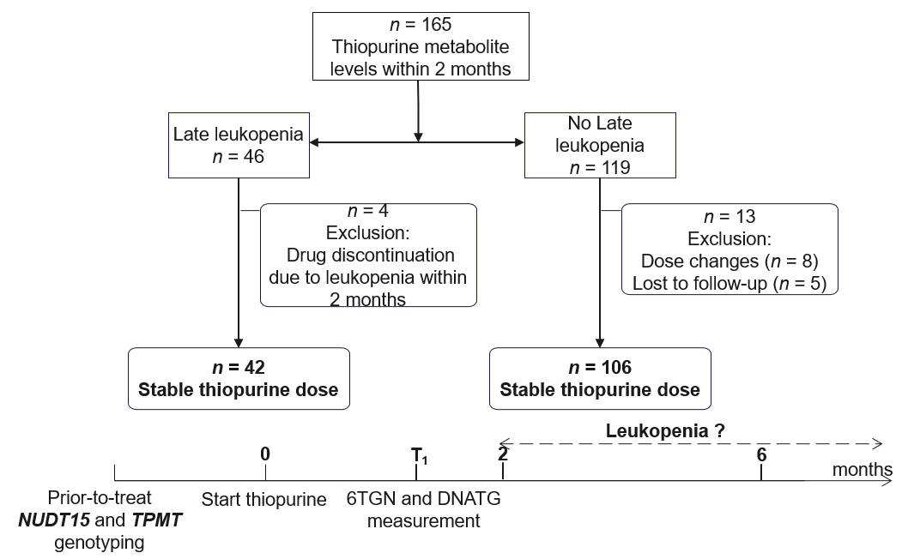
Figure 1 Flow chart of patient enrolment, exclusion, and follow-up. Late leucopenia was defined as a leukocyte count < 3.5 × 10⁹/L over two months. The stable dose (2.0 mg/kg/d azathioprine and 1.0 mg/kg/d 6-mercaptopurine, approximately) is reached approximately one to two weeks after the initial administration. NUDT15: Nudix hydrolase 15; TPMT: Thiopurine methyltransferase; 6TGN: 6-thioguanine nucleotides; DNATG: DNA-thioguanine.

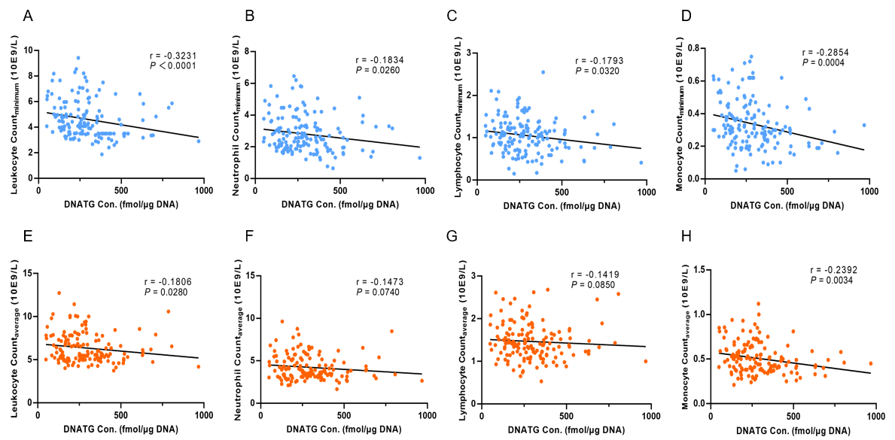
Figure 2 Correlation between early DNA-thioguanine concentration and peripheral leukocyte, neutrophil, lymphocyte, and monocyte counts. A-D: There was a significant negative correlation between early DNA-thioguanine (DNATG) concentration, and the minimum peripheral leukocyte, neutrophil, lymphocyte, and monocyte counts during follow-up; E-H: A marginally significant negative correlation was found between early DNATG concentration and the average peripheral leukocyte, neutrophil, lymphocyte, and monocyte counts. P values were determined by the nonparametric Spearman test. DNATG: DNA-thioguanine.

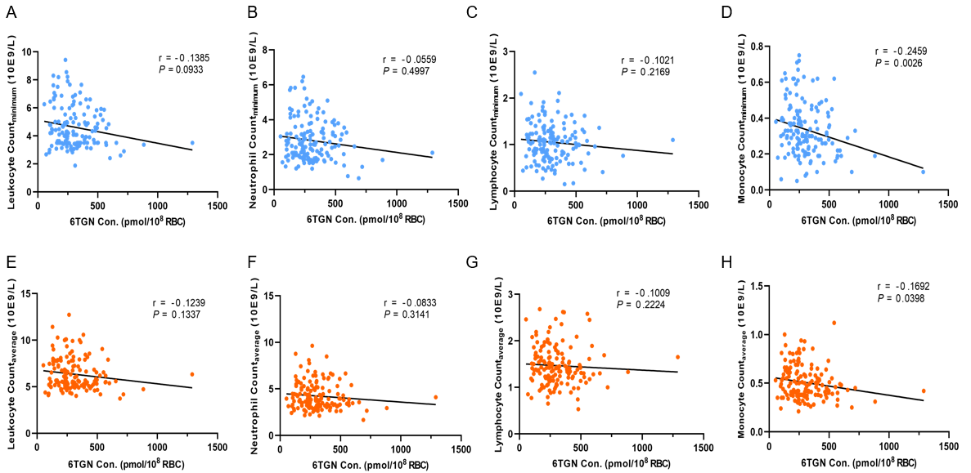
Figure 3 Correlation between early 6-thioguanine nucleotide concentration and peripheral leukocyte, neutrophil, lymphocyte, and monocyte counts. A-H: There was no significant correlation between early 6-thioguanine nucleotides (6TGN) concentration, and the minimum or average peripheral leukocyte, neutrophil, and lymphocyte counts during follow-up (P > 0.05) (A-C, E-G). There was a correlation between early 6TGN concentration and the minimum or average peripheral monocyte counts (P < 0.05) (D and H). P values were determined by the nonparametric Spearman test. 6TGN: 6-thioguanine nucleotides; RBC: Red blood cell.

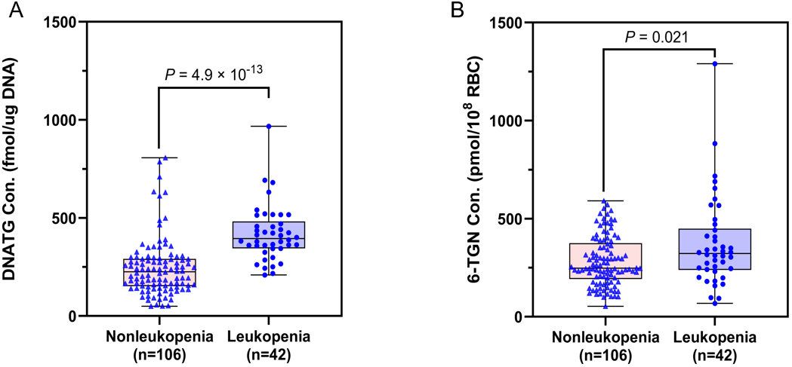
Figure 4 Early DNA-thioguanine concentration was associated with late leucopenia with immense significance compared to 6-thioguanine nucleotides. A: Patients who developed leucopenia had much higher early DNA-thioguanine levels compared with those who did not (P = 4.9 × 10⁻¹³); B: Patients who developed leucopenia had slightly higher early 6-thioguanine nucleotides levels compared with those who did not (P = 0.021). P values were determined by the Mann-Whitney test. 6TGN: 6-thioguanine nucleotides; DNATG: DNA-thioguanine.

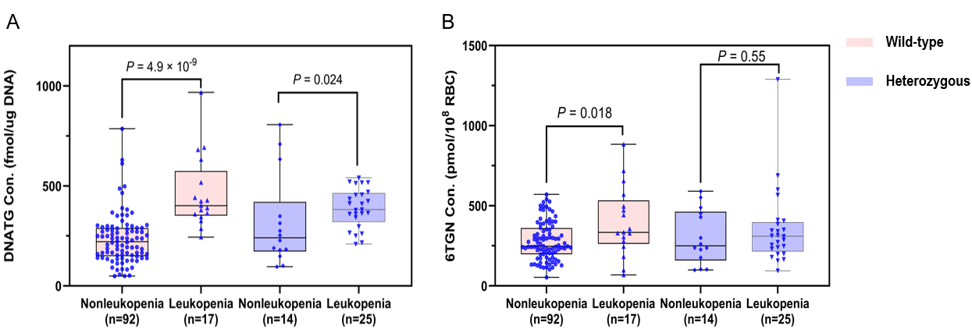
Figure 5 Early DNA-thioguanine concentration was significantly associated with late leucopenia, especially in thiopurine methyltransferase/nudix hydrolase 15 wild-type patients compared to 6-thioguanine nucleotides. A: Early DNA-thioguanine concentration was associated with late leucopenia, especially in nudix hydrolase 15 (NUDT15)/thiopurine methyltransferase (TPMT) wild-type patients (P = 4.9 × 10⁻⁹ vs P = 0.024); B: 6-thioguanine nucleotides was correlated with late leucopenia in NUDT15/TPMT wild-type patients (P = 0.018) but not in heterozygous subgroups (P =0.55). P values were determined by the Mann-Whitney test. 6TGN: 6-thioguanine nucleotides; DNATG: DNA-thioguanine; RBC: Red blood cell.

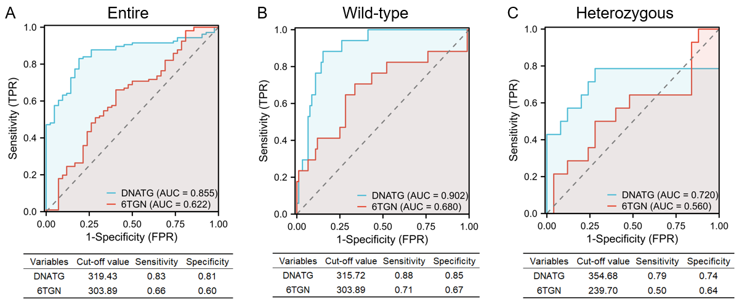
Figure 6 Performance of early DNA-thioguanine and 6-thioguanine nucleotides concentrations in the prediction of late leucopenia in the entire population, nudix hydrolase 15/thiopurine methyltransferase wild-type and heterozygous subgroups. A: Performance in the entire population; B: Performance in nudix hydrolase 15 (NUDT15)/thiopurine methyltransferase (TPMT) wild-type subgroups; C: Performance in NUDT15/TPMT heterozygous subgroups. 6TGN: 6-thioguanine nucleotides; DNATG: DNA-thioguanine; AUC: Area under the curve; FPR: False positive rate; TPR: True positive rate.

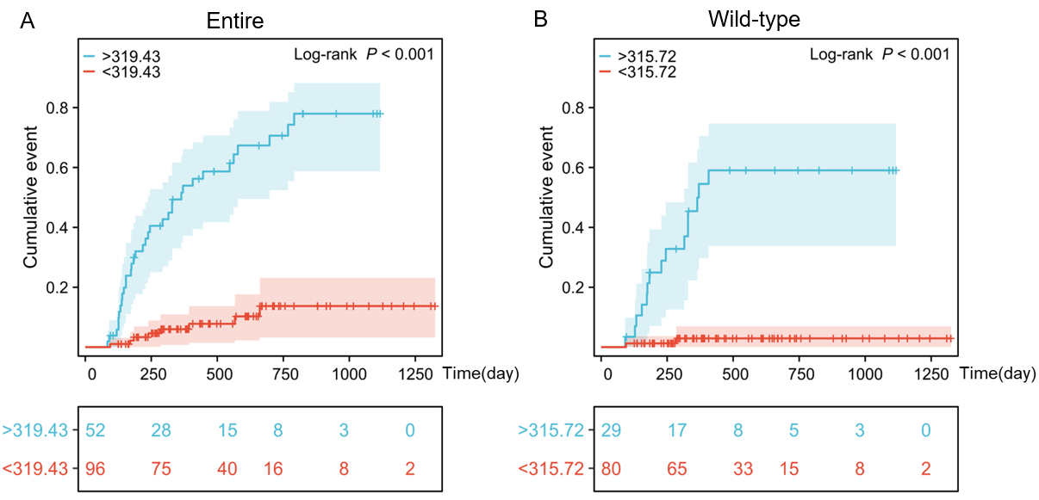
Figure 7 The cumulative events of leucopenia with corresponding DNA-thioguanine thresholds in the entire and thiopurine methyltransferase/nudix hydrolase 15 wild-type populations. A: Cumulative incidence rates were significantly greater in patients with DNA-thioguanine (DNATG) concentrations of more than 319.43 fmol/μg DNA in the entire population; B: Cumulative incidence rates were significantly greater in patients with DNATG concentrations of more than 315.72 fmol/μg DNA in the thiopurine methyltransferase/nudix hydrolase 15 wild-type population. Both log-rank P < 0.001. Kaplan-Meier survival analysis followed by the log-rank test was employed to estimate cumulative leucopenia events.

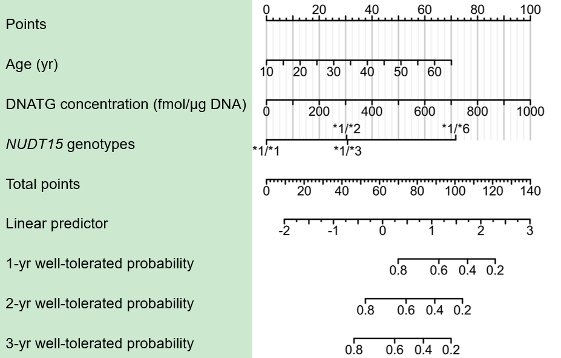
Figure 8 Nomogram based on the multivariate analysis results shown in Table 2. For example, a 65-year-old patient with the wild-type nudix hydrolase 15 (NUDT15)*1/*1, having a DNA-thioguanine (DNATG) concentration of 200 fmol/μg DNA, would score 70 for age, 20 for DNATG concentration, and 0 for the NUDT15 genotype, resulting in a total score of 90. Correspondingly, the estimated 1-year, 2-year, and 3-year well-tolerated (no occurrence of late leukopenia) probabilities are approximately 0.6, 0.4, and 0.3, respectively. DNATG: DNA-thioguanine; NUDT15: Nudix hydrolase 15.

Table 1 Baseline characteristics of the 148 patients included in the study
Characteristics | Patients |  | P value | Odds ratio (95%CI)
 | Leucopenia | Nonleucopenia
Number of subjects (%) | 42 (28.4) | 106 (71.6)
Female, n (%) | 14 (33.3) | 22 (20.8) | 0.11 | 1.91 (0.86-4.23)
Age (yr) | 29 (12-59) | 26 (13-61) | 0.03 | 0.96 (0.92-0.99)
Azathioprine, n (%) | 37 (26.6) | 102 (73.4) | Reference | 0.29 (0.07-1.14)
6-mercaptopurine, n (%) | 5 (55.6) | 4 (44.4) | 0.08 | 1.05 (1.01-1.10)
Thiopurine dose (mg) | 87.5 (25-100) | 75 (50-150) | 0.76 | 0.99 (0.98-1.01)
Azathioprine | 75 (25-100) | 75 (50-150)
6-mercaptopurine | 50 (37.5-50) | 37.5 (25-50)
Weight (kg) | 52 (40-69) | 55 (37-79) | 0.02 | 1.05 (1.01-1.10)
Hematologic indices
Leukocyte count (10⁹/L) | 6.25 (4.09-16.66) | 6.92 (4.09-17.60) | 0.83 | 1.31 (0.11-15.71)
Absolute neutrophil count (10⁹/L) | 3.98 (1.30-15.55) | 4.59 (1.91-14.76) | 0.78 | 0.70 (0.06-8.31)
Absolute lymphocyte count (10⁹/L) | 1.64 (0.41-4.45) | 1.53 (0.27-4.26) | 0.79 | 0.94 (0.57-1.53)
Monocyte count (10⁹/L) | 0.49 (0.22-1.98) | 0.57 (0.10-1.72) | 0.66 | 1.29 (0.42-3.91)
Hemoglobin (g/L) | 126 (76-165) | 130 (66-166) | 0.43 | 1.01 (0.99-1.02)
Platelets (10⁹/L) | 287 (122-589) | 302 (150-680) | 0.10 | 1.00 (0.99-1.01)
Comedication (%)
Anti-TNF agents | 2 (4.76) | 16 (15.09) | 0.49 | 0.46 (0.05-4.09)
Corticosteroids | 2 (4.76) | 5 (4.72) | 0.76 | 1.41 (0.16-12.47)
Genotypes (phenotypes)
NUDT15*1/*1 (NM) | 18 (42.86) | 93 (87.74) | Reference
NUDT15*1/*3 (IM) | 13 (30.95) | 8 (7.55) | 0.95 | 0.97 (0.34-2.72)
NUDT15*1/*2 (IM) | 9 (21.43) | 5 (4.72) | 0.61 | 1.42 (0.37-5.44)
NUDT15*1/*6 (IM) | 2 (4.76) | 0 | 0.99
TPMT*1/*1 (NM) | 40 (95.24) | 105 (99.06) | Reference
TPMT*1/*3C (IM) | 2 (4.76) | 1 (0.94) | 0.19 | 0.94 (0.47-2.35)
CI: Confidence interval; NM: Normal metabolizer; IM: Intermediate metabolizer; NUDT15: Nudix hydrolase 15; TPMT: Thiopurine methyltransferase.

Table 2 Univariate and multivariate analysis of independent predictors for leucopenia
Characteristics | Univariate analysis |  | Multivariate analysis
 | HR (95%CI) | P value | HR (95%CI) | P value
Age (yr) | 1.04 (1.01-1.08) | 0.005 | 1.06 (1.02-1.09) | 0.002
Weight (kg) | 0.95 (0.91-0.99) | 0.013 | 0.96 (0.92-1.00) | 0.076
DNATG (fmol/μg DNA) | 1.004 (1.002-1.005) | < 0.001 | 1.004 (1.002-1.005) | < 0.001
NUDT15 genotypes |  | < 0.001
NUDT15*1/*1 | Reference |  | Reference
NUDT15*1/*6 | 17.99 (3.95-81.90) | < 0.001 | 11.62 (1.51-89.26) | 0.018
NUDT15*1/*3 | 4.93 (2.41-10.10) | < 0.001 | 3.21 (1.54-6.71) | 0.002
NUDT15*1/*2 | 4.50 (2.01- 10.03) | < 0.001 | 3.25 (1.41-7.50) | 0.006
6TGN (pmol/8 × 10⁸ RBC) | 1.003 (1.001-1.004) | < 0.001 | 1.000 (0.998-1.002) | 0.98
Sex |  | 0.19
Female | Reference
Male | 0.64 (0.34-1.22) | 0.17
TPMT genotypes |  | 0.31
TPMT*1/*1 | Reference
TPMT*1/*3C | 2.38 (0.57-9.87) | 0.25
HR: Hazard ratio; CI: Confidence interval; NUDT15: Nudix hydrolase 15; TPMT: Thiopurine methyltransferase; 6TGN: 6-thioguanine nucleotides; DNATG: DNA-thioguanine; RBC: Red blood cell.

