Name of Journal: World Journal of Hepatology
Manuscript NO: 58594
Manuscript Type: CASE REPORT

Successful hepatic resection for recurrent hepatocellular carcinoma after lenvatinib treatment: A case report

Yokoo H et al. Hepatectomy for recurrent HCC after lenvatinib

Hideki Yokoo, Hiroyuki Takahashi, Masahiro Hagiwara, Hiroyoshi Iwata, Koji Imai, Yoshinori Saito, Naoto Matsuno, Hiroyuki Furukawa

Hideki Yokoo, Hiroyuki Takahashi, Masahiro Hagiwara, Hiroyoshi Iwata, Koji Imai, Naoto Matsuno, Hiroyuki Furukawa, Division of Hepato-Biliary-Pancreatic Surgery and Transplant Surgery, Department of Surgery, Asahikawa Medical University, Asahikawa 078-8510, Hokkaido, Japan

Yoshinori Saito, Department of Gastroenterology, Asahikawa-Kosei General Hospital, Asahikawa 078-8211, Hokkaido, Japan

Author contributions: Yokoo H, Takahashi H, Hagiwara M, Iwata H, and Imai K were the patient’s hepato-biliary-pancreatic surgeons, reviewed the literature, and contributed to manuscript drafting; Yokoo H, Takahashi H, and Saito Y analyzed and interpreted the imaging findings; Matsuno N and Furukawa H were responsible for the revision of the manuscript for important intellectual content; All authors issued final approval for the version to be submitted.

Corresponding author: Hideki Yokoo, MD, PhD, Associate Professor, Division of Hepato-Biliary-Pancreatic Surgery and Transplant Surgery, Department of Surgery, Asahikawa Medical University, 2-1 Midorigaoka-Higashi, Asahikawa 078-8510, Hokkaido, Japan. hidekiyokoo@asahikawa-med.ac.jp

Received: July 28, 2020
Revised: September 29, 2020
Accepted: October 21, 2020
Published online:

Abstract
BACKGROUND
Lenvatinib has been shown to be noninferior to sorafenib regarding prognosis and recurrence rate in patients with unresectable hepatocellular carcinoma (HCC) who have not received prior systemic chemotherapy. In patients treated with lenvatinib, 40% of cases achieved sufficient tumor reduction to make potential surgery possible. However, the outcomes of such surgery are unknown. We report a successful case of hepatic resection for recurrent HCC after lenvatinib treatment.

CASE SUMMARY
A 69-year-old man underwent right anterior sectionectomy for HCC in segment 8 of the liver. Ten months later, he was found to have an intrahepatic HCC recurrence that grew rapidly to 10 cm in diameter with sternal bone metastases. After confirming partial response to lenvatinib administration for 2 mo, a second hepatectomy was performed. Pathological examination showed that 80% of the tumor was necrotic. The patient did not develop any adverse effects under lenvatinib treatment. He was discharged at 25 d after surgery. Radiation therapy for bone metastases continued to be given under lenvatinib, and the patient has remained alive for 1 year after the second hepatectomy.

CONCLUSION
The prognosis of patients with recurrent HCC may be improved by liver resection combined with prior lenvatinib therapy.

Key Words: Conversion to surgery; Lenvatinib; Recurrent hepatocellular carcinoma; Case report; Neoadjuvant therapy; Molecular targeted therapy

Yokoo H, Takahashi H, Hagiwara M, Iwata H, Imai K, Saito Y, Matsuno N, Furukawa H. Successful hepatic resection for recurrent hepatocellular carcinoma after lenvatinib treatment: A case report. World J Hepatol 2020; In press

Core Tip: We report a case of intrahepatic hepatocellular carcinoma recurrence with rapid growth and sternal bone metastases after initial resection. A second surgery was successfully achieved after lenvatinib administration induced tumor shrinkage. Because the patient had bone metastases, multidisciplinary therapy, postoperative radiation therapy, and lenvatinib administration were performed, and the patient remains alive at 1 year postoperatively. In this case, lenvatinib induced a partial response for rapid growth of recurrent hepatocellular carcinoma with bone metastases, and conversion to surgery was successfully achieved for the purpose of controlling the intrahepatic lesion for the first time.
INTRODUCTION
The treatment strategy for hepatocellular carcinoma (HCC) has been established in various guidelines, including the Clinical Practice Guidelines for Hepatocellular Carcinoma in Japan^{[1]}, Barcelona Clinic Liver Cancer Guidelines^{[2]}, American Association for the Study of the Liver Diseases Guidelines^{[3]}, and European Association for the Study of the Liver European Organization for Research and Treatment of Cancer Guidelines^{[4]}. Hepatectomy is a potential curative treatment for early-stage HCC. However, the indications for liver resection are limited by tumor progression and liver function, and many cases are not eligible for resection. Transarterial chemoembolization(TACE) is commonly used for these unresectable cases, but the outcomes, especially of chemotherapy, have not been satisfactory compared with liver resection until recently^{[5,6]}.
Against this background, the systemic chemotherapy landscape for HCC changed more than a decade ago, with sorafenib demonstrating a survival benefit in the first-line setting and becoming the first systemic therapy to receive approval for HCC. More recently, regorafenib and ramucirumab have been approved in the second-line setting after sorafenib, and lenvatinib has emerged in the first-line setting after a positive phase 3 study^{[7-11]}. The advent of these effective molecular targeted agents has allowed multidisciplinary treatments combined with chemotherapy and liver resection for HCC.
Regarding colorectal cancer, there are many reports on postoperative adjuvant therapy to prevent recurrence after resection and preoperative neoadjuvant chemotherapy for colorectal cancer and its liver metastases^{[12-15]}. Thus, conversion therapy in colorectal cancer has become a routine practice. Although conversion therapy for HCC has not yet been established, lenvatinib is expected to be a possible candidate agent because it exhibited a tumor-reducing effect in 40% of cases in the REFLECT study^{[14]}. There is a possibility that patients with unresectable or recurrent HCC can be converted to surgery after lenvatinib treatment. In the present case, lenvatinib induced a partial response (PR) for rapid growth of recurrent HCC with bone metastases, and conversion to surgery was successfully achieved for the purpose of controlling the intrahepatic lesion.

CASE PRESENTATION
Chief complaints
The patient complained of general malaise.

History of present illness
A 69-year-old man was referred to our facility with a diagnosis of recurrent HCC. He had undergone right anterior sectionectomy for two tumors in segment 8 at another hospital 10 mo previously. The pathological diagnosis of the two tumors was moderately differentiated HCC and poorly differentiated HCC, respectively, without vascular invasion. The pathological stage was stage III according to the Union for International Cancer Control 8th edition.

History of past illness
The patient had undergone appendectomy for appendicitis at 27 years of age.

Personal and family history
The patient’s father had experienced lung cancer, and his sister had suffered from breast cancer.

Physical examination
On physical examination, the patient had a temperature of 36.6 °C, heart rate of 76 bpm, respiratory rate of 16 breaths/min, blood pressure of 143/86 mmHg, and oxygen saturation in room air of 98%. The patient’s weight was 59 kg. He had no jaundice or anemia in the bulbar conjunctiva. There was an operative scar for an inverted L-shaped incision on the abdomen from the previous liver resection. No ascites and encephalopathy were detected.

Laboratory examinations
The preoperative liver functional reserve was good. Laboratory data revealed serum albumin of 3.5 g/dL, total bilirubin of 0.9 mg/dL, prothrombin time of 93%, and indocyanine green retention rate at 15 min of 5.2%. The Child–Pugh score/classification was 5/A and the albumin-bilirubin (ALBI) score/modified ALBI grade was -2.19/2b. The alpha fetoprotein value was within the normal range, while the protein-induced vitamin K absence or antagonist II value was elevated at 998 mAU/mL.

Imaging examinations
A computed tomography scan of the abdomen demonstrated a heterogeneous contrast-enhanced mass of 10 cm in size in segment 7, which had rapidly increased in 5 mo (Figure 1A and 1B). The magnetic resonance imaging (MRI) images at 5 mo before the second operation are shown in Figure 2 (A: T1 image; B: T2 image). There was no evidence of the recurrent tumor on these MRI images. A positron emission tomography examination showed elevated standardized uptake volume in the sternum and slight uptake in the liver (Figure 3A and 3B). The patient was diagnosed as recurrent HCC in segment 7 of the liver with metastasis in the sternum.

MULTIDISCIPLINARY EXPERT CONSULTATION
Yoshinori Saito, MD, PhD, Chief, Department of Gastroenterology, Asahikawa-Kosei General Hospital
As a treatment strategy, we should administer lenvatinib at a dose of 8 mg because the patient weighed less than 60 kg to suppress the rapidly increasing intrahepatic lesion, and if the intrahepatic lesion exhibited shrinkage, we should surgically remove the lesion. The reason for choosing lenvatinib was that in addition to the intrahepatic recurrence, there was a sternal metastasis. Therefore, we considered that systemic therapy would be better than transcatheter therapy, such as B-TACE. The reason for not choosing surgical resection without prior lenvatinib was that the site of recurrence was rapidly increasing, and it was thought that new lesions might appear in other parts of the liver immediately after surgical resection. In addition, after surgical treatment, we should perform postoperative radiation therapy and treatment using molecular targeted drugs for the metastatic bone lesions.

FINAL DIAGNOSIS
Computed tomography imaging after 1 mo of lenvatinib administration revealed that 90% of the tumor had lost the contrast effect. The response evaluation was PR, though close to complete response by the modified Response Evaluation Criteria in Solid Tumors^{[16]} (Figure 1C and 1D). Protein-induced vitamin K absence or antagonist II decreased to 434 mAU/mL at 2 mo after the treatment (Figure 4).

TREATMENT
Because the intrahepatic recurrent tumor was reduced by administration of lenvatinib, hepatectomy of segment 7 was performed, with blood loss of 3913 mL and operation time of 545 min. Segments 5 and 6 were successfully preserved without bile duct injury (Figure 5). Histopathological findings showed that 80% of the tumor was necrotic, and the resected margin of the liver had no cancer component (Figure 6). The reason for choosing surgical resection after lenvatinib was that long-term administration of lenvatinib may result in decreased liver function such as decreased albumin, which can make surgery impossible. Early surgery was selected because it was unknown whether lenvatinib would result in a complete response, and it was better to aim for complete removal of the tumor by surgery.

OUTCOME AND FOLLOW-UP
No serious complications, such as bile leakage, were observed. The protein-induced vitamin K absence or antagonist II level decreased to the normal range after surgery (Figure 3). The patient was discharged on day 25 after the operation. Radiation therapy for bone metastases was performed by dividing 30 Gy irradiation into ten applications. At 1 mo after the end of radiotherapy, there was a small intrahepatic recurrence, and lenvatinib was immediately administered. PR was obtained, and the patient has remained alive on administration for 1 year after the second hepatectomy.

DISCUSSION
Here, we report a case in which lenvatinib was administered to a rapidly growing recurrent HCC, and conversion to hepatectomy was achieved after PR was obtained. There are previous case reports describing conversion to surgery for HCC after molecular targeted drug therapy with sorafenib and regorafenib^{[17,18]}. The present case report describing conversion to surgery for recurrent HCC after lenvatinib treatment appears to be the first case.
Numerous papers have been published on conversion to surgery for colorectal liver metastases^{[19,20]}. However, conversion therapy for HCC has not been established. Lenvatinib is expected to be a possible candidate agent and provides a new treatment perspective for recurrent HCC. To date, most reports have described cases of unresectable or recurrent HCC that were converted after local treatment, such as TACE and hepatic arterial infusion chemotherapy (HAIC), or after conventional anticancer drug treatment^{[21,22]}. For example, in a report from the MD Anderson Cancer Center^{[23]}, the chemotherapy regimen was cisplatin, interferon α-1b, doxorubicin, and 5-fluorouracil, but the doses and administration schedules had two types (conventional and modified). The study compared and examined the resection rate (conversion rate to curative surgery) and survival rate between the two regimens. In the results, the 3-yr survival rates were 70% for modified chemotherapy plus surgery (n = 11) compared with 20% for modified chemotherapy alone (n = 22) and 60% for conventional chemotherapy plus surgery (n = 8) compared with 5% for conventional chemotherapy alone (n = 76). Therefore, the cases with conversion to surgery showed better survival rates for both the conventional and modified regimens. There are various other reports on conversion to surgery. Hamaoka et al^{[22]} investigated the safety of hepatectomy and overall survival (OS) in 52 patients with unresectable advanced HCC treated with HAIC combined with three-dimensional chemoradiation therapy for portal vein tumor thrombus and compared the resection group with the nonresection group. As a result, OS was significantly higher in the resection group than in the nonresection group. A multivariate analysis identified conversion to surgery as an independent factor influencing OS.
A recent report described a case of HCC with hepatic vein tumor thrombosis protruding into the inferior vena cava that was successfully treated by surgery after second-line chemotherapy with regorafenib^{[24]}. Administration of sorafenib was initially started for this case, but 5 wk later the lesion had increased in size. Therefore, regorafenib was subsequently given as second-line therapy and administered for 12 mo. After shrinkage of the inferior vena cava-hepatic vein tumor thrombus, conversion to surgery was successful and a better prognosis was achieved. Meanwhile, Sato et al^{[25]} described a patient with initially unresectable HCC and an arterioportal shunt who underwent conversion hepatectomy after multidisciplinary treatment including lenvatinib^{[25]}.
Thus, it is expected that the number of conversion cases will increase with the advent of molecular targeted drugs thereby contributing to improvement in the prognosis of HCC. Similar to previous reports, our patient obtained PR for recurrent HCC after lenvatinib administration and conversion to surgery was achieved. Therefore, it is anticipated that survival can be prolonged by continuing treatment with lenvatinib for bone metastases only.
The limitation is that the administration period for the molecular targeted drug before surgery and the timing of conversion to surgery are unknown. Therefore, it is necessary to collect more cases and perform further studies to clarify these points.

CONCLUSION
In conclusion, we have reported a case of recurrent HCC in which PR was obtained and conversion to surgery was achieved after lenvatinib administration. We believe that even for unresectable advanced and recurrent HCC, hepatectomy can be performed after administration of molecular targeted therapeutic drugs such as lenvatinib and can thus contribute to improvement of the prognosis.

REFERENCES
1 Kokudo N, Takemura N, Hasegawa K, Takayama T, Kubo S, Shimada M, Nagano H, Hatano E, Izumi N, Kaneko S, Kudo M, Iijima H, Genda T, Tateishi R, Torimura T, Igaki H, Kobayashi S, Sakurai H, Murakami T, Watadani T, Matsuyama Y. Clinical practice guidelines for hepatocellular carcinoma: The Japan Society of Hepatology 2017 (4th JSH-HCC guidelines) 2019 update. Hepatol Res 2019; 49: 1109-1113 [PMID: 31336394 DOI: 10.1111/hepr.13411]
2 Llovet JM, Brú C, Bruix J. Prognosis of hepatocellular carcinoma: the BCLC staging classification. Semin Liver Dis 1999; 19: 329-338 [PMID: 10518312 DOI: 10.1055/s-2007-1007122]
3 Heimbach JK, Kulik LM, Finn RS, Sirlin CB, Abecassis MM, Roberts LR, Zhu AX, Murad MH, Marrero JA. AASLD guidelines for the treatment of hepatocellular carcinoma. Hepatology 2018; 67: 358-380 [PMID: 28130846 DOI: 10.1002/hep.29086]
4 European Association for the Study of the Liver. EASL Clinical Practice Guidelines: Management of hepatocellular carcinoma. J Hepatol 2018; 69: 182-236 [PMID: 29628281 DOI: 10.1016/j.jhep.2018.03.019]
5 Luo J, Guo RP, Lai EC, Zhang YJ, Lau WY, Chen MS, Shi M. Transarterial chemoembolization for unresectable hepatocellular carcinoma with portal vein tumor thrombosis: a prospective comparative study. Ann Surg Oncol 2011; 18: 413-420 [PMID: 20839057 DOI: 10.1245/s10434-010-1321-8]
6 Eun JR, Lee HJ, Moon HJ, Kim TN, Kim JW, Chang JC. Hepatic arterial infusion chemotherapy using high-dose 5-fluorouracil and cisplatin with or without interferon-alpha for the treatment of advanced hepatocellular carcinoma with portal vein tumor thrombosis. Scand J Gastroenterol 2009; 44: 1477-1486 [PMID: 19958061 DOI: 10.3109/00365520903367262]
7 Llovet JM, Ricci S, Mazzaferro V, Hilgard P, Gane E, Blanc JF, de Oliveira AC, Santoro A, Raoul JL, Forner A, Schwartz M, Porta C, Zeuzem S, Bolondi L, Greten TF, Galle PR, Seitz JF, Borbath I, Häussinger D, Giannaris T, Shan M, Moscovici M, Voliotis D, Bruix J; SHARP Investigators Study Group. Sorafenib in advanced hepatocellular carcinoma. N Engl J Med 2008; 359: 378-390 [PMID: 18650514 DOI: 10.1056/NEJMoa0708857]
8 Cheng AL, Kang YK, Chen Z, Tsao CJ, Qin S, Kim JS, Luo R, Feng J, Ye S, Yang TS, Xu J, Sun Y, Liang H, Liu J, Wang J, Tak WY, Pan H, Burock K, Zou J, Voliotis D, Guan Z. Efficacy and safety of sorafenib in patients in the Asia-Pacific region with advanced hepatocellular carcinoma: a phase III randomised, double-blind, placebo-controlled trial. Lancet Oncol 2009; 10: 25-34 [PMID: 19095497 DOI: 10.1016/S1470-2045(08)70285-7]
9 Bruix J, Qin S, Merle P, Granito A, Huang YH, Bodoky G, Pracht M, Yokosuka O, Rosmorduc O, Breder V, Gerolami R, Masi G, Ross PJ, Song T, Bronowicki JP, Ollivier-Hourmand I, Kudo M, Cheng AL, Llovet JM, Finn RS, LeBerre MA, Baumhauer A, Meinhardt G, Han G; RESORCE Investigators. Regorafenib for patients with hepatocellular carcinoma who progressed on sorafenib treatment (RESORCE): a randomised, double-blind, placebo-controlled, phase 3 trial. Lancet 2017; 389: 56-66 [PMID: 27932229 DOI: 10.1016/S0140-6736(16)32453-9]
10 Kudo M, Finn RS, Qin S, Han KH, Ikeda K, Piscaglia F, Baron A, Park JW, Han G, Jassem J, Blanc JF, Vogel A, Komov D, Evans TRJ, Lopez C, Dutcus C, Guo M, Saito K, Kraljevic S, Tamai T, Ren M, Cheng AL. Lenvatinib vs sorafenib in first-line treatment of patients with unresectable hepatocellular carcinoma: a randomised phase 3 non-inferiority trial. Lancet 2018; 391: 1163-1173 [PMID: 29433850 DOI: 10.1016/S0140-6736(18)30207-1]
11 Zhu AX, Kang YK, Yen CJ, Finn RS, Galle PR, Llovet JM, Assenat E, Brandi G, Pracht M, Lim HY, Rau KM, Motomura K, Ohno I, Merle P, Daniele B, Shin DB, Gerken G, Borg C, Hiriart JB, Okusaka T, Morimoto M, Hsu Y, Abada PB, Kudo M; REACH-2 study investigators. Ramucirumab after sorafenib in patients with advanced hepatocellular carcinoma and increased α-fetoprotein concentrations (REACH-2): a randomised, double-blind, placebo-controlled, phase 3 trial. Lancet Oncol 2019; 20: 282-296 [PMID: 30665869 DOI: 10.1016/S1470-2045(18)30937-9]
12 Mitry E, Fields AL, Bleiberg H, Labianca R, Portier G, Tu D, Nitti D, Torri V, Elias D, O'Callaghan C, Langer B, Martignoni G, Bouché O, Lazorthes F, Van Cutsem E, Bedenne L, Moore MJ, Rougier P. Adjuvant chemotherapy after potentially curative resection of metastases from colorectal cancer: a pooled analysis of two randomized trials. J Clin Oncol 2008; 26: 4906-4911 [PMID: 18794541 DOI: 10.1200/JCO.2008.17.3781]
13 Hasegawa K, Saiura A, Takayama T, Miyagawa S, Yamamoto J, Ijichi M, Teruya M, Yoshimi F, Kawasaki S, Koyama H, Oba M, Takahashi M, Mizunuma N, Matsuyama Y, Watanabe T, Makuuchi M, Kokudo N. Adjuvant Oral Uracil-Tegafur with Leucovorin for Colorectal Cancer Liver Metastases: A Randomized Controlled Trial. PLoS One 2016; 11: e0162400 [PMID: 27588959 DOI: 10.1371/journal.pone.0162400]
14 Foubert F, Matysiak-Budnik T, Touchefeu Y. Options for metastatic colorectal cancer beyond the second line of treatment. Dig Liver Dis 2014; 46: 105-112 [PMID: 23954144 DOI: 10.1016/j.dld.2013.07.002]
15 Saltz LB, Clarke S, Díaz-Rubio E, Scheithauer W, Figer A, Wong R, Koski S, Lichinitser M, Yang TS, Rivera F, Couture F, Sirzén F, Cassidy J. Bevacizumab in combination with oxaliplatin-based chemotherapy as first-line therapy in metastatic colorectal cancer: a randomized phase III study. J Clin Oncol 2008; 26: 2013-2019 [PMID: 18421054 DOI: 10.1200/JCO.2007.14.9930]
16 Lencioni R, Llovet JM. Modified RECIST (mRECIST) assessment for hepatocellular carcinoma. Semin Liver Dis 2010; 30: 52-60 [PMID: 20175033 DOI: 10.1055/s-0030-1247132]
17 Nakamura K, Beppu T, Hayashi H, Okabe H, Imai K, Nitta H, Chikamoto A, Ishiko T, Sasaki M, Baba H. Recurrence-free survival of a hepatocellular carcinoma patient with tumor thrombosis of the inferior vena cava after treatment with sorafenib and hepatic resection. Int Surg 2015; 100: 908-914 [PMID: 26011214 DOI: 10.9738/INTSURG-D-14-00133.1]
18 Barbier L, Fuks D, Pessaux P, Muscari F, Le Treut YP, Faivre S, Belghiti J. Safety of liver resection for hepatocellular carcinoma after sorafenib therapy: a multicenter case-matched study. Ann Surg Oncol 2013; 20: 3603-3609 [PMID: 23715965 DOI: 10.1245/s10434-013-3029-z]
19 Tomasello G, Petrelli F, Ghidini M, Russo A, Passalacqua R, Barni S. FOLFOXIRI Plus Bevacizumab as Conversion Therapy for Patients With Initially Unresectable Metastatic Colorectal Cancer: A Systematic Review and Pooled Analysis. JAMA Oncol 2017; 3: e170278 [PMID: 28542671 DOI: 10.1001/jamaoncol.2017.0278]
20 Morine Y, Ikemoto T, Iwahashi S, Saito YU, Yamada S, Takasu C, Higashijima J, Imura S, Shimada M. Clinical Impact of FOLFOXIRI Aiming for Conversion Surgery in Unresectable Multiple Colorectal Liver Metastasis. Anticancer Res 2019; 39: 5089-5096 [PMID: 31519620 DOI: 10.21873/anticanres.13703]
21 Kishi Y, Saiura A, Yamamoto J, Koga R, Seki M, Morimura R, Yoshioka R, Kokudo N, Yamaguchi T. Preoperative transarterial chemoembolization for hepatocellular carcinoma. Hepatogastroenterology 2012; 59: 2295-2299 [PMID: 23435144]
22 Hamaoka M, Kobayashi T, Kuroda S, Iwako H, Okimoto S, Kimura T, Aikata H, Nagata Y, Chayama K, Ohdan H. Hepatectomy after down-staging of hepatocellular carcinoma with portal vein tumor thrombus using chemoradiotherapy: A retrospective cohort study. Int J Surg 2017; 44: 223-228 [PMID: 28676383 DOI: 10.1016/j.ijsu.2017.06.082]
23 Kaseb AO, Shindoh J, Patt YZ, Roses RE, Zimmitti G, Lozano RD, Hassan MM, Hassabo HM, Curley SA, Aloia TA, Abbruzzese JL, Vauthey JN. Modified cisplatin/interferon α-2b/doxorubicin/5-fluorouracil (PIAF) chemotherapy in patients with no hepatitis or cirrhosis is associated with improved response rate, resectability, and survival of initially unresectable hepatocellular carcinoma. Cancer 2013; 119: 3334-3342 [PMID: 23821538 DOI: 10.1002/cncr.28209]
24 Takeda K, Tsurumaru Y, Yamamoto Y, Araki K, Kogure Y, Mori K, Nakagawa K, Shimizu T, Matsuda G, Niino H, Sekido H, Kobayashi S, Morimoto M, Kunisaki C, Endo I. Treatment of hepatocellular carcinoma with hepatic vein tumor thrombosis protruding into the inferior vena cava by conversion surgery following chemotherapy with regorafenib: a case report. Clin J Gastroenterol 2020; 13: 428-433 [PMID: 31970661 DOI: 10.1007/s12328-019-01077-4]
25 Sato N, Beppu T, Kinoshita K, Yuki H, Suyama K, Chiyonaga S, Motohara T, Komohara Y, Hara A, Akahoshi S. Conversion Hepatectomy for Huge Hepatocellular Carcinoma With Arterioportal Shunt After Chemoembolization and Lenvatinib Therapy. Anticancer Res 2019; 39: 5695-5701 [PMID: 31570469 DOI: 10.21873/anticanres.13768]

Footnotes
Informed consent statement: Informed written consent was obtained from the patient for publication of this report and any accompanying images.

Conflict-of-interest statement: The authors declare that they have no conflict of interest.

CARE Checklist (2016) statement: The authors have read the CARE Checklist (2016), and the manuscript was prepared and revised according to the CARE Checklist (2016).

Open-Access: This article is an open-access article that was selected by an in-house editor and fully peer-reviewed by external reviewers. It is distributed in accordance with the Creative Commons Attribution NonCommercial (CC BY-NC 4.0) license, which permits others to distribute, remix, adapt, build upon this work non-commercially, and license their derivative works on different terms, provided the original work is properly cited and the use is non-commercial. See: http://creativecommons.org/Licenses/by-nc/4.0/

Manuscript source: Invited manuscript

Peer-review started: July 28, 2020
First decision: September 17, 2020
Article in press:

Specialty type: Gastroenterology and hepatology
Country/Territory of origin: Japan
Peer-review report’s scientific quality classification
Grade A (Excellent): 0
Grade B (Very good): B
Grade C (Good): C, C
Grade D (Fair): 0
Grade E (Poor): 0

P-Reviewer: Eso Y, Tuo BG S-Editor: Gao CC L-Editor: Filipodia P-Editor:

Figure Legends
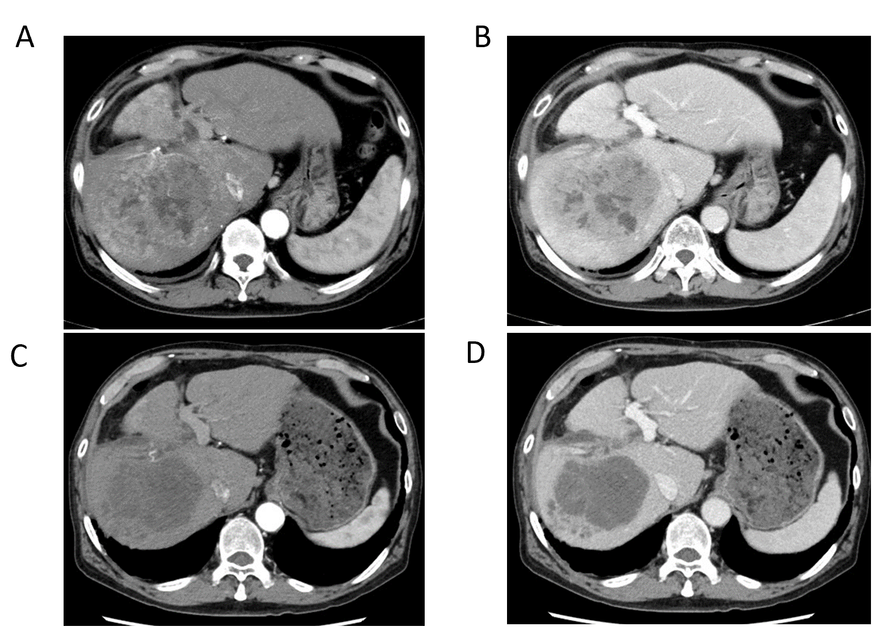
Figure 1 Preoperative computed tomography findings. Before lenvatinib administration, tumor stain was observed in the arterial phase and washout was observed in the portal phase. After lenvatinib administration, the tumor stain disappeared in the arterial phase, and the tumor size was found to have decreased slightly in the portal phase. A and B: Images of the arterial phase (A) and portal phase (B) before administration of lenvatinib; C and D: Images of the arterial phase (C) and portal phase (D) after lenvatinib administration.
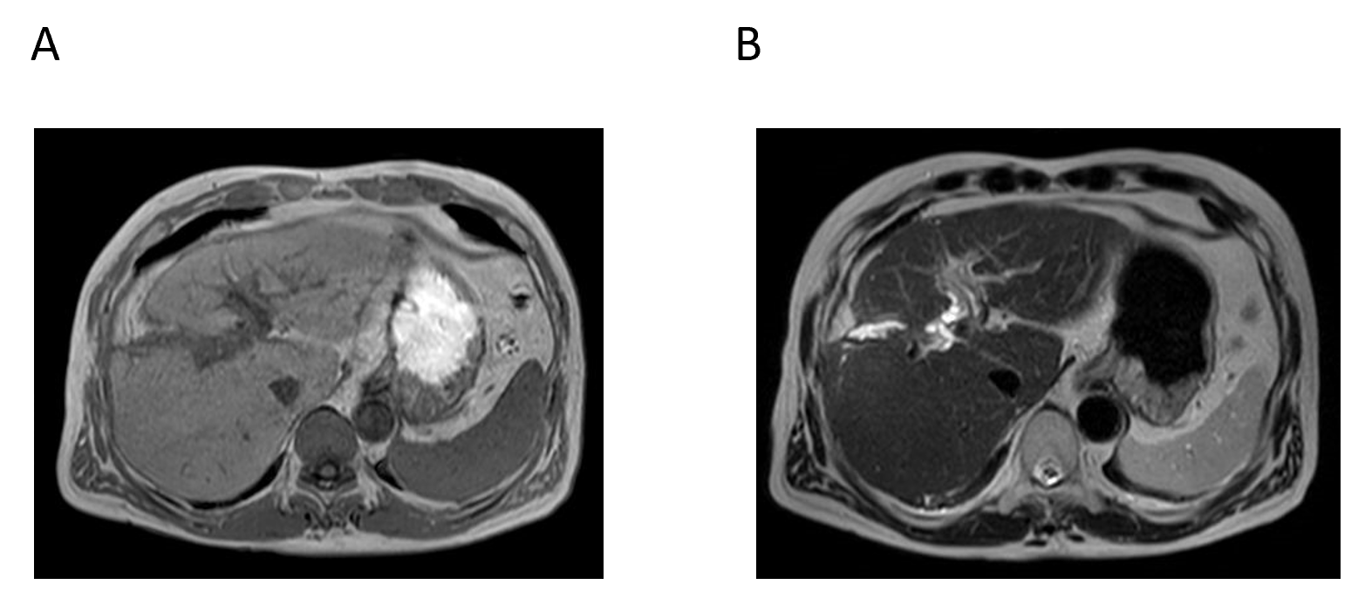
Figure 2 Magnetic resonance imaging findings at 5 mo before the second operation. There was no evidence of the recurrent tumor on the magnetic resonance imagines. A: T1 image; B: T2 image.
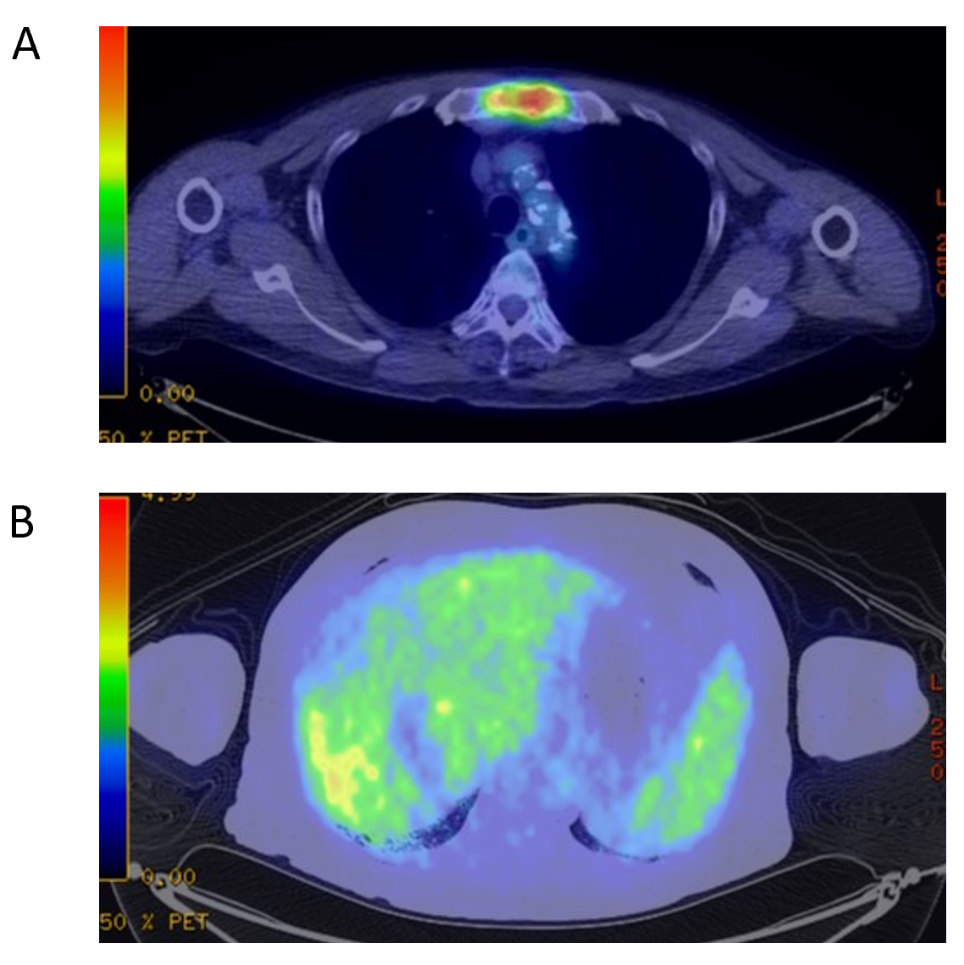
Figure 3 Preoperative fluorodeoxyglucose-positron emission tomography-computed tomography. A: The positron emission tomography-computed tomography scan revealed accumulation of fluorodeoxyglucose in the sternum. The diagnosis was bone metastases of hepatocellular carcinoma; B: Slight uptake was observed in the liver.
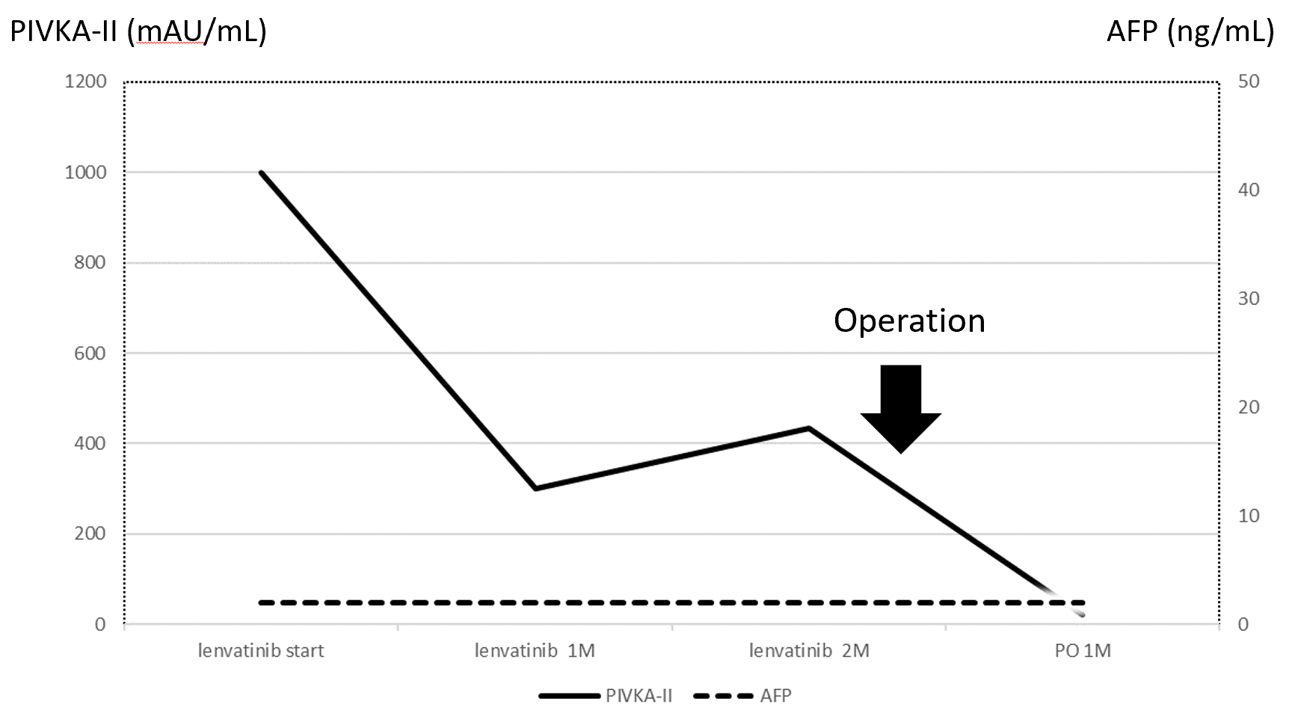
Figure 4 Perioperative tumor marker changes. The protein-induced vitamin K absence or antagonist II level before lenvatinib administration was high at 998 mAU/mL. The protein-induced vitamin K absence or antagonist II level decreased to 434 mAU/mL at 2 mo after lenvatinib administration, and further decreased to 20 mAU/mL at 1 mo after the second surgery. AFP: α-Fetoprotein; M: Month; PO: Post-operation; PIVKA-II: Protein-induced vitamin K absence or antagonist II.
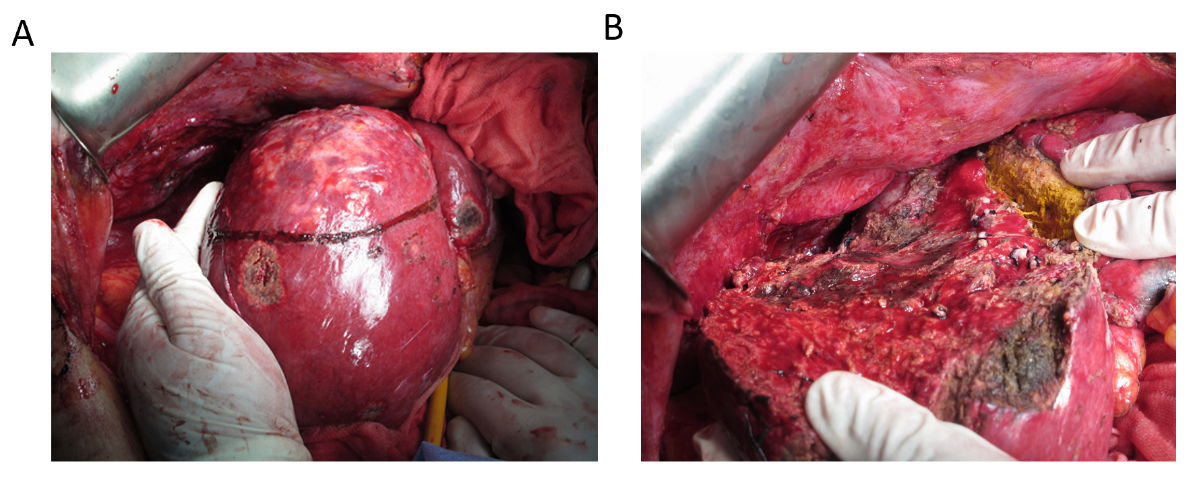
Figure 5 Surgical findings. Findings before (A) and after (B) the second hepatectomy.
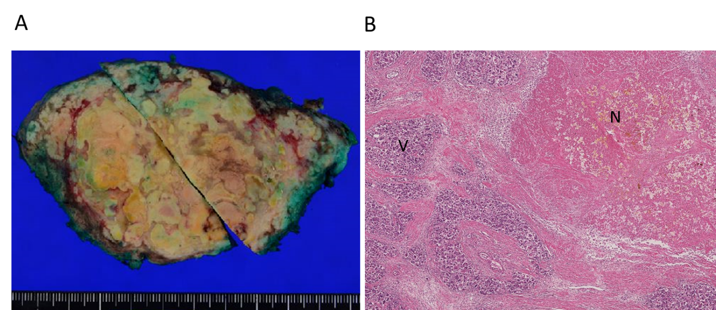
Figure 6 Macroscopic and pathological findings of the resected specimen. The findings revealed that 80% of the tumor was necrotic and the resected margin of the cut liver surface showed no cancer component. A: Macroscopic findings; B: Pathological findings. N: Necrotic lesion; V: Viable lesion.

