Name of Journal: World Journal of Gastroenterology
ESPS Manuscript NO: 31784
Manuscript Type: CASE REPORT

Multiple clear-cell sarcomas of small intestine with parotid gland metastasis: A case report

Hao Su et al. clear cell sarcoma of gastrointestinal tract

Hao Su, Wen-Hao Ren, Peng Wang, Lei Shi, Hai-Tao Zhou

Hao Su, Peng Wang, Lei Shi, Hai-Tao Zhou, Department of Colorectal Surgery, Cancer Hospital, Chinese Academy of Medical Science and Peking Union Medical College, Beijing 100021, China

Wen-Hao Ren, Department of Pathology, Cancer Hospital, Chinese Academy of Medical Science and Peking Union Medical College, Beijing 100021, China

Author contributions: Su H collected the data and drafted the manuscript; Zhou HT designed the study and helped revise the manuscript; Ren WH participated in the descriptions and detailed discussions of the postoperative pathology; Shi L conceived the study and participated in its coordination; Wang P participated in the data interpretation; All authors read and approved the final manuscript.

Institutional review board statement: This case report was exempt from the Institutional Review Board standards at Cancer Hospital, Chinese Academy of Medical Science and Peking Union Medical College.

Informed consent statement: The patient involved in this study gave her written informed consent authorizing use and disclosure of her protected health information.

Conflict-of-interest statement: All the authors have no conflicts of interests to declare.

Open-Access: This article is an open-access article which was selected by an in-house editor and fully peer-reviewed by external reviewers. It is distributed in accordance with the Creative Commons Attribution Non Commercial (CC BY-NC 4.0) license, which permits others to distribute, remix, adapt, build upon this work non-commercially, and license their derivative works on different terms, provided the original work is properly cited and the use is non-commercial. See: http://creativecommons.org/licenses/bync/4.0/

Manuscript source: Unsolicited manuscript

correspondence to: Hai-Tao Zhou, MD, Professor, Department of Colorectal Surgery, Cancer Hospital, Chinese Academy of Medical Science and Peking Union Medical College, No. 17, Pan jia yuan Nan li, Chaoyang district, Beijing 100021, China. zhouhaitao01745@163.com
Telephone: +86-10-67787110
Fax: +86-10-67787110

Received: December 6, 2016
Peer-review started: December 8, 2016
First decision: January 10, 2017
Revised: January 23, 2017
Accepted: February 16, 2017
Article in press:
Published online:
Abstract
Clear-cell sarcoma is a rare, malignant soft tissue tumor that displays melanocytic differentiation with a distinct molecular profile. It is rarely localized in the gastrointestinal tract. Herein we reported a case of multiple synchronous clear-cell sarcomas of the gastrointestinal tract with parotid gland metastasis. A 51-year-old male patient presented with a growing painless mass lesion under the right ear. A preoperative positron emission tomography/computed tomography showed multiple intestinal masses and a mass in the right parotid with increased glucose uptake, and he subsequently underwent operative treatment with resection of three tumors in the jejunum and ileum and then received a right parotidectomy. Postoperative pathological examination showed cells in the intestinal tumor were consistent with clear-cell sarcoma of the gastrointestinal tract, and the malignant cells in the parotid gland were similar to the intestinal tumor. Immunohistochemical studies revealed positive expression of HMB-45, Melan-A, and S-100. EWSR1 gene fusion transcripts were undetectable by fluorescence in situ hybridization.

Key words: Clear-cell sarcomas; Clear-cell sarcomas of the gastrointestinal tract; Parotid gland metastasis; Immunohistochemistry

© The Author(s) 2017. Published by Baishideng Publishing Group Inc. All rights reserved.

Core tip: Over the past 13 years, only 53 cases of clear-cell sarcomas of the gastrointestinal tract have been reported in the world. Most of the literature on clear-cell sarcoma of the gastrointestinal tract (CCS-GI) describes a single tumor in the diagnosis; our presentation is the third report of simultaneous tumors during the diagnosis to date and is the first case of CCS-GI with metastasis to the parotid gland. Our article reviewed all cases of CCS-GI in the literature to date. Because of the high rarity, more cases need to be accumulated for further analysis.

Su H, Ren WH, Wang P, Shi L, Zhou HT. Multiple clear cell sarcomas of small intestine with parotid gland metastasis: a case report. World J Gastroenterol 2017; In press

INTRODUCTION
Clear-cell sarcoma (CCS) is a rare tumor of unknown cell origin that was first described by Enzinger et al^{[1]} in 1965. CCS shows a predilection for the tendons or aponeuroses in the extremities in young adults 20-40 years old ^{[2]}. Ekfors et al^{[3]} described the first clear-cell sarcoma of the gastrointestinal tract (CCS-GI) in1993, which occurred in the duodenum. Only finger countable cases^{[4]} of CCS-GI have been reported in the literature to date, but CCS-GI shows specific histopathological, immunohistochemical, and genetic features. Here, we presented a case of three synchronous clear-cell sarcomas in the jejunum and ileum with parotid gland metastasis.

Case report
Patient details
A 51-year-old male presented with a two-year history of a growing painless mass lesion under the right ear, initially the size of a soybean. The mass grew noticeably in the last six months. There was a one-year history of night sweats and frequent stool (three to four times a day). There was no history of fever, weakness, dysphagia, dyspnea, cough, hoarseness, jaundice, vomiting, melena, hematochezia, abdominal pain, abdominal distension or significant weight loss. The patient had a 5-year medical history of hypertension and he was a hepatitis-B carrier of 30 years and a smoker of 40 pack-years. There was no family history of cancer.
On palpation, a 20 mm×20 mm relatively well-defined and soft mass with no tenderness was observed along with multiple enlarged cervical nodules. Abdominal examination did not reveal any organomegaly or palpable lumps.
Ultrasonography of the neck two months ago revealed a relatively undefined hypoechoic mass measuring approximately 15 mm×27 mm in its greatest dimension in the right parotid gland and submandibular gland (Figure 1) along with compared with multiple enlarged right supraclavicular and upper cervical lymph nodes. A needle biopsy of the mass was performed and the pathologic report found malignant tumor cells. The patient was recommended for surgery for the mass in the parotid gland. The preoperative blood routine examination showed that the HGB was 106 g/L. Therefore, the patient underwent positron emission tomography/computed tomography (PET/CT). A 36 mm×33 mm intestinal mass with increased glucose uptake, and multiple peripheral lymph nodes in the right mid-abdomen were found (Figure 2), and the maximum standard uptake values (SUV) was 6.6. An intestinal lesion with increased glucose uptake in the right hypogastrium was also seen and the SUV was 7.0. The mass in the right parotid and peripheral lymph nodes were also compared with increased glucose uptake, and the SUV was 10.3. Preoperative tumor maker, such as CA125, CA15-3, CA19-9,CA72-4, AFP, cyfra21-1, NSE,SCC, CEA, and ProGRP, did not show abnormal expression.

Treatment
The patient received an exploratory laparotomy and the excision of multiple intestinal neoplasms. Operative exploration showed no ascites, pelvic, periaortic, peritoneal, omental deposits, or liver metastasis. No tumors were palpated in the cavity of the stomach, duodenum, colon, rectum, or the mesentery root. Three masses were found at the jejunum and ileum. Intra-operatively, the first tumor was present in the jejunum, located at 80 cm distal to the duodenojejunal junction. Intussusception was observed from here, and the involved bowels were swelled and expanded (Figure 3). The second tumor was at end of the intussusception (approximately at the fourth group of intestines). The third tumor was present in the ileum, located at 80 cm proximal to the ileocecal junction. The three tumors of varying sizes invaded the serosa, and the surface of serosa shrunk and was depressed. Multiple enlarged lymph nodes were observed in the intestinal mesentery. Following serial ligation of the mesenteric vessels, resection of the involved bowels with the masses and mesentery was performed with a proximal margin of 10 cm and a distal margin of 10 cm. The first tumor and the second tumor were removed together in one segment of the intestine (Figure 4a and 4b). Then, a primary anastomosis formed. The patient recovered gradually and then received a right parotidectomy with retaining facial nerve and right cervical lymph node dissection 17 d after abdominal surgery because the pathology of the parotid gland neoplasms was not clear, and there were only solitary parotid gland and local cervical lymph node metastasis detected by PET/CT.

Postoperative pathology
Intestinal neoplasms: Grossly, the specimen consisted of two segments of the small intestine; the larger was approximately 26 cm in length with attached mesentery, and the other segment was 7.8 cm with attached mesentery. Two tumors were on the larger intestine; 11 cm from one margin there was a 2.5 cm× 2.2 cm× 1 cm tumor and 19 cm from the same margin there was a 6.5 × 5.5 × 4 cm tumor. A 2.5 cm× 1.9 cm× 1 cm tumor was on the other segment of small intestine. The cut surface of the three tumors had hard, obscure borders, white to tan in appearance.
Microscopically, the jejunum and ileum tissues were infiltrated with malignant cells, which was consistent with CCS-GI (a type of gastrointestinal neural ectoderm tumors, GNET) by morphology and immunohistochemistry (Figure 5a). The tumors invaded the mucosal and muscular layers. There was no exact focal necrosis, vessel invasion or nerve invasion. The mitotic index exceeded 20/10 HPF, and the tumor was grade G3 according to the FNCLL (French Fédération Nationale des Centres de Lutte Contre le Cancer) system.
Lymph node metastases (1/29), not invading outside lymph node capsule: (1) Peripheral lymph nodes of jejunum 1/26; and (2)Peripheral lymph nodes of ileum 0/3.
Immunohistochemistry: S100 (3+), Vim (3+), GFAP (-), HMB-45 (2+), Melan-A (2+), Melanomapan (1+), CD56 (2+), Syn (-), CgA (-), AE1/AE3 (-), CD138 (-), CD19 (-), CD20 (-), CD3 (-), CD38 (-), CD79a (-), Ki-67 (+40%), LCA (-), MUM1 (-), CD117 (lesion+), CD34 (-), DOG1 (-), CD10 (-), Calponin (-), P63 (-), EBER (-).
Gene detection: EWSR1 gene fusion transcripts were undetectable by fluorescence in situ hybridization (FISH).

Parotid gland neoplasms: Grossly, a 1 cm diameter nodule was found in 5.5 cm× 3 cm× 2 cm tissues; the cut surface of the nodule had a tough, grey to yellow appearance.
Microscopically, parotid gland tissues were infiltrated with malignant cells, which was consistent with clear-cell sarcoma morphology and immunohistochemistry and similar to the previous intestinal tumor morphologically (Figure 5b). Lymph tissues were found in the tumor and tumor edge, which may be metastatic lesions.
No lymph node metastases (0/30): (1) right cervical lymph nodes level II 0/10; (2) right cervical lymph nodes level III 0/12; (3) right cervical lymph nodes level V 0/5; (4) peripheral lymph nodes of superficial lobe of right parotid gland 0/2; (5) peripheral lymph nodes of caudate lobe of right parotid gland and tumor 0/1.
Immunohistochemistry: S100 (3+), Melan-A (3+), Melanomapan (3+), HMB-45 (3+), AE1/AE3 (-), CK18 (-), Calponin (-), P63 (-), SMA (-).

Follow-up
Twenty days after the surgery on the parotid gland, the patient received computed tomography (CT) imaging of the neck, thorax and abdominopelvic area; no recurrence or metastasis was observed. Then, he began 6 cycles of chemotherapy with the regimen of EI (Epirubicin 100 mg + Ifosfamide 2 g D1-4+Mesna 0.4 g 0 h, 4 h, 8 h after the Ifosfamide D1-4). At the time this article was written, the patient was in the first cycle of the chemotherapy.

Discussion
CCS-GI is so rare that only 53 cases (including our case) have been reported in the literature to date (Table 1)^{[3,5-39]}. Most of the literature on CCS-GI describes a single tumor in the diagnosis; only two cases^{[25,38]} report two simultaneous tumors during the diagnosis to date. CCS-GI often involves the ileum and jejunum, stomach and colon^{[4-7,9-12,14-35,38,39]}. Because of the aggressive clinical course, regional and distant metastases are common in CCS-GI at presentation[5-7,9,10,15,17,21,25,27,29,31,37,39]. Lymph nodes, liver, and mesentery are the most common destinations of metastases at the time of presentation. The patient in our report had three synchronous masses in in the jejunum and ileum, with a metastasis to the parotid gland, and he came to the hospital mainly due to the swollen parotid gland. Lymph nodes inside and outside of parotid gland make it a common metastatic destination for head and neck neoplasms^{[40]}, but it is very rare for gastrointestinal tumors. Among the limited literature on CCS-GI, this is the first case of CCS-GI with metastasis to the parotid gland.
CCS-GI shows specific histopathological, immunohistochemical, ultrastructural, and genetic features^{[2,4]}. In 2010, Kosemehmetoglu et al^{[41]} first divided CCS-GI into two subtypes according to the histomorphology: (1) clear-cell sarcoma-like gastrointestinal tumor (CCSLGT); and (2) clear-cell sarcoma of soft tissue (CCS-ST). However, there was disagreement about whether they were two independent entities^{[31]}. In 2003, Zambranode et al^{[10]} reported 6 cases of CCSLGTs. They found CCSLGT was at least focally positive for the S100 protein, but most did not express melanocytic markers such as HMB-45 or Melan-A. While Huang et al^{[36]} found parts of CCS-STs were positive for the S100 protein, and most could express melanocytic markers such as HMB-45 or Melan-A. Some reports found that > 90% of cases of CCS were associated with the reciprocal translocation t (12; 22) (q13; q12), resulting in fusion of the EWSR1 gene located at 22q12 and the ATF1 gene located at 12q13^{[2,41-46]}. To date, these translocations have never been observed in malignant melanoma^{[13,22,43-46]}, which has a very similar histologic appearance to CCS^{[20]}. Immunohistochemical staining of CCS reveals positivity for the S100 protein as well as melanocyte-specific markers, with this combination of staining allowing for CCS to be distinguished from malignant melanoma histologically. In our case, the tumor was consistent with CCS-GI by morphology, positive for S100 protein, and expressed melanocytic markers such as HMB-45 and Melan-A, but EWSR1 gene fusion transcripts were undetectable by FISH.
Currently the most effective treatment for the CCS-GI is extensive resection of the tumor and peripheral lymph nodes; chemotherapy and radiotherapy appear to have little effect^{[31]}. The clinical behavior of CCCS-GI appears to be highly aggressive, with high local recurrence, lymph node or visceral metastases, or death generally in < 36 mo^{[41,46]}. The patient underwent excision of multiple intestinal neoplasms and right parotidectomy before the first cycle of the chemotherapy and no recurrence or metastasis was observed from the follow-up to date.
In conclusion, CCS-GI is a highly rare soft-tissue sarcoma with distinct morphological, immunohistochemical, and genetic features. This case demonstrates that the parotid gland is a potential metastatic site for CCS-GI. For the routine method to diagnose and treat of CCS-GI, more cases need to be accumulated for further analysis.

COMMENTS
Case characteristics
A 51-year-old male presented with a two-year history of a growing painless mass lesion under the right ear, which grew noticeably in the last six months, and a one-year history of night sweats and frequent stool.

Clinical diagnosis
A relatively well-defined and soft mass with no tenderness was observed along with multiple enlarged cervical nodules.

Differential diagnosis
Small intestinal stromal tumors, lymphoma, head and neck neoplasm, Sarcomatoid carcinoma

Laboratory diagnosis
The patient had no remarkable findings for the laboratory tests.

Imaging diagnosis
PET/CT showed an intestinal mass with multiple peripheral lymph nodes and mass in the right parotid.

Pathological diagnosis
Intestinal neoplasms and parotid gland neoplasms were consistent with clear-cell sarcoma by morphology and immunohistochemistry.

Treatment
The patient received a curative resection and postoperative chemotherapy.

Related reports
Only 53 cases of CCS-GI have been reported in the literature to date; CCS-GI shows distinct morphological, immunohistochemical, and genetic features.

Term explanation
Clear-cell sarcoma of the gastrointestinal tract ( CCS-GI) is a highly rare soft tissue sarcoma.

Experiences and lessons
The present case report is the third diagnosis with simultaneous multiple CCS-GI to date and the first case of CCS-GI with metastasis to the parotid gland.

Peer-review
The authors have described a case of multiple clear-cell sarcomas of the small intestine with parotid gland metastasis. The article highlights the morphological, immunohistochemical, and genetic features of the tumors.

REFERENCES
1 Enzinger FM. Clear-Cell Sarcoma Of Tendons And Aponeuroses. An Analysis Of 21 Cases. Cancer 1965; 18: 1163-1174 [PMID: 14332545]
2 Hocar O, Le Cesne A, Berissi S, Terrier P, Bonvalot S, Vanel D, Auperin A, Le Pechoux C, Bui B, Coindre JM, Robert C. Clear cell sarcoma (malignant melanoma) of soft parts: a clinicopathologic study of 52 cases. Dermatol Res Pract 2012; 2012: 984096 [PMID: 22693489 DOI: 10.1155/2012/984096]
3 Ekfors TO, Kujari H, Isomäki M. Clear cell sarcoma of tendons and aponeuroses (malignant melanoma of soft parts) in the duodenum: the first visceral case. Histopathology 1993; 22: 255-259 [PMID: 7684355]
4 Stockman DL, Miettinen M, Suster S, Spagnolo D, Dominguez-Malagon H, Hornick JL, Adsay V, Chou PM, Amanuel B, Vantuinen P, Zambrano EV. Malignant gastrointestinal neuroectodermal tumor: clinicopathologic, immunohistochemical, ultrastructural, and molecular analysis of 16 cases with a reappraisal of clear cell sarcoma-like tumors of the gastrointestinal tract. Am J Surg Pathol 2012; 36: 857-868 [PMID: 22592145 DOI: 10.1097/PAS.0b013e31824644ac]
5 Alpers CE, Beckstead JH. Malignant neuroendocrine tumor of the jejunum with osteoclast-like giant cells. Enzyme histochemistry distinguishes tumor cells from giant cells. Am J Surg Pathol 1985; 9: 57-64 [PMID: 2578748]
6 Donner LR, Trompler RA, Dobin S. Clear cell sarcoma of the ileum: the crucial role of cytogenetics for the diagnosis. Am J Surg Pathol 1998; 22: 121-124 [PMID: 9422325]
7 Fukuda T, Kakihara T, Baba K, Yamaki T, Yamaguchi T, Suzuki T. Clear cell sarcoma arising in the transverse colon. Pathol Int 2000; 50: 412-416 [PMID: 10849331]
8 Hu XL, Wang WX. Clear cell sarcoma of the rectum: a case report. Zhonghua Bing Li Xue Za Zhi 2001; 30: 77 [DOI: 10.3760/j.issn:0529-5807.2001.01.032]
9 Pauwels P, Debiec-Rychter M, Sciot R, Vlasveld T, den Butter B, Hagemeijer A, Hogendoorn PC. Clear cell sarcoma of the stomach. Histopathology 2002; 41: 526-530 [PMID: 12460205]
10 Zambrano E, Reyes-Mugica M, Franchi A, Rosai J. An osteoclast-rich tumor of the gastrointestinal tract with features resembling clear cell sarcoma of soft parts: reports of 6 cases of a GIST simulator. Int J Surg Pathol 2003; 11: 75-81 [PMID: 12754623]
11 Achten R, Debiec-Rychter M, De Wever I, Sciot R. An unusual case of clear cell sarcoma arising in the jejunum highlights the diagnostic value of molecular genetic techniques in establishing a correct diagnosis. Histopathology 2005; 46: 472-474 [PMID: 15810965 DOI: 10.1111/j.1365-2559.2005.02010.x]
12 Venkataraman G, Quinn AM, Williams J, Hammadeh R. Clear cell sarcoma of the small bowel: a potential pitfall. Case report. APMIS 2005; 113: 716-719 [PMID: 16309433 DOI: 10.1111/j.1600-0463.2005.apm_243.x]
13 Covinsky M, Gong S, Rajaram V, Perry A, Pfeifer J. EWS-ATF1 fusion transcripts in gastrointestinal tumors previously diagnosed as malignant melanoma. Hum Pathol 2005; 36: 74-81 [PMID: 15712185 DOI: 10.1016/j.humpath.2004.10.015]
14 Taminelli L, Zaman K, Gengler C, Peloponissios N, Bouzourene H, Coindre JM, Hostein I, Guillou L. Primary clear cell sarcoma of the ileum: an uncommon and misleading site. Virchows Arch 2005; 447: 772-777 [PMID: 16021514 DOI: 10.1007/s00428-005-0019-y]
15 Friedrichs N, Testi MA, Moiraghi L, Modena P, Paggen E, Plötner A, Wiechmann V, Mantovani-Löffler L, Merkelbach-Bruse S, Buettner R, Wardelmann E. Clear cell sarcoma-like tumor with osteoclast-like giant cells in the small bowel: further evidence for a new tumor entity. Int J Surg Pathol 2005; 13: 313-318 [PMID: 16273186]
16 Huang W, Zhang X, Li D, Chen J, Meng K, Wang Y, Lu Z, Zhou X. Osteoclast-rich tumor of the gastrointestinal tract with features resembling those of clear cell sarcoma of soft parts. Virchows Arch 2006; 448: 200-203 [PMID: 16220298 DOI: 10.1007/s00428-005-0051-y]
17 Antonescu CR, Nafa K, Segal NH, Dal Cin P, Ladanyi M. EWS-CREB1: a recurrent variant fusion in clear cell sarcoma--association with gastrointestinal location and absence of melanocytic differentiation. Clin Cancer Res 2006; 12: 5356-5362 [PMID: 17000668 DOI: 10.1158/1078-0432.CCR-05-2811]
18 Granville L, Hicks J, Popek E, Dishop M, Tatevian N, Lopez-Terrada D. Visceral clear cell sarcoma of soft tissue with confirmation by EWS-ATF1 fusion detection. Ultrastruct Pathol 2006; 30: 111-118 [PMID: 16517477 DOI: 10.1080/01913120500406400]
19 Comin CE, Novelli L, Tornaboni D, Messerini L. Clear cell sarcoma of the ileum: report of a case and review of literature. Virchows Arch 2007; 451: 839-845 [PMID: 17636326 DOI: 10.1007/s00428-007-0454-z]
20 Lyle PL, Amato CM, Fitzpatrick JE, Robinson WA. Gastrointestinal melanoma or clear cell sarcoma? Molecular evaluation of 7 cases previously diagnosed as malignant melanoma. Am J Surg Pathol 2008; 32: 858-866 [PMID: 18408594 DOI: 10.1097/PAS.0b013e31815b8288]
21 Abdulkader I, Cameselle-Teijeiro J, de Alava E, Ruiz-Ponte C, Used-Aznar MM, Forteza J. Intestinal clear cell sarcoma with melanocytic differentiation and EWS [corrected] rearrangement: report of a case. Int J Surg Pathol 2008; 16: 189-193 [PMID: 18417679 DOI: 10.1177/1066896907306841]
22 Lagmay JP, Ranalli M, Arcila M, Baker P. Clear cell sarcoma of the stomach. Pediatr Blood Cancer 2009; 53: 214-216 [PMID: 19350639 DOI: 10.1002/pbc.22014]
23 Joo M, Chang SH, Kim H, Gardner JM, Ro JY. Primary gastrointestinal clear cell sarcoma: report of 2 cases, one case associated with IgG4-related sclerosing disease, and review of literature. Ann Diagn Pathol 2009; 13: 30-35 [PMID: 19118779 DOI: 10.1016/j.anndiagpath.2008.10.003]
24 Terazawa K, Otsuka H, Morita N, Yamashita K, Nishitani H. Clear-cell sarcoma of the small intestine detected by FDG-PET/CT during comprehensive examination of an inflammatory reaction. J Med Invest 2009; 56: 70-75 [PMID: 19262017]
25 Shenjere P, Salman WD, Singh M, Mangham DC, Williams A, Eyden BP, Howard N, Knight B, Banerjee SS. Intra-abdominal clear-cell sarcoma: a report of 3 cases, including 1 case with unusual morphological features, and review of the literature. Int J Surg Pathol 2012; 20: 378-385 [PMID: 22084426 DOI: 10.1177/1066896911425485]
26 Balkaransingh P, Saad SA, Govil SC, Thind PK, Ballance CM, Weiss AR. Clear cell sarcoma of the gastrointestinal tract presenting as a second malignant neoplasm following neuroblastoma in infancy. Pediatr Blood Cancer 2012; 58: 481-482 [PMID: 21990209 DOI: 10.1002/pbc.23330]
27 Yang JC, Chou AJ, Oeffinger KC, La Quaglia MP, Wolden SL. Clear cell sarcoma of the gastrointestinal tract after very low-dose therapeutic radiation therapy: a case report. J Pediatr Surg 2012; 47: 1943-1945 [PMID: 23084213 DOI: 10.1016/j.jpedsurg.2012.08.014]
28 Suárez-Vilela D, Izquierdo FM, Tojo-Ramallo S, R Riera-Velasco J, Escobar-Stein J. Malignant gastrointestinal neuroectodermal tumor showing overlapped immunophenotype with synovial sarcoma: CD99 and SOX10 antibodies are useful in differential diagnosis. Am J Surg Pathol 2012; 36: 1905-198; author reply 1908 [PMID: 23154774 DOI: 10.1097/PAS.0b013e31826f5b28]
29 D'Amico FE, Ruffolo C, Romeo S, Massani M, Dei Tos AP, Bassi N. Clear cell sarcoma of the ileum: report of a case and review of the literature. Int J Surg Pathol 2012; 20: 401-406 [PMID: 22207412 DOI: 10.1177/1066896911428073]
30 Lasithiotakis K, Protonotarios A, Lazarou V, Tzardi M, Chalkiadakis G. Clear cell sarcoma of the jejunum: a case report. World J Surg Oncol 2013; 11: 17 [PMID: 23351137 DOI: 10.1186/1477-7819-11-17]
31 Huang HF, Liu Q, Hong BU, Chen M, Chen HJ, Lin YY, Zhang HY, Pathology DO, Hospital WC and University S. Clear cell sarcoma of gastrointestinal tract: clinicopathologic analyses and review of literatures. Linchuang Yu Shiyan Binglixue Zazhi 2014; 30: 383-388 [doi: 10.13315/j.cnki.cjcep.2014.04.007]
32 Mallick S, Singh L, Rajan K, Sharma MC, Bansl V, Dinda AK. Malignant melanoma of soft parts with osteoclast-rich giant cells: A rare tumour of the jejunum. Australas Med J 2014; 7: 181-184 [PMID: 24817912 DOI: 10.4066/AMJ.2014.1970]
33 Kong J, Nan LI, Shiwu WU, Guo X, Congyou GU and Feng Z. Malignant gastrointestinal neuroectodermal tumor: A case report and review of the literature. Oncol Lett 2014; 8: 2687-2690 [DOI: 10.3892/ol.2014.2524]
34 Liu C, Ren Y, Li X, Cao Y, Chen Y, Cui X, Li L, Li F. Absence of 19 known hotspot oncogenic mutations in soft tissue clear cell sarcoma: two cases report with review of the literature. Int J Clin Exp Pathol 2014; 7: 5242-5249 [PMID: 25197404]
35 Thway K, Judson I, Fisher C. Clear cell sarcoma-like tumor of the gastrointestinal tract, presenting as a second malignancy after childhood hepatoblastoma. Case Rep Med 2014; 2014: 984369 [PMID: 24715928 DOI: 10.1155/2014/984369]
36 Huang J, Luo RK, Du M, Zeng HY, Chen LL, Ji Y. Clear cell sarcoma of the pancreas: a case report and review of literature. Int J Clin Exp Pathol 2015; 8: 2171-2175 [PMID: 25973121]
37 Yegen G, Güllüoğlu M, Mete Ö, Önder S, Kapran Y. Clear cell sarcoma-like tumor of the gastrointestinal tract: a case report and review of the literature. Int J Surg Pathol 2015; 23: 61-67 [PMID: 25145707 DOI: 10.1177/1066896914547046]
38 Moslim MA, Falk GA, Cruise M, Morris-Stiff G. Simultaneous Clear Cell Sarcomas of the Duodenum and Jejunum. Case Rep Med 2016; 2016: 1534029 [PMID: 27375743 DOI: 10.1155/2016/1534029]
39 Chen L, Zhou AP. Small intestinal clear cell sarcoma in gestation period masquerading as an abdominal abscess. Clin Misdiagnosis and Mistherapy 2016; 29: 33-34 [DOI: 10.3969/j.issn.1002-3429.2016.04.011]
40 Park SW, Eade T, Pang L, Wignall A, Veivers D. Role of neck dissection in metastatic squamous cell carcinoma to the parotid gland. J Laryngol Otol 2016; 130 Suppl 4: S54-S59 [PMID: 27488339 DOI: 10.1017/S0022215116008343]
41 Kosemehmetoglu K, Folpe AL. Clear cell sarcoma of tendons and aponeuroses, and osteoclast-rich tumour of the gastrointestinal tract with features resembling clear cell sarcoma of soft parts: a review and update. J Clin Pathol 2010; 63: 416-423 [PMID: 20418233 DOI: 10.1136/jcp.2008.057471]
42 Coindre JM. [New WHO classification of tumours of soft tissue and bone]. Ann Pathol 2012;32(5 Suppl): S115-6 [PMID: 23127926 DOI: 10.1016/j.annpat.2012.07.006]
43 Wang WL, Mayordomo E, Zhang W, Hernandez VS, Tuvin D, Garcia L, Lev DC, Lazar AJ, López-Terrada D. Detection and characterization of EWSR1/ATF1 and EWSR1/CREB1 chimeric transcripts in clear cell sarcoma (melanoma of soft parts). Mod Pathol 2009; 22: 1201-1209 [PMID: 19561568 DOI: 10.1038/modpathol.2009.85]
44 Panagopoulos I, Mertens F, Isaksson M, Mandahl N. Absence of mutations of the BRAF gene in malignant melanoma of soft parts (clear cell sarcoma of tendons and aponeuroses). Cancer Genet Cytogenet 2005; 156: 74-76 [PMID: 15588860 DOI: 10.1016/j.cancergencyto.2004.04.008]
45 Panagopoulos I, Mertens F, Dêbiec-Rychter M, Isaksson M, Limon J, Kardas I, Domanski HA, Sciot R, Perek D, Crnalic S, Larsson O, Mandahl N. Molecular genetic characterization of the EWS/ATF1 fusion gene in clear cell sarcoma of tendons and aponeuroses. Int J Cancer 2002; 99: 560-567 [PMID: 11992546 DOI: 10.1002/ijc.10404]
46 Langezaal SM, Graadt van Roggen JF, Cleton-Jansen AM, Baelde JJ, Hogendoorn PC. Malignant melanoma is genetically distinct from clear cell sarcoma of tendons and aponeurosis (malignant melanoma of soft parts). Br J Cancer 2001; 84: 535-538 [PMID: 11207050 DOI: 10.1054/bjoc.2000.1628]

P-Reviewer: Muhammad JS, Mulder ke S-Editor: Ma YJ L-Editor: E-Editor:

Specialty type: Gastroenterology and hepatology
Country of origin: China
Peer-review report classification
Grade A (Excellent): 0
Grade B (Very good): B
Grade C (Good): 0
Grade D (Fair): D
Grade E (Poor): 0

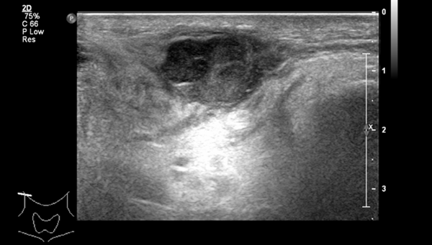
Figure 1 ultrasonogram of the neck showed 15 mm×27 mm mass in the right parotid gland.

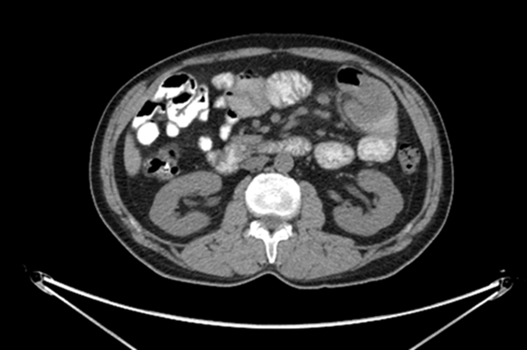
Figure 2 PET/CT showed a 36 mm×33 mm intestinal mass with multiple peripheral lymph nodes in the right midabdomen.

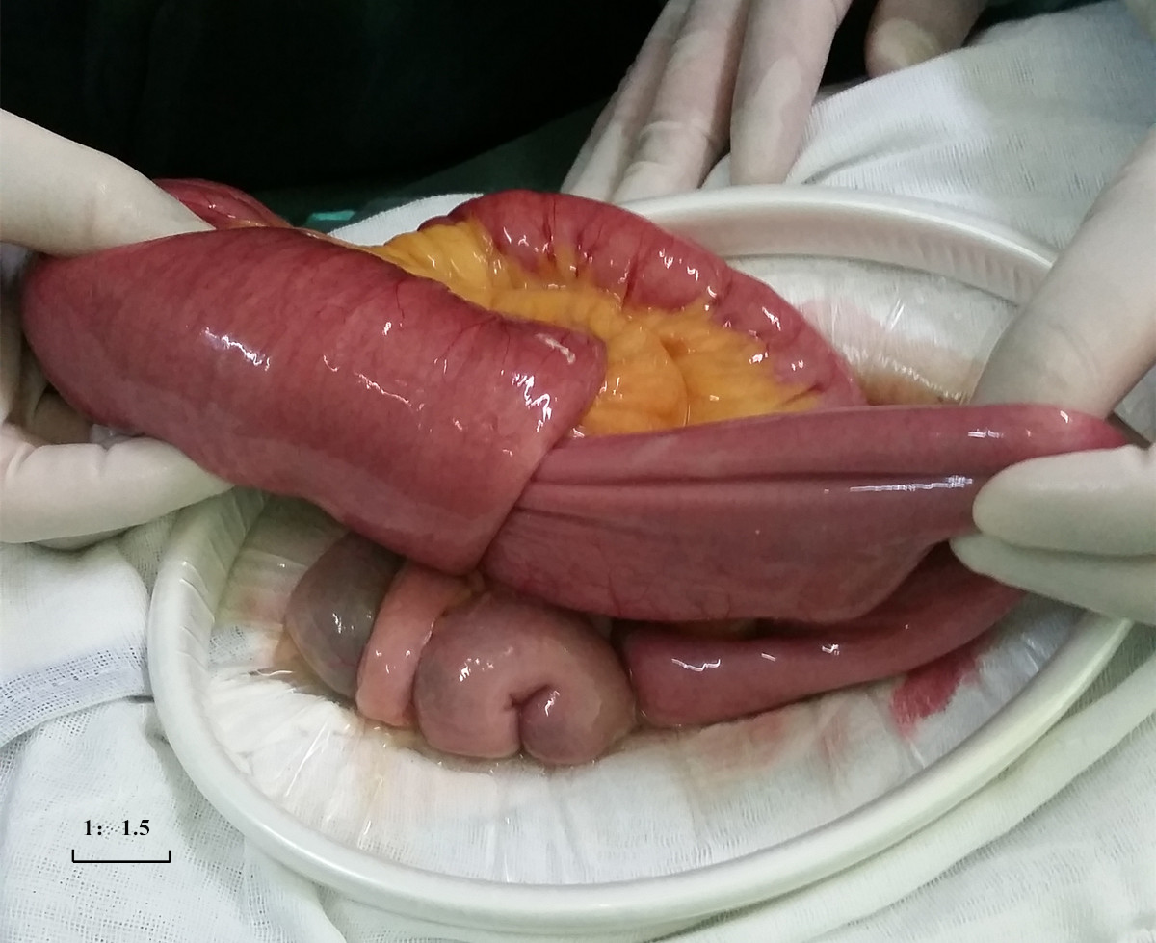
Figure 3 Intussusception was observed 80 cm distal to the duodenojejunal junction and involved bowels swelled and expanded.

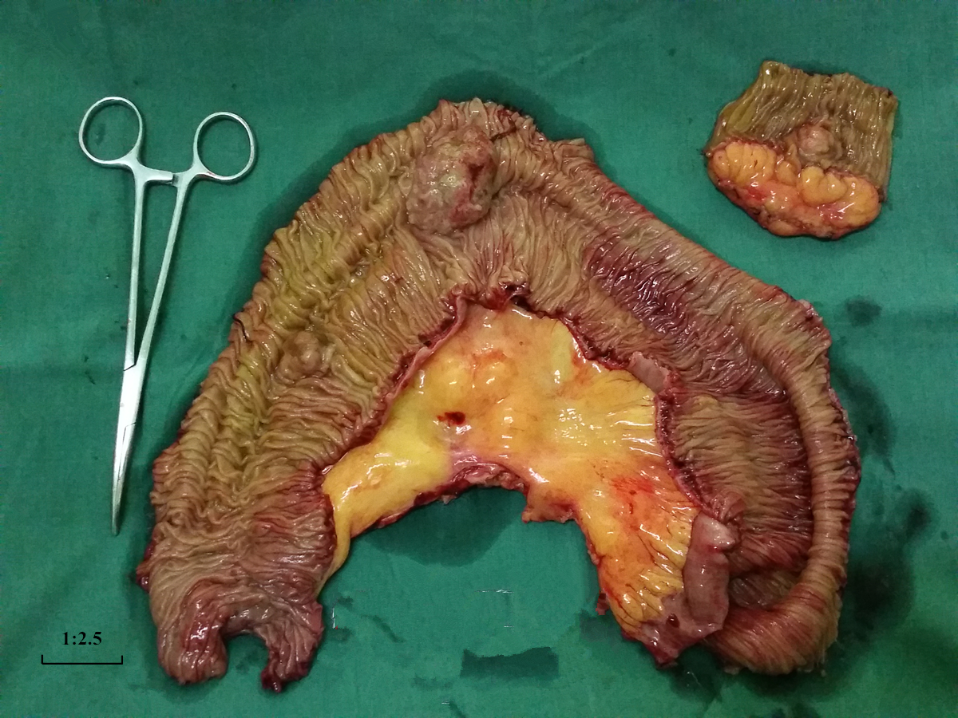
Figure 4 Involved bowels with the masses and mesentery was resected with proximal 10 cm and distal 10 cm margin.

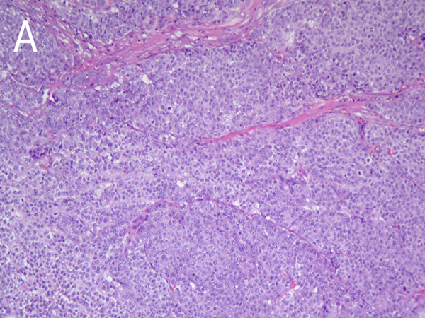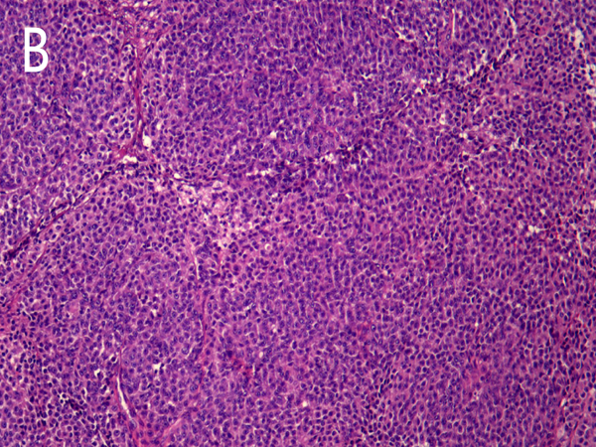
Figure 5 Microscopic observation of intestinal neoplasms and parotid gland neoplasms. A: Microphotography shows polygonal malignant cells of intestinal neoplasms were separated by fibrous tissues, arranging in sheets and nests, with eosinophilic or clear cytoplasm and there was no exact necrosis, vessel invasion and nerve invasion. Nucleolus was obvious and the mitotic index exceeded 20/10 HPF (Hematoxylin-Eosin G×10); B: Malignant cells of parotid gland neoplasms were similar to the intestinal tumor by microphotography (Hematoxylin-Eosin G×10).

Table 1 clinical, pathological, immunohistochemical, and genetic features of clear-cell sarcoma of the gastrointestinal tract in previously reported cases
Ref. | Age(yr)/sex | Location | Maximum diameter of tumor(cm) | S-100 | HMB-45 | Melan-A | Genetic  findings | Outcome
Alpers et al^{[5]} | 26/F | Jejunum | 1.5 | ND | ND | ND | ND | Liver mets
Ekfors et al^{[3]} | 38/M | Duodenum | 3 | Positive | Positive | ND | ND | Not given
Donner et al^{[6]} | 37/M | Ileum | 6.5 | Positive | Negative | ND | t(12;22)(q13;q12-13) | Liver mets at 24 and 36 mo
Fukuda et al^{[7]} | 74/M | Colon | 3 | Positive | Positive | ND | EWSR1-ATF1 by RT-PCR | Liver mets at 9 mo
Hu et al^{[8]} | 10/M | Rectum | 5 | Positive | Positive | ND | ND | NA
Pauwels et al^{[9]} | 30/M | Stomach | 4 | Positive | Negative | ND | t(12;22)(q13;  q12) | LN and peritoneal mets at diagnosis
Zambrano et al^{[10]} | 15/F | Jejunum | 5 | Positive | Negative | Negative | t(12;22)(q13;  q12) | DOD 16 mo
 | 21/F | Jejunum | 4 | Positive | Negative | Negative | ND | DOD 12 mo
 | 35/F | Ileum | 3.5 | Positive | Negative | Negative | ND | Liver mets at 12 mo
 | 37/F | Ileum | 4.5 | Positive | Negative | Negative | ND | NA
 | 32/M | Ileum | 5 | Positive | Negative | Negative | ND | NA
 | 13/M | Stomach | 6.7 | Positive | Negative | Negative | ND | Local recurrence at 12 mo;2nd Local recurrence at 36 mo
Achten et al^{[11]} | 57/M | Jejunum | 6.5 | Positive | Negative | Negative | EWSR1 rearrangement by FISH | NA
Venkataraman et al^{[12]} | 21/F | Ileum | 7 | Positive | Negative | Negative | EWSR1 rearrangement by FISH | NA
Covinsky et al^{[13]} | 47/F | Pancreas | NA | Positive | Positive | Positive | EWSR1-ATF1  by RT-PCR and  FISH | NED 24 mo
 | 85/F | Mesentery | NA | Positive | Positive | Positive | EWSR1-ATF1  by RT-PCR and  FISH | DOD 1 mo
Taminelli et al^{[14]} | 35/M | Ileum | 1.8 | Positive | Negative | Positive | EWSR1-ATF1/ by RT-PCR | DOD 15 mo
Friedrichs et al^{[15]} | 41/M | Jejunum | 8.7 | Positive | Negative | Negative | EWSR1 rearrangement by FISH | Liver mets at 6 mo
Huang et al^{[16]} | 40/M | Stomach | 3 | Positive | Negative | Positive | ND | NED 9 mo
Antonescu et al^{[17]} | 81/F | Colon | 7.5 | Positive | Negative | Negative | EWSR1-CREB1 by RT-PCR | Mets to liver and  peritoneum at  60 mo
 | 42/F | Ileum | 5.7 | Positive | Negative | Negative | EWSR1-CREB1 by RT-PCR | NA
 | 42/F | Ileum | 3.5 | Positive | Negative | Negative | EWSR1-CREB1 by RT-PCR | Peritoneal and  liver mets at  diagnosis
 | 51/F | Jejunum | NA | Positive | Negative | Negative | EWSR1  rearrangement  by FISH | Peritoneal and  liver mets; AWD
 | 18/F | Jejunum | NA | Positive | Negative | Negative | EWSR1-ATF1 by RT-PCR | Local recurrence
Granville et al^{[18]} | 16/M | Ileum | 5 | Positive | Negative | ND | EWSR1-ATF1 by RT-PCR; t(12;22)(q13;q12) | DOD 15 mo
Comin et al^{[19]} | 31/F | Ileum | 2.8 | Positive | Negative | Negative | EWSR1 rearrangement by FISH | NA
Lyle et al^{[20]} | 46/M | Jejunum | 11 | Positive | Positive | Positive | EWSR1 rearrangement by FISH; EWSR1-ATF1 by RT-PCR | NED 7 mo
 | 49/M | Cecum | 10.5 | Positive | Positive | Positive | EWSR1 rearrangement by FISH; EWSR1-ATF1 by RT-PCR | DOD 12 mo
 | 60/M | Jejunum | 10 | Positive | Positive | Positive | EWSR1-ATF1 by RT-PCR | DOD 28 mo
 | 62/M | Ileum | 4 | Positive | Positive | Positive | EWSR1 rearrangement by FISH; EWSR1-ATF1 by RT-PCR | DOD 12 mo
Abdulkader et al^{[21]} | 37/M | Jejunum | 8.2 | Positive | Negative | ND | EWSR1 rearrangement by FISH | Liver mets at 2 mo
Lagmay et al^{[22]} | 10/F | Stomach | 7.8 | Positive | Negative | Negative | EWSR1 rearrangement by FISH; EWSR1-ATF1 by RT-PCR | NED 4 mo
Joo et al^{[23]} | 60/M | Ileum | 2.4 | Positive | Negative | Negative | EWSR1 rearrangement by FISH | NA
 | 46/M | Jejunum | 6 | Positive | Negative | Negative | EWSR1 rearrangement by FISH | NA
Terazawa et al^{[24]} | Early 20s/F | Ileum | 3 | Positive | ND | ND | EWSR1-ATF1 by RT-PCR | NED at 24 mo
Shenjere et al^{[25]} | 53/F | Ileum | 5 | Positive | Negative | Negative | EWSR1-ATF1  by RT-PCR | Regional LN mets at diagnosis/  NED at 7 mo
 | 26/F | ¹Small and large bowel | 13.5/10.1 | Positive | Negative | Negative | EWSR1-CREB1 by RT-PCR | NA
 | 66/M | Ileum | 2.5 | Positive | Negative | Negative | EWSR1-CREB1 by RT-PCR | Regional LN mets at diagnosis/NED
Balkaransingh et al^{[26]} | 15/M | Ileum | NA | ND | ND | ND | EWSR1 rearrangement by FISH | NA
Yang et al^{[27]} | 15/M | Ileum | 4 | Positive | ND | ND | EWSR1 rearrangement by FISH | Liver mets at 12 mo
Suarez-Vilela et al^{[28]} | 36/F | Jejunum | 1.5 | Positive | Negative | Negative | EWSR1 rearrangement by FISH | NA
D’Amico et al^{[29]} | 69/F | Ileum | 4 | Positive | Negative | ND | EWSR1 rearrangement by FISH | Liver mets at 2 mo
Lasithiotakis et al^{[30]} | 49/F | Jejunum | 3 | Positive | Negative | Negative | EWSR1 rearrangement by FISH | NED 20 mo
Huang Hui-fen et al^{[31]} | 45/F | Colon | 4 | Positive | Negative | Negative | EWSR1 rearrangement by FISH | Liver mets at 20 mo
Mallick et al^{[32]} | 45/M | Jejunum | 4.4 | Positive | Negative | Negative | ND | NA
Kong et al^{[33]} | 17/M | Stomach | 6 | Positive | Negative | Negative | EWSR1 rearrangement by FISH | NED 10 mo
Liu et al^{[34]} | 76/M | Jejunum | 2.5 | Positive | Negative | Negative | EWSR1-ATF1 by RT-PCR | NA
Thway et al^{[35]} | 36/M | Ileum | 3 | Positive | Negative | Negative | EWSR1-CREB1 by RT-PCR | DOD 7 mo
Huang et al^{[36]} | 36/M | Pancreas | 4 | Positive | Positive | Positive | EWSR1 rearrangement by FISH | Liver mets at 10 mo
Yegen et al^{[37]} | 25/F | Ileum | 3.2 | Positive | Negative | Negative | EWSR1 rearrangement by FISH | Liver mets at diagnosis and at 15 mo. Ovarian mets and peritoneal dissemination at 47 mo
Moslim et al^{[38]} | 57/M | ²Duodenum and Jejunum | 5.5/7.5 | Positive | Negative | Positive | EWSR1 rearrangement by FISH | NED 30 mo and then DOD 4 mo later
Chen et al^{[39]} | 29/F | Jejunum | 6 | Positive | Negative | Negative | EWSR1 rearrangement by FISH | NED 17 mo
Our case | 51/M | ³Duodenum and Jejunum | 6.5/2.5/2.5 | Positive | Positive | Positive | EWSR1 rearrangement undetectable by FISH | NED up to date
¹Two simultaneous tumors in small and large bowel; ²Two simultaneous tumors in Duodenum and Jejunum; ³Three simultaneous tumors in duodenum and Jejunum. AWD: Alive with disease; DOD: Dead of disease; FISH: Fluorescence in situ hybridisation; LN: Lymph node; Mets: Metastases; NA: Not acquired; ND: Not done; NED: No evidence of disease; RT: Reverse transcription.

