Name of Journal: World Journal of Diabetes
Manuscript NO: 76146
Manuscript Type: SCIENTOMETRICS

Mapping the global research landscape on insulin resistance: Visualization and bibliometric analysis

Zyoud SH et al. Global research landscape on insulin resistance

Sa’ed H Zyoud, Muna Shakhshir, Amer Koni, Amani S Abushanab, Moyad Shahwan, Ammar Abdulrahman Jairoun, Rand Al subu, Adham Abu Taha, Samah W Al-Jabi

Sa’ed H Zyoud, Amer Koni, Amani S Abushanab, Samah W Al-Jabi, Department of Clinical and Community Pharmacy, College of Medicine and Health Sciences, An-Najah National University, Nablus 44839, Palestine

Sa’ed H Zyoud, Poison Control and Drug Information Center, College of Medicine and Health Sciences, An-Najah National University, Nablus 44839, Palestine

Sa’ed H Zyoud, Clinical Research Centre, An-Najah National University Hospital, Nablus 44839, Palestine

Muna Shakhshir, Department of Nutrition, An-Najah National University Hospital, Nablus 44839, Palestine

Amer Koni, Division of Clinical Pharmacy, Department of Hematology and Oncology Pharmacy, An-Najah National University Hospital, Nablus 44839, Palestine

Moyad Shahwan, Department of Pharmacy, Ajman University, Ajman 346, United Arab Emirates

Moyad Shahwan, Centre of Medical and Bio Allied Health Sciences Research, Ajman University, Ajman 346, United Arab Emirates

Ammar Abdulrahman Jairoun, Department of Health and Safety, Dubai Municipality, Dubai 67, United Arab Emirates

Rand Al Subu, Department of Medicine, College of Medicine and Health Sciences, An-Najah National University, Nablus 44839, Palestine

Adham Abu Taha, Department of Biomedical Sciences, College of Medicine and Health Sciences, An-Najah National University, Nablus 44839, Palestine

Adham Abu Taha, Department of Pathology, An-Najah National University Hospital, Nablus 44839, Palestine

Author contributions: Zyoud SH developed the concept for the manuscript, reviewed the literature, designed the study, collected the data, analyzed the data, made significant contributions to the existing literature search and interpretation of the manuscript, and wrote the manuscript; Shakhshir M, Koni A, Abushanab AS, Jairoun AA, Shahwan WM, Al Subu R, Abu Taha A, and Al-Jabi SW participated in interpretation of the data and made revisions to the initial draft; and all authors provided critical review and approved the final manuscript before submission.

Corresponding author: Sa’ed H Zyoud, PhD, Associate Professor, Department of Clinical and Community Pharmacy, College of Medicine and Health Sciences, An-Najah National University, Academic Street, Nablus 44839, Palestine. saedzyoud@yahoo.com

Received: March 3, 2022
Revised: May 4, 2022
Accepted: August 5, 2022
Published online:

Abstract
BACKGROUND
Insulin resistance is a risk factor for metabolic syndromes and is associated with a wide variety of metabolic illnesses, including obesity, type 2 diabetes, and cardiovascular disease.

AIM
To investigate and map global insulin resistance studies.

METHODS
A bibliometric methodology was applied to the literature retrieved from the Scopus database and Reference Citation Analysis (https://www.referencecitationanalysis.com) by using a validated search strategy. The study period was limited from 2002 to 2021. Bibliometric indicators and mapping were presented.

RESULTS
A total of 26808 articles on the topic of insulin resistance were included in the Scopus database. The articles included research articles (n = 21918; 81.76%), review articles (n = 2641; 9.85%), and letters (n = 653; 2.44%). During the study period, 136 countries contributed to the research on insulin resistance. The highest number of articles was from the United States (n = 7360; 27.45%), followed by China (n = 3713; 13.85%), Japan (n = 1730, 6.45%), Italy (n = 1545; 5.54%), and the United Kingdom (n = 1484; 5.54%). The retrieved articles identified two main research themes: “inflammatory mechanisms in the regulation of insulin resistance” and “mechanisms linking obesity to insulin resistance”.

CONCLUSION
Our data show that insulin resistance has steadily gained interest from researchers, as evidenced by the number of citations and yearly publications. Publications have grown significantly in the last decade, while low-income countries with greater burdens continue to produce fewer publications in this field. This approach might assist researchers in choosing new research areas and recognizing research hotspots and frontiers. In the future, perhaps high-quality clinical evidence will be acquired.

Key Words: Insulin resistance; Research hotspots; Scopus; VOSviewer; Bibliometric

Zyoud SH, Shakhshir M, Koni A, Abushanab AS, Shahwan M, Jairoun AA, Al Subu R, Abu Taha A, Al-Jabi SW. Mapping the global research landscape on insulin resistance: Visualization and bibliometric analysis. World J Diabetes 2022; In press

Core Tip: Several bibliometric studies have been conducted in the field of diabetes research. However, no bibliometric study has been conducted on insulin resistance research. Therefore, the current study aims to investigate and map global research on insulin resistance. The retrieved articles identified two main research themes: “inflammatory mechanisms in the regulation of insulin resistance” and “mechanisms linking obesity to insulin resistance”. This approach might assist researchers in choosing new research areas and recognizing research hotspots and frontiers. In the future, perhaps high-quality clinical evidence will be acquired.

INTRODUCTION
During the last two decades, the global prevalence of diabetes has increased dramatically. Diabetes is increasing worldwide, both in terms of prevalence and the number of affected^{[1]}. For more than half a century, insulin resistance and type 2 diabetes have been associated. Insulin resistance is not only a powerful predictor of future type 2 diabetes development but is also a therapeutic target in the presence of hyperglycemia^{[2]}. Insulin resistance is defined as a reduced physiological response to insulin stimulation of target tissues, especially adipose tissue, liver, and muscle. Insulin resistance limits glucose disposal, leading to a compensatory increase in beta cell insulin synthesis and hyperinsulinemia^{[3]}. More than 30 years ago, hyperinsulinemia and insulin resistance were hypothesized to be key contributors to hypertension, hyperglycemia, dyslipidemia, hyperuricemia, visceral adiposity, elevated inflammatory markers, prothrombic state, and endothelial dysfunction related to obesity and the metabolic syndrome^{[4]}.
Several bibliometric studies have been conducted in diabetes research^{[5-9]} or in depression and insulin research^{[10]}. However, no bibliometric study has been conducted on insulin resistance research. As a scientific evaluation approach, bibliometrics can assess the research impact of organizations and individuals^{[11]}. Similarly, bibliometrics provide evidence to promote the formation of future research hotspots^{[12,13]}. As a result, this research aims to examine the scientific development in insulin resistance thoroughly. Therefore, this bibliometric analysis was designed to examine the research trend related to insulin resistance and identify future research hotspots. Furthermore, the study offers some important information by providing references and ideas for future studies on insulin resistance pathophysiology and clinical applications.

MATERIALS AND METHODS
Data acquisition
The documents in the current study were obtained and downloaded from the Scopus database on January 29, 2022 to prevent bias caused by the database’s daily updates. With more than 36000 titles from around 11678 publishers, of which 34346 were peer-reviewed journals, Scopus is one of the most extensive and authoritative databases for collecting academic information^{[14,15]}. Unfortunately, only one database may be utilized in bibliometric analyses because data from many databases cannot be integrated and analyzed. On the other hand, systematic reviews use multiple databases to retrieve a large number of documents for further analysis^{[16]}. Furthermore, only one database was chosen on the topic and objective coverage, and past research has shown that Web of Science and PubMed are included in the Scopus database. Based on previous studies and findings, it was recommended to use Scopus (Elsevier database) because it was the most comprehensive database on the subject, offering all the data needed for quantitative analysis^{[17,18]}.

Search strategy
Keywords used in the Scopus engine to achieve the aim of this study were chosen from previous systematic reviews and meta-analyses on insulin resistance^{[19-21]}. “Insulin resistance” or “insulin sensitivity” was used as a search expression in the title search in the Scopus database over the last two decades (January 2002 to December 2021). This study used the keywords “insulin resistance” or “insulin sensitivity” because we are more interested in these terms than related terminology. Therefore, keywords were used instead of a title/abstract search in the title search. Consequently, the search for the title will provide the fewest false positive documents, making it a trustworthy strategy^{[22-26]}. A title/abstract search, on the other hand, will provide numerous false positives in which the main focus is not on insulin resistance per se.

Bibliometric analysis
As described in previous studies, the bibliometric technique was applied^{[27-30]}. The following bibliometric indicators were generated when the refined findings were exported to Microsoft Excel: (1) Growth pattern; (2) Type of publications; (3) Core countries; (4) Core institutions; (5) Core funding agencies; (6) Prolific authors; (7) Core journals with their impact factors (IF); and (8) Top 10 cited articles. The Impact Index per article for the top 10 highly-cited papers collected from Reference Citation Analysis, https://www.referencecitationanalysis.com, was presented. Reference Citation Analysis is an open, multidisciplinary citation analysis database owned by Baishideng Publishing Group Inc. (Pleasanton, CA 94566, United States)^{[31]}.

Visualized analysis
VOSviewer 1.6.18 was used to perform a co-occurrence analysis and visualize the collaborative networks of the countries to determine a worldwide scientific cooperation network across countries/regions and keywords in the titles and/or abstracts to determine hotspots and research trends. VOSviewer maps have nodes or frames that are colored and scaled differently. The node or the frame size is proportional to the number of times it appears. The node’s or the frame’s color indicates its link to other nodes with similar colors^{[32]}.

RESULTS
Current status and annual trend
A total of 26808 articles on insulin resistance were included in the Scopus database. The articles included research articles (n = 21918; 81.76%), review articles (n = 2641; 9.85%), and letters (n = 653; 2.44%). After 2003, as shown in Figure 1, the number of publications on insulin resistance studies increased rapidly. In 2021, 1645 papers were published, the highest amount in two decades.

Analysis of countries
During the study period, 136 countries contributed to research on insulin resistance. The highest number of articles was from the United States (n = 7360; 27.45%), followed by China (n = 3713; 13.85%), Japan (n = 1730, 6.45%), Italy (n = 1545; 5.54%), and the United Kingdom (n = 1484; 5.54%) (Table 1). The country network map included 42 frames (Figure 2). The top three countries in terms of centrality were the United States, China, and the United Kingdom. The centrality proved that they had close relationships and substantial intellectual effects on other countries.

Analysis of institutions
The top 10 active institutions are listed in Table 2. Harvard Medical School was first with 515 (1.92%) articles, followed by INSERM with 451 (1.68%) articles and the National Institutes of Health with 298 (1.11%). The top 10 active institutions were mainly based in the United States.

Analysis of funding agencies
Table 3 lists the top 10 funding agencies with the highest output. Seven funding agencies are from the United States, and one each is from Japan, China, and Canada. These countries contributed 10459 (39.01%) documents. The three most productive funding agencies were the National Institute of Diabetes and Digestive and Kidney Diseases (n = 2548; 9.50%), the National Institutes of Health (n = 2094, 7.81%), and National Heart, Lung, and Blood Institute (n = 1140, 4.25%).

Analysis of journals
Table 4 shows the top 10 most active journals. Diabetes Journal was first (n = 830; 3.10%), followed by Clinical Endocrinology and Metabolism (n = 692, 2.58%) and Diabetes Care (n = 623; 2.32%). Four of the journals on the active list were on the subject of diabetes. All the journals on the active list have a relatively high impact factor.

Analysis of citations
Table 5 lists the top 10 articles that were the most cited in research related to insulin resistance from 2002 to 2021. The 10 highest citations ranged from 4911 to 1827^{[33-42]}. Furthermore, the 10 most cited articles have an impact index per article of 101.5 to 241.2 (Table 5).

Term co-occurrence cluster analysis of research hotspots
The term co-occurrence analysis provided a complete summary of hot topics discussed in insulin resistance research. VOSviewer detected 456 keywords that appeared a minimum of 300 times in the titles and abstracts of the included articles by analyzing the contents of the titles and abstracts. All terms were sorted into clusters on the VOSviewer keyword co-occurrence visualization map, and various clusters were colored differently (Figure 3). There are two clusters: (1) Cluster #1, shown by green dots, contained phrases typically found in publications relating to “inflammatory mechanisms in the regulation of insulin resistance”; and (2) Cluster #2, shown by red dots, contained phrases typically found in publications relating to “mechanisms linking obesity to insulin resistance”. Hotspots in the field of insulin resistance were revealed via an overlay visualization map scaled by occurrence. The colored terms differ depending on when they appeared in the literature. The blue keywords were first shown, followed by the yellow keywords. After 2013, the most popular terms were related to inflammatory mechanisms in the regulation of insulin resistance (Figure 4).

Analysis of authorship
The total number of authors who participated in the publication of the retrieved documents was 80932, a mean of 3.1 authors per document. The list of the top 10 active authors in insulin resistance research, ranked by the total number of publications in the last two decades (2002-2021), is shown in Table 6. The top 10 list included four from the United States, three from Germany, two from Spain, and one from Italy.

DISCUSSION
Bibliometric analysis of insulin resistance publications in the last 20 years revealed that the number of articles published has gradually increased in recent years, indicating that more and more researchers are becoming involved in insulin resistance research. To our knowledge, this is the first bibliometric study that comprehensively examined worldwide trends in insulin resistance research over the last 20 years. The current study showed that research activity on insulin resistance was worldwide and involved countries in different world regions. The United States and China had a noticeable edge on this topic, probably due to a greater economy and investment in the scientific field. The research output from these countries may be related to a diverse spectrum of researchers interested in this topic and strong financial support for researchers.
Another important reason for the contribution of different world regions is the high level of international collaboration, as evident from the thick lines coming out from most countries in the visualization map. This collaboration was initiated because different regions of the research groups in different regions of the world were involved in different aspects of insulin resistance research or different complications of insulin resistance. Another area of relevance for the current study with regard to scientific publications on insulin resistance is the quality of research papers. It is worth noting that nine of the top 10 cited articles were published in journals with an IF larger than 10, implying that they have a large impact in medicine: Journal of Clinical Investigation, Cell Metabolism, and Nature. As shown, articles related to insulin resistance have been published both in endocrinology and non-endocrinology subject areas, such as medicine, biochemistry, genetics, and molecular biology, nursing, pharmacology, toxicology, and pharmaceutics, agricultural and biological sciences, neuroscience, and immunology and microbiology journals, revealing the contribution and collaboration of many researchers from different subject areas. Previous research has confirmed that^{[43-45]}. The findings of this study confirm the close association between IF and citations and the fact that the most cited articles are frequently published in journals at the top of the IF list, which helps these journals maintain their high IF.
Furthermore, the increase in insulin resistance publications can be attributed to the fact that numerous hot topics were published during this period^{[33-37]}, exposing novel hypotheses and establishing new research fields such as “inflammatory mechanisms in the regulation of insulin resistance” and “mechanisms linking obesity and insulin resistance”. Several studies have shown that inflammation is a critical mediator in obesity-induced insulin resistance. Most of these investigations examined the links between adipose tissue in obesity and the regulation of inflammation and insulin resistance^{[46-49]} and the mechanisms by which dietary anti-inflammatory components/functional nutrients may be helpful^{[50-52]}.
Publications with the highest citation frequencies have the greatest academic effect^{[53,54]}. For example, the study published in the Journal of Clinical Investigation in 2003 by Xu et al^{[36]} was ranked first. It was revealed that macrophages in white adipose tissue are involved in morbid obesity and that macrophage-associated inflammatory activities may contribute to the pathophysiology of obesity-induced insulin resistance^{[36]}. The article ranked second was published in Diabetes by Cani et al^{[40]}. Metabolic endotoxemia was found to alter the inflammatory tone of the body, causing weight gain and diabetes^{[40]}.

Strengths and limitations
This is the first bibliometric and visual analysis study to investigate research trends and hotspots in insulin resistance from 2002 to 2021. The current study reviewed linked papers on this issue from numerous perspectives, demonstrated a comprehensive view of understanding in this field during the last few years, and gave direction for future investigations. New researchers in this discipline may simply access meaningful and relevant material with the aid of this bibliometric study. However, certain limitations apply to the generalizability of these findings. First, bibliometric analyses solely used published material from the Scopus database. This may underestimate the amount of research done in South America, China, the Middle East, and other regions of the globe with non-English and unindexed publications. Second, because bibliometric data changes over time, indexing delays may have caused a slight (but not significant) in the number of documents or other metrics. Third, to avoid selection bias, the current study only searched the title for terms such as “insulin resistance” or “insulin sensitivity”. As a result, the possibility of false positive or false negative results should always be considered. Fourth, Scopus’s results reflect the type and content of Scopus’s database. As a result, if prolific authors have two or more Scopus profiles, their research output is likely to be dispersed, and their names may not appear in the active list. The same is true when alternative spellings of an institution’s name are used in published documents. As a result, interpreting data about the most active authors, institutions, and nations should be limited to the Scopus findings produced using the described technique.

CONCLUSION
To our knowledge, this was the first study to conduct a comprehensive bibliometric analysis of insulin resistance publications from 2002 to 2021, covering the publication year, the number of citations, and current hot topics and trends projected from them. Our data showed that insulin resistance has steadily gained interest from researchers, as evidenced by the number of citations and yearly publications. So far, the United States has been the undisputed leader in this topic, which cannot be divorced from adequate funding sources. Publications have grown significantly in the last decade, while low-income countries with greater burdens continue to produce fewer publications in this field. “Inflammatory mechanisms in the regulation of insulin resistance” and “mechanisms linking obesity to insulin resistance” were hotspots for insulin resistance research in the past 20 years. This approach might assist researchers in choosing new research areas and recognizing research hotspots and frontiers. In the future, perhaps high-quality clinical evidence will be acquired.

ARTICLE HIGHLIGHTS
Research background
Insulin resistance is a condition in which muscle cells take up and store glucose and triglycerides, resulting in elevated amounts of glucose and triglycerides circulating in the bloodstream.

Research motivation
Several bibliometric studies have been carried out on the subject of diabetic investigation. However, no bibliometric study has been done on research into insulin resistance.

Research objectives
This bibliometric study aimed to identify and assess the current state and trends in insulin resistance research production worldwide and visually analyze research hotspots on this subject.

Research methods
The Scopus database and Reference Citation Analysis were used to compile the literature on insulin resistance. In addition, VOSviewer software was used to visually assess data collected from relevant publications.

Research results
This is the first bibliometric analysis of trends in insulin resistance. The number of publications on insulin resistance has increased in the last decade. Our results indicated that the “inflammatory mechanisms in the regulation of insulin resistance” and “mechanisms linking obesity to insulin resistance” will remain research hotspots in the future.

Research conclusions
Our findings indicate that interest in insulin resistance has gradually increased among researchers, as shown by the increasing number of citations and annual publications. Moreover, publications in this field have increased significantly in the last decade, while low-income countries with higher burdens continue to produce fewer publications.

Research perspectives
This paper contributes essential information by providing references and suggestions for future research on pathophysiology and clinical uses of insulin resistance. This approach may aid researchers in identifying new topics of inquiry and identifying research hotspots and frontiers. Perhaps in the future, high-quality clinical evidence will be collected.

REFERENCES
1 World Health Organization. Diabetes. [cited 5 February 2022]. Available from: https://www.who.int/news-room/fact-sheets/detail/diabetes
2 Taylor R. Insulin resistance and type 2 diabetes. Diabetes 2012; 61: 778-779 [PMID: 22442298 DOI: 10.2337/db12-0073]
3 Freeman AM, Pennings N. Insulin Resistance. 2022 Jul 4. In: StatPearls [Internet]. Treasure Island (FL): StatPearls Publishing; 2022 Jan- [PMID: 29939616]
4 da Silva AA, do Carmo JM, Li X, Wang Z, Mouton AJ, Hall JE. Role of Hyperinsulinemia and Insulin Resistance in Hypertension: Metabolic Syndrome Revisited. Can J Cardiol 2020; 36: 671-682 [PMID: 32389340 DOI: 10.1016/j.cjca.2020.02.066]
5 Song Y, Zhao F. Bibliometric analysis of metabolic surgery for type 2 diabetes: current status and future prospects. Updates Surg 2022; 74: 697-707 [PMID: 35094308 DOI: 10.1007/s13304-021-01201-5]
6 Chen L, Ma S, Hu D, Lin H, Zhu Y, Chen K, Chen L, Zheng C, Liu J, Liao Y. Bibliometric Study of Sodium Glucose Cotransporter 2 Inhibitors in Cardiovascular Research. Front Pharmacol 2020; 11: 561494 [PMID: 33041801 DOI: 10.3389/fphar.2020.561494]
7 Lin X, Chen P, Lin F. Mapping global research trends in diabetes and COVID-19 outbreak in the past year: a bibliometric analysis. Ann Palliat Med 2022; 11: 1241-1252 [PMID: 34806394 DOI: 10.21037/apm-21-2636]
8 Dong Y, Liu Y, Yu J, Qi S, Liu H. Mapping research trends in diabetic retinopathy from 2010 to 2019: A bibliometric analysis. Medicine (Baltimore) 2021; 100: e23981 [PMID: 33545985 DOI: 10.1097/MD.0000000000023981]
9 Hosseinkhani S, Aazami H, Hashemi E, Dehghanbanadaki H, Adibi-Motlagh B, Razi F. The trend in application of omics in type 2 diabetes researches; A bibliometric study. Diabetes Metab Syndr 2021; 15: 102250 [PMID: 34419857 DOI: 10.1016/j.dsx.2021.102250]
10 Zou X, Sun Y. Bibliometrics Analysis of the Research Status and Trends of the Association Between Depression and Insulin From 2010 to 2020. Front Psychiatry 2021; 12: 683474 [PMID: 34366917 DOI: 10.3389/fpsyt.2021.683474]
11 Bornmann L. Measuring impact in research evaluations: a thorough discussion of methods for, effects of and problems with impact measurements. High Educ 2017; 73: 775-787 [DOI: 10.1007/s10734-016-9995-x]
12 Gu D, Li J, Li X, Liang C. Visualizing the knowledge structure and evolution of big data research in healthcare informatics. Int J Med Inform 2017; 98: 22-32 [PMID: 28034409 DOI: 10.1016/j.ijmedinf.2016.11.006]
13 Wang X, Guo J, Gu D, Yang Y, Yang X, Zhu K. Tracking knowledge evolution, hotspots and future directions of emerging technologies in cancers research: a bibliometrics review. J Cancer 2019; 10: 2643-2653 [PMID: 31258772 DOI: 10.7150/jca.32739]
14 Sweileh WM. Substandard and falsified medical products: bibliometric analysis and mapping of scientific research. Global Health 2021; 17: 114 [PMID: 34556126 DOI: 10.1186/s12992-021-00766-5]
15 Sweileh WM. Global research activity on mathematical modeling of transmission and control of 23 selected infectious disease outbreak. Global Health 2022; 18: 4 [PMID: 35062966 DOI: 10.1186/s12992-022-00803-x]
16 Sweileh WM. A bibliometric analysis of health-related literature on natural disasters from 1900 to 2017. Health Res Policy Syst 2019; 17: 18 [PMID: 30744641 DOI: 10.1186/s12961-019-0418-1]
17 Cebrino J, Portero de la Cruz S. A worldwide bibliometric analysis of published literature on workplace violence in healthcare personnel. PLoS One 2020; 15: e0242781 [PMID: 33227018 DOI: 10.1371/journal.pone.0242781]
18 Sweileh WM. Bibliometric analysis of global scientific literature on vaccine hesitancy in peer-reviewed journals (1990-2019). BMC Public Health 2020; 20: 1252 [PMID: 32807154 DOI: 10.1186/s12889-020-09368-z]
19 Su KZ, Li YR, Zhang D, Yuan JH, Zhang CS, Liu Y, Song LM, Lin Q, Li MW, Dong J. Relation of Circulating Resistin to Insulin Resistance in Type 2 Diabetes and Obesity: A Systematic Review and Meta-Analysis. Front Physiol 2019; 10: 1399 [PMID: 31803062 DOI: 10.3389/fphys.2019.01399]
20 Sampath Kumar A, Maiya AG, Shastry BA, Vaishali K, Ravishankar N, Hazari A, Gundmi S, Jadhav R. Exercise and insulin resistance in type 2 diabetes mellitus: A systematic review and meta-analysis. Ann Phys Rehabil Med 2019; 62: 98-103 [PMID: 30553010 DOI: 10.1016/j.rehab.2018.11.001]
21 Shoshtari-Yeganeh B, Zarean M, Mansourian M, Riahi R, Poursafa P, Teiri H, Rafiei N, Dehdashti B, Kelishadi R. Systematic review and meta-analysis on the association between phthalates exposure and insulin resistance. Environ Sci Pollut Res Int 2019; 26: 9435-9442 [PMID: 30734259 DOI: 10.1007/s11356-019-04373-1]
22 Sweileh WM. Global research activity on antimicrobial resistance in food-producing animals. Arch Public Health 2021; 79: 49 [PMID: 33849636 DOI: 10.1186/s13690-021-00572-w]
23 Sweileh WM. Bibliometric analysis of peer-reviewed literature on antimicrobial stewardship from 1990 to 2019. Global Health 2021; 17: 1 [PMID: 33397377 DOI: 10.1186/s12992-020-00651-7]
24 Sweileh WM. Health-related publications on people living in fragile states in the alert zone: a bibliometric analysis. Int J Ment Health Syst 2020; 14: 70 [PMID: 32868982 DOI: 10.1186/s13033-020-00402-6]
25 Sweileh WM. Global research publications on systemic use of off-label and unlicensed drugs: A bibliometric analysis (1990-2020). Int J Risk Saf Med 2022; 33: 77-89 [PMID: 34275912 DOI: 10.3233/JRS-210012]
26 Sweileh WM. Global Research Activity on Elder Abuse: A Bibliometric Analysis (1950-2017). J Immigr Minor Health 2021; 23: 79-87 [PMID: 32488667 DOI: 10.1007/s10903-020-01034-1]
27 Abushamma F, Barqawi A, Al-Jabi SW, Akkawi M, Maree M, Zyoud SH. Global Analysis of Research Trends on Kidney Function After Nephron-Sparing Surgery: A Bibliometric and Visualised Study. Cancer Manag Res 2021; 13: 7479-7487 [PMID: 34611441 DOI: 10.2147/CMAR.S324284]
28 Zyoud SH, Smale S, Waring WS, Sweileh W, Al-Jabi SW. Global research trends in the microbiome related to irritable bowel syndrome: A bibliometric and visualized study. World J Gastroenterol 2021; 27: 1341-1353 [PMID: 33833487 DOI: 10.3748/wjg.v27.i13.1341]
29 Barqawi A, Abushamma FA, Akkawi M, Al-Jabi SW, Shahwan MJ, Jairoun AA, Zyoud SH. Global trends in research related to sleeve gastrectomy: A bibliometric and visualized study. World J Gastrointest Surg 2021; 13: 1509-1522 [PMID: 34950437 DOI: 10.4240/wjgs.v13.i11.1509]
30 Zyoud SH, Al-Jabi SW. Mapping the situation of research on coronavirus disease-19 (COVID-19): a preliminary bibliometric analysis during the early stage of the outbreak. BMC Infect Dis 2020; 20: 561 [PMID: 32738881 DOI: 10.1186/s12879-020-05293-z]
31 Baishideng Publishing Group Inc. Reference Citation Analysis. [cited 2 February 2022]. Available from: https://www.referencecitationanalysis.com
32 van Eck NJ, Waltman L. Software survey: VOSviewer, a computer program for bibliometric mapping. Scientometrics 2010; 84: 523-538 [PMID: 20585380 DOI: 10.1007/s11192-009-0146-3]
33 Kadowaki T, Yamauchi T, Kubota N, Hara K, Ueki K, Tobe K. Adiponectin and adiponectin receptors in insulin resistance, diabetes, and the metabolic syndrome. J Clin Invest 2006; 116: 1784-1792 [PMID: 16823476 DOI: 10.1172/JCI29126]
34 Newgard CB, An J, Bain JR, Muehlbauer MJ, Stevens RD, Lien LF, Haqq AM, Shah SH, Arlotto M, Slentz CA, Rochon J, Gallup D, Ilkayeva O, Wenner BR, Yancy WS Jr, Eisenson H, Musante G, Surwit RS, Millington DS, Butler MD, Svetkey LP. A branched-chain amino acid-related metabolic signature that differentiates obese and lean humans and contributes to insulin resistance. Cell Metab 2009; 9: 311-326 [PMID: 19356713 DOI: 10.1016/j.cmet.2009.02.002]
35 Hirosumi J, Tuncman G, Chang L, Görgün CZ, Uysal KT, Maeda K, Karin M, Hotamisligil GS. A central role for JNK in obesity and insulin resistance. Nature 2002; 420: 333-336 [PMID: 12447443 DOI: 10.1038/nature01137]
36 Xu H, Barnes GT, Yang Q, Tan G, Yang D, Chou CJ, Sole J, Nichols A, Ross JS, Tartaglia LA, Chen H. Chronic inflammation in fat plays a crucial role in the development of obesity-related insulin resistance. J Clin Invest 2003; 112: 1821-1830 [PMID: 14679177 DOI: 10.1172/JCI19451]
37 Shoelson SE, Lee J, Goldfine AB. Inflammation and insulin resistance. J Clin Invest 2006; 116: 1793-1801 [PMID: 16823477 DOI: 10.1172/JCI29069]
38 Kanda H, Tateya S, Tamori Y, Kotani K, Hiasa K, Kitazawa R, Kitazawa S, Miyachi H, Maeda S, Egashira K, Kasuga M. MCP-1 contributes to macrophage infiltration into adipose tissue, insulin resistance, and hepatic steatosis in obesity. J Clin Invest 2006; 116: 1494-1505 [PMID: 16691291 DOI: 10.1172/JCI26498]
39 Kahn SE, Hull RL, Utzschneider KM. Mechanisms linking obesity to insulin resistance and type 2 diabetes. Nature 2006; 444: 840-846 [PMID: 17167471 DOI: 10.1038/nature05482]
40 Cani PD, Amar J, Iglesias MA, Poggi M, Knauf C, Bastelica D, Neyrinck AM, Fava F, Tuohy KM, Chabo C, Waget A, Delmée E, Cousin B, Sulpice T, Chamontin B, Ferrières J, Tanti JF, Gibson GR, Casteilla L, Delzenne NM, Alessi MC, Burcelin R. Metabolic endotoxemia initiates obesity and insulin resistance. Diabetes 2007; 56: 1761-1772 [PMID: 17456850 DOI: 10.2337/db06-1491]
41 Houstis N, Rosen ED, Lander ES. Reactive oxygen species have a causal role in multiple forms of insulin resistance. Nature 2006; 440: 944-948 [PMID: 16612386 DOI: 10.1038/nature04634]
42 Shi H, Kokoeva MV, Inouye K, Tzameli I, Yin H, Flier JS. TLR4 links innate immunity and fatty acid-induced insulin resistance. J Clin Invest 2006; 116: 3015-3025 [PMID: 17053832 DOI: 10.1172/JCI28898]
43 Tas F. An analysis of the most-cited research papers on oncology: which journals have they been published in? Tumour Biol 2014; 35: 4645-4649 [PMID: 24414487 DOI: 10.1007/s13277-014-1608-7]
44 Sharma M, Sarin A, Gupta P, Sachdeva S, Desai AV. Journal impact factor: its use, significance and limitations. World J Nucl Med 2014; 13: 146 [PMID: 25191134 DOI: 10.4103/1450-1147.139151]
45 Saha S, Saint S, Christakis DA. Impact factor: a valid measure of journal quality? J Med Libr Assoc 2003; 91: 42-46 [PMID: 12572533]
46 Olefsky JM, Glass CK. Macrophages, inflammation, and insulin resistance. Annu Rev Physiol 2010; 72: 219-246 [PMID: 20148674 DOI: 10.1146/annurev-physiol-021909-135846]
47 Vandanmagsar B, Youm YH, Ravussin A, Galgani JE, Stadler K, Mynatt RL, Ravussin E, Stephens JM, Dixit VD. The NLRP3 inflammasome instigates obesity-induced inflammation and insulin resistance. Nat Med 2011; 17: 179-188 [PMID: 21217695 DOI: 10.1038/nm.2279]
48 Dandona P, Aljada A, Bandyopadhyay A. Inflammation: the link between insulin resistance, obesity and diabetes. Trends Immunol 2004; 25: 4-7 [PMID: 14698276 DOI: 10.1016/j.it.2003.10.013]
49 Bastard JP, Maachi M, Lagathu C, Kim MJ, Caron M, Vidal H, Capeau J, Feve B. Recent advances in the relationship between obesity, inflammation, and insulin resistance. Eur Cytokine Netw 2006; 17: 4-12 [PMID: 16613757]
50 McArdle MA, Finucane OM, Connaughton RM, McMorrow AM, Roche HM. Mechanisms of obesity-induced inflammation and insulin resistance: insights into the emerging role of nutritional strategies. Front Endocrinol (Lausanne) 2013; 4: 52 [PMID: 23675368 DOI: 10.3389/fendo.2013.00052]
51 Maeda N, Shimomura I, Kishida K, Nishizawa H, Matsuda M, Nagaretani H, Furuyama N, Kondo H, Takahashi M, Arita Y, Komuro R, Ouchi N, Kihara S, Tochino Y, Okutomi K, Horie M, Takeda S, Aoyama T, Funahashi T, Matsuzawa Y. Diet-induced insulin resistance in mice lacking adiponectin/ACRP30. Nat Med 2002; 8: 731-737 [PMID: 12068289 DOI: 10.1038/nm724]
52 Vrieze A, Van Nood E, Holleman F, Salojärvi J, Kootte RS, Bartelsman JF, Dallinga-Thie GM, Ackermans MT, Serlie MJ, Oozeer R, Derrien M, Druesne A, Van Hylckama Vlieg JE, Bloks VW, Groen AK, Heilig HG, Zoetendal EG, Stroes ES, de Vos WM, Hoekstra JB, Nieuwdorp M. Transfer of intestinal microbiota from lean donors increases insulin sensitivity in individuals with metabolic syndrome. Gastroenterology 2012; 143: 913-6.e7 [PMID: 22728514 DOI: 10.1053/j.gastro.2012.06.031]
53 Filion KB, Pless IB. Factors related to the frequency of citation of epidemiologic publications. Epidemiol Perspect Innov 2008; 5: 3 [PMID: 18302781 DOI: 10.1186/1742-5573-5-3]
54 Opthof T. Differences in citation frequency of clinical and basic science papers in cardiovascular research. Med Biol Eng Comput 2011; 49: 613-621 [PMID: 21567267 DOI: 10.1007/s11517-011-0783-6]

Footnotes
Conflict-of-interest statement: All the authors report no relevant conflicts of interest for this article.

PRISMA 2009 Checklist statement: The authors have read the PRISMA 2009 Checklist, and the manuscript was prepared and revised according to the PRISMA 2009 Checklist.

Open-Access: This article is an open-access article that was selected by an in-house editor and fully peer-reviewed by external reviewers. It is distributed in accordance with the Creative Commons Attribution NonCommercial (CC BY-NC 4.0) license, which permits others to distribute, remix, adapt, build upon this work non-commercially, and license their derivative works on different terms, provided the original work is properly cited and the use is non-commercial. See: https://creativecommons.org/Licenses/by-nc/4.0/

Provenance and peer review: Invited article; Externally peer reviewed
Peer-review model: Single blind

Peer-review started: March 3, 2022
First decision: April 17, 2022
Article in press:

Specialty type: Endocrinology and metabolism
Country/Territory of origin: Palestine
Peer-review report’s scientific quality classification
Grade A (Excellent): 0
Grade B (Very good): B, B
Grade C (Good): C
Grade D (Fair): 0
Grade E (Poor): E

P-Reviewer: Balbaa ME, Egypt; Dabravolski SA, Belarus; LI L, China; Zeng Y, China S-Editor: Wang JJ L-Editor: Filipodia P-Editor:

Figure Legends
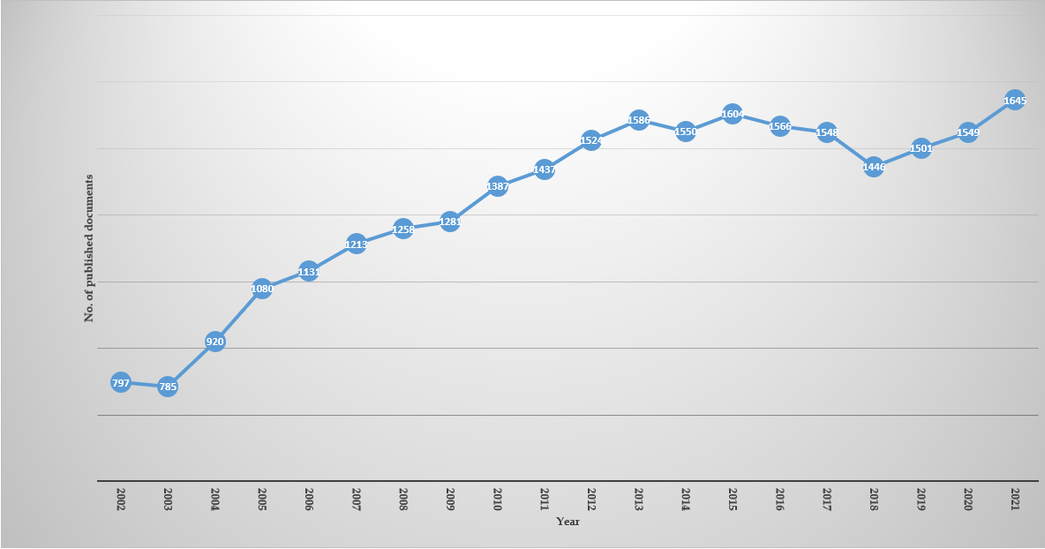
Figure 1 Annual growth of publications on insulin resistance research the last two decades (2002-2021). Source: Own elaboration, based on Scopus; this figure created using EXCEL version 2013.

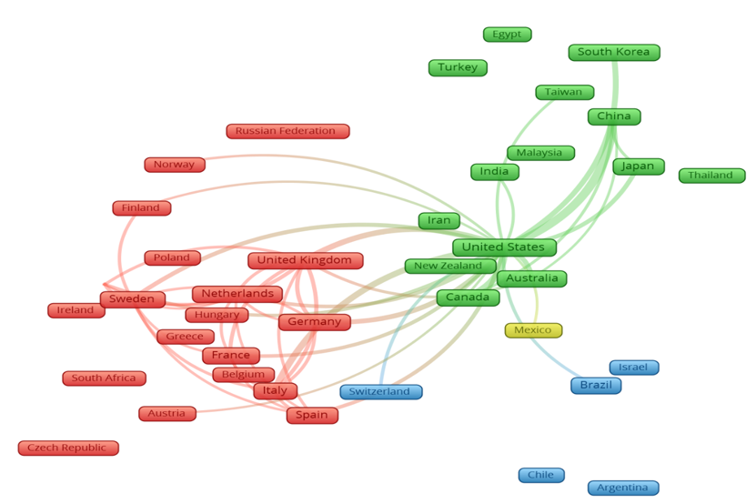
Figure 2 Map of visualization of worldwide research collaboration network. Countries with short distances and extensive connecting lines had a significant research collaboration. This collaborative map was built when each country had at least 100 articles. Source: Own elaboration, based on Scopus database; figure created using VOSviewer Software.

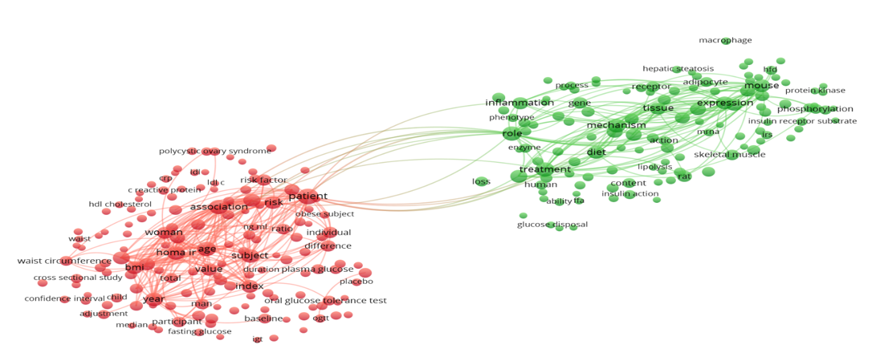
Figure 3 Network visualization map of terms in the titles/abstracts with a minimum occurrence of 300 or more. Of the 250809 terms in this field, 456 achieved this threshold, were grouped into two clusters, and colored differently. Each cluster represents a general research theme present in the retrieved documents. Source: Own elaboration, based on Scopus database; figure created using VOSviewer Software. LDL-C: Low-density lipoprotein cholesterol; HDL: High-density lipoprotein; IGT: Impaired glucose tolerance; OGTT: Oral glucose tolerance test; BMI: Body mass index; HFD: High fat diet; IRS: Insulin receptor substrate; CRP: C-reactive protein; HOMA-IR: Homeostatic Model Assessment of Insulin Resistance.

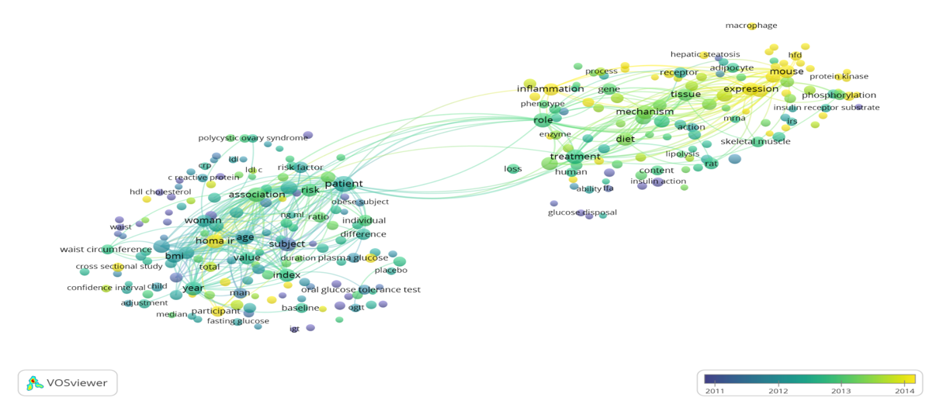
Figure 4 Network visualization map of terms in the title/abstract according to the average timing of their appearance. Blue represents early appearance, and yellow represents late appearance. Source: Own elaboration, based on Scopus database; figure created using VOSviewer Software. LDL-C: Low-density lipoprotein cholesterol; HDL: High-density lipoprotein; IGT: Impaired glucose tolerance; OGTT: Oral glucose tolerance test; BMI: Body mass index; HFD: High fat diet; IRS: Insulin receptor substrate; CRP: C-reactive protein; HOMA-IR: Homeostatic Model Assessment of Insulin Resistance.

Table 1 Top 10 most productive countries on insulin resistance research, ranked by the total number of publications in the last two decades (2002-2021)
Ranking | Country | Number of documents | %
1st | United States | 7360 | 27.45
2nd | China | 3713 | 13.85
3rd | Japan | 1730 | 6.45
4th | Italy | 1545 | 5.76
5th | United Kingdom | 1484 | 5.54
6th | Canada | 1186 | 4.42
7th | Germany | 1070 | 3.99
8th | Spain | 1061 | 3.96
9th | South Korea | 1056 | 3.94
10th | France | 858 | 3.20

Table 2 Top 10 most productive institutions in insulin resistance research, ranked by the total number of publications in the last two decades (2002-2021)
Ranking | Institute | Country | n | %
1st | Harvard Medical School | United States | 515 | 1.92
2nd | INSERM | France | 451 | 1.68
3rd | National Institutes of Health | United States | 298 | 1.11
4th | University of Toronto | Canada | 286 | 1.07
5th | Københavns Universitet | Denmark | 280 | 1.04
6th | Karolinska Institutet | Sweden | 268 | 1.00
7th | Consiglio Nazionale delle Ricerche | Italy | 263 | 0.98
8th | VA Medical Center | United States | 253 | 0.94
9th | Universidade de São Paulo | Brazil | 247 | 0.92
10th | Yale School of Medicine | United States | 234 | 0.87

Table 3 The top 10 funding agencies having the most publications on insulin resistance, ranked by the total number of publications in the last two decades (2002-2021)
Ranking | Institute | Country | n | %
1st | National Institute of Diabetes and Digestive and Kidney Diseases | United States | 2548 | 9.50
2nd | National Institutes of Health | United States | 2094 | 7.81
3rd | National Heart, Lung, and Blood Institute | United States | 1140 | 4.25
4th | National Natural Science Foundation of China | China | 1137 | 4.24
5th | National Center for Research Resources | United States | 1051 | 3.92
6th | United States Department of Health and Human Services | United States | 629 | 2.35
7th | National Institute on Aging | Canada | 521 | 1.94
8th | Japan Society for the Promotion of Science | Japan | 466 | 1.74
9th | National Center for Advancing Translational Sciences | United States | 450 | 1.68
10th | Eunice Kennedy Shriver National Institute of Child Health and Human Development | United States | 423 | 1.58

Table 4 Top 10 most productive journals on insulin resistance research, ranked by the total number of publications in the last two decades (2002-2021)
Ranking | Journal | n | % | IF¹
1st | Diabetes | 830 | 3.10 | 9.461
2nd | Journal of Clinical Endocrinology and Metabolism | 692 | 2.58 | 5.958
3rd | Diabetes Care | 623 | 2.32 | 19.112
4th | Plos One | 517 | 1.93 | 3.2400
5th | Diabetologia | 499 | 1.86 | 10.122
6th | Clinical and Experimental | 425 | 1.59 | 8.694
7th | American Journal of Physiology Endocrinology and Metabolism | 377 | 1.41 | 4.310
8th | Diabetes Research and Clinical Practice | 227 | 0.85 | 5.602
9th | Obesity | 219 | 0.82 | 5.002
10th | Scientific Reports | 218 | 0.81 | 4.379
¹2020 Journal Citation Reports® Science Edition (Clarivate Analytics, 2021). IF: Impact factor

Table 5 Top 10 most cited papers on research related to insulin resistance, ranked by the total number of citations in the last two decades (2002-2021)
Ranking | Ref. | Journal name | Cited by | IF¹ | Impact index per article² | Type of paper
1st | Xu et al^{[36]}, 2003 | Journal of Clinical Investigation | 4911 | 14.808 | 241.2 | Original article
2nd | Cani et al^{[40]}, 2007 | Diabetes | 3645 | 9.461 | 222.2 | Original article
3rd | Kahn et al^{[39]}, 2006 | Nature | 3109 | 49.962 | 185.2 | Review articles
4th | Shoelson et al^{[37]}, 2006 | Journal of Clinical Investigation | 2822 | 14.808 | 156.4 | Review articles
5th | Shi et al^{[42]}, 2006 | Journal of Clinical Investigation | 2521 | 14.808 | 149.0 | Original article
6th | Hirosumi et al^{[35]}, 2002 | Nature | 2503 | 49.962 | 112.6 | Letter to the editor
7th | Kadowaki et al^{[33]}, 2006 | Journal of Clinical Investigation | 2140 | 14.808 | 112.9 | Review articles
8th | Newgard et al^{[34]}, 2009 | Cell Metabolism | 1852 | 27.787 | 139.7 | Original article
9th | Houstis et al^{[41]}, 2006 | Nature | 1838 | 49.962 | 101.5 | Letter to the editor
10th | Kanda et al^{[38]}, 2006 | Journal of Clinical Investigation | 1827 | 14.808 | 105.4 | Original article
¹2020 Journal Citation Reports® Science Edition (Clarivate Analytics, 2021). ²The Impact Index Per Article is presented based on Reference Citation Analysis, https://www.referencecitationanalysis.com [Source: Baishideng Publishing Group Inc (Pleasanton, CA 94566, United States)]. IF: Impact factor.

Table 6 List of top 10 active authors in insulin resistance research, ranked by the total number of publications in the last two decades (2002-2021)
Ranking | Author | Country | n | % | H index
1st | Shulman GI | United States | 150 | 0.56 | 154
2nd | Haffner SM | United States | 86 | 0.32 | 144
3rd | Reaven GM | United States | 76 | 0.28 | 120
3rd | Roden M | Germany | 76 | 0.28 | 86
5th | Häring HU | Germany | 75 | 0.28 | 104
6th | Fritsche A | Germany | 70 | 0.26 | 80
7th | Fernández-Real JM | Spain | 68 | 0.25 | 75
7th | Izaola O | Spain | 68 | 0.25 | 32
7th | Wagenknecht LE | United States | 68 | 0.25 | 87
10th | Pacini G | Italy | 65 | 0.24 | 65

