Name of Journal: World Journal of Gastroenterology
Manuscript NO: 83082
Manuscript Type: MINIREVIEWS

Biliary complications after liver transplantation: A computed tomography and magnetic resonance imaging pictorial review

Vernuccio F et al. Imaging of post-liver transplantation biliary complications

Federica Vernuccio, Irene Mercante, Xiao Xiao Tong, Filippo Crimì, Umberto Cillo, Emilio Quaia

Federica Vernuccio, Department of Radiology, University Hospital of Padova, Padova 35128, Italy

Irene Mercante, Xiao-Xiao Tong, Filippo Crimì, Emilio Quaia, Department of Radiology-DIMED, University of Padova, Padova 35128, Italy

Umberto Cillo, Department of Surgery, Hepatobiliary Surgery and Liver Transplant Center, Oncology and Gastroenterology (DISCOG), University of Padova, Padova 35128, Italy

Author contributions: Vernuccio F conceptualized the manuscript, wrote the outline of the manuscript, prepared some of the figures, and extensively revised the draft of the manuscript; Mercante I and Tong XX performed the literature search, wrote the first draft of the manuscript, and prepared most of the figures; Crimì F and Cillo U revised the draft of the manuscript and provided input; Quaia E conceptualized the manuscript, provided input, and revised the draft of the manuscript.

Corresponding author: Federica Vernuccio, MD, PhD, Staff Physician, Department of Radiology, University Hospital of Padova, 2 Via Nicolò Giustiniani, Padova 35128, Italy. federicavernuccio@gmail.com

Received: January 6, 2023
Revised: March 23, 2023
Accepted: April 27, 2023
Published online:

Abstract
Biliary complications are the most common complications after liver transplantation. Computed tomography (CT) and magnetic resonance imaging (MRI) are cornerstones for timely diagnosis of biliary complications after liver transplantation. The diagnosis of these complications by CT and MRI requires expertise, mainly with respect to identifying subtle early signs to avoid missed or incorrect diagnoses. For example, biliary strictures may be misdiagnosed on MRI due to size mismatch of the common ducts of the donor and recipient, postoperative edema, pneumobilia, or susceptibility artifacts caused by surgical clips. Proper and prompt diagnosis of biliary complications after transplantation allows the timely initiation of appropriate management. The aim of this pictorial review is to illustrate various CT and MRI findings related to biliary complications after liver transplantation, based on time of presentation after surgery and frequency of occurrence.

Key Words: Liver transplantation; Biliary; Complications; Computed tomography; Magnetic resonance imaging; Hepatic imaging; Biliary tract; Cholangiopancreatography; Stricture

Vernuccio F, Mercante I, Tong XX, Crimì F, Cillo U, Quaia E. Biliary complications after liver transplantation: A computed tomography and magnetic resonance imaging pictorial review. World J Gastroenterol 2023; In press

Core Tip: Biliary complications are the most common surgical complications after liver transplantation, and represent a major source of morbidity and mortality in liver transplant recipients. Magnetic resonance cholangiopancreatography is the gold standard for the non-invasive diagnosis of intra- and extrahepatic biliary complications. Computed tomography may also be helpful for the assessment of biliary complications, and it is often used due to its more widespread availability as compared to that of magnetic resonance imaging.

INTRODUCTION
Computed tomography (CT) and magnetic resonance imaging (MRI) are cornerstones in the postoperative assessment of patients after liver transplantation^{[1]}. Complications may be categorized by etiology, and include surgical, graft-related, immunologic, infectious, and neoplastic. Complications can also be classified based on their timing: early (within 6 mo) or late (after 6 mo; Table 1). Surgical complications are typically categorized as vascular, biliary, or parenchymal. Biliary complications are the most common and represent a major source of morbidity and mortality in liver transplant recipients with an incidence of 10%-32%^{[2-4]}. Biliary complications after liver transplantation include anastomotic stricture, non-anastomotic stricture, bile leak, bile cast, biloma, sphincter of Oddi dysfunction, and mucocele of the cystic duct remnant^{[4-9]}. Biliary complications have a significant negative impact on patient survival and may lead to the need for re-transplantation^{[3,6]}. Magnetic resonance cholangiopancreatography (MRCP) is currently the gold standard for the diagnosis of intra- and extrahepatic biliary complications, while invasive cholangiography should be restricted for therapeutic uses or when MRCP is equivocal^{[10]}.
The aim of this pictorial review is to illustrate CT and MRI findings of surgery-related biliary complications after liver transplantation, classified based on their usual timing of appearance and their frequency. The knowledge of surgical techniques is of key importance to understand postoperative anatomic changes and imaging evaluation. Therefore, we will first provide a short summary of the main techniques of liver transplantation with focus on biliary anastomosis. Then, we will discuss imaging tips and tricks for the prompt diagnosis of biliary complications on CT and MRI.

SURGICAL TECHNIQUE
Most liver transplantations are performed with orthotopic implantation of a deceased donor whole liver graft, and may be performed with a conventional or piggyback technique. Other surgical options include split or segmental liver transplantation (Figure 1)^{[7]}. The split liver procedure may be performed by either of 2 approaches: in the most common approach, the liver is divided into a left lateral segment graft (II + III ± IV segments) if the recipient is a child or a right extended liver lobe graft (I + V-VIII ± IV segments) if the recipient is an adult; in the less common and more challenging variant of this procedure, the liver is split into 2 hemigrafts and the left side (I-IV) is transplanted to a small adult or a teenager and the right side (V-VIII) to a medium-sized adult. In patients with prior biliary disease or re-transplantation, a different biliary anastomosis technique may be performed^{[7]}. Liver transplantation is a multi-step surgery. After skin preparation and incision, the surgeon checks if there is any undiagnosed malignancy or anatomic variant and then dissects the recipient’s liver and gallbladder. The donor’s liver, without the gallbladder, is then implanted into the recipient with the anastomoses between recipient and donor performed in the following order: (1) systemic venous outflow (inferior cava vein-hepatic veins); (2) portal venous inflow; (3) hepatic arterial inflow; and (4) biliary anastomosis. The types of anastomosis depend on donor and recipient anatomy and surgeon preference. Finally, when the surgical field is dry, the abdomen is closed. Each of the above-mentioned steps is critical, and complications may be directly or indirectly related to failure of any of these steps^{[11,12]}.
Biliary anastomosis is known as the “Achilles tendon” of liver transplantation. The most common form of biliary reconstruction is choledochocholedochostomy (duct-to-duct anastomosis)^{[7]}, which may be performed in an end-to-end or end-to-side fashion. Choledochocholedochostomy can be performed either with a T-tube, which allows rapid decompression of the biliary tree if needed and reduces the risk of anastomotic stricture formation but may lead to biliary leakage and cholangitis at the time of removal, or without a T-tube^{[13]}. Choledochojejunostomy to a Roux-en-Y defunctionalized intestinal loop (i.e. the connection of the bile duct to jejunum loop) (Figure 1F) is the second most common type of biliary reconstruction technique, usually preferred in patients with pre-existing biliary disease and in case of size mismatch between donor and recipient ducts, re-transplantation, or previous biliary surgery^{[7]}. Potential complications of choledochojejunostomy include stricture, leakage, and bleeding at the jejuno-jejunostomy site. Choledochocholedochostomy is preferred over choledochojejunostomy due to shorter operation time, lower risk of septic complication, preserved sphincter of Oddi, better physiologic enteric function, and easier endoscopic access to the biliary tree for any future need.

CT/MRI OF BILIARY COMPLICATIONS
MRI has sensitivity and specificity of 98%-99% and 94%-96%, respectively, for the diagnosis of biliary complications after liver transplantation^{[14,15]}. MRI protocol includes 2D-MRCP and 3D-MRCP and an unenhanced T1-weighted sequence, while gadoxetate disodium hepatobiliary MRI is performed in selected cases^{[16]}. Ultrasound is usually performed first, and may help identify any features that suggest the presence of complication. Despite not being as comprehensive as MRI, CT may also be helpful for the assessment of biliary complications and is often used due to its more widespread availability. Table 2 summarizes biliary complications related to surgery classified according to frequency, time of occurrence, and treatment^{[4-10]}.

Biliary strictures
Biliary strictures are distinguished as anastomotic or non-anastomotic. Anastomotic strictures (Figure 2) account for about 47% of biliary complications, being slightly more frequent after choledochocholedochostomy vs choledochojejunostomy, and may also occur after split liver donation^{[3]}. Currently, percutaneous biliary techniques are considered effective treatment options with good outcomes in the setting of liver transplant with anastomotic biliary stricture^{[17]}. Non-anastomotic strictures account for about 23% of all biliary complications, being slightly more frequent after choledochojejunostomy vs choledochocholedochostomy^{[3]}. Non-anastomotic strictures (Figure 3) typically comprise ischemic-type biliary lesions in the early period after transplant, and are mostly related to recurrence of the primary biliary disease, chronic rejection, or secondary sclerosing cholangitis if occurring in the late postoperative period.
Biliary strictures are one of the most critical complications in ABO-incompatible living donor liver transplant recipients, and may occur as perihilar or diffuse, with the latter having worse clinical outcomes^{[18]}.
MRI demonstrates any stenosis at the level of the stricture as well as upstream irregular dilation of the biliary system; typically, the change in duct caliber at the level of the stricture is abrupt. Anastomotic strictures tend to be single, short in length, and occur at the level of anastomosis, usually in the late postoperative period. Non-anastomotic strictures are frequently multiple, long, hilar in location, and tend to occur early after transplantation and may result in graft loss. Radiologists should report the level of the biliary injury and the length of the obstruction. Although not routinely recommended for the diagnosis of biliary strictures, MRCP with hepatobiliary contrast may allow the assessment of the severity of bile duct obstruction based on the degree of hepatobiliary contrast filling distal to the stricture. Complete obstruction of the biliary tree is demonstrated in the case of absence of contrast distal to the stricture, while the obstruction is partial if there is limited passage of contrast beyond the stricture. In the case of complete obstruction, hepatic function may be impaired as evidenced by elevated bilirubin, which may hamper the excretion of hepatobiliary contrast^{[19]}. Biliary strictures must be differentiated from their mimickers on MRI, which may include size mismatch of the donor and recipient common ducts (appearing as gradual tapering of the bile duct lumen at the anastomosis) and postoperative edema (can cause extrinsic compression at the level of the anastomosis and have a tapered “hour-glass” appearance). Other potential mimickers of biliary strictures on MRI include pneumobilia (which may occur normally if a choledochojejunostomy anastomosis has been performed) and MRI susceptibility artifacts caused by nearby surgical clips. CT may help in identifying the inadvertent placement of metallic surgical clips. In ABO-incompatible living donor liver transplant recipients, imaging and clinical follow-up is recommended if post-transplantation CT at 1 mo demonstrates subtle intrahepatic duct dilatation with perihilar abnormality to assess for the possible occurrence of diffuse intrahepatic duct dilatation stricture^{[18]}.

Biliary leak and biloma
Biliary leaks account for approximately 23% of all biliary complications^{[3]}. They may be anastomotic or non-anastomotic (Figure 4) and are more common after choledochocholedochostomy vs choledochojejunostomy. Leaks at the biliary anastomosis are most common^{[20]}. Non-anastomotic leaks may occur at the level of T-tube insertion, cystic duct, or the cut surface of a partial liver graft. The use of a T-tube may be a risk factor for biliary leak, most commonly after removal of the tube^{[21]}. However, there are discordant data with respect to the causative mechanism of T-tube-related biliary leaks^{[22,23]}. Non-anastomotic biliary leaks may be cut-surface leaks, such as those originating from small bile ducts that are transected perioperatively during hepatic resection, from the cystic duct stump, or may be caused by bile duct necrosis in patients with hepatic artery occlusion. Biliary leaks may result in the development of bilomas. Bilomas may be intra- or extrahepatic depending on the origin of the leak, although they most commonly occur in the perihepatic space. Bilomas may become infected and can potentially lead to sepsis. Another potential serious complication of biloma is erosion of the adjacent hepatic artery. Ultrasound (US) and CT are most commonly performed as first-line imaging techniques due to their wide availability; biliary leak or biloma are demonstrated as free fluid or fluid collection, usually in the perihepatic and subhepatic spaces, mostly anechoic on US and hypoattenuating with fluid density on CT. On MRI, biliary leaks and biloma are hypointense on T1-weighted sequence and hyperintense on T2-weighted sequence, with the former appearing as free fluid and the latter as a fluid collection (Figure 5). However, these findings are nonspecific, and biliary leaks and bilomas are virtually indistinguishable from other types of fluid collection and ascites. In the case of a biliary leak occurring after bile duct necrosis in the setting of hepatic artery occlusion, intrahepatic bilomas or bile lakes may develop in the early postoperative period, with a characteristic appearance on imaging as cystic or linear dilatations of the intrahepatic bile ducts (Figure 6). MRCP with hepatobiliary contrast has 100% sensitivity and 98% specificity with respect to the diagnosis of bile leaks^{[24,25]}. MRCP with hepatobiliary contrast allows to demonstrate the level and the entity of biliary leakage, showing contrast agent extravasation into bilomas in case of active leakage. However, small bilomas are often self-limiting, and active extravasation may not be demonstrated. The lack of active bile leak into a biloma as evidenced on imaging is highly clinically relevant, as it may help in choosing a conservative management. However, it is important to highlight that the diagnostic accuracy of MRCP with hepatobiliary contrast depends on the timing of acquisition of the hepatobiliary phase. When conventional acquisition at 20 min only is adopted, sensitivity may be as low as 42.9%^{[26]}, while the acquisition at 60 min-90 min, 150 min-180 min, or even 210 min-240 min to 390 min increases the sensitivity^{[26,27]}. The reason behind the lower sensitivity of the 20 min hepatobiliary phase compared to acquisitions at later times may be 2-fold. On one hand, the increased bilirubin in these patients may result in low uptake of hepatobiliary contrast by the hepatocytes at 20 min; indeed, bilirubin is taken up at the hepatocyte level by the same family of organic anion transport proteins of gadoxetate disodium (Figure 7). On the other hand, bile duct obstruction may result in the upregulation of a multidrug resistance protein, which could reduce the excretion of gadoxetate disodium, delaying or preventing the visualization of the bile ducts and any bile leak^{[28,29]}. For this reason, based on consensus reports for liver MRI, an elevated bilirubin level is considered a relative contraindication to injection of gadoxetate disodium at some centers, with threshold bilirubin levels from 2.0 mg/dL-5.0 mg/dL. Overall, delayed acquisitions may prove to be helpful for the diagnosis of biliary leaks^{[29,30]}.

Biliary casts, stones and sludge
Biliary casts, stones, or sludge account for about 6% of all biliary complications^{[3]}, and usually complicate any biliary stricture present. Casts, stones, or sludge may occur at both the intra- and extrahepatic bile ducts as the consequence of bile stasis and may lead to cholangitis, graft failure, or the need for re-transplantation^{[31]}. Biliary concretions after liver transplantation are related to a heterogenous group of lithogenic conditions mostly related to bile tract damage with a multifactorial, complex pathophysiology^{[32]}. Biliary casts complicate up to 4.5% of liver transplantations, may recur, and may lead to biliary strictures in up to 85.0% of patients on follow-up^{[4]}. Morphologically, biliary casts after liver transplantation may have a cordlike, columnar, or dendritic shape within the biliary tree^{[33]}. The prompt identification of biliary casts is of utmost importance, as patients with biliary cast syndrome have lower overall and graft survival rates compared to patients with non-anastomotic and anastomotic strictures only^{[4]}. MRCP has very good sensitivity in the identification of biliary concretions, which appear as filling defects surrounded by a thin film of hyperintense bile (Figure 8). Importantly, the sensitivity for biliary cast detection increases when using T1-weighted imaging compared to T2-weighted MRCP; unenhanced T1-weighted images show hyperintensities in the bile ducts (Figure 8C), leading to the correct diagnosis of biliary cast^{[34]}. As recently pointed out, intraductal hyperintense filling material on T1-weighted MRI is a sensitive sign for biliary casts, and intraductal filling defect on T2-weighted MRI with the duct-in-a-duct feature is a specific sign and likely reflects biliary mucosal detachment^{[4]}.

Sphincter of Oddi dysfunction
Sphincter of Oddi dysfunction (SOD) comprises functional or mechanical obstruction of the sphincter of Oddi and involves the biliary sphincter and/or the pancreatic sphincter. Biliary and pancreatic SOD have each been subclassified into 3 types based on related symptoms, laboratory testing, and imaging (common bile duct diameter of at least 12 mm): Type I with biliary pain, abnormal liver enzymes and dilatation of the common bile duct; Type II with biliary pain and either abnormal liver enzymes or dilatation of the common bile duct; and Type III with biliary pain and no objective criteria^{[35,36]}. More recently, the Rome IV consensus has proposed new classification, as most type I patients present with papillary stenosis rather than a functional disorder and have an excellent response after sphincterotomy; type II has now been renamed as suspected functional biliary sphincter disorder; and type III patients have no response to sphincterotomy^{[37,38]}. SOD after liver transplantation has been reported in about 2%-5% of patients, with papillary stenosis (i.e. SOD type I) accounting for about 1% of cases and suspected functional biliary sphincter disorder (i.e. SOD type II) for about 1% as well^{[39]}. The pathogenesis of biliary sphincter disorder in liver transplantation recipients is poorly understood; possible predisposing factors include the use of a T-tube, the presence of opportunistic infection, and postsurgical edema^{[40,41]}. Patients with functional biliary sphincter disorder after liver transplantation may be asymptomatic due to hepatic denervation after the surgery and immunosuppression, thus making the diagnosis more difficult^{[41]}. Therefore, suspicion of SOD after liver transplantation should be raised when cholestasis or dilation of bile ducts appears in the absence of bile stones or other structural abnormalities. Sphincter of Oddi manometry has been the gold standard for years, although it is invasive, patient- and operator-dependent, and may lead to post-procedure pancreatitis. Due to these factors, it is no longer routinely used in all patients with suspected SOD and its general utility has been questioned^{[39-41]}. Hepatobiliary scintigraphy can demonstrate structural or functional partial biliary obstruction as evidenced by increased time to hepatic peak, delayed biliary visualization, delayed clearance of the radiotracer from the dilated bile ducts, and prolonged biliary to bowel transit^{[42-44]}. MRCP may be used to exclude biliary lithiasis and other structural abnormalities, and may show an enlarged papilla in some cases of papillary stenosis (Figure 9). Secretin-MRCP may suggest the diagnosis of SOD, showing stenosis of the sphincter and lack of relaxation of the main pancreatic duct after secretin injection, increased prominence of pancreatic duct side branches, or acinarization^{[45]}. Secretin-MRCP seems more useful for SOD type II, with a diagnostic accuracy of 73%, rather than for SOD type III for which accuracy drops to only 46%^{[46]}. Given the low accuracy, the cost of secretin, and the acquisition time of at least 15 min, secretin-MRCP for SOD should be considered only in a few selected cases (i.e. noninvasive evaluation is preferred or when endoscopic evaluation is not available or impractical)^{[45]}. Gadoxetate disodium-enhanced MRCP may help in ruling out SOD in the case of normal passage of hepatobiliary contrast in the duodenum at 20 min-30 min, and in suggesting the diagnosis in the case of delayed or no passage of bile through the ampulla of Vater after 30 min-1 h^{[47]}. Interestingly, the diagnostic accuracy of gadoxetate disodium-enhanced MRCP for SOD has not yet been investigated; this represents an area of interest particularly when invasive evaluation is not indicated.

Mucocele of the cystic duct remnant
Mucocele of the cystic duct remnant, whether recipient or donor in origin, is an extremely rare complication after liver transplantation^{[48-51]}. It is characterized by an abnormally dilated cystic duct remnant with flattening of the walls of the residual cystic duct to form a collection of mucus from cells lining the cystic duct remnant. The causative mechanism of the mucocele is still unclear. Lack of nervous regulation of the biliary tract after liver transplant may affect bile secretion and outflow. The differential diagnosis includes abscess, biloma, hemobilia, tumor, or aneurysm. If left untreated, the enlarged mucocele may cause chronic mechanical compression of the biliary system; however, it may also remain stable in size^{[50]}. Ultrasound and CT demonstrate the presence of a collection at the level of the hepatic hilum. MRCP demonstrates a rounded and well-circumscribed collection adjacent to the common hepatic duct in the absence of other cause of obstruction (Figure 10).

Bile duct redundancy
Bile duct redundancy is described as a surgically reconstructed donor-recipient extrahepatic bile duct that creates a looped, sigmoid-shaped appearance in the absence of any anastomotic stricture^{[8]}. A redundant bile duct occurs when the donor or the recipient bile duct is too long, and may lead to delayed bile flow into the duodenum, functionally translating into cholestasis, abnormal liver laboratory test results, and cholangitis; it may also predispose to kinking of the redundant bile duct with subsequent obstruction^{[8,52,53]}. Two-dimensional and 3-dimensional MRCP may demonstrate the abnormal long-constructed donor-recipient extrahepatic bile duct shape as well as any kinking, if present.

Vanishing bile duct syndrome
Vanishing bile duct syndrome is a very rare biliary complication occurring after liver transplantation, characterized by progressive destruction and disappearance of the intrahepatic bile ducts in the portal area leading to cholestasis^{[54,55]}. It is caused by an acute or chronic T-cell-mediated rejection of the allograft^{[54,55]}. The diagnosis of vanishing bile duct syndrome is suspected in a patient with liver biochemical abnormalities consistent with cholestasis in the absence of other conditions associated with cholestasis^{[54-56]}. Histologic examination through liver biopsy is needed for the diagnosis, and MRI may help in excluding other causes of cholestasis^{[54,56]}.

CONCLUSION
In conclusion, biliary complications represent a clinically relevant problem after liver transplantation and occur in up to 1/3 of liver transplant recipients. Radiologists need to be aware of surgical techniques and post-surgical anatomy as well as clinical information for comprehensive image interpretation. MRCP is an established non-invasive procedure for the diagnosis of post-transplantation biliary complications. In selected cases, gadoxetate disodium-enhanced MRCP is needed for improving diagnostic accuracy of biliary complications and the protocol for this technique must be tailored based on the clinical suspicion.

REFERENCES
1 Di Martino M, Rossi M, Mennini G, Melandro F, Anzidei M, De Vizio S, Koryukova K, Catalano C. Imaging follow-up after liver transplantation. Br J Radiol 2016; 89: 20151025 [PMID: 27188846 DOI: 10.1259/bjr.20151025]
2 Daniel K, Said A. Early Biliary complications after liver transplantation. Clin Liver Dis (Hoboken) 2017; 10: 63-67 [PMID: 30992762 DOI: 10.1002/cld.654]
3 Rönning J, Berglund E, Arnelo U, Ericzon BG, Nowak G. Long-term Outcome of Endoscopic and Percutaneous Transhepatic Approaches for Biliary Complications in Liver Transplant Recipients. Transplant Direct 2019; 5: e432 [PMID: 30882037 DOI: 10.1097/TXD.0000000000000869]
4 Lemmers A, Pezzullo M, Hadefi A, Dept S, Germanova D, Gustot T, Degré D, Boon N, Moreno C, Blero D, Arvanitakis M, Delhaye M, Vandermeeren A, Njimi H, Devière J, Le Moine O, Lucidi V. Biliary cast syndrome after liver transplantation: A cholangiographic evolution study. J Gastroenterol Hepatol 2021; 36: 1366-1377 [PMID: 33150992 DOI: 10.1111/jgh.15318]
5 Millson C, Considine A, Cramp ME, Holt A, Hubscher S, Hutchinson J, Jones K, Leithead J, Masson S, Menon K, Mirza D, Neuberger J, Prasad R, Pratt A, Prentice W, Shepherd L, Simpson K, Thorburn D, Westbrook R, Tripathi D. Adult liver transplantation: UK clinical guideline - part 2: surgery and post-operation. Frontline Gastroenterol 2020; 11: 385-396 [PMID: 32879722 DOI: 10.1136/flgastro-2019-101216]
6 Akamatsu N, Sugawara Y, Hashimoto D. Biliary reconstruction, its complications and management of biliary complications after adult liver transplantation: a systematic review of the incidence, risk factors and outcome. Transpl Int 2011; 24: 379-392 [PMID: 21143651 DOI: 10.1111/j.1432-2277.2010.01202.x]
7 Miller C, Diago Uso T. The liver transplant operation. Clin Liver Dis (Hoboken) 2013; 2: 192-196 [PMID: 30992860 DOI: 10.1002/cld.232]
8 Torres V, Martinez N, Lee G, Almeda J, Gross G, Patel S, Rosenkranz L. How do we manage post-OLT redundant bile duct? World J Gastroenterol 2013; 19: 2501-2506 [PMID: 23674851 DOI: 10.3748/wjg.v19.i16.2501]
9 Lisotti A, Fusaroli P, Caletti G. Role of endoscopy in the conservative management of biliary complications after deceased donor liver transplantation. World J Hepatol 2015; 7: 2927-2932 [PMID: 26730271 DOI: 10.4254/wjh.v7.i30.2927]
10 Magro B, Tacelli M, Mazzola A, Conti F, Celsa C. Biliary complications after liver transplantation: current perspectives and future strategies. Hepatobiliary Surg Nutr 2021; 10: 76-92 [PMID: 33575291 DOI: 10.21037/hbsn.2019.09.01]
11 McElroy LM, Daud A, Davis AE, Lapin B, Baker T, Abecassis MM, Levitsky J, Holl JL, Ladner DP. A meta-analysis of complications following deceased donor liver transplant. Am J Surg 2014; 208: 605-618 [PMID: 25118164 DOI: 10.1016/j.amjsurg.2014.06.006]
12 Polak WG, Porte RJ. The sequence of revascularization in liver transplantation: it does make a difference. Liver Transpl 2006; 12: 1566-1570 [PMID: 17058245 DOI: 10.1002/Lt.20797]
13 Scatton O, Meunier B, Cherqui D, Boillot O, Sauvanet A, Boudjema K, Launois B, Fagniez PL, Belghiti J, Wolff P, Houssin D, Soubrane O. Randomized trial of choledochocholedochostomy with or without a T tube in orthotopic liver transplantation. Ann Surg 2001; 233: 432-437 [PMID: 11224633 DOI: 10.1097/00000658-200103000-00019]
14 Boraschi P, Donati F, Gigoni R, Volpi A, Salemi S, Filipponi F, Falaschi F. MR cholangiography in orthotopic liver transplantation: sensitivity and specificity in detecting biliary complications. Clin Transplant 2010; 24: E82-E87 [PMID: 20041910 DOI: 10.1111/j.1399-0012.2009.01190.x]
15 Boraschi P, Donati F, Pacciardi F, Ghinolfi D, Falaschi F. Biliary complications after liver transplantation: Assessment with MR cholangiopancreatography and MR imaging at 3T device. Eur J Radiol 2018; 106: 46-55 [PMID: 30150050 DOI: 10.1016/j.ejrad.2018.07.009]
16 Vernuccio F, Whitney SA, Ravindra K, Marin D. CT and MR imaging evaluation of living liver donors. Abdom Radiol (NY) 2021; 46: 17-28 [PMID: 31901101 DOI: 10.1007/s00261-019-02385-6]
17 Kulkarni CB, Prabhu NK, Kader NP, Rajeshkannan R, Pullara SK, Moorthy S. Percutaneous transhepatic techniques for management of biliary anastomotic strictures in living donor liver transplant recipients. Indian J Radiol Imaging 2017; 27: 92-99 [PMID: 28515595 DOI: 10.4103/0971-3026.202950]
18 Choi SH, Kim KW, Kim SY, Kim JS, Kwon JH, Song GW, Lee SG. Computed tomography findings in ABO-incompatible living donor liver transplantation recipients with biliary strictures. Eur Radiol 2018; 28: 2572-2581 [PMID: 29294154 DOI: 10.1007/s00330-017-5226-9]
19 Khouri Chalouhi C, Vernuccio F, Rini F, Duca P, Tuscano B, Brancatelli G, Vanzulli A. Hepatobiliary phase in cirrhotic patients with different Model for End-stage Liver Disease score: comparison of the performance of gadoxetic acid to gadobenate dimeglumine. Eur Radiol 2019; 29: 3090-3099 [PMID: 30547205 DOI: 10.1007/s00330-018-5884-2]
20 Verdonk RC, Buis CI, Porte RJ, van der Jagt EJ, Limburg AJ, van den Berg AP, Slooff MJ, Peeters PM, de Jong KP, Kleibeuker JH, Haagsma EB. Anastomotic biliary strictures after liver transplantation: causes and consequences. Liver Transpl 2006; 12: 726-735 [PMID: 16628689 DOI: 10.1002/Lt.20714]
21 Sundaram V, Jones DT, Shah NH, de Vera ME, Fontes P, Marsh JW, Humar A, Ahmad J. Posttransplant biliary complications in the pre- and post-model for end-stage liver disease era. Liver Transpl 2011; 17: 428-435 [PMID: 21445926 DOI: 10.1002/lt.22251]
22 Sotiropoulos GC, Sgourakis G, Radtke A, Molmenti EP, Goumas K, Mylona S, Fouzas I, Karaliotas C, Lang H. Orthotopic liver transplantation: T-tube or not T-tube? Systematic review and meta-analysis of results. Transplantation 2009; 87: 1672-1680 [PMID: 19502959 DOI: 10.1097/TP.0b013e3181a5cf3f]
23 Huang WD, Jiang JK, Lu YQ. Value of T-tube in biliary tract reconstruction during orthotopic liver transplantation: a meta-analysis. J Zhejiang Univ Sci B 2011; 12: 357-364 [PMID: 21528489 DOI: 10.1631/jzus.B1100054]
24 Ratcliffe GE, Kirkpatrick ID, Anik Sahni V, Greenberg HM, Henderson B, Radulovic D, Mottola JC. Detection and localization of bile duct leaks after cholecystectomy using Gd-EOB-DTPA-enhanced MR cholangiography: retrospective study of 16 patients. J Comput Assist Tomogr 2014; 38: 518-525 [PMID: 24651750 DOI: 10.1097/RCT.0000000000000083]
25 Alegre Castellanos A, Molina Granados JF, Escribano Fernandez J, Gallardo Muñoz I, Triviño Tarradas Fde A. Early phase detection of bile leak after hepatobiliary surgery: value of Gd-EOB-DTPA-enhanced MR cholangiography. Abdom Imaging 2012; 37: 795-802 [PMID: 22213118 DOI: 10.1007/s00261-011-9834-6]
26 Spies CK, Unglaub F. Comment on "3-T direct MR arthrography of the wrist: value of finger trap distraction to assess intrinsic ligament and triangular fibrocartilage complex tears", Cerny M et al Eur J Radiol (2013). Eur J Radiol 2013; 82: e909 [PMID: 24016831 DOI: 10.1016/j.ejrad.2013.08.022]
27 Kul M, Erden A, Düşünceli Atman E. Diagnostic value of Gd-EOB-DTPA-enhanced MR cholangiography in non-invasive detection of postoperative bile leakage. Br J Radiol 2017; 90: 20160847 [PMID: 28181823 DOI: 10.1259/bjr.20160847]
28 Belinsky MG, Dawson PA, Shchaveleva I, Bain LJ, Wang R, Ling V, Chen ZS, Grinberg A, Westphal H, Klein-Szanto A, Lerro A, Kruh GD. Analysis of the in vivo functions of Mrp3. Mol Pharmacol 2005; 68: 160-168 [PMID: 15814571 DOI: 10.1124/mol.104.010587]
29 Merkle EM, Zech CJ, Bartolozzi C, Bashir MR, Ba-Ssalamah A, Huppertz A, Lee JM, Ricke J, Sakamoto M, Sirlin CB, Ye SL, Zeng M. Consensus report from the 7th International Forum for Liver Magnetic Resonance Imaging. Eur Radiol 2016; 26: 674-682 [PMID: 26070500 DOI: 10.1007/s00330-015-3873-2]
30 Koh DM, Ba-Ssalamah A, Brancatelli G, Fananapazir G, Fiel MI, Goshima S, Ju SH, Kartalis N, Kudo M, Lee JM, Murakami T, Seidensticker M, Sirlin CB, Tan CH, Wang J, Yoon JH, Zeng M, Zhou J, Taouli B. Consensus report from the 9(th) International Forum for Liver Magnetic Resonance Imaging: applications of gadoxetic acid-enhanced imaging. Eur Radiol 2021; 31: 5615-5628 [PMID: 33523304 DOI: 10.1007/s00330-020-07637-4]
31 Gor NV, Levy RM, Ahn J, Kogan D, Dodson SF, Cohen SM. Biliary cast syndrome following liver transplantation: Predictive factors and clinical outcomes. Liver Transpl 2008; 14: 1466-1472 [PMID: 18825683 DOI: 10.1002/lt.21492]
32 Cillo U, Burra P, Norberto L, D'Amico D. Bile duct stones and casts after liver transplantation: Different entities but similar prevention strategy? Liver Transpl 2008; 14: 1400-1403 [PMID: 18825732 DOI: 10.1002/lt.21628]
33 Yang YL, Zhang C, Lin MJ, Shi LJ, Zhang HW, Li JY, Yu Q. Biliary casts after liver transplantation: morphology and biochemical analysis. World J Gastroenterol 2013; 19: 7772-7777 [PMID: 24282366 DOI: 10.3748/wjg.v19.i43.7772]
34 Kinner S, Umutlu L, Dechêne A, Ladd SC, Barkhausen J, Gerken G, Lauenstein TC, Hunold P. Biliary complications after liver transplantation: addition of T1-weighted images to MR cholangiopancreatography facilitates detection of cast in biliary cast syndrome. Radiology 2012; 263: 429-436 [PMID: 22517958 DOI: 10.1148/radiol.12111625]
35 Hogan WJ, Geenen JE. Biliary dyskinesia. Endoscopy 1988; 20 Suppl 1: 179-183 [PMID: 3168947 DOI: 10.1055/s-2007-1018172]
36 Geenen JE, Hogan WJ, Dodds WJ, Toouli J, Venu RP. The efficacy of endoscopic sphincterotomy after cholecystectomy in patients with sphincter-of-Oddi dysfunction. N Engl J Med 1989; 320: 82-87 [PMID: 2643038 DOI: 10.1056/NEJM198901123200203]
37 Cotton PB, Elta GH, Carter CR, Pasricha PJ, Corazziari ES. Rome IV. Gallbladder and Sphincter of Oddi Disorders. Gastroenterology 2016 [PMID: 27144629 DOI: 10.1053/j.gastro.2016.02.033]
38 Cotton PB, Pauls Q, Keith J, Thornhill A, Drossman D, Williams A, Durkalski-Mauldin V. The EPISOD study: long-term outcomes. Gastrointest Endosc 2018; 87: 205-210 [PMID: 28455162 DOI: 10.1016/j.gie.2017.04.015]
39 Fernandez-Simon A, Sendino O, Chavez-Rivera K, Córdova H, Colmenero J, Crespo G, Fundora Y, Samaniego F, Ruiz P, Fondevila C, Navasa M, Cárdenas A. The presence and outcome of biliary sphincter disorders in liver-transplant recipients according to the Rome IV classification. Gastroenterol Rep (Oxf) 2021; 9: 299-305 [PMID: 34567561 DOI: 10.1093/gastro/goab025]
40 Riediger C, Müller MW, Michalski CW, Hüser N, Schuster T, Kleeff J, Friess H. T-Tube or no T-tube in the reconstruction of the biliary tract during orthotopic liver transplantation: systematic review and meta-analysis. Liver Transpl 2010; 16: 705-717 [PMID: 20517904 DOI: 10.1002/lt.22070]
41 Douzdjian V, Abecassis MM, Johlin FC. Sphincter of Oddi dysfunction following liver transplantation. Screening by bedside manometry and definitive manometric evaluation. Dig Dis Sci 1994; 39: 253-256 [PMID: 8313805 DOI: 10.1007/BF02090194]
42 Tulchinsky M, Ciak BW, Delbeke D, Hilson A, Holes-Lewis KA, Stabin MG, Ziessman HA; Society of Nuclear Medicine. SNM practice guideline for hepatobiliary scintigraphy 4.0. J Nucl Med Technol 2010; 38: 210-218 [PMID: 21078782 DOI: 10.2967/jnmt.110.082289]
43 Sostre S, Kalloo AN, Spiegler EJ, Camargo EE, Wagner HN Jr. A noninvasive test of sphincter of Oddi dysfunction in postcholecystectomy patients: the scintigraphic score. J Nucl Med 1992; 33: 1216-1222 [PMID: 1597742]
44 Rosenblatt ML, Catalano MF, Alcocer E, Geenen JE. Comparison of sphincter of Oddi manometry, fatty meal sonography, and hepatobiliary scintigraphy in the diagnosis of sphincter of Oddi dysfunction. Gastrointest Endosc 2001; 54: 697-704 [PMID: 11726844 DOI: 10.1067/mge.2001.118946]
45 Swensson J, Zaheer A, Conwell D, Sandrasegaran K, Manfredi R, Tirkes T. Secretin-Enhanced MRCP: How and Why-AJR Expert Panel Narrative Review. AJR Am J Roentgenol 2021; 216: 1139-1149 [PMID: 33263419 DOI: 10.2214/AJR.20.24857]
46 Pereira SP, Gillams A, Sgouros SN, Webster GJ, Hatfield AR. Prospective comparison of secretin-stimulated magnetic resonance cholangiopancreatography with manometry in the diagnosis of sphincter of Oddi dysfunction types II and III. Gut 2007; 56: 809-813 [PMID: 17005767 DOI: 10.1136/gut.2006.099267]
47 Lee NK, Kim S, Lee JW, Lee SH, Kang DH, Kim GH, Seo HI. Biliary MR imaging with Gd-EOB-DTPA and its clinical applications. Radiographics 2009; 29: 1707-1724 [PMID: 19959517 DOI: 10.1148/rg.296095501]
48 Chatterjee S, Das D, Hudson M, Bassendine MF, Scott J, Oppong KE, Sen G, French JJ. Mucocele of the cystic duct remnant after orthotopic liver transplant: a problem revisited. Exp Clin Transplant 2011; 9: 214-216 [PMID: 21649573]
49 Caputo M, Piolanti M, Riccioli LA, Pazienza L, Fabbro E, Gruppioni F, Grazi G, Gavelli G. [Nonobstructive residual mucocele of the cystic duct. Reassessment of complications in our 13 years' experience with liver transplantation]. Radiol Med 2000; 100: 354-356 [PMID: 11213414]
50 Zajko AB, Bennett MJ, Campbell WL, Koneru B. Mucocele of the cystic duct remnant in eight liver transplant recipients: findings at cholangiography, CT, and US. Radiology 1990; 177: 691-693 [PMID: 2243970 DOI: 10.1148/radiology.177.3.2243970]
51 Chaly T, Campsen J, O'Hara R, Hardman R, Gallegos-Orozco JF, Thiesset H, Kim RD. Mucocele mimicking a gallbladder in a transplanted liver: A case report and review of the literature. World J Transplant 2017; 7: 359-363 [PMID: 29312865 DOI: 10.5500/wjt.v7.i6.359]
52 Killenberg PG, Clavien PA, Smith A, M¿llhaupt B. Medical Care of the Liver Transplant Patient: Total Pre-, Intra- and Post-Operative Management. 3rd Edition. Wiley-Blackwell, 2008 [DOI: 10.1016/j.dld.2006.09.014]
53 Nöldge G, Otto G, Theilmann L. Cholangiography After Orthotopic Liver Transplantation. Heidelberg: Springer Berlin, 1996 [DOI: 10.1007/978-3-642-61064-6]
54 Hubscher SG, Buckels JA, Elias E, McMaster P, Neuberger J. Vanishing bile-duct syndrome following liver transplantation--is it reversible? Transplantation 1991; 51: 1004-1010 [PMID: 1851580 DOI: 10.1097/00007890-199105000-00014]
55 Inomata Y, Tanaka K. Pathogenesis and treatment of bile duct loss after liver transplantation. J Hepatobiliary Pancreat Surg 2001; 8: 316-322 [PMID: 11521176 DOI: 10.1007/s005340170003]
56 Yeh KH, Hsieh HC, Tang JL, Lin MT, Yang CH, Chen YC. Severe isolated acute hepatic graft-versus-host disease with vanishing bile duct syndrome. Bone Marrow Transplant 1994; 14: 319-321 [PMID: 7994249]

Footnotes
Conflict-of-interest statement: The authors report having no relevant conflicts of interest for this article.

Open-Access: This article is an open-access article that was selected by an in-house editor and fully peer-reviewed by external reviewers. It is distributed in accordance with the Creative Commons Attribution NonCommercial (CC BY-NC 4.0) license, which permits others to distribute, remix, adapt, build upon this work non-commercially, and license their derivative works on different terms, provided the original work is properly cited and the use is non-commercial. See: https://creativecommons.org/Licenses/by-nc/4.0/

Provenance and peer review: Invited article; Externally peer reviewed.
Peer-review model: Single blind

Peer-review started: January 6, 2023
First decision: March 18, 2023
Article in press:

Specialty type: Radiology, nuclear medicine and medical imaging
Country/Territory of origin: Italy
Peer-review report’s scientific quality classification
Grade A (Excellent): A
Grade B (Very good): 0
Grade C (Good): C
Grade D (Fair): 0
Grade E (Poor): 0

P-Reviewer: Gupta T, India; Oura S, Japan S-Editor: Chen YL L-Editor: Filipodia P-Editor:
Figure Legends
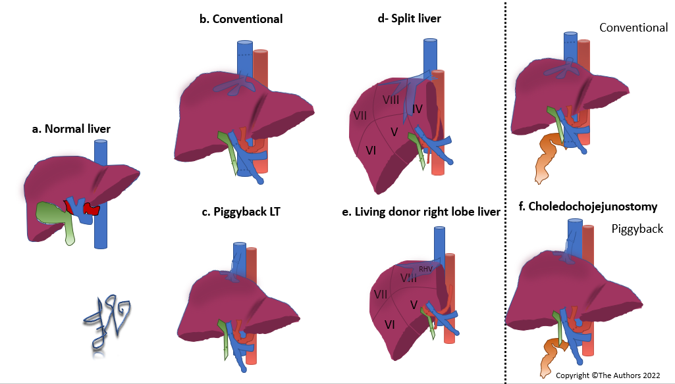
Figure 1 Schematic representation of surgical techniques for liver transplantation. A: Normal anatomy of the liver; B: Conventional technique for liver transplantation; C: Piggyback technique; D: Split liver technique in adults; E: Living donor right lobe liver transplantation; F: Conventional (top row) and piggyback (bottom row) techniques with choledochojejunostomy.

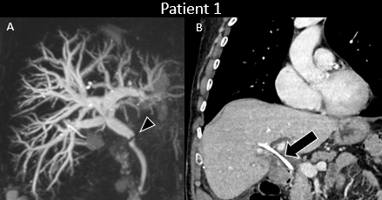
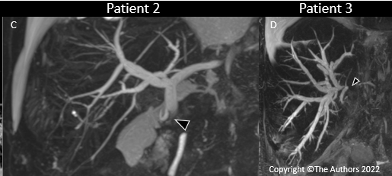
Figure 2 Anastomotic biliary strictures. A: Anastomotic stricture of choledochocholedochostomy 3 mo after liver transplantation. Endoscopic retrograde cholangiopancreatography was performed with balloon dilatation of the stricture and stent positioning. Magnetic resonance cholangiopancreatography (MRCP) maximum intensity projection (MIP) demonstrates anastomotic biliary stricture (arrowhead) with marked upstream biliary dilatation; B: Contrast enhanced computed tomography in the coronal plane shows in the same patient the stent in the biliary tree (arrow) and normal biliary tree caliber; C: Anastomotic stricture of choledochojejunostomy 6 mo after liver transplantation. MRCP MIP demonstrates anastomotic biliary stricture (arrowhead) with marked upstream biliary dilatation; D: Anastomotic stricture of end-to-end biliary anastomosis after split liver transplantation with right split lobe. MRCP MIP demonstrates anastomotic biliary stricture (arrowhead) with marked upstream biliary dilatation of the right split transplanted lobe.

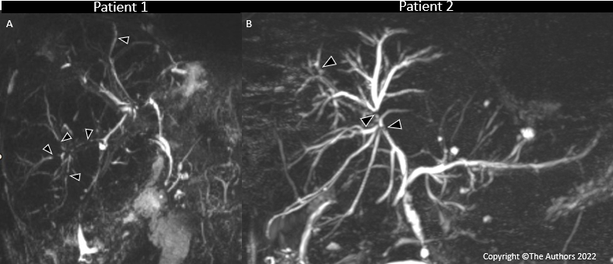
Figure 3 Non-anastomotic biliary strictures. A: Non-anastomotic strictures in a patient with chronic rejection demonstrated at biopsy 11 y after transplant and then re-transplanted. Magnetic resonance cholangiopancreatography (MRCP) maximum intensity projection (MIP) demonstrates multiple non-anastomotic biliary strictures (arrowheads); B: Non-anastomotic strictures in a patient with recurrent secondary cholangitis 4 y after liver transplantation. MRCP MIP demonstrates multiple non-anastomotic biliary strictures (arrowheads) with upstream biliary dilatation.

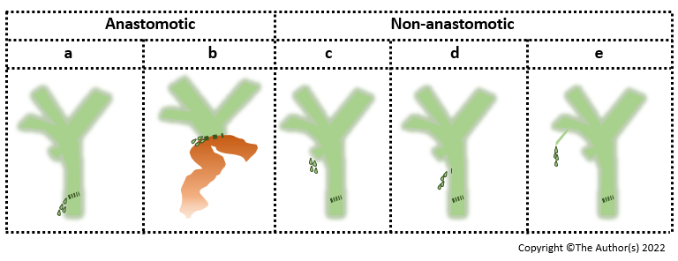
Figure 4 Schematic representation of biliary leaks. A: Anastomotic leak at the level of choledochocholedochostomy; B: Anastomotic leak at the level of choledochojejunostomy; C: Non-anastomotic leak at the level of the cystic duct stump; D: Non-anastomotic leak at the level of T-tube removal; E: Non-anastomotic leak from small bile ducts that are transected perioperatively during hepatic resection.

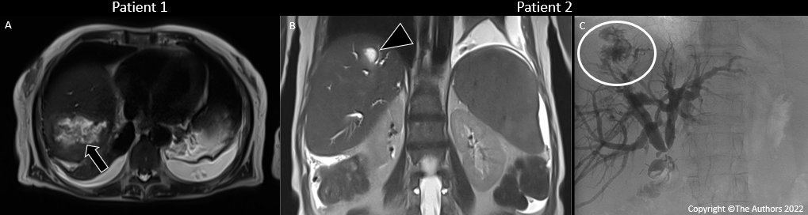
Figure 5 Biloma and biliary leak after liver transplantation. A: Patient with biloma occurring 9 mo after liver transplantation. T2-weighted axial image shows a collection (arrow) in the right hepatic lobe with internal heterogenous signal intensities. Percutaneous drainage of the collection was performed demonstrating superinfected biloma; B: Patient with biliary leak occurring after liver transplantation. T2-weighted coronal magnetic resonance imaging shows an intrahepatic fluid collection (arrowhead) consistent with biloma; C: Cholangiographic image in the same patient demonstrated the biliary leak (circle) causing an intrahepatic biloma.

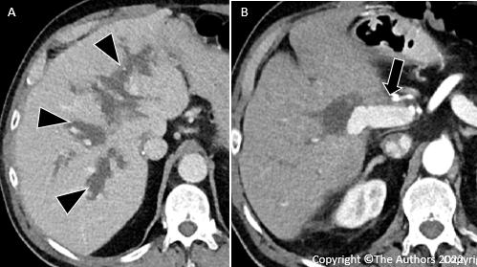
Figure 6 Biliary lakes occurring after liver transplantation. A: Contrast-enhanced computed tomography (CT) in the axial plane in the portal venous phase demonstrates biliary lakes (arrowheads) adjacent to the portal vein branches; B: Contrast-enhanced CT in the arterial phase demonstrates lack of enhancement of the hepatic artery (arrow) caused by the adjacent surgical clip.

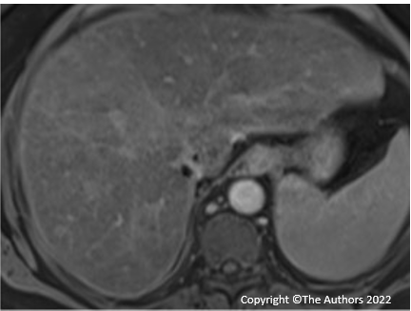
Figure 7 Lack of excretion of hepatobiliary contrast after liver transplantation in a patient with increased serum bilirubin of 2.2 mg/dL. Gadoxetate disodium-enhanced magnetic resonance imaging in the hepatobiliary phase acquired at 20 min is inadequate as demonstrated by hypointensity of the liver parenchyma compared to that of hepatic vessels and lack of contrast in the biliary tree.

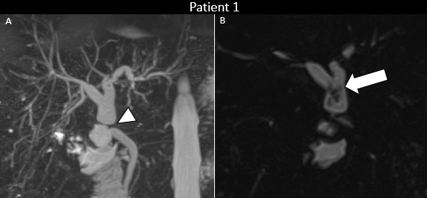
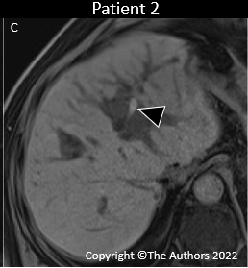
Figure 8 Biliary sludge and biliary cast. A: Patient with biliary sludge and anastomotic stricture 3 mo after liver re-transplantation. Magnetic resonance cholangiopancreatography (MRCP) maximum intensity projection image demonstrates anastomotic biliary stricture (arrowhead) with marked upstream biliary dilatation; B: Three-dimensional MRCP in the coronal plane in the same patient demonstrates biliary sludge (arrow) in the dilated hepatic duct extending into the left and right ducts. C: Patient with biliary cast 2 y after liver transplantation. Unenhanced T1-weighted gradient-recalled image shows hyperintense content (arrowhead) in the left biliary duct, consistent with biliary cast.

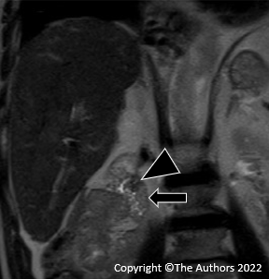
Figure 9 Enlarged ampullary papilla occurring years after liver transplantation and causing minimal cholestasis. T2-weighted imaging in the coronal plane demonstrates an enlarged ampullary papilla (arrowhead) protruding in the duodenal lumen (arrow). Ultrasonography-endoscopy confirmed the enlarged ampullary papilla and biopsy was performed, which excluded malignancy and confirmed the diagnosis of papillary stenosis (i.e. sphincter of Oddi dysfunction); sphincterotomy was then performed.

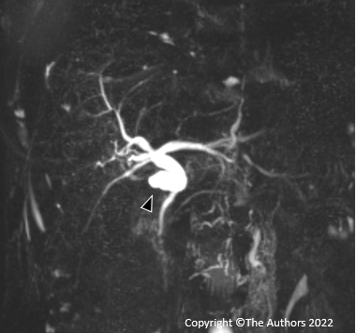
Figure 10 Mucocele occurring years after liver transplantation. Magnetic resonance cholangiopancreatography maximum intensity projection shows a fluid collection in communication with biliary tree. Biliary content was confirmed with percutaneous drainage.
Table 1 Post-transplant complications with the relevance of computed tomography and magnetic resonance imaging in diagnosis
Time of onset | Type of complications | Relevance of CT/MRI for diagnosis
Early (< 6 mo) | Surgical | ++++
 | Graft-related | ++
 | Immunologic | +
 | Infectious | ++
Late (> 6 mo) | Surgical | ++++
 | Graft-related | ++
 | Immunologic | +
 | Infectious | +++
 | Neoplastic | ++++
 | Disease recurrence | ++
++++: Highly relevant, often mandatory; +++: Very useful; ++: Useful; + sometimes helpful, but clinical diagnosis is usually very relevant. CT: Computed tomography; MRI: Magnetic resonance imaging.
Table 2 Post-transplant biliary complications related to surgery based on frequency, onset, and management
Type of complication | Frequency | Timing of onset | Common treatment
Biliary stricture | 5%-15% (up to 30% in LDLT) | Early late | Refashioning after stenting
Biliary leak | 2%-25% | Early | ERCP and stenting if anastomotic
Biloma/Biliary lake | 2.6%-11.5% | Early | Percutaneous drainage and antibiotics if large
Bile duct filling defect | 3%-6% | Early late | ERCP/percutaneous drainage
Sphincter of Oddi dysfunction | 2%-5% | Late | ERCP with sphincterotomy and consideration of stent placement
Redundant common bile duct | Rare | Late | Stent
Mucocele of bile duct remnant | Rare | Late | Surgery if causing compression
ERCP: Endoscopic retrograde cholangiopancreatography; LDLT: Living donor liver transplantation.

