Name of journal: World Journal of Gastroenterology
ESPS Manuscript NO: 5720
Columns: CASE REPORT

Nodular fasciitis in mesentery, a differential diagnosis of peritoneal carcinomatosis

Shiga M et al. Nodular fasciitis mimicked peritoneal dissemination

Mai Shiga, Ken Okamoto, Manabu Matsumoto, Hiromichi Maeda, Ken Dabanaka, Tsutomu Namikawa, Sunao Uemura, Masaya Munekage, Michiya Kobayashi, Kazuhiro Hanazaki

Mai Shiga, Ken Okamoto, Hiromichi Maeda, Ken Dabanaka, Tsutomu Namikawa, Sunao Uemura, Masaya Munekage, Michiya Kobayashi, Kazuhiro Hanazaki, Department of Surgery, Kochi Medical School, Kochi 783-8505, Japan

Manabu Matsumoto, Laboratory of Diagnostic Pathology, Kochi Medical School Hospital, Kochi 783-8505, Japan

Ken Okamoto, Hiromichi Maeda, Michiya Kobayashi, Cancer Treatment Center, Kochi Medical School, Kochi 783-8505, Japan

Author contributions: Shiga M, Okamoto K, Maeda H, Namikawa T, Uemura S, Munegkage M and Kobayashi M designed the report; Shiga M, Okamoto K, Maeda H and Dabanaka K were attending doctors for the patients and performed surgical operation; Matsumoto M performed pathological examinations; Shiga M, Maeda H and Kazuhiro H wrote paper.

Correspondence to: Hiromichi Maeda, MD, PhD, Department of Surgery, Kochi Medical School, Kohasu Oko-cho, Nankoku-city, Kochi 783-8505, Japan. hmaeda@kochi-u.ac.jp

Telephone: +81-88-8802370 Fax: +81-88-8802371
Received: September 23, 2013 Revised: October 29, 2013
Accepted: November 12, 2013
Published online:

Abstract
Nodular fasciitis is a benign proliferative lesion of fibroblast-like cells that affects various sites in the body. We describe a patient with nodular fasciitis in the mesentery, encountered during laparotomy for the treatment of ascending colon cancer. The nodular fasciitis in our patient resembled peritoneal dissemination of malignancy on macroscopic observation. Because the treatment options change with concomitant peritoneal dissemination of gastrointestinal tract malignancy, recognition of this rare condition and preparation for unexpected nodular lesions is crucial.

© 2013 Baishideng Publishing Group Co., Limited. All rights reserved.

Key words: Colon cancer; Digestive system cancer; Laparoscopic surgery; Soft tissue neoplasms; Neoplasm metastasis; Immunohistochemistry

Core tip: Nodular fasciitis is a rare benign lesion composed of fibroblast-like cells that occurs at various sites in the body. In our patient, firm nodular lesions were incidentally identified in the mesentery during surgical treatment for colon cancer. Although the lesions were initially diagnosed as peritoneal carcinomatosis, the pathological examination revealed nodular fasciitis. This case highlights the need for all clinicians to know about this rare condition and to prepare for unexpected nodular lesions during surgical treatment of gastrointestinal tract malignancy.

Shiga M, Okamoto K, Matsumoto M, Maeda H, Dabanaka K, Namikawa T, Uemura S, Munekage M, Kobayashi M, Hanazaki K. Nodular fasciitis in mesentery, a differential diagnosis of peritoneal carcinomatosis. World J Gastroenterol 2013;
Available from: URL: http://www.wjgnet.com/esps/
DOI: http://dx.doi.org/10.3748/wjg.v19.i0.0000

INTRODUCTION
Nodular fasciitis is a rare benign lesion comprising a proliferation of spindle, plump, or stellate fibroblast-like cells embedded in myxomatous stroma^{[1,2]}. Nodular fasciitis involves subcutaneous fat, fascia, and less commonly, areas without true fascia^{[3,4]}. Thus, nodular fasciitis can occur in any part of the body, although the upper extremities or trunk are the sites of predilection^{[1]}. Nodular fasciitis is a reactive fibroblastic growth; however, the majority of patients lack an apparent (recognized) history of injury^{[1]}, and its etiology remains unclear.
The classical course of nodular fasciitis varies from stable size to rapid growth^{[1,2]}. Surgical resection is often the treatment for growing nodules and those causing symptoms (such as tenderness and pain), while careful observation of asymptomatic nodules and those that are stable in size is recommended because of possible spontaneous regression^{[5]}. Diagnosis of nodular fasciitis relies largely on the clinical features and careful morphological evaluation of the specimen, including hematoxylin and eosin (HE) staining^{[6]}. Efforts are being made to establish the typical pattern of immunohistochemical staining of nodular fasciitis to help distinguish it from other soft tissue tumors.
Nodular fasciitis is well known to dermatologists and pathologists due to its preferential occurrence in subcutaneous tissue and importance in the differential diagnosis of soft-tissue tumors. Nodular fasciitis is rarely encountered in other fields of clinical practice. In this case report, we describe a patient with nodular fasciitis in the mesentery that mimicked peritoneal dissemination of colon cancer macroscopically.

CASE REPORT
An 88-year-old male patient presented with intermittent gross hematochezia. He had a history of appendectomy for appendicitis about 40 years earlier. Preoperative colonoscopy revealed a tumor mass with mild distortion of the intestinal lumen, suggesting tumor infiltration deeper than the submucosal layer. The biopsy confirmed tubular adenocarcinoma of the ascending colon. Computed tomography (CT) and ¹⁸F-fluorodeoxy glucose positron emission tomography showed no sign of metastatic lesion or peritoneal dissemination. The preoperative diagnosis was colon cancer, T3, N0, M0, stage IIA of the Union for International Cancer Control (UICC) classification^{[7]}. Thus, the patient underwent laparoscope-assisted ileocecal resection with regional lymphadenectomy. After resection of blood vessels and mobilization of the ascending colon, the lesion was removed from the abdominal cavity through a 7-cm incision. A flat and slightly reddish hard nodule of 2 cm in diameter was observed on the mesentery of the terminal ileum (Figure 1A), and a few smaller, whitish nodules were found around it. Peritoneal dissemination of colon cancer was suspected, although intraoperative pathological examination was not considered to change the surgical method because the primary site of the colon cancer had been removed completely. Two large nodules that were suspected dissemination of the colon cancer were resected for pathological diagnosis and symptom prophylaxis. Functional end-to-end anastomosis was performed between the terminal ileum and ascending colon.
The postoperative course was uneventful, and the pathological examination revealed sub-mucosal infiltration of colon cancer without lymph node metastasis (Figure 1B) (T1, N0, M0, Stage I of UICC classification^{[7]}). The resected nodule of the mesentery was composed of spindle-like cells in myxomatous stroma without proliferation of adenocarcinoma cells (Figure 1C and D). The nodule was located adjacent to the true muscle layer and there was no encapsulation. The cells of the nodule were positive for vimentin, α-smooth muscle actin (α-SMA), calponin, and negative for podoplanin (D2-40), thrombomodulin, cluster of differentiation molecule 34 (CD34), β-catenin, anaplase lymphoma kinase, S100 protein, cluster of differentiation molecule 56 (CD56), and stem cell factor receptor (c-kit) according to immunohistochemistry staining. Most of the nodule was negative for AE1/AE3 and carletinin. The diagnosis of nodular fasciitis was based on observation of the specimen with HE staining and the immunohistochemical results.

DISCUSSION
This case of nodular fasciitis in the mesentery mimicked peritoneal dissemination of colon cancer, and to the best of our knowledge, is the first such case report. A diagnosis of nodular fasciitis should thus be considered when unexpected nodular lesions suggesting peritoneal dissemination of gastroenterological malignancy are encountered, and such lesions should be treated carefully.
The pathological diagnosis of nodular fasciitis is difficult because of the rarity of the condition, the resemblance of its pathological features to other soft tissue tumors, and the lack of typical diagnostic symptoms or pattern of immunohistochemical staining. In this case, the fibroblast-like cells were arranged haphazardly in the myxomatous stroma, giving a “tissue-culture appearance”^{[8]}. Although the fibroblast-like cells varied in terms of nucleus size and amount of cytoplasm, they differed from the cells found in sarcoma, which typically have higher cellularity, bizarre nuclei, and less intercellular material; therefore, the nodule was considered a reactive proliferative lesion rather than a true tumor. The nodule was positive for vimentin according to immunohistochemical staining, suggesting that the tumor was derived from soft tissue. The majority of nodular fasciitis is negative for cytokeratin, with few cytokeratin-positive cases reported^{[9]}. A few spindle cells of nodular fasciitis in our patient were positive for cytokeratin and calretinin, indicating a possible relationship with the mesothelium. Positive staining of α-SMA and calponin suggested myofibroblastic differentiation and less possibly of sarcoma^{[6]}. The nodule was negative for CD34, CD56, S100 protein, and β-catenin, reducing the possibility of another differential diagnosis (Table 1). A previous report of seven patients demonstrated that approximately half of leiomyosarcoma lesions were negative for cluster of differentiation molecule 10 (CD10) staining^{[10]}, while all nodular fasciitis were positive for CD10^{[6]}. In our patient, none of the cells expressed CD10, suggesting the need to further evaluate the utility of this marker. Comprehensive judgment based on examination of multiple related markers and close morphological observation is indispensable for the diagnosis of nodular fasciitis.
As many as 10% of patients with colorectal cancer develop peritoneal carcinomatosis during the course of the disease, and half of these are diagnosed at the initial evaluation^{[11]}. While about 20% of T4 tumors are accompanied by peritoneal dissemination, less than 1% of T2 tumors have synchronous peritoneal dissemination. This suggests that less infiltrating tumors have a small, but definite, possibility of peritoneal dissemination, probably occurring via a hematological or lymphatic route. While preoperative CT or other imaging modalities may help assess primary tumors, detecting small peritoneal nodules is still difficult, and laparotomy remains an important method for identifying peritoneal dissemination. Ideally, the intraoperative pathological examination for unexpected peritoneal nodules should be performed to inform the choice of surgical methods. When intraoperative pathological diagnosis is not available, judgment regarding surgical options (ranging from observation and biopsy to aggressive surgical resection) must be based on multiple factors including the patient’s condition, tumor spread, and the surgeon’s skill. When resection seems inappropriate, biopsy of the nodule for subsequent pathological diagnosis should be performed without exception.
In conclusion, nodular fasciitis in the mesentery can present as unexpected nodules of peritoneum that resemble peritoneal dissemination of gastrointestinal tract malignancy. It is important to recognize this rare condition because the existence of peritoneal dissemination influences the choice of treatment for gastrointestinal tract malignancy.

COMMENTS
Case characteristics
The patients had no symptom related to nodular fasciitis.

Clinical diagnosis
Asymptomatic firm nodular lesions were incidentally identified in the mesentery during surgical treatment for colon cancer.

Differential diagnosis
Because the peritoneal nodular fasciitis resembled peritoneal carcinomatosis on macroscopic observation, pathological examination was inevitable.

Imaging diagnosis
The lesions were not identified on the preoperative computed tomography (CT) or ¹⁸F-fluorodeoxy glucose positron emission tomography CT.

Pathological diagnosis
Hematoxylin and eosin staining revealed benign proliferation of spindle-like cells in myxomatous stroma, and immunohistochemistry staining suggested the diagnosis of nodular fasciitis.

Treatment
The nodular fasciitis was surgically resected.

Related reports
Nodular fasciitis could occur at any site in the body. However, the case of nodular fasciitis in abdominal cavity is quite rare.

Experiences and lessons
The nodular fasciitis in our patient closely resembled peritoneal dissemination of colon cancer. Because the treatment options could change with concomitant peritoneal dissemination of gastrointestinal tract malignancy, recognition of this rare condition and preparation for unexpected nodular lesions are crucial.

Peer review
Although nodular fasciitis shows a reactive fibroblastic growth, the majority of patients, including our patient, lack an apparent history of injury and etiology of nodular fasciitis remains unclear. The further accumulation of clinical experience is necessary to solve this clinical question.

REFERENCES
1 Price EB, Silliphant WM, Shuman R. Nodular fasciitis: a clinicopathologic analysis of 65 cases. Am J Clin Pathol 1961; 35: 122-136 [PMID: 13737962]
2 Shimizu S, Hashimoto H, Enjoji M. Nodular fasciitis: an analysis of 250 patients. Pathology 1984; 16: 161-166 [PMID: 6462780 DOI: 10.3109/00313028409059097]
3 Allen PW. Nodular fasciitis. Pathology 1972; 4: 9-26 [PMID: 4501523 DOI: 10.3109/00313027209068920]
4 Terai M, Oka M, Kunisada M, Kawakami F, Nishigori C. Intradermal nodular fasciitis. Eur J Dermatol 2011; 22: 285-286 [PMID: 22265886 DOI: 10.1684/ejd.2012.1657]
5 Yanagisawa A, Okada H. Nodular fasciitis with degeneration and regression. J Craniofac Surg 2008; 19: 1167-1170 [PMID: 18650753 DOI: 10.1097/SCS.0b013e318176ac1a]
6 Morgen EK, Carter P, Weinreb I, Al-Habeeb A, Ghazarian DM. Immunohistochemistry in nodular fasciitis of the head and neck. Pathology 2013; 45: 432-433 [PMID: 23635823 DOI: 10.1097/PAT.0b013e328360f06a]
7 Leslie HS, Mary KG, Christian W. TNM classification of Malignant Tumors. 7th ed. New York: Wiley-Liss, 2009: 100-105
8 Bernstein KE, Lattes R. Nodular (pseudosarcomatous) fasciitis, a nonrecurrent lesion: clinicopathologic study of 134 cases. Cancer 1982; 49: 1668-1678 [PMID: 6279273 DOI: 10.1002/1097-0142(19820415)49: 8<1668: : AID-]
9 Kyriakos M, Coffin CM, Swanson PE. Differential Diagnosis in Surgical pathology. Weidner N. editor. Philadelphia: Saunders, 1996: 732-737
10 Deniz K, Çoban G, Okten T. Anti-CD10 (56C6) expression in soft tissue sarcomas. Pathol Res Pract 2012; 208: 281-285 [PMID: 22464152 DOI: 10.1016/j.prp.2012.02.002]
11 Kerscher AG, Chua TC, Gasser M, Maeder U, Kunzmann V, Isbert C, Germer CT, Pelz JO. Impact of peritoneal carcinomatosis in the disease history of colorectal cancer management: a longitudinal experience of 2406 patients over two decades. Br J Cancer 2013; 108: 1432-1439 [PMID: 23511564 DOI: 10.1038/bjc.2013.82]

P-Reviewers: Chen YJ, Pan WS, Kim YJ, Rodrigo L S-Editor: Gou SX L-Editor: E-Editor:

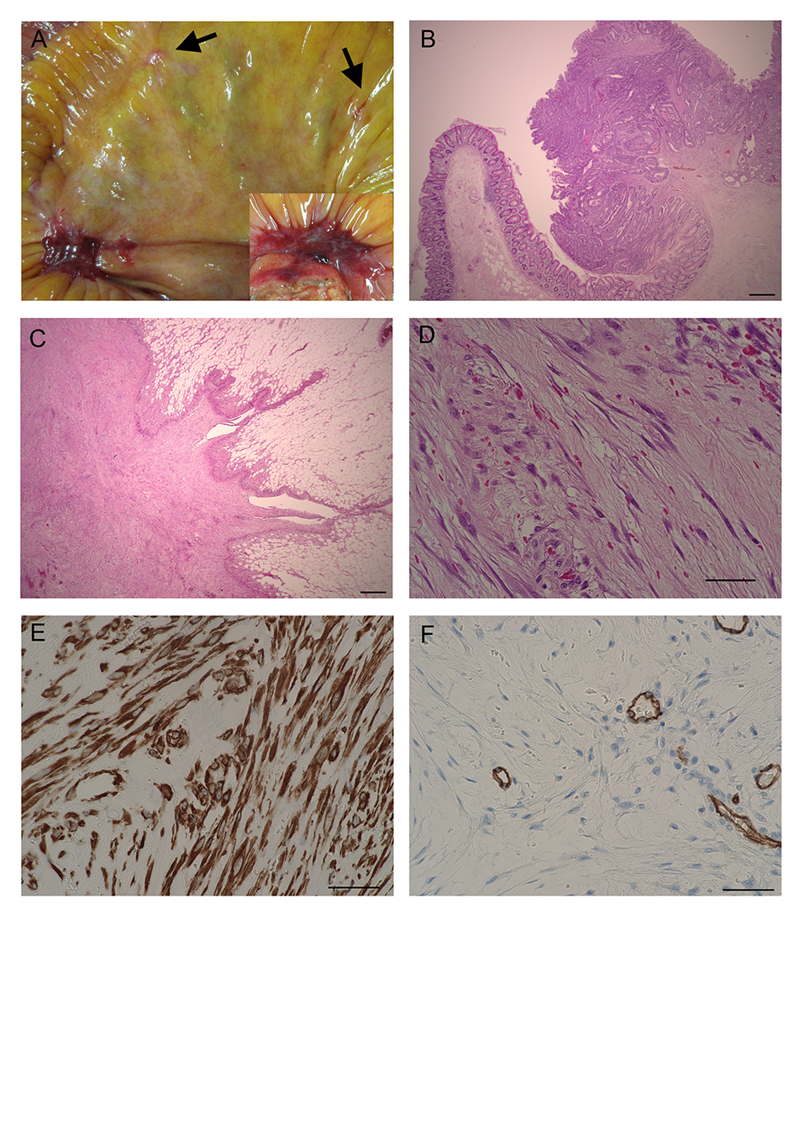
Figure 1 Intraoperative and pathological findings. A: A relatively flat, reddish, and firm nodule was observed on the mesentery of the terminal ilium. The large nodule was accompanied by several whitish, smaller nodules (arrows). The inset shows another resected nodule; B: Resected Type 1 ascending colon cancer infiltrating the submucosal layer; C: Lower magnification of nodular fasciitis showing growth in the adipose tissue, radiating outwardly in one part and growing expansively in another part. The margin of the nodule is not clear or encapsulated. Part of the nodule has sparse proliferation of fibroblast-like cells (less-pink area, center), while other parts have a quite dense striform proliferative pattern (pink-red color area); D: Higher magnification of nodular fasciitis demonstrating spindle-shape cells, which are arranged haphazardly throughout the abundant myxomatous interstitial ground substance. Numerous capillaries and extravasation of erythrocytes are visible. Some nuclei are plump, but do not have the hyperchromatic or bizarre pleomorphic features characteristically observed in sarcoma; E: The cytosol of the cells is positive for α-SMA staining, suggesting myofibroblastic differentiation; F: The nodule is negative for CD34, except for endothelial-cell CD34. The mucoid materials on the left side separate the thin spindle-shaped fibroblast-like cells, while the right side of the cells have plump nuclei. The bars for B and C are 500 μm, and the bars for D to F are 50 μm. α-SMA: α-smooth muscle actin.

Table 1 Immunohistochemistry staining for diagnosis of nodular fasciitis.
 | Nodular Fasciitis | Implication
α-SMA | + | Myofibroblastic differentiation
Vimentin | + | Negative in epithelial tumors
Calponin | + | Often negative in myofibroblastic sarcoma
CD10 | + | Negative in 50% of leiomyosarcoma
DGP9.5 | + | Negative in dermatofibrosarcoma protuberans
AE1/AE3 | - | Positive in epithelial tumors
CD56 | - | Positive in leiomyoma, nerve sheath tumor, leiomyosarcoma
S100 protein | - | Positive in shwannoma
desmin | - | Positive in various sarcoma
CD34 | - | Positive in solitary fibrous tumor
β-catenin | - | Positive in desmoid fibromatosis
α-SMA: α-smooth muscle actin; CD: Cluster of differentiation molecule.

