Name of Journal: World Journal of Gastrointestinal Endoscopy
ESPS Manuscript NO: 18908
Manuscript Type: Case Report

Duodenal polyposis secondary to portal hypertensive duodenopathy

Gurung A et al. Duodenal polyposis in portal duodenopathy

Ananta Gurung, Philip E Jaffe, Xuchen Zhang

Ananta Gurung, Xuchen Zhang, Department of Pathology, Yale University School of Medicine, New Haven, CT 06510, United States

Ananta Gurung, Department of Pathology, Royal Columbian Hospital, New Westminster, British Columbia V3L 3W7, Canada

Philip E Jaffe, Gastroenterology Center of Connecticut, Hamden, CT 06518, United States

Xuchen Zhang, Pathology and Laboratory Medicine Service, VA CT Healthcare System, West Haven, CT 06516, United States

Author contributions: Jaffe PE performed esophagogastroduodenoscopy; Gurung A and Zhang X performed histopathological examination; Gurung A wrote the initial draft of the manuscript; the final manuscript was reviewed and revised by Jaffe PE and Zhang X.

Institutional review board statement: Case reports do not require examination and are considered exempt by the Yale University Institutional Review Board. Ethical considerations were upheld and patient personal information was protected.

Informed consent statement: Written informed consent was obtained for all interventions and follow up.

Conflict-of-interest statement: The authors declare that there is no conflict of interests.

Open-Access: This article is an open-access article which was selected by an in-house editor and fully peer-reviewed by external reviewers. It is distributed in accordance with the Creative Commons Attribution Non Commercial (CC BY-NC 4.0) license, which permits others to distribute, remix, adapt, build upon this work non-commercially, and license their derivative works on different terms, provided the original work is properly cited and the use is non-commercial. See: http://creativecommons.org/licenses/by-nc/4.0/

Correspondence to: Xuchen Zhang, MD, PhD, Pathology and Laboratory Medicine Service, VA CT Healthcare System, 950 Campbell Ave, West Haven, CT 06516, United States. xuchen.zhang@yale.edu
Telephone: +1-203-9325711
Fax: +1-203-9374704

Received: April 28, 2015
Peer-review started: April 30, 2015
First decision: July 26, 2015
Revised: October 2, 2015
Accepted: October 16, 2015
Article in press:
Published online:
Abstract
Portal hypertensive duodenopathy (PHD) is a recognized, but uncommon finding of portal hypertension in cirrhotic patients. Lesions associated with PHD include erythema, erosions, ulcers, telangiectasia, exaggerated villous pattern and duodenal varices. However, duodenal polyposis as a manifestation of PHD is rare. We report a case of a 52-year-old man who underwent esophagogastroduodenoscopy and was found with multiple small duodenal polyps ranging in size from 1-8 mm. Biopsy of the representative polyps revealed polypoid fragments of duodenal mucosa with villiform hyperplasia lined by reactive duodenal/gastric foveolar epithelium and underlying lamina propria showed proliferating ectatic and congested capillaries. The features were diagnostic of polyps arising in the setting of PHD.

Key words: Cirrhosis; Portal hypertension; Portal duodenopathy; Polyposis

© The Author(s) 2015. Published by Baishideng Publishing Group Inc. All rights reserved.

Core tip: Duodenal polyposis secondary to portal hypertensive duodenopathy is rare. We report a case of portal hypertensive duodenopathy presenting as polyposis.

Gurung A, Jaffe PE, Zhang X. Duodenal polyposis secondary to portal hypertensive duodenopathy. World J Gastrointest Endosc 2015; In press
INTRODUCTION
Portal hypertensive duodenopathy (PHD) is a recognized, but uncommon finding of portal hypertension in cirrhotic patients. While other associations of portal hypertension such as portal hypertensive gastropathy and portal hypertensive colopathy have been described and studied, data concerning duodenal alterations is relatively scarce. The lesions described in PHD include erythema, erosions, ulcers, telangiectasia, exaggerated villous pattern and duodenal varices^{[1]}. Recently, there have been emerging reports of polyps as a manifestation of PHD^{[2-5]}. Herein, we report a patient with duodenal polyposis secondary to portal hypertension, review the literature and describe the spectrum of histopathologic changes.

CASE REPORT
A 52-year-old man with compensated alcoholic cirrhosis presented for follow up esophagogastroduodenoscopy. Past medical history includes remote T1N0 colon cancer (status post right hemicolectomy 4 years), low-grade gastrointestinal blood loss, iron deficiency anemia, gastric antral vascular ectasia, portal hypertensive gastropathy and hypertension. He was diagnosed with cirrhosis 13 years ago when he presented with jaundice and ascites and had a recent history of hepatic encephalopathy. Abdominal U/S and magnetic resonance imaging showed a large heterogenous liver, recanalization of the umbilical vein, splenomegaly, splenorenal shunt, additional collateral vessels inferior to the left renal vein and scattered renal cysts. Endoscopy revealed numerous small 1-2 mm polyps extending from the duodenal bulb to the second portion of the duodenum. The three largest polyps included a 6 mm polyp in the mid duodenal bulb (Figures 1A and 1B), 8 mm polyp distal to this along the anterior wall, and 8 mm polyp in the second part of the duodenum (Figure 1C). The esophagus was normal and no esophageal varices were noted. The stomach showed diffuse “snake skin” appearance, an area of friable mucosa with a polypoid appearance and surface erosions in the antrum and pre-pyloric area with spontaneous oozing of blood. The three duodenal largest polyps were biopsied and histologic examination revealed polypoid fragments of duodenal mucosa with villiform hyperplasia lined by reactive duodenal and gastric foveolar epithelium. The underlying lamina propria showed proliferating ectatic and congested capillaries (Figures 2A and 2B, 2D and 2E). The findings were diagnostic of multiple portal hypertensive duodenal polyps.

DISCUSSION
Common gastrointestinal tract manifestations of portal hypertension include esophageal/gastric/anorectal varices and gastric antral vascular ectasia. In addition, less common features include portal hypertensive gastropathy^{[6-8]}, congestive jeujnopathy^{[9,10]}, portal colopathy^{[11,12]} and PHD^{[1,13]}. PHD is commonly defined as the appearance of patchy or diffuse congestion of the duodenal mucosa associated with friability, erosions or ulcerations^{[14,15]}. The prevalence of PHD in cirrhotic patients with portal hypertension ranges from 8.4%^{[16]} to 51.4%^{[1]}. The lesions described in PHD include erythema, erosions, ulcers, telangiectasia, exaggerated villous pattern and duodenal varices^{[1]}. Coexistence of severe gastropathy and higher hepatic venous pressure gradients are more frequent in PHD patients and features of PHD have been reported to disappear after liver transplantation^{[16]}.
Duodenal polyps as a manifestation of PHD, an uncommon event, have been reported previously (summarized in Table 1). These include an ulcerated solitary 3 cm polyp in the descending duodenum^{[3]}, multiple sessile polyps in the first portion of the duodenum^{[2]} and a recent report documenting two to “several” duodenal or jejuno-ileal polypoid lesions ranging in size from < 5 mm to 15 mm in 5 patients^{[4]}. The spectrum of histopathologic findings in the polyps includes the presence of numerous capillaries with vascular ectasia/congestion/thrombi as well as fibrosis and smooth muscle proliferation. In addition gastric foveolar metaplasia, reactive atypia and ulceration may be seen. Devadason et al^{[5]} reported “duodenal capillary hemagiomatous polyps” in 3 pediatric patients (aged 1, 4 and 6 years old). All these 3 patients presented with multiple duodenal polyps in either the 1st or 2nd portion of the duodenum in the setting of extrahepatic portal venous obstruction. Polyps were biopsied in two patients, both of which demonstrated lobular capillary proliferation within the polyps^{[5]}. Although they favored the term “duodenal capillary hemagiomatous polyps”, it appears from their description, as well as accompanying image, that the polyps they described share similar morphological features to the polyps in our case and other reported polyps in the setting of PHD.
To date, including our case, there are 11 documented reports of polyps associated with PHD (Table 1). There is no gender predilection (6 male and 5 female), the ages of patients ranges from 1 to 73 years and in the majority of cases (10/11), multiple polyps are seen. The etiology of portal hypertension in adult patients include alcoholic cirrhosis (37.5%, 3/8), hepatitis C cirrhosis (25%, 2/8) and cryptogenic cirrhosis (37.5%, 3/8), while extrahepatic portal venous obstruction accounts for all cases in the pediatric population (100%, 3/3).
Histologically, the PHD associated polyp’s surface- and crypt-lining epithelium may focally show cells with mucin depletion and contain slightly pencillate nuclei with mild hyperchromasia (Figures 2C and 2F). These features may mimic duodenal adenomatous polyp, a precancerous lesion in the duodenum. Our current case was previously diagnosed as “duodenal adenomas” at an outside institution. The initial diagnosis of duodenal adenoma in our patient’s prior biopsy highlights the challenges that the reactive atypia may pose during histological evaluation. The differential diagnosis of polypoid lesions in the duodenum is diverse (Table 2) and we limit our discussion to more commonly seen and lesions with similar histologically features to PHD associated polyps. While duodenal adenomas with low-grade dysplasia (which are histologically similar to those seen in the colon) are typically composed of mucin depleted cells with hyperchromatic pencillate nuclei, compared to the reactive atypia seen in polyps associated with PHD, nuclei show a greater degree of enlargement, hyperchromasia and stratification. PHD polyps differ from duodenal hamartomatous polyps seen in Peutz-Jegher syndrome as polyps in the latter typically show disorganized mucosa with thick arborizing smooth muscle fibers of the muscularis mucosa. Although there may be histologic overlap between Juvenile polyps, inflammatory bowel disease (IBD) associated inflammatory polyps and PHD associated polyps, Juvenile polyps are characterized by dilated mucin filled crypts, while IBD associated polyps tend to have prominent glandular architectural distortion in the background of inflammatory bowel disease.
In summary, duodenal polyps secondary to PHD is uncommon. With our case, the total number of patients reported in the literature to date is 11. The finding of multiple polyps in a patient with portal hypertension should raise suspicion for this entity and careful histopathologic examination is necessary to render the appropriate diagnosis.

COMMENTS
Case characteristics
A 52-year-old man with compensated alcoholic cirrhosis presented for follow up esophagogastroduodenoscopy and multiple duodenal polyps were found.

Clinical diagnosis
Cirrhosis and duodenal polyps.

Differential diagnosis
Duodenal adenomatous polyp, polyposis syndrome, duodenal pancreatic or gastric ectopia, or other benign neoplasms.

Imaging diagnosis
Endoscopy revealed numerous small 1-2 mm polyps extending from the duodenal bulb to the second portion of the duodenum. The three largest polyps included a 6 mm polyp in the mid duodenal bulb, 8 mm polyp distal to this along the anterior wall, and 8 mm polyp in the second part of the duodenum.

Pathological diagnosis
Portal hypertensive duodenal polyps.

Related reports
Duodenal polyps as a manifestation of portal hypertensive duodenopthy (PHD), an uncommon event, have been reported previously. The prevalence of PHD in cirrhotic patients with portal hypertension ranges from 8.4% to 51.4%. However, manifestation as multiple duodenal polyps is rare.

Term explanation
Portal hypertensive duodenal polyps are seen in patients with cirrhosis and portal hypertension. The spectrum of histopathologic findings in the polyps includes the presence of numerous capillaries with vascular ectasia/congestion/thrombi as well as fibrosis and smooth muscle proliferation. In addition gastric foveolar metaplasia, reactive atypia and ulceration may be seen.

Experiences and lessons
PHD is a recognized, but uncommon finding of portal hypertension in cirrhotic patients. Multiple duodenal polyps can be an endoscopic finding of PHD.

Peer-review
The authors reported a 52-year-old patient with cirrhosis and portal hypertension who underwent endoscopy and was found with multiple portal hypertensive duodenal polyps. This is an interesting case report and literature review. It is very well written with excellent images. The article highlights the clinical characteristics of PHD and provides information about differential diagnosis of portal hypertensive duodenal polyps.
REFERENCES:
1 Barakat M, Mostafa M, Mahran Z, Soliman AG. Portal hypertensive duodenopathy: clinical, endoscopic, and histopathologic profiles. Am J Gastroenterol 2007; 102: 2793-2802 [PMID: 17900330 DOI: 10.1111/j.1572-0241.2007.01536.x]
2 Pillai SB, Ram Ganesh VR, Mohanakrishnan A, Nirmala V. Portal duodenopathy presenting as polyposis. Indian J Pathol Microbiol 2010; 53: 558-559 [PMID: 20699526 DOI: 10.4103/0377-4929.68271]
3 Zeitoun JD, Chryssostalis A, Terris B, Prat F, Gaudric M, Chaussade S. Portal hypertensive duodenal polyp: a case report. World J Gastroenterol 2007; 13: 1451-1452 [PMID: 17457981]
4 Lemmers A, Evrard S, Demetter P, Verset G, Gossum AV, Adler M, Devière J, Moine OL. Gastrointestinal polypoid lesions: a poorly known endoscopic feature of portal hypertension. United European Gastroenterol J 2014; 2: 189-196 [PMID: 25360302 DOI: 10.1177/2050640614529108]
5 Devadason D, Murphy MS, Brown R, Wilson D, McKiernan PJ. Duodenal capillary hemangiomatous polyps: a novel manifestation of extrahepatic portal hypertension? J Pediatr Gastroenterol Nutr 2007; 45: 114-116 [PMID: 17592373 DOI: 10.1097/01.mpg.0000252185.67051.f0]
6 McCormack TT, Sims J, Eyre-Brook I, Kennedy H, Goepel J, Johnson AG, Triger DR. Gastric lesions in portal hypertension: inflammatory gastritis or congestive gastropathy? Gut 1985; 26: 1226-1232 [PMID: 3877665]
7 Qureshi K, Al-Osaimi AM. Approach to the management of portal hypertensive gastropathy and gastric antral vascular ectasia. Gastroenterol Clin North Am 2014; 43: 835-847 [PMID: 25440929 DOI: 10.1016/j.gtc.2014.08.012]
8 Zardi EM, Ghittoni G, Margiotta D, Viera FT, Di Matteo F, Rossi S. Portal hypertensive gastropathy in cirrhotics without varices: a case-control study. Eur J Gastroenterol Hepatol 2015; 27: 91-96 [PMID: 25386762 DOI: 10.1097/MEG.0000000000000234]
9 Nagral AS, Joshi AS, Bhatia SJ, Abraham P, Mistry FP, Vora IM. Congestive jejunopathy in portal hypertension. Gut 1993; 34: 694-697 [PMID: 8504973 DOI: 10.1136/gut.34.5.694]
10 Desai N, Desai D, Pethe V, Deodhar KP, Sawant P, Nanivadekar S. Portal hypertensive jejunopathy: a case control study. Indian J Gastroenterol 2004; 23: 99-101 [PMID: 15250567]
11 Kozarek RA, Botoman VA, Bredfeldt JE, Roach JM, Patterson DJ, Ball TJ. Portal colopathy: prospective study of colonoscopy in patients with portal hypertension. Gastroenterology 1991; 101: 1192-1197 [PMID: 1936789]
12 Urrunaga NH, Rockey DC. Portal hypertensive gastropathy and colopathy. Clin Liver Dis 2014; 18: 389-406 [PMID: 24679502 DOI: 10.1016/j.cld.2014.01.008]
13 Vigneri S, Termini R, Piraino A, Scialabba A, Bovero E, Pisciotta G, Fontana N. The duodenum in liver cirrhosis: endoscopic, morphological and clinical findings. Endoscopy 1991; 23: 210-212 [PMID: 1915136 DOI: 10.1055/s-2007-1010658]
14 Gupta R, Saraswat VA, Kumar M, Naik SR, Pandey R. Frequency and factors influencing portal hypertensive gastropathy and duodenopathy in cirrhotic portal hypertension. J Gastroenterol Hepatol 1996; 11: 728-733 [PMID: 8872769 DOI: 10.1111/j.1440-1746.1996.tb00322.x]
15 Shudo R, Yazaki Y, Sakurai S, Uenishi H, Yamada H, Sugawara K. Duodenal erosions, a common and distinctive feature of portal hypertensive duodenopathy. Am J Gastroenterol 2002; 97: 867-873 [PMID: 12003421 DOI: 10.1111/j.1572-0241.2002.05602.x]
16 Menchén L, Ripoll C, Marín-Jiménez I, Colón A, Gómez-Camarero J, González-Asanza C, Menchén P, Cos E, Bañares R. Prevalence of portal hypertensive duodenopathy in cirrhosis: clinical and haemodynamic features. Eur J Gastroenterol Hepatol 2006; 18: 649-653 [PMID: 16702855 DOI: 10.1097/00042737-200606000-00012]

P- Reviewer: Therapondos G, Thandassery RB S- Editor: Gong XM
L- Editor: E- Editor:

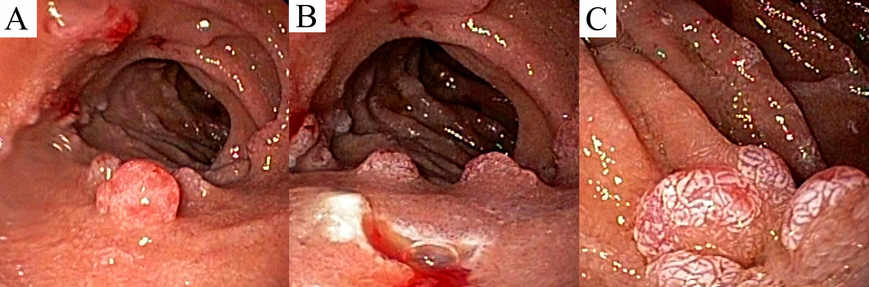

Figure 1 Duodenal polyposis under esophagogastroduodenoscopy. A 6 mm, sessile polyp was seen [prior to removal (A); immediately after removal (B)] in the mid duodenal bulb. A separate 8 mm polyp was seen along the lateral aspect of the second part of the duodenum (C).
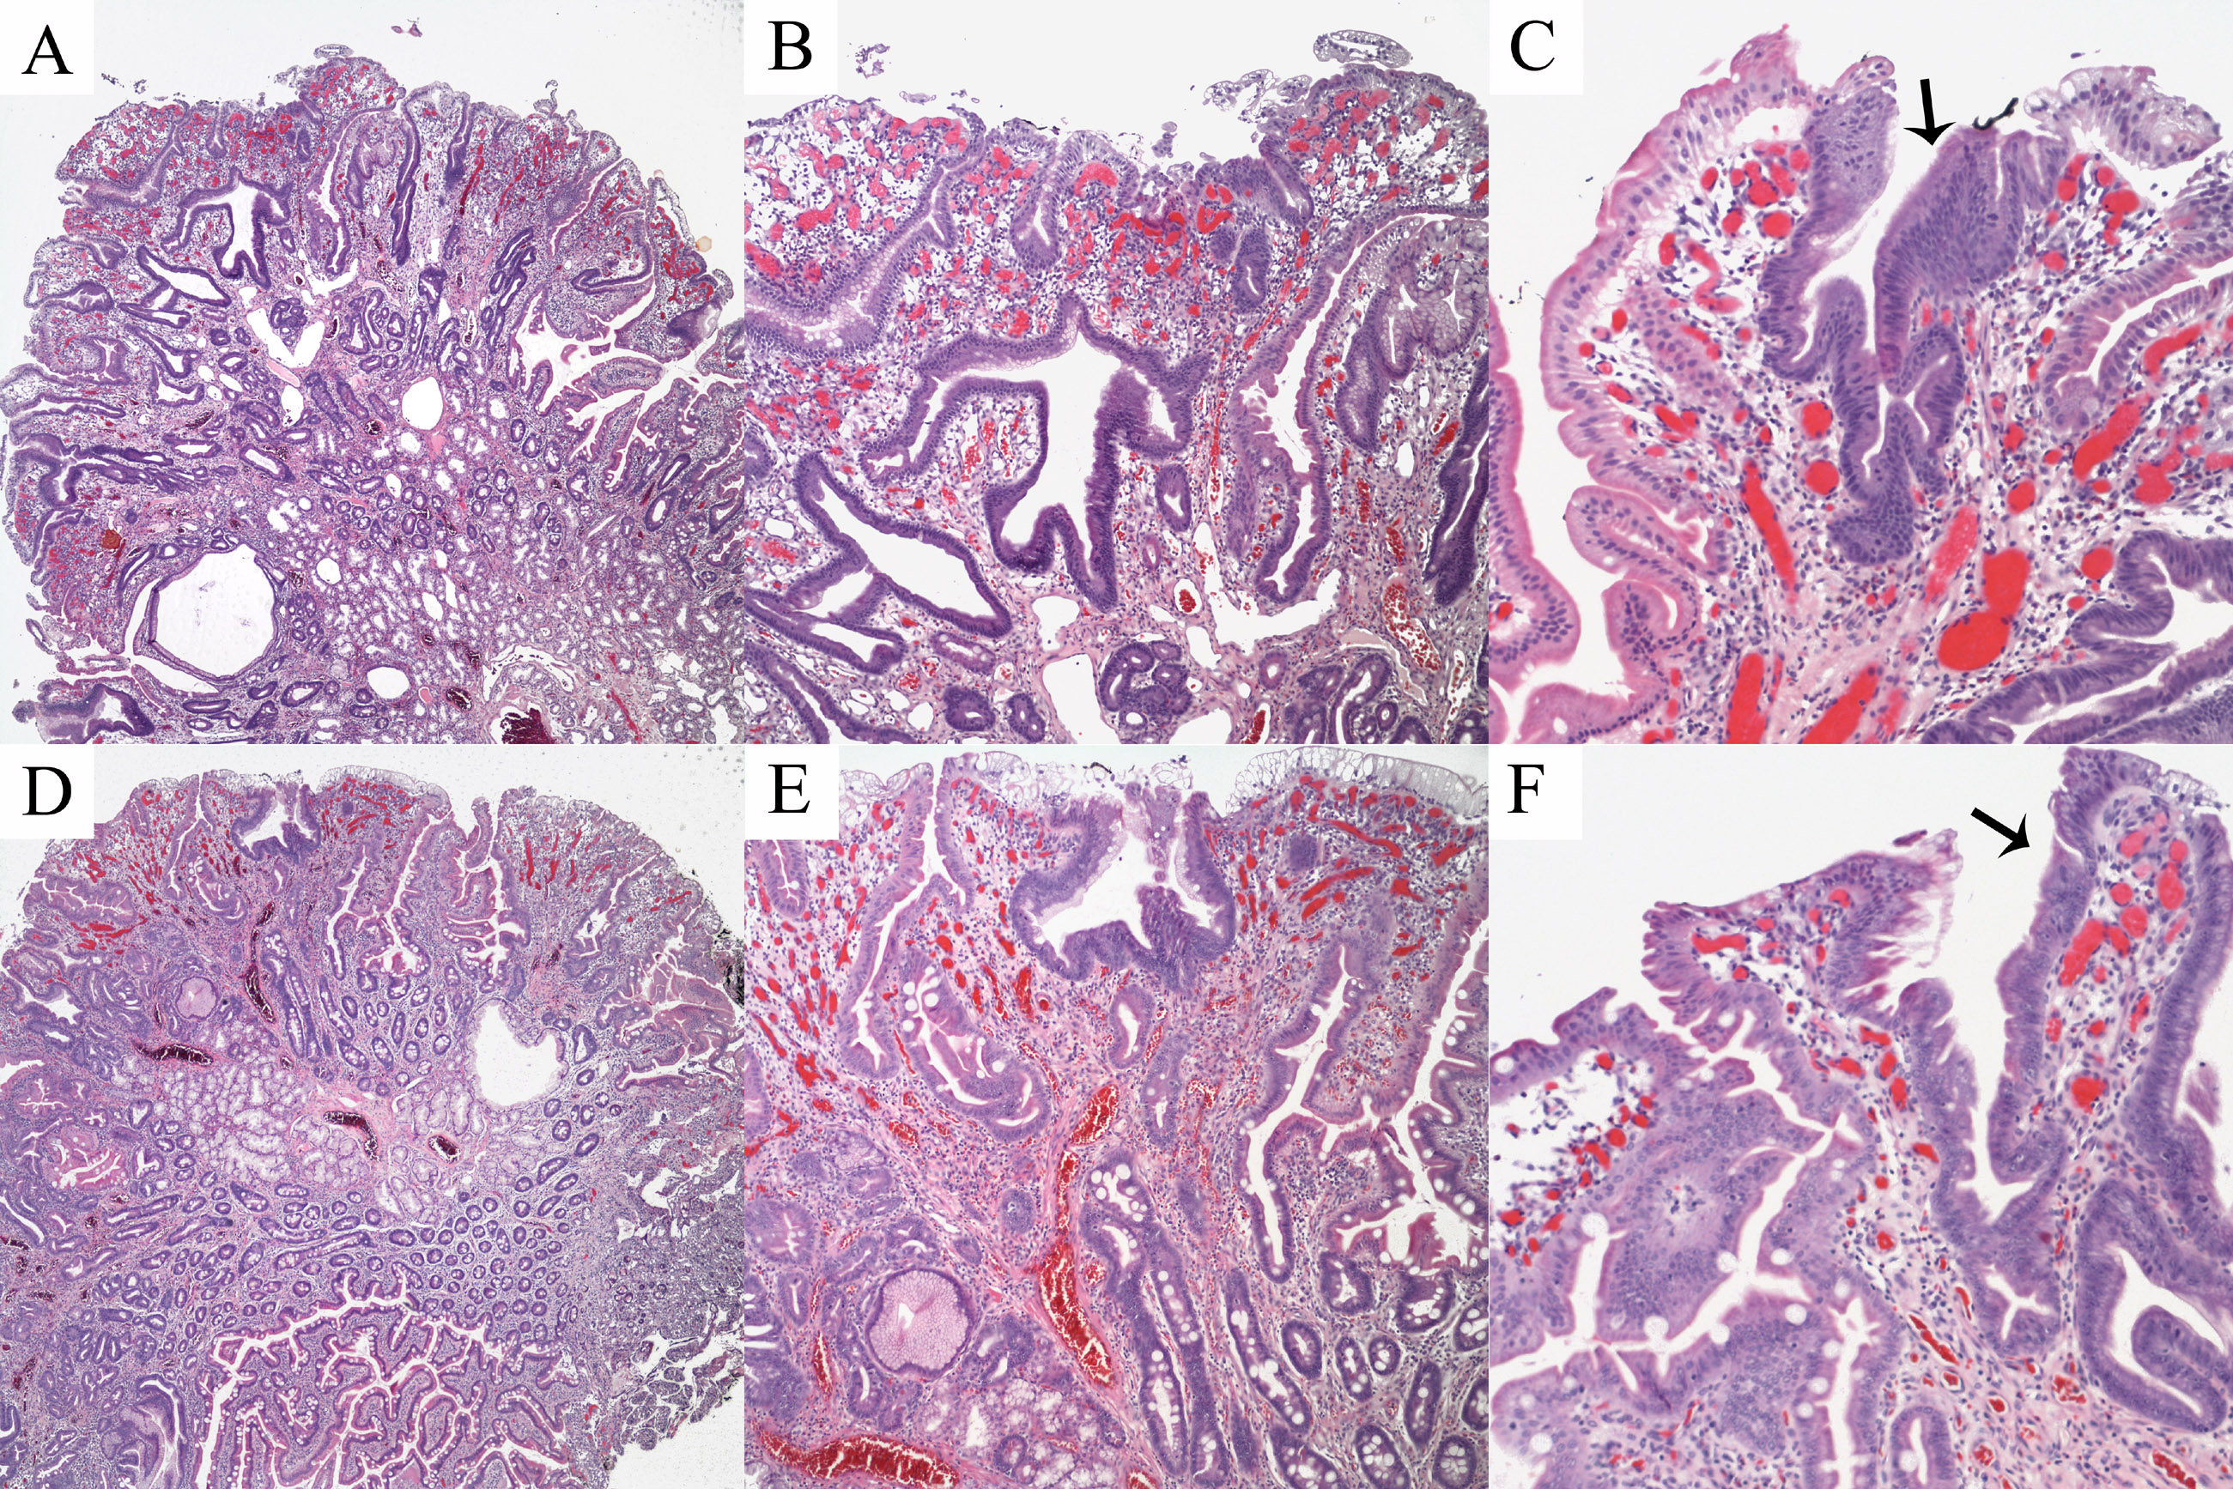

Figure 2 Histopathologic findings. Biopsies from the mid duodenal bulb polyp showed villiform hyperplasia of intestinal and gastric foveolar epithelium with numerous capillaries demonstrating congestion and vascular ectasia (A and B). Similar changes seen in the polyp from the second part of the duodenum (D-E). The epithelium lining the surface and crypts focally (arrows) showing cells with mucin depletion and slightly pencillate nuclei with hyperchromasia (C and F). Representative images of hematoxylin and eosin stained slides taken at 40 × (A, D: 4 × objective and 10 × ocular magnification), 100 × (B, E – 10 × objective and 10 × ocular magnification) and 200 × (C, F: 20 × objective and 10 × ocular magnification).

Table 1 Reported small intestinal polyps secondary to portal hypertension (including current case)

Ref. | Age (yr)/gender | Location(s) | Number/sizes of polyps | Pathologic findings | Etiology of portal hypertension
Current report | 52/M | Duodenal bulb to second portion | Greater than 7, majority 1-2 mm, largest 8 mm | Villiform hyperplasia of reactive intestinal and gastric foveolar epithelium, proliferating ectatic and congested lamina propria vessels | Alcoholic cirrhosis
Pillai et al^{[2]} | 55/M | 1st portion of duodenum | “multiple sessile polyps”, sizes NS | Polypoid muocsa lined by small intestinal and gastric foveolar type epithelium with ectatic capillaries, fibrosis and smooth muscle proliferation of lamina propria | Alcoholic cirrhosis
Zeitoun et al^{[3]} | 70/M | 2nd portion of duodenum | Single polyp, 3 cm | Numerous thick-walled capillaries with vascular ectasia in lamina propria | Alcoholic cirrhosis
¹Lemmers et al^{[4]} | 50/F | Jueuno-ileal | “Several”, > 5 mm | Lamina propria vascular dilation and thrombi without epithelial atypia | Hepatitis C cirrhosis
 | 73/M | Jejunal | Two “bumps”, < 5 mm | Not biopsied | Cryptogenic cirrhosis
 | 67/M | Duodenal | “Several”, 5 mm | Lamina propria vascular dilation and inflammation with epithelial atypia and ulceration | Alcoholic cirrhosis
 | 74/F | Antral/duodenal | “Several”, 15 mm | Lamina propria vascular dilation and epithelium with crenellated glands | Hepatitis C cirrhosis
 | 66/F | Duodenal/jejuno-ileal | “Several”, 5/< 5 mm | Not biopsied | Cryptogenic cirrhosis
Devadason et al^{[5]} | 6 yr/M | 1st and 2nd portion of duodenum | “polyps”, sizes NS | Lobular capillary proliferation in a hemagiomatous pattern in lamina propria | EHPVO
 | 4 yr/F | 2nd portion of duodenum | “numerous”, sizes NS | Lobular capillary proliferation in a hemagiomatous pattern in lamina propria | EHPVO
 | 1 yr/F | 2nd portion of duodenum | “polyps”, sizes NS | Polyp not biopsied, mucosa adjacent to polyp with ecatsia and congestion of lamina propria with smooth muscle hypertrophy | EHPVO
¹Data obtained from Table 1 (provided by Dr. Lemmers via email). EHPVO: Extrahepatic portal venous obstruction; NS: Not specified.
Table 2 Histological differential diagnosis of polyps in the duodenum
Primary | Epithelial  Duodenal adenoma/adenocarcinoma  Ampullary adenoma/adenocarcinoma
Hyperplasia, heterotopias, ectopias, inflammatory
Brunners gland hyperplasia/hamartoma
Gastric/pancreatic hetertopia/ectopia
IBD associated inflammatory pseudopolyps
Inflammatory fibroid polyp
Peutz Jegher polyps
Juvenile polyps (JPS or PTEN associated)
Cronkhite-Canada syndrome polyps
Neuroendocrine/neural
Neuroendocrine tumors
Mixed adenocarcinoma neuroendocrine carcinoma
Gangliocytic paranglioma
Neurofibroma
Ganglioneuroma
Schwannoma
Perinerioma
Mesenchymal
Gastrointestinal stromal tumor
Leiomyoma
Lipoma
Hemangioma
Granular cell tumor
Kaposi sarcoma
Lymphoid
Lymphoid hyperplasia
B and T cell lymphomas
Secondary | Metastases
Miscellaneous | Malakoplakia, mucosal prolapse related, lymphangiectasia, xanthoma
IBD: Inflammatory bowel disease.

