Name of Journal: World Journal of Clinical Cases
Manuscript No: 44650
Manuscript Type: CASE REPORT

Vein of Galen aneurismal malformations - clinical characteristics, treatment and presentation: Three cases report
Spazzapan P et al. Vein of Galen aneurismal malformations

Peter Spazzapan, Zoran Milosevic, Tomaz Velnar

Peter Spazzapan, Tomaz Velnar, Department of Neurosurgery, University Medical Centre Ljubljana, Ljubljana 1000, Slovenia

Zoran Milosevic, Department of Radiology, University Medical Centre Ljubljana, Ljubljana 1000, Slovenia

ORCID number: Peter Spazzapan (0000-0002-5278-7947); Zoran Milosevic (0000-0002-6283-3454); Tomaz Velnar (0000-0002-6283-4348).

Author contributions: All authors contributed equally to this work; Spazapan P designed the research; Milosevic Z analysed the data; Velnar T collected the data; Spazzapan P, Milosevic Z and Velnar T wrote the paper.

Informed consent statement: Informed written consent was obtained from the patient for publication of this report and any accompanying images.

Conflict-of-interest statement: The authors declare that they have no conflict of interest.

CARE Checklist (2016) statement: The authors have read the CARE Checklist (2016), and the manuscript was prepared and revised according to the CARE Checklist (2016).

Open-Access: This article is an open-access article that was selected by an in-house editor and fully peer-reviewed by external reviewers. It is distributed in accordance with the Creative Commons Attribution Non Commercial (CC BY-NC 4.0) license, which permits others to distribute, remix, adapt, build upon this work non-commercially, and license their derivative works on different terms, provided the original work is properly cited and the use is non-commercial. See: http://creativecommons.org/licenses/by-nc/4.0/

Manuscript source: Invited manuscript

Corresponding author: Tomaz Velnar, MD, PhD, Assistant Professor, Doctor, Department of Neurosurgery, University Medical Centre Ljubljana, Zaloska 7, Ljubljana 1000, Slovenia. tvelnar@hotmail.com
Telephone: +386-1-5223250
Fax: +386-1-5222218

Received: November 21, 2018
Peer-review started: November 21, 2018
First decision: December 29, 2018
Revised: January 21, 2019
Accepted: March 16, 2019
Article in press: March 16, 2019
Published online: April 6, 2019
Abstract
BACKGROUND
The vein of Galen aneurismal malformations (VGAM) are rare arteriovenous malformations of the embryonic choroid plexus. They represent about 30% of paediatric neurovascular disorders and show diverse characteristics. The VGAM is constituted by a midline dilated venous structure that receives blood from abnormal macroscopic or microscopic arteriovenous shunting vessels. Two types of VGAM exist, the choroidal and the mural. The treatment represents a challenge with the therapeutic objective to preserve the normal brain development without creating new neurological deficits.

CASE SUMMARY
We present three cases of VGAM in the early postnatal period and their treatment. All patents were treated with the endovascular technique, which was successful. According to our experience, the endovascular technique is a safe and efficient mode of VGAM treatment.

CONCLUSION
The objective of treatment aims to child’s normal neurological development. A proper selection of patients and a thorough diagnostic workup is of vital importance. When the endovascular treatment is performed, the primary aim is not a complete VGAM exclusion at one time, which could produce a sudden reversal of blood flow with consequent venous infarction and ischemia. The aim is therefore to occlude as much of the VGAM as needed to relieve the congestive cardiac failure, to gain time and to create the conditions for a normal maturation of the neurovascular system. With the use of endovascular techniques, which represent not only the first choice of treatment but also the only safe therapeutic modality, the natural history of VGAM and their risks may be avoided safely.

Key words: Vein of Galen; Aneurismal malformation; Children; Treatment; Case reports

© The Author(s) 2019. Published by Baishideng Publishing Group Inc. All rights reserved.

Core tip: The vein of Galen aneurismal malformations are rare arteriovenous malformations of the embryonic choroid plexus. Their treatment represents a big challenge with the therapeutic objective to preserve the normal brain development without creating new neurological deficits.

Citation: Spazzapan P, Milosevic Z, Velnar T. Vein of Galen aneurismal malformations - clinical characteristics, treatment and presentation: Three cases report. World J Clin Cases 2019; 7(7): 855-862
URL: https://www.wjgnet.com/2307-8960/full/v7/i7/855.htm
DOI: https://dx.doi.org/10.12998/wjcc.v7.i7.855

INTRODUCTION
The vein of Galen aneurysmal malformation (VGAM) is a rare arteriovenous malformation of the embryonic choroid plexus^{[1]}. They represent about 30% of all paediatric neurovascular disorders^{[2,3]}. The VGAM is constituted by a midline dilated venous structure that receives blood from abnormal macroscopic or microscopic arteriovenous shunting vessels^{[4]}. This pathology was first described by Raybaud as a malformation of the choroidal system draining into the median prosencephalic vein, which is the embryonic precursor of the vein of Galen^{[5]}.
The treatment of VGAM represents a big challenge. The therapeutic objective is to preserve the normal brain development without creating new neurological deficits. Anatomic exclusion of the lesion is therefore not always the goal, even though it may represent a technical success^{[1]}.
We present three cases of VGAM that were symptomatic in the early postnatal period. All three children presented with typical clinical manifestations and were treated with endovascular technique at the University Medical Centre in Ljubljana, Slovenia. The approval from the hospital Ethical committee was obtained for the study.

CASE PRESENTATION
Case 1
A male child was born in the 37th wk of gestation. Soon after birth, he developed tachypnea, tachycardia and oliguria. Clinically, a low cardiac output and cardiomegaly were observed (Figure 1A). No past illnesses were documented in the new-born or mother and also personal and family history were unremarkable. The transfontanellar ultrasound (US) and a magnetic resonance imaging (MRI) demonstrated a 22 mm × 14 mm choroidal VGAM (Figure 1 B-E). The feeders originated from the posterior choroidal and pericallosal arteries, thus giving the characteristic persistent limbic ring (Figure 1F).

Case 2
A male child born in the 36th wk of gestation with an Apgar score 10/10/10. Soon after birth, he presented with a heart murmur and progressive dyspnoea. No past illnesses were documented in the new-born or mother. Personal and family histories were unremarkable. During the physical examination upon admission, a progressive dyspnoea was evident and ascites was present. The chest radiography revealed a dilatation of the right heart (Figure 2A) and lung oedema. The MRI showed a 35 mm × 45 mm VGAM with main feeders arising from both posterior cerebral arteries, posterior communicating arteries, anterior choroidal arteries and callosomarginal arteries. The VGAM drained into a persistent falcine sinus (Figure 2 B and C). There was no hydrocephalus.

Case 3
A male child was born in the 37th wk and presented with dyspnoea and oedema. After birth, a heart murmur was noted and the child developed a congestive heart failure. No past illnesses were documented in the new-born or mother. The personal and family histories were unremarkable as well. During the physical examination upon admission, typical signs of congestive heart failure were observed with oedema and cyanosis. The imaging examinations included the transfontanellar US and the MRI. They have revealed the presence of a choroidal VGAM, which measured 26 mm × 30 mm. A mild ventriculomegaly was also seen.

FINAL DIAGNOSIS
In all three new-borns that were treated at our medical centre, an aneurismal malformation of the vein of Galen was confirmed after the diagnostic follow-up and this was the final diagnosis.

TREATMENT
Case 1
An endovascular transarterial embolization was performed and the VGAM was partially occluded with seven coils (Figure 1 G-I). Three months after the procedure the child presented with hydrocephalus, this was successfully treated with an endoscopic ventriculostomy.

Case 2
Endovascular treatment was performed on the 17th d. The VGAM was excluded with 19 coils. Postoperatively, there was a clear amelioration of the heart function.

Case 3
The endovascular procedure was performed on the 15th d of life. The VGAM was partially occluded and the MRI and MR angiography one year after the procedure showed no residual flow in the VGAM. Only a mild ventriculomegaly was present (Figure 3A).

OUTCOME AND FOLLOW-UP
Case 1
The MRI was performed 15 mo after treatment and it revealed almost complete thrombosis of the VGAM with a good venous drainage toward the sagittal, transverse and sigmoid sinuses (Figure 1 J-L). At a follow-up of three years, the neurocognitive development of the child was normal.

Case 2
The VGAM was closed successfully with the endovascular procedure. The MRI one year after treatment showed no residual flow through the VGAM (Figure 2 D and E).

Case 3
At follow up, no neurological deficits were recorded. The child was developing normally. The MR angiography at the age of 4 years showed only a small flow through the VGAM and a normal flow in the posterior cerebral arteries and in the straight sinus (Figure 3B).

DISCUSSION
Embryology and angioarchitecture
Between the 6th and the 11th wk of intrauterine life, the arterial supply to the forming telencephalic choroidal plexus comes from the primary terminal branches of the internal carotid artery, while the venous drainage is directed toward the median prosencephalic vein. This vessel than regresses and form the two internal cerebral veins and, in its most caudal part, the vein of Galen. The failure of the regression of the median prosencephalic vein causes the formation of direct arteriovenous fistulae within the velum interpositum and the quadrigeminal cistern, where the vein is located. The median prosencephalic vein dilates and may reach a balloon size and the high flow into the fistula does not allow the normal dural sinuses to form^{[6]}. The foetal venous structures persist, such as the falcine sinus, that connects the median prosencephalic vein to the superior sagittal sinus (Figure 2 B and C).
The arterial supply of a VGAM involves the choroidal arteries and the other arteries that normally supply the tela choroidea and the quadrigeminal plate. More arterial feeders come from the subependymal vessels of the posterior circle of Willis. In half of the neonatal patients, this arterial angioarchitecture gives rise to a typical conformation of the persistent limbic arch (Figure 1F), through which the pericallosal arteries bridge to the anterior choroidal and posterior cerebral arteries. Due to the haemodynamic disorder, the normal cerebral veins drain into unusual channels. The thalamostriate veins open into the subtemporal vein or into lateral mesencephalic vein^{[5]}. The superior sagittal sinus and the torcular may be dilated and the venous blood is captured from the cavernous sinus, which than drains into the orbits, the pterygoid plexus and the inferior petrosal sinus. In the majority of older, chronic patients, the facial veins become also dilated and there can be an occlusion of the sigmoid sinus and jugular veins^{[4]}.

Classification
There are two types of VGAM, the choroidal and the mural. The choroidal VGAM is seen in most neonates with a low clinical score, because of cardiac failure. It is supplied from all choroidal arteries and their branches that open into the enlarged venous pouch. All three children presented in this series had a high-flow, choroidal type of VGAM.
The mural VGAM is better tolerated and is seen in infants without cardiac symptoms. It is formed from single or multiple direct AV fistulae within the wall of the VGAM. These two types of VGAM must be differentiated from the vein of Galen aneurysmal dilatation, which represents the dilatation of a normally developed vein of Galen, secondary to an outflow obstruction. These lesions arise in older children and adults and cause haemorrhages, seizures or focal neurological deficits^{[6]}.

Natural history
Cardiac manifestations: While in utero the low resistance of the placental circulation competes with the cerebral arteriovenous shunt, soon after birth there is an abrupt increase in the flow across the fistula^{[6]}. In the most severe cases up to 80% of the left ventricular output may be directed toward the brain. There is a parallel high flow through the pulmonary circulation and a pulmonary hypertension. This promotes the persistence of right-left shunts through foramen ovale and ductus arteriosus, and finally brings to cyanosis, tachycardia and respiratory distress^{[7]}. The coronary artery flow is reduced, thus promoting to myocardial ischemia. The cardiac manifestations can range from asymptomatic cardiomegaly to severe congestive cardiac failure (CCF). This rapidly progressive disease worsens within the first three days of life. The medical treatment is based on low dose inotropic support and peripheral vasodilatation that improve the cardiac output^{[8]}. CCF resolves spontaneously after a proper endovascular treatment of the VGAM. The absence of response to medical treatment is an indicator of poor outcome. The expected mortality in severe cases is almost 100%^{[8,9]}.
The CCF was present in all three children treated from our institution. The natural course of this condition was rapidly progressive and successfully reversed after the endovascular treatment of the VGAM. Additionally, the CCF can also appear later in infancy, especially after a lung infection or a renal and liver dysfunction^{[8]}.

Macrocrania and hydrocephalus: Hydrocephalus can appear soon after birth or later in infancy, when it can represent the first revealing sign of a VGAM. In these situations it can cause irritability, alteration of consciousness and seizures.
Hydrocephalus is the result of the high pressure in the venous sinuses, which can reach levels higher than 30 cm H₂O^{[10]}. The venous sinuses and this situation results in hydrocephalus, cerebral oedema and hypoxia cannot normally reabsorb the CSF. The three patients in our series demonstrate three different courses of VGAM related hydrocephalus. In Case 1, hydrocephalus did not resolve after the treatment on the VGAM and was later resolved by an endoscopic ventriculostomy. Case 2 presented no hydrocephalus. Case 3 presented a mild ventriculomegaly, which resolved, once that the occlusion of VGAM restored the normal CSF absorption.

Dural Sinus occlusion and pial reflux: In the VGAM, the efferent blood from the malformation is directed toward the embryonic falcine, occipital and marginal sinuses and not to the sigmoid sinus which remains thin. In chronic patients, it can be also occluded and consequently the VGAM drains directly within the pial venous system. This represents a high risk for haemorrhage and venous infarction. In the long term, this reflux causes a permanent insult to the brain. The most frequent consequences of a not properly treated VGAM are seizures and mental retardation. The typical MRI or computer tomography (CT) findings are diffuse calcifications and cerebral atrophy, giving the aspect of a ventriculomegaly^{[10]}.

Management
When a neonate is diagnosed with a VGAM, the prognosis is determined by the Bicêtre neonatal evaluation score^{[1]}. This score is based on clinical and radiological findings (MRI, EEG, transfontanellar US, cardiac US, chest X-ray and evaluation of renal and liver function). A score of less than 8 indicates a grave prognosis and no treatment is proposed. A score between 8 and 12 indicates the need for urgent embolization. A score between 12 and 21 indicates a more stable condition, which allows the postponement of the endovascular treatment to the age of five months. Treatment at that age is better tolerated and the risk of delay in brain maturation is still low.
When the endovascular treatment is performed in the neonate, the aim is not a complete VGAM exclusion at one time, which could produce a sudden reversal of blood flow with consequent venous infarction and ischemia^{[11]}. The aim is therefore to occlude as much of the VGAM as needed to arrest the CCF, to gain time and to create the conditions for a normal maturation of the neurovascular system.
Infants and children, who present between the age of one month and two years, have usually a single fistula with a smaller shunt. The cardiac symptoms are mild or absent. They usually present with macrocephaly and hydrocephalus. The aim of treatment is to maintain the CSF-venous balance and to allow the development of normal brain. The ideal treatment of hydrocephalus is the proper embolization of the VGAM, which can restore the hemodynamic balance. A ventriculoperitoneal (VP) shunt should be avoided before the occlusion of the VGAM since it can worsen the cerebral venous hypertension^{[6]}. It can be placed only later in the infancy, if the hydrocephalus and increased intracranial pressure does not resolve after embolization. Endoscopic ventriculostomy is today a good alternative to VP-shunting.
Older children and adults have usually a low-flow fistula and clinical and radiological signs of venous hypertension. These patients present with seizures, headache, developmental delay and focal neurological deficits. This situation represents an indication for endovascular treatment, to balance the VGAM outflow and the draining capacity of the posterior outlets veins.

Technical notes and strategies
The most used endovascular approach to VGAM is the transarterial path, using coils, cyanoacrylates or detachable balloons. The aim is to obtain a complete exclusion in the smallest possible number of sessions, considering the clinical stability of the child and the angioarchitecture of the VGAM. The transvenous route carries many complications, especially venous infarction and haemorrhage. There have been some attempts to treat the VGAM with stereotactic Gamma knife surgery, but the long-term result is not known. Indeed, the time required is too long for the developing brain to be acceptable. Payne reported a favourable outcome with Gamma knife surgery in 88.9%^{[12]}. Alternatively, radiotherapy may be used when multiple residual fistulae remain present after the embolization^{[4]}. Despite these good results, the endovascular treatment achieved so much success, that all other methods cannot be compared with it, especially in terms of the mortality rate^{[2]}.

Follow up and results
The large series of endovascular treated VGAM by Lasjounas showed that an obliteration o less than 50% was achieved in 6.2%, an obliteration of 50 to 90% in 38.5% and more than 90% in 55%. Some slow flow demonstrated into the VGAM does not represent a significant risk for the child^{[1]}. In his series, Lajounas reported that 74% of the survived children were normal at a long term follow up. The overall mortality rate was 10.6%, but most of these cases were the poor neonatal cases, that would not even be treated today, based on a Biĉetre score less than 8^{[1]}.
In the meta-analysis of Yan, which included 34 studies and 667 patients with VGAM, all treated with endovascular techniques, the overall mortality was 10% and a good outcome was achieved in 68%^{[2]}. A poor outcome was described in 31%. From a technical point of view, a complete occlusion was possible in 57% and a partial occlusion in 43%.
In our small series, none of the three children had a complete occlusion of the lesion during the early endovascular treatment, but in the long term, all three children experienced a favourable outcome, with almost complete thrombosis of the VGAM and the complete resolution of the venous hypertension. There was no need for multiple endovascular treatments, since some small amount of flow into the VGAM did not represent a risk.
All these results show that the natural history of VGAM has changed radically after the introduction of endovascular treatment. In the series of Johnston where all cases were treated surgically, the results were poor, with a mortality rate of 55.6%, which raised to 91.4% in the neonatal cases^{[13]}.

CONCLUSION
The VGAM are vascular lesions of the infancy showing different characteristics and risks. A better understanding of the angioarchitecture, best timing of treatment methods and associated problems have increased the overall survival and the quality of life in these children. The patient selection is therefore important and the objective of treatment is a child’s normal neurological development, with no deficits. The natural history of the VGAM has been changed by the use of endovascular techniques, which represent the first choice of treatment and an effective and often the only safe therapeutic modality.
REFERENCES
1 Lasjaunias PL, Chng SM, Sachet M, Alvarez H, Rodesch G, Garcia-Monaco R. The management of vein of Galen aneurysmal malformations. Neurosurgery 2006; 59: S184-94; discussion S3-13 [PMID: 17053602 DOI: 10.1227/01.NEU.0000237445.39514.16]
2 Yan J, Wen J, Gopaul R, Zhang CY, Xiao SW. Outcome and complications of endovascular embolization for vein of Galen malformations: a systematic review and meta-analysis. J Neurosurg 2015; 123: 872-890 [PMID: 26230476 DOI: 10.3171/2014.12.JNS141249]
3 Casasco A, Lylyk P, Hodes JE, Kohan G, Aymard A, Merland JJ. Percutaneous transvenous catheterization and embolization of vein of galen aneurysms. Neurosurgery 1991; 28: 260-266 [PMID: 1997895 DOI: 10.1227/00006123-199102000-00013]
4 Brunelle F. Arteriovenous malformation of the vein of Galen in children. Pediatr Radiol 1997; 27: 501-513 [PMID: 9174022 DOI: 10.1007/s002470050169]
5 Raybaud CA, Strother CM, Hald JK. Aneurysms of the vein of Galen: embryonic considerations and anatomical features relating to the pathogenesis of the malformation. Neuroradiology 1989; 31: 109-128 [PMID: 2664553 DOI: 10.1007/BF00698838]
6 Gupta AK, Rao VR, Varma DR, Kapilamoorthy TR, Kesavadas C, Krishnamoorthy T, Thomas B, Bodhey NK, Purkayastha S. Evaluation, management, and long-term follow up of vein of Galen malformations. J Neurosurg 2006; 105: 26-33 [PMID: 16874888 DOI: 10.3171/jns.2006.105.1.26]
7 Saliba E, Santini JJ, Chantepie A, Pottier JM, Cheliakine C, Gold F, Bloc D, Laugier J. [Cardiac and cerebral involvement in aneurysms of the ampulla of Galen. Contribution of echography and cerebral Doppler flowmeter in the neonatal period]. Neurochirurgie 1987; 33: 296-301 [PMID: 2960906]
8 Frawley GP, Dargaville PA, Mitchell PJ, Tress BM, Loughnan P. Clinical course and medical management of neonates with severe cardiac failure related to vein of Galen malformation. Arch Dis Child Fetal Neonatal Ed 2002; 87: F144-F149 [PMID: 12193525 DOI: 10.1136/fn.87.2.F144]
9 Karadeniz L, Coban A, Sencer S, Has R, Ince Z, Can G. Vein of Galen aneurysmal malformation: prenatal diagnosis and early endovascular management. J Chin Med Assoc 2011; 74: 134-137 [PMID: 21421209 DOI: 10.1016/j.jcma.2011.01.029]
10 Mickle JP, Quisling RG. Vein of Galen fistulas. Neurosurg Clin N Am 1994; 5: 529-540 [PMID: 8086804 DOI: 10.1016/S1042-3680(18)30518-7]
11 Iizuka Y, Kakihara T, Suzuki M, Komura S, Azusawa H. Endovascular remodeling technique for vein of Galen aneurysmal malformations--angiographic confirmation of a connection between the median prosencephalic vein and the deep venous system. J Neurosurg Pediatr 2008; 1: 75-78 [PMID: 18352807 DOI: 10.3171/PED-08/01/075]
12 Payne BR, Prasad D, Steiner M, Bunge H, Steiner L. Gamma surgery for vein of Galen malformations. J Neurosurg 2000; 93: 229-236 [PMID: 10930008 DOI: 10.3171/jns.2000.93.2.0229]
13 Johnston IH, Whittle IR, Besser M, Morgan MK. Vein of Galen malformation: diagnosis and management. Neurosurgery 1987; 20: 747-758 [PMID: 3601022 DOI: 10.1227/00006123-198705000-00013]

P-Reviewer: Sariboyaci AEE, Exbrayat JM S-Editor: Dou Y L-Editor: A E-Editor: Wu YXJ

Specialty type: Research and Experimental Medicine
Country of origin: Slovenia
Peer-review report classification
Grade A (Excellent): 0
Grade B (Very good): B
Grade C (Good): C
Grade D (Fair): 0
Grade E (Poor): 0

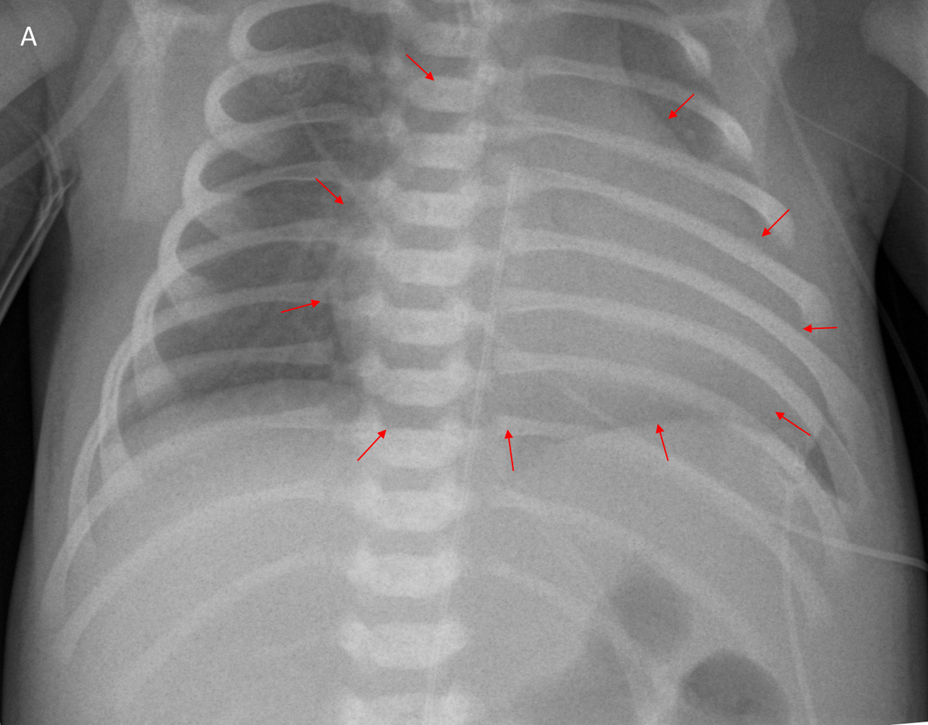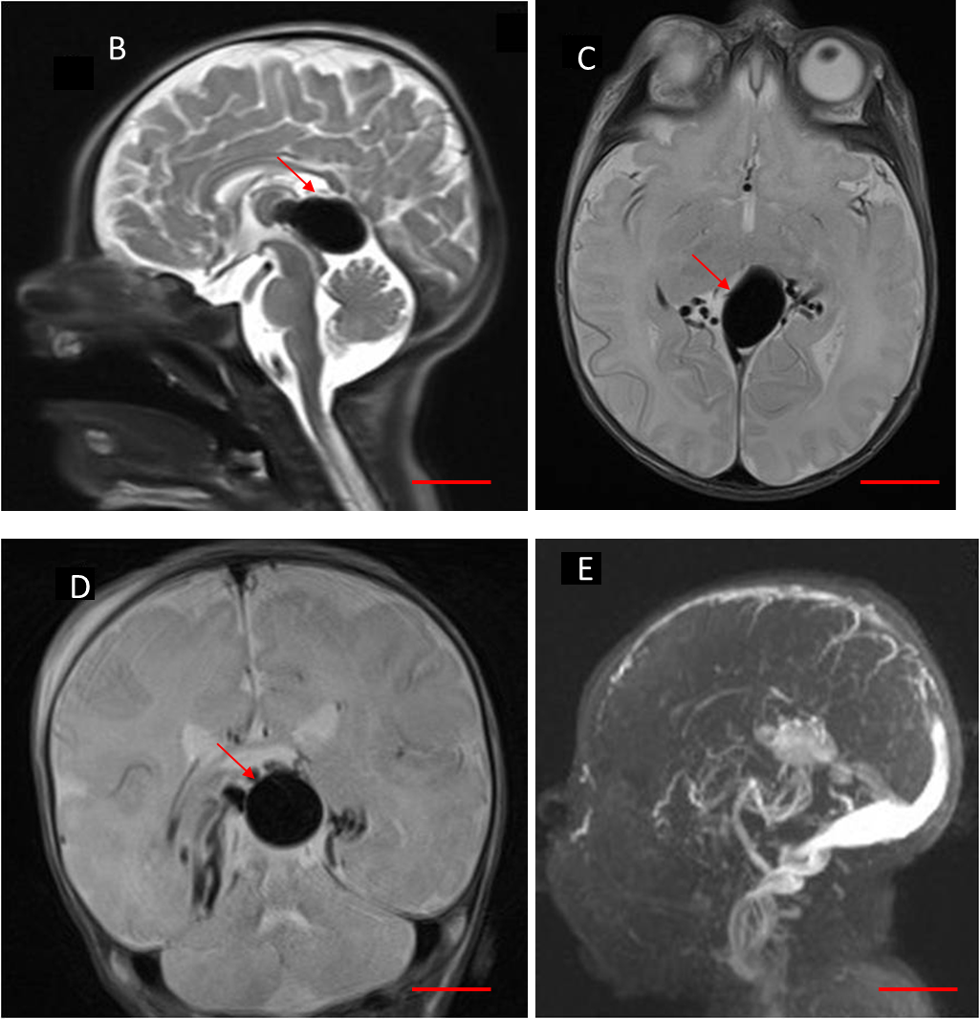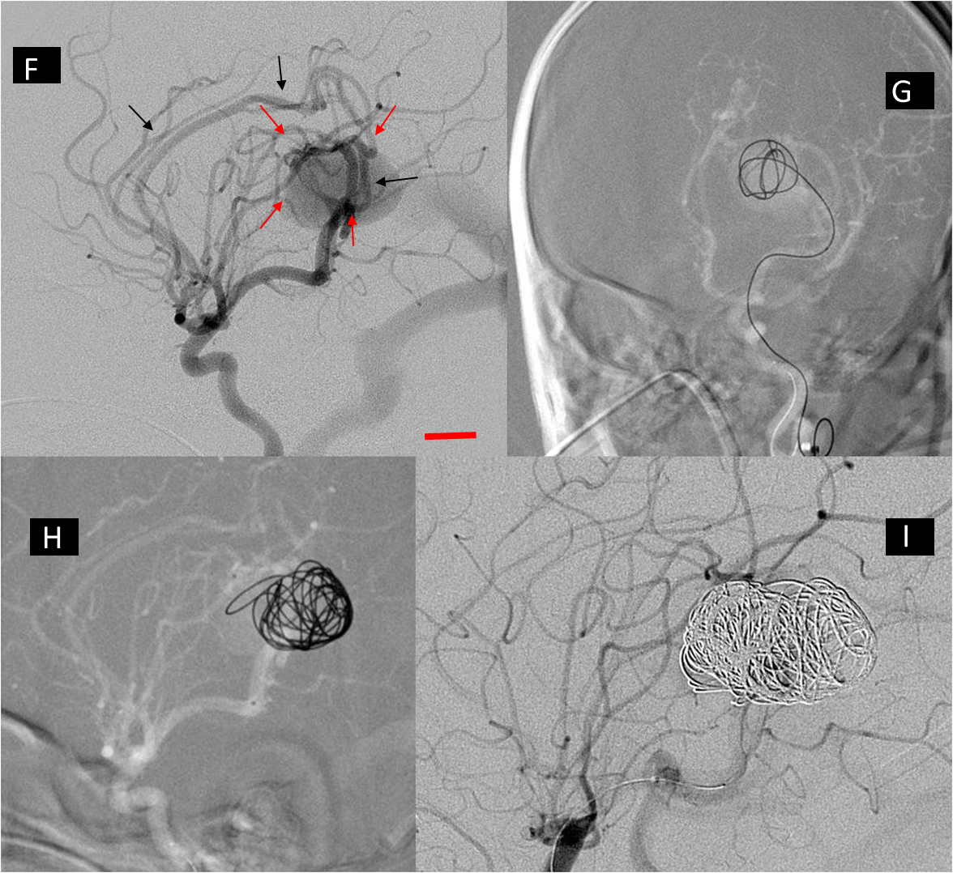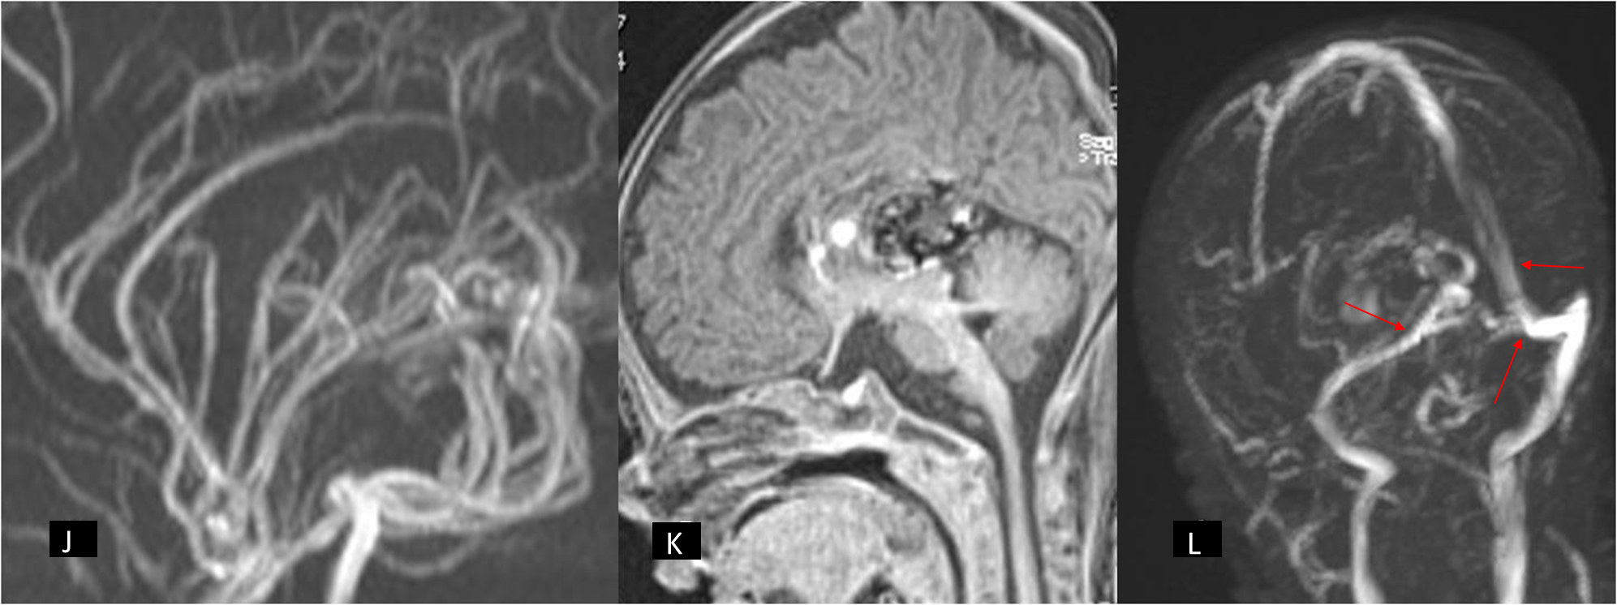
Figure 1 Imaging examinations of patient 1. A: Chest x-ray with cardiomegaly. The arrows indicate the outlines of cardiac silhouette; B-E: The MRI showing a 22 mm x 14 mm choroidal VGAM (red arrow pointing on the malformation). The scale indicates 2 cm; F: Angiography showing the feeders originating from the posterior choroidal and pericallosal arteries (red arrows) with the characteristic persistent limbic ring (black arrows). The scale indicates 1 cm; G-I: The partially occluded VGAM after an endovascular transarterial embolization with coils, which are visible in the malformation; J-L: A control MRI 15 mo after treatment. Almost complete thrombosis of the VGAM (J and K) with a good venous drainage (arrows) toward the sagittal, transverse and sigmoid sinuses may be seen (L).

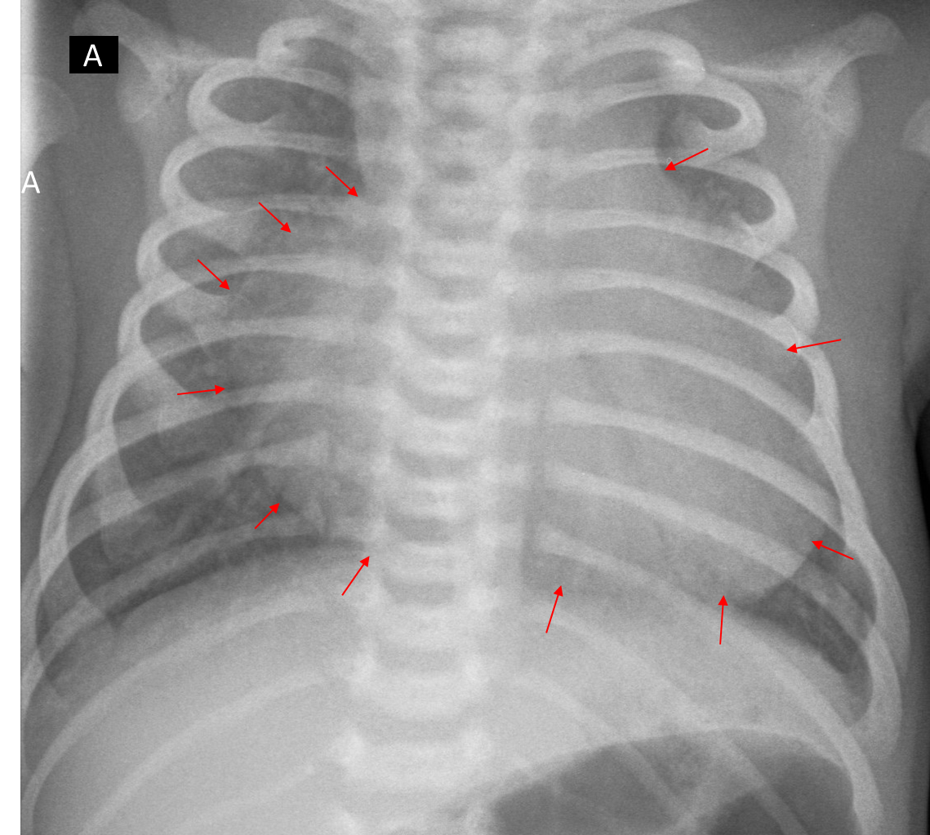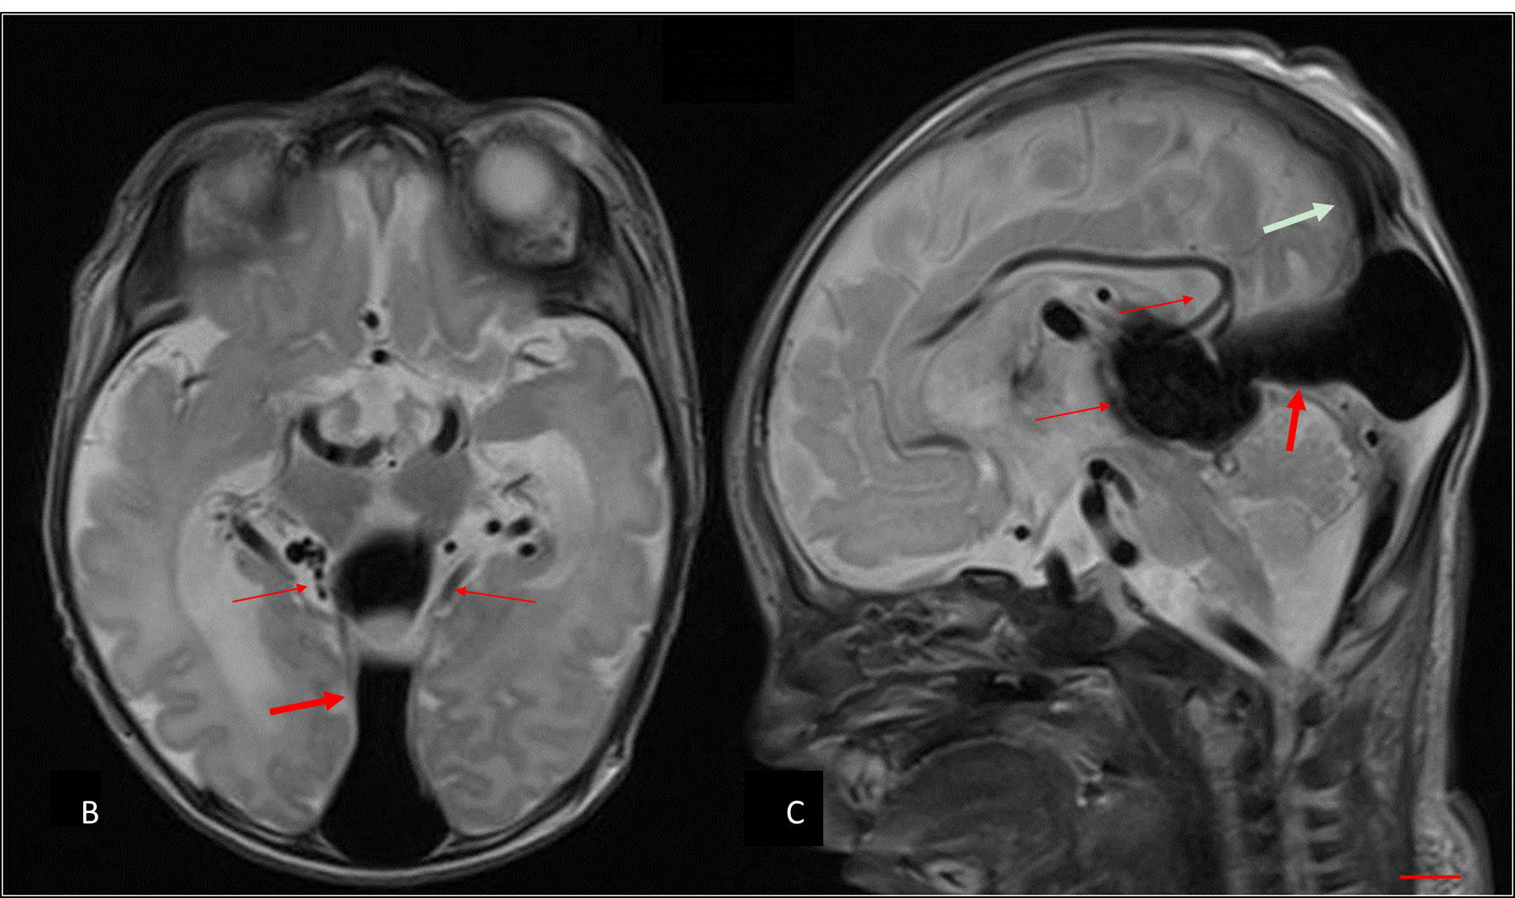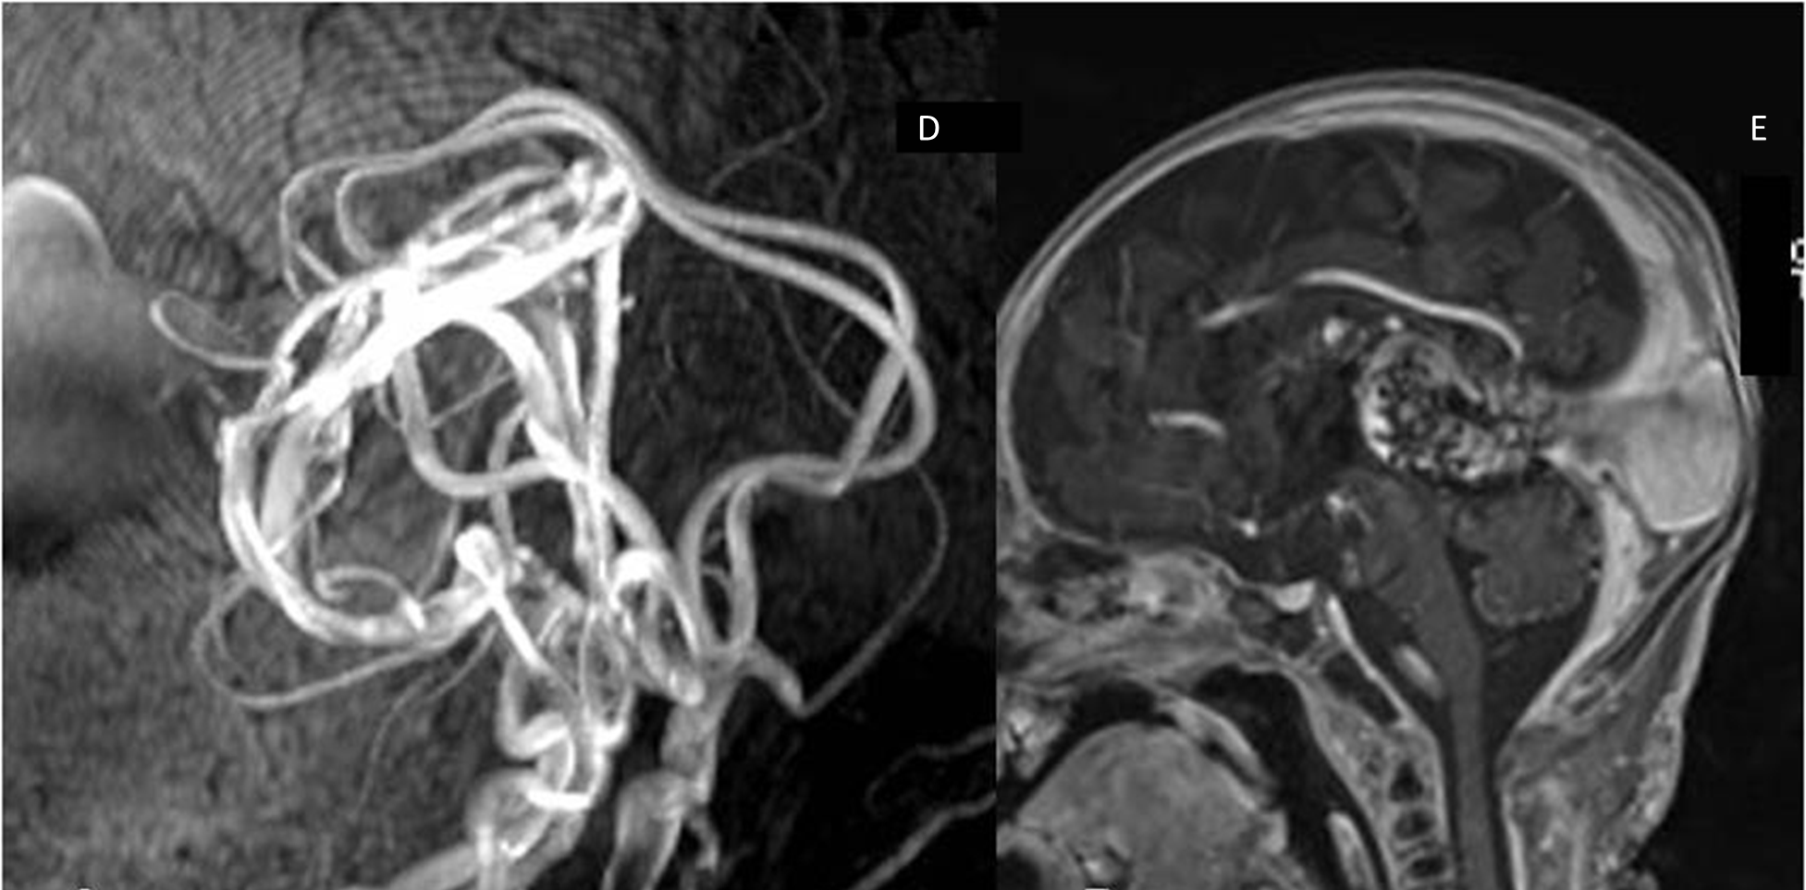Figure 2 Imaging examinations of patient 2. A: The chest x-ray showing dilatation of the right heart (red arrows indicate the heart silhouette) and lung oedema (white spots in the lung parenchima); B,C: The MRI showing a 35 mm × 45 mm VGAM (thick arrow) with main feeders arising from both posterior cerebral arteries, posterior communicating arteries, anterior choroidal arteries and callosomarginal arteries (thin arrows). The VGAM drains into a persistent falcine sinus (white arrow) (C). The scale indicates 1 cm; D, E: A control MRI one year after treatment. No residual flow through the VGAM can be seen.

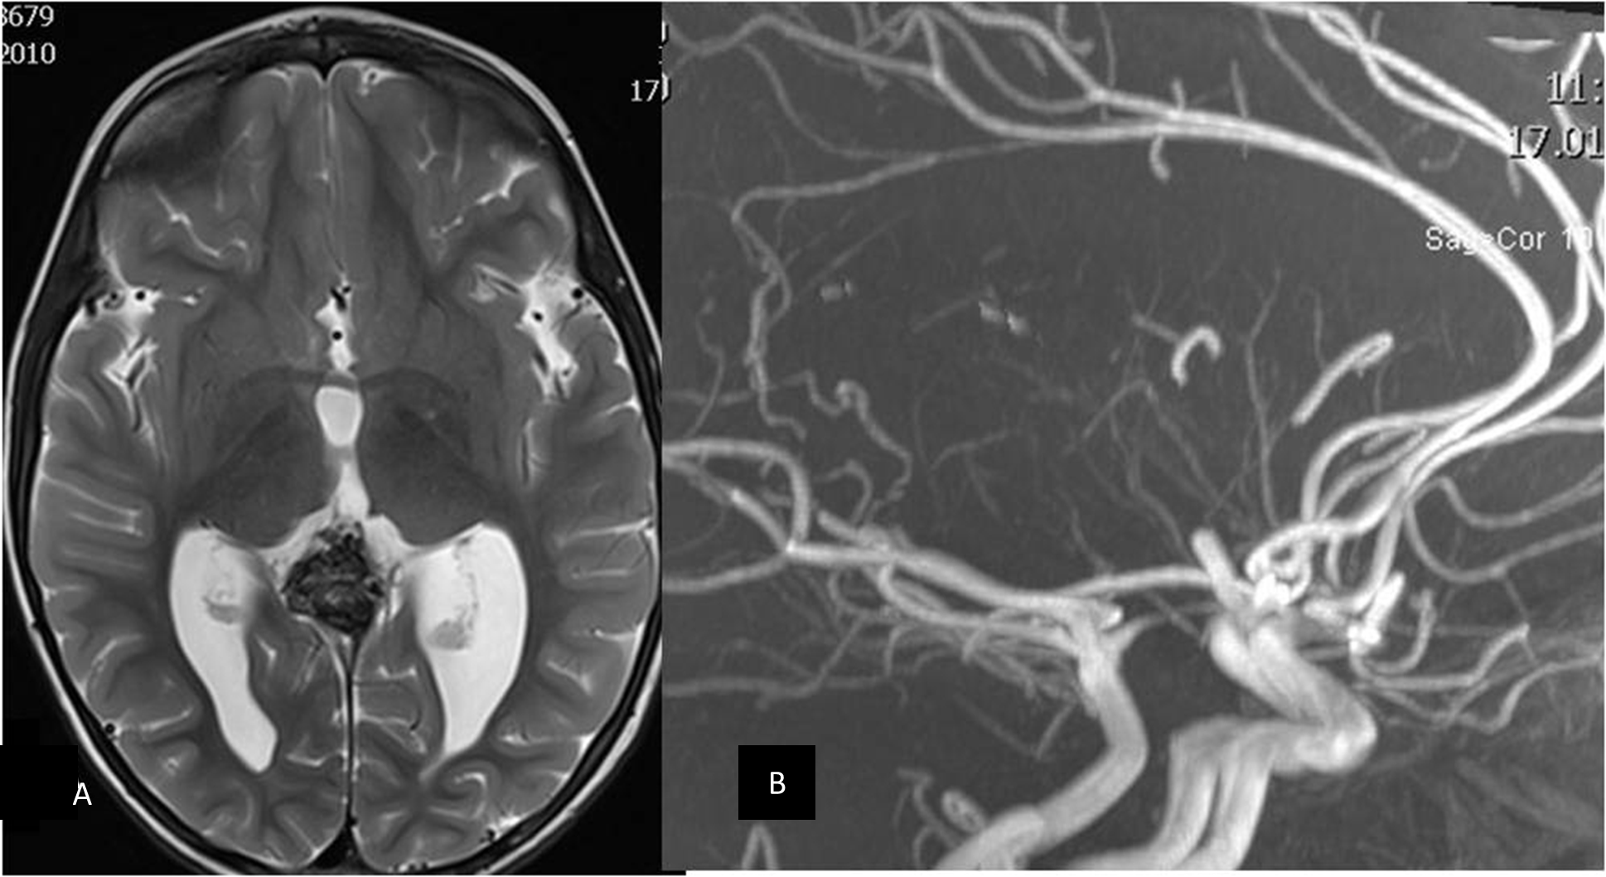Figure 3 Imaging examinations of patient 3. A: The MR angiography one year after treatment showed mild ventricular dilatation, especially of the left occipital horn; B: No residual flow in the VGAM is seen. The VGAM was occluded completely.

