Name of Journal: World Journal of Gastroenterology
Manuscript NO: 33850
Manuscript Type: ORIGINAL ARTICLE

Basic Study
Changes of the Ghrelin/GOAT axis and the mTOR pathway in the hypothalamus after sleeve gastrectomy in obese type-2 diabetes rats

Wang Q et al. Does SG change food intake centrally?

Qiang Wang, Wei Tang, Wen-Sheng Rao, Xin Song, Cheng-Xiang Shan, Wei Zhang

Qiang Wang, Wen-Sheng Rao, Xin Song, Cheng-Xiang Shan, Wei Zhang, Department of General Surgery, Changzheng Hospital, Second Military Medical University, Shanghai 200003, China

Wei Tang, Department of Surgery, University of Tokyo Hospital, Tokyo 113-8655, Japan

Author contributions: Wang Q and Rao WS contributed equally to this work; Shan CX, Tang W and Zhang W designed the research; Song X performed the statistical analysis; Zhang W and Wang Q wrote this paper.

Supported by National Natural Science Foundation of China, No. 81270969 (to Zhang Wei) and No. 81300723 (to Shan Cheng-Xiang); Shanghai Science and Technology Commission Foundation, No. 12ZR1439100 (to Zhang Wei).

Institutional review board statement: This study was reviewed and approved by the institutional board and ethics committee of Changzheng hospital.

Institutional animal care and use committee statement: All procedures in this study conformed to and received approval from the institutional standards of The Second Military Medical University Animal Care and Use committee (animal permit number: SCXK(H) 2013-0016).

Conflict-of-interest statement: We declare that there are no conflicts of interest to disclose.

Data sharing statement: No additional data are available.

Open-Access: This article is an open-access article which was selected by an in-house editor and fully peer-reviewed by external reviewers. It is distributed in accordance with the Creative Commons Attribution Non Commercial (CC BY-NC 4.0) license, which permits others to distribute, remix, adapt, build upon this work non- commercially, and license their derivative works on different terms, provided the original work is properly cited and the use is non-commercial. See: http://creativecommons.org/licenses/by-nc/4.0/

Manuscript source: Unsolicited manuscript

Correspondence to: Zhang Wei, Professor, Department of General Surgery, Changzheng Hospital, Second Military Medical University, No. 415 Fengyang Road, Shanghai 200003, China. zhangwei412@aliyun.com
Telephone: +86-21-81885802
Fax: +86-21-63520020

Received: March 8, 2017
Peer-review started: March 9, 2017
First decision: April 21, 2017
Revised: May 2, 2017
Accepted: June 1, 2017
Article in press:
Published online:

Abstract
Aim
To examine the changes of the ghrelin/ghrelin O-acyltransferase (GOAT) axis and the mTOR pathway in the hypothalamus after sleeve gastrectomy.

Methods
A total of 30 obese type-2 diabetes rats (Sprague-Dawley [SD] rats, 6 wk of age, fed with high-sugar and high-fat fodder for 2 mo plus intraperitoneal [i.p.] injection of STZ) were randomly divided into three groups: non-operation group (S0 group, n = 10), sham operation group (Sh group, n = 10) and sleeve gastrectomy group (SG group, n = 10). Body mass, food intake, oral glucose tolerance test (OGTT), acylated ghrelin (AG) and total ghrelin (TG) were collected and measured on the first day (when the rat was 6 weeks old), preoperative day 3 and postoperative week 8. The mRNA expression of preproghrelin, GOAT and NPY, and protein expression of ghrelin, GOAT, GHSR and the mTOR pathway (p-Akt, p-mTOR and p-S6) were measured in the hypothalamus.

Results
SG can significantly improve metabolic symptoms by reducing body mass and food intake. The obese rats show lower serum TG levels and no change in AG, but the ratio of AG/TG was increased. When compared with the S0 and Sh groups, the SG group showed decreased TG (1482.03 ± 26.55, 1481.49 ± 23.30 and 1206.63 ± 52.02 ng/L, respectively, p < 0.05) but unchanged AG (153.06 ± 13.74, 155.37 ± 19.30 and 144.44 ± 16.689 ng/L, respectively, p > 0.05). As a result, the ratio of AG/TG was further increased in the SG group (0.103 ± 0.009, 0.105 ± 0.013 and 0.12 ± 0.016, respectively, p < 0.05). When compared with the S0 group, SG suppressed mRNA and protein levels of preproghrelin (0.63 ± 0.12 vs 0.5 ± 0.11, p < 0.05) and GOAT (0.96 ± 0.09 vs 0.87 ± 0.08, p < 0.05) but did not change NPY mRNA expression (0.61 ± 0.04 vs 0.65 ± 0.07, p > 0.05) in the hypothalamus. The protein levels of p-Akt, p-mTOR and p-S6 were higher in the SG group, which indicates that the hypothalamic mTOR pathway was activated after SG on the postoperative week 8.

Conclusion
The reduction of ghrelin expression and activation of the mTOR pathway might have opposite effects on food intake, as SG improves obesity and T2DM.

Key words: Ghrelin; GOAT; Hypothalamus; mTOR; Obesity; Sleeve gastrectomy; Type-2 Diabetes

© The Author(s) 2017. Published by Baishideng Publishing Group Inc. All rights reserved.

Core tip: Recent studies have demonstrated a complex relation between ghrelin, ghrelin O-acyltransferase (GOAT) and the mTOR pathway. In our study, we examined the changes of the ghrelin/GOAT axis and the mTOR pathway in the hypothalamus after sleeve gastrectomy (SG). The mRNA and protein levels of ghrelin and GOAT decreased after SG, while NPY mRNA expression is no change. We also found SG increased the protein levels of p-Akt, p-mTOR and p-S6. The reduction of ghrelin expression and activation of the mTOR pathway might have opposite effects on food intake. These founding might explain the weight, glucose and food intake regain after SG.

Wang Q, Tang W, Rao WS, Song X, Shan CX, Zhang W. Changes of the Ghrelin/GOAT axis and the mTOR pathway in the hypothalamus after sleeve gastrectomy in obese type-2 diabetes rats. World J Gastroenterol 2017; In press

Introduction
Obesity and type-2 diabetes mellitus (T2DM) are closely related epidemic diseases with increasing incidence rates worldwide. Lifestyle factors such as high-fat diet, lack of physical activity, genetic and environmental factors are important causes of diabetes. As one of the most commonly used bariatric surgeries, sleeve gastrectomy (SG) can effectively reduce obesity and improve metabolic symptoms by weight loss and hormonal changes. Recent studies have found that weight loss and T2DM remission may be related to ghrelin, bile acids and microbiota changes after SG^{[1]}.
Ghrelin, found mainly in the stomach, is an endogenous ligand for the growth hormone secretagogue receptor type 1a (GHS-R1a) and has two major molecular forms, acylated ghrelin (AG) and unacylated ghrelin (UAG)^{[2-4]}. As the activated form of ghrelin, AG is best known for its effect on growth hormone-releasing neurons. For instance, AG was shown to increase neuropeptide Y (NPY) mRNA expression levels by the mammalian target of rapamycin (mTOR) in the hypothalamus^{[5,6]}. The enzyme responsible for transforming UAG to AG was identified in 2008 and named ghrelin O-acyltransferase (GOAT)^{[7]}. A recent study found that AG could regulate GOAT expression in the stomach^{[8]} and that the widespread expression of GOAT corresponded to the widespread distribution of ghrelin expression, e.g., in the pancreas, stomach and hypothalamus^{[8,9]}. Since then, multiple studies have demonstrated that both ghrelin and GOAT play important roles in the regulation of obesity, blood glucose and insulin^{[5,10,11]}. However, it is not known whether the ghrelin/GOAT axis in the hypothalamus (via autocrine/paracrine signaling) may be involved in the maintenance of blood glucose concentrations and energy homeostasis by restricting food intake after SG.
Recent studies suggested that mTOR has an important and complex impact on several cellular functions, such as cell growth, weight loss, food intake and even insulin resistance^{[12-16]}. It was also demonstrated that both energy deprivation and AG can activate the mTOR pathway to affect food intake^{[6,17]}. Meanwhile, insulin inhibits GOAT expression via the mTOR pathway in islet cells^{[3]} and SG can suppress the remnant stomach mRNA levels of preproghrelin and GOAT in a remnant stomach^{[18]}. However, changes of the Ghrelin/GOAT axis and the mTOR pathway in the hypothalamus after SG have not yet been investigated. The aim of this study was to evaluate these changes to explain the mechanism of SG from a central point of view.

Materials and methods

Animals and experimental protocol
Seventy-seven male Sprague-Dawley rats (6 wk of age, weight: 150–180 g) were obtained from the Laboratory Animal Center of the Second Military Medical University. Equipment and reagents were obtained from the following sources: electronic analytical balance (Libror AEL-200 type, Japan); Roche glucometer (ACCU-CHEK® Performa, Roche Diagnostics); streptozotocin (Sigma-Aldrich, China); rat total ghrelin, acylated ghrelin and Insulin ELISA assay kit (R&D system, United States); ghrelin, GHSR, GOAT, p-AKT(s473), mTOR, p-mTOR(s2448), P70s6k, GAPDH antibody (Abcam, USA); and p-S6 (s235/236) antibody (Sigma-Aldrich, United States). All procedures conformed to and received approval from the institutional standards of The Second Military Medical University Animal Care and Use committee (animal permit number: SCXK(H) 2013-0016).

Establishment of the animal model
Rats had a mean body mass of 173.82 ± 14.32 g and were randomly divided into NF (fed normal fodder, n = 20) or HF groups (fed high-sugar and high-fat fodder, n = 57). During the 2-month experiment, all rats were housed at 20–25 °C and 40%–60% relative humidity. Rats with a 20% higher body mass than the average weight of the NF group^{[19]} were defined as obese rats. Noninsulin-dependent diabetes mellitus was induced in overnight-fasted rats by a single intraperitoneal (i.p.) injection of 45 mg/kg streptozotocin. Blood glucose was measured from the tail vein once daily within 3 d after injecting streptozotocin. Only rats with an average blood glucose concentration > 16.7 mmol/L were included as successful T2DM models. Of all rats, 32 were confirmed to be the successful model, corresponding to a rate of 56.14%.

Animal grouping
Of the 32 T2DM model rats, two rats died after SG. The remaining 30 rats were randomly divided into three groups: non-operation (S0 group, n = 10), sham operation (Sh group, n = 10) or sleeve gastrectomy group (SG group, n = 10).

Surgical operation and intervention study
All rats of the operation groups (both Sh and SG) were food- and water-deprived for 12 hours before surgery. The rats were anesthetized by an i.p. injection of 0.3% sodium pentobarbital (50 mg/kg) and observed until corneal and pain reflexes were absent. A hypodermic injection of 0.9% sodium chloride solution (20 mL) and an intramuscular injection of penicillin sodium (800000 IU) were given to prevent dehydration and infection before the surgery began.
A 3-cm incision was made 1 cm below the xiphoid process. After opening the abdominal cavity, the liver was lifted with to expose the stomach. Then, the ligaments surrounding the stomach and gastroepiploic tissues were broken. A 3–5-mm transverse incision was made along the greater curvature near the pylorus to empty the stomach contents. This step could avoid the contents outflow quickly to prevent abdominal infection. After empting the stomach contents, the gastric fundus and a large portion of the gastric body (70% of the total stomach) were resected (Figure 1A). The residual stomach was then closed by a single-layer continuous suture using 6-0 absorbable lines (Figure 1B). Before closure of the skin, the abdominal cavity was rinsed with a warm 0.9% sodium chloride solution (20–30 mL).
Sham-operated rats underwent a similar procedure as the SG group, including anesthesia, a 3–5-mm transverse incision was made along the greater curvature near the pylorus to empty stomach contents. After empting the stomach contents, the incision was extended to 2 cm, a waiting time that corresponded to the resection time in SG rats, then stomach closure. Rats that were operated on were allowed to consume water 2 h after surgery but were fasted for 24 h post-operation. After 2–3 d, they were fed a non-residue diet; after recovery, they consumed their preoperative diet.

Body mass, food intake, oral glucose tolerance test, ghrelin measurements
Body mass was measured once every 5 d preoperatively and once a day postoperatively for 8 wk. Food intake was measured by recording the total amount of fodder consumed per week. To perform the oral glucose tolerance test (OGTT), all rats were fasted overnight and received a 50% glucose solution (1 g/kg) by oral gavage^{[20]}. Blood was collected from the orbital vein for measurements of glucose and insulin concentrations at 0, 15, 30, 60, 90 and 120 min post glucose infusion on the first day (rat was 6 weeks old), preoperative day 3 and postoperative week 8. The area under the glucose curve (AUC-glucose), AUC-insulin and HOMA-IR (fasting insulin × fasting glucose/22.5) were calculated. The blood collected from the OGTT at 0 min was also used to measure AG and TG.
Hypothalamic tissue was collected for western blot and real-time polymerase chain reaction (PCR). All rats were sacrificed by an overdose of anesthesia. Sections containing the hypothalamus were cut according to the rat brain atlas of Paxinos and Watson and immediately frozen in liquid nitrogen^{[21]}.

Western blot analysis
The hypothalamus was crushed in PMSF lysate (50 mmol/L Tris-HCl, pH 8.0, 150 mmol/L NaCl, 1% Triton X-100, 100 µg/mL PMSF) for 30 min and then centrifuged at 12000 rpm for 5 min. Protein concentration was measured by the BCA protein assay reagent. A total of 40 µg of protein was separated by a 10% SDS-PAGE and transferred to polyvinylidene fluoride (PVDF) membranes. All membranes were incubated overnight at 4°C with primary antibodies. They were then incubated with secondary antibodies at room temperature for 1 h and visualized using the GChemiDoc MP imaging system and image lab software (Bio-Rad, United States). All results were expressed as target protein/GAPDH ratio.

Real-time PCR analysis
Total RNA was extracted with Trizol Reagent (Invitrogen, United States). Then, 2 µg total RNA was reverse transcribed with Oligo (dT) primer and M-MLV Reverse Transcriptase (Promega, United States), according to the manufacturer’s instructions. The complementary DNA was used for real-time PCR, and a final volume of 20 μL was made as follows: 10 μL 2 × SYBR premix exTaq (TaKaRa, China), 0.8 μL forward and reverse primers (2.5 μmol/L, 5 μL cDNA, 4.2 μL ddH₂O). PCR and data collection were performed on a CFX Connect™ Real-Time PCR Detection System (Takara), and data analysis was operated with the 2-ΔΔCt method normalized to the endogenous control β-actin. Primers used in real-time PCR were as follows: Rat preproghrelin: 5′-AAG CCC AGC AGA GAA AGG AAT C-3′ (forward); 5′-CAA CAT CGA AGG GAG CAT TGA AC-3′ (reverse). Rat GOAT: 5′-ATT TGT GAA GGG AAG GTG GAG-3′ (forward); 5′-CAG GAG AGC AGG GAA AAA GAG-3′ (reverse). Rat NPY: 5′-GGC CAG ATA CTA CTC CGC TC-3′ (forward); 5′-GTC TTC AAG CCT TGT TCT GGG-3′ (reverse). Rat β-actin: 5′-GAG ACC TTC AAC ACC CCA GCC-3′ (forward); 5′-TCG GGG CAT CGG AAC CGC TCA-3′ (reverse).

2.8 Statistical analysis
Data are presented as the mean ± SD. SPSS 20.0 (IBM, New York, United States) was used for statistical analyses, and GraphPad Prism 6.0c (GraphPad Software, San Diego, CA, United States) was used to edit images. Statistical indicators between the three groups (S0, Sh and SG) were determined by one-way ANOVA, followed by least significance difference (LSD) post hoc comparison. The statistical indicator between two time points in one group was determined by a paired t-test, whereas Student’s t-test was used to compare the means of two independent groups at the same time point.

Results

Body mass and food intake
Baseline body mass before surgery did not differ between groups (p > 0.05). Rats in the Sh group and SG group weighed significantly less in the first postoperative week, which gradually normalized and increased in the second week after surgery when rats continued with their preoperative diet. The minimum weight was 442.17 ± 9.57 g in Sh rats at postoperative day 7 and 409.25 ± 12.7 g in SG rats at postoperative day 9. The weight in the sham group was restored to preoperative levels at postoperative day 17. The weight of SG rats remained low and did not reach baseline levels (Figure 2).
Food intake was significantly decreased in the Sh group and the SG group but was consistently higher in the Sh group compared to the SG group (Figure 3).

OGTT

Fasting blood glucose: Fasting blood glucose did not differ between treatment groups on the first day (p > 0.05) and significantly increased in obese model rats (p < 0.05). Eight weeks after surgery, the fasting blood glucose levels in the SG group were significantly lower than in the S0 and Sh groups (p < 0.05; Table 1)

Blood glucose and AUC-glucose: Blood glucose levels of the S0, Sh and SG groups did not differ at any time points on the first day but significantly increased as rats became obese models. Blood glucose levels and AUC-glucose in the SG group significantly decreased after surgery and were significantly lower than in the S0 and Sh groups (Figure 4, Table 2).

Blood insulin and AUC-insulin: Fasting insulin and maximal insulin were significantly increased, and the maximal insulin excretion time was at the 90th min in all groups after glucose loading on preoperative day 3, while the maximal insulin excretion time was at the 60th min after glucose loading on the first day. Compared with the S0 and Sh groups, the SG group had lower fasting insulin and maximal insulin concentrations. The maximal insulin excretion time in SG rats was at the 60th min again. AUC-glucose and AUC-insulin were increased in all obese model groups and were significantly reduced in the SG group at 8 weeks after surgery. HOMA-IR, which reflects insulin resistance, was also significantly reduced in the SG group (Table 3, Figures 5 and 6).

TG and AG
The obese rats showed a lower serum TG level and no change in AG, but the ratio of AG/TG was increased. When compared with the S0 and Sh groups, the SG group showed decreased TG (1482.03 ± 26.55, 1481.49 ± 23.30 and 1206.63 ± 52.02 ng/L, respectively, p < 0.05) but unchanged AG (153.06 ± 13.74, 155.37 ± 19.30 and 144.44 ± 16.689 ng/L, respectively, p > 0.05). As a result, the ratio of AG/TG was further increased in the SG group (0.103 ± 0.009, 0.105 ± 0.013 and 0.12 ± 0.016, respectively, p < 0.05) (Figure 7).

mRNA expression levels of preproghrelin, GOAT and NPY in the hypothalamus
The mRNA expression levels of preproghrelin and GOAT were lower in the SG group than in the S0 group, while NPY mRNA expression did not differ between groups (Table 4).

Ghrelin, GHSR and GOAT protein in the hypothalamus
Ghrelin and GOAT protein expression was significantly reduced in SG rats, while the level of GHSR protein expression was increased (Figure 8).

Protein expression of the mTOR pathway in the hypothalamus
The levels of p-Akt, p-mTOR and p-S6 protein expression were higher in SG rats, while the protein expression levels of mTOR and P70S6K did not differ between the Sh and SG groups (Figure 9).

Discussion
As a bariatric surgery, SG can not only significantly reduce body weight but also effectively improve T2DM and obesity-induced metabolic complications^{[1]}. More and more surgeons worldwide choose SG, especially in Asia, because of the lower difficulty and complications of SG when compared with other bariatric surgeries. As the number of SGs is increasing, the surgeons’ viewpoint of SG changes from bariatric surgery to metabolic surgery. However, when compared with Roux-en-Y gastric bypass (RYGB), which is regarded as the “gold standard” in metabolic surgery, the effect of SG on improving metabolic symptoms and weight loss is seemingly imperfect^{[22-24]}. Weight and blood glucose regain is still the most disputed problem after SG. Our data showed that body mass, food intake, fasting blood glucose, postprandial blood glucose, AUC-glucose, AUC-insulin and HOMA-IR were significantly reduced after SG. However, the body mass levels at postoperative week 8 were comparable to the preoperative level. Remarkably, hyperglycemia and insulin resistance were significantly improved. The mechanism of SG is still unclear; the most important mechanisms are believed to be the restriction of calories and the complex hormonal changes. One of these hormonal changes include the markedly reduced ghrelin levels after removal of the gastric fundus.
Previous studies demonstrated that low plasma ghrelin levels are beneficial in elevating fasting insulin levels and improving hyperglycemia, insulin resistance and obesity, while higher levels of ghrelin inhibit insulin release in the pancreas and enhance the food intake signals in the hypothalamus^{[25,26]}. Furthermore, ghrelin gene knock-out mice had lower blood glucose and higher blood insulin levels^{[5]}. As one of the two existing forms of ghrelin in the body, AG is commonly considered the active form due to its “negative” effect on blood glucose metabolism and positive effect on food intake signals in the hypothalamus^{[27,28]}, whereas UAG can antagonize AG’s effects^{[29-31]}. Recent studies found that obese individuals have lower blood ghrelin levels but no change in serum AG levels or the ratio of AG/UAG. SG can further reduce serum UAG but not AG levels and increase the ratio of AG/UAG^{[32]}. Our data demonstrated that the level of TG was significantly decreased in obese rats; however, AG levels were unchanged and the ratio of AG/TG was increased. As shown in Figure 7, SG can further reduce the serum TG levels after SG-induced resection of the gastric fundus. However, AG was still not changed, but the ratio of AG/TG was further increased. Since SG can only reduce the levels of serum TG or UAG, it is unclear how SG can improve obesity and T2DM with increasing ratios of AG/TG or AG/UAG. Previous studies mentioned that ghrelin secretion depends on a specific secretion cue related to fasting and feeding^{[33]}, which should be abolished by SG. However, our and other studies did not confirm whether SG really abolished ghrelin’s special cyclic secretion. We propose that altered ghrelin secretion cues might be more important than plasma TG, AG or UAG in SG-induced improvement of obesity and metabolic symptoms.
AS is required for active ghrelin to bind with and activate its receptor; GOAT is essential for octanoylation of ghrelin^{[34]}. A number of studies demonstrated that GOAT mainly exists in tissues that play an important role in the regulation of food intake, blood glucose metabolism and energy homeostasis, such as the stomach, hypothalamus and pancreas^{[8]}. However, the relationship between GOAT expression and energy homeostasis is inconsistent. Gonzalez^{[35]} found that a 30% food reduction for 21 days increased GOAT expression in the gastric mucosa, while a 48-hour fasting period had no effect on GOAT expression in rats. On the contrary, other studies reported that GOAT expression was decreased after food restriction^{[36,37]}. Body energy level is not the only factor determining GOAT expression. Manuel et al^{[8]} found that AG could increase GOAT expression in the stomach, whereas insulin inhibited the expression of GOAT mRNA via the mTOR pathway^{[3]}. In our study, both mRNA and protein expression levels of ghrelin and GOAT significantly decreased after SG, while GHSR protein expression significantly increased. As mentioned above, this phenomenon may be related to the abolishment of ghrelin’s special cyclic secretion. The “override inhibition” theory^{[38]} describes a phenomenon in which hormones, normally secreted in response to an episodic stimulus, are paradoxically inhibited when that stimulus occurs continuously. Therefore, SG may eliminate the periodic effect of cyclic ghrelin on the hypothalamus, resulting in a reduced expression level of preproghrelin mRNA and ghrelin protein, as well as a GHSR compensatory increase. The reduction of GOAT mRNA and protein may be due to a local ghrelin decrease and energy deprivation after SG. Although ghrelin was significantly decreased, the level of NPY mRNA expression in SG rats did not change, which may be related to the activation of the mTOR pathway in the negative energy balance of the hypothalamus after SG.
Several studies have shown that the hypothalamic mTOR pathway plays a major role in the regulation of energy homeostasis and food intake^{[6]}. A recent study demonstrated that energy deprivation and administration of ghrelin into the 4th ventricle led to increased levels of p-mTOR and increased NPY mRNA expression and promoted feeding through the activation of the hypothalamic mTOR pathway. Moreover, rapamycin could significantly inhibit mTOR activity and reduce food intake^{[6,17]}. Our data suggest that SG can significantly increase the protein levels of p-Akt, p-mTOR and p-S6 in the hypothalamus. As a classic restrictive metabolic surgery, it is possible that SG first reduces the calorie intake, which then activates the mTOR pathway. Therefore, the activation of the mTOR pathway may be the reason for the increased NPY level after SG. One of the limitations of our study is that we did not compare SG with other restrictive metabolic surgeries. Takahide et al^{[21]} found no difference in hypothalamic mRNA expression of NPY between normally fed rats and SG rats. However, when compared with gastric banding rats, the NPY mRNA expression in SG rats was significantly lower. The reduction of ghrelin expression and activation of the mTOR pathway might have an opposite effect on food intake after SG.
Overall, altered glucose metabolism and food intake changes following SG should be divided into peripheral and central changes. In the periphery, SG can significantly reduce food intake by decreasing gastric volume and changing blood ghrelin levels. Further studies should focus on how SG changes ghrelin’s special cyclic secretion, especially AG’s. Centrally, as mentioned above, we found two opposite factors for the regulation of food intake. A recent study has shown that a residual stomach expansion occurred in more than 50% of the SG patients over a short-term period^{[39,40]}. Increased food intake may be the most important reason for the residual stomach expansion. The results of our study provide a clue for further studies on SG and its regulation of food intake from a central point of view.

comments
Background
Sleeve gastrectomy (SG), which is a classic restrictive metabolic surgery, is more and more popular in the world because of its lower difficulty and complications. However, weight and blood glucose regain is still the most disputed problems after SG. Increasing food intake might be the most important reason for these problems.

Research frontiers
This study is aim to examine the changes of the ghrelin/GOAT axis and the mTOR pathway in the hypothalamus after sleeve gastrectomy. These changes provide a clue for further studies on SG and its regulation of food intake from a central point of view.

Innovations and breakthroughs
The author compared with SG rats and non-operation rats in Ghrelin/GOAT axis and the mTOR pathway in the hypothalamus. This study found SG could suppress mRNA and protein levels of preproghrelin and GOAT but did not change NPY mRNA expression. The protein levels of p-Akt, p-mTOR and p-S6 were higher in the SG group, which indicates that the hypothalamic mTOR pathway was activated after SG on the postoperative week 8.

Applications
The findings in this study suggest that patients who were underwent SG still need to control food intake for better improvement of obesity and glucose metabolism.

Terminology
Sleeve gastrectomy (SG) is a novel procedure of metabolic surgery to remove at least 70% of stomach from the greater curvature. Ghrelin, mainly found in the stomach, could increase food intake and should be inhibited after SG. Ghrelin O-acyltransferase (GOAT) is essential for transforming unacylated ghrelin (UAG) to acylated ghrelin (AG). The mTOR pathway has an important and complex impact on several cellular functions, such as cell growth, weight loss, food intake and even insulin resistance

Peer-review
The authors examined changes of the ghrelin/GOAT axis and the mTor pathway in the hypothalamus after sleeve gastrectomy. This is a carefully done study and the findings are of considerable interest.

REFERENCES
1 Lee WJ, Almulaifi A. Recent advances in bariatric/metabolic surgery: appraisal of clinical evidence. J Biomed Res 2015; 29: 98-104 [PMID: 25859263 DOI: 10.7555/jbr.28.20140120]
2 Granata R, Baragli A, Settanni F, Scarlatti F, Ghigo E. Unraveling the role of the ghrelin gene peptides in the endocrine pancreas. J Mol Endocrinol 2010; 45: 107-118 [PMID: 20595321 DOI: 10.1677/JME-10-0019]
3 An W, Li Y, Xu G, Zhao J, Xiang X, Ding L, Li J, Guan Y, Wang X, Tang C, Li X, Mulholland M, Zhang W. Modulation of ghrelin O-acyltransferase expression in pancreatic islets. Cell Physiol Biochem 2010; 26: 707-716 [PMID: 21063108 DOI: 10.1159/000322338]
4 Folgueira C, Seoane LM, Casanueva FF. The brain-stomach connection. Front Horm Res 2014; 42: 83-92 [PMID: 24732927 DOI: 10.1159/000358316]
5 Sun Y, Asnicar M, Smith RG. Central and peripheral roles of ghrelin on glucose homeostasis. Neuroendocrinology 2007; 86: 215-228 [PMID: 17898534 DOI: 10.1159/000109094]
6 Martins L, Fernández-Mallo D, Novelle MG, Vázquez MJ, Tena-Sempere M, Nogueiras R, López M, Diéguez C. Hypothalamic mTOR signaling mediates the orexigenic action of ghrelin. PLoS One 2012; 7: e46923 [PMID: 23056530 DOI: 10.1371/journal.pone.0046923]
7 Gualillo O, Lago F, Dieguez C. Introducing GOAT: a target for obesity and anti-diabetic drugs? Trends Pharmacol Sci 2008; 29: 398-401 [PMID: 18606462 DOI: 10.1016/j.tips.2008.06.003]
8 Gahete MD, Córdoba-Chacón J, Salvatori R, Castaño JP, Kineman RD, Luque RM. Metabolic regulation of ghrelin O-acyl transferase (GOAT) expression in the mouse hypothalamus, pituitary, and stomach. Mol Cell Endocrinol 2010; 317: 154-160 [PMID: 20035826 DOI: 10.1016/j.mce.2009.12.023]
9 Lim CT, Kola B, Grossman A, Korbonits M. The expression of ghrelin O-acyltransferase (GOAT) in human tissues. Endocr J 2011; 58: 707-710 [PMID: 21646729 DOI: 10.1507/endocrj.K11E-117]
10 Kouno T, Akiyama N, Ito T, Okuda T, Nanchi I, Notoya M, Oka S, Yukioka H. Ghrelin O-acyltransferase knockout mice show resistance to obesity when fed high-sucrose diet. J Endocrinol 2016; 228: 115-125 [PMID: 26645250 DOI: 10.1530/joe-15-0330]
11 Trivedi A, Babic S, Heiman M, Gibson WT, Chanoine JP. Ghrelin, Ghrelin O-Acyltransferase, and Carbohydrate Metabolism During Pregnancy in Calorie-Restricted Mice. Horm Metab Res 2017; 49: 64-72 [PMID: 27701682 DOI: 10.1055/s-0042-116117]
12 Cota D, Matter EK, Woods SC, Seeley RJ. The role of hypothalamic mammalian target of rapamycin complex 1 signaling in diet-induced obesity. J Neurosci 2008; 28: 7202-7208 [PMID: 18614690 DOI: 10.1523/JNEUROSCI.1389-08.2008]
13 Haissaguerre M, Saucisse N, Cota D. Influence of mTOR in energy and metabolic homeostasis. Mol Cell Endocrinol 2014; 397: 67-77 [PMID: 25109278 DOI: 10.1016/j.mce.2014.07.015]
14 Yoon MS, Choi CS. The role of amino acid-induced mammalian target of rapamycin complex 1(mTORC1) signaling in insulin resistance. Exp Mol Med 2016; 48: e201 [PMID: 27534530 DOI: 10.1038/emm.2015.93]
15 Cota D, Proulx K, Smith KA, Kozma SC, Thomas G, Woods SC, Seeley RJ. Hypothalamic mTOR signaling regulates food intake. Science 2006; 312: 927-930 [PMID: 16690869 DOI: 10.1126/science.1124147]
16 Takei N, Furukawa K, Hanyu O, Sone H, Nawa H. A possible link between BDNF and mTOR in control of food intake. Front Psychol 2014; 5: 1093 [PMID: 25309497 DOI: 10.3389/fpsyg.2014.01093]
17 Zhang W, Zhang C, Fritze D, Chai B, Li J, Mulholland MW. Modulation of food intake by mTOR signalling in the dorsal motor nucleus of the vagus in male rats: focus on ghrelin and nesfatin-1. Exp Physiol 2013; 98: 1696-1704 [PMID: 23955309 DOI: 10.1113/expphysiol.2013.074930]
18 Fedonidis C, Alexakis N, Koliou X, Asimaki O, Tsirimonaki E, Mangoura D. Long-term changes in the ghrelin-CB1R axis associated with the maintenance of lower body weight after sleeve gastrectomy. Nutr Diabetes 2014; 4: e127 [PMID: 25027795 DOI: 10.1038/nutd.2014.24]
19 Qiu NC, Zhang Q, Song X, Liu ME, Li XK, Shan CX, Qiu M. Impact of the hepatic branch of the vagus and Roux-en-Y gastric bypass on the hypoglycemic effect and glucagon-like peptide-1 in rats with type 2 diabetes mellitus. J Surg Res 2014; 191: 123-129 [PMID: 24768143 DOI: 10.1016/j.jss.2014.03.062]
20 Zhong MW, Liu SZ, Zhang GY, Zhang X, Hu SY. Effects of sleeve gastrectomy with jejuno-jejunal or jejuno-ileal loop on glycolipid metabolism in diabetic rats. World J Gastroenterol 2016; 22: 7332-7341 [PMID: 27621579 DOI: 10.3748/wjg.v22.i32.7332]
21 Kawasaki T, Ohta M, Kawano Y, Masuda T, Gotoh K, Inomata M, Kitano S. Effects of sleeve gastrectomy and gastric banding on the hypothalamic feeding center in an obese rat model. Surg Today 2015; 45: 1560-1566 [PMID: 25724939 DOI: 10.1007/s00595-015-1135-1]
22 Rosenthal RJ; International Sleeve Gastrectomy Expert P, Diaz AA, Arvidsson D, Baker RS, Basso N, Bellanger D, Boza C, El Mourad H, France M, Gagner M, Galvao-Neto M, Higa KD, Himpens J, Hutchinson CM, Jacobs M, Jorgensen JO, Jossart G, Lakdawala M, Nguyen NT, Nocca D, Prager G, Pomp A, Ramos AC, Rosenthal RJ, Shah S, Vix M, Wittgrove A, Zundel N. International Sleeve Gastrectomy Expert Panel Consensus Statement: best practice guidelines based on experience of & gt; 12,000 cases. Surg Obes Relat Dis 2012; 8: 8-19 [PMID: 22248433 DOI: 10.1016/j.soard.2011.10.019]
23 Quan Y, Huang A, Ye M, Xu M, Zhuang B, Zhang P, Yu B, Min Z. Efficacy of Laparoscopic Mini Gastric Bypass for Obesity and Type 2 Diabetes Mellitus: A Systematic Review and Meta-Analysis. Gastroenterol Res Pract 2015; 2015: 152852 [PMID: 26167173 DOI: 10.1155/2015/152852]
24 Zhang Y, Wang J, Sun X, Cao Z, Xu X, Liu D, Xin X, Qin M. Laparoscopic sleeve gastrectomy versus laparoscopic Roux-en-Y gastric bypass for morbid obesity and related comorbidities: a meta-analysis of 21 studies. Obes Surg 2015; 25: 19-26 [PMID: 25092167 DOI: 10.1007/s11695-014-1385-9]
25 Yada T, Dezaki K, Sone H, Koizumi M, Damdindorj B, Nakata M, Kakei M. Ghrelin regulates insulin release and glycemia: physiological role and therapeutic potential. Curr Diabetes Rev 2008; 4: 18-23 [PMID: 18220691 DOI: 10.2174/157339908783502352]
26 Dezaki K, Sone H, Yada T. Ghrelin is a physiological regulator of insulin release in pancreatic islets and glucose homeostasis. Pharmacol Ther 2008; 118: 239-249 [PMID: 18433874 DOI: 10.1016/j.pharmthera.2008.02.008]
27 Khatib N, Gaidhane S, Gaidhane AM, Khatib M, Simkhada P, Gode D, Zahiruddin QS. Ghrelin: ghrelin as a regulatory Peptide in growth hormone secretion. J Clin Diagn Res 2014; 8: MC13-MC17 [PMID: 25302229 DOI: 10.7860/JCDR/2014/9863.4767]
28 Chen CY, Asakawa A, Fujimiya M, Lee SD, Inui A. Ghrelin gene products and the regulation of food intake and gut motility. Pharmacol Rev 2009; 61: 430-481 [PMID: 20038570 DOI: 10.1124/pr.109.001958]
29 Chen CY, Inui A, Asakawa A, Fujino K, Kato I, Chen CC, Ueno N, Fujimiya M. Des-acyl ghrelin acts by CRF type 2 receptors to disrupt fasted stomach motility in conscious rats. Gastroenterology 2005; 129: 8-25 [PMID: 16012930 DOI: 10.1053/j.gastro.2005.04.015]
30 Pacifico L, Poggiogalle E, Costantino F, Anania C, Ferraro F, Chiarelli F, Chiesa C. Acylated and nonacylated ghrelin levels and their associations with insulin resistance in obese and normal weight children with metabolic syndrome. Eur J Endocrinol 2009; 161: 861-870 [PMID: 19773372 DOI: 10.1530/EJE-09-0375]
31 Kumar R, Salehi A, Rehfeld JF, Höglund P, Lindström E, Håkanson R. Proghrelin peptides: Desacyl ghrelin is a powerful inhibitor of acylated ghrelin, likely to impair physiological effects of acyl ghrelin but not of obestatin A study of pancreatic polypeptide secretion from mouse islets. Regul Pept 2010; 164: 65-70 [PMID: 20619300 DOI: 10.1016/j.regpep.2010.06.005]
32 Ezquerro S, Méndez-Giménez L, Becerril S, Moncada R, Valentí V, Catalán V, Gómez-Ambrosi J, Frühbeck G, Rodríguez A. Acylated and desacyl ghrelin are associated with hepatic lipogenesis, β-oxidation and autophagy: role in NAFLD amelioration after sleeve gastrectomy in obese rats. Sci Rep 2016; 6: 39942 [PMID: 28008992 DOI: 10.1038/srep39942]
33 Spiegel K, Tasali E, Leproult R, Scherberg N, Van Cauter E. Twenty-four-hour profiles of acylated and total ghrelin: relationship with glucose levels and impact of time of day and sleep. J Clin Endocrinol Metab 2011; 96: 486-493 [PMID: 21106712 DOI: 10.1210/jc.2010-1978]
34 Li Z, Mulholland M, Zhang W. Ghrelin O-acyltransferase (GOAT) and energy metabolism. Sci China Life Sci 2016; 59: 281-291 [PMID: 26732975 DOI: 10.1007/s11427-015-4973-6]
35 González CR, Vázquez MJ, López M, Diéguez C. Influence of chronic undernutrition and leptin on GOAT mRNA levels in rat stomach mucosa. J Mol Endocrinol 2008; 41: 415-421 [PMID: 18835978 DOI: 10.1677/JME-08-0102]
36 Reimer RA, Maurer AD, Lau DC, Auer RN. Long-term dietary restriction influences plasma ghrelin and GOAT mRNA level in rats. Physiol Behav 2010; 99: 605-610 [PMID: 20149910 DOI: 10.1016/j.physbeh.2010.01.034]
37 Kirchner H, Gutierrez JA, Solenberg PJ, Pfluger PT, Czyzyk TA, Willency JA, Schürmann A, Joost HG, Jandacek RJ, Hale JE, Heiman ML, Tschöp MH. GOAT links dietary lipids with the endocrine control of energy balance. Nat Med 2009; 15: 741-745 [PMID: 19503064 DOI: 10.1038/nm.1997]
38 Cummings DE, Overduin J, Shannon MH, Foster-Schubert KE. Hormonal mechanisms of weight loss and diabetes resolution after bariatric surgery. Surg Obes Relat Dis 2005; 1: 358-368 [PMID: 16925248 DOI: 10.1016/j.soard.2005.03.208]
39 Disse E, Pasquer A, Pelascini E, Valette PJ, Betry C, Laville M, Gouillat C, Robert M. Dilatation of Sleeve Gastrectomy: Myth or Reality? Obes Surg 2017; 27: 30-37 [PMID: 27334645 DOI: 10.1007/s11695-016-2261-6]
40 Ferrer-Márquez M, García-Díaz JJ, Moreno-Serrano A, García-Díez JM, Ferrer-Ayza M, Alarcón-Rodríguez R, Artero EG, Soriano-Maldonado A. Changes in Gastric Volume and Their Implications for Weight Loss after Laparoscopic Sleeve Gastrectomy. Obes Surg 2017; 27: 303-309 [PMID: 27484976 DOI: 10.1007/s11695-016-2274-1]

P-Reviewer: Kimura A S-Editor: Ma YJ L-Editor: E-Editor:

Specialty type: Gastroenterology and hepatology
Country of origin: China
Peer-review report classification
Grade A (Excellent): 0
Grade B (Very good): B
Grade C (Good): 0
Grade D (Fair): 0
Grade E (Poor): 0

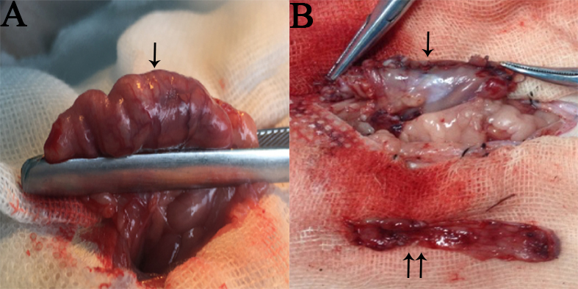
Figure 1 An intact stomach before SG (A) and the remnant stomach (↓) and resected gastric fundus (↑↑) after SG (b). The ↓ appearing in the figure A means that the gastric fundus and a large portion of the gastric body should be resected.

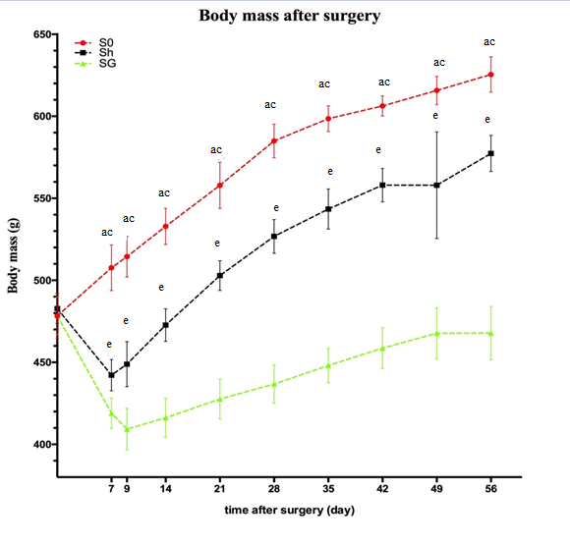
Figure 2 Body mass before and after surgery. Statistical differences were analyzed by one-way ANOVA followed by the LSD-t. ªp < 0.05, S0 vs SG; ^{c}p < 0.05, S0 vs Sh; ^{e}p < 0.05, Sh vs SG. LSD: least significance difference; Sh: sham operation group; SG: sleeve gastrectomy.

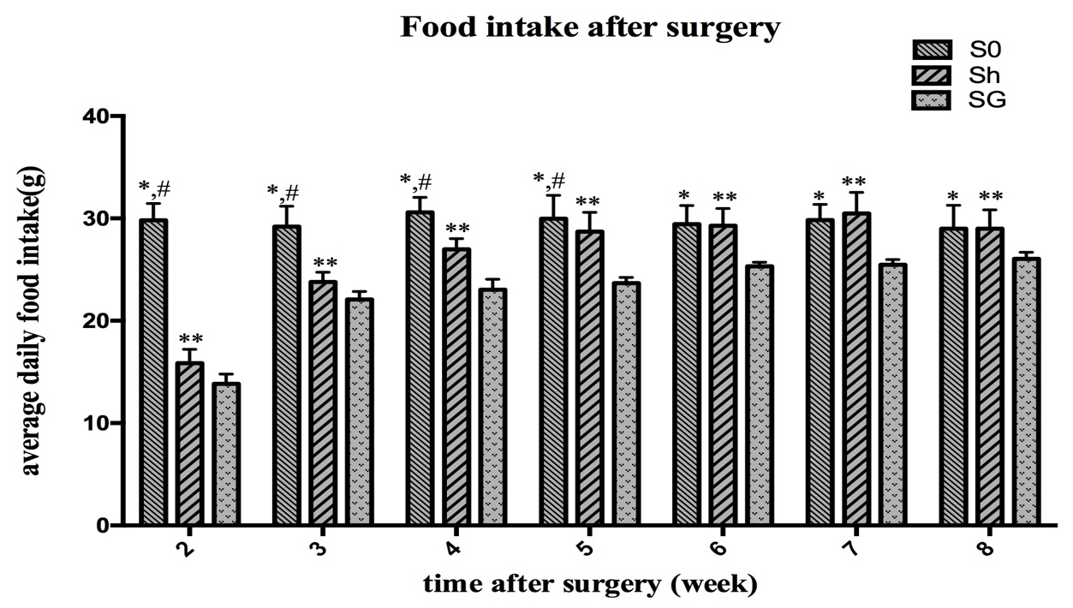
ac
a
e
a
e
e
a
e
e
e
ac
ac
ac
e
Figure 3 Food intake after surgery. Statistical differences were analyzed by one-way ANOVA followed by the LSD-t. ªp < 0.05, S0 vs SG; ^{c}p < 0.05, S0 vs Sh; ^{e}p < 0.05, Sh vs SG. LSD: least significance difference; Sh: sham operation group; SG: sleeve gastrectomy.

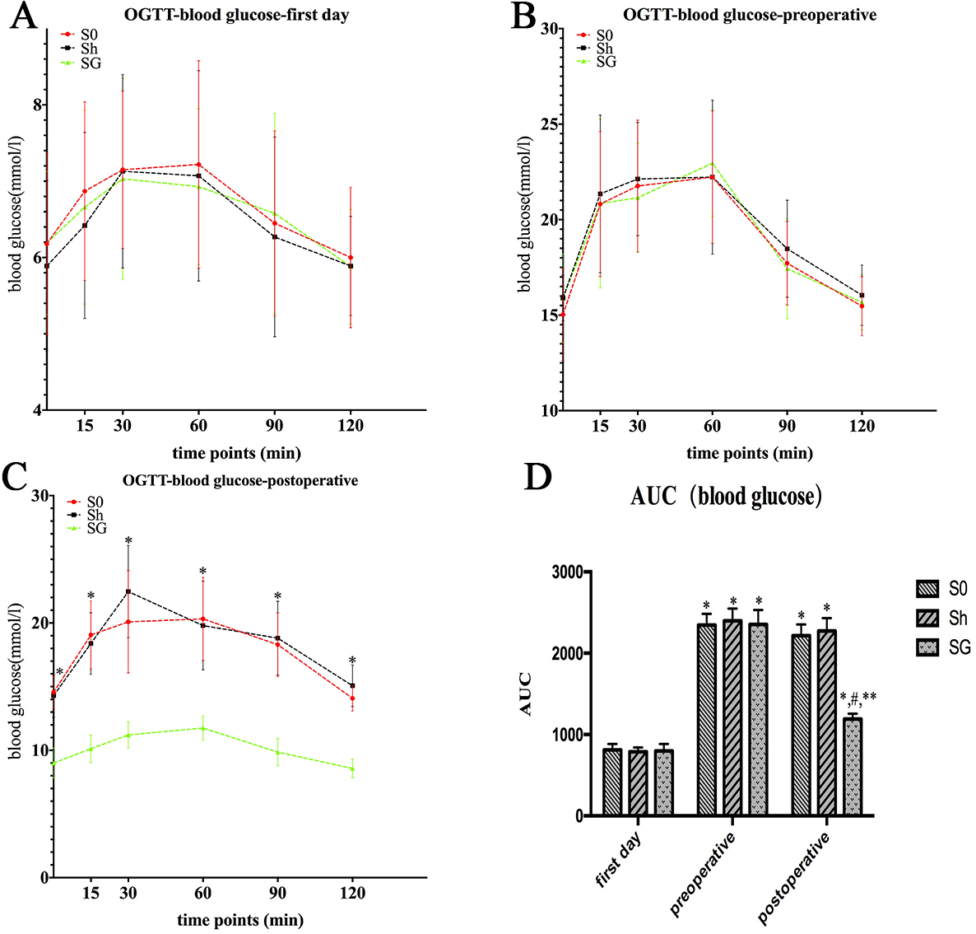
ceg
c
c
c
c
c
a
a
a
a
a
a
Figure 4 OGTT curve of blood glucose at the first day (A), preoperative (B) and postoperative (C) and AUC-blood glucose (D). Statistical differences among the three groups at the same time point were analyzed by one-way ANOVA followed by LSD-t and between two time points in one group using paired t-test. C: ªP < 0.05, SG vs S0 and Sh at the same time point; ^{c}P < 0.05, preoperative or postoperative vs first day in the same group; ^{e}P < 0.05, postoperative vs preoperative in the SG group; ^{g}P < 0.05, SG vs S0 and Sh at postoperative. OGTT: oral glucose tolerance test; Sh: sham operation group; SG: sleeve gastrectomy; LSD: least significance difference.

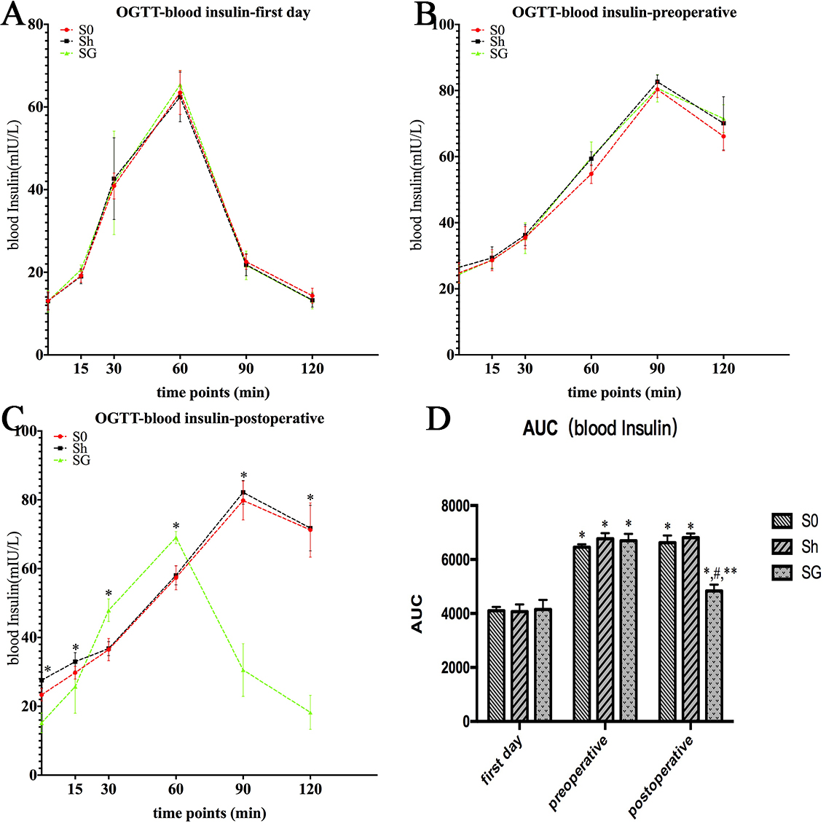
ceg
c
c
c
c
c
a
a
a
a
a
a
Figure 5 OGTT curve of blood insulin at the first day (A), preoperative (B) and postoperative (C) and AUC-blood insulin (D). Statistical differences among the three groups at the same time point were analyzed by one-way ANOVA followed by LSD-t and between two time points in one group using paired t-test. ªP < 0.05, SG vs S0 and Sh at the same time point; ^{c}P < 0.05, preoperative or postoperative vs first day in the same group; ^{e}P < 0.05, postoperative vs preoperative in the SG group; ^{g}P < 0.05, SG vs S0 and Sh at postoperative. OGTT: oral glucose tolerance test; Sh: sham operation group; SG: sleeve gastrectomy; LSD: least significance difference.

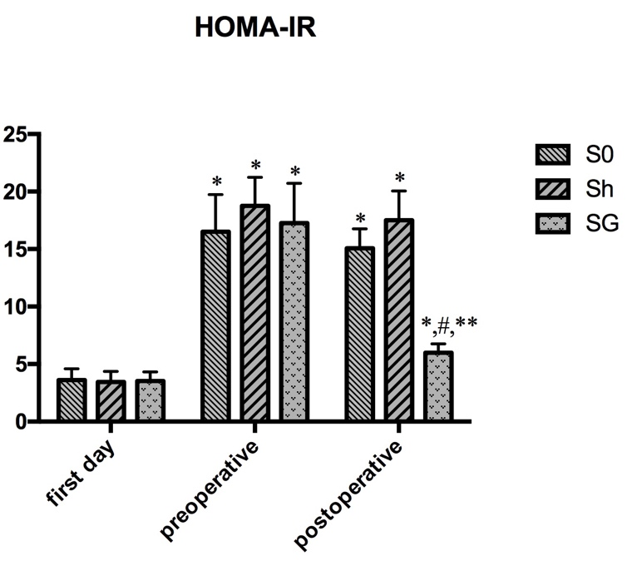

a
a
a
a
a

ace

Figure 6 HOMA-IR in the S0, Sh and SG at the first day, preoperative and postoperative. Statistical differences among the three groups at the same time point were analyzed by one-way ANOVA followed by the LSD-t and between two time points in the same group using paired t-test. ªP < 0.05, preoperative or postoperative vs first day in the same group; ^{c}P < 0.05, postoperative vs preoperative in the SG group; ^{e}P < 0.05, SG vs S0 and Sh at postoperative. Sh: sham operation group; SG: sleeve gastrectomy.

a
a
a
a
a
acee
acee
a
a
a
a
a
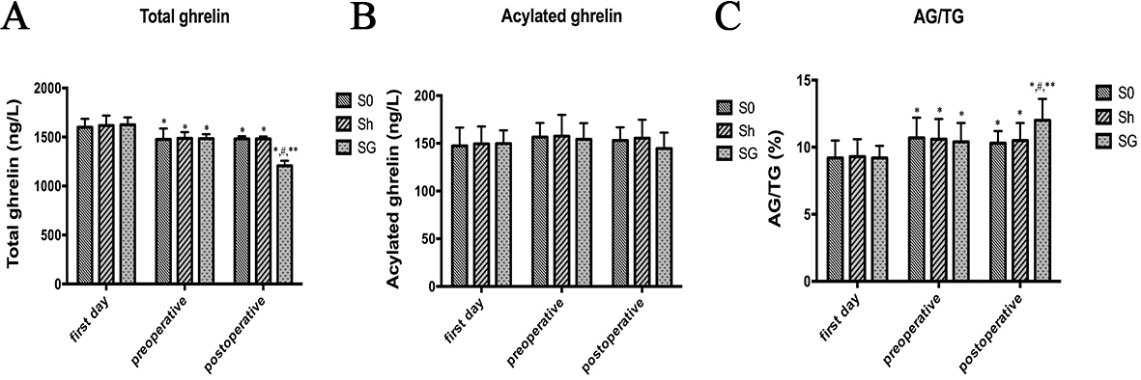
Figure 7 Changes of total ghrelin (A), acylated ghrelin (B) and AG/TG (C) at the first day, preoperative and postoperative. Statistical differences among the three groups at the same time point were analyzed by one-way ANOVA followed by the LSD-t and between two time points in the same group using paired t-test. ªP < 0.05, preoperative or postoperative vs first day in the same group; ^{c}P < 0.05, postoperative vs preoperative in the SG group; ^{e}P < 0.05, SG vs S0 and Sh at postoperative. AG: acylated ghrelin; TG: total ghrelin; Sh: sham operation group; SG: sleeve gastrectomy; LSD: least significance difference.

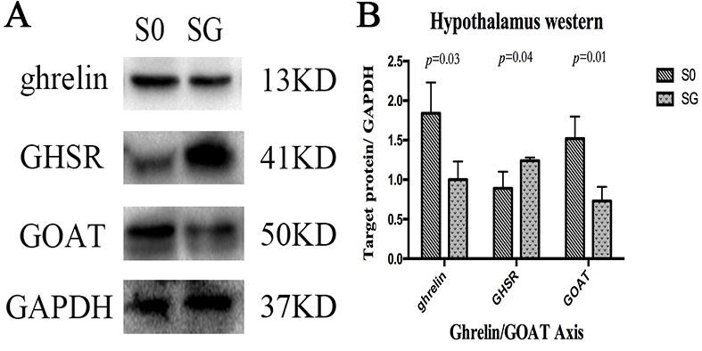
Figure 8 Ghrelin/GOAT Axis in Hypothalamus. A: Expression of ghrelin, GOAT and GHSR protein in the hypothalamus. GAPDH was used as an internal control; B: Ratio of target protein gray value to GAPDH gray value. Statistical differences between the two groups were analyzed by Student’s t-test. GOAT: ghrelin O-acyltransferase; SG: sleeve gastrectomy.

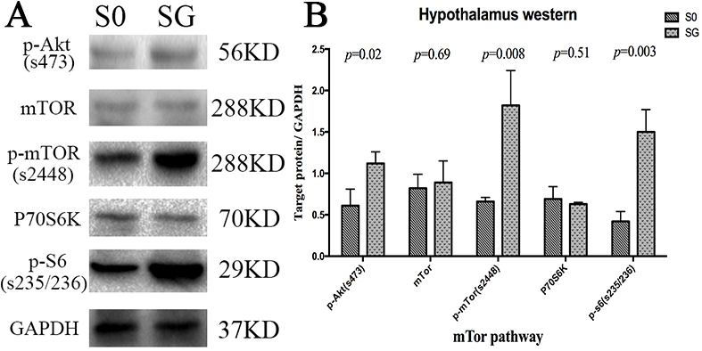
Figure 9 The mTOR pathway in hypothalamus. A: Protein expression of the mTOR pathway in the hypothalamus. GAPDH was used as an internal control; B: Ratio of target protein gray value to GAPDH gray value. Statistical differences between the two groups were analyzed by Student’s t-test. SG: sleeve gastrectomy.

Table 1 Changes in fasting blood glucose
Fasting blood glucose (mmol/L) |  | Group
 |  | S0 | Sh | SG
Time points | First day | 6.18 ± 1.19 | 5.89 ± 1.12 | 6.19 ± 0.94
 | Preoperative | 15.03 ± 2.4ª | 15.9 ± 1.2ª | 15.88 ± 2.32ª
 | Postoperative 8 wk | 14.55 ± 1.29 | 14.29 ± 1.69 | 9 ± 1.17^{ce}

Statistical differences among the three groups were analyzed by one-way ANOVA followed by LSD-t and between two time points in one group using a paired t-test. ªP < 0.05, preoperative vs first day in the same group; ^{c}P < 0.05, postoperative vs preoperative in the SG group; ^{e}P < 0.05, SG vs S0 and Sh at postoperative. LSD: least significance difference; Sh: sham operation group; SG: sleeve gastrectomy.

Table 2 Oral glucose tolerance test of blood glucose
Blood glucose (mmol/L)  Time points (min) | First day |  |  |  | Preoperative |  |  |  | Postoperative
 | S0 | Sh | SG |  | S0 | Sh | SG |  | S0 | Sh | SG
0 | 6.18 ± 1.19 | 5.89 ± 1.12 | 6.19 ± 0.94 |  | 15.03 ± 2.4ª | 15.9 ± 1.2ª | 15.88 ± 2.32ª |  | 14.55 ± 1.29 | 14.29 ± 1.69 | 9 ± 1.17^{ce}
15 | 6.18 ± 1.17 | 6.42 ± 1.22 | 6.66 ± 1.27 |  | 20.82 ± 3.8ª | 21.35 ± 4.13ª | 20.84 ± 4.41ª |  | 19.06 ± 2.68 | 18.39 ± 2.42 | 10.12 ± 1.07^{ce}
30 | 7.15 ± 1.03 | 7.13 ± 1.27 | 7.03 ± 1.32 |  | 21.76 ± 3.45ª | 22.13 ± 2.96ª | 21.15 ± 2.86ª |  | 20.09 ± 4.02 | 22.47 ± 3.63 | 11.21 ± 1.02^{ce}
60 | 7.22 ± 1.36 | 7.07 ± 1.38 | 6.93 ± 1.02 |  | 22.23 ± 3.47ª | 22.23 ± 4.03ª | 22.96 ± 2.78ª |  | 20.32 ± 3.26 | 19.8 ± 3.49 | 11.75 ± 0.95^{ce}
90 | 6.45 ± 1.21 | 6.27 ± 1.31 | 6.58 ± 1.31 |  | 17.72 ± 2.19ª | 18.48 ± 2.54ª | 17.43 ± 2.61ª |  | 18.3 ± 2.5 | 18.81 ± 2.9 | 8.76 ± 1.01^{ce}
120 | 6 ± 0.92 | 5.89 ± 0.65 | 5.58 ± 0.75 |  | 15.47 ± 1.55ª | 15.04 ± 1.58ª | 15.67 ± 1.44ª |  | 14.08 ± 1 | 15.07 ± 1.63 | 6.98 ± 1.13^{ce}
Statistical differences among the three groups were analyzed by one-way ANOVA followed by LSD-t and between two time points in one group using a paired t-test. ªP < 0.05, preoperative vs first day in the same group at the same time point; ^{c}P < 0.05, postoperative vs preoperative in the SG group; ^{e}P < 0.05, SG vs S0 and Sh at postoperative. LSD: least significance difference; Sh: sham operation group; SG: sleeve gastrectomy.

Table 3 Oral glucose tolerance test of blood insulin
Blood insulin (mU/L)  Time points (min) | First day |  |  |  |  |  | Model |  |  |  |  |  | Surgery
 | S0 | Sh | SG |  |  | S0 |  | Sh | SG |  |  | S0 |  | Sh | SG
0 | 13.06 ± 2.21 | 13.03 ± 2.01 | 12.97 ± 2.63 |  |  | 24.79 ± 3.06ª |  | 26.48 ± 2.19ª | 24.37 ± 2.51ª |  |  | 23.33 ± 1.81 |  | 27.58 ± 2.24 | 15.21 ± 2.87^{ce}
15 | 19.16 ± 1.57 | 19.04 ± 1.83 | 20.63 ± 1.17 |  |  | 28.66 ± 3.2ª |  | 29.38 ± 3.33ª | 28.72 ± 2.39ª |  |  | 29.78 ± 2.86 |  | 32.95 ± 2.65 | 25.71 ± 7.73^{ce}
30 | 40.9 ± 3.15 | 42.65 ± 9.89 | 41.64 ± 12.51 |  |  | 35.47 ± 3.36ª |  | 36.27 ± 3.21ª | 35.33 ± 4.68ª |  |  | 36.49 ± 3.25 |  | 36.78 ± 2.05 | 47.93 ± 3.31^{ce}
60 | 63.46 ± 5.3 | 62.43 ± 6.01 | 65.38 ± 3.45 |  |  | 54.76 ± 2.85ª |  | 59.37 ± 2.12 | 59.81 ± 4.63ª |  |  | 57.36 ± 3.51 |  | 58.08 ± 2.77 | 69.05 ± 1.74^{ce}
90 | 22.55 ± 1.8 | 21.81 ± 2.65 | 21.68 ± 3.23 |  |  | 80.35 ± 2.42ª |  | 82.68 ± 2.02ª | 80.68 ± 4.13ª |  |  | 79.79 ± 5.66 |  | 82.14 ± 3.46 | 30.55 ± 7.66^{ce}
120 | 14.3 ± 1.82 | 13.25 ± 1.67 | 13.14 ± 2.02 |  |  | 66.15 ± 4.38ª |  | 70.11 ± 8.05ª | 71.52 ± 4.2ª |  |  | 71.26 ± 7.88 |  | 71.76 ± 6.63 | 18.23 ± 4.95^{ce}
Statistical differences among the three groups were analyzed by one-way ANOVA followed by LSD-t and between two time points in one group using a paired t-test. ªP < 0.05, preoperative vs first day in the same group at the same time point; ^{c}P < 0.05, postoperative vs preoperative in the SG group; ^{e}P < 0.05, SG vs S0 and Sh at postoperative. LSD: least significance difference; Sh: sham operation group; SG: sleeve gastrectomy.
Table 4 Hypothalamic mRNA expression of preproghrelin, GOAT and NPY

X-mRNA/β-acting-mRNA | S0 | SG
preproghrelin | 0.63 ± 0.12 | 0.5 ± 0.11ª
GOAT | 0.96 ± 0.09 | 0.87 ± 0.08ª
NPY | 0.61 ± 0.04 | 0.65 ± 0.07

Hypothalamic mRNA expression of preproghrelin, GOAT and NPY was quantified using PCR and expressed as the ratio to the β-actin mRNA. Statistical differences between the two groups were analyzed using Student’s t-test. ªP < 0.05, S0 vs SG. GOAT: ghrelin O-acyltransferase; SG: sleeve gastrectomy.

